Contents

Virtual Hard Disks in Windows Server 2008 R2 and Windows 7 4

In this section 4

What's New in Virtual Hard Disks 4

What's new in VHDs? 4

Who will want to use VHDs? 5

What are the benefits of the new and changed features? 5

What are the dependencies? 5

Getting Started with Virtual Hard Disks 6

Introduction to Virtual Hard Disks 7

In this topic 7

Introduction 7

Supported operating systems 7

Overview of tools 8

Common usage scenarios 9

Scenario one: Image consolidation 9

Scenario two: Server provisioning 10

Scenario three: Server repurposing 11

Scenario four: Application development and validation 11

Scenario five: Virtual desktop infrastructure 12

How to Perform Common Tasks 13

In this topic 13

Creating, attaching, and detaching VHDs by using Disk Management 13

Create a VHD 14

Attach and detach a VHD 18

Creating, attaching, and detaching VHDs by using DiskPart 19

Create a VHD 20

Create a dynamic disk 20

Create a differencing disk 21

Attach and detach a VHD 22

Creating a bootable VHD 23

Before you begin 24

Step 1: Use DiskPart to create and attach a VHD 24

Step 2: Locate the install.wim image to apply to the VHD 26

Step 3: Apply a .wim image to the VHD 27

Using the Install-WindowsImage.ps1 Windows PowerShell script 27

Apply image by using the ImageX deployment tool 29

Creating VHDs by using Hyper-V 30

Preparing a VHD image for boot 35

Prepare a VHD image for native boot 35

Prepare a VHD image to boot inside a virtual machine 38

Deploying a bootable VHD by using Xcopy 39

Deploying VHDs by using Windows Deployment Services 41

Migrating VHDs between physical and virtual environments 41

Move from a virtual to a physical environment 42

Move from a physical to a virtual environment 43

Servicing images 46

Add drivers 46

Add Windows features 47

Backing up images 47

Performing advanced tasks by using DiskPart 48

Expand VHD 48

Extend partition 49

Compact a VHD 50

Merge VHD 51

Display VHD information 52

Appendix: Tools, Scripts, and APIs 53

In this topic 53

Tools used to maintain VHD images 54

Diskpart 54

Disk Management MMC snap-in 55

Imagex 56

Sysprep 57

BCDEdit 58

BCDBoot 59

Deployment Image Servicing and Management Tool (DISM) 60

Hyper-V Manager 62

Windows Deployment Services 62

Scripts 63

Install-WindowsImage 63

APIs 64

Frequently Asked Questions: Virtual Hard Disks in Windows 7 65

What are the different VHD file types? 65

Why are fixed VHDs recommended for production? 67

When is it appropriate to use dynamic VHDs? 67

What does it mean to create, attach, and detach VHDs? 68

What is a native-boot VHD? 69

What are the recommendations for using VHDs for native boot? 70

What is not supported for native boot using VHDs? 71

What are the best practices for backing up VHDs? 71

Power Management for Network Devices in Windows 7 73

What is Networking Power Management? 73

What’s new in the Networking Power Management? 73

Who should use this guide? 73

In this guide 74

Overview of Features 74

Prerequisites 76

Configuring power management using the user interface 76

Configuring Wake on LAN settings using the command line 77

Configuring power management using keywords 77

Configuring Power Management using the WMI API 78

GUID_NDIS_PM_ADMIN_CONFIG 79

GUID_NDIS_PM_ACTIVE_CAPABILITIES 79

Summary 80

What's New in Power Management for Network Devices 80

Who will want to use power management for networking devices? 80

What are the new and changed features? 80

Wake on LAN and Wake on Wireless LAN 80

Low Power on Media Disconnect 81

What's the impact of these changes on power management for network devices? 81

How can power management for network devices be used? 81

# Virtual Hard Disks in Windows Server 2008 R2 and Windows 7

## In this section

What's New in Virtual Hard Disks

Getting Started with Virtual Hard Disks

Frequently Asked Questions: Virtual Hard Disks in Windows 7

In addition to these topics, see the following resources:

• [Windows Native VHD Boot Deployment Scenarios](http://go.microsoft.com/fwlink/?LinkId=177538) (see the attachment at the end of the blog)

• Walkthrough: Deploy a Virtual Hard Disk for Native Boot

• Add a Native-Boot Virtual Hard Disk to the Boot Menu

# What's New in Virtual Hard Disks

The Microsoft® virtual hard disk (VHD) file format specifies a virtual hard disk, which is encapsulated in a single file and capable of hosting native file systems and supporting standard disk operations.

## What's new in VHDs?

In Windows® 7, a VHD can be used as the running operating system on designated hardware without any other parent operating system, virtual machine, or hypervisor. You can use the Windows 7 disk management tools (the DiskPart command-line tool and the Disk Management MMC snap-in) to create a VHD file. You can deploy a Windows 7 image (in .wim format) to the VHD, and you can copy the VHD file to multiple systems. You can configure the Windows 7 boot manager for a native or physical boot of the Windows image that is contained in the VHD. Furthermore, you can connect the VHD file to a virtual machine for use with the Hyper-V role in Windows Server 2008 R2. Native-boot VHD files are not designed or intended to replace full-image deployment on all client or server systems. Previous versions of Windows do not support a native boot from a VHD, and they require a hypervisor and virtual machine to boot from a VHD file.

For more information including instructions, see Getting Started with Virtual Hard Disks and Frequently Asked Questions: Virtual Hard Disks in Windows 7.

## Who will want to use VHDs?

Enterprise environments that already manage and use VHD files for virtual machine deployment will find the most benefit from the new features in this release. Although enterprise environments are moving an increasing number of applications to virtual machines, they still use physical computers to operate a significant part of the data center. For this reason, IT administrators have to maintain two sets of images: one set based on the .wim format for physical computers, and another set based on the VHD format for virtual machines. The VHD format supports physical computers and virtual machines, and it provides flexibility in image deployment and simplifies image management.

An image format that runs on both physical computers and virtual machines also benefits developers and testers. This is because they use virtual machines to test new system and application software, but sometimes they need to run tests on physical computers to access a specific hardware device, like the graphics card, or to get accurate performance profiling. Furthermore, native-boot VHDs enable developers and testers to boot into a Windows 7 image without creating a separate partition on the physical computer for installing Windows.

## What are the benefits of the new and changed features?

Native support for VHDs simplifies image management and reduces the number of images that you must catalog and maintain. To create a VHD on Windows Server 2008, you install the Hyper-V server role, create a VHD file, and then start the virtual machine to install Windows from the CD or DVD onto a partition in the VHD.

In Windows 7, native-boot VHDs allow you to create and modify VHD files without installing the Hyper-V server role. You can attach VHD files by using the disk management tools, and you can service the Windows image inside the VHD. You can use the deployment tools in the Windows Automated Installation Kit (Windows AIK) to apply a Windows image to the VHD and to apply updates to the image in the VHD file.

## What are the dependencies?

The steps for deploying a Windows 7 or Windows Server 2008 R2 image to a VHD file depend on the Windows deployment tools. For example, Imagex.exe is one of the tools in the Windows AIK. You use Imagex.exe to capture a Windows operating system partition into a Windows image (.wim) file, and then to apply the .wim file to a file system partition (which may reside inside a VHD file). You must install the latest version of the Windows AIK at Windows Automated Installation Kit for Windows 7 Beta. The Windows AIK download is an ISO image that you burn to a DVD and then install on your system. After installing the Windows AIK, ImageX.exe is located in the Windows AIK\PE Tools directory.

The native boot scenario also requires the Windows 7 boot environment. The Windows 7 boot environment is initialized during a full operating system installation, and it includes the Windows Boot Manager, Boot Configuration Data (BCD), and other supporting files. For more information about the tools you use, see Appendix: Tools, Scripts, and APIs.

# Getting Started with Virtual Hard Disks

Windows Server® 2008 R2 and Windows® 7 is the first version of Windows to provide native support for virtual hard disks (VHDs). This guide describes the scenarios that guided the development of this feature, detailed steps about how to employ the functionality (including image creation, deployment, and maintenance), and the associated tools, scripts, and APIs.

Note

To download a .doc version of this guide, see <http://go.microsoft.com/fwlink/?LinkId=159058>.

Note

In addition to this guide, see [Windows Native VHD Boot Deployment Scenarios](http://go.microsoft.com/fwlink/?LinkId=177538) (see the attachment at the end of the blog post).

• Introduction to Virtual Hard Disks

• Introduction

• Supported operating systems

• Overview of tools

• Common usage scenarios

• How to Perform Common Tasks

• Creating, attaching, and detaching VHDs by using Disk Management

• Creating, attaching, and detaching VHDs by using DiskPart

• Creating a bootable VHD

• Creating VHDs by using Hyper-V

• Preparing a VHD image for boot

• Deploying VHDs by using Windows Deployment Services

• Deploying a bootable VHD by using Xcopy

• Migrating VHDs between physical and virtual environments

• Servicing images

• Backing up images

• Performing advanced tasks by using DiskPart

• Appendix: Tools, Scripts, and APIs

• Tools used to maintain VHD images

• Scripts

• APIs

# Introduction to Virtual Hard Disks

## In this topic

• Introduction

• Supported operating systems

• Overview of tools

• Common usage scenarios

Note

To download a .doc version of this guide, see <http://go.microsoft.com/fwlink/?LinkId=159058>.

## Introduction

The virtual hard disk file format (.vhd) specifies the format of a file that represents a virtual hard disk. To use VHDs on Windows Server 2008 and previous versions of Windows, you must install the Hyper-V role, Microsoft Virtual Server, or Windows Virtual PC. However, with Windows 7 and Windows Server 2008 R2, you can create, configure, and boot physical computers from VHDs without a virtual machine or hypervisor. This functionality simplifies image management because it enables you to:

• Standardize the image format and toolsets in your organization.

• Reduce the number of images to catalog and support.

• Enable increased server utilization to conserve energy.

## Supported operating systems

Support for VHDs in Windows 7 and Windows Server 2008 R2 is targeted toward managed environments. Datacenters and large enterprises that maintain a managed deployment solution, including master images, will derive the greatest benefit from this feature.

All of the operating systems in the following table support VHD operations (such as creating and attaching VHDs). The table shows those that support booting from a VHD.

|  |  |
| --- | --- |
| Windows 7 Editions | Boot from a VHD |
| Home Basic | No |
| Home Premium | No |
| Professional | No |
| Enterprise | Yes |
| Ultimate | Yes |
| Starter | No |

|  |  |
| --- | --- |
| Windows Server 2008 R2 Editions | Boot from a VHD |
| Standard | Yes |
| Enterprise | Yes |
| Datacenter | Yes |
| Web | Yes |
| Standard (Core) | Yes |
| Enterprise (Core) | Yes |
| Datacenter (Core) | Yes |
| Web (Core) | Yes |
| For Itanium-based systems | Yes |
| Foundation Edition | No |

## Overview of tools

This section contains a list of the tools that you use to create and maintain VHDs. For a more detailed overview of these tools, including screenshots, see Appendix: Tools, Scripts, and APIs.

The following tools are included in Windows 7 and Windows Server 2008 R2:

• DiskPart   A command-line tool that you can use to create, attach, and detach VHDs. You can also perform more advanced tasks like compacting, expanding, and merging VHDs. For more information, see [DiskPart](http://go.microsoft.com/fwlink/?LinkId=128458) on Microsoft TechNet (http://go.microsoft.com/fwlink/?LinkId=128458).

• Disk Management   A Microsoft Management Console (MMC) snap-in that you can use to create, attach, and detach VHDs.

• BCDEdit   A command-line tool that you use to manage boot configuration data (BCD) stores. For more information, see [BCDEdit](http://go.microsoft.com/fwlink/?LinkId=128459) on Microsoft TechNet (http://go.microsoft.com/fwlink/?LinkId=128459).

• BCDBoot   A command-line tool that you can use to manage and create new BCD stores and BCD boot entries. BCDBoot can be used to create a new boot entry when configuring a system to boot from a new VHD. For more information, see [BCDBoot Command-Line Options](http://go.microsoft.com/fwlink/?LinkID=155166) on Microsoft TechNet (http://go.microsoft.com/fwlink/?LinkID=155166).

• Deployment Image Servicing and Management (DISM)   A command-line tool that you use to apply updates, drivers, and language packs to a Windows image. For more information, see [Deployment Image Servicing and Management Technical Reference](http://go.microsoft.com/fwlink/?LinkId=155029) on Microsoft TechNet (http://go.microsoft.com/fwlink/?LinkId=155029).

• Windows Hyper-V Manager   An MMC snap-in that supports VHD image creation. You can specify the type and size of VHD and install Windows from a CD or DVD, or from an ISO Image file. The Hyper-V Manager is only available on computers that are running Windows Server 2008 or Windows Server 2008 R2 with the Hyper-V role installed.

• Sysprep   A tool that enables you to remove user and computer-specific data from the operating system image. This enables you to capture the image and deploy it to other computers. For more information, see [Sysprep Technical Reference](http://go.microsoft.com/fwlink/?LinkId=155027) on Microsoft TechNet (http://go.microsoft.com/fwlink/?LinkId=155027).

The following tool are included in the Windows Automated Installation Kit (Windows AIK):

• ImageX   A command line tool that enables you to capture, create, modify, and apply Windows images. For more information, see [ImageX Technical Reference](http://go.microsoft.com/fwlink/?LinkId=155340) on Microsoft TechNet (http://go.microsoft.com/fwlink/?LinkId=155340).

## Common usage scenarios

Microsoft used the following scenarios to guide development and support for VHDs in Windows 7 and Windows Server 2008 R2.

### Scenario one: Image consolidation

Goal: Enable customers to create, deploy, and maintain a single image format for physical and virtual computers.

Background:

Enterprise and datacenter administrators who manage large numbers of servers typically generate a set of master images to simplify operating system maintenance and deployment. Each master image is for a particular hardware and operating system configuration (for example, it has a specific set of applications, drivers, and so on). These master images comprise an organization’s image library, which includes a variety of image formats. Administrators must maintain separate processes and toolsets to support each format in the library.

Scenario description:

Josh Bailey, the IT administrator of Wide World Importers, maintains an image library that contains 14 master images to support physical and virtual environments. The images include the following types:

• Windows Imaging file format (WIM images)

• Hyper-V (VHD images)

• VMware virtual appliances

• PowerQuest

• Altiris

Josh is using the following tools to create, maintain, and deploy the images:

• Microsoft System Center Configuration Manager for the WIM and VHD

• HP Systems Insight Manager (SIM) for the VMware images

• PowerQuest Drive Image for the PowerQuest images

• HP Insight Rapid Deployment (RDP) for the Altiris images

Josh has decided to standardize all physical and virtual images on the .vhd format and to migrate the Windows 2000 workloads to a virtualized environment. Standardizing has allowed him to reduce the total number of images from 14 to 11 and reduce the number of supported image formats from four to one. Using only the .vhd format allows him to adopt a single application—Configuration Manager—to create, maintain, and deploy the images instead of the four applications he used to use.

With the tools that are provided in Windows Server 2008 R2 and the Windows AIK, Josh creates generalized Windows Server 2008 R2 VHDs that run in physical and virtual environments. Using System Center Virtual Machine Manager, Josh preconfigures VHDs that run in virtual environments for the Windows Server 2008 R2 operating system. He also uses these tools to create and maintain VHDs that support workloads for the Windows 2000 operating system.

Simplifying the toolset saved Josh significant time and expense in tool development, licensing, and maintenance. It also allowed him to merge infrastructure and deployment processes, which significantly reduced operation and capital expenses.

### Scenario two: Server provisioning

Goal: Enable customers to provision physical computer resources.

Background:

Enterprise and datacenter administrators who want to operate a flexible and dynamic environment frequently need to quickly provision computer resources. To achieve this goal, they deploy images from an image library that contains master images as part of a managed deployment solution.

Scenario description:

Phil Spencer is an administrator for Woodgrove Bank who used the VHD format to standardize all images. After he completed the standardization, his boss told him that the company needs additional capacity for the servers that currently run their Web site. Phil determines that three physical servers are required to satisfy this request.

The deployment and provisioning service in his organization executes scripts to do the following:

1. Create a new allocation record in the configuration management database.

2. Capture the required configuration parameters.

3. Store the parameters in the new allocation record.

4. Turn on three reserve servers that are configured to network boot, copy, and launch a Windows Deployment Services client.

The Windows Deployment Services client is provided an Unattend.xml file that describes the storage and operating system configuration of the server and identifies the correct image to deploy. The image is contained on a VHD, which includes Windows Server 2008 R2 with Internet Information Services (IIS) installed and configured. The deployment process also configures the local boot environment for each server. After the VHD is copied to the destination server, the server restarts and Setup continues. The server restarts again and another script is run to finalize the server configuration.

Standardizing the physical images on the VHD format enables Phil to perform a simple and rapid deployment of Windows images without requiring him to set up the operating system or apply the image. Image deployment is reduced to copying a file and configuring the boot environment, which minimizes the deployment time.

### Scenario three: Server repurposing

Goal: Enable customers to repurpose hardware without increasing the complexity of deployment or servicing.

Background:

Enterprise and data center administrators who want to operate a flexible and dynamic environment frequently need to quickly repurpose computer resources. To achieve this goal, they deploy images from an image library that contains master images as part of a managed deployment solution.

Scenario description:

A. Datum Corporation offers services for hosting web, mail and application server workloads for customers. Customers can lease physical computers from A. Datum in increments of as little as 12 hours or more for each of the three workloads.

By using VHDs, A. Datum can configure each physical computer with the ability to run any of the three workloads. The administrator can transition between the workloads by updating the boot environment and rebooting the computer. After the computers are configured, customers are allocated a VHD instead of an entire physical computer that contains an operating system image and the specific workload. All changes that are made by the customer to the image are captured to a differencing disk. When the customer’s lease ends, the differencing disk is archived and the boot environment can be reconfigured to boot a workload as required by the next customer.

### Scenario four: Application development and validation

Goal: Enable ISVs to develop a common, reusable image that can be quickly deployed for validation.

Background:

Many ISVs who develop software and drivers to support hardware devices often need to perform tests (for performance, reliability, and so on) on real hardware. Traditionally this required ISVs to install Windows on a destination computer, run specific tests, and then debug in that environment. Products like Virtual PC allow ISVs to virtualize test resources for development purposes. However, virtualization solutions in general do not support virtualization of specialized hardware, which may be a key part of testing scenarios. As a result, this testing must occur on physical computers.

Scenario description:

Contoso, Ltd. develops the software and hardware for a graphics card. They test continually to validate that the hardware and software work correctly. In addition, Contoso performs monthly validation passes across a broad range of hardware configurations. To manage these processes, Contoso has created a set of generalized operating system VHDs that contain various user applications.

At the beginning of the week, Contoso deploys each image to a set of hardware configurations. After the image is deployed and specialized, Contoso deploys a differencing disk to which all additional data is written, including all test data. At the end of a test run, the differencing disk is analyzed for test failures and a new one is created for the next test run. If failures occurred during a run, the differencing disk is archived for future use.

Using differencing disks in this way allows Contoso to run each test from a clean installation. The administrators do not have to worry about discrepancies in the environment from a previously failed test run. In addition, by archiving the differencing disks from the failed runs, developers can debug these failures on their schedule without worrying about stalling other runs. They can re-create an approximation of the test failure by using the archived differencing disk.

### Scenario five: Virtual desktop infrastructure

Goal: Enable customers to deploy one image type to both physical and virtual client computers.

Background:

Many enterprises are moving to a virtual desktop infrastructure (VDI) to host client computers. VDIs typically use Terminal Services or virtual machines. In both cases, there is a host server that provides a server image. With a virtual machine-based VDI solution, there are client images on a VHD. When administrators run all the virtual machines, there is no problem with using VHDs; however, when the administrator wants to migrate a user from a VDI to a physical computer, he needs to deploy the operating system image to a physical computer. This requires the administrator to have two images: one for the physical computers and one for the VDI.

Scenario description:

Contoso,Ltd. has a call center with hundreds of employees. One-hundred of the employees work remotely through VDI, but need the same desktop images as the employees who work onsite using physical computers.

As part of its highly managed environment, Contoso uses Folder Redirection and roaming user profiles so that the user state of remote employees is not stored in the image. Contoso also uses Windows Deployment Services and multicasting to deploy the VHD images to multiple computers at one time. By using native support for VHD boot in Windows 7, Contoso is able to create and deploy VDI images to all 100 remote employees. When an employee requires a transition to a physical computer, their VDI image is prepared with Sysprep and configured to boot to a physical computer boot. After the image is deployed to a physical computer and joined to a domain, the user profile data and redirected folders are available to the user. If employees are migrated back to VDI, the process can be reversed. That is, the images are prepared with Sysprep and configured for the virtual memory boot. After they are joined to a domain, the redirected folders and profile data are available.

# How to Perform Common Tasks

This section contains step-by-step instructions for completing various common tasks. Note that these tasks require administrative credentials. Therefore, you should:

• Run all commands at an elevated command prompt (click Start, right-click Command Prompt, and then click Run as Administrator).

• Accept any confirmation dialog boxes that you receive from User Account Control (UAC).

## In this topic

• Creating, attaching, and detaching VHDs using Disk Management

• Creating, attaching, and detaching VHDs using DiskPart

• Creating a bootable VHD

• Creating VHDs by using Hyper-V

• Preparing a VHD image for boot

• Deploying a bootable VHD by using Xcopy

• Deploying VHDs by using Windows Deployment Services

• Migrating VHDs between physical and virtual environments

• Servicing images

• Backing up images

• Performing advanced tasks by using DiskPart

## Creating, attaching, and detaching VHDs by using Disk Management

Disk Management is an MMC snap-in that you can use to perform the following operations:

• Create a VHD. This task creates a new VHD by using the available disk space on the computer, and then saves it to the location that you specify.

• Attach a VHD. This task attaches (sometimes referred to as “mounts” or “surfaces”) the VHD so that it shows up as a disk and assigns it a drive letter.

• Detach a VHD. This task detaches (sometimes referred to as “unmounts” or “unsurfaces”) the VHD and unassigns a drive letter.

### Create a VHD

Use the available disk space on the computer to create a VHD, and then save it.

To create a VHD by using Disk Management

|  |
| --- |
| 1. Open Disk Management (click Start, type Disk Management in the Search box, and then press ENTER).  2. Select Create from the Action menu. This launches a dialog box that you can use to specify the parameters for a new VHD.    3. Specify the following:  • Location: This is the location and file name where the new VHD will be saved when it is created. For example: E:\test.vhd.  • Virtual hard disk size: This is the size of the VHD. Note that if you select Dynamically expanding, the virtual hard disk size is the maximum size the VHD will expand to.  • Virtual hard disk format: This is the format of the VHD. You can select either of the following:  • Fixed size: The size of a fixed VHD is allocated based on the maximum size and it does not change. Fixed size VHDs are recommended for production environments.  • Dynamically expanding: A dynamic VHD is as large as the data that is written to it at any given time.  Note  When you create a dynamic VHD, Windows does not test for free space on the physical computer based on the maximum size requested. Therefore it is possible to create a dynamic VHD with a maximum size that is larger than the available free space on the hard disk drive on the physical computer. The maximum size of a dynamic VHD is 2,040 GB.  For example, the following screenshot will create a 1 GB, dynamically expanding VHD, and save it to the drive E.        4. Click OK to create the VHD. After it is created, the VHD is attached and it appears as an uninitialized disk.  5. To initialize the disk, right-click it in the Disk Management pane (in the example below, right-click the area that says Disk 3), and then click Initialize Disk. |

After the VHD is initialized, you can treat the VHD as any other disk. For example, you can create new volumes, format volumes, and assign drive letters to volumes within the VHD. The following screenshot shows the user interface when you format a VHD.

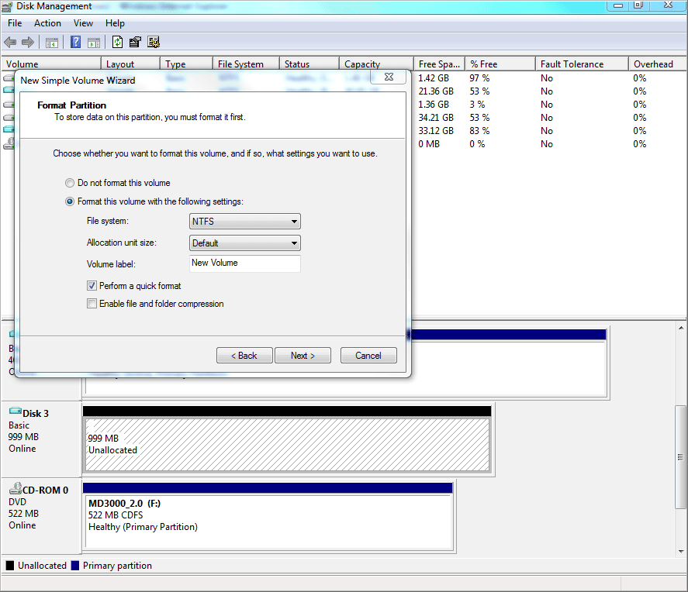

### Attach and detach a VHD

If you have an existing VHD, you can attach it and the VHD shows up as a disk.

To attach an existing VHD

|  |
| --- |
| 1. Select Attach VHD from the Action menu.  2. Enter the path to the VHD and specify whether it should be attached as a read-only disk.        3. Click OK. After the VHD is attached, you can treat it as any other disk. For example, you can create new volumes, format volumes, and assign drive letters to volumes within the VHD. Additionally you can browse existing volumes within the VHD.  4. Optionally, you can detach the VHD so that it no longer shows up as a disk. To do this, right-click the disk, and then click Detach VHD. |

## Creating, attaching, and detaching VHDs by using DiskPart

You can use the DiskPart command-line tool to perform the following VHD operations:

• Create a VHD. This task creates a new VHD by using the available disk space on the computer, and then saves it to the location that you specify.

• Attach a VHD. This task attaches (sometimes referred to as “mounts” or “surfaces”) the VHD so that it shows up as a disk, and then assigns it a drive letter.

• Detach a VHD. This task detaches (sometimes referred to as “unmounts” or “unsurfaces”) the VHD, and then unassigns a drive.

Note

All of VHD operations in this section are scriptable. For more information about scripting DiskPart commands, see [DiskPart](http://go.microsoft.com/fwlink/?LinkId=128458) on Microsoft TechNet (http://go.microsoft.com/fwlink/?LinkId=128458).

### Create a VHD

You can use the DiskPart command-line tool to create a new VHD. You must specify the maximum size of the VHD. Optionally, you can specify the following:

• To create a dynamically expanding VHD (the default is fixed).

• A source VHD. When you specify a source VHD, Windows populates the new VHD with the contents of the source VHD.

• A parent VHD. When you specify a parent VHD, Windows creates a new differencing VHD that is a child of the parent.

#### Create a dynamic disk

The following screenshot shows a series of commands that perform the following tasks:

• Create a new 2 GB dynamically expanding VHD (called test.vhd)

• Create a 1 GB primary partition inside the new VHD

• Format the new 1 GB partition

• Assign a drive letter (M:) to the new partition

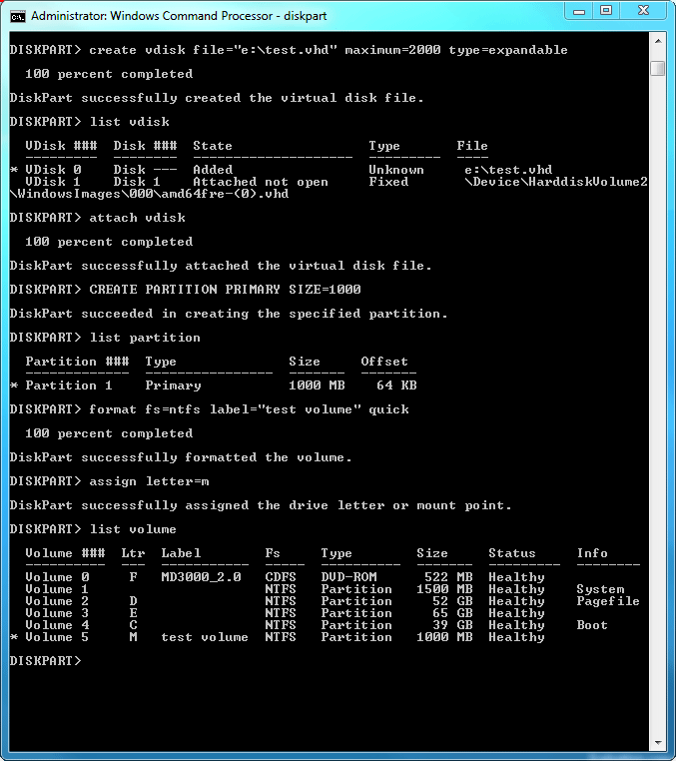

#### Create a differencing disk

A differencing disk is similar to a dynamic VHD, but it contains only the modified disk blocks of the associated parent VHD. The parent VHD is read-only, so you must modify the differencing disk. A differencing disk is sometimes referred to as a “child” VHD. To create a differencing disk, you must have a parent VHD.

The following screenshot shows a command that creates a new, dynamically expanding differencing VHD (called child.vhd), which is the child of another VHD called 7105.serverenterprise.vhd.

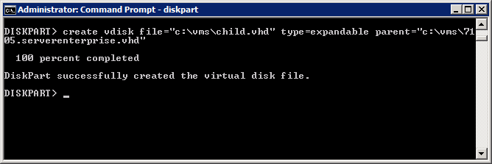

### Attach and detach a VHD

The following screenshot shows a series of commands that perform the following tasks:

• Attach the VHD. This task mounts the VHD so that it shows up as a disk and assigns it a drive letter.

• Detach the VHD. This task unmounts the VHD and unassigns a drive letter.

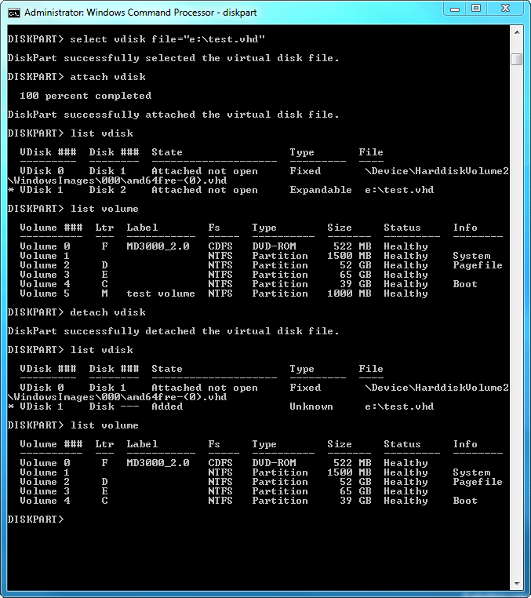

## Creating a bootable VHD

This section describes how to create a VHD and apply a Windows image from a .wim file to a partition in the VHD. You apply the Windows image by using a Windows PowerShell script, Install-WindowsImage, or ImageX (which is included in the Windows AIK). You can configure a VHD that contains a Windows 7 Ultimate or Windows Server 2008 R2 image for native VHD boot or for booting in a Hyper-V virtual machine.

The steps that are covered in this section are:

• Create and attach a VHD file by using DiskPart.

• Locate the install.wim image to apply to the VHD.

• Apply a .wim image to a partition in the VHD.

After you create a .vhd file by using the steps in this section, you can configure it for native boot or to boot in a virtual machine by following the instructions in the Preparing a VHD image for boot section later in this document.

### Before you begin

Before you continue, do the following:

• Ensure that you have the following prerequisites:

• A computer with Windows 7 or Windows Server 2008 R2 installed and running.

• Access to media that contains Windows 7 or Windows Server 2008 R2.

• Download and install the Windows AIK or Windows PowerShell. You can create and attach a VHD file and configure it for native boot by using features in Windows 7 (Steps 1 and 2 below). However, to create a bootable Windows 7 VHD (Step 3), you need to use the Windows AIK or Windows PowerShell to apply a .wim to the VHD. Specifically, you can use the Windows PowerShell script, Install-WindowsImage.ps1, or the Imagex.exe deployment tools.

• Consider using WIM2VHD. You can use the Windows Image to Virtual Hard Disk (WIM2VHD) command-line tool to automate many of the steps in this section. To download WIM2VHD, see the MSDN Code Gallery (http://go.microsoft.com/fwlink/?LinkId=155155). Documentation for WIM2VHD is available on the MSDN site. WIM2VHD must be run from a system running Windows 7, Windows Server 2008 R2, or Windows Server 2008 with Hyper-V enabled. WIM2VHD also requires that the Windows AIK for Windows 7 be installed to use ImageX.

Specifically, WIM2VHD automates the following tasks:

• Creates a new VHD of a specified type and size

• Applies a WIM to a VHD

• Uses an Unattend file to automate the OOBE portion of Windows setup the first time a generalized VHD is booted (optional)

• Applies updates to VHDs (optional)

• Enables a kernel debugger (optional)

### Step 1: Use DiskPart to create and attach a VHD

Before you begin, note the following:

• The default VHD type created when you use DiskPart is a fixed VHD. Therefore, to create another type of file, you must specify TYPE=EXPANDABLE as shown below. Note that creating a fixed VHD takes quite a bit longer because the entire file is allocated at the time it is created.

• You can also use the Disk Management console to perform the above steps if you prefer. For instructions, see the Creating, attaching, and detaching VHDs by using Disk Management section earlier in this document.

To create and attach a VHD

|  |
| --- |
| 1. Open an elevated Command Prompt window (click Start, right-click Command Prompt, and click Run as administrator).  2. Run the following commands to create and attach the VHD. This example creates a dynamic VHD that has 25 GB maximum size and saves the VHD file in a folder, c:\vhd.  diskpart       create vdisk file=C:\VHD\<filename>.vhd maximum=25000 type=expandable       select vdisk file=C:\VHD\<filename>.vhd       attach vdisk       create partition primary       assign letter=v       format quick FS=NTFS label=VHD  exit |

For more information about these commands, run diskpart help create vdisk in the command line. The complete output for this example is shown in the following screenshot.

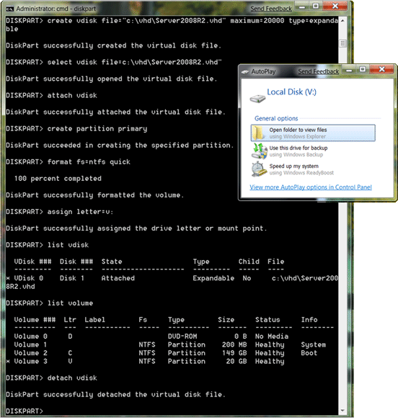

### Step 2: Locate the install.wim image to apply to the VHD

The next step is to locate a Windows 7 installation image (.wim) to apply to the volume in the VHD. Before you begin, ensure that you have a .wim image from one of the following locations:

• The product DVD. The installation image is located at \sources\install.wim. Note that the DVD also contains a Boot.wim file, which is the Windows PE image that you can use to network boot to run Windows Setup.

• A Windows installation that you have captured to a .wim by using Imagex.exe or the Image Capture Wizard for Windows Deployment Services.

• A product DVD .iso image. These images are available to MSDN and TechNet subscribers, and they are also available from the [Windows Products Home page](http://go.microsoft.com/fwlink/?LinkId=155370) (http://go.microsoft.com/fwlink/?LinkId=155370). You must mount .iso images or burn them to physical media to access the .wim files within the .iso file.

Note

The Windows PE image in Boot.wim does not support native VHD boot

### Step 3: Apply a .wim image to the VHD

There are two ways that you can apply a .wim image to a VHD.

• Use the Install-WindowsImage.ps1 Windows PowerShell script. The Windows PowerShell script has fewer options than Imagex.exe and does not require you to download the Windows AIK. The script can perform two tasks: display a list of images in a .wim and apply a .wim to a partition in a VHD. You should use the script if you are not familiar with the Windows AIK and Imagex.exe, or if the Windows AIK is unavailable.

• Use the Imagex.exe command-line tool.

#### Using the Install-WindowsImage.ps1 Windows PowerShell script

Before you begin, note that the first time you run Windows PowerShell, you may get an error that unsigned scripts cannot be executed.

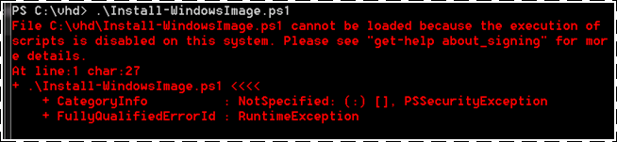

If you receive this error, you need to set the Windows PowerShell execution policy to allow unsigned local scripts, but still require signed scripts from remote locations. To configure this, run set-ExecutionPolicy RemoteSigned at the Windows PowerShell command prompt.

To use the Install-WindowsImage.ps1 script

|  |
| --- |
| 1. Click Start, and type PowerShell in the Start text box.  2. In the results, right-click Windows PowerShell, and click Run as Administrator.  • To list the images and index numbers in a .wim, use the following syntax:  C:\Vhd\Install-WindowsImage.ps1 -WIM <path to .wim>  • To view the help for this script, run help .\Install-WindowsImage.ps1 –detailed or see the Appendix in this guide.  3. To apply an image from a .wim to a VHD, use the following syntax:  C:\Vhd\Install-WindowsImage.ps1 –WIM <String> -Apply –Index <Int32> -Destination <Drive> |

In the following example, volume D: is the DVD drive with Windows product DVD, and volume V: is the VHD created in Step 1:

C:\vhd> PowerShell

PS C:\vhd> .\Install-WindowsImage.ps1 -WIM D:\sources\install.wim

Index Image Name

[1] Windows Server 2008 R2 Standard (Full Installation)

[2] Windows Server 2008 R2 Standard (Server Core Installation)

[3] Windows Server 2008 R2 Enterprise (Full Installation)

[4] Windows Server 2008 R2 Enterprise (Server Core Installation)

[5] Windows Server 2008 R2 Datacenter (Full Installation)

[6] Windows Server 2008 R2 Datacenter (Server Core Installation)

[7] Windows Web Server 2008 R2 (Full Installation)

[8] Windows Web Server 2008 R2 (Server Core Installation)

Done.

PS C:\vhd> .\Install-WindowsImage.ps1 -WIM D:\sources\install.wim -Apply -Index 5 -Destination V:

Applying "Windows Server 2008 R2 Datacenter" to V:...

WARNING: This may take up to 15 minutes...

Elapsed Time: 00:10:57.6302827

Done.

#### Apply image by using the ImageX deployment tool

If you have the Windows AIK installed on your computer, you can use Imagex.exe to apply a .wim to a VHD. If you do not have the Windows AIK, you can download and install it on the computer where you will create a VHD. You can also use ImageX to capture a customized Windows image into a .wim file before you apply the .wim to a VHD.

To apply a .wim image to a VHD

|  |  |  |  |  |  |  |  |  |  |  |  |  |  |  |  |  |  |  |  |  |  |  |
| --- | --- | --- | --- | --- | --- | --- | --- | --- | --- | --- | --- | --- | --- | --- | --- | --- | --- | --- | --- | --- | --- | --- |
| 1. The Install.wim (on the Windows product DVD) contains multiple images for different versions of the operating system. To apply the proper image, locate the index for the version of the image that you need. The following table contains the index for the operating systems that support native VHD boot. Note that all Windows Server 2008 R2 versions support native VHD boot.  Note  You can view the index of an image by running imagex /info <path to .wim>. The output lists the metadata for all images in the .wim file. To find the index for the version of the image that you want, view the <DESCRIPTION> element for each of the images in the output.   |  |  | | --- | --- | | Index | Operating System Version | | 4 | Windows 7 Ultimate | | 1 | Windows 7 Enterprise | | 1 | Windows Server 2008 R2 Standard (Full Installation) | | 2 | Windows Server 2008 R2 Standard (Server Core Installation) | | 3 | Windows Server 2008 R2 Enterprise (Full Installation) | | 4 | Windows Server 2008 R2 Enterprise (Server Core Installation) | | 5 | Windows Server 2008 R2 Datacenter (Full Installation) | | 6 | Windows Server 2008 R2 Datacenter (Server Core Installation) | | 7 | Windows Web Server 2008 R2 (Full Installation) | | 8 | Windows Web Server 2008 R2 (Server Core Installation) |   2. Use the following syntax to apply the Windows image from the install.wim to the VHD volume, using the applicable index. If you are applying a .wim from a network share instead of local media, use a wired network connection for a faster network connection speed to transfer the image file.  Imagex /apply <path to .wim> <image_index> <path to apply>  For example, to apply the Datacenter version of the image from the install.wim to the VHD partition, use the image index 5. Using the DVD media in the DVD drive with volume letter F:, and the VHD partition volume V:, the command would be the following:  D:\>imagex /apply F:\sources\install.wim 5 V:\  Note  It takes approximately 10-15 minutes to apply the image.  Now that you have created a VHD file, you can configure it for native boot or to boot in a virtual machine by following the instructions in the Preparing a VHD image for boot section later in this document. |

## Creating VHDs by using Hyper-V

You can use the Hyper-V Manager to create VHDs. Some customers prefer this method because there is a user interface that leads users through the process.

Note

VHDs that you create by using Hyper-V Manager will be configured for virtual machine boot by default. To configure the VHD for native boot, follow the instructions for Prepare a VHD image for native boot in the Preparing a VHD image for boot section.

To create a bootable VHD by using the Hyper-V Manager

|  |
| --- |
| 1. Start Hyper-V Manager (click Start, click Administrator Tools, and click Hyper-V Manager).  2. Click Action, click New, and then click Virtual Machine.  3. Specify a Name and Location for the new virtual machine, and then click Next.            4. Click Next on the Configure Networking screen.  5. Click Create a virtual hard disk, specify the storage location and maximum size for the VHD, and then click Next.        6. Click Install an operating system from a boot CD/DVD-ROM, and then select the drive or the .iso file.        7. Click Next, and then click Finish. When the wizard completes, Windows will create a new virtual machine in the Off state.  Use the following procedure to start the new virtual machine to begin installing Windows: |

To start the new virtual machine

|  |
| --- |
| 1. Right-click the new virtual machine.  2. To add a DVD or a virtual DVD to a virtual machine, click Settings.  3. Under IDE Controller, select DVD Drive.  4. Specify one of the following, and then click Apply:  a. If installing from a physical DVD, select Physical CD\DVD drive, and then specify the drive letter.  b. If installing from a bootable .iso file, browse to the path under Specify the media to use with your virtual CD\DVD drive, click Image file.  5. Select the virtual machine from the Virtual Machines pane, and then in the Actions pane, click Connect.  6. Click Actions, and then click Start.  7. When you are prompted to Press any key to boot from CD\DVD, press a key and proceed with the installation. |

Now that you have created a VHD, you can configure it for native boot or to boot in a virtual machine by following the instructions in the following section: Preparing a VHD image for boot.

## Preparing a VHD image for boot

After you have a VHD, you can configure it for native VHD boot or for booting in a virtual machine. The locations of the boot configuration data (BCD) store and the other boot files that are required to boot the system are different for native boot and virtual machine boot.

• For native VHD boot, you configure the boot entry in the BCD store to be on the physical system partition outside the VHD. The system partition can be the same or different than the volume that hosts the VHD file. For instance, by default Windows 7 Setup will create a separate 100MB partition to host the BCD store.

• For a virtual machine boot, you configure the boot entry in the BCD store to be on the volume inside the VHD.

Note

You must use an elevated Command Prompt window (right-click Command Prompt, and then click Run as Administrator) to run the commands that update the boot configuration data.

### Prepare a VHD image for native boot

Use the procedure in this section to prepare a VHD for native boot. For more information about BCDBoot parameters, see [BCDBoot Command-Line Options](http://go.microsoft.com/fwlink/?LinkId=155166) (http://go.microsoft.com/fwlink/?LinkId=155166).

Note

If you are an advanced user and familiar with BCDEdit, you can update the BCD manually instead of using the following procedure (using BCDBoot). To do this, run the following syntax at an elevated command prompt and note the GUID in the output: bcdedit /copy {default} /d “<your boot menu description>”. Next, using the GUID from the previous command, run the following two commands: bcdedit /set {GUID} device vhd=[C:]\VHD\<yournewvhd>.vhd and bcdedit /set {GUID} device vhd=[C:]\VHD\<yournewvhd>.vhd

To update the BCD for native VHD boot

|  |
| --- |
| 1. This procedure assumes you have Windows 7 installed and you want to add a second boot option to boot from the VHD. For this example, the VHD file is located in C:\VHD\<yournewvhd>.vhd, and the VHD is attached and assigned the volume letter, V. The following command creates a new BCD entry for native VHD boot of the Windows image in your VHD file:  V:\Windows\System32\bcdboot V:\Windows  BCDBoot creates the boot configuration entry so that Windows Boot Loader can boot from the VHD image. It also sets the default boot option for the computer to boot Windows from the VHD, which is currently assigned volume letter V.  Optionally, you can use steps 2-4 if you want to modify the default boot entry.  2. Run bcdedit (with no parameters) to display the system boot configuration entries.  The following screenshot shows an example of the BCDEdit output with two Windows Boot Loader entries. The default boot option, {default}, is for the VHD boot from volume V, the other boot option is for the Windows 7 image that is installed on volume C.        3. If you have Windows 7 installed on the hard disk drive, and you configure native VHD boot of Windows 7, there will be two entries in the list with the description text string Windows 7. To change the text in the boot menu (from Windows 7), use the following syntax where the GUID is the identifier of the VHD boot entry:  bcdedit /set {GUID} description=”Windows 7 RC VHD”  Note  Some boot entries have aliases instead of GUIDs (such as {default} for the default boot entry or {current} for the boot entry of the current system). To find the associated GUID, view the verbose output for all the boot entries by running bcdedit -v.  4. To change the default system boot option to be the installed Windows 7 image, instead of the native VHD boot image (or an additional VHD image on the same system), run the following syntax where the GUID is the Windows Boot Loader entry that you want to be the default:  bcdedit /default {GUID}  When the system restarts, the Windows Boot Manager displays a menu with a list of available images to boot. |

### Prepare a VHD image to boot inside a virtual machine

If you still have the VHD attached after running the Install-WindowsImage.ps1 script or the Imagex/apply command, you can use BCDBoot to prepare the VHD image to boot inside a virtual machine.

To prepare an attached VHD image to boot inside a virtual machine

|  |
| --- |
| 1. Open an elevated Command Prompt window.  2. Use the BCDBoot /s <volume> command to specify which volume you want to use as the System volume for the Windows Boot Manager and boot configuration data. For example, if the VHD is attached and assigned volume V:, run the following command:  V:\windows\system32\bcdboot V:\windows /s V:  This command creates the boot configuration data on the partition inside the VHD that is used to boot Windows 7 in a virtual machine. You do not need to perform any other steps to prepare the image to boot in a virtual machine. Optionally, you can prepare the same VHD file to boot inside a virtual machine or for native VHD boot.  3. To view the BCD entry that was created by BCDBoot inside the VHD, run the bcdedit /store <path> option to specify the BCD file inside the VHD. For example:  bcdedit /store v:\boot\BCD        Note  You can specify the /store<path> option with a BCDEdit command to update a BCD store other than the current store. Note that when you are running Windows in a virtual machine, you do not need to specify the BCDEdit /store option to update a configuration store for the running virtual machine. |

## Deploying a bootable VHD by using Xcopy

The following section provides step-by-step instructions for deploying a bootable VHD without using a managed deployment solution. This is useful for customers who want to develop a custom deployment solution.

To deploy a bootable VHD

|  |
| --- |
| 1. Save a bootable VHD on a computer or network share.  2. Insert a Windows 7 or Windows Server 2008 R2 product DVD into the target computer and boot to the DVD.  3. Configure the disk and select where to install Windows by using the disk configuration screen.        4. Press Shift+F10 to launch a Command Prompt window.  5. In the Command Prompt window, run Startnet.cmd to start networking.        6. To copy the VHD from the file share to a destination on the local computer prepared in step 3, run xcopy <source> <destination>.  7. Use Diskpart to attach the VHD (for instructions, see Creating, attaching, and detaching VHDs by using DiskPart earlier in this document).  8. Prepare the boot environment by following the steps in the Preparing a VHD image for boot section of this document. |

## Deploying VHDs by using Windows Deployment Services

You can deploy bootable VHDs by using Windows Deployment Services. To do this, you must first install and configure the Windows Deployment Services server role on a computer that is running Windows Server 2008 R2. For instructions, see the [Windows Deployment Services Getting Started Guide](http://go.microsoft.com/fwlink/?LinkId=84628) (http://go.microsoft.com/fwlink/?LinkId=84628).

For additional information about configuring Windows Deployment Services to catalog and deploy VHDs, see [Deploying Virtual Hard Disk Images](http://go.microsoft.com/fwlink/?LinkId=146973) (http://go.microsoft.com/fwlink/?LinkId=146973).

You use the WDSUTIL command line tool to catalog VHDs to the Windows Deployment Services image library.

## Migrating VHDs between physical and virtual environments

The following section provides step-by-step instructions for how to migrate a bootable VHD image between physical and virtual environments. This process relies on using the Sysprep tool. For more information, see the [Sysprep Technical Reference](http://go.microsoft.com/fwlink/?LinkID=155027) (http://go.microsoft.com/fwlink/?LinkID=155027).

### Move from a virtual to a physical environment

To migrate a VHD that is using Hyper-V to a physical environment

|  |
| --- |
| 1. Boot the VHD image.  2. Double-click Sysprep to prepare and generalize the operating system.  3. In System Cleanup Action, select Enter System Out-of-Box Experience (OOBE).  4. Select the Generalize check box.  5. In Shutdown Options, click Shutdown.    Now you are ready to configure the VHD for native boot or to boot in a virtual machine by following the instructions in the Preparing a VHD image for boot section.      6. To deploy the image, follow the instructions in the Deploying a bootable VHD by using Xcopy section earlier in this document. |

### Move from a physical to a virtual environment

To migrate a VHD that is running on a physical computer to a Hyper-V environment

|  |
| --- |
| 1. Boot into the VHD on the computer.  2. Double-click Sysprep to prepare and generalize the operating system.  3. In System Cleanup Action, select Enter System Out-of-Box Experience (OOBE).  4. Select the Generalize check box.  5. In Shutdown Options, click Shutdown.        6. Boot Windows PE (or another instance of Windows) on the computer.  7. Copy the image that you prepared using Sysprep to the server running Hyper-V.  8. On the Hyper-V server, launch Hyper-V Manager.  9. Click Action, click New, and then click Virtual Machine.  10. Specify a Name and Location for the new virtual machine.        11. Assign resources to the virtual machine.        12. Configure the new virtual machine to boot from the VHD that you prepared with Sysprep.        13. Now you are ready to configure the VHD for native boot or to boot in a virtual machine by following the instructions in the Preparing a VHD image for boot section. |

## Servicing images

You can service a VHD offline or online using command-line tools such as Deployment Image Servicing and Management (DISM.exe).

### Add drivers

To add drivers to a VHD image

|  |
| --- |
| 1. Attach the VHD. For instructions, see Creating, attaching, and detaching VHDs by using DiskPart earlier in this document.  2. To add a single driver, run the following command. In this example, the VHD is assigned drive letter Z::  Dism /image:Z:\ /Add-Driver /driver:C:\drivers\OEM.INF  Alternatively, to add multiple drivers to the VHD image, run:  Dism /image:Z:\ /Add-Driver /driver:C:\drivers\OEM.INF  /driver:c:\drivers\OEM1.inf /driver:c:\drivers\OEM2.inf  3. To confirm that the drivers were added to the image, view the output of the following command:  Dism /image:Z:\ /Get-Drivers |

### Add Windows features

To enable server roles and features in a VHD image

|  |
| --- |
| 1. Attach the VHD. For instructions, see Creating, attaching, and detaching VHDs by using DiskPart earlier in this document.  2. Run the following command to list all the features in the VHD. The following example assumes that the VHD is assigned drive letter Z::  Dism /image:Z:\ /Get-Features  3. To display information about the state of a specific Windows role or feature, run:  Dism /image:Z:\ /Get-FeatureInfo /FeatureName:DHCPServer  4. To enable a specific Windows role or feature, run the following command (this example installs the DHCP Server role):  Dism /image:Z:\ /Enable-Feature /FeatureName:DHCPServer |

For additional information about using DISM for servicing VHDs, see the following references:

• [Deployment Image Servicing and Management Command-Line Options](http://go.microsoft.com/fwlink/?LinkId=155182)

(http://go.microsoft.com/fwlink/?LinkId=155182)

• [Windows 7 Walkthrough: Deployment Image Servicing and Management](http://go.microsoft.com/fwlink/?LinkId=155183)

(http://go.microsoft.com/fwlink/?LinkId=155183)

## Backing up images

Windows Server Backup is a backup and recovery solution for computers that are running the Windows Server 2008 R2 operating system. You can use Windows Server Backup to back up VHD volumes with some restrictions.

• For a list of the restrictions and recommendations, see [Frequently Asked Questions: Virtual Hard Disks in Windows 7](http://go.microsoft.com/fwlink/?LinkId=155786)

(http://go.microsoft.com/fwlink/?LinkId=155786)

• For general information, see [Windows Server Backup Overview](http://go.microsoft.com/fwlink/?LinkId=155187)

(http://go.microsoft.com/fwlink/?LinkId=155187)

## Performing advanced tasks by using DiskPart

This section shows the commands for performing the following operations:

• Expand vdisk. Expands the maximum size available in a VHD, including the steps to extend a partition that is contained with a VHD.

• Compact vdisk. Compacts or reduces the size of a VHD. This is useful if you need to reduce the size of a dynamic VHD because these files increase in size as you add files, but they do not automatically reduce in size when you delete files.

• Merge vdisk. Merges a differencing disk with its parent.

• Detail vdisk. Displays detailed information about a VHD, including the path, file name, state, virtual size, physical size, associated disk, whether the VHD is a differencing disk, and the path and file name of the parent.

### Expand VHD

The following screenshot shows a series of commands that expand a VHD from 2 GB to 3 GB.

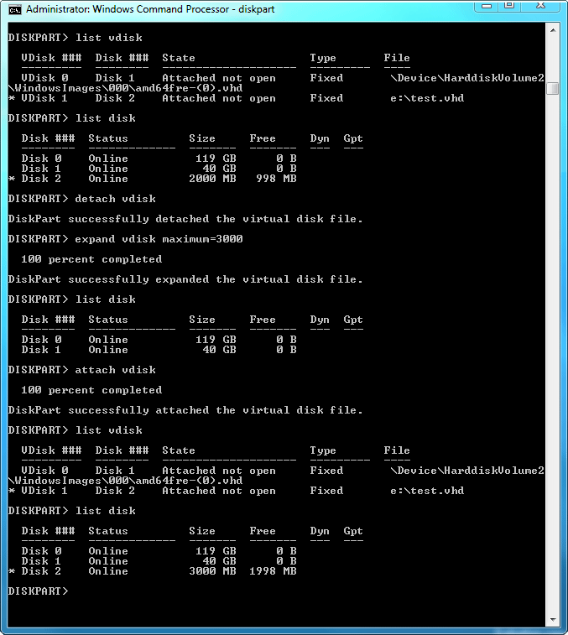

### Extend partition

In the following example, the VHD contains a 1 GB partition (M:) and the entire VHD is 3 GB in size. The screenshot shows a series of commands that increases the size of M: from 1 GB to 2 GB.

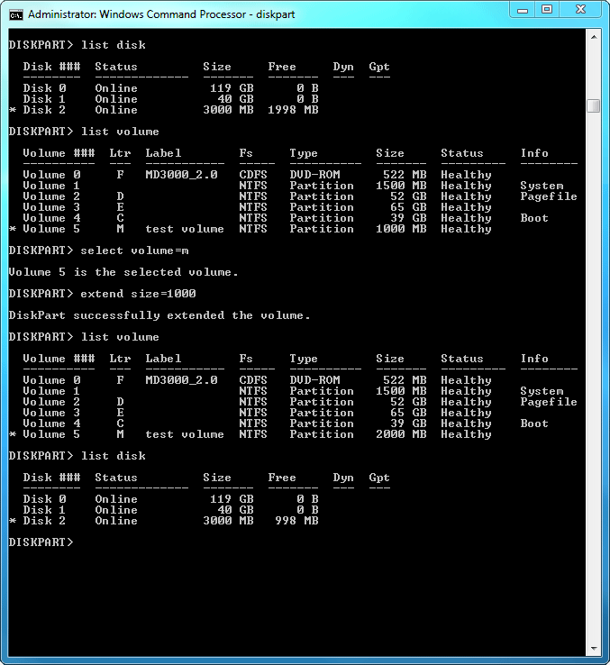

### Compact a VHD

The following screenshot shows a series of commands that perform the following tasks:

• Display information about the virtual and physical size of a VHD. For dynamic VHDs, the virtual size is the maximum size of the VHD (specified when you create the VHD), and the physical size is the actual size. For fixed VHDs, these values are the same.

• Attach the VHD as a read-only file.

• Reduce the size of (that is, compact) the VHD.

• Display information about the new physical size of a VHD.

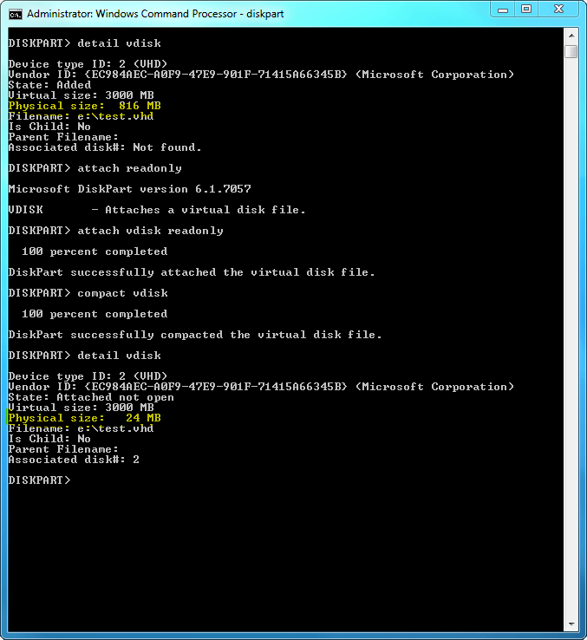

### Merge VHD

The following screenshot shows a series of commands that perform the following tasks:

• Attach the selected differencing VHD.

• Display the parent VHD (this is optional).

Detach the selected differencing VHD.

• Merge the differencing disk with the parent. In this step, note that Depth=1 is indicates that 1 level of the differencing chain will be merged. If you specify a number larger than 1, the VHD must have a differencing chain that is more than 2.

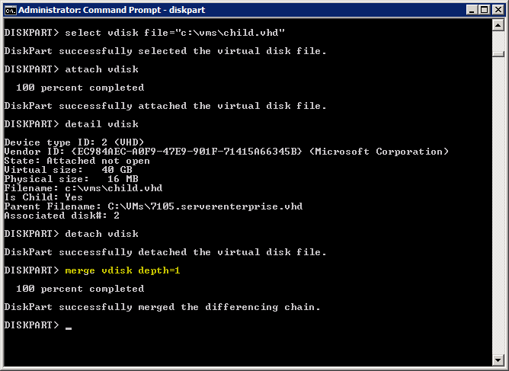

### Display VHD information

The following screenshot shows a series of commands that perform the following tasks:

• Attach the VHD.

• Display information about the VHD.

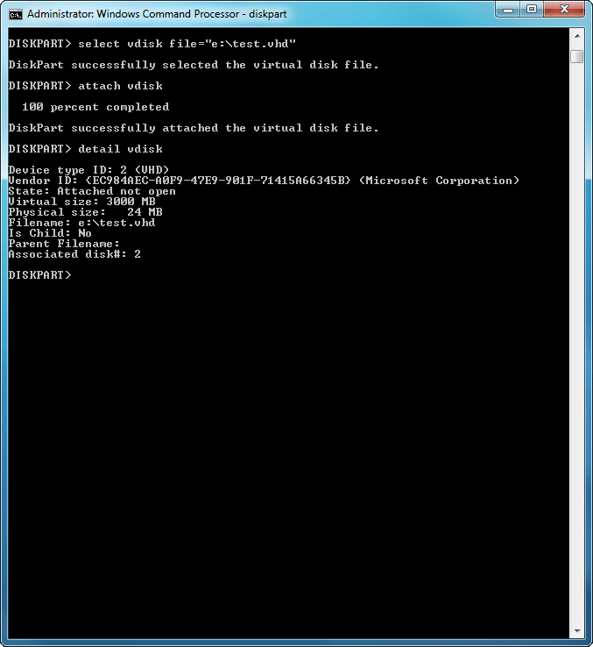

# Appendix: Tools, Scripts, and APIs

## In this topic

• Tools used to maintain VHD images

• Scripts

• APIs

## Tools used to maintain VHD images

This section describes the tools that you can use to perform common tasks such as creating and configuring VHDs.

### Diskpart

Diskpart is included in Windows 7 and Windows Server 2008 R2, and it supports the following VHD operations:

• Create vdisk. Create a new VHD. The VHD can be empty or it can contain an image from an existing VHD. The new VHD can also be a differencing disk.

• Attach vdisk. Attaches (sometimes referred to as “mounts” or “surfaces”) a VHD and assigns it a drive letter.

• Detach vdisk. Detaches (sometimes referred to as “unmounts” or “unsurfaces”) a VHD.

• Compact vdisk. Compacts or reduces the size of a VHD. This is useful if you need to reduce the size of a dynamic VHD because these files increase in size as you add files, but they do not automatically reduce in size when you delete files.

• Expand vdisk. Expands the maximum size available in a VHD.

• Merge vdisk. Merges a differencing disk with its parent disk.

• Detail vdisk. Displays information about a VHD, including the path and file name, state, virtual size, physical size, associated disk, whether it is a differencing disk, and the path and file name of the parent.

For more information about Diskpart, see DiskPart Command-Line Options (<http://go.microsoft.com/fwlink/?LinkId=155231>).

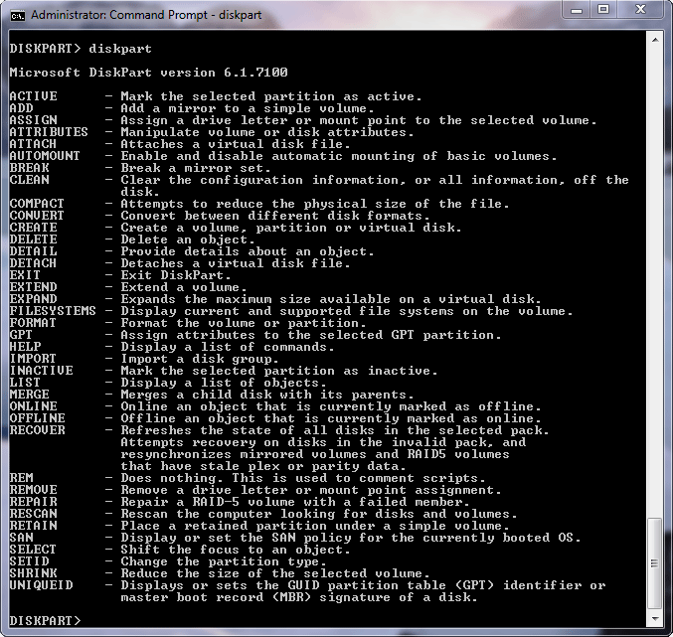

### Disk Management MMC snap-in

Disk Management supports the following VHD operations:

• Create vdisk. Create a new VHD. The VHD can be empty or it can contain an image from an existing VHD. The new VHD can also be a differencing disk.

• Attach vdisk. Attaches (sometimes referred to as “mounts” or “surfaces”) a VHD and assigns it a drive letter.

• Detach vdisk. Detaches (sometimes referred to as “unmounts” or “unsurfaces”) a VHD.

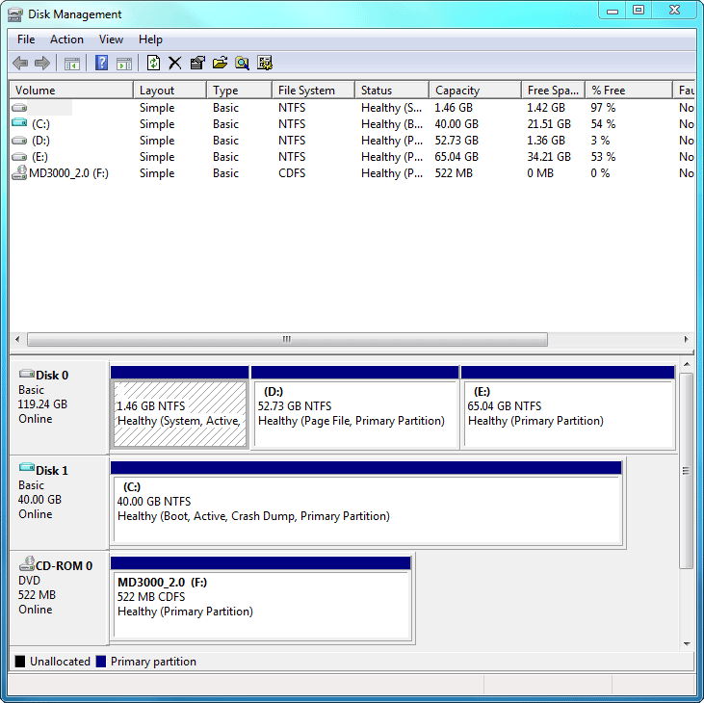

### Imagex

ImageX is a command-line tool that you can use to capture, modify, and apply file-based disk images for deployment. ImageX works with Windows image (.wim) files (for copying to a network), or it can work with other technologies that use .wim images, such as Windows Setup, Windows Deployment Services, and the System Management Server (SMS) Operating System Feature Deployment Pack. For more information, see What Is ImageX? (<http://go.microsoft.com/fwlink/?LinkId=155232>).

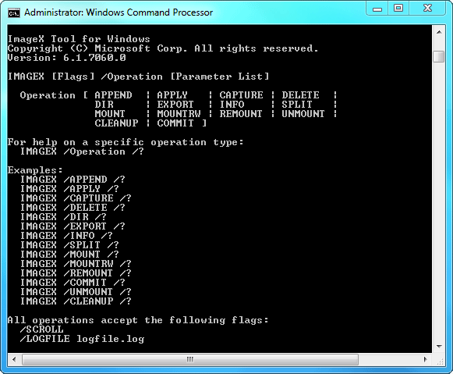

### Sysprep

The System Preparation Tool, or Sysprep, is a tool that is designed for corporate system administrators, OEMs, and others who need to deploy the Windows operating system on multiple computers. After performing the initial setup steps on a single operating system, you can run Sysprep to prepare the sample computer for cloning.

If you want to migrate VHD-based operating system images between physical computers, from physical to virtual environments, or from virtual to physical environments, you must first use Sysprep to prepare the operating system image for migration to another computer. Running Sysprep removes user and computer specific data from the operating system image, which enables you to clone or migrate the operating system image to other computers.

For more information, see the Sysprep Technical Reference (<http://go.microsoft.com/fwlink/?LinkID=155027>).

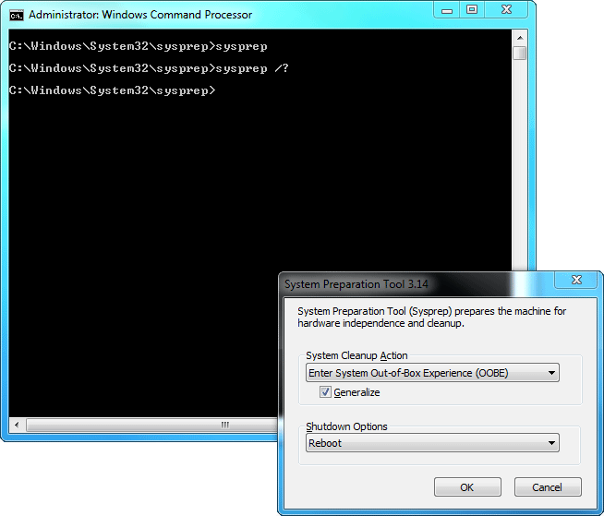

### BCDEdit

BCDEdit is a command-line tool that you can use to manage boot configuration data (BCD) stores. When you are configuring a computer to boot from a new VHD, you can use BCDEdit to create the new BCD. For more information about BCDEdit, see BCDEdit Command Line Options (<http://go.microsoft.com/fwlink/?LinkId=155233>).

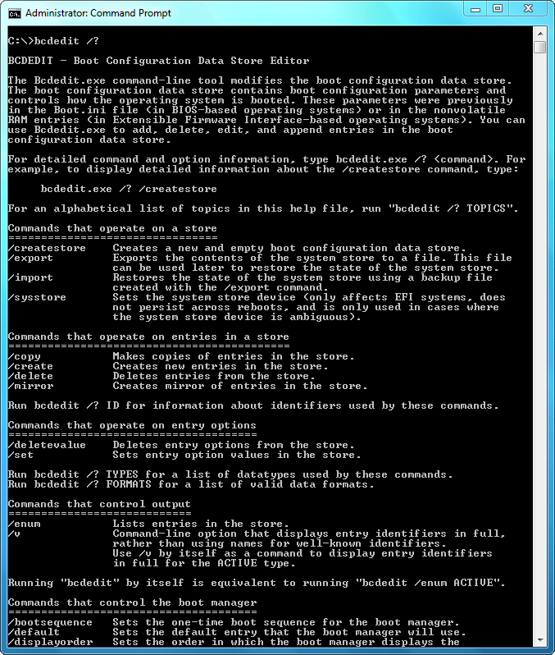

### BCDBoot

BCDBoot is a command-line tool that you can use to manage and create new BCD stores and BCD boot entries. When you are configuring a computer to boot from a new VHD, you use BCDBoot to create a new BCD boot entry. For more information about BCDBoot, see BCDBoot Command-Line Options (<http://go.microsoft.com/fwlink/?LinkID=155166>).

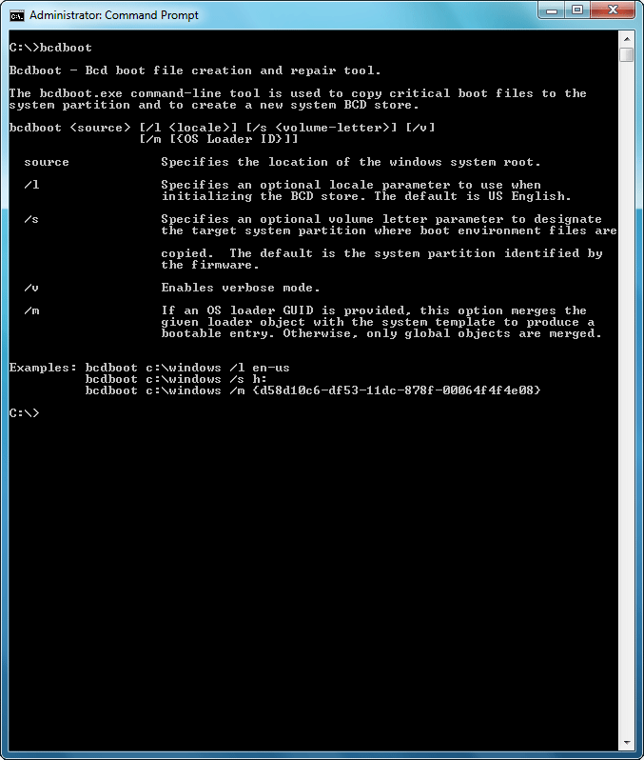

### Deployment Image Servicing and Management Tool (DISM)

Deployment Image Servicing and Management (DISM.exe) is a command-line tool that you use to install, configure and update the features and packages in offline Windows images, offline Windows PE images, and VHD images.

For more information about DISM, see:

• Walkthrough: Deployment Image Servicing and Management (<http://go.microsoft.com/fwlink/?LinkID=155183>)

• Deployment Image Servicing and Management Technical Reference (<http://go.microsoft.com/fwlink/?LinkID=155029>)

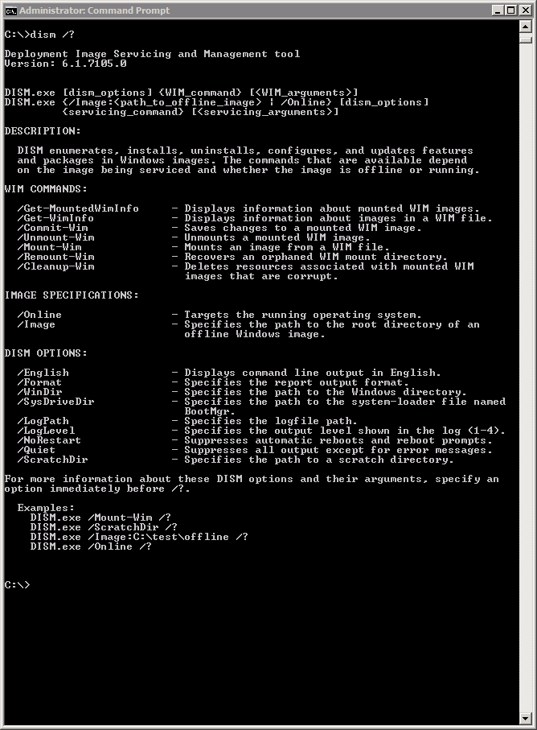

### Hyper-V Manager

Hyper-V Manager supports VHD image creation. You can specify the type and size of VHD and install Windows from a CD or DVD, or from an .iso image file. The Hyper-V Manager is only available on computers that are running Windows Server 2008 or Windows Server 2008 R2 with the Hyper-V role installed.For more information about using Hyper-V Manager, see What’s New in Hyper-V (<http://go.microsoft.com/fwlink/?LinkId=155234>).

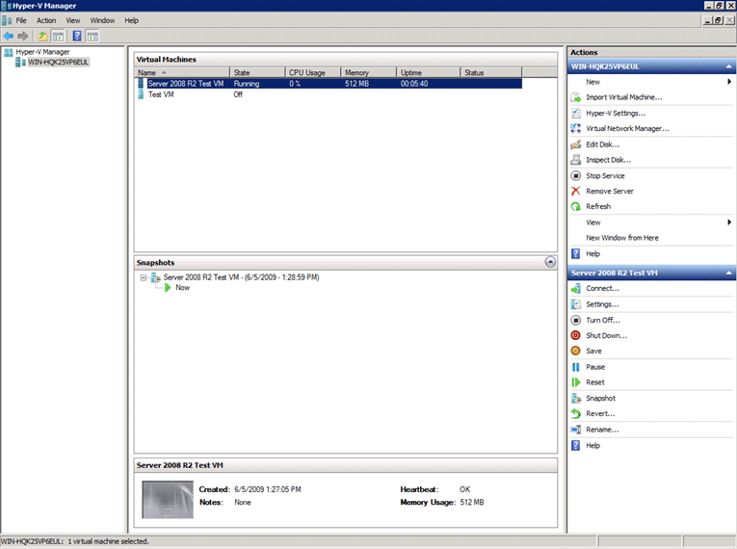

### Windows Deployment Services

You can deploy virtual hard disk (.vhd) images to a physical (not virtual) computer by using Windows Deployment Services. To deploy .vhd images, you need to create an image group and add images to it. Then you create an Unattend file and configure the server. After that, you are ready to deploy and image. For more information, see Deploying Virtual Hard Disk Images (<http://go.microsoft.com/fwlink/?LinkId=146973>).

## Scripts

### Install-WindowsImage

The following is the help text for the Install-WindowsImage.ps1 Windows Powershell script. For more information, see Install-WindowsImage PowerShell Script (<http://go.microsoft.com/fwlink/?LinkId=155235>)

PS > help .\Install-WindowsImage.ps1 –detailed

NAME

    Install-WindowsImage.ps1

SYNOPSIS

    Lists or applies Windows Images in .WIM containers.

SYNTAX

    C:\Vhd\Install-WindowsImage.ps1 -WIM <String> [<CommonParameters

    >]

    C:\Vhd\Install-WindowsImage.ps1 -WIM <String> -Apply -Index <Int

    32> -Destination <String> [<CommonParameters>]

DESCRIPTION

PARAMETERS

    -WIM <String>

        Specifies the .WIM file to examine and/or apply images from.

    -Apply [<SwitchParameter>]

        Specifies that the specified image index should be applied to the specified De

        stination.

    -Index <Int32>

        Specifies the image index of the Windows Image to apply to the specified Desti

        nation.

    -Destination <String>

        The drive or folder to apply the specified Windows Image to.

    <CommonParameters>

        This cmdlet supports the common parameters: Verbose, Debug,

        ErrorAction, ErrorVariable, WarningAction, WarningVariable,

        OutBuffer and OutVariable. For more information, type,

        "get-help about_commonparameters".

    -------------------------- EXAMPLE 1 --------------------------

    C:\PS>This example will list the available images in the D:\Sources\Install.wim co

    ntainer.

    .\Install-WindowsImage.ps1 -WIM D:\Sources\Install.wim

    -------------------------- EXAMPLE 2 --------------------------

    C:\PS>This example will apply image number 8 from D:\Sources\Install.wim to X:\.

    .\Install-WindowsImage.ps1 -WIM D:\Sources\Install.wim -Apply -Index 8 -Destinatio

   n X:\

## APIs

• Win32 APIs. Windows 7 and Windows Server 2008 R2 support a set of Win32 APIs for use by system components and other software to perform operations on VHDs. All higher level VHD APIs will be wrappers around these Win32 APIs. For more information about the Win32 APIs and data structures supporting VHD operations, see the VHD Reference (http://go.microsoft.com/fwlink/?LinkId=155236).

• VDS APIs. The Virtual Disk Service (VDS) exposes an API that supports operations on VHDs. For more information about the VDS interfaces, types, and data structures, see VDS Reference (<http://go.microsoft.com/fwlink/?LinkId=155237>).

• Remote VHD management interfaces

• VDS. Virtual Disk Service (VDS) provides an object model that supports DCOM as a remote communication transport. It enables remote invocation of VDS interfaces and management of VDS objects. For more information about the VDS object model and remote communication with DCOM, see Transport 2.1 (<http://go.microsoft.com/fwlink/?LinkId=155238>).

• Hyper-V WMI provider. WMI supports remote access to management interfaces that are exposed by a WMI provider. The Hyper-V WMI provider supports remoting of VHD interfaces and operations to enable remote management of VHDs on computers with the Hyper-V WMI provider installed (the Hyper-V server role is required). For more information, see Virtualization WMI Provider (<http://go.microsoft.com/fwlink/?LinkId=155629>).

# Frequently Asked Questions: Virtual Hard Disks in Windows 7

This article provides answers to common questions about virtual hard disks (VHDs) in Windows® 7 and Windows Server® 2008 R2.

Note

For step-by step-instructions, also see [Windows Native VHD Boot Deployment Scenarios](http://go.microsoft.com/fwlink/?LinkId=177538) (the attachment is at the end of the blog post).

• What are the different VHD file types?

• Why are fixed VHDs recommended for production?

• When is it appropriate to use dynamic VHDs?

• What does it mean to create, attach, and detach VHDs?

• What is a native-boot VHD?

• What are the recommendations for using VHDs for native boot?

• What is not supported for native boot using VHDs?

• What are the best practices for backing up VHDs?

## What are the different VHD file types?

There are three types of VHDs: fixed, dynamic, and differencing. You can create these files by using the Hyper-V™ Manager or the Windows disk-management tools.

|  |  |
| --- | --- |
| Type | Explanation |
| Fixed | A fixed VHD has an allocated size that does not change. For example, if you create a fixed VHD that is 24 gigabytes (GB), the file will be approximately 24 GB (with some space used for the internal VHD structure) regardless of the data that is written to it. |
| Dynamic | The size of a dynamic (or expandable) VHD is as large as the data that is written to it. As more data is written to a dynamic VHD, the file dynamically increases to a maximum size. For example, a 24 GB dynamic VHD is initially around 80 megabytes (MB) on the host file system. As data is written to the VHD, the file grows, but it has a maximum size of 24 GB. |
| Differencing | A differencing VHD is similar to a dynamic VHD, but it contains only the modified disk blocks of the associated parent VHD. The parent VHD is read-only, so you must modify the differencing VHD.  A differencing VHD is sometimes referred to as a “child” VHD. The parent VHD can be any of the three VHD file types, including another differencing VHD. Multiple differencing VHDs create a differencing chain. Note the following requirements for differencing VHDs:  **•** You should not modify the parent of a differencing VHD. If the parent VHD is changed or replaced by a different VHD (even if it has the same file name), the block structure between the parent and differencing VHD will no longer match and the differencing VHD will be corrupted.  **•** You must keep both files (the parent VHD and the differencing VHD) in the same directory on a local volume for native-boot scenarios. For native-boot VHDs, the parent VHD and the differencing disk cannot reside on different volumes, even if they reside on the same local disk. However, when you attach a differencing VHD that is not used for native boot (for example, if you plan to use it for image management), the parent VHD can be in different directories, and on a different volume or even on a remote share.  For more information, see What is a native-boot VHD? later in this document. |

## Why are fixed VHDs recommended for production?

Fixed VHDs are recommended for production instead of dynamic or differencing VHDs for the following reasons:

• The I/O performance is highest for fixed VHDs because the file is not dynamically expanded.

• When a dynamic disk is expanded, the host volume could run out of space and cause the write operations to fail. Using fixed VHDs ensures this does not happen.

• The file data will not become inconsistent due to lack of storage space or power loss. Dynamic and differencing VHDs depend on multiple write operations to expand the file. The internal block allocation information can become inconsistent if all I/O operations to the VHD file and the host volume are not complete and persisted on the physical disk. This can happen if the computer suddenly loses power.

## When is it appropriate to use dynamic VHDs?

Dynamic VHDs are useful in nonproduction environments where flexible storage requirements and frequently changing the VHD image is more of an advantage than the reliability of the data within the VHD. In addition, dynamic VHDs are best for testing environments because there is less impact if you have to rebuild the VHD. For example, a test environment can use multiple dynamic VHDs, each with a different Windows image and set of applications to test. If the VHD files are modified during testing or accidentally become corrupt, you can replace the VHDs from a safe copy and restart testing.

Using dynamic VHDs in a test environment provides the following benefits:

• Flexible use of disk space. You can use free space for the VHD to expand during native VHD boot. This space would have been unavailable if the volume hosted multiple VHDs in a fixed format.

• Faster transfer time when copying VHDs between locations. The file size for a dynamic VHD that is not using its maximum capacity, will transfer in less time between a network share and a local disk than a fixed VHD of equivalent maximum size.

Although rare, you may consider using dynamic VHDs in production environments if all of the content of the dynamic VHD can be regenerated from other sources and if critical data is stored on volumes outside the dynamic VHD.

## What does it mean to create, attach, and detach VHDs?

The disk management tools (the DiskPart command-line tool and the Disk Management console) allow you to create, attach, and detach VHDs.

• Create. You can create a new VHD with a type and size that you specify. When you first create a VHD, it is similar to an uninitialized hard disk drive. You can create one or more partitions in the VHD and format the partition(s) by using FAT, ExFAT, or NTFS.

• Attach. Attaching a VHD activates the VHD so that it appears on the host computer as a local hard disk drive. This is sometimes called “surfacing a VHD” because the VHD is now visible to users. If the VHD already has a disk partition and file system volume when you attach it, the volume inside the VHD is assigned a drive letter. The assigned drive letter is then available for use, similar to when you insert a USB flash drive into a USB connector. All users (not just the current user) can use the attached VHD in the same way they use other volumes on local physical hard disk drives (depending on security permissions). Furthermore, because you can attach a VHD that is located on a remote server message block (SMB), you can manage your images remotely.

Note the following restrictions for attaching VHDs:

• You must have volume management privileges (which is granted by default only to administrators) to attach a VHD because attaching a VHD is equivalent to bringing a hard disk drive or volume online.

• You can only attach a VHD that is located on an NTFS volume. However, if you already have a VHD file, you can place the file on any FAT, ExFAT, NTFS, or UDFS volume for storage or transfer.

• You cannot attach a VHD that has been compressed by NTFS or encrypted using Encrypting File System on the host volume. However, you can compress or encrypt the volumes inside the VHD if compression and encryption are otherwise supported.

• You cannot configure two attached VHDs to be a dynamic disk. A dynamic disk is a physical disk that you have initialized for dynamic storage. It contains dynamic volumes such as simple, spanned, striped, or mirrored volumes or RAID-5 volumes.

• You cannot attach a VHD located on a network file system (NFS) or File Transfer Protocol (FTP) server. However, as mentioned previously, you can attach a VHD that is located on a Server Message Block (SMB) share.

• You cannot use client-side caching on the remote SMB share to attach a VHD. If you use a file share to store VHD files that you want to attach remotely, change the caching properties of the share to disable automatic caching.

• You can only attach two nested VHDs. When you create a VHD within another VHD, it is referred to as a nested VHD. The limit for nested VHDs is two. That is, you can attach a VHD within another attached VHD, but you cannot attach a third.

For example, you have a fixed VHD on a computer at C:\vhd\ExampleFixed.vhd. Inside the ExampleFixed.vhd, you create a partition, initialize an NTFS file system volume, and assign the drive letter M: to the volume. You then create another VHD at M:\vhd\NestedFixed.vhd. The NestedFixed.vhd file is called a nested VHD because it is created on the file system volume inside the first VHD. If you attach both VHDs (C:\vhd\ExampleFixed.vhd and M:\vhd\NestedFixed.vhd), then both N: and M: drives would be available on the computer for users to use.

• When an operating system restarts, VHDs that were attached before reboot are not automatically attached. If you native boot to a VHD, only the file system partitions contained in the VHD are automatically attached. If there are other VHDs on the physical volume that were attached during a previous boot, they are not automatically attached.

• Detach. Detaching a VHD stops the VHD from appearing on the host computer. When a VHD is detached, you can copy it to other locations.

## What is a native-boot VHD?

In Windows 7 and Windows Server 2008 R2 you can configure a VHD for native boot. This means that a VHD can be used as the running operating system on designated hardware without a parent operating system, virtual machine, or hypervisor. Furthermore, if you use native boot, you have full access to all devices and file system volumes on the physical computer, including the volumes inside the VHD. In contrast, when Windows runs in a virtual machine, only one file system volume in the virtual disk (volume C:) is available to guest machines (unless you share another volume to the virtual machine).

Note the following functionality with native boot:

• Native boot from VHD is only available with Windows 7 Enterprise, Windows 7 Ultimate and all versions of Windows Server 2008 R2.

• When you perform a native boot, file system partitions that are contained in the VHD are automatically attached and the virtual volumes are visible.

• Native-boot supports all three VHD file types: fixed, dynamic, and differencing. When you native boot from a dynamic VHD file, the VHD is automatically expanded to the maximum size. If the physical host volume of the VHD file does not have enough free disk space for the maximum size of the dynamic VHD, the boot process will fail.

• Native-boot is supported on computers that have either BIOS-based or UEFI-based firmware.

For instructions about how to configure a computer for native boot from a VHD, see Walkthrough: Deploy a Virtual Hard Disk for Native Boot.

## What are the recommendations for using VHDs for native boot?

You should use the following best practice when using VHDs for native boot.

• Store all critical data outside the native-boot VHDs. When you store critical data outside the VHD that contains the Windows boot image, it is easier to recover the data if the VHD becomes unusable.

• Use fixed VHDs for production environments. You can use all three VHD file types (fixed, dynamic, and differencing) to native boot, but we recommend using fixed VHDs for production and using dynamic or differencing VHDs for development and test environments.

• Create VHD files with a maximum size that is larger than the minimum disk requirements for the operating system. When you create a VHD that is used for native boot, the maximum size of the VHD must be larger than the minimum disk space requirements for the operating system that you intend to deploy. The minimum disk space requirements are 16 GB for Windows 7 and 10 GB (but 40 GB is recommended) for Windows Server 2008 R2. The VHD contains additional information about the virtual disk, so you need to add approximately 100 MB when determining the maximum size of the VHD.

• Ensure that there is sufficient space on the host volume for paging files (Pagefile.sys). During native boot, a dynamic VHD is automatically expanded to the maximum size on the host volume, and the paging file is created on the host volume outside the virtual volume. The paging files must be located on a physical volume outside the VHD for system performance. If the host volume does not have enough free space for a paging file, Windows attempts to find free space on another volume. The paging file size depends on how much physical RAM is available on the system (you should estimate approximately 5 GB of available space in addition to the maximum size of the VHD file).

Note

When Windows is running on a virtual machine, a paging file is created inside the VHD because the system volume in the virtual disk can be used for paging.

• Run Sysprep to generalize the image before using a VHD for native boot on a different computer. Sysprep generalize prepares a Windows image that is installed on a physical partition or on a native boot VHD that is to be used on another computer. After you run Sysprep, you can copy the VHD to multiple physical computers or virtual machines for native boot. During the first boot from the VHD, Windows completes the specialize configuration pass to detect the hardware devices and initializes Windows to run on the new computer.

For more information about preparing an image for deployment, see the Windows Setup Configuration Passes topic in the Windows Automated Installation Kit for Windows 7.

## What is not supported for native boot using VHDs?

Native boot VHDs do not support all of the features that are available when Windows is installed or deployed to a physical disk. You may need to consider the limitations of booting Windows from a VHD when you are planning how to deploy Windows for your environment. The following scenarios are not supported for native boot using VHDs:

• Using VHDs to native boot with previous versions of Windows. Windows Vista® and Windows Server 2008 (and previous versions of Windows) do not support native boot. Native boot VHD requires significant changes to the operating system and these changes are new in Windows 7.

• Hibernating to conserve power. An operating system that is booted from a VHD image does not support hibernation. Native boot is primarily targeted to Windows Server or managed desktops, and development and test computers where hibernation is not a critical feature.

• Using compressed or encrypted VHDs for native boot. VHDs that have been compressed by NTFS or encrypted using Encrypting File System on the host volume are not supported for native boot.

• Configuring native VHD boot if the host volume is protected by BitLocker™. You can save a VHD file on a file system that is protected by BitLocker, but you cannot use the VHD for native boot or enable Bitlocker on the volume(s) that are contained inside a VHD.

• Booting to a VHD that is located on a remote share or a USB flash drive. Windows does not support booting to a remote share or a USB flash drive, whether installed on a physical volume or from a VHD. You can boot the Windows Preinstallation Environment (Windows PE) from a USB flash drive, which is supported for Windows deployment. Windows PE typically boots from either a Boot.wim or an installed image, but booting Windows PE from a VHD is not supported.

• Upgrading the operating system booted from a VHD. If you boot from a VHD, you cannot upgrade the Windows version in the VHD to a newer version.

## What are the best practices for backing up VHDs?

You should plan your backup strategy carefully for computers with virtual volumes. This section uses the example shown in the following table. The Example.vhd file, which contains a Windows 7 image, is located on volume C: (the host volume). After it has been attached, the file system volume inside Example.vhd is volume D: (the virtual volume).

|  |  |  |
| --- | --- | --- |
|  | Physical Hard Disk | Virtual Hard Disk |
| Volume | Host volume C: | Virtual volume D: |
| File System | \Vhd\Example.vhd | \Windows |

Important

Volume Shadow Copy Service (VSS) does not support creating a shadow copy of a virtual volume and the host volume in the same snapshot set. VSS does support creating snapshots of volumes on a VHD (in the example, this is D:), if backup of the virtual volume is necessary.

• Determine whether your backup software will support VHD backup. Your existing backup and restore software may not support backing up or restoring the volumes contained in attached VHDs. The storage configuration of physical volumes that host VHDs, and volumes that are available to the system by attached VHDs requires careful planning to correctly back up the data on these volumes.

• Detach any attached VHDs before you back up data. Windows does not support backing up a host volume (for example, C:) and the attached VHD (virtual volume D:) in the same backup set. If Example.vhd is attached and your backup includes the host volume C: and virtual volume D:, Windows will fail to create the snapshot because this is not supported. Instead, you should detach Example.vhd before backing up drive C:, and then Windows will successfully back up the host volume and any other data on the host volume (including the VHD). After backup of C: is complete, you can reattach the virtual volume D:. To restore the virtual volume D:, you need to restore the host volume C:, which includes the Example.vhd file in the backup.

• Do not store critical data on the same volume as (or within) a native-boot VHD. If the native boot VHD does not contain critical data, it is easy to replace the VHD from a master copy or create a new VHD without the need to backup the virtual volume. However, if you store critical data on the same volume that hosts the VHD used to boot the system, it will be difficult to create a backup of the data. Therefore, we recommend that you store critical data outside the virtual volume that contains the system image (the native boot VHD). We also recommend that you do not store critical data on the same physical volume as the VHDs that are used for native boot or VHDs that have been attached for a long time. You can store VHD files on the same volume as other data (such as a network share) and back up the entire volume as long as the VHDs are not attached.

• Store the VSS storage space for a VHD on the same virtual volume. You can back up a virtual volume (that is, an attached VHD), as long as the snapshot does not include both the virtual and host volumes together. The VSS storage space contains the change information for a snapshot, and you can configure the snapshot to reside on a volume other than the source volume. However, the storage space for a virtual volume (a native boot VHD or an attached VHD) must reside on the same virtual volume. Furthermore, a virtual volume cannot be used as the target volume for the snapshot of another volume. The virtual volume can store only the shadow copies that are associated with its own snapshots.

# Power Management for Network Devices in Windows 7

## What is Networking Power Management?

Networking power management refers to the set of features that you can configure to allow the computers in your network to save energy. For example, the most common networking power management feature is Wake on LAN (sometimes referred to as WoL). Wake on LAN allows the computer to be woken up from sleep by desired network traffic. This paper describes the networking power management capabilities of Windows 7, how to use them, and what controls you can use to customize their behavior.

### What’s new in the Networking Power Management?

Enhancements in Windows 7 have been made in the areas of Wake on LAN, Wake on Wireless LAN and Low Power on Media Disconnect (sometimes referred to as D3 on disconnect).

• Wake on LAN and Wake on Wireless LAN. The Wake on LAN patterns in Windows 7 were designed to ensure that the computer wakes when accessed by the network while minimizing spurious wakes. Windows 7 does not wake on directed packets (for example, ping) which have been known to cause frequent and unnecessary wakes.

In addition to more targeted wake patterns, Windows 7 adds support for Address Resolution Protocol (ARP) and Neighbor Solicitation (NS) offloads. ARP and NS protocols map Internet Protocol (IP) addresses to a MAC address. ARP and NS protocols are commonly used to verify whether a computer is still present on the network, often without actually needing to access the computer. By offloading ARP and NS responses to the network adapter, the computer is no longer woken up merely to maintain network presence. Support for these offloads depends on the network adapter and driver (NDIS 6.20) and may not be available on older hardware.

• Low Power on Media Disconnect. This is a new Windows 7 feature that enables the computer to save energy by placing the network adapter in the low power state when the LAN cable is unplugged and the computer is running. This feature is only available when supported by the network adapter.

These enhancements in Windows 7 improve the ability of the operating system to stay asleep while still maintaining a network presence. This helps enterprise and home computers to save energy by entering into sleep mode when they are not in use.

### Who should use this guide?

Users, IT Professionals, and OEMs that are interested in understanding and configuring the networking power management enhancements in Windows 7.

## In this guide

• Overview of Features

• Prerequisites

• Configuring power management using the user interface

• Configuring Wake on LAN using the command line

• Configuring power management using keywords

• Configuring power management using the WMI API

• Summary

## Overview of Features

This section outlines the technical details of the power .management features in Windows 7.

• Wake Patterns. Wake patterns refer to network packet filters that determine if incoming network traffic should wake the computer. You can enable these patterns on the network adapter. The following wake patterns may be supported by a network adapter:

• Wake on new incoming TCP connection for IPv4 and IPv6 (TCP SYN IPv4 and TCP SYN IPv6).

• 802.1x re-authentication packets

• Bitmapped Patterns. Most network adapters can be programmed with bitmapped pattern filters. Bitmapped patterns are defined by a bitmap mask and a pattern filter. As network packets are received, they are masked using the bitmap mask and then compared to the pattern filter. If there is a match, the network adapter wakes the computer.

• Magic packet. The magic packet is always supported and does not need or use a pattern. Magic packet is used by some applications including most media sharing applications.

The patterns that are chosen by default are based on the network adapter’s capabilities and whether the computer is joined to a domain as follows:

|  |  |  |
| --- | --- | --- |
| Capabilities supported by the network adapter | Default for a computer that is joined to a domain | Default for a computer that is not joined to a domain |
| ARP & ND offload | Magic Packet  NETBIOS name query  TCP SYN v4  TCP SYN v6 | Magic Packet  NETBIOS name query  TCP SYN v4  TCP SYN v6 |
| ARP offload only | Magic Packet  NETBIOS name query  TCP SYN v4  TCP SYN v6 | Magic Packet  NETBIOS name query  TCP SYN v4  TCP SYN v6  NS |
| No offload | Magic packet | Magic Packet |

• Network Presence. Windows 7 adds support for ARP and NS network presence offloads.

• ARP offload. ARP offload is the ability of the network adapter to respond to an IPv4 ARP request without waking the computer. Both the hardware and the driver must support ARP offload to enable this feature.

• NS offload. NS offload is the ability of the network adapter to respond to a Neighbor Discovery Neighbor Solicitation request with a Neighbor Advertisement without waking the computer. Both the hardware and the driver must support NS offload to enable this feature.

• Low Power on Media Disconnect. Lower Power on Media Disconnect is the ability of the network adapter to go to sleep when it is not in use. When Windows detects that media has been disconnected (for example, a cable is unplugged), Windows will put the device into the low power state and disable the LAN. The computer will automatically detect when the cable is plugged in again and return the network adapter to full power. Low Power on Media Disconnect is disabled when the computer goes to sleep.

• Wake On Wireless LAN. The Wake on Wireless LAN implementation in Windows 7 represents a superset of Wake on LAN. In addition to the features defined for a wired LAN, devices that support Wake on Wireless LAN must be able to maintain a connection to the access point while the computer is in sleep mode. In addition to receiving packets from the wireless access point and filtering them, the wireless network adapter must be able to handle security key updates. GroupWise Transient Key updates are handled by the wireless network adapter while the computer is in sleep state. For Pairwise Transient Key updates or user authentication, the network adapter must wake the computer and allow Windows to handle the request.

As with wired WoL, while the computer is in the sleep state, the network adapter will apply the packet filters and respond using power management offloads (if applicable). If the connection is lost, the network adapter may re-establish the connection to the same access point. To roam or connect to another access point, the network adapter must wake the computer.

Power management settings are controlled by standard registry keywords. You can modify the standard keywords using the device properties user interface, the netsh command, or Windows Management Instrumentation (WMI). Networking power management is controlled on a per network adapter basis.

## Prerequisites

Update hardware and drivers to NDIS 6.20. Wake on LAN, Wake on Wireless LAN, power management offloads and Low Power on Media Disconnect must be supported by both the network adapter and the driver. Wake on LAN pattern enhancements will function with both Windows 7 and previous driver versions. For previous driver versions, Windows 7 will translate Wake on LAN patterns to match the older power management capabilities of the driver. Support for power management offloads must be enabled by both the hardware and a Windows 7 version of the driver (NDIS 6.20).

## Configuring power management using the user interface

To turn power management features on or off

|  |
| --- |
| 1. Open Network and Sharing Center (click the Start button, type Network and Sharing in the Start Search box, and press Enter).  2. Click the Change adapter settings link in the upper left of the navigation pane.  3. Right click the network connection you want to enable/disable power management support on and click Properties.  4. Click Configure.  5. On the Power Management tab, check or clear the Allow the computer to turn off this device to save power check box.  • When checked, power management is enabled on the network adapter.  • When cleared, power management is disabled on the network adapter.  6. You can enable Wake on LAN for all wake methods or just enable magic packet WoL:  • To enable Wake on LAN for all methods, check the Allow this device to wake the computer check box.  • To enable Wake on LAN for magic packet only, check the Allow this device to wake the computer check box and then check Only allow a magic packet to wake the computer check box.  Note  For devices that do not support ARP and NS offloads, Windows will default to wake only on magic packet.  7. Click OK. |

## Configuring Wake on LAN settings using the command line

You can use the netsh command to force the operating system to wake on ARPs, and NS on a per network adapter basis—but only for computers that are joined to a domain.

To force a network adapter to wake on ARP and NS

|  |
| --- |
| 1. Open a command prompt with administrator privileges. (click the Start button, type Command Prompt in the Start Search box, right click Command Prompt, and click Run as Administrator.)  2. Type netsh interface ipv4 show interfaces. This will list all of the available network interfaces; note the index (labeled Idx) of the network adapter you want to modify.  Note  You can replace ipv4 with ipv6 for Internet Protocol version 6.  3. To force the network adapter to wake on ARP and NS type netsh interface ipv4 set interface [index] forcearpndwolpattern=enabled. If successful, OK will be returned.  4. To revert to system default type netsh interface ipv4 set interface [index] forcearpndwolpattern=disabled. If successful, OK will be returned. |

## Configuring power management using keywords

You can use keywords to configure which power management features are enabled or disabled. Keyword settings may be modified using either WMI scripts or the advanced properties page of the device properties. Keyword settings influence which patters are programmed on the network adapter. The keywords that a network adapter must support along with their default settings are shown in the following table.

|  |  |  |
| --- | --- | --- |
| SubkeyName | Explanation | Default Setting |
| *WakeOnPattern | Defines if a network adapter is enabled to wake the computer on pattern matches. | 0 - Disabled  1 (Default) - Enabled |
| *WakeOnMagicPacket | Defines if a network adapter is enabled to wake a computer on the magic packet. | 0 - Disabled  1 (Default) - Enabled |
| *DeviceSleepOnDisconnect | Defines if a network adapter is allowed to go to low power when media is disconnected and wake when media is connected again. | 0 - Disabled  1 (Default) - Enabled |
| *PMARPOffload | Defines if a network adapter is enabled to offload ARP when the computer goes to sleep state. | 0- Disabled  1 (Default) - Enabled |
| *PMNDOffload | Defines if a network adapter is enabled to offload NS when the computer goes to sleep state. | 0 - Disabled  1 (Default) - Enabled |
| *PMWiFiRekeyOffload | Defines if a network adapter is enabled to offload GTK rekeying for WoWLAN when the computer goes to sleep state. | 0- Disabled  1 (Default) - Enabled |

## Configuring Power Management using the WMI API

WMI is a programmatic means by which an application or administrator can control power management settings. Example scenarios for controlling power management capabilities using WMI scripting include:

• Applications may not allow a computer to sleep unless specific Wake on LAN capabilities are supported and enabled. For example, Media Center or Media Center extenders.

• An OEM, shipping computers with multiple network adapter cards, can enable WoL for selected network adapters. Management utilities can display and allow you to modify the power management capabilities for a network adapter using WMI scripts. These utilities will be able to read hardware capabilities and allow custom configuration.

The following WMI methods allow you to query and control Wake on LAN:

• GUID_NDIS_PM_ADMIN_CONFIG is used to query and set keyword switches.

• GUID_NDIS_PM_CAPABILITIES is used to query both the hardware capabilities and the state of current capabilities.

### GUID_NDIS_PM_ADMIN_CONFIG

The GUID_NDIS_PM_ADMIN_CONFIG method is called to query or to set keyword values and parameters. Each keyword may be one is the following three values:

• Unspecified. In a query, it means the keyword does not exist. In a set, it means the user does not want to change the keyword’s current value.

• Disabled. In a query, it means the keyword is currently disabled. In a set, it means to disable the keyword.

Enabled. In a query, it means the keyword is currently disabled. In a set, it means to enable the keyword.

The keywords used in GUID_NDIS_PM_ADMIN_CONFIG are composed in the following struct:

struct _NDIS_WMI_PM_ADMIN_CONFIG

{ NDIS_PM_ADMIN_CONFIG_STATE WakeOnPattern;

NDIS_PM_ADMIN_CONFIG_STATE WakeOnMagicPacket;

NDIS_PM_ADMIN_CONFIG_STATE DeviceSleepOnDisconnect;

NDIS_PM_ADMIN_CONFIG_STATE PMARPOffload;

NDIS_PM_ADMIN_CONFIG_STATE PMNSOffload;

NDIS_PM_ADMIN_CONFIG_STATE PMWiFiRekeyOffload;

}

### GUID_NDIS_PM_ACTIVE_CAPABILITIES

The GUID_NDIS_PM_ACTIVE_CAPABILITIES method will query and return the current capabilities. Each capability will be reported in one of three enumerated values as follows:

• Unsupported. Means the hardware does not support this capability.

• Inactive. Means the hardware supports the capability, but a keyword or other logic has this capability disabled.

• Active. Means the hardware supports the capability and it is actively enabled.

The capabilities returned in GUID_NDIS_PM_ACTIVE_CAPABILITIES are composed in the following struct:

struct _NDIS_WMI_PM_ACTIVE_CAPABILITIES

{ NDIS_PM_CAPABILITY_STATE WakeOnPattern;

NDIS_PM_CAPABILITY_STATE WakeOnMagicPacket;

NDIS_PM_CAPABILITY_STATE DeviceSleepOnDisconnect;

NDIS_PM_CAPABILITY_STATE PMARPOffload;

NDIS_PM_CAPABILITY_STATE PMNSOffload;

NDIS_PM_CAPABILITY_STATE PMWiFiRekeyOffload;

}

## Summary

The enhancements made to Windows 7 for managing power settings for network adapters greatly reduces the number of spurious wakes, allowing computers to sleep for longer periods of time when idle. Furthermore, you can configure the power management settings to meet the needs of your users through device properties, standard registry keywords, or WMI. The result is energy savings and a more environment friendly computer.

# What's New in Power Management for Network Devices

Enhancements in Windows® 7 have been made in the areas of Wake on LAN, Wake on Wireless LAN, and Low Power on Media Disconnect (sometimes referred to as "D3 on disconnect").

For more information about configuring the features listed in this topic, see Power Management for Network Devices in Windows 7.

## Who will want to use power management for networking devices?

Users, IT professionals, and OEMs who are interested in understanding and configuring the power management for network devices in Windows 7 will be interested in these features.

## What are the new and changed features?

### Wake on LAN and Wake on Wireless LAN

Wake patterns refer to network packet filters that determine if incoming network traffic should wake the computer. Wake on LAN is enabled by default in Windows 7. The Wake on LAN patterns were designed to ensure that the computer wakes when accessed by the network while minimizing spurious wakes. Windows 7 does not wake on directed packets (such as ping), which have been known to cause frequent and unnecessary wakes.

In addition to more targeted wake patterns, Windows 7 adds support for Address Resolution Protocol (ARP) and Neighbor Solicitation (NS) offloads. ARP and NS protocols map Internet Protocol (IP) addresses to a MAC address. ARP and NS protocols are commonly used to verify whether a computer is still present on the network, often without actually needing to access the computer. By offloading ARP and NS responses to the network adapter, the computer is no longer woken up merely to maintain network presence. Support for these offloads depends on the network adapter and driver (NDIS 6.20) and may not be available on older hardware.

### Low Power on Media Disconnect

Lower Power on Media Disconnect is a new Windows 7 feature that enables the network adapter to go to sleep when it is not in use. By placing the network adapter in the low power state when the LAN cable is unplugged and the computer is running, the computer saves energy. This feature is only available when supported by the network adapter.

These enhancements in Windows 7 improve the ability of the operating system to stay asleep while still maintaining a network presence. This helps enterprise and home computers to save energy by entering into sleep mode when they are not in use.

## What's the impact of these changes on power management for network devices?

Because of the changes in Wake on LAN in Windows 7, you will notice that your computer will sleep for longer when compared to Windows Vista—saving more energy.

## How can power management for network devices be used?

The following scenarios illustrate the new capabilities of power management for network devices:

• Sharing media content. In the home, a Windows 7–based computer that shares media content through Media Center can go to sleep and be remotely woken when the content is accessed. A media device, such as other Windows 7 computers, an Xbox® video game system, or a Media Extender, wakes the sleeping computer by sending a Magic Packet. This scenario works with any network adapter because all modern network adapters support Wake on LAN and Magic Packet.

Note

The following scenarios will work only if ARP and NS offloads are supported by the network adapter.

Sharing files and printers. Users often share files and printers over the network. With Windows 7, the computer can go to sleep when idle, saving energy. When another computer on the network attempts to print or access a file, a request is sent to wake the computer. The computer wakes and accepts the connection.

• Connecting to a remote computer. Corporate users often connect remotely to their work computer from home for tasks such as checking e-mail and retrieving files. From home, they initiate a Remote Desktop connection to their work computer on the corporate network. The work computer has idled to sleep to save energy, but when the user initiates a Remote Desktop connection, the work computer wakes from sleep. The user then has access to work resources.

• Updating computers in an enterprise. Computers in an enterprise will wake when an IT administrator accesses the computer to administer an update. After the update is complete, the computer will go back to sleep again.

• Saving power without using the sleep feature. Windows 7 can also save power used by the adapter when the system is awake. This is done by putting the Ethernet network adapter into a lower power state whenever the media cable is disconnected.