

Step-by-Step Guide to Getting Started with Microsoft Windows Server Update Services
Microsoft Corporation
Published: March 14, 2005
Author: Tim Elhajj
Editor: Sean Bentley

Abstract
This paper provides step-by-step instructions for getting started with Microsoft® Windows Server™ Update Services (WSUS). You will find instruction for basic tasks involved with deploying WSUS on your network, including installing WSUS on Microsoft Windows Server 2003 operating systems, configuring WSUS to obtain updates, configuring client computers to install updates from WSUS, and approving, testing, and distributing updates. Although WSUS is a feature-rich update-management solution, this guide offers only a single way to accomplish any of these tasks. You can find more comprehensive instructions in the “Deploying Microsoft Windows Server Update Services” white paper.

The information contained in this document represents the current view of Microsoft Corporation on the issues discussed as of the date of publication. Because Microsoft must respond to changing market conditions, it should not be interpreted to be a commitment on the part of Microsoft, and Microsoft cannot guarantee the accuracy of any information presented after the date of publication.

This White Paper is for informational purposes only. MICROSOFT MAKES NO WARRANTIES, EXPRESS, IMPLIED OR STATUTORY, AS TO THE INFORMATION IN THIS DOCUMENT.

Complying with all applicable copyright laws is the responsibility of the user. Without limiting the rights under copyright, no part of this document may be reproduced, stored in or introduced into a retrieval system, or transmitted in any form or by any means (electronic, mechanical, photocopying, recording, or otherwise), or for any purpose, without the express written permission of Microsoft Corporation.

Microsoft may have patents, patent applications, trademarks, copyrights, or other intellectual property rights covering subject matter in this document. Except as expressly provided in any written license agreement from Microsoft, the furnishing of this document does not give you any license to these patents, trademarks, copyrights, or other intellectual property.

Unless otherwise noted, the example companies, organizations, products, domain names, e-mail addresses, logos, people, places, and events depicted herein are fictitious, and no association with any real company, organization, product, domain name, e-mail address, logo, person, place, or event is intended or should be inferred.

©2005 Microsoft Corporation. All rights reserved.

Microsoft, SQL Server, Windows, and Windows Server are either registered trademarks or trademarks of Microsoft Corporation in the United States and/or other countries.

All other trademarks are property of their respective owners.

Contents
Step-byStep Guide to Getting Started with Microsoft Windows Server Update Services 7
Step 1: Review WSUS Installation Requirements 7
Software Requirements 8
Disk Requirements and Recommendations 8
Automatic Updates Requirements 9
Step 2: Install WSUS on Your Server 9
Step 3: Configure the Network Connection 15
Step 4: Synchronize the Server 18
Step 5: Update and Configure Automatic Updates 19
Step 6: Create a Computer Group 22
Step 7: Approve and Deploy Updates 23

Step-byStep Guide to Getting Started with Microsoft Windows Server Update Services
Microsoft Windows Server Update Services (WSUS) provides a comprehensive solution for managing updates within your network. This document offers step-by-step instructions for basic tasks involved with deploying WSUS on your network. Use this guide to perform the following tasks:
• Install WSUS to Microsoft Windows Server 2003 operating systems.
• Configure WSUS to obtain updates from Microsoft.
• Configure client computers to install updates from WSUS.
• Approve, test, and distribute updates.
Although WSUS is a feature-rich update-management solution, this guide offers only a single way to accomplish any of these tasks. When there are options to perform a task in different ways, a note calls out these choices and points to more comprehensive instructions in the “Deploying Microsoft Windows Server Update Services” white paper or the “Microsoft Windows Server Update Services Operations Guide” white paper. The latest versions of these documents are available on the Microsoft Web site for Windows Server Update Services at http://go.microsoft.com/fwlink/?LinkId=47374.

Step 1: Review WSUS Installation Requirements
This guide offers instruction for installing Microsoft Windows Server Update Services (WSUS) on Microsoft Windows Server 2003 operating systems (except for Web Edition and all 64-bit versions). If you have a server running Microsoft Windows 2000 Server and need more information, see the “Deploying Microsoft Windows Server Update Services” white paper.
The following are the baseline installation requirements for installations that use the default options. You can find hardware and software requirements for other installations in the “Deploying Microsoft Windows Server Update Services” white paper.
Hardware recommendations for a server with up to 500 clients are as follows:
• 1 gigahertz (GHz) processor
• 1 gigabyte (GB) RAM

Software Requirements
To install WSUS with default options, you must have the following installed on your computer. For more information about WSUS software requirements, see the “Deploying Microsoft Windows Server Update Services” white paper. If any of these updates require restarting the computer when installation is completed, you should restart your server prior to installing WSUS.
• Microsoft Internet Information Services (IIS) 6.0. For instruction about how to install IIS, see the “Deploying Microsoft Windows Server Update Services” white paper or Help and Support Center in Windows Server 2003.
• Microsoft .NET Framework 1.1 Service Pack 1 for Windows Server 2003. To obtain this software, go to the Download Center at http://go.microsoft.com/fwlink/?LinkId=47358.
An alternative is to go to http://www.windowsupdate.com and scan for Critical Updates and Service Packs – Install Microsoft .NET Framework 1.1 Service Pack 1 for Windows Server 2003.
• Background Intelligent Transfer Service (BITS) 2.0. BITS 2.0 for Windows Server 2003 is not available from the Download Center at this time. To obtain this software, go to the Microsoft Web site for Windows Server Update Services Open Evaluation at http://go.microsoft.com/fwlink/?LinkId=47357.
Note:
Although database software is required to install WSUS, it is not listed here because the default WSUS installation on Windows Server 2003 includes Windows SQL Server™ 2000 Desktop Engine (WMSDE) database software.

Disk Requirements and Recommendations
To install WSUS, the file system of the server must meet the following requirements:
• Both the system partition and the partition on which you install WSUS must be formatted with the NTFS file system.
• A minimum of 1 GB free space is required for the system partition.
• A minimum of 6 GB free space is required for the volume where WSUS stores content; 30 GB is recommended.
• A minimum of 2 GB free space is required on the volume where WSUS Setup installs Windows SQL Server 2000 Desktop Engine (WMSDE).

Automatic Updates Requirements
Automatic Updates is the client component of WSUS. Automatic Updates has no hardware requirements other than being connected to the network. You can use Automatic Updates with WSUS on computers running any of the following operating systems:
• Microsoft Windows 2000 Professional with Service Pack 3 (SP3) or Service Pack 4 (SP4), Windows 2000 Server with SP3 or SP4, or Windows 2000 Advanced Server with SP3 or SP4.
• Microsoft Windows XP Professional, with or without Service Pack 1 or Service Pack 2.
• Microsoft Windows Server 2003, Standard Edition; Windows Server 2003, Enterprise Edition; Windows Server 2003, Datacenter Edition; or Windows Server 2003, Web Edition.

Step 2: Install WSUS on Your Server
After reviewing the installation requirements, you are ready to install WSUS. You must log on to the server you plan to install WSUS on by using an account that is a member of the local Administrators group. Only members of the local Administrators group can install WSUS.
The following procedure uses the default WSUS installation options for Windows Server 2003, which include installing Windows SQL Server 2000 Desktop Engine (WMSDE) for the WSUS database software, storing updates locally, and using the IIS Default Web site on port 80. You can find procedures for custom installation options, such as using a different operating system, different database software, or a Web site using a custom port number, in the “Deploying Microsoft Windows Server Update Services” white paper.
To install WSUS on Windows Server 2003
1. Double-click the installer file WSUSSetup.exe.
Note:
The latest version of WSUSSetup.exe is available on the Microsoft Web site for Windows Server Update Services at http://go.microsoft.com/fwlink/?LinkId=47374.
2. On the Welcome page of the wizard, click Next.
3. Read the terms of the license agreement carefully, click I accept the terms of the License Agreement, and then click Next.
4. On the Select Update Source page, you can specify where clients get updates. If you select the Store updates locally check box, updates are stored on the WSUS server and you select a location in the file system to store updates. If you do not store updates locally, client computers connect to Microsoft Update to get approved updates.
Keep the default options, and click Next.
Select Update Source Page
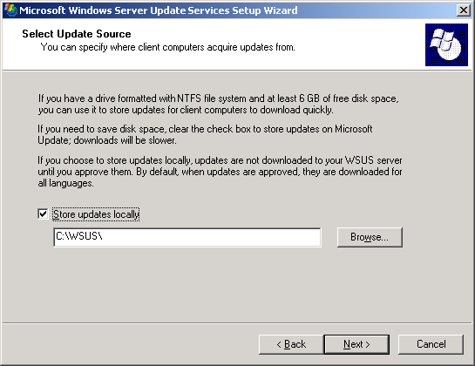

5. On the Database Options page, you select the software used to manage the WSUS database. By default, WSUS Setup offers to install WMSDE if the computer you are installing to runs Windows Server 2003.
If you cannot use WMSDE, you must provide a SQL Server instance for WSUS to use, by clicking Use an existing database server on this computer and typing the instance name in the SQL instance name box. For more information about database software options besides WMSDE, see the “Deploying Microsoft Windows Server Update Services” white paper.
Keep the default options, and click Next.
Database Options Page
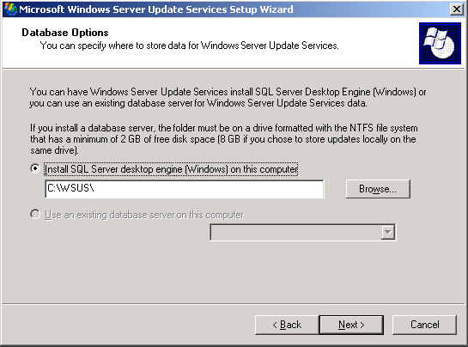

6. On the Web Site Selection page, you specify the Web site that WSUS will use. This page also lists two important URLs based on this selection: the URL to which you will point WSUS client computers to get updates, and the URL for the WSUS console where you will configure WSUS.
If you already have a Web site on port 80, you may need to create the WSUS Web site on a custom port. For more information about running WSUS on a custom port, see the “Deploying Microsoft Windows Server Update Services” white paper.
Keep the default option and click Next.
Web Site Selection Page
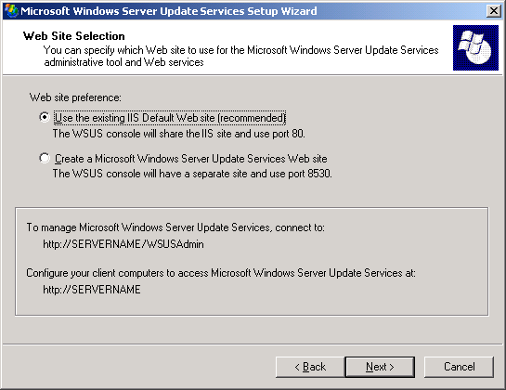

7. On the Mirror Update Settings page, you can specify the management role for this WSUS server. If this is the first WSUS server on your network or you want a distributed management topology, skip this screen.
If you want a central management topology, and this is not the first WSUS server on your network, select the check box, and type the name of an additional WSUS server in the Server name box. For more information about management roles, see the “Deploying Microsoft Windows Server Update Services” white paper.
Keep the default option and click Next.
Mirror Update Settings Page
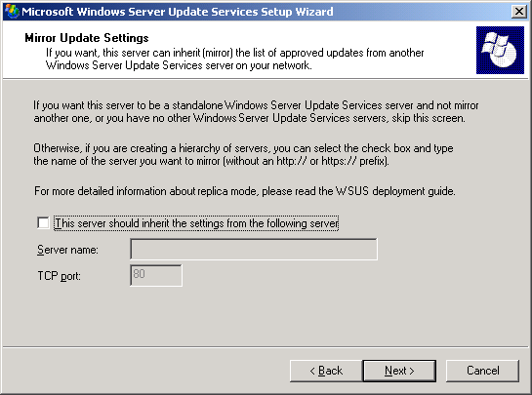

8. On the Ready to Install Windows Server Update Services page, review the selections and click Next.
Ready to Install Windows Server Update Services Page
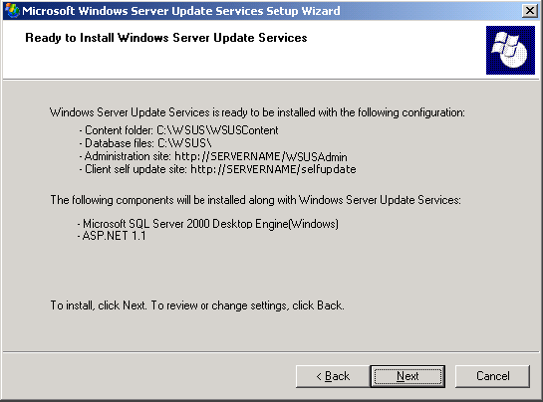

9. If the final page of the wizard confirms that WSUS installation was successfully completed, click Finish.

Step 3: Configure the Network Connection
After installing WSUS, you are ready to access the WSUS console in order to configure WSUS and get started. By default, WSUS is configured to use Microsoft Update as the location to obtain updates. If you have a proxy server on your network, use the WSUS console to configure WSUS to use the proxy server. If there is a corporate firewall between WSUS and the Internet, you might need to configure the firewall to ensure that WSUS can obtain updates.
Note:
Although you must have Internet connectivity to download updates from Microsoft Update, WSUS offers you the ability to import updates onto networks not connected to the Internet. For more information, see the “Deploying Microsoft Windows Server Update Services” white paper.
Step 3 contains the following procedures:
• Configure your firewall so that WSUS can obtain updates.
• Open the WSUS console.
• Configure proxy-server settings so that WSUS can obtain updates.
To configure your firewall
• If there is a corporate firewall between WSUS and the Internet, you might need to configure that firewall to ensure that WSUS can obtain updates. To obtain updates from Microsoft Update, the WSUS server uses port 80 for HTTP protocol and port 443 for HTTPS protocol. This is not configurable.
• If your organization does not allow those ports and protocols open to all addresses, you can restrict access to only the following domains so that WSUS and Automatic Updates can communicate with Microsoft Update:
• http://windowsupdate.microsoft.com
• http://*.windowsupdate.microsoft.com
• https://*.windowsupdate.microsoft.com
• http://*.update.microsoft.com
• https://*.update.microsoft.com
• http://*.windowsupdate.com
• http://download.windowsupdate.com
• http://download.microsoft.com
• http://*.download.windowsupdate.com
• http://wustat.windows.com
• http://ntservicepack.microsoft.com
Note:
The steps for configuring the firewall above are meant for a corporate firewall positioned between WSUS and the Internet. Because WSUS initiates all its network traffic, there is no need to configure Windows Firewall on the WSUS server.
Although the connection between Microsoft Update and WSUS requires ports 80 and 443 to be open, you can configure multiple WSUS servers to synchronize with a custom port. For more information about synchronizing WSUS servers with a custom port, see the “Deploying Microsoft Windows Server Update Services” white paper.
To open the WSUS console
• On your WSUS server, click Start, point to All Programs, point to Administrative Tools, and then click Microsoft Windows Server Update Services.
Note:
You must be a member of either the WSUS Administrators or the local Administrators security groups on the server on which WSUS is installed in order to use the WSUS console.
If you do not add http://<WSUS Web site name> to the list of sites in the Local Intranet zone in Internet Explorer on Windows Server 2003, you might be prompted for credentials each time you open the WSUS console.
If you change the port assignment in IIS after you install WSUS, you need to manually update the shortcut on the Start menu.
You can also open the WSUS console from Internet Explorer on any server or computer on your network by entering the following URL: http://WSUSservername/WSUSAdmin
To specify a proxy server
1. On the WSUS console toolbar, click Options, and then click Synchronization Options.
2. In the Proxy server box, select the Use a proxy server when synchronizing check box, and then type the proxy server name and port number (port 80 by default) in the corresponding boxes.
3. If you want to connect to the proxy server by using specific user credentials, select the Use user credentials to connect to the proxy server check box, and then type the user name, domain, and password of the user in the corresponding boxes. If you want to enable basic authentication for the user connecting to the proxy server, select the Allow basic authentication (password in clear text) check box.
4. Under Tasks, click Save settings, and then click OK in the confirmation dialog box.

Step 4: Synchronize the Server
After you configure the network connection, you can obtain updates. By default, WSUS is configured to download Critical and Security Updates for all Microsoft products. To get updates, you must synchronize the WSUS server.
Synchronization involves the WSUS server contacting Microsoft Update. After making contact, WSUS determines if any new updates have been made available since the last time you synchronized. Because this is the first time you are synchronizing the WSUS server, all of the updates are available and are ready for your approval for installation.
Note:
This paper describes synchronizing using the default settings, but WSUS includes options that enable you to minimize bandwidth use during synchronization. For more information, see the “Deploying Microsoft Server Windows Update Services” white paper.
To synchronize your WSUS server
1. On the WSUS console toolbar, click Options, and then click Synchronization Options.
2. Under Tasks, click Synchronize now.
After the synchronization finishes, click Updates on the WSUS console toolbar to view the list of updates.

Step 5: Update and Configure Automatic Updates
WSUS client computers require a compatible version of Automatic Updates. WSUS Setup automatically configures IIS to distribute the latest version of Automatic Updates to each client computer that contacts the WSUS server.
Note:
Although most versions of Automatic Updates can be pointed to the WSUS server and they will automatically self-update to the WSUS-compatible version, the version of Automatic Updates included with Windows XP without any service packs cannot update itself automatically. If you have Windows XP without any service packs in your environment, and you have never used Software Update Services (SUS), see the “Deploying Microsoft Windows Server Update Services” white paper for instruction.
The best way to configure Automatic Updates depends upon your network environment. In an Active Directory environment, you can use an Active Directory-based Group Policy object (GPO). In a non-Active Directory environment, use the Local Group Policy object. Whether you use the Local Group Policy object or a GPO stored on a domain controller, you must point your client computers to the WSUS server, and then configure Automatic Updates.
The following instructions assume that your network runs Active Directory. These procedures also assume that you have already set up and are familiar with Group Policy and use it to manage your network. You need to create a new Group Policy object (GPO) for WSUS settings, and link the GPO on the domain level.
For more information about Group Policy, see the Group Policy page at http://go.microsoft.com/fwlink/?LinkID=47375.
Step 5 contains the following procedures:
• Load the WSUS Administrative Template.
• Configure Automatic Updates.
• Point client computers to your WSUS server.
• Manually initiate detection on the client computer.
Perform the next three procedures on an Active Directory-based Group Policy object.
To add the WSUS Administrative Template
1. In Group Policy Object Editor, click either of the Administrative Templates nodes.
2. On the Action menu, click Add/Remove Templates.
3. Click Add.
4. In the Policy Templates dialog box, click wuau.adm, and then click Open.
5. In the Add/Remove Templates dialog box, click Close.
To configure the behavior of Automatic Updates
1. In Group Policy Object Editor, expand Computer Configuration, expand Administrative Templates, expand Windows Components, and then click Windows Update.
2. In the details pane, double-click Configure Automatic Updates.
3. Click Enabled, and then click one of the following options:
• Notify for download and notify for install. This option notifies a logged-on administrative user prior to the download and prior to the installation of the updates.
• Auto download and notify for install. This option automatically begins downloading updates and then notifies a logged-on administrative user prior to installing the updates.
• Auto download and schedule the install. If Automatic Updates is configured to perform a scheduled installation, you must also set the day and time for the recurring scheduled installation.
• Allow local admin to choose setting. With this option, the local administrators are allowed to use Automatic Updates in Control Panel to select a configuration option of their choice. For example, they can choose their own scheduled installation time. Local administrators are not allowed to disable Automatic Updates.
4. Click OK.
Note:
The setting Allow local admin to choose setting only appears if Automatic Updates has updated itself to the version compatible with WSUS.
To point the client computer to your WSUS server
1. In Group Policy Object Editor, expand Computer Configuration, expand Administrative Templates, expand Windows Components, and then click Windows Update.
2. In the details pane, double-click Specify intranet Microsoft update service location.
3. Click Enabled, and type the HTTP URL of the same WSUS server in the Set the intranet update service for detecting updates box and in the Set the intranet statistics server box. For example, type http://servername in both boxes.
4. Click OK.
Note:
If you are using the Local Group Policy object to point this computer to WSUS, this setting takes effect immediately and this computer should appear in the WSUS administrative console in about 20 minutes. You can speed this process up by manually initiating a detection cycle.
After you set up a client computer, it will take a few minutes before it appears on the Computers page in the WSUS console. For client computers configured with an Active Directory-based GPO, it will take about 20 minutes after Group Policy refreshes (that is, applies any new settings to the client computer). By default, Group Policy refreshes in the background every 90 minutes, with a random offset of 0 to 30 minutes. If you want to refresh Group Policy sooner, you can go to a command prompt on the client computer and type: gpupdate /force.
For client computers configured with the Local GPO, Group Policy is applied immediately and it will take about 20 minutes.
Once Group Policy is applied, you can initiate detection manually. If you perform this step, you do not have to wait 20 minutes for the client computer to contact WSUS.
To manually initiate detection by the WSUS server
1. On the client computer click Start, and then click Run.
2. Type cmd, and then click OK.
3. At the command prompt, type wuauclt.exe /detectnow. This command-line option instructs Automatic Updates to contact the WSUS server immediately.

Step 6: Create a Computer Group
Computer groups are an important part of WSUS deployments, even a basic deployment. Computer groups enable you to target updates to specific computers. There are two default computer groups: All Computers and Unassigned Computers. By default, when each client computer initially contacts the WSUS server, the server adds it to both these groups.
You can create custom computer groups. One benefit of creating computer groups is that it enables you to test updates before deploying them widely. If the testing goes well, you can roll out the updates to the All Computers group. There is no limit to the number of custom groups you can create.
Setting up computer groups is a three-step process. First, you specify how you are going to assign computers to the computer groups. There are two options: server-side targeting and client-side targeting. Server-side targeting involves manually adding each computer to its group by using WSUS. Client-side targeting involves automatically adding the clients by using either Group Policy or registry keys. Second, you create the computer group on WSUS. Third, you move the computers into groups by using whichever method you chose in the first step.
This paper explains how to use server-side targeting and manually move computers to their groups by using the WSUS console. If you had numerous client computers to assign to computer groups you could use client-side targeting, which would automate moving computers into computer groups.
You can use Step 6 to set up a test group that contains at least one test computer.
This step contains the following procedures:
• Specify server-side targeting.
• Create a group.
• Move computers to the group.
To specify the method for assigning computers to groups
1. On the WSUS console toolbar, click Options, and then click Computer Options.
2. In the Computer Options box, click Use the Move computers task in Windows Server Update Services.
3. Under Tasks, click Save settings, and then click OK when the confirmation dialog box appears.
To create a group
1. On the WSUS console toolbar, click Computers.
2. Under Tasks, click Create a computer group.
3. In the Group name box, type Test, and then click OK.
Use the next procedure to assign a client computer appropriate for testing to the test group. A client computer appropriate for testing is any computer with software and hardware indicative of the majority of computers on your network, but not a computer assigned to a critical role. In this way, you can tell how well the computers comparable to the test computer will fare with the updates you approve.
To manually add a computer to the Test group
1. On the WSUS console toolbar, click Computers.
2. In the Groups box, click the group of the computer you want to move.
3. In the list of computers, click the computer you want to move.
4. Under Tasks, click Move the selected computer.
5. In the Computer group list, select the group you want to move the computer to, and then click OK.

Step 7: Approve and Deploy Updates
In this step you approve an update for any test client computers in the Test group. Computers in the group will check in with the WSUS server over the next 24 hours. After this period, you can use the WSUS reporting feature to determine if those updates have been deployed to the computers. If testing goes well, you can then approve the same update for the rest of the computers in your organization.
Step 7 contains the following procedures:
• Approve and deploy an update.
• Check the Status of Updates report.
To approve and deploy an update
1. On the WSUS console toolbar, click Updates. By default, the list of updates is filtered to show only Critical and Security Updates that have been approved for detection on client computers. Use the default filter for this procedure.
2. On the list of updates, select the updates you want to approve for installation. Information about a selected update is available on the Details tab. To select multiple contiguous updates, press and hold down the SHIFT key while selecting; to select multiple non-contiguous updates, press and hold down the CTRL key while selecting.
3. Under Update Tasks, click Change approval. The Approve Updates dialog box appears.
4. In the Group approval settings for the selected updates list, click Install from the list in the Approval column for the Test group, and then click OK.
Note:
There are many options associated with approving updates, such as setting deadlines and uninstalling updates. These are discussed in the “Microsoft Windows Server Update Services Operations Guide” white paper.
After 24 hours, you can use the WSUS reporting feature to determine if those updates have been deployed to the computers.
To check Status of Updates report
1. On the WSUS console toolbar, click Reports.
2. On the Reports page, click Status of Updates.
3. If you want to filter the list of updates, under View, select the criteria you want to use, and then click Apply.
4. If you want to see the status of an update by computer group and then by computer, expand the view of the update as necessary.
5. If you want to print the Status of Updates report, under Tasks, click Print report.
If the updates were successfully deployed to the Test group, you can approve the same updates for the rest of the computers in your organization.

