

SAP with Microsoft SQL Server 2005:
Best Practices for High Availability, Maximum Performance, and Scalability
SQL Server Technical Article

Writers: Juergen Thomas and Jon Catanzano
Technical Reviewers: Juergen Thomas, Bryan McCutchan, Bernardo Zamora, Mike Hatch
Project Editor: Digital One, info@virtualse.com
Designer: Digital One, info@virtualse.com

Published: November 2005
Applies To: SQL Server 2005

Summary: This white paper describes best practices that customers, system integrators, and partners can use to design and install reliable, high-availability SAP implementations that deliver maximum performance, scalability, and security by using SQL Server 2005. The paper describes typical architectures, installation and configuration, and performance monitoring and tuning. The paper also describes special considerations for SAP BW and for 64-bit computing configurations.

Copyright

The information contained in this document represents the current view of Microsoft Corporation on the issues discussed as of the date of publication. Because Microsoft must respond to changing market conditions, it should not be interpreted to be a commitment on the part of Microsoft, and Microsoft cannot guarantee the accuracy of any information presented after the date of publication.

This White Paper is for informational purposes only. MICROSOFT MAKES NO WARRANTIES, EXPRESS, IMPLIED, OR STATUTORY, AS TO THE INFORMATION IN THIS DOCUMENT.

Complying with all applicable copyright laws is the responsibility of the user. Without limiting the rights under copyright, no part of this document may be reproduced, stored in or introduced into a retrieval system, or transmitted in any form or by any means (electronic, mechanical, photocopying, recording, or otherwise), or for any purpose, without the express written permission of Microsoft Corporation.

Microsoft may have patents, patent applications, trademarks, copyrights, or other intellectual property rights covering subject matter in this document. Except as expressly provided in any written license agreement from Microsoft, the furnishing of this document does not give you any license to these patents, trademarks, copyrights, or other intellectual property.

Unless otherwise noted, the example companies, organizations, products, domain names, e-mail addresses, logos, people, places, and events depicted herein are fictitious, and no association with any real company, organization, product, domain name, e-mail address, logo, person, place, or event is intended or should be inferred.

 2005 Microsoft Corporation. All rights reserved.

Microsoft, Windows, Windows NT, and Windows Server are either registered trademarks or trademarks of Microsoft Corporation in the United States and/or other countries.

The names of actual companies and products mentioned herein may be the trademarks of their respective owners.

Contents
Executive Summary 1
Introduction 2
SAP—Microsoft Alliance 2
SAP Solutions and SQL Server 3
SAP with SQL Server 2005 3
SQL Server 2005 Enterprise Edition 4
What’s new in SQL Server 2005 5
Solution Architecture 6
Installation 6
Hardware 6
Architectural considerations 7
Failover clustering 7
RAID 8
Small-scale solution 8
Midsize solution for mySAP 10
Large solution for mySAP 12
High-availability solution for SAP BW 14
Microsoft IT SAP solution architecture 16
High-availability considerations 18
Database mirroring 18
Log shipping 19
SAP Multilevel Client-Server Architecture 20
SAP NetWeaver Application Server 21
SAP NetWeaver Application Server architecture 22
SAP NetWeaver Application Server with Windows 23
SAP Connections to SQL Server 25
Security context of SAP transactions 25
SAP statement execution 26
SAP database schema 27
Collation and code page 27
Upgrading from SQL Server 2000 to SQL Server 2005 29
Migration considerations for SAP products 29
Installation and Configuration 30
SQL Server installation with SAP 30
Volume and growth projections 30
Number and size of SQL Server data files 31
Number of log files for SAP databases 33
tempdb considerations 34
Multi-instance support for SAP components 35
SAP database configuration 35
SQL Server configuration for SAP 35
SAP settings for the SQL Server lock manager 44
SQL Server 2005 Data-Availability Features 45
Backup and recovery improvements 45
Online backups 45
Media reliability 46
Database snapshots 47
Online indexing 47
Performance Monitoring and Tuning 49
SQL Server performance monitoring 49
SQL Server Profiler 49
Dynamic management views 49
Monitoring index usage 50
sys.dm_db_index_usage_stats 51
SAP performance tuning 52
Common performance problems 52
System performance is poor 53
Database server causes slowdown 55
CPU is pegged 55
I/O is very slow 56
Slow SAP transactions hamper the user experience 58
Special Considerations for SAP BW 63
SAP BW queries 63
SAP BW table partitioning 64
Range partitioning 64
Missing or outdated optimizer statistics 65
Creating aggregates 65
Loading and maintaining infocubes 67
64-Bit Computing Configurations 68
32-Bit computing architecture 68
64-Bit computing architecture 68
SQL Server 2005, Enterprise Edition (64-bit) 69
SAP applications on a 64-bit platform 71
SAP availability and support of 64-bit platforms 71
Related Links and Online Resources 72

Executive Summary
Companies face numerous challenges when managing and integrating information across enterprise business processes. Customers need faster analysis and deeper business insight to improve their decision making and to respond to changing business needs. Companies frequently choose an Enterprise Resource Planning (ERP) solution to fulfill these business requirements. The leading ERP applications with the greatest market share are the mySAP™ ERP and SAP® R/3® industry solutions from SAP AG.
mySAP ERP is comprised of a comprehensive range of products that empower the enterprise with a flexible, end-to-end solution. mySAP solutions can increase business productivity, enhance operational efficiency, and reduce total cost of ownership (TCO). mySAP solutions also offer the scalability needed to manage ever-increasing workloads. mySAP solutions enable companies to pinpoint inefficiencies in current business operations and to provide the resources needed to extend best practices to the entire value chain.
A critical challenge in implementing a mySAP solution is in the selection of a data platform that can deliver the advanced features and capabilities needed to support the most demanding workloads. Companies can choose Microsoft® SQL Server™ as the best solution for mySAP. Microsoft SQL Server 2005 is the database of choice for deploying reliable, highly available, high-performance, scalable, and more secure mySAP installations.
SQL Server 2005 is an integrated data management and analysis solution. SQL Server 2005 enables SAP customers of any size to share data across multiple platforms, applications, and devices, while making it easier to connect to internal and external systems. SQL Server 2005 high-availability features can minimize downtime in SAP implementations. SQL Server 2005 maximizes productivity by making it easier to create robust database extensions at a lower cost.
mySAP solutions running on SQL Server 2005 realize native performance improvements. SQL Server 2005 contains built-in tools that simplify installation and make it easy to deploy and manage SAP implementations. In addition, the SQL Server 2005 engine dynamically tunes database parameters automatically to respond to changing usage characteristics.
This white paper describes best practices that customers, system integrators, and partners can use to design, deploy, and operate high-availability SAP implementations by using SQL Server 2005. This paper is provided to ensure that the common aspects of SAP with SQL Server 2005 implementations reflect the specific characteristics of SAP business applications.
The paper describes typical architectures, installation and configuration, and performance monitoring and tuning, including how to resolve common problems. The paper also describes special considerations for SAP® Business Information Warehouse (SAP BW) and for 64-bit computing configurations.
The paper assumes that the reader has at least a general understanding of mySAP ERP solutions and Microsoft SQL Server database concepts and features. The SAP with SQL Server 2005 best practices that are described in this white paper were developed from the combined experiences of thousands of SAP customers worldwide.

Introduction
SAP AG is the recognized leader in providing collaborative business solutions for all types of industries and for every major market. SAP delivers powerful solutions to more than 26,150 customers in 96,400 installations with 12 million users in over 120 countries/regions around the world. SAP software offers distinct solutions that address the needs of small and midsize businesses and provides enterprise-scale solutions for global organizations.
SAP is the world's largest inter-enterprise software company and the world's third-largest independent software supplier overall. Today, SAP employs more than 32,000 people in 50 countries/regions. With enhanced collaboration provided by more than 1,500 partners, SAP professionals provide high-level customer support and services.
SAP industry solutions offer multiplatform support for business processes in more than 25 distinct industries including high technology, retail, public sector, and financial services. mySAP ERP products optimize business processes and improve collaboration and integration across the extended enterprise.
mySAP ERP solutions use SAP NetWeaver™ as a comprehensive integration and application platform. SAP NetWeaver works with existing information technology (IT) infrastructures to enable and manage change.

SAP—Microsoft Alliance
Since 1993, SAP and Microsoft have been working together closely to ensure that the Microsoft platform and SAP solutions are fully integrated. SAP and Microsoft have a strong, long-term relationship that is driven by customer satisfaction.
As a result of this alliance, Microsoft is now the most selected platform for R/3 and mySAP deployments:
- More than 46,000 SAP application installations run on Microsoft Windows®; more than all other platforms combined. In addition, 65 percent of all new SAP deployments run on Microsoft Windows.
- More than 20,000 customers worldwide are running SAP applications with SQL Server. And, 40 percent of all new R/3 and mySAP deployments use SQL Server.
- The number of SAP installations that use SQL Server has grown in every quarter since 1993.
SAP and Microsoft are uniquely positioned to provide integrated business value. Examples include:
- Extending mySAP through the SAP Connector for Microsoft® .NET.
- Accessing mySAP business processes through the Microsoft® Office System.
- Using SQL Server business intelligence (BI) features such as Reporting Services to directly access SAP BW.

SAP Solutions and SQL Server
SAP and Microsoft have been working together to develop tight integration between SAP solutions and SQL Server:
- SAP R/3 for Microsoft Windows NT® version 3.51 was released in 1994. By mid-1995, SAP began using R/3 with SQL Server™ version 6.0 in customer implementations.
- Between 1996 and 1998, SAP and Microsoft developed SQL Server™ version 7.0 by building on their direct experience with customers. In particular, the SQL Server development team removed limitations on the use of SQL Server with SAP systems to improve scalability and performance. SQL Server 7.0 was released at the end of 1998.
- The release of Microsoft SQL Server™ 2000 dramatically improved the performance and administration of SAP products. Using standard benchmarks, SQL Server 2000 performed best on an Intel® hardware platform running the Microsoft Windows Server™ operating system. Customers migrating to SQL Server 2000 were able to increase system performance by extending memory addressability using Microsoft Windows Server™ 2000 and Windows Server™ 2003.

SAP with SQL Server 2005
Today, Microsoft SQL Server 2005 Enterprise Edition is the foundation of a tightly integrated data platform that can be used to share and apply company information. SQL Server 2005 Enterprise Edition was tuned jointly with Microsoft and SAP engineers to ensure maximum performance, reliability, and enhanced interoperability.
The advantages of using SAP with SQL Server 2005 include:
- Improves performance. Enhancements in SQL Server 2005 enable tune-up and autoadministration features to work for all SAP application deployments.
- Supports very large databases. mySAP and R/3 installations running on SQL Server 2005 can accommodate larger and more complex databases. Multiterabyte databases and 45,000 tables in a single mySAP database are increasingly more common.
- Offers advanced capabilities as standard features. Customers can take advantage of these capabilities without the need for additional licenses, limitations, special hardware, or special database versions.
- Contains comprehensive data management features. Data management features include advanced data mining; integration services; extraction, transformation, and loading (ETL); BI; high availability; manageability; and security.
- Runs on standard commodity servers and storage. SAP customers have two options for licensing SQL Server 2005. When SQL Server 2005 is licensed through Microsoft and is used for more than one application, the database is licensed per processor, not per core, as is common with some competitors. This reduces the cost by a factor of three or greater. When SQL Server 2005 is licensed through SAP and is used for one application only, even greater savings can be realized.
- Allows for scalability using standard commodity hardware. SQL Server 2005 is highly scalable and can allow for future growth by using standard commodity servers and storage. In addition, SQL Server 2005 takes advantage of the latest hardware architectures. mySAP on SQL Server 2005 can now run workload levels on four-processor commodity servers that, only four years ago, would have required a 32-processor server and a one-million dollar investment.
- Offers the most compelling TCO. SQL Server offers the best TCO for SAP implementations, including lower management costs. Meta research concluded that Windows offers two to three times better TCO than other enterprise platforms when used in ERP scenarios.

SQL Server 2005 Enterprise Edition
SQL Server 2005 Enterprise Edition is a comprehensive, integrated end-to-end data solution that delivers a reliable, secure, and productive platform for enterprise data and BI applications. SQL Server 2005 delivers new and improved features that are tightly integrated with mySAP products based on the following support considerations:
- For SAP products, SQL Server 2005 uses Windows Server 2003, Service Pack 1 and later. SAP and SQL Server 2005 are supported on the 32-bit, Itanium 64 (IA64), and x64 computing platforms.
- SQL Server 2005 is qualified for use on SAP products that run on the SAP 6.40 kernel and later. This includes SAP R/3 4.7E, most of the NetWeaver 2004 products such as mySAP ERP Central Component (ECC 5.0), mySAP™ Supply Chain Management (mySAP SCM 4.1), and SAP NetWeaver 2004S products. In particular, SAP supports SQL Server 2005 on SAP BW 3.5 and later.
- SQL Server 2005 is not supported on products earlier than SAP Basis release 6.20. This includes the products with Basis release 4.6x, including releases 4.6B and 4.6C. In addition, SQL Server 2005 is not supported on SAP BW releases 3.0 and 3.1.
SQL Server is part of the Windows Server System™, a comprehensive and integrated server infrastructure that simplifies the development, deployment, and operation of information systems.

What’s new in SQL Server 2005
SQL Server 2005 Enterprise Edition contains new features and improvements including:
- Enterprise data management. SQL Server 2005 reduces application downtime and increases scalability and performance, availability, manageability, and security.
- Developer productivity. SQL Server 2005 includes many new technologies that significantly increase developer productivity.
- Business intelligence. SQL Server 2005 enhances Microsoft leadership in BI through innovations in scalability, data integration, development tools, and rich analytics, including comprehensive integration, analysis, and reporting capabilities.
- Highly productive developer environment. SQL Server 2005 provides a rich, powerful, and integrated single development environment that allows developers to more easily create robust database extensions at a lower cost.
When deployed with SQL Server 2005 Enterprise Edition, SAP provides:
- Enterprise class high availability and scalability. SQL Server 2005 can support the most demanding mySAP and R/3 implementations out-of-the-box. SQL Server 2005 high-availability capabilities can minimize downtime in SAP implementations.
- Easy installation and management. SQL Server 2005 contains built-in tools that simplify installation and make it easy to deploy and manage SAP implementations. The SQL Server 2005 database engine dynamically tunes database parameters to respond to changing usage characteristics.

Solution Architecture
This section describes typical reference architectures that are capable of supporting small-scale, midsized, and the largest, most demanding SAP implementations. The architectures show the basic elements that can be used in a variety of implementation scenarios. This section also provides an example implementation of Microsoft Information Technology (IT) SAP with SQL Server 2005.
In practice, each SAP implementation must be adapted and designed jointly with a SAP-certified hardware vendor to address the customer’s unique requirements. These might be, for example, preexisting infrastructures, business models, or business impact assessments.
Each of the mySAP with SQL Server 2005 reference architectures meets the following requirements:
- High availability. The architectures are designed for high availability to provide the best performance and to ensure fault tolerance.
- Scalability. Additional servers can be added quickly and easily without disrupting the existing site, thereby enabling SAP installations to rapidly increase the number of concurrent users.
- Support for large volumes of data. The application and database configuration can grow from hundreds of gigabytes to multiterabyte databases.

Installation
In most SAP implementations, customers install mySAP and SQL Server 2005 Enterprise Edition with the assistance of a SAP-certified partner. Microsoft-certified partners with SAP-certified consultants are available to support the installation of SQL Server 2005.

Hardware
The SAP with SQL Server 2005 reference architectures are designed to use commodity servers and storage that is available from leading hardware vendors. This reduces the TCO and ensures that maintenance and support costs can be well-managed.

Architectural considerations
The mySAP with SQL Server 2005 architectures are designed to provide maximum availability and to ensure reliability by offering multiple levels of failover support and redundancy including:
- Failover clustering. SQL Server 2005 can run two to eight server nodes in a failover cluster to provide redundancy in the event of server downtime.
- RAID. Common Redundant Array of Independent Disks (RAID) is used to provide redundancy in the event of a disk failure.
- Networked storage. Storage Access Network and Networked Attached Storage (NAS) technologies can be designed with complete redundancy to ensure data integrity and avoid data loss. SQL Server 2005 is optimized for native integration with Storage Access Network hardware.

Failover clustering
mySAP with SQL Server 2005 architectures can take advantage of failover clustering. In SQL Server 2005, failover clustering offers a complete, fault-tolerant server solution that supports high availability and data integrity, and reduces the costs associated with downtime.
SQL Server 2005 failover clustering exploits Microsoft Windows Clustering Services (MSCS) to create fault-tolerant virtual servers that enable fast failover in the event of a database server or critical line-of-business (LOB) application failure. SQL Server 2005 supports two to eight servers as cluster nodes. In SQL Server 2005, support for failover clustering has been extended to SQL Server Analysis Services, Notification Services, and SQL Server replication.
The clustered servers are configured as shown in the following diagrams. A typical Microsoft clustering scenario includes running the SAP Central Instance (CI) on one of the cluster nodes and SQL Server 2005 on the other cluster node. In this case, if the primary node for SQL Server 2005 or for the SAP CI fails, or if that node is taken offline for maintenance, the clustered components will start on the active cluster node without a service interruption.
It is important to note that, when clustering is employed in a 64-bit computing scenario and SQL Server 2005 (64-bit) is used, SAP x64 application support is required.
For more information, see “Failover Clustering” in the Microsoft Developer Network (MSDN) Library at
http://msdn.microsoft.com/library/default.asp?url=/library/en-us/adminsql/ad_clustering_7t9v.asp.

RAID
mySAP with SQL Server 2005 architectures use common RAID levels including 1, 1+0, and 0+1, as shown in the diagrams later in this section. For the best performance with full recoverability, customers frequently use RAID 0+1. RAID 5 can be used as a lower cost alternative. The choice of RAID level is dependent on the workload and this choice can directly affect the way SQL Server 2005 performs.
Note that RAID levels greater than 10 (1 + 0) offer additional fault tolerance or performance improvements. However, systems using RAID 10 and greater tend to be proprietary. For more information about specific RAID system capabilities, contact the hardware vendor.
For more information, see “RAID Levels and SQL Server” in the MSDN Library at http://msdn.microsoft.com/library/default.asp?url=/library/en-us/optimsql/odp_tun_1_87jm.asp.
For general information on common RAID levels, see “RAID” in the MSDN Library at http://msdn.microsoft.com/library/default.asp?url=/library/en-us/optimsql/odp_tun_1_0m5g.asp.

Small-scale solution
The small-scale solution for using mySAP and SAP BW with SQL Server 2005 typically has the following characteristics:
- Support for 100 or fewer concurrent users, depending on the workload
- A low SAP batch workload
- No major differences between SAP products (mySAP and SAP BW)
This architecture is commonly used in small scale SAP development or test systems. See Figure 1.

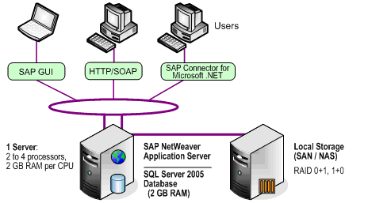
Figure 1

Architecture | Description
Server
SAP NetWeaver Application Server / SQL Server 2005 Database | 1 commodity server having 2 to 4 central processing units (CPUs), each with 2 gigabytes (GB) RAM per CPU core.  2-GB random access memory (RAM) is assigned to support SQL Server 2005.
Failover Clustering | None
RAID | RAID 0+1, 1+0
Local Storage
mySAP Storage Requirements | For data files (assuming RAID 1 or similar):  - 4 partitions for each disk with 6 disks minimum  For transaction log (assuming RAID 1 or similar):  - 1 partition for each disk with 8 disks minimum  For tempdb and log (assuming RAID 1 or similar):  - 1 partition for each disk with 6 disks minimum
SAP BW Storage Requirements | For data files (assuming RAID 1 or similar):  - 4 partitions for each disk with 6 to 8 disks minimum  For transaction log (assuming RAID 1 or similar):  - 1 partition for each disk with 6 to 8 disks minimum  For tempdb and log (assuming RAID 1 or similar):  - 1 partition for each disk with 6 disks minimum  The recommended storage requirements for the data files and transaction log differ for mySAP and for SAP BW. The tempdb and log requirements are the same for either system.

Midsize solution for mySAP
The midsize solution for mySAP with SQL Server 2005 (as shown in Figure 2) has the following characteristics:
- Support for 250 or more concurrent users, depending on the workload
- A low to medium SAP batch workload
- Differences between products (mySAP and SAP BW)

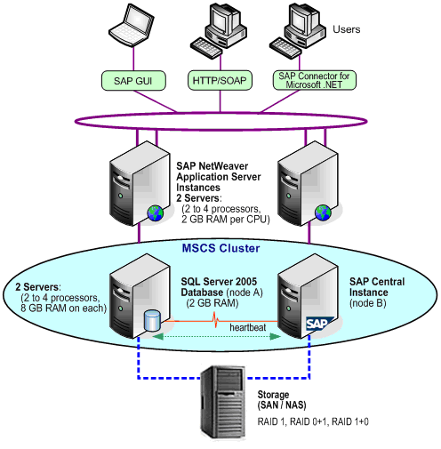
Figure 2

Architecture | Description
Servers
SAP NetWeaver Application Server Instances | 2 commodity servers, each server having 2 to 4 CPUs, each with 2-GB RAM per CPU core.
SQL Server 2005 Database Server / SAP Central Instance (CI) Server | 2 commodity servers, each having 2 to 4 processors, each with 8-GB RAM. 2-GB RAM is assigned to support SQL Server 2005.
Failover Clustering | Set to active-to-passive mode, running SAP CI on the second node.  Clusters are networked storage configurations that are dependent on a shared storage infrastructure.
RAID | RAID 1, 0+1, 1+0
Networked Storage
Storage Area Network | Storage Area Network, NAS, or locally-attached storage. Storage devices can use a multicluster device, according to the Windows Hardware Compatibility List (HCL).
mySAP Storage Requirements | For data files (assuming RAID 1 or similar):  - 4 partitions for each disk with 14 disks minimum  For transaction log (assuming RAID 1 or similar):  - 1 partition for each disk with 10 disks minimum  For tempdb and log (assuming RAID 1 or similar):  - 1 partition for each disk with 10 disks minimum

Large solution for mySAP
The large-size solution for mySAP with SQL Server 2005 (Figure 3) has the following characteristics:
- Support for 250 or more concurrent users depending on the workload
- A high SAP batch workload
- Differences between products (mySAP and SAP BW)

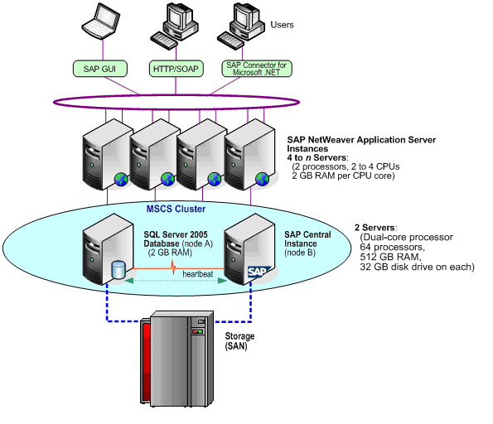
Figure 3

Architecture | Description
Servers
SAP NetWeaver Application Server Instances | 4 to n two-processor commodity servers with 2 to 4 CPUs, each with 2-GB RAM per CPU core.
SQL Server 2005 Database Server / SAP Central Instance (CI) Server | 2 servers, commodity or noncommodity, dual-core with up to 64 processors and up to 512-GB RAM.
Failover Clustering | Set to active-to-passive mode, running SAP CI on the second node.  Eventually, use pure SQL Server active-to-active clustering between Productive Database Instance and Test Database Instance.  Clusters are networked storage configurations that are dependent on a shared storage infrastructure.
RAID | Per the vendor’s networked storage installation requirements.
Networked Storage
Storage Area Network | Storage Area Network or, rarely, using locally-attached storage. Storage devices must be on a multicluster device according to the HCL.
mySAP Storage Requirements | 100 to 250 disks:  1 data file / processor core

High-availability solution for SAP BW
The high-availability solution for SAP BW with SQL Server 2005 (Figure 4) has the following characteristics:
- Support for 250 or more concurrent users depending on the workload
- Differences between products (mySAP and SAP BW)

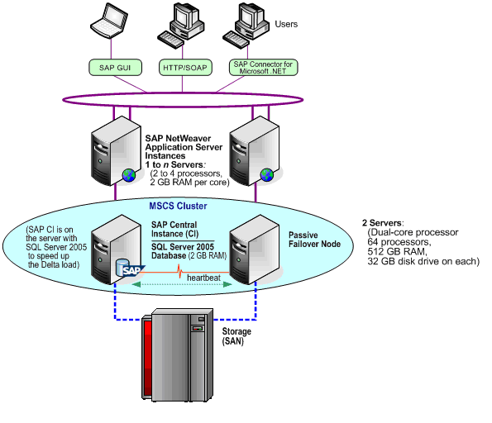
Figure 4

Architecture | Description
Servers
SAP NetWeaver Application Server Instances | 1 to n commodity servers with 2 to 4 CPUs, each with  2-GB RAM per CPU core.
SQL Server 2005 Database Server / SAP Central Instance (CI) Server | 2 servers, commodity or noncommodity, dual-core with up to 64 processors and up to 512-GB RAM.
Failover Clustering | Set to active-to-passive mode.  Eventually use pure SQL Server active-to-active clustering between the Productive Database Instance and Test Database Instance.  Clusters are networked storage configurations that are dependent on a shared storage infrastructure.
RAID | Per the vendor’s networked storage installation requirements.
Networked Storage
Storage Area Network | Storage Area Network or, rarely, using locally-attached storage. Storage devices must be on a multicluster device according to the HCL.
SAP BW Storage Requirements | 80 to 250 disks:  1 data file / processor core

Microsoft IT SAP solution architecture
Microsoft IT uses a large scale mySAP with SQL Server implementation to support Microsoft business processes and operations. The Microsoft IT SAP solution (Figure 5) has the following characteristics:
- Support for 200 to 600 or more concurrent users, depending on the workload
- A high SAP batch load responsible for over 65 percent of the workload
- 2.2-terabyte database
- Database mirroring for high availability

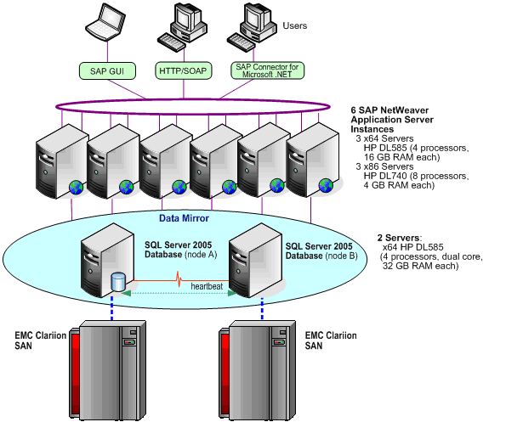
Figure 5

Architecture | Description
Servers
SAP NetWeaver Application Server Instances | 3 x64 Hewlett-Packard® (HP) ProLiant DL585 4-processor commodity servers, each with 16-GB RAM.  3 x86 HP ProLiant DL740 8-processor servers, each having 4 GB RAM.
SQL Server 2005 Database Server | 2 servers, each with x64 HP DL585 4 processors (dual-core), each with 32-GB RAM.
Failover Clustering | Set to active-to-passive mode.  Clusters are networked storage configurations that are dependent on a shared storage infrastructure.
RAID | Raid 0+1
Networked Storage
Storage Area Network | EMC2® Clarion® CX series  12 logical drives
mySAP Storage Requirements | 180 disks:  12 data files / database

High-availability considerations

Database mirroring
Database mirroring is a new feature in SQL Server 2005. Database mirroring will become available for use in the first half of 2006. At the time of this writing, only a small number of selected customers are using database mirroring in a production environment.
Database mirroring ensures that a transactionally consistent, hot-standby mySAP database is rapidly available in the event of a database failure. Database mirroring allows for geographical redundancy with network traffic encrypted by default.
SQL Server 2005 offers three database-mirroring configurations:
- Asynchronous mirroring
- Synchronous mirroring with failover
- Synchronous mirroring without failover
The appropriate configuration to use with SAP depends primarily on the customer’s specific failover requirements and infrastructure. However, synchronous mirroring without failover is not recommended for SAP systems.
Asynchronous mirroring and synchronous mirroring with failover are described in the following sections.

Asynchronous mirroring
Asynchronous database mirroring uses a standby server when network resources or physical distance precludes the use of synchronous mirroring with failover. The transaction log records are sent asynchronously to the mirrored server. The primary database server does not wait for the mirrored server to acknowledge the receipt of the transactions before confirming the commit to the application.
Asynchronous mirroring does not guarantee that all transactions committed on the principal server will be saved to the mirrored server. With asynchronous mirroring, it is not possible to have automatic failover. However, the secondary system is available in the event of a failure.
Asynchronous mirroring can be used in disaster-recovery scenarios when the database is mirrored to a remote site across wider distances. Currently, most SAP customers use log shipping for that purpose. Asynchronous mirroring is an effective alternative that improves transactional consistency and, most importantly, provides a mirrored image of the database that is close to the principal image of the database.

Synchronous mirroring with failover
For synchronous mirroring with failover, the primary server confirms the transaction to the application only after acknowledgement from the mirrored server is received. This configuration enables automatic failover of the primary system to the secondary system. This is similar to a Windows clustering scenario.
However, this configuration offers two-phased transactional consistency. Instead of having only a single copy of the data on shared storage, there are two separate and consistent copies.
Automatic failover requires the addition of a witness instance of SQL Server, which can be a server running Microsoft SQL Server 2005 Express Edition. The witness server provides the quorum logic necessary in automatic failover clusters in cases where two of the three servers must agree on failover. If the principal server goes down, the witness and mirrored servers form a quorum and then arbitrate to bring the mirrored server online and redirect clients to the mirrored server.

Log shipping
SQL Server 2005 supports log shipping to feed transaction logs from one database to another on a constant basis. Continually backing up the transaction logs from a primary database, and then copying and restoring the logs to a secondary database, keeps the databases synchronized. This provides a backup server for disaster recovery and also offers a means to offload query processing from the primary server to a read-only destination server.
Log shipping is recommended for use in a variety of scenarios. Some customers use it across geographically distant data centers as part of their disaster-recovery configuration. Note that with log shipping there is no automatic failover and committed transactions can be lost. This is dependent on the frequency with which transaction log backups are performed.

SAP Multilevel Client-Server Architecture
This section describes how mySAP architecture relates to SQL Server 2005. It includes an overview of the NetWeaver Application Server, formerly the SAP Web Application Server. This section also describes security, statement execution, database schema, and information for migrating and upgrading to SQL Server 2005.
Note that some of the information in this section is unique to mySAP products and does not necessarily follow the practices used by SQL Server 2005 in other applications.
All SAP products employ a multitiered client-server architecture as shown in the following diagram.

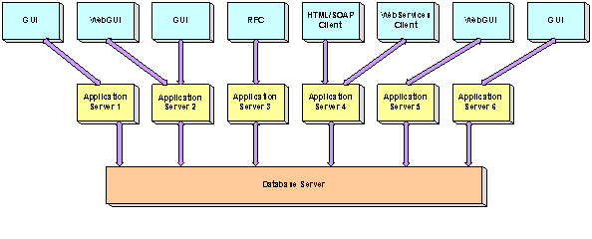
Figure 6

The SAP multitiered client-server architecture is comprised of three levels:
- Presentation tier. This tier supports SAP Graphic User Interfaces (GUIs) such as SAP GUI, SAP WebGUI, and other products that connect to the SAP NetWeaver Application Server by using one of the supported interfaces. The Presentation tier also enables applications to access SAP using Web services. Examples might be applications that include smart clients and Microsoft Office applications that integrate SAP data, such as when Microsoft Excel is used with Web services.
Note that the Web services interface will be supported in the NetWeaver 2004S Application Server release.
- Application tier. This tier can contain multiple SAP NetWeaver Application Server instances, with each instance pointing to the same database server. Each application server instance is typically run on separate server hardware. However, the Application tier and Database tier can run on the same server hardware on small-scale systems and in some very large hardware configurations.
- Database tier. This tier supports the SAP database, including mySAP or R/3 and other SAP applications that are hosted on SQL Server 2005. The Database tier typically runs one database schema for each SAP product by using separate server hardware. The database servers can be connected to a Storage Area Network, NAS, or locally attached storage.

SAP NetWeaver Application Server
The SAP NetWeaver Application Server is a system that supports Web services and business applications.

SAP servers
In Figure 7, the SAP Application Servers sample shows examples of instances for one R/3 system that uses multiple hardware servers. Some of the servers are running more than one SAP NetWeaver Application Server instance.
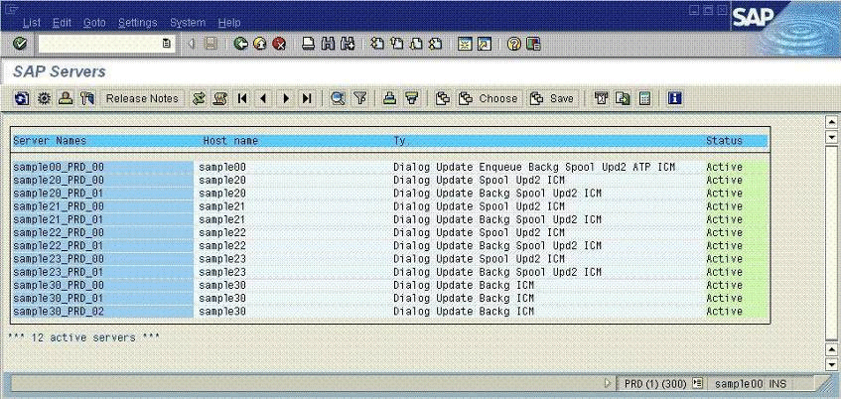
Figure 7
A SAP system can contain dozens of NetWeaver Application Server instances running on multiple servers.

SAP NetWeaver Application Server architecture
SAP NetWeaver Application Server is the main building block for deploying highly scalable SAP Web applications and Web services. SAP NetWeaver Application Server supports the Application tier of the SAP multilevel client-server architecture and it typically runs on separate server hardware.
The SAP NetWeaver Application Server architecture contains a number of interfaces as shown in the following diagram.
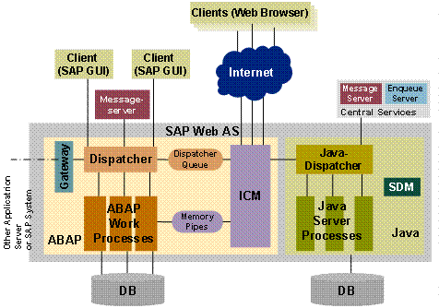
Figure 8

The SAP NetWeaver Application Server User tier (also called the Presentation layer) connects to the SAP NetWeaver Application Server Layer through the HTTP/SOAP, Web services, or Request for Comments (RFC) interfaces. The User tier is handled by using dialog processes, which are dedicated to user interaction on the SAP application server.
The SAP NetWeaver Application Server Layer contains the following logical components:
- Virtual machines (ABAP and JAVA). The Advanced Business Application Programming (ABAP) virtual machine (VM) is the heart of SAP NetWeaver Application Server. Nearly all business report logic runs through the ABAP VM. The Java VM is also used to process business logic including the SAP Enterprise Portals.
- Dispatcher (Queue Manager). The Dispatcher accepts requests coming from different types of SAP NetWeaver Application Server interfaces. The Dispatcher queues and distributes requests to other SAP processes. The Dispatcher maintains communication with Presentation tier interfaces.
The first time a request from the Presentation tier is made to SAP NetWeaver Application Server, it is introduced as a Dispatcher process of a particular instance. The Dispatcher process locates a free process in the instance with the requested functionality. All of the different processes in one instance communicate with the Dispatcher process.
- Central services. Central services include Batch Scheduling, Memory Services, and Enqueue Services.
- Data persistence layer. Each VM has a data persistence layer that operates on different schemas within the SAP database. Shared transactions (database transactions) cannot be performed between the ABAP and Java VMs.
- Message server. This server is the communication port for the SAP CI. The message server handles all communication with other instances within the same system. It also handles the initial communication to establish a client session with the Dispatcher of an instance.
For more information, see “SAP NetWeaver: Providing the Foundation to Enable and Manage Change” at http://www.sap.com/solutions/netweaver/index.epx.

SAP NetWeaver Application Server with Windows
In contrast to products such as SQL Server 2005 that are developed on a Windows platform, SAP NetWeaver Application Server is a multiprocess application, not a multithread application.
SAP processes that are configurable within one SAP NetWeaver Application Server instance include:
- Dialog process. This process allows user interaction to move from the Presentation tier to the Application tier. Normally, there are multiple processes offering dialog services in each instance.
- Update process. SAP processes execute asynchronous changes on the database. There must be one update process for each system. There can be instances without an update process.
- Batch process. This process handles long-running, noninteractive jobs in the background. SAP product tasks can be scheduled to run at a certain point in time or when an event occurs.
- Enqueue process. This process handles SAP logical locking management. There must be at least one Enqueue process for each SAP system. This process runs only on the SAP Central Instance.
In some cases, when there is a gap between a user confirmation and the end of an asynchronous update, a SAP object such as the Material or Customer object must be locked before the database is accessed. In these cases, the Enqueue process handles the locking and unlocking of requests on the SAP NetWeaver Application Server Layer system-wide. Database locks could harm concurrency on the database. The Enqueue process keeps the database from being flooded with locks and it blocks objects not yet released.
- Spool process. This process enables print services for a SAP system. The process sends a print request to the Windows spool manager.
- Message server process. This process allows for communication between the different NetWeaver Application Server instances within one SAP system. The message server runs on the SAP CI.
- Gateway process. This process is responsible for external communication between NetWeaver Application Servers.

SAP process overview
The sample in Figure 9 lists the different processes in one SAP instance. The sample does not show the Dispatcher, message server, or gateway processes.
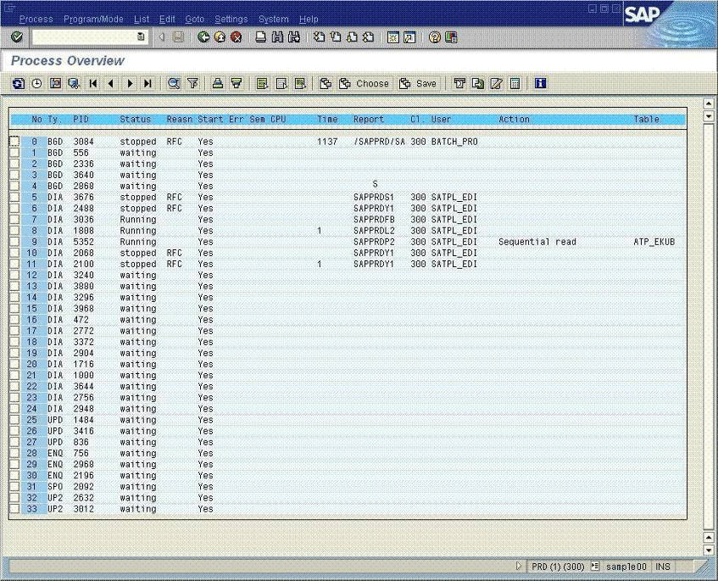
Figure 9
One specific SAP NetWeaver Application Server instance represents a collection of processes. Most SAP services are realized using different processes. The NetWeaver Application Server Layer can be distributed over several servers to perform processes. In this case, different instances of SAP NetWeaver Application Server can be configured differently, based on the user or job assignments to those instances.
SAP NetWeaver Application Server instances can be configured to enable only one or two types of processes or nearly all types of processes. The specific configuration depends on the size of the SAP system and on the available hardware.

SAP Connections to SQL Server
With SQL Server 2005, multiple open client-side cursors can use one connection such as Multiple Active Result Sets (MARS). In contrast to earlier SQL Server releases, the number of connections of a SAP process to SQL Server 2005 is limited to two connections for each SAP process as shown in Figure 10.
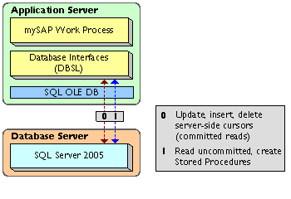
Figure 10

SAP executes “dirty” reads. In order to scale, SAP reads most of the data on an uncommitted read isolation level. This is done on one of the two connections.
All data modifications, plus some reads requiring read-committed isolation, are handled on the other SAP connection.

Security context of SAP transactions
mySAP benefits from SQL Server 2005 integrated security for strong, trustworthy installations. The security context of SAP transactions is established during the installation of SAP NetWeaver Application Server:
- SAP creates two Windows users named SAPService<SID>, for example, SAPServicePRD and <SID>adm such as PRDadm. The <SID> represents the three-character SAP System ID.
- Windows users are created as logins. In SQL Server 2005, two Windows users log in by using Windows Authentication. SAP recommends installing SQL Server 2005 integrated security to accept connections only. For SAP databases, these two logins are assigned to the SQL Server system administrator (sa) role and the dbo database role.
- A SQL Server login is created for each user owning a schema in the SAP database. A login cannot be performed interactively because SQL Server only accepts integrated security connection attempts. Each user is assigned to the SQL Server serveradmin fixed server role. Each user owning a schema in the SAP database is assigned to the dbo database role.
- After the SAP process, SAPService<SID> establishes a connection using integrated security. The process acts as a user owning a schema in the SAP database by executing SETUSER <SID>.
For troubleshooting, note the following:
- When accessing a SAP database with SQL Server 2005 query tools, the SETUSER <SID> statement must be executed before data can be read.
- Because the SAP customer can install more than one schema in one SAP database, ensure that the schema is correct. Most schemas have a set of objects that are named in the same manner in both schemas.
Note that this is not a security gap because SQL Server 2005 installs accepted Integrated Security logins only.
The preceding SAP security considerations involve the last two releases of the SAP NetWeaver Application Server, which are supported by SQL Server 2005. In older releases, a SAP database could contain only one schema owned by the dbo database role.

SAP statement execution
NetWeaver Application Server executes a combination of parameterized statements and static stored procedures against SQL Server 2005. The intention is to cache and reuse the query plans resulting from those parameterized statements and parameterized stored procedures. This keeps the number of statement compilations and recompilations extremely low (usually in the low single digits per second).
SAP can dynamically create and reuse static stored procedures. A stored procedure usually contains one statement only. SAP products can contain up to several hundred thousand stored procedures. SAP identifies static stored procedures by using naming conventions derived from the ABAP source code. When the ABAP source code changes, new stored procedures can be created on the fly.
In addition:
- SAP uses a minimum number of ad hoc queries—less than one per second.
- There are relatively few database locks, because 99.9 percent of all reads are uncommitted. The number of database locks typically ranges from a few thousand to ten thousand or more.
- With SQL Server 2005, all SAP statement and stored procedure executions are prepared by using the SAP application, making it extremely difficult to use SQL Server Profiler to trace those executions.
- With SQL Server 2005, SAP only supports the OLE DB programming interface integrated in SQL Native Client. SQL Native Client needs to be installed on each application server to allow SAP NetWeaver Application Server to connect to SQL Server 2005. SQL Native Client contains the Client APIs of SQL Server 2005. The Client APIs are deployed by SQL Server only and are independent of Microsoft Data Access Components (MDAC).

SAP database schema
SAP business applications database schema can include up to 45,000 tables, depending on the SAP product.
- Clustered and nonclustered indexes. Nearly all tables use the primary key constraint of SQL Server 2005. This results in a clustered index over the fields of the primary key. No other constraints are used. Nearly 20 to 25 percent of the tables have one or more nonclustered indexes. The order of deployed, nonclustered indexes can be changed. In addition, a clustered index can be made nonclustered and conversely, a nonclustered index can become a clustered index.
- Additional indexes. In a standard deployment, a database table has a maximum of seven indexes. However, customers can create additional indexes to suite their customization of SAP business logic or customer-coded business logic. Indexed views or indexes on computed columns cannot be created outside of SAP.
- Index column order. The order of index columns is nonstandard, with the most unselective columns first. The order of index columns follows the order of columns in the table. Except for the primary key index, the order of the columns is free and can be changed (although this is usually unnecessary). The order of the columns in the primary key index may not be changed, because an ABAP construct might rely on the defined order of the primary key.
- Index creation. Creating indexes or changing existing indexes must be performed over the SAP Index Maintenance Transaction to guarantee that SAP can export the index.

Collation and code page
All SAP products use code page (cp) 850_BIN or 850_BIN2 as the server code page with the exception of the SAP® Mobile Sales client and SAP® Business One. SQL Server 2005 must be installed with cp850_BIN2.
When upgrading a database from SQL Server 2000 to SQL Server 2005, attach the database using cp850_BIN2. For more information, see SAP OSS Note 600027.
SQL Server 2005 Setup screen
The sample in Figure 11 shows the code page selection screen during a SQL Server 2005 installation. For SAP installations with SQL Server 2005, the code page selection should be Binary Order based on code point comparison, for use with 850 (Multilingual) as shown in Figure 11. Do not choose any other option and do not choose Binary sort order for cp850.

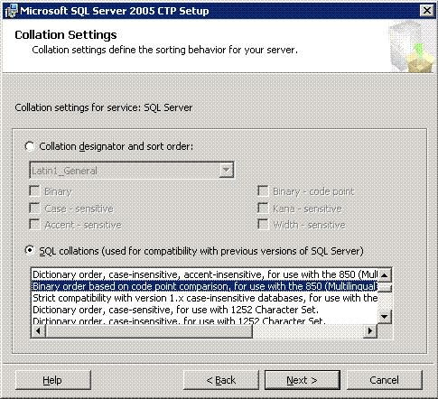
Figure 11

Data types used by SAP
SAP uses simple data types including:
- Variable length character types only
- Normal integers and a few small integers
- Float and decimal, especially for the SAP BW fact tables
In addition, for SQL Server 2005 the varbinary(max) data type is used instead of the image data type for BLOB and Clob fields. The data type image/varbinary(max) is used in approximately 450 tables. The data type is changed from image to varbinary(max) as a metadata operation only. No data movement takes place when changing the data type. For more information, see SAP OSS Note 799058.
Note that SAP does not use user-defined data types and SQL variants.

Upgrading from SQL Server 2000 to
SQL Server 2005
Upgrading SQL Server 2000 to SQL Server 2005 does not require severe changes in the physical data structure. Typically, SAP products run with a 6.40 kernel, which is required to support SQL Server 2005. Check the SAP Product Support Matrix for more details.
There are the two alternative methods of upgrading to SQL Server 2005:
- Uninstall SQL Server 2000 and install SQL Server 2005. Then attach the SQL Server 2000 SAP databases to SQL Server 2005.
- Install SQL Server 2005 in the same location without uninstalling SQL Server 2000.
Before uninstalling the SQL Server 2000 instance, verify that the SAP database is on code page cp850_BIN2. For more information, see SAP OSS Note 600027.
After the SQL Server 2000 database is attached to SQL Server 2005, a special version of SAP SAPINST needs to be run to adapt the database to some of the SQL Server 2005 features that are used by SAP. For more information, see SAP OSS Note 799058.
SQL Server 7.0 cannot be upgraded to SQL Server 2005 with SAP products. SAP products no longer support SQL Server 7.0.

Migration considerations for SAP products
Migrating SAP products from a non-SQL Server platform to a SQL Server 2005 platform is supported by SAP under these conditions:
- SAP supports only the SAP Migration toolkit as the tool for migrating the SAP database schema and data from a non-SQL Server database to SQL Server 2005. No other tools are supported.
- The migration is a complete data unload on the source system and a complete data load on the destination system.
- Only objects including tables, views, and indexes that were created by using SAP object maintenance transactions are migrated. No objects that were created purely on the database are migrated; for example, an index that was created on the database is not migrated.
- Typically, 3- to 4-terabyte data volumes can be migrated over a weekend according to companies such as RealTech, which specializes in migrations.
- When assistance is needed, hire a consultant who is both SAP-certified and a Microsoft Certified Partner to perform the SAP migration.

Installation and Configuration
The cornerstone of a successful SAP with SQL Server 2005 installation is careful planning. For example, no installation should begin before all prerequisite tasks are finished. Prerequisite tasks include defining the machine names, developing the physical layout of the SAP product database, and sizing the disk space requirements. The number of data files depends on the configuration and must be defined in advance because this is difficult to change after the SAP system is in production.

SQL Server installation with SAP
The installation of SAP products does not require that SQL Server 2005 be configured in a special way, with the exception of the code page. For more information, see Collation and Code Page in the preceding section.
Before SAP starts the data import, it automatically changes a few SQL Server configuration parameters, such as the network packet size, to guarantee optimum performance during the initial import of SAP data.
During the initial data load, the SAP database is set to the simple recovery model. Most of those settings are reversed when the data load and the installation of the SAP product are complete.

Volume and growth projections
Projections for the volume and growth of SAP product databases over time are often underestimated. The growth rate is typically higher than expected. When growth projections are in error, SAP products can require reconfiguration and adaptation on the hardware or on the database to satisfy hardware growth requirements.
Note that any sizing of an SAP system must be done by a SAP-certified hardware partner.
For the initial configuration, ensure that the size of the database is sufficient to sustain the first 6 to 12 months of production. In addition, assume that each subsequent release of a SAP product will tend to increase the weekly or monthly growth rate, as compared to its predecessor. For example:
- For midrange companies, the mySAP or SAP BW database can grow from 2 to 5 GB each week.
- For larger companies, the database can grow from 10 to 12 GB each week.
- For very large implementations, the database can grow from 20 to 30 GB each month.
Do not use SQL Server 2005 features to shrink the database or data file. Archiving data from a SAP database using SQL Server 2005 shrink functionality causes opposite logical-to-physical page order within one extent (a 64-KB block of 8 pages). This could be problematic for the Storage Area Network back-end read-ahead functionality.

Number and size of SQL Server data files
The number of data files is chosen during SAP product installation. Three data files (the default that SAP typically uses) are appropriate for the majority of smaller SAP installations. In SQL Server 2005, data access performance within a data file is not related to the size of the data file, but to its concurrency on internal administration pages within the data file.
For the best performance, the ideal number of data files for the SAP installation is typically equal to the number of CPU or processor cores dedicated to SQL Server 2005 at a 1:1 ratio. For example, a dual-core processor such as an Advanced Micro Devices® (AMD) Opteron™ or dual-core Intel® Itanium® processor Montecito, counts as two CPUs. A four-processor dual-core HP ProLiant DL585 server counts as eight cores; therefore, eight data files are recommended.
Additional data files are sometimes required when there is a handling issue, such as when data files become too large to handle in copying or other activities.
For the best distribution, create the data files of the same size and distribute the files evenly. Each data file can be assigned to the same number of spindles, making the disk I/O system easy to maintain. When the data file size needs to be increased, increase each of the data files by the same amount. This allows you to maintain an approximately equal amount of free space in each file.
In addition, if data files are added to an established database, make the size of the new files equal to the free space of the existing data files. This allows SQL Server 2005 to distribute new data evenly between the old and new data files.
Considerations for defining the number and size of data files include:
- Establishing a Unicode system. Use the 1:1 ratio between CPU cores and data files when installing a new system or migrating a system from non-Unicode to Unicode characters. Assume that the implementation of a particular SAP product typically increases in stages, indicating that a much larger database server might be required in the future.
- Evaluating disk configurations. Evaluate the available storage hardware, including the number of disk arrays and partitions, and the amount of available storage space on disk arrays.
- Estimating database growth. Consider the estimated database growth during production. To stay flexible in disk configurations, avoid using very large data files. Very large data files can create problems in handling, for example, setting up sandbox systems, copying, and so on.
- Evaluating nonproduction environments. Keep in mind that each SAP production system is supported by test and development systems. This means that the test system must be periodically synchronized with the production database. A sandbox system that is based on the SAP production system might also be required.
- Increasing the number of data files. In some cases, the infrastructure might require more than three data files with more CPU cores available. However, too many data files often increase monitoring requirements. The use of a large number of data files should be avoided. Most customers use from 4 to 24 data files.
- Setting autogrowth. Using autogrowth is highly recommended for all data files, even if the autogrowth of a data file limits the proportional fill functionality of SQL Server over the data files. It is better to have some unevenly distributed data than to have SAP components such as mySAP stop running. When automatic growth is used, set each data file to a 10 percent growth allowance.

Proportional fill
Figure 12 shows the proportional fill feature, which is used to spread the data between the data files according to each file’s available free space.
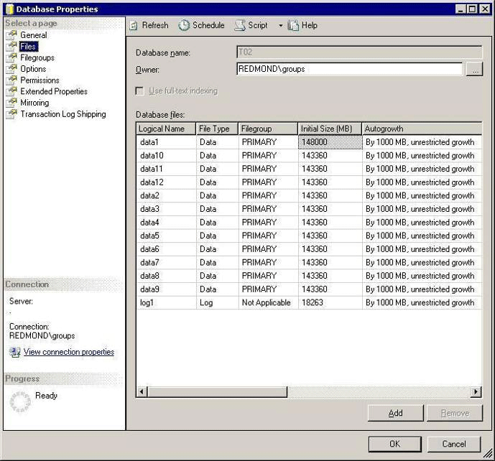
Figure 12
The considerations for using the proportional fill include:
- Extending the data file size. As volume increases, manually extend the size of the data files by the same amount. Assume that each file was created to the same size.
- Proportionally fill the data files. When data is inserted into the database, the data files are filled proportionally using the free space in each data file.
If the data files were created to the same size, SQL Server 2005 distributes the data of each table evenly over the existing files. This makes the read/write workload even, simplifies placing the data files over a storage backend, and avoids hot spots on specific disks.
- Recalculating the proportional fill factor. Periodically, SQL Server recalculates the proportional fill factor for each file based on the available free space. When one of the data files becomes full, the proportional fill goes out of balance. In this case, it fills the other files, grows only one of the files, and fills this file. Then it grows the next file, and so on.
- Setting autogrowth. Avoid situations where automatic growth is set by manually increasing the size of the data files proportionally in advance. Although the data files can be manually manipulated proactively, leave autogrowth on as a safety measure in case of an emergency such as when the database runs full.

SAP and SQL Server file groups
SQL Server 2005 allows for the creation of file groups to place individual tables in dedicated locations. SQL Server file groups are similar to Oracle® tablespaces.
SQL Server 2005 collects the SAP data and each of the SAP data files in the default file group, unless otherwise specified in the CREATE TABLE statement. See Number and size of SQL Server data files in this paper for more information.
File groups require complex administrative overhead. Therefore, SAP does not support SQL Server file groups. Using file groups in SAP databases can lead to errors in SAP release upgrades or failures when applying support packages because SAP products cannot create objects in file groups.

Number of log files for SAP databases
The number of log files is chosen during SAP product installation. Because the SQL Server 2005 transaction log is written sequentially, typically only one transaction log file is required. Considerations for defining the number and size of log files include:
- Using multiple log files. Having multiple physical log files on different partitions does not improve performance. Multiple log files are generally used on an exception basis only when there is a lack of space on one partition. SQL Server 2005 cannot write to multiple log files in parallel. To ensure that the transaction log file does not get lost in a hardware failure, duplicate the log in storage by using at least RAID 1.
- Setting the physical log file size. It is important to create a physical log file that is of a sufficient size, even if the log file is set to autogrow. The SAP installation program typically uses a default log file size of 1 GB. For a SAP installation, set the initial size of the transaction log file to 5 GB. In most high-end SAP systems, the size of the transaction log file ranges from 10 to 20 GB.
- Setting the size of virtual log files. Internally, the physical log file is administered by virtual log files. The size and number of virtual log files depends on the size of the physical log file, plus the growth portion. For performance reasons, it is better to have fewer larger virtual log files, instead of a large number of small virtual log files. During installation, SAP initially configures the growth factor of the log file to 50 percent, which is recommended.

tempdb considerations
The temporary database for SQL Server 2005 is named tempdb. This database is used by queries to execute large join, sort, and group operations when the SQL Server buffer pool cannot provide enough memory. tempdb is also heavily used by SQL Server 2005 base features, including snapshot isolation levels, which are used for online index maintenance or to assemble data that is pushed into text/image or varchar(max)/varbinary(max) data type columns.
SAP products such as mySAP™ Customer Relationship Management (mySAP CRM), and SAP BW each stress tempdb in different ways and have different performance requirements. The use of tempdb differs according to the type of workload. The two types of workloads are an online workload, as in the case of mySAP™ CRM, and mySAP Enterprise Portal (mySAP EP) and an online analytical processing (OLAP) oriented workload such as those created by SAP BW:
- Online workloads. mySAP products with online workloads, including mySAP CRM and mySAP EP, use tempdb infrequently, such as for larger join operations, aggregation, and smaller sorts. tempdb typically does not load or sort gigabytes of data and does not affect performance. The only exception is when a physical consistency check is run on a SAP database. For installation, set the tempdb space from 1 to 2 GB with six to eight spindles throughput. For Storage Area Network storage, tempdb can share space with the tempdb log files.
- OLAP-oriented workloads. For SAP BW, tempdb can expand to larger sizes. For example, join operations, especially those that fully scan the fact table of a cube, can use gigabytes of space to store temporary result sets, large sorts, or hash probes or to build aggregates. In these cases, tempdb is used to perform most of the work because the memory space usually is not sufficient to process gigabytes of data. In extreme cases, when the whole fact table is read to build an aggregate, tempdb can grow to the size of the fact table, up to several hundred gigabytes.
- SAP BW tempdb performance. For SAP BW, tempdb I/O performance can become a major bottleneck when executing reporting queries that use the fact table or that perform aggregation. To prevent bottlenecks, set the tempdb size to 1.5 times the space of the largest fact table. Manage tempdb strictly as a normal SAP BW database. Use one data file of tempdb on the same partition with each data file of the SAP BW database. In this case, the tempdb space should provide fast read/write performance. In addition, do not place tempdb on the same partition and disks that contain the transaction log.
- Use with SQL Server 2005. Some features of SQL Server 2005, such as online index maintenance, use tempdb. In contrast to earlier SQL Server releases, tempdb is also used to insert BLOB fields into database tables. (BLOB fields are raw fields longer than 3,800 bytes in SAP products).

Multi-instance support for SAP components
SAP products support multiple instances of SQL Server 2005 on the same server. However, running the database of the SAP production system together with other application databases on one server is not recommended. Multiple-instance SAP configurations are typically used to run test, development, and demo systems on one server.
An alternative is to run two or three SAP databases on one SQL Server 2005 instance. The advantage of having multiple SAP databases handled by one SQL Server 2005 instance is easy administration. The trade-off is that different SAP systems must share the resources of one SQL Server 2005 instance, including data cache, processors, and tempdb. The resources used by each instance can be restricted, although adding this restriction entails more administration overhead.

SAP database configuration
This section describes the settings that are used by a SQL Server 2005 instance running a SAP database. It also discusses the special settings for SAP with the SQL Server 2005 lock manager.
Most of the SQL Server 2005 parameters described in this section are set correctly when the SAP software is installed. These installation settings cover most needs, even on high-end systems. These parameter settings are typically changed only occasionally, such as when there is a need to improve performance.
Note that most of the tuning and balancing on memory allocations, I/O, and so on within the SQL Server instance is automated.

SQL Server configuration for SAP
SQL Server 2005 contains approximately 50 instance global configuration options that are usually accessed using the sp_configure stored procedure. These configuration options can increase the flexibility and uptime of SQL Server 2005. Typically, only a small number of these configuration options require that a change be made to run SAP products proficiently.
This section describes the options that are commonly used for tuning the SAP workload.

affinity mask
The affinity mask option defines the specific processors on which SQL Server threads can execute. When SQL Server 2005 runs as the dedicated database server or with a SAP application, the affinity mask option uses the default setting of 0.
The 0 setting permits SQL Server threads to execute on all processors. In most situations, the 0 setting provides the best performance because it avoids trapping SQL Server connections on a single processor, while leaving excess capacity on other processors. The 0 setting is used with dedicated database servers and SAP two-tier configurations.
Use the affinity mask option when multiple SQL Server instances and a number of SAP instances run on consolidated hardware. For example:
- When multiple instances of SQL Server run on a single server.
- To assign each SQL Server instance to particular processes on the server.
The affinity mask option is represented as a binary pattern that is expressed by a decimal number. The affinity mask option settings are shown in the following table.

 | affinity mask
First processor only | 1
Second processor only | 2
First and second processor only | 3
First four processors | 15
First eight processors | 255

affinity I/O mask
The affinity I/O mask option defines the specific processors on which SQL Server I/O threads can execute. The affinity I/O mask option has a default setting of 0, indicating that SQL Server threads are allowed to execute on all processors.
The affinity I/O mask option is defined according to the same conditions as the affinity mask option. It is best to use the default setting of 0.
The sample in Figure 13 shows the affinity mask and affinity I/O mask options set to 0 (the default) in the Server Properties dialog box.
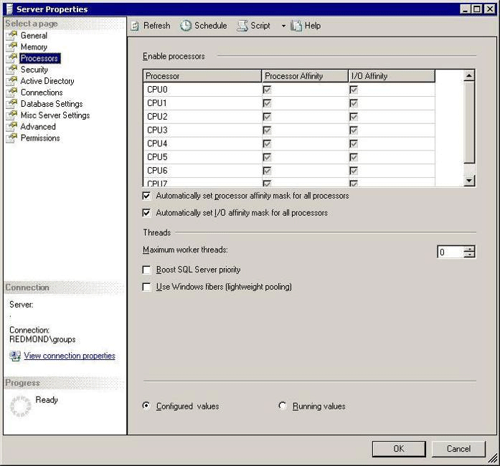
Figure 13

awe enabled
The awe enabled option is used with a larger data buffer to maximize the virtual address space for high-end database servers using the 32-bit platform (x86). Address Windowing Extensions (AWE) cannot be used with any of the 64-bit platforms. AWE administrated memory only can be used for data pages. Caches and structures such as statement or procedure cache, lock structures, and buffer headers remain in the virtual address space and do not use memory accessed over AWE functionality.
- To use the awe enabled option, the /PAE option must be set in the boot.ini file of the Windows operating system.
- The user context used to start SQL Server requires permission to lock pages in memory.
- For SAP, the 3-GB virtual address space is typically used, although some customers only require a 2-GB virtual address space. The 3 GB of memory is enabled by adding the /3gb option in the boot line in the boot.ini file.
In some cases, using up to 16 GB of real memory in 32-bit high-end dedicated database servers that are configured to use AWE with a 14-GB (maximum) cache can achieve a positive customer experience for some SAP workloads. However, using more than 16 GB of memory on a 32-bit SQL Server 2005 platform under a SAP workload is not recommended. If more than 16 GB of memory is required, it is recommended that the client move to a 64-bit computing platform. For more information, see 64-Bit Computing Configurations in this paper.
For SAP to use up to 16 GB of real memory, set the max server memory option to a fixed value of 14 to 15 GB maximum and assign the set working set size option to 0. During startup, SQL Server allocates the AWE portion of the memory immediately.
Note that the memory usage of the SQL Server process is not indicated correctly by the Windows Server 2003 Task Manager. The footprint of the SQL Server process shows a very low number of bytes that does not reflect reality.
However, the commit charge under the Performance tab of the Windows Server 2003 Task Manager indicates when a large amount of memory was allocated. The allocation of AWE memory can extend the startup time of SQL Server to about a minute.

lightweight pooling
In general, the lightweight pooling option is not recommended because it results in only minor performance improvements. This option is typically used for benchmark workloads that are extremely uniform.
Note that in the past, activating lightweight pooling (set to 1) was recommended for running a server based on the Unisys ES7000 architecture.

max degree of parallelism
The max degree of parallelism option defines the maximum number of threads (CPUs) that can be used for parallel query execution. The max degree of parallelism option has a default setting of 0 after installation. This means all processors can be used in parallel to execute a query.
Before each parallel query is executed, SQL Server 2005 checks the available resources such as processors, available worker threads, and memory to determine the number of processors to use for the query. Figure 14 shows where to modify the max degree of parallelism option.
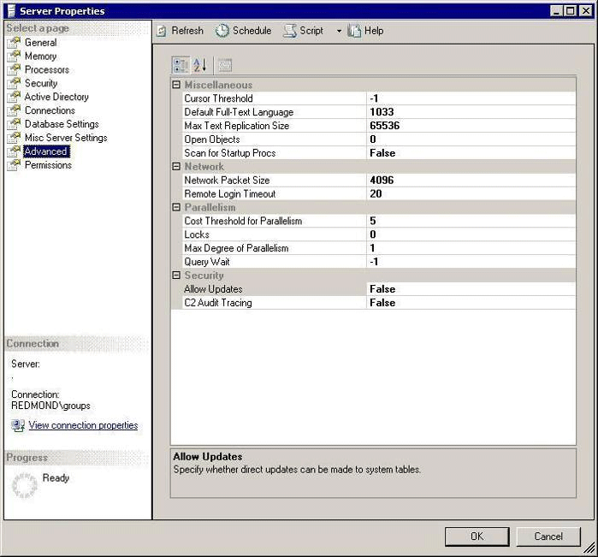
Figure 14

When there are multiple executions of the same query, the query execution can be single-threaded with different degrees of parallelism dependent on the actual workload at the time of execution.
This dynamic for parallel query execution is based on higher resource consumption. Multiple streams of data get sorted in parallel and are merged afterward, making the consumption of buffers in the cache higher. In addition, the momentary CPU consumption of a single query usually increases with the degree of parallelism.
Although a query executed in parallel can be much faster, there is a point at which the parallel query execution becomes inefficient and can even extend the execution time. For example, parallel queries performing small joins and aggregations on small data sets might be inefficient. Because of different degrees of parallelism chosen at execution time, response times for one query can be different, depending on resource availability such as CPU and memory. Varying response times can be experienced by SAP system end users.
The following considerations are based on the workload profile of different SAP products:
- SAP online transaction processing (OLTP) workload products. Less than one percent of queries benefit from parallel execution. Most of the heavier queries are executed by using batch jobs. In this case, set the max degree of parallelism option to 1.
- SAP BW. The number of SAP BW queries that can be executed in parallel can be up to 10 percent. Because of the high percentage of heavy, resource-consuming queries, most SAP BW queries would typically be executed serially. In this case, set the max degree of parallelism option to 1 for the daily user workload. Set the parameter to 0 when aggregates are being built or rebuilt and during the delta load.

max server memory / min server memory
SQL Server 2005 can adapt its memory consumption to the workload. When the max server memory and min server memory options are set to the defaults (2147483647 and 0, respectively), SQL Server allocates memory dynamically within the range of the real memory. Use this setting for a dedicated database server that does not make the most of AWE.
The memory setting becomes more restrictive when SAP components are running on the same server. In this case, at a minimum, an upper boundary should be defined for SQL Server.
Assume that even a lightly loaded two-tier SAP installation requires at least 2 GB of memory to be allocated to run the SAP instance. Eventually, more memory will be required. If the SAP instance is heavily loaded, memory requirements range from 4 to 6 GB.
Note that these two parameters can be adjusted on the fly, even for AWE-allocated memory.
In dedicated database server configurations, a fixed memory allocation can be set on dedicated database servers. However, ensure that some memory is left for the operating system. Figure 15 shows where to modify the memory allocation parameters.
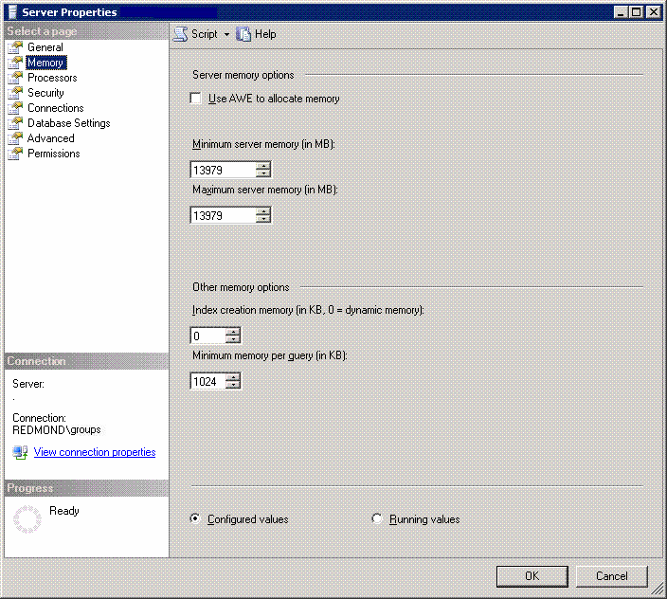
Figure 15

max worker threads
The max worker threads option defines the maximum number of worker threads that are available to handle user requests.
In contrast to competitor databases, an incoming connection to SQL Server 2005 does not result in a shadow process. Rather, the incoming connection is assigned to a scheduler thread. One scheduler thread is assigned to each of the processors or cores (CPUs) on which SQL Server is allowed to run. See affinity mask earlier in this paper.
Incoming connections are assigned to the scheduler threads in a round-robin manner. This guarantees an even distribution of the hundreds of connections, or in many cases, thousands of connections that can result in large three-tier SAP systems.
Every scheduler thread has a pool of worker threads. When a query request arrives over a connection, the scheduler thread assigns a worker thread, which executes the query request. Then the worker thread is available to serve another connection.
There is no 1:1 relationship between the number of connections and worker threads. SQL Server 2005 can reassign connections to other schedulers if the original scheduler is overloaded, thereby avoiding an uneven CPU load.
As shown in Figure 16, for SQL Server 2005, the max worker threads option is dynamic and should remain at the default of 0. Note that this setting is different from the one used with SQL Server 2000, where a value had to be set because the logic used was not dynamic.
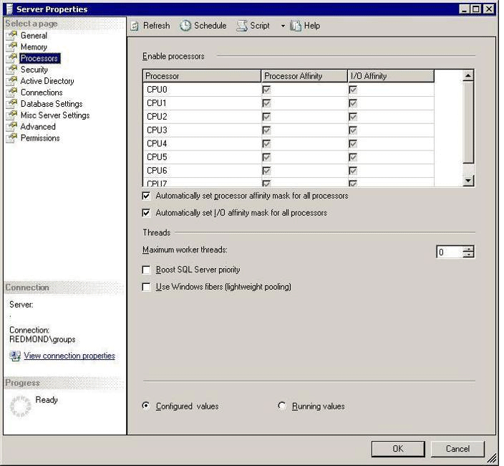
Figure 16

network packet size
The network packet size option determines the size of packets transmitted over the network. SQL Server 2005 allocates three buffers that use the parameter size for every connection. This parameter does not have an effect if the application request contains a different value. At connection time, SAP NetWeaver Application Server overwrites the network packet size option in SQL Server 2005 when it is set to other than 8192.
Because 8192 is set by the SAP client application, the network buffers are allocated outside of the SQL Server buffer pool, but in the SQL Server virtual address space. SQL Server usually leaves a virtual address space of approximately 300 to 350 megabytes (MB) outside the buffer pool. In large SAP systems, up to 150 MB of the 300 to 350 MB can be allocated by the network buffers. In turn, this can lead to problems with the virtual address space in a 32-bit computing environment.
As a workaround, SQL Server can be forced to leave more virtual address space by adding –gxxx, with xxx=number specifying MB – default =256 MB in SQL Server 2005, as a start up parameter to define a value above 256 MB. This is not a problem in 64-bit computing platforms.

priority boost
The priority boost option defines the priority of SQL Server processes. Having the value set to 1 gives SQL Server processes a slightly higher priority. The current recommendation is to set the priority boost option to 0, which leaves SQL Server processes with a normal priority.
In the past, SAP and Microsoft recommended setting the priority boost option to 1. However, this recommendation was recently changed. They now recommend setting the priority boost parameter set to 0. This is because of situations where operating system network threads were starved in favor of the SQL Server process, thereby causing failure situations and transaction rollbacks.
In addition, because of improvements in SQL Server 2005 and Windows Server 2003, the advantages formerly achieved by increasing the priority of SQL Server processes have been minimized.

recovery interval (min)
The recovery interval option controls the checkpoint interval, as seen in Figure 17. SAP recommends using the default setting of 0. In customer scenarios, using 0 causes a checkpoint interval to occur every 30 to 60 seconds in situations where no other event triggered a checkpoint (such as a Commit statement triggering a checkpoint).
SQL Server checkpoint intervals are extremely sensitive with disk resources. SQL Server works to avoid overloading the I/O during checkpoint writes. In the past, there have been no customer issues with I/O flooding caused by SQL Server checkpoints.
In contrast to competitor databases, the mySAP space does not require this value to be adjusted to achieve better control of checkpoint effects.
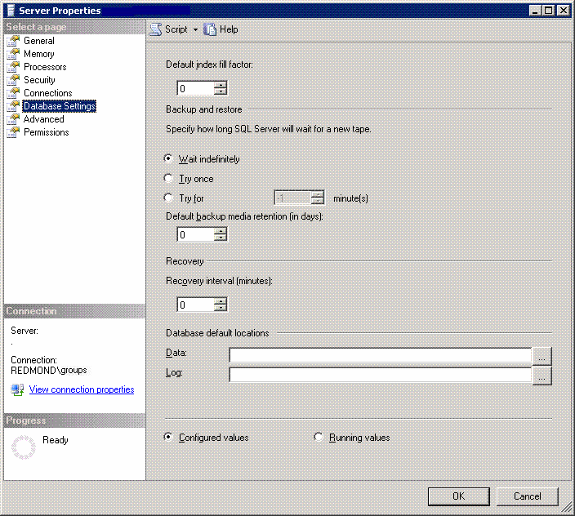
Figure 17

set working set size
The set working set size option was initially used to keep memory allocated by SQL Server from being paged out to the pagefile. In the past, mySAP used a set working set size value of 1 during the SAP product installation. The current recommendation is to set the option to 0.
Within the last two years, there have been concerns about the effect of having this option set to 1. It has been the source of some problems in high-end database servers. In addition, this option no longer has an effect on SQL Server 2005. At present, this parameter is used only to avoid setup application failures.

SAP settings for the SQL Server lock manager
The SQL Server 2005 lock manager provides improved lock-handling for increased performance when a large number of concurrent users are accessing SAP applications. SQL Server 2005 uses row-level locks by default, although in some cases SQL Server can also use the following alternative locking options:
- Table locks. Locking granularity to the table level saves memory. In this case, when memory pressure results from lock structures using too much of the buffer pool, SQL Server tries to escalate the lock granularity to table locks. Typically, this situation does not occur in SAP product installations given the size of SAP database servers and the amount of memory available (from a few hundred megabytes to a few gigabytes of buffer pool) compared to the small number of bytes used for each lock (~100 bytes).
- Table locks if over 5,000 locks are requested. If SQL Server estimates that over 5,000 locks could be acquired by executing a specific query, a table lock is requested. If another transaction already has locks conflicting with a table lock, row-level locks are used instead.
- Trace flag 611. Start SQL Server 2005 with trace flag 611 to report each lock escalation with the handle of the originating statement to the errorlog. Trace flag 611 is new in SQL Server 2005.
- Trace flag 1211. In very specific cases, start SQL Server with trace flag 1211 to suppress the request for table locks. This also disables lock escalation because of memory pressure.
- Trace flag 1224. As alternative, use trace flag 1224 in SQL Server 2005 to suppress lock escalation rooted in the estimated number of locks, but allow lock escalation because of memory pressure. Trace flag 1224 is new in SQL Server 2005 and it does not exist in earlier SQL Server versions.
- Page locks. The SQL Server query optimizer can request page-level locks, instead of row locks, when it estimates that almost the entire table will be locked anyway. The current practice for SAP installations is to disable page-level locks on SAP queuing tables. For example, typical queuing tables include VBHDR, VBMOD, and VBDATA, which store update requests, and ARFCRDATA, ARFCSDATA, TRFCQUEUE. For more information, see SAP OSS Note 327494.
Page locks can be eliminated or disallowed on a per table basis by using the Transact-SQL command:
sp_indexotion <table_name> ‘DisAllowPageLocks’, TRUE
In addition, use the following Transact-SQL command to verify that these settings were performed:
Select INDEXPROPERTY(object_id(‘<table_name>’), ‘<Index_name>’, ‘IsPageLockAllowed’)

SQL Server 2005 Data-Availability Features
SQL Server 2005 data availability features take full advantage of the data on the primary image and on one computing node. It is a best practice to exploit the SQL Server 2005 data availability features before considering high availability architectures to guarantee availability and improve reliability. For more information, see Solution Architecture earlier in this paper.

Backup and recovery improvements
mySAP can take advantage of new SQL Server 2005 backup capabilities, including fine-grained online repairs, online backups, and redo controlled by checkpoint to speed up recovery. Unlike other databases, a special backup tool is not required when using SAP with SQL Server 2005.

Online backups
In SQL Server 2005, online backups perform only one data backup at a time for each database. The backup and restore functionality includes full-text catalogs.
In addition, fine-grained online repairs can be performed so the database is available while single pages or file groups are restored. Fine-grained online repairs allow the database administrator to work with the system at a granular level, leaving only part of the system offline such as to check and restore data at the page-level.
Online backups allow transaction log backups to be performed at the same time. That is, database files and file groups and the log can be backed up concurrently.
- Transaction log backup cycling. With typical SAP customers, the cycling of transaction log backups during online backup performs well, especially in scenarios where large batch schedules are run during the night. This increases the safety level on the customer side and the ability to restore to a point in time, even to the timeframe during which the online backup ran.
- Single page restoration with the database online. SQL Server 2005 can restore single pages from online and transaction log backups while the rest of the database remains online. This is an advantage in common support cases, including cases where the page corruption of one or a few pages results in the destruction of data. In such cases, a SAP customer does not need to restore terabytes of data to get the database physically consistent again. Instead, a customer can restore the few corrupt pages while the rest of the data remains accessible.
- Recovery Phase. In SQL Server 2005, a database in the recovery phase becomes available after all of the transactions not covered by the last checkpoint are redone. The recovery phase consists of two main phases that change data on the database—the redo phase and the undo phase.
- Redo phase. In the redo phase, data modification that is recorded in the SQL Server transaction log after the last checkpoint is executed is written to the data files. In contrast to earlier SQL Server releases, SQL Server 2005 opens the database after this phase. Any uncommitted data residing in the data files after the redo phase performed is protected by database locks. This prevents the data that is to be rolled back in the next phase of the recovery process from being accessed.
- Undo phase. In the undo phase, the data from uncommitted transactions is rolled back. The database is available when the undo begins. In most cases, the undo phase takes significantly longer than the redo phase.
- Fast recovery improvements. These improvements in recovery lead to faster failover time for server clustering (MSCS) and faster failover for synchronous database mirroring with failover. In SAP database-mirroring configurations, fast recovery reduces to a minimum the amount of downtime that is triggered by problems.

Media reliability
SQL Server 2005 delivers a number of media reliability improvements including:
- Backup with multiple destinations. With SQL Server 2005, a backup can write to up to four different destinations. Multiple sets of tapes can be written for the same backup. When redundant backups are written, the tapes from each destination set are interchangeable with the same tape in the other sets. For example, if a tape from one destination set is lost, the same tape from one of the other sets can be used instead.
- Verification of page restores. The RESTORE VERIFYONLY Transact-SQL statement thoroughly investigates the physical structure of a page. The linkage between the pages and the accuracy of the allocation pages is not checked. Pages written with checksum are automatically checked when the page is read into the buffer pool. The change on the page is detected before the page is accessed. This includes disk I/O errors that were not reported by the hardware or operating system.
- Restore sequence reliability. The SQL Server 2005 restore sequence continues despite physical inconsistency to give customers an opportunity to repair errors. The restore sequence continues as far as possible before the database needs to be repaired.
- Detection of torn pages. SQL Server 2005 allows a checksum to be written on each page. This checksum is used when the page is read back. When irregularities are detected, each is written to the error log.

Database snapshots
A database snapshot instantly creates a completely new set of data files that are used to store the original state of the pages at a point in time. No additional log file is created. A database snapshot does affect performance on the originating database because of a higher I/O load and a little more commutation time.
A database snapshot is extremely space efficient because it does not require a complete copy of the data. A database snapshot shares unchanged pages with the original database and only requires extra storage for the changed pages. After the snapshot is created and a page is changed for the first time, SQL Server 2005 copies the original page to the snapshot files (copy-on-write).
A database snapshot allows for the recovery of reduced availability from operator error by instantly creating persistent read-only copies. The snapshot appears to the outside as a read-only version of the original database, which was frozen at a point in time.
There are two basic scenarios for creating a snapshot:
- Snapshot of the mirrored database. Create a snapshot on the mirrored database in a database-mirroring configuration to catch human errors that occur because of deleting or manipulating data. In this case, the snapshot of the mirrored database can be used for read-only purposes when the mirrored database is not accessible.
- Mirror on the primary database. Create a mirror on the primary database when critical changes or imports are run and a failure or errors might entail complete restoration of the database. For example, applying SAP support packages is not a reversible operation, except by restoring the support packages to their earlier state, which entails a huge effort. In this case, a database snapshot can be used as a backup to revert the state of the database to the time when the snapshot was taken.
Multiple snapshots of a database can be created. However, as more snapshots are created, the I/O load increases. Note that a snapshot cannot be backed up. A clone of a snapshot cannot be created because a database snapshot does not permit background copying. In addition, the snapshot cannot be changed or attached to another server as a database to perform changes.

Online indexing
Online indexing is a new feature of SQL Server 2005 that allows index maintenance modifications to be performed online in OLTP systems such as SAP. Incremental reindexing with read consistent scans and lock handling improve SAP performance.
In SQL Server 2005, index creation can be performed in online or offline mode. In online mode, parallel change activity on the table is allowed. Index maintenance is performed offline by default with the table locked exclusively for this purpose.
With online indexing, SQL Server 2005 introduces a new parameter to the index DDL commands. For example, simple command syntax includes:
Create index [x~0] on x (a) with (online = on)
Drop index x.[x~0] with (online = on)
In addition, during index creation, the number of CPUs used can be defined, overriding the global setting for parallelism:
Create index x~0 on x (a) with (online = on, maxdop=2)
where maxdop=2 indicates that two CPUs are used.
Modifications to the table are allowed when an index is built, recreated, or dropped online. During this process, a transaction is not blocked if it hits the primary table. Modifications to the table or index create, rebuild, or drop are not blocked. Index maintenance continues while the application runs.
Online indexing can be used to create, rebuild, drop, or reorganize an index, including BLOBs, and to use index-based constraints such as the primary key. SQL Server 2005 tracks the transactions that were created during the index operation. Because this process can be performed during production, maintenance that would otherwise have required downtime or caused blocking on the system can be performed.
Creating an online index can take up to three times longer when using an online clause. Because there is no blocking, the SAP application continues to run until complete.
For SAP systems, online indexing is used on occasions when a new program in SAP requires a new index or index maintenance (rebuild, for example). In a SAP environment, in addition to SQL Server metadata, the application maintains a data dictionary and tools that allow for index and table maintenance.
If custom indexes are created, these indexes must be added to the SAP dictionary for change management. Then the index modification is transported from development to test to production. SAP supports the creation of indexes in online mode.
When custom indexes are transported between SAP instances by using the SAP transport facility (test to production, for example), the SAP data dictionary tools so far are unaware of new SQL Server 2005 online indexing capabilities and use offline mode by default.
To take advantage of online indexing capabilities, create the custom index in the development environment, getting the name of the new index and its exact column order from the development system. Manually apply the index modification to the production instance by using online index creation. Then the SAP transport can be released. The transport imported into the production system will not create the index. It simply updates the SAP Data Dictionary. More recent SAP releases are able to take advantage of online index maintenance by using a system-wide setting.

Performance Monitoring and Tuning
SQL Server 2005 does not require additional tools or extra resources to maintain SAP applications. SQL Server 2005 offers advanced query optimization that automatically improves query performance and response time.
In addition, SQL Server 2005 autotuning adjusts resources dynamically and tunes database parameters to respond to changing workloads and usage characteristics without manual intervention. Routine tasks are automated. Memory and lock resources and file sizes are adjusted dynamically.

SQL Server performance monitoring
This section describes the SQL Server 2005 performance monitoring tools and features. In particular, SQL Server 2005 introduces a number of new dynamic management views (DMVs). These DMVs permit a wide variety of options for monitoring SQL Server internals. Many of the DMVs will be implemented into the SAP Database Monitor over time.

SQL Server Profiler
SQL Server Profiler monitors the query performance of Transact-SQL statements executed by SQL Server 2005. However, this tool cannot aggregate query performance data. Instead, SQL Server Profiler lists each execution of a query separately, causing enormous amounts of data to be written.
Because of SAP user management and its scheduling of user requests, it is not possible to restrict profiling on user names or specific connections to SQL Server. For this reason, SQL Server Profiler should be used only to profile and monitor a system with low activity. It is not generally used in SAP production systems.
In most cases, SAP systems are monitored by using SAP tools such as SAP Database Monitor or the features described in SAP Performance Tuning in this paper.

Dynamic management views
SQL Server 2005 contains a number of new DMVs. These DMVs give greater transparency and visibility into the database for proactive health and performance monitoring.

sys.dm_exec_query_stats
The sys.dm_exec_query_stats DMV stores aggregated performance data for queries that were run since SQL Server was started. This data can be used to provide a trend analysis of how the system is performing.
The data provided in this view is similar to the data from SAP Database Monitor. This view also contains additional data that is not available in earlier versions of SQL Server and SAP including:
- A SELECT statement against this view displays performance statistics on statements in the statement cache and on some statements that were already flushed out of the cache. However, data on queries that were executed a number of hours earlier on a busy system can be flushed.
- A trace event is created to flush the statistics. The event and performance data can use the SQL Server trace framework or the SQL Server Profiler.
For sys.dm_exec_query_stats, a query is identified by using the sql_handle argument. This handle obtains the text of the query. The execution plan of the query is obtained using plan_handle. The result is an XML type query plan.
Examples of queries leveraging this view include the following.
The following query lists the performance figures of all queries in statement cache.
select * from sys.dm_exec_query_stats
The following example shows the Transact-SQL statement text where the specific handle was read from the result set of the first query.
select * from sys.dm_exec_sql_text(sql_handle)
This query shows the query plan.
select query_plan from sys.dm_exec_query_plan(plan_handle)
The results from this DMV contain columns with performance metrics for each query including:
- Physical reads and writes.
- Logical reads and writes.
- Time spent in common language runtime (CLR) for all statements that refer to a CLR function.
- Number of executions.
- Worker time, showing the time spent in processing.
- Elapsed end-to-end time from the point when the request came into SQL Server to the time when the result is returned, including statement execution and wait times.
- Average per executions calculated from the columns displayed.

Monitoring index usage
SAP production systems that have been active for many years have received periodic SAP release upgrades and custom changes. In some cases, when SAP release upgrades are made, custom-programmed functionality can be discontinued, leaving related database structures such as database indexes in the database. In this case, the sys.dm_db_index_usage_stats DMV is used to collect and track the usage of each index and to assist in determining which indexes are actually in use.

sys.dm_db_index_usage_stats
In a SAP landscape over a period of time, the custom indexes on tables for particular programs can change. For example, because of business or program changes, some indexes might no longer have relevance. In addition, a nonclustered index that was created previously by a customer can consume extra space.
The sys.dm_db_index_usage_stats view monitors index utilization. This view shows where index utilization is occurring on the aggregate and identifies queries and indexes that are not being used.
The sys.dm_db_index_usage_stats view:
- Determines whether indexes are actually being used. Generally, there should be no more than about 10 indexes on a table.
- Lists the index, categorized by user and system, and indicates how the indexes have been used. This view indicates when an index has been affected by maintenance commands such as DBCC CHECKDB or by a user-initiated query. It lists the category of usage of indexes as user queries (read or modify data) and system usage (update statistics, consistency checks).
The sys.dm_db_index_usage_stats view counts the data during the uptime of the database server. When the server is brought down, the data is lost. This functionality will be used by SAP Database Monitor. The data is used to analyze whether custom deployed indexes are still in use. The data is tracked on a long-term basis to ensure that special periods are covered such as month-end or quarter-end reporting.
Do not use the data to delete SAP standard indexes. In some cases, changes in the use of SAP functionality or changes in customization or in leveraging new SAP functionality might require that SAP indexes be deployed during the installation of the SAP product. For this reason, do not delete SAP deployed indexes even when those shown are not used.
The following table shows the data of the user category, including the categorization of seeks, scans, and lookups in SQL Server 2005.

name | user_-seeks | user_-scans | user_-lookups | user_-updates | last_-user_-  seek | last_-user_  scan | last_-user_  lookup | last_-user_  update
TBTCO^9 | 0 | 3 | 0 | 37402 | NULL | 5/20/05 18:12 | NULL | 5/23/05 13:48
TBTCO__0 | 97294 | 12 | 10463 | 37402 | 5/23/05 13:48 | 5/23/05 4:00 | 5/23/05 13:45 | 5/23/05 13:48
TBTCO__5 | 13 | 0 | 0 | 37107 | 5/23/05 2:30 | NULL | NULL | 5/23/05 13:48
TBTCO__1 | 0 | 0 | 0 | 37107 | NULL | NULL | NULL | 5/23/05 13:48
TBTCO__3 | 6399 | 0 | 0 | 37402 | 5/23/05 13:45 | NULL | NULL | 5/23/05 13:48
TBTCO__7 | 4078 | 4 | 0 | 37402 | 5/23/05 13:45 | 5/23/05 4:00 | NULL | 5/23/05 13:48

- A seek accesses a table that uses the index B-tree; the scan does not indicate the number of rows being retrieved. A seek can read the whole table by using the index
B-tree.
- A scan reads the data layer without the index B-tree, for example, to scan the table’s data layer to create an index.
- A lookup can only occur on a clustered index when additional nonclustered indexes are defined on the table. The lookup categorizes a seek on a nonclustered index. In this case, a clustered index is used to retrieve the data rows when the nonclustered index does not cover the query. The sum of all seeks on nonclustered indexes is greater than or equal to the lookups on the clustered index.
- Updates show how often an index has been updated for data modifications. An update modification does not always trigger an index update. With SQL Server 2005, only indexes that are affected directly by the updated data are changed.
Following is an example of a query that finds indexes not used in the current database:
select object_name(object_id), i.name
from sys.indexes i
where i.index_id NOT IN (select s.index_id
from sys.dm_db_index_usage_stats s
where s.object_id=i.object_id and i.index_id=s.index_id )
order by object_name(object_id) asc

SAP performance tuning
SQL Server 2005 contains features for monitoring performance and, to a certain degree, resource consumption. Similarly, SAP systems provide a number of key features for performance tuning. These features take advantage of SQL Server–specific functionality, as well as some functionality that is SAP-specific.

Common performance problems
The principal problem classes that might require performance tuning include:
- The entire system is slow. The entire SAP system is sluggish and slow, the system does not perform as anticipated, and it continues to perform slowly. SAP end users experience slow response times executing most business transactions.
- Certain SAP business transactions are slow. One certain transaction or job experiences a slowdown and remains in that state. This causes SAP end-user complaints and a few batch jobs can be affected or slowdown.
- Certain SAP functionality or jobs have intermittent slowdowns. Some SAP functionality or jobs run fast most of the time, but slowly at other times, such as a slowdown that lasts for a few hours or a day. In this case, jobs might run fast for days at a time until another slowdown occurs.

System performance is poor
When SAP system performance is poor, determine which component is having problems before checking the database server. In a three-tier SAP landscape, the database server might not be the immediate cause of slow system performance.
The first step is to analyze which of the SAP layers introduces the general slowdown. Use the SAP ST03 transaction to:
- Check the performance of the SAP application servers.
- List the different categories of the SAP workload (dialog, update, batch, and so on). Check the response times and the time spent in different stages of the overall system.
- Check the response time of the database.
- Check the time it takes the SAP application server to deliver the data to the SAP user interface at the end user’s computer (also listed in the ST03 transaction).
- Check the aggregated data over several days and weeks.

ST03 Monitoring Transaction
Use the ST03 monitoring transaction to determine which SAP component is having a problem. ST03 differentiates between problems such as CPU consumed on the SAP application server, user requests waiting for the application server, database response time performance, and time to deliver data to the user interface.

Overall Performance (One Day)
The ST03 sample in Figure 18 shows the performance of an entire system of nine application servers for a one-day period. ST03 row entries show the different SAP process types in the grid. The columns show the measurements for different components.
The ST03 sample shows that the dialog process (in row six) has an overall response of 775.9 milliseconds (ms) for each SAP Dialogstep (SAP unit of work).
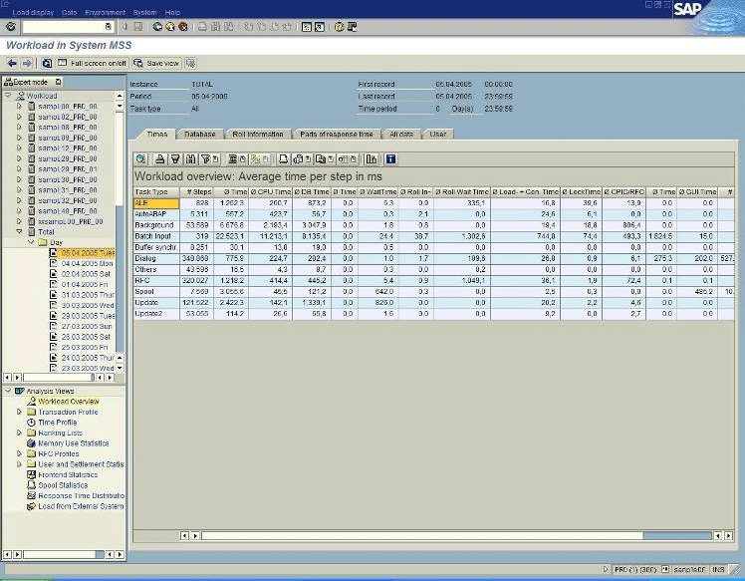
Figure 18

In addition, the dialog process shows that 224.7 ms were spent using the application servers CPUs, with 282.4 ms on average spent accessing the database.
Note that the database response time for the dialog process should be below 50 percent and not higher than 50 to 60 percent for typical interactive SAP transactions.

Performance (Several Days)
The ST03 sample in Figure 19 provides a summary of performance, such as the times spent in the different components, over the last 30 days. ST03 provides an overview of the work generated by the SAP application layer and shows all process types. Note that the sample shows a history of the number of dialog steps.

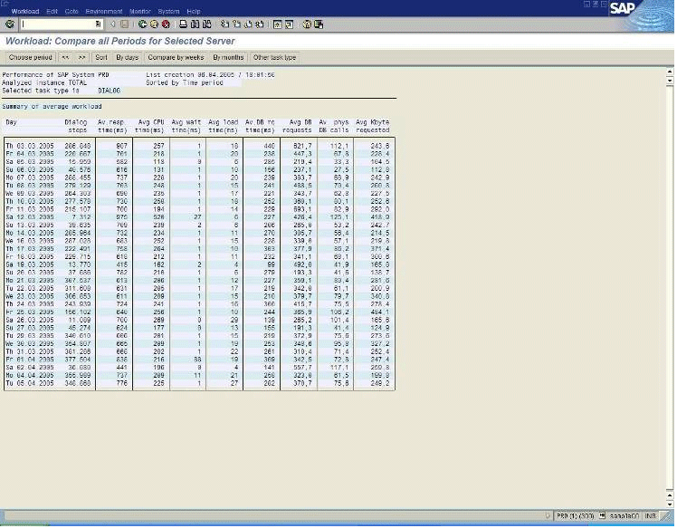
Figure 19

Severe changes to components such as application server hardware or database server hardware should become visible by lowering the response times in the particular column.

Database server causes slowdown
If the database is the main contributor to the slow performance, check CPU consumption and I/O performance. Observe the disk I/O performance counters in Windows System Monitor (Performance Monitor in Windows NT) for each disk separately. These counters report the volume of the I/O and its performance (response time). Often disk access statistics measured directly on Storage Area Network devices show faster access times. However, SQL Server 2005 experiences response times such as those reported by Windows System Monitor. If the response times are not satisfactory, SQL Server 2005 experiences slow I/O performance.

CPU is pegged
When the CPU is pegged, check the SQL Server configuration max degree of parallelism option. See SQL Server Installation with SAP earlier in this paper. If this setting is other than 1, set it to 1. Having the parameter set to other than 1 could permit a few queries to use most of the CPU on the server, thereby increasing the I/O volume by a factor of 2 to 4.
If the max degree of parallelism option is set to 1, check the threads that can be run in SQL Server 2005 by executing the SQL statements described below. In system processes such as the SQL Server 2005 DMV, the start time of a statement and the handle to the statement are displayed.
- In the SQL query window, execute:
select * from sys.dm_exec_requests
- Check statements that are running the longest on threads.
- Use sql_handle to get the SQL statement.
- In the SQL query window, execute:
select * from sys.dm_exec_sql_text(<sql_handle)
- Check the statements for their selectivity. Determine if there are statements that do not contain specific Where clause restrictions and return large amounts of data.

I/O is very slow
For nearly half of all SAP customers, performance escalations are related to I/O back-end problems. The most common observation is that SAP systems record extremely slow response times from the database. However, the CPU is not being utilized for the database.
Having enough bandwidth for reading and writing, combined with a fast response time, is vital, especially for high-end database servers. However, as it concerns the storage layout and I/O throughput capacity planning, bear in mind that a conventional SQL Server online backup creates an additional I/O workload by reading the data from the SQL Server data files. Not having any I/O bandwidth left for SQL Server online backup, can result in a severe performance effect to response times when running an online backup. For more information, see Online Backups earlier in this paper.
The most common errors observed include:
- Too few disks are utilized.
- An incorrect partition offset was selected for Storage Area Network partitions.
- Note that each SQL Server 2005 I/O results in multiple I/Os at the back end. Unless this factor is understood, the partitions for Storage Area Network storage might not be set up correctly. Consult with the Storage Area Network hardware vendor to determine the correct setup of storage for SAP with SQL Server 2005.
- There are too few Host Based Adapters (HBA). The queue depth of the HBA is left as the default of 32, instead of setting it to 128 or even 255. Check with the storage hardware vendor for the proper settings and maximum values.
- SecurePath or PowerPath software was incorrectly configured in failover mode, instead of workload balancing mode.

I/O Usage Patterns
Concerning disk usage patterns, SQL Server 2005 can read four different formats:
- 8-KB read. The most common format is a single page 8-KB read that is used with most SAP products having an OLTP characteristic (greater than 90 percent) workload.
- 64-KB read. The 64-KB format is typically used for tape media backup when a block format of 64 KB is recommended to resolve performance issues. This format reads a whole extent and can be observed frequently in SAP BW. In this case, SQL Server 2005 reads ahead during index scans.
- 256-KB read. SQL Server 2005 reads the allocation order within different data files, such as for index creation, using an allocation-oriented scan such as a table scan. 256-KB reads might be used in SAP BW. These reads are rarely seen in SAP products having an OLTP workload.
- 1-MB read. During the disk backup, SQL Server 2005 reads 1-MB blocks of data over the network to a central tape library to speed up the backup. 1-MB reads are SAP-independent.
SAP products having an OLTP type of workload require a balanced system layout with excellent I/O performance on the database side:
- The read pattern primarily includes 8-KB pages and random reads from SQL Server 2005.
- For writes, the transaction log performance must be excellent, with reads in 1 KB to 64-KB formats. On data files, the queuing tables require superior write performance while inserting data.
SAP BW and mySAP SCM are applications where read performance is very important and the most critical reads are performed in a 64-KB format. These particular SAP products typically perform critical queries such as joins over various tables. In addition, time critical processes, such as in SAP BW, require excellent write performance. In SAP BW, performance on tempdb is also critical.
Windows System Monitor can determine the average I/O performance values. In this case, measure I/O performance for at least 15 minutes, usually for one hour minimum, to ensure that the values are representative of actual performance.
In high-end systems, I/O SQL Server data files perform in the following range:
- Up to 10 ms is good.
- 10 to 20 ms is acceptable. Less than 20 ms is acceptable for an I/O against data files.
- 20 to 30 ms is not acceptable. A time is greater than 30 ms causes alarm and triggers an investigation.
- Above 30 ms shows an effect on the performance of the system and it is usually not acceptable, especially in high-end systems.
SQL Server transaction log file performance can be categorized in the following range:
- Up to 10 ms is good.
- 10 to 20 ms is acceptable. A duration that is longer than 20 ms can result in problems using CPU resources.
- Over 20 ms indicates that CPU resources of the database server are not fully utilized.
SQL Server 2005 has at least three 64-KB buffers to which the SQL threads write their transaction log entries. If one thread executes a commit, the transaction log buffer that is holding the commit record must be flushed. The thread writing the commit record must wait until the acknowledgement of a successful I/O write of the buffer is returned by the I/O subsystem.
If this takes a long time, the thread waits and it cannot be used. Typically, there are more than three buffers when more than four CPUs are on the server. When there is extremely low I/O performance against the log files, situations can occur where there is no free buffer and a large number of threads are waiting for I/O to be acknowledged. This indicates that available CPU resources are not being leveraged.

SQL Server 2005 I/O performance
SQL Server 2005 measures I/O performance as a built-in function. For example, notice the SQL command:
select * from ::fn_virtualfilestats(<db_id>,-1)
This gives the number of read I/Os and write I/Os and the bytes read and written to each file of the specified database. The stall time of read or write activity for each file is calculated as the number of bytes read divided by the sum of the “read stall time” or the number of bytes written divided by the sum of the “write stall time.”
The result of the SELECT statement can indicate if the proportional fill is working properly, as described in Proportional Fill earlier in this paper.
The output also indicates whether all files show similar performance. The numbers get accumulated over the entire run time of the SQL Server instance from startup. For this reason, these numbers can be much lower than those indicated by current Windows System Monitor measurements. The accumulated output data might not reflect timeframes with poor I/O time accurately and the data cannot be reset.

Slow SAP transactions hamper the user experience
When only a few transactions are slow, restrict the problem to specific SAP transactions or jobs. The SAP NetWeaver Application Server design assigns the user request to a SAP process at run time. If the problem can be reproduced, the executions can be traced by using the SAP ST05 SQL Trace transaction to filter conditions such as the user name, a specific SAP process within an instance, or a specific SAP report. The ST05 transaction runs locally on the application server. ST05 can trace activity on the specific application server on which it runs.

ST05 SQL Trace transaction
Figure 20 shows the ST05 transaction with the SQL statements that were executed against the database. The duration is shown in microseconds.
For many statements, two or three lines are shown to characterize the different phases of statement execution. The SAP Open phase is typically used to determine the performance of the execution.
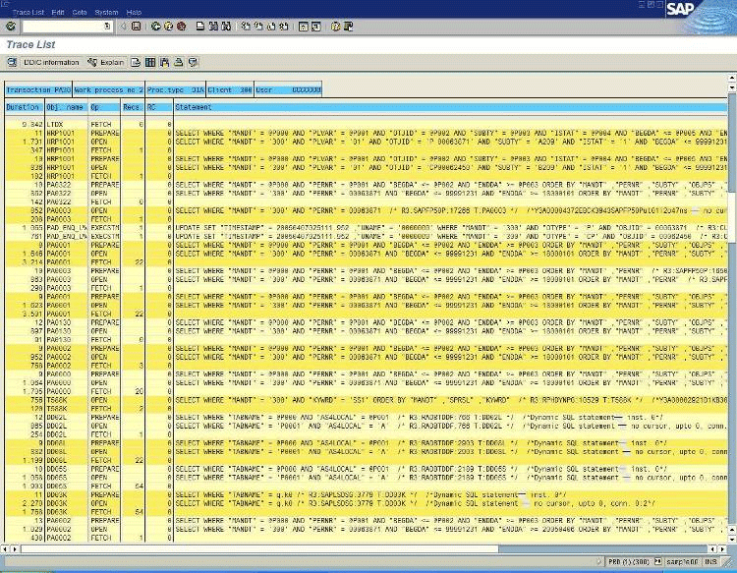
Figure 20

The SAP Fetch phase is used to count the time required to retrieve the data from the database server to the application server. Most often, the Fetch time is the smaller amount of time, unless large numbers of rows are returned.
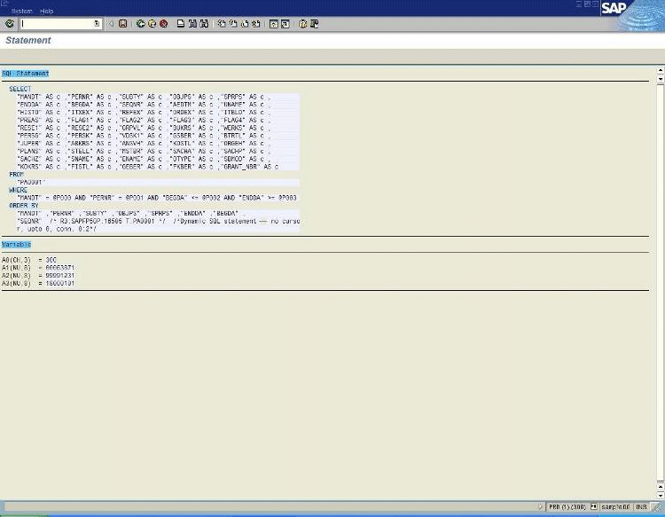
Figure 21
In ST05, double-click the open line of a statement to display the full statement and its parameters. At the end of the statement text, the stored procedure name or the dynamic Transact-SQL statement string provides SQL Server port-specific information about how the Transact SQL statement from ABAP was executed in SQL Server 2005.
ST05 indicates when there is no server-side cursor on the committed read connection only. For example, the description conn 0:1 indicates that connection number 1 of the SAP process was used to execute the statement.
Because the enumeration starts with 0, connection 1 is the uncommitted read connection.
The ST05 sample in Figure 22 shows that, by marking the statement, the ABAP coding that triggers the database statement can be reviewed. This permits a deeper analysis of the ABAP code to be performed to achieve improvements.
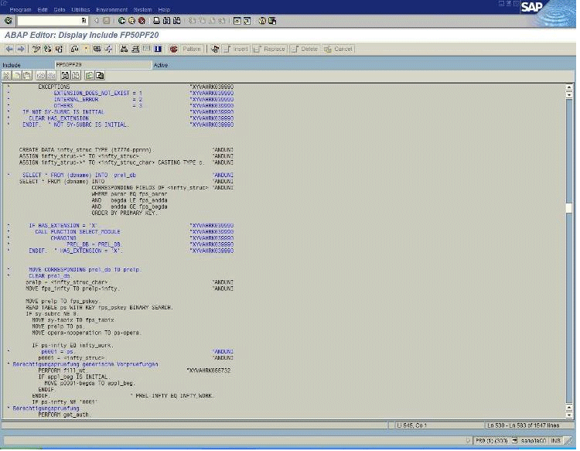
Figure 22

The sample in Figure 23 shows that the Query Plan Display of SQL Server 2005 can also be used to view the query execution plan. If the analysis is performed immediately after the trace is taken, the query execution plan is usually in the displayed cache. If the analysis is performed at a later time after the trace is taken and the trace is no longer in cache, a new query execution plan is created. Unfortunately, there is no easy way to determine if the execution plan is in cache or if it was newly generated.
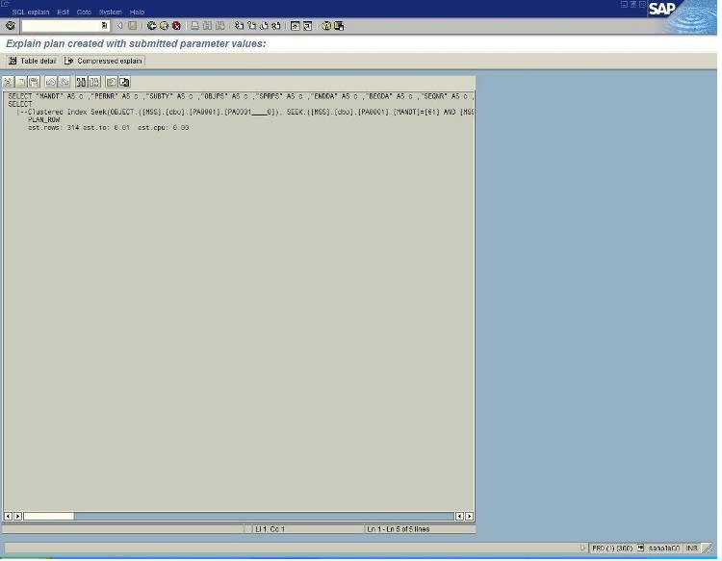
Figure 23

ST04 Database Monitor transaction
Query performance statistics are available only by using the SAP ST04 Database Monitor transaction. ST04 is used to view the SAP database operations. This is useful, for example, to verify the database status and statistics when query performance is not clearly reproducible or the query cannot be rerun.
The ST04 transaction is typically the only way SAP support can monitor the database in depth. ST04 displays all types of data collected in the database instance. ST04 can be used to check values, including the cache hit ratio, errorlogs of SQL Server, and different values such as wait statistics.
The ST04 transaction pages display an overview, details, query statistics, query performance statistics, and query details as follows.

Overview page
The ST04 Overview page illustrated in Figure 24 provides general SQL Server 2005 information, including the operating system release on which SQL Server runs. The most important information includes the cache hit ratio numbers and the trace flags used.
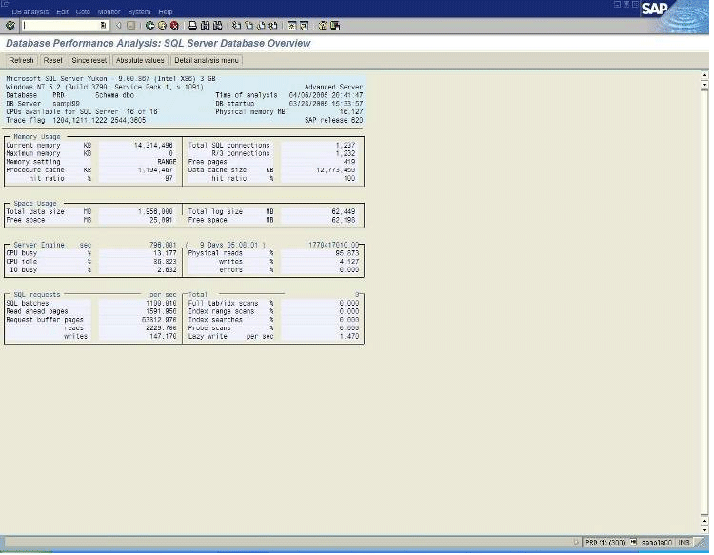
Figure 24

Details page
In Figure 25, the ST04 Details page selections include:
- Checks on the errorlogs and a list of deadlocks.
- Checks for immediate blocking lock situations or statistics on lock situations of over one minute.
- Checks for performance problems using SAP statistics on stored procedures.
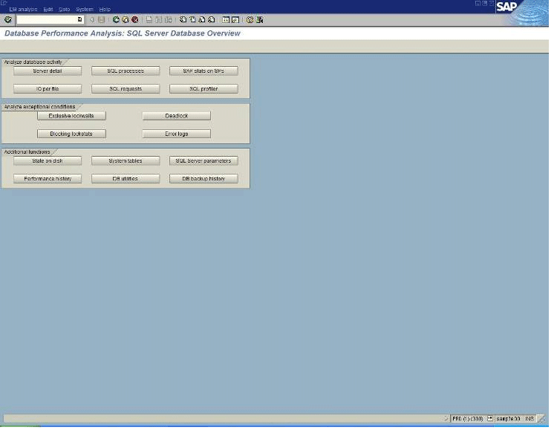
Figure 25

Query Statistics page
In Figure 26, the ST04 Query Statistics page shows the performance data that was accumulated by each application server or by selected application servers.
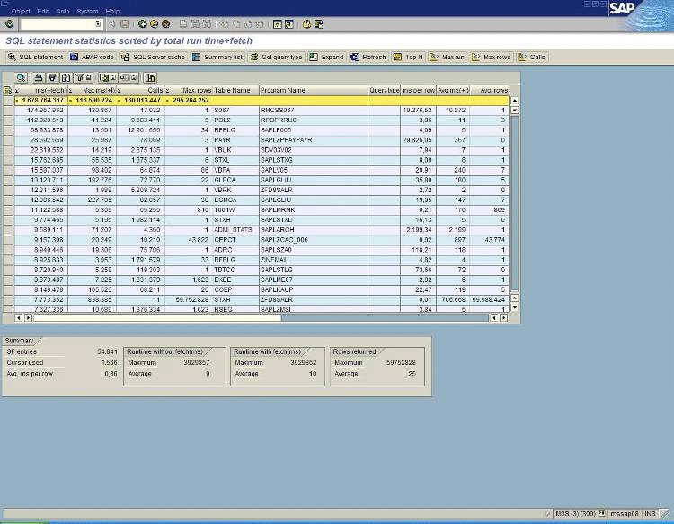
Figure 26

Query Performance Statistics page
The sample in Figure 27 shows the ST04 Query Performance Statistics page. ST04 displays the performance numbers for the top executed queries. The list is sorted by the sum of execution times including the fetch time, maximum execution time per query, number of executions, average rows returned per execution, and average execution time.
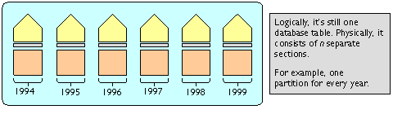
Figure 27

Query Details page
If the statement is not in the cache, SQL Server generates a new query execution plan based on the parameters of the longest execution of the query. Because SAP specifies the primary key for each update, viewing the query execution plan is not necessary.
Note that in the new Database Monitor SAP releases with NetWeaver 2004S, the parameters used for creating the query execution plan will be shown with SQL Server 2005.

Special Considerations for SAP BW
Although SAP BW uses the same basic SQL Server configuration as other SAP products, using SAP BW with SQL Server 2005 has some special considerations. This section describes these considerations, including the layout of tempdb for SAP BW and the specific methods for investigating SAP BW performance issues.

SAP BW queries
The best way to investigate performance issues with SAP BW is to repeat and trace the queries. Similar to other OLAP warehouse products, SAP BW tries to buffer queries and associated results. The base foundations allow a query to be run manually for investigation. SAP BW queries are named and stored in the SAP BW cache.
Using the SAP BW transaction code RSRT, a SAP BW query can run repeatedly in order perform investigations. The RSRT transaction helps to rule out issues on the client side, such as the client reporting or network issues on the way to the client.
The RSRT transaction can be used with the option to Execute + Debug. To use this option:
- Browse for a query or type the name of the query.
- Select the query display option such as List, BEx Broadcaster (SAP BW Business Explorer Broadcaster), or HTML (HyperText Markup Language).
- Click Execute + Debug to display a pop-up window that enables certain items to be selected. In addition, a second window requesting query parameters can appear.

The most important selections are:
- Display Aggregate Found. Indicates if SAP BW is using any aggregates for the query.
- Display Run Schedule. This selection is below Display SQL Query. The selection presents the Transact-SQL statement that is generated and sent to SQL Server and to the query plan.
- Do Not Use Cache. Do not use SAP BW cache to execute the query in the database server.
When the transaction is executed, SAP BW shows the Transact-SQL statement and the query plan. After reviewing the information, click Back (green button) in the top SAP BW menu list to send the query to SQL Server.
When a multiprovider is used, the transaction shows and runs all SQL queries created for the different infocubes in the multiprovider. In some cases, more than one query is produced for each cube, such as in hierarchical processing. In this case, a single SAP BW query might be comprised of more than 20 SQL queries.
This type of investigation is performed instead of using SQL Server Profiler or the SAP ST05 SQL Trace because of the manner in which SAP BW functions. From the query side, SAP BW builds a view for the complex queries by executing joins, and then executes a SELECT statement without any further restrictions against that view (no Where clause in the SELECT statement). Then SAP BW deletes the view again.
A statement cannot be reexecuted because randomized names are always used for the views, and the origin view was already dropped. The best way to address this issue is to investigate from the SAP BW side.

SAP BW table partitioning
In SQL Server 2005, table partitioning can improve performance and scalability and increase the ease of administration of SAP BW implementations. Table partitioning is fully implemented in SAP BW, starting with release 3.5.
Table partitioning applies to tables and indexes residing in a single database. Table partitioning breaks a single object into multiple manageable parts in a manner that is transparent to the application. Table partitioning allows data to be deleted from the SAP BW transaction log by using the row as the unit of measure.
For SAP BW, data deletion is a resource-consuming process because the transaction log volume is usually quite large and deletions are row by row. The majority of transaction log data is deleted from the SAP BW PSA table, F-Fact table, and E-Fact table.

Range partitioning
In SQL Server 2005, an unpartitioned table contains a data layer, with one or more index B-trees on top. In the data layer, the data is sorted according to the clustered index key if there is a clustered index on the table.
With range partitioning, the physical structures for the data layer and the index B-tree are aligned with the partitioned data, making it easy to move a partition. Whether an index contains the column with which the partition is aligned or not, B-trees are aligned with the partition column.
Notice the example diagram in Figure 27.
When a partition is deleted from a partitioned table, that partition is switched into a normal table outside of the partitioned table by using a metadata operation that takes only one or two seconds. No data is moved. This switch operation can be performed to switch a normal table into a partitioned table.
However, SAP BW supports the switching out of a partitioned table into a stand-alone table as shown in the following diagram.
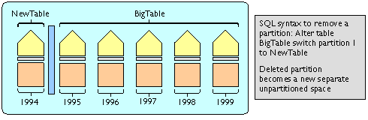
Figure 28
After a partition is transformed into a table, it can be dropped, truncated, archived, and so on. The stand-alone table can be deleted in minimal time. The deletion of millions of rows takes only a matter of a few seconds. The deleted rows cannot be restored from the transaction logs.
SAP supports SQL Server 2005 range partitioning on the following classes of tables in SAP BW versions 3.5 and higher:
- Persistent Staging Area (PSA) table. This is the main table for the staging data that is coming from the outside into SAP BW. Here the partition criteria is the LoadID. The LoadID is an artificial partitioning key for PSA tables that correlates to the number of rows per partition.
- F-Fact (part of a SAP BW infocube). The F-Fact table in the cube allows duplicate rows. The F-Fact table contains the Request ID. This is the request that is associated with loading the data into the cube. The Request ID is the dimension to which the partitions are lined. Each new load is stored in its own partition.
- E-Fact table (part of a SAP BW infocube). The partitioning of the E-Fact table is not mandatory, but it is recommended because the data from the F-Fact table is compressed into the E-Fact table. Duplicates in the F-Fact table are rolled up into one row, making the E-Fact table smaller. Because the Request ID is not part of the E-Fact table, the implementation of SAP uses the time dimension for partitioning. Either the month or the fiscal year can be used for E-Fact tables. The time range is defined at the creation time of the cube.

Missing or outdated optimizer statistics
The Automatic Statistics feature in SQL Server 2005 does not work as expected for small tables of less than 500 rows. For more information, see SAP OSS Note 542468. Following the instructions in the SAP OSS Note is strongly recommended.
For a quick test, use the Query Analyzer to directly run Transact-SQL statements that update statistics. The Query Analyzer can send Transact-SQL statements directly to SQL Server, bypassing SAP BW. Because the problem only occurs on small tables, it is sufficient to update the information on the dimension tables. For more information, see SAP OSS Note 542468. The recommendation is to use SQL Server to periodically update statistics, such as on a schedule or update them manually on an exception basis only. SAP typically relies on SQL Server AUTO_UPDATE_STATISTICS.

Creating aggregates
Materialized aggregates and preaggregated query results are important for SAP BW. In cases where many well-defined reports are running on a daily basis, typical practice is to create SAP BW aggregates to preaggregate reports or parts of reports. When there are hundreds of interactive users, it is vital to build SAP BW aggregates for well-known reports. Creating SAP BW aggregates avoids marginalizing database resources to perform aggregation on the fly while executing reports.
When SAP BW aggregates are created against a SAP BW cube, performance is improved by using the aggregates during the interactive query phase. However, during the delta load phase, these aggregates must be updated (rolled-up), which extends the run time of the delta load phase. The alternative to this trade-off is to marginalize resources to read huge volumes of data from the fact tables of the SAP BW cubes.

Parallelism for initial creation of aggregates
Aggregates in SAP BW are essential for good query performance. However, creating aggregates is typically a time- and resource-consuming process, especially when a scan and join is performed on a very large fact table. A large aggregate might involve a fact table with millions of rows. Alternatively, an aggregate might contain fewer than 100 rows, although SQL Server might have to scan and join 500 million rows to obtain this result. Note that creating an aggregate always includes a GROUP BY on the Transact-SQL statement level.
In particular, parallelism is useful when the creation of an aggregate requires a large query to scan and join the fact table of the cube with a number of dimension tables that are usually small. When parallelism is turned on, SQL Server uses all CPUs to process this query in parallel using multiple threads, depending on the specific setting. Using parallelism can achieve better performance than using only one CPU. However, as discussed earlier, the max degree of parallelism option is used for creating aggregates and indexes only. It is not used for online reporting.

Block size in SAP BW
Because creating an aggregate can be very resource intensive, SAP BW provides the option to split the process into <n> steps. For example, suppose the SAP BW F-Fact table has 10 million rows.
- When the block size is set to a value larger than 10 million, SAP BW uses one step to create the aggregate.
- When the block size is set to one million, SAP BW uses 10 steps to create the aggregate. In this case, SAP BW searches the query for a WHERE clause that contains an additional "artificial" filter that scans only one million rows per step.
- The challenge is to define the artificial filter. Because SAP BW calculates the block size automatically, it might not be possible to enter some ranges manually, depending on the data distribution.
Use the SAP BW SPRO transaction to set the block size for an aggregate. To run SPRO, select SAP Reference IMG, then Business Information Warehouse, then General SAP BW Settings, and then Parameters for Aggregates. In SAP BW 3.5, the default block size for the fact table is 100 million rows.
- Benefits of using a smaller block size. With a smaller block size, each step can run serially and use far fewer resources than when you create an aggregate using one large block size. The drawback is that a large fact table must be scanned multiple times. Smart table partitioning eliminates partitions in the scan process.
- Setting the block size. There is no optimal setting for the block size. The size is dependent on the type of aggregate, the size of the fact table, and the available physical resources, such as the number of CPUs and amount of physical memory. One solution is to create the aggregate using one large block size to see if there are performance issues and/or increased tempdb usage. If this occurs, reduce the block size and create the aggregate in multiple steps.

Aggregate compression
Using compression for aggregates means removing the Request ID, as described in Cube Compression later in this paper. Compression reduces the size of aggregate tables. This improves query performance and saves space.
Use the SAP BW RSA1 transaction to start compression. To run RSA1, select InfoProvider on the left side and then right-click the cube where the aggregates are to be compressed. In the pop-up window, click Manage. In the next window, select Rollup and then mark Compress after rollup in the Aggregates check box.
Analyzing aggregate creation on a database level
Aggregates in SAP BW are normal database tables that are created and then filled. An Execute + Debug button is not used in this process. The SAP ST05 transaction or an SQL Server Profiler trace can be used to view Transact-SQL statements that are sent to the database to create the aggregate. For more information, see Performance Monitoring and Tuning in this paper.
The aggregate can be created by using one large query or a set of queries, depending on the specific settings in SAP BW, such as the block size.

Loading and maintaining infocubes

Indexes on the fact table
The initial load of an infocube can insert many millions of rows into the fact table, which is usually "/BIC/F....". In this case, SAP BW creates a few indexes on every fact table. These indexes improve query performance, but slow down inserts, updates, and deletions. However, for the initial load of an infocube, it is a best practice to drop the indexes before the load. This improves the load time dramatically. Then recreate the indexes after the load. After creating a new infocube and performing an initial load, see Missing or Outdated Optimizer Statistics for more information.

Cube compression
Cube compression in SAP BW can have a massive impact on database tables. On a database level, every infocube uses the E-Fact table and F-Fact table. The E-Fact table contains rows without a Request ID; the F-Fact table contains rows with a Request ID. SAP BW stores a Request ID in the fact tables of the infocubes. Every load job that inserts data into the cube is given a new Request ID.
Rows in the fact tables are identified by a number of key columns. Because of the Request ID, a unique row can occur many times. This allows data from a certain load job to be deleted if necessary. However, creating aggregates or running queries directly on the cube increases space requirements and processing power use.
Cube compression removes the Request ID and combines all rows that have the same key columns. Depending on the load job history, the reduction in the number of rows can be huge. The result is placed in the E-Fact table. The SAP BW RSA1 transaction can be used to initiate cube compression.
Select the infocube after selecting InfoProvider. Right-click the cube and select Manage from the pop-up window. In the next window, select Collapse to activate the compression.

64-Bit Computing Configurations
SQL Server 2005 Enterprise Edition for SAP products is supported on the 32-bit, Itanium 64 (IA64), and x64 computing platforms. For the most demanding applications, SAP 64-bit products, and Microsoft SQL Server 2005 (64-bit) and Microsoft Windows Server 2003 (64-bit) can be used to enable SAP customers to implement large-scale deployments. Large SAP workloads can be processed by using 64-bit computing because it offers a sizeable amount of memory, including SAP BW cubes and Unicode implementations.
In many organizations, SAP applications have outgrown the memory addressing capabilities of 32-bit platforms. For example, frequent out-of-memory errors can occur when running large batch jobs on two-tier SAP application servers. In this situation, increasing memory capabilities in some 32-bit SAP processes can require complicated workarounds that reduce performance.
In addition, the increased need for CPU processing power has pushed the addressing of memory to the limits of the 32-bit computing. Some organizations will need to upgrade to a 64-bit platform as 32-bit server hardware reaches the end of its life cycle.

32-Bit computing architecture
The typical 32-bit architecture limits computing power in memory-intensive processing and might produce bottlenecks and slowdowns.
- Limited memory management. In 32-bit computing, a flat, 32-bit virtual address space that can be addressed to 4 GB is used. In this case, 2 GB or 3 GB are directly addressable by an application and only 2 GB are addressable by the operating system. The 32-bit virtual address space is shared across all processes, further limiting the available memory that can be addressed directly. Because each server has a limited processing capability, the 4-GB virtual address memory ceiling in 32-bit architecture can inhibit growth, degrade overall performance, and increase costs.
- Limited development opportunities. Existing 32-bit architectures might not meet the demanding workloads found in a SAP environment. For example, 32-bit computing may not allow adequate amounts of RAM to perform processes in a convenient way.

64-Bit computing architecture
The use of 64-bit processors is steadily increasing because 64-bit computing:
- Offers extended memory management, allowing more memory to be addressed in a linear manner.
- Provides greater memory access than its 32-bit predecessors and speeds numeric calculations.
- Eliminates the 4-GB memory barrier inherent with 32-bit systems, enables larger I/O buffering, and improves throughput.
- Supports up to 1 terabyte of physical memory.
- Offers an extensive virtual memory address space. The 64-bit architecture allows virtual memory to be addressed in a flat address space of up to 16 terabytes, divided evenly between user mode and kernel mode. This gives native 64-bit applications 8 terabytes of virtual address space.

SQL Server 2005, Enterprise Edition (64-bit)
SQL Server 2005 Enterprise Edition (64-bit) supports both the IA64 and x64 computing platforms and makes no distinction between these platforms concerning their limitations. SQL Server 2005 (64-bit) provides an increased linear address space, without requiring the use of an additional layer such as AWE.
In terms of memory handling, the 32-bit virtual memory constraints can inhibit the use of SQL Server 2005 and slow performance in memory-intensive applications. This includes SAP products that store and process large amounts of data in memory. For example, with SQL Server 2005 (64-bit), complex queries can be assigned higher quotas on buffers based on real memory.
The following is a comparison of 64-bit memory addressability on quotas:
- 32-bit computing. For a complex query, a quota in SQL Server 2005 can be assigned no more than 25 percent of the data buffers for sort, group, or hash operations. Assuming a virtual address space of 3 GB is configured for SQL Server 2005, roughly 700 MB could be assigned for this query at best. When more space is needed, parts of the intermediate data of the query are pushed to disk in tempdb. Using AWE would not change this behavior.
- 64-bit computing. If the same complex query were run on SQL Server 2005 (64-bit) on a server with 64 GB of memory, the query can be assigned up to 16 GB of memory to perform joins, sorts, and grouping, leaving only a very small number of queries that need tempdb. Most queries can be performed fully in memory by using the data buffers available to SQL Server 2005 (64-bit), greatly improving performance.
In addition, having the capability to address more than 64 GB of memory directly provides opportunities that were previously unavailable because of the drawbacks of the 32-bit platform. Doubling or quadrupling memory can dramatically reduce the I/O rate. This improves the response time by a factor of 2 to 4 and lowers investment costs for I/O hardware. In addition, SQL Server 2005 (64-bit) can be expanded in workload areas that could not be touched with 32-bit platforms.

Microsoft x64 computing platform
The SQL Server 2005 (64-bit) x64 computing platform is a Microsoft architecture that extends the x86 instruction set to 64 bits. SQL Server 2005 uses Windows Server 2003 x64 Edition and requires drivers and software that are specifically compiled for the x64 instruction set. Windows Server 2003 (64-bit) supports both the AMD Opteron and Intel processors with Extended Memory Technology (EM64T).
The Microsoft x64 platform offers support both for 32-bit and 64-bit computing. Existing 32-bit software can be used without being recompiled. The x64 computing platform can act as an x86 processor when an x64 system is booted into a 32-bit operating system.
Note that the SQL Server 2005 (64-bit) x64 platform does not run 64-bit IA64 versions of the Windows Server operating system or 64-bit IA64 drivers that are compiled for Itanium. The 64-bit IA64 platform is not compatible with SQL Server 2005 (64-bit). Different sets of executables are required.

64-bit memory and CPU limitations
The general memory limitations both for the 32-bit and 64-bit computing platforms are shown in the following table.

General Memory Limits | 32-bit | 64-bit
Total virtual address space | 4 GB | 16 terabytes
Virtual address space per 32-bit process | 2 GB (3 GB if the system is booted with the /3gb switch)  4 GB if compiled with /LARGEADDRESSAWARE  2 GB otherwise | Not applicable
Virtual address space per 64-bit process | Not applicable | 8 terabytes
Paged pool | 470 MB | 128 GB
Nonpaged pool | 256 MB | 128 GB
System cache | 1 GB | 1 terabyte

The physical memory and CPU limitations for the 32-bit and 64-bit Windows operating systems are shown in the following table.

Physical Memory and CPU Limits | 32-bit | 64-bit
Windows Server 2003 Standard Edition | 4 GB/1 to 4 CPUs | 32 GB/1 to 4 CPUs
Windows Server 2003 Enterprise Edition | 64 GB/1 to 8 CPUs | 1 terabyte/1 to 8 CPUs
Windows Server 2003 Datacenter Edition | 64 GB/1 to 32 CPUs | 1 terabyte/1 to 64 CPUs

Migration to SQL Server 2005 (64-bit)
Despite the fact that the binaries of the IA64 and x64 platforms and the 32-bit platform are not fully interchangeable, the SQL Server 2005 on-disk structures between all three supported platforms (IA64, x64 and x86) are the same. This means that migrating from a 32-bit computing platform to one of the 64-bit platforms can be handled easily either by copying the database files to the new 64-bit hardware or by restoring a backup from the 32-bit platform to the 64-bit platform.

SAP applications on a 64-bit platform
The main problem with running SAP application instances using 32-bit computing is that the address space for a single process of the SAP instance is limited to 3 GB. Because of SAP’s extensive buffering for the NetWeaver Application Server, those buffers use a large amount of memory in the address space of a process. Over the last six years, SAP releases have nearly doubled their demand on memory.
In fact, situations where SAP users are performing processing that reaches the upper limits of the 32-bit x86 platform are becoming more frequent. In particular, the usage of SAP Unicode products increases the problem because the Unicode products address memory in a severe manner. For SAP Unicode products, the recommendation is to use a 64-bit platform to run the SAP Application Server Layer.
In addition, 64-bit computing is in demand with the SAP® Advanced Planning & Optimization (SAP APO) component of mySAP SCM. In particular, the SAP APO liveCache is an in-memory database where 64-bit addressability is mandatory.

SAP availability and support of 64-bit platforms
SAP supports the SQL Server 2005 (64-bit) 32-bit, IA64, and x64 platforms. However, in configurations that use Microsoft clustering, it might be necessary to have SAP executables running on the native platform. In this case, make sure SAP supports the 64-bit computing platform for the specific SAP product and release that is in use. More recent SAP products are available on IA64. For x64, the SAP ABAP stack should become available toward the beginning of 2006 for the most recent SAP releases.

Related Links and Online Resources
Microsoft SQL Server 2005:
http://www.microsoft.com/sql/2005/productinfo/overview.mspx
Windows Server 2003:
http://www.microsoft.com/windowsserver2003
Microsoft – SAP Customer Information Center:
http://www.microsoft-sap.com/
http://www.microsoft-sap.com/technology.aspx
mySAP and SAP R/3 on SQL Server 2005 training courses for administrators:
http://www.microsoft-sap.com/events.aspx
SAP AG:
http://www.sap.com/index.epx
SAP NetWeaver:
http://www.sap.com/solutions/netweaver/index.epx

Note that the SAP OSS Notes and SAP Product Support Matrix are only available to registered customers of SAP AG and SAP Service Marketplace.

Failover Clustering in the MSDN Library:
http://msdn.microsoft.com/library/default.asp?url=/library/en-us/adminsql/ad_clustering_7t9v.asp
RAID Levels and SQL Server in the MSDN Library:
http://msdn.microsoft.com/library/default.asp?url=/library/en-us/optimsql/odp_tun_1_87jm.asp
General information on common RAID levels:
http://msdn.microsoft.com/library/default.asp?url=/library/en-us/optimsql/odp_tun_1_0m5g.asp

For more information:
http://www.microsoft.com/sql/

Did this paper help you? Please give us your feedback. On a scale of 1 (poor) to 5 (excellent), how would you rate this paper?

As of the third quarter of 2005.
The SAP/Microsoft joint development project is called “Mendocino.”
For more information, see “Microsoft – SAP Customer Information Center” at http://microsoft-sap.com/
For more information, see “Microsoft SQL Server 2005” at http://www.microsoft.com/sql/2005/productinfo/overview.mspx
For more information, see “What's New in SQL Server 2005” at http://www.microsoft.com/sql/2005/productinfo/overview.mspx#ECAA
For more information, see “Microsoft – SAP Customer Information Center” at http://www.microsoft-sap.com/technology.aspx
tempdb is typically 1.5 times the size of the largest SAP fact table.
Database mirroring is currently included in the initial release of SQL Server 2005 for testing and non-productive environments only. After launch, Microsoft plans to release an update that will enable database mirroring for productive environments.
The SAP OSS Notes are only available to registered customers of SAP AG.
The SAP Product Support Matrix is only available to registered customers of SAP AG.
Product lists are for reference only. The lists do not represent final or actual product names or convey equal functionality between the 32-bit and 64-bit versions of Windows.

