

Comparing SQL Server 2005 and Oracle 10g as a Database Platform for Microsoft .NET Developers

A Comparison of Developer Productivity

Author: Mitch Ruebush
Published: April 2005
Summary: This paper compares SQL Server 2005 and Oracle 10g from the perspective of the Visual Studio® developer. The focus is on answering the question: “Which of the two databases is a more productive application development platform for the .NET platform developer?”
Audience: The paper is targeted toward technology decision makers as well as information technology managers, architects, and database application developers.

Copyright
This is a preliminary document and may be changed substantially prior to final commercial release of the software described herein.
The information contained in this document represents the current view of Microsoft Corporation on the issues discussed as of the date of publication. Because Microsoft must respond to changing market conditions, it should not be interpreted to be a commitment on the part of Microsoft, and Microsoft cannot guarantee the accuracy of any information presented after the date of publication.
This White Paper is for informational purposes only. MICROSOFT MAKES NO WARRANTIES, EXPRESS, IMPLIED OR STATUTORY, AS TO THE INFORMATION IN THIS DOCUMENT.
Complying with all applicable copyright laws is the responsibility of the user. Without limiting the rights under copyright, no part of this document may be reproduced, stored in or introduced into a retrieval system, or transmitted in any form or by any means (electronic, mechanical, photocopying, recording, or otherwise), or for any purpose, without the express written permission of Microsoft Corporation.
Microsoft may have patents, patent applications, trademarks, copyrights, or other intellectual property rights covering subject matter in this document. Except as expressly provided in any written license agreement from Microsoft, the furnishing of this document does not give you any license to these patents, trademarks, copyrights, or other intellectual property.
© 2005 Microsoft Corporation. All rights reserved.
Microsoft, IntelliSense, Visual Basic, Visual Studio, and Windows Server are either registered trademarks or trademarks of Microsoft Corporation in the United States and/or other countries.
The names of actual companies and products mentioned herein may be the trademarks of their respective owners.

Contents

A Comparison of Developer Productivity 1
Introduction 1
Basis for Comparison 1
Integration with Visual Studio and the Microsoft .NET Platform 1
SOA-based application development 2
Deployment flexibility 2
Summary of Results 3
Visual Studio and .NET CLR Integration 3
Visual Studio integration 3
.NET integration 4
SOA Application Development 4
Deployment Flexibility 5
Integration with the Microsoft .NET Common Language Runtime 5
In-Process versus Out-of-Process Hosting 6
CLR 1.1 versus CLR 2.0 6
Database Object Types Supported 6
Storage of .NET Assemblies 6
Visual Studio Integration 6
SQL Server 2005 and Visual Studio 2005 7
Server Explorer 7
ADO.NET programming 9
Query Designer 9
Debugging stored procedures 10
SQL Server projects 11
Integration of BI technologies 13
SQL Server Analysis Service 13
SQL Server 2005 Reporting Services 14
SQL Server Integration Services 15
Visual Studio Integration with Oracle 16
Oracle Explorer 16
Project support 18
Debugging stored procedures 18
Integration of BI components 19
Integration with Visual Studio: Summary 19
SOA-Based Application Development 19
Comparison of XML Support 19
Native XML Type and XQuery 19
Indexing 20
Updating XML 20
XML schema collections and schema evolution 20
Comparison of Web Services Support 21
SQL Server 2005 21
Oracle Database 10g 21
The differences 22
Comparison of Support for Asynchronous Messaging 22
The differences 23
Comparison of Event Notification Services 23
SQL Server 2005 23
Oracle Database 10g 24
Comparison of Query Notification Services 24
SQL Server 2005 24
Oracle Database 10g 24
Comparison Summary 25
About the Author 27

Introduction
Traditionally, decision makers responsible for comparing and choosing a database management system have focused on the deployment aspects of a database as the primary criterion for selecting a database. As a result, numerous studies that compare the performance, scalability, reliability, availability, and manageability of competing databases are available to guide decision makers. While deployment capabilities are certainly important factors that need to be considered when choosing a database, it is equally important to evaluate databases from an application development platform perspective. Gartner published a report in May 2002 called “The Cost and Risk of Application Development Decisions” by Joseph Feiman and Tom Berg that shows that development time and support costs are the largest part of an application’s overall cost for most companies. In other words, developer productivity has a huge impact on the total cost of ownership (TCO) and the return on investment (ROI) associated with a database. It is imperative that decision makers take developer productivity into account as they compare and choose databases.

Basis for Comparison
Both Microsoft® SQL Server™ and Oracle are mature databases that are rich in development and deployment features. So how does one compare the two databases for developer productivity? This paper focuses on three key elements of the two databases that will have the biggest impact on developer productivity for a broad category of application developers. The three elements are:
- Integration with Microsoft Visual Studio® and the Microsoft .NET platform
- Support for Service Oriented Architecture (SOA)-based application development
- Deployment flexibility

Integration with Visual Studio and the Microsoft .NET Platform
Microsoft Visual Studio is the most popular application development tool on the market today. Microsoft .NET has emerged as the most popular platform for developing applications. As a result, both Oracle and Microsoft have integrated their database offerings (Oracle 10g and SQL Server 2005 respectively) with Visual Studio and the .NET platform. Integration with Visual Studio and the .NET CLR (common language runtime) represents one of the biggest advancements in developer productivity for database application development in the last decade. This paper compares the how well Oracle 10g and SQL Server integrate with Visual Studio and the .NET CLR.

SOA-based application development
The next generation of networked, connected, and distributed applications will be based on the concepts of Service Oriented Architecture (SOA). SOA will fundamentally change how applications are designed, developed and deployed. Databases have a significant role to play in Service Oriented Architecture. Hence both Oracle and SQL Server include several new features to support the development of SOA-based applications. These features include:
- XML: The ability to store, parse, validate, query and update XML documents efficiently in the database.
- Web Services: The ability to expose database objects (tables, stored procedures, and so on) as Web services as well as being able to invoke external Web services from within the database.
- Asynchronous Message Queuing: The ability to guarantee the delivery of messages, exactly once, to other networked and distributed applications in spite of system failures.
- Event Notification: The ability to distribute important business events to a large number of users and devices, in a format appropriate to the receiver, in an efficient manner.
- Query Notification: The ability for an application to “subscribe” to changes in the databases that affect the results of a specific query and to be notified when the changes take place.
The paper will compare the two databases in their ability to support the development of SOA-based applications.

Deployment flexibility
Customers like to have the flexibility to deploy applications on a database edition that is most appropriate for their current requirements based on the number of users, data volumes, and the size of the hardware and features required. Furthermore, they like to be able to redeploy the same application at a later date with little or no modification. To satisfy this requirement, all of the database editions must support the same basic APIs. This is especially important for Independent Software Vendors (ISVs) who create packaged applications and want to develop an application just once and give their customers the choice to deploy it on any edition. Otherwise, applications have to be developed separately for every edition, which can be very time consuming and expensive. Both Oracle and SQL Server have addressed this requirement by offering multiple editions, each with different functionality and price points. Later in the paper, we examine how Oracle and SQL Server compare in this capability.

Summary of Results
The observations in this paper are based on the publicly documented features and public statements about SQL Server 2005 and Oracle 10g. Here is the summary of the author’s findings. The rest of the paper expands on these observations in detail.

Visual Studio and .NET CLR Integration
While both Oracle Database 10g and SQL Server 2005 have been integrated with Visual Studio and the Microsoft .NET platform. SQL Server integration is more comprehensive, more seamless, more functional, and better performing than Oracle 10g.

Visual Studio integration
Currently Oracle provides only basic integration with Visual Studio. Oracle provides a plug-in to Visual Studio called Oracle Developer Tools for Visual Studio .NET. If you search the Oracle site for .NET Developer Tools, you will find various downloads and information for developing with Oracle from the .NET platform. Oracle does not offer many important features that have a major impact on developer productivity, including:
- Debugging of stored procedures through Visual Studio. Oracle does not permit stored procedures implemented in its proprietary language, PL/SQL, to be debugged through Visual Studio. Developers will have to use a separate tool such as JDeveloper for debugging.
- Visual Studio projects. Visual Studio offers a powerful capability called SQL Server Project that simplifies the development of a SQL Server application by managing all the database objects (Stored Procedures, Triggers, User-Defined Functions, User-Defined Objects, Aggregates, and Class Diagrams) as a single coherent entity. SQL Server projects also allow developers to take advantage of Visual Studio Team Services (VSTS) features such as source code control and versioning.
Oracle has no equivalent to SQL Server Project, a significant setback to developer productivity.
- Auto-deployment through Visual Studio. After a SQL Server database objects have been developed in a SQL Server project, they can be deployed to the SQL Server database with a single click. The single-click deployment applies to .NET assemblies too. Oracle’s integration with Visual Studio does not support this capability.
- Integration of business intelligence (BI) technologies. All of SQL Server BI technologies including SQL Server Analysis Services, Reporting Services, and Integration Services are integrated with Visual Studio. However, none of Oracle’s BI technologies such as Oracle OLAP option, Oracle Data Mining Option, Oracle Reports, or Oracle Warehouse Builder is integrated in any way with Visual Studio. Therefore, a .NET developer who wants to incorporate Oracle’s BI capabilities into their applications will have to learn to use another tool such as JDeveloper, adversely impacting developer productivity.
The bottom line is that while SQL Server is completely integrated with Visual Studio, Oracle’s integration is incomplete. With SQL Server, a .NET developer does not need any other tool besides Visual Studio for all aspects of application development. On the other hand, Oracle will require the use of its JDeveloper tool or other third-party tools in addition to Visual Studio, resulting in a suboptimal development experience, increased learning curve, and decreased productivity for the developer.

.NET integration
On the surface it would appear that both Oracle and SQL Server 2005 offer the same type of integration with the Microsoft .NET CLR. However on closer examination, it is clear that SQL Server has a tighter integration that offers more functionality, better performance, and better manageability than Oracle 10g. The main reason for this difference is that while SQL Server hosts the .NET CLR in-process, Oracle plans to host it out-of-process. The difference, and the implication to developer productivity, is examined in greater detail later in this paper.

SOA Application Development
Both Oracle and SQL Server provide the same set of features to enable the development of SOA-based applications. However the difference is in the ease of use of use. SQL Server has easy-to-use features that are included in the database server and are seamlessly integrated. Oracle has spread the functionality across multiple products (database and application server) and the features are not well integrated. Furthermore, many of the APIs are based on Java standards (such as Java Messaging Service) and offer no value to the .NET developer. SQL Server provides a well-designed, better-integrated, and more-productive platform for developing SOA applications than Oracle 10g.
These observations are explained in greater detail later in the paper.

Deployment Flexibility
While both Oracle and SQL Server offer multiple editions of the database, only SQL Server provides the same development environment (.NET), tools (Visual Studio), and APIs across all editions. As a result, developers need develop an application only once; they can deploy it on any of the SQL Server editions—Mobile, Express, Workgroup, Standard or Enterprise Edition—without having to recode or modify the application. Oracle falls short in two ways:
- Oracle does not offer a free version of its database. Its cheapest version is Oracle Lite. SQL Server Express Edition is free.
- Oracle Lite does not support PL/SQL, the primary language used by Oracle database developers to implement stored procedures, triggers, and object methods. Therefore it may not be possible to deploy applications developed on other Oracle database editions—Standard One, Standard, and Enterprise—on Oracle Lite. SQL Server does not suffer from such limitations.

Integration with the Microsoft .NET Common Language Runtime
Acknowledging the popularity of the Microsoft .NET platform with application developers, both Oracle and Microsoft have integrated the .NET CLR into their database products. CLR integration will have a dramatic impact on how database applications are designed, developed and deployed. CLR integration offers many benefits to the application developers.
- Application developers now have choice—they can develop database logic in any .NET Framework language. They are no longer confined to Transact-SQL (in the case of SQL Server) or PL/SQL (in the case of Oracle). In addition to increased developer productivity, businesses also benefit because all the.NET platform developers in the company can develop database application logic without having to learn a specialized language.
- Application developers now have a choice—they can deploy application logic in either the database tier, the middle tier, or in the smart client. Furthermore, the logic can be easily moved—at any time—to whatever is the most appropriate tier at that time.
- Microsoft and its partners are constantly enriching the functionality of the .NET platform. Database developers can increase their productivity by leveraging these frameworks. They do not have to develop everything from scratch, as is the case with Transact-SQL or PL/SQL.
So, given the tremendous impact CLR integration has on developer productivity, let us look more closely at Oracle and SQL Server implementations.

In-Process versus Out-of-Process Hosting
SQL Server 2005 hosts the CLR “in process” where Oracle 10g Release 2 will host the CLR out-of-process. In-process hosting means that the .NET CLR executes within the SQL Server process space. So invocations to database logic (stored procedures, triggers, and user-defined functions) implemented as managed code do not have to pay the overhead of inter-process communication. However, because Oracle is planning to host the .NET CLR externally out-of-process, its performance will be considerably impacted. Note that both SQL Server and the .NET CLR have their own thread and memory management models. SQL Server has integrated its threading and memory management models with the .NET CLR resulting in a greater ability for the .NET developer to fine tune applications. Because Oracle is hosting the CLR process externally, inefficiencies will exist because there are two threading and memory management models.

CLR 1.1 versus CLR 2.0
Oracle 10g Release 2 supports version 1.1 of the CLR and lacks the richer APIs provided with version 2.0 of the CLR that SQL Server 2005 supports. This means that SQL Server 2005 provides features like the ADO.NET 2.0 in-process provider which creates a server-side view of data and integrated memory and thread management with the database server.

Database Object Types Supported
With SQL Server you can develop stored procedures, triggers, user-defined functions, and user-defined aggregates in managed code. It is clear that Oracle plans to support stored procedures in managed code, but its support for other database objects is not clear.

Storage of .NET Assemblies
SQL Server 2005 stores the .NET assemblies implementing the stored procedures, triggers, and functions within the database, while Oracle 10g Release 2 will store the assemblies outside the database. The advantage to the SQL Server approach is integrated management: Because the .NET assemblies are within the database they are managed just like any other database object from a backup, restore, replication, and data mirroring perspective. In the case of Oracle, the .NET assemblies are stored in files external to the database and have to be managed separately, increasing complexity and potentially leading to errors.
SQL Server 2005 has a deeper, more comprehensive integration with the .NET CLR resulting in a significantly better development experience for the application developer.

Visual Studio Integration
Given that Visual Studio is the most popular and productive integrated development environment (IDE) for developers, it is only natural that both Oracle and SQL Server should integrate with it. We can expect that this integration will continue to be enhanced over time.
Microsoft has encouraged partners to extend Visual Studio with their own offerings. The Microsoft Visual Studio Industry Partner Program (VSIP) has been created for this purpose. Visual Studio also provides the framework and the APIs to enable database partners to integrate their databases with Visual Studio. Oracle has joined the VSIP program and has integrated the Oracle database with Visual Studio through Oracle Developer Tools for Visual Studio .NET.
This section compares how well Oracle and SQL Server integrate with Visual Studio and the resulting implications to developer productivity. We start first with SQL Server.

SQL Server 2005 and Visual Studio 2005

Server Explorer
SQL Server 2005 integrates with Visual Studio through a SQL Server OLE DB provider that allows the developer to interact with the database through Server Explorer. Server Explorer allows a developer to manage various services through Visual Studio as shown in Figure 1.
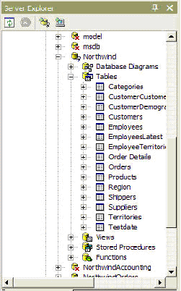
Figure 1: Server Explorer with SQL Server 2005
A developer using Server Explorer will find many of the familiar tools of SQL Server Management Studio available to them. For example, a developer will be able to:
- Create database diagrams.
- Design tables.
- View data in tables.
- Create and execute views, stored procedures, triggers, and user-defined functions.
A developer can even set up database constraints and indexes on the database server through Server Explorer if they have the proper permissions.
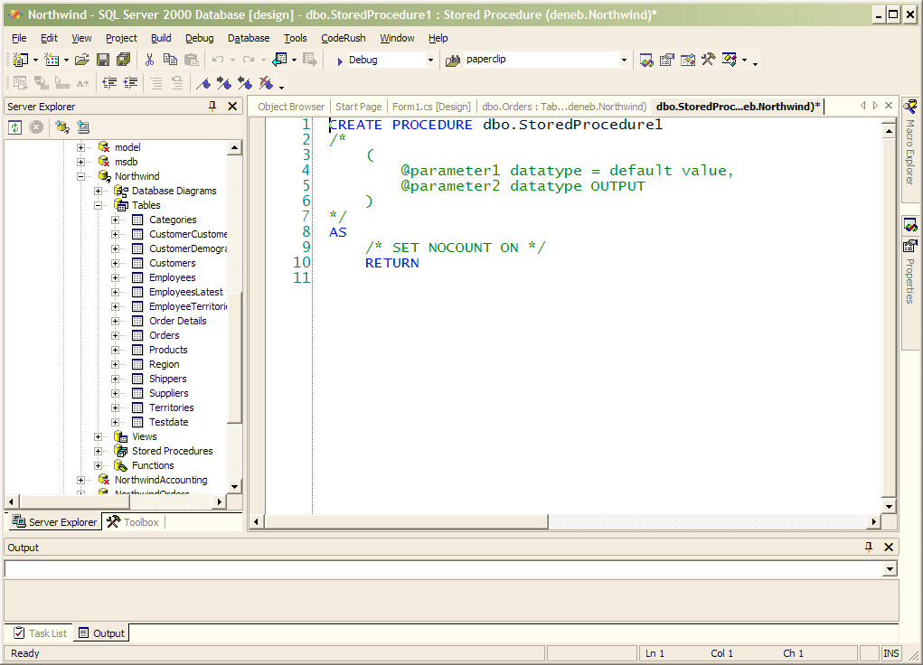
Figure 2: Creating a stored procedure through Server Explorer

ADO.NET programming
Visual Studio integration allows a developer to program ADO.NET graphically. In addition, ADO.NET includes an optimized provider that delivers high performance data access to SQL Server. A Visual Studio developer can drag and drop artifacts such as SqlConnection, SqlCommand, and SqlDataAdapter onto a design surface, and wizards guide the developer in using these artifacts to connect to SQL Server. (See Figure 3.)
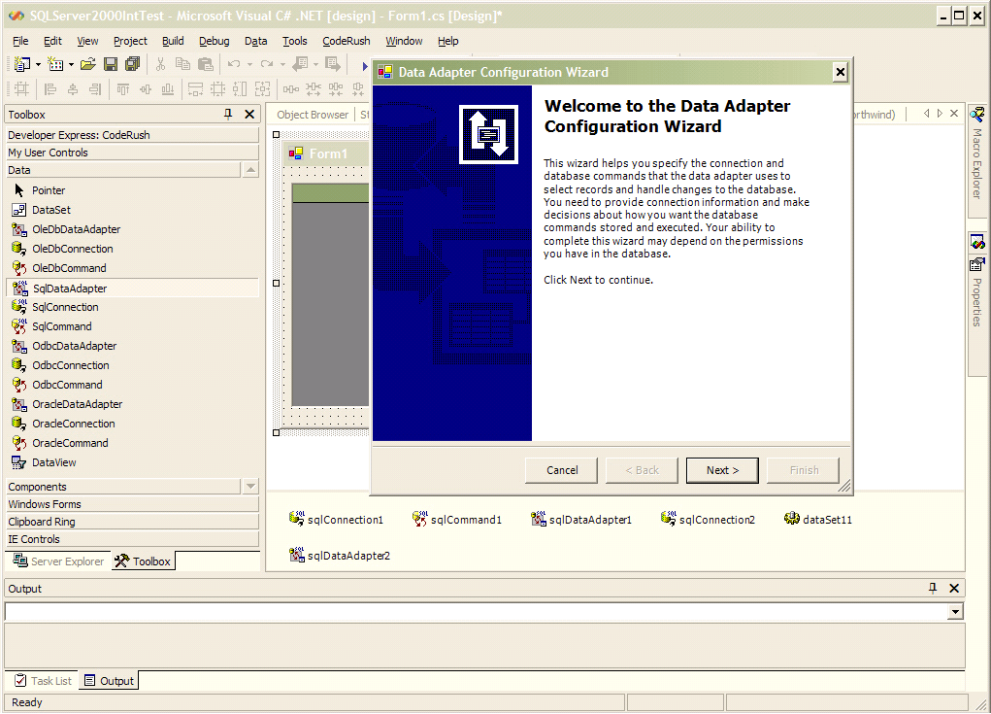
Figure 3: Dragging a SqlDataAdapter launches a configuration wizard

Query Designer
Visual Studio also provides Query Designer, a tool for creating queries and manipulating data in the database as shown in Figure 4. The driver also exposes the database diagram feature so that you can view the entity relationship diagrams of the database.
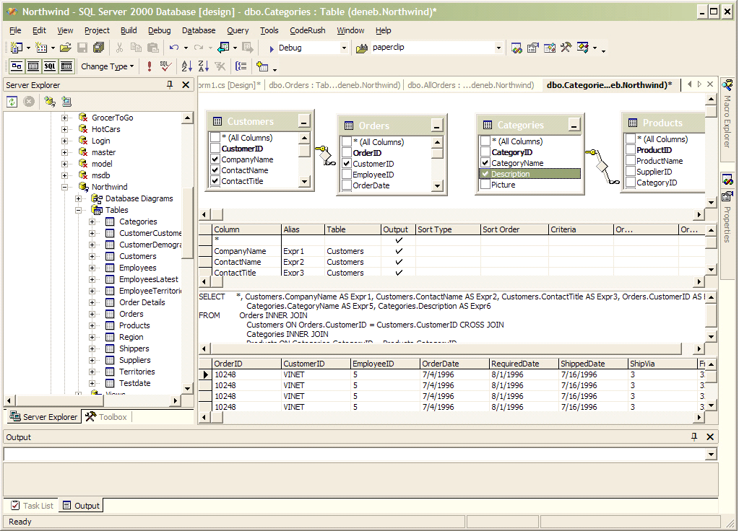
Figure 4: Entity relationship diagrams as viewed in the Query Designer

Debugging stored procedures
A significant amount of a developer’s time is spent debugging applications. Therefore, debugging tools are very valuable to developers. Visual Studio features a Transact-SQL debugger that allows a developer to step into stored procedures.
To debug a stored procedure:
Launch Visual Studio.
- On the View menu, select Server Explorer to navigate to Server Explorer.
- Navigate to the SQL Server instance.
- Expand the SQL Server instance node, then the Database node, and finally the Stored Procedures node in Server Explorer.
- Right-click the stored procedure that you want to debug and select Step Into Stored Procedure as shown in Figure 5.
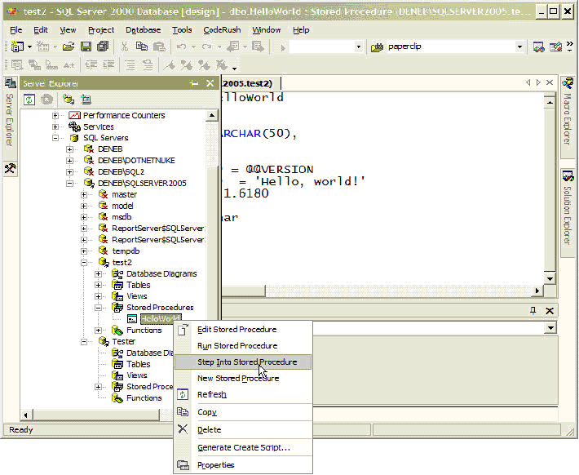
Figure 5: Stepping into a stored procedure with Visual Studio and SQL Server 2005
- You can inspect local variables from the Locals window and edit their values.
- Press F10 to step one line into a stored procedure and watch the variables change.
- You can insert breakpoints by right-clicking the line where you want to insert a breakpoint and choose Insert Breakpoint from the context menu.

SQL Server projects
Visual Studio 2005 integration is also enhanced through the SQL Server Project template, a key productivity feature. You can create a SQL Server project in Visual Studio to facilitate managing the database (Figure 6).
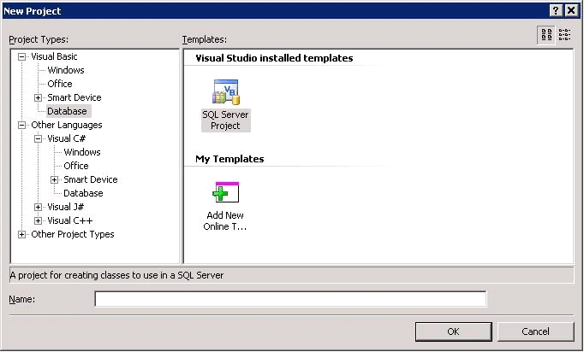
Figure 6: Creating a SQL Server project in Visual Studio 2005.
When you have a SQL Server project, you can add any of the following templates to the project to create the different user objects in the database (Figure 7). The template will create starter code that contains the attributes and references necessary for the object.
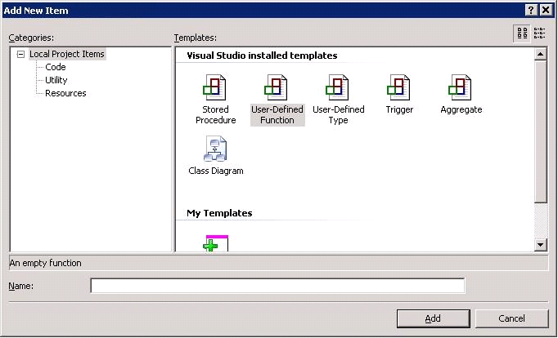
Figure 7: You can choose several objects to create in a SQL Server project
After you have created the project, you will have full debugging capabilities for the code, including stepping into code, break points, and watch variables. You can step through each language, which means you can step from C# code to T-SQL to Visual Basic® .NET. In short, all the features that Visual Studio .NET developers rely on will be available for debugging their database code. The SQL Server project also automates the process of deploying the code to the server running SQL Server. All the developer needs to do is configure the project for deployment. In essence, the developer can use the same tools for developing and debugging database objects that they use in the middle tier and client tier.
Visual Studio 2005 also offers other great integration features. For example, you also get syntax highlighting and IntelliSense® in Transact-SQL and easy deployment of CLR-based SQL Server objects. After a successful build of the project, you just build the project, and then select Build, then the Deploy menu option, and select the project name.

Integration of BI technologies
SQL Server has a broad BI platform that includes the following:
- SQL Server Analysis Service for analysis and data mining.
- SQL Server Integration Services for extraction, transformation, and loading
- SQL Server Reporting Services for designing and generating reports in various popular formats like Microsoft Excel, HTML, and Adobe PDF.
Visual Studio is the foundation for all the management and development tools required to develop and manage BI applications with SQL Server.

SQL Server Analysis Service
SQL Server offers the Business Intelligence Development Studio to help developers built analytic and data mining applications. The Business Intelligence Development Studio uses the familiar Visual Studio interface (Figure 8) so that the learning curve is minimized.
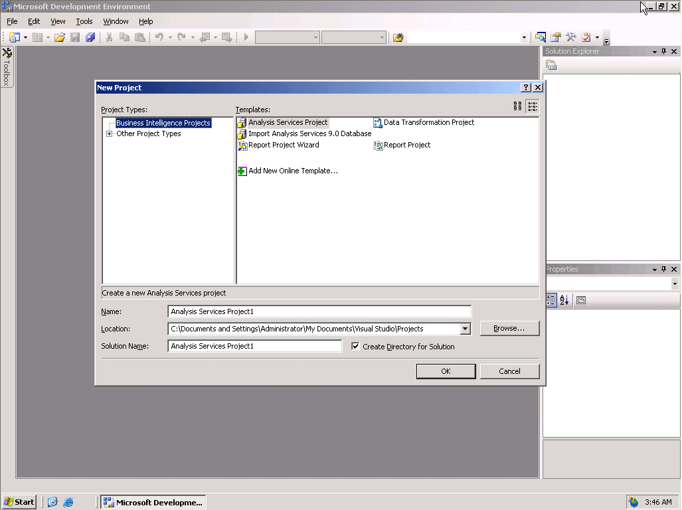
Figure 8: Business Intelligence Development Studio with various project types.

SQL Server 2005 Reporting Services
SQL Server Reporting Services uses Visual Studio as the designer environment (see Figure 9) to create rich reports that can be delivered in various formats such as PDF, Microsoft Excel, or HTML.
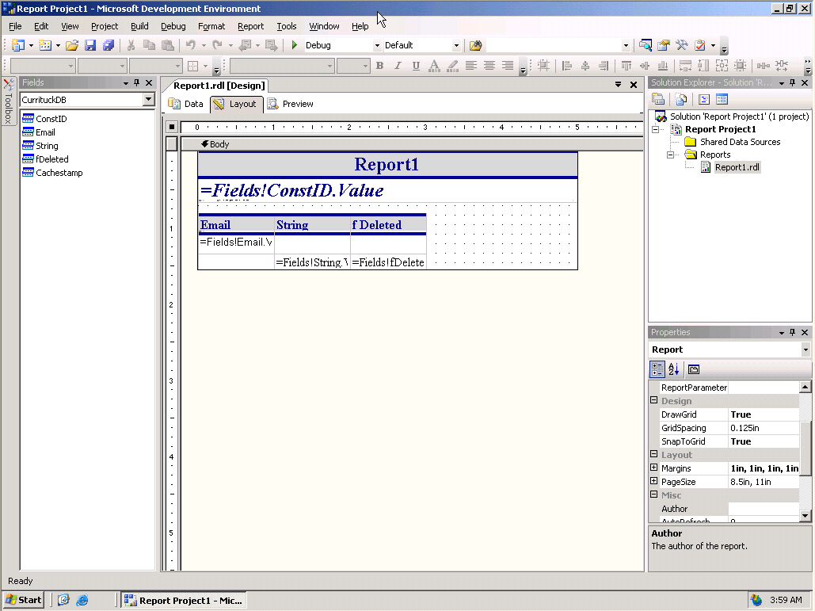
Figure 9: Visual Studio Integration of SQL Reporting Services
Reporting Services is tightly integrated with Visual Studio and the .NET Framework. Report generation enables developers to encapsulate complex logic in assemblies used for calculating values in the report. This will allow a Visual Studio developer reuse their business logic. It also serves as an engine to schedule reports that need to run on a regular basis, or users can run reports on demand.

SQL Server Integration Services
Integration Services provides a graphical environment built on Visual Studio for creating workflows to extract, load, and transform data (ETL). Integration Services has been revamped for SQL Server 2005 to provide a better, faster, and more flexible environment for the ETL engine through the use of Visual Studio (Figure 10). Integration Services is also fully extensible with the code from any language that can use the .NET Framework so a developer can create their own objects.
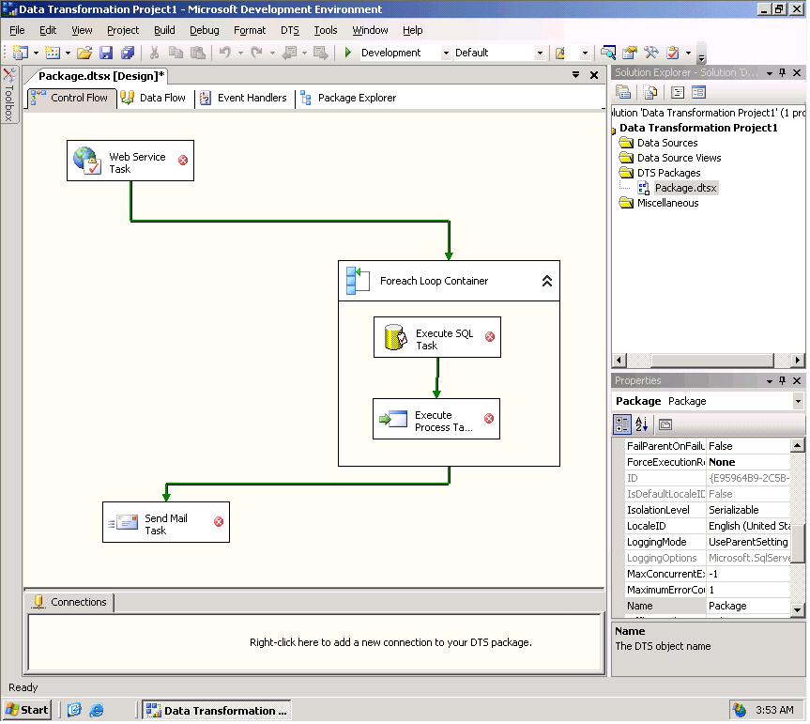
Figure 10: SQL Server Integration Services.

Visual Studio Integration with Oracle
Now we will look at how Oracle integrates with Visual Studio.

Oracle Explorer
Oracle provides the Oracle Explorer to give Visual Studio users the ability to browse an Oracle database. A developer can view standard database objects such as tables, views, stored procedures, and triggers. In addition, developers can view some Oracle-specific objects like synonyms and packages. You can click the Database Diagrams node and view entity-relationship diagrams of an Oracle database. You can use the Table designer to create your table structure in Oracle. See Figure 11.
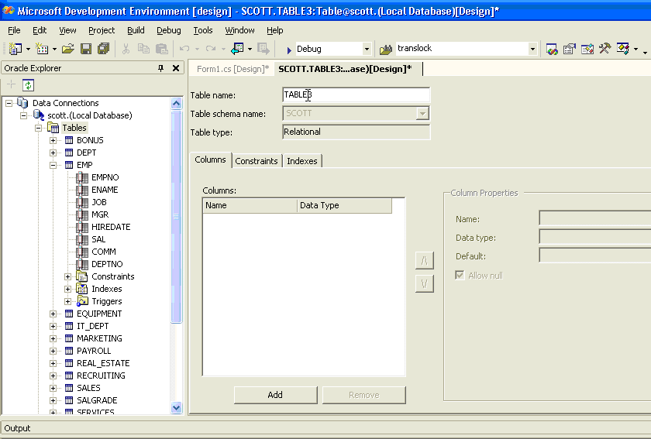
Figure 11: Using Oracle Explorer to create database tables from Visual Studio
You can also use the Oracle Explorer to launch a simple editor to work with stored procedures, triggers, and functions. The editor supports context-sensitive help; you can highlight a work in the PL/SQL stored procedure and press F1 to launch help. Oracle Explorer lets you drag-and-drop stored procedures, views, or tables to generate database-driven code. See Figure 12.
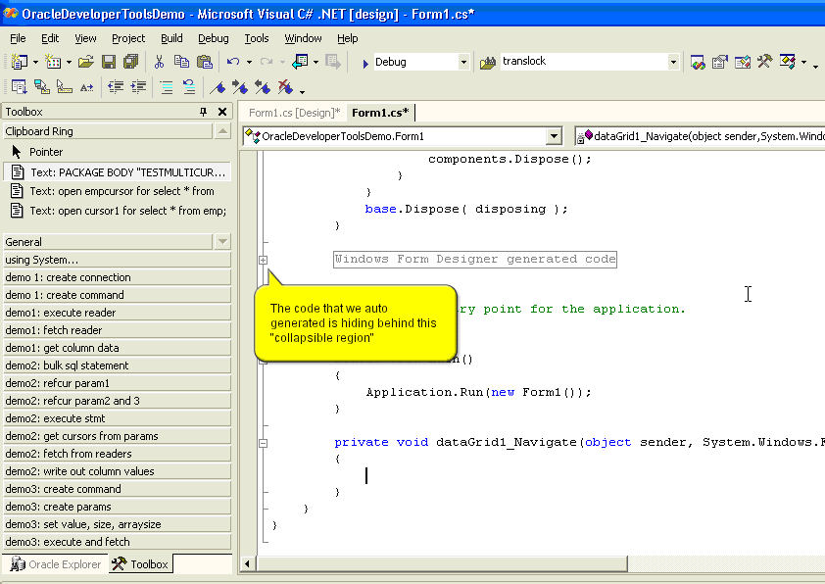
Figure 12: Oracle Developer Tools for Visual Studio .NET

Project support
Oracle 10g has no equivalent to the SQL Server project. So there is no way to manage all the different database objects as a coherent whole through Visual Studio. Oracle does not provide a template for developing applications. There is no way to automatically deploy the database objects to the database through Visual Studio. The lack of Visual Studio project support is one of the major weaknesses in Oracle’s integration with Visual Studio and major setback to developer productivity.

Debugging stored procedures
Oracle’s integration with Visual Studio does not include the ability to debug stored procedures through Visual Studio. Developers will have to use a completely different tool, such as JDeveloper, to debug PL/SQL stored procedures or resort to cumbersome techniques like using trace files. Debugging is a significant component of application development and not having an integrated state-of-the-art debugger is another huge drawback for the .NET Framework developer.

Integration of BI components
Oracle also offers a rich BI platform that includes the following:
- Oracle OLAP Option for analysis
- Oracle Data Mining Option for data mining
- Oracle Reports for designing and generating reports
- Oracle Warehouse Builder for ETL
- Oracle BI Beans for developing OLAP applications
In addition to being extra-cost products, the biggest drawback of Oracle’s BI platform to the developer is that they are not integrated with Visual Studio. The development framework of choice for developing BI applications is JAVA not .NET Framework. Also, the tools provided by Oracle for developing and managing the BI components such as JDeveloper, Oracle Discoverer, and Oracle Enterprise Manager are HTML-based and in no way integrated with Visual Studio.

Integration with Visual Studio: Summary
Oracle has made the right decision in integrating with Visual Studio .NET. The current integration is a step in the right direction, but falls short of the deep and comprehensive integration that exists between SQL Server 2005 and Visual Studio. SQL Server 2005 and Visual Studio are the best combination of a database and IDE on the market today. The seamless integration between the two products lives up to the Microsoft “Better Together” claim.

SOA-Based Application Development

Comparison of XML Support
XML has emerged as the de-facto standard for data interchange for a wide variety of modern applications. It is also a core technology for SOA-based applications and Web services. Databases will have to support these applications by enabling them to store, query, and update XML documents. Both Oracle and SQL Server offer comprehensive support for developing XML-based applications.

Native XML Type and XQuery
Both Oracle and SQL Server have a native XML type, which means that they actually “understand” that a column contains a XML document. This means that:
- They will validate XML documents against an XML schema before storing it in the database.
- Allow stored XML documents to be queried using the industry XQuery query language as well as XPATH.
Note Oracle 10g Release 1 does not support XQuery. Oracle claims that they will support XQuery in Oracle 10g Release 2.
However, some differences exist in the XML support provided by the two databases.

Indexing
Indexing is essential for fast execution of queries. SQL Server 2005 supports B*Tree indexes on elements, values, and paths of the XML field. Indexing greatly speeds up query execution. SQL Server 2005 also supports other indexes to speed up other types of queries to XML data through PATH indexes, PROPERTY indexes, and VALUE indexes. Oracle provides only regular text indexing and functional indexes, that is, no indexing specific to XML.

Updating XML
XQuery as currently defined only supports reading/fetching XML content. It does not define how XML that is stored in the database is updated. Oracle offers two approaches to addressing this issue:
- Replace the entire XML document: If the XML document is stored in the database as a text object, then Oracle will let you replace the entire document with the new document. This is inefficient if the XM document is large and only a small part is being updated.
- Shred the XML document: In this approach, the XML document has to be shredded and stored as an object-relational object in the database. Then standard SQL calls can be used to update the appropriate part of the XML document. This requires that the developer be aware of how the XML document is mapped to the underlying object-relational object.
Clearly, both approaches have their own drawbacks.
SQL Server 2005 addresses this issue by extending XQuery to include update operations. SQL Server 2005 includes a language for adding and deleting subtrees and updating scalar values. This makes working with SQL Server 2005 XML data types easier and more efficient for the developer.

XML schema collections and schema evolution
SQL Server supports the ability to store multiple unrelated XML documents in the same XML column. This feature is enabled by creating an XML SCHEMA COLLECTION which consists of one or more XSD schemas. A SQL Server XML schema collection constrains the types of XML documents that can be stored in the XML column. Users can add new top-level XML schema components and top-level elements to the existing schema namespaces.
This feature provides a graceful way to migrate XML data. If any of these schemas evolve over time and create a new schema namespace, you can add the evolved XML schema to the same XML schema collection. Existing XML instances in an XML column continue to exist as before, while instances conforming to the new schema namespace can be added to the XML column and be indexed.
Oracle does not have a comparable feature. Oracle allows only single-rooted XML instances. In Oracle you can have an “umbrella” schema in which the top-level element type must be modified to accommodate the evolved schema. Only if the schema evolves by derivation, then it does not require any change. Thus, schema evolution is restricted and nonuniform in Oracle.

Comparison of Web Services Support

SQL Server 2005
SQL Server 2005 provides native support for Web services. It can act as a Web service provider as well as a Web service consumer.
Web Service Provider:
SQL Server provides a very simple, easy to use mechanism to allow external applications to invoke stored procedures, Transact-SQL statements, and user-defined functions as Web Services using standard protocol such as SOAP through HTTP. By providing SOAP/HTTP access, even zero-footprint clients (such as Web browsers) can access the database because there is no longer a need to a Microsoft Data Access Component (MDAC) stack on the client device.
Enabling SOAP/HTTP access to SQL Server is very easy for the developer. All they have to do is create a HTTP endpoint and specify all the database objects that are exposed by the endpoint. SQL Server takes care of the rest. Authentication and security are integrated with SQL Server so that only authorized users can invoke the stored procedures. SQL Server makes the most of the kernel mode https.sys driver of Microsoft Windows Server™ 2003 so that there is no need to have IIS installed. This simplifies administration.
Web Service Consumer
Because SQL Server is integrated with the .NET CLR, so it is easy to call-out to external Web services from within the database.
Combined with Visual Studio, SQL Server is a powerful platform for developing and deploying SOA-based applications.

Oracle Database 10g
Oracle Database can also act as a Web service provider as well as a consumer. Oracle provides a tool called JPublisher for simplifying database access from Java and creating Web Services around the database logic. Following is a brief overview of this works.
Web Service Provider
JPublisher can generate Java “wrapper” classes, various database objects such as PL/SQL packages, stored procedures, SQL queries, and server-side Java classes. These JPublisher-generated java classes can be exposed as Web services by the Oracle Application Server Web Services Assembler tool.
Web Service Consumer
Oracle provides two ways to call out to Web services from within the database. The first way is to manually use the SOAP. The second way is to create a Java proxy class using JPublisher. The generated proxy classes can be invoked by Java server-side classes or PL/SQL.

The differences
While both Oracle 10g and SQL Server 2005 can act as Web service consumers and providers, some differences are very significant to a .NET platform developer. These include:
- Oracle Database 10g requires an additional product, Oracle Application Server, to produce and consume Web services. Oracle Application Server has to be purchased separately. Requiring the use of the Oracle Application Server increases the learning curve and reduces developer productivity. As mentioned earlier, SQL Server does not require IIS or any additional product.
- To use the Web service capability of Oracle 10g, a developer must know Java and/or PL/SQL. So clearly it does nothing for the .NET platform developer.
- Oracle’s Web service capabilities are not integrated with Visual Studio in any way. The primary IDE offered by Oracle for this purpose is JDeveloper. Again, this is a significant drawback for the .NET developer.

Comparison of Support for Asynchronous Messaging
Reliable, asynchronous communication between distributed, autonomous program execution units is a key technology required for developing SOA-based applications. Traditionally message queuing systems such as IBM’s MQ Series (now known as WebSphere MQ) were used for this purpose. However, integrating message queuing systems with databases has many advantages. So both Oracle and SQL Server have integrated asynchronous, reliable message queuing into Oracle 10g and SQL Server 2005—Oracle Advanced Queuing and SQL Server Service Broker respectively. An in-depth examination of the features and capabilities are beyond the scope of this paper. Here is a brief summary of the key features common to both Oracle Advanced Queuing and SQL Server Service Broker.
- Both can guarantee the delivery of messages to the destination, exactly once.
- Both allow the sender and receiver to exist in the same database, the same computer, or distributed across a network.
- Both use queues to persistently store messages. The queues are stored completely within the database as tables. Both provide SQL access to the queues. Both can retain messages indefinitely in the queues.
- Both have integrated the message queuing system with the database, so that an external transaction coordinator is not required to coordinate between the queuing system and the database.

The differences
While both databases provide similar core functionality, SQL Server has made it easy to use Service Broker for the casual application developer by providing a higher level abstraction. Oracle Advanced Queuing, as the name indicates offers a queue as the primary metaphor. All of the APIs that use Oracle Advanced Queuing are based on queue operations such as enqueue and dequeue. Its primary interface is JMS—the Java Messaging Service.
SQL Server Service Broker provides a higher level set of abstraction such as dialogs, contracts, and services. Developers do not have to deal with low-level queuing operations, if they don’t want to. Service Broker also supports automatic service program activation, a feature not available with Oracle Advanced Queuing.
Advanced Queuing has many features that are currently not supported by Service Broker such as the publish-subscribe communication model, the ability to transform messages on the way to the subscriber, and the ability to control the delivery schedule.

Comparison of Event Notification Services

SQL Server 2005
Microsoft SQL Server Notification Services enables developers to easily develop and deploy applications that generate and send notifications to users. Notifications are personalized, timely messages that can be sent to a wide variety of devices.
Notifications reflect the preferences of the subscriber. The subscriber enters a subscription to express an interest in information. For example, "notify me when the stock price of Adventure Works reaches $70.00," or "notify me when the strategy document my team is writing is updated."
A notification can be generated and sent to the user as soon as a triggering event occurs, or it can be generated and sent on a predetermined schedule that the user specifies. The user's subscription specifies when the notification should be generated and sent.
Notifications can be sent to a wide variety of devices. For example, a notification can be sent to a user's mobile phone, personal digital assistant (PDA), Microsoft Windows Messenger, or an e-mail account. Because these devices often accompany the user, notifications are ideal for sending high-priority information.

Oracle Database 10g
Oracle does not have anything that is directly comparable to SQL Server Notification Services. To get equivalent functionality, developers will have to combine several technologies from the Oracle database (such as Oracle Advanced Queuing, job scheduling, and triggers) as well technologies from the Oracle Application Server such as the Oracle Application Server Wireless. Oracle Advanced Queuing has a rules engine that can match events to subscribers and the Oracle Application Server Wireless can deliver the events to subscribers using wireless and handheld devices like SQL Server Notification Services can, but it is up to the developer to integrate these systems which translates into more time and cost of delivering such a system.

Comparison of Query Notification Services

SQL Server 2005
SQL Server 2005 introduces notification support for SQL Server queries. You can use this support to send a command to SQL Server, and to request that a notification be generated if executing the same command again produces different results from those obtained initially. You accomplish this by using a dependency object that detects when the underlying data is changed. Commands that are sent to the server through any of the client APIs such as ADO.NET, OLE DB, Open Database Connectivity (ODBC), Microsoft Active Data Objects (ADO), or SOAP may include a tag that requires a notification. For each statement that is executed as part of the request, the server creates a "Notification Subscription" that fires once for each statement that is included in the request. Notifications are delivered through a SQL Service Broker queue that applications can poll, and use activation services or blocking statements that return whenever the notifications are available. Query notifications are useful for enabling the caching of results in applications such as database-driven Web sites.

Oracle Database 10g
Oracle’s version of ADP.NET is Oracle Data Provider for .NET (ODP). ODP does not have anything equivalent to SQL Server Query Notification. To achieve something comparable you will have to combine several products such as the Oracle Web Cache and the Oracle Java Object Cache, both of which are separate products, sold as part of the Oracle Application Server. Neither of these technologies are integrated with Visual Studio .NET. The Java Object Cache, as the name indicates, works only with Java and so provides no benefits to the .NET platform developer.

Comparison Summary

Feature | SQL Server 2005 |  | Oracle 10g R2
CLR Integration
Integration with CLR |  | Yes  (In-process) | Yes  (out-of-process)
Stored procedures in any .NET language |  | Yes | Yes
Triggers in any .NET language |  | Yes | Not Sure
User-defined functions |  | Yes | Not sure
.NET objects stored inside the database |  | Yes | No
Visual Studio Integration
Can view database objects through Visual Studio | Yes  (through Server Explorer) |  | Yes  (through Oracle Explorer)
Ability to debug stored procedures through Visual Studio | Yes |  | No
Support for Visual Studio Project | Yes |  | No
Auto-deployment of database objects through Visual Studio | Yes |  | No
Context-sensitive online help for editing stored procedures | No |  | Yes
BI technologies integrated with Visual Studio | Yes |  | No
SOA Application Development
XML Support
Native XML type in the database | Yes |  | Yes
XQuery support | Yes |  | Yes
XML update functions | Yes |  | No
XML indexes for improved performance | Yes |  | No  (Text and Functional indexes only)
Web Services
Database as a Web service producer | Yes (built-in HTTP endpoint requires no additional Web server) |  | Yes (requires extra-cost Oracle Application Server)
Database as a Web service consumer | Yes (with .NET CLR integration) |  | Yes (but requires extra-cost Oracle Application Server)
Integration with Visual Studio | Yes |  | No
Primary programming language | Any CLR language |  | Java
Asynchronous Message Queuing
Product name | SQL Server Service Broker |  | Oracle Advanced Queuing
Guaranteed, exactly once delivery | Yes |  | Yes
Queues stored in database | Yes |  | Yes
Transactional integration with database | Yes |  | Yes
Publish-Subscribe communication model | No (point-to-point only) |  | Yes
Abstraction level | Queues, messages |  | Services, Dialogs, Contracts
Query Notification
Query Notification through ADO.NET | Yes |  | No  (Equivalent functionality requires Oracle Web Cache and Oracle Java Object Cache; these are features of the Oracle Application Server Product)

About the Author
Mitch Ruebush, MCSD, MCDBA, MCSE, MCT, is a .NET Architect for ING DIRECT, fsb. He is a Microsoft Regional Director and Visual C# MVP and has been developing on various Windows and UNIX platforms for 15 years. He has presented at Microsoft DevDays, Microsoft Security Summit, Visual Studio .NET 2002 Launch, user group meetings, and MSDN webcasts. He currently believes that C# and .NET development is the most delightful platform to develop on, but he also designs and develops solutions in C, C++, Java, VB, VB.NET, PL/SQL and T/SQL on Windows and Linux/UNIX. He is coauthor on MCAD/MCSD: Visual Basic .NET Windows and Web Applications Study Guide, MCAD/MCSD: Visual Basic .NET XML Web Services and Server Components Study Guide, and MCSE: Windows Server 2003 Network Security Design Study Guide for Sybex.

This article was developed in partnership with A23 Consulting.
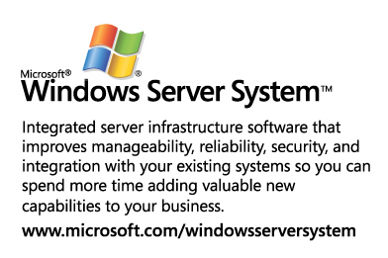

For more information, search for “Oracle Developer Tools” on the Oracle Web site.
For more information on Web services, see “Overview of Native XML Web Services for Microsoft SQL Server 2005” on the Microsoft Developer Network (MSDN).
For more information on JPublisher, search for the article called “Simplifying Database Access” on the Oracle Web site.
For more information on Oracle Advanced Queuing, search for “Advanced Queuing (AQ)” on the Oracle Web site.
For more information on SQL Server Service Broker, see “A First Look at SQL Server 2005 Service Broker on MSDN.”
For more information, search for “Oracle Application Server Wireless” on the Oracle Web site.
For more information, see “Query Notifications in ADO.NET 2.0” on MSDN.
For more information, search for “Oracle Application Server Web Cache 10g” on the Oracle Web site.
For more information, search for “Oracle Java Object Cache” on the Oracle Web site.

