
Microsoft Office Home and Student 2007
February 2006

Table of Contents

Cover is for
position only

Overview of Microsoft Office Home and Student 2007 1
Create High-Quality Documents 2
Work with Enhanced Reliability and Security Features 2
Find Menus, Commands, and Help More Easily 3
Organize Your Information and Notes in One Place 3
Create High-Quality Documents 4
New Results-Oriented Menus and Toolbars 4
Improved Advanced Formatting 5
New Charting and Graphics Tools 6
Improved Templates and New Fonts 8
Improved Quick Styles 9
New Preview Galleries 10
New Custom Slide Layouts 11
Work with Enhanced Reliability and Security Features 12
Improved Document Recovery Tool 12
New Digital Signature 12
New Document Inspector 12
Find Menus, Commands, and Help More Easily 14
New Command Tabs 14
Improved Tutorials 15
Improved and Easy-to-Use Help 15
Improved Tooltips 16
Organize Your Information and Notes in One Place 17
New Organization and Navigational Pane 17
Improved Ways to Find Many Types of Information 18
Improved Tools for Getting More Organized 19
Summary 20
Resources 21
System Requirements 22

Overview of Microsoft Office Home and Student 2007

Welcome to Microsoft® Office Home and Student 2007, the exciting new version of the familiar and widely used productivity software. Office Home and Student 2007 is the software suite that empowers you to quickly and easily create great-looking documents, worksheets, and presentations and manage your notes and information at home. With improved menus and tools, enhanced graphics and formatting capabilities, new time management tools, and more reliability and security, Office Home and Student 2007 makes it easier and more enjoyable for you to get things done.
Office Home and Student 2007—consisting of Microsoft Office Word 2007, Microsoft Office Excel® 2007 spreadsheet software, the Microsoft Office OneNote® 2007 note-taking program, and the Microsoft Office PowerPoint® 2007 presentation graphics program—offers easy access to a comprehensive set of powerful tools and resources. The redesigned results-oriented menus and toolbars, one of the most significant visual makeovers in the history of the Microsoft Office system, help you access the commands you need while you work.
This guide provides an overview of new and improved features in Office Home and Student 2007. You’ll also see examples of Office Home and Student 2007 in action that demonstrate its powerful new capabilities.
Office Home and Student 2007 in Action
There’s always someone in the Alexander family in front of the computer. David tracks the house budget and taxes with Office Excel 2007 worksheets. His wife, Michelle, uses Office Word 2007 to work on her book of short stories and save family photos. Their children, Sean and Michael, use the computer to do homework, play games, and listen
to music.

Create High-Quality Documents
Office Home and Student 2007 simplifies the way you work with documents. The redesigned, results-oriented menus and toolbars enable you to quickly and easily create high-quality documents, worksheets, and presentations. Enhanced graphics and formatting capabilities help make your user experience more enjoyable and productive.
- New! Results-oriented menus and toolbars make it more straightforward to find and use the product features you use most to get the results you want.
- Improved! Formatting makes it easier to consistently format documents.
- New! Text effects and diagram and graphics galleries enable you to preview and format items.
- Improved! Quick Styles can be used to create a consistent appearance across Office Word 2007 documents, Office Excel 2007 worksheets, and Office PowerPoint 2007 presentations.

Work with Enhanced Reliability and Security Features
Powerful new security features enable you to work with confidence.
- Improved! Automatic document recovery helps retrieve Office Word 2007 documents you were working on during a system crash.
- New! Digital Signature can be added to your document to help others verify that content has not been changed since it was published.
- New! Document Inspector protects your private information by automatically removing personally identifiable information, comments, and tracked changes from Office Word 2007 documents.

Find Menus, Commands, and Help More Easily
Office Home and Student 2007 offers improved menus and tools that significantly simplify how you access commands. Commonly used commands appear on the results-oriented menus and tools in a tabbed “Ribbon” instead of in drop-down menus. In addition, an enhanced Help system, including tutorials with step-by-step instructions, enables you to quickly find answers to your questions.
- New! Command tabs on the results-oriented Ribbon reveal commonly used commands that previously appeared only in lengthy drop-down menus.
- Improved! Tutorials provide you with step-by-step instructions for common tasks.
- Improved! The easy-to-use Help system offers a smooth transition between the Help menu in the Microsoft Office system and Help on the Internet (when you’re connected).
- Improved! Tooltips are context-sensitive, changing automatically depending upon the task that you are trying to complete.

Organize Your Information and Notes in One Place
Office Home and Student 2007 helps you manage the increasing amount of information you face every day. With new and improved features in Office OneNote 2007, you can gather, store, organize, and find virtually any type of information in one place. As a result, you can stay on top of everything and work more efficiently.
- New! The organization and navigational pane allows you to quickly and easily navigate the sections in your notebook.
- New! Drag-and-drop functionality has the same look and feel as Microsoft Office Outlook® 2007, making it familiar and easy to use.
- Improved! Powerful keyword search enables you to quickly find nearly any type of information you are looking for, including handwritten notes, the text in pictures, and spoken words in audio recordings.

Create High-Quality Documents
Office Home and Student 2007 makes it easier than ever to format your documents, worksheets, and presentations. New and improved features such as enhanced graphics and advanced formatting capabilities help you deliver high-quality documents in lightning-fast time. In addition, new features in Office PowerPoint 2007 make it easier to share and reuse presentations, providing a more enjoyable experience.

New Results-Oriented Menus and Toolbars
The richer, redesigned menus and toolbars reflect an overall effort by Microsoft to deliver a more user-driven product. Rather than rethinking the product from a feature-oriented viewpoint, Microsoft focused Office Home and Student 2007 on the user’s results-oriented perspective. The end product delivers one of the most significant makeovers in the history of the Microsoft Office system. The new menus and toolbars are more intuitive and offer more easily accessible features. It’s less about commands and more about results. At the same time, although the look is very new, its evolution from previous versions of the Microsoft Office system will make it feel extremely familiar.
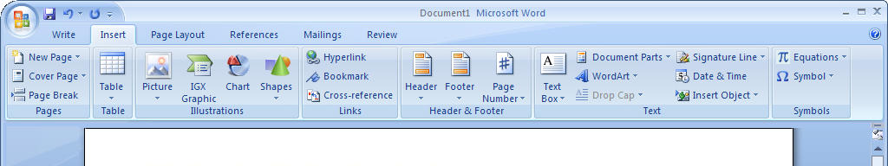
Figure 1: Office Word 2007 task-based user interface
The new results-oriented menus and toolbars significantly simplify how you author documents by:
- Making the experience more predictable, with less-complicated features and less guesswork.
- Maximizing your workspace and being less intrusive by not popping up images and dialog boxes over the top of your work.
- Putting a majority of the most commonly used commands on the first tab so you don’t have to dig for commands in lengthy drop-down menus.
Office Home and Student 2007 in Action
Michelle serves on the Parent Teacher Association (PTA) board for her children’s school and volunteers at the zoo. She uses Office Home and Student 2007 to write letters to parents and design zoo flyers. Although comfortable with the menus in previous versions of the Microsoft Office system, she was frustrated with having to hunt down commands in the drop-down menus. With the redesigned results-oriented menus and toolbars in Office Home and Student 2007, all of the tools she needs become available automatically when and where she needs them. As a result, she can spend less time on formatting documents and more time doing what is important to her.

Improved Advanced Formatting
With the addition of more consistent numbering, bullet, and table features in Office Home and Student 2007, you won’t have to waste time formatting and reformatting your Office Word 2007 documents. Office Home and Student 2007 simplifies document formatting by:
- Making it possible for you to create and apply Quick Formats for text and tables with a single click.
- Quickly providing previews of your formatting changes in galleries.
- Maintaining formatting across Microsoft Office system programs when you copy text or tables from one program to another.
- Providing more consistent and stable bullet and number formatting.
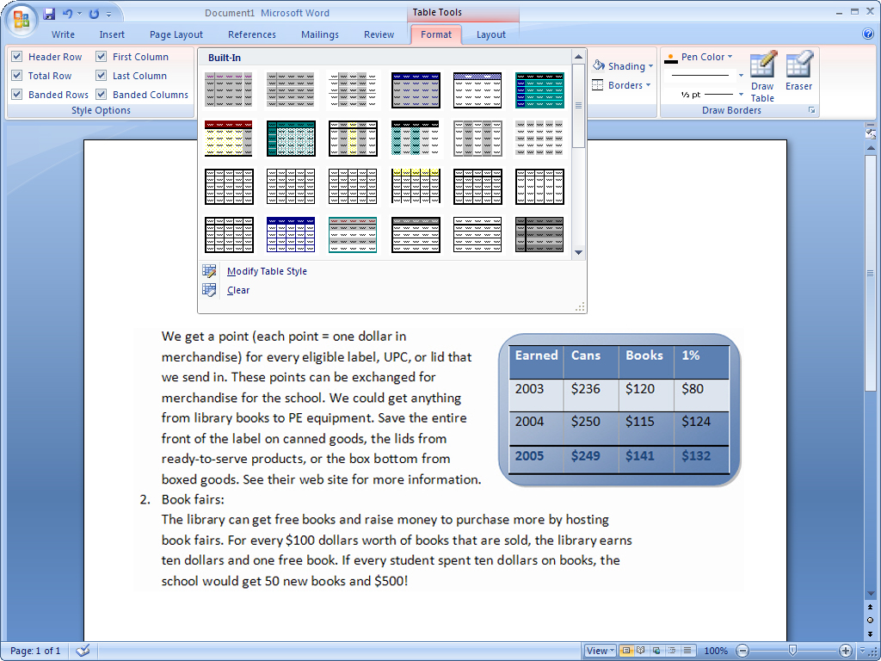
Figure 2: Table formats in Office Word 2007

New Charting and Graphics Tools
Improved graphics capabilities in Office Home and Student 2007 help you to quickly produce better-looking documents, worksheets, and presentations. With Office Home and Student 2007, you can give your documents and worksheets a more professional look by using rich design and typography tools including:
- 3-D effects.
- Shadows, glows, and blurs.
- A gallery of many standard chart and diagram types.
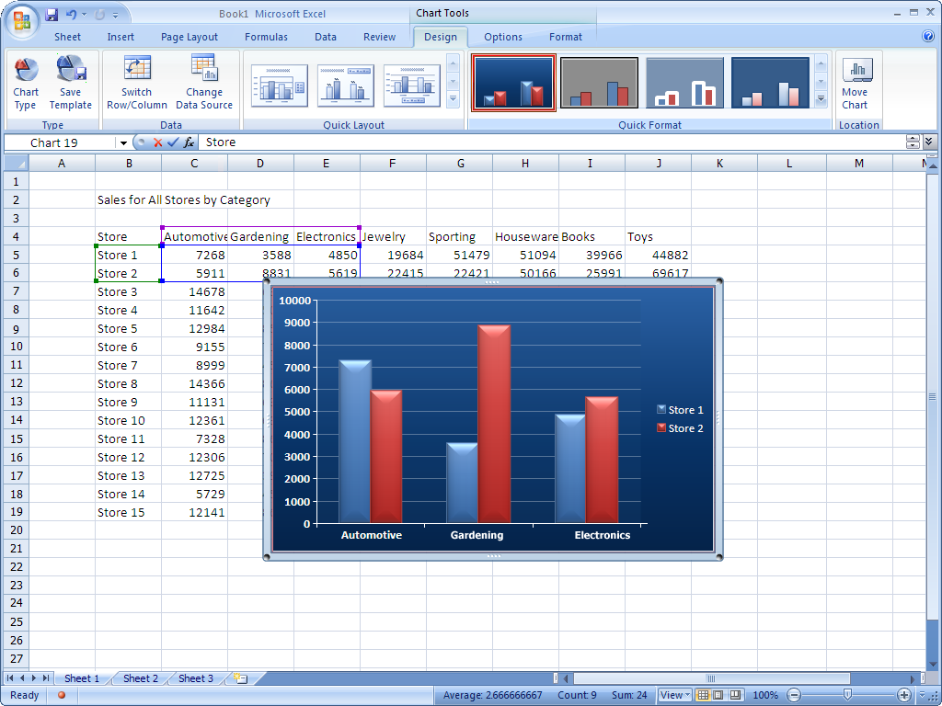
Figure 3: Charting tools in Office Excel 2007
Office Home and Student 2007 in Action
Michael used to find all schoolwork boring. Now he’s excited about working on his presentation for his fourth grade class about the three branches of the United States federal government. He has already written the paper, but that’s only part of what he wants to do. He’s looking for that “wow” factor to win over his peers. Right now, he’s adding sound effects in certain places and using 3-D effects to make his work come
alive on the screen. He never thought that doing assigned work could offer such an interesting challenge.

Improved Templates and New Fonts
New and improved out-of-the-box templates in Office Home and Student 2007 enable you to create professional-looking documents more quickly and easily. You can either get started with the templates that are included in the product or search the preformatted templates available at Microsoft Office Online. In addition, Office Home and Student 2007 includes new and improved fonts such as Cambria that make on-screen reading easier.
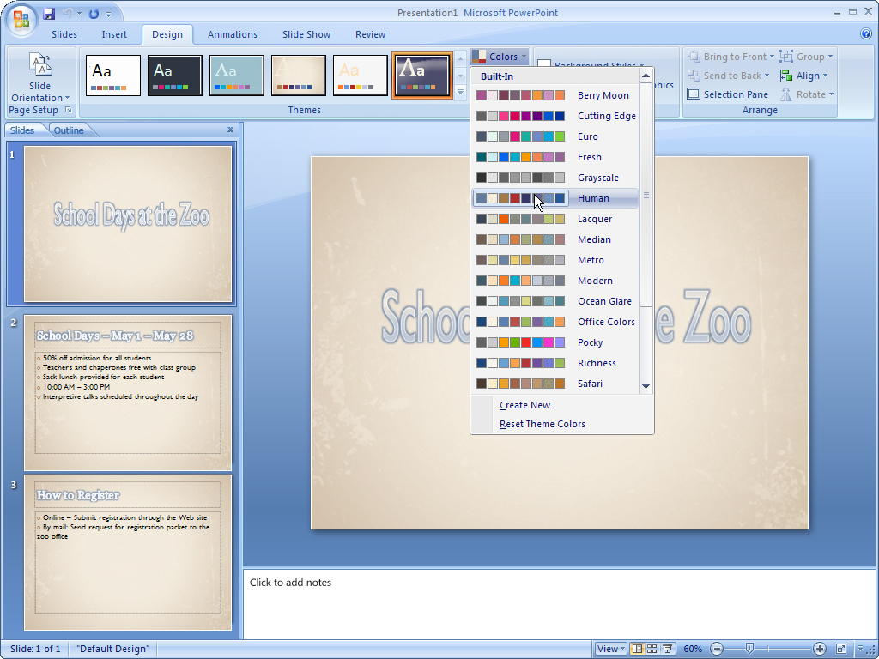
Figure 4: Slide templates and color gallery in Office PowerPoint 2007

Improved Quick Styles
Quick Styles is an improvement that helps you maintain a consistent look among your Office Word 2007 documents, Office Excel 2007 worksheets, and Office PowerPoint 2007 presentations. This predictability means that when you copy tables and objects between programs, the items maintain their appearance. As a result, working simultaneously with different programs becomes more consistent and less frustrating.
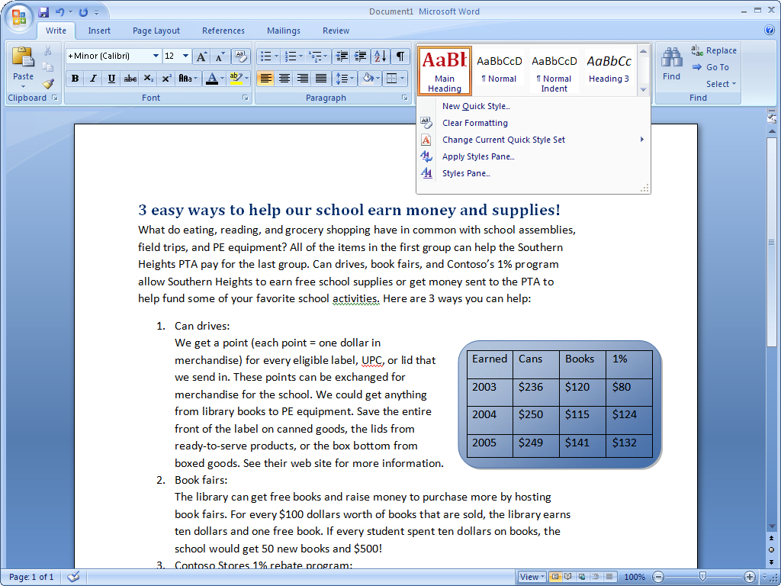
Figure 5: Quick Styles in Office Word 2007
Office Home and Student 2007 in Action
David and Michelle are considering building an addition to their house. They use Office Excel 2007 to analyze and track the projected costs. They also use Office Word 2007 documents and Office PowerPoint 2007 presentations to record their design ideas and logistics. The new Quick Styles in Office Home and Student 2007 help ensure that all information transferred between programs maintains its appearance. As a result, David and Michelle can quickly shuffle information between different programs, knowing that what they see is what they will get. This helps them plan more efficiently and with greater confidence.

New Preview Galleries
We all want to create the highest-quality documents possible in the shortest amount of time, yet accomplishing this often requires experimenting with different styles and formats. Office Home and Student 2007 enables you to quickly preview proposed changes to your document. You can actually view formatting choices right inside your document while you’re working on it, without having to repeatedly search through drop-down menus. By test-driving your proposed formatting, you can save time and experiment more easily. The end result is a quickly created document that looks the way you want it to look. These galleries can be found in Office Word 2007, Office Excel 2007, and Office PowerPoint 2007.
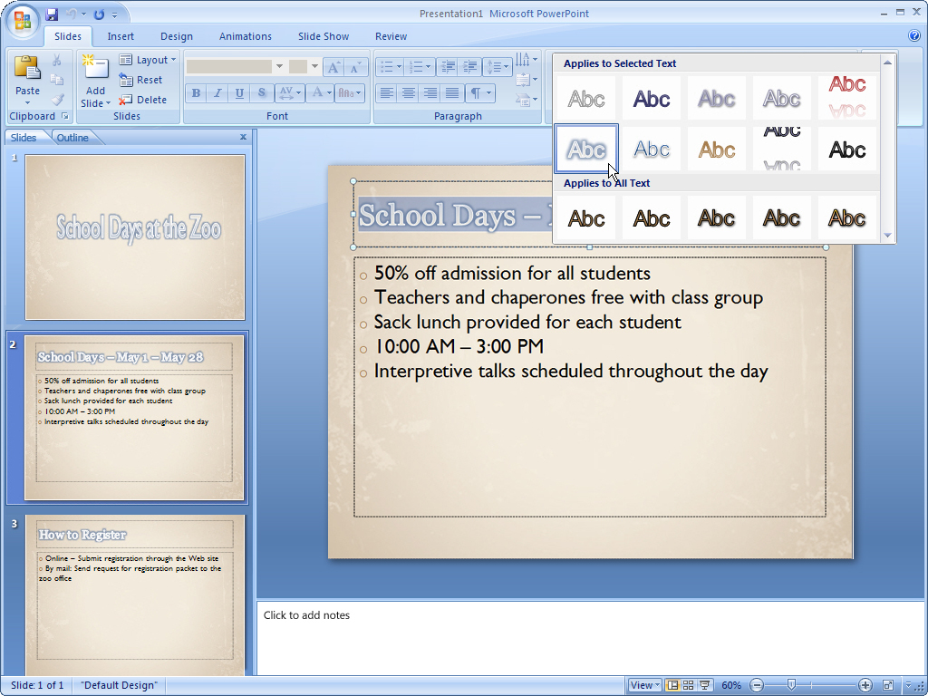
Figure 6: Word Art Gallery in Office PowerPoint 2007
Office Home and Student 2007 in Action
Michelle wants to design a baby shower invitation for her sister. She knows the details of the event but can’t decide upon the design. With the formatting galleries in Office Home and Student 2007, she can preview different fonts simultaneously within her document before making a decision. For help with margins, she can quickly preview visual images of multiple options. She finds that these new preview features make her feel more comfortable experimenting with different looks.

New Custom Slide Layouts
The new Custom Slide Layouts feature in Office PowerPoint 2007 frees you from confining prepackaged layouts. Now you can quickly create and save information-rich layouts with multiple charts, tables, and text. You can then save these layouts as templates for future presentations.

Work with Enhanced Reliability and Security Features
Office Home and Student 2007 offers new and improved features such as Document Recovery and Document Inspector that give you peace of mind by automatically recovering documents after a system crash and giving you the option to remove personally identifiable information from your documents before you share them with others. Digital Signature verifies that no one has altered or edited your document since you created it.

Improved Document Recovery Tool
The Document Recovery tool in Office Home and Student 2007 better protects your documents against sudden computer crashes. If a Microsoft Office system program encounters a problem or stops responding, you can now close the program in a controlled manner. The files you had open are analyzed for errors, and whenever possible, recovered. You can then view any repairs that were made to the files.

New Digital Signature
Office Home and Student 2007 helps you create a digital signature that lets others know that your document has not been modified since you created it. Simply add a signature line to each Office Word 2007 document. This line will require a digital signature for any of your documents that are edited by others. People reading digitally signed documents can easily verify that your document has not changed since it was signed.

New Document Inspector
The Office Home and Student 2007 Document Inspector provides an easy and efficient way to protect your personal information. This tool automatically searches your documents for comments, revisions, tracked changes, headers and footers, and hidden text. You can delete your choice of personal information in a matter of seconds. When you distribute your documents, you can be confident that no unwanted personally identifiable or other information is accidentally included.
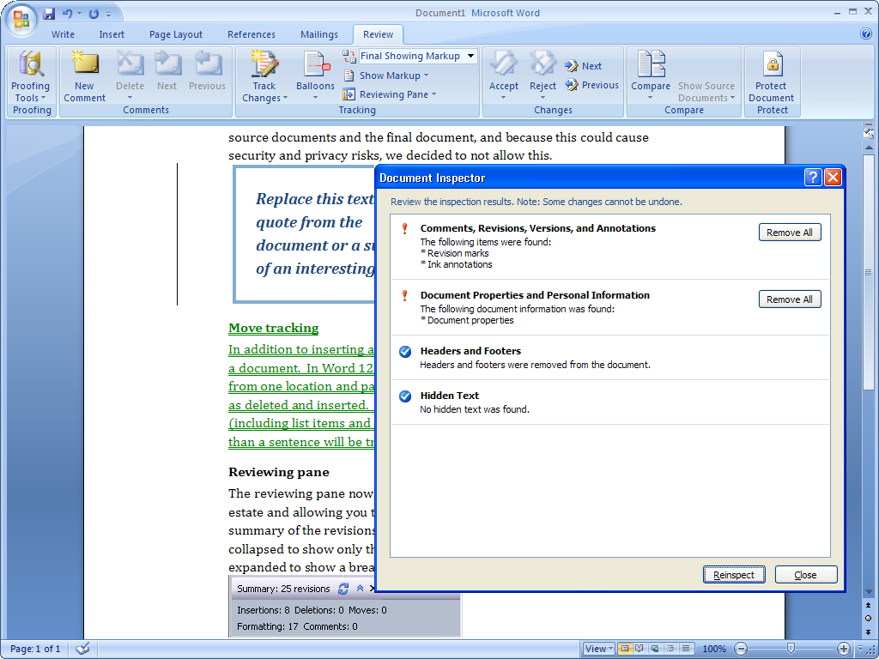
Figure 7: Document Inspector in Office Word 2007
Office Home and Student 2007 in Action
Twice a year, the Alexanders send a family newsletter to friends and family. Michelle used to reread the finished product several times because she was afraid that she’d inadvertently left something in the letter that should have been edited out. Now, with Office Home and Student 2007, she can use Document Inspector to search her documents and automatically remove personal information such as tracked changes before sending the documents. As a result, Michelle sleeps better at night.

Find Menus, Commands, and Help More Easily
Office Home and Student 2007 offers improved menus and tools that make document creation easier, faster, and more intuitive. The new design emphasizes user efficiency and feature discoverability, helping reduce your frustration level by quickly finding relevant help for your questions. Tutorials and templates help you get started and understand more about the software’s capabilities.

New Command Tabs
Most people use only a small percentage of the commands available in Microsoft Office system programs. With the new results-oriented menus and toolbars in Office Home and Student 2007, you can learn more about the capabilities of the Microsoft Office system through command tabs, which replace the previous drop-down menus. Commonly used commands once buried are now available at your fingertips. You get access to the right tools when you need them, helping you learn more and get the results you want.
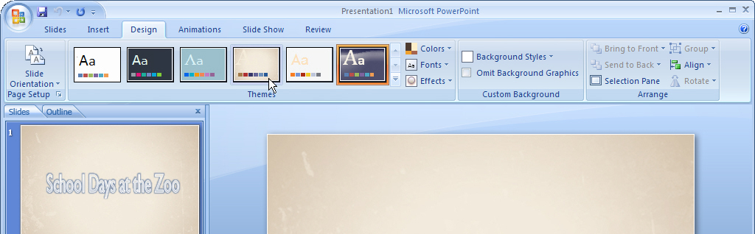
Figure 8: Design command tab in Office PowerPoint 2007
Certain sets of commands are relevant only when editing objects of a particular type. These sets are known as contextual command tabs. The tabs change automatically depending upon the task that you are trying to complete.
Office Home and Student 2007 in Action
Michelle rarely has enough time. As a result, she has never taken the time to discover all the functionality available in the Microsoft Office system. With hundreds of commands in Word alone, this means she hasn’t benefited from capabilities that could simplify and improve her experience. By using the contextual command tabs in Office Home and Student 2007, she can get fast access to commands that relate to what she is doing at the moment. Now she can complete whatever she is working on faster than before.

Improved Tutorials
An improved Getting Started experience in Office Home and Student 2007 significantly reduces the learning curve for new users. Tutorials offer step-by-step instructions for using your Microsoft Office system software. Getting Started brings to the surface additional Help options in the product, such as Microsoft Office Online integration.

Improved and Easy-to-Use Help
Tired of wasting your time trying to find answers to your functionality questions? Office Home and Student 2007 provides more direct links to Help content than ever before. Take advantage of the smooth transition between the Help menu in the product and Help on the Internet (when you’re connected).

Improved Tooltips
Office Home and Student 2007 offers larger, more informative tooltips than were available in previous versions of the Microsoft Office system. Tooltips provide quick access to information about a command directly from the command’s location. Popping up when you rest your mouse pointer on any menu item or command, a tooltip often gives you enough information about a feature to enable you to use it immediately without further assistance. This capability gives you easy access to all of the functionality of Microsoft Office system menus and tools. As a result, you can save yourself time and become more productive.
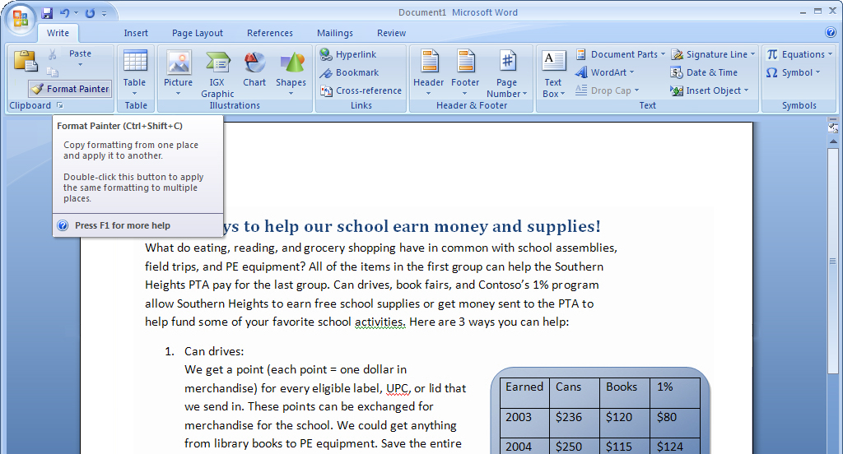
Figure 9: Format Painter tooltip in Office Word 2007

Organize Your Information and Notes
in One Place

Office OneNote 2007, included in Office Home and Student 2007, enables you to capture, organize, and reuse your notes electronically. Gather and manage almost any type of information—typed text, audio, video, digital handwritten notes, digital hand-drawn diagrams and pictures, graphics and photos from the Web, and information from other Microsoft Office system programs—in one place. With Office OneNote 2007, you’ll work more efficiently by getting quick access to the information you need.

New Organization and Navigational Pane
Office OneNote 2007 comes with a new organizational and navigational pane that enables you to easily navigate your notebook. Quickly capture your information in multiple ways and then organize and reuse that information according to your needs. Features such as drag-and-drop functionality save you time by helping you work with your notes more productively.
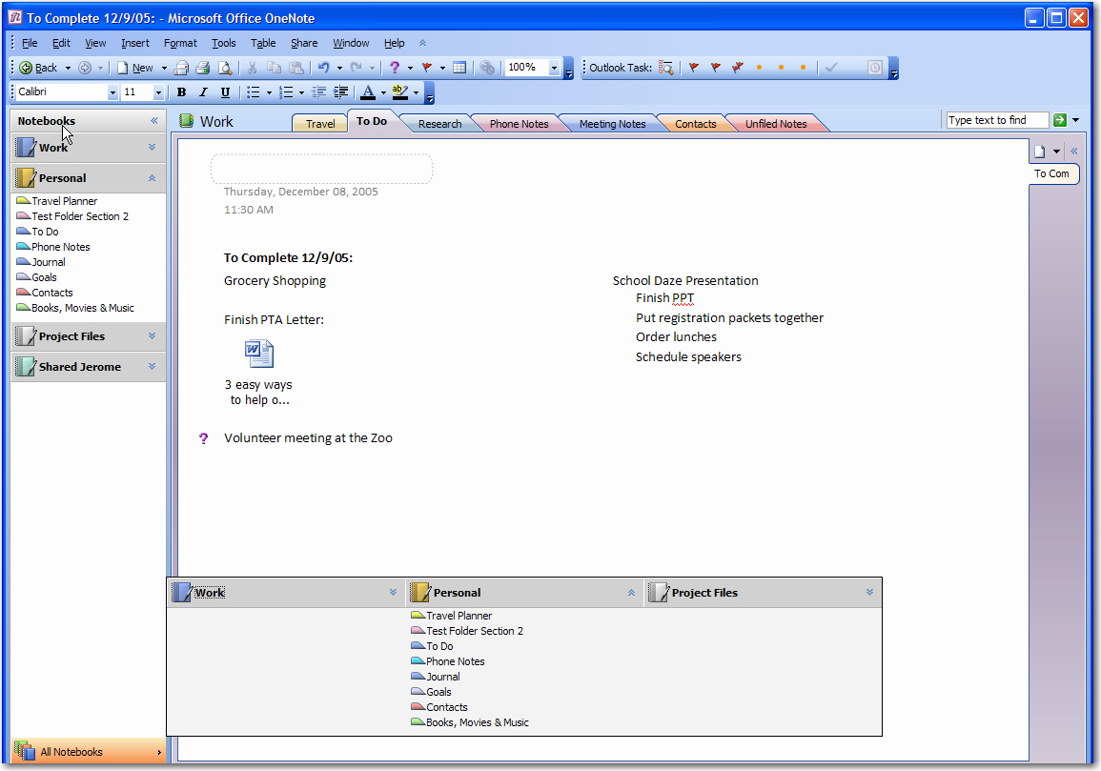
Figure 10: Office OneNote 2007 with expanded Navigation pane

Improved Ways to Find Many Types of Information
With Office OneNote 2007, you can quickly find nearly any type of information you are looking for, which saves you time and helps you be more productive. The powerful new search tool lets you gather and manage typed text, audio, video, and notes from all the various Microsoft Office system programs, as well as others—in one place. Search handwritten notes, the text in pictures, scanned documents, even digital hand-drawn diagrams to locate what you need. You can also redefine or change the scope of your search at any time.

Improved Tools for Getting More Organized
Office OneNote 2007 enables you to rearrange, separate, or combine content anywhere on the page. You can create as many folders, sections, and pages as you want, and then customize and organize them according to your needs.

Other exciting organizational features within Office OneNote 2007 include the following:
- Track important action and to-do items with more customizable note flags.
- Timestamp notes on the page so you know when they were taken and so you can track your information more easily.
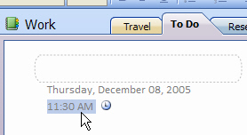
Figure 11: Timestamp in Office OneNote 2007

- Reuse your notes in other Microsoft Office system programs.
- Create individual notebook sections for each project you work on.
Office Home and Student 2007 in Action
David is interested in genealogy. He hopes to pass on his family’s history to his children. He uses Office OneNote 2007 to gather and organize all his research in a single location. This research includes audio, video, scanned documents, even information downloaded from the Internet. For example, he digitally recorded interviews with relatives and dragged census records from genealogy Web sites into his Office OneNote 2007 notebook. He also sends his notes as e-mail messages (when connected to the Internet) directly from Office OneNote 2007 to relatives around the country. He hopes that by distributing and sharing these notes with other family members, they will, in turn, remember more. If it weren’t for Office OneNote 2007, he doesn’t think this family project would be possible.

Summary
Office Home and Student 2007 delivers a new and exciting software suite that provides you with all the essential tools you need to quickly and easily create great-looking documents, worksheets, and presentations at home. Focusing its efforts more on results than on features, Microsoft has developed a product that makes it easier and more enjoyable for you to get things done. You get the tools you need to quickly deliver the quality outcome you want. You can also coordinate your time and tasks in a simpler, more efficient manner. The end result is that your computer tasks are a lot easier and more fun.

Resources
For more information about Office Home and Student 2007, please refer to the following resources:
Office Home and Student 2007 Overview
http://www.microsoft.com/office/preview/suites/home/overview.mspx
Office Home and Student 2007 Demo
http://www.microsoft.com/office/preview/suites/home/demo.mspx
Office Home and Student 2007 Top 10 Benefits (Reasons to Upgrade)
http://www.microsoft.com/office/preview/suites/home/top10.mspx
Office Home and Student 2007 FAQs
http://www.microsoft.com/office/preview/suites/home/faq.mspx
Office Home and Student 2007 Highlights Tab
http://www.microsoft.com/office/preview/suites/home/highlights.mspx
Office Home and Student 2007 New Interface Tab
http://www.microsoft.com/office/preview/suites/home/newui.mspx

System Requirements
For complete system requirements, visit www.microsoft.com/office/preview/beta/sysreq.mspx.
This document is developed prior to the product’s release to manufacturing, and as such, we cannot guarantee that all details included herein will be exactly as what is found in the shipping product. The information contained in this document represents the current view of Microsoft Corporation on the issues discussed as of the date of publication. Because Microsoft must respond to changing market conditions, this document should not be interpreted to be a commitment on the part of Microsoft, and Microsoft cannot guarantee the accuracy of any information presented after the date of publication. The information represents the product at the time this document was printed and should be used for planning purposes only. Information is subject to change at any time without prior notice.

This document is for informational purposes only. MICROSOFT MAKES NO WARRANTIES, EXPRESS OR IMPLIED, IN THIS DOCUMENT.

© 2006 Microsoft Corporation. All rights reserved.

Microsoft, Excel, the Office logo, OneNote, Outlook, and PowerPoint are either registered trademarks or trademarks of Microsoft Corporation in the United States and/or other countries. All other trademarks are property of their respective owners. The example companies, organizations, products, domain names, e-mail addresses, logos, people, places, and events depicted herein are fictitious. No association with any real company, organization, product, domain name, e-mail address, logo, person, places, or events is intended or should be inferred.

Visit Office Online at http://office.microsoft.com
Requires Tablet PC capability.

