Identifying Server Candidates for Virtualization
Situation
For several years, Microsoft IT was aware that the number of servers in its data centers was growing rapidly, while utilization of these servers was very low. Many business groups were buying new servers based on personal desire and historical expectations, rather than based on need. As a result, the data centers at Microsoft had essentially reached their capacity for space and power by the summer of 2007.
Solution
Microsoft IT has identified virtualization as one of the prime strategies to address the issues of server underutilization and data-center capacity. The goal for Microsoft IT was to have 25 percent of servers running as virtual machines by June 2008 Microsoft IT developed the RightSizing initiative to identify servers that could be virtualized. Microsoft IT used System Center Operation Manager 2007 and Microsoft Operations Manager 2005 to gather server performance data and created tools to track virtualization progress.
Benefits
- The total number of physical servers deployed in data centers will decrease.
- The amount of space and power used in the data centers will decrease.
- Microsoft will save millions of dollars in direct hosting costs.
Products & Technologies
- Microsoft Operations Manager 2005 and Microsoft System Center Operations Manager 2007
- Virtualization
- Microsoft Virtual Server 2005
- Hyper-V
Published: June 2008
Like many organizations, Microsoft Information Technology (Microsoft IT) is using virtualization to reduce space and power consumption in its data centers, and to ensure that servers are utilized appropriately. To identify the servers that are the best candidates for virtualization, Microsoft IT developed the RightSizing initiative. This initiative identifies server candidates and communicates the virtualization strategy to the Microsoft business groups.
Situation
For several years, Microsoft IT was aware that the number of servers in its data centers was growing rapidly, while server utilization was very low. Microsoft has about 13,000 servers located in data centers or managed lab facilities, which provide computing power to 550 buildings in 98 countries.
In September 2005, the average processor utilization for Microsoft data center servers was only 9.75 percent. By estimating processor demands against improvements in processor capability, Microsoft IT projected that by 2008, processor utilization could be as low as 2 percent. One of the goals of the RightSizing initiative was to ensure that processor utilization did not continue to decrease.
During this same time, many Microsoft business groups were buying new servers based on personal desire, preconceived expectations, or similar prior purchases, rather than need. For example, business groups that had always purchased mid-size servers to run business applications were continuing to buy mid-size servers without any evaluation of server capacity or utilization. However, a mid-size server purchased in 2008 has at least six times as much processing power as a mid-size server purchased in 2005. In many cases, servers that were running at less than 5 percent utilization and reaching end of life were being replaced by servers that were several times more powerful, without increasing the server workload.
The issue was exacerbated by the number of business groups purchasing servers and the lack of capacity planning, either within the business group or across the corporation. In 2005, Microsoft had up to 40 different business groups that could place hardware in corporate data centers, yet many of these business groups did not have a consistent planning process for purchasing hardware. In addition, each business group operated autonomously; no planning occurred for hardware capacity across business groups.
Solution
Microsoft IT identified virtualization as one of the prime strategies to address the issues of server underutilization and data-center capacity. By using Microsoft® Virtual Server 2005 to implement virtualization on servers running the Windows Server® 2003 operating system, Microsoft IT could run multiple virtual machines on a single physical server. Because many of the servers (particularly in the development and test lab environment) were running at extremely low server utilization, Microsoft IT could run as many as 25 virtual machines on one physical server in a lab environment, and run up to 10 virtual machines on one physical server in a production environment.
This solution presents significant benefits:
- By deploying virtual machines rather than physical computers, the total number of servers in the data centers would decrease rather than continuously increase.
- By deploying 25 lab or 10 production virtual machines (each replacing a physical server of two to four rack units) on one physical server of four rack units, the amount of space used in the data center would significantly decrease.
- By implementing virtual machines, the power required to run the servers would significantly decrease. Microsoft IT has estimated that on average, a virtual machine with typical utilization requires about 90 percent less power than a physical server.
The goal for Microsoft IT was to have 25 percent of both production servers and Microsoft IT–managed lab servers running as virtual machines by June 2008. By May 2008, Microsoft IT was close to achieving that goal, with 3,000 virtual servers running in the data centers and managed lab environments. Microsoft has set a further goal of running 50 percent of production and managed lab servers on Windows Server® 2008 and Hyper-V™ technology by June 2009.
The potential cost savings to Microsoft are hard to ignore. One estimate is that if Microsoft IT virtualizes 2,500 servers, it will save $7 million US in direct hosting costs per year. By year three, the cost savings will grow to $20 million per year, because the 2,500 servers will not need to be replaced with new physical hardware.
Implementing the Solution
To address the issues regarding data-center space and server utilization, Microsoft IT started the Compute Utility strategy in the summer of 2005. A key component of this strategy is the RightSizing initiative. These efforts promote new models for deploying servers, including virtualization. An important element in the RightSizing initiative is identifying proposed server purchases that are candidates for virtualization, and redirecting those purchases to an offering of a virtual machine platform.
Note: For more information about the tools and processes that Microsoft IT uses to encourage business groups to adopt virtualization, refer to the IT Showcase article "Virtualization Strategy Provides Tools, Processes, and Compliance Capabilities to Enhance Business Support and Drive Adoption."
Compute Utility Strategy
Microsoft IT implemented the Compute Utility strategy to remove the concept of server ownership for business groups and replace it with a concept of purchasing computing capacity. With this strategy, Microsoft business groups define their computing capacity requirements for the applications that they need to run their business, and then Microsoft IT focuses on meeting the computing capacity requirements.
Microsoft IT uses the Standard Performance Evaluation Corporation (SPEC) benchmarks to assign a compute unit to each server. The compute unit is a measure of the computing capacity for a server: A typical high-end server may have 160 to 180 compute units. Microsoft IT uses this value to match computing capacity with the business requirements. For example, if a business application is running on an older server with 40 compute units, and that server is only 20 percent utilized, replacing that server with new hardware that has 160 compute units may decrease the utilization to less than 5 percent.
If a physical server is the only way to meet the business requirements, Microsoft IT provides a physical server. However, in many cases, a virtual machine can amply meet business requirements. The Compute Utility strategy attempts to create a level of abstraction for the business group; the group is now purchasing computing capacity and space on a storage area network, not an actual physical server.
Note: The benchmarks that Microsoft originally used, the SPEC CPU2000 – CINT2006 Rates – Baseline Rates, have been retired. Microsoft IT is now using the SPEC CPU2006 – CINT2006 Rates – Base Results. For more information about the SPEC benchmarks and ratings for individual servers, visit the Standard Performance Evaluation Corporation Web site at http://www.spec.org.
RightSizing Initiative
The RightSizing initiative is one component of a broader Compute Utility strategy and has two goals. The first goal is to identify servers that would make good candidates for virtualization, and then to encourage business groups to replace those physical servers with virtual machines. The second goal is to ensure that if a business group requires a physical server, the server is appropriately sized.
To identify servers that would make good candidates for virtualization, Microsoft IT implemented the following steps:
- Identify the performance characteristics of servers currently in the data center.
To identify the performance characteristics of the servers in the data center, Microsoft IT used Microsoft Operations Manager 2005—and later, Microsoft System Center Operations Manager 2007—to collect information about each server. Microsoft IT configured the systems to capture CPU utilization data at 15-minute intervals each day. This effort provided CPU utilization information at 96 points per day, and at about 2,880 points per month. Microsoft IT maintained this level of detail per server, for at least 12 months.
The RightSizing team needed more information for a historical perspective, so it also collected the daily Microsoft Operations Manager aggregation data. This aggregated data for most servers was available for approximately 18 months. The daily aggregated data contained the following values:
- Maximum: The highest level of CPU utilization captured during the reported day.
- Average: An average of all the CPU utilization data points captured during the reported day (sum of data points / quantity of data points = average).
- Minimum: The lowest level of CPU utilization captured during the reported day.
The RightSizing team then developed a cube by using the daily aggregated data, to provide the following monthly comparison values:
- Maximum Value: The highest daily aggregation value that Microsoft Operations Manager captured for the reporting period.
- Average Max Value: A one-month average of the daily Maximum Values reported (sum of Maximum Value data points for the month / quantity of data points = Avg Max Value).
- Average Mean Value: A one-month average of the daily Average Values reported (sum of Average Value data points for the month / quantity of data points = Avg Mean Value). This can also be thought of as “averaging averages.”
- Average Min Value: A one-month average of the daily Minimum Values reported (sum of Minimum Value data points for the month / quantity of data points = Avg Min Value).
To improve the readability of the RightSizing report, the RightSizing team defined four “temperature” categories: Permafrost, Cold, Warm, and Hot. Each temperature has a defined utilization-level value for Mean CPU % (Avg Mean Value) and Max CPU % (Avg Max Value). Table 1 shows the temperatures and values.
Table 1. Identifying Server Utilization by Temperature
Temperature | Mean CPU % | Max CPU %
Permafrost | <=1 | <=5
Cold | <=5 | <=20
Warm | <=20 | <=50
Hot | >20 | >50

By using this performance data, the RightSizing team could identify which servers were excellent candidates for virtualization. Essentially, the team considered any server identified as Permafrost or Cold to be a candidate for virtualization.
- Collect information about the hardware, operating system, and applications running on the data-center servers.
To identify the servers that were good candidates for virtualization, the RightSizing team needed to collect more information about the servers. In addition to the Microsoft Operations Manager data, the team used configuration information stored in a Configuration Management database.
- Develop application-specific recommendations for server virtualization.
Over time, the RightSizing team identified which server applications were good candidates for virtualization. Microsoft IT deployed virtual machines on Virtual Server 2005 running on Windows Server 2003. The initial guidance from the team recommended that any servers running Internet Information Services (IIS) or functioning as Web servers in a Microsoft SharePoint® deployment should be virtualized. These recommendations focused first on lab environments but also included some production servers.
When the RightSizing team was developing initial recommendations, it did not consider applications that required a 64-bit operating system or that had hardware component dependencies (such as hardware encryption cards and fax line cards) to be candidates for virtualization. In addition, the team did not recommend heavily utilized servers (for example, servers running multiple instances of Microsoft SQL Server®) for virtualization. All other systems were virtualization candidates.
However, Microsoft IT has recently begun deploying virtual machines on Windows Server 2008 Hyper-V. Hyper-V provides better performance and supports 64-bit virtual machines.
- Communicate RightSizing to business groups.
While collecting data and recommendations, the RightSizing team also worked on ways to present the information to Microsoft business groups. To do this, the team developed a RightSizing scorecard. The RightSizing scorecard uses the information collected from Microsoft Operations Manager 2005 and System Center Operations Manager 2007 to present a comprehensive view of the business group's current virtualization status, as well as presenting future possibilities for additional virtualization.
The RightSizing scorecard provides high-level information about the deployment of physical servers and virtual machines for the entire organization, as well as detailed information about the performance of each business group. The RightSizing scorecard includes several views, as described in the following sections.
Summary View
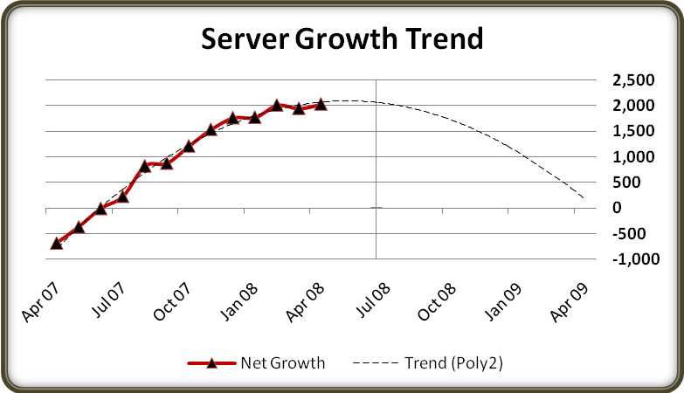
The RightSizing scorecard summary view provides high-level information that encompasses several virtualization-related criteria. For example, the graph in Figure 1 shows the growth trend of servers over time.
Figure 1. Server growth trend at Microsoft
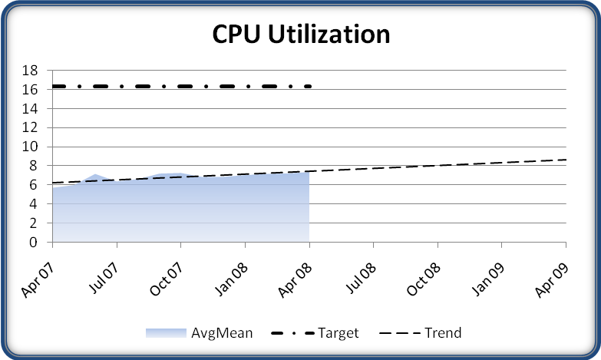
The graphs in Figures 2, 3, and 4 show CPU utilization, underused servers, and virtual machine ratio (respectively), over time.
Figure 2. Server CPU utilization
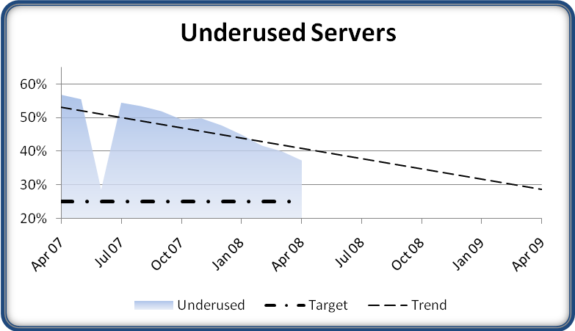
Figure 3. Underused servers

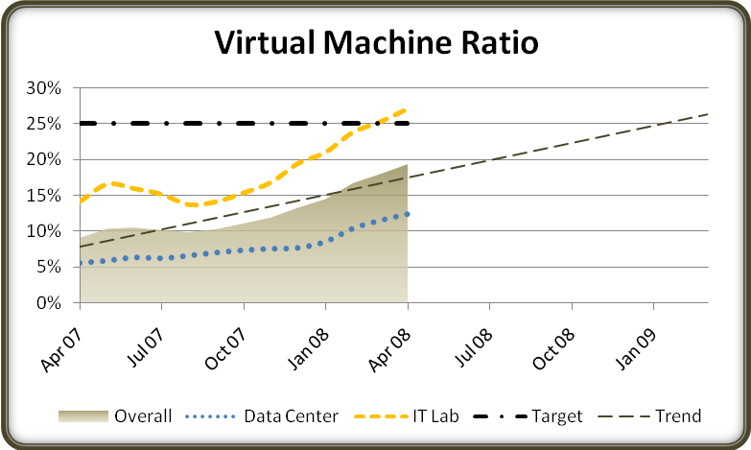
Figure 4. Virtual machine ratio
The RightSizing scorecard also provides a summary report that details how each business group is performing in comparison to other business groups. The categories for each business group include the number of server instances (physical and virtual machines) deployed in the data centers (both the year-to-date amount and the current month’s information) and the ratio of virtual machines to physical machines.
Business Group Views
In addition to the summary view, the RightSizing scorecard shows detailed information about the status of server deployment and virtualization within each business group.
The RightSizing scorecard shows several views for each business group. One view (shown in Figure 5) lists the number of servers deployed in both data centers and IT-managed labs. Each view highlights the number of virtual machines and the percentage of virtual machines.
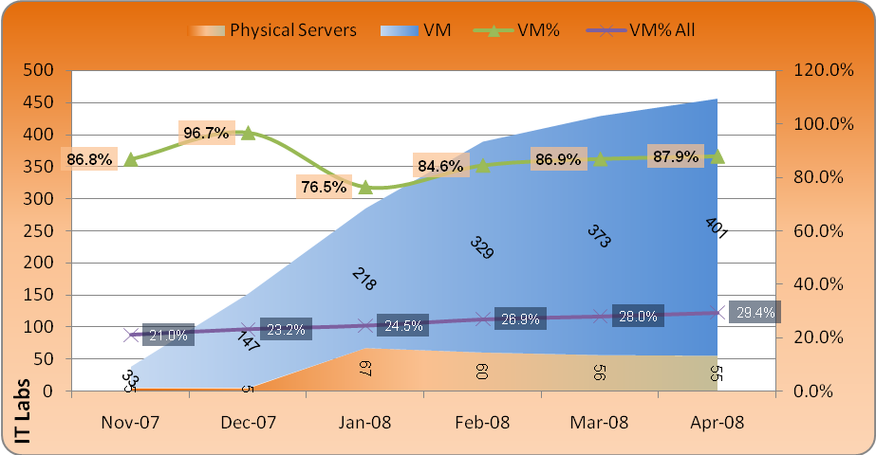
Figure 5. Physical servers and virtual machines deployed
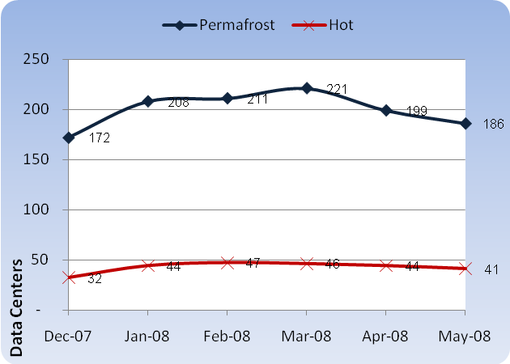
The business group views also provide information about the number of servers at each of the temperature settings that Microsoft IT defined. Figure 6 shows the number of Permafrost and Hot servers deployed.
Figure 6. Permafrost and Hot servers deployed
A key component in the business group views is the Virtual Server Utility (VSU) Opportunities section. This section provides details on the cost savings available if the business group replaced physical servers with virtual machines.
The VSU Opportunities section defines three options for business groups:
- Option A: Replace all end-of-life and end-of-warranty servers that have a temperature of Permafrost and Cold. End-of-life servers are servers that Microsoft IT no longer supports in its production environments for performance, supportability, or cost reasons.
- Option B: Option A, plus replace all end-of-life and end-of-warranty servers for which no CPU utilization value exists. (Many lab computers are not monitored for CPU utilization.)
- Option C: Option B, plus replace 50 percent of retired servers that have a temperature of Permafrost and Cold.
Table 2 shows a sample VSU Opportunities report.
Table 2. VSU Opportunities Report
 | Option A | Option B | Option C
Number of servers | 127 | 175 | 285
Actual hosting cost (12 months) | $650,814 | $920,744 | $1,439,536
VSU one-time cost | $258,318 | $355,950 | $578,673
Additional one-time cost (20%) | $51,664 | $71,190 | $115,735
VSU hosting (12 months) | $297,180 | $409,500 | $665,730
Total VSU cost (12 months) | $607,162 | $836,641 | $1,360,138
Savings (12 months) | $43,653 | $84,104 | $79,398
Months to get money back | 10.5 months | 10.0 months | 10.8 months
Savings by server (12 months) | $344 | $481 | $279

The RightSizing scorecard also provides detailed information for each business group, including:
- Number of physical computers versus virtual machines.
- Number of servers running 64-bit operating systems.
- Number of servers running Windows Server 2008.
- Server performance statistics.
- Number of servers at each temperature level.
For each category, the scorecard includes information about how well the specific organization and business groups are performing in comparison with other Microsoft organizations and business groups.
Lessons Learned
The Compute Utility strategy and RightSizing initiative greatly increased the visibility and deployment of virtualization at Microsoft. Microsoft IT currently provides and manages all virtual servers at Microsoft, and it provides VSU as one of its services. However, despite the efforts of the RightSizing team, the number of physical servers deployed in the Microsoft data centers continued to grow at a rate close to 2,000 servers per year during 2006 and 2007. Many business groups virtualized some servers but still showed a preference to purchase physical servers rather than use less expensive virtual servers.
By May 2007, the issue became acute when the data centers in Redmond, Washington, essentially reached their capacity for space and power. Deploying a single server in the data center could have taken months, because the RightSizing team would have had to identify which server needed to be removed so that it could deploy the new server.
With almost no space left in the data centers, Microsoft had to take additional actions to increase the adoption of virtualization. In the spring of 2007, upper management created the Application Service Management (ASM) group to consolidate operations across business groups and realize cost savings through process optimization. The ASM group could manage server purchases across multiple business groups. Although this group adopted many of the RightSizing tools and scorecards, it also had the authority to enforce virtualization in all cases, except where a business group demonstrated a requirement for physical hardware.
Despite the benefits of virtualization, some issues arose in implementing a full-scale adoption of this technology. The lessons learned from these issues include:
- Gather accurate information about the server environment. Microsoft IT had fairly complete information about the performance characteristics for the servers in the data center, less complete information about the servers in the managed labs. Because the lab computers were often the most logical candidates for virtualization, this information would have been useful. In addition, the Configuration Manager database, which should have provided information about all of the servers in the data centers, was occasionally incomplete or inaccurate. Without accurate information, identifying ideal candidates for virtualization is difficult.
- Start implementing virtualization now rather than waiting until data-center space and power availability reach crisis levels. Although Microsoft IT implemented the RightSizing initiative well before its data centers were full, the continued preference for purchasing physical servers meant that the data centers reached capacity before the ASM group enforced virtualization. In addition, after the data centers reach capacity, deploying even one physical server to host the virtual machines is difficult.
- Develop consistent guidelines for capacity planning and virtualization across all business groups. These guidelines will help ensure that business groups adopt virtualization across the entire organization, and they will maximize the benefits of implementing virtualization.
Conclusion
Many organizations are realizing that their data centers are reaching capacity, even while many servers in those data centers are running at significantly less than full capacity. Microsoft IT identified server virtualization as one of the most important tools in addressing both concerns. To identify servers that were candidates for virtualization, Microsoft implemented the RightSizing initiative to collect data about server performance. By doing this, the RightSizing team identified many servers that consistently ran at less than 20 percent capacity.
The RightSizing team also needed to communicate its findings and recommendations to Microsoft business groups. To do this, the team developed a scorecard that provides graphical and detailed information about the advantages and adoption of virtualization across business groups. By identifying servers that are good candidates for virtualization and by promoting virtualization, the RightSizing initiative has become one of the critical components of the virtualization strategy at Microsoft.
For More Information
For more information about Microsoft products or services, call the Microsoft Sales Information Center at (800) 426-9400. In Canada, call the Microsoft Canada information Centre at (800) 563-9048. Outside the 50 United States and Canada, please contact your local Microsoft subsidiary. To access information via the World Wide Web, go to:
http://www.microsoft.com
http://www.microsoft.com/technet/itshowcase

© 2008 Microsoft Corporation. All rights reserved.
This document is for informational purposes only. MICROSOFT MAKES NO WARRANTIES, EXPRESS OR IMPLIED, IN THIS SUMMARY. Microsoft, Hyper-V, SharePoint, SQL Server, and Windows Server are either registered trademarks or trademarks of Microsoft Corporation in the United States and/or other countries. The names of actual companies and products mentioned herein may be the trademarks of their respective owners.

