MSlogo_rev_1118

September 2006

Microsoft Office

Enterprise Project Management Solution

Table of Contents

Cover is for   
position only

[Microsoft Office Enterprise Project Management Solution 2](#_Toc145838174)

[Overview 2](#_Toc145838175)

[Microsoft Office Project Portfolio Server Life Cycle Support 3](#_Toc145838176)

[Create 3](#_Toc145838177)

[Select 4](#_Toc145838178)

[Plan 4](#_Toc145838179)

[Manage 5](#_Toc145838180)

[Top 10 Benefits 6](#_Toc145838181)

[Microsoft Office Project Professional 2007 8](#_Toc145838182)

[Overview 8](#_Toc145838183)

[Understand and Control Project Schedules and Finances 9](#_Toc145838184)

[Effectively Communicate and Present Project Information 9](#_Toc145838185)

[Microsoft Office Project Server 2007 11](#_Toc145838186)

[Overview 11](#_Toc145838187)

[Gain Visibility and Insights 11](#_Toc145838188)

[Enterprise Ready 12](#_Toc145838189)

[Easier to Get Started 12](#_Toc145838190)

[Extensible and Programmable 13](#_Toc145838191)

[Microsoft Office Project Portfolio Server 2007 14](#_Toc145838192)

[Overview 14](#_Toc145838193)

[Gain Visibility and Control 15](#_Toc145838194)

[Objectively Prioritize and Evaluate Competing Investments 15](#_Toc145838195)

[Optimize Budget and Align Investments with Business Strategy 15](#_Toc145838196)

[Tightly Integrate with Office Project Server 2007 16](#_Toc145838197)

[Architecture 17](#_Toc145838198)

[The Front End 17](#_Toc145838199)

[The Middle Tier 18](#_Toc145838200)

[The Back End 18](#_Toc145838201)

[Role-based Access 19](#_Toc145838202)

[System Requirements 20](#_Toc145838203)

[Office Project Professional 2007 20](#_Toc145838204)

[Office Project Server 2007 21](#_Toc145838205)

[Office Project Web Access 22](#_Toc145838206)

[Office Project Portfolio Server 2007 23](#_Toc145838207)

[Office Project Portfolio Web Access 24](#_Toc145838208)

[Additional Resources 26](#_Toc145838209)

# Microsoft Office Enterprise Project Management Solution

## Overview

The Microsoft® Office Enterprise Project Management (EPM) Solution is an end-to-end collaborative project and portfolio environment. The Office EPM Solution helps your organization gain visibility and insight into—and thus, control of—all work, which enhances decision-making, improves alignment with business strategy, maximizes resource utilization, and makes it possible to measure and increase operational efficiency.

With the Office EPM Solution, you can effectively manage and prioritize projects and resources across your organization. Microsoft designed the Office EPM Solution for organizations needing strategic portfolio capabilities, strong team coordination, standardization in managing projects and programs, and centralized resource management, as well as high-level analysis and reporting. Office EPM Solution provides a central repository for project and resource information so that organizations can consistently manage and report across the enterprise.

The Office EPM Solution includes the following servers from the Microsoft Office Project 2007 family to provide organizations with an end-to-end project portfolio management (PPM) solution:

* Microsoft Office Project Server 2007
* Microsoft Office Project Portfolio Server 2007

This guide covers how these servers interact with each other using a bidirectional gateway, as well as how their functions are exposed through their Web clients. Further, Microsoft Office Project Professional 2007 provides a rich desktop client for Office Project Server 2007.

## Microsoft Office Project Portfolio Server Life Cycle Support

The Office EPM Solution helps organizations to effectively manage and track projects and programs throughout their entire life cycle.

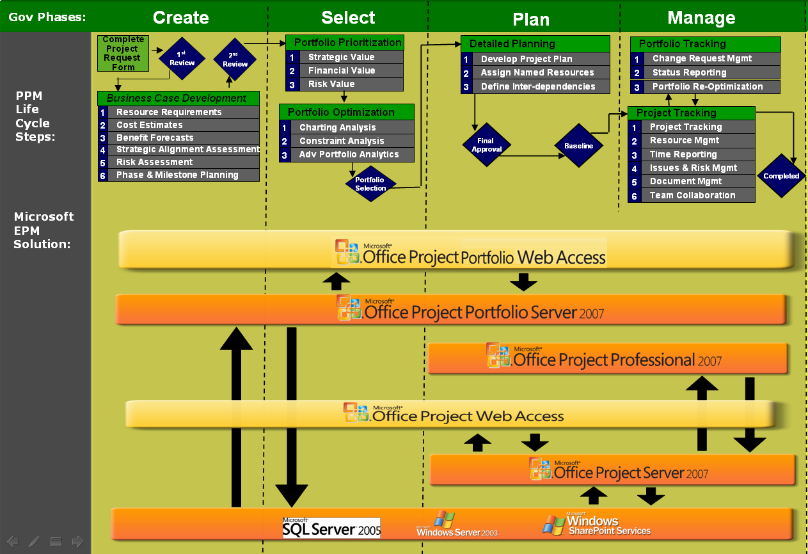

Figure 1: An example of how the Office EPM Solution can be deployed to support an end-to-end project portfolio management (PPM) governance process.

### Create

In the first phase of the life cycle, the Office EPM Solution enables organizations to develop and capture all types of new initiatives, including their resource requirements, cost estimates, benefit forecasts, strategic alignment assessment, risk assessment, and phase and milestone planning. Initiatives can range from simple proposals or activity plans designed to clarify an idea, to elaborate and complex projects and programs. Predefined workflows help ensure that projects are subjected to the appropriate governance controls throughout their life cycle, from proposal to post-implementation.

### Select

To facilitate the selection of projects within a portfolio, the Office EPM Solution helps objectively prioritize business strategy for the upcoming planning horizon, drive consensus among key stakeholders, and evaluate and prioritize competing investments from multiple dimensions. Using embedded best practice prioritization methodologies and tools, organizations can derive common scoring criteria for projects, programs, and applications, enabling “apples-to-apples” comparisons among dozens or hundreds of competing investments along factors such as strategic value, financial value, and overall risk. The Office EPM Solution further provides tools and embedded best practice methodologies, including the Business Alignment Framework, to optimize budgets and recommend portfolios that best align with the organization’s business strategy. This objective process enforces a rational rather than emotional approach to portfolio selection, helping to ensure that the selected investments deliver the maximum business value.

### Plan

Following portfolio selection, the Office EPM Solution enables an organization to develop detailed project plans, including assigning resources to projects, defining tasks, setting interdependencies, and building out all the other details for execution. A dependable, scalable offering, the Office EPM Solution provides a high-performance, manageable infrastructure for the enterprise that organizations can use to efficiently manage resources and work, from simple projects to large programs. The Office EPM Solution is further extensible and programmable, providing the flexibility to meet evolving business requirements and capable of integration with your existing infrastructure.

### Manage

The Office EPM Solution provides organizations with easy-to-use, familiar tools (such as the Microsoft Internet Explorer® Internet browser, Microsoft Office Outlook® messaging and collaboration client, and Microsoft Windows® SharePoint® Services) and functionality that offer significant visibility and insight into a company’s project portfolio, promoting collaboration among project teams across the organization. Managers can easily find, analyze, track, and report on all types of project information, from on-the-fly projects to complex programs and portfolios. Users can create real-time project and portfolio performance dashboards and scorecards to help ensure that decision makers gain visibility, insight, and control across the project portfolio, by utilizing intuitive generators to define and publish enterprise templates that standardize and streamline project management and reporting processes organization-wide. In addition to active projects, users can now see the entire project life cycle from before initiation as Proposals to tracking ongoing work after project completion as Activity Plans.

## Top 10 Benefits

Here are 10 ways that the Office EPM Solution can help you intelligently manage your organization’s work.

1. **Standardize and automate governance processes.**  
   Define multiple workflows to subject each project to appropriate governance controls throughout its life cycle—from proposal to post-implementation—resulting in lowered costs, faster cycle times, and increased quality.
2. **Capture all investments within a central repository.**  
   Consolidate business and information technology (IT) investments within an enterprise repository to improve visibility, insight, and control. The Office EPM Solution enables you to implement repeatable processes as templates to standardize and streamline data collection across the organization. Centralized data facilitates cross-project analyses of finances, resources, and schedules, as well as other data trends and status for informative reports.
3. **Objectively prioritize business strategy and competing investments.**   
   Employ proven techniques to define and prioritize your organization’s business strategy for the upcoming planning period, and automatically derive objective prioritization scores to effectively evaluate the competing investments from multiple dimensions.
4. **Align the selected portfolios with the business strategy.**  
   Run optimization what-if scenarios to identify tradeoffs and select the optimal portfolio under varying budgetary and business constraints to find the one that best aligns with your organization’s business strategy. Take advantage of advanced portfolio analytical techniques to identify and break the constraints prohibiting the portfolio from reaching the Efficient Frontier.
5. **Effectively manage resources.**  
   Without understanding long-term workloads and capacity, companies can experience inefficient hire-fire cycles, resulting in higher overhead, lost knowledge, and poor employee morale. By providing visibility into overall work commitments, actual timesheets, and resource capabilities, the Office EPM Solution helps you create resource plans to align your strategic recruiting and outsourcing with your long-term business objectives.
6. **Collaborate and coordinate easily.**  
   Helping ensure that teams share common goals and work together effectively becomes more vital as organizations become more geographically and culturally diverse. Web-based access to timely, business-critical project information stored by the Office EPM Solution means teams can share knowledge, collaborate smoothly to complete tasks and deliverables, and adjust activities quickly to accommodate project changes and updates.
7. **Measure and track portfolio performance.**  
   Effectively measure and track projects, programs, and applications throughout their life cycle, so you can proactively identify potential issues, make decisions, and help ensure that your portfolios maximize return on investment (ROI) and improve operational efficiencies.
8. **Get more from existing technology investments.**  
   The Office EPM Solution is built on the Microsoft Windows Server® operating system, Microsoft SQL Server™, and Windows SharePoint Services, so you can get the most out of your organization’s skills in these Microsoft technologies. The Office EPM Solution also includes prebuilt integration with the Microsoft Office system, Microsoft enterprise resource planning (ERP) applications, and the Microsoft collaboration platform. So, users can contribute data to the Office EPM Solution while working in familiar applications such as Office Outlook or Microsoft Office SharePoint Server.
9. **Tightly integrate with line-of-business (LOB) applications.**   
   A well-defined Project Server Interface, an Eventing Model supporting the Windows Workflow Foundation, a Software Development Kit (SDK) with reference samples, and other tools make the Office EPM Solution a flexible and extensible platform from which to manage your work. Utilize the Project Server Interface, a Web services–based API, to seamlessly integrate the Office EPM Solution with General Ledger, HR, ERP, customer relationship management (CRM), and other LOB applications.
10. **Quickly realize a return on investment.**  
    The Office EPM Solution provides organizations with an end-to-end project portfolio management solution. By enabling increased employee productivity, faster cycle times, reduced costs, and improved time management, the Office EPM Solution offers a positive and sustainable return on your investment. In IT portfolio management, the software potentially can cut costs by 2 to 5 percent, improve productivity by 25 to 20 percent, and shift 10 to 15 percent of budgets to more-strategic projects. In developing and bringing new products to market, the best performers—those workers who have applied rigorous process and technology to their research and development and go-to-market activities—can likely reduce time-to-market by more than 30 percent.

# Microsoft Office Project Professional 2007

## Overview

Designed for workers with deadlines and deliverables, and for project managers who work as individual contributors, Microsoft Office Project Professional 2007 software helps you plan, manage, and communicate project information, resulting in increased productivity and effectiveness.

Office Project Professional 2007 provides robust project management tools with the right blend of usability, power, and flexibility, so you can manage projects more efficiently and effectively. You can stay informed and control project work, schedules, and finances; keep project teams aligned; and be more productive through integration with familiar Microsoft Office system programs.

In several key areas, Office Project Professional 2007 empowers users to:

* Achieve individual excellence by creating work plans that help to ensure timely project deliverables.
* Understand the impact of scope changes to help control work, schedule, and finances.
* Align efforts by communicating effectively and reporting on project information.

With Office Project Professional 2007, you can quickly create project plans by using templates, importing task lists, following the online guide, or building your own. Track your people, equipment, and other resources in Project for insight into utilization and scheduling. Test scenarios with a clearer understanding of their impact on the schedule—and easily reverse your changes. New financial capabilities give you control and rich analytics. Set expectations of all stakeholders in your work with clear communications, either directly in Project reports or through integration with other Microsoft Office system programs.

Office Project Professional 2007 also includes the ability to connect with Microsoft Office Project Server 2007, which enables collaborative project management for teams rather than individuals. This connectivity is enabled by a Client Access License (CAL) that also entitles the user to work with Microsoft Office Project Web Access.

## Understand and Control Project Schedules and Finances

Set realistic expectations with project teams, management, and customers using Office Project Professional 2007 to build schedules, allocate resources, and manage budgets. You will find it easier to understand the schedule, how changes affect the schedule, and to test what-if scenarios.

* **New!** **Tasks Drivers** show prerequisites and resource constraints that drive the start date of the selected task. Simply click these drivers to link to relevant information.
* **New!** Determine the impact of each change you make with **Visual Change Highlights**, indicating all other dependent tasks.
* **New!** Reverse the most recent series of changes: undo and redo changes to views, data, and options with **Multiple Level Undo**. With this functionality you can also undo actions or sets of actions from macros or third-party applications.
* **New!** Predefined financial fields, such as cost codes, improve mapping to the financial fields tracked in project accounting systems.
* **New!** Use the **Budget** field to define a budget at a high level (program or project) so that the project manager can allocate funds and track costs against the budget.
* **New!** Now planned and actual costs can be assigned to a task with **Cost Resources**, which also supports integration of Project with accounting systems.

## Effectively Communicate and Present Project Information

Easily present information in various formats according to the needs of stakeholders. You can format and print one-page schedules or other reports. Smoothly export project-related data into Microsoft Office Word for formal documents, the Microsoft Office Excel® spreadsheet program for custom charts or spreadsheets, the Microsoft Office PowerPoint® presentation graphics program for crisp presentations, or Microsoft Office Visio® drawing and diagramming software for diagrams.

* **New!** Use Office Excel and Office Visio Professional to product charts, graphs, and diagrams based on Project data by means of the **Visual Reports** feature. You can easily define custom report templates and share these with other Project users. These reports include a data cube for drilldowns and PivotTable® dynamic views.
* **New!** **Background Cell Highlighting** enables you to shade cells, similar to how you can in Office Excel, in order to convey additional meaning.
* **New!** With enhancements to the **Calendar Interface** and the addition of **3-D Gantt bars**, you can create even more visually effective reports.

For more information, please see the [Project home page](http://www.microsoft.com/office/project).

# Microsoft Office Project Server 2007

## Overview

Microsoft Office Project Server 2007 enables you to effectively manage projects and resources across your organization. Microsoft designed Office Project Server 2007 for organizations needing strong team coordination, standardization in managing projects and programs, and centralized resource management. Office Project Server 2007 provides a central repository for information so that organizations can analyze, manage, and report across the enterprise.

The capabilities of Office Project Server 2007 are exposed through its clients: Microsoft Office Project Professional 2007 and Microsoft Office Project Web Access (PWA), which requires the Office Project Server 2007 Client Access License (CAL).

The new version of Office Project Server 2007 delivers improvements in several areas:

* Visibility and insights
* Enterprise readiness
* Ease in getting started
* Extensibility and programmability

## Gain Visibility and Insights

Visibility means you can easily find, analyze, and report on all types of information about your projects. From impromptu projects to complex programs, organizations can analyze their work and resources investment. In addition to active projects, you can now see the entire project life cycle from before initiation as Proposals to after project completion as Activity Plans.

Key improvements to deliver these capabilities include:

* **New! Activity Plan**
* **New! Budget Tracking**
* **New! Cost Resources**
* **New! Cube Building Service**
* **New! Multiple Currencies**
* **New! Proposals**
* **New! Reporting Data Service**
* **New! Resource Plans**
* **New! Visual Reports**

## Enterprise Ready

A dependable, scalable offering, an Office Project Server 2007 deployment provides a high-performance, manageable infrastructure that organizations can use to efficiently manage work from simple projects to large programs of multiple projects. Key features that deliver greater enterprise readiness include:

* **New! Active Cache**
* **New! Assignment Owner**
* **New! Deliverables**
* **New! Import Project Task Lists**
* **New! Programs**
* **New! Queuing Service**
* **New! Team Resource**
* **Enhanced! Timesheets**

## Easier to Get Started

The new version enhances participation across the entire organization with richer access through familiar applications that integrate with Office Project Server 2007 to view, update, and analyze project information. This functionality promotes coordination among project teams, which improves collaboration and yields more data for analysis and reporting. For example, the integration of Office Project Server 2007 with Microsoft Windows SharePoint Services 3.0 enables you to centrally store, link, and share project-related issues, risks, and documents for collaborative tracking. Propagate best practices for project work with enterprise templates to improve project management process throughout your organization. A number of improved features contribute to expanding the value and use of the system in your organization.

* **Enhanced! Outlook Integration**
* **Enhanced! Project Guide**
* **Enhanced! Project Web Access**
* **Enhanced! Project Workspaces**
* **Enhanced! Templates**

## Extensible and Programmable

Office Project Server 2007 provides the flexibility to meet your needs as your business requirements evolve. You can customize and integrate Project Server data with existing systems through the new Project Server Interface (PSI) application programming interface and Microsoft Visual Basic® for Applications object model changes. A redesigned architecture and new features support more users with better performance. Office Project Server 2007 reduces the burden of administration with setup improvements, while Office Project Web Access provides an improved administrative interface. Office Project Server 2007 includes many other useful new features, such as:

* **Enhanced! Administration User Interface**
* **New! Event Model**
* **New! Project Server Interface**
* **New! Project Web Access as Web Services**
* **New! Server-Side Scheduling**

For more information, please refer to the [Office Project Server home page](http://www.microsoft.com/office/projectserver).

# Microsoft Office Project Portfolio Server 2007

## Overview

Microsoft Office Project Portfolio Server 2007 is a top-down portfolio management solution that helps organizations to realize their potential by identifying, selecting, managing, and delivering portfolios that best align with their business strategy. Office Project Portfolio Server 2007, a key component of the Office EPM Solution, can help executives gain visibility, insight, and control across their project, program, and application portfolios.

Office Project Portfolio Server 2007 can help organizations to:

* Automate and standardize governance processes to subject projects to appropriate controls.
* Consolidate business and IT investments within an enterprise repository to improve visibility and insight.
* Objectively evaluate and prioritize competing investments from multiple dimensions.
* Optimize budget utilization and select investments that best align with the organization’s business strategy.
* Tightly integrate with Office Project Server 2007 to track the performance of each investment throughout its life cycle, from business case to benefits realization.

The capabilities of Office Project Portfolio Server 2007 are exposed through Office Project Portfolio Web Access, Web client software used to access the information stored on the server. Using Office Project Portfolio Web Access requires an Office Project Portfolio Server 2007 CAL.

Office Project Portfolio Server 2007 is optimized for enterprise and upper mid-market (UMM) organizations that require portfolio analytical tools to improve decision-making and help ensure that selected portfolios align with the organization’s strategic priorities. The server is intended for the following stakeholders:

* Executives and business decision makers
* Portfolio analysts and project management office staff
* Program managers and project managers
* Application managers

## Gain Visibility and Control

Quickly gain visibility and control across your project, program, and application portfolios by automating governance processes, standardizing and streamlining the collection of data, and tracking portfolio performance to maximize ROI and improve operational efficiencies.

* Consolidate the collection of essential data for all business and IT investments in a central enterprise repository.
* Define multiple workflows to standardize, communicate, and enforce the portfolio governance framework across the organization.
* Create personalized scorecards to track investments throughout their life cycle.

## Objectively Prioritize and Evaluate Competing Investments

Employ proven best practice techniques to help objectively prioritize your organization’s business strategy for the upcoming planning period. Automatically derive prioritization scores to evaluate project, program, and application portfolios from multiple dimensions.

* Define and prioritize business strategy and drive consensus among executives using the pair-wise comparison matrix.
* Derive prioritization scores such as strategic value, financial value, risk, architectural fit, and operational performance to objectively assess projects, programs, and applications.
* Generate charts to effectively evaluate potential investments within the portfolios.

## Optimize Budget and Align Investments with Business Strategy

Use embedded best practice methodologies, including the Business Alignment Framework, to optimize budgets and recommend portfolios that best align with the organization’s business strategy. This objective process enforces a rational rather than emotional approach to portfolio selection, to help ensure that the selected investments deliver the maximum business value.

* Employ sophisticated optimization algorithms to determine the optimal project or program portfolio under varying budget and business constraints.
* Use advanced portfolio analytical techniques, including insight analysis, to identify and break the constraints prohibiting the portfolio from reaching the Efficient Frontier.
* Undertake a business alignment assessment to help ensure that the selected portfolios are optimally aligned with the organization’s business strategy.

## Tightly Integrate with Office Project Server 2007

Tight integration between Office Project Portfolio Server 2007 and Office Project Server 2007 provides organizations with an end-to-end project portfolio management solution. Office Project Portfolio Server 2007 is a key component within the Microsoft EPM Solution, providing the following benefits:

* Helps ensure that customers and partners can quickly deploy world-class portfolio analytical techniques and tools within the Office EPM Solution.
* Maintains data integrity between the two environments through regular synchronization events.
* Enables portfolio analysts to link federated computers running Office Project Server 2007 to Office Project Portfolio Server 2007 and consolidate projects into an enterprise repository.
* Provides organizations with a scalable end-to-end project portfolio management solution.

For more information, please see the [Office Project Portfolio Server home page](http://www.microsoft.com/office/portfolioserver).

# Architecture

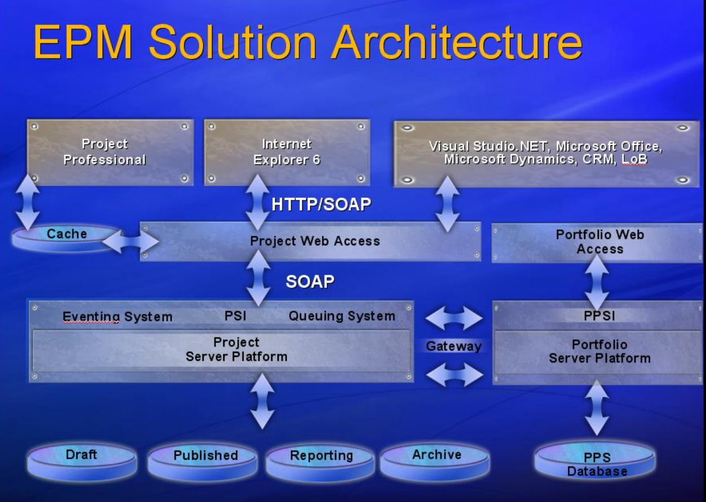

Figure 2: The Office EPM Solution three-tier architecture.

## The Front End

Office Project Server 2007 provides a rich set of browser-based functionality through its component Office Project Web Access, a Microsoft ASP.NET application that usesProject Server Web services through Microsoft Internet Explorer and Project Server Web Parts in Windows SharePoint Services 3.0.   
  
As Office Project Web Access is built on top of Windows SharePoint Services 3.0, it offers all of Windows SharePoint Services’ advantages, such as a rich browser experience by using AJAX development techniques and the Web Part and Integration framework. In addition to the Web-based client software, Office Project Server 2007 is accessible through Office Project Professional 2007 and other Win32® API–based clients such as the Microsoft Visual Studio® development system.

Office Project Portfolio Server 2007 capabilities are accessed using Office Project Portfolio Web Access, the ASP.NET-based front end of Office Project Portfolio Server 2007.

## The Middle Tier

Office Project Server 2007 provides a real application server that includes the new Project Server Interface (PSI), discrete business objects, server-side events, a common data access layer (DAL), and queuing services. The PSI provides Web services that can be consumed by other applications. Office Project Portfolio Server 2007 delivers the Project Portfolio Server Interface (PPSI), which helps organizations to integrate with other LOB applications. Office Project Server 2007 and Office Project Portfolio Server 2007 are connected through the middle-tier components. This out-of-the-box connection is known as the Project Server Gateway, a bidirectional link that enables administrators to associate multiple Office Project Servers to Office Project Portfolio Server 2007, providing executives with a consolidated view of all projects within the organization. Further information on Project Server development can be found in the SDK posted on the MSDN® developer program site.

## The Back End

Office Project Server 2007 and Office Project Portfolio Server 2007 use SQL Server 2000 SP4 or SQL Server 2005 SP1. (Note: Office Project Portfolio Server 2007 requires SQL Server 2005). Office Project Server 2007 takes advantage of some of the new features in SQL Server 2005, such as security enhancements and improved Analysis Services and Reporting Services.

# Role-based Access

Depending on a user’s role, he or she will use a different front-end client application. The products within the Office EPM Solution, especially Office Project Web Access, expose different functions and data based on role.

The table below shows that not all users need the complete desktop client (for example, Office Project Professional 2007) license. In many cases, users need only a CAL to the specific server they want to use: Office Project Server 2007 or Office Project Portfolio Server 2007.

|  |  |  |  |
| --- | --- | --- | --- |
| **Product** | **Role** | | |
| Project Managers | Executives, Resource Managers, Team Members | External Users |
| Microsoft Office Project Professional 2007 | License required | Not required | Not required |
| Microsoft Office Project Server 2007 | Client Access License (CAL) included in Project Professional license | CAL | CAL or External Connector |
| Microsoft Office Project Portfolio Server 2007 | CAL | CAL | CAL |

For additional pricing and licensing information, please refer to the [Office EPM home page](http://office.microsoft.com/en-us/epmsolution/FX101935291033.aspx).

# System Requirements

## Office Project Professional 2007

To use Office Project Professional 2007, you need:

| **Component** | **Requirement** |
| --- | --- |
| **Computer and processor** | 700 megahertz (MHz) processor or higher |
| **Memory** | 512 MB of RAM or higher |
| **Hard disk** | 1.5 GB of available hard disk space for installation |
| **Drive** | CD-ROM or DVD drive |
| **Display** | Minimum 800 x 600; 1,024 x 768 or higher-resolution monitor recommended |
| **Operating system** | Microsoft Windows XP SP2 or later, Microsoft Windows XP Tablet Edition 2005 Service Pack SP2 or later, Microsoft Windows Server 2003 SP1 or later, Microsoft Windows Vista™ (or later) required |
| **Browser** | Microsoft Internet Explorer 6.0 with service packs (or later); 32-bit browser version is supported |
| **Network connection** | 2 megabits per second (Mbps) or faster is required to connect to Office Project Server 2007 |
| **Additional components** | * Office Project Server 2007 is required for enterprise project and resource management capabilities. * Microsoft Office Project Web Access with Office Project Professional 2007 and Microsoft Office Outlook 2003 SP2 or later is required for importing tasks to the Outlook calendar or tasks list. * Windows Server System™ 2.0 or later is required to open documents from or save to a Windows Server System documents site. * Windows Server System 3.0 (gets installed as part of Microsoft Office Project Server 2007) is required for publishing projects, Windows Workflow Foundation, and Project Tasks List. * Microsoft Office Excel XP SP2 or later is required to export to Office Excel. * Office Word, Office PowerPoint, and/ or Office Visio XP SP2 or later is required to use Copy Picture to Office. * Office Outlook 2003 SP2 or later is required to use the Import Outlook Tasks feature. * Microsoft .NET Framework 2.0 is required for the Resource Substitution Wizard.   To use Visual Reports the following is required:   * Office Excel 2003 SP2 or later * Office Visio Professional 2007 |

## Office Project Server 2007

To use Office Project Server 2007, you need:

| **Component** | **Requirement** |
| --- | --- |
| **Operating system** | Microsoft Windows Server 2003 SP1 or higher (32-bit or x64) |
| **Stand-alone installation** | Server with a processor speed of at least 2.5 GHz; RAM capacity minimum of 1 GB, 2 GB recommended; Microsoft SQL Server 2005 SP1 Express needs to be installed on the same server; disk space: 2 GB for installation |
| **Single box installation** | * Server with a processor speed of at least 2.5 GHz; RAM capacity minimum of 1 GB, 2 GB recommended; disk space: 1 GB for installation * Microsoft SQL Server 2000 SP3a (or later) or SQL Server 2005 SP1 with a processor speed of at least 2.5 GHz, minimum 2 GB of RAM |
| **Farm deployment** | * Web server with a processor speed of at least 2.5 GHz, minimum 2 GB of RAM; disk space: 500 MB for installation * Application server with a processor speed of at least 2.5 GHz, minimum 2 GB of RAM; disk space: 500 MB for installation * Microsoft SQL Server 2000 SP3a (or later) or SQL Server 2005 SP1 with a processor speed of at least 2.5 GHz, minimum 2 GB of RAM |
| **Drive** | DVD drive |
| **Display** | Minimum 800 x 600; 1,024 x 768 or higher-resolution monitor recommended |
| **Browser** | Microsoft Internet Explorer 6.0 with service packs (or later); 32-bit browser version is supported. |
| **Network connection** | 100 megabits per second (Mbps) connection speed is required to utilize Project Server functionality. |
| **Other requirements** | Microsoft .NET Framework 3.0; Internet Information Services (IIS) 6.0; ASP.NET 2.0; ASP.NET Web services extensions must be enabled in IIS. |
| **Additional Components** | Project Server 2007 processor, RAM, and hard disk requirements are highly dependent on the number of services installed on the computer and the load on the server.   * Microsoft SQL Server Analysis Services 2005 SP1 or later (included with Microsoft SQL Server) is required for Data Analysis (OLAP Reporting). * Internet Simple Mail Transfer Protocol/Post Office Protocol 3 (SMTP/POP3), Internet Message Access Protocol 4 (IMAP4), or MAPI-compliant messaging software is required for e-mail notifications. |

## Office Project Web Access

To use Office Project Web Access (requiring an Office Project Server 2007 CAL), you need:

| **Component** | **Requirement** |
| --- | --- |
| **Computer and processor** | 700 MHz processor or faster |
| **Memory** | 128 MB of RAM or more recommended (additional memory may be required depending on operating system requirements) |
| **Hard disk** | 5 MB of available hard disk space per workstation |
| **Operating system** | Windows 2000 SP4 or later, Windows XP SP2 or later, Windows XP Tablet Edition SP1 or later, Microsoft Windows Vista (or later) required |
| **Display** | Minimum 800 x 600; 1,024 x 768 or higher-resolution monitor recommended |
| **Applications** | For Data Analysis and Resource Availability views, the following are required:   * For read-only mode, Microsoft Office Web Components (OWC) 2003 running on Windows 2000 with Service Pack 3 or later. * In addition, to use Office Web Components in full interactive mode to create Data Analysis views, a valid end-user license for a Microsoft Office 2003 Edition, Office Project Professional 2007, or any Microsoft Office System program is needed.   32 MB of hard disk space is required for the OWC install per workstation. |
| **Browser** | Microsoft Internet Explorer 6.0 with service packs (or later); 32-bit browser version is supported. |
| **Network connection** | 256 KB or faster connection |
| **Other** | * Microsoft Office Outlook 2003 SP2 or later is required for importing tasks to the Outlook calendar or tasks list. * Internet SMTP/POP3, IMAP4, or MAPI-compliant messaging software is required for e-mail notifications. |

## Office Project Portfolio Server 2007

To use Office Project Portfolio Server 2007, you need:

| **Components** | **Requirements** |
| --- | --- |
| **Operating system** | Microsoft Windows Server 2003 SP1 or higher (32-bit) |
| **Stand-alone installation** | Server with a processor speed of at least 2.5 GHz; RAM capacity minimum of 1 GB, 2 GB recommended; Microsoft SQL Server 2005 SP1 with a processor speed of at least 2.5 GHz, minimum 2 GB of RAM |
| **Single box installation** | * Server with a processor speed of at least 2.5 GHz; RAM capacity minimum of 1 GB, 2 GB recommended; disk space: 1 GB for installation * Microsoft SQL Server 2005 SP1 with a processor speed of at least 2.5 GHz, minimum 2 GB of RAM |
| **Farm deployment** | * Web/application server with a processor speed of at least 2.5 GHz, minimum 2 GB of RAM; disk space: 500 MB for installation * Microsoft SQL Server 2005 SP1 with a processor speed of at least 2.5 GHz, minimum 2 GB of RAM |
| **Drive** | CD-ROM or DVD drive |
| **Display** | Minimum 800 x 600; 1,024 x 768 or higher-resolution monitor recommended |
| **Browser** | Microsoft Internet Explorer 6.0 with service packs (or later); 32-bit browser version is supported. |
| **Network connection** | 100 megabits per second (Mbps) connection speed is required to utilize Project Portfolio Server functionality. |
| **Other requirements** | Microsoft .NET Framework 2.0; IIS 6.0; ASP.NET 2.0 |
| **Additional Components** | Office Project Portfolio Server 2007 processor, RAM, and hard disk requirements are highly dependent on the number of services installed on the computer and the load on the server.   * Microsoft SQL 2005 Reporting Services (included with Microsoft SQL Server) is required for reporting. * Microsoft Office Project Server 2007 is required in order to use the Project Server Gateway (the bidirectional link between Office Project Portfolio Server 2007 and Office Project Server 2007). * Microsoft Windows SharePoint Services 3.0 (included in Microsoft Windows Server 2003) is required for document management. |

## Office Project Portfolio Web Access

To use Office Project Portfolio Web Access (requiring an Office Project Portfolio 2007 CAL), you need:

| **Components** | **Requirements** |
| --- | --- |
| **Computer and processor** | 700 MHz processor or faster |
| **Memory** | 128 MB of RAM or more recommended (additional memory may be required depending on operating system requirements) |
| **Hard disk** | 40 MB of available hard disk space per workstation |
| **Operating system** | Windows XP SP2 or later, Windows XP Tablet Edition SP1 or later, Microsoft Windows Vista (or later) required |
| **Display** | Minimum 800 x 600; 1,024 x 768 or higher-resolution monitor recommended |
| **Browser** | Microsoft Internet Explorer 6.0 with service packs (or later); 32-bit browser version is supported. |
| **Network connection** | 256 KB or higher connection |
| **Other** | * Microsoft Office Excel 2003 (or later) is required to load the matrix views in the Portfolio Optimizer module and generate reports. * Adobe Acrobat 5.0 (or later) is required to generate reports in PDF format. |

# Additional Resources

To learn more about the Microsoft Office Enterprise Project Management (EPM) Solution, please refer to the following list of related links for additional resources and information.

* Project Home Page  
  <http://www.microsoft.com/office/project>
* Business Value from the Microsoft Office Enterprise Project Management Solution  
  <http://www.microsoft.com/business/epm.aspx>
* Microsoft Office Project Portfolio Server 2007 Home Page   
  <http://www.microsoft.com/office/portfolioserver>
* Microsoft Office Project Server 2007 Home Page  
  <http://www.microsoft.com/office/projectserver>
* MPA, the official industry association for Microsoft Office Project   
  <http://www.mympa.org>
* Microsoft Office Project Communities  
  <http://www.microsoft.com/technet/community/en-us/project/default.mspx>
* Microsoft Office Project Developer Center  
  <http://msdn.microsoft.com/office/program/project/>
* Microsoft Office Project TechNet  
  <http://www.microsoft.com/technet/prodtechnol/office/project/default.mspx>
* Microsoft Office Project Support Information  
  <http://support.microsoft.com/default.aspx>

This document is developed prior to the product’s release to manufacturing, and as such, we cannot guarantee that all details included herein will be exactly as what is found in the shipping product. The information contained in this document represents the current view of Microsoft Corporation on the issues discussed as of the date of publication. Because Microsoft must respond to changing market conditions, it should not be interpreted to be a commitment on the part of Microsoft, and Microsoft cannot guarantee the accuracy of any information presented after the date of publication. The information represents the product at the time this document was printed and should be used for planning purposes only. Information is subject to change at any time without prior notice.

This document is for informational purposes only. MICROSOFT MAKES NO WARRANTIES, EXPRESS OR IMPLIED, IN THIS DOCUMENT.

© 2006 Microsoft Corporation. All rights reserved.

Microsoft, Excel, Internet Explorer, Microsoft Dynamics, MSDN, the Office logo, Outlook, PivotTable, PowerPoint, SharePoint, Visio, Visual Basic, Visual Studio, Win32, Windows, the Windows logo, Windows Server, Windows Server System, and Windows Vista are either registered trademarks or trademarks of Microsoft Corporation in the United States and/or other countries. All other trademarks are property of their respective owners.