

MIIS 2003 Capacity Planning
Microsoft Corporation
Published: October 2005
Author: Dave Kreitler
Editor: Justin Hall

Abstract
This document presents capacity planning recommendations for the configuration of a server hosting Microsoft Identity Integration Server (MIIS) 2003. The recommendations presented here are based on tests designed to determine the most effective use of central processing units (CPUs), memory capacity, disk access, and disk capacity on a server hosting MIIS 2003. Other factors, such as database performance and the impact of the network, are also included.

The information contained in this document represents the current view of Microsoft Corporation on the issues discussed as of the date of publication. Because Microsoft must respond to changing market conditions, it should not be interpreted to be a commitment on the part of Microsoft, and Microsoft cannot guarantee the accuracy of any information presented after the date of publication.
This White Paper is for informational purposes only. MICROSOFT MAKES NO WARRANTIES, EXPRESS, IMPLIED OR STATUTORY, AS TO THE INFORMATION IN THIS DOCUMENT.
Complying with all applicable copyright laws is the responsibility of the user. Without limiting the rights under copyright, no part of this document may be reproduced, stored in or introduced into a retrieval system, or transmitted in any form or by any means (electronic, mechanical, photocopying, recording, or otherwise), or for any purpose, without the express written permission of Microsoft Corporation.
Microsoft may have patents, patent applications, trademarks, copyrights, or other intellectual property rights covering subject matter in this document. Except as expressly provided in any written license agreement from Microsoft, the furnishing of this document does not give you any license to these patents, trademarks, copyrights, or other intellectual property.
Unless otherwise noted, the example companies, organizations, products, domain names, e-mail addresses, logos, people, places and events depicted herein are fictitious, and no association with any real company, organization, product, domain name, e-mail address, logo, person, place or event is intended or should be inferred.
© 2005 Microsoft Corporation. All rights reserved.
Active Directory, Microsoft, MS-DOS, Visual Studio, Windows, and Windows NT are either registered trademarks or trademarks of Microsoft Corporation in the United States and/or other countries.
The names of actual companies and products mentioned herein may be the trademarks of their respective owners.

Acknowledgements
Microsoft wishes to thank the following for their contributions during the research and development of this guide:
- IBM® Center for Microsoft Technologies (ICMT) in Kirkland, Washington for providing the hardware and lab time to perform the tests for the document.
- Almero Steyn of Inobits Consulting Pty. Ltd. for arranging the testing resources and overseeing the testing process.

Contents
MIIS 2003 Capacity Planning 9
Executive Summary 9
Capacity Testing Summary 11
Processor Configuration 11
SQL server performance 12
Disk Configuration 13
Memory Utilization 13
Database Size 14
Network Utilization 14
Conclusions and recommendations 15
Server Configuration 15
Database Configuration 15
Disk Configuration 15
Memory Configuration 16
Network Configuration 16
MIIS 2003 Capacity Planning Test Summary - Processor 16
Test Description 16
Expected Results 17
Test Results Summary 18
Recommended Best Practices 18
Test Scenario 18
Server Hardware Configuration 18
Processor Count and Speed 20
MIIS Configuration 21
Database Configuration 21
Management Agent Configuration 21
Run Profile Configuration 23
Test Results 24
Staging Performance 24
Synchronization Performance 27
Delta Operation Performance Data 30
Delta Staging Statistics 30
External Factors and Other Considerations 35
Testing for Additional Hardware Considerations 35
MIIS 2003 Capacity Planning Test Summary - SQL Server 35
Test Description 35
Expected Results 36
Test Result Summary 37
Recommended Best Practices 37
Test Scenario 37
Server Hardware Configuration 38
MIIS Configuration 39
Database Configuration 40
Management Agent Configuration 40
Run Profile Configuration 41
Test Results 42
Observations 43
External Factors and Other Considerations 44
MIIS Capacity Planning Test Summary - Disk Performance 44
Test Description 44
Expected Results 45
Test Results Summary 45
Recommended Best Practices 45
Test Scenario 45
Server Hardware Configuration 46
Disk Configuration 46
MIIS 2003 Configuration 47
Management Agent Configuration 48
Run Profile Configuration 49
Test Results 49
Staging Performance 50
Synchronization Performance 51
External Factors and Other Considerations 52
MIIS 2003 Capacity Planning Test Summary - Memory 52
Test Description 52
Expected Results 53
Test Results Summary 53
Recommended Best Practices 53
Test Scenario 53
Server Hardware Configuration 53
MIIS 2003 Configuration 54
Database Configuration 54
Management Agent Configuration 54
Run Profile Configuration 55
Test Results 56
Observations 57
MIIS 2003 Capacity Planning Test Summary - Database Size 58
Test Description 58
General Observations and Recommendations 58
Test Scenario 59
Test Results 59
Database Sizing Based on Processor Testing Scenario 60
Database Growth Based on Multiple Management Agent Testing 62
MIIS 2003 Capacity Planning Test Summary - Network 67
Test Description 67
Expected Results 67
Test Results Summary 68
Recommended Best Practices 68
Test Scenario 69
Server Hardware Configuration 69
Network Configuration 70
Test Results 70
MIIS Server and Remote MIIS Database 70
MIIS Server and a Remote Connected Data Source 72
MIIS 2003 Capacity Planning - Additional Performance Considerations 73
Other Capacity and Performance Considerations 73
MIIS 2003 Implementation 73
Metaverse Design 73
Attribute Types 74
Rules Extensions 75
Management Agent Behavior 77
Database Considerations 77
Run History 77
Server Workload 78
External Considerations 78
Hardware Considerations 79

MIIS 2003 Capacity Planning
This document presents capacity planning recommendations for the configuration of a server hosting Microsoft Identity Integration Server (MIIS) 2003. The recommendations presented here are based on tests designed to determine the most effective use of central processing units (CPUs), memory capacity, disk access, and disk capacity on a server hosting MIIS 2003. Other factors, such as database performance and the impact of the network, are also included.
MIIS 2003 gathers identity-related data from a collection of data sources and then synchronizes and stores the data in its own database before exporting the synchronized data back to data sources. During this process, many potential factors can impact the performance of the MIIS 2003 environment. For example, the server running MIIS 2003 uses a SQL server database. Each time the server running MIIS 2003 needs to read from or write information to the database, the performance of the SQL server directly impacts the performance of the server running MIIS 2003. If the SQL server is located remotely, then each of these transactions must occur through a network connection. If the network segment used is operating near maximum capacity, then available bandwidth may be insufficient, further limiting the overall performance of the MIIS 2003 infrastructure.
This document presents the results of the tests and makes specific recommendations regarding hardware configuration to maximize the performance of the MIIS 2003 server. An overview of each test and a general discussion of the results are included so you can see exactly what was tested and have your own discussions about the data presented. Factors attributed to the performance of the external data sources that are being synchronized are outside the scope of this discussion.

Executive Summary
A group of tests were performed to determine how the configuration of the hardware that hosts the MIIS 2003 environment affects the performance of MIIS 2003. Five different aspects of configuration were tested: processor configuration, database location, memory, disk drive configuration, and network bandwidth.
Different processor configurations were tested to determine whether the number of processors or the speed of the processors most significantly affected the performance of the MIIS 2003 server. Database tests were performed to determine how the location of the MIIS 2003 database, whether on the same server as MIIS 2003 or on a remote SQL server, impacted the performance of MIIS 2003. Memory tests were performed to determine how MIIS 2003 utilizes memory so recommendations could be made regarding how to determine the amount of RAM necessary to optimize performance of the MIIS 2003 server. Different disk configurations were tested to determine how the number of spindles and the location of log and database files affected performance. During tests that utilized the network, network traffic was monitored to measure the impact of various types of operations on network bandwidth.
The results of the tests indicated that an optimal server configuration for MIIS 2003 should follow these guidelines:
• Processors: Use a dual-processor server that contains the fastest processors you can acquire. The speed of the processors has more impact on the performance of MIIS 2003 than the number of processors. No significant performance gains were seen when switching from a dual-processor platform to a quad-processor platform where the other configuration aspects remained constant. Significant performance improvements were seen when a 3.2-GHz dual-processor platform was compared to a 2.8-GHz quad-processor platform.
• Database Location: If your administrative and security policies will permit it, locate the SQL server hosting the MIIS 2003 database on the same server that is hosting MIIS 2003. Even if the SQL server is optimized for peak performance, if it is located remotely, any performance gain realized by the optimization will not overcome the latency introduced by the network when transmitting the data between the MIIS 2003 server and a remote SQL server. You might have other considerations beyond performance, such as hosting SQL Server in a clustered environment, that might override this recommendation.
• Memory: At a minimum, servers should be configured with at least 1 GB of RAM for each processor. If you will be managing 50,000 or more objects from more than two data sources, then it is recommended that you use 2 GB of RAM for each processor.
• Disk Configuration: Use a RAID array with as many spindles as possible on the server that hosts the MIIS 2003 database. Locate the database and log files on separate volumes.
• Network: The impact on available bandwidth is negligible as long as you have LAN connectivity (10 megabits per second or greater) between the MIIS 2003 server and the SQL server that hosts the MIIS 2003 database, even when synchronizing large numbers of objects (100,000 were tested). If you use a remote SQL server to host your MIIS 2003 database, it is recommended that the speed of the connection between the two servers is greater than 5 Mbps.
These recommendations are based on the results of the tests presented in this document. Other external factors, such as budget constraints, administrative, or security policies within your organization, might dictate that other configuration options be used. If other factors apply to your environment, use the recommendations presented in this document as a starting point for the planning process and to provide examples about how to approach making some of these configuration decisions.

Capacity Testing Summary
The tests presented here focus on configuration options for the server hosting MIIS 2003 and help answer common questions with regards to these options:
• Processor configuration: Which is more beneficial: To invest in servers with a large number of processors or invest in servers that have fewer, but faster processors?
• Database performance: How does the location of SQL server that hosts the MIIS database affect performance? Are there advantages or disadvantages associated with using SQL server in a remote location?
• Memory utilization: How do you calculate the amount of memory the server will need? Is it related to the number of objects being managed? The number of data sources being synchronized?
• Disk drive performance: What disk configuration provides the best performance?
• Network bandwidth utilization: How is performance impacted by network traffic? How do MIIS 2003 operations affect the available bandwidth on my network?

Processor Configuration
The processor performance of the MIIS 2003 server significantly affects the performance of MIIS 2003. During import operations, each object must be examined to determine whether or not any connector filter synchronization rules need to be applied. During synchronization operations, join and projection rules are processed for each object in addition to any rules extension code. By themselves, most of these operations are generally quite simple. Considered individually, they do not amount to a significant use of processor time. However, when you consider the fact that some staging and synchronization operations in some deployments involve hundreds of thousands of objects, these operations can quickly amount to a significant load on the server.
In order to gauge how these operations impact processor utilization, two servers were configured to host MIIS 2003. The first server was configured with dual-processors operating at 3.2 GHz, and the second server was configured with four processors running at 2.8 GHz. For some tests, two of the four processors running at 2.8 GHz were shut off so a direct comparison could be made between two and four processors running at the same clock speed.
A number of steps were taken to minimize any outside influences on the tests being performed. For all tests, the servers used the same disk array for storage in order to avoid skewing the tests based on differences in disk access time. Similarly, an isolated network was used to connect the various servers involved in the test. The only traffic on the network was that being generated by the tests. This helped avoid skewing the tests based on network latency created by traffic from other systems on the network. A pool of 500,000 user objects was created for use in the processor tests. Each user object had 25 attributes defined. Each time a test was run, a group of users from this pool was used. This helped ensure that the test results would not be skewed due to inconsistent test data. Each test used the same pool of users and maintained the same ratio of user objects-to-attributes.
For the first test, 10,000 objects were first staged and then synchronized. Performance statistics on the total time it took to complete the operations and the number of operations per second were recorded. The next test used 50,000 user objects, the test after that used 100,000, and so forth until 500,000 objects were tested. All of the performance data was collected and analyzed to determine how different numbers of objects impacted the utilization of the processor.

SQL server performance
One option of any MIIS 2003 installation is whether to install Microsoft SQL Server 2000 on the same server that is hosting MIIS 2003 or to use a remote SQL server database and access it over the network. Some customers install MIIS 2003 and Microsoft SQL Server 2000 on separate servers to balance the workload of MIIS 2003 operations across multiple servers.
Other factors can dictate the use of separate servers. Some organizations dedicate a SQL Server team to oversee the operation of all databases within the organization. For management and disaster recovery purposes, the SQL Server team dictates where the database exists. Also, some organizations have clustered SQL database servers that are used to consolidate corporate data stores. In both cases, databases are located according to internal policy rather than performance considerations.
An alternative opinion on the use of remote SQL servers is that network latency during communication between the MIIS 2003 server and the SQL server will have a greater impact on the overall performance than the added workload of hosting both MIIS 2003 and SQL on the same server. Thus, it is more efficient to install both services on the same server if the administrative policies of your organization permit it.
To test these scenarios, MIIS 2003 and SQL Server were installed on one quad-processor server and one dual-processor server. Two management agents were configured on each MIIS 2003 server. The data sources were two text files that each contained 100,000 user objects with 15 attributes defined. During the tests, one management agent was used to stage and project the users into the metaverse. The other management agent was used to stage and then join the metaverse objects. These tests were performed on different combinations of server configurations (such as when MIIS 2003 was installed on the dual-processor server while SQL Server was installed on the quad-processor server or when both MIIS 2003 and SQL Server were installed on the quad-processor server). Performance data was collected for each test and analyzed to determine which configuration provided the best performance.

Disk Configuration
The configuration of the disk subsystem has a significant impact on the performance of MIIS 2003. MIIS 2003 uses a SQL server database as it central data store. Most MIIS 2003 operations require access to the database. By hosting the SQL database on a server that is configured with an optimized disk subsystem, you can improve performance in your MIIS 2003 environment.
To test this, two server platforms were used to stage and then synchronize user objects (in various increments, from 10,000 to 500,000). The disk drive configuration of the first platform consisted of 2 internal hard disks that hosted both MIIS 2003 and the SQL server database used by it. The second platform was configured to use an external, SCSI attached RAID 0+1 containing ten spindles. For this configuration, the database and log files were stored on separate volumes to help optimize performance. Operations per second were monitored to determine the difference in performance.

Memory Utilization
As more identities are managed, the MIIS 2003 server uses more memory. Each identity is stored as an object and the amount of memory required depends on the number of objects being managed and the number and type of attributes associated with each object.
To test the relationship between the number of objects managed and the amount of memory used, ten management agents were created. Each management agent was used to process batches of objects, ranging from 10,000 to 500,000 objects. For each test pass, the first management agent staged and projected the objects into the metaverse. The remaining nine management agents were used to join those metaverse objects. Memory usage was then monitored to see how the number of objects being processed related to the amount of memory used.
The test results indicated that servers should be configured with at least 1 GB RAM for each processor. If more than 50,000 objects are being managed and more than two data sources are being used, then it is recommended that you use 2 GB RAM for each processor.

Database Size
During the processing of various tests for this document, database size was monitored to determine how the different operations affected the size of the MIIS 2003 database. Although this document does not provide any specific guidelines around managing database size, the section "MIIS 2003 Capacity Planning Test Summary - Database Size" contains a discussion of the database growth data recorded during the testing of other resources.
Trends can be found in this data that may be used as a basis for estimating how various operations might affect the size of the MIIS 2003 database. The discussion around these trends is not meant to provide definitive data on the relationship between database size and the operations tested. The intention is to provide an example of how you might go about examining test data based on your own environment and make estimates based on that information.

Network Utilization
Due to the distributed nature of an MIIS 2003 environment, it is likely that most of the different components will be connected by your organization's network. During import and export operations, data needs to flow between the MIIS 2003 server and one or more connected data sources. If the MIIS 2003 database is on a remote SQL server, then data also must flow between the MIIS 2003 server and the SQL server. Because virtually every type of MIIS 2003 operation requires access to the database, network traffic is generated if the database is remote.
MIIS 2003 deployments can potentially require managing millions of objects. All of this data must flow between the data sources that host those objects, the MIIS 2003 server, and the MIIS 2003 database.
With such potentially large sets of data and the possibility of connecting many data sources, some administrators are concerned about how much network bandwidth is consumed during import, export, and synchronization. This is a notable concern for administrators of systems that do not support delta import. Delta-based operations are more efficient because MIIS 2003 processes only objects that have changed. For data sources that do not support delta-based operations, every object must be processed during import operations, including objects that are unchanged.
During a number of the tests performed for the research presented in this guide, network traffic was monitored to observe the impact of operations such as the synchronization of 100,000 objects when MIIS 2003 is using a remote SQL Server to host its database. Other tests were monitored to observe the impact of importing data from a remotely located data source.
The results of these tests demonstrated that network impact is quite low. Experiences in the test environment indicated that as long as you have LAN connectivity (10 Mbps or more) the overall impact on bandwidth is negligible. Reliability of the connection proved to be more important than speed.

Conclusions and recommendations
Based on the results of the tests described in this document, the following configuration options are recommended:

Server Configuration
Use a dual-processor platform with the fastest processors that your budget allows. The tests demonstrated that a dual-processor platform will outperform platforms with additional processors.
Note
If your environment frequently requires a large number of concurrent staging or export operations, a server with more than two processors might provide better performance. If possible, test this configuration before making a decision.

Database Configuration
If the administrative policies of your organization permit it, install MIIS 2003 and SQL Server on the same server. This will result in performance gains through more efficient processor use and eliminate the impact of network latency between MIIS 2003 and a remote SQL server.

Disk Configuration
Optimize the disk subsystem on the server that hosts the SQL database used by MIIS 2003. Any optimization, such as faster interfaces or high speed storage arrays, will yield improvements. Because the majority of MIIS 2003 transactions involve accessing the database, any performance enhancements applied to the SQL server will result in better MIIS 2003 performance.

Memory Configuration
Servers should be configured with at least 1 GB RAM for each processor. If you will be managing 50,000 or more objects from more than two data sources, then it is recommended that you use 2 GB RAM for each processor.

Network Configuration
If possible, use a 100 Mbps network connection or better. Also, when multiple servers are used to host MIIS 2003 and SQL Server they should be placed on the same network segment. At that speed, network bandwidth should not be a concern. If there are restrictions in your environment, you can use a network as slow as 5 Mbps. However, at that speed, you need to make sure that the network connection is very reliable.

MIIS 2003 Capacity Planning Test Summary - Processor
This section presents a discussion of the different tests used to evaluate processor performance. It describes the hardware platforms used, the data set used, the test procedures, and the results of each test.
Currently, little information is available about the scalability and performance of MIIS 2003 relative to the hardware platform that hosts it. The goals of the tests presented in this section are to provide a set of recommendations for selecting a processor configuration that ensures the best performance for the MIIS 2003 server and present the resulting test data to substantiate those recommendations.

Test Description
The processor tests consisted of staging and synchronizing data representing between 10,000 and 500,000 user accounts on servers using different processor configurations. The tests gathered statistical data, such as time to complete and operations per second, to determine how processor configuration affected the performance of the servers. The goal was to determine whether the processor speed or the number of processors most significantly affected server performance.
The staging and synchronization processes were tested because they are the most processor-intensive operations performed by MIIS 2003. During staging, any connector filter rules that have been defined must be evaluated and applied to every object being processed. During synchronization, all join and projection rules are applied to all objects being processed.
To isolate processor performance during these tests, other elements in the environment remained as constant as possible. Specifically, the following conditions were maintained throughout the testing cycles:
• Memory - All test platforms were configured with 1 GB RAM for each processor.
• Storage - All platforms used the same storage array so disk performance would be consistent for all tests.
• Network - The tests were performed on an isolated network to eliminate interference from external traffic.
• Data - The same data set was used for each test to maintain a consistent number of objects and to maintain a consistent ratio of objects-to-attributes. Only the number of users changed for various tests.
• Sequential Processing - All tests were performed sequentially to avoid interference with each other.

Expected Results
MIIS 2003 supports concurrent processing of management agents. This means that multiple management agents can be run at the same time and that each management agent will process data separately. Concurrent processing of management agents, such as staging or export operations, can utilize additional processors. However, synchronization operations follow a different behavior and do not process multiple requests at the same time and may encounter database record locks, which can result in retries. When considering processor utilization, this implies that all tasks benefit from higher processor speeds while only a subset of tasks benefit from more processors.
Although SQL Server supports the use of multiple processors, none of the tests indicated that additional processors significantly improved performance during MIIS 2003 transactions. In fact, even during the tests involving 500,000 user objects, the processor utilization levels on the SQL servers stayed well below maximum and the difference between the dual-processor and quad-processor platforms was negligible. Multiple processor considerations for SQL servers become more important if they are centrally located and service other clients in addition to MIIS 2003. In that type of environment, the multiprocessor support for SQL Server would provide better performance.
If you intend to run concurrent staging or export operations, your environment will benefit from multiple processors. If you do not intend to perform concurrent staging or export operations, there will be little or no advantage to purchasing a high number of processors. In this case, processor speed would be a better investment.

Test Results Summary
The majority of the test results indicated that MIIS 2003 performance is more influenced by the speed of the processors in the server rather than the number of processors in the server.

Recommended Best Practices
• When making your choice regarding processor configuration, select a server based on the speed of the processors rather than the number of processors. Based on the results of these tests, a fast dual-processor server is recommended. If the future scalability of the server is a concern, a quad-processor chassis can be purchased but only install two of the processors until such a time that the workload on the server requires the addition of the remaining two processors.

Test Scenario
During this test, a variety of platform configurations were used to complete a series of MIIS 2003 staging and synchronization operations. The operations were designed to put load on the system processors. User account objects were imported from SQL Server and file-based management agents and then synchronized. Once this was complete, the user objects were exported into a clean instance of Active Directory. The same series of tests was performed on each hardware configuration. Over the course of the testing cycles, the number of users was increased from 10,000 to 500,000 in varying increments to explore the impact on performance.

Server Hardware Configuration
Two servers in various configurations were used to perform these tests. The table below summarizes the configuration of each server used in the testing process.
Table 1: Server hardware configuration
Server Designation | Model | Description
Test Server 1 | IBM xSeries 336 | Dual Intel EMT64 @ 3.6 GHz  No hyper-threading  2 GB RAM  Internal LSI SCSI controller  Dual 34.6 GB Ultra 320 HDD (10,000 RPM)  Windows Server 2003 Enterprise Edition (32-bit edition)
Test Server 2 | IBM xSeries 445 | Quad Intel Xeon MP @ 2.8 GHz  No hyper-threading  4 GB RAM  Internal LSI SCSI Controller  Dual 34.6 GB Ultra 320 HDD (10,000 RPM)  Windows Server 2003, Enterprise Edition (32-bit edition)
Storage Solution | IBM EXP 400 | 14-Disc SCSI Enclosure (10 spindles used)
Storage Controller | IBM ServeRAID-6i | Used in the IBM xSeries 445 for connectivity to the storage enclosure.
Storage Controller | IBM ServeRAID-4 | Used in the IBM xSeries 336 for connectivity to the storage enclosure.

All servers used the same storage solution to reduce performance variances based on disk access, although the two test servers did have different controllers.

Processor Count and Speed
Two sets of tests were run to monitor and measure CPU performance. In both cases, the MIIS configuration during the tests was identical, but the number of objects within the connected directories and the hardware configuration changed.
Three hardware platform configurations where used during these tests. For the purposes of this discussion the configurations will be referred to using a single letter to indicate the number of processors (D for dual-processor, Q for quad-processor) followed by two digits that indicate clock speed. For example the server designation D36 indicates it is a dual-processor server running at 3.6 GHz, and Q28 is a quad-processor server running at 2.8 GHz. The three configurations used for these tests are listed in the following table.
Table 2: Processor configuration
Server Designation | Model | Configuration
D28 | IBM xSeries 445 | Dual 2.8 GHz processors  No hyper-threading  2 GB RAM
D36 | IBM xSeries 336 | Dual 3.6 GHz processors  No hyper-threading  2 GB RAM
Q28 | IBM xSeries 445 | Quad 2.8 GHz processors  No hyper-threading  4 GB RAM

The two IBM 445 configurations provided information about the effects of an increase in the number of processors, where as the IBM 336 test was added to compare the effect of an increased processor speed rating. The IBM 445 platform tests were conducted on a single server.
Note
The IBM xSeries 336 has faster memory, Front Side Bus (FSB) and processor ratings than the IBM xSeries 445. Even though the processors use a 64-bit architecture, the operating systems were 32-bit editions. Therefore, there would be no real benefits to using the 64-bit architecture. None of the tests compared 32-bit performance to 64-bit performance.

MIIS Configuration
Microsoft Identity Integration Server 2003 with Service Pack 1 was used on the servers being tested. The different roles of the servers in the test environment and the software installed are summarized in the table below.
Table 3: Server configurations
Server Role | Installed Software | Description
MIIS Server | MIIS 2003 SP1  Microsoft SQL Server 2000 SP3a | The different hardware platforms being tested were set up using this configuration. Each server hosted an instance of MIIS 2003 SP1 and the SQL database used by it. The text files for the file-based management agents were also located on each MIIS 2003 server.
SQL Data Source | Microsoft SQL Server 2000 SP3a | This server hosted another SQL database that was used as a data source for some tests.
Active Directory Data Source | Microsoft Windows Server 2003, Enterprise Edition | This server hosted the instance of Active Directory that was used for exported data.

The following sections describe additional details of the installation.

Database Configuration
The MIIS 2003 database was hosted on the same server as MIIS 2003. This eliminated the need to send the data over the network.

Management Agent Configuration
Three management agents were installed on MIIS 2003. The following table summarizes the configuration of each one.
Table 4: Management agents
Management Agent Name | Type | Notes
ADMA | Active Directory management agent | • Data and logs on different volumes for performance.  • Remote data source (dedicated Active Directory server).  • At the beginning of each test, the directory is empty except for default administrative accounts created during setup.
SQLMA | SQL Server management agent | • Data and logs on different volumes for performance.  • Remote data source (dedicated SQL server).  • Varying number of user objects based on the test cycle being performed (10,000, 50,000, 100,000, 200,000, and 500,000).  • Each user object has 25 attributes defined.  • No multivalued or reference attributes.
TXTMA | Text File management agent | • Local data source (text files used as the data source are located on the MIIS 2003 server)  • Varying number of user objects based on the test cycle being performed (10,000, 50,000, 100,000, 200,000, and 500,000).  • Each user object has 25 attributes defined.  • No multivalued or reference attributes.

Run Profile Configuration
Separate run profiles were created for the staging and synchronization operations and both run profiles were configured to use full operations rather than deltas. This was necessary because MIIS 2003 was reset after each test in order to begin each test with an empty connector space and metaverse. Because no objects existed prior to each test, full staging and synchronization operations were required. Delta-related data has been included in the section "Additional Performance Data - Delta Operations" below.
Note
The synchronization portion of the tests included staging the user objects for export to Active Directory. Run profiles for actually exporting the staged data to Active Directory were created and the export operations were performed. However, the statistics for the actual export operations were not included in the test results being presented here because the performance of the export operations is skewed based on the performance of the data source that received the export. Our goal for the tests presented here is to focus entirely on the performance of MIIS 2003.
No concurrent operations were tested; all run profiles were executed sequentially.

Rules Extensions
No rules extensions were used with any of the management agents. The provisioning code used was only the minimum amount required to create the user objects in Active Directory and a Microsoft Exchange mailboxes for each user.

Test Results
As the staging and synchronization tests were performed, the results were compiled and recorded. The following is a detailed presentation of the results for each test.

Staging Performance
The staging tests compared the performance of various platforms by using the SQLMA and TXTMA run profiles.

Staging Time
Figure 1: Total staging time of SQLMA and TXTMA Management Agents (in seconds)
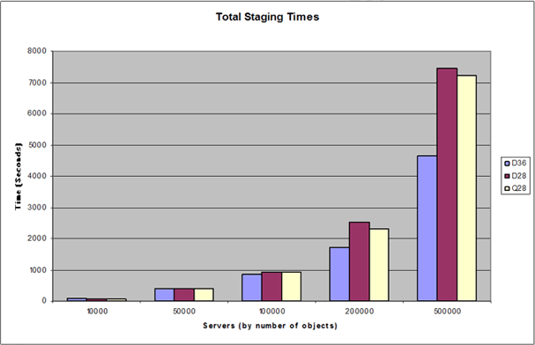

Table 5: Source data for Figure1 (in seconds)
Users | D36 | D28 | Q28
10,000 | 79 | 71 | 72
50,000 | 412 | 402 | 412
100,000 | 853 | 929 | 921
200,000 | 1734 | 2517 | 2316
500,000 | 4638 | 7448 | 7235

Observations
• Because the staging tests were run sequentially, a common scenario for many customers, and the fact that each management agents is run as a single-threaded process the, faster server (D36) outperforms the other server configurations tested (D28 and Q28).
• If multiple concurrent operations were processed, such as staging TXTMA and SQLMA at the same time, the multiple processors in Q28 would have been better utilized and might have outperformed D36. Concurrent processing can be used as long as the concurrent operations do not need to access the same metaverse objects at the same time. If this occurs, object access might be locked by one process and prevent access by the other. The majority of deployments process management agents sequentially so tests performed for this document were based on sequential processing. Organizations that process run profiles concurrently should perform additional testing to determine the actual performance advantage of the additional processors in their environment.
• Note that there is only a small performance increase when the additional processors are added (D28 compared to Q28). During the 500,000 user test, Q28 completes the staging process only a few minutes quicker.
• When a smaller number (100,000 and fewer) of objects is being managed, there is almost no difference in the staging performance between the various platform configurations. A visible performance increase only becomes apparent when more than 100,000 objects are being processed.

Objects Staged Per second
Figure2: Objects staged per second for each processor configuration (objects/sec)
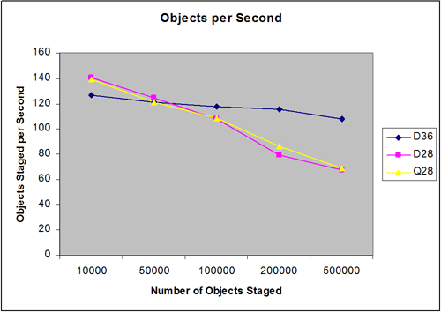

Table 6: Source data for Figure 2 (objects/sec)
Users | D36 | D28 | Q28
10,000 | 126.58 | 140.85 | 138.89
50,000 | 121.36 | 124.38 | 121.36
100,000 | 117.23 | 107.64 | 108.58
200,000 | 115.34 | 79.46 | 86.36
500,000 | 107.81 | 67.13 | 69.11

Observations
• Note that D36 maintains a more constant level of performance as the number of objects increases. While its performance is not as good in the small scenarios, D36 outperforms the other platforms in all the scenarios that involve 100,000 or more user objects.

Synchronization Performance
Some variations in the data are difficult to see when attempting to describe both large and small data sets in a chart format. This section separates the data into two groups: one is fewer than 100,000 objects and the other is 100,000 objects or more. For each group, it compares the staging performance of the various platforms during all synchronization operations.

Synchronization Time
Figure 3: Synchronization times (seconds) for fewer than 100,000 objects
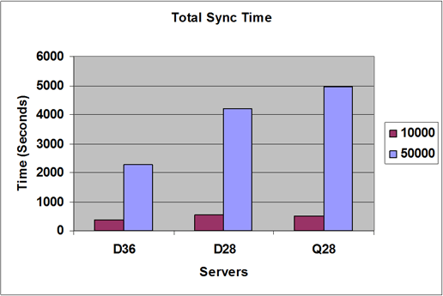

Table 7: Source data for Figure 3 (seconds)
Users | D36 | D28 | Q28
10,000 | 368 | 551 | 497
50,000 | 2,286 | 4,200 | 4,958

Figure 4: Synchronization times (seconds) for 100,000 objects or more
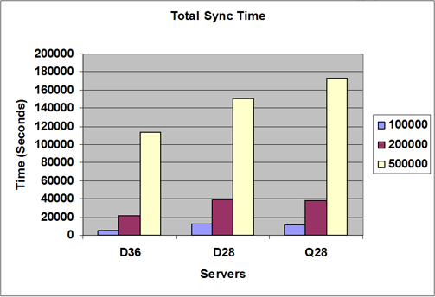

Table 8: Source data for Figure 4 (seconds)
Users | D36 | D28 | Q28
100,000 | 5,537 | 12,685 | 11,708
200,000 | 21,188 | 38,957 | 38,067
500,000 | 113,442 | 150,852 | 172,798

Observations
• The synchronization statistics show that the faster server (D36) outperforms the server with more processors. This is a clear indication that the synchronization process benefits from faster processors rather than more processors.

Objects Synchronized per Second
Figure 5: Object synchronized per second (objects/sec)
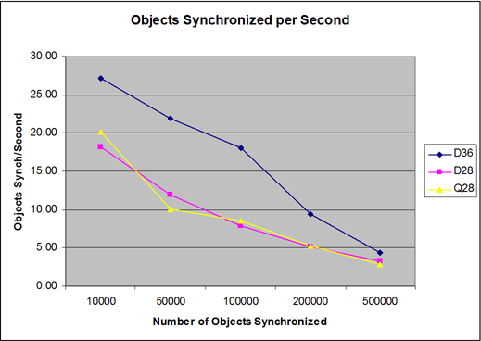

Table 9: Source data for Figure 5 (objects/seconds)
Users | D36 | D28 | Q28
10,000 | 27.17 | 18.15 | 20.12
50,000 | 21.87 | 11.90 | 10.08
100,000 | 18.06 | 7.88 | 8.54
200,000 | 9.44 | 5.13 | 5.25
500,000 | 4.41 | 3.31 | 2.89

Observations
• Once again the data shows that the server with faster processors (D36) consistently shows better performance than the server with a higher number of processor (Q28).
• The performance converges as the number of objects being processed increases. When synchronizing 500,000 objects, the performance difference is only around one object per second, compared to the difference of seven objects per second during the tests of the smaller data sets. Data sets of more than 500,000 objects were not tested.

Delta Operation Performance Data
After tests of the staging and synchronization of new user objects were completed, additional tests were run after making modifications and deletions to the original data set. The tests were designed to determine any difference in performance characteristics of the hardware configurations when performing full staging and synchronization operations as compared to delta staging and synchronization operations. The results of the tests demonstrated the same trends in performance whether full or delta-based operations were being run.

Delta Staging Statistics
Two sets of tests were performed. For the first set of tests, changes were made to five attributes of 20% of each of the user objects. For the second set of tests, 10% of the objects were deleted. New run profiles were created to perform delta operations and the tests were run using the same hardware platforms as for the earlier tests.

Delta Staging Time - Modified Objects
Figure 6: Total delta staging time (20% of total objects modified, measured in seconds)
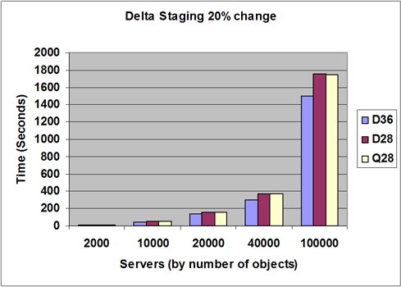

Table 10: Source data for Figure 6. (Seconds)
Users | D36 | D28 | Q28
2,000 | 8 | 8 | 8
10,000 | 47 | 48 | 48
20,000 | 139 | 159 | 161
40,000 | 294 | 371 | 368
100,000 | 1,497 | 1,757 | 1,747

Observations
• There is not a significant performance increase visible for delta staging. In fact the curve looks similar to that of the full staging tests presented earlier. Keep in mind, the scale of the curves is different and this test involves only 20% of the original data set. For the test involving the 500,000 object data set (100,000 modified user objects), the difference in total staging time between D36 and Q28 is about five minutes.
• The performance increase, while minimal, is still maintained by the faster dual processor server. This test supports the pervious recommendations.

Delta Staging Time - Deleted Objects
Figure 7: Total delta staging time (10% of total objects deleted, measured in seconds)
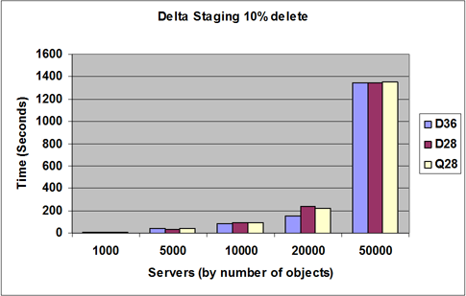

Table 11: Source data for Figure 7. (Seconds)
Users | D36 | D28 | Q28
1,000 | 8 | 8 | 8
5,000 | 39 | 38 | 39
10,000 | 87 | 95 | 94
20,000 | 155 | 236 | 224
50,000 | 1,341 | 1,347 | 1,353

Observations
• As with the performance statistics for Delta Staging Time - Modified Objects, there is little gain in performance when staging so few changes.
• The results of this test support previous recommendations.

Delta Staging Operations per Second - Modified Objects
Figure 8: Delta synchronization objects per second)
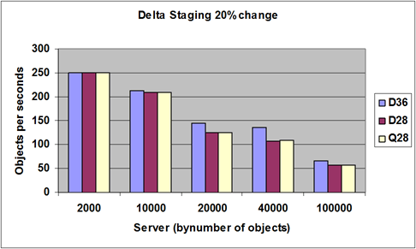

Table 12: Source data for Figure 8. (Seconds)
Users | D36 | D28 | Q28
2,000 | 250.00 | 250.00 | 250.00
10,000 | 212.77 | 208.33 | 208.33
20,000 | 143.88 | 125.79 | 124.22
40,000 | 136.05 | 107.82 | 108.70
100,000 | 66.80 | 56.92 | 57.24

Observations
• Test results confirm previous recommendations.
• There is a notable difference in the number of objects per second being processed in the larger test, which also supports the previously discussed testing trends.

Delta Staging Operations per Second - Deleted Objects
Figure 9: Delta synchronization objects per second
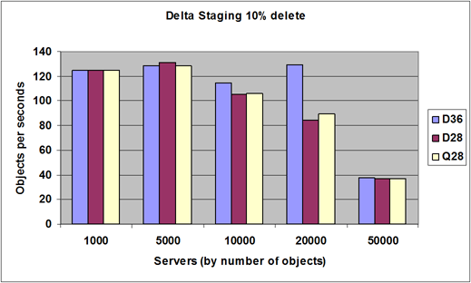

Table 13: Source data for Figure 9. (Seconds)
Users | D36 | D28 | Q28
1,000 | 125.00 | 125.00 | 125.00
5,000 | 128.21 | 131.58 | 128.21
10,000 | 114.94 | 105.26 | 106.38
20,000 | 129.03 | 84.75 | 89.29
50,000 | 37.29 | 37.12 | 36.95

Observations
• Test results confirm previous recommendations.

External Factors and Other Considerations
This document represents the first effort at providing some basic guidance around hardware selection, specifically processor configuration, based on the specific requirements of MIIS 2003. By no means is it a comprehensive study of all external factors that can affect the processor performance in all environments. Because every environment has unique characteristics that affect the overall performance of all deployed components, accurately reproducing and testing all external factors is not possible. This document presents a baseline set of tests that can be built upon to provide a complete assessment of performance considerations for components of an MIIS environment.
For more information about external factors that can affect performance, see "Other Capacity and Performance Considerations" in MIIS Capacity Planning - Additional Performance Considerations in this guide.

Testing for Additional Hardware Considerations
The following options were not tested:
• The effect of 64-bit processors
• The effect of hyper-threading

MIIS 2003 Capacity Planning Test Summary - SQL Server
This section presents different tests that evaluated how the location of the SQL database used by MIIS 2003 affected performance.
MIIS 2003 uses a Microsoft SQL Server 2000 database for its central data store. MIIS 2003 can access the database whether it exists on the same server that is hosting MIIS 2003 or a remote SQL server. The goals of this section are to present a set of recommendations for selecting the location of the SQL server that hosts the MIIS 2003 data store and the resulting test data to substantiate those recommendations.

Test Description
The SQL Server tests consisted of staging and synchronizing 100,000 new user objects from two file-based management agents into an MIIS 2003 database hosted on a SQL server. Some tests were performed on servers that had both MIIS 2003 and the SQL Server installed on the same server. Other tests were run on servers where MIIS 2003 and the SQL server were located on separate servers, requiring data to be sent across the network.
The goal of these tests was to determine whether database-intensive operations performed better on servers that host both SQL Server and MIIS 2003 as compared to configurations where SQL Server and MIIS 2003 were installed on separate servers.
The tests were intended to determine whether any performance gain was realized when the SQL database was hosted on a dedicated SQL Server, and if that performance gain offset the latency introduced by the requirement to send the data over the network to a dedicated SQL server. The staging and synchronization processes were used for the tests because they are both database-intensive activities.
To avoid having other factors interfere with database performance during these tests, other elements in the environment were kept as constant as possible. Specifically, the following conditions were maintained throughout the testing cycles:
• The same hardware platforms were used for all tests
• Storage - All platforms used the same storage array so disk performance would be uniform for all tests.
• Network - The tests were performed on an isolated network so no external traffic could interfere.
• Data - The same data set was used for each test to maintain a consistent number of objects and to maintain a consistent ratio of objects-to-attributes.
• Data Sources - The data sources for the tests were two text files located on the MIIS 2003 servers. This avoided introducing any network-related latency to the staging process and avoided creating network traffic that would conflict with the traffic between the MIIS 2003 server and the remote SQL server.

Expected Results
The configuration of both MIIS 2003 and SQL server on the same server will demonstrate better performance than when they are hosted on different servers. Disk I/O, especially if RAID is implemented, will have less impact on MIIS 2003 performance than latency caused by sending data over the network to a remote SQL server.

Test Result Summary
The results confirm that the configurations that hosted both SQL server and MIIS 2003 on the same server showed much better performance than environments where they were installed on separate servers.
Result highlights:
• Processor utilization improves if both the SQL Server and MIIS 2003 are hosted on the same server.
• A single server outperforms the separate servers during both staging and synchronization operations, in some tests completing the same amount of work in 40% less time.

Recommended Best Practices
Install the SQL Server that hosts the MIIS 2003 database on the same server that is hosting MIIS 2003. Ensure that no operational factors or policies within your organization prohibit MIIS 2003 and SQL Server 2000 being hosted on the same server and that the solution objectives do not require a high availability configuration using SQL clustering.
Note
When selecting the hardware platform to host MIIS 2003 and SQL Server 2000, follow the recommendations presented in the other sections of this document.

Test Scenario
During this test, a variety of platform configurations completed a series of MIIS 2003 staging and synchronization operations designed to test the performance of database operations. From two file-based management agents, 100,000 user objects were staged and synchronized into the metaverse hosted on a SQL server database. The tests collected performance statistics, such as operations per second and total time to complete the operations, for analysis.
The two scenarios tested were referred to as the same server scenario and the split server scenario. In the same server scenario tests, MIIS 2003 and SQL server were installed on the same server. For the split server scenario tests, MIIS 2003 and SQL server were installed on separate servers connected by 100 Mbps Ethernet. The same series of tests was performed for both scenarios to explore the impact of the different hardware configuration on database performance.

Server Hardware Configuration
Various server configurations were used to perform these tests. This was accomplished by installing both MIIS 2003 and Microsoft SQL Server 2000 on two servers and then using different combinations of the two servers and the software installed on each.
For the purposes of this discussion the server configurations will be referred to using a single letter to indicate the number of processors (D for dual-processor, Q for quad-processor) followed by two digits to indicate clock speed. For example the server designation D32 indicates it is a dual-processor server running at 3.2 GHz, and Q30 is a quad-processor server running at 3.0 GHz. Details of the two server platforms are summarized in the table below.
Table 14: Server hardware configuration
Server Designation | Model | Description
Q30 | HP DL580 G2 | Quad Intel Xeon MP @ 3 GHz  Hyper-threading  4 GB System RAM  (200 MHz DDR, 400MHz FSB)  Internal 5i SCSI controller  4x 34.6 GB Ultra 320 HDD (10k)  Windows Server 2003, Enterprise Edition
D32 | HP DL380 G3 | Dual Intel Xeon MP @ 3.2 GHz  Hyper-threading  4 GB System RAM  (266 MHz DDR, 533 MHz FSB)  Internal 5i SCSI Controller  4x 34.6 GB Ultra 320 HDD (10k)  Windows Server 2003, Enterprise Edition

MIIS Configuration
MIIS 2003 with Service Pack 1 was used on the servers being tested. For the purpose of this discussion, the test platforms have been named using a multiletter designation where the first letter, Q or D, indicates the quad-processor server or the dual-processor server respectively, followed by a single letter indicating the software installed on that server (M for MIIS 2003 and S for SQL Server). For example, QMS designates the test platform using the quad-processor server and both MIIS 2003 and SQL Server are installed on that server. DMQS designates the test platform where the dual-processor server has MIIS 2003 installed and SQL Server is installed on the quad processor server. The different test platforms are summarized in the table below.
Table 15: Server software configuration
Test Platform Designation | Server(s) | Description
QMS | Q30 | Same server scenario:  MIIS 2003 SP1 and Microsoft SQL Server 2000 SP3a installed on the quad-processor server.
DMS | D32 | Same server scenario:  MIIS 2003 SP1 and Microsoft SQL Server 2000 SP3a installed on the dual-processor server.
QMDS | Q30  D32 | Split server scenario:  MIIS 2003 SP1 installed on the quad-processor server and Microsoft SQL Server 2000 SP3a installed on the dual-processor server.
DMQS | D32  Q30 | Split server Scenario:  MIIS 2003 SP1 installed on the dual-processor server and Microsoft SQL Server 2000 SP3a installed on the quad-processor server.

The following sections describe additional details of the installation.

Database Configuration
On both Q30 and D32, Microsoft SQL Server 2000 was installed with the SQL data and SQL log files residing on the D: drive created on a RAID 1 array of two 34.6 GB Ultra 320 hard disks.

Management Agent Configuration
Two management agents were installed on MIIS 2003. The following table summarizes the configuration of each one.
Table 16: Management agent configuration
Management Agent Name | Type | Notes
TXT01 | Text File | • Local data source (text files used as the data source are located on the MIIS 2003 server being tested to avoid impact by network latency)  • Delimited text file  • Used to project objects into the metaverse.  • 100,000 user objects  • Each user object has 15 attributes defined.  • No multivalued attributes.
TXT02 | Text File | • Local data source (text files used as the data source are located on the MIIS 2003 server being tested to avoid impact by network latency)  • Delimited text file  • Used to join objects in the metaverse using a single indexed attribute.  • 100,000 user objects  • Each user object has 15 attributes defined.  • No multivalued attributes.

Run Profile Configuration
Four run profiles were created for the staging and synchronization operations: a full import for staging and a full synchronization for each management agent. They were configured as full run profiles rather than delta because MIIS 2003 was reset after each test in order to begin each test with an empty connector space and metaverse. Because no objects existed prior to each test, full staging and synchronization operations were required rather than deltas.
During the testing process, all run profiles were executed sequentially. No concurrent operations were tested.

Test Results
The staging and synchronization tests were performed for both same server scenarios and both split server scenarios. The results were recorded and analyzed. The following two charts are a summary of the results.
Figure 10: Total time to complete all run profile operations on each platform (in seconds)
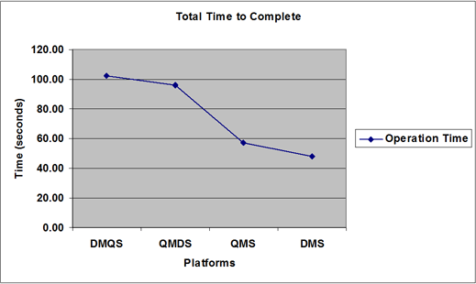

Figure 11: Total operations per second completed by each platform
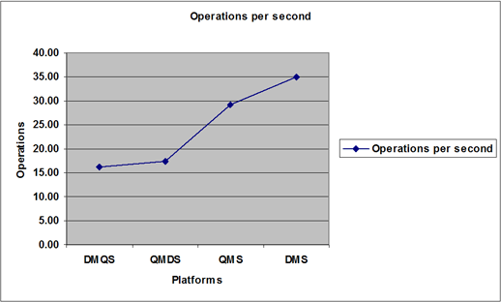

Observations

Same Server Scenarios
Platform: DMS
This configuration outperformed all the other configurations. This result is consistent with the results of the processor tests presented in "MIIS 2003 Capacity Planning Test Summary - Processor". This is a result of the slightly faster processors, memory, and FSB installed in this platform.
Platform: QMS
This configuration still performed much faster than any of the split scenario tests. There is almost a 40% decrease in the time required to complete the operations when compared to the fastest split scenario configuration.

Split Server Scenarios
Platform: DMQS
The test results show that there is no performance benefit to having the MIIS database hosted on a large SQL server. The latency introduced by the network far outweighs any benefit gained from the use of a dedicated SQL server. In fact, it may result in underutilization of the platform hosting the SQL server.
Platform: QMDS
There is a slight performance increase in this configuration, but it still demonstrates lower levels of performance than those achieved in the same server scenarios.

External Factors and Other Considerations
Based on the administrative and operating policies in your environment, you may not have a choice regarding the location of the SQL server. If the server must be located remotely, make sure that you use the fastest network transport at your disposal. In the scenarios tested for this document, the servers were connected by using isolated 100 Mbps LAN connections. This recommendation is more of a precaution to prevent unexpected problems in the event of an unusually high amount of network traffic. During the testing process, even tests of 100,000 users did not generate significant amounts of traffic on the network segment used to connect the two servers.

MIIS Capacity Planning Test Summary - Disk Performance
This section presents different tests that evaluated disk performance. It describes the hardware platforms, data sets that were used, the test procedures, and the results.
The goals of the tests presented in this section are to arrive at a set of recommendations for selecting an optimal disk configuration for the MIIS 2003 server.

Test Description
To test disk performance, two rounds of tests were each performed on different disk configurations. During the first round, different groups of user objects, ranging from 10,000 to 500,000 objects, were first staged and then synchronized by using a server configured with only two internal disk drives. The operations per second were recorded to track performance.
For the second round, of tests the same groups of user objects were staged and synchronized. However, the server was reconfigured to use an external storage array that contained 10 spindles and was attached to the server by a SCSI interface. As with the first round of tests, the operations per second were recorded to track performance.

Expected Results
MIIS 2003 performance is directly related to Microsoft SQL Server performance because MIIS 2003 utilizes SQL Server for all its storage requirements. It is therefore expected that the performance of the MIIS 2003 environment would improve if the SQL Server performance is optimized through the use of multiple physical spindles and database file placement according to best practice recommendations. You can verify whether or not the SQL server has been optimized according to SQL server 2000 best practices by using the Best Practice Analyzer Tool found at the Microsoft Web site (http://go.microsoft.com/fwlink?linkid=55322).

Test Results Summary
The test results indicate that optimizing the SQL server that hosts the MIIS 2003 database will improve the performance of MIIS 2003. Both staging and synchronization operations were tested and both showed significant performance gains when the MIIS 2003 database was hosted on a SQL server configured for optimized disk I/O (in this case, by using an external SCSI disk array that contained 10 additional spindles).

Recommended Best Practices
Because MIIS 2003 relies on SQL Server 2000 for its database requirements, the overall MIIS solution performance will increase when the I/O subsystem is optimized. Thus is it is recommended that the I/O subsystem is optimized according to SQL Server 2000 best practices.
• Place the database, log files, and TempDB file on different volumes – different physical spindles and different channels if possible.
• More spindles improve performance.
• Try to use RAID configurations that will yield the best performance while still providing for redundancy. For example, use RAID 0+1 split across various channels and as many drivers as possible.

Test Scenario
The scenario used during this testing was identical to the scenario that was configured during the previous hardware testing. The only difference is that during this specific round of testing, the first test was performed on a server configured to use its own internal storage. Subsequent tests were run on a server configured to use external SCSI attached storage units. This provided an easy way to monitor the impact that different I/O subsystem configurations could have on MIIS 2003 performance.

Server Hardware Configuration
For this test matrix, a single server utilizing two different disk configurations was used. As different disk configurations were tested the use of the same server helped eliminate other configuration factors such as memory speed, front side bus speed, and the storage controller cache that might have skewed the tests if completely different servers had been used.
The configuration of the server is described in the table below.
Table 17: Server hardware configuration
Server Designation | Model | Description
Q28 | IBM xSeries 445 | Quad Intel Xeon MP @ 2.8 GHz  No hyper-threading  4 GB System RAM  Internal LSI SCSI Controller  2x 34.6-GB Ultra 320 HDD (10k)  Windows Server 2003, Enterprise Edition (32-bit edition)
Storage Solution | IBM EXP 400 | 14 Disc SCSI Enclosure (10 slots used)
Storage Controller | IBM ServeRAID-6i | Used in the IBM xSeries 445 for connectivity to the storage enclosure.

Disk Configuration
During the first round of tests, the server was configured to only use internal storage, which in this case is a mirrored set of 36.4-GB SCSI U320 disk drives. Because this was the only physical volume, it hosted both the Microsoft SQL Server 2000 transaction log and the MIIS 2003 database.
During the second round of tests, the server was connected to an external IBM EXP 400 SCSI-attached storage unit. Both channels of the storage unit were used to increase I/O throughput and the storage unit, which hosted 10 additional hard disk drives, was configured as follows:
Table 18: Disk drive configuration
Drive Letter | Function | Description
G: | SQL Data Volume | 4 x 18.2-GB 10,000 rpm (RAID 0+1)
F: | SQL Logs Volume | 4 x 18.2-GB 10,000 rpm (RAID 0+1)
T: | SQL TempDB Volume | 2 x 18.2-GB 10,000 rpm (RAID 1)

MIIS 2003 Configuration
MIIS 2003 with Service Pack 1 (SP1) was installed on the server being tested. The different roles of the servers in the test environment and the software installed are summarized in the following table.
Table 19: Server software configuration
Server Role | Installed Software | Description
MIIS 2003 | MIIS 2003 SP1  Microsoft SQL Server 2000 SP3a | The server hosted the instance of MIIS 2003 being tested and the SQL database used by that instance of MIIS 2003. The text files for the text based management agents were also located on the MIIS 2003 server.
SQL data source | Microsoft SQL Server 2000 SP3a | This server hosted another SQL database that was used as a data source for some tests.
Active Directory data source | Microsoft Windows Server 2003, Enterprise Edition | This server hosted the instance of Active Directory that was used as a data source.

Management Agent Configuration
Three management agents were installed on MIIS 2003. The following table summarizes the configuration of each one.
Table 20: Management agent configuration
Management Agent Name | Type | Notes
ADMA | Active Directory | • Located on a dedicated server.  • At the beginning of each test, the directory is empty except for default administrative accounts created during setup.
SQLMA | SQL Server | • Remote data source (dedicated SQL server).  • Varying numbers of user objects based on the test cycle being performed (10,000, 50,000,100,000, 200,000, and 500,000).  • Each user object has 25 attributes defined.  • No multivalued attributes.
TXTMA | Text File | • Local data source (text files used as the data source are located on the MIIS server)  • Varying number of user objects based on the test cycle being performed (10,000, 50,000,100,000, 200,000, and 500,000).  • Each user object has 25 attributes defined.  • No multivalued attributes.

Run Profile Configuration
Separate run profiles were created for the staging and synchronization operations and both were configured as full run profiles rather than deltas. This was necessary because MIIS 2003 was reset after each test in order to begin each test with an empty connector space and metaverse. Because no objects existed prior to each test, full staging and synchronization operations were required rather than deltas.
During the testing process, all run profiles were executed sequentially. No concurrent operations were tested.

Rules Extensions
No rules extensions were used with any of the management agents. The only provisioning code used was the minimal amount required to create the user objects in Active Directory. This included the creation of Microsoft Exchange mailboxes for each user.

Test Results
The results of the disk I/O tests focus on the performance of the various platforms that were tested as measured by operations per second. This provides a simple way to compare overall performance.

Staging Performance
In this series of tests, the staging performance of the various platforms is compared during processing of the SQLMA and TXTMA run profiles, based on the number of operations that each platform completes per second.
Figure 12: Operations per second for staging from SQL and TXT connected directories.
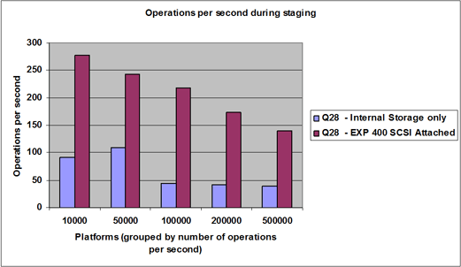

Table 21: Source data for Figure 12 (in operations/seconds)
Users Objects Tested | Internal Storage | EXP 400 SCSI Attached
10,000 | 91 | 278
50,000 | 109 | 243
10,0000 | 45 | 217
200,000 | 42 | 173
500,000 | 39 | 139

Observations
• As expected with optimization on the I/O subsystem, the MIIS 2003 operations per second increase greatly.
• There appears to be a linear performance on the external storage unit whereas the internal storage fluctuates somewhat. We were unable to determine the cause of the fluctuation.

Synchronization Performance
In this series of tests, the synchronization performance of the various platforms is measured based on the number of operations processed per second during all synchronization operations.
Figure 13: Operations per second for synchronizing both the SQL and TXT connected directories.
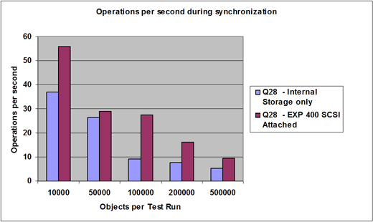

Table 22: Source data for Figure 13 (in operations/seconds)
Users Objects Tested | Internal Storage | EXP 400 SCSI Attached
10,000 | 37 | 56
50,000 | 26 | 29
10,0000 | 9 | 27
200,000 | 8 | 16
500,000 | 5 | 10

Observations
• A visible performance increase occurs when staging objects on the platform with an optimized I/O subsystem.
• Again, as with the staging tests, there is an anomalous performance indicator on 50,000 objects. Once again we were unable to determine the cause of this.

External Factors and Other Considerations
Some additional hardware considerations regarding the tests discussed in this section:
• The effect of different drive speeds was not taken into consideration. For example, multiple drive or array configurations were not tested. Instead, two data points where selected in an effort to prove that an optimized I/O subsystem will drastically increase the performance of an MIIS 2003 environment. This is due to the increases performance of the SQL server.
• There is no single correct disk configuration. As long as you are seeing adequate performance based on the requirements of your specific environment, an alternate configuration is unnecessary.

MIIS 2003 Capacity Planning Test Summary - Memory
This section discusses tests performed to determine how MIIS 2003 utilizes memory and presents the results.

Test Description
Staging and synchronization operations for groups of objects were tested. The tests used a management agent to project groups of objects into the metaverse. These groups of objects were tested in various increments, from 10,000 objects to 500,000 objects. Nine additional management agents then performed a number of join operations with those objects based on indexed metaverse attributes. Memory was monitored during these tests to determine whether or not any predictable relationship existed between the number of objects being processed and the memory used.

Expected Results
Microsoft SQL Server 2000 limits memory usage to 2 GB by default. It is expected that the server will utilize the effective default of 2 GB RAM and this limit will be reached faster when processing a larger number of objects.

Test Results Summary
The tests did confirm that the 2 GB addressable limit was reached by Microsoft SQL Server 2000. As expected, the limit was reached faster when larger batches of objects were processed.

Recommended Best Practices
At a minimum, servers should be configured with at least 1 GB RAM for each processor. If you will be managing 50,000 or more objects from more than two data sources, then it is recommended that you use 2 GB RAM for each processor.

Test Scenario
The test environment consisted of a single server configured with ten management agents and run profiles configured to perform staging and synchronization operations for groups of user objects that ranged in size from 10,000 to 500,000 objects. The details of the server configuration and test results are described below.

Server Hardware Configuration
A single server configuration was used to perform the tests. Both MIIS 2003 and Microsoft SQL Server 2000 were installed on the same server. For the purposes of this discussion, the server configuration will be referred to as Q30. As in previous tests, Q30 indicates the number of processors (Q for a quad-processor server) followed by two digits to indicate clock speed. Details of the server platform are summarized in the table below.
Table 23: Server hardware configuration
Server Designation | Model | Configuration
Q30 | HP DL580 G2 | Quad Intel Xeon MP @ 3.0 GHz  Hyper-threading  4 GB System RAM  Internal 5i SCSI controller  4x 36.4 GB Ultra 320 HDD (10k)  Windows Server 2003, Enterprise Edition  Advanced Windowing Extensions (AWE) not enabled

MIIS 2003 Configuration
MIIS 2003 with Service Pack 1 was installed on the server being tested. An increasing number of management agents were executed on the test platform to explore the memory usage of MIIS 2003 and SQL server under increasing load.

Database Configuration
On the Q30 test platform, Microsoft SQL Server 2000 with Service Pack 3a was installed with the SQL database and SQL log files residing on the D: drive and E: drive respectively. These volumes were created on a single 36.4 GB Ultra 320 hard disk.

Management Agent Configuration
Ten management agents were installed on MIIS 2003. The following table summarizes the configuration of each one.
Table 24: Management agent configuration
Management Agent Name | Type | Notes
TXT01 | Text File | • Local data source (text files used as the data source are located on the MIIS 2003 server being tested to avoid impact by network latency)  • Delimited text file  • Used to project objects into the metaverse.  • Variable range of objects (10,000 – 50,000 - 100,000 – 200,000 and 500,000)  • Each user object has 25 attributes defined.  • No multivalued attributes.
TXT02 - TXT10 | Text File | • Used to join objects to the existing metaverse objects.  • In all other respects, they are configured the same as TXT01.

Run Profile Configuration
For each management agent, two run profiles were created for the staging and synchronization operations: a full import run profile for staging and a full synchronization run profile for projections and joins. As with previous tests, this was done because the MIIS 2003 metaverse was reset at the beginning of each test. These full import and synchronization profiles were necessary to populate the database. During the testing process, all run profiles were executed sequentially. No concurrent operations were tested.

Test Results
During the test runs, user objects from the first management agent were first staged and then added to the metaverse. The remaining nine management agents were then run and their objects were joined to those already in the metaverse. Memory utilization was monitored during these processes. The following different batches of user objects were tested: 10,000, 50,000, 100,000, 200,000 and 500,000. The results of the 10,000 object test and the 50,000 object test are shown below.
Figure 14: Memory utilization during the 10,000 object test (Measured in bytes used)
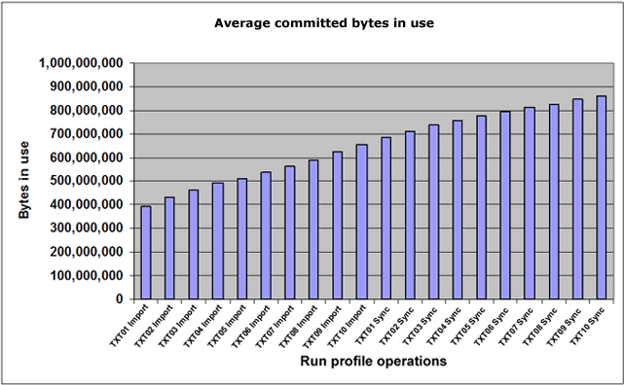

Figure 15: Memory utilization during the 50,000 object test (Measured in bytes used)
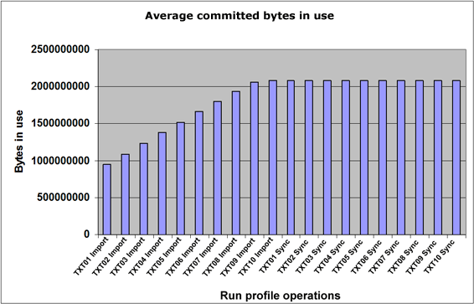

For groups of more than 50,000 objects, MIIS 2003 memory utilization exceeded 1 GB RAM but did not exceed the 2-GB RAM limit. Once the ninth management agent was processed, MIIS utilized the 2-GB RAM limit every time.

Observations
• When groups of 10,000 objects were processed, memory usage did not reach 1 GB even when all ten management agents had been processed.
• When groups of 50,000 objects were processed, 1 GB was exceeded as soon as the second management agent was run. The 2-GB limit was reached when the tenth management agent was processed.
• It was found that although the limit of 2GB was reached when groups of 100,000 and 200,000 objects were processed, the number of pages errors remained at zero.

MIIS 2003 Capacity Planning Test Summary - Database Size
This section discusses data that was gathered during other performance tests and analyzed to determine any relationship between MIIS 2003 database size and the number of objects being managed.

Test Description
While the other tests presented in this capacity planning document were being run, database size was tracked to see how it was affected by the operations being performed. The information presented in this section is an analysis of that data rather than the result of tests performed specifically to generate size-related information.

General Observations and Recommendations
There is no definitive methodology to determine how the MIIS 2003 database will grow during normal operations. Providing estimates that apply to the broad range of MIIS 2003 deployments is difficult. Factors that impact the database size are:
• Number of management agents in the solution: More management agents require more storage for the connector space. The connector space stores a complete subset of the information staged from the connected directory.
• Number of objects in each management agent.
• The number of attributes being staged for each object.
• The size of each attribute.
• The number of multivalued attributes and the size of their values.
• The schedule at which run profiles are executed in the solution: More frequent scheduling of MIIS 2003 run profiles requires more run history data to be collected.
• The frequency with which an organization clears the run history. Run history data is collected over time and if the data is not periodically cleared it can drastically increase database size.
• Maintaining sufficient storage space to be able to clear the run history: MIIS 2003 cleans out the run history information within the MIIS 2003 database within one SQL transaction. The result is that the SQL database log expands in size to contain all the deleted run history information. It does not shrink until the transaction is committed. Thus, you need sufficient additional storage for the database for this expansion. The amount of expansion depends on the size of the MIIS 2003 solution and the amount of run history the organization maintains.
The following section provides examples of the database sizes that where observed during the tests of other MIIS 2003 capacity planning components. Some of these examples can be used to estimate the size of an MIIS 2003 database.
It is recommended that you perform tests in a controlled environment by using a representative sample of data from your production environment to help you estimate your own database size requirements. In doing so, your estimates will be based on actual data and the same type of staging and synchronization operations that will be used in your production environment. Based on these data points, some broad estimates could be made about the projected database size.

Test Scenario
The data presented in this section was gathered from the other tests described elsewhere in this document (specifically, the processor and memory tests). The data was collected from the various platforms used for those tests. For information about the particular server configuration used in each test, see "Server Hardware Configuration" and "MIIS 2003 Configuration" in "MIIS 2003 Capacity Planning Test Summary - Processor" and "MIIS 2003 Capacity Planning Test Summary - Memory" in this document.

Test Results
Data that pertains to the database size from two test scenarios is presented here. The first set of data is from tests that determined the processor requirements for MIIS 2003. This scenario consisted of two management agents that imported data into the metaverse and then exported information to a third management agent. During these tests, the database growth was measured.
The second set of data was gathered from the memory tests. It provides an example of what happens to the database size when the number of management agents that process data increases. That scenario used ten management agents to import and synchronize data into an MIIS 2003 database. Database growth was also monitored during these tests.
Collectively, the data provided below indicates both total size and the rate the database grew.

Database Sizing Based on Processor Testing Scenario
For a complete description of the server configuration used to generate this data, see the "Server Hardware Configuration" and "MIIS 2003 Configuration" information in "MIIS 2003 Capacity Planning Test Summary - Processor" in this document.
Table 25: Physical Database File Size Growth (File level measured in MB)
Management Agent | Operation | 10,000  Objects | 50,000  Objects | 100,000  Objects | 200,000  Objects | 500,000  Objects
Empty Database |  | 4 | 4 | 4 | 4 | 4
Active Directory | Full Import | 4 | 4 | 4 | 4 | 4
TXT | Full Import | 40 | 169 | 329 | 641 | 1,662
SQL | Full Import | 71 | 329 | 641 | 1,374 | 3,564
Active Directory | Full Sync | 71 | 329 | 641 | 1,374 | 3,564
TXT | Full Sync | 139 | 705 | 1,374 | 2,945 | 7,640
SQL | Full Sync | 169 | 853 | 1,662 | 3,240 | 8,404
Active Directory | Export | 169 | 853 | 1,662 | 3,240 | 8,404
Active Directory | Delta Import | 186 | 853 | 1,829 | 3,564 | 8,404
SQL | Delta Import (20% changed records) | 186 | 853 | 1,829 | 3,564 | 8,404
SQL | Delta Sync | 186 | 853 | 1,829 | 3,564 | 8,404
Active Directory | Export | 186 | 853 | 1,829 | 3,564 | 9,245
Active Directory | Delta Import | 186 | 853 | 1,829 | 3,564 | 9,245
SQL | Delta Import (10% deleted records) | 186 | 853 | 1,829 | 3,564 | 9,245
SQL | Delta Sync | 186 | 938 | 1,829 | 3,564 | 9,245
Active Directory | Export | 186 | 938 | 1,829 | 3,564 | 9,245
Active Directory | Delta Import | 186 | 938 | 1,829 | 3,564 | 9,245

Note
These figures do not include any additional increase in size due to run history data that would normally be generated by run profile activity in a production environment. In the test environment, the run profiles were only processed a limited number of times. In a production environment, they might get processed multiple times daily.
The database sizes are based upon the physical MDF file size on the file system. This is why the file grows to a certain point and then remains constant. This is due to the extents that SQL Server performs. By default this is a 10% growth in database size. In the case of these tests, the data added to the database did not warrant another extent.
Table 26: Description of run profile operations used to generate the data in Table 25.
Management Agent | Operation
Active Directory | Empty Active Directory staged to Active Directory management agent connector space
TXT | Variable number of user staged from TXT management agent (see columns in Table 16 above)
SQL | Variable number of user staged from SQL management agent (see columns in Table 16 above)
Active Directory | Synchronization of Active Directory management agent connector space
TXT | Synchronization of TXT management agent connector space
SQL | Synchronization of SQL management agent connector space
Active Directory | Export the number of users to Active Directory
Active Directory | Delta Import from Active Directory management agent
SQL | Delta Import of 20% change in published number of objects
SQL | Delta Synchronization of changed records
Active Directory | Export the changes to Active Directory
Active Directory | Delta Import from Active Directory management agent
SQL | Delta Import of 10% deletions in the published number of objects
SQL | Delta Synchronization of the deleted records
Active Directory | Export the deletions to Active Directory
Active Directory | Delta Import from Active Directory MA

Database Growth Based on Multiple Management Agent Testing
During these tests, ten identical text sources were sequentially imported and synchronized into an MIIS 2003 server. All the data within each of the management agents were identical and thus joined 100% to other records within the metaverse. During these tests, the file size of the database, as reported by SQL Server and the file system, was recorded.
For a complete description of the server configuration used to generate this data, see "Server Hardware Configuration" and "MIIS 2003 Configuration" in the "MIIS 2003 Capacity Planning Test Summary - Memory" in this document.
Figure 16: Database growth ratio during staging
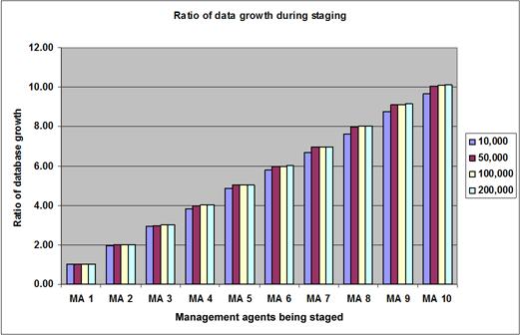

Table 27: Ratio of growth during staging, based on database size compared to initial database size. (Used to plot Figure 16)
Objects | MA1 | MA2 | MA3 | MA4 | MA5 | MA6 | MA7 | MA8 | MA9 | MA10
10,000 | 1.00 | 1.95 | 2.92 | 3.83 | 4.86 | 5.78 | 6.68 | 7.61 | 8.74 | 9.67
50,000 | 1.00 | 2.00 | 2.99 | 4.00 | 5.03 | 5.98 | 6.94 | 7.98 | 9.10 | 10.06
100,000 | 1.00 | 1.99 | 2.99 | 4.02 | 5.04 | 5.99 | 6.95 | 8.01 | 9.11 | 10.07
200,000 | 1.00 | 2.01 | 3.01 | 4.04 | 5.06 | 6.02 | 6.97 | 8.03 | 9.16 | 10.12

Observations
• We can see a linear relation to the growth of the database, which was expected because all the sources that were imported into the database were equal in size.
• Note that with the run history information and the extra management agent data, the database doubles in size after each run profile staging operation.
Figure 17: Database growth ratio during staging
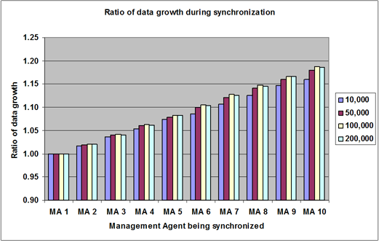

Table 28: Ratio of growth during synchronization, based on database size compared to initial database size. (Used to plot Figure 17)
Objects | MA1 | MA2 | MA3 | MA4 | MA5 | MA6 | MA7 | MA8 | MA9 | MA10
10,000 | 1.00 | 1.02 | 1.04 | 1.05 | 1.07 | 1.09 | 1.11 | 1.13 | 1.15 | 1.16
50,000 | 1.00 | 1.02 | 1.04 | 1.06 | 1.08 | 1.10 | 1.12 | 1.14 | 1.16 | 1.18
100,000 | 1.00 | 1.02 | 1.04 | 1.06 | 1.08 | 1.11 | 1.13 | 1.15 | 1.17 | 1.19
200,000 | 1.00 | 1.02 | 1.04 | 1.06 | 1.08 | 1.10 | 1.13 | 1.15 | 1.17 | 1.19

Observations
• Again a linear growth of the database is apparent, which was expected because all the sources that were synchronized into the database were equal in size and joined perfectly to all existing data.
We also notice that the cost in terms of database size to facilitate the linking between is quite small. Because all records in all connector spaces were identical, the metaverse itself did not grow after the initial projection. Upon closer examination, we found that most of the information was written to the “mms_csmv_link” table, which contains linkage between the various connector spaces and the metaverse objects. The rest of the information was written to the run history tables in the MIIS 2003 database.
Table 29a: Database growth as reported by both SQL Server and the server file system during processing of 10,000 and 50,000 objects (listed in Kbytes)
MA | Operation | 10,000  SQL DB | MDF DB | 50,000  SQL DB | MDF DB
Empty Database |  | 904 | 2,359 | 904 | 2,359
TXT01 | Import | 28,192 | 33,227 | 135,728 | 153,289
TXT02 | Import | 55,024 | 59,048 | 271,632 | 298,910
TXT03 | Import | 82,216 | 86,442 | 405,424 | 437,649
TXT04 | Import | 108,032 | 115,081 | 542,664 | 582,550
TXT05 | Import | 137,128 | 153,289 | 682,360 | 704,905
TXT06 | Import | 162,816 | 185,532 | 811,736 | 853,017
TXT07 | Import | 188,448 | 204,079 | 942,608 | 1,032,192
TXT08 | Import | 214,624 | 224,526 | 1,083,528 | 1,135,411
TXT09 | Import | 246,408 | 271,712 | 1,234,616 | 1,373,897
TXT10 | Import | 272,560 | 298,910 | 1,364,992 | 1,511,326
TXT01 | Sync | 299,488 | 328,794 | 1,504,248 | 1,662,452
TXT02 | Sync | 304,400 | 328,794 | 1,534,200 | 1,662,452
TXT03 | Sync | 310,576 | 328,794 | 1,564,328 | 1,662,452
TXT04 | Sync | 315,552 | 328,794 | 1,595,320 | 1,662,452
TXT05 | Sync | 321,720 | 361,693 | 1,623,848 | 1,828,717
TXT06 | Sync | 325,304 | 361,693 | 1,654,912 | 1,828,717
TXT07 | Sync | 331,320 | 361,693 | 1,687,128 | 1,828,717
TXT08 | Sync | 337,160 | 361,693 | 1,716,312 | 1,828,717
TXT09 | Sync | 343,488 | 361,693 | 1,744,944 | 1,828,717
TXT10 | Sync | 347,272 | 361,693 | 1,773,856 | 1,828,717

Table 29b: Database growth as reported by both SQL Server and the server file system during processing of 100,000 and 200,000 objects (listed in Kbytes)
MA | Operation | 100,000  SQL DB | MDF DB | 200,000  SQL DB | MDF DB
Empty Database |  | 904 | 2,359 | 904 | 2,359
TXT01 | Import | 264,320 | 298,910 | 518,864 | 582,550
TXT02 | Import | 527,168 | 582,550 | 1,042,680 | 1,135,411
TXT03 | Import | 791,160 | 853,017 | 1,562,704 | 1,662,452
TXT04 | Import | 1,061,400 | 1,135,411 | 2,093,984 | 2,212,823
TXT05 | Import | 1,331,976 | 1,373,897 | 2,623,080 | 2,945,384
TXT06 | Import | 1,582,112 | 1,662,452 | 3,121,848 | 3,239,969
TXT07 | Import | 1,836,888 | 2,011,628 | 3,615,928 | 3,920,429
TXT08 | Import | 2,116,352 | 2,212,823 | 4,166,984 | 4,312,465
TXT09 | Import | 2,408,968 | 2,677,604 | 4,752,512 | 5,218,173
TXT10 | Import | 2,661,424 | 2,945,384 | 5,253,304 | 5,740,036
TXT01 | Sync | 2,940,536 | 3,239,969 | 5,821,616 | 6,314,066
TXT02 | Sync | 3,002,392 | 3,239,969 | 5,940,104 | 6,314,066
TXT03 | Sync | 3,062,384 | 3,239,969 | 6,061,168 | 6,314,066
TXT04 | Sync | 3,126,416 | 3,239,969 | 6,184,776 | 6,314,066
TXT05 | Sync | 3,185,096 | 3,563,979 | 6,301,720 | 6,945,505
TXT06 | Sync | 3,249,712 | 3,563,979 | 6,424,568 | 6,945,505
TXT07 | Sync | 3,315,240 | 3,563,979 | 6,551,032 | 6,945,505
TXT08 | Sync | 3,375,392 | 3,563,979 | 6,669,616 | 6,945,505
TXT09 | Sync | 3,431,872 | 3,563,979 | 6,787,696 | 6,945,505
TXT10 | Sync | 3,492,112 | 3,920,429 | 6,906,944 | 7,640,056

Observations
• Because of the way that the MDF file gets extended by SQL server, there is usually a huge jump in growth at various points.

MIIS 2003 Capacity Planning Test Summary - Network
The following section discusses the network requirements for MIIS 2003 based on data collected during various tests presented throughout this document.

Test Description
Network traffic during staging and synchronization operations was monitored between an MIIS 2003 server and a remote SQL Server hosting the MIIS 2003 database. Network traffic during staging operations also monitored between an MIIS 2003 server and a connected data source.

Expected Results
Many believe that increasing available bandwidth increases performance. In an MIIS 2003 environment, a significant number of factors affect performance. Testing results indicated that other components of the MIIS environment are strained much more than the network bandwidth. As such, the requirements on the network should not be too intensive. One possible exception is the situation where the SQL server is remote to the MIIS server, which might be a greater load on the network.

Test Results Summary
Test results show that MIIS 2003 staging operations have a low impact on available bandwidth. In the tests presented here, the impact was consistently less than 1.5% of the available bandwidth. Even the use of a remote SQL server database had low load on the network.
The tests presented here are based on sequential processing of each management agent. If run profiles are executed concurrently in your environment, it is recommended that you test the impact of multiple sources passing information across the network.
The results confirm that the network requirements for MIIS 2003 are not severe. During the testing, however, it did become apparent that reliability of the network connection played a much more important role than speed.
Result highlights:
• A 100Mpbs network connection should be more than sufficient
• The reliability of the connection is a very important factor for a stable and efficient MIIS 2003 environment.
• During sequential run profile execution, the network requirements never exceeded 1.5 Mbps.

Recommended Best Practices
Use at least a 100 Mbps local network connection between the MIIS 2003 server and its connected data sources. If you use a remote SQL Server to host the MIIS 2003 database, use at least a 100 Mbps local network connection between the MIIS 2003 server and the SQL Server. The network layer will not be a bottleneck if this requirement is met.
If the data source is remote to the physical location and 100 Mbps service is not available, use a reliable link that is no slower than 5 Mbps. Operating MIIS 2003 across a slow link (less than 5 Mbps) is not recommended. However, if your environment makes it necessary to operate MIIS 2003 across a slow link, reliability is the primary concern.
Note
If the link is unreliable, resolve the unreliability issues before you deploy MIIS 2003. Although the time-outs on the various management agents can be increased, this should not be a workaround for unreliable links. An unreliable link can significantly impact the performance and operational efficiency of MIIS 2003.

Test Scenario
The data used for this section was gathered during the SQL Server and processor tests presented in the "MIIS 2003 Capacity Planning Test Summary - SQL Server" and "MIIS 2003 Capacity Planning Test Summary - Processor" sections of this document. Those specific tests were chosen because of the increased network load created by remotely locating the SQL Server.
Two sets of the SQL Server tests involved staging and synchronizing a large number of objects where the MIIS 2003 server was located on a different server than the SQL database used by MIIS 2003. The first set of network test results summarize the traffic generated when staging and synchronization data was sent between the MIIS 2003 server and the SQL Server hosting the MIIS database during those tests. The results of these network tests demonstrate the impact on network traffic if you decide to remotely locate the SQL Server that hosts the MIIS 2003 database.
The second set of network test results summarize the traffic generated between an MIIS 2003 server and a connected data source during staging operations. This data was gathered during the processor tests presented earlier in this document.

Server Hardware Configuration
The server configuration used to gather this data is the same configuration used for the SQL Server tests presented in the "MIIS 2003 Capacity Planning Test Summary - SQL Server" and "MIIS 2003 Capacity Planning Test Summary - Processor" sections of this document. For the first test, this data was collected from the two split server scenarios using the two test platforms designated as DMQS and QMDS. For a detailed description of the hardware configuration of those two platforms and a complete description of how MIIS 2003 was configured on those platforms, see the "Server Hardware Configuration" information in the section "MIIS 2003 Capacity Planning Test Summary - SQL Server" in this document.
Data for the second test was collected during the processor tests by monitoring traffic between the MIIS 2003 server and the SQL server that acted as a connected data source. For a detailed description of the hardware configuration of those two platforms and a complete description of how MIIS 2003 was configured on those platforms, see the "Server Hardware Configuration" information in the section "MIIS 2003 Capacity Planning Test Summary - Processor" in this document.

Network Configuration
During this test, the network between the two servers was a 100-Mbps VLAN Switched connection. Monitoring of performance was conducted on a separate monitoring network interface.

Test Results
The first test presents results of monitoring staging and synchronization traffic between the MIIS 2003 server and a remote SQL Server that hosts the MIIS 2003 database. The second test monitors staging traffic between an MIIS 2003 server and a remote SQL Server that acts as a connected data source.

MIIS Server and Remote MIIS Database
Figure18: Percentage utilization of a 100-Mbps network connection during various run profile operations (Measured in % of 100-Mbps link)
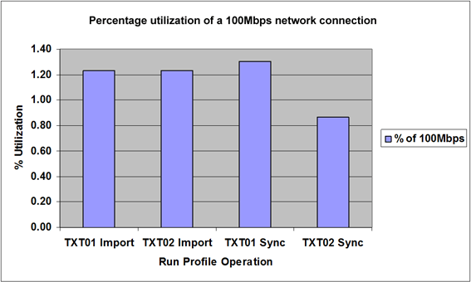

Table 30: Source data for Figure 18
Operation | % of 100Mbps
TXT01 Import | 1.23
TXT02 Import | 1.23
TXT01 Sync | 1.30
TXT02 Sync | 0.87

Observations
• During this test, 100,000 objects were staged and synchronized to a remote SQL database server.
• Even with a remote SQL server, the network load does not exceed 1.3Mbps.
• Note the decline in network traffic during the second synchronization run profile (TXT02 Sync). This is because more time is now spent doing index queries to attempt to join objects together as opposed to the large amount of T-SQL INSERT’s that happened in the preceding operations.

MIIS Server and a Remote Connected Data Source
Figure 19: Breakdown of inbound and outbound traffic from the remote SQL Server. (Measured in Bytes/ Sec)
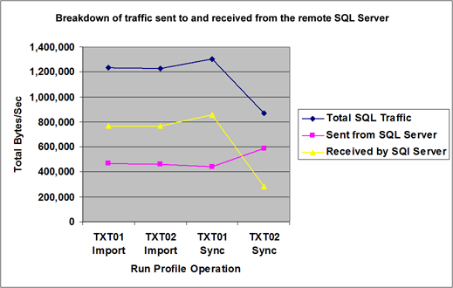

Table 31: Breakdown of inbound and outbound traffic from the remote SQL Server. (Measured in Bytes/ Sec)
100,000 Objects | Total SQL Traffic | Sent from SQL Server | Received by SQL Server
TXT01 Import | 1,231,861 | 463,843 | 768,019
TXT02 Import | 1,229,771 | 462,704 | 767,068
TXT01 Sync | 1,302,425 | 443,643 | 858,937
TXT02 Sync | 868,961 | 588,059 | 280,902

Observations
• Note that the network load during staging is quite similar, but more traffic is received by MIIS 2003 from the SQL Server when synchronization operations begin. This is due to the fact that following the INSERT statements executed during the staging, the SQL server has to return information about objects in the metaverse that can possibly be joined to objects being synchronized. The rules for join and projection are evaluated in the MIIS 2003 server and thus these records concerning these operations have to be passed from the SQL server to the MIIS 2003 server.
• During the second synchronization, this becomes very apparent as the amount of data sent from the SQL server to MIIS 2003 increases by almost 100Kb/sec.

MIIS 2003 Capacity Planning - Additional Performance Considerations

Other Capacity and Performance Considerations
Due to the way MIIS 2003 interacts with so many different and diverse systems, it is difficult to create a single, definitive source for capacity and performance related information. While the scope of this document is focused mostly on the server hosting MIIS 2003, many other capacity and performance-related factors should be considered.
This section presents a brief discussion on some of those factors. It does not present specific recommendations or include any test data. This section is intended to present additional factors that are commonly encountered in MIIS 2003 deployments.

MIIS 2003 Implementation
Many of the basic design decisions you make about the design of your MIIS 2003 environment can have a long-term effect on performance. MIIS 2003 creates a database of all the identity related data it has been configured to manage. Many operations it performs involve searching through the stored data and performing some operation on each object. A database that contains a large amount of extra, non-essential data can adversely affect search performance. While many design decisions are made based on storage capacity, you should also consider the impact they will have on performance.

Metaverse Design
During metaverse design, two opposing options for populating the metaverse are often considered. The first approach minimizes metaverse growth by dictating that only the objects and attributes that are to be managed by MIIS 2003 are imported into the metaverse. The idea underlying this approach is that the metaverse should only be populated with data that MIIS 2003 is currently responsible for managing. One advantage of this approach is that the size of the metaverse remains as small as possible. This results in better search performance and faster convergence if the synchronization rules are changed. One disadvantage is that future growth to support the management of additional objects and attributes might be more difficult to implement.
An alternative approach dictates that you examine your environment and determine which objects, and their associated attributes, you want to manage. You also include any objects and attributes that you think might be managed by MIIS 2003 in the future. This approach front loads the metaverse and provides a more stable base for growth. However, the additional data might impact the performance of database-intensive operations such as metaverse searches and resynchronization after changes to synchronization rules.

Attribute Types
Performance is also impacted by the number and type of attributes you choose to store in the metaverse. Two types in particular, multivalued and indexed attributes, have significant performance implications.
Multivalued attributes are single attributes that can contain more than one value. For example, a group object might have a single attribute called Membership. If that group has 100 members, that attribute might contain 100 different values. If your deployment utilizes many multivalued attributes, your metaverse might contain a lot more information than is apparent. This size can affect search and synchronization operations.
Searches that involve multi-valued attributes also can affect performance. The values stored in a multivalued attribute are actually stored by concatenating the individual values together into a single string. This makes it easy to detect any changes made because the new string can be compared to the old string that is stored in the metaverse. However, the use of a single string makes search operations more complex. The values are not sorted before they are concatenated into the string for storage. Therefore, when a search operation is initiated, each string must be parsed to get the individual values, and then the values must be sorted, before the search occurs. The parsing and sorting causes additional overhead that results in slower performance during search operations.
Indexed attributes can be used for more efficient search and join operations, thereby increasing the performance of those operations. The disadvantage is that indexed attributes utilize slightly more space in the database. But this is a negligible consideration especially when compared to the improved search and join performance gained by the use of the index.

Rules Extensions
Rules extensions are customized procedures written to handle special requirements of a customer's environment. They are customized .NET assemblies written in VB.NET or C# to augment the functionality of MIIS 2003. Care must be taken to prevent the introduction of performance issues into your MIIS 2003 environment when implementing your rules extensions.

Optimize your code
Put as much thought into optimizing any rules extension code you develop as you put into selecting an optimal hardware configuration to maximize the performance of your MIIS 2003 server.
Make sure you follow good coding habits. Try to avoid unnecessary decisions and function calls. When examining code examples posted on newsgroups and discussion lists it appears that many authors are intent on solving a particular problem but completely ignore any performance considerations of the code they write. If these examples are copied and implemented into production environments many would have a seriously negative impact on performance.

Logical Operators
Thoroughly test any rules extension code you develop. Ensure that it is functioning properly and producing the desired result, and that it is performing as expected. For example, VB.NET does not handle some logical operations in the manner some developers expect. Consider the two logical operators And and Or. In many programming languages, during the processing of a statement such as:
If ConditionX or ConditionY then StatementZ
ConditionY will not be evaluated if ConditionX is true. The nature of the Or operator is such that if one condition is true, then the entire statement evaluates to true. If the first condition evaluates to true, the second condition is not evaluated because the whole statement is true regardless of the second condition. This type of behavior helps optimize the code, especially if the second condition involves a function call.
VB.NET does not process the Or statement in this manner. Regardless of how the first condition is evaluated, VB.NET still processes the second condition.
A new operator called OrElse has been introduced so that VB.NET can support this functionality. Using the OrElse operator for this type of decision will produce code that runs more efficiently but still behaves in an expected fashion. When you consider the implications of this small change in an MIIS 2003 environment, the potential performance ramifications can be significant. Consider the following statement:
If ConditionX or ConditionY then StatementZ
where ConditionY requires a function call that requires an operation such as a metaverse search. Each time this statement is processed, a metaverse search occurs even if ConditionX has already evaluated as true and there is no need to evaluate ConditionY. Now think about the ramifications of this if this line of code is called for each object in the metaverse and you are processing a million objects. Simply using the OrElse operator instead solves this problem and provides much more efficient code. Similar efficiencies might be gained by replacing the And operator with the new operator AndAlso.
This is an example where code you develop could be producing the proper output but it is not performing as efficiently as you expect. Extra time spent making sure the code is as efficient as possible can have significant rewards.

IsPresent
You can increase code efficiency by skipping blocks of code that deal with attributes that have not been initialized. Many code samples assume that all attributes are present and make calls based on that assumption. IsPresent is a property that indicates whether or not an attribute exists as part of an object. Verifying that an attribute is present before calling the code to process it will make your code run more efficiently, reduce errors (especially in more complicated implementations) and improve performance.

Utils.FindMVEntry
Avoid using Utils.FindMVEntry whenever possible. This will initiate a query against the metaverse which can result in slowing down the synchronization process. If you need to use this function then use it with indexed attributes.

Exception Handling
Structured exception handling might also be missing from code samples that are leveraged for production environments. Using the Exception class in conjunction with TRY CATCH statements allows you to manage control of your code even when unexpected events occur. Whereas the default behavior may be to attempt to process each object and record an error if an exception occurs, structured exception handling can be used to solve the problem causing the error. This can be preferable to recording an error message in a log or terminating the process altogether so no additional time is wasted by repeatedly recording an error message while failures continue to occur for each object processed.

Calling External Processes
Another coding convention to avoid is writing extension code that makes calls to systems that are external to MIIS 2003. For example, avoid practices such as calls to Active Directory to see if a user account already exists before processing some provisioning code or code that sends e-mail to someone if some event occurs while the extension code is still being processed. While this type of functionality can help solve some administrative processes, they can also reduce performance of the MIIS 2003 environment. Consider what would happen if the system being called was unavailable during the synchronization process, or only had intermittent connectivity. Instead, consider how this type of functionality can be managed entirely within MIIS 2003.

Management Agent Behavior
Make sure you understand everything a management agent is doing and how it will impact your environment before deploying it to your production environment. Some management agents require the addition of new object types to the metaverse and some have a significant amount of code in their rules extensions. Set up a test environment and deploy the new management agent so you can anticipate the impact on performance before implementing it in your production environment.

Database Considerations
Although this document presents results from limited testing of database performance issues, issues that pertain to database size and the workload on the database server also need to be considered.

Run History
The number of objects and attributes you decide to store in the metaverse is not the only factor that contributes to the size requirements of the MIIS 2003 database. Another significant contributing factor is MIIS 2003 run profile history.
Each time a run profile is processed, MIIS 2003 compiles a detailed report that lists the changes made to each object and attribute. This report is called the run history and is stored in the MIIS 2003 database. Repeated staging and synchronization operations that involve many objects and attributes can result in considerable space being consumed by the storage of run history information.
The MIIS Resource Tool Kit 2.0 (http://go.microsoft.com/fwlink/?LinkId=30738) contains a command line tool called MIISClearRunHistory that can be used to clear run history records from the database. This tool can be scheduled to run periodically and clear a range of run history records from the database. The number of records you clear and the frequency you run the tool will be determined by your reporting requirements and any database size restrictions.

Server Workload
One other performance consideration for the MIIS 2003 database is the workload of the server that hosts it. As discussed in the summary of the database tests earlier in this document, many organizations maintain their database servers in a centralized location for management and security reasons. In these scenarios, the database server is not likely controlled by the MIIS 2003 administrators.
Make sure that service levels around database server performance are agreed upon and maintained because they directly impact the performance of the MIIS 2003 environment. If the database servers become too busy serving other database clients throughout the organization, the performance of MIIS 2003 is degraded.

External Considerations
The environment outside of MIIS 2003 must also be considered for performance issues, both from the perspective of how it impacts MIIS 2003 and how MIIS 2003 impacts that environment. Implementing MIIS 2003 requires integrating environments, not just adding another. Due to this integrated relationship, anything that happens in one environment has the potential to affect the other environments managed by MIIS 2003. This includes planned activities, such as backup operations, as well as unplanned activities such as outages and disaster recovery operations.
Many of the data sources that MIIS 2003 interacts with are servers that are most likely providing services to other clients on the network. If they are overloaded, their response times to MIIS 2003 will be diminished and adversely affect the performance of the MIIS 2003 environment.
This particular problem also applies to MIIS 2003 and the requests it sends to the data sources. If MIIS 2003 attempts to stage a large number of objects, it might impact the performance of the data source server such that other clients using services from that server will start experiencing performance problems.
Two examples of data sources that are susceptible to both these issues are servers hosting Active Directory and Microsoft Exchange. Servers hosting these services are almost always mission-critical servers with many clients depending on the services they provide.
Make sure you consider the impact that staging 100,000 user objects might have on the domain controller that hosts Active Directory or the impact on the Exchange server of synchronizing global address lists for 50,000 contacts. Of less significance but still worth mentioning are network bandwidth considerations. In addition to routine e-mail traffic, Active Directory replication traffic, and client authentication traffic on the network, MIIS 2003 staging operations result in data being sent across the network. If a million objects are being staged, this will amount to a significant amount of traffic. Although communication across a slow link is not a recommended configuration for MIIS 2003, it may be necessary due to other limitations in the environment. In this situation, network bandwidth might be the most important consideration of all performance issues.
When integrating servers of this type into an MIIS 2003 environment, make sure that service level agreements are in place for both the well being of the MIIS 2003 environment and the well being of the data sources. Also perform adequate testing. These steps will help ensure that any impact on the performance of these servers is anticipated and steps have been taken to maintain service levels.

Hardware Considerations
Two additional considerations for the performance of the server platform that hosts MIIS 2003 are hyper-threaded processors and 64-bit platforms. We did not have an opportunity to test the affect of hyper-threading on performance for the tests presented in this document. It is assumed that you would see increased performance on a platform utilizing hyper-threaded processors, but we have no data to indicate how much of a benefit would be realized.
Regarding 64-bit platforms, currently MIIS 2003 is a 32-bit based application, so it is not likely any significant performance would be seen by deploying it on a 64-bit platform. Platforms of this type were not tested.

