Document Workflow Advances in Windows Vista
January 26, 2006
Abstract
This paper describes how using the XPS Document technologies of the Microsoft® Windows Vista™ supports and enhances document workflows and the document life cycle. It provides decision-makers and implementers with information about this new technology and how they can apply it to their business or product line. The paper also highlights opportunities for third-parties to use these technologies to add value to their document processing and management products.
This information applies for the following operating systems:
Microsoft Windows® Vista
Microsoft Windows Server™ 2003
Microsoft Windows XP
The current version of this paper is maintained on the Web at:
http://www.microsoft.com/whdc/xps/XPSworkflow.mspx
References and resources discussed in this paper are listed at the end of the paper.

Contents
XPS Document Technology Overview 3
XPS Document Technologies in the Document Workflow 4
Document Origination 4
Save as XPS Feature 5
Scan to XPS Feature 5
Document Management and Processing 5
Security 5
Safety 5
Document Consumption 5
XPS Document Printing 6
XPS Document Viewing 6
XPS Document Distribution and Publishing 6
Archive 7
Document Workflow Scenarios 7
The Law Firm of Litware, Inc. 7
Organized Workflow 8
Protected Information 8
High-Fidelity Documents 8
Compatible Storage 8
Archive-ready Format 9
Adventure Works 9
Background 9
Workflow 10
Document Create-Review-Publish Workflow 10
Call to Action 11
References and Additional Resources 11
Disclaimer
This is a preliminary document and may be changed substantially prior to final commercial release of the software described herein.

The information contained in this document represents the current view of Microsoft Corporation on the issues discussed as of the date of publication. Because Microsoft must respond to changing market conditions, it should not be interpreted to be a commitment on the part of Microsoft, and Microsoft cannot guarantee the accuracy of any information presented after the date of publication.

This White Paper is for informational purposes only. MICROSOFT MAKES NO WARRANTIES, EXPRESS, IMPLIED OR STATUTORY, AS TO THE INFORMATION IN THIS DOCUMENT.

Complying with all applicable copyright laws is the responsibility of the user. Without limiting the rights under copyright, no part of this document may be reproduced, stored in or introduced into a retrieval system, or transmitted in any form or by any means (electronic, mechanical, photocopying, recording, or otherwise), or for any purpose, without the express written permission of Microsoft Corporation.

Microsoft may have patents, patent applications, trademarks, copyrights, or other intellectual property rights covering subject matter in this document. Except as expressly provided in any written license agreement from Microsoft, the furnishing of this document does not give you any license to these patents, trademarks, copyrights, or other intellectual property.

Unless otherwise noted, the example companies, organizations, products, domain names, e-mail addresses, logos, people, places and events depicted herein are fictitious, and no association with any real company, organization, product, domain name, email address, logo, person, place or event is intended or should be inferred.

© 2005 Microsoft Corporation. All rights reserved.

Microsoft, Outlook, Sharepoint, Win32, WinFX, Windows, Windows Server, and Windows Vista are either registered trademarks or trademarks of Microsoft Corporation in the United States and/or other countries.

The names of actual companies and products mentioned herein may be the trademarks of their respective owners.

XPS Document Technology Overview
Microsoft® Windows Vista™ brings advances in document creation, management, processing, sharing, and storage. At the heart of these advances is the XML Paper Specification, which describes a new, open standard for document storage and publishing. Microsoft Windows® Vista also applies several new, related technologies to the document workflow that improve document simplicity, safety, and security. These improvements are also in Microsoft Office “12” (the next version of Office) and other applications.
The XML Paper Specification (XPS) is royalty free and available to everyone. The specification describes the XPS Document format, which uses an XML-based language to store document text, graphical elements, and other metadata in a file (or document package).
The physical layer of the XPS Document format is defined by the Open Packaging Conventions specification, which is also royalty free. The Open Packaging Conventions uses XML for flexibility and the .zip archive file format for efficient storage and compression. The physical layer of the document can contain digital signatures and supports Windows Rights Management Services (RMS) for additional information protection. Digital signatures can be used to authenticate the document contents and the identity of the authors and reviewers. Windows RMS can restrict access to a document’s information and prevent unauthorized persons from viewing document contents.
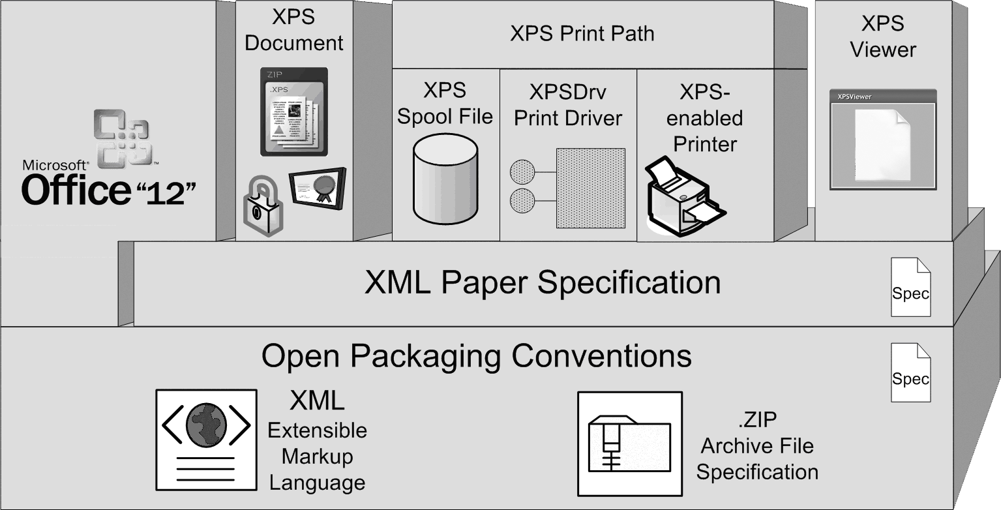
Figure 1. XPS Document technologies
Windows Vista incorporates the XPS Document format throughout the print subsystem and uses the format as a native spool file format. Together, the XPS Spool File format, XPSDrv print drivers, and XPS-enabled printers form the new XPS print path in Windows Vista. The XPS Spool File format is identical to the XPS Document format and brings new graphics abilities to the print subsystem. Document fidelity and performance are much better with XPSDrv print drivers than with print drivers that are based on the graphics device interface (GDI). XPS-enabled printers also use the XPS Document format as the printer page description language (PDL), which allows the document to remain in the same format as it moves from the application to the printer. Using the same format for document storage, spooling, printing, and viewing preserves the original document fidelity throughout the document life cycle.
The XPSViewer utility is hosted in Microsoft Internet Explorer and is based on the Microsoft WinFX® DocumentViewer control. The XPSViewer presents XPS Documents on the screen in the same way in which they appear in printed form. With XPS Documents, what you see is really what you get, regardless of where you view the documents.
The XML Paper Specification and the Open Packaging Conventions are the foundation for a new set of document management features in Windows. This paper provides an overview of these new features and how they can benefit end users and create opportunities to independent software vendors (ISVs), system integrators, and independent hardware vendors (IHVs).

XPS Document Technologies in the Document Workflow
The XPS Document technologies of Windows Vista provide a common foundation for all aspects of document creation, storage, and publishing. Document processing workflows no longer need to be an amalgamation of different technologies.
Figure 2 illustrates some of the more common methods of document origination and consumption and how XPS Document technologies can be applied to each of them.
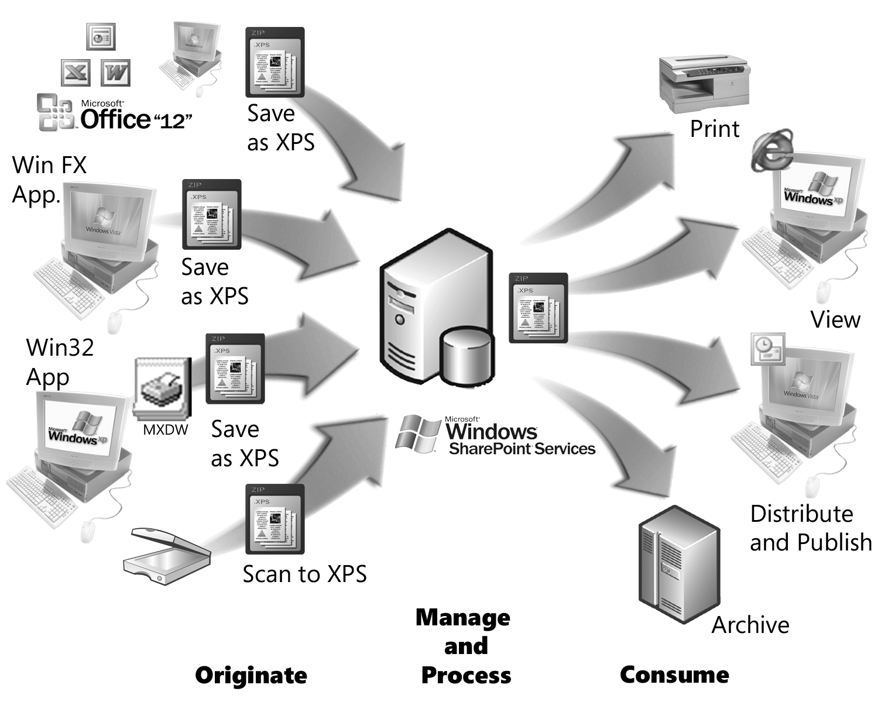
Figure 2. Document workflow that uses XPS Document technologies

Document Origination
XPS Document technologies provide new capabilities for document origination. Windows Vista supports the origination of XPS Documents from new applications and from those that were written before the availability of XPS Document technologies.

Save as XPS Feature
Virtually all Windows applications that can print a document can create XPS Documents in Windows Vista. Office “12” supports publishing XPS Documents directly from Office “12” applications. To integrate XPS Documents into their document workflow, Office “12” users simply save their Office “12” document as an XPS Document.
Windows Presentation Foundation (WPF) applications can include the save as XPS function that uses the XPS Document application programming interfaces (APIs) in WinFX. These APIs serialize the application’s extensible application markup language (XAML) code and write it to an XPS Document.
Users of unmodified Microsoft Win32®-based applications can also publish XPS Documents and take advantage of an XPS Document-based workflow. These applications employ the Microsoft XPS Document Writer (MXDW), a print driver that is included with WinFX Runtime. To create an XPS Document, users just select the MXDW from the list of installed printers in the Print dialog box. After saving the XPS Document, the user can apply access rights that are managed by Windows RMS and digital signatures to it by using the XPSViewer.

Scan to XPS Feature
Scanner vendors have announced plans to produce scanners that support XPS Documents. These XPS-enabled scanners create XPS Documents that contain a full-page image of the scanned page. Optical character recognition (OCR) technology then makes the text available for searching and printing.

Document Management and Processing
Regardless of how an XPS Document is created, after it has been published as an XPS Document, it can be managed, published, and consumed while Window RMS and digital signatures provide information protection.

Security
A document often undergoes a series of revisions between the time it is originated and the time it is published or distributed. The security features of the Open Packaging Conventions make it possible to protect document information throughout this process.
Office “12” applications store documents according to the Open Packaging Conventions, which includes information protection features. Because of this, Office “12” applications can support collaboration while providing information protection by using Windows RMS and digital signatures. XPS Documents are also based on the Open Packaging Conventions. Therefore, documents from Office “12” applications can apply the same information protection to the XPS Documents that they publish as they do to their working documents.

Safety
The modular nature of the XPS Document format, together with the .zip archive file format and XML-based content, makes the XPS Document more reliable and makes data recovery easier. Using the .zip file format provides error detection data to help protect the physical integrity of the data.

Document Consumption
XPS Document technologies carry the document fidelity and information protection features that were provided during the authoring process into the document publishing and consumption phase of the document life cycle.

XPS Document Printing
When documents are printed on XPS-enabled printers that use XPSDrv printer drivers, XPS Document technology supports document printing throughout the entire printing process. XPS Documents enter the printing process when they are queued for printing in the XPS Spool File format. XPS Documents do not require a file format conversion when spooled, as is the case with documents that are printed by an older, GDI-based print driver.
XPSDrv print drivers directly process documents in the XPS Spool File format. This means that the print driver is processing the contents of the original XPS Document instead of the contents of an intermediate file. Processing the XPS Document contents directly enables XPSDrv print drivers to provide richer graphics processing than GDI-based print drivers do. XPSDrv print drivers can take advantage of the more advanced XPS Document imaging model, a graphics model that is based on the WPF imaging model. Further, using the same data format throughout the print process eliminates the file format conversions that are required by the Win32, GDI-based print drivers.
The XML Paper Specification is also a printer PDL. XPS-enabled printers can directly consume XPS Documents and process the document contents for printing in the printer hardware. This minimizes, and in some cases eliminates, the print processing load on the print server and can also take advantage of hardware acceleration in the printer.

XPS Document Viewing
XPS Documents can be viewed in the XPSViewer with no dependency on the original authoring program. The XPSViewer is an Internet Explorer–hosted, WPF-based utility that is based on the DocumentViewer control that runs on Windows Vista. It also runs on Microsoft Windows XP and Microsoft Windows Server™ 2003 that have WinFX Runtime Components installed. Having support for Windows XP and Windows Server 2003 makes it easy to integrate XPS Documents into the document workflow immediately.
The XPSViewer utility performs strict XML schema definition (XSD) validation of the document text before opening XPS Documents, which ensures XPS Document compliance by XPS producers and consumers. The XPSViewer is an RMS-enabled application that implements the special information protection features of the DocumentViewer control and authenticates only by using Windows RMS.
Developers can also create custom viewing applications by using the DocumentViewer control. These custom viewers can support extensions to the XPS Document that add custom content such as 3-D views, animation, or other functions.
XPS Documents are not limited to only Windows-based computers. Any application can include an XPS Document viewer regardless of its native platform because the XML Paper Specification is an open, royalty-free specification that specifies how to create and render XPS Documents.

XPS Document Distribution and Publishing
The information protection features of XPS Documents make document distribution and publishing safer, more secure, and economical. Documents that have been protected by application of Windows RMS can be distributed to a wide audience while sensitive information is protected from unauthorized access.
Office “12” applications use the Open Packaging Conventions in their new Open XML file formats. Both support the same information protection features that are in XPS Documents. For example, if the user restricts the rights on a Microsoft Word “12” document, those same restrictions are transferred when that document is saved as an XPS Document. Likewise if a user composes a message in Microsoft Outlook® “12” and protects the message by Windows RMS, those same protections are applied to the XPS Documents that are attached to the message.
XPS Documents can also be signed with digital signatures so that persons reading them can be sure that the document contents are authentic and valid. Digital signatures provide the electronic equivalent of a tamper-proof seal on the document content by becoming invalid if the signed content is modified after the signature has been applied.
Although these security features add several layers of protection, they do not complicate the workflow because of the integration of XPS technologies into Microsoft applications. For example, Office and SharePoint support the Windows RMS features and the XPSViewer enables digital signature review.

Archive
The XPS Document format is especially suited for archiving documents because it is designed for longevity and uses a text-based language that is defined by an open specification that can be easily read and processed. The XPS Document format is also designed for space-efficient storage and transmission by using the .zip archive file format as described in the Open Packaging Conventions.
XPS Document content is stored with all the elements that are necessary to reproduce the document—images, fonts, and text are all contained in an XPS Document. The document content is described in XML by using a subset of the XAML that WPF applications use. All of this content is then stored as a compressed archive file in the .zip archive format. Using an open specification based on industry-standard technologies for content and storage ensures that the document content is available in the future.

Document Workflow Scenarios
This section describes some possible scenarios in which XPS Document technologies simplify and organize an existing workflow. The company names, people, and scenarios are fictitious and are presented for illustration purposes only.

The Law Firm of Litware, Inc.
Litware, Inc., is a successful law firm in a large city. It currently employs many lawyers, has many clients, and handles many cases. Ordinarily, this type of success would be positive; however, the document processing at the firm has become extremely difficult. The firm has found it necessary to hire temporary office staff just to handle the task. One day, Holly, a senior partner in the firm, looked at the flurry of papers in the file room and decided the process needed to be more efficient. She called Jan at Trey Research, its Microsoft Solution Provider, to see what could be done.
The law firm was already using Office for much of its document origination and SharePoint for document storage, collaboration services, and internal communications. Because the new technologies of Windows Vista are designed to work smoothly with Office and SharePoint, the firm already had a good foundation for its document workflow.
Jan told Holly about the new XPS Document technologies that will be part of Windows Vista and how using these technologies could better organize the firm's current workflow and provide a foundation for future growth. Holly explained the current situation and workflow to Jan, and together they came up with the following solution.

Organized Workflow
Currently, the cases are assigned an internal case number. The case number relates to an entry in the firm’s case database that also contains the list of attorneys working on the case, client information, and other information about the case. This database also includes links to billing and accounting. After the documents receive their case numbers, they are scanned directly to an XPS Document by an XPS-enabled scanner. OCR software then processes the scanned documents to extract the text. The case number that is read from the document is then used to properly place the document in the computerized workflow. This reduces the chance of misfiling or misplacing the documents.

Protected Information
Because document security and confidentiality are critical in a law firm, XPS Documents are perfect for Litware’s needs. After a document is scanned, the electronic copy of the document goes to the appropriate SharePoint document library based on the information that was retrieved from the case database.
In an XPS Document, document content can be protected by Windows RMS. To protect confidentiality, information from the case database is used to give access to the document only to persons who are associated with the case. If the document ends up in the hands of an unauthorized person, the information is protected. This assurance greatly relieved Holly's concerns.
To guarantee that the contents of the electronic document are authentic, the scanner and OCR software can apply a digital signature to the document to indicate when the content was scanned and translated to text. Any subsequent tampering with the document’s contents is easily identified by an invalid digital signature.

High-Fidelity Documents
Jan asked Holly if document image quality was important. Holly replied that it was more than important—it was vital. Image readability and document fidelity are absolute requirements. Real estate cases are really helping to fuel the firm's growth and often, these cases included drawings, blueprints, and photographs. Litware desperately needed a way to integrate these different document types into its electronic workflow while retaining high image fidelity.
Jan told Holly that XPS Documents are well suited for all kinds of data types, can support multiple image types, and can provide great document fidelity and readability. XPS Documents support much higher quality graphics processing than was easily available in earlier versions of Windows, and documents can now be viewed or printed in higher fidelity.

Compatible Storage
Holly explained that, although the firm used Office to originate many of its documents, it also had other line-of-business applications that are not based on Office. She asked Jan if the firm's output could also be processed in an XPS Document-based workflow. Jan replied that documents produced by other applications fit seamlessly into the XPS Document-based workflow. Older, Win32-based applications can publish XPS Documents by simply saving as XPS Documents by using the Microsoft XPS Document Writer, a print driver that looks like a printer to the user but writes the document to an XPS Document file. So the firm's line-of-business applications can publish XPS Documents and integrate them into the XPS Document workflow.
This sounded perfect, but the thought of upgrading the firm's computers to Windows Vista, all at once, to take advantage of these features appeared somewhat intimidating. Lost time is lost money, so interrupting a case to upgrade the computer would be expensive. Jan told Holly that, to use these new features, it was unnecessary to upgrade all computers to the new operating system. Because many of these features are part of WinFX Runtime, computers that run Windows XP must install only WinFX Runtime to use many of these new features.

Archive-ready Format
Holly was concerned about introducing another file format into the current mix of formats that the firm already must maintain for archival purposes. She wondered to Jan if they would be able to read the XPS Documents in the future. Jan told Holly how XPS Documents were stored in a plain-text, XML-based format that uses elements that are defined in the XML Paper Specification. These plain-text document parts are stored in a file that is compressed by using the .zip archive file format. The .zip archive file format is described in a specification that was published over 10 years ago and is industry standard. Therefore, it is likely to be readable for a long time. If the firm must convert to other file formats some time in the future, the conversion could be as simple as an XSL transform.
Holly asked Jan about the archiving and storage space requirements for all these documents. Jan replied by saying that both Office “12” documents and XPS Documents use the Open Packaging Conventions for document file storage. This means that the documents are stored in .zip archive files and that their content can be compressed to make them more space efficient than many other document types.
Holly was convinced and began planning the conversion.

Adventure Works
Adventure Works is a small partnership that conducts custom adventure trips and vacations. Because each trip is all inclusive and tailored to the individual client, preparation and coordination are extensive. Adventure Works services are expensive, but its comprehensive planning and friendly staff have been key factors in building its steadily-growing list of satisfied clientele.

Background
At first, planning was done by the three original partners sitting around a table making telephone calls, taking notes, and passing around a piece of paper that served as their planning sheet until the trip was ready. Now that they have three offices in the United States, one in Alaska, several more in Central and South America, and a new office in Asia, passing a piece of paper around the table just doesn’t work for the partnership any more.
As the company grew, it tried several different types of software to coordinate the travel plans but eventually decided to use SharePoint as the main application for archiving and coordination and Office applications for worksheets and correspondence. As early adopters, here is how they applied XPS Document technologies.

Workflow
An account representative works directly with the client to prepare a general description of a trip. This can include information such as customer preferences in lodging, food, transportation, points of interest, and other related information. A planning team receives this information from the account representative, organizes the itinerary, makes the reservations and arrangements, and prepares the proposal and the quote.
The planning team relies on SharePoint to manage its Office “12” documents as they collaborate throughout the planning phase. Eventually, the details are added and the plans are finalized. The team publishes its final plans to an XPS Document. To prevent any unauthorized changes to the plan, this document is digitally signed by the planning team leader. Any changes to the final plan might require the planning team to revise the quote. If so, they publish a new XPS Document and apply a new digital signature. Adventure Works takes its customer’s satisfaction very seriously and doesn’t want any mistakes.
The planning team leader returns the final, digitally-signed plan to the account representative. The account representative is assured that all the details have been taken care of because the plan is not signed until the team leader is certain that everything is ready. The account representative then prepares the customer information package that includes detailed information about the trip, complete with photos and the price quote. The finished package is published as an XPS Document and sent to the customer.
Customers appreciate receiving the information as an XPS Document because they can easily view the information in Internet Explorer and they do not need the authoring application to view the document. More than one customer has been impressed by the beautiful photos in the information package. The image quality of the photographs is the result of the rich image format support in XPS.
When customers are satisfied with the plan, they apply their digital signature directly in the XPSViewer and the finished plan is forwarded to the field office that will handle the trip.

Document Create-Review-Publish Workflow
In many setting, the create-review-publish workflow is very common. This workflow is characterized by a document that is created by one person or perhaps a small group. The document is then reviewed, edited, and approved by another group. When the document is ready, it is then published to a wider audience. The information protection features of XPS Documents are especially suited to facilitating this workflow while preserving the security and integrity of the document.
Initially, a document might be created by a small team so, during this process, the document can be protected to prevent tampering by persons outside the team. Windows RMS could be used to apply protection to the document so that only team members can open and edit the document during this phase. Applying rights to an Office “12” document is a simple and powerful feature that has the added benefit of keeping the access rights attached to the document. If the document is mailed, for example, the document remains protected and can be accessed only by a person who has been granted access to the document.
SharePoint and Office “12” support publishing to XPS Documents, so when the Office document is ready for review, the original team can save the Office “12” document as an XPS Document. Because Office “12” documents and XPS Documents both use the Open Packaging Conventions, rights applied in Office “12” are automatically inherited by the XPS Document when they are published as XPS. Users can also sign the document’s content to indicate that they have completed their work. For reviewing, the access list on the document would be changed to allow the reviewers to read and sign the document.
After the document is ready for publishing to a wider audience, the access controls are changed again to grant access to the new audience. Windows RMS access control is part of the document, so this protection travels with the document. If the document is copied or forwarded to a user who has not been granted access, that user cannot view the document’s information. Because the XPSViewer is a Windows RMS-enabled application, applied rights are enforced at viewing time.

Call to Action
The XPS Document technologies that are part of Windows Vista provide advances in document creation, management, processing, and storage. The new, open standard for document processing made possible by XPS provides benefits throughout the document workflow to improve the simplicity, safety, and security of document processing.
- IT professionals should understand the benefits of the XPS Document technologies and how, with Windows Vista and WinFX Runtime, they can be deployed in their enterprise.
- Business process owners should look at how their systems and applications can benefit from an XPS Document–based workflow. They should understand that many of these benefits are included with the adoption of Windows Vista and Office “12.”
- Application developers should understand that applications can easily include many of the XPS Document–related technologies. They should review the WinFX and XPS Document programming documentation to better understand how they can apply this technology.

References and Additional Resources
XPS Web site:
http://www.microsoft.com/xps
XML Paper Specification:
http://www.microsoft.com/whdc/xps/xpsspec.mspx
Open Packaging Conventions:
http://www.microsoft.com/whdc/xps/xpspkg.mspx
Windows Rights Management Services:
http://www.microsoft.com/rms
Windows Workflow Foundation:
http://msdn.microsoft.com/windowsvista/building/workflow/
Introducing Microsoft Windows Workflow Foundation: An Early Look:
http://msdn.microsoft.com/windowsvista/building/workflow/default.aspx?pull=/library/en-us/dnlong/html/WWFIntro.asp
For additional information, send an e-mail to xpsinfo@microsoft.com.

