Virtual Address Space Usage in Windows Game Development
August 2, 2007
Abstract
Windows Vista® significantly improved the way in which the operating system handles the graphic processing unit (GPU). The Windows Vista Display Driver Model (WDDM) enables better sharing of GPU resources among multiple graphics applications. The video memory manager component of WDDM virtualizes the available video memory resources for applications to use. This enables the new Windows Aero experience to run alongside other applications, such as video playback, which also use the GPU.
However, the virtualization of video memory increases the amount of virtual address space that applications use. Consequently, some applications may exhaust virtual address space when running on 32-bit Windows Vista. This paper describes the types of applications that might encounter such problems and the steps that Microsoft is taking to reduce virtual address space pressure for games running under WDDM.
This information applies for the Windows Vista operating system.
The current version of this paper is maintained on the Web at:
http://www.microsoft.com/whdc/device/display/WDDM_VA.mspx
References and resources discussed here are listed at the end of this paper.
Contents
Introduction 3
Virtual Address Space Limits in 32-Bit Windows 3
Solutions 4
Interim Solution 4
Long-Term Solution 4
Resources 5

Disclaimer
This is a preliminary document and may be changed substantially prior to final commercial release of the software described herein.

The information contained in this document represents the current view of Microsoft Corporation on the issues discussed as of the date of publication. Because Microsoft must respond to changing market conditions, it should not be interpreted to be a commitment on the part of Microsoft, and Microsoft cannot guarantee the accuracy of any information presented after the date of publication.

This White Paper is for informational purposes only. MICROSOFT MAKES NO WARRANTIES, EXPRESS, IMPLIED OR STATUTORY, AS TO THE INFORMATION IN THIS DOCUMENT.

Complying with all applicable copyright laws is the responsibility of the user. Without limiting the rights under copyright, no part of this document may be reproduced, stored in or introduced into a retrieval system, or transmitted in any form or by any means (electronic, mechanical, photocopying, recording, or otherwise), or for any purpose, without the express written permission of Microsoft Corporation.

Microsoft may have patents, patent applications, trademarks, copyrights, or other intellectual property rights covering subject matter in this document. Except as expressly provided in any written license agreement from Microsoft, the furnishing of this document does not give you any license to these patents, trademarks, copyrights, or other intellectual property.

Unless otherwise noted, the example companies, organizations, products, domain names, e-mail addresses, logos, people, places and events depicted herein are fictitious, and no association with any real company, organization, product, domain name, email address, logo, person, place or event is intended or should be inferred.

© 2007 Microsoft Corporation. All rights reserved.

Microsoft, DirectX, Windows, Windows NT, and Windows Vista are either registered trademarks or trademarks of Microsoft Corporation in the United States and/or other countries.

The names of actual companies and products mentioned herein may be the trademarks of their respective owners.

Introduction
Windows Vista® significantly improved the way in which the operating system handles the graphic processing unit (GPU). The Windows Vista Display Driver Model (WDDM) enables better sharing of GPU resources among multiple graphics applications. WDDM was designed to work with both the new Microsoft® DirectX® 10 architecture and the existing DirectX 9 and older architectures. Existing DirectX games work with both the Windows® XP Display Driver Model (XPDM) and WDDM drivers.
In Windows XP, video memory was allocated on a "first-come, first-served" basis. If a single application used all the available video memory, other applications were completely starved. In Windows Vista, however, the video memory manager component of WDDM virtualizes the available video memory resources for applications to use. Thus, video memory is available for multiple DirectX and Desktop graphics applications that execute simultaneously. Virtualization enables the new Windows Aero experience to run alongside other applications, such as video playback, that also use the GPU.
The virtualization of video memory in WDDM uses more virtual address space within an application’s address space than previous models. For applications that already approach the limits of their address space on 32-bit systems, running under WDDM can result in the exhaustion of the address space. This paper describes the virtual address space problem on a 32-bit Windows operating system and details the steps that Microsoft is taking to reduce virtual address space pressure for games running under WDDM.

Virtual Address Space Limits in 32-Bit Windows
On modern operating systems such as Windows, applications execute within their own private virtual address space. The size of the virtual address space is typically fixed at 2 GB for 32-bit applications. The amount of virtual address space is not related to the amount of physical memory on the machine.
Every memory allocation, file mapping, or library that is loaded by an application consumes space in this virtual address space. When the application consumes all of its virtual address space, any further such operations simply fail. Although all applications should be coded to handle memory allocation failures, many applications do not recover properly from such failures and consequently become unstable or crash.
Existing games and other graphics applications often allocate virtual memory for a copy of the video memory resources that they create. The application uses the copy to quickly restore the display if the contents of video memory are lost, as might occur if the user presses ALT+TAB, places the machine in Standby mode, and so forth. The DirectX run time typically manages the copy on behalf of the application when the application creates a managed resource, but an application can also manage the copy itself. The amount of virtual memory that the copy uses is directly proportional to the amount of video memory resources that the application allocates.
Nowadays, a GPU can have 512 MB or more of video memory. Applications that try to take advantage of such large amounts of video memory can use a large proportion of their virtual address space for an in-memory copy of their video resources. On 32-bit systems, such applications may consume all of the available virtual address space.
With the introduction of DirectX 10 and WDDM in Windows Vista, it is no longer necessary for an application to maintain a copy of its resources in system memory. Instead, the video memory manager ensures that the content of every video memory allocation is maintained across display transitions. For compatibility reasons, Windows Vista emulates "device lost" for DirectX versions earlier than DirectX 10 to ensure that no application-visible API behavior changes.
To virtualize video memory, the video memory manager in Windows Vista assigns a virtual address range to every video memory resource. This range is conceptually similar to the copy that an application might create except that the video memory manager manages it much more efficiently than the application. The video memory manager uses the virtual address range to handle transitions or over-commitment of video memory. However it is typically unused on a system with a large amount of video memory. As long as this virtual address range remains unused, no physical memory is allocated for it. In contrast, the system memory copy maintained in the older driver model is guaranteed to be fully populated with physical memory.
If an application creates its own in-memory copy of its video resources or uses DirectX 9 or earlier, the virtual address space contains the WDDM video memory manager’s virtualized range in addition to the application’s copy. Applications that use graphics APIs earlier than DirectX 10 and target GPUs that have large amounts of video memory can easily exhaust their virtual address space.

Solutions
In the short term, Microsoft is changing the video memory manager to use less virtual memory. As applications continue to grow and to require more virtual memory than is possible on 32-bit hardware, the long-term solution is to migrate such applications to 64-bit platforms.

Interim Solution
To address this problem, Microsoft is changing the way in which the video memory manager persists the content of video memory resources to avoid using a permanent virtual address range for each virtualized allocation. With the new approach, only allocations that are created as "lockable" consume space in the virtual address space of the application. Allocations that are not created as "lockable" do not consume space. This approach significantly reduces the use of virtual address space so that the application can run on large video memory configurations without reaching the limits.
Although this approach reduces virtual address consumption, it does not eliminate the 2-GB virtual address space limit, which many applications are approaching quickly on their own. It is only a matter of time until applications reach the limit for other reasons.
This interim solution is covered in the Knowledge Base Article 940105, "Virtual Address Space Usage in Windows Game Development."

Long-Term Solution
The long-term solution to this virtual address space problem is 64-bit hardware, which has significantly more address space. Windows Vista X64 provides 8 TB (8,096 GB) of user-mode virtual address space to native 64-bit applications. This is large enough to allow growth on both video memory configurations and application memory usage for many years.
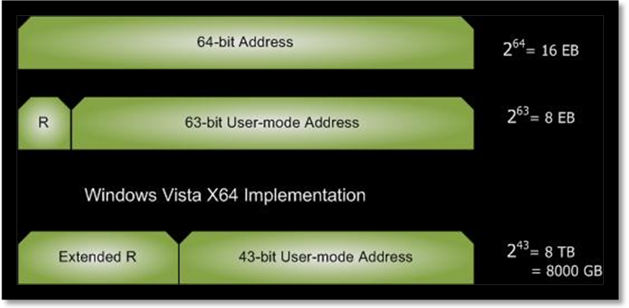

Independent software vendors (ISVs) are strongly encouraged to port their games to native 64-bit applications. All graphics independent hardware vendors (IHVs) already make WDDM drivers available for 64-bit platforms at the same time as x86. Microsoft provides several tools that enable ISVs and IHVs to port their applications and drivers to the 64-bit platform. The Windows Logo Program requires that all third-part device drivers that are logo'd for Windows Vista comply with the 64-bit requirements.

Resources
If you have any questions that are not answered in this paper, send e-mail to:
directx@microsoft.com
Knowledge Base Article 940105:
"Virtual Address Space Usage in Windows Game Development"
http://support.microsoft.com/kb/940105
DirectX SDK Technical Article:
"64-bit programming for Game Developers"
http://go.microsoft.com/fwlink/?LinkId=96202
Visual Studio C++ Developer Center:
"64-Bit Programming"
http://go.microsoft.com/fwlink/?LinkId=96203
Windows Internals, Fourth Edition
Russinovich and Soloman, Microsoft Press

