How to Enable Processor Power Management in Windows Server 2003
October 24, 2006
Abstract
Server power consumption and its associated operating costs are becoming increasingly important in the data center. Processor power management technologies that were once limited to mobile processor designs are now being offered on server processors from all leading processor vendors. Microsoft® Windows Server® 2003 supports these processor power-saving technologies, which can be enabled with a simple change to the Microsoft Windows® active power policy. This white paper provides details on how to enable this support on capable platforms, as well as tips for verifying that processor power management is working.
This information applies for the Microsoft Windows Server 2003 Service Pack 1 operating system.
This current version of this paper is available on the Web at:
http://www.microsoft.com/whdc/system/pnppwr/powermgmt/w2k3_ProcPower.mspx
References and resources discussed here are listed at the end of this paper
Contents
Introduction 3
Background 3
Windows Processor Power Management Support 3
Enabling Windows Processor Power Management 4
Requirements 4
Determining Platform Capabilities 4
Processor Driver Support 4
Verifying Windows Support 4
Selecting a Windows Power Policy 5
Using Power Options 5
Using the Powercfg.exe Command-line Item 7
Monitoring Processor Performance State Transitions 7
Next Steps 9
References 9
Appendix A. Remote Management Scripting 10
Appendix B. Windows Power Policies and Processor Power Management 11
Appendix C. Detecting the Presence of Processor Performance States 12

Disclaimer
This is a preliminary document and may be changed substantially prior to final commercial release of the software described herein.

The information contained in this document represents the current view of Microsoft Corporation on the issues discussed as of the date of publication. Because Microsoft must respond to changing market conditions, it should not be interpreted to be a commitment on the part of Microsoft, and Microsoft cannot guarantee the accuracy of any information presented after the date of publication.

This White Paper is for informational purposes only. MICROSOFT MAKES NO WARRANTIES, EXPRESS, IMPLIED OR STATUTORY, AS TO THE INFORMATION IN THIS DOCUMENT.

Complying with all applicable copyright laws is the responsibility of the user. Without limiting the rights under copyright, no part of this document may be reproduced, stored in or introduced into a retrieval system, or transmitted in any form or by any means (electronic, mechanical, photocopying, recording, or otherwise), or for any purpose, without the express written permission of Microsoft Corporation.

Microsoft may have patents, patent applications, trademarks, copyrights, or other intellectual property rights covering subject matter in this document. Except as expressly provided in any written license agreement from Microsoft, the furnishing of this document does not give you any license to these patents, trademarks, copyrights, or other intellectual property.

Unless otherwise noted, the example companies, organizations, products, domain names, e-mail addresses, logos, people, places and events depicted herein are fictitious, and no association with any real company, organization, product, domain name, email address, logo, person, place or event is intended or should be inferred.

© 2006 Microsoft Corporation. All rights reserved.

Microsoft, Visual Basic, Windows, and Windows Server are either registered trademarks or trademarks of Microsoft Corporation in the United States and/or other countries.

The names of actual companies and products mentioned herein may be the trademarks of their respective owners.

Introduction
Higher energy costs, higher density computing environments, and increased environmental concerns have all contributed to a renewed interest in power-efficient computing. This is particularly applicable to large server deployments, where the processor may consume a large portion of the overall platform power budget and the number of involved systems can dramatically amplify not only the cost of the power consumed, but also the savings possible through levering power management technologies. The emergence of processor power management features on server systems and the power management support in Microsoft® Windows Server® 2003 presents an opportunity to easily address these power concerns in the data center.
This paper describes the processor power management support in Windows Server 2003 and enumerates the steps that are required to enable it. In addition, platform requirements and expected results are also described.

Background
The Advanced Configuration and Power Interface (ACPI) Specification, Version 2.0, introduced support for processor performance states. This processor power management technology allows a simultaneous reduction in the processor’s core voltage and clock frequency while the processor continues to run. Lowering the processor performance state when CPU demand is low can significantly reduce CPU dynamic power consumption. These processor performance states may be changed very quickly in response to CPU demand while software continues to execute. This technique, sometimes referred to as demand-based switching (DBS), allows the operating system to provide automatic scaling of the processor’s power consumption in response to varying workloads, with no required user intervention and no perceivable impact to system performance.
The use of processor performance states is ubiquitous in today’s laptop computers, where the power savings that these states provide play a significant role in extending laptop battery life and managing system thermal performance. Processor performance state technologies have existed for several years and have continued to mature and refine to the point where this technology is quite robust and well tested.
Processor performance state technologies are now offered on server processors from most leading processor manufacturers, and system vendors have begun enabling this feature in their server designs. This makes significant power savings available to server deployments, enabling improved computing power efficiency with no perceivable impact on server performance.

Windows Processor Power Management Support
Microsoft Windows Server 2003 includes support for ACPI processor performance states. This feature is available when running on systems with capable hardware and must be enabled via the Microsoft Windows® power policy. By default, Windows Server 2003 is not configured to use a power policy that uses DBS.
Functional Overview. Windows detects the presence of processor performance states that are supported by a platform through the ACPI BIOS. The Windows power manager manages the system’s processor power policy. Windows uses a processor driver to enumerate and control performance states by using controls that are specific to each processor model. This processor driver model allows Windows to abstract the differences between various processors.
As the system runs, the Windows power manager continually monitors CPU usage and determines the correct processor performance state based on the current CPU workload and power policy. When a change to a new performance state is required, the Windows power manager invokes the transition by calling in to the processor driver.

Enabling Windows Processor Power Management
This section provides details on the system requirements and the steps to enable processor power management on systems running the Windows Server 2003 operating system.

Requirements
To enable processor power management support on systems running the Windows Server 2003 operating system, the following requirements must be met.
- The underlying system hardware must be capable of processor performance states.
- The system firmware must support ACPI 2.0 processor performance states.
- The system must include a processor driver for the specific make and model of processor.
In some cases, the correct processor driver must be procured from the system vendor or processor manufacturer.
- Processor power management must be enabled in the Windows power policy.
Note: Windows Server 2003 SP1 is required in order to enable processor power management when running on systems with multiple processors. This applies to systems with multiple cores, multiple logical threads such as Intel Hyper-Threading Technology, or multiple physical sockets. For details, refer to Microsoft Knowledge Base article 896256.

Determining Platform Capabilities
To determine if your systems can support processor performance states, consult your product documentation or contact your system vendor. System support consists of both hardware and firmware (BIOS) features. Your system vendor can provide details on any BIOS settings that may be required to expose the proper firmware support to the operating system.

Processor Driver Support
Windows requires a processor driver to control the performance state interfaces that are specific to each CPU vendor’s models. Windows Server 2003 includes the processor driver intelppm.sys that supports all current Intel processors. To acquire the processor driver for AMD processors, contact your system vendor or AMD.

Verifying Windows Support
To examine the capabilities that Windows has enumerated and has available for use, you may run the sample script pstates.vbs in "Appendix C. Detecting the Presence of Processor Performance States." Note that this script requires that the correct processor driver is installed, as described in "Processor Driver Support" earlier in this paper.
When pstates.vbs is run from a command prompt, the script presents output that is similar to that shown in Figure 1. This example shows two processors in the system, each having two performance states. The highest performance state is the 100-percent state, and the lowest performance state will run the processor at 93 percent of the maximum processor frequency.
c:\scripts\pstates.vbs
Microsoft (R) Windows Script Host Version 5.6
Copyright (C) Microsoft Corporation 1996-2001. All rights reserved.

Processor: 0
=============
P-State0 frequency: 100%
P-State1 frequency: 93%

Processor: 1
=============
P-State0 frequency: 100%
P-State1 frequency: 93%
Figure 1. pstates.vbs Output Showing Available States

Selecting a Windows Power Policy
To utilize processor performance states, Windows Server 2003 must be using a power policy that enables DBS. By default, Windows Server 2003 SP1 sets the system power scheme to “Always On.” This has the effect of running the system at full power regardless of workload demands. Windows Server 2003 SP1 includes a power policy named “Server Balanced Processor Power and Performance” that implements DBS by using the entire range of performance states that are available on the system.
The Sever Balanced Processor Power and Performance power scheme can be selected through the Power Options Control Panel item or through the command line by using the powercfg.exe utility.

Using Power Options
Use the following steps to select a power scheme from the control panel. For details, refer to Figures 2 and 3.
To select a power scheme from Control Panel
1. On the taskbar click Start, point to Control Panel, and then click the Power Options item.
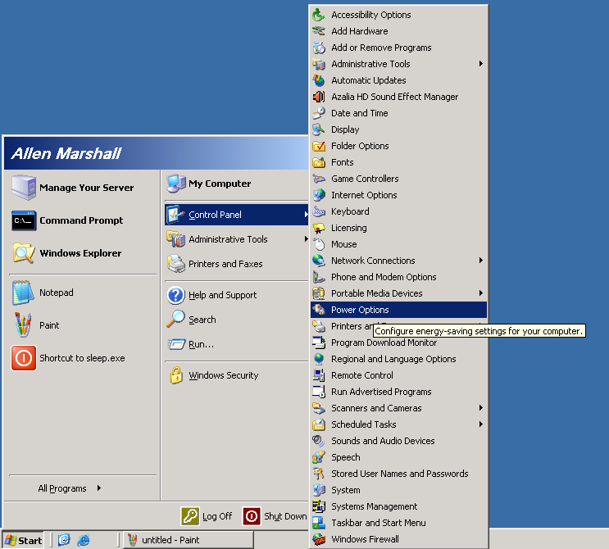
Figure 2. Launching the Power Options Control Panel Item
2. On the Power Options Properties dialog box, the Power Schemes tab, select Server Balanced Processor Power and Performance from the drop-down list.
3. Click OK.
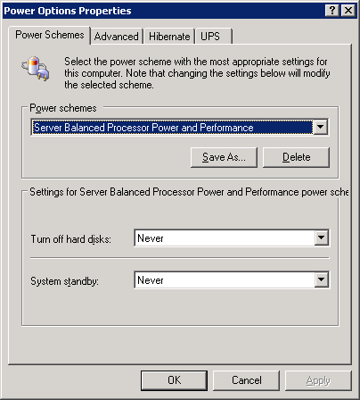
Figure 3. Selecting a Power Scheme

Using the Powercfg.exe Command-line Item
To select the Server Balanced Processor Power and Performance power scheme from the command line, run the following command:
powercfg.exe –s "Server Balanced Processor Power and Performance"

For more information on using powercfg.exe, consult support article Q324347.

Monitoring Processor Performance State Transitions
The Windows Performance Monitor may be used to visibly monitor and confirm Windows use of processor performance states versus processor usage.
The following steps show how to view performance state usage. Refer to Figures 4 through 7.
To view performance state usage
1. On the taskbar, click Start, point to Administrative Tools, and then click Performance.
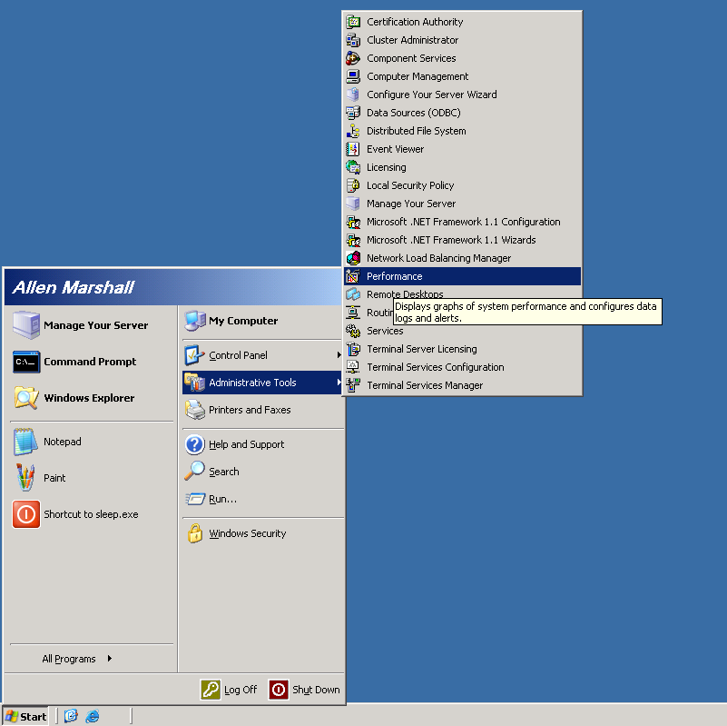
Figure 4. Launching Performance Monitor
2. When the Performance Monitor console appears, remove the default counters:
- Select the counters, circled in red in Figure 5.
- Delete these default counters by pressing the DEL key.
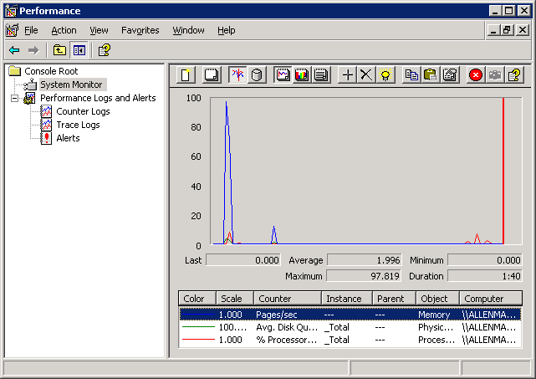
Figure 5. Deleting the Default Performance Monitor Counters
3. Press CTRL+I to open the Add Counters dialog box.
4. Under Performance object, from the drop-down list, select ProcessorPerformance.
5. Be sure that the Select counters from list button is selected and select % of Maximum Frequency from the list.
6. Click Add.
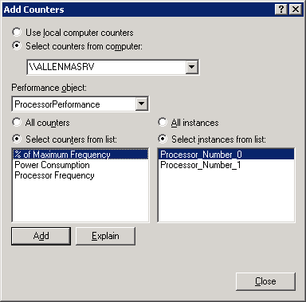
Figure 6. Selecting the Processor Frequency Counter
After you complete these steps, Performance Monitor displays the current processor performance state versus processor usage, as shown in Figure 7. In this example, note that Windows dynamically adjusts between the 93-percent and 100-percent performance states that are available on this machine (the blue line) in response to increased processor usage (the red line).
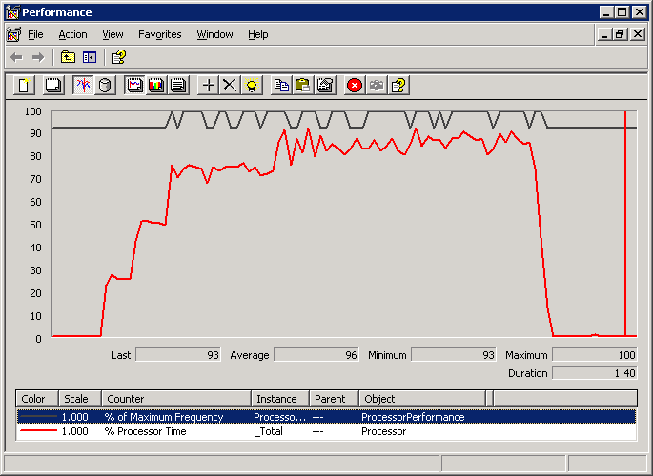
Figure 7. Performance Monitor Display of Performance State Utilization

Next Steps
Industry advancements in server processor power management present an attractive opportunity to lower average server power consumption without impacting server performance or availability. Windows Server 2003 fully supports these power savings technologies, which can be enabled through the simple steps outlined in this white paper. Server administrators are encouraged to enable this support on capable server systems and take advantage of the lower power and cooling operating costs that are made possible by processor power management technologies.

References
KB Article:
896256: Computers that are running Windows XP Service Pack 2 and that are equipped with multiple processors that support processor power management features may experience decreased performance
http://support.microsoft.com/default.aspx?scid=kb;en-us;896256
Support Article:
324347: How to use Powercfg.exe in Windows Server 2003
http://support.microsoft.com/kb/324347
AMD Support Information:
http://www.amd.com/us-en/Processors/TechnicalResources/0,,30_182,00.html

Appendix A. Remote Management Scripting
It is often impractical to manage server platforms individually. As an alternative, it may be advantageous to remotely script operations on server systems. Appendix A provides a sample script that may be used for this purpose to change the current Windows power scheme remotely. By taking advantage of the rich scripting environment on Windows Server, an IT administrator could remotely manage this feature on a large number of computing systems.
The following Microsoft Visual Basic® script allows IT administrators to remotely enable adaptive processor throttling. This script could be combined with other scripts to enable very flexible scenarios on a wide set of systems.
REM
REM SetBalancedPower.vbs
REM
REM Remotely enable “Server Balanced Processor Power and Performance” scheme on a targeted
REM server system.
REM

if NOT wscript.arguments.count = 3 then
wscript.echo "usage: SetBalancedPower user password computername"
wscript.echo "e.g: SetPower mydomain\administrator MyPasswd ServerABC"
wscript.quit
end if

REM
REM load username, password, and remote computer name from incoming arguments
REM

user = wscript.arguments(0)
password = wscript.arguments(1)
computer = wscript.arguments(2)

REM
REM Contact the WMI provider on the remote system, then
REM initiate the command-line utility to activate the
REM 'Server Balanced Power' scheme.
REM

set locator = createobject("wbemscripting.swbemlocator")
set services = locator.connectserver( computer, "root/cimv2",user,password,null,null,0,null)
Set ProcessMaker = services.Get("//./root/cimv2:Win32_Process", 0, null)
result = ProcessMaker.Create("powercfg.exe -s ""Server Balanced Processor Power and Performance"" ",".",NULL, pid)

REM
REM Report any errors to our caller.
REM

if NOT 0 = result then
wscript.Echo "Attempt to start process failed with: " & result
end if

Appendix B. Windows Power Policies and Processor Power Management
Windows Server 2003 uses four dynamic processor throttling policies that determine how the Windows power manager chooses a processor performance state. These policies are shown in Table A1. On systems that do not support processor performance states, these policies have no effect and the system runs as normal.
Table A1. Windows Dynamic Processor Throttling Policies
Policy | Description
None | Always run at the highest performance state
Constant | Always run at the lowest performance state
Adaptive | Performance state chosen automatically according to demand
Degrade | Always run at the lowest performance state, plus use additional linear performance reduction as battery discharges1
1 Note that the Degrade processor throttling policy is only applicable to laptop systems that expose an ACPI long-term battery and support ACPI 1.0 linear stop-clock throttle states. On a server system with no battery or linear clock throttle states, this policy would act the same as the Constant processor throttling policy and simply use the lowest performance state.

In Windows Server 2003, the processor throttling policy is linked to the Power Scheme setting in the standard Power Options Control Panel item.
Table A2. Windows Power Schemes and Processor Throttling Policies
Power scheme | Processor throttling policy
Always On | None
Server Balanced Processor Power and Performance | Adaptive
Home/Office Desktop | None
Portable/Laptop | Adaptive
Presentation | Adaptive

Appendix C. Detecting the Presence of Processor Performance States
This sample script allows an administrator to determine what processor performance states are supported by the platform and properly detected by the Windows power manager. The following Visual Basic script can be used to enumerate the existing processor performance states that are available.
REM
REM EnumeratePerfStates.vbs
REM
REM List available processor performance states.
REM

REM
REM Contact the WMI provider to query for processor information.
REM
on error resume next
set Service = GetObject("winmgmts:{impersonationLevel=impersonate}!root/wmi")
set EnumSet = Service.InstancesOf("ProcessorStatus")

REM
REM For each Processor, enumerate performance states.
REM

ProcessorCount = 0
for each instance in EnumSet

wscript.echo ""
wscript.echo "Processor: " & ProcessorCount
wscript.echo "============="

for Index = 0 to instance.PerfStates.Count - 1

set State = instance.PerfStates.State(Index)
if State.Flags = 1 then
wscript.echo " P-State" & Index & " frequency: " & State.PercentFrequency & "%"
end if
next
ProcessorCount = ProcessorCount + 1
next

