Microphone Array Support in Windows Vista
August 26, 2005 Revision
Abstract
Under less than ideal conditions, even the best microphone embedded in a laptop or monitor does a poor job of capturing sound. An array of microphones can do a better job of isolating a sound source and rejecting ambient noise and reverberation. This paper provides information about the advantages microphone arrays can offer and about the support for microphone arrays provided in the Microsoft® Windows Vista™ operating system.
If you are a laptop or monitor manufacturer or designer working to provide better sound capturing quality by integrating microphone arrays with Universal Audio Architecture (UAA) -compliant High Definition (HD) Audio-based devices, or if you are a hardware manufacturer designing Windows-based external USB Audio microphone arrays, this paper provides design guidelines for building microphone arrays that will work well with Windows Vista.
References and resources discussed here are listed at the end of this paper.
The current draft of this paper is available on the WHDC web site at:
http://www.microsoft.com/whdc/device/audio/default.mspx
Contents
Introduction 3
Microphone Arrays as PC Product Solutions: An Overview 3
Windows Vista and Microphone Array Solutions 3
About Microphone Arrays 4
Beam Forming 5
Array Directivity 5
Constant Beam Width 6
Microphone Array Characteristics 7
Ambient Noise Gain 7
A-Weighted Ambient Noise Gain 7
Directivity Index 8
Supported Microphone Array Geometries 8
Two-Element Arrays 9
Four-Element Arrays 10
Design Considerations 11
Hardware Interface 12
Requirements for Microphones and Preamplifiers 12
Requirements for ADCs 12
Use of MEMS Microphones for PC Microphone Arrays 13
Number of Microphones 14
Microphone Array Geometry 14
Placement of the Microphone Array 15
Acoustical Design and Construction 17
Next Steps 18
References 19

Disclaimer

This is a preliminary document and may be changed substantially prior to final commercial release of the software described herein

The information contained in this document represents the current view of Microsoft Corporation on the issues discussed as of the date of publication. Because Microsoft must respond to changing market conditions, it should not be interpreted to be a commitment on the part of Microsoft, and Microsoft cannot guarantee the accuracy of any information presented after the date of publication.

This White Paper is for informational purposes only. MICROSOFT MAKES NO WARRANTIES, EXPRESS, IMPLIED OR STATUTORY, AS TO THE INFORMATION IN THIS DOCUMENT.

Complying with all applicable copyright laws is the responsibility of the user. Without limiting the rights under copyright, no part of this document may be reproduced, stored in or introduced into a retrieval system, or transmitted in any form or by any means (electronic, mechanical, photocopying, recording, or otherwise), or for any purpose, without the express written permission of Microsoft Corporation.

Microsoft may have patents, patent applications, trademarks, copyrights, or other intellectual property rights covering subject matter in this document. Except as expressly provided in any written license agreement from Microsoft, the furnishing of this document does not give you any license to these patents, trademarks, copyrights, or other intellectual property.

Unless otherwise noted, the example companies, organizations, products, domain names, e-mail addresses, logos, people, places and events depicted herein are fictitious, and no association with any real company, organization, product, domain name, email address, logo, person, place or event is intended or should be inferred.

© 2005 Microsoft Corporation. All rights reserved.

Microsoft, MSN, OneNote, Windows, Windows NT, and Windows Vista are either registered trademarks or trademarks of Microsoft Corporation in the United States and/or other countries.

The names of actual companies and products mentioned herein may be the trademarks of their respective owners.

Introduction
Under less than ideal conditions, even the best microphone embedded in a laptop or monitor does a poor job of capturing sound. An array of microphones can do a better job of isolating a sound source and rejecting ambient noise and reverberation.
Because of the advantages that microphone arrays can offer to improve sound-capture for PC computing, Microsoft is creating new support for microphone arrays in the Microsoft® Windows Vista™ operating system. The support in Windows Vista includes:
- A class driver to support Universal Audio Architecture (UAA) compliant High Definition (HD) Audio devices and USB Audio devices.
- Algorithms to support several tested microphone array geometries.
- The ability to identify microphone array geometries based on descriptors provided through the future standardization of HD Audio Codec pin configuration register defaults or as reported by a USB device.

This paper describes the research and implementation details that provide the foundation for the Windows Vista support for microphone arrays. It also provides specific design and implementation guidelines for good quality, cost-effective microphone array designs that will work well with Windows Vista.

Microphone Arrays as PC Product Solutions: An Overview
PCs and other computing devices can usually play sounds well, but they do a poor job of capturing sound. With the processing power, storage capacities, broadband connections, and speech-recognition engines available today, computing devices can use better sound capture to deliver more value to customers.
With current PC-based audio technology, it is possible to provide better live communication than phones, much better record/playback or note-taking devices than tape recorders, and better command of the user interface than remote controls. For all applications that use sound, end users could benefit from better sound capturing. Consider, for example, all of these real-time communication applications:
- Microsoft Windows Messenger, MSN® Messenger, and all other applications built on top of the Microsoft Real-Time-Communication stack, such as AOL Instant Messenger, other applications for VoIP, and enhanced telephony.
- Enterprise solutions for collaboration and groupware applications, such as Live Meeting, the meeting recording capabilities in Microsoft OneNote®, and voice-messaging applications.

Robust speech-recognition technologies are still under development, but many Windows-based applications already have voice commands integration that work satisfactorily, but only when the user wears a headset with a close-talk microphone that enables decent sound-capturing quality. Such technologies are convenient for tablet PCs and handheld devices, where otherwise users have to type with a stylus.

Windows Vista and Microphone Array Solutions
Most PCs or laptops still have just a single microphone. This is a poor solution for capturing speech, because the microphone picks up too much ambient noise and adds too much electronic noise. The captured signal also includes the room reverberation, which decreases intelligibility and confuses speech recognition algorithms. Signal processing techniques have their own limitations for removing stationary noise and reverberation from a single channel. As a result, users are typically forced into using “tethered” or wireless close-proximity microphone headsets to achieve decent sound-capturing quality.
Numerous studies show that users don’t like to wear headsets or to be tethered to the computer. In many scenarios, headsets are not an option. For example, walking with a headset and a Tablet PC in your hand feels awkward. Using an array of microphones with PCs and other computing devices can alleviate the problems caused by using only one microphone. The goal—“Wear no close-proximity microphone gear; just talk to your computer”—implies mobility and freedom of movement.
Microphone array solutions should follow these basic design guidelines:
- Implement the characteristics of the tested microphone array geometries that are supported in Windows Vista as summarized in Table 1 in this paper.
- Meet the design requirements for low noise, directionality, and low manufacturing tolerances for microphones and preamplifiers, as summarized in Table 2 in this paper.
- Follow the recommendations for analog-to-digital converters for sampling rate, sampling synchronization, and anti-aliasing filters as summarized in Table 3 in this paper.
- Choose and place the appropriate number of microphones based on the usage scenario, with recommended choices illustrated in Figure 11 of this paper.
- Observe the acoustical and construction considerations, to insulate from environmental factors that will affect performance, as summarized near the end of this paper.

Windows Vista includes microphone array support as part of a complete audio subsystem that provides these advances:
- Improved acoustic echo cancellation
- Microphone array support
- Stationary noise suppressor
- Automatic gain control
- Wideband quality of sound capturing and processing

Microphone array processing is linear and doesn’t introduce distortions to the signal, so the microphone array output is good for a human listener and friendly for the speech recognition engine. The Windows Vista audio stack can be used both for real-time communication applications such as Windows Messenger and for speech recognition-enabled applications such as voice commands and dictation.
The rest of this paper explores the technical details supporting the design and implementation of good quality microphone arrays that will work well with Windows Vista.

About Microphone Arrays
A microphone array is a set of closely positioned microphones. Microphone arrays achieve better directionality than a single microphone by taking advantage of the fact that an incoming acoustic wave arrives at each of the microphones at a slightly different time. The chief concepts that are used in the design of microphone arrays are beam forming, array directivity, and beam width.

Beam Forming
By combining the signals from all microphones, the microphone array can act like a highly directional microphone, forming what is called a “beam.” This microphone array beam can be electronically managed to point to the originator of the sound, which is referred to in this paper as the “speaker.”
In real time, the microphone array engine searches for the speaker position and acts as if it points a beam at the current speaker. The higher directivity of the microphone array reduces the amount of captured ambient noises and reverberated waves. More details about the algorithm for beamform design can be found in reference [1]. (Numbered references are listed at the end of this paper.)

Array Directivity
Because the microphone array output contains less noise and has less reverberation than a single microphone, the stationary noise suppressor does a better job than it would with a signal from a single microphone. A typical directivity pattern of a microphone array beam for 1,000 Hz is shown on Figure 1. The pattern is more directive than even that of an expensive, high-quality hypercardioid microphone.

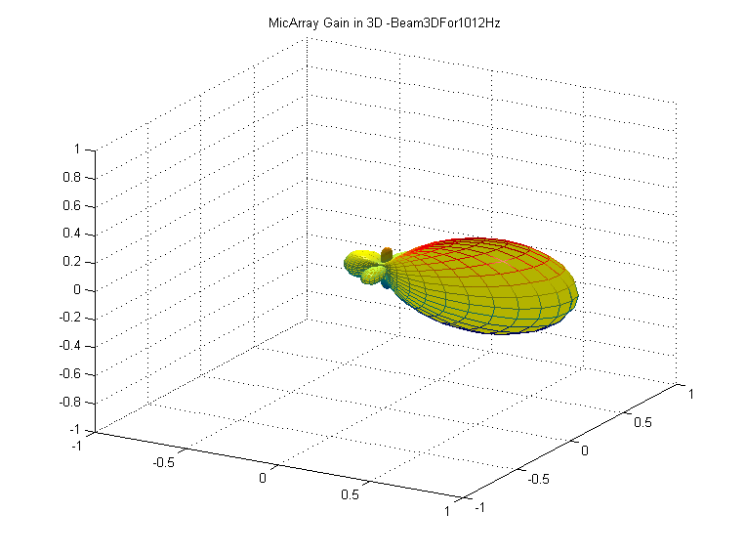
Figure 1. Microphone array directivity pattern in three dimensions
During sound capturing, the microphone array software searches for the speaker’s position and aims the capturing beam in that direction. If the person speaking moves, the beam will follow the sound source. The “mechanical” equivalent is to have two highly directional microphones: one constantly scans the work space and measures the sound level, and the other—the capturing microphone—points to the direction with highest sound level; that is, to the speaker.

Constant Beam Width
The normal work band for speech capturing is from 200 Hz to 7,000 Hz, so wavelengths can vary by a factor of 35. This makes it difficult to provide a constant width of the microphone array beam across the entire work band. The problem is somewhat simpler in a typical office environment, where most of the noise energy is in the lower part of the frequency band—that is, below 750 Hz. Reverberation is also much stronger at these low frequencies and is practically absent above 4,000 Hz.
Figure 2 shows the directivity pattern of a four-element linear microphone array as a function of the frequency. The combination of this microphone array geometry and the related microphone array support in Windows Vista provides nearly constant beam width in the diapason of 300 to 5,000 Hz, covering the most important area of the work band.

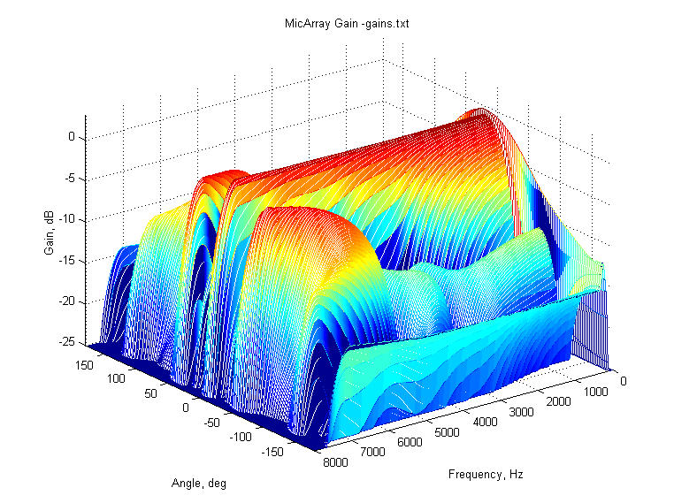
Figure 2. Microphone array directivity as a function of frequency, horizontal plane

Microphone Array Characteristics
The acoustical parameters of a microphone array are measured like those of any directional microphone. This section defines a set of parameters that are used later to compare different microphone array designs. Because of their directivity, microphone arrays offer better signal-to-noise ratio (SNR) and signal-to-reverberation ratio (SRR) than a single microphone can.

Ambient Noise Gain
The isotropic ambient noise gain for a given frequency is the volume of the microphone array beam:
$G_{\text{AN}}(f)=\frac{1}{V}∰_{V}{B(f,c)\text{dc}}$
Where:
V is the microphone array work volume—that is, the set of all coordinates $c=\left\{ϕ,θ,ρ\right\}$ (direction, elevation, distance).
$B(f,c)$ is the microphone array beam directivity pattern—that is, the gain as a function of the frequency and incident angle. An example for one frequency is shown on Figure 1. An example in one plane is shown on Figure 2.
The total ambient noise gain NG in decibels is given by:
$$\text{NG}=\text{20}{\text{log}}_{\text{10}}\left[\int_{0}^{F{}/2}{N_{A}(f)\text{.}H(f)\text{.}G_{\text{AN}}(f)\text{.}\text{df}}\right]$$
Where:
$N_{A}(f)$ is the noise spectrum.
$H(f)$ is the preamplifier frequency response (ideally flat between 200 and 7,000 Hz, with falling slopes from both sides going to zero at 80 and 7,500 Hz respectively).
$F_{S}$ is the sampling rate (typically 16 kHz for voice applications).

Ambient noise gain gives the proportion of the noise floor RMS in relation to the output of the microphone array and to the output of an omnidirectional microphone. A lower value is better, and 0 dB means that the microphone array does not suppress ambient noise at all.

A-Weighted Ambient Noise Gain
Because humans hear different frequencies differently, many acoustic parameters are weighted by using a standardized A-weighting function. The A-weighted total ambient noise gain NGA in decibels is given by:
$$\text{NGA}=\text{20}{\text{log}}_{\text{10}}\left[\int_{0}^{F{}/2}{A(f)\text{.}N_{A}(f)\text{.}H(f)\text{.}G_{\text{AN}}(f)\text{.}\text{df}}\right]$$
Where:
$A(f)$ is the standard A-weighting function; other parameters are the same as above.

A-weighted ambient noise gain gives the proportion of the noise floor in relation to the output of the microphone array and to the output of an omnidirectional microphone as they would be compared by a human. In this case, –6 dB NGA means that a human would say that the noise on the output of a microphone array is half that of an omnidirectional microphone.

Directivity Index
Another parameter to characterize the beamformer is the directivity index DI, given as:
$P(f,ϕ,θ)={\left|B(f,c)\right|}^{2}$, $ρ=ρ_{0}=\text{const}$
$$D=\int_{f=0}^{{F_{S}}/2}{\frac{P(f,ϕ_{T},θ_{T})}{\frac{1}{4π}\int_{0}^{π}{dθ\int_{0}^{2π}{dϕ⋅P(f,ϕ,θ)}}}\text{df}}$$
Where:
$P(f,ϕ,θ)$ is called power pattern.
$ρ_{0}$ is the average distance (depth) of the work volume.
$(ϕ_{T},θ_{T})$ is the steering direction or main response axis (MRA).

The directivity index characterizes how well the microphone array detects sound in the direction of the MRA while suppressing sounds, such as additional sound sources and reverberation, that come from other directions. The DI is measured in decibels, where 0 dB means no directivity at all. A higher number means better directivity. An ideal cardioid microphone should have DI of 4.8 dB, but in practice cardioid microphones have a DI below 4.5 dB.

Supported Microphone Array Geometries
The proper microphone array geometry (number, type, and position of the microphones) is critical for the final results. To ensure successful design and a good user experience, Windows Vista supports a number of carefully analyzed and tested geometries that cover the most common scenarios in the office and on the go.
The summary of these microphone arrays characteristics is shown in Table 1. Details about the geometries are given in the rest of this section. The table shows:
- Noise gain (NG)
- A-weighted noise gain (NGA)
- Directivity index (DI)

Table 1. Characteristics of supported microphone arrays
Microphone array | Elements | Type | NG, dB | NGA, dB | DI, dB
Linear, small | 2 | uni-directional | -12.7 | -6.0 | 7.4
Linear, big | 2 | uni-directional | -12.9 | -6.7 | 7.1
Linear, 4el | 4 | uni-directional | -13.1 | -7.6 | 10.1
L-shaped | 4 | uni-directional | -12.9 | -7.0 | 10.2
Linear, 4 el second geometry | 4 | integrated | -12.9 | -7.3 | 9.9

Table 1 shows only the noise reduction due to microphone array processing. The stationary noise suppressor in the audio stack will add 8 to 13 dB of noise reduction. The microphone array not only reduces the amount of ambient noise, but it also helps this noise suppressor to do a better job. Suppose that the signal-to-noise-ratio (SNR) in the room is 3 dB when captured with an omnidirectional microphone. With this input SNR, a stationary noise suppressor cannot do much noise reduction without introducing heavy nonlinear distortions and adding audible artifacts called musical noises. The noise reduction can add around 3 dB as well, so in this case the output SNR is 6 dB.
Under the same conditions, the microphone array reduces 13 dB of the ambient noise, and now the noise suppressor has a 16 dB SNR on its input. It can easily reduce an additional 13 dB of stationary noise without significant distortion in the signal and audible musical noises. The output SNR in this case will be 29 dB, which is 23 dB better than a system with an omnidirectional microphone. The total noise reduction of the audio stack reaches an impressive 26 dB, creating high sound quality with a very low level of distortion and artifacts.

Two-Element Arrays
Two-element microphone arrays can cover a quiet office or cubicle with good sound capturing when the speaker is less than 0.6 meters (2 feet) from the microphones. These arrays are suitable for integration into laptops and tablets or as standalone devices. Both microphones point directly forward to the speaker. These microphone arrays steer the beam in a horizontal direction only, in the range of ±50^{O}. The directivity in a vertical direction is provided by the uni-directional microphones. The geometries are shown on Figure 3.
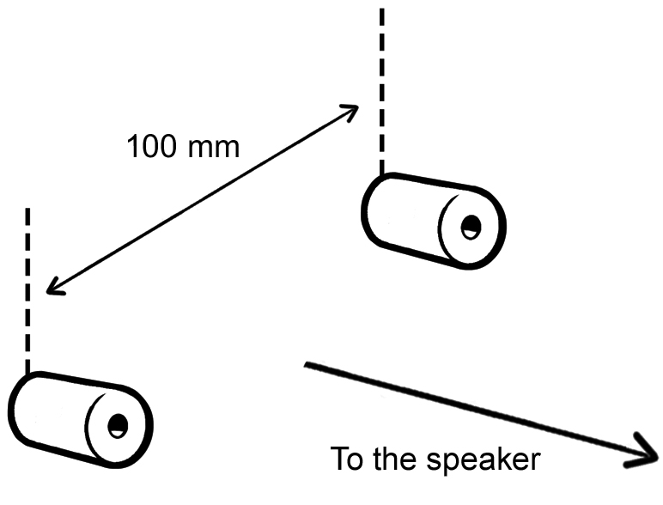 | 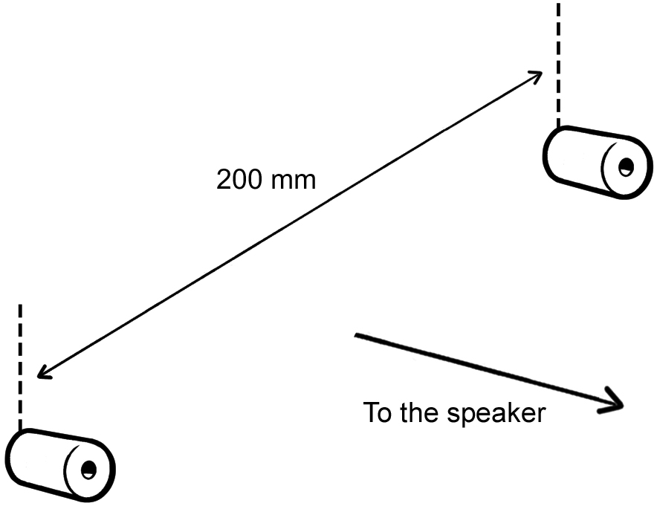
a) Small two-element array | b) Big two-element microphone array
Figure 3. Two-element microphone arrays
Small Two-Element Array. A small two-element array uses two uni-directional microphones 100 millimeters (4 inches) apart. Work area: ±50^{O} horizontally, ±60^{O} vertically. The channels order is: 1 –left, 2 –right, looking from front of the microphone array.
Big Two-Element Array. A big two-element array uses two uni-directional microphones 200 millimeters (8 inches) apart. Work area: ±50^{O} horizontally, ±60^{O} vertically. The channels order is: 1 – left , 2 – right, looking from front of the microphone array.

Four-Element Arrays
A four-element microphone array can cover an office or cubicle with good sound capturing when the speaker is up to 2.0 meters (6 feet) away.
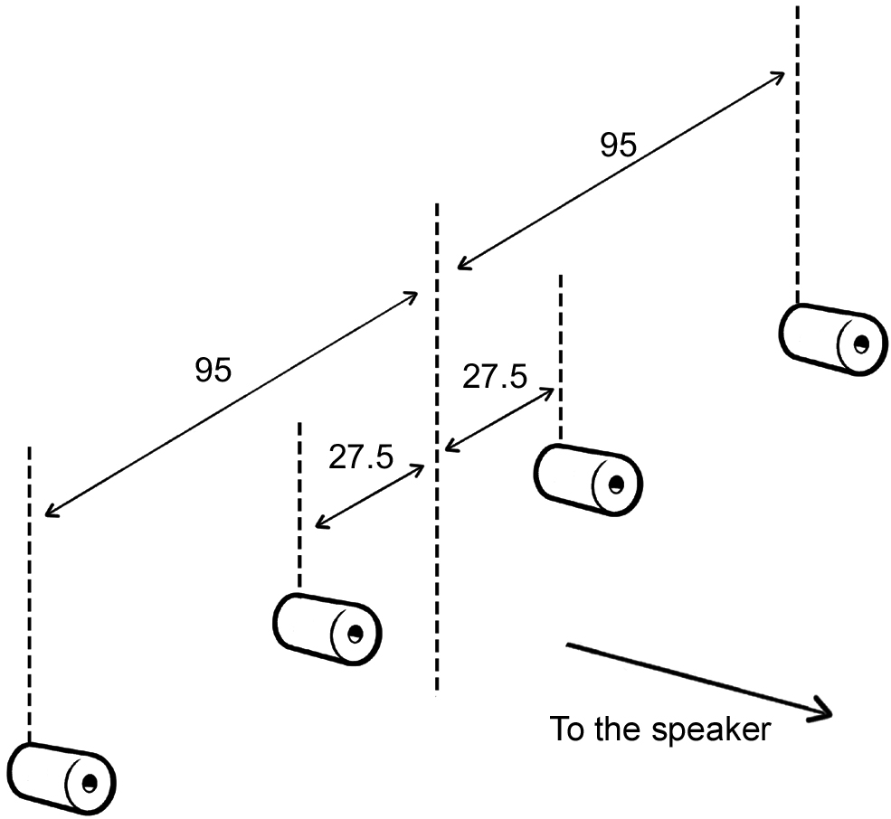 | 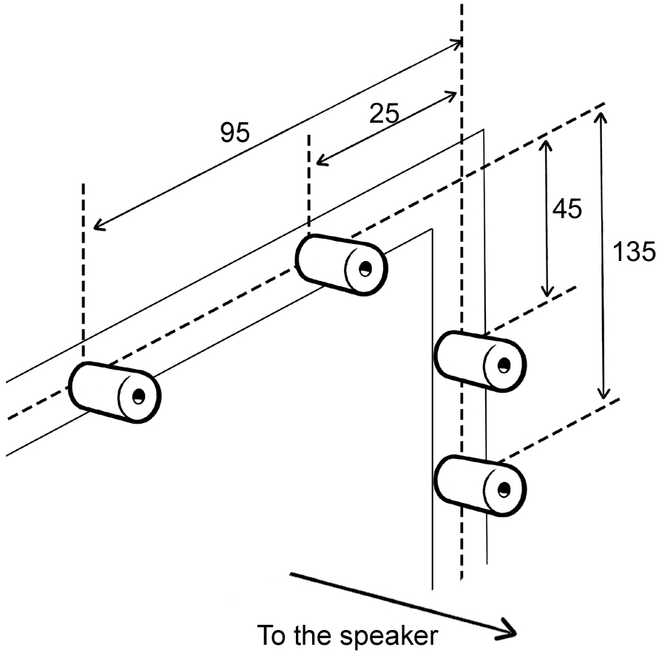
a) Linear four-element microphone array | b) L-shaped four-element microphone array
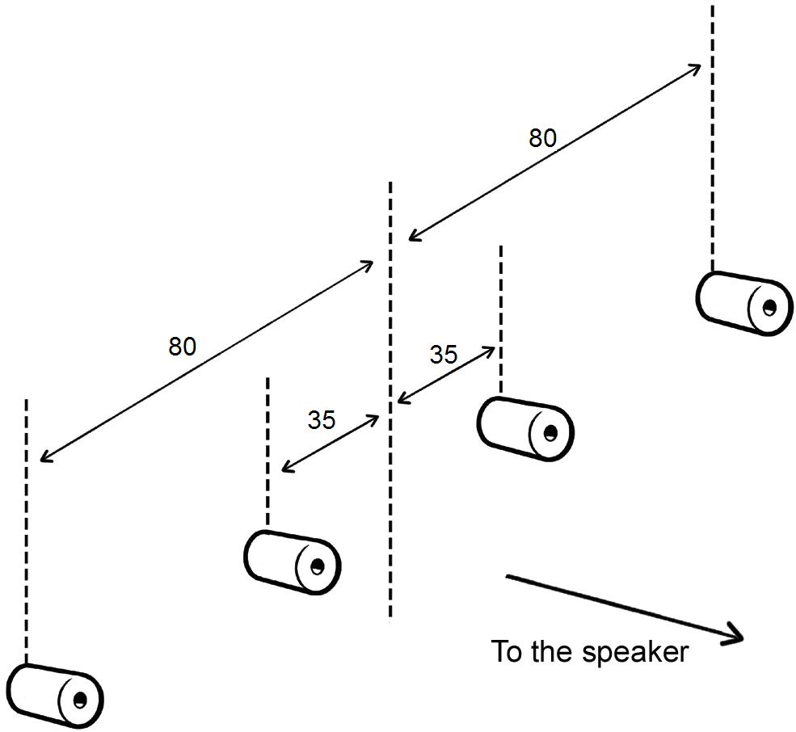
b) Linear four-element microphone array second geometry
Figure 4. Four-element microphone arrays
These arrays are suitable for both external microphone array implementation and for integration into laptops and tablets working under normal noise conditions in the office or on the go. All microphones point directly forward to the speaker, as shown in Figure 4.
Linear Four-Element Array. A linear four-element array uses four uni-directional microphones 190 millimeters and 55 millimeters apart. Work area: ±50^{O} horizontally, ±60^{O} vertically. This microphone array implemented as external USB device is shown on Figure 5. It steers the beam in a horizontal direction only, in the range of ±50^{O}. Directivity in a vertical direction is provided by the uni-directional microphones. The channels order is from left to right looking from front of the microphone array, that is, 1 is the most left, 4 is the most right microphone.
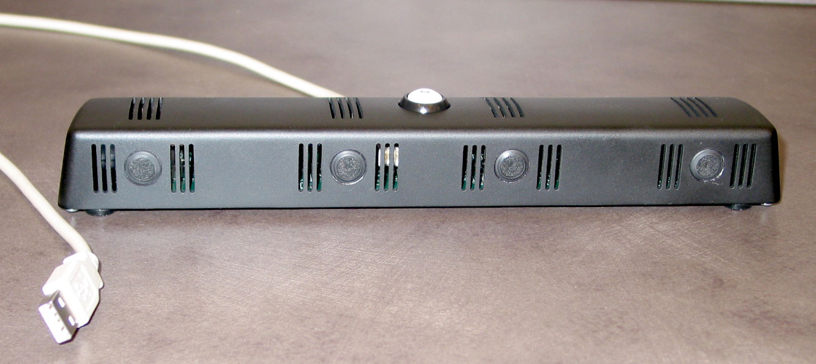
Figure 5. Linear four-element USB microphone array
L-shaped Four-Element Array. An L-shaped four-element array uses four uni-directional microphones and is designed especially for laptop/tablet convertibles. Two of the microphones are positioned on the upper bezel of the screen at 95 and 25 millimeters from the right edge; the second pair is positioned on the right bezel of the screen at 45 and 135 millimeters from the upper horizontal edge.
With this geometry, the microphones are not covered by the hand for either left-handed or right-handed users, and they are away from the keyboard and the speakers. These positions are for laptop mode.  Work area: ±50^{O} horizontally, ±50^{O} vertically. This microphone array integrated into a tablet is shown on Figure 6. Note that in tablet mode, after the screen rotation, the microphones are positioned along the left bezel of the screen.  L-shaped four-element arrays steer the beam in horizontal direction only, in the range of ±50O, but having microphones with different vertical coordinates improves the directivity in vertical direction.  The channels order: 1 and 2 are the left and right microphones in the horizontal side, 3 and 4 are respectively the upper and lower microphones in the vertical side. | 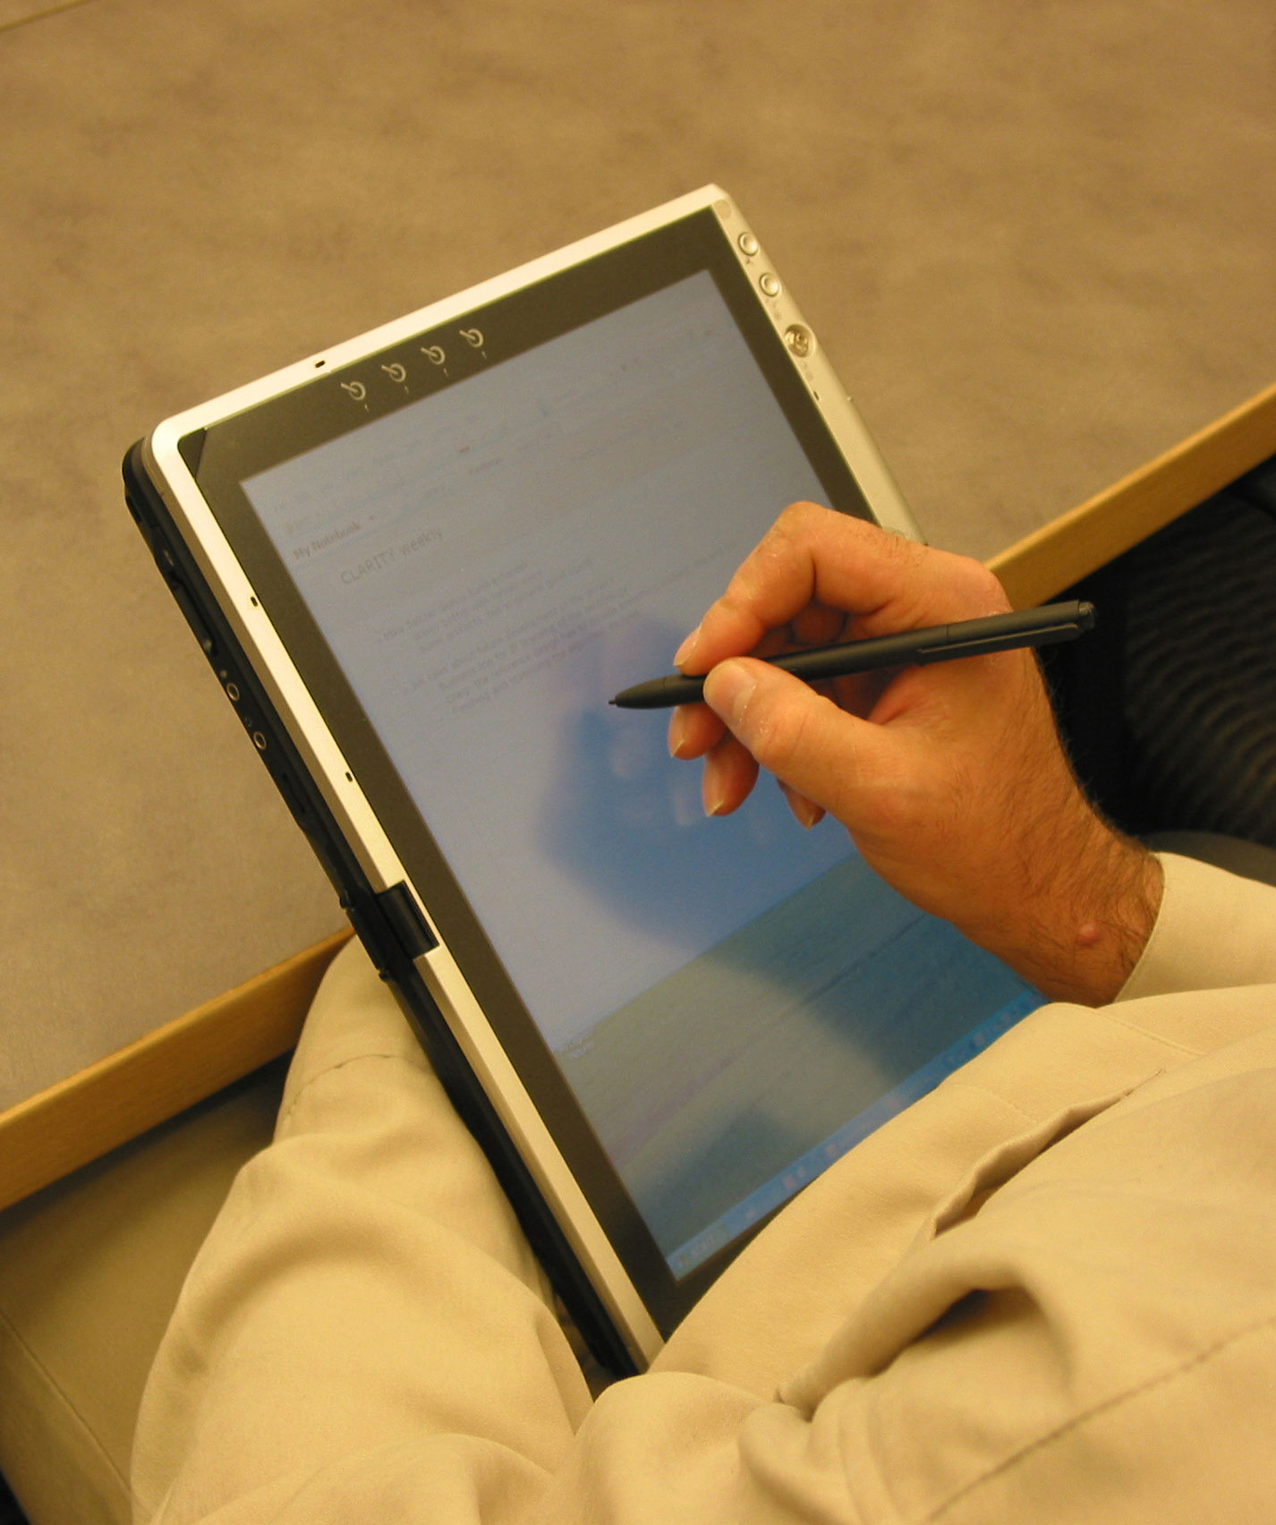  Figure 6. L-shaped microphone array integrated into a tablet PC
Linear Four-Element Array Second Geometry. A linear four-element array uses four omnidirectional microphones 160 millimeters and 70 millimeters apart. Otherwise it looks the same as the one on Figure 4a). The channels order is from left to right looking from front of the microphone array, that is, 1 is the most left, 4 is the most right microphone.

Design Considerations
The Microsoft microphone array algorithm is CPU time-efficient. It moves signal processing inside the PC and enables the manufacture of very inexpensive microphone array devices. The device itself is nothing more than a multichannel microphone connected to a UAA-compliant audio hardware solution. The device captures the signals from the microphones, converts them to digital form, and sends them to the computer. The integrated microphone array support in Windows Vista will do all the processing and combine the signals, providing high-quality audio output to the application layer.

Hardware Interface
There are two ways to connect the microphone array to a personal computer:
- Using a digital USB interface. The advantages to this approach are guaranteed sound-capturing quality, uniformly good user experience through the discoverability of USB devices, and compatibility with most computers available today. This solution is suitable for both external and integrated microphone arrays. The device consists of microphones, preamplifiers, analog-to-digital-converters (ADCs), and a USB controller.
- Using an analog multichannel audio interface provided by the next-generation integrated-PC audio solution, HD Audio. This is a less expensive solution; microphones are connected to the HD Audio codec already on the board. The microphone array definitions for HD Audio are being standardized and will be available in the near future. This solution is more suitable for integrated microphone arrays, but if a standard multichannel analog connector becomes available, external microphone arrays can be built for computers equipped with HD Audio codecs.

Requirements for Microphones and Preamplifiers
The microphone elements used in a design solution should be low noise, directional, and with low manufacturing tolerances. Under any circumstances, ribbon, carbon, crystal, ceramic, and dynamic microphones must not be used for building microphone arrays.
For microphone arrays integrated into tablets and laptops, it is acceptable to use omnidirectional microphones. The laptop, tablet body, or screen provides certain directivity of the microphone; however, in general such microphone array will have lower noise suppression. For external microphone arrays, using omnidirectional microphones is unacceptable.
To prevent adding electrical noises, shielded cables should be used to connect the microphones with preamplifiers. The preamplifiers should be low noise and should provide high-pass filtering.
The tolerances of elements used should provide close matching of the preamplifiers’ parameters. The Microsoft adaptive microphone-array software can compensate to some degree for variations in the manufacturing tolerances [2]. For best results, it is recommended that solutions meet the requirements specified in Table 2.
Table 2. Requirements for microphones and preamplifiers
Component | Requirement
Work band | 200-7,000 Hz
Microphone type | Uni-directional
Microphone SNR | Better than 60 dB
Sensitivity tolerances, microphone and preamplifier | In the range of ±4 dB or better for all frequencies in the work band
Phase response tolerances, microphone and preamplifier | In the range of ±10^{O} for all frequencies  in the work band
High-pass filter cut-off | 150 Hz at –3 dB
High-pass filter slope | Better than 18 dB/oct

Requirements for ADCs
We assume that ADCs used in microphone arrays have integrated anti-aliasing filters and do not place any requirements for low-pass filtering.
For capturing voice for telecommunication and speech recognition, a bandwidth of 200 to 7,000 Hz is considered sufficient. This means that a minimum sampling rate of 16 kHz is required. Increasing the sampling rate beyond this minimum only increases the processing time without bringing any additional benefits.
The sampling rate of the ADCs used should be synchronized for all microphone channels. Not only should all ADCs use the same sampling frequency (a common clock generator can ensure this), but they should also all be in the same phase with a precision of better than 1/64th of the sampling period. This last point requires taking some additional measures that depend on the ADCs used. For a four-channel microphone array, a typical solution uses two stereo ADCs with a synchronized sampling rate.
The requirements for ADCs are specified in Table 3.
Table 3. Requirements for the ADCs
Component | Requirement
Sampling rate | 16,000 Hz, synchronized for all ADCs
Sampling synchronization | Better than 1/64th of the sampling period
Anti-aliasing filter | Integrated

Use of MEMS Microphones for PC Microphone Arrays
The recent improvements in development of micro-electromechanical systems (MEMS) technology has made possible manufacturing of MEMS microphones into a single chip with prices comparable to electret microphones. So-called digital MEMS microphones contain the analog-to-digital converter and directly output a digital signal. The benefits of MEMS microphones for microphone arrays include the following:
- Single-chip MEMS microphones have low manufacturing tolerances, which makes them more suitable for microphone-array applications where microphone matching is important.
- MEMS microphones are small and therefore can be used in very compact products or when product design must accommodate space limitations in areas such as the bezel of a laptop monitor.
- Digital MEMS microphones are less affected by radio frequency and electromagnetic interferences, which makes them attractive for mobile PCs or for placement near the RF antenna in tablets or laptops.
- The digital audio signal can be carried over normal wires, replacing the shielded cables necessary for analog microphones. This makes digital microphones attractive for integration into laptops where putting several shielded cables trough the hinge might be a problem. Designers can place one or more of these microphones in positions based solely on the optimization of acoustic performance and functionality.

The requirements described in this paper for noise and directivity also apply to analog and digital MEMS microphones. For digital MEMS microphones, as with analog microphones, it is important that the sample rate of the ADCs used on each digital MEMS microphone is synchronized and in phase, as described in this paper.

Number of Microphones
The number of microphones depends of the scenario. More microphones means better noise suppression and greater ability to provide good sound quality in noisy environments. On the other hand, it also means a more expensive array and more CPU power needed for the real-time computations.
- For capturing a speaker voice from up to 2 meters away in office or cubicle noise conditions and ±50^{O} work area, four microphones should be sufficient and provide a good trade-off of price versus performance.
- A two-element microphone array can be used for capturing the PC user’s voice in a quiet office when the user is very close to the microphones—for example, when the user is sitting in front of the PC display monitor.

The chart in Figure 10 compares the directivity index of a good unidirectional microphone with those of two-microphone and four-microphone arrays. The two-element microphone array has a slightly better DI than a high-quality hypercardioid microphone does, but the array is much less expensive and more convenient for integration into laptops and monitors. The four-element microphone array, with only a slight increase in cost, has an impressive DI of over 10 dB.
Figure 10. Directivity Index comparison

Microphone Array Geometry
The Microsoft generic microphone array support can work with an arbitrary number of microphones and can provide close-to-optimal sound capturing with a given number, type, and position of microphones; together, these factors are referred to as the microphone-array geometry. The microphone-array geometry is critical for achieving good sound capturing. In general, poorly designed and analyzed microphone-array geometry leads to bad results.
To provide a good design and a good user experience, Windows Vista supports a number of tested microphone-array geometries with proven quality parameters. For details, see the “Supported Microphone Array Geometries” section. The processing software needs information about the geometry of the microphone array. This information, in a format that the software can use, is referred to as the microphone-array descriptor. This descriptor can be provided in these ways:
- Microphone-array descriptor reporting for integrated microphone arrays with future standardization of HD Audio Codec pin configuration register defaults.
System vendors should provide the geometry of the microphone array in the system’s HD Audio codec using the defined type table and an upcoming ECR to the HD Audio specification that identifies a new register set used for this purpose. This is suitable for integrated analog microphone arrays.
For example, if a four-element microphone array is integrated into a laptop and the hardware uses a UAA-compliant HD Audio solution, the microphone array descriptor should use the to-be-defined reporting mechanism in the HD Audio codec. The detailed format for the microphone array will become part of the Intel HD Audio specification, which can be obtain through a free RAND license from the Intel Corporation [3].
- Microphone-array descriptor provided by the USB device
During Plug and Play detection, Windows Vista automatically recognizes a UAA-compliant USB Audio device as a USB microphone array. It queries the device, and the device provides the microphone-array descriptor.

Table 4. Type Table
Type | Description
Type 1 | Linear 2-element, 100 mm
Type 2 | Linear 2-element, 200 mm
Type 3 | Linear 4-element geometry
Type 4 | L-shaped 4-element
Type 5 | Linear 4-element, second geometry

Placement of the Microphone Array
In general, follow these guidelines for placing the microphone array:
- As far as possible from noise sources such as loudspeakers, keyboards, hard drives, and the user’s hands.
- As close as possible to the speaker’s mouth.

Appropriate Placement Choices. Figure 11 shows several microphone array placement ideas for laptops, monitors, and tablets.
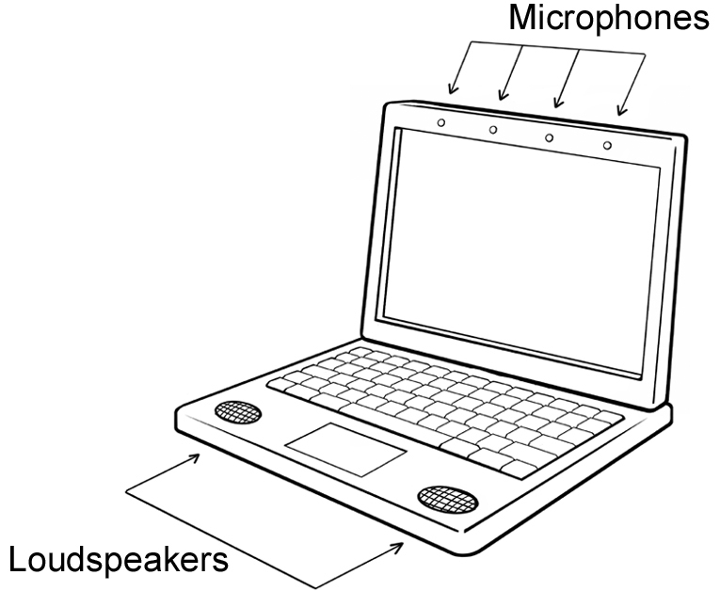 | 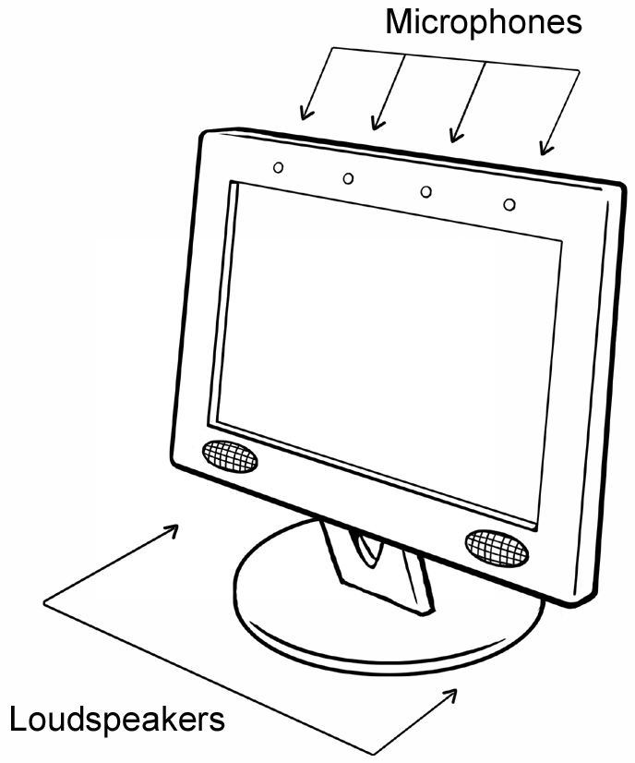
a) Laptop: microphones on the top bezel,  speakers in front, away from them | b) Monitor: microphones close to the user, loudspeakers low on the monitor
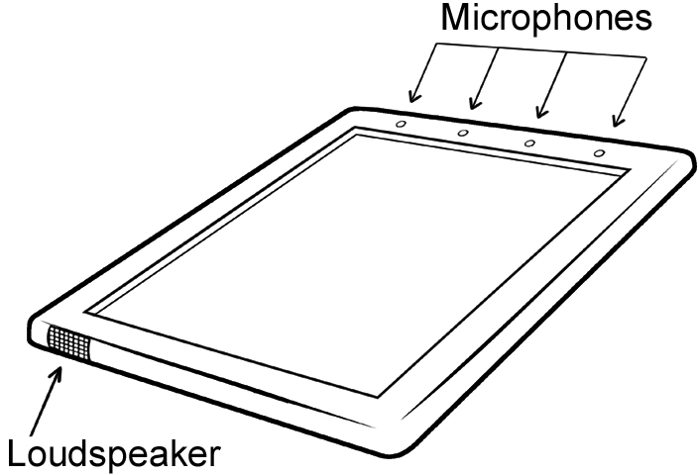 | 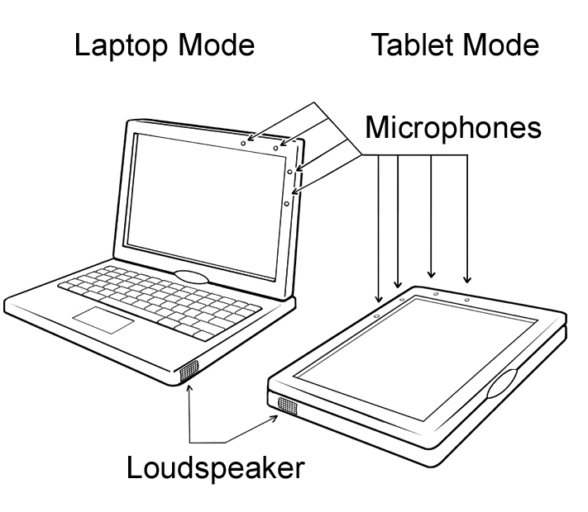
c) Tablet: microphone array on the top,  the speaker on the opposite side | d) Laptop/tablet convertible: L-shaped array in good position in laptop mode and not covered by hand in tablet mode
Figure 11. Microphone-array placement ideas for laptops, tablets and monitors
The design of the array should assume that the user listens to the loudspeakers, types on the keyboard, and talks to the computer simultaneously. Based on such a design assumption:
- The best place for integration in laptops or monitors is in the upper bezel of the screen.
- For laptop/tablet convertibles, these conditions should be met in both laptop and tablet modes. An additional noise source in tablet mode is the user’s hand writing on the screen. The hand should not cover the microphones for either right-handed or left-handed users.
- In offices or cubicles, the best place for an external microphone array is on top of the monitor.

Poor Placement Choices. Some examples for places that are not a good idea for the microphone array (and microphones in general) are shown in Figure 12:
- Do not put the microphone array on the front part of the laptop, where it will be too close to the keyboard and will often be covered by the user’s hands.
- Do not put the microphone array on top of the hard drive. The microphones will pick up mechanical noise from the spindle and from repositioning of the heads.
- Do not put the microphone array close to the loudspeaker. This placement is a very common mistake, probably caused by the erroneous assumption that both are part of the audio system and so should be together.
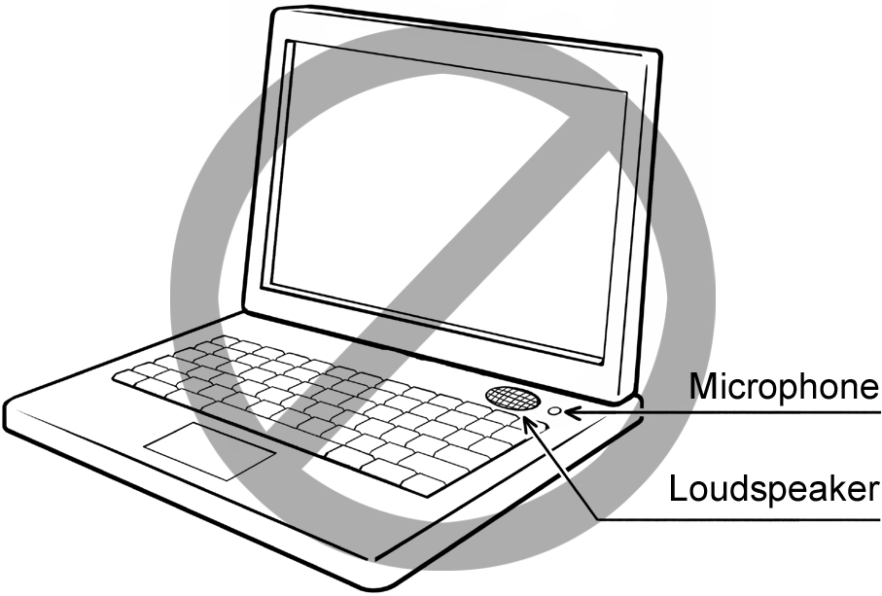 | 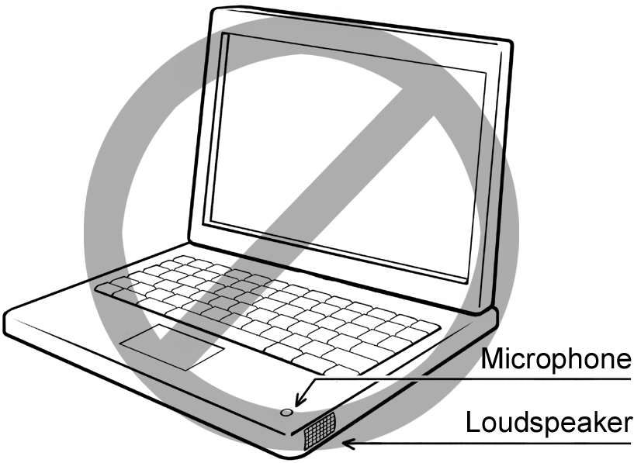
a) Do not place the microphone close to the loudspeaker | b) Do not place the microphone where the user’s hands will cover it
Figure 12. Examples for poor places for microphone or microphone array

Acoustical Design and Construction
All microphones should be acoustically insulated from rattles and vibrations of the laptop, monitor, or enclosure by placing them in rubber holders. In case of strong mechanical noises or vibrations, additional measures should be taken, such as putting the microphones in foam beds.
Directional microphones need the sound to reach them from both front and back. Ideally, a microphone’s enclosure should be acoustically transparent; that is, acoustically the microphones should appear to be hanging in the air in their respective positions. This condition can be simulated with proper vents in front and back of the microphone array enclosure.
Dust and humidity are other factors that can lead to changes in the microphone parameters. The acoustic vents should be covered with acoustically transparent fabric to protect the array.
For integrated solutions in laptops and monitors, the loudspeakers should be acoustically insulated from the chassis so they transmit as little sound and vibration as possible inside the body of the laptop or monitor. There should not be vibrating elements in the loudspeakers’ holding or attachment construction. Glue, foam, and rubber should be used to minimize rattles and vibrations and to improve playback sound quality.
If the system microphone array and loudspeakers are going to be used for real-time communications, the loudspeakers should have less than 5% total harmonic distortion (THD) in the work band (typically 200 to 7,000 Hz). Higher quality loudspeakers are needed, and the gain of the microphone preamplifiers has to be adjusted to prevent clipping on the capturing side. These things are required because the acoustic echo canceller (AEC) expects a linear transfer function between the loudspeakers and the microphones. Thus, the AEC will not suppress all harmonics due to nonlinear distortions.
For the real-time communications scenario, it is important that the microphones be placed as far as possible from the loudspeakers. Suppose that AEC suppresses 30 dB of the sound from the loudspeaker. In a real-time communication session, the loudspeaker level is usually set to provide sound as loud as a human speaker. If the user is 60 centimeters away from the microphone and the loudspeaker is only 5 centimeters away from the microphone, then the signal that the microphone captures from the loudspeaker will be 12 times (21.5 dB) louder than the signal it captures from the human speaker.
The interference from the loudspeaker reduces the effect of the AEC, and the output will have only an 8.5 dB ratio between the voice of the user speaking and the sound from the loudspeakers. In this case, annoying echoes will be heard during the real-time communication session. If the loudspeaker is 20 centimeters from the microphone, this ratio would be 20.5 dB, which is acceptable for good communication. A powerful method for reducing the acoustical connection between loudspeaker and microphone is to take advantage of the microphone’s directivity by placing the loudspeakers in an area of minimal microphone sensitivity.

Next Steps
For system manufacturers:
- Integrate microphone arrays in your laptops or monitors. This will make your products more appealing to end users, because microphone arrays meet their actual needs without requiring the user to wear a headset.
- Consider the value-add up-sell opportunity that external microphone array devices create for your PC product lines.
- Use Microsoft UAA class drivers to support the audio devices in your systems. These Microsoft drivers will provide the hardware microphone-array characteristics to the microphone-array algorithm in Windows Vista.

For firmware engineers:
- When writing firmware for USB microphone arrays, ensure compatibility with Windows Vista requirements and with UAA-compliant USB Audio design guidelines.

For device manufacturers:
- Consider the business opportunities in manufacturing external UAA-compliant USB Audio microphone arrays for office and conference room use.

For driver developers:
- Ensure that your driver supports the property set defined to pass microphone-array descriptions to the Windows Vista microphone-array algorithm.
- Enable multichannel capture.
- Ensure the driver provides all the individual channels from the array to the Windows Audio Subsystem.
- Use WaveRT miniport model to ensure glitch resilience of the audio data. [5]

For application developers:
- Take advantage of the high-quality audio captured by microphone arrays using the new Windows Vista audio-capturing stack in new application scenarios.
- If your application captures sound, use the Microsoft audio stack to benefit from the better sound quality if there is a microphone array connected to the computer.
- If your application does real-time communication, use the Microsoft RTC API to benefit from the better sound quality and from improvements in establishing the connection, transportation, and encoding and decoding of audio and video streams.

Feedback
To provide feedback about sound capture capabilities in Windows using microphone arrays, please send e-mail to micarrex@microsoft.com.

Specification Notification
Notification of availability of related specifications will be published in the Microsoft Hardware Newsletter. Subscribe to this newsletter at http://www.microsoft.com/whdc/newsreq.mspx.

References
[1] I. Tashev, H. Malvar. A New Beamformer Design Algorithm for Microphone Arrays. Proceedings of ICASSP, Philadelphia, PA, USA, March 2005.
[2] I. Tashev. Gain Self-Calibration Procedure for Microphone Arrays. Proceedings of ICME, Taipei, Taiwan, July 2004.
[3] Intel High Definition Audio specification at http://www.intel.com/standards/hdaudio/.
[4] A Wave Port Driver for Real-time Audio Streaming at http://www.microsoft.com/whdc/device/audio/wavertport.mspx.

