

The Microsoft iSCSI Software Initiator v2.0 integrates sophisticated multipathing functionality, supports x64 capabilities, and provides numerous supportability and deployment enhancements.

If you want to make use of existing IT network infrastructure expertise to get into storage networking, iSCSI is a smart way to go. Since Microsoft released the first version of the iSCSI Software Initiator in June of 2003, storage over IP has accelerated storage area network adoption significantly. That’s because iSCSI offers the benefits of storage area networks (SANs)—starting with shared, centralized storage—to anyone with network expertise, and often at a lower costs than previously available alternatives.
And now with the latest version of the Microsoft iSCSI Software Initiator, iSCSI functionality has been further extended.
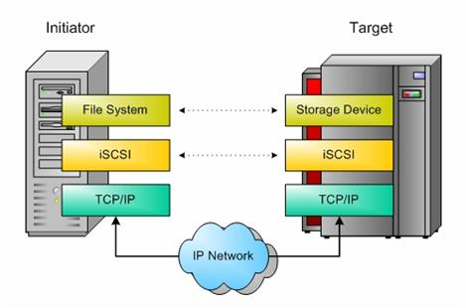
Built-in Multipathing. Storage area networks unlock storage from the server—storage resources are centralized onto a network, and provisioning and management are simplified. But to thoroughly safeguard your stored resources, each path between server and storage must be protected—a single link between the two is also a single point of failure, and if the link goes down, that server’s access to storage is lost. With the appropriate software support, however, the administrator can implement a high availability solution through deployment of multiple paths between servers and storage. Multipathing provides an automatic means of persisting I/O without error, failing over the workload to a redundant path should one path fail.
Version 2.0 of the iSCSI Software Initiator provides sophisticated high availability solutions through either:
- Multiple Connections per Session (MC/S), or
- Microsoft MPIO support.
MC/S allows multiple TCP/IP connections between the initiator (server) and target (storage array) during the same iSCSI session, either on the same or a different physical link. This allows load balancing and failover over among multiple network interface cards (NICs).
Microsoft MPIO support allows the initiator to log in multiple sessions to the same target, enabling load balancing and failover among multiple NICs and iSCSI Host Bus Adapters (HBAs). Both methods support failover only (no load balancing, all other paths on standby), as well as a failover plus I/O load balancing.
Load balancing policies include:
- Round robin (all paths active, I/O sent in round robin fashion),
- Round robin with a subset of active paths,
- Weighted path, in which I/O is distributed to the path with the lowest assigned weight.
- Least Queue Depth, in which I/O is sent on the path with the shortest I/O queue. This is only available for MC/S.
Note that a key difference between the two multipathing approaches is that for MC/S, load balancing policies apply to all logical disks (LUNs) exposed by a session; for MPIO, the policies apply to individual logical disks.
Support for x64. The new 64-bit processors provide both 32 and 64-bit capabilities on the same processor, supporting both older 32 bit applications without loss of performance, as well as newer 64 bit applications. X64 technologies enable faster and more efficient application performance, because more data can be preloaded into virtual memory, thereby reducing the time it takes to seek, read, and write to storage devices. Version 2.0 of the iSCSI Software Initiator enables applications on an iSCSI SAN to take advantage of the higher performance and scalability of x64 processors.
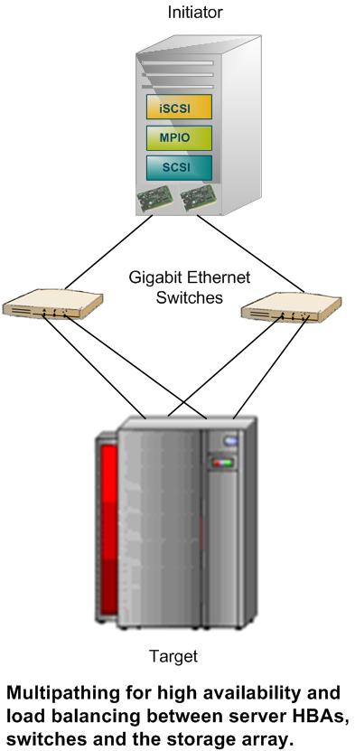
Supportability and Deployment Enhancements. The newest version of the Microsoft iSCSI Software Initiator improves event log messaging, providing new details on multipathing status, load balancing, and bound volumes.
The initial iSCSI release required attended setup; the latest release supports unattended setup in either passive or quiet mode (defaults used in both cases; passive mode runs the UI on screen, quiet mode does not).
The new release also includes enhanced graphical user and command line interfaces.
Support for IPv6. Also known as the Next Generation Internet Protocol, IPv6 is designed to fully interoperate with the current standard (IPv4), and has been architected specifically for Gigabit Ethernet. IPv6, fully supported in the new iSCSI Software Initiator, solves many of the problems associated with IPv4, including security issues, autoconfiguration and extensibility.
For more information about Microsoft storage, visit http://www.microsoft.com/storage/. For information about iSCSI, visit http://www.microsoft.com/windowsserver2003/technologies/storage/iscsi/deployiscsi.mspx.

© 2005 Microsoft Corporation. All rights reserved. This data sheet is for informational purposes only. MICROSOFT MAKES NO WARRANTIES, EXPRESS OR IMPLIED, IN THIS SUMMARY. Microsoft, the Windows logo, and WindowsServer are either registered trademarks or trademarks of Microsoft Corporation in the United States and/or other countries.

Other Enhancements. The new iSCSI Software Initiator provides support for a number of additional features:
- In addition to support for error recovery level 0, the new version supports error recovery levels 1 and 2 (CRC and connection failure recovery, respectively). Both error recovery levels are critical for tape backup scenarios, because if the tape fails, the application typically aborts. Error recovery level 2 allows reestablishment of the iSCSI connection without application disruption.
- Auto-discovery of iSNS server.
- Integration with VDS clients, including Storage Manager for SANs (part of Windows Server™ 2003 R2). iSCSI integration allows administrators to configure targets using Storage Manager for SANs.
- Persistent binding of targets other than disk, such as tape devices and changers.
- Persistent binding of administrator-specified volumes, rather than default binding of all volumes.

