

Deploying IP SANs
with the Microsoft iSCSI Architecture

July 2004

Abstract
This paper presents the steps for delivering block storage over an existing IP infrastructure. A number of “proof of concept” IP SAN deployment scenarios are described, including a basic configuration, backup, and clustering, as well as more advanced configurations such as bridge to Fibre Channel SAN and iSCSI boot from SAN.
This paper is designed for system administrators who work in small and medium-sized organizations and who are exploring the ways in which iSCSI SANs can benefit their organizations, without having to invest in a complete Fibre Channel infrastructure. System administrators in large organizations may also be interested in this paper, if they have previously deployed a Fibre Channel solution. They may find that iSCSI provides an additional storage solution for many scenarios.

Contents
Introduction 2
Enter Internet SCSI 2
Advantages of iSCSI 3
Who Can Benefit from iSCSI SANs? 4
iSCSI SAN Components 4
Planning the iSCSI Solution 7
Deployment Scenarios 10
Deployment #1: Basic iSCSI SAN 11
Deployment #2: iSCSI Backup 24
Deployment #3: iSCSI Cluster 44
Basic Clustering Requirements 45
A. Exchange Clustering Setup 47
B. SQL Clustering Setup 75
Deployment #4: iSCSI Bridge to FC SAN 86
Deployment #5: iSCSI Boot from SAN 96
Other Deployment Scenarios 105
Remote MAN/WAN 105
NAS Head to IP SAN 106
Troubleshooting 107
Common Networking Problems 107
Common Security Problems 108
Improving Network and iSCSI Storage Performance 108
Conclusion 110
Additional Resources 111

Introduction
Networked storage solutions have enabled organizations to more effectively share, consolidate, and manage resources than was possible with direct attached storage (DAS). The shift from server-centric storage to networked storage has been dependent on the development of technologies that can transfer data to and from storage as fast as, or faster than, direct attached technologies while also overcoming the limitations inherent in parallel SCSI, the dominant interconnect for DAS.
All data is stored on disks in block form (without file system formatting), whether it originates from the application as blocks (as in the case of most database applications) or as files. Parallel SCSI transmits data to storage in block format; however, it has limited usefulness for networks because the cabling cannot extend more than 25 meters, and it cannot connect more than 16 devices on a network.
Fibre Channel is currently the dominant infrastructure for storage area networks (SANs); it separates storage resources on a dedicated high speed network. The Fibre Channel protocol and interconnect technology grew from the need to provide high performance transfers of block data, as well as the need to overcome the connectivity and distance limitations of DAS. The most common Fibre Channel installations connect devices up to a distance of about 10 kilometers (newer, more costly installations can extend that distance to several hundred kilometers), and do so without imposing any practical limit on the number of devices that can attach to the SAN.
Network attached storage (NAS), unlike SANs, transfers data in file format and can attach directly to the IP network. Deploying NAS devices, which use the Server Message Block (SMB) protocol to transmit database block data, is less efficient, however, than using the Fibre Channel SCSI-based protocol.

Enter Internet SCSI
Internet SCSI (iSCSI) is an industry standard developed to enable transmission of SCSI block commands over the existing IP network by using the TCP/IP protocol. iSCSI is a technological breakthrough that offers organizations the possibility of delivering both messaging traffic and block-based storage over existing Internet Protocol (IP) networks, without installing a separate Fibre Channel network.
While Fibre Channel storage networks currently have the advantage of high throughput, interoperability among multi-vendor components remains a shortcoming. iSCSI networks, which are based on the mature TCP/IP technology, are not only free of interoperability barriers but also offer built-in gains such as security. And, as Gigabit Ethernet is increasingly deployed, throughput using iSCSI is expected to increase, rivaling or even surpassing that of Fibre Channel.

Advantages of iSCSI
The long delay in ratifying iSCSI standards delayed adoption of the technology well into 2003, but by the end of that year, a number of innovative organizations had implemented functional and effective iSCSI solutions, demonstrating that the long-touted advantages of iSCSI could, in fact, be realized. These include:
- Connectivity over long distances. SANs have delivered on the promise to centralize storage resources—at least for organizations with resources that are limited to a metropolitan area. Organizations with divisions distributed over wide areas have a series of unlinked “SAN islands” that the current Fibre Channel (FC) connectivity limitation of 10 km cannot bridge. (There are new means of extending Fibre Channel connectivity up to several hundred kilometers but these methods are both complex and costly.) iSCSI over wide area networks (WANs) provides a cost-effective long distance connection that can be used as a bridge to existing Fibre Channel SANs (FC SANs)—or between native iSCSI SANs—using in-place metropolitan area networks (MANs) and WANs.
- Lower costs. Unlike an FC SAN solution, which requires the deployment of a completely new network infrastructure and usually requires specialized technical expertise and specialized hardware for troubleshooting, iSCSI SAN solutions capitalize on the preexisting LAN infrastructure and make use of the much more ubiquitous IP expertise available in most organizations.
- Simpler implementation and management. iSCSI solutions require little more than the installation of the Microsoft iSCSI initiator on the host server, a target iSCSI storage device, and a Gigabit Ethernet switch in order to deliver block storage over IP. Managing iSCSI devices for such operations as storage configuration, provisioning, and backup can be handled by the system administrator in the same way that such operations for direct attached storage are handled. Solutions, such as clustering, are actually simpler with iSCSI than with Fibre Channel configurations.
- Built-in security. No security measures are built into the Fibre Channel protocol. Instead, security is implemented primarily through limiting physical access to the SAN. While this is effective for SANs that are restricted to locked data centers (where the wire cannot be “sniffed”), as the FC protocol becomes more widely known and SANs begin to connect to the IP network, such security methods lose their efficacy.
In contrast to Fibre Channel, the Microsoft implementation of the iSCSI protocol provides security for devices on the network by using the Challenge Handshake Authentication Protocol (CHAP) for authentication and the Internet Protocol security (IPSec) standard for encryption. Currently, iSCSI targets are implementing CHAP, but have not yet implemented more advanced methods.
Because these methods of securing communications already exist in Microsoft® Windows®, they can be readily extended from LANs to SANs. Windows also provides Quality of Service (QoS) mechanisms to ensure that that network connectivity and performance are optimized.

Who Can Benefit from iSCSI SANs?
iSCSI SANs may not be a solution for everyone. Initial deployments of iSCSI SANs may not deliver the same performance that Fibre Channel SANs can deliver unless they use Gigabit Ethernet and offload some CPU processing from the server to a network adapter (sometimes called a NIC) or host bus adapter (HBA).
But, for organizations with extensive IP networks in place, or which have not yet invested in Fibre Channel, iSCSI offers a lower cost means by which to deliver block storage without the constraints associated with direct attached storage.
For those organizations with existing FC SANs, using iSCSI over IP allows an inexpensive means by which to connect isolated SANs, and enables the implementation of highly robust disaster recovery scenarios.
iSCSI success stories have led IDC, a global market research firm for IT industries, to predict that iSCSI disk array sales in 2004 will be about $45 million, a threefold increase from sales in 2003 (the year the iSCSI protocol was ratified). By 2007, revenue is predicted to be over $1 billion. (Market Analysis (2003): Worldwide Disk Storage Systems Forecast and Analysis, 2003-2007, http://www.idc.com/getdoc.jsp?containerId=31208), indicating a substantial increase in new iSCSI storage array adoption. Even more significantly, by 2007, the number of systems (host initiators) using iSCSI to connect to in-place storage—FC SANs—is forecast to be 6.5 million.

iSCSI SAN Components
iSCSI SANs components are largely analogous to FC SAN components. These components are as follows:

iSCSI Client/Host
The iSCSI client or host (also known as the iSCSI initiator) is a system, such as a server, which attaches to an IP network and initiates requests and receives responses from an iSCSI target. Each iSCSI host is identified by a unique iSCSI qualified name (IQN), analogous to a Fibre Channel world wide name (WWN).
To transport block (SCSI) commands over the IP network, an iSCSI driver must be installed on the iSCSI host. An iSCSI driver is included with the Microsoft iSCSI initiator.
A Gigabit Ethernet adapter (transmitting 1000 megabits per second--Mbps) is recommended for connection to the iSCSI target. Like the standard 10/100 adapters, most Gigabit adapters use Category 5 or Category 6E cabling that is already in place. Each port on the adapter is identified by a unique IP address.

iSCSI Target
An iSCSI target is any device that receives iSCSI commands. The device can be an end node, such as a storage device, or it can be an intermediate device, such as a bridge between IP and Fibre Channel devices.
Each iSCSI target is identified by a unique IQN, and each port on the storage array controller (or on a bridge) is identified by one or more IP addresses.

Native and Heterogeneous IP SANs
The relationship between the iSCSI initiator and the iSCSI target is shown in Figure 1. In this case, the iSCSI initiator (or client) is the host server and the iSCSI target is the storage array. This topology is considered a native iSCSI SAN, because it consists entirely of components that transmit the SCSI protocol over TCP/IP.
Figure 1. iSCSI in a Native SAN
In contrast, heterogeneous IP SANs, such as the one illustrated in Figure 2, consist of components that transmit SCSI both over TCP/IP and over Fibre Channel interconnects. To accomplish this, a bridge or gateway device is installed between the IP and the Fibre Channel components. The bridge serves to translate between the TCP/IP and Fibre Channel protocols, so that the iSCSI host sees the storage as an iSCSI target.
Note
Servers that directly access the Fibre Channel target must contain HBAs rather than the network adapter cards of iSCSI hosts. iSCSI hosts can use either a NIC or a HBA.
Figure 2. iSCSI in a Heterogeneous IP SAN

Planning the iSCSI Solution
Whether an iSCSI solution makes sense for a specific organization depends on data access format, storage configurations, security considerations, and the equipment that is deployed. The system administrator should take stock of the organization’s current environment, pinpointing existing trouble areas and assessing future needs when deciding which iSCSI configuration would be best for your data access and storage needs.
In addition to the storage topology, the administrator also needs to determine, for each in-place server, the number of processors (single, dual or more), and the number and type of network adapter cards (standard or Gigabit Ethernet).

Data Access Format
Review the organization’s mission-critical applications. Do the majority of these applications access data in file format or in block format?
- File format. If the majority of data is accessed in file format, storage resources can be rapidly and effectively centralized by deploying a NAS device, such as Microsoft® Windows® Storage Server 2003. NAS solutions are particularly effective when serving files across multiple platforms.
- Block format. If the majority of your applications access data in block format, as is the case with transactional databases or applications such as Microsoft® Exchange and Structured Query Language (SQL), SAN technologies offer the highest performance. Similarly, backup servers can benefit from placement on the SAN, because backup is much faster.

Storage Configurations: Scalability and Performance Considerations
Depending on how storage resources are accessed, different considerations prevail, ranging from controlling escalating management costs to controlling security.
- DAS. What types of servers are currently deployed? What are their scalability and performance needs? Are any of the servers single points of failure? Not all servers benefit from being connected to a SAN. Web servers that serve static content, and servers that fulfill infrastructure requests (such as DNS or DCHP), do not typically require a great deal of disk space and can generally perform well enough as is. Mail servers, backup servers, database servers, transaction servers, and many application servers commonly require access to large or increasing amounts of disk space and high performance disk input/output. For these reasons, and to eliminate single points of failure, these servers can directly benefit from connecting to an IP SAN by using the existing local area network (LAN) infrastructure. If clustering for high availability is being considered, the shared storage of SANs is a prerequisite.
- NAS. Organizations heavily reliant on sharing a high volume of files will most likely already have network attached storage (NAS) servers on the LAN. These servers provide good scalability (typically up to several terabytes); however, scalability, performance, and centralization of resources can all be enhanced through attachment to an IP SAN.
- SAN. Many organizations already have FC SANs in place, but the SANs themselves are usually restricted to centralized data centers, separate from other storage resources in the organization and from other SANs. MAN and WAN IP connections between FC SANs can provide a low cost means of linking isolated SANs over campus or metropolitan-wide distances, or over even longer distances.

Security Considerations
The IP network does not include a default security mechanism. To secure IP packets (the data stream), use CHAP and IPSec.

CHAP
The Microsoft® iSCSI initiator uses CHAP to verify the identity of iSCSI host systems that are attempting to access storage targets. Authentication occurs during initial session establishment between the target and the host. The authentication depends upon a secret password known only to the target array and the host. During authentication, the password and a challenge is sent from the authenticator to the requestor as a hashing algorithm. If the response hash matches the original, the connection is maintained; otherwise, it is terminated.

IPSec
IPSec is a standards-based means of ensuring secure transfer of information across IP networks through the use of authentication and encryption. IPSec guards against both active and passive attack. Before implementing IPSec, determine which computers should be secured and how tight the security should be. Because IPSec adds traffic to the network and requires additional CPU for processing, deploy IPSec only on those computers whose roles require additional security.
- Security Levels. Depending on the sensitivity of the data being transferred, IPSec offers three levels of security.
- In cases where the data does not to be kept private through encryption but must be protected from modification, use the authentication header (AH).
- In cases where the data must be kept secret, the Encapsulating Security Payload (ESP) should be used to provide encryption.
- The highest level of security is provided by using both the AH and ESP. That way, both the header and the data are protected.
- Authentication Methods. In environments in which different operating systems are running (such as different versions of the Windows operating system), systems attempting to establish communication must have a common method of authentication.
- Kerberos v5 allows communication between Microsoft® Windows Server™ 2003 and Windows® 2000 Server domains.
- A public key certificate is useful if communication is with computers outside the domain or across the Internet. This type of communication is often found among partners that do not run Kerberos but share a common root certification authority (CA).
- If neither Kerberos nor CA is available, a pre-shared key can be used to provide authentication. This is useful for standalone computers outside a domain and without access to the Internet.
Note
Although Microsoft supports IPSec, there is only one iSCSI target vendor, String Bean Software, that supports IPSec because IP storage is such a young technology. This is expected to change in the near future.

Equipment Recommendations for iSCSI Deployments
The following are minimal hardware recommendations for all iSCSI deployments:
- Dual processors in all iSCSI hosts.
- Two iSCSI network adapters or iSCSI HBA host adapters:
- One standard 10/100 network adapter (previously known as a network interface card or NIC) for connection to the public LAN
- One Gigabit Ethernet network adapter for connecting to the target storage array. (Gigabit adapters transmit data at 1000 Mbps and, like standard adapters, connect to Category 5 cabling.)
- Isolation of the target storage array onto a private network.
- At a minimum, use of CHAP authentication between iSCSI host and target.

Deployment Scenarios
A number of “proof of concept” IP SAN deployment scenarios are presented in this paper to assist administrators in exploring the benefits of iSCSI SANs without having to invest in a complete Fibre Channel infrastructure. By experimenting with these iSCSI scenarios, administrators can deliver both messaging traffic and block-based storage over existing Internet Protocol (IP) networks while gaining additional benefits, such as security and freedom from interoperability barriers.
Instructions for configuring the following five scenarios are presented in this paper:
- Deployment #1: Basic iSCSI SAN
- Deployment #2: iSCSI backup
- Deployment # 3: iSCSI cluster (with Exchange and SQL clustering)
- Deployment #4: iSCSI Bridge to FC SAN
- Deployment #5: iSCSI Boot from SAN

These five deployment scenarios are followed by general descriptions of two additional possible deployment scenarios.

Deployment #1: Basic iSCSI SAN
In the most basic iSCSI SAN deployment, two production servers (iSCSI hosts) access their storage from an iSCSI target storage array. One server runs Microsoft® Windows® Small Business Server 2003 (Standard Edition) to provide Exchange and SharePoint Services, and the second runs Microsoft Windows Server 2003 to provide file and print capabilities. A schematic of the setup is shown in Figure 3.
Figure 3. Basic IP SAN Configuration
Clients on the LAN attach to each server through a network adapter (previously referred to as a network interface card, or NIC). A second Gigabit adapter in each server provides access to a private iSCSI SAN connecting to the iSCSI target storage array through an Ethernet switch. The SAN hardware components are listed in Table 1.
Table 1. SAN Hardware Components Used in the Basic iSCSI SAN Deployment
SAN Hardware | Version | Other Information
EqualLogic PeerStorage Array 100E | - Firmware v 2.0.0  - PeerStorage Group Manager (through Web browser)  - VSS hardware provider v 1.0 | - 14 disk drives (two spare)  - 3.5 TB total storage
Asanté FriendlyNET Switch | - GX5-800P Gigabit Workgroup | - Eight 10/100/1000 Ethernet ports

As small and medium-sized businesses experience the need for more storage, the possibility of an iSCSI deployment provides a useful alternative to buying more servers with direct attached storage.
Figure 4 summarizes the deployment steps for this configuration. Detailed deployment steps are presented in the text after the figure.

Figure 4. A Summary of the Steps Required to Set up a Basic iSCSI SAN

Set Up the iSCSI Target
- Install the iSCSI target storage array according to vendor instructions.
An EqualLogic PeerStorage Array was used in this deployment. The array contains two controllers, three network adapters (eth0-eth2) and can hold a maximum of 14 disks, two of which are spares.
- Connect the array to a network and a console terminal.
- From the console terminal, use the setup utility to configure the array on the network according to EqualLogic PeerStorage Array manual instructions.
- Configure the array on the network (information in brackets indicates the settings used for this deployment):
- Assign a member name to the array (for example, iSCSIarray).
- Choose the network adapter used on the array (eth0).
- Assign the IP address for the network adapter (10.10.0.5).
- Assign the netmask (255.0.0.0).
- Assign a default gateway on the same subnet as the array (10.10.0.1) so that the servers can access the storage volumes.
- Configure the group:
- Assign the group name (iSCSI).
- Assign the group address (10.10.0.10). This is used for discovery and management of the PeerStorage group.
- Determine whether the application requires disk formatting optimized for performance (RAID-1 + 0) or for capacity (RAID-5 + 0).
After setup is complete, the storage array is ready to be configured.
- Install the switch. For this deployment, an Asanté FriendlyNET 8-port Gigabit Ethernet switch was used.
Note
An IP address is not required with this switch.

Set up the iSCSI Hosts
This deployment assumes that the server software is already installed on each host.
- If a second network adapter card is not already present, install one in each server:
- Connect one adapter to the public LAN. If there is a Domain Name Server (DNS) on the LAN, an IP address is automatically assigned.
- Connect the second adapter to a private network to the storage array:
- Assign an IP address for the adapter (10.10.0.20).
- Assign the subnet address (255.0.0.0).
- Assign a default gateway to enable servers to access volumes on the storage array (10.10.0.1).
- Download and install the Microsoft iSCSI Software Initiator (Microsoft iSCSI initiator)on each server.
The Microsoft iSCSI initiator service enables the host server to connect to the iSCSI volumes on the storage array.
- You can find the Microsoft iSCSI Software Initiator (http://go.microsoft.com/fwlink/?LinkId=28169) on the Microsoft Download Center. Install the Microsoft iSCSI initiator on both nodes, according to the instructions.
- Both a graphical user interface (GUI) and a command line interface (CLI) are available for host configuration.
- Install the Microsoft iSNS server on one server.
The iSNS server automatically discovers available targets on the network, eliminating the need for manually entering the target addresses. Note that the iSNS server can be installed on either a production server or a dedicated server.
- Download and install the free Microsoft iSNS server software from the Microsoft Download Center. (http://go.microsoft.com/fwlink/?LinkId=27966)

Configure Storage
- Ensure that the most recent firmware is installed on the storage array. Incompatible firmware versions can result in the host failing to detect volumes with certain security settings enabled.
- Use either the CLI from the console, or launch the Web browser on a server to use the GUI.
Note
For the EqualLogic Web browser to work, it is necessary to first install Java on the server from which the browser will be run.
- Create volumes for the group member “iscsiarray”:
- In the Activities pane, click Create volume, and then follow the instructions in the Create Volume Wizard.
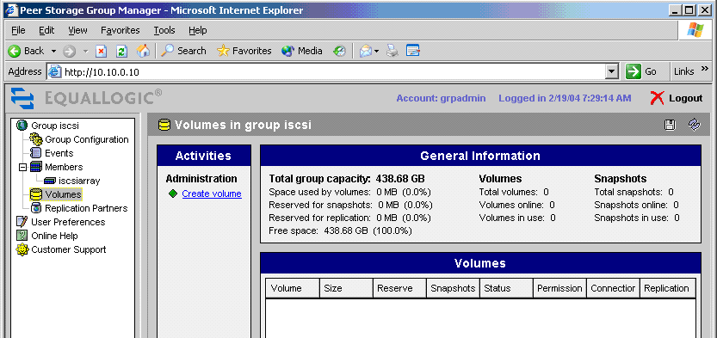
Figure 5. PeerStorage Group Manager Volumes Window
- Assign a volume name (for example, FS01) and size for the volumes on each server. For more details on this process for Exchange, see the Exchange Clustering Setup section in Deployment # 3, iSCSI Cluster Exchange later in this paper.
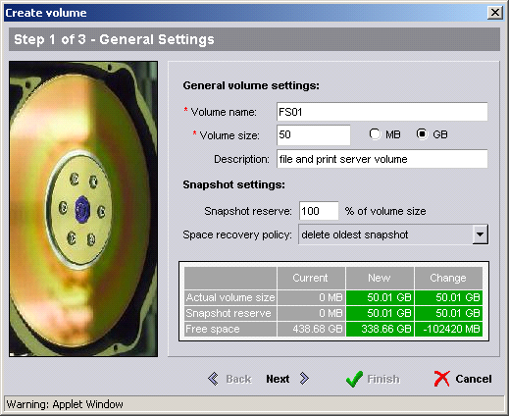
Figure 6. PeerStorage Group Manager Create Volume Wizard Page 1
- Set the access restrictions and authentication method:
- Click Restricted access.
- Select Authenticate using CHAP; user name, and then type the authorized user name.
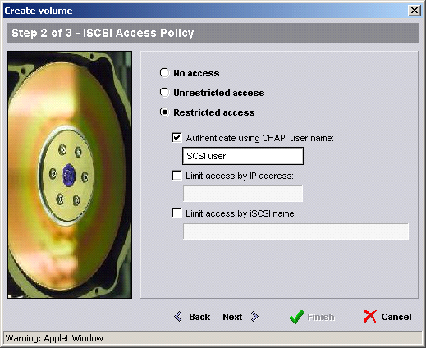
Figure 7. PeerStorage Group Manager Create Volume Wizard Page 2
- Configure security for each created volume:
- In the left navigation bar, click Group Configuration, and then click the CHAP tab.
Note
To enable the automated discovery of targets using iSNS server, select Group Configuration, click the Network tab, and then check iSNS in the Network Services box.
- In the Local CHAP dialog box, select Enable local CHAP server, and then click Add.
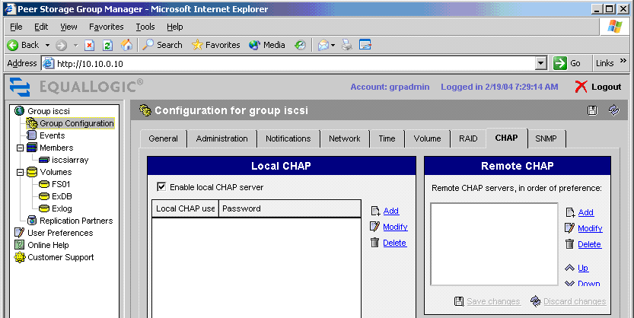
Figure 8. PeerStorage Group Manager CHAP Tab
- Type a user name and password.
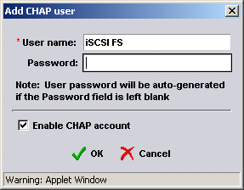
Figure 9. PeerStorage Group Manager Add CHAP User Dialog Box

Assign Host Access Rights
- On the file and print server, click the Start button, click Control Panel, and then click iSCSI Initiator to open the Microsoft iSCSI initiator service. The Microsoft iSNS server automatically discovers available targets.
Note
All volumes on the storage array are listed. Only the volumes intended for use with the file and print server should be made available to that host. For further information on exposing volumes to the host, consult the EqualLogic user guide that came with your hardware.
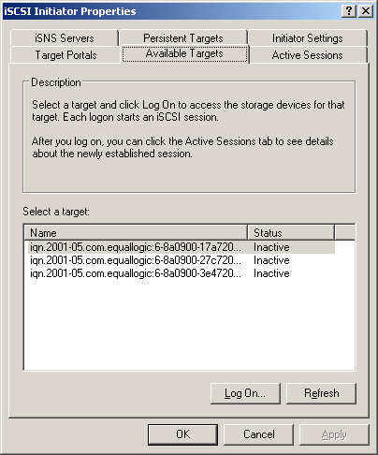
Figure 10. Microsoft iSCSI Initiator Service Available Targets Tab
- Log on to the target volume to make it available to the server:
- Click a target to select it, and then click Log On. The target is identified with an iSCSI qualified name (IQN). The final extension on the name, in this case fs01, identifies the specific target volume.
- Check Automatically restore this connection when the system boots. This ensures that the target volumes are made persistent to each server.
- Click Advanced.
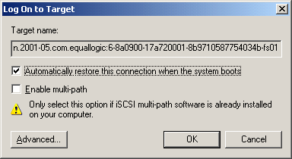
Figure 11. Microsoft iSCSI Initiator Service Log on to Targets Dialog Box
- In the Advanced Settings property sheet:
- Leave “Default” in the Local adapter and Physical port text boxes.
- Select CHAP logon information as the authentication method.
- Type the same user name and target secret that you previously entered on the storage array. The volumes should be listed in the iSCSI Initiator Properties property sheet as connected.
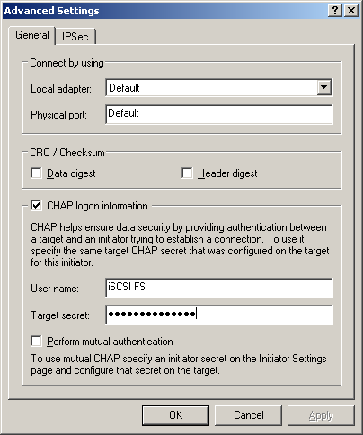
Figure 12. Microsoft iSCSI Initiator Service Advanced Settings Property Sheet
- Click the Persistent Targets tab to verify that the volumes are listed as persistent.
Important
Do not log onto the remaining volumes from the file server. These remaining volumes are allocated to the Small Business Server and must be logged onto from that server only.
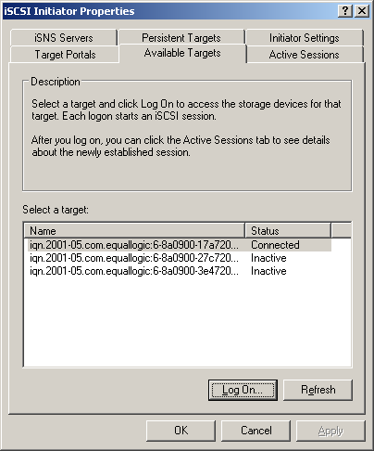
Figure 13. Microsoft iSCSI Initiator Service Available Targets Tab
- Repeat Host Access Rights steps 1-2 to make the ExDB and Exlog volumes accessible to the Small Business Server.

Format Disks
- Format the disk for each server:
- From the All Programs menu, click Administrative Tools, and then click Computer Management.
- In the left navigation bar, click Storage to expand it, and then click Disk Management.
- Right-click each disk to initialize it.
- To format each disk with the NTFS file system, right-click each partition and select Format (in the example shown in the following figure, the Exchange volumes for the Small Business Server Exchange are formatted). All disks must be formatted as basic (not dynamic).
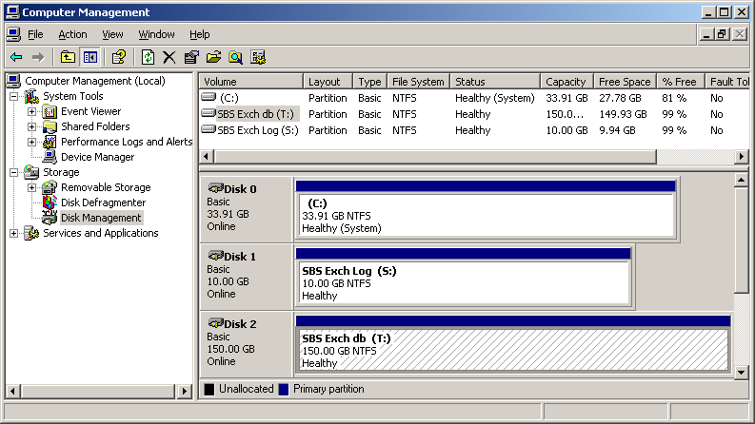
Figure 14. Computer Management Window
- Start the storage array Web UI, for example, PeerStorage Group Manager.
- In the left navigation bar, click Volumes. All volumes should be listed as online.
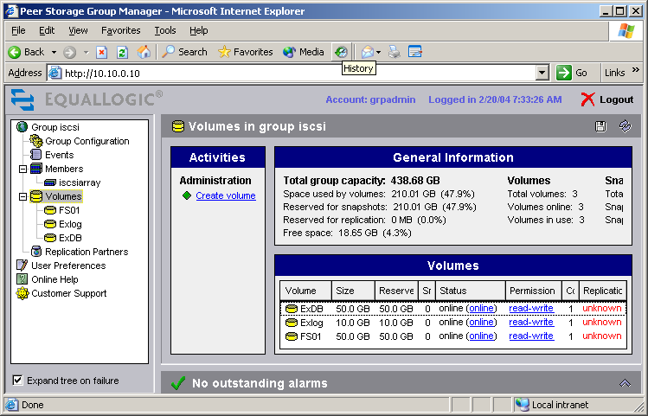
Figure 15. PeerStorage Group Manager Volumes Window

Test Configuration
In addition to testing the backup and restore capabilities of each server, you also need to perform tests appropriate for your configuration and organizational needs.

Put into Production
Each server now has access only to its own formatted storage volumes. The servers are ready to enter production. Depending on the needs of the organization, data saved on local disks may either be migrated to the storage array or remain local.

Deployment #2: iSCSI Backup
Because direct attached storage is highly centralized, managing backups can be both time consuming and costly. Pooling storage resources on an IP SAN enables centralization of the backup process, lowering costs and increasing efficiencies. In the deployment scenario shown in Figure 16, production servers access the private Gigabit Ethernet network of the IP SAN through a Gigabit network adapter, while clients access server resources across the public LAN using a standard 10/100 network adapter. The backup server and tape library (and the target storage array) attach directly to the IP SAN.
Figure 16. IP SAN Backup Configuration
For this deployment, the Microsoft® Volume Shadow Copy service (VSS) is used to create high fidelity point-in-time shadow copies (or “snapshots”) of volumes. These shadow copies can be maintained on the disk or can be transported to another server for backup and archiving to tape. VSS, an infrastructure new to Windows Server 2003 (installed on each production server), is designed to enable backups even when the application is in use, eliminating the need for taking the application offline and the long backup windows that used to be the standard. The application-specific VSS writers for Exchange and SQL are included with Windows Server 2003.
Important
Both the storage array and the backup application must support VSS technology. A storage array-specific VSS hardware provider must be installed on each production server. In addition, the backup application must provide a mechanism by which to use the application-specific VSS writers. (In Computer Associates BrightStor® ARCserve® Backup, the backup software used in this deployment, that functionality resides in the BrightStor® ARCserve® Backup Agent for VSS Snap-shot and is supported in ARCserve r11.1 and forward. The Backup server requires BrightStor® ARCserve® Backup for Windows r11.1, Enterprise Module and the license for BrightStor® ARCserve® Backup for Enterprise Option for VSS Hardware Snap-shot r11.1)
Version 1.0 of VSS does not support CHAP authentication; future versions will provide support for CHAP.
Table 2 lists the SAN hardware components needed for Deployment # 2,”iSCSI Backup.”

Table 2. SAN Hardware Components Used in the iSCSI SAN Backup Configuration
SAN Hardware | Version | Other Information
EqualLogic PeerStorage Array | - Firmware v 2.0.0  - PeerStorage Group Manager (through Web browser)  - VSS hardware provider v 1.0 | - 14 disk drives (two spare)  - 3.5 TB total storage
Spectra Logic Spectra 2K iSCSI tape library | - Firmware: v 4.2.82 | - Two AIT-3 tape drives  - Holds 15 tapes, each tape has 100 GB native capacity.
Dell PowerConnect 5224 Gigabit Ethernet Managed Switch |  | - 24 Gigabit Ethernet ports  - Jumbo frames enabled

Figure 17 summarizes the deployment steps for the iSCSI backup configuration. Detailed deployment steps are presented in the text after the figure.
Figure 17. A Summary of the Deployment Steps for the iSCSI SAN Backup Configuration

Set Up the iSCSI Target
- Install iSCSI target storage array according to vendor instructions. This deployment made use of an EqualLogic PeerStorage Array. Refer to Deployment #1: Basic iSCSI SAN, for more details on setting up the storage array. For more details regarding the switch hardware, consult the user guide for your switch.
- Connect the Ethernet switch to the network, and then enable jumbo frames on the switch.
- Connect the storage array to a console.
- Use the setup program to set up the storage array as a group member, and name the group (iscsigrp).
- Log on to the storage array by using either the CLI or Web browser GUI.
- Create Exchange server volumes for each application server on the storage array. Follow the same process when setting up the SQL and backup servers.
Figures 18a and 18b show the steps you need to follow to create the Exchange server volumes using the EqualLogic command line interface.
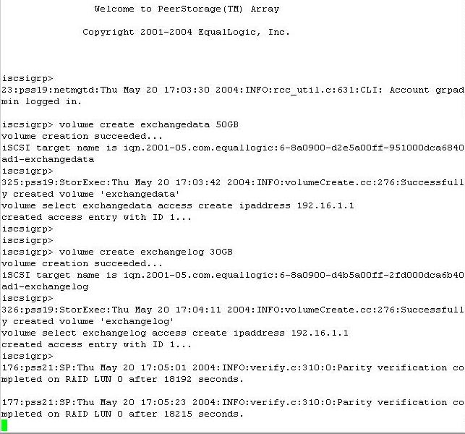
Figure 18a. The EqualLogic Volume Create Commands for Exchange
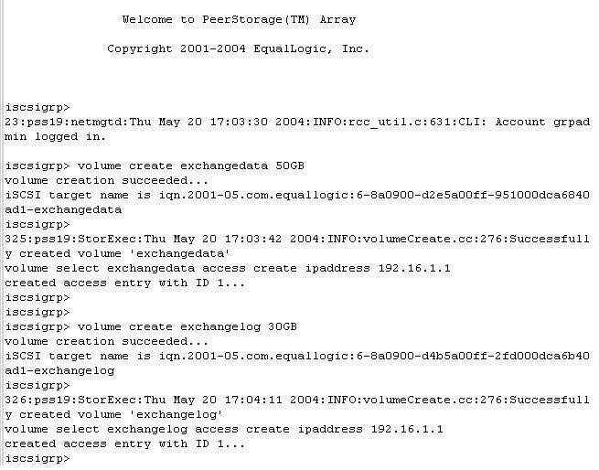
Figure 18b. The EqualLogic Volume Create Commands for Exchange
Refer to the user guide for each application to find recommendations on the appropriate size and number of volumes. For this deployment, server storage was configured as follows:
- Microsoft® Exchange server: One volume for log files and volumes for database files. The number of volumes you create depends on organizational needs. While a single volume is sufficient, four were created in this case to allow for different retention policies for each storage group.
- Microsoft® SQL Server: One volume for log files, one volume for database.
- Backup server: Five volumes for optional disk-to-disk backup of Exchange and SQL database volumes.
The following screenshot shows the pooled volumes for all applications.
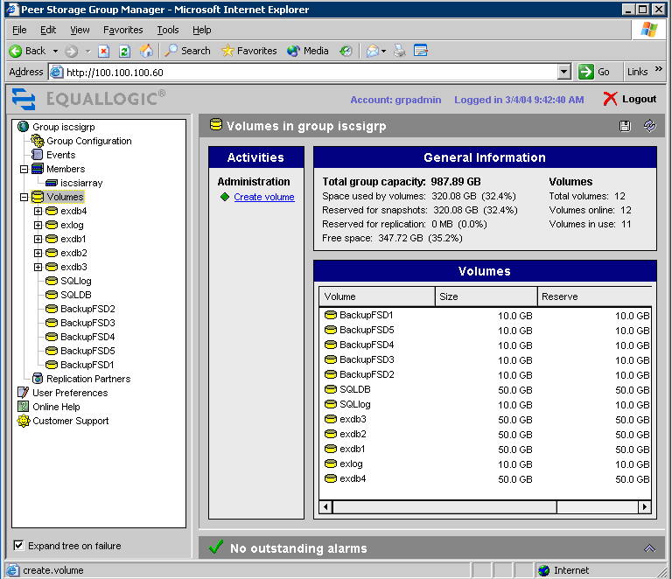
Figure 19. PeerStorage Group Manager Volumes Window
Important
An EqualLogic hardware provider for use with VSS must be installed on each server targeted for backup (see the next section, “Set up iSCSI Hosts”).

Set up iSCSI Hosts
- Prepare the Exchange server, SQL Server, the backup servers, and the Microsoft® Active Directory® directory service on the servers.
- Ensure that each host has two network adapter cards (the Active Directory server only requires one for connection to the public LAN).
- Configure the adapter card for the backup server by using the adapter-specific utility, and then enable jumbo frames.
- Connect each host to the public LAN.
- Connect the Exchange server, the SQL Server, and the backup servers to the private storage array.
- Install Windows Server 2003 on all application servers and on the backup server.
- Install Active Directory on the designated Active Directory server.
- Promote this server to domain controller.
- Ensure that the DNS server is running in the domain.
- Install Microsoft ® Exchange Server 2003 on the designated Exchange server (for further details, see Deployment #3: iSCSI Cluster).
- Perform preliminary setup steps:
- Ensure that the Exchange server has access to the domain controller.
- Ensure that the appropriate administrator rights are granted.
- In the Control Panel, click Add/Remove Programs, and then verify that Network News Transfer Protocol (NNTP), Simple Mail Transfer Protocol (SMTP), HTTP and ASP.NET are installed.
- Run the ForestPrep tool to extend the Active Directory schema to Exchange.
- Run the DomainPrep tool in the domain targeted for hosting Exchange.
- Run the Microsoft Exchange Installation Wizard.
- Install SQL 2000 on the designated SQL Server.
- Run the Microsoft SQL Installation Wizard.
- Install the latest service pack.
- Install backup software on the appropriate server.
- Install BrightStor ARCserve Backup (including Manager, Server, and Server Admin) and Enterprise Module on the backup server.
- On the Exchange Server 2003:
- Install BrightStor ARCserve Backup Client Agent for Windows, Agent for VSS Snap-Shot, and Agent for Microsoft Exchange (enables mailbox or document level backup).
- On the SQL Server 2000
- Install BrightStor ARCserve Backup Client Agent for Windows, Agent for VSS Snap-Shot (this exposes the SQL Writer labeled as MSDEWriter to the back server), and Agent for Microsoft SQL Server.
- Install Microsoft iSCSI initiator on each host.
- Install the EqualLogic SNAPapp on the Exchange and SQL application servers:
- Unzip the file eqlvss.zip into a local directory on each server.
- At the command prompt, run the install command script install.cmd.

Set up Tape Library
This deployment employed the Spectra Logic Spectra 2K iSCSI tape library for tape backups. The system has two tape drive iSCSI targets.
- Install the tape library according to the vendor’s instructions.
- Assign an IP address to the library.
- From the tape library iSCSI configuration tool, check the default settings. In the Protocols property sheet, make sure that Authentication is disabled (because VSS does not currently support CHAP security).
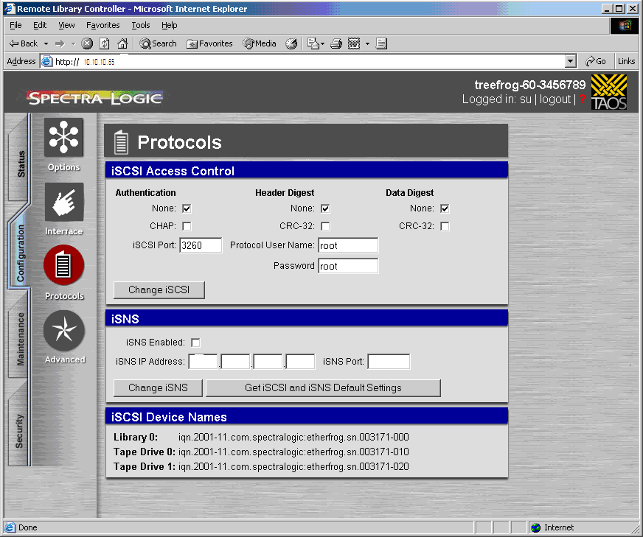
Figure 20. Remote Library Controller Protocols Window
- On the backup host, select the backup device:
- From the All Programs menu, point to Computer Associates, BrightStor, ARCserve Backup, and then click Device Configuration.
- Select Windows Server on Welcome to Device Configuration screen, and then click on Next >.
- Select Tape/Optical Library, and then click on Next >.
Note
To enable disk-to-disk backup, select File System Devices instead.
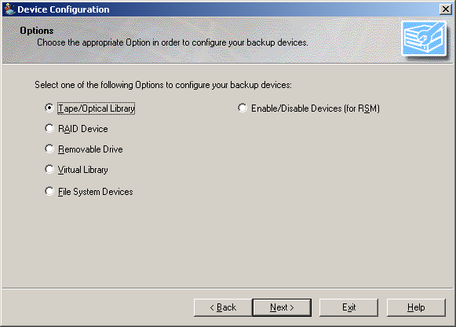
Figure 21. Device Configuration Dialog Box
- Tape Drives should be automatically assigned to their Tape Library in Assign Devices screen.
- Review the tape library configuration to ensure that the Spectra Logic tape drive changer and two tape drives are correctly configured, and then click Finish.
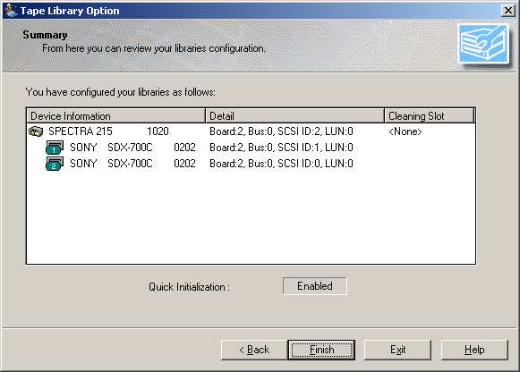
Figure 22. Tape Library Option Property Sheet

Assign Host Access Rights
Note that, for this deployment, CHAP security is not used. The current version of VSS does not support CHAP.
- On the Exchange server:
- Start the Microsoft iSCSI initiator.
- Log on to the Exchange volumes and make the targets persistent.
- Verify that only the Exchange volumes are listed as connected.
- On the SQL Server:
- Start the Microsoft iSCSI initiator.
- Log on to the SQL volume and make the target persistent.
- Verify that only the SQL volume is listed as connected.
- On the backup server:
- Start the Microsoft iSCSI initiator.
- Log on to the tape changer and the two tape drive targets, and make sure that each of the three targets are persistent.
- Verify that only the Spectra Logic targets are listed as connected.
- Optional: Log on to the backup volumes (for disk-to-disk backups) and make the targets persistent.
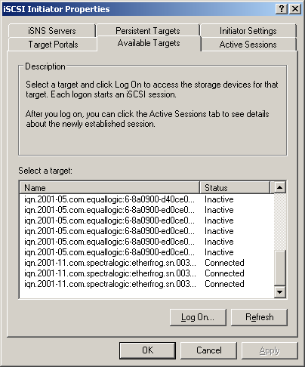
Figure 23. Microsoft iSCSI Initiator Properties Available Targets Tab

Format Disks
- From the All Programs menu, click Administrative Tools, and then click Computer Management:
- To see the disks, expand Storage, and then click Disk Management.
- Right-click each disk and initialize.
- To format each disk with the NTFS file system, right-click each partition and select Format. Format all disks as basic (not dynamic).
- Assign drive letters.
- Start the storage array Web UI and make sure that all the volumes are listed as formatted and connected.
- Put the servers into production.

Test Backup
This section briefly reviews the backup process. For details on fine-tuning the backup process using BrightStor ARCserve Backup, refer to the BrightStor ARCserve Backup Guides (see “Additional Resources” or contact Computer Associates International, Inc.
- On the backup server, start BrightStor ARCserve Backup Manager.
- Log on as administrator to the domain that the server is in.
- On the Quick Start menu, click Backup.
- Click the Source tab to choose the data source targeted for backup:
  - Highlight Windows NT/2000/XP/2003 Systems, right click it, and select Add Machine/Object. Add Agent dialog opens.
  - Enter the host name of your Exchange server, select Use Computer Name Resolution or enter the IP address of your Exchange server, and then click Add.
  - Repeat Step a and b to add more servers.
- Select the application server targeted for backup. In this deployment as shown in Figure 24, iSCSI4 is the backup server, iSCSI1 is the Exchange server (targeted for backup), and iSCSI3 is the SQL Server.
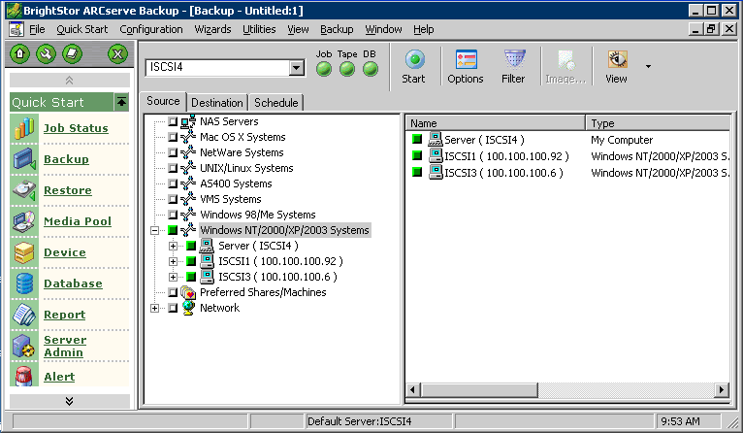
Figure 24. BrightStor ARCserve Backup Source Tab
Use Microsoft Exchange Writer to start VSS for shadow copy creation:
- Click iSCSI1 (the Exchange server) to expand the tree, and then click Microsoft Exchange Writer.
- Select the storage group(s) targeted for backup (in this case, the Exchange databases, labeled Exdb1-4)
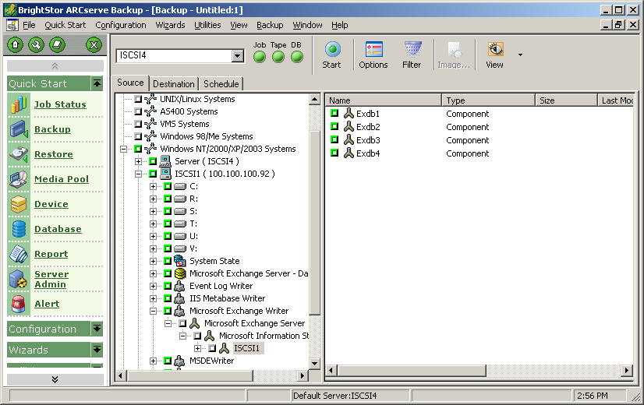
Figure 25. BrightStor ARCserve Backup Source Tab
- Choose the destination to which the data will be backed up:
- Click the Destination tab.
- Select the destination Group from Group list. In this case Tape. (Disks 1-5 are for disk-to-disk backup). Slots 5, 8 and 13 are assigned in this TAPE group..
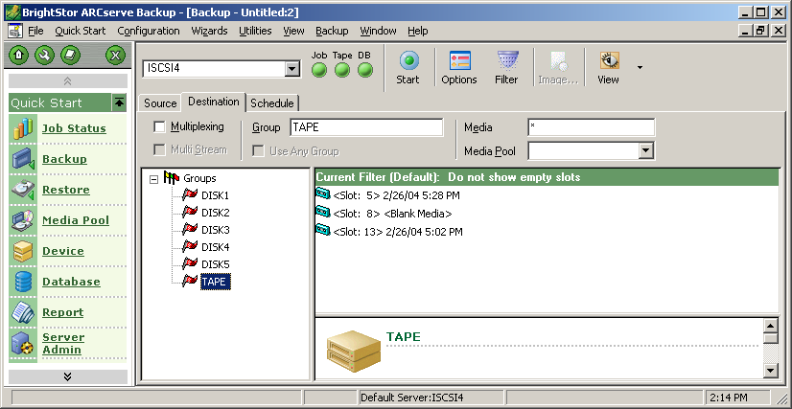
Figure 26. BrightStor ARCserve Backup Source Tab
- Click Options, click the Volume Shadow Copy Service tab, and then check “Use VSS” to enable VSS for file system backup.
- Start the backup process by clicking Start. The snapshot is created, and then written to tape. You can use the backup log file to determine whether or not the process succeeded.
- In the left navigation bar the PeerStorage Group Manager, click a storage group (for example, exdb1) to confirm that shadow copies have been created on the storage array.
If the shadow copies were successfully created, they will be visible in the left navigation bar, listed by date and time of creation. Shadow copies can be transported to another server for data mining or other purposes.
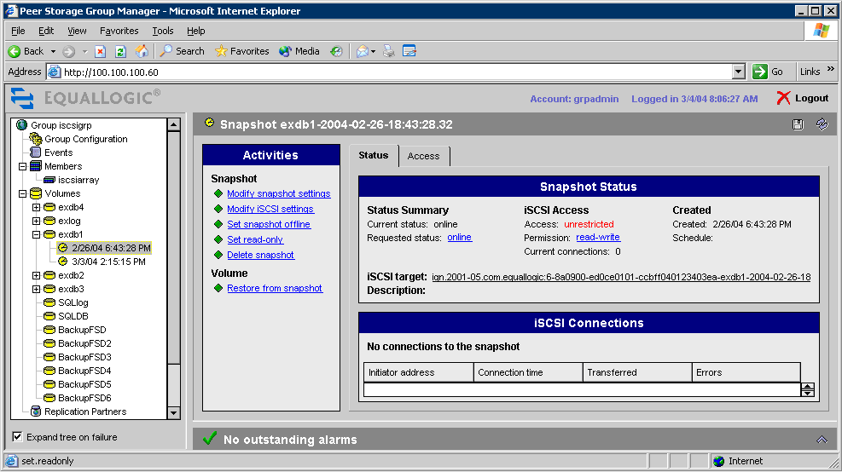
Figure 27. PeerStorage Group Manager Status Tab

Test Restore
Prior to starting the tape restore process, the active Exchange or SQL storage groups must be dismounted and made inaccessible to users. Neglecting this step will cause the restore process to fail.
- On the Exchange Server, dismount stores:
- Start the Exchange System Manager.
- Right-click each storage group (for example, Exdb1), and then click Dismount Store. The red down arrow indicates a dismounted store.
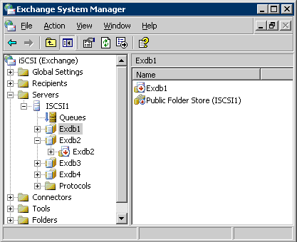
Figure 28. Exchange System Manager Dismount Store Property Sheet

- On the backup server, start BrightStor ARCserve Backup Manager.
- Click Restore from Quick Start Menu, and then click on Source tab.
- In the drop-down list, choose Restore by Tree.
- Choose the storage group(s) to restore.
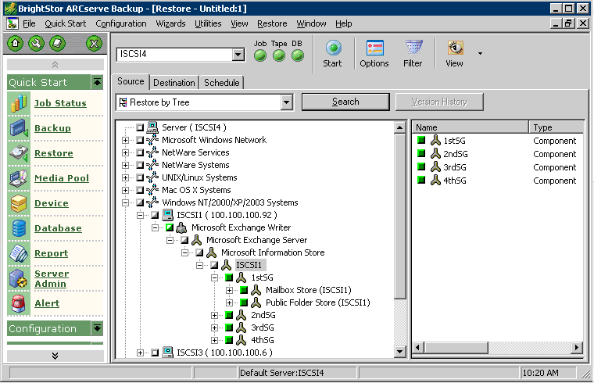
Figure 29. BrightStor ARCserve Backup Source Tab
- Click the Destination tab.
- Choose Restore to Original Location or Restore to a Different Server (such as a standby Exchange server).
- Select scheduling options.
- Start the restore process:
- Click Start. The archived data is restored from tape to target array.
- Check the log file to ensure that the restore was successful.
- On the Exchange server, remount the stores:
- Start Exchange System Manager.
- Right-click each storage group, and then click Remount Store.
The full backup and restore testing process is now complete.

Test Configuration
In addition to testing the backup and restore capabilities of each server, you also need to perform tests appropriate for your configuration and organizational needs.

Put into Production
Each server now has access only to its own verified backup and restore process. The servers are ready to enter production. Depending on the needs of the organization, data saved on local disks may either be migrated to the storage array or remain local.

Deployment #3: iSCSI Cluster
Server clusters (or nodes) are independent servers that use clustering software to perform as a single “virtual server.” Clustered servers share access to the same disks. In the event of planned or unplanned downtime of one node, clustering software (such as Microsoft Cluster Service) automatically redirects (fails over) clients to a second node without loss of application services. When a failed server comes back online, the cluster service rebalances the workload between the nodes.
Depending on the server version, Windows Server 2003 can support from two to eight node configurations. For the sake of simplicity, a two node cluster was used for the deployments discussed here. Only one node can access a given disk at any point in time; the other cluster node does not use its path to the disk unless the application is failed over. (This configuration is known variously as a “shared-nothing” or “active-passive” cluster. The alternative is a “shared disk” or “active-active” cluster in which applications on both nodes can access the same disks simultaneously.)
In an iSCSI cluster deployment, shown in Figure 30, Active Directory services are accessed by the clustered servers. The iSNS server (indicated by the asterisk) can also be accessed in the same manner, although it is not detailed in setup steps to this deployment. Clients access the Exchange and SQL servers through the public LAN, and both Exchange and SQL clusters access target storage resources through a Gigabit adapter connected to a private IP SAN. Deploying a backup server and a tape library on the IP SAN (not detailed in this deployment; see Deployment #2: ISCSI Backup for details) can make these resources available SAN-wide, as well as decreasing LAN traffic during backup and restore.
Figure 30. Clustered Exchange and SQL Servers
Table 3 lists the details of the SAN hardware components needed for Deployment #3: “iSCSI Clusters.”

Table 3. SAN Hardware Components Used in the Exchange and SQL iSCSI Cluster Configuration
SAN Hardware | Version | Other Information
Intransa IP5000 Storage System | - Controller: SC5100 (firmware v 22)  - Disk enclosure: DE5200-16  - StorControl Management Tool (firmware v 1.2) | - 16 disk drives  - 4 TB total storage  - Supports SCSI reservations
Dell PowerConnect 5224 Gigabit Ethernet Managed switch |  | - 24 Gigabit Ethernet ports  - Jumbo frames enabled
Adaptec iSCSI ASA-7211C storage accelerator HBA | - Firmware: Palomar 1.2, build 33 | - Gigabit Ethernet interface  - Supports iSCSI protocol  - TCP/IP offload on HBA

Basic Clustering Requirements
The basic clustering requirements listed here are common to both Exchange and SQL applications. This section, which consists of two parts, is intended to provide only the highlights. Part A describes a deployment scenario for Exchange clustering, and Part B describes an SQL clustering deployment. Because clustering requirements can be quite extensive, refer to the Clustering sub-section in the “Additional Resources” section of this paper for more information.

Software Requirements
- Windows Server 2003, Datacenter Edition or Enterprise Edition, installed on all nodes.
- Exchange Server.
- A name resolution method such as Domain Name System (DNS).
- An existing domain. All cluster nodes must be in the same domain.

Hardware Requirements
- Hardware that conforms with the cluster service Hardware Compatibility List (HCL). For full details on the clustering requirements, go to the Windows Hardware and Driver Central Web site (http://go.microsoft.com/fwlink/?LinkId=31539) and search on clustering.
Note
If you are installing this cluster on a storage area network (SAN) and plan to have multiple devices and clusters sharing the SAN with a cluster, the solution must also be on the “Cluster/Multi-Cluster Device” Hardware Compatibility List. For additional information, see Microsoft Knowledge Base Article 304415, “Support for Multiple Clusters Attached to the Same SAN Device” (http://go.microsoft.com/fwlink/?LinkId=31540).
- Two PCI network adapter cards per node.
- Two storage array controllers.

Network Requirements
- Access to a domain controller.
- A statically assigned IP address for each network adapter on each node.
- Nodes that connect to two physically independent networks:
- A public interface supporting both node-to-node communication and client-to-cluster communication.
- A private interface reserved for internal communication between the two nodes.
- A dedicated private subnet for the cluster network.
- A separate network for the storage array (a requirement when using the Intransa Storage System).

Shared Disk Requirements
- All shared disks must be physically attached to the same bus.
- A dedicated quorum disk (necessary for cluster management) of at least 50 MB must be available. A partition of at least 500 MB is recommended for optimal NTFS file system performance.
- All disks must be configured as basic (not dynamic).
- All disks must be formatted with NTFS.

A. Exchange Clustering Setup
Prior to setting up the Exchange cluster, determine the number of users that Exchange Server is expected to support. Average users generate about .25 read/write disk requests (I/Os) per second (IOPS); heavy users, twice that. Storage arrays must be able to support the total user load. Microsoft recommends the following capacity ranges:
- Low capacity = 250 users
- Medium capacity = 750 users
- High capacity = 1500 users
Thus, an Exchange server hosting 250 mailboxes must have a storage array that can support at least 62.5 IOPS.
Figure 31 lists the Deployment #3: iSCSI Cluster summary steps for setting up the Exchange and SQL clusters.
Figure 31. Summary of Deployment Steps for Setting up iSCSI Clustering with Exchange

Perform Preliminaries
Configure the storage array to support the expected database volume size, which is dependent on the amount of storage available to each user. After these preliminaries are determined, the clustering setup can begin.

Set up the iSCSI Target
- Install the iSCSI target storage array according to vendor instructions:
- The Intransa storage subsystem used in this configuration requires a separate network. Twelve of the switch ports provide a VLAN network for the storage array; the remaining twelve are used for the iSCSI network.
- The user can use either the command line interface or the StorControl Management Tool to manage the IP SAN. The GUI was used for the Exchange deployment.
- Use the storage array management tool to configure storage:
- Open the StorControl™ Management Tool. The main StorControl window lists all volumes, disks and other components contained in the IP SAN.
- Right-click All Volumes and select New Volume.
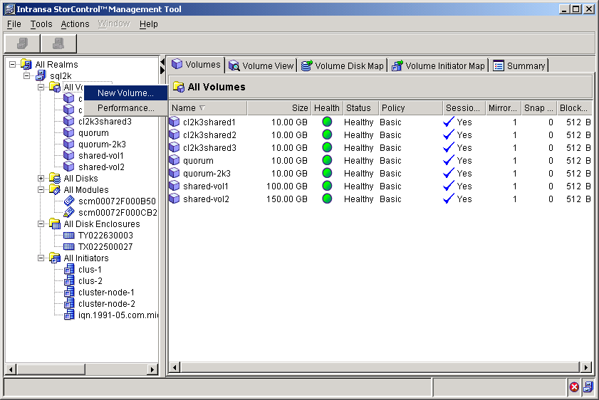
Figure 32. StorControl Management Tool Volumes Tab
- Configure RAID levels for the quorum disk and transaction log disks:
- In the Volume policy list, click Mirror (RAID-1), and then click Next.
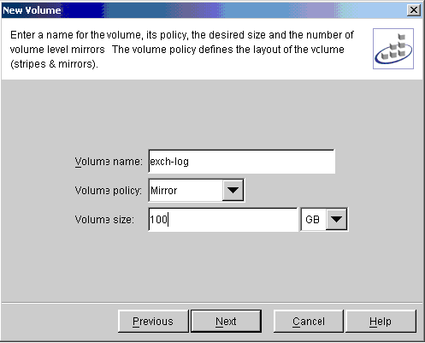
Figure 33. StorControl Management Tool New Volumes Dialog Box
- Select New as the volume placement policy (this restricts the volume from sharing its spindles).
- Assign the volume to all iSCSI host initiators targeted to be members of the Exchange cluster.
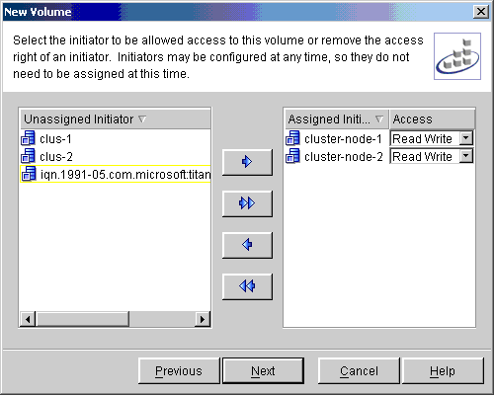
Figure 34. StorControl Management Tool New Volumes Property Sheet
This step enables the initiator to access the volumes. In non-clustered configurations, only one host server (initiator) can access a volume with full read/write permissions; if more than one initiator has access, data may be corrupted. In clustered configurations, however, at least two initiators must be able to have read/write access to the volumes.
- Configure RAID levels for the database disks:
- To ensure maximum performance, select striped mirrors (RAID-10) as the volume policy.
- Assign the volume to all iSCSI initiators.
- Balance the volumes across the storage controllers:
- Assign the database volume on a separate controller from the quorum and log volumes. Assigning the volumes to different controllers spreads the workload, thereby maximizing performance.
- To view the created volumes, click the Volume View tab on the StorControl Management tool.

Set up the iSCSI Hosts
Both iSCSI host servers must be set up for access (through the HBA) to the shared storage array. This process involves first logging on to one host and configuring the storage, then logging out and logging into the second node to verify that the server has access to the same correctly formatted storage. The HBA and the correct firmware must be installed for this process to work correctly.
- Download and install the free Microsoft iSCSI initiator. Install on both nodes according to initiator instructions and select the option to install only the Microsoft iSCSI initiator service.
Note
- Both GUI and CLI are available for host configuration.
- Install the host bus adapter.
- Ensure that the correct Adaptec firmware is installed. This configuration was run using Palomar 1.2.

Assign Host Access Rights
- Add the iSCSI target to the portal target list:
- Click the Available Targets tab, and then log on to node 1 (named iSCSI-1).
- Click the Target Portals tab, and then type the target portal IP address or DNS name for the Intransa storage system.
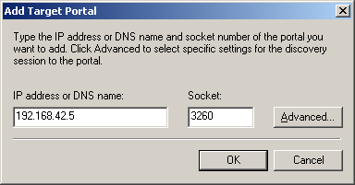
Figure 35. StorControl Management Tool Add Target Dialog Box
- Click Advanced, and then select the Adaptec HBA adapter to connect server and storage target.
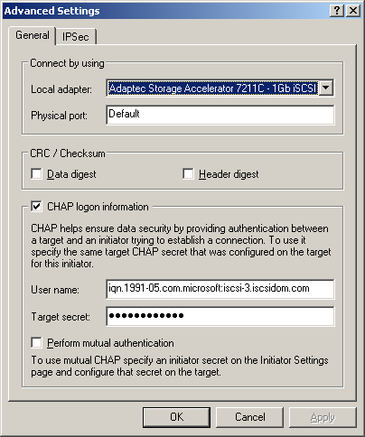
Figure 36. StorControl Management Tool Advances Settings Property Sheet
- Select CHAP logon information to perform authentication between initiator and target. Allow persistent binding of targets. When the system restarts, the initiator will automatically attempt to reconnect to the assigned target.
- Add the target. The initiator automatically establishes a discovery session and gathers target information.
- Log on to the storage target from node 1:
- Click the quorum disk (disk 1) to select it, and then log on to it.
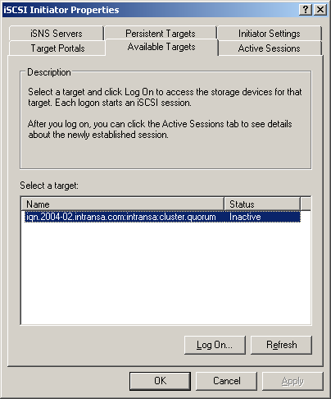
Figure 37. Microsoft iSCSI Initiator Properties Available Targets Tab
- Use CHAP to authenticate the initiator-target connection.
- Format the quorum disk with NTFS.
- Assign drive letter (Q).
- Use diskmgt.exe to determine if the quorum disk is present (logon is successful).
- Log on to storage target from node 2.
- Log off node 1.
- Log on to node 2 (named iSCSI-3).
- Ensure that the volume is correctly formatted (as NTFS) and that the drive letter matches the first node (disk Q).
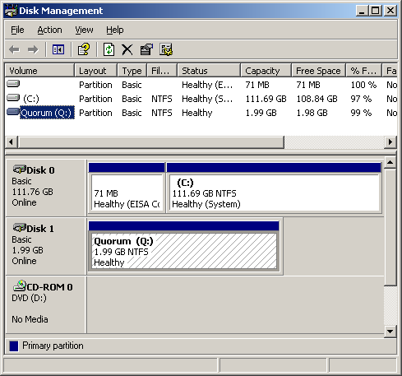
Figure 38. Disk Management Window

Set up Clustering
Setting up a cluster requires first assigning the resources to one node (server), and then to the other node. Currently, in this configuration, the administrator is still logged into node 2. These steps can begin on that node.
- Install Windows Server 2003, Datacenter or Enterprise Edition.
- Run the Cluster Administrator, CluAdmin.exe, to begin clustering setup.
- When prompted by the Open Connection to Cluster Wizard dialog box, click Create new cluster, in the Action list, as shown in Figure 39.
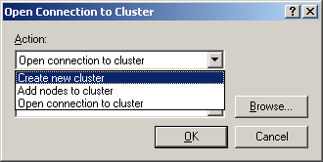
Figure 39. Cluster Administrator Open Connection to Cluster Wizard
- Using the New Server Cluster Wizard, create a new cluster on one node (node 2):
- Click Start, click All Programs, click Administrative Tools, and then click Cluster Administrator.
- Click Create a new cluster.
- Add a DNS resolvable name for new cluster (iscsidom.com, in this example) and name the new cluster (iscsicluster in this example).
- Because it is possible to configure clusters remotely, you must verify or type the name of the server that is going to be used as the first node to create the cluster.
Note
The Install wizard verifies that all nodes can see the shared disks the same. In a complex storage area network the target identifiers (TIDs) for the disks may sometimes differ, and the setup program may incorrectly detect that the disk configuration is not valid for Setup. To work around this issue you can click Advanced, and then click Advanced (minimum) configuration.
The Setup process now analyzes the node for possible hardware or software problems that may cause problems with the installation. Review any warnings or error messages. You can also click Details to get detailed information about each one.
- Type a static IP address that maps to the cluster name.
- Type the user name and password of the cluster service account that was created during pre-installation.
- Select the domain name in the Domain list, and then click Next. At this point, the Cluster Configuration Wizard validates the user account and password.
- Use the cluster administrator account to administer a cluster (a separate account is recommended for any application that requires logon credentials for a service).
- Review the Summary page, to verify that all the information that is about to be used to create the cluster is correct (scroll down to ensure that disk Q is used as the quorum resource).
- Review any warnings or errors encountered during cluster creation. To do this, click the plus signs to see more information. Warnings and errors appear in the Creating the Cluster page.
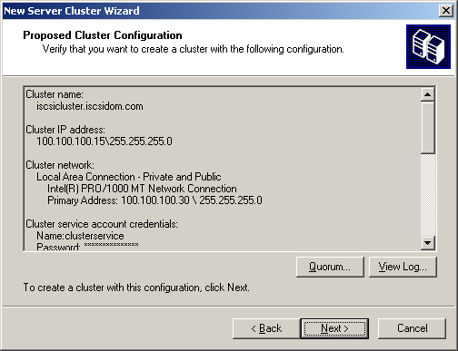
Figure 40. Cluster Administrator New Server Cluster Wizard
- Click Start, click Programs, click Administrative Tools, click Cluster Administrator, and then verify that the cluster resources came online successfully. In this case, node 2 (iSCSI-3) is correctly listed as part of the group ISCSICLUSTER (virtual server).
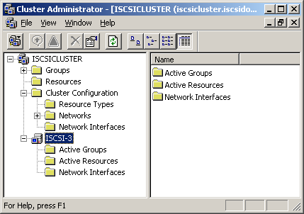
Figure 41. Cluster Administrator Cluster Window
- Check that the other node is honoring the SCSI reservation:
- Log on to the quorum disk on node 1.
- Open the Disk Management tool and ensure that the quorum disk (disk 1) is not initialized.
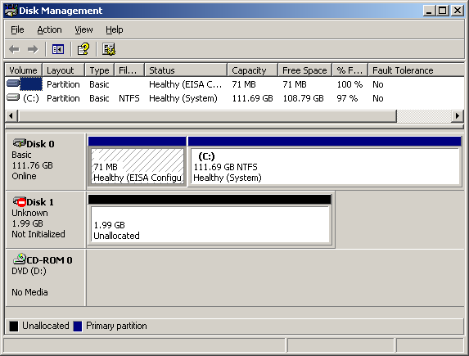
Figure 42. Disk Management Window
Important
- Only qualified iSCSI targets that have passed the HCT to ensure compliance with SCSI specifications should be used.
- If the disk is listed as “online” rather than “not initialized,” the SCSI reservation has not been honored by the storage subsystem. As a consequence, node 1 will be able to both read and write to the disk reserved by node 2 and data corruption will result. Although the Intransa storage subsystem honors SCSI reservations, not all storage subsystems do, so this verification is an important step.
- Set up a cluster on second node:
- On node 1, open the Cluster Administrator tool.
- Click File, click New, and then click Node.
- The Add Cluster Computers wizard will start. Click Next.
- If you are not logged on with appropriate credentials, you will be asked to specify a domain account that has administrative rights over all nodes in the cluster.
- Use the wizard to add node 1 (iSCSI-1) to the existing cluster. The local host (iSCSI-1) should appear as the computer name. (If not, there may be problems with DNS or Active Directory.) The Setup wizard will perform an analysis of all the nodes to verify that they are configured properly.
- Type the logon information for the domain account under which the cluster service will be run.
- Review the summary information that is displayed, making sure that it is accurate. The summary information will be used to configure the other nodes when they join the cluster. If the cluster configuration is correct, add the second node. Two nodes should be running on the cluster; ISCSI-1 and ISCSI-3.
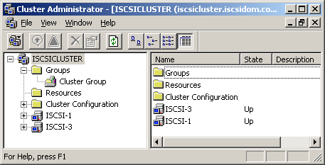
Figure 43. Cluster Administrator Cluster Group Window
- Configure the heartbeat:
- Click Start, click Programs, click Administrative Tools, and then click Cluster Administrator.
- In the left pane, click Cluster Configuration, click Networks, right-click Heartbeat, and then click Properties. Network resources are currently identified by IP name. We recommend renaming these “Client” and “Heartbeat” to help clarify their roles.
- Select Enable this network for cluster use.
- Click Internal cluster communications only (private network), as shown in Figure 45.
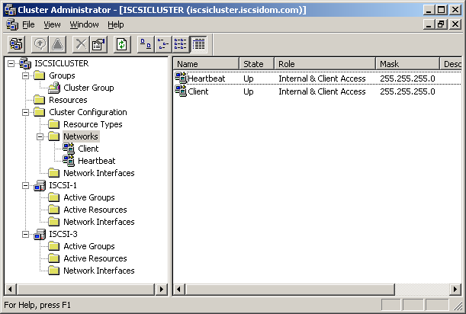
Figure 44. Cluster Administrator Networks Window
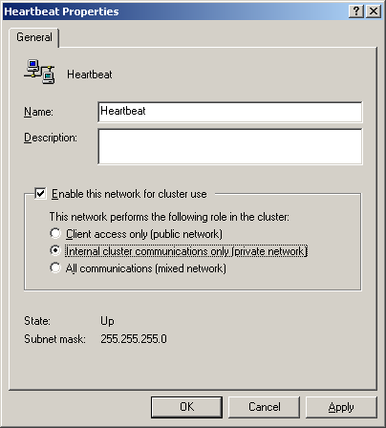
Figure 45. Cluster Administrator Heartbeat Dialog Box
Note
When using only two network interfaces, it is imperative that the client network support both internal communication and client communication. Without this support, fault tolerance is not possible.
- Verify that failover works.
Failover is generally verified in two ways: graceful and hard failover. “Graceful” failover is a non-stressed failover in which the cluster group is moved from one node to the other to ensure that both nodes can access the disks. A “hard” failover involves breaking a link to one of the nodes in the cluster and ensuring that the disk subsystem correctly handles reallocation of disks to the surviving node.
- Conduct a graceful failover:
- Click Start, click Programs, click Administrative Tools, and then click Cluster Administrator, right-click Cluster Group. Resources are currently assigned to node 1.
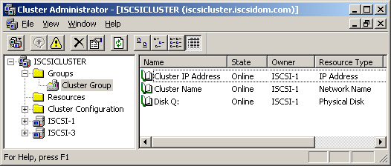
Figure 46. Cluster Administrator Cluster Group Window
- Right-click node 1 (ISCSI-1), and then click Move Group. The resources are automatically reassigned to node 2. After a short period of time, the Disk Q: R: will be brought online on the second node. Watch the window to see this shift. When this occurs, close the Cluster Administrator.
- Conduct a hard failover:
- Remove all cables from node 2 (ISCSI-3 of the previous screenshot), including the heartbeat cable.
- If the disk subsystem correctly handles disk reservations and task management functions, the cluster will fail over to node 1 (ISCSI-1) in about 60 seconds.
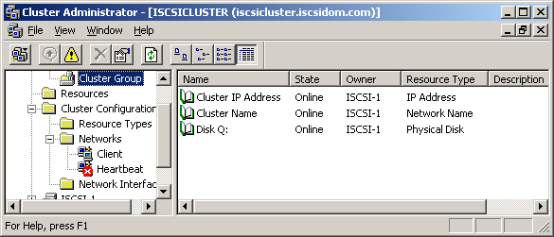
Figure 47. Cluster Administrator Cluster Group Window
- Reconnect all cables and ensure that the downed node automatically rejoins the cluster. This could take between 1-2 minutes.

Set up Application
- Ensure that the Distributed Transaction Coordinator (DTC) is installed.
Prior to installing Exchange, ensure that the DTC is installed on both server nodes. DTC enables Exchange to transfer data between the nodes on the cluster. After this is installed on both nodes, it must also be enabled for the virtual cluster.
- Use Add/Remove Windows Components tool to enable DTC access (keep the default Application Server subcomponents selected).
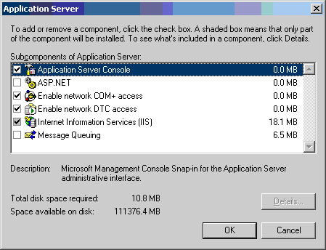
Figure 48. Application Server Set Up Screen
- If desired, select Internet Information Services (IIS), and then click Details, and then select SMTP and NNTP.
- On iSCSI-1, start the Cluster Administrator tool. On the File menu, point to New, and then click Resource.
- Select the Distributed Transaction Coordinator as a new resource. Both nodes will be now be listed as possible owners. Click Next.
- In the Dependencies dialog box, select both the quorum disk and the Cluster Name, and then click Add. The cluster resource is created successfully.
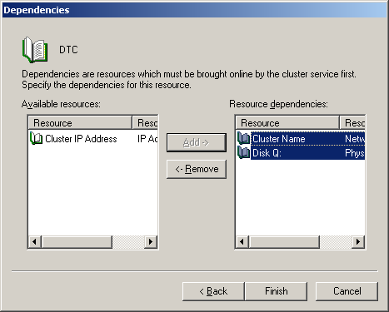
Figure 49. Application Server Dependencies Screen
- In the Cluster Administrator tool, right-click Cluster Group, and then click Bring Online.
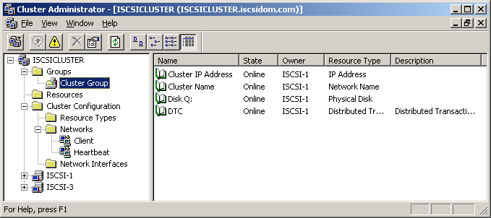
Figure 50. Cluster Administrator Cluster Group Screen
- Perform forest and domain preparation. Do this on one node only.
- Start the Exchange directory either from CD or network share and change the directory to \setup\i386.
- At the command prompt, type setup /forestprep. The Exchange Installation Wizard opens.
- Verify that ForestPrep has been successful. (On the Component Selection menu, “ForestPrep” should show up as a default action.)
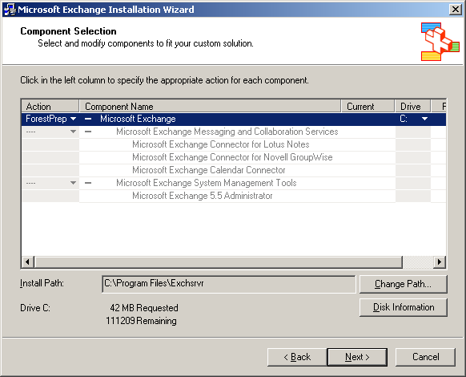
Figure 51. Exchange Installation Wizard
- At the command prompt, type setup/domainprep.
- Use the Exchange Installation Wizard to verify that DomainPrep shows up as a default action.
- Install Exchange on the local drive (C: ) of both nodes:
- Run setup.exe on the node that does NOT currently own the cluster resources (because installation puts the node into pause state and failover cannot occur).
- Install both Messaging and Collaboration Services and System Management Tools.
- Create a new Exchange organization (the default name is “First Organization”).
- After installation is complete for this node, give it ownership of cluster resources.
- Install Exchange on the other node, which no longer has access to cluster resources.
- Configure Exchange.
After the disks are created on each node, they will be linked by creating a virtual server grouping the Exchange disks.
- From one node, log on to the iSCSI targets for the database (exch-db) and log (exch-log) disks.
- Using the Disk Management tool, format both volumes with NTFS.
- Verify that both nodes have the same drive letters mapped to each disk (this simplifies management and ensures that failover of the Exchange processes will be unhindered).
- Start the Cluster Administrator tool, create a new cluster group for the Exchange virtual server (for example, EXCHSRVR), and then click Next.
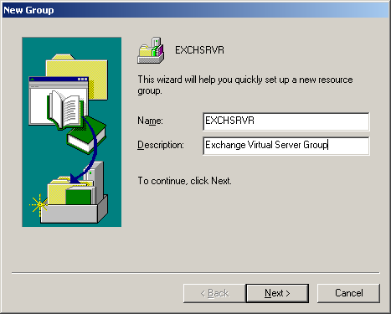
Figure 52. Cluster Administrator New Group Wizard
- In the Preferred Owners dialog box, verify that preferred owners is unassigned (assigning preferred owners will prevent failback), and then click Finish.
- After the cluster group has been successfully created, bring EXCHSRVR online, and then add new resources.
- Add new application resources to the cluster:
- Start the Cluster Administrator tool, select File, point to New, and then click Resource.
- Create a new resource for disk R:, the transaction log disk (exch-log), then another for disk S:, the Exchange database disk.
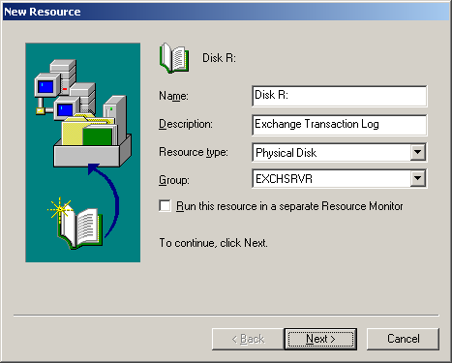
Figure 53. Cluster Administrator New Resource Wizard
- Do not assign owners or dependencies for the R: or S: disks.
- Bring the entire EXCHSRVR group online.
- Add a new resource for the Exchange virtual IP address (EXCH IP ADDR). Do not assign dependencies.
- In the left navigation bar of the Cluster Administrator tool, click Network, right-click Client, and then click Properties.
- On the General tab, click Internet Protocol (TCP/IP), and then select Enable NetBIOS for this address.
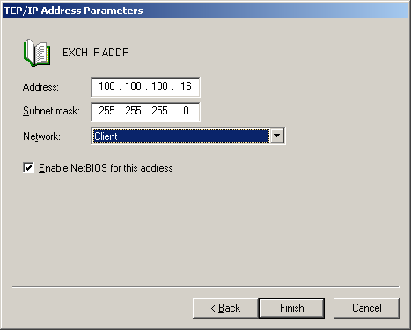
Figure 54. Cluster Administrator Network Client Wizard
- Bring IP address online.
- Add a new resource for the network name (for example, EXCH NET NAME).
- Assign Exchange IP address as a dependency, and then click Next.
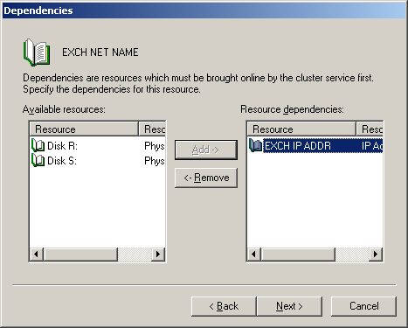
Figure 55. Cluster Administrator Dependencies Dialog Box
- For the EXCH NET NAME (ISCSIMAIL), check DNS Registration must succeed (the name must be DNS resolvable).
- Bring EXCHSRVR online.
- Add a new resource for System Attendant (EXCH SYS ATT).
- Assign disk R:, disk S:, and network name as resource dependencies. (This is necessary to ensure that shutdown happens cleanly.)
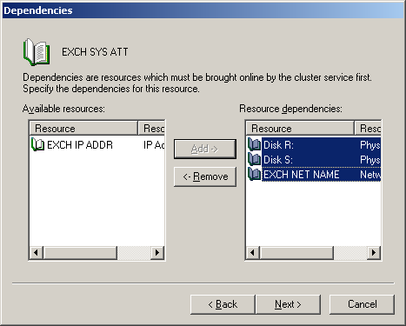
Figure 56. Cluster Administrator Dependencies Dialog Box
- Select the location where the Exchange virtual server will be created. (The default name is “First Administrative Group.”)
- Select the Exchange routing group in which the Exchange virtual server will be created. (The default name is “First Routing Group.”)
- Choose the log disk (R:).
- Verify summary parameters and click Finish.
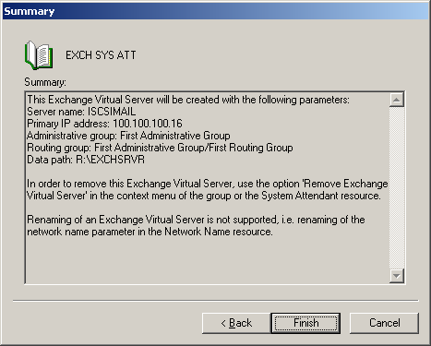
Figure 57. Cluster Administrator Summary Dialog Box
- If Web access to Outlook is required, configure secure socket layer (SSL) in IIS.
- Run the Exchange System Manager to verify that the transaction logs and system path are on disk R:.
- At the command prompt, create a directory for the database: mkdir s:\exchsrvr\mdbdata.
- Start the mailbox store properties, and move both public and private Exchange and streaming databases from R: to S:.
Figure 58 shows mailbox stores on R:
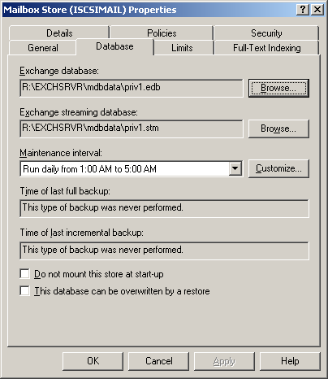
Figure 58. Mailbox Store Property Sheet, Database Tab
Figure 59 shows mailbox stores moved to S:
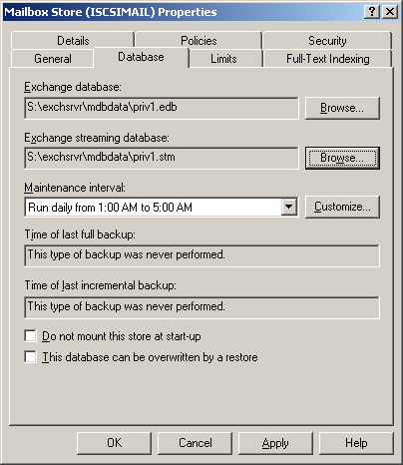
Figure 59. Mailbox Store Property Sheet, Database Tab
- Test failover:
- Perform a graceful failover. Disks are initially on ISCSI-1.
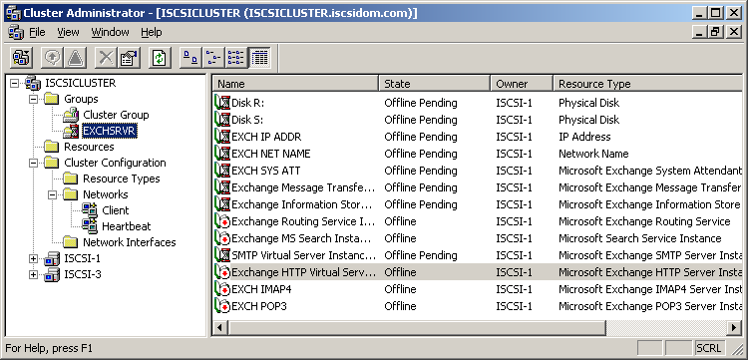
Figure 60. Cluster Administrator EXCHSVR Group Failure
After failover, disks are automatically moved over to ISCSI-3.
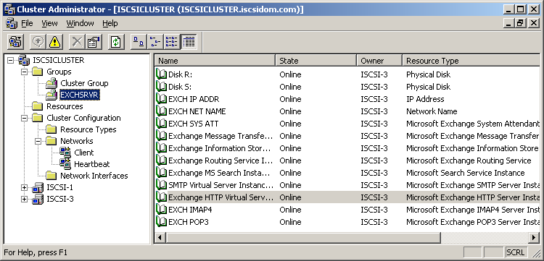
Figure 61. Cluster Administrator EXCHSVR Group Move
- Perform a hard failover test (remove both client and heartbeat cables from ISCSI-3) to ensure that failover to ISCSI-1 is successful.
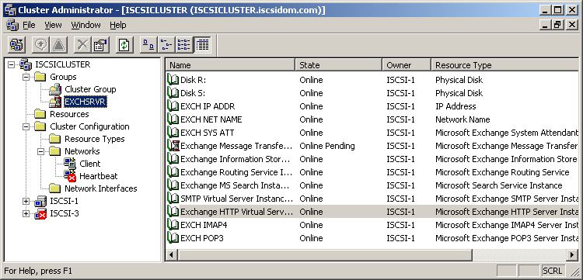
Figure 62. Cluster Administrator EXCHSVR Hard Failover Test
- Reconnect all cables and ensure that the Exchange cluster comes back online.
Setup now has sufficient information to start copying files.
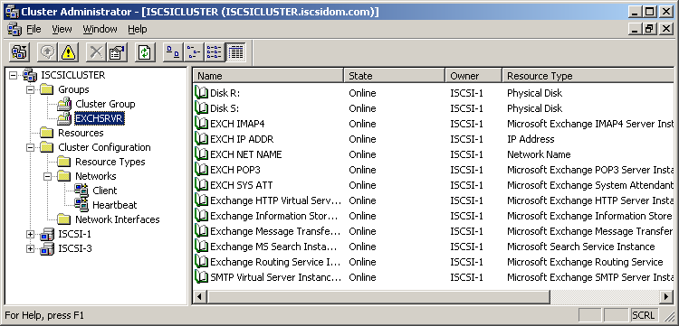
Figure 63. Cluster Administrator EXCHSVR Group Online

Test on Client
You can simulate performance under a messaging load by using Load Simulator 2003. This benchmarking program enables administrators to determine whether or not the server can handle its load.
- Install Microsoft Exchange Server Load Simulator (LoadSim) 2003 on clients to test performance under a messaging load.
- Set up users.
- Test performance (refer to LoadSim documentation for details).
- After these steps are complete and verified to be functioning correctly, move the Exchange cluster into production for organizational use.

Test Configuration
In addition to testing the backup and restore capabilities of each server, you also need to perform tests appropriate for your configuration and organizational needs.

Put into Production
Each server now has access only to its own Exchange and SQL Server cluster. The servers are ready to be put into production. Depending on the needs of the organization, data saved on local disks may either be migrated to the storage array or remain local.

B. SQL Clustering Setup
The initial steps for setting up the hardware for the SQL cluster are nearly identical to those for setting up the Exchange hardware. Refer to the Exchange Clustering Setup section, earlier in this deployment scenario, for full details. This section contains details specific to the SQL installation for clustering.

Perform Preliminaries
Configure the storage array to support the expected database volume size, which is dependent on the amount of storage available to each user. After these preliminaries are determined, the clustering setup can begin.

Set up iSCSI Target
- Set up the Intransa storage array:
- Create four volumes for SQL: one each for the quorum and log disks, and two for the database disks.
- Create both the quorum disk and the log disk as mirrors (RAID-1).
- Create the database disks as RAID-10 for maximum performance.

Set up iSCSI Hosts
- Set up the SQL host server with two network adapter cards and the Adaptec HBA.
- Set up the network.
- Join the domain.
- Ensure that client and heartbeat connections are established and named.
- Install the Microsoft iSCSI initiator service on both host servers.
- Start the Microsoft iSCSI initiator service on one of the targeted SQL servers.
- Log on to the storage array target.
- Assign drive Q.
- Add the node to a new cluster:
- Using CluAdmin.exe, create an iSCSI SQL cluster (“iSCSISQLcluster”).
- Assign the domain and a unique IP address.
- To start the cluster service, log on to the domain.
- Add the second node to the cluster while still logged into node 1:
- Assign the domain and a unique IP address.
- Add the quorum disk.
- Use the Add Node Wizard to add the second node to the cluster.
- Perform a graceful failover between the two nodes to ensure that clustering functions as expected.
- Create a new resource group to contain disks and SQL Server:
- Start the Cluster Administrator tool, point to New, and then select Group.
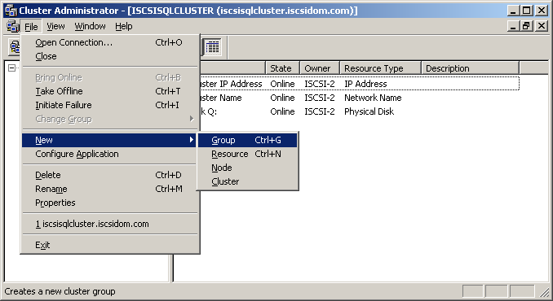
Figure 64. Cluster Administrator Creating New Resource
- Name the group (in this case, SQLSRVR).
Important
Do NOT set preferred owners.
- Log on to the disks from the Microsoft iSCSI initiator.
- Log on to all disks and make targets persistent.
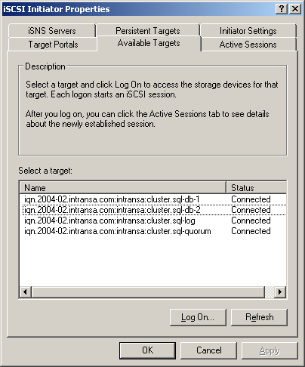
Figure 65. Microsoft iSCSI Initiator Available Targets Property Sheet
- Initialize and format disks:
- Using the Disk Management tool, initialize the disks as basic (do not convert to dynamic disks).
- Format the disks’s primary NTFS partitions and assign drive letters (rename drives R: and S: to sql-db-1 and sql-db-2, respectively).
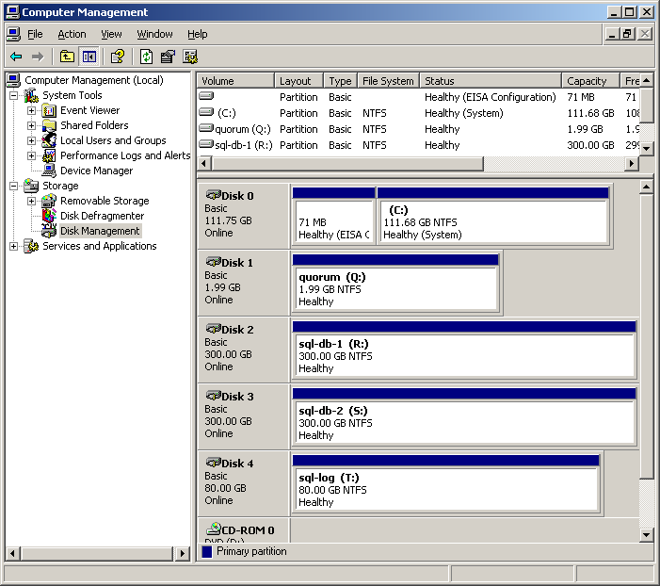
Figure 66. Computer Management Disk Management Window
- Add the disks to the cluster:
- Start the Cluster Administrator tool, select File, point to New, click Resource, and then add a new resource.
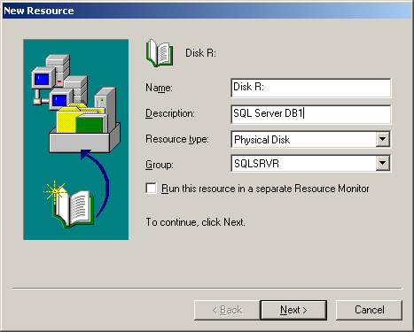
Figure 67. Cluster Administrator New Resource Dialog Box
- Follow the remainder of the setup steps in the wizard (do not add any dependencies).
- After the cluster resource is successfully added, bring the disk online.
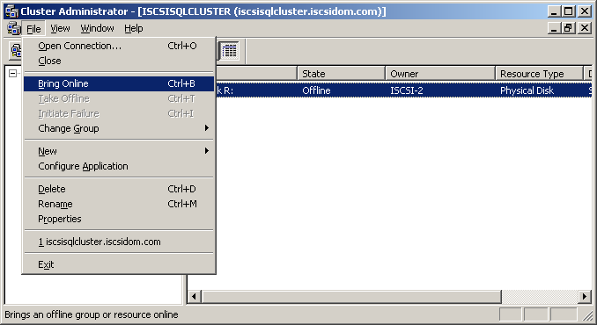
Figure 68. Cluster Administrator Resource File Menu
- Repeat the actions listed in step 11a-c for all other disks.
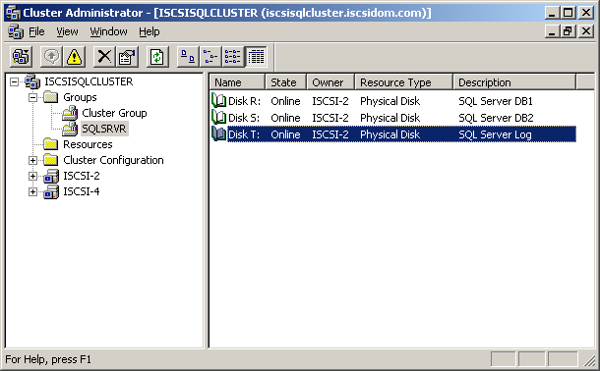
Figure 69. Cluster Administrator Group Window
- Use the Microsoft iSCSI initiator to add the disks to the other node.
- Log on to all disks.

Install SQL
- Begin SQL 2000 installation process (Service Pack 3 must be installed to work with Windows Server 2003):
- Select SQL Server 2000 components.
- Install the database server.
- Follow the steps in the Installation wizard:
- Install a new instance of SQL on a virtual server.
- Type the IP address and set up the client network.
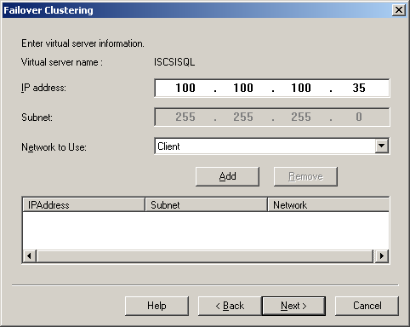
Figure 70. Cluster Administrator Failover Clustering Dialog Box
- Set up the heartbeat network.
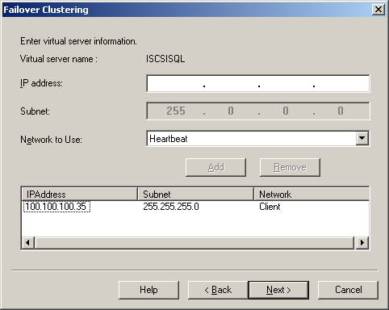
Figure 71. Cluster Administrator Failover Clustering Dialog Box
- Select the cluster disk where the data files will be placed (in this case, R: ).
- Type the administrator account user name and password for nodes on cluster.
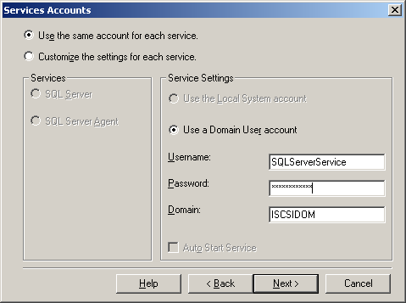
Figure 72. Cluster Administrator Services Accounts Dialog Box
- Choose default installation.
- Choose setup type (“Typical” is recommended for most users).
- Set service accounts and proceed to the next page of the wizard.
- Fill out licensing information. SQL automatically detects both nodes and installs files to both at once.
- Exit the wizard when setup is complete.
- Assign clustering dependencies. Assigning dependencies to disk resources ensures that the shutdown process proceeds cleanly, with any unwritten data being saved prior to disk resources going offline
- Use the Cluster Administrator tool to check online cluster resources.
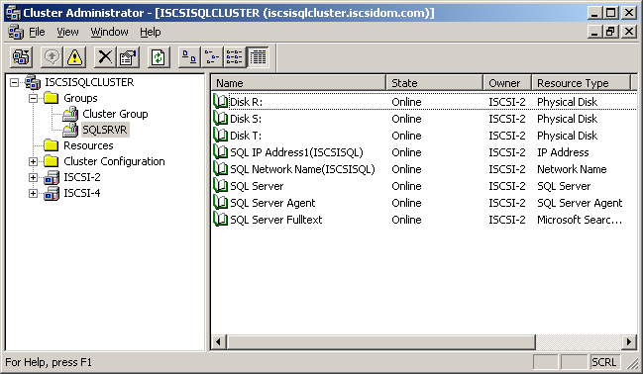
Figure 73. Cluster Administrator Group Window
- Take the SQL Server offline (on the File menu, and then click Take Offline).
- Assign dependencies (on the File menu, and then click Properties).
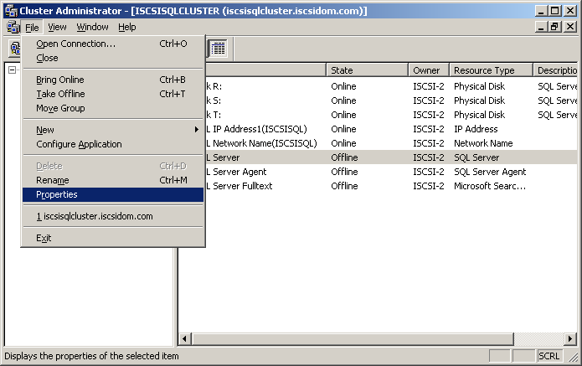
Figure 74. Cluster Administrator File Menu
- Click the Dependencies tab, and then click Modify. Currently the only resources online are disk R: and the SQL network name.
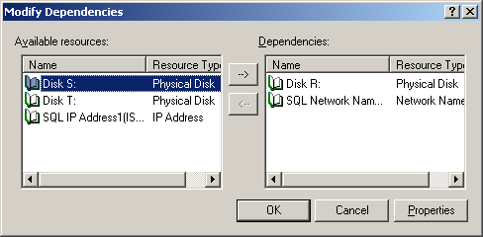
Figure 75. Cluster Administrator Modify Dependencies Dialog Box
- Add resources S: and T:.
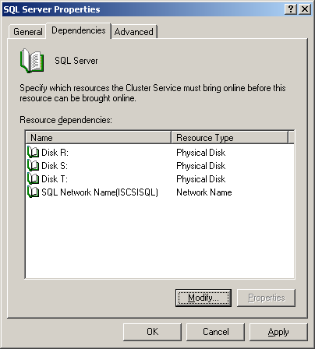
Figure 76. Cluster Administrator SQL Server Properties Dependencies Tab
- Bring the SQL Server back online (on the File menu, and then click Take Online).

Test on Client
Test graceful and hard failover as detailed in the “Exchange Clustering Setup” section of this deployment scenario. With these working correctly, you can enter the SQL cluster into production.

Test Configuration
In addition to testing the backup and restore capabilities of each server, you also need to perform tests appropriate for your configuration and organizational needs.

Put into Production
Each server now has access only to its own Exchange and SQL Server cluster. The servers are ready to be put into production. Depending on the needs of the organization, data saved on local disks may either be migrated to the storage array or remain local.

Deployment #4: iSCSI Bridge to FC SAN
Fibre Channel SANs are often restricted to data centers within organizations, with other storage resources distributed outside core resource centers. The benefits of an FC SAN can be extended to “edge” resources by connecting these additional servers to the SAN. This approach, which requires a gateway or bridge to translate between IP and FC protocols (see Figure 77), enables organizations to consolidate storage resources, conferring both increased storage availability and usage, at a cost that is lower than the cost of adding Fibre Channel infrastructure throughout the organization.
Figure 77. iSCSI Bridge to FC SAN Configuration
As with other deployments, a Gigabit adapter in the iSCSI host is recommended for connecting the private IP network back to the core SAN. Table 4 lists the gateway and SAN hardware components needed for Deployment #4: iSCSI Bridge to FC SAN.
Table 4. SAN Hardware Components Used in the iSCSI Bridge to FC SAN Configuration
SAN Hardware | Vendor | Model | Details
Multilayer Director switch | Cisco Systems, Inc. | MDS 9509 | Modular director switch, providing Fibre Channel or Gigabit Ethernet services
iSCSI target (gateway) | Cisco | IPS Module | Integrates with Fibre Channel switches, enables routing of traffic between any of its 8 Gigabit Ethernet ports and any other Cisco switch in the same fabric
Storage array | HP | StorageWorks Enterprise Storage Array 3000 | Provides FC storage volumes

Figure 78 summarizes the deployment steps for this configuration. Detailed deployment steps are presented in the text after the figure.
Figure 78. A Summary of the Deployment Steps to Set Up an iSCSI Bridge to FC SAN

Set up IP Switch
The Cisco Director switch provides multi-protocol switching services, security and SAN management services. To set up the switch, you must:
- Install and perform initial switch configuration, which must be configured out-of-band through the IP interface.
- Configure supervisor and switch modules.
For full details on setting up the Cisco switch, refer to the Cisco 9000 series configuration manual.

Set up Fibre Channel SAN
For the purposes of this deployment, it is assumed that the Fibre Channel SAN—including the FC switch—is already installed. This section is intended to provide context through a high level summary of the steps.
For full details on setting up the Fibre Channel interfaces (between switches, switches and hosts, switches and storage, etc.), see the Cisco 9000 series configuration manual.
- Configure switch interface mode.
Fibre Channel switch interfaces can function in a variety of modes, including E-ports (expansion ports, which connect switches), F-ports (fabric ports, connecting a switch to a N-port on a device such as storage), and TE-ports (trunking ports, which enable the port to send and receive information over the same port), depending on the nature of the connection. World Wide Name (WWN) assignment is automatic during this configuration.
- Set the interface speed.
- Set up access controls between servers and the storage array by using zoning. By default, all devices are members of the same zone. Zoning restricts communication to members of the same zone.
- Obtain the storage device WWN.
- After the initiator is configured, the storage devices must be placed into the same zone as the initiator. For more information about configuring the initiator, see step 3 of the Set Up the iSCSI Target section, later in this scenario.
- Set up the name server on the SAN. The name server performs the following functions:
- Maintains a database of all hosts and storage devices on the SAN.
- Indicates changes of state, such as when a device enters or leaves the fabric.
- Configure security.
Configure FC routing services and protocol, as appropriate.
Notes
- User authentication information can be stored locally on the switch or remotely on a RADIUS server.
- Fabric Shortest Path First (FSPF) is the default protocol. It calculates the shortest path between any two switches in a fabric, and selects an alternate path in the event of path failure.

Set Up the iSCSI Target (Gateway)
The Cisco IP Storage Services (IPS) Module is the gateway (also known as a “bridge”) that provides IP hosts with access to Fibre Channel storage devices. The IPS module gateway plugs directly into the Cisco switch. This section provides a summary of the steps required to set up the gateway so that the Fibre Channel storage targets are mapped as iSCSI targets and made accessible to the IP hosts. For full details, refer to the Cisco manual.
- Install the IPS Module.
- Configure the IPS Gigabit Ethernet interface (ports).
- Open Device Manager.
- Click slot 9, port 1 (circled in the Figure 79).
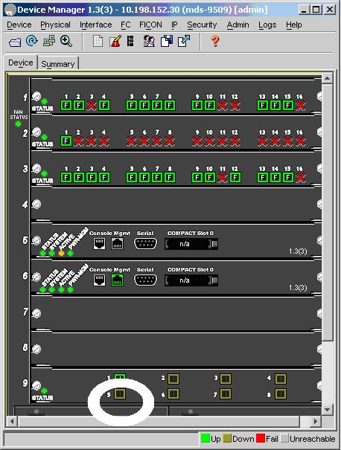
Figure 79. Device Manager Device Window
- Click the Interface tab and select Configure.
- Select the GigE tab and then click up (for port 9/1).
- Assign the IP address/mask of the iSCSI target IPS module.
- Choose security options (because this deployment is a locked down lab, “None” is chosen).
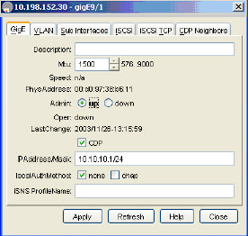
Figure 80. Device Manager GigE Tab
- Select the iSCSI tab.
- Select the following options:
- initiator ID mode: ipaddress (not named).
- Admin: up.
- Click Apply.
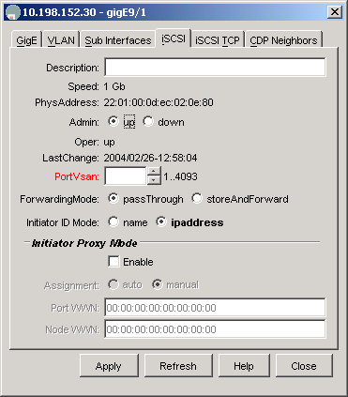
Figure 81. Device Manager iSCSI Tab
- Add in the Microsoft iSCSI initiator:
- On the Device Manager menu, click IP, and then click iSCSI.
- Click the Initiators tab.
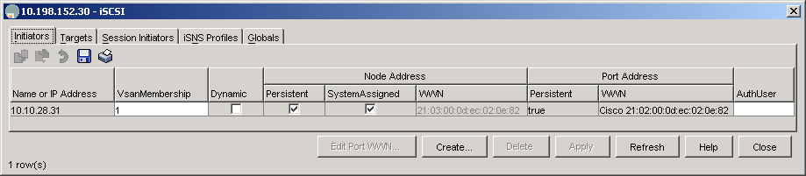
Figure 82. Device Manager Initiators Tab
- Add the IP address of the iSCSI initiator:
- Select Persistent as the Node Address.
- Click System Assigned to allow the system to assign the node WWN, and then click Create.
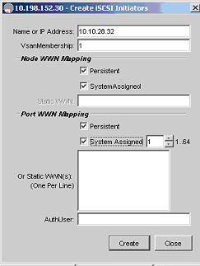
Figure 83. Device Manager Create iSCSI Initiators Dialog Box
The new iSCSI initiator is listed.
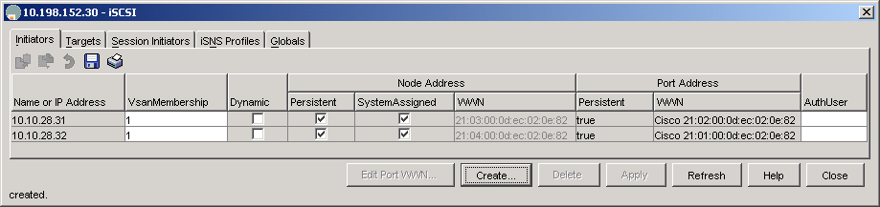
Figure 84. Device Manager Initiators Tab
- Create the iSCSI target.
- Click the Targets tab
- Type the iSCSI target name.
- Restrict access to iSCSI initiator address by listing the addresses in the Initiator Access box.
Important
Do not create LUNs for all initiators unless it is intentional for iSCSI cluster use.
- Type a specific host IQN for this single target LUN.
- Select gigE9/1 for presentation IP port, and then click Create.
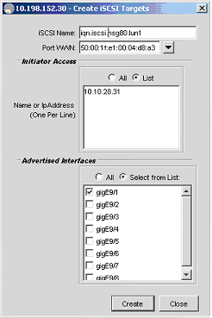
Figure 85. Device Manager Create iSCSI Targets Dialog Box
The Fibre Channel LUN is statically (manually) remapped to an iSCSI LUN.
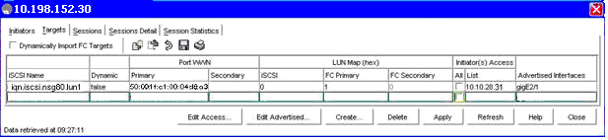
Figure 86. Device Manager Targets Tab
- Verify that the target was created correctly and that access is restricted.

Set up the iSCSI Initiator
It is assumed that Windows Server 2003 is already running on the initiator host.
- On the iSCSI host, download and install the Microsoft iSCSI initiator.
- Add the iSCSI target (gateway):
- Open the Microsoft iSCSI initiator.
- Click Target Portals.
- Click Add and type the IP address of the iSCSI target gateway.
- Log on to the iSCSI target:
- Click Available Targets.
- Select the IP address of the inactive gateway target.
- Click Logon.
- Click Automatically restore this connection when system boots.
- Click OK. The target should be listed as connected

Configure Storage
- Open Windows Disk Management. The target disks should appear.
- Initialize the disks as basic.
- Format the disks with NTFS.
- Add drive letter.
- Test the disk initialization.

Test Configuration
In addition to testing the backup and restore capabilities of each server, you also need to perform tests appropriate for your configuration and organizational needs.

Put into Production
The servers are ready to enter production. To the IP hosts accessing the FC storage array, the LUN targets now appear as iSCSI targets. To the FC storage array, the IP hosts appear as normal FC hosts. Depending on the needs of the organization, data saved on local disks may either be migrated to the storage array or remain local.

Deployment #5: iSCSI Boot from SAN
With Windows Server 2003 support for boot from SAN, you no longer need a directly attached boot disk to load the operating system. Booting from a remote disk on the SAN enables organizations to centralize the boot process and consolidate equipment resources by using thin and blade servers.
To boot from SAN over an IP network, you must install an iSCSI HBA supporting iSCSI boot in the server (currently, diskless iSCSI boot is not supported when you use the Microsoft iSCSI Software Initiator alone). The HBA BIOS contains the code instructions that enable the server to find the boot disk on the SAN storage array.
Figure 87 shows the basic iSCSI boot configuration. While only a single server is shown here, multiple servers can access the storage array for the purpose of booting; however, each server must access its own boot LUN (a LUN is a target portal containing a list of available targets) because Windows does not currently permit sharing of boot LUNs.
Figure 87. iSCSI Boot from SAN Configuration
For more details on booting from the storage area network, refer to the white paper, “Boot from SAN in Windows Server 2003 and Windows 2000 Server” (http://go.microsoft.com/fwlink/?LinkId=28164).
Table 5 lists the SAN hardware components used in Deployment #5, iSCSI Boot.

Table 5. SAN Hardware Components used in the iSCSI Boot from SAN Configuration
SAN Hardware | Firmware Version | Other Information
EqualLogic PeerStorage Array 100E | v 2.0.0 | - 14 disk drives (two spare)  - 3.5 TB total storage  - RAID-10
Adaptec HBA, ASA-7211C | iSCSI BIOS1.2.33 (Palomar 1.2) | - Gigabit Ethernet interface  - TCP/IP offload on HBA
Dell PowerConnect 5224 Gigabit Ethernet Managed Switch |  | - 24 Gigabit Ethernet ports  - Jumbo frames enabled

Figure 88 summarizes the deployment steps for the Deployment #5: iSCSI Boot from SAN configuration. Detailed deployment steps are presented in the text following the figure.
Figure 88. A Summary of the Steps to Set up iSCSI Boot from SAN

Set up iSCSI Target
- Set up the iSCSI target storage array according to vendor instructions. (For details on setting up and configuring the EqualLogic Storage Array, refer to Deployments #1 and #2.)
- Assign a private IP address to the array (100.100.100.60).
- Create a volume for the boot drive:
- Click Create volume and follow the instructions in the Create Volume Wizard.
- Assign a volume name and size for each server’s volumes.
- Click Next.
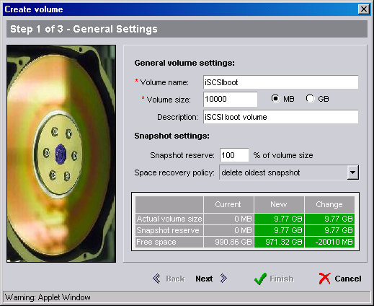
Figure 89. Storage Array Create Volume Wizard, Step 1
- Set access restrictions and authentication method for the volume:
- Select Authenticate using CHAP; user name, and then type in the user name.
- Click Next.
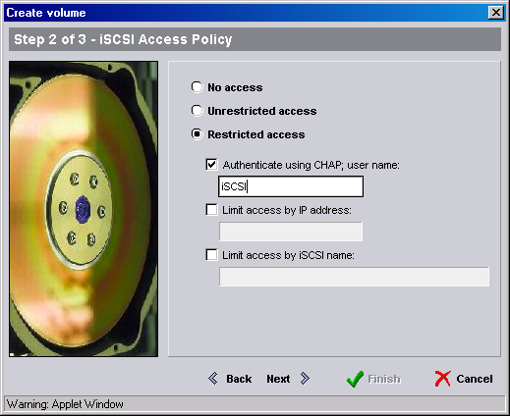
Figure 89. Storage Array Create Volume Wizard, Step 2
- Finish creating the volume:
- Review the summary of volume settings, and then click Finish.
- Repeat steps 1-5 for additional volumes for the server.
- Start the PeerStorage Group Manager. Then, in the left navigation bar, select Group Configuration, and then click the CHAP tab.
- On the CHAP tab, select Enable local CHAP user, and then click Add.
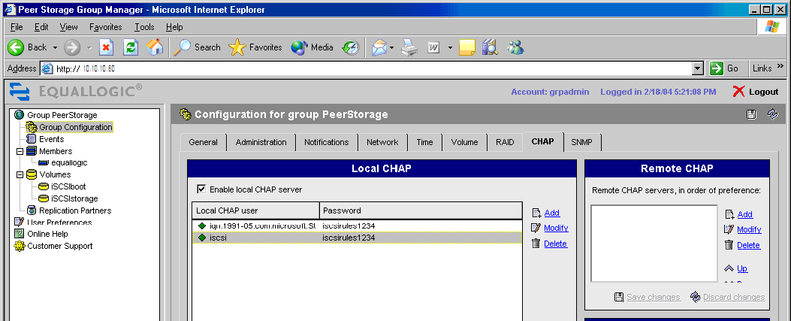
Figure 90. PeerStorage Group Manager CHAP Tab
- In the Add CHAP user dialog box, type the user name and password.
- Select Enable CHAP account.
Figure 91. Add CHAP User Dialog Box
- In the PeerStorage Group Manager left navigation bar, click Volumes to verify that the created volumes are online.
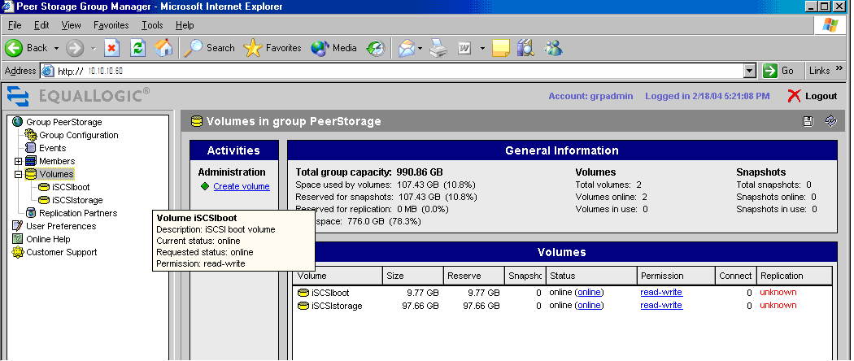
Figure 92. PeerStorage Group Manager Volumes Window

Set Up HBA
In order for the iSCSI boot process to work, the HBA adapter must be configured with the initiator name and an IP address, as well as the target boot LUN information. The Adaptec HBA can be configured to support CHAP security. After the configuration is complete, restart the system. Follow these steps:
- Turn iSCSI host on and wait while the BIOS initializes.
- Press CTRL+a to enter the Adaptec BIOS utility.
- On the main menu, click Adapter Configuration.
- Click Controller Configuration. The following information is listed:
- Controller description (AdapteciSCSIHostBusAdapter)
- Firmware version (v1.20.36)
- BIOS version (v1.20.33)
- Press F6 to get a default unique iSCSI initiator name, for example: iqn.1992-08.com.adaptec.0-0-d1-25-1c-92.
- Enable BIOS INT13.
- Close the menu.
- Click Network Configuration.
- Type the IP address of network port #0.
- Type the netmask address for the HBA.
- Configure the adapter with the target storage array information.
- Return to the main menu and click Target Configuration.
- Click Add Targets.
- Type the target name, for example: iqn.2001-05.com.equallogic:6-8a0900-74dce0101-b9fffo4007c40328.
- Type the target IP address for the discovery target/portal (this portal gives info to HBA regarding all other portals to storage), for example: 10.10.10.60.
- Make the target available after restarting the computer.
- Save settings.
- Add in the LUN targets. In Target menu, select Rescan Target.
- Set security for discovery target
- In the Target menu, select Manage Targets.
- Select Available Targets.
- Select target #0 (the discovery target). The following information is listed::
- Type target IP address: 10.10.10.60
- Type target name: “iqn.2001-05.com.equallogic… iscsiboot”
- Type port number: 3260
- Type the authentication method: CHAP
- Type the initiator CHAP name, for example: iscsi and target secret
- Make the target available after restart.
- Select target #1 (the storage target) and confirm the following, for example:
- Type target IP address: 10.10.10.60
- Type target name: “iqn.2001-05.com.equallogic… iscsistorage”
- Type port number: 3260
- After setup is complete, restart your computer. The system automatically displays the Windows splash screen.

Install HBA Driver
When the system restarts, the newly configured HBA BIOS will run, locating the boot LUN on the iSCSI target storage array. After the HBA drivers are loaded, the boot LUN can be partitioned and then the Windows operating system installation files can be loaded onto the boot LUN. Because the target has been configured as persistent, all subsequent boots for the initiator will take place from the storage array.
- Insert the Windows operating system installation CD into the CD drive, and then press ENTER to boot from CD.
- Install the HBA driver (Palomar .2) from floppy disk.
- Press F6 during Windows setup, and then select the SCSI adapter: Adaptec Windows Server 2003 1 GB iSCSI Miniport Driver.
- Press ENTER to load drivers.
- Continue Setup to install operating system. Setup will find boot LUN (disk 0) on the storage target.

Partition Boot LUN
Create a partition on boot LUN:
- In the Setup utility, partition the boot LUN volume.
- The boot LUN will then be formatted and ready for installation of files.

Install Windows
When the system reboots, the newly configured HBA BIOS will run, locating the boot LUN on the iSCSI target storage array. After the HBA drivers are loaded, the boot LUN can be partitioned and then the Windows OS installation files can be loaded onto the boot LUN. Because the target has been configured as persistent, all subsequent boots for the initiator will take place from the storage array.
- Adaptec HBA BIOS runs.
- Load the Windows OS installation CD. “Enter” then boots from CD.
- Install HBA driver (Palomar .2) from floppy disk.
- Enter F6 in Windows Setup.
- Press ENTER to load drivers.
- Continue Setup to install operating system. Setup finds boot LUN (disk 0) on the storage target.
- Create partition on boot LUN.
- In the Setup utility, partition the boot LUN volume.
- The boot LUN will then be formatted and ready for installation of files.
- Install the operating system on the boot LUN.
- Accept the license agreement.
- Continue normal operating system installation from this point forward.

Other Deployment Scenarios
There are numerous other situations in which using iSCSI connectivity to transport block data over IP networks can solve critical customer problems. This section briefly outlines two such additional scenarios.

Remote MAN/WAN
Using Fibre Channel networks to access storage resources over metropolitan or distances that exceed 10 km has only recently been possible, and adoption is slow because of the high cost. iSCSI technologies not only enable shared access to storage resources across wide distances, but do so by using a technology that is already in place, well known, and reliable. Figure 93 shows a schematic of a remote MAN/WAN connection over IP.
Figure 93. Connecting to Remote MAN/WAN Sites by Using IP
For companies that wish to offload some of their storage management tasks—such as backup, restore and disaster recovery—outsourcing storage resource management to a service provider at a remote site can be a cost effective solution. BlueStar Solutions, deploying Intransa’s IP5000 Storage System and the Microsoft iSCSI initiator on customer host systems, was able to use existing Gigabit Ethernet infrastructure to provide remote backup and restore services for a large customer. For more details, see the BlueStar case study at http://www.intransa.com/products/casestudies.html.

NAS Head to IP SAN
Many organizations have network attached storage devices (NAS filers) already in place. NAS devices provide dedicated file serving and storage capabilities to organizations, and attach to existing IP networks. The benefits of NAS filers can be extended by attaching them to an IP SAN, enabling maximal consolidation, scalability, manageability, and flexibility in resource provisioning.
Figure 94. NAS Gateway to an IP SAN
A number of hardware vendors provide NAS gateway to IP SAN solutions, including:
- MaXXan Systems, which offers two NAS gateways (using Windows Storage Server 2003) that connect to EqualLogic’s iSCSI target storage array.
- LeftHand Networks, which offers a SAN filer with an integrated iSCSI target. For support with Windows Storage Systems, you must either use Microsoft’s iSCSI initiator or an iSCSI HBA qualified under the Designed for Microsoft® Windows® logo for iSCSI HBAs.

Troubleshooting
While setting up IP SANs is far less complex than setting up a Fibre Channel storage area network, some common support issues can arise. Such problems, and the basic steps to resolve them, are detailed in this Troubleshooting section.

Common Networking Problems
Most iSCSI deployment problems stem from network connection problems. Careful network setup in which connections are configured correctly will ensure that the iSCSI network functions as expected.
You may, however, need to troubleshoot adapter and switch settings or some common TCP/IP problems.

Adapter and Switch Settings
Speed. By default, the adapter and switch speed is selected through “auto negotiation” which may be slow (10 or 100 Mbps). You can correct this problem by fixing the negotiated speed. For the adapter, open the Device Manager, click Network Adapter, click Properties, click Advanced, click Link Speed, and then use the switch configuration tools to increase the link speed.
Size of Data Transfers. Adapter and switch performance can also be negatively impacted if you are making large data transfers. You can correct this problem by enabling jumbo frames on both devices (assuming both support jumbo frames).
Network Congestion. If the network experiences heavy traffic that results in heavy congestion, you can improve conditions by enabling flow control on both adapter and switch. Congestion can also impact inter-switch links. Careful network setup can reduce network congestion.
General Problem Detection. The following practices can help you detect problems:
- For each port in use on the switch, check error counters.
- For both initiator and target connections, check TCP/IP counters.
- Use the System Monitor to check iSCSI counters.
- Type perfmon in the Run dialog box to start the System Monitor.
- Click System Monitor
- Check iSCSI counters (if not already present, right-click Counter and then select Add Counters) and storage performance counters, as appropriate.

Common TCP/IP Problems
Common causes of TCP/IP problems include duplicate IP addresses, improper netmasks, and improper gateways. These can all be resolved through careful network setup.

Common Security Problems
Common causes of security problems include:
- Duplicate IP addresses for HBA and network adapter cards on separate physical networks. Do not duplicate the IP addresses for these devices, even if they are on separate physical networks.
- The software initiator will only establish a single security association to a target address. If a security association already exists for the address of a target portal, a new session or connection will reuse that association. Use the IP Security Monitor to view the success or the failure of authentication or security associations.
To run the IP Security Monitor
- Click Start, and then click Run.
- Type IPsecmon, and then click OK. The IP Security Monitor displays statistics for the local computer.
- To specify a remote computer, click Start, and then click Run.
- Type IPsecmon computer_name, where computer_name is the name of the remote computer that you want to view, and then click OK. .
- The software initiator will not override any IPSec security policy database information that is established by Active Directory.
To modify IPSec policy integrity
- Open the IP Security Monitor.
- Right-click IP Security Policies on the Local Machine, point to All Tasks, and then click Check Policy Intregrity.
- Modify the IPSec policy as needed.
- Mismatched keys can be caused by a variety of conditions that result in security issues.
See “Security Issues” in the SMS Operations Guide (http://go.microsoft.com/fwlink/?LinkId=31839).
For troubleshooting IPSec, use the IP Security Monitor snap-in (Windows Server 2003 and Windows XP) or the IPSecMon tool (Windows 2000 Server).

Improving Network and iSCSI Storage Performance
Poor network performance can be impacted by a number of factors, but the primary factors are generally incorrect network configuration or limited bandwidth. When troubleshooting network performance problems, also check:
- Write-through versus write-back policy.
- Degraded RAID sets or missing spares.
Network and storage performance can generally be improved by undertaking one or more of the following measures:
- Add more disks.
- Add more arrays.
- Access multiple volumes.
- Use multipathing.
- Use an HBA or TOE card rather than a software initiator.
- Add processors.
For additional information on improving performance on Windows Server 2003, please see “Performance Tuning Guidelines for Windows Server 2003” (http://go.microsoft.com/fwlink/?LinkId=24798).
For additional troubleshooting steps, see the most recent version of the Microsoft iSCSI initiator User Guide (http://go.microsoft.com/fwlink/?LinkId=28169), available from the Microsoft Download Center.

Conclusion
The iSCSI deployment scenarios described in this paper are presented as “proof of concept” deployments designed to demonstrate the various benefits and uses for iSCSI SANs in organizations. With the various scenarios presented in this paper (basic IP SAN setup, backup over IP SAN, clustering, bridge to Fibre Channel SAN, and iSCSI boot) administrators can explore the benefits of iSCSI SANs without having to invest in a complete Fibre Channel infrastructure. By experimenting with the iSCSI scenarios, administrators can deliver both messaging traffic and block-based storage over existing Internet Protocol (IP) networks while gaining additional benefits, such as security and freedom from interoperability barriers. Additionally, administrators implementing iSCSI SANs into their networks will be ready to leverage the speed advantages offered by Gigabit Ethernet. The scenarios and products referenced here are merely a subset of possible scenarios that can be created with various iSCSI products.

Additional Resources
For the details on Microsoft support for iSCSI, refer to the white paper, “Microsoft Support for iSCSI” (http://go.microsoft.com/fwlink/?LinkId=26635), available on the Microsoft Storage Web site.

Basic IP SAN
For information on the EqualLogic Storage array, visit the EqualLogic Web site http://www.equallogic.com/.
- For details on setting up the storage array, refer to the “PeerStorage Group Administration” manual and the “PeerStorage QuickStart” document.

Backup Over iSCSI SAN
- For information on the EqualLogic Storage array, visit the Web site http://www.equallogic.com/
- For information on Computer Associates backup technologies, visit their Web site at http://www.ca.com/.
- For information on Spectra Logic tape libraries, refer to the Spectra Logic Web site at http://www.spectralogic.com.

Clustering
- For information on Microsoft Clustering Services, refer to the following resources:
- Windows Clustering: Server Cluster Configuration Best Practices (http://go.microsoft.com/fwlink/?LinkId=28170).
- Guide to Creating and Configuring a Server Cluster under Windows Server 2003 (http://go.microsoft.com/fwlink/?LinkId=28171).
- Windows Server 2003 “Using Clustering with Exchange 2003: An Example” (http://go.microsoft.com/fwlink/?LinkId=28172), Sept 2003.
- For information on the Intransa IP5000 Storage System, visit the Intransa Web site at http://www.intransa.com.
- For details on using the Intransa storage array, refer to the document “StorControl Management Tool User’s Guide v1.2.”

Bridge to FC SAN
For information on Cisco switches and the IP Storage module visit the Cisco Web site at http://www.cisco.com/.
- For information on setting up the Cisco IP gateway, see the “Cisco MDS 9000 Family Configuration Guide, July 2003.”

iSCSI Boot
For information on Adaptec HBAs, visit the Adaptec Web site at http://www.adaptec.com/.
- For information on the Adaptec ASA-7211 iSCSI HBA, see http://www.adaptec.com/worldwide/product/markeditorial.html?prodkey=ipstorage_asa7211&type=Common&cat=/Common/IP+Storage
For detailed information on using the Windows platform to boot from a storage area network, see the white paper “Boot from SAN in Windows Server 2003 and Windows 2000 Server,” (http://go.microsoft.com/fwlink/?LinkId=28173).

Other Deployment Scenarios
- For information on using iSCSI to connect to remote MAN/WAN storage, see the “BlueStar Solution Deploys Intransa’s IP5000 Storage System as their Online Storage for Remote Backup and Restore,” http://www.intransa.com/casestudies/index.html .
- For information on using NAS as the gateway to a SAN, see the white paper, “An Introduction to Windows Storage Server 2003 Architecture and Deployment,” (http://go.microsoft.com/fwlink/?LinkId=27960).

NAS Gateway
For information on MaXXan products, visit the MaXXan System, Inc. Web site at http://maxxan.com/ .

SAN Filers
For information on LeftHand Networks products, visit the LeftHand Web site at http://www.lefthandnetworks.com/index.php .

Windows Server System is the comprehensive, integrated
server software that simplifies the development, deployment, and operation of agile business solutions.
www.microsoft.com/windowsserversystem

The information contained in this document represents the current view of Microsoft Corporation on the issues discussed as of the date of publication. Because Microsoft must respond to changing market conditions, it should not be interpreted to be a commitment on the part of Microsoft, and Microsoft cannot guarantee the accuracy of any information presented after the date of publication.
This white paper is for informational purposes only. MICROSOFT MAKES NO WARRANTIES, EXPRESS OR IMPLIED, IN THIS
DOCUMENT.
Complying with all applicable copyright laws is the responsibility of the user. Without limiting the rights under copyright, no part of this document may be reproduced, stored in, or introduced into a retrieval system, or transmitted in any form or by any means (electronic, mechanical, photocopying, recording, or otherwise), or for any purpose, without the express written permission of Microsoft Corporation.
Microsoft may have patents, patent applications, trademarks, copyrights, or other intellectual property rights covering subject matter in this document. Except as expressly provided in any written license agreement from Microsoft, the furnishing of this document does not give you any license to these patents, trademarks, copyrights, or other intellectual property.
© 2004 Microsoft Corporation. All rights reserved.
Microsoft, Windows, Windows Server, and Active Directory are either registered trademarks or trademarks of Microsoft Corporation in the United States and/or other countries. The names of actual companies and products mentioned herein may be the trademarks of their respective owners.

The hardware design makes this difficult. To sniff the wire, a special analyzer would have to be inserted between the host bus adapter and the storage.
Although, in this screenshot, the storage groups are labeled 1stSG-4thSG, they are the same groups previously labeled Exdb1-4. iSCSI4 is the backup server, iSCSI1 is the Exchange Server (targeted for backup), and iSCSI3 is the SQL Server. Exdb1-4 databases on the storage groups targeted for backup.

