Downloading Microsoft Software Assurance
E-Learning Content Files
Common questions answered for Benefits Administrators

This purpose of this document is to guide the organization’s Software Assurance Benefits Administrator through the process of downloading Microsoft E-Learning content files.

Questions and Answers
Q. What are Microsoft E-Learning downloads?
A. In addition to the access and use of some online E-Learning courses, Software Assurance customers are also entitled to download some Microsoft E-Learning content files for use behind their organization’s corporate firewall.
Q. What does it cost to obtain this content?
A. Microsoft E-Learning downloads are provided at no charge to Software Assurance customers. You can either download them from the Microsoft Volume License Services (MVLS) Web site or order the learning kit of CD(s) for a small shipping and handling charge. Contact your Large Account Reseller (LAR) to order the learning kits.
Q. Is all of the Software Assurance E-Learning content available for download?
A. No. Only the Applications and Systems courses are available for download. The server courses are available only online due to the sophistication of the virtual labs contained in the courses.
Q. What are the requirements for using this content?
A. There are two types of content currently available on the Product Download site: MELL and SCORM content-only files.
MELL
• MELL content is an older E-Learning offering that was discontinue in July 2006. It still remains as a download due to customer requirements for older titles. (See attachment A for a complete listing of CDs and included courses).
• MELL content comes with its own viewer and can be installed on a server to share across a network or deployed on individual workstations.
• MELL content was not developed to be placed into a Learning Management System (LMS).
• The MELL deployment guide and a list known issues can be found at http://support.microsoft.com/kb/936761/en-us.

SCORM (Shareable Content Object Reference Model)
• SCORM is a set of standards for building, hosting, and displaying e-learning content created by the Department of Defense under the Advanced Distributed Learning project. (www.adlnet.gov).
• The Microsoft E-Learning content has been tested for SCORM conformance using the ADL Conformance Test Suite.
• Microsoft E-Learning has provide SCORM content-only files for Microsoft® Office 2003, the 2007 Microsoft Office system, Windows® XP, Windows Vista®, and other products. (See Appendix B for a complete listing of courses currently available.)

Q. How do I download the content?
A. You must be a Software Assurance Benefits Administrator for your organization or be given the rights to download Microsoft E-Learning content by your administrator. IMPORTANT: Microsoft Learning recognizes that some customers have an internal Learning Management System (LMS) and prefer to host the Software Assurance E-Learning. With such a large number of LMSs available in the industry, Microsoft Learning is unable to provide support for loading these files onto any specific LMS. If you are choosing to host the Software Assurance E-Learning, you should contact your LMS provider for support.
Go to the MVLS site, located at https://licensing.microsoft.com/eLicense/l1033/Default.asp.
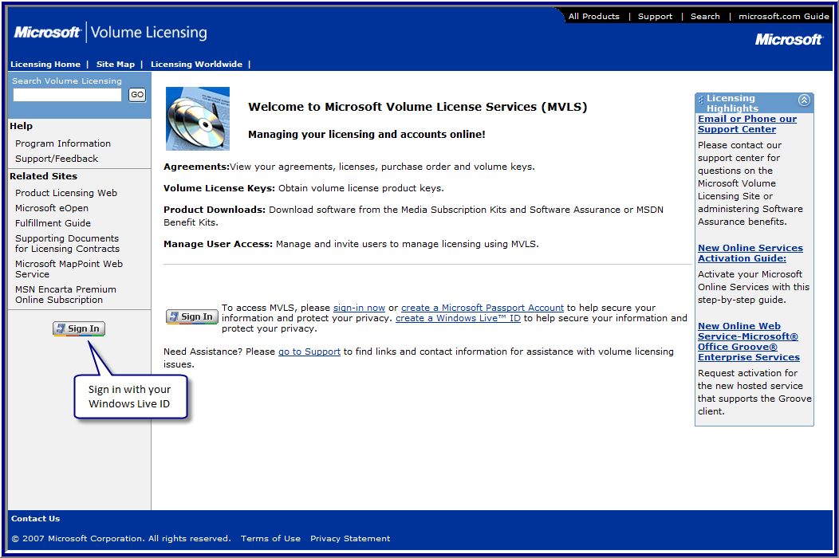

Sign in by using your Windows Live ID.
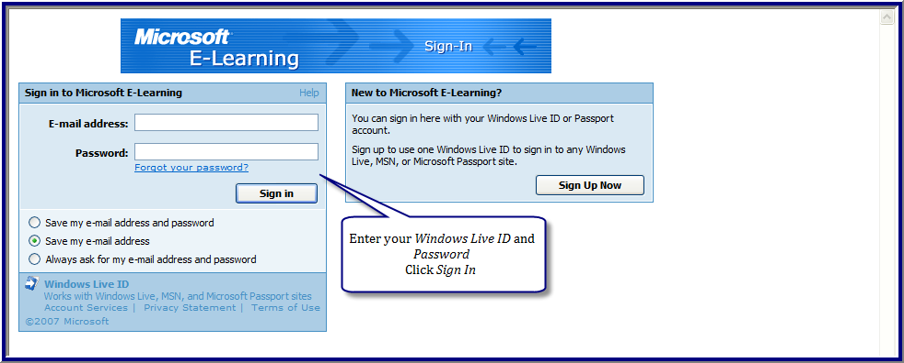
On the main MVLS menu, click Product Downloads.
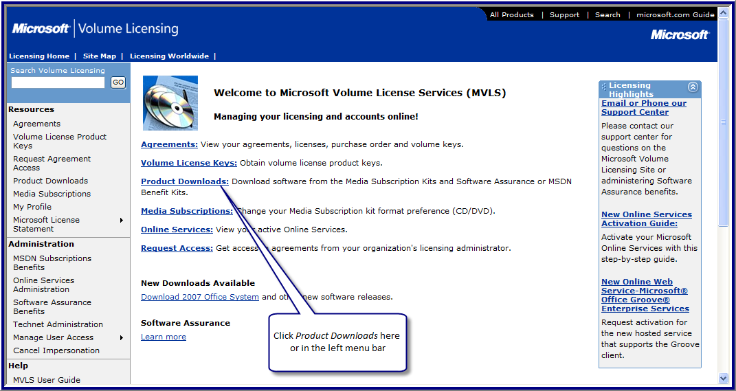

On the Software Downloads screen, scroll down to the Software Assurance section and select Office Applications (Content Only Application) or Windows Client (Content Only).
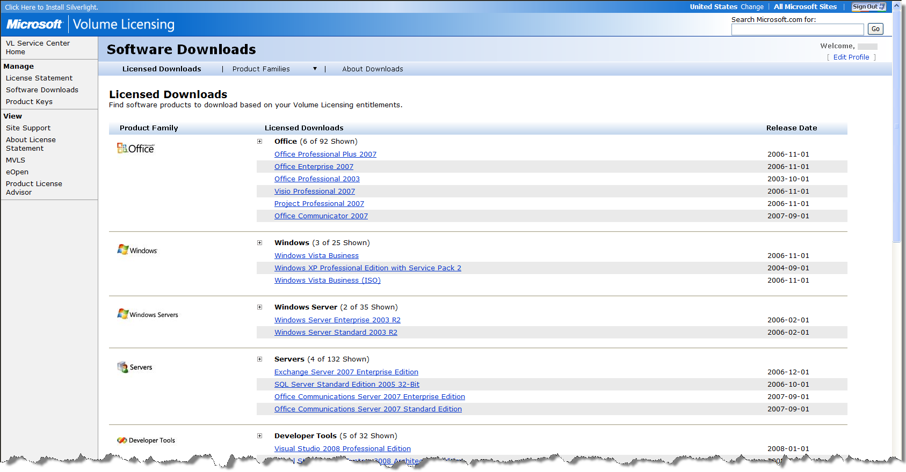
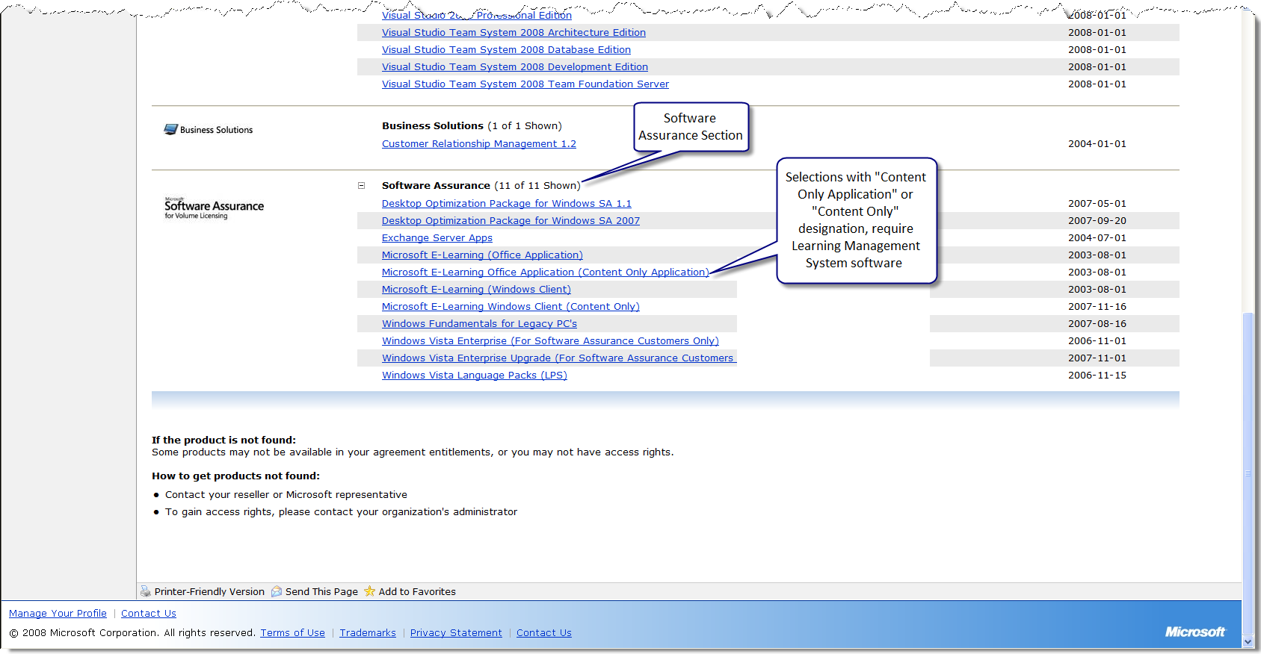

Select you language and connection speed, and then click Continue Download.
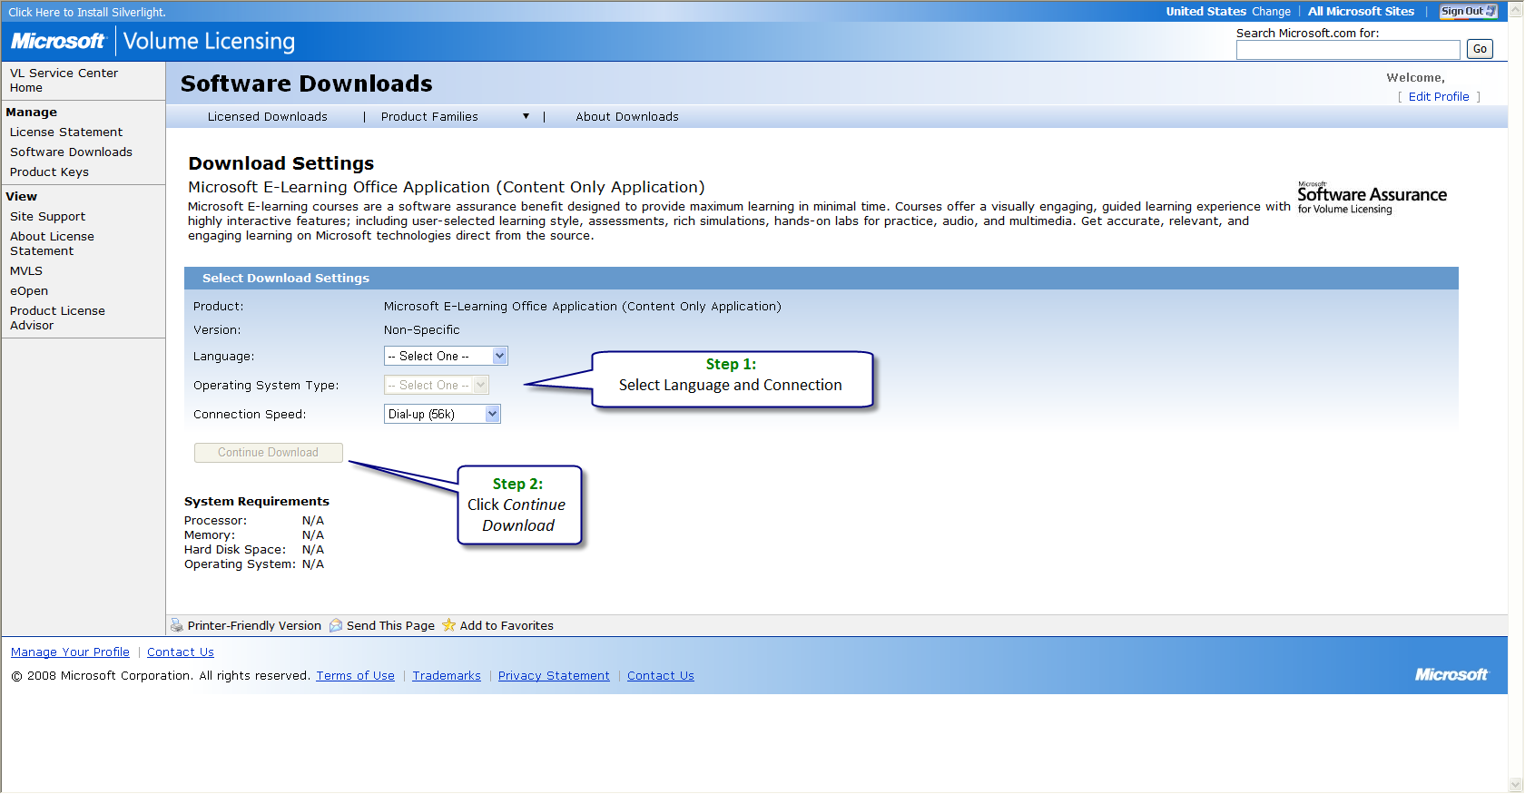

Click Download.
Note: The Download Manager will resume if interrupted. The Web browser download will need to begin again if interrupted.
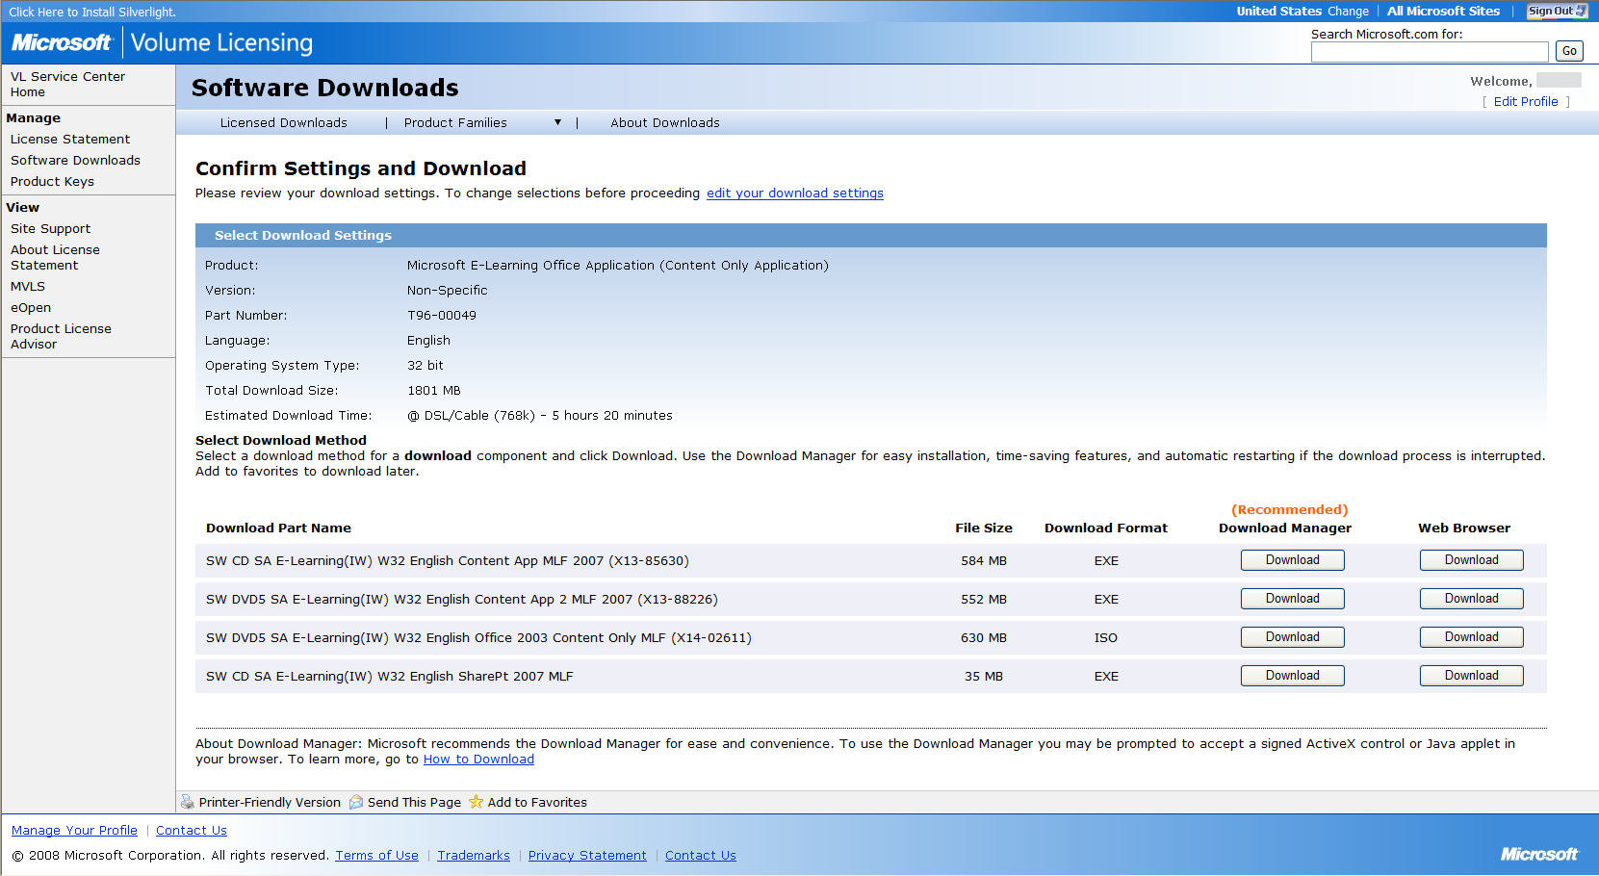

You may need to install an ActiveX control for the download process.
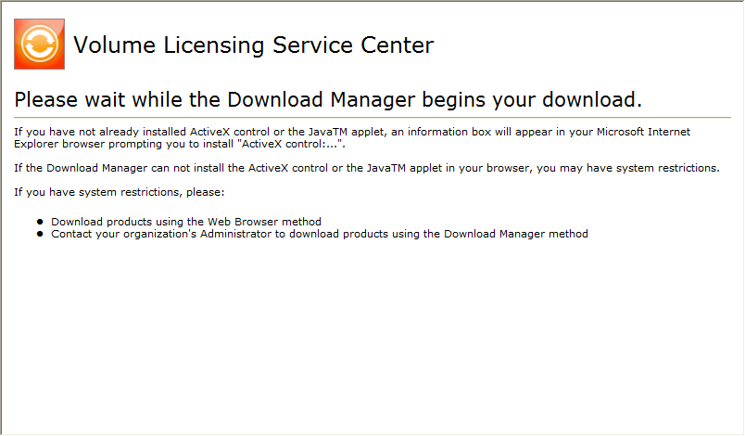

Browse to the folder where you want the download to be placed, and then click Save.
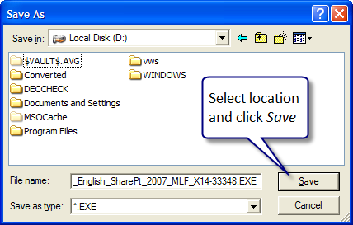

The Download Manager will display the file(s) that are being downloaded and progress.
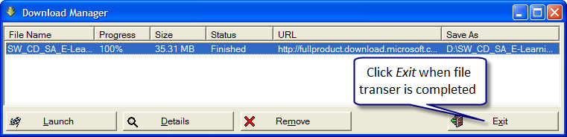
The downloaded CD or DVD contains zipped or iso files. Use the appropriate software to extract the files if needed.

Q. Does Microsoft provide support for my LMS?
A. Microsoft Learning recognizes that some customers have an internal Learning Management System (LMS) and prefer to host the Software Assurance E-Learning. With such a large number of LMSs available in the industry, Microsoft Learning is unable to provide support on loading these files into any specific LMS. If you are choosing to host the Software Assurance E-Learning, you should contact your LMS provider for support on loading these files.
Q. Does Microsoft offer an LMS?
A. No, although a community supported SharePoint Learning Kit (SLK), originally developed by Microsoft, is available at http://www.codeplex.com/SLK. This is a community-supported LMS. Microsoft does not provide support for the SLK.
Q. Does Microsoft have any suggestions for installing the SCORM content-only files into my LMS?
A. The following suggestions were identified during initial testing:
- Make sure the course manifest is saved with ANSI encoding.
- Open the course manifest, imsmanifest.xml, in Notepad. Choose Save As and then make sure that Save as type is All Files and that Encoding is ANSI.
- Without performing this step, the course packages will fail the conformance test; the log will display an error related to not being well-formed.
- This may be due to the Java-based XML parser used. Microsoft Learning releases all imsmanifest.xml files with UTF-8 encoding because UTF-8 encoding is required in cases where special characters are used that are represented within the ANSI character set, such as in the localized manifests.

Q. Will Microsoft provide any other guidance for using the SCORM content-only files in my LMS?
A. Currently Microsoft has an ongoing project to test the SCORM content-only files on several LMSs. Results from those tests will be posted to the Microsoft E-Learning Web site.

Appendix A: Download Title and Course Listing – MELL

SW CD SA E-Learning(IW) W32 English v 2.3 #1 MLF
(Office XP Professional, Office XP Standard, Advanced Training for Office XP, Deploying Office XP, Office XP Productivity, and What's New in Office XP Collections Disc 1)
- Advanced Training for Microsoft® Office XP
  - Advanced Training for Microsoft® Excel® 2002
  - Advanced Training for Microsoft® Outlook® 2002
  - Advanced Training for Microsoft® Word 2002
- Deploying Microsoft® Office XP
  - Deploying Microsoft® Office XP
- Microsoft® Office XP Productivity
  - Core Training for Microsoft® FrontPage® 2002
  - Core Training for Microsoft® Project 2002
  - Core Training for Microsoft® Visio® Standard 2002
- Microsoft® Office XP Professional
  - Core Training for Microsoft® Access 2002
  - Core Training for Microsoft® Excel 2002
  - Core Training for Microsoft® Outlook® 2002
  - Core Training for Microsoft® PowerPoint® 2002
  - Core Training for Microsoft® Word 2002
- Microsoft® Office XP Standard
  - Core Training for Microsoft® Office XP
- What's New in Microsoft® Office XP
  - What's New: Microsoft® Office 97 to Microsoft® Office XP
  - What's New: Microsoft® Office 2000 to Microsoft® Office XP

SW CD SA E-Learning (IW) W32 English v 2.3 #2 MLF
(Office 2000 Collection Disc 2)
- Microsoft Office 2000
  - Core Training for Microsoft® Access 2000
  - Core Training for Microsoft® Excel 2000
  - Core Training for Microsoft® FrontPage® 2000
  - Core Training for Microsoft® Outlook® 2000
  - Core Training for Microsoft® PowerPoint® 2000
  - Core Training for Microsoft® Word 2000

SW CD SA E-Learning (IW) W32 English v 2.4 MLF
(Microsoft® Office 2003 Collection (Upgrading to Microsoft® Office 2003 Collection))
- Microsoft Office Standard Edition 2003
  - Core Training for Microsoft® Office Excel 2003
  - Course 4104: Core Training for Microsoft® Office Outlook® 2003
  - Core Training for Microsoft® Office PowerPoint® 2003
  - Core Training for Microsoft® Office Word 2003

SW CD SA E-Learning (IW) W32 English v 2.5 MLF
(Advanced Training for Office 2003 & Communicate and Manage with Office 2003 Collections)
- Advanced Courses on Microsoft Office 2003
  - Advanced Training for Microsoft® Office Excel 2003
  - Course 4107: Advanced Training for Microsoft® Office Outlook® 2003
  - Advanced Training for Microsoft® Office Word 2003
- Communicate and Manage with Microsoft Office 2003
  - Core Training for Microsoft® Office Access 2003
  - Core Training for Microsoft® Office FrontPage® 2003
  - Core Training for Microsoft® Office Project 2003

SW CD SA E-Learning (IW) W32 English v 2.6 MLF
(Office System Collection)
- Microsoft Office System
  - Core Training for Microsoft® Office OneNote® 2003
  - Core Training for Microsoft® Office Visio® Standard 2003

SW CD SA E-Learning (IW) W32 English v 2.7 MLF
(Office InfoPath® 2003 & Windows® SharePoint® Services Collections)
- Microsoft® Office InfoPath® 2003
  - Designing Forms Using Microsoft® Office InfoPath® 2003
  - Working with Forms Using Microsoft® Office InfoPath® 2003
- Microsoft® Windows® SharePoint® Services
  - Getting Started with Microsoft® Windows® SharePoint® Services
  - Doing More with Microsoft® Windows® SharePoint® Services

SW CD SA E-Learning (Clnt) W32 English v 2.4 MLF
- Deploying Microsoft Windows 2000
  - Pre-Installing and Deploying Microsoft® Windows® 2000 Professional
- Deploying Microsoft Windows XP
  - Deploying Microsoft® Windows® XP Professional
  - Implementing and Supporting Microsoft® Windows® XP Professional
- Microsoft Windows
  - Core Training for Microsoft® Windows® 2000 Professional
  - Core Training for Microsoft® Windows® XP Professional
  - What's New: Microsoft® Windows® 2000 Professional to Windows XP Professional

SW CD SA E-Learning (Clnt) W32 English v 2.5 MLF
- Supporting Microsoft Windows 2000 Professional
  - Implementing Microsoft® Windows® 2000 Professional and Windows 2000 Server

SW CD SA E-Learning (Clnt) W32 English v 2.6 MLF
- Microsoft Windows XP SP2
  - Core Training for Microsoft® Windows® XP Professional Service Pack 2

SW CD SA E-Learning (Clnt) W32 English v 2.7 MLF
- Microsoft Windows SharePoint Services
  - Getting Started with Microsoft® Windows® SharePoint® Services
  - Doing More with Microsoft® Windows® SharePoint® Services

Appendix B: Download Title and Course Listing – SCORM

SW DVD5 SA E-Learning (IW) W32 English Office 2003 Content Only MLF
- 4110 Core Training for Microsoft® Office Professional Enterprise Edition 2003
- 4116 What's New in Microsoft® Office Professional Enterprise Edition 2003

- 4106 Core Training for Microsoft® Office Excel 2003
- 4104 Core Training for Microsoft® Office Outlook® 2003
- 4103 Core Training for Microsoft® Office PowerPoint® 2003
- 4105 Core Training for Microsoft® Office Word 2003

- 4101 Advanced Training for Microsoft® Office Excel 2003
- 4107 Advanced Training for Microsoft® Office Outlook® 2003
- 4102 Advanced Training for Microsoft® Office Word 2003

- 4100 Core Training for Microsoft® Office Access 2003
- 4108 Core Training for Microsoft® Office FrontPage® 2003
- 4111 Core Training for Microsoft® Office Project 2003

- 4109 Core Training for Microsoft® Office OneNote® 2003
- 4112 Core Training for Microsoft® Office Visio® Standard 2003

- 4113 Designing Forms Using Microsoft® Office InfoPath® 2003
- 4117 Working with Forms Using Microsoft® Office InfoPath® 2003

- 4114 Doing More with Microsoft® Windows® SharePoint® Services
- 4115 Getting Started with Microsoft® Windows® SharePoint® Services

SW DVD5 SA E-Learning (IW) W32 English Content App 2 MLF
- 5262 - What's New in Microsoft Office System 2007 Collection
  - 5443 - What’s New in Microsoft® Office Access™ 2007
  - 5444 - What’s New in Microsoft® Office Excel® 2007
  - 5445 - What’s New in Microsoft® Office InfoPath® 2007
  - 5446 - What’s New in Microsoft® Office OneNote® 2007
  - 5447 - What’s New in Microsoft® Office Outlook® 2007
  - 5448 - What’s New in Microsoft® Office PowerPoint® 2007
  - 5449 - What’s New in Microsoft® Office Word 2007
  - 5450 - What’s New in Microsoft® Office Visio® 2007

- 5263 - Core Training for Microsoft® Office Access 2007 Collection
  - 5451 - Getting Started with Microsoft® Office Access™ 2007
  - 5452 - Importing and Exporting Information in Microsoft® Office Access™ 2007
  - 5453 - Working with Forms in Microsoft® Office Access™ 2007
  - 5454 - Locating Specific Information in Microsoft® Office Access™ 2007
  - 5455 - Keeping Information Accurate and Secure in Microsoft® Office Access™ 2007
  - 5456 - Working with Reports in Microsoft® Office Access™ 2007

- 5264 - Core Training for Microsoft® Office Project 2007 Collection
  - 5457 - Getting Started with Microsoft® Office Project 20075458: Working with Resources with Microsoft® Office Project 2007
  - 5459 - Formatting and Printing Your Project Plan with Microsoft® Office Project 2007
  - 5460 - Tracking Progress on Tasks with Microsoft® Office Project 2007

- 5265 - Core Training for Microsoft® Visio® 2007 Collection
  - 5461 - Getting Started with Microsoft® Office Visio® 2007
  - 5462 - Working with Shapes and Connectors with Microsoft® Office Visio® 2007
  - 5463 - Creating Special Diagrams with Microsoft® Office Visio® 2007
  - 5464 - Visualizing Data in Diagrams with Microsoft® Office Visio® 2007

- 5267 - Core Training for Microsoft® OneNote® 2007 Collection
  - 5469 - Getting Started with Microsoft® Office OneNote 2007
  - 5470 - Taking Notes with Microsoft® Office OneNote 2007
  - 5471 - Performing Web-based Research using Microsoft® Office OneNote 2007
  - 5472 - Sharing Information with Other Users and Applications using Microsoft® Office OneNote 2007

- 5268 - Core Training for Microsoft® Office InfoPath® 2007 Collection
  - 5473 - Getting Started with Microsoft® Office InfoPath 2007
  - 5474 - Creating and Modifying Forms with Microsoft® Office InfoPath 2007
  - 5475 - Working with Data using Microsoft® Office InfoPath 2007
  - 5476 - Collaborating with Others using Microsoft® Office InfoPath 2007

SW CD SA E-Learning (IW) W32 English Content App MLF.X13-85630
- 5258 - Core Training for Microsoft® Office Word 2007 Collection
  - 5419 - Getting Started with Microsoft® Office Word 2007
  - 5420 - Editing and Proofreading Documents in Microsoft® Office Word 2007
  - 5421 - Formatting Documents in Microsoft® Office Word 2007
  - 5422 - Working with Columns and Tables in Microsoft® Office Word 2007
  - 5423 - Working with Graphical Elements in Microsoft® Office Word 2007
  - 5424 - Working with Longer Documents in Microsoft® Office Word 2007

- 5259 - Core Training for Microsoft® Excel® 2007 collection
  - 5425 - Getting Started with Microsoft® Office Excel® 2007
  - 5426 - Performing Calculations on Data in Microsoft® Office Excel® 2007
  - 5427 - Formatting and Printing Worksheets in Microsoft® Office Excel® 2007
  - 5428 - Filtering and Summarizing Data in Microsoft® Office Excel® 2007
  - 5429 - Working with Pivot Tables and Charts in Microsoft® Office Excel® 2007
  - 5430 - Collaborating with Others in Microsoft® Office Excel® 2007

- 5260 - Core Training for Microsoft® Office PowerPoint® 2007 collection
  - 5431 - Getting Started with Microsoft® Office PowerPoint® 2007
  - 5432 - Working with Slides in Microsoft® Office PowerPoint® 2007
  - 5433 - Working with the Slide Layout and Themes in Microsoft® Office PowerPoint® 2007
  - 5434 - Working with Tables, Charts, and Diagrams in Microsoft Office PowerPoint® 2007
  - 5435 - Enhancing the Slides with Multimedia Elements in Microsoft Office PowerPoint® 2007
  - 5436 - Printing, Reviewing, Sharing, and Delivering a Presentation in Microsoft Office PowerPoint® 2007

- 5261 - Core Training for Microsoft® Outlook® 2007 Collection
  - 5437 - Getting Started with Microsoft® Office Outlook® 2007
  - 5438 - Working with E-mail Messages in Microsoft® Office Outlook® 2007
  - 5439 - Managing Mail and Contact Information in Microsoft® Office Outlook® 2007
  - 5440 - Managing the Calendar in Microsoft® Office Outlook® 2007
  - 5441 - Working with Tasks and Notes in Microsoft® Office Outlook® 2007
  - 5442 - Sharing and Remotely Accessing Data in Microsoft® Office Outlook® 2007

- 4698 - Getting Started with Microsoft® Groove® 2007

SW CD SA E-Learning (IW) W32 English #1 SharePoint 2007 Content Only MLF
- 5266 - Core Training for Windows SharePoint Services 3.0 Collection
  - 5465 - Getting Started with Windows SharePoint Services 3.0
  - 5466 - Creating and Managing Windows SharePoint Services 3.0 Sites
  - 5467 - Team Collaboration with Windows SharePoint Services 3.0
  - 5468 - Using Windows SharePoint Services 3.0 with Microsoft Office System Applications

SW CD SA E-Learning (Clnt) W32 English Content Sys 2 MLF
- 5257 - Core Training for Windows Vista®
  - 5413 - Working with Programs in Windows Vista®
  - 5414 - Making Connections with Windows Vista®
  - 5415 - Working with Digital Media in Windows Vista®

SW CD SA E-Learning (Clnt) W32 English Content Sys
- 5257 - Core Training for Windows Vista Collection
  - 5407 - Getting Started with Windows Vista®
  - 5408 - Working Efficiently in Windows Vista®
  - 5409 - Working with Folders and Files in Windows Vista®
  - 5410 - Personalizing Windows Vista®
  - 5411 - Installing and Configuring Devices in Windows Vista®
  - 5412 - Using Windows® Internet Explorer® 7 in Windows Vista®

SW CD SA E-Learning (Clnt) W32 English XP Content Only MLF
- 4120 - Core Training for Microsoft® Windows® XP Professional
- 4119 - Core Training for Microsoft® Windows® XP Professional Service Pack 2
- 4114 - Doing More with Microsoft® Windows® SharePoint® Services
- 4115 - Getting Started with Microsoft® Windows® SharePoint® Services

General Q&A for Software Assurance Benefits Administrator: Microsoft E-Learning
These Q&As are the result of the support calls received by Microsoft. Additional Q&As will be added as needed.
Q. Why are some users from other divisions of our company unable to access to the Microsoft E-Learning?
A. Check the domains entered. Companies with sub-domains may need to add them if they are used in corporate e-mail addresses used for validation. For example, someone@example.com vs. someone@us.example.com.
Sign in to the MVLS Web site.
In the left navigation bar, click Software Assurance Benefits.
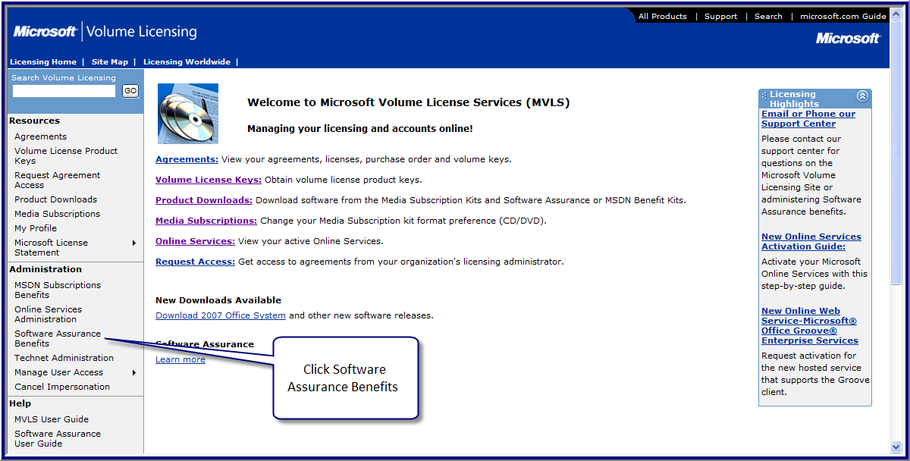

Select the agreement that you want to modify by clicking the agreement number.
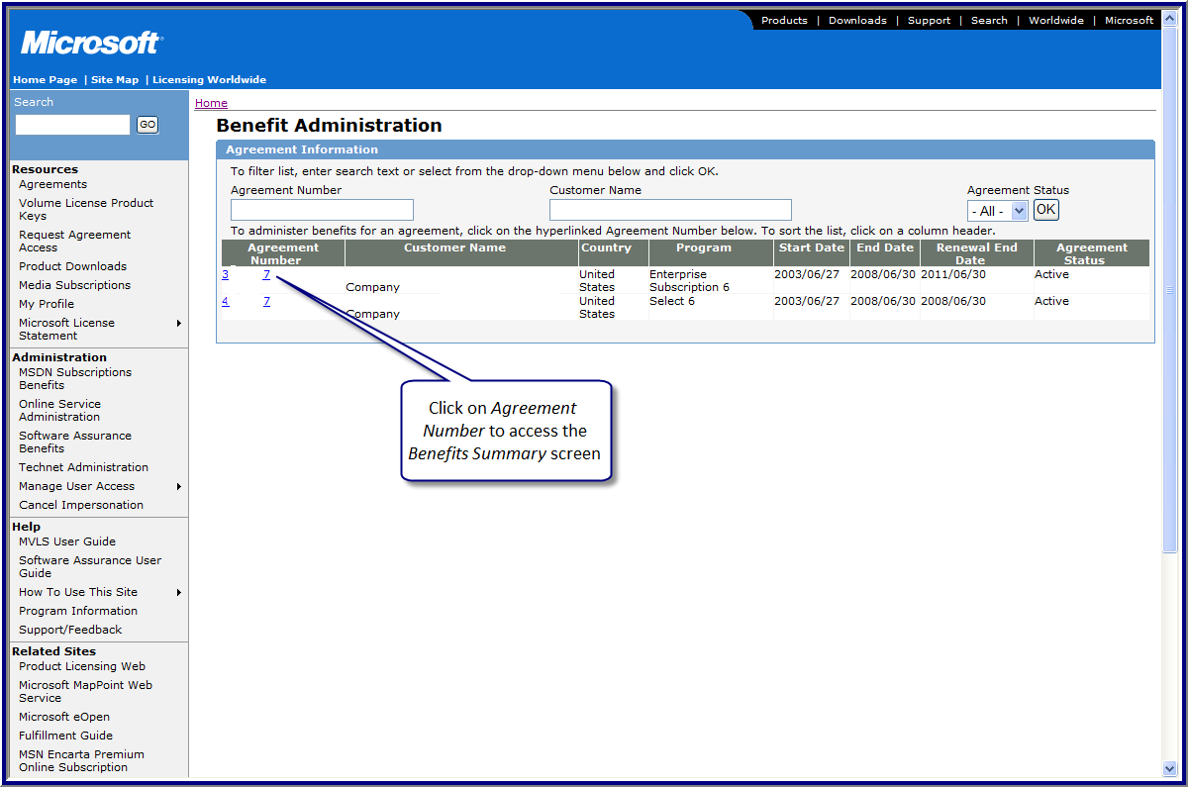

Select the pool that needs to be modified by clicking the pool name.
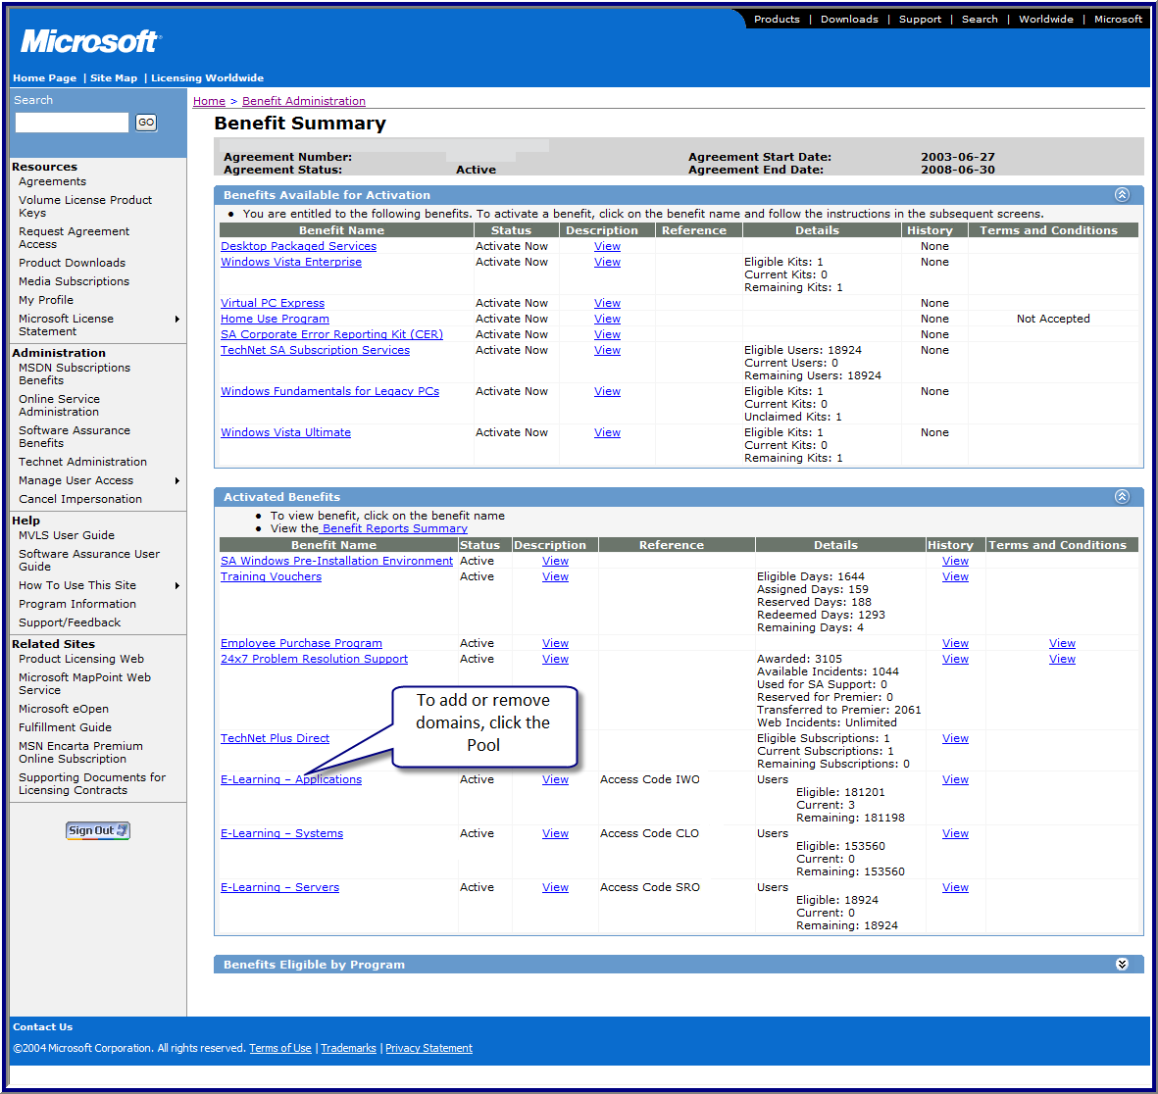

Enter the domain or sub-domains to be added. Then click Add.
You can also remove domains if they are no longer used.
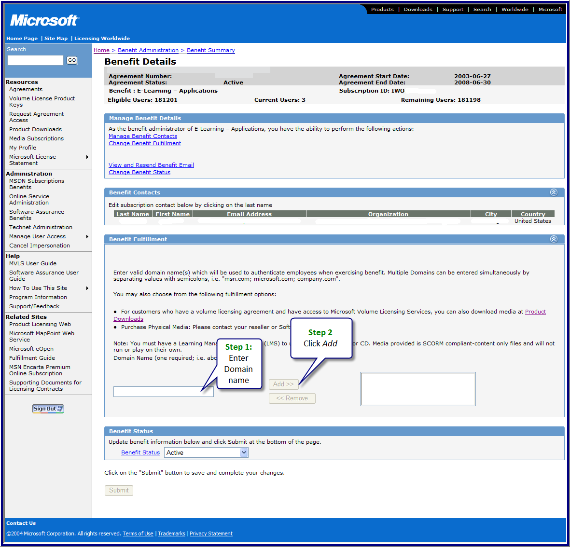

Q. If someone leaves the company can they still access their training?
A. Yes. There is no way to delete a user from access to the pool after they have used an access code.
Q. How long does a user have to complete the training?
A. Students can access the course 12 months from the first activation of the course. If the agreement expires, access to courses started prior to the agreement end date will continue to be available to the student for the full 12 months.

Q. My users receive a message that they are not authorized to use the site. How can I get them access?
A. The most common reason for this error is the registration process was not completed properly.
Check to see if the user received the confirmation e-mail message from Microsoft. Did the user click the link in the letter to complete the process? If the user still has the e-mail message, have him or her try clicking the link again. If that does not solve the problem or if the user does not have the e-mail message, call support at (866) 230-0560.
Q. Why did a user receive this error message?
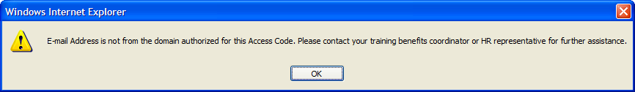
A. The domain of the user e-mail address does not match the domain name for the access code. Have the user check spelling. Make sure the domain the user is using is authorized for the access code.

This reference material is supplied as-is. Nothing in this document, expressed or implied,
modifies any agreements between you (the customer) and Microsoft.

Information in this document, including URL and other Internet Web site references, is subject to change without notice. Unless otherwise noted, the companies, organizations, products, domain names, e-mail addresses, logos, people, places, and events depicted in examples herein are fictitious. No association with any real company, organization, product, domain name, e-mail address, logo, person, place, or event is intended or should be inferred. Complying with all applicable copyright laws is the responsibility of the user. Without limiting the rights under copyright, no part of this document may be reproduced, stored in or introduced into a retrieval system, or transmitted in any form or by any means (electronic, mechanical, photocopying, recording, or otherwise), or for any purpose, without the express written permission of Microsoft Corporation. If, however, your only means of access is electronic, permission to print one copy is hereby granted.
Microsoft may have patents, patent applications, trademarks, copyrights, or other intellectual property rights covering subject matter in this document. Except as expressly provided in any written license agreement from Microsoft, the furnishing of this document does not give you any license to these patents, trademarks, copyrights, or other intellectual property.
©2008 Microsoft Corporation. All rights reserved.
Microsoft, Access, Excel, FrontPage, Groove, InfoPath, Internet Explorer, OneNote, Outlook, PowerPoint, SharePoint, Visio, Windows, and Windows Vista are trademarks of the Microsoft group of companies.
All other trademarks are property of their respective owners.

