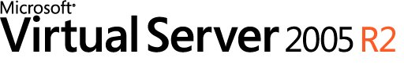

Microsoft Virtual Server 2005 R2 Reviewer's Guide

Microsoft Corporation
Published: November 2005

Abstract
Microsoft® Virtual Server 2005 R2 is a cost-effective and well-supported server virtualization technology for the Windows Server System™ platform. As a key part of any server consolidation strategy, Virtual Server increases hardware utilization and enables organizations to rapidly configure and deploy new servers. In conjunction with Windows Server™ 2003, it provides a virtualization platform that runs most major x86 operating systems in a guest environment, and is supported by Microsoft as a host for Windows Server operating systems and Windows Server System applications. Virtual Server 2005 R2’s comprehensive COM API, in combination with the Virtual Hard Disk (VHD) format and support for virtual networking, provide administrators complete scripted control of portable, connected virtual machines and enables easy automation of deployment, and ongoing change and configuration. Additionally, its integration with a wide variety of existing Microsoft and third-party management tools allows administrators to seamlessly manage a Virtual Server 2005 R2 environment with their existing physical server management tools. There are a wide variety of complementary product and service offerings available from Microsoft and a broad set of partners to help businesses plan for, deploy, and manage Virtual Server 2005 R2 in their environment. Due to its ability to increase server hardware utilization and enhance administrative productivity, Virtual Server 2005 R2 plays a key role in Microsoft’s Dynamic Systems Initiative (DSI)–an industry-wide effort to dramatically simplify and automate how businesses design, deploy, and operate IT systems.
This is a preliminary document and may be changed substantially prior to final commercial release of the software described herein.
The information contained in this document represents the current view of Microsoft Corporation on the issues discussed as of the date of publication. Because Microsoft must respond to changing market conditions, it should not be interpreted to be a commitment on the part of Microsoft, and Microsoft cannot guarantee the accuracy of any information presented after the date of publication.
This reviewer’s guide is for informational purposes only. MICROSOFT MAKES NO WARRANTIES, EXPRESS OR IMPLIED, AS TO THE INFORMATION IN THIS DOCUMENT.
Complying with all applicable copyright laws is the responsibility of the user. Without limiting the rights under copyright, no part of this document may be reproduced, stored in or introduced into a retrieval system, or transmitted in any form or by any means (electronic, mechanical, photocopying, recording, or otherwise), or for any purpose, without the express written permission of Microsoft Corporation.
Microsoft may have patents, patent applications, trademarks, copyrights, or other intellectual property rights covering subject matter in this document. Except as expressly provided in any written license agreement from Microsoft, the furnishing of this document does not give you any license to these patents, trademarks, copyrights, or other intellectual property.
© 2005 Microsoft Corporation. All rights reserved.
Microsoft, Active Directory, ActiveX, BackOffice, the BackOffice logo, the Microsoft Internet Explorer logo, MSDN, Visual Basic, Windows, the Windows logo, Windows NT, Windows Server, and Windows Server System are either registered trademarks or trademarks of Microsoft Corporation in the United States and/or other countries.
The names of actual companies and products mentioned herein may be the trademarks of their respective owners.

Contents

Figures v
Product Overview 1
Virtual Server 2005 R2 Maximizes Business Value 1
Consolidate infrastructure, application, and branch office server workloads 1
Consolidate and re-host legacy applications 2
Automate and consolidate software test and development environments 2
Disaster and recovery 3
Virtual Server 2005 R2 Primer 4
Virtual Machine Technology 5
Microsoft Virtual Server 2005 R2 Architecture 6
Microsoft Virtual Machine Technology Architecture 7
Virtual Network Architecture 8
Virtual Server 2005 R2 Technology Differentiators 9
Efficient use of hardware resources 9
Enhanced administrative productivity and responsiveness 9
Best-supported server virtualization solution 9
System Requirements 10
Getting Started with Virtual Server 2005 R2 11
Pre-install Tasks 11
Installation 12
Completing Installation 16
Managing and Using Microsoft Virtual Server 2005 R2 17
Easy to Manage 17
Managing Virtual Server 2005 R2 18
Managing Virtual Machines 19
Managing Virtual Networks 22
Operating Virtual Machines in Virtual Server 2005 R2 23
Technical Overview 25
Efficient use of hardware resources 25
Enhanced administrative productivity and responsiveness 28
Best-supported server virtualization solution 32
Feature Summary 33
More Information 33
Summary 34
Related Links 35

Figures

Figure 1. Virtual Server 2005 R2 architecture. 6
Figure 2. Virtual Server 2005 R2 virtual machine architecture. 7
Figure 3. Virtual Server 2005 R2 virtual network architecture. 8
Figure 4. IIS installation prior to installing Virtual Server 2005 R2. 11
Figure 5. Initial Virtual Server 2005 R2 setup screen. 12
Figure 6. Virtual Server 2005 R2 installation. License agreement. 13
Figure 7. Virtual Server 2005 R2 installation. Installation type. 13
Figure 8. Virtual Server 2005 R2 installation. Component configuration. 14
Figure 9. Virtual Server 2005 R2 installation. Firewall exception configuration. 15
Figure 10. Installation summary. 16
Figure 11. Virtual Server Administration Website user interface. Master Status page. 17
Figure 12. Virtual Server Administration Website user interface. Administration Website Properties page. 18
Figure 13. Virtual Server Administration Website user interface. Create Virtual Machine page. 19
Figure 14. Virtual Server Administration Website user interface. Virtual machine configuration page. 20
Figure 15. Virtual Server Administration Website user interface. Differencing Virtual Hard Disk configuration page. 21
Figure 16. Virtual Server Administration Website user interface. Virtual network configuration page. 22
Figure 17. VMRC remote control stand-alone client. 23
Figure 18. VMRC browser-based remote control. 24

Product Overview
Customers across all industries and segments are looking for ways to reduce cost and risk while increasing quality and agility in their IT infrastructure. Frequently these benefits can be realized in-part through server consolidation of infrastructure, application, and branch office server workloads, to re-host legacy applications, and to help provision software test and development environments, in addition to contributing to disaster and recovery plans. Virtualization is a key enabling technology to achieving business benefits through these means. Improvements in software technology and in hardware architecture and I/O have enabled virtual machine technology to operate effectively on lower cost server systems.
Microsoft® Virtual Server 2005 R2 hosted on the Microsoft Windows Server™ 2003 operating system delivers the performance necessary to carry out consolidation, migration and isolation tasks through virtualization technology in an enterprise-ready computing environment with advanced levels of scalability, manageability and reliability.
Microsoft Virtual Server 2005 R2 is the most cost-effective virtual machine solution designed for Windows Server 2003 to improve operational efficiency in software test and development, legacy line of business application migration, and server consolidation scenarios.

Virtual Server 2005 R2 Maximizes Business Value
Microsoft Virtual Server 2005 R2 is a cost-effective and well supported server virtualization technology for the Windows Server System™ platform. As a key part of any server consolidation strategy, Virtual Server increases hardware utilization and enables organizations to rapidly configure and deploy new servers with the following key benefits:
- Efficient use of hardware resources: Virtual Server 2005 R2 is production quality. Virtual machine isolation and resource management enable multiple workloads—including production workloads—to coexist on fewer servers, allowing organizations to make more efficient use of their hardware resources. Virtual Server 2005 works with Windows Server 2003 to provide broad interoperability with existing storage, network and security infrastructures.
- Enhanced administrative productivity and responsiveness: Virtual Server 2005 R2 enables IT organizations to enhance their administrative productivity and rapidly deploy new servers to address changing business needs. Features such as the comprehensive COM API in Virtual Server 2005 and network booting (PXE booting) for virtual machines enable automated deployment and configuration of connected virtual machines that are easily administered with standard server management tools.
- Best-supported server virtualization solution: Virtual Server 2005 R2 is extensively tested and supported by Microsoft in conjunction with its server operating systems and applications. Hence Virtual Server 2005 R2 is a well-supported virtualization solution both within Microsoft and across the broader ISV community.
Four key scenarios for organizations and server administrators point to the ways in which Microsoft Virtual Server 2005 R2 leverages these advantages and delivers maximally on improving hardware efficiency and increasing administrator productivity.

Consolidate infrastructure, application, and branch office server workloads
Virtual Server 2005 R2 is ideal for server consolidation in both the datacenter and the branch office, allowing organizations to make more efficient use of their hardware resources.
It also allows IT organizations to enhance their administrative productivity and rapidly deploy new servers to address changing business needs.
Server consolidation reduces the amount of server hardware under management for an optimized IT infrastructure. Microsoft recommends consolidation by workload. (A table showing recommended approaches appears in the appendix.)
Virtual Server 2005 R2 is the recommended approach for server consolidation of infrastructure services and department or branch office services—especially for server-based applications on industry-standard hardware. Virtual Server 2005 R2 accomplishes this by allowing multiple applications and services on disparate operating systems to coexist on the same hardware, thus increasing hardware utilization and manageability while reducing capital and recurring costs related to hardware and hosting.
Ultimately, fewer physical systems are required, which reduces the enterprise hardware footprint. Microsoft Virtual Server 2005 R2 offers a highly compelling price/performance virtual machine solution for increased application compatibility, manageability and resource utilization on the Windows Server 2003 platform.

Consolidate and re-host legacy applications
Virtual Server 2005 R2 enables re-hosting of legacy operating systems and their associated custom applications from older hardware to new hardware running Windows Server 2003.
As IT infrastructure enables increasingly powerful and reliable solutions, an ongoing challenge for many businesses is the management and maintenance of existing legacy server-based applications. Business applications often outlive their original operating system or hardware, and as support for these primary infrastructural elements diminishes over time, cost of ownership steadily increases. Under ideal conditions, customers would prefer to continue running business applications unchanged, but three factors increase the urgency of legacy application migration:
- Extensive resource demands required to administer and maintain server hardware for individual legacy applications;
- High cost and risk to upgrade or rewrite legacy applications for increased quality and agility; and,
- Diminishing hardware support for legacy operating systems.
Customers need a solution to enable legacy or orphaned applications, such as those written for Windows NT® Server 4.0 or Windows® 2000 Server, to run on new hardware and software platforms. Many organizations find, for example, that the ISV who installed their application years ago may not be in business. Customers have called for a solution that assures smooth application migration while delivering solid application compatibility. Virtual Server 2005 R2 delivers the best of both worlds: application compatibility with legacy environments, while taking advantage of the reliability, manageability and security features of Windows Server 2003. Virtual Server 2005 R2 delivers this capability by enabling customers to run legacy applications in their native software environment in virtual machines, without rewriting application logic, reconfiguring networks or retraining end users. This gives customers time to refresh out-of-warranty infrastructure systems first, then either upgrade or rewrite out-of-service applications on a timetable that best fits their business needs. Virtual Server 2005 R2 enables better customer choice for legacy application migration with outstanding application compatibility.

Automate and consolidate software test and development environments
Virtual Server 2005 R2 enables businesses to consolidate their test and development server farm and automate the provisioning of virtual machines.
Customers across all segments are looking for ways to decrease costs and accelerate application and infrastructure installations and upgrades, while delivering a comprehensive level of quality assurance. In order to achieve testing coverage goals prior to going into production, multiple challenges must be overcome:
- Network operations: Incorrect configuration of a test network could endanger production networks.
- Developer productivity: Developer productivity is wasted on time-consuming administrative tasks.
- Server operational and capital costs: High-quality application test coverage requires replicating production computing environments, which requires costly hardware and human resources posing risk to budgets and schedules.
Virtual machine technology was developed over a quarter century ago to address these same challenges first encountered during the mainframe era, enabling side-by-side testing and production partitions on the same system. For x86-based servers, Virtual Server 2005 R2 enables better test coverage, developer productivity and user experience.
Developers can also leverage Virtual Server 2005 R2 as an efficient tool to simulate distributed applications on a single physical server. Deployment and testing of distributed server applications typically requires quantities of available hardware resources and considerable amounts of time to configure the hardware and software systems in a lab environment to simulate a desired scenario.
Virtual Server 2005 R2 is a potent time and resource-saving solution that optimizes hardware and human resource utilization in distributed server application development scenarios. Virtual Server 2005 R2 enables individual developers to easily deploy and test a distributed server application using multiple virtual machines on one physical server. Marrying the robust features in Virtual Server 2005 R2, like disk hierarchy and virtual networking, with the value of machine consolidation gives developers a powerful and efficient way to simulate complex network environments. The result is a development environment solution that is supremely time and cost effective as less hardware, less real estate and less time are required for build-out.

Disaster and recovery
Virtual Server 2005 R2 can be used as part of a disaster and recovery plan that requires application portability and flexibility across hardware platforms. Consolidating physical servers onto fewer physical machines running virtual machines decreases the number of physical assets that can be damaged or compromised in a disaster. In the event of recovery, virtual machines can be hosted anywhere, on host machines other than those affected by a disaster, speeding up recovery times and maximizing organization flexibility.

Virtual Server 2005 R2 Primer
Virtual Server 2005 R2 delivers virtualization technology as a server on the award winning Windows Server 2003 platform. Virtual Server 2005 R2 addresses customer demand for an application migration solution based on virtualization and supported by Microsoft.
A server is normally limited to running one operating system at a time. A conventional computer configuration matches one hardware unit with one operating system and the applications designed for that operating system. The hardware includes the mouse and keyboard, processor, memory, disk drives and drive controllers, video and network cards, and other physical devices. The operating system runs on and controls the hardware. Applications run on the operating system.
In contrast, the virtual machine technologies built into Virtual Server 2005 R2 enable one server to run an array of operating systems and related applications simultaneously. A virtual machine uses software and selected hardware devices to create a simulated environment.
Some advantages of Virtual Server 2005 R2 include:
- Broad x86 guest operating system compatibility. Virtual Server 2005 R2 runs most major x86 operating systems in the virtual machine guest environment. Thus almost any 32-bit physical server can be run virtually on Virtual Server 2005 R2. This provides customers with the best of both worlds: the ability to keep running their customized legacy servers on their choice of physical machines.
Moreover, Virtual Server 2005 R2 takes advantage of the broad hardware support already in place for the Windows Server 2003 operating system. The list of devices that have passed testing with Windows Server is known as the Hardware Compatibility List (HCL); it consists of thousands of servers and peripherals, and it is frequently updated with new releases. Customers thus have tremendous flexibility in deciding how to migrate or consolidate applications while at the same time being assured that investments in Virtual Server 2005 R2 will not become obsolete because of limited hardware support in the future.
- Membership in an integrated stack. Virtual Server 2005 R2 is a fully integrated component of a comprehensive solution stack. Microsoft fully tests the entire stack top-to-bottom ensuring that all layers work together cohesively. The testing extends to Windows operating systems running as virtual machines in Virtual Server 2005 R2.
Comprehensive testing results in reliable, predictable performance. Customers save time and decrease administrative burden by using a comprehensive solution that is designed, tested and optimized to work together.
- Standards-based management. Virtual Server 2005 R2 makes use of industry-standard technologies like Hypertext Transfer Protocol (HTTP), RDP (terminal services), Extensible Markup Language (XML) and Performance Monitoring (PerfMon) to handle common management tasks. Virtual machine configurations are stored in XML files, and server monitoring and configuration is done through an HTTP/HTML interface. It is easy to integrate the management of the virtualization solution into any enterprise management toolset used in an IT organization.
What is more, Virtual Server 2005 R2 uses existing management tools. Microsoft server management tools function seamlessly across physical and virtual machines. A broad set of existing management tools means no additional tools are required for managing virtual machines in the Virtual Server 2005 R2 environment. Additionally, since the same tools are utilized across physical and virtual machines, companies can continue to leverage existing partners and the extensive partner support for Microsoft management tools.
- Extensibility. Virtual Server 2005 R2 supports a full-featured Component Object Model (COM) Application Programming Interface (API) that contains 42 interfaces and hundreds of calls, allowing scripts to control nearly every aspect of the product. Because the scripting model is based on COM, users are not tied to a specific scripting language, but can choose between Visual Basic®, C#, Perl and many other modern development languages. Furthermore, scripts can be “triggered” by certain events within Virtual Server 2005 R2. Customers benefit from greater ease of customization and automation using the Virtual Server 2005 R2 COM API.
- Less training. Because Virtual Server 2005 R2 is a Windows-based solution, the operating system is already familiar to administrators, and little additional training is required to implement the virtualization solution. This results in lower cost, better returns and faster deployment for the IT organization.
- Active Directory Integration. Active Directory® directory service allows the same directory management features for virtual machines as are provided for physical machines by using a centralized repository for hierarchical information about users and computers on the network. Active Directory incorporates significant improvements in management and performance in Windows Server 2003 which can be leveraged through virtual machines hosted by Virtual Server 2005 R2.
- Security. Windows Server 2003 brings enhanced protection against the dangers of malicious and poorly designed code. The Common Language Runtime (CLR) tracks code and checks for errors at runtime that may compromise the security and dependability of your network. Applications written using the .NET Framework make use of common code libraries, reducing the danger that your network will be compromised by poor developer practices. The COM API in Virtual Server 2005 R2 uses the .NET Framework, bringing the same benefits to Virtual Server 2005 R2.

Virtual Machine Technology
Modern industry-standard computers consist of multiple layers of hardware and software that operate together as a system. Hardware resources typically include a central processor, display, storage, networking, peripheral devices, and so forth. Operating system components (device drivers) control hardware resources, which translate operating system instructions into the specific device control language. Drivers are developed with an assumption of exclusive device ownership. For example, it is assumed that a video driver owns the video adapter exclusively. Any software application that calls the video adapter must interact with the hardware via the video driver. When assumptions about exclusive device ownership are broken, systems typically fail to function properly.
The concept of exclusive device ownership typically precludes the possibility of running more than one operating system concurrently on a computer. Virtual machine technology is one approach to overcoming this limitation. Virtualization involves redirecting interactions with device resources at lower levels in such a way that higher-level application layers are unaffected. In this way, Microsoft Virtual Server 2005 R2 enables customers to run multiple operating systems concurrently on a single physical system.

Microsoft Virtual Server 2005 R2 Architecture
Virtual Server 2005 R2 is a multithreaded application that runs as a system service, with each virtual machine running in its own thread of execution; I/O (input/output) occurs in child threads. Virtual Server 2005 R2 derives two core functions from the host operating system: 1) the underlying host operating system kernel schedules CPU resources, and 2) device drivers of the host operating system provide access to system devices. The Virtual Server 2005 R2 Virtual Machine Monitor (VMM) provides the software infrastructure to create virtual machines, manage instances, and interact with guest operating systems.
A description of the hardware that Virtual Server 2005 R2 emulates is contained in the Technical Overview below.
Figure 1 illustrates the Virtual Server 2005 R2 architecture.

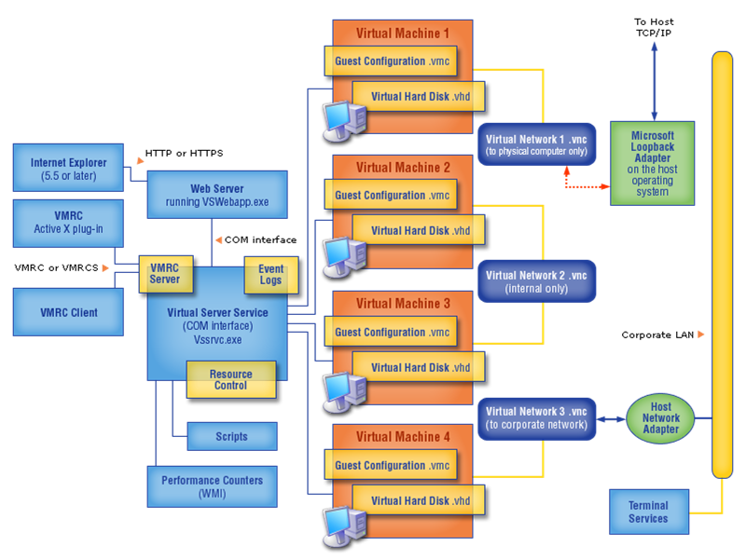
Figure 1. Virtual Server 2005 R2 architecture.

Microsoft Virtual Machine Technology Architecture
Figure 2 illustrates the architecture of Microsoft's virtual machine technology. Starting from the bottom of the logical stack, the host operating system—Windows Server 2003—manages the host system. Virtual Server 2005 R2 provides a Virtual Machine Monitor virtualization layer that manages virtual machines, providing the software infrastructure for hardware emulation. Each virtual machine consists of a set of virtualized devices. Finally, guest operating system and applications run in the virtual machine—unaware, for example, that the network interface card (NIC) that it interacts with via Virtual Server 2005 R2 is only a software simulation of a physical Ethernet device. When a guest operating system is running, the special-purpose Virtual Machine Monitor kernel takes mediated control over the CPU and hardware during virtual machine operations, creating an isolated environment in which guest operating system and applications run close to the hardware at the highest possible performance.

virtual machine operating system and applications
virtual machine operating system and applications

x86 or x64 Server
Windows Server 2003 (32-bit or 64-bit)
Virtual Server 2005 R2
Virtual Hardware
Virtual Hardware
Figure 2. Virtual Server 2005 R2 virtual machine architecture.

Virtual Network Architecture
During installation, the virtual network service driver is installed on the host operating system at a low level, just above the hardware network driver. The virtual network service driver determines the routing of network packages, sending them to the host operating system or to a guest operating system.
The host operating system can read, monitor or capture the network traffic of guest virtual machines running on it. Also, virtual machines configured for external network only cannot read, monitor or capture the network traffic of other virtual machines.
The following figure depicts virtual network architecture in Virtual Server 2005 R2.

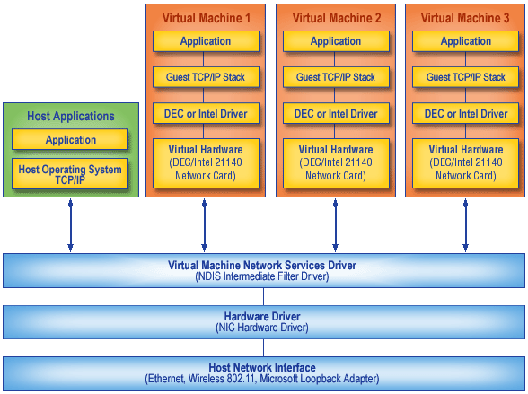
Figure 3. Virtual Server 2005 R2 virtual network architecture.

Because the virtual network driver is installed below the Network Load Balancing driver in the network stack, Network Load Balancing is not available with Virtual Server 2005 R2.

Virtual Server 2005 R2 Technology Differentiators
Virtual Server 2005 R2 is differentiated from other similar technologies by improved hardware efficiency, increased administrator productivity, and by being the best supported virtualization solution.

Efficient use of hardware resources
Customers can leverage existing investments in infrastructure as Virtual Server 2005 R2 takes advantage of the broad device compatibility for Windows Server 2003. Complete support for Windows Server environments coupled with policy-based control for balanced workload management facilitate more efficient use of hardware. Virtualization and resource management enable multiple workloads to coexist on fewer servers.
Virtual Server 2005 R2 is production quality and can be used to host production server workloads. Moreover, because virtual machines running on Virtual Server 2005 R2 are isolated, virtual machines are prevented from accessing the resources or data owned by other virtual machines or the host server. This allows a virtual machine and the host system to continue running even if another virtual machine encounters a software failure. The result is robustness and resiliency, meaning that customers can run even unstable applications in a stable, security enhanced environment. Additionally, the industry-standard device models in Virtual Server 2005 R2 help customers to achieve unrivaled application compatibility with Virtual Server 2005 R2. This allows customers to leverage existing storage, network and security infrastructures with minimal disruption, maximizing hardware efficiency.

Enhanced administrative productivity and responsiveness
Virtual Server 2005 R2 includes a rich scripting API for powerful extensibility and automation with a powerful event model to automate the configuration, management and integration of virtual machines in customer environments. The scripting API includes 42 interfaces with hundreds of calls, enabling developers and administrators to reduce operational costs through enhanced manageability and automation.
Virtual Server 2005 R2 supports PXE boot, allowing network administrators to provision their virtual servers the same way that they provision their physical servers. This opens the way to greater administration automation and efficiency.
Decoupling applications from hardware through encapsulation simplifies capacity planning, deployment and management practices. Encapsulation packages data and processing within a single object. In the case of virtual machines, this facilitates the ability to package a virtual machine into a single file, a Virtual Hard Disk, which can be moved between host systems running Virtual Server 2005 R2.

Best-supported server virtualization solution
Microsoft Virtual Server 2005 R2 is a well supported virtualization solution both within Microsoft and across the broader ISV community. Virtual machines utilize the qualified device drivers in the Windows host operating system, ensuring robust and stable device support and broad device compatibility. Microsoft extensively tests Virtual Server in conjunction with Windows Server 2003 and Windows 2000 Server. In addition, the Windows Server System Common Engineering Criteria require that all server products will support Virtual Server 2005 and must be capable of running on a virtual machine.
ISVs and customers are able to integrate with Virtual Server 2005 R2 for enhanced functionality and manageability. This is accomplished through the comprehensive COM management interfaces published by Microsoft and utilized by management tool vendors. Microsoft’s VHD file format is now available under royalty-free license, allowing ISVs such as security and management vendors to natively interoperate with Virtual Server 2005 R2.

System Requirements
Microsoft Virtual Server 2005 R2 System Requirements
Minimum CPU Speed | 550 MHz
Number of Processors | Standard Edition: Supports 1 to 4 physical processors  Enterprise Edition: Supports up to 32 physical processors.
Recommended CPU Speed | 1.0 GHz or faster
Processor Information | Intel Pentium III, Pentium 4, Celeron, or Xeon families  AMD Athlon, Athlon 64, Athlon X2, Opteron, Sempron, or Duron families
Supported Host Operating Systems | - Microsoft Windows Server 2003 Standard Edition, Enterprise Edition, or Datacenter Edition;  - Windows Server 2003 Standard Edition Service Pack 1, Enterprise Edition Service Pack 1  - Windows Server 2003 Standard x64 Edition, Enterprise x64 Edition;  - Windows XP Professional Service Pack 2, Professional x64 Edition (for non-production use);  - Windows Small Business Server 2003 Standard Edition or Premium Edition
Minimum RAM | 256 MB  (512 MB RAM required for Windows Small Business Server 2003, Premium Edition and for Windows Server 2003, Datacenter Edition)  (guest operating systems require additional memory)
Required Available Hard-disk Space | 2 GB  (4 GB minimum disk space required for Windows Small Business Server 2003, Standard Edition and Windows Small Business Server 2003, Premium Edition)  (guest operating systems require additional disk space)
Recommended Monitor | Super VGA (800x600) or higher-resolution monitor
Required Peripheral Devices | Keyboard and Microsoft Mouse or compatible pointing device, or hardware that supports console redirection required

Getting Started with Virtual Server 2005 R2
This section provides a walk-through of the screens that appear during the setup of Virtual Server 2005 R2. Setup and installation of Virtual Server 2005 R2 is a straight-forward task that requires minimal pre-configuration of the server operating system. The default installation is seven simple steps.
Note: Microsoft Virtual Server can be configured so that the Virtual Server service and the Administration Web site, with its corresponding installation of IIS, are on different computers. You may want to install the Administration Web site on a different physical computer if you want to have multiple physical computers running Virtual Server, but only one IIS server, or if you want to dedicate a physical computer to running only the Virtual Server service. This might be for performance or security considerations. For review purposes, these installation steps detail installing a full installation of Virtual Server on a single server.

Pre-install Tasks
Prior to installation of Virtual Server 2005 R2, the host server must be configured as an application server, which installs Internet Information Services 6.0 (IIS).

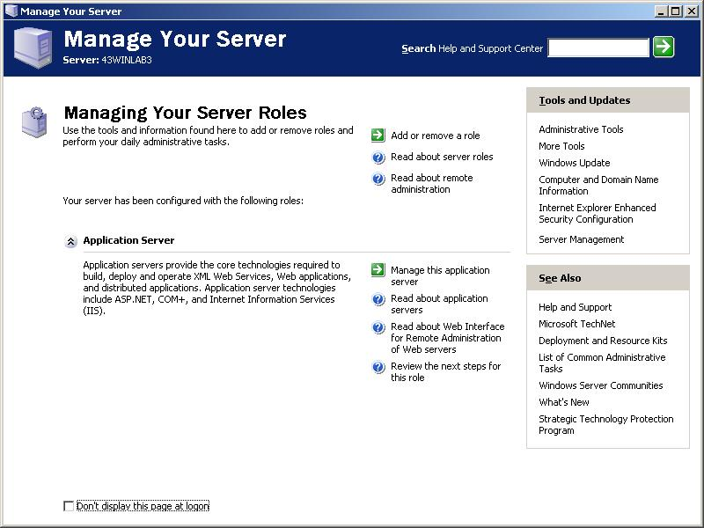
Figure 4. IIS installation prior to installing Virtual Server 2005 R2.

Installation
Like many applications, installation of Virtual Server 2005 R2 begins with a comfortable, understandable interface. The following image shows the start of this installation process, as it appears to the customer.

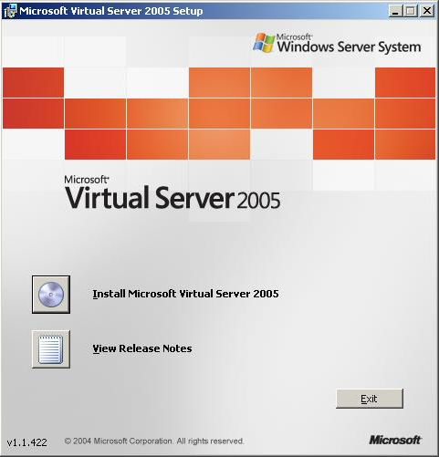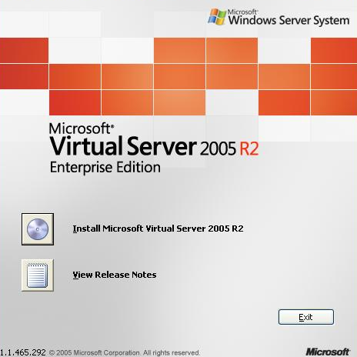
Figure 5. Initial Virtual Server 2005 R2 setup screen.

After choosing to install Virtual Server 2005 R2 a licensing agreement (Figure 6) is presented for acceptance. The install proceeds in an expected way with acceptance of the license agreement followed by entry of customer information and a 25-character product key and setup options (Figure 7).
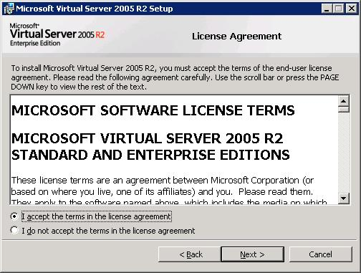
Figure 6. Virtual Server 2005 R2 installation. License agreement.

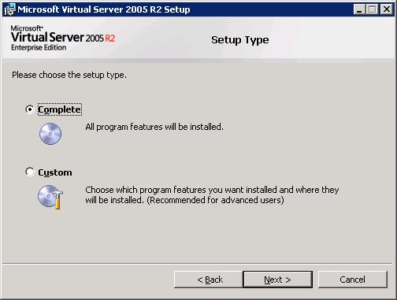
Figure 7. Virtual Server 2005 R2 installation. Installation type.

A complete setup is appropriate for most all instances of Virtual Server 2005 R2. Choosing a custom setup allows the customer to opt to install any of the following components:
- Virtual Server Service
- Documentation and Developer Resources
- Virtual Machine Remote Control Client
- Virtual Server Web Application
Note: Microsoft Virtual Server can be configured so that the Virtual Server service and the Administration Web site, with its corresponding installation of IIS, are on different computers. You may want to install the Administration Web site on a different physical computer if you want to have multiple physical computers running Virtual Server, but only one IIS server, or if you want to dedicate a physical computer to running only the Virtual Server service. This might be for performance or security considerations. For review purposes, these installation steps detail installing a full installation of Virtual Server on a single server.
The Virtual Server Service and Virtual Server Web Application are required to run and manage Virtual Server 2005 R2. The Virtual Machine Remote Control Desktop Client is also an important component as it is the medium through which customers access a virtual machine’s interface outside the Virtual Server Administration Website. The documentation and developer resources only require a small amount of additional space (approximately 1M) and contain valuable information, even for usage scenarios where no custom development is anticipated.
The screen shown in Figure 8 (below) is a required pre-configuration of the Web server. Completion of this step facilitates access to the management features. In particular, it properly configures IIS for the browser-based Virtual Server Administration Website.

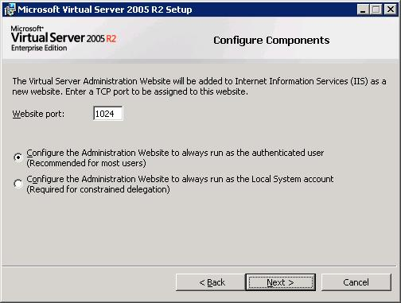
Figure 8. Virtual Server 2005 R2 installation. Component configuration.
The installation wizard will also ask you whether or not you wish to configure Windows Firewall to allow remote access of Virtual Server (Figure 9). Note: this setup step will configure remote access through a firewall only if you are using Windows Firewall; if you are using a different firewall product, you will need to consult the Virtual Server Administrator’s guide for remote access configuration guidance.

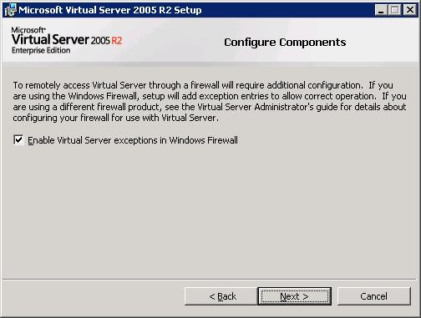
Figure 9. Virtual Server 2005 R2 installation. Firewall exception configuration.
The final steps confirm the installation location, and then progress is shown during the installation process. Any issues encountered during installation stop and roll back installation tasks. Like all standard installations, you receive confirmation upon completion that installation was successful.

Completing Installation
Following completion of install, an Installation Summary page opens in Internet Explorer giving you quick reference to essential information to get started with Virtual Server 2005 R2, including locations to immediately access Virtual Server 2005 R2 management and documentation.
After installation, this page is accessible at any time from the Virtual Server options in the Start menu.

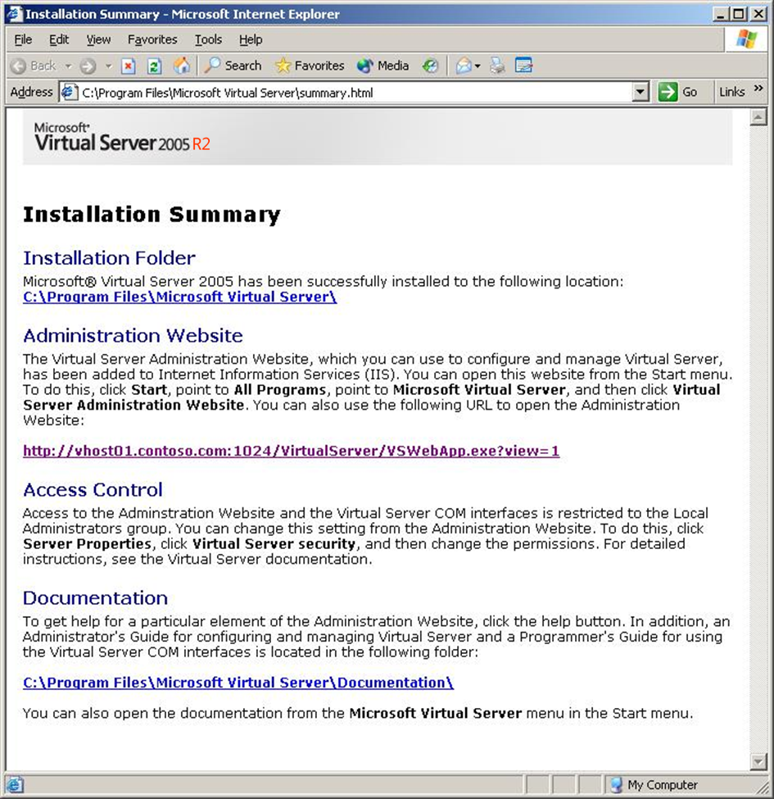
Figure 10. Installation summary.

Managing and Using Microsoft Virtual Server 2005 R2
Simple, easy to use management interfaces are one part of the value of Microsoft Virtual Server 2005 R2. The following screen images show some of the management and configuration interfaces.

Easy to Manage
Management of Virtual Server 2005 R2 and of the running virtual machines is accomplished through the Virtual Server Administration Website. The Master Status page shows the various options for management alongside the virtual machines that are configured. A remote view thumbnail image of running virtual machines provides administrators with a glimpse of the state of the server. Opposite the remote view is a graphical depiction of CPU usage. The page also includes status descriptions of the virtual machine—showing whether machines are running, stopped, stopping, or saved. Finally, at the bottom of the page, an event log describes recent events. Events are also recorded in the host event log.
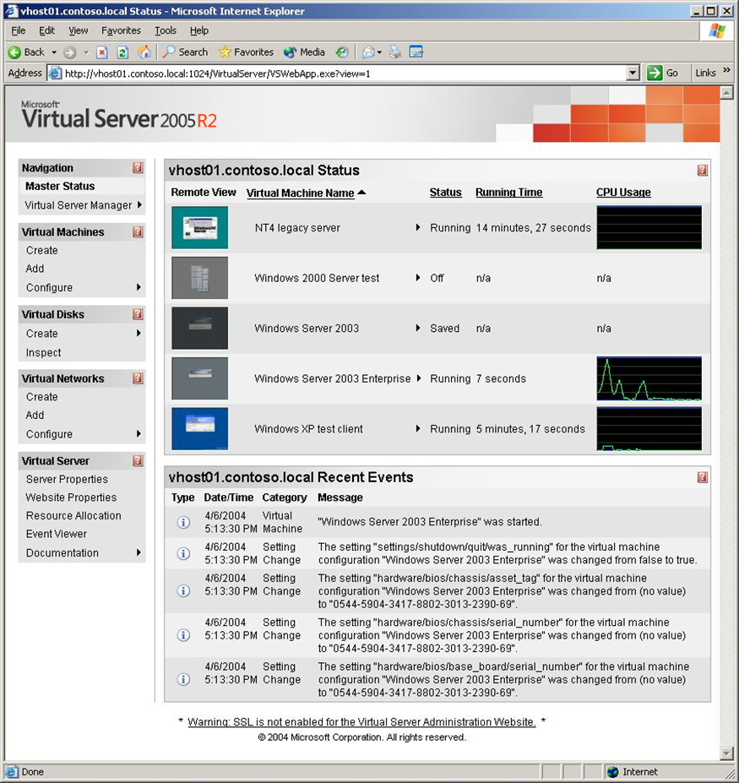
Figure 11. Virtual Server Administration Website user interface. Master Status page.

Managing Virtual Server 2005 R2
The Virtual Server 2005 R2 management features can be readily configured to suit an organization’s needs through the Administration Website Properties page. Preferences chosen here modify the display properties of the page, customizing it for the administrative needs of any organization.

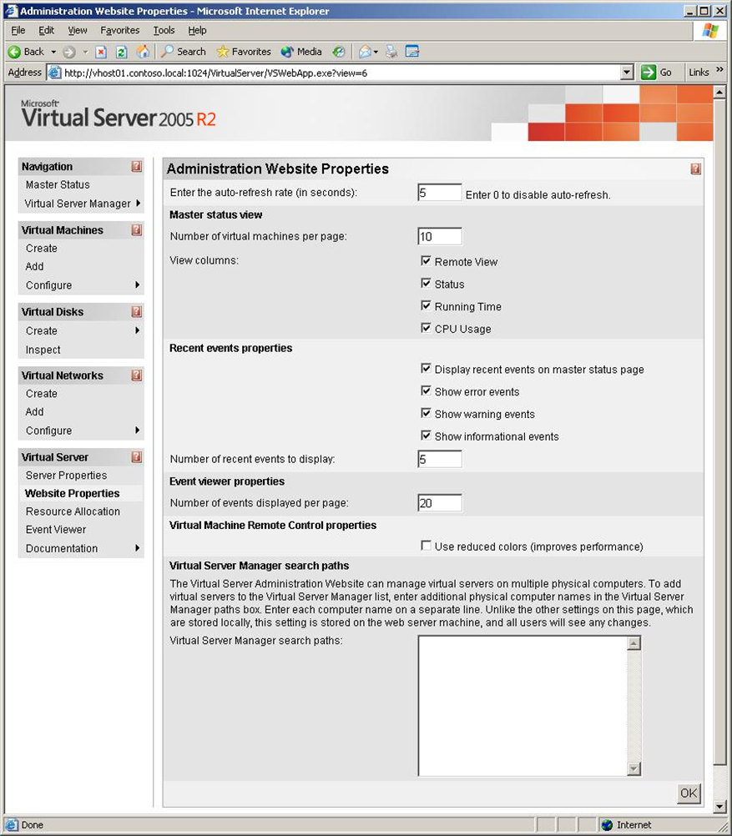
Figure 12. Virtual Server Administration Website user interface. Administration Website Properties page.

Managing Virtual Machines
Virtual machines are created in Virtual Server 2005 R2 through a simple form. The administrator dictates the virtual operating environment for the machine. In a conventional machine, many of these settings are dictated by the hardware. Virtual Server 2005 R2 derives virtual machine properties from a combination of hardware specifications (e.g. processor speed, physical network adapters) and virtual settings (e.g. hard disk size, memory allocation). Virtual Server 2005 R2 includes the ability to select the bus type (IDE or SCSI) at the time of virtual machine creation.

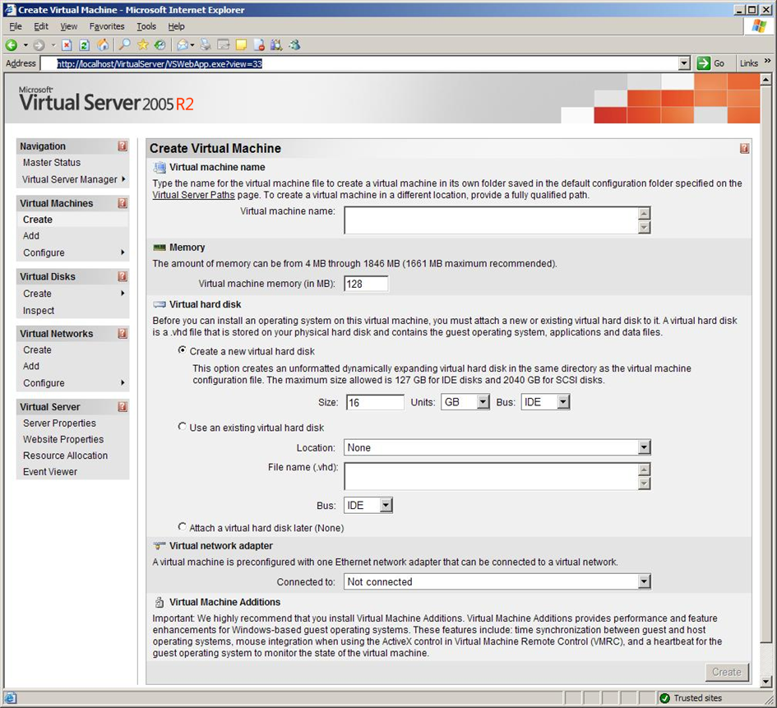
Figure 13. Virtual Server Administration Website user interface. Create Virtual Machine page.

Once created, individual virtual machines can be monitored and modified by viewing the virtual machine configuration page. On one page, all of the virtual machine’s current performance and configuration information is displayed. While running, many configuration modification options are disabled to avoid interference with machine operation.

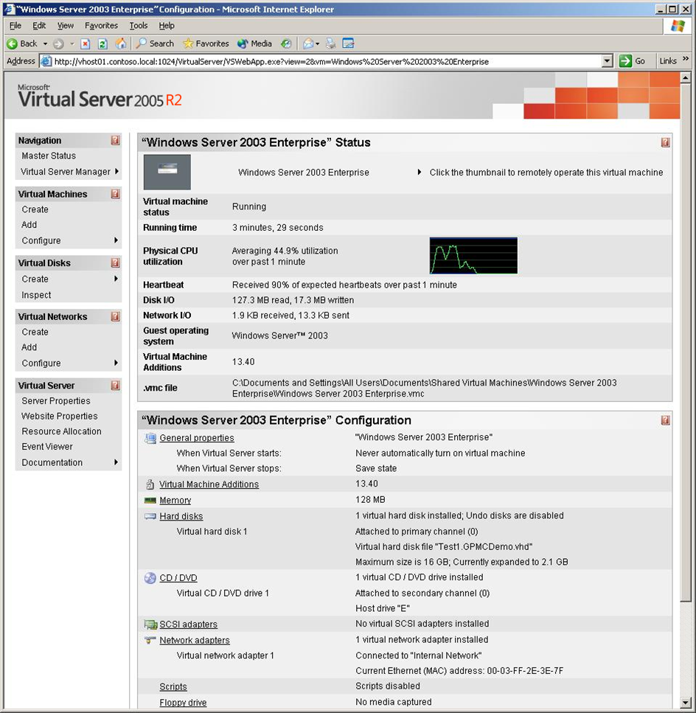
Figure 14. Virtual Server Administration Website user interface. Virtual machine configuration page.

Virtual Server 2005 R2 enables disk hierarchy, allowing multiple machines to run from the same base machine configuration, or parent virtual hard disk. Virtual Server 2005 R2 saves the changes to the machine in a unique disk known as a differencing virtual hard disk. The differencing virtual hard disk is paired with the parent virtual hard disk to operate the virtual machine. Many differencing virtual hard disks can run concurrently in conjunction with a single parent virtual hard disk. Like other configurations, Differencing virtual hard disks are configured easily through one simple form.

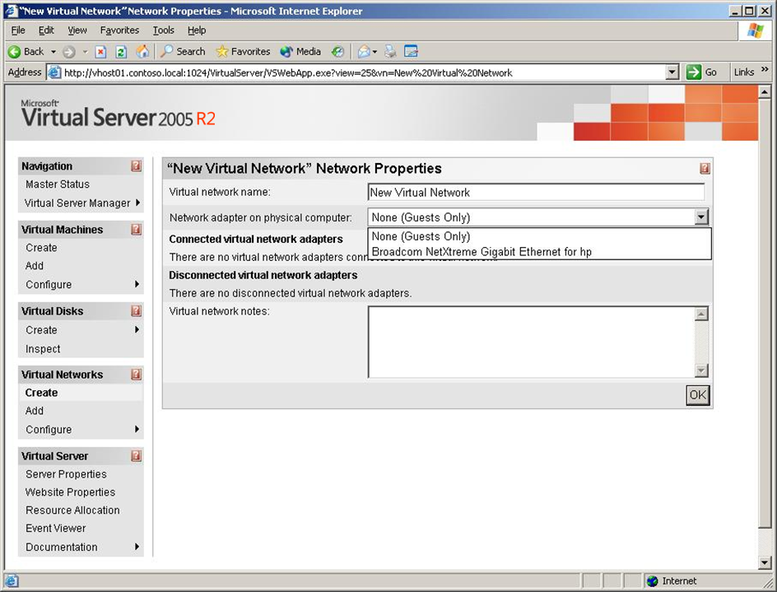
Figure 15. Virtual Server Administration Website user interface. Differencing Virtual Hard Disk configuration page.

Managing Virtual Networks
The virtual network settings interface allows the creation of an unlimited number of virtual networks. Virtual machines can support up to four virtual network connections.

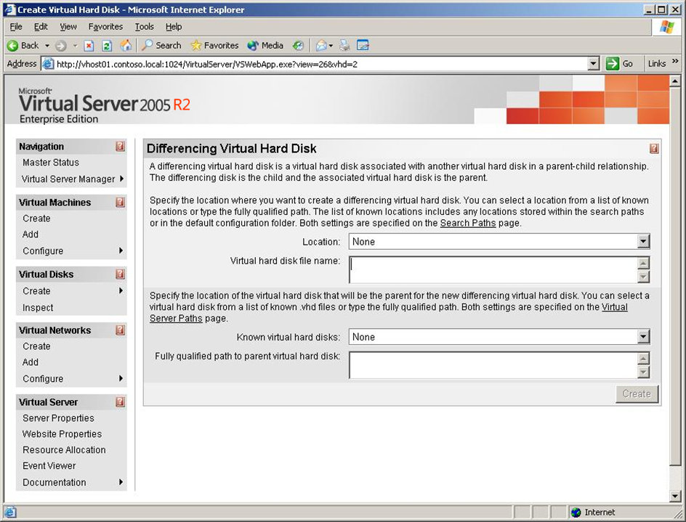
Figure 16. Virtual Server Administration Website user interface. Virtual network configuration page.

Operating Virtual Machines in Virtual Server 2005 R2
The Virtual Machine Remote Control (VMRC) client is one manner through which virtual machine user interfaces are accessed in Virtual Server 2005 R2. The VMRC client enables user access to virtual machines in two ways: 1) as a stand-alone application (Figure 16); and 2) through an Active X® control in the Virtual Server Administration Website in Internet Explorer (Figure 17).

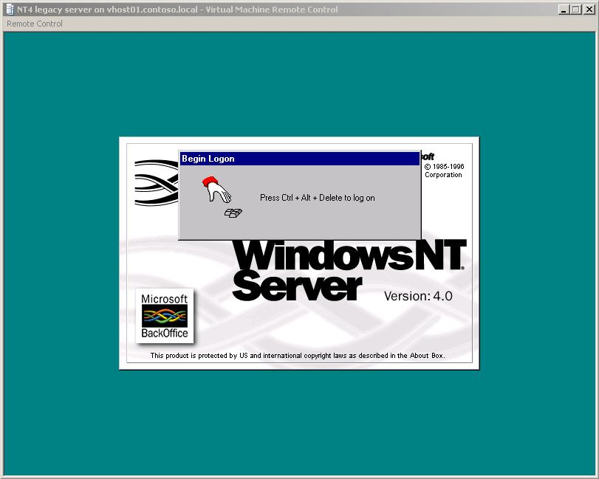
Figure 17. VMRC remote control stand-alone client.

The VMRC simplifies management and saves administration time by facilitating virtual machine access from any location with an Internet connection. All of the same security and networking principals that apply to conventional machines apply to virtual machines, so operating system configuration may be required to enable access through Terminal Services or a Remote Desktop Connection (RDP).

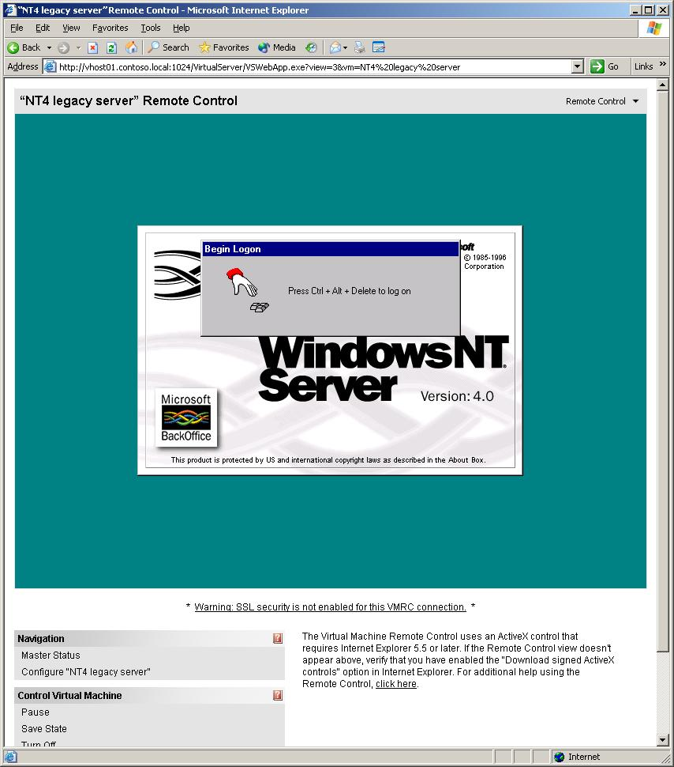
Figure 18. VMRC browser-based remote control.

Technical Overview
The subsections that follow provide an overview of key technologies and features included in Microsoft Virtual Server 2005 R2.

Efficient Use of Hardware Resources
Virtual Server 2005 R2 is production-quality and is an ideal way to consolidate multiple workloads onto a physical server, allowing organizations to make more efficient use of their hardware resources.

Feature | Description
Virtualization:
High performance virtualizations on a fully tested and qualified Microsoft stack
Broad x86 guest OS compatibility | Virtual Server 2005 R2 running on Windows Server 2003 supports most Windows Server Catalog devices, providing customers with compatibility to run Virtual Server 2005 R2 on a wide range of hardware.  - Each virtual machine presents the same set of virtualized devices:  - A single Virtual Processor (ID based on the real processor).  - Up to 3.6GB of system memory.  - Virtual Server 2005 R2 can support up to 64G of host memory.  - Host memory cannot be over-allocated to virtual machines.  - 440BX chipset.  - Adaptec 2940 PCI SCSI controller (up to 4 buses).  - S3 Trio64 SVGA (with 2D hardware acceleration).  - Intel 21140 Ethernet adapter (up to four virtual NICs).  - A local virtual network connection does not need to be associated with a device.  - Virtual machines can also be configured to have no virtual network connection.  - IDE/ATAPI controller.  - Legacy devices - keyboard, mouse, COM and LPT ports, CMOS, PIC, DMA, etc.  Virtual Server 2005 R2 implements support for two node local clustering between virtual machines on the same Virtual Server 2005 R2 host computer.  - Virtual Server 2005 R2 clustering uses a virtual shared SCSI bus to implement the quorum device.  - The feature provides software failover support between the clustered virtual machines.  x86 applications that require direct access to a specific hardware device (e.g., a specific PCI card) will not run in a virtual machine environment. Applications that require more than one processor also will not run in a virtual machine environment.
x64 host support | Virtual Server 2005 R2 runs natively within 64-bit (x64) Windows host operating system, providing customers not only with increased performance but also with more memory headroom for greater scalability.  Native components of Virtual Server 2005 R2 include:  - 64-bit VMM driver  - 64-bit VMNS (networking driver)  - 64-bit VS service  - 64-bit ActiveX control  The additional memory address space of 64-bit operating systems allow for more guest machines to be run on one host server:  - Virtual Server 2005 R2 running on 64-bit systems does not have a memory aperture limit.  - The hard limit of 64 virtual machines per host system remains.  Virtual Server 2005 R2 is supported by the following 64-bit host operating systems:  - Windows Server 2003 Standard x64 Edition  - Windows Server 2003 Enterprise x64 Edition  - Windows XP Professional x64 Edition
High availability through clustering | Virtual Server 2005 R2 enables clustering of guest operating systems and host computers, enabling important high availability scenarios. Clustering host computers offers a cost-effective means of increasing server availability, enabling migration and failover of virtual machines among the Virtual Server hosts in the cluster. Using Windows Server 2003, Microsoft Cluster Service, and Virtual Server 2005 R2 organizations can create a high availability virtual machine environment that can effectively accommodate both planned and unplanned downtime scenarios without requiring the purchase of additional software tools.  For example, IT administrators can effectively anticipate server restarts required by system updates. With a properly configured Virtual Server host cluster, running virtual machines can be migrated to another host in the cluster with only seconds of downtime.  In unplanned downtime scenarios, such as hardware failure, the virtual machines running on the host are automatically migrated to the next available Virtual Server 2005 R2 host.  Guest clustering allows cluster-aware applications to be clustered within virtual machines across Virtual Server 2005 R2 host computers. This is possible by leveraging the Microsoft iSCSI 2.0 client with Virtual Server 2005 R2.
Resource management:
Policy-based control for balanced workload management
CPU Resource Allocation | CPU resource allocation supports both weighting and constraint methods for fine-grained control.  - Multithreaded for highly scalable performance on systems with up to 32 processors and 64GB RAM.  - Each virtual machine can use up to 100% of a single host processor.  - On Hyper-threaded systems the single host processor is a logical processor.  - Multiple virtual machines can execute concurrently to make use of multiple host processors.  - The Virtual Server process creates a thread of execution for each VM.  - Additional threads are created to perform IO, service the COM API, etc.  - The number of virtual machines that can be hosted on any server depends on:  - The combined processor, memory and IO load the virtual machines put on the host, and  - The processor, memory and IO capacity available on the host system.  - Virtual processor resources can be changed dynamically via the administration Website or the COM API.  - Virtual Server supports both weight-based and constraint-based CPU resource allocation for balanced workload management.  - Maximum capacity is the highest percentage of the total resources of a single CPU that can be consumed by a virtual machine at any given time.  - Relative weight: The relative weight given to the resource needs of this virtual machine compared to all other virtual machines. A virtual machine with a higher relative weight is dynamically allocated additional resources as needed from other virtual machines that have lower relative weights. By default, all virtual machines have a relative weight of 100, so that their resource requirements are equal, and none is given preference.  - Capacity and Weight algorithms operate concurrently:  - Contention can occur for the maximum system capacities.  - Relative weights indicate how to allocate resources during contention.
Memory Resource Allocation | Virtual Server 2005 R2 enables flexible memory configuration on a per-virtual machine basis. Memory over commit (page sharing) is not supported because of performance and reliability considerations. Memory size cannot be reconfigured while a virtual machine is running.  Memory resource allocation supports memory resizing at virtual machine boot time.  - Support is included for NUMA-aware scheduling and memory allocation.  - On non-NUMA systems VS relies on the Host operating system scheduler.

Enhanced Administrative Productivity and Responsiveness
Virtual Server 2005 R2 enables automated deployment and configuration of connected virtual machines that are easily administered with standard server management tools. This allows IT organizations to better enhance their administrative productivity and rapidly deploy new servers to address changing business needs.

Feature | Description
Deploy:
Complete scripted control of portable, connected virtual machines enables automated configuration and deployment
Virtual Hard Disks | Virtual hard disks (VHDs) provide storage for virtual machines. Within the virtual machine, the virtual hard disk is represented as a physical disk and is used by the virtual machine as if it were a physical disk. Technically, the virtual hard disk is a file that resides on a physical disk that the host operating system can access. On the physical disk, the virtual hard disk file is stored as a .vhd file. Each VHD is created through the Virtual Server Web Administration console. Upon creation of a virtual machine, the customer specifies the size and type of the disk and the VHD is created automatically. Virtual Server 2005 R2 allows the customer to create a new VHD, use an existing VHD or connect a VHD to the virtual machine at a later time. The Virtual Server Administration Website can create a VHD on any storage that the host file system can access including IDE, SCSI, RAID, SAN, NAS, and so forth.  The virtual machine accesses the virtualized IDE/SCSI device and the virtual machine monitor maps that to the physical device access. Virtual machines can access VHDs on any storage topology, including SAN and NAS configurations, supported by the underlying Windows host server. VHDs support the following formats and functionality:  - Dynamically expanding virtual hard disks. A dynamically expanding virtual hard disk is one in which the size of the .vhd file grows as data is written to the virtual hard disk. This is the default type of virtual hard disk created by Virtual Server.  - Fixed-size virtual hard disks. A fixed-size virtual hard disk is a .vhd file whose size is determined when the file is created. Even when the amount of data being stored on the file changes, the size of the .vhd file remains fixed. For example, if you create a fixed-size virtual hard disk of 1 GB, Virtual Server creates a 1 GB .vhd file.  - Linked virtual hard disks. A linked virtual hard disk is a virtual hard disk that points to and uses an entire physical disk for the purpose of converting a physical disk to a virtual hard disk. A linked disk can be associated only to a drive; it cannot be associated to a volume.  - Differencing virtual hard disks. This VHD format enables disk hierarchy, with a parent disk sharing a base configuration across one or more child disks. Each child disk can have only one parent, but parent disks can be chained linearly into grand parents and great-grand parents and so forth. Parent disks are read-only; changes are stored in the child disk. On the host file system, differencing disks appear as multiple files, but from within the virtual machine they appear as a single VHD.  - Undo disk. This VHD format also enables a disk hierarchy, in which changes made to the disk of a particular virtual machine are stored in a separate file, the undo disk. At the end of a session, changes made during that session can be either committed or discarded. Committed changes are merged with the original disk. Undo disks are specified on a per-virtual machine basis, whereas differencing disks are specified on a per-VHD basis.  Virtual Server 2005 R2 supports conversion between disk types.  Once created, virtual machines in Virtual Server 2005 R2 consist of two components:  - an XML configuration file that contains metadata describing the virtual machine, and  - a VHD file containing the virtual machine data.  The nature and relationship of the XML configuration file and the VHD file allows for the existence of various disk entities: dynamically expanding virtual hard disks, fixed-size virtual hard disks, differencing virtual hard disks and undo disks. The virtual hard disk contains virtual machine data and the XML file separately contains all configured metadata. This flexibility enables fast and economical deployment leveraging existing storage, networking, security and management infrastructure.  Each virtual machine can connect up to 32 VHDs using virtualized IDE and SCSI controllers.  - Up to four VHDs can be connected to the virtual IDE controller.  - Each VHD can be up to 128G.  - A virtual machine can have up to four virtual SCSI controllers.  - The guest operating system sees a virtualized multi function Adaptec 2940 PCI adaptor.  - Each controller creates a single SCSI bus.  - Up to seven VHDs can be attached to each SCSI bus.  - Each VHD can be up to 2TB.  The maximum storage per virtual machine is over 56TB.
Virtual Networking | Virtual networks are used to connect a virtual machine to internal or external networks. Virtual Server 2005 R2 supports up to four virtual network connections per virtual machine. By default, one default internal virtual network is created to enable virtual machine-to-virtual machine networking, and one virtual network is created for each host Ethernet interface, connecting virtual machines to external networks. Additional virtual networks can be created through the network settings page in the Virtual Server Administration Website and a unique MAC address is created for each virtual network connection.  For each virtual network with no NIC connected, all networking is performed local to Virtual Server 2005 R2 using memory copies, and a virtual DHCP server is available to provide IP addresses to virtual machines (Gateways, DNS/WINS servers and IP leases are configurable).  Virtual Server 2005 R2 supports any Ethernet interface on the host system—including teamed NICs—enabling powerful, security enhanced configurations for optimized network operations. Virtual Server 2005 R2 allows users to create an unlimited number of virtual networks with the following topologies:  - External networking. Virtual machines interoperate with physical machine equivalency as stand-alone servers on the network, and are able to communication with other nodes on the network, including other virtual machines configured for external networking.  - Virtual machine-to-virtual machine networking. Virtual machines communicate via simulated Ethernet and Virtual DHCP server with other virtual machines also running on the same host computer. Virtual machine-to-virtual machine networking does not transmit packets over the physical network, but rather by using host system memory copies.  Virtual machine-to-host networking. Virtual machines communicate with the host system via the Microsoft loopback adapter.
Comprehensive COM API | Virtual Server 2005 R2 exposes a rich COM interface that contains 42 interfaces and hundreds of calls which permits the user to monitor and control the virtual machine environment. All of the web-based user interfaces in Virtual Server 2005 use this COM interface via a scripting language, which allows easy customization of the virtual machines. The scripting model is based on COM; therefore users are not tied to a specific scripting language. Developers can choose between Visual Basic, C#, Perl, and many other modern development languages. Furthermore, scripts can be “triggered” by certain events within Virtual Server 2005 R2. Customers benefit from greater ease of customization and automation using the Virtual Server 2005 R2 COM API.  The scripting API makes Virtual Server 2005 R2 a powerful platform for virtualization solutions.  - The scripting API enables programmatic control over the configuration and administration of virtual machines.  - It automates virtual machine deployment and operations.  It enables customers to integrate virtual machines into their existing IT infrastructural operations for reduced cost and enhanced manageability.
PXE Boot | The emulated network card in Virtual Server 2005 R2 now supports Pre-boot Execution Environment (PXE) boot. This network boot allows customers to provision their virtual machines in all of the same ways that they do their physical servers.  Note: To take advantage of this feature, the PXE infrastructure needs to be implemented in the host network.
Manage and Migrate:
Use existing server management tools to administer virtual machines running on a familiar host operating system
Virtual Server Administration Website | As a reference implementation of the scripting API, the Virtual Server Administration Website showcases the broad management capabilities of Virtual Server 2005 R2. The Virtual Server Administration Website controls a single instance of Virtual Server 2005 R2. It enables authenticated administration and remote access.  The Virtual Server service installs as a headless service on the host operating system. The COM API is used to create the content in the Virtual Server Administration Website. All actions performed through the Virtual Server Administration Website can be automated through the COM API, which enables automated creation, configuration and control of virtual machines.  - The Virtual Server Administration Website can control the state of each virtual machine:  - Remote Control – Present the UI for the virtual machine selected.  - Turn on – Boot the virtual machine BIOS and operating system.  - Pause – Stop virtual machine execution.  - Resume – Start the virtual machine from the Paused state.  - Save state - Save the virtual hardware context to disk and stop virtual machine execution.  - Restore the saved state - Start the virtual machine from a Saved State context.  - Discard Saved State – Discard the Saved State context for the virtual machine.  - Shutdown the Guest operating system – Send a shutdown request to the guest operating system to properly shutdown. Requires the additions to be installed and Windows 2000 or greater guest operating system.  - Turn off – Equivalent of pushing a server’s power button.  - Reset – Equivalent of pushing a server’s reset button.  - Remove – Removes the virtual machine from the Virtual Server Administration Website; the virtual machine files are unaltered.  - The Virtual Server Administration Website can control the configuration of each virtual machine:  - Default action of the virtual machine on Host startup and shutdown  - Set the access controls for the virtual machine  - Change the hardware configuration, including memory, network, storage, floppy, CD and port configurations  - Change the virtual machine CPU resource management settings  - Install additions in the virtual machine  - Attach a script to a virtual machine event  - The Virtual Server Administration Website facilitates remote access through VMRC:  - The Virtual Server Administration Website enables administrative and client remote access from anywhere on the network.  - Interface access for each virtual machine is accomplished using a Virtual Machine Remote Control (VMRC) link.  - VMRC uses SSL data encryption and Active Directory and Kerberos user authentication.  - Remote access can also be accomplished via Terminal Services or a Remote Desktop Connection (RDP), but certain configurations may be required on the guest operating system to enable the service.  - SSL configuration is provided though the Virtual Server Administration Website.  Use Virtual Server Administration Website in conjunction with standard server management tools to administer virtual machines.  - Virtual Server 2005 R2 provides three levels of administrative access to virtual machines based on host ACLs, with administrators of the host operating system having default access to all three:  - Creation of new virtual machines.  - Reconfiguration of a specific virtual machine.  - User access to a specific virtual machine.
Active Directory Integration | Active Directory allows the same directory management features to be used for virtual machines as are used for physical machines by providing a centralized repository for hierarchical information about users and computers on the network. Active Directory incorporates significant improvements in management and performance in Windows Server 2003 which can be leveraged through virtual machines hosted by Virtual Server 2005 R2.  Integration with Active Directory enables delegated administration and authenticated guest access. Virtual Server 2005 R2 enables fine-grained administrative control over virtual machines with per-virtual machine ACLs that can be managed from within Active Directory’s Group Policy Management Console. Event logs are integrated with Active Directory and Microsoft Management Consoles.
Microsoft Operations Manager 2005 Management Pack for Virtual Server | Companies can leverage existing tools to manage across physical and virtual machines. Microsoft is developing management tools to make the current manageability product set virtual machine-aware. For example, to distinguish host/guest hierarchical relationships, to represent and manage the topology, and expose it to other management solutions. Microsoft Operations Manager 2005 Management Pack for Virtual Server provides extensible guest-host mapping for event and performance management.  Virtual Server 2005 R2 provides WMI counters on the host system, and can be passed to Microsoft Operations Manager for health monitoring and alerting.  Events are logged and displayed in the Virtual Server 2005 R2 event log. This log is available on the Virtual Server Administration Website from the Master Status Page. Virtual Server events are also displayed on the host system event log, which can be passed to Microsoft Operations Manager for alerting, or it can be integrated into a third-party management solution.  Virtual Server 2005 R2 uses an extensible XML file format to enable virtual machine configuration management from external management software. This can leveraged through the COM API for asset management, automated provisioning and deployment and more.
Automated Deployment Services and Virtual Server Migration Toolkit | The Virtual Server Migration Toolkit (VSMT) is a free download that provides command-line tools for migrating from physical computers to virtual machines or virtual machines to other virtual machines (P2V), easing migration to a Virtual Server virtual machine environment.  Used in conjunction with Automated Deployment Services, VSMT provides the tools and the process to allow you to simplify and streamline the migration to a Virtual Server virtual machine environment.

Well-supported Server Virtualization Solution
Virtual Server is a well supported virtualization solution both within Microsoft and across the broader ISV community.
Feature | Description
Support:
Comprehensive testing and support for Virtual Server in conjunction with Microsoft Windows Server operating systems and Microsoft server applications
Windows qualified drivers | Virtual machines utilize the Windows host operating system’s qualified device drivers, ensuring robust and stable device support and broad device compatibility.
Windows Server System family support | The Windows Server System Common Engineering Criteria 2005 states, “To help customers improve the utilization of hardware resources, all server products will support Microsoft Virtual Server 2005. Each product must be capable of running from within a virtual instance.”
Ecosystem Support:
ISVs and customers are able to integrate with Virtual Server for enhanced functionality and manageability
Extensibility | Comprehensive COM management interfaces are published and utilized by management tool vendors.
VHD file format | Microsoft’s VHD file format is available under royalty-free license, allowing ISVs such as security and management vendors to natively interoperate with Virtual Server.

Feature Summary
Virtual Server 2005 R2 delivers business value through a feature-rich virtual machine solution. Taking advantage of Windows Server 2003, Virtual Server 2005 R2 offers:
- Efficient use of hardware resources:
  - Virtualization: High performance virtualizations on a fully tested and qualified Microsoft stack.
  - Resource management: Policy-based control for balanced workload management.
- Enhanced administrative productivity and responsiveness:
  - Deploy: Complete scripted control of portable, connected virtual machines enables automated configuration and deployment.
  - Manage and Migrate: Use existing server management tools to administer virtual machines running on a familiar host operating system.
- Best supported server virtualization solution:
  - Support: Comprehensive testing and support for Virtual Server in conjunction with Microsoft Windows Server operating systems and Microsoft server applications.
  - Ecosystem Support: ISVs and customers are able to integrate with Virtual Server for enhanced functionality and manageability.

More Information
For further technical information about this technology, visit the Microsoft Virtual Server 2005 Web site at the following link: http://www.microsoft.com/windowsserversystem/virtualserver.

Summary
Microsoft Virtual Server 2005 R2 is a cost-effective and well supported server virtualization technology for the Windows Server System platform. Use it to:
• Consolidate infrastructure, application, and branch office server workloads: Virtual Server 2005 R2 is ideal for server consolidation in both the datacenter and the branch office, allowing organizations to make more efficient use of their hardware resources. It also allows IT organizations to enhance their administrative productivity and rapidly deploy new servers to address changing business needs.
• Consolidate and re-host legacy applications: Virtual Server 2005 R2 enables re-hosting of legacy OSes (Windows NT Server 4.0 and Windows 2000 Server) and their associated custom applications from older hardware to new hardware running Windows Server 2003.
• Automate and consolidate software test and development environments: Virtual Server 2005 R2 enables businesses to consolidate their test and development server farm and automate the provisioning of virtual machines.
• Disaster and Recovery: Virtual Server 2005 R2 can be used as part of a disaster and recovery plan that requires application portability and flexibility across hardware platforms.

Related Links
For further information about Virtual Server 2005 R2, see the Virtual Server 2005 R2 Web site at http://www.microsoft.com/windowsserversystem/virtualserver. Among the many resources on the site are in-depth technical articles describing fundamentals of virtualization technology as well as the benefits of implementation. Link directly to the Technical Overviews page at http://www.microsoft.com/windowsserver2003/techinfo/overview/virtualization.mspx.
Supporting information also can be found for:
- Windows Server 2003 at http://www.microsoft.com/windowsserver2003/default.mspx
- Microsoft .NET at http://www.microsoft.com/net
- Windows 2000 operating system at http://www.microsoft.com/windows2000/default.asp
- Windows Server System at http://www.microsoft.com/windowsserversystem/default.mspx
- MSDN® at http://www.microsoft.com/msdn
- TechNet at http://www.microsoft.com/technet

