Overview  Country or Region: India  Industry: Pharmaceuticals  Customer Profile  RiteCare Pharmacy (India) offers quality medicines, healthcare supplements, and personal care products. It has 55 employees and serves 10 retail locations in Hyderabad from one warehouse.  Business Situation  RiteCare wanted to scale its warehouse operations to accommodate a rapid increase in stores, without significantly increasing overhead. It also wanted to reduce order turnaround time and improve order accuracy.  Solution  The company deployed the S3Edge RTVS solution suite for Warehouse Visibility—which includes Microsoft® BizTalk® RFID Mobile and Microsoft BizTalk Server 2006 R2—to expedite its warehouse operations.  Benefits  - Order fulfillment time cut in half  - Warehouse inventory reduced by 60 percent  - Scalability increased  - Implementation expedited  - Operations visibility enhanced |  |  | “BizTalk RFID Mobile, delivered with S3Edge RTVS, will help us serve many more stores for about the same cost that we have now. Saving the cost of adding even 10 employees will return my investment.”  Seshu Guddanti, Managing Director, RiteCare Pharmacy
 |  |  | With 10 stores in India and plans for dozens more, RiteCare Pharmacy (India) wanted to make its warehouse operations more efficient before launching its next growth phase. As part of that process, RiteCare wanted to reduce the time required to fulfill store orders, increase order accuracy, reduce warehouse space requirements, and make it easier for workers to locate products. To address those needs, the company chose the S3Edge RTVS™ solution suite for Warehouse Visibility that includes Microsoft® BizTalk® RFID Mobile and Microsoft BizTalk Server 2006 R2. This solution optimizes the placement, retrieval, and flow of products throughout the warehouse and provides real-time visibility of all warehouse operations. As a result, RiteCare cut its order fulfillment time in half, reduced inventory by 60 percent, and increased the accuracy of fulfilling store orders to 97 percent.
 |  |  | 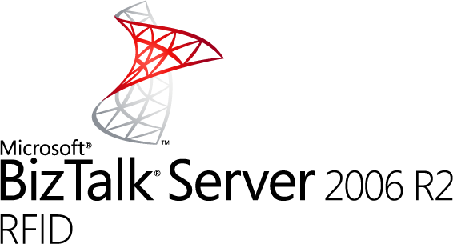

Situation
RiteCare Pharmacy (India) operates a rapidly growing chain of pharmacy stores in Hyderabad, the second largest city in India. At present, the chain has a total of 15 employees at its warehouse and 40 at the company’s 10 stores within the Hyderabad metropolitan area. The company plans to rapidly scale its store count over the next three years.

The company’s competitors range from small, stand-alone, neighborhood medical shops to large drug store chains with several hundred stores. To effectively compete with both ends of the spectrum, RiteCare is committed to having the right products, available at the right price, at the right store, at all times. Although that is challenging to accomplish with 10 stores, it expects that goal to become exponentially more difficult to reach as the number of stores increases.

RiteCare stocks thousands of product SKUs from several distributors. Pharmaceutical operations can be very complex because products must be carefully tracked for batch numbers, expiration date, and dosage. Seasonal fluctuations and the addition of new products can also create challenges for warehouse storage and picking and packing operations.

Toward the end of 2007, RiteCare management realized that to maintain a high level of customer service and maintain profitability as it grows, it needed to streamline its warehouse operations. Its goal was to scale its operations to a few hundred stores without having to expand its existing 2,550-square-foot warehouse or significantly increase its warehouse staff. “When some of our competitors grew to 100 stores their warehouse staff also grew to 100 or 150,” says Seshu Guddanti, Managing Director, RiteCare Pharmacy. “There is no benefit to scaling if my incremental labor costs increase at the same rate. One of our main goals for this solution is to avoid having to ramp up labor when we grow.”

RiteCare warehouse operations were very labor-intensive. Stores sent orders to the warehouse based on the previous day’s sales. The warehouse purchase manager consolidated those orders and fulfilled as many as possible from warehouse inventory. Products that were not available in the warehouse were ordered from distributors the next morning. Typically, products arrived from distributors on the third day―at which time warehouse workers manually entered the items into the computer, invoiced the stores, and shelved the products in the warehouse. On the fourth day, the products were picked and packed and sent to stores.

“The products were placed on the shelves in alphabetical order; however if we received more of any item than would fit in its alphabetical section, the picker would put the excess in a different location,” says Guddanti. “As a result, sometimes pickers had to spend a lot of extra time looking for a product and sometimes couldn’t find it even though the inventory showed that it was there.”

Orders were crosschecked before they were sent to the stores, but still stores would sometimes receive the wrong quantity or the wrong dosage of a product. Resolving the discrepancy added another day or two to the process. “The typical order had between 200 and 250 products per day per store, so someone had to tediously check the product name, the quantity, and the expiration date very closely,” says Guddanti. “Still mistakes slipped through, which increased costs, extended turnaround time, and eroded customer satisfaction.”

RiteCare wanted to streamline its warehouse operations so that it could scale to serve many more stores with the current staff and current warehouse space. It also sought to reduce turnaround time between the warehouse and stores and to improve order accuracy to improve customer service.

Solution
RiteCare decided to deploy the S3Edge RTVS™ solution suite for Warehouse Visibility that uses radio frequency identification (RFID) technology to make it possible for warehouse managers to visualize physical warehouse operations in real time. Based on Microsoft® BizTalk® Server 2006 R2 and BizTalk RFID Mobile, this solution offers tremendous flexibility, quick deployment, and ease of use for various vertical industries, including pharmaceuticals.
“Our ERP system tells us how much inventory is there. The RTVS solution shows us the flow of the products through the warehouse.”
Seshu Guddanti, Managing Director, RiteCare Pharmacy

BizTalk Server 2006 R2 includes an RFID server that is capable of accessing and working with RFID data from multiple sources. And BizTalk RFID Mobile supports collecting inventory and workflow events on a mobile RFID reader, storing them locally and forwarding them to the server to be stored in a Microsoft SQL Server™ database.

“BizTalk RFID and BizTalk RFID Mobile provide a comprehensive foundation for deploying real-time business solutions across the extended enterprise,” says Guddanti. “With experts like S3Edge to help us deploy these solutions, the decision to enable our real-time warehouse on this rich platform was an extremely easy one for us to make.”

S3Edge worked with the RiteCare IT staff to set up a proof of concept in February 2008. S3Edge RTVS software was installed on a dedicated Web-based management console that runs the Windows Server® 2003 operating system, BizTalk Server 2006 R2, and Microsoft SQL Server 2005 data management software. RiteCare uses four Unitech RH767 mobile RFID Readers that run the Windows® CE 5.0 operating system, the RTVS client, and BizTalk RFID Mobile. With the BizTalk RFID Mobile–based system, RiteCare workers can easily carry the S3Edge RTVS capabilities with them throughout the warehouse. RTVS interfaces to the company’s ERP system so warehouse workers can see real-time information on store orders and invoices from any point within the warehouse.

The solution’s RFID tags include a binary identification number that users can dynamically link to specific products and shelf locations in the warehouse through the RTVS software to support RFID-driven warehouse workflows. The tags are affixed to:
- Large store totes that carry products from the warehouse to stores
- Smaller warehouse totes that store products on shelves in the warehouse
- Shelves in the warehouse where the totes are stored

The association of those tags with either a specific product or a shelf location within the warehouse can be changed in the software to accommodate changes in the product line.

In the initial phase of the proof of concept, RiteCare pulled SKUs from two vendors into the S3Edge RTVS software. An S3Edge consultant worked with RiteCare pickers for about two-weeks demonstrating how to use the RFID reader and supporting the pickers’ efforts to train other staff.

RiteCare tested the proof of concept until July 2008 and then moved the solution into production and expanded it to include products from the remaining distributors. With the new solution, the first part of the process is the same as before: stores send orders to the warehouse in the morning. If the product isn’t in the warehouse, the warehouse purchase manager orders it and it arrives the next day. When the product is received from the distributor, the new process starts.

When the ordered products arrive at the RiteCare warehouse, the purchase manager makes sure the batch number and expiration date match the order. Then, instead of placing the product in the warehouse, warehouse workers cross-dock the ordered items directly into store totes for delivery to stores on the same day. The picker scans the RFID tag on the tote with the mobile RFID reader. While placing each product in the tote, the picker enters the product into the RTVS client. The mobile reader guides users each step of the way, asking them to select “yes” on the screen to confirm as they put each product in the tote. Each store receives an average of three totes every day.

After the incoming products are cross-docked, any additional products that are to be fulfilled from inventory are picked and placed in the tote. Pickers use the RTVS client on the RFID reader to quickly locate the additional products. With the mobile reader in read mode, they can automatically see all RFID tags within three to four feet to further ease their search.
“With RTVS and BizTalk RFID Mobile capabilities, we are able to cross-dock and quickly decide where a product needs to go.... This helps reduce our turnaround from four days to two days.”
Seshu Guddanti, Managing Director, RiteCare Pharmacy

Any excess products that were ordered to replenish inventory are put in standard totes and placed on a shelf in the warehouse. The picker scans the RFID tag on the tote and on the shelf to lock that product tote with that location. Every time the product is added or removed from a tote, the picker enters the change on the RFID reader.
With S3Edge RTVS software and BizTalk RFID Mobile, RiteCare has streamlined order fulfillment and improved accuracy.
Using the RTVS solution, warehouse managers can quickly see which tote a product was loaded into, where that tote was shipped, or where it was stored in the warehouse. “Our ERP system tells us how much inventory is there. The RTVS solution shows us the flow of the products through the warehouse,” says Guddanti.

In the next phase of the project, RiteCare and S3Edge plan to extend RFID tagging to the item level, so that each strip or bottle of pills is identified with an RFID tag.
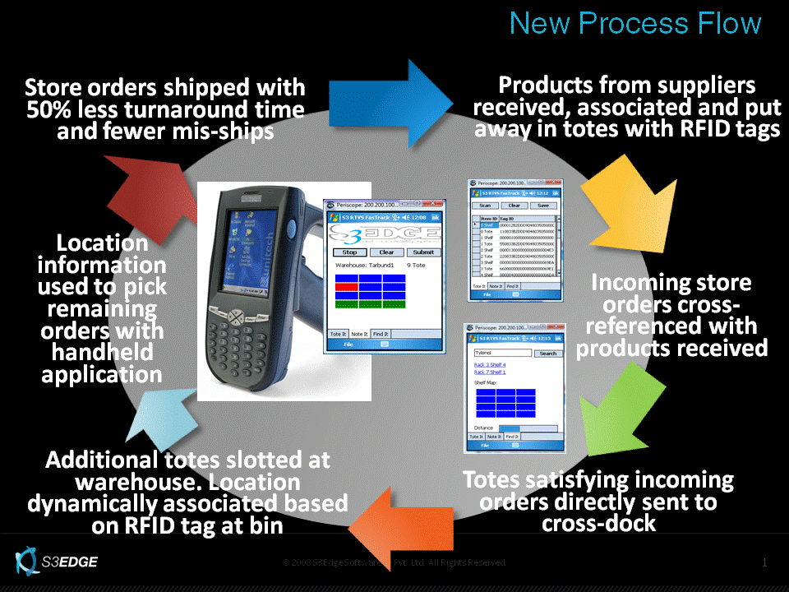
Benefits
The S3Edge RTVS solution takes advantage of the broad RFID capabilities in BizTalk RFID Mobile and BizTalk Server 2006 R2 to provide RiteCare with a solution that is easy to deploy and manage, and that provides a real-time view of its warehouse processes. As a result, the company was able to improve its service through faster turnaround time, increased accuracy, and real-time visibility of products at every point in the warehouse. This solution will also help the company scale to many additional stores without increasing staff or warehouse space.

Order Fulfillment Time Cut in Half
With the paper-based picking and packing processes, order turnaround time in the RiteCare warehouse took four days. Rather than the old process of painstakingly looking at every item and verifying quantity and batch number to the invoice, purchase managers now accept the products as is and then verify the details as part of the cross-docking process. “Now with RTVS and the BizTalk RFID Mobile capabilities, we are able to cross-dock and quickly decide where a product needs to go, rather than put it away one day and pull it out the next. This helps reduce our turnaround from four days to two days,” says Guddanti. “Pickers are excited because now they are able to locate items in minutes instead of hours because they know exactly where to find products and can quickly confirm that they have the correct batch and dosage.” Quickly locating the products increases the productivity of pickers thus enabling RiteCare to grow without additional costs.

Warehouse Inventory Reduced
by 60 Percent
The ability to cross-dock products and the resulting reduction in turnaround time have also helped RiteCare reduce warehouse inventory by 60 percent. “A large percentage of our orders now comes in one door and goes out the other to the stores on the same day,” says Guddanti. “We used to shelve extra products in the warehouse to reduce turnaround time. But now that we can turn around products in two days we no longer need to do that. We’ve also stopped storing most of the slow-moving products, which represents about a 60 percent reduction in the inventory we have to carry and manage.”

In addition, because products are now arranged in the warehouse according to RFID tag rather than by alphabet, the space is optimized. “With RTVS, we can collapse those holes on the shelves, because when a product is removed, you can easily associate that tote to a new product in the software and fill it up again,” says Guddanti.

Scalability Increased
By increasing warehouse staff productivity and reducing warehouse space requirements, RiteCare can easily scale to serve more stores without adding employees or expanding warehouse space. “BizTalk RFID Mobile, delivered with the S3Edge RTVS, will help us serve many more stores for about the same cost that we have now,” says Guddanti. “Saving the cost of adding even 10 employees, will return my investment because we’re a growing company.”
Implementation Expedited
Microsoft BizTalk RFID Mobile, with its comprehensive platform for developing real-time, device-agnostic mobile RFID applications and its native connectivity to BizTalk Server RFID, allowed RiteCare to quickly move from concept to implementation. “There is nothing in the market today that provides the framework and flexibility that BizTalk RFID Mobile provides for quickly creating, deploying, and managing these real-time processes,” says Ravi Vankamamidi, Chief Solutions Officer for S3Edge Software. “BizTalk RFID Mobile abstracts away much of the plumbing that is needed to talk to a reader, so we went from pilot to production in four weeks at RiteCare.”

Operations Visibility Enhanced
RiteCare has gained real-time visibility into all of its warehouse operations. S3Edge RTVS integrates with SQL Server 2005 to create real-time reports of picking, cross-dock, putaway, and shipping operations. “With RTVS reports, we can tell which operator is working on which operation, for how long, and how many items he or she processed,” says Guddanti. “We also get historical reports such as the total amount of product picked per hour, per week, and per month.”

These reports help RiteCare track the efficiency and error rates of individual pickers. Also, because RiteCare now has a much clearer view of the flow of products through the warehouse, and because the RFID reader alerts pickers if they try to put a product into the wrong tote, this solution has helped increase the accuracy of fulfilling store orders to 97 percent. “We didn’t want to add more and more workers to reduce the error rate. Instead, we are using technology to ensure that the right product is in the right location at the right time, and that we aren’t losing inventory,” says Guddanti. This increased accuracy also reduces the pressure on pickers and helped the stores to improve customer satisfaction.
Microsoft Server Product Portfolio
For More Information
For more information about Microsoft products and services, call the Microsoft Sales Information Center at (800) 426-9400. In Canada, call the Microsoft Canada Information Centre at (877) 568-2495. Customers who are deaf or hard-of-hearing can reach Microsoft text telephone (TTY/TDD) services at (800) 892-5234 in the United States or (905) 568-9641 in Canada. Outside the 50 United States and Canada, please contact your local Microsoft subsidiary. To access information using the World Wide Web, go to: www.microsoft.com

For more information about S3Edge Software products and services, call (310) 943-7992 or visit the Web site at: www.s3edge.com

For more information about RiteCare Pharmacy (India) products and services, call (91) 996337-9627 or visit the Web site at:
www.ritecareindia.com

This case study is for informational purposes only. MICROSOFT MAKES NO WARRANTIES, EXPRESS OR IMPLIED, IN THIS SUMMARY.

Document published December 2008

Software and Services  - Microsoft Server Product Portfolio  - Windows Server 2003  - Microsoft BizTalk Server 2006 R2  - Microsoft SQL Server 2005  - Windows CE 5.0  - Microsoft BizTalk RFID Mobile | Hardware  - Dell T105 server computer  - Unitech RH767 UHF handheld terminal  Partners  - S3Edge Software

For more information about the Microsoft server product portfolio, go to:
www.microsoft.com/servers/default.mspx

