Microsoft Office Groove 2007

**Microsoft® Office Groove® 2007 is a collaboration software program that teams can use to work together dynamically in collaborative workspaces from virtually any location.**

Work Together Effectively with the Team, Tools, and Information in One Place—Right on Your Desktop

Office Groove 2007 meets the needs of today’s teams that must form quickly to get work done regardless of location or organizational affiliation.

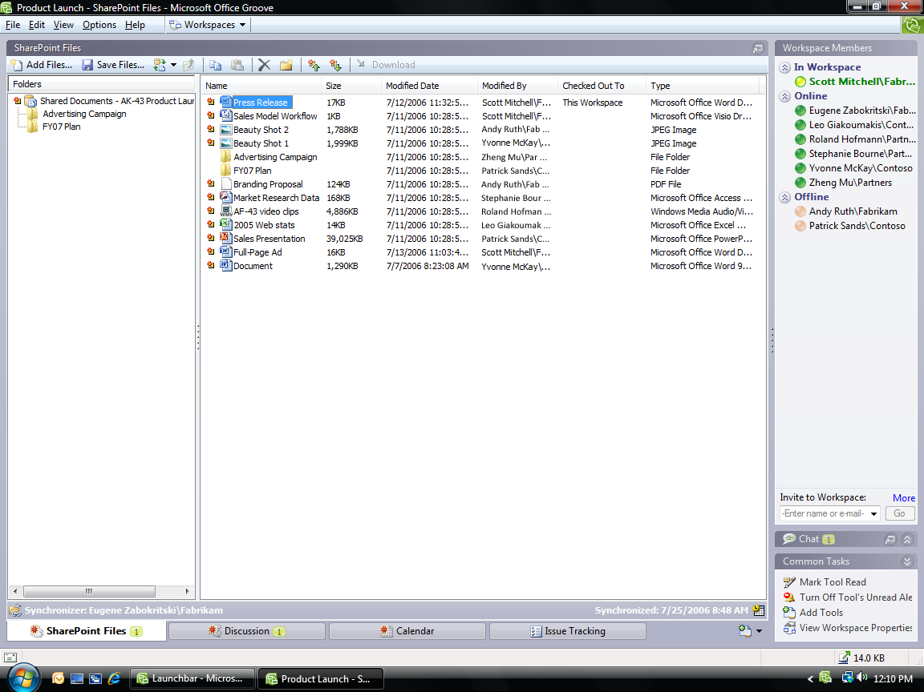

Example of Office Groove 2007 interface.

* **Create workspaces with two clicks without IT help or server space.**

Office Groove 2007 is software that runs on your computer like other Microsoft Office system applications. Creating a new workspace is as easy as creating a new Microsoft Office Word document or new Microsoft Office Outlook® e-mail message.

* **Customize workspaces to meet your project needs.**

Choose from more than 10 included workspace tools, such as file sharing, threaded discussions, team meetings, shared calendar, and more. Add content to workspace tools right from your computer or other systems.

* **Invite the team across departments, offices, and organizations.**

Inviting a partner, supplier, or customer to your Groove workspace is as easy as inviting a colleague. And you can share your workspace with confidence as Office Groove 2007 encrypts data on computers and as it travels across networks and firewalls.

* **Automatic synchronization keeps you and the team up to date.**

Office Groove 2007 keeps everyone up to date by automatically synchronizing each and every change made within the workspace.

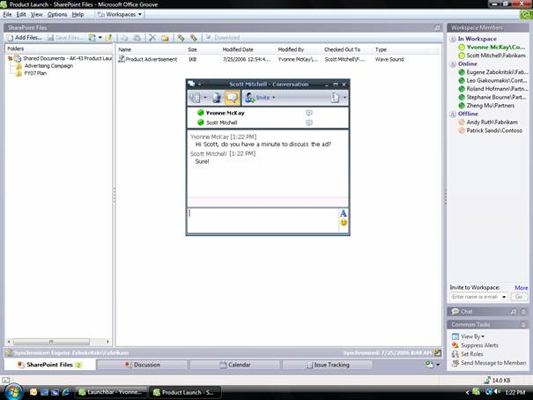

Work with familiar Microsoft Office system applications.

Increase Your Personal Impact on Team Projects

Because all your Groove workspaces are stored right on your computer, you can stay productive anywhere you need to work.

Work effortlessly anywhere—online or offline.

You don’t have to lose valuable work time just because a network connection is unavailable. Any changes you make in Groove workspaces while offline will be synchronized automatically the next time you connect.

* + **Share your document updates smoothly.**

When your documents are in a Groove workspace, you never have to worry about attaching, uploading, or copying updated documents to share them with your team. Groove automatically sends just your changes to your team members. Share and revise large files with ease.

Keep multiple computers in sync.

If you have multiple computers—a portable computer and desktop, for example—Office Groove 2007 can keep a copy of all your workspaces and data synchronized on each computer, even if they’re never online at the same time.

Create and Manage Content More Effectively

Office Groove 2007 helps streamline the process of creating and managing content—both unstructured and structured—by enabling teams to share and work together on information from existing business systems and applications and easily publish their final deliverables.



*Groove Alerts appear conveniently in the Windows Taskbar.*

* Simplify document publishing and workflows with SharePoint® document library integration.

You can now work smoothly with SharePoint document libraries, which enables you and your team members to share and iterate documents in a Groove workspace. Then, publish final versions to Microsoft Windows® SharePoint Services 3.0 or Microsoft Office SharePoint Server 2007 for workflows, storage, and retrieval.

* Extend structured business processes into Groove workspaces with Microsoft Office InfoPath® 2007 integration.

Now you can import your InfoPath forms into a Groove workspace to quickly and easily collect and track structured data among your distributed team. You can also integrate the data captured with back-end systems using Microsoft Office Groove Server 2007.

* + Help shorten cycle times with built-in communication tools.

If you’re working with your team in a Groove workspace, the integrated presence awareness and alerts tell you who’s online and who’s working on what, when. And with Microsoft Office Communicator 2007 integration, you can launch a real-time chat or phone call at just the right time.

Extend just the right data at the right time.

Project teams work on both unstructured and structured data, some of which comes from line-of-business applications. But when teams manually export data, redundancy and errors can result. With SharePoint Server and InfoPath integration, and a services-based integration platform, IT organizations can extend “live” data into Groove workspaces at just the right time. And Office Groove 2007 makes sure any changes are updated in the business systems—automatically.

For More Information

Learn more about Office Groove 2007 and the Microsoft Office system at <www.microsoft.com/office/groove>.

For complete system requirements, visit [www.microsoft.com/office/groove](http://www.microsoft.com/office/groove).

This document is for informational purposes only. MICROSOFT MAKES NO WARRANTIES, EXPRESS OR IMPLIED, IN THIS SUMMARY.

The example companies, organizations, products, domain names, e-mail addresses, logos, people, places, and events depicted herein are fictitious. No association with any real company, organization, product, domain name, e-mail address, logo, person, place, or event is intended or should be inferred.

MSlogo_k_1118© 2006 Microsoft Corporation. All rights reserved. Microsoft, Groove, InfoPath, the Office logo, Outlook, SharePoint, and Windows are either registered trademarks or trademarks of Microsoft Corporation in the United States and/or other countries. All other trademarks are property of their respective owners.