

Product Guide
February 2001

For more information, contact:
Rapid Response Team
Waggener Edstrom
(503) 443-7000
rrt@wagged.com

Abstract
This document provides an overview of Microsoft Office Developer XP. Microsoft Office Developer XP includes all the essential tools for quickly building and deploying Microsoft Office solutions.
For a complete discussion of Microsoft Office XP, see the Microsoft Office XP Product Guide.

© 2001 Microsoft Corp. All rights reserved.
The information contained in this document represents the current view of Microsoft Corp. on the issues discussed as of the date of publication. Because Microsoft must respond to changing market conditions, it should not be interpreted to be a commitment on the part of Microsoft, and Microsoft cannot guarantee the accuracy of any information presented after the date of publication.
This document is for informational purposes only. MICROSOFT MAKES NO WARRANTIES, EXPRESS OR IMPLIED, IN THIS DOCUMENT.
Complying with all applicable copyright laws is the responsibility of the user. Without limiting the rights under copyright, no part of this document may be reproduced, stored in or introduced into a retrieval system, or transmitted in any form or by any means (electronic, mechanical, photocopying, recording or otherwise), or for any purpose, without the express written permission of Microsoft Corp.
Microsoft may have patents, patent applications, trademarks, copyrights or other intellectual property rights covering subject matter in this document. Except as expressly provided in any written license agreement from Microsoft, the furnishing of this document does not give you any license to these patents, trademarks, copyrights or other intellectual property.
Microsoft, Microsoft Press, FrontPage, MSDN, PowerPoint, SQL Server, Visual Basic, Visual SourceSafe, Windows, and Windows NT are either registered trademarks or trademarks of Microsoft Corp. in the United States and/or other countries.
The names of actual companies and products mentioned herein may be the trademarks of their respective owners.
Microsoft Corp.• One Microsoft Way • Redmond, WA 98052-6399 • USA

Contents
Introducing Microsoft Office XP Developer 1
Office as a Development Platform 1
Overview of Office Developer 1
Who is the Office Developer 2
Packaging and Localization 2
Resources for Reviewers 3
Office XP Developer Design Goals 4
Productivity 5
Visual Basic for Applications 5
Code Librarian 5
COM Add-In Designer 6
Code Commenter and Error Handler 7
XML Designer 8
Integration with Visual Studio .NET shell 8
Integration with Visual SourceSafe 9
Tools for New Solutions 10
Smart Tag SDK 10
Workflow Designers 10
Digital Dashboard Template and Web Part Designer 12
Deployment of Office Solutions 14
Licensing and Distribution rights 14
Packaging Wizard 14
Conclusions 15

Introducing Microsoft Office XP Developer
Welcome to the Microsoft Office Developer Product Guide. Microsoft Office XP Developer provides all the essential tools for building and deploying solutions based on Microsoft Office XP. This document presents information that will help you evaluate Office Developer in terms of the new tools and solution types enabled by Office XP, as well as features that enhance developer productivity and facilitate deployment and management of Office solutions in the enterprise.

Office as a Development Platform
More than 2.6 million developers currently use Microsoft Office as part of their custom business solutions. The popularity of Office as a development platform can be attributed to its popularity as a suite of desktop productivity applications. Developers recognize that leveraging the Office platform found on 125 million desktops is the best way to build business solutions that integrate into a familiar environment.
With the release of Office XP, Microsoft has worked hard to augment the award-winning work in previous versions of Office with new features that enable broader types of custom solutions. With this release, Microsoft has continued to improve the Component Object Model (COM) and to integrate Visual Basic® for Applications (VBA) throughout Office. The Office XP applications include a broad set of new features and services that extend the types of custom Office solutions that can be built for both the enterprise and the Web. Office XP Developer provides the tools and features to enable developers to make use of this new functionality, as well as enhancements that ensure developer productivity.

Overview of Office Developer
The first version of Microsoft Office targeted specifically for developers was released in 1997. Dubbed the “Office 97 Developer Edition,” this product combined the Microsoft Office 97 applications with the Access Developer Toolkit and additional resources, such as documentation. The product proved to be popular among developers building solutions with Office. By gathering all the Office applications, tools, documentation, sample code, and redistributable components into a single box, Office Developer provided developers with a single source for everything needed to build solutions with Office.
Office 2000 Developer extended the Office platform by including a major release of Visual Basic for Applications (and VBA tools) and Workflow Designers for both Exchange 2000 Server and SQL ServerTM, which enable developers to build Web-based or server-based solutions to automate business processes within a department or corporation.
Office XP Developer improves upon the features of previous versions and adds new features that enhance Office as a development platform. These include programmatic access to the new features of Office XP, as well as tools that streamline development and deployment of Office solutions.

Who is the Office Developer
The Office developer base can be divided into two broad segments: corporate developers and solution providers (or value-added resellers). Corporate developers are typically IT or MIS staff within companies that have already committed to the Office productivity applications. These companies favor a “buy vs. build” approach, but still prefer to customize the applications and tool for the specific needs of their business. Their corporate customers emphasize the need for new tools to increase workers’ productivity, but seek to minimize costs of deployment and training. Solution providers offer services to the same type of customers, but place more emphasis on their own productivity and on the marketability of their skill set. In addition, solution providers increasingly target their solutions toward the Web (Internet or intranet) in whole or in part.
Office XP Developer meets the needs of both developer segments. Solutions built with Office result in shorter development cycles and satisfied end users. By building on the world’s most popular suite of productivity applications, Office solutions leverage the corporate customers investment in software as well as end-user training. Office XP has added features to include Web-based functionality and enhance collaboration. Combined with the robust workflow tools and integration with server-based solutions introduced in Office 2000 Developer, Office XP Developer represents the ideal platform for developers targeting the corporate market.

Packaging and Localization
Office XP Developer includes all the essential tools for building and deploying Microsoft Office solutions. Office XP Developer components include:
- Microsoft Office Professional
- Microsoft Word version 2002
- Microsoft Excel version 2002
- Microsoft PowerPoint® version 2002
- Microsoft Access version 2002
- Microsoft Outlook® version 2002
- Microsoft FrontPage® version 2002
- Workflow Designer for SQL Server
- Workflow Designer for Exchange 2000 Server
- Developer-only versions of SQL Server and Exchange 2000
- Smart Tag SDK
- VBA Productivity Tools
- Visual SourceSafe®
- Royalty-free distribution licenses for the Access Runtime and MSDE.
- Full year subscription to the MSDN® Library

Office XP Developer is localized into English, Simplified Chinese, Korean, Traditional Chinese, Dutch, Swedish, Japanese, Italian, French, Spanish, and German.

Resources for Reviewers
There are many resources available to help you review Microsoft Office Developer XP. If you need help beyond what is included with this document and the accompanying material, your primary resource is the Reviews Team at Waggener Edstrom. If you have questions about the product or require technical support, e-mail rrt@wagged.com or phone (503) 443-7000.
The following resources are also available to help guide your review:
- Microsoft Office Product Guide provides detailed descriptions of the individual Office applications, including design goals and new/enhanced features of interest to end users as well as developers.
- Microsoft Office Developer’s Guide is included with Microsoft Office Developer and is available from Microsoft Press®.
- The Microsoft Office Developer Center on MSDN includes in-depth articles on a variety of development topics. http://msdn.microsoft.com/office.

Office XP Developer Design Goals
The design effort for Office XP in general, and Office XP Developer in specific, took into account the business conditions and trends that drive demand for new, custom business applications, as well as feedback from both customers and professional developers. Based on this input, Microsoft arrived at three major design goals for Office XP Developer:
- Provide tools that enable new solution types. Business and computing are becoming increasingly focused on the Web—both the Internet and corporate intranets—as the primary medium to deliver and share information and applications. To meet this trend, Microsoft has built Web technologies into all Office applications. Office XP also delivers tools and components that enable the development of Web-based collaboration, workflow, and data-driven solutions.
- Improve developer productivity. Product cycle times continue to decrease. Both developers and their customers place high priority on achieving fast time to market and fast time to benefit, with no degradation of quality. Office XP Developer focused on providing enhanced development tools and documentation to enable developers to build Microsoft Office solutions quickly.
- Facilitate deployment and management. Businesses are focused on the bottom line. Reducing costs associated with deploying and maintaining software and services has direct impact on profitability. Office XP Developer provides all of the necessary tools for easily deploying and managing Office solutions, and includes updated licensing models.
The following sections introduce specific features of Office XP Developer, as they relate to these design goals.

Productivity
The following new features and enhancements are designed to allow developers to work more efficiently, streamlining development times and making the developer’s job easier.

Visual Basic for Applications
One of the most significant technologies that contribute to the extent to which an application is customizable is Visual Basic for Applications (VBA). VBA is a version of the Microsoft Visual Basic development system designed specifically for applications. VBA provides developers with a consistent development language and environment for customizing and integrating applications. VBA enables millions of developers to build solutions specifically for Microsoft Word, Access, Excel, PowerPoint, FrontPage and Outlook (or any of more than 70 third-party applications that host VBA). This enables companies to connect desktop solutions with every part of their organization, across multiple line-of-business applications. When creating solutions in VBA, developers benefit from the increased performance of code running in the same memory space as the host application—up to 200 times faster than code running outside of the application.
The VBA tools in Office XP are designed to meet the needs of millions of professional developers building solutions with Microsoft Office and Visual Basic for Applications. These developers recognize the benefits of reusing rich application functionality to quickly build solutions that customize and integrate Office with line-of-business applications and data.

Code Librarian
The Office XP Developer Code Librarian is a powerful but simple tool for managing reusable code. It makes development more efficient by facilitating re-use of code, and by allowing developers to manage and share libraries of snippets and sample code. A popular feature of Office 2000 Developer v1.5, the Code Librarian has been upgraded to make organizing and sharing code easier than ever.
With Office XP Developer, the Code Librarian is fully integrated with the Visual Studio® shell. As such, it inherits features such as the project explorer, edit window, and property browser. Developers can search through libraries visually or by using a search utility. Once the desired code segment has been found, the developer can drag snippets of code directly from the code librarian window to the code window of the Visual Basic for Applications Editor or Visual Studio.
The Code Librarian Viewer enables users who do not have the Code Librarian to view and retrieve code snippets from a published library.
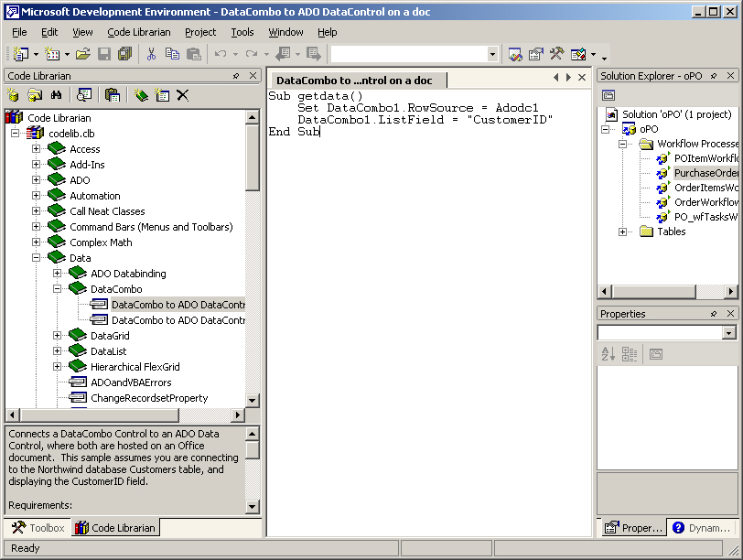
The updated Code Librarian makes organizing and sharing code easier than ever.

COM Add-In Designer
COM Add-ins are useful for adding functionality at the application level, where the code applies to any document, spreadsheet, or presentation. A developer can use a COM Add-In to create extensions to any of the Office applications; for example, an add-in could query customer information from a SQL Server database and insert that information into an Outlook message. A COM Add-in is a dynamic-link library (DLL) that is specially registered so that it can be loaded by the Office XP applications.
The Office XP Developer COM Add-in Designer enables developers to quickly create COM Add-Ins, right from the VBA environment. Developers using the VBA Tools can use the COM Add-in Designer to create a standalone, Add-in project. Developers using the Visual Studio development system can also use the Visual Basic, Java, and C++ templates that are included to build COM Add-ins for Office.

Code Commenter and Error Handler
In Office XP Developer, two popular tools have been consolidated into a single interface. The Code Commenter and Error Handler automate repetitive tasks and help developers to follow best practices for design consistency and error handling within their applications.
The VBA Code Commenter and Error Handler merges a user-supplied template with the code in a project, enabling developers to accommodate design consistency or departmental requirements with very little effort. Developers can add structured headers or standardized error handlers to every single procedure within an application from a simple, automated interface. Templates can be created at any time and saved for later use, so each developer can apply specific comment syntax to their area of a project, at the Project, Module, or specific Procedure level.
Both the Code Commenter and Error Handler derive formatted text from a default template included with Office XP Developer. This template can be edited, or it can also be replaced with custom templates (.txt files) that might be required for specific projects or teams.
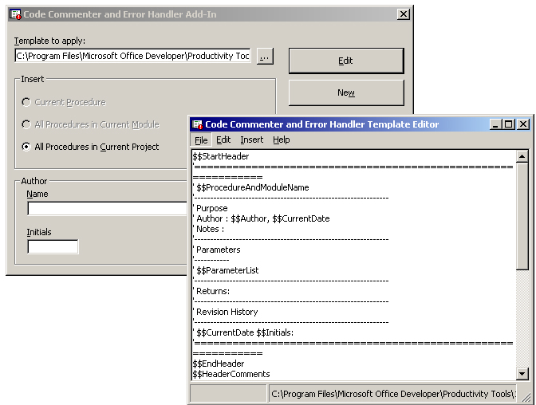
The Code Commenter and Error Handler Add-In automates repetitive tasks, allowing developers to apply structured headers from editable templates.

XML Designer
Extensible Markup Language (XML) provides a standard for exchanging data between applications and/or disparate business systems. Native XML support in Excel and Access enables Office developers to create data-driven solutions that share data with a virtually unlimited number of sources and interoperate with external applications, whether within the corporation or over the Web.
Office XP Developer includes a new XML Designer that allows developers to easily create and manipulate XML data using a designer. The XML Designer provides an XML Source view for working with XML and XSD (XML schema definition) files. The XML Source view provides an editor for creating and editing XML, which offers color-coding and Microsoft® IntelliSense® statement completion. Developers can create or edit XML code by typing directly in the Source View editor window. The designer color-codes the XML source code as it is input and automatically completes tags, offering a pop-up list of available properties as a tag is inserted.

Integration with Visual Studio .NET shell
Several Office XP Developer tools efficiently leverage the skills of developers who are already familiar with the Microsoft Visual Studio development tools. The environments of the Office XP Developer Workflow Designers, Web Part Designer, and Code Librarian are immediately recognizable as the Visual Studio shell, and include all the features that make Visual Studio the most popular integrated development environment (IDE) in the world.
For professional developers who use Visual Studio, the Workflow Designers and Web Part Designer can be used alone or as a project within Microsoft Visual Studio .NET. In either case, developers have access to the features such as statement completion, drag and drop, and a world-class HTML editor, which ensure maximum developer productivity. Developers who routinely use Visual Studio will appreciate the ability to open Office XP Developer projects—including the Workflow Designers and Web Part Designer—alongside the world-class development languages and tools available in Visual Studio.

Integration with Visual SourceSafe
Office XP Developer facilitates source code control by integrating the Microsoft Visual SourceSafe version control system into VBA. Source Safe enables users to store current files along with past changes to documents, source code, and Web content, so they can easily recreate previous versions and maintain an audit trail for any file. By using Visual Source Safe, developers not only have easy-to-use version control for private office projects, but when working in a team environment, they can automate the process of managing the source code with read/write security, file sharing, source code browsing, and many other shared code services.
In a team environment, the ability to maintain tight control of code versions shared by a number of developers reduces the chance for lost work. Different members of a development group, perhaps from different business units, can effectively contribute to a solutions framework by checking their code in or out without leaving their development environment or disrupting the integrity of trusted source code.

Tools for New Solutions
The following new tools support innovation. By taking advantage of the new features and services available in Office XP, developers can create custom solutions tailored to the unique needs of an organization or industry.

Smart Tag SDK
One of the most exciting new features of Office XP, Smart Tags, provides a broad opportunity for developers to create custom, innovative solutions. Using the Smart Tag infrastructure introduced in Office XP, developers can add intelligence to Office applications and custom solutions by developing “recognizers” that identify strings of one or more specific data types (for example, book titles, chemical formulas, or case numbers).
The Smart Tag Software Development Kit (SDK) enables developers to quickly create powerful Smart Tags that take full advantage of the capabilities of this exciting technology. The SDK includes detailed information on the interfaces and samples to get started.
The recognition of Smart Tag types is supported in Microsoft Word and Microsoft Excel, and support has been added for exposing Smart Tag actions within Internet Explorer, so that documents created with these Office applications will retain their Smart Tags when viewed as a Web page.

Workflow Designers
Office XP Developer includes a set of professional tools specifically for developing collaboration and workflow solutions using SQL Server 7.0 (or greater) and Exchange 2000 Server. These tools enable developers to visually define a workflow process that controls information flow and automates business processes within a department or corporation.
First introduced in Office 2000 Developer v1.5, the Workflow Designers have proven popular with developers creating solutions that support corporate knowledge management. Office XP Developer improves in the designer interface and developer experience, allowing access to both the SQL and Exchange Workflow Designers from a single interface.
Office XP Developer includes the following workflow tools:
- Workflow Designer for Exchange 2000 Server. Design and build collaborative workflow and tracking solutions. Easily define information flow and create business rules within Exchange Server-based solutions, such as Office document routing.
- Workflow Designer for SQL Server. Design and build solutions that automate business processes on SQL Server data. Quickly build Web-based solutions that automate a series of tasks, designate task order, and assign permissions on who can perform them. The workflow designer for SQL Server enables developers to visually design workflow processes on SQL Server data when using Access as a front end to SQL server data.
- Developer-only versions of SQL Server 7.0 and Exchange 2000 Server. Bundled versions of SQL Server and Exchange Server enable Office developers to test their workflow solutions thoroughly before deploying them to the enterprise.
- Workflow samples and white papers. These resources help developers learn to build workflow solutions with reference materials, including fully functional workflow solutions and step-by-step white papers.
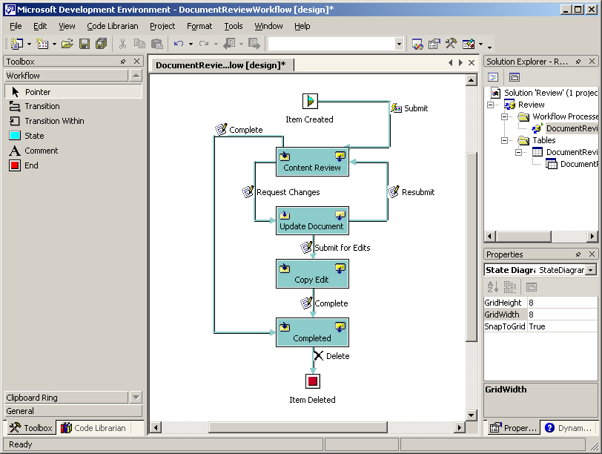
The graphical Workflow Designer enables developers to create solutions that automate business process and manage information flow.

Digital Dashboard Template and Web Part Designer
Digital dashboards enable better knowledge management by consolidating personal, team, corporate, and external information and providing single-click access to analytical and collaborative tools—-all in a single, familiar desktop view. Because they rely on widely available Web technologies and the familiar user interface of Microsoft Internet Explorer 5.0 or Microsoft Outlook, digital dashboards provide exceptional ease of use and ease of development. And because they provide users with access an unlimited realm of corporate or external information and data analysis tools, digital dashboards represent provide the most efficient and flexible knowledge management solutions available today.
Digital dashboards are built on “Web Parts,” reusable components that can contain any kind of Web-based information. Developers can quickly build Web Parts from HTML and other Web-based controls, and deploy them using the existing Digital Dashboard infrastructure. The Office XP Developer Digital Dashboard project template includes tools for building Web Parts or complete Digital Dashboards that run against Exchange 2000 Server or the new Microsoft SharePointTM Portal Server.
The Dashboard template and Web Part Designer can be used as standalone applications or opened as a project in Visual Studio .NET. In each case, developers benefit from the features of the Visual Studio shell, including
- Solution Explorer, which hierarchically represents the dashboard and any resources, Web Parts or sub-dashboards that it contains.
- Properties Grid, which exposes the properties of the Web Parts and Dashboards.
- Common HTML Editor, which supports color-coding and statement completion.
- Toolbox, which contains the HTML design-time controls that you can drag and drop into Web Parts.
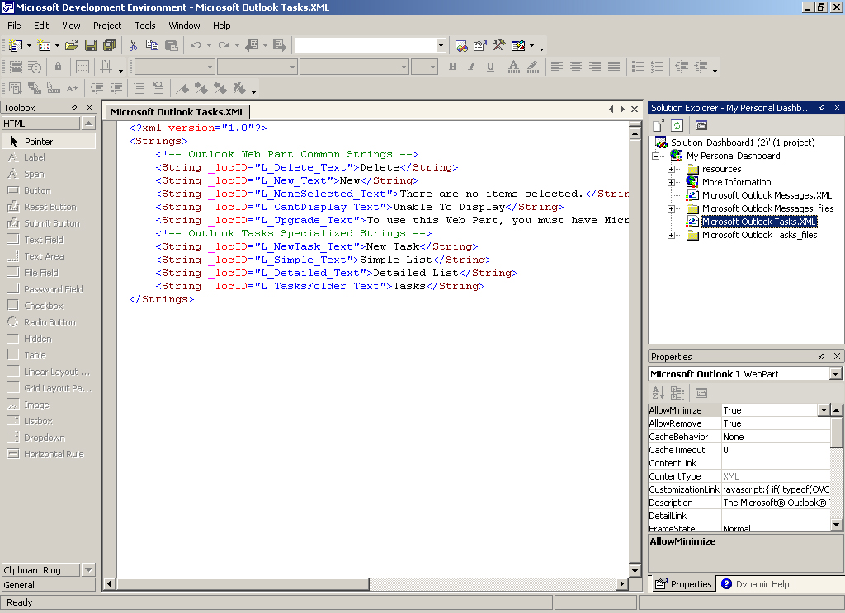
The Web Part Designer includes familiar features of the Visual Studio environment, such as color-coding, automatic statement completion,
drag-and-drop controls, and the properties grid.
Office XP Developer streamlines the deployment of Web Parts and Digital Dashboards by providing the ability to save a dashboard, its Web Parts, sub-dashboards and all its properties from one store location to another store location. Developers creating solutions for SharePoint can also open the SharePoint Portal Server workspace in the MOD development environment and create Web Parts (or editing content) directly on the portal. Developers can also save Web Parts and their resources as XML and import Web parts and their resources as XML into a dashboard project.
Office XP Developer includes a library of pre-built Web Parts to give developers a jump start on their Digital Dashboard projects.

Deployment of Office Solutions
Office XP Developer Makes it easier than ever before to deploy and manage solutions built on the Office platform. New tools for packaging and deployment facilitate the process, while new licensing and distribution agreements make it easier for developers to bring solutions to market, whether to a small business or a large enterprise, as a third party or internal developer.

Licensing and Distribution rights
The licensing agreements included with Office XP Developer make it easier than ever to distribute solutions or code segments:
- Access Runtime. Distribute Access solutions to any desktop. MOD includes royalty-free Access Runtime (including the Microsoft Graph run time application), which allows distribution of Access applications and Access Data Projects.
- Redistributable MSDE. The SQL-compatible Microsoft data engine (MSDE) allows developers to build solutions that can easily scale to SQL Server with no code change. MOD ships with the royalty-free redistributable MSDE, so developers can quickly deploy databases and solutions that are compatible with SQL Server.
- Code Librarian Viewer. Using the Code Librarian, developers can freely distribute code samples and snippets to other developers, who can easily re-use this code in their own solutions. MOD includes a freely distributable read-only version of the Code Librarian, which can be used without MOD.

Packaging Wizard
Office XP Developer includes a Packaging Wizard that makes it easy for developers to create professional setup routines for solutions built with Office XP. The wizard identifies dependency files and creates a setup program that can be distributed on any media for installation from disk, over a network, or on the Web.
The wizard works with solutions created in Access, Word, Excel, and PowerPoint, as well as Visio®, Project and Publisher. It can also be used with SQL-based solutions and workflow solutions. (FrontPage and Outlook are not supported.)

Conclusions
Developers have been building custom solutions based on Microsoft Office for a long time. Each new version of Office has introduced new tools and technologies that make it easier to develop and deliver custom Office-based solutions. Microsoft Office Developer XP continues this tradition by offering everything developers need to access a rich platform of pre-built functionality on which to build their solutions.

