Microsoft® Identity Integration Server (MIIS) 2003 helps you
- Synchronize identity information across a wide variety of identity stores.
- Easily provision and de-provision accounts and identity information across systems.
- Synchronize passwords and enable self-service and helpdesk- initiated password management and reset from a Web browser.

Microsoft Identity Integration Server 2003, Enterprise Edition (SP1)
MIIS 2003, Enterprise Edition, Service
Pack 1 includes support for a wide variety of identity repositories including:
- Active Directory®
- Active Directory Application Mode
- Delimited, AVP, & fixed-width text files
- Directory Services Markup Language
- Global Address Lists (Exchange)
- IBM DB2 databases, Directory Server
- LDAP Directory Interchange Format
- Lotus Notes/Domino 4.6, 5.x, and 6.x
- Microsoft Windows NT 4 Domains
- Microsoft Exchange 5.5 Bridgeheads
- Microsoft Exchange 5.5, 2000, & 2003
- Microsoft SQL 7 and 2000 databases
- Novell eDirectory v8.6.2 and v8.7.3
- Oracle 8i and 9i databases
- SunONE/iPlanet/Netscape Directory
- IBM Informix, dBase, Access, Excel, OLE DB via SQL DTS
- A management agent software development toolkit (SDK) and packager enables customers and ISVs to connect to any data source and create management agents that can be integrated with MIIS 2003.
Synchronize Identity Information
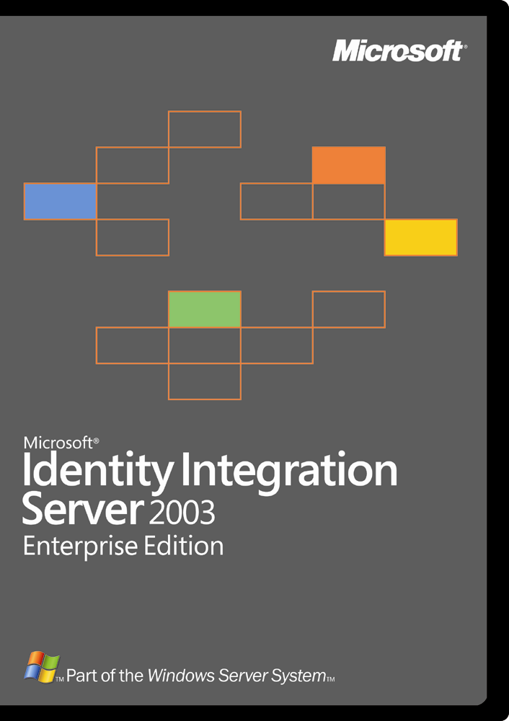
MIIS 2003 enables a company to synchronize identity information across a wide variety of heterogeneous directory and non-directory identity stores. This allows customers to automate the process of updating identity information across heterogeneous platforms while maintaining the integrity and ownership of that data across the enterprise.
You benefit from improved productivity and reduced administrative costs as identity data is kept up to date across an enterprise without manual intervention.
Provision User Accounts and More
MIIS 2003 allows you to easily provision and de-provision user accounts and identity information like distribution, e-mail, and security groups across systems and platforms. Customers will be able to quickly create new accounts for employees based on events or changes in authoritative stores like the human resources system. Additionally, when employees leave a company, they can be immediately de-provisioned from those same systems.
End users can be more productive by accessing needed systems faster while corporate security is improved as employees’ access to systems is automatically terminated when they leave. Administrators benefit from having these processes automated which improves their own productivity and helps to lower administrative costs.
Manage and Synchronize Passwords
Passwords can be synchronized from Active Directory to any connected system automatically. Additional password management capabilities allow end users or helpdesk staff to easily reset passwords across multiple systems from one easy-to-use Web interface. End users and helpdesk staff will no longer have to use multiple tools to change their passwords across multiple systems.
Password resets are the single greatest cost associated with a helpdesk. These features help companies to reduce the cost of their helpdesk operations while improving the productivity of their information technology workforce.

Other Key Benefits
SQL Server 2000 Integration
SQL Server 2000 provides a powerful and comprehensive data management platform with revolutionary self-tuning and dynamic self-configuring features that optimize database performance—all of which makes SQL a perfect fit as the data repository for your identity information.

Visual Studio .NET Integration Customers who wish to customize or extend the capabilities of MIIS 2003 can use any of the languages supported by Visual Studio® .NET 2003, such as Visual Basic .NET, Visual C++ .NET, Visual C# .NET, Visual J# .NET, or a third-party language such as Perl. Visual Studio .NET 2003 offers a highly productive environment in which you can extend or customize your MIIS 2003 implementation.
Summary
MIIS 2003 enables a company to both increase security and productivity while lowering IT costs. With features like password synchronization, self-service password management, enhanced user provisioning, and connectivity to a wide variety of platforms and systems, MIIS 2003 is a company’s best choice for a scalable, reliable, integrated identity system.

