Spreadsheet Compliance in the 2007 Microsoft Office System
White Paper
April 2006
Table of Contents

Executive Summary 3
Introduction 3
Regulatory Compliance 3
Background 3
Spreadsheets: An Enterprise Software Resource 3
Process Challenge 3
Every Situation is Unique 3
Compliance Strategies for Spreadsheets 3
1. Evaluate the Current Situation 3
2. Implement Appropriate Controls 3
3. Develop a Long-Term Spreadsheet Development and Maintenance Methodology 3
How the 2007 Microsoft Office System Can Help Address Compliance Challenges 3
Preventing Unauthorized Access to Spreadsheets 3
Managing and Monitoring Spreadsheet Changes 3
Retaining and Archiving Spreadsheets 3
Developing Robust Spreadsheet Models 3
Conclusion 3
Links 3
Information About the 2007 Microsoft Office System 3
Financial Regulation Documents 3
Appendix 3
Table of Relevant Regulations 3
Microsoft Office System Capabilities Matrix 3

Executive Summary

Spreadsheets offer the flexibility and ease of use of a desktop application, combined with the power to perform complex data analysis. As a result, spreadsheets are used to support critical business processes in most organizations. In fact, research indicates that over half of financial management reporting is performed with spreadsheets. Despite this, a disparity exists between the importance of spreadsheets to business processes and the level of corporate resources devoted to spreadsheet development, testing, and maintenance.

Organizations today are under considerable regulatory pressure to ensure that financial reporting processes are both transparent and well-documented. Three visible examples of such legislation are the Sarbanes-Oxley Act (United States, 2002), the Data Protection Act (European Union, 1998), and the Basel Capital Accord (Basel II, 2006), which together impact most publicly-traded companies around the world. However, corporate finance is just one area affected by compliance legislation; separate industry and local regulations also exist. An organization must take into account all applicable policies and requirements when developing a regulatory compliance framework.

Implementing a sustainable spreadsheet compliance framework requires cooperation between each level of an organization, from executive management to the individual business user. Such a framework must meet the needs of both the business and the IT department. This paper will describe the steps that should be taken to identify and control spreadsheets once an overall compliance frame work has been implemented. An example of the approach taken by the Microsoft Corporation Financial Compliance Group is also included.

When combined with a sound compliance strategy, technology can help enforce policies and increase business productivity. The final section will discuss capabilities available in the 2007 release of the Microsoft® Office system that can help address the following common compliance challenges:

- Preventing unauthorized access to spreadsheets
- Managing and monitoring spreadsheet changes
- Retaining and archiving spreadsheets
- Developing robust spreadsheet models

The strategies and technology described in this paper can help organizations achieve success in establishing spreadsheet control policies that meet both regulatory requirements and business needs.
Introduction

Because of the ease of use, flexibility, and power of spreadsheets, they support many critical business functions and often fill roles where other solutions would be too slow or costly to implement. As a result, spreadsheets have quietly become a key component in the analysis and reporting processes within most organizations, including the mission-critical area of financial reporting.

In the United States and around the world, there has been increasing focus on demonstrating regulatory compliance, especially within corporate financial processes. This is due in part to new legislation, such as the Sarbanes-Oxley Act and an increased public scrutiny of corporate accounting practices, that has highlighted a need for stricter controls over the analysis supporting financial statements. Because spreadsheets are an enterprise resource that support key business processes, it is important to determine how they fit into an overall strategy for regulatory compliance.

This paper will provide the reader with a set of practical strategies for addressing spreadsheet compliance from an organizational level. It will also describe capabilities in the 2007 release of the Microsoft Office system that can help support and enforce a compliant spreadsheet environment. While these strategies highlight financial analysis and reporting scenarios, they are not regulation-specific and can be applied to scenarios where spreadsheets are employed across different industries and geographies.

Regulatory Compliance

Background
Regulatory compliance is now, more than ever, a key issue for organizations around the world. Financial compliance is one area in particular that has received much scrutiny in recent years. New legislation has been written to ensure that organizations’ financial analysis and reporting processes are both transparent and accurate. The three most visible examples of this legislation are the Sarbanes-Oxley Act (United States, 2002), the Data Protection Act (European Union, 1998), and the Basel Capital Accord (Basel II, 2006), which together affect most publicly traded companies. Corporate finance, however, is just one of many areas where compliance policies have been defined and enforced. The pharmaceutical and health industries, for example, have been subject to strict regulation for years. Compliance policies also are subject to local legislation, with regional governments often establishing their own compliance requirements. An organization must take into account all applicable policies and requirements when developing a regulatory compliance framework.

Spreadsheets: An Enterprise Software Resource
Though they may not be thought of in the same manner as database or custom software systems, spreadsheets are a key enterprise asset for most organizations. In the words of auditor PricewaterhouseCoopers, spreadsheets are “an integral part of the information and decision-making framework for companies.” However, evidence has shown that in some organizations there is the general perception that spreadsheets are a tactical tool without strategic importance. As a result, the resources dedicated toward the implementation and control of critical spreadsheets are small in comparison to other information technology assets. These disparities represent the most significant road block to spreadsheet compliance. Before controls can be implemented and enforced, management must acknowledge spreadsheets as a critical enterprise resource and then budget and plan accordingly.

Process Challenge
One common misconception in organizations is that spreadsheet compliance can be achieved through the use of technology. While technology plays a role in any compliance strategy, the most important component is process. Critical spreadsheets and other enterprise IT resources require sound development and usage practices that include controlled testing, deployment, maintenance, and use. An effective plan will incorporate these steps into the larger compliance framework for spreadsheets and other enterprise resources. The points listed below are prerequisite to developing such a plan.

Executive-Level Commitment
The need for compliance policies must be recognized at all levels within the organization. Cooperation between managers across functional departments is important to defining robust controls that are in line with business objectives. Without executive-level commitment it will be difficult, if not impossible, to enforce and maintain an effective compliance strategy.

Getting IT and Business Users on the Same Page
To be successful, a compliance strategy must be driven by the needs of the business and its users. A plan that fails to do so will hinder business productivity and prove unsustainable. This problem can be addressed from the start by engaging both IT staff and individual users. Collaboration is particularly important when defining spreadsheet controls because members of the business team often serve as both users and developers of critical spreadsheet applications. Because IT staff have knowledge of spreadsheet functionality, getting them involved early can help reduce duplication of work and increase the robustness of the solution.

Allocating Appropriate Resources
Implementing an effective compliance strategy takes time and effort. Representatives from many different groups must assist in defining controls that meet business objectives. Representatives often include members of the IT, internal audit, and finance departments, but can involve others depending on the needs of the organization. Additionally, it may make sense to use software to help monitor and control spreadsheets, but this can require financial and development resources as well. Once implemented, the control processes must be monitored and enforced by dedicated people with an understanding of the overall compliance strategy.

Every Situation is Unique
Every organization is unique in how it uses technology in its business, and each has its own set of challenges and goals to consider when developing a compliance framework. As a result, there is no single prescriptive compliance solution that satisfies the needs of all. An effective strategy will consider the operational risks, business objectives, and specific regulations with which the organization must comply. The following section offers specific steps for identifying and controlling critical financial spreadsheets, but these strategies can be adapted to meet the particular needs of the organization’s larger compliance framework.

Compliance Strategies for Spreadsheets

Once an organization has an overall framework for regulatory compliance, the following steps can help identify and control critical spreadsheets in a way that can be maintained. There are three key steps to implementing this process:

- Evaluate the current situation.
- Implement the appropriate controls.
- Develop a long-term spreadsheet development and maintenance methodology.

This section will cover each of these in detail.

1. Evaluate the Current Situation
Inventory Relevant Spreadsheets
Before critical spreadsheets can be controlled they must first be identified. Perform an inventory to count the number of spreadsheets in the organization that may have an impact on compliance. In most organizations this applies to spreadsheets concentrated in specific high-risk departments. In the case of corporate finance this includes areas that support the analysis and reporting of financial accounting data. During the inventory, note each spreadsheet’s purpose and relationship to critical business processes. This information will be important for determining the appropriate controls for each spreadsheet. Inventories can be completed manually by inspecting hard drives and shared folders, or automatically by using software that scans a corporate network to target spreadsheets.

Identify Business-Critical Spreadsheets
Not all spreadsheets in an organization require rigorous compliance controls. An inventory may return thousands, if not hundreds of thousands of spreadsheets, many of which will likely have little or no compliance impact. It would be overwhelming and unproductive to implement strict controls for each spreadsheet. Therefore, teams must identify and isolate the spreadsheets that support critical business processes, where a lack of controls could lead to material errors. In corporate finance, materiality is often defined as an error that involves 5 percent of net income or total assets, but this definition should be tailored to satisfy the organization’s compliance requirements and the departments involved. In most cases, only a small percentage of an organization’s spreadsheets match these criteria.

Case Study: Microsoft Corporation
As an example, the Microsoft Corporation Financial Compliance Group works with management, internal auditors, and external auditors to perform an inventory of important spreadsheets used for financial reporting. A recent inventory yielded 42 business-critical spreadsheets in use. The following filtering criteria were used to identify these spreadsheets.

Quantitative Criteria
Microsoft uses the following criteria to flag inventoried spreadsheets for further analysis.

- A spreadsheet that documents a journal entry greater than a pertinent dollar threshold. This threshold is derived as a percentage of materiality on a quarterly basis to support quarterly reporting.
- A spreadsheet that serves as a recording ledger for an account with a balance greater than a pertinent dollar threshold. This threshold is derived as a percentage of materiality roughly four times greater than the threshold for supporting a journal entry.
- A spreadsheet that directly supports a financial statement disclosure.

Qualitative Criteria
Qualitative criteria are formed by an assessment of the inherent and historical risks of the information contained within a spreadsheet. Microsoft conducted a risk assessment to identify these important criteria.
Examples of qualitative criteria used by Microsoft include:

- Whether the spreadsheet contained a high degree of complexity. For example, the spreadsheet includes complex use of formulas and calculation, a high number of connections to multiple worksheets or external data sources, or employs macros or other code.
- Whether the spreadsheet is used by a new department or division that lacks an established report history.

It is important to note that quantitative and qualitative criteria are not applied sequentially; instead they form a two-pronged approach to identifying business-critical spreadsheets. While it is often the case that business-critical spreadsheets meet both quantitative and qualitative criteria, this is not a requirement.

2. Implement Appropriate Controls
Once business-critical spreadsheets have been identified and the risks defined, the next step is to implement appropriate controls for each one. Often this process cannot be implemented all at once. It may be necessary to break up the work by division or business unit, addressing the most important areas first. The section below describes the risks and corresponding control activities Microsoft uses to manage its critical spreadsheets.

Control Activities
Control activities are the steps taken to mitigate risk and to meet the control objectives. The control activities employed by Microsoft corporate controllers fall into two categories:

- Preventative—controls that prevent undesirable events from occurring.
- Detective—controls that detect undesirable events that have already occurred.

The table below specifies the potential compliance risks for business-critical spreadsheets and the corresponding control activities defined by the Microsoft Financial Compliance Group.

Potential risk | Control activity
Unauthorized access and modification of data or formulas may result in output or reporting errors. Loss of the archived (prior reporting period) spreadsheets may damage the audit trail. | Save spreadsheets to a location that allows restricted user access and regular backups.
Unauthorized modification of historical data may damage audit trail. | Convert spreadsheets from previous reporting periods to a read-only format and securely archive them for later retrieval.
Spreadsheets may be initially set up with incorrect formulas or inadvertent changes may degrade the model integrity of the spreadsheet, resulting in output and reporting errors. | 1. Test overall model mechanics and material changes before the spreadsheets are used.
 | 2. Retest spreadsheets once annually.
 | 3. Lock formula cells to prevent inadvertent changes.
 | 4. Review mechanics each reporting period in sufficient detail to detect inadvertent changes.
Entered data is incomplete or disagrees with the source, which results in output and reporting errors. | Check cells* are used to validate data accuracy and the completeness of entry.  *A check cell is subtotal cell that counts how many records (line items) are entered and the value of the records entered.
Lack of knowledge about how to properly use spreadsheets compromises the current and future ability to generate correct results and accurate reports. | Divide spreadsheets into three worksheets to separate input values, formulas, and resulting calculations.
 | Document key elements of spreadsheets, such as input cells, formula cells, output cells, and data sources; and summarize calculation methodology and spreadsheet use procedure.

Defining and implementing control activities, including those described above, is an important step toward addressing the compliance risks associated with business-critical spreadsheets. The next section describes how an organization can apply these principles to new business-critical spreadsheets through a controlled development process.

3. Develop a Long-Term Spreadsheet Development and Maintenance Methodology
A long-term strategy for mitigating risk should include the use of a development methodology for critical spreadsheets. Academic research indicates that spreadsheet development shares many characteristics with traditional software development. Error rates tend to be similar between the two, as are the benefits gained from a sound development lifecycle that includes design, inspection, and maintenance. Historically, spreadsheet development has not received the level of developmental rigor given to other forms of enterprise software. As a result, spreadsheets that drive key aspects of the business often lack important controls and thus introduce a compliance risk for the organization. The solution is to treat the development of business-critical spreadsheets like enterprise software and adhere to a formal development methodology when creating them.

Here is a recommended development approach to creating spreadsheets:

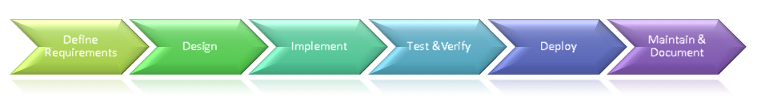
Define Requirements
Begin by defining the requirements of the spreadsheet model. This phase should include a detailed description of the spreadsheet’s business purpose, including the functions it will perform and its impact on the broader business process. It is wise to scope and define boundaries here as well; this will help prevent the spreadsheet from growing large and unwieldy during the design and development phases. Additionally, this phase should include validation from each spreadsheet user that the model will satisfy their business needs.
Design
The design phase maps a detailed plan for implementing the business requirements defined in the first phase and should result in a spreadsheet blueprint. This blueprint describes the formulas and functions needed for the core logic and layout of spreadsheet.

Well-designed spreadsheets include the following characteristics:

- A clear, visual separation of input, output, and calculation cells.
  - This can be achieved through layout, placement, and formatting.
- Lockable and protectable cells that should not be modified.
- A standard organizational method.
  - For example, a top-down organization in which formulas never refer to cells located below them.
- Standard naming conventions throughout the spreadsheet.
- Named ranges to reduce errors and increase formula readability.
- Simple formulas.
  - This can be achieved by dividing complex business logic among multiple cells.
- Extensive documentation throughout the spreadsheet.
  - For example, embedded comments throughout the spreadsheet and tables of contents and formatting legends to clarify structure and layout.

It is imperative to incorporate spreadsheet user feedback during the Design phase to ensure that the final blueprint is flexible enough to be used, but strict enough to respond to organizational controls.

Implement
Once the blueprint has been created and validated, it is time to create the spreadsheet. If the Requirements and Design phases have been completed with care and a high level of detail, this step should simply assemble the pieces as described in the spreadsheet blueprint.

Test and Verify
Like any new piece of custom software, spreadsheets will contain errors. Thus, testing and verifying the spreadsheet’s calculation accuracy is critical to ensuring confidence in the model. Different ways to test a spreadsheet include targeted audits, test case verification, scenario testing, and code inspection. Of these methods, code inspection has been shown to be the most complete for catching errors. Research indicates that code inspections tend to find on average over 80 percent of the errors in spreadsheets. However, this method is also the most resource intensive, involving teams of 1 to 3 reviewers who have a firm understanding of the spreadsheet to analyze it closely for logic and input errors. Regardless of the method, test passes should happen regularly throughout the implementation phase by individuals other than those who initially created the spreadsheet. In addition to good testing practices, third-party testing tools can be used to help identify and repair spreadsheet errors.

Deploy
At deployment, control activities must be determined and applied. The controls needed for compliance will vary depending on the complexity and importance of the spreadsheet. Examples of spreadsheet controls were described in the previous section of this paper.

Other activities to consider at deployment include:

- A formal transition to a production environment.
- Back up of source files.
- Storage in a secure location, with strong file access management.
- Sign-off from development, test, and business users.
- A formal approach to versioning and documented release criteria and management.
- Training and education for users of the spreadsheet.
- Creation of a detailed user manual.
- Training courses to educate users and to verify proficiency using the spreadsheet.

Maintain and Document
Maintenance and documentation are critical to ensure the long-term usefulness of a spreadsheet. Continued testing and verification of all changes made after deployment will help ensure that the logic remains correct. Further, documentation is important because it allows users, developers, and testers to learn and understand the purpose and function of the spreadsheet. These procedures will reduce the need for future testing and minimize user error.

Documentation for critical spreadsheets should include the following:

- A detailed description of the spreadsheet’s purpose.
- A change log that includes who made changes and how the changes affected the spreadsheet.
- Embedded comments to explain all input, output, and calculation cells.
- A description of standard, defined spreadsheet naming conventions.
- A legend that explains the formatting used in the spreadsheet.
- A user’s manual that explains the proper use of the spreadsheet with example input and output values.
- Contact information for the person who created and is responsible for the spreadsheet.

How the 2007 Microsoft Office System Can Help Address Compliance Challenges

While technology alone cannot ensure spreadsheet compliance, organizations should take full advantage of the tools and technology available to help fulfill the compliance recommendations outlined above. Risks to spreadsheet compliance can be mitigated by implementing controls on important elements of business-critical spreadsheets to allow only authorized users to view content, make changes, and share information.

This section presents a set of technologies included in the 2007 release of the Microsoft Office system that can be used in conjunction with a sound compliance strategy to address compliance challenges with spreadsheet use. These capabilities include:

- Preventing unauthorized access to spreadsheets.
- Managing and monitoring spreadsheet changes.
- Retaining and archiving spreadsheets.
- Developing robust spreadsheet models.

Some of these capabilities are available in the current release of the Microsoft Office System.

Preventing Unauthorized Access to Spreadsheets
As the complexity and importance of a spreadsheet increases, so too does the cost of errors and innaproriate disclosures of data. The 2007 Microsoft Office system offers a number of options for helping to secure critical spreadsheets from unauthorized access and modification on both the client and server. This section will take a closer look at the following four technologies.

- Microsoft Office Sharepoint® Server 2007 permissions
- Sharing spreadsheets using Excel® Services
- Information Rights Management
- Workbook encryption

1. Office SharePoint Server 2007 Permissions
Office SharePoint Server 2007 is a scalable enterprise portal, content management, and collaboration server built on Microsoft Windows® SharePoint Services. Organizations can use Office SharePoint Server 2007 to store, protect, share, and track important documents and information through a single Web-based portal. All interactions within Office SharePoint Server 2007 are protected and monitored by a single sign-on system to safeguard against unauthorized access to critical documents.

Office SharePoint Server 2007 uses a security model based on site groups and rights. Site groups are groups of users with related security requirements. Site owners can assign Security rights to each security group. An organization can customize the rights assigned to these site groups or add new site groups as needed. By default, Office SharePoint Server 2007 includes six site groups: Administrator, Web Designer, Contributor, Reader, Guest, and Viewer.

Once groups and permissions have been defined, Office SharePoint Server 2007 safeguards the sites and documents stored within the portal using this permission structure.

2. Sharing Spreadsheets Using Excel Services
Excel Services is a new server-based technology that supports loading, calculating, and rendering Microsoft Office Excel spreadsheets in a Web browser. Excel Services comprises two primary interfaces: Microsoft Office Excel Web Access allows customers to view spreadsheets in a Web browser and the Excel application programming interface (API) allows developers to share Excel features among applications. With the Microsoft Office system, customers can publish spreadsheets and view them with any modern browser, without the need to install software on the local computer. This allows organizations to share spreadsheets without exposing sensitive business logic. Finally, because Excel Services is part of Office SharePoint Server 2007, it takes full advantage of document management and workflow capabilities to help maintain control over critical spreadsheets.

Controlling What Users Can See
Publishing a spreadsheet to Office SharePoint Server 2007 saves the entire spreadsheet to the server to allow for data refreshes and recalculation. However, the parts of the spreadsheet accessible to viewers and available for download through the Web browser are controlled by the author of the spreadsheet.

Microsoft Office Excel 2007 spreadsheet software provides three options for controlling the viewable area of the spreadsheet on the server:

- The entire workbook (default). Users can view the entire workbook and download it to the desktop.
- A subset of sheets. The workbook author permits users to view and download a subset of sheets. This does not affect how the spreadsheet appears when opened in Office Excel 2007, only how it appears when viewed on the server. This mode is useful when workbooks contain numerous “behind the scenes” worksheets that hold intermediate calculations, source data, etc., but only a few sheets that users should see.
- A set of named items, such as Named Ranges, charts, tables, and PivotTable® and PivotChart® dynamic views. In this mode, users can only view and download specific items selected by the workbook author. Users access these items through a drop-down menu in their Web browser.

The View Item Right
Office SharePoint Server 2007 adds a new feature for spreadsheets (and other documents) stored in SharePoint document libraries. With this View Item Right, spreadsheet administrators can restrict user access to viewing and executing on the server. Users cannot download a copy of the spreadsheet or access any areas that were not published to be viewable on the server. This feature can hide and make inaccessible proprietary information contained in the workbook, such as specific formulas, the proprietary model, the external data connections, and hidden elements. The View Item Right affects the way Excel Web Access and the Excel API allow access to a workbook.

3. Information Rights Management
Organizations can use Information Rights Management (IRM) to protect and maintain greater control over digital information, including confidential and sensitive spreadsheets. Microsoft Windows Rights Management Services (RMS) in the Microsoft Windows Server™ 2003 operating system allows organizations and individual users to set policies that allow better control over who can open, copy, print, or forward information created in Office Excel 2007.
IRM in Office Excel 2007
With Office Excel 2007, Information rights management policies allow users to set different levels of file protection to balance the needs to efficiently share information and help protect privacy.

- Set file permissions at different levels and change the level for specific users and groups of users.
- Assign permissions according to roles and responsibilities. For example, set different permissions for a viewer, a reviewer, or a file editor.
- Restrict file printing to reduce the number of times a sensitive spreadsheet can be copied.
- Set expiration dates to provide a date after which a spreadsheet file can no longer be opened or used by others.
- Help prevent forwarded files from unauthorized access. Unintended recipients cannot open files protected with IRM policies. Instead, a message informs the recipient that they do not have access rights. Optionally, the file owner can include an e-mail address for contact.

IRM and Office SharePoint Server 2007
Sharepoint document libraries are also highly integrated with Information Rights Management policies. Using IRM, Office Sharepoint Server 2007 can apply policies automatically to help protect spreadsheets as they are downloaded to a user’s laptop. Offline use is unhindered, but permissions such as forwarding, printing, or editing can be disallowed as needed on a user-by-user basis. Finally, Office Sharepoint Server 2007 can employ IRM policies to expire content after a specified time. This helps reduce erroneous access and distribution of outdated spreadsheets.

4. Workbook Encryption
Customers without Office Sharepoint Server 2007 can use the “Secure a Workbook” functionality in Office Excel 2007 to establish a basic level of file security. The Secure a Workbook feature allows users to specify a password to open the workbook. The workbook is encrypted using a symmetric encryption type known as 40-bit RC4. Stronger encryption types can be selected depending on the security needs of the organization.

Managing and Monitoring Spreadsheet Changes
Critical spreadsheets are living applications that inevitably change over time. A sound compliance strategy will include some level of on-going change management and monitoring for critical spreadsheets. In this section we will take a closer look at how Enterprise Content Management within Office SharePoint Server 2007 can facilitate this process.

Enterprise Content Management in Office SharePoint Server 2007
The versioning, auditing, and workflow capabilities in Office SharePoint Server 2007 allow users to better manage important spreadsheets and documents without sacrificing productivity.

Versioning
Office SharePoint Server 2007 has a robust check-in/check-out and versioning mechanism that allows users to check in changes under a new major (1.0 to 2.0) or minor (1.8 to 1.9) version. Office Sharepoint Server 2007 will store as many back versions as is needed with a full version history showing who created the version and when each version was created. The author or administrator can set permissions to allow only a small group of authors in the immediate working group to see the latest minor version currently in use, while a larger group of readers can access the last fully-approved major version. Additionally, Office SharePoint Server 2007 has built-in retention and expiration functionality that can be used together with the versioning feature to destroy older versions of a document based on policy. This helps save space and reduce risk and confusion.

Auditing
Office System SharePoint Server 2007 allows administrators to audit key events within document libraries. While there is no built-in capability to audit changes within spreadsheets individually, the audit log records spreadsheet events such as Open, Modify, and Delete. Several built-in reports and mechanisms to generate custom Excel reports can be used to analyze information contained in the audit log. This data can also be accessed by custom systems for further analysis and reporting.

Workflow
With Office SharePoint Server 2007 customers can build workflows that map to important business processes. These capabilities facilitate more manageable collaboration, enforcable and measurable business processes, and more intelligent records management.

Content Approval, which existed in Office Sharepoint Portal Server 2003, can now be augmented with workflow features. This allows administrators to set up a document library in which all documents must be reviewed (by an administrator or appointee such as the financial analyst in charge of the library) and approved before being available for broader use. This approval can be as simple as the administrator monitoring and changing a flag on the spreadsheet in the document library, or it can be a custom workflow that sends e-mail messages to a group of approvers to confirm that the spreadsheet meets internal requirements needed for approval.

Beyond content approval, Office SharePoint Server 2007 includes a set of out-of-the-box workflows for approval, gathering feedback, gathering signatures, and other business processes common to most organizations. Custom workflows can be created with Microsoft Office Sharepoint Designer® 2007 or the Microsoft Visual Studio® 2005 development system to codify crucial processes within the business.

Retaining and Archiving Spreadsheets
The ability to archive spreadsheets is just one component of a larger records management process that includes the collection, management, and disposal of corporate records (information important for the history, knowledge, or legal defense of a company) in a consistent and uniform manner based on the company’s policies. The 2007 Microsoft Office system can help companies ensure that vital corporate records, including critical spreadsheets, are properly retained for legal, compliance, and business purposes and then properly disposed of when no longer needed. This section details the new record management capabilities provided with Office SharePoint Server 2007.

Office SharePoint Server 2007 Record Repository
Office SharePoint Server 2007 provides a scalable and efficient records management system with a specialized Records Repository site template. The Records Repository acts as the hub for all record management processes, including content collection (e.g., spreadsheets, documents, e-mail, and non-digital items), policy enforcement, item retention in response to external events, and content disposal (see Figure 1).

The following capabilities, new to Office SharePoint Server 2007, help users fulfill records management requirements.

Vault Capabilities
The Records Repository has several features that help ensure the integrity of files stored in the repository. First is the ability to ensure that records are never automatically modified by the system. This means that records uploaded to a records repository and then downloaded later will be identical, byte for byte. Second are default version and audit settings that monitor changes to content to prevent direct tampering of records. Third, records managers can add and maintain metadata on items separately from the record’s metadata. This allows information such as who manages the item to be changed without modifying the underlying record. Changes to this metadata are versioned as well.

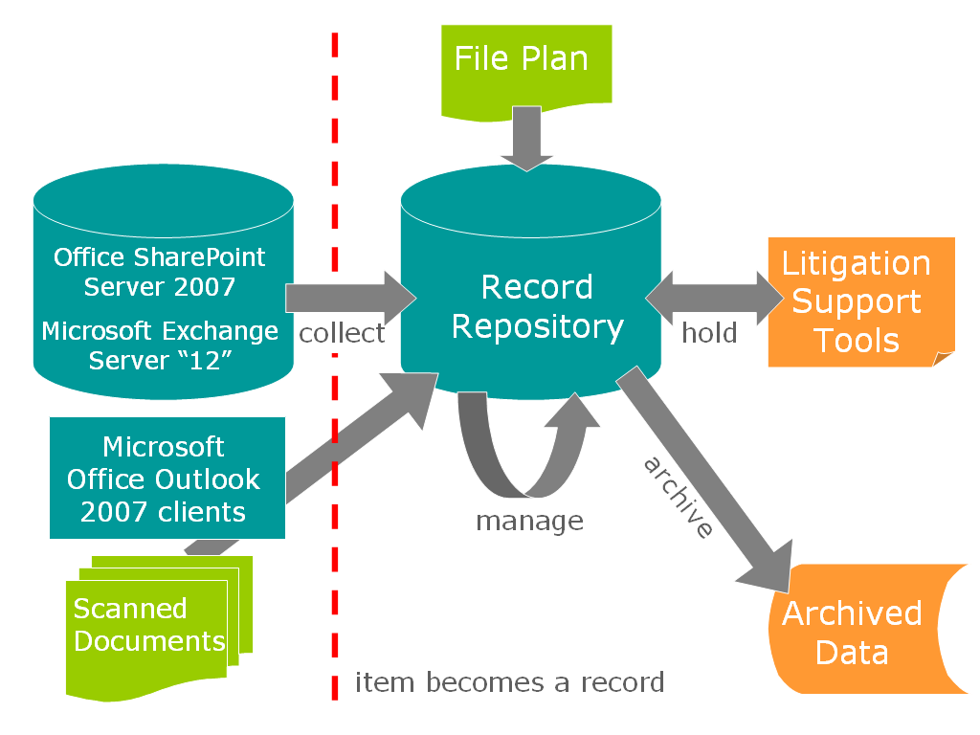
Figure 1

Information Management Policies
These policies provide controls that consistently and uniformly enforce the labeling, auditing, and expiration of records. Policies can be configured for a specific storage location or content type. For example, to ensure that all contracts are retained uniformly in an organization, expiration dates can be based on a common property such as the contract execution date.

Hold
The Records Repository allows IT staff, records managers, and legal authorities to apply one or more holds that suspend records management policies on specific items to prevent documents from being changed during litigation, audits, or other investigations. The process of creating, managing, and releasing holds is monitored and recorded so that the system can account for all actions taken.

Record Collection Interface
Records repositories provide a set of services that aid in content collection. These services allow people and automated systems to easily submit content to a records repository without necessarily having access or permission to any of the contents of the site. Content can be submitted through a Web service by using the SOAP protocol or through e-mail by using the SMTP protocol.

Record Routing
Content submitted to a records repository can be routed to the proper location within the records management system based on content type.

Extensibility
To support deployments that require additional capabilities, Office SharePoint Server 2007 provides robust extensibility mechanisms. For example, the Record Collection Interface can be implemented on a different repository, allowing Office 2007 clients and servers to treat third-party repositories as records repositories. Additionally, records management policies are built on an extensible framework that allows customers to buy or build custom policies to extend or replace existing ones.

Developing Robust Spreadsheet Models
Microsoft Office Excel 2007 can be used to create a robust spreadsheet model that meets compliance challenges and enhances productivity. The following capabilities in Office Excel 2007 can help an organization deploy spreadsheet models that make it easier to become, and stay, compliant.

- Cell Styles
- Lock important cells
- Using Excel Tables to reduce errors
- Defined Names
- Formula auditing tools

1. Cell Styles
Complex spreadsheets with multiple contributors can be unclear and difficult to read. Users interpret the information in the spreadsheet differently, make errors based on assumptions, and are unable to quickly interpret or analyze the data. Cell formatting is an important tool that can be used to visually clarify the structure of a spreadsheet with color, font, borders, and data formats. Office Excel 2007 allows users to quickly define reusable cell formatting styles that make it easy to clearly indicate input cells, formulas, output cells and other key components. To make formatting updates simple, style changes are automatically applied to all cells using that style.

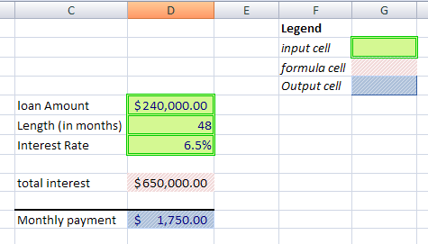
Cell styles help distinguish input cells from calculation cells

2. Lock Important Cells
In addition to making the spreadsheet more understandable, organizations can reduce user errors by password protecting (or locking) specific cells, ranges, or sheets. This is a key step in the development of a robust spreadsheet.

Protect Worksheets
This feature can be used to lock important areas of a spreadsheet to prevent users from modifying the values or formulas in those cells. For example, an author can password-protect selected cells and prevent different types of changes to cells and other elements in the worksheet.

Allow Users to Edit Ranges
Similar to the Protect Worksheet functionality, the Allow Users to Edit Ranges feature allows users to lock specific areas of a spreadsheet. In addition, an author can grant edit permissions to specific groups, users, or computers based on Windows authentication.

3. Using Excel Tables to Reduce Errors
Tables are common elements in spreadsheets, and they are the standard method for organizing and displaying structured data. Office Excel 2007 now recognizes tables as a native object in spreadsheets, which allows users to create robust tables that better maintain structure and are significantly easier to interact with.

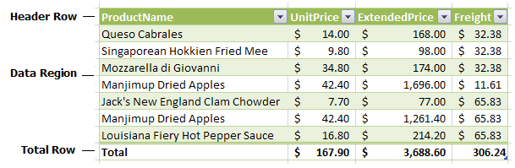
A table consists of three pieces: header row, data region, and total row

Common Tasks
Tables make common tasks easier to perform and more robust. As data is added to a table, any elements associated with the table automatically adjust. Formatting applies to new rows and formulas update to include new data. PivotChart views, PivotTable views, Conditional Formatting, and Data Validation all will update to fit the new data.

Referencing Data
Formulas that reference data in a table do so by name (the name of the column, e.g. “Sales”) rather than by an undecipherable A1-style address (e.g., D1:D10). This type of referencing is called “Structured Referencing” and it increases the readability of formulas to make them easier to maintain and edit later.

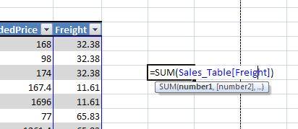
Structured referencing in Office Excel 2007

Better Formatting
With Office Excel 2007, table formatting features behave intelligently. For example, if alternate-row formatting is enabled on a table, Office Excel 2007 will maintain the alternating format rule through actions that would have traditionally disrupted this layout, such as filtering, hiding rows, or manual rearranging of rows and columns. Additionally, Office Excel 2007 includes a large number of professionally designed table styles that look good out of the box.


Office Excel 2007 tables support complex row and column banding that automatically adjust with the data

4. Defined Names
Defined names simplify writing formulas in complex spreadsheets, especially those spreadsheets shared among several people. However, when a spreadsheet contains hundreds or even thousands of defined names, it becomes more challenging to perform tasks such as deleting multiple names, renaming names, and finding broken names. The new Name Manager dialog box, designed specifically for viewing and managing defined names, makes it easier to:

- View important details such as the name’s reference, value, and scope.
- Create and scope names.
- Rename existing names.
- Delete multiple names at once.
- Sort and filter the name list by common criteria including scope, type, and if the name returns an error.

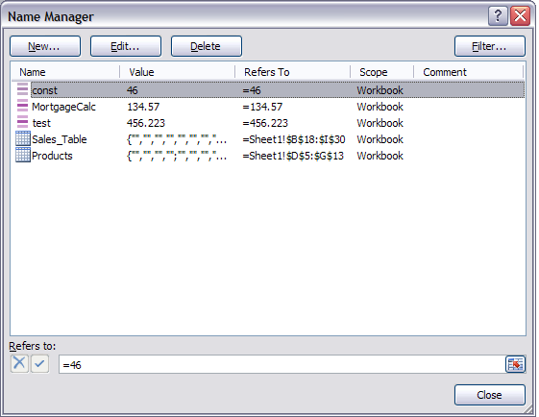
The Name Manager dialog box

5. Formula Auditing Tools
Regulatory compliance legislation requires auditable and transparent practices for spreadsheets used in financial reporting. Office Excel 2007 provides auditing tools that, along with a consistent use of cell styles and naming conventions, can accelerate the testing of spreadsheet models and reduce the risk of error once a spreadsheet is in production. Auditing tools in Office Excel 2007 enable users to:

- Graphically display (or “trace”) the relationships between cells and formulas.
- Trace a cell's precedents (the cells that provide information to that cell).
- Trace a cell's dependents (the cells that receive information from that cell.)
- Check for errors in a formula.

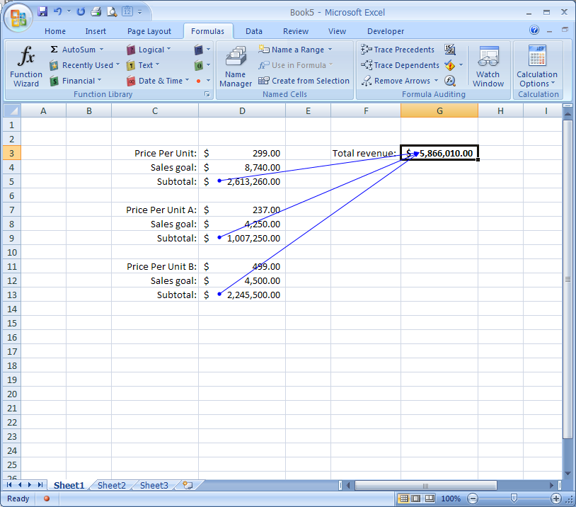
A formula showing its precedents using auditing arrows

Conclusion

Spreadsheets are commonly used as a critical resource in most organizations, yet they often receive little budgetary resources or sound management policies. This can result in an unnecessary exposure to regulatory compliance risks. As a result, it is important for organizations to develop a spreadsheet compliance framework that includes rigorous process controls around the development, testing, and use of business-critical spreadsheets. When these controls are combined with the current and forthcoming capabilities in the 2007 Microsoft Office system, companies will have greater success in implementing and enforcing spreadsheet policies.

Links

Information About the 2007 Microsoft Office System
2007 Microsoft Office system Web site
www.microsoft.com/office/preview/default.mspx

Microsoft Office Excel 2007 Blog
blogs.msdn.com/excel

Financial Regulation Documents
Sarbanes-Oxley Act, 2002
www.sec.gov/rules/final/33-8238.htm

Data Protection Act, 1998
www.opsi.gov.uk/acts/acts1998/19980029.htm

Basel II: International Convergence of Capital Measurement and Capital Standards
www.bis.org/publ/bcbs118.htm

Appendix

Table of Relevant Regulations

Name of law or regulation | Issuing authority | Primarily applies to
Sarbanes-Oxley | United States | Public companies
Data Protection Act | United Kingdom | Companies doing business in the U.K.
Markets in Financial Instruments Directive (MiFID) | United Kingdom | Banks and financial institutions
Basel II | international | Banks and financial institutions
HIPAA | United States | Healthcare companies
GLBA | United States, federal and state | Financial institutions
Patriot Act | United States | Financial institutions
DoD 5015.2 | United States | Government contractors
California SB 1386 | State of California | All companies doing business in California
Note: this table is not a complete list

Microsoft Office System Capabilities Matrix

 | 2007 Release | 2003 Release
SharePoint Server
Permissions | ✓ | Partial Support
Excel Services | ✓ | ✗
Enterprise Content Management | ✓ | Partial Support
Record Repository | ✓ | ✗
Excel
Secure a Workbook | ✓ | ✓
Information Rights Management | ✓ | Partial Support
Protect Worksheet | ✓ | ✓
Allow Users to Edit Ranges | ✓ | ✓
Cell Styles | ✓ | Partial Support
Excel Tables | ✓ | Partial Support
Defined Names | ✓ | ✓
Formula Auditing Tools | ✓ | ✓

This is a preliminary document and may be changed substantially prior to final commercial release of the software described herein.

The information contained in this document represents the current view of Microsoft Corporation on the issues discussed as of the date of publication. Because Microsoft must respond to changing market conditions, this document should not be interpreted to be a commitment on the part of Microsoft, and Microsoft cannot guarantee the accuracy of any information presented after the date of publication.

This White Paper is for informational purposes only. MICROSOFT MAKES NO WARRANTIES, EXPRESS, IMPLIED, OR STATUTORY, AS TO THE INFORMATION IN THIS DOCUMENT.

Complying with all applicable copyright laws is the responsibility of the user. Without limiting the rights under copyright, no part of this document may be reproduced, stored in or introduced into a retrieval system, or transmitted in any form or by any means (electronic, mechanical, photocopying, recording, or otherwise), or for any purpose, without the express written permission of Microsoft Corporation.

Microsoft may have patents, patent applications, trademarks, copyrights, or other intellectual property rights covering subject matter in this document. Except as expressly provided in any written license agreement from Microsoft, the furnishing of this document does not give you any license to these patents, trademarks, copyrights, or other intellectual property.

© 2006 Microsoft Corporation. All rights reserved.

This case study is for informational purposes only. MICROSOFT MAKES NO WARRANTIES, EXPRESS OR IMPLIED, IN THIS SUMMARY. Microsoft, Designer, Excel, the Office logo, Outlook, PivotChart, PivotTable, SharePoint, Visual Studio, and Windows are either registered trademarks or trademarks of Microsoft Corporation in the United States and/or other countries.

All other trademarks are property of their respective owners.

A list of relevant regulations can be found in the Appendix.
PricewaterhouseCoopers. “The Use of Spreadsheets: Considerations for Section 404 of the Sarbanes-Oxley Act.” July 2004.
Panko, Raymond R. and Nicholas Ordway. “Sarbanes-Oxley: What about All the Spreadsheets?” University of Hawaii, 2005.
Adapted from the waterfall software development lifecycle.
Panko, Raymond R. and Nicholas Ordway. “Sarbanes-Oxley: What about All the Spreadsheets?” University of Hawaii, 2005.

