Application Template: Competitive Analysis Site
Functional Overview for
Business Decision Makers

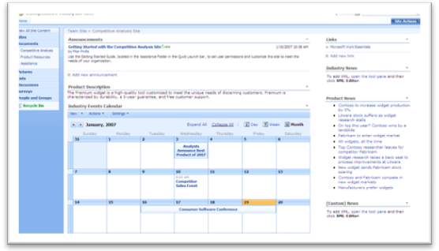
Description of Template
The Competitive Analysis Site application template for Microsoft® Windows® SharePoint® Services 3.0 helps teams organize and structure the work done to analyze competitors and their products. The site contains several useful tools and techniques, including an industry calendar, links to product news and competitor’s websites as well as template files of common competitive analysis techniques. The site’s event calendar functionality allows users to automatically create event specific ‘sub-sites’ to manage meeting objectives, track attendees, capture notes and assign action items.

As with most Windows SharePoint Services 3.0 based sites, the Competitive Analysis Site integrates with Microsoft Office 2007 with features such as automated alerts, RSS feeds and synchronization of calendar items. This site also includes a web part to capture XML based product and industry news feeds from external sites.

Sample Activities Performed in this Application Template
The following examples show the various ways Microsoft anticipates this template will be utilized in a typical organization. If you wish to add additional features, please ask your IT provider to research Microsoft Office SharePoint Designer 2007.

Pilar Pinilla is a product manager at Litware, Inc., a consumer software company. As part of her job, she coordinates and tracks the company’s main competitors and their products. To simplify the process of structuring and capturing the competitive information she receives, Pilar utilizes her company’s Competitive Analysis Site built on Windows SharePoint Services 3.0.

Today, Pilar is updating the Strength, Weaknesses, Opportunities and Threats (SWOT) analysis for her competitors. She opens the Microsoft Office Excel® 2007 template provided by the site and proceeds to enter the information she’s collected. She saves the spreadsheet back to the site, making it available for her extended product and sales teams to review change and update the SWOT analysis.
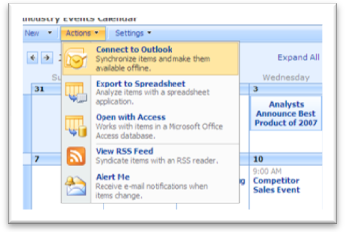
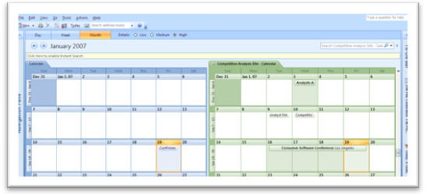
Next, Pilar decides to begin work on documenting the customer buying process for her company’s product. Opening the site’s Microsoft Office Visio® 2007 template, she begins to detail how her customers locate, evaluate and buy her products. She clicks on the provided flowchart to change the process flow to what she knows works for her product. She closes the Office Visio 2007 document, saving her changes and proceeds to open the Microsoft Office Word 2007 Positioning and Messaging Framework she’s been working on.

As the product and sales team learns of industry events, they visit the Competitive Analysis Site to enter them into the site’s calendar. Pilar enters a new event into the calendar, a January Consumer Software Conference in Los Angeles. Since her entire team has ‘connected’ the Competitive Analysis Site calendar to their personal Microsoft Office Outlook® 2007 calendar, they all have the event synchronized. Changes made either through Office Outlook 2007 or the site will be synchronized to all the team members automatically.

About Microsoft Windows SharePoint Services 3.0
Microsoft Windows SharePoint Services 3.0 is technology in Windows Server® that offers an integrated portfolio of collaboration and communication services designed to connect people, information, processes and systems both within and beyond the organizational firewall. Now available at no additional charge, the technology provides a platform for developing Web-based business applications. Application Templates provide out-of-the-box scenarios to address the needs of specific business processes.

More Information
For more information on the technologies described in this article, please visit:

Microsoft Windows SharePoint Services 3.0:
http://www.microsoft.com/sharepoint

Application Templates for Windows SharePoint Services:
http://www.microsoft.com/sharepointapps

