

Why Upgrade to SQL Server 2005 Business Intelligence: A Technical Overview
White Paper
Published: November 2005
For the latest information, please see http://www.microsoft.com/sql/


Contents
Improving Business Intelligence 1
The new business intelligence platform 1
A firm foundation 1
Make the most of your investment 1
An out-of-the-box upgrade 1
New and Improved Business Intelligence Features 2
Database engine in SQL Server 2005 2
Integration Services 2
Reporting Services in SQL Server 2005 3
Analysis Services in SQL Server 2005 3
Notification Services in SQL Server 2005 4
Improved Productivity and Collaboration 5
Business Intelligence Development Studio 5
Management Studio 6
Integrated tools and environment 7
Managing Costs 8
Increasing your capabilities 8
Build on existing skills 8
Security, Reliability, and Availability 9
Enhanced security 9
Fault tolerance and high availability 9
An Upgrade Process Made Easy 10
Straightforward upgrade paths 10
Upgrade Advisor gets you there 10
Resources 11
Conclusion 12

Improving Business Intelligence

The new business intelligence platform
Finding a single version of the truth is the goal of business intelligence (BI), and SQL Server 2005 will help you find it. You need technology that works tirelessly to support your business. You need a suite of tools that integrate seamlessly and scale to support your enterprise demands. That’s what SQL Server 2005 delivers. If you are considering upgrading your BI solution, read on to find out why you should switch to SQL Server 2005.

A firm foundation
SQL Server 2005 builds upon the firm foundation laid by SQL Server 2000 and has many new and improved features, including the following:
- Integration Services, the successor to Data Transformation Services (DTS), is a dynamic, configurable, and scalable enterprise-class data integration platform.
- Analysis Services includes new features that allow you to build an enterprise-class analytics infrastructure to fulfill the BI requirements of diverse business users.
- Reporting Services is an extensible enterprise-class reporting solution that allows you to go beyond traditional reporting to meet the needs of today’s enterprises.

Make the most of your investment
SQL Server 2005 is fully backward-compatible with SQL Server 2000, so you can take advantage of your current investment in BI solutions, infrastructure, and training. This is much more cost-effective than rebuilding your current solution using a new technology.
- Maximize current SQL Server 2000 hardware investments. With SQL Server 2005, you can do more with your current hardware and preserve the investments you’ve made in your information technology (IT) infrastructure. By upgrading your existing solution built on SQL Server 2000 to SQL Server 2005, you gain new capabilities without the extensive overhead of building a new solution from scratch to meet your analytical needs.
- Build on your team’s current SQL Server 2000 skill set. Your team can take immediate advantage of their SQL Server 2000 skills after upgrading to SQL Server 2005. In fact, development and administration tasks will be easier and more efficient, freeing the time of those who perform these tasks to focus on business needs instead of technology needs.

An out-of-the-box upgrade
With an out-of-the-box upgrade from SQL Server 2000 to SQL Server 2005, you will realize immediate gains on two fronts:
- The back end. Your administrators will experience improved performance, availability, management, and security.
- The front end. Your users will experience improved functionality in areas such as data transformation, unified analysis, and reporting.
SQL Server 2005 includes a suite of upgrade tools that make the process simple and straightforward. The gains will be immediate and measurable.

New and Improved Business Intelligence Features

Database engine in SQL Server 2005
The core relational engine in SQL Server 2005 includes several new features to support your mission-critical, 24-hour-a-day, 7-day-a-week BI applications:
- SQL Server 2005 is built to support massive growth with linear scalability. Its relational engine has the proven ability to handle terabytes of data.
- It offers native support for 64-bit chip technologies, giving you the power to handle such challenges as large dimensions and complex transformations.
- But what about the ability to scale downward? SQL Server 2005 Mobile Edition will run on your Pocket PC devices for those on the go.
- Database mirroring provides a low-overhead but readily available backup.
- More online database operational tasks, such as online indexing and dynamic configuration, eliminates the need for you to take your application offline to perform routine maintenance.
- An improved security model helps to protect data confidentiality, integrity, and availability with data encryption, password policy enforcement, and more detailed data security management.
- With enhancements to Transact-SQL and the common language runtime, you will be better equipped to tackle complex business problems quickly and more efficiently.

Integration Services
The core of any BI solution is the data integration process, and the new data integration engine in SQL Server 2005, Integration Services, is ready to meet your enterprise integration needs.
SQL Server 2000 DTS provides easy-to-use data copy processes, and its broad adoption earned industry recognition. But with the new data integration engine in SQL Server 2005, the game has been taken to a new level. The following features in Integration Services are reason enough to upgrade to SQL Server 2005.
- Its processing architecture competes and surpasses other enterprise-class extraction, transformation, and loading (ETL) tools with a quicker learning curve that adds immediate value for dozens of data processing needs.
- It supports more built-in source connection types, the ability to extract from multiple sources and integrate data in memory, and the flexibility to write to multiple destinations.
- Handling common data warehouse processes such as data mining, data cleansing, and slowly changing dimensions is built into the processing engine.
- It supports parallel operations and data streaming for optimal processing.
- For developers, deployment is easy with dynamic package configuration.
- For administrators, package management is friendly with native monitoring and logging capabilities.
Overall, upgrading your SQL 2000 Data Transformation Services (DTS) environment to Integration Services provides the benefits of an enterprise-class data integration platform to meet the requirements of the global enterprise.

Reporting Services in SQL Server 2005
Running a successful business requires consistent operational evaluation metrics, so enterprise reporting is here to stay. With the reporting capabilities of SQL Server 2005, your environment will benefit from:
- Faster report development.
- More flexible user interaction.
- Timely information availability and alerting.

Report Builder
SQL Server 2005 Reporting Services includes a new dynamic ad hoc report tool, Report Builder, which greatly simplifies report development and provides self-service report generation for business users. Collaboration time formerly spent between the developer and end user can now be directed toward value-added report generation with Report Builder. Extending on the SQL Server 2000 Reporting Services model, the new platform can handle multivalue and hierarchical parameters so that the categories that drive your business can be represented and selected in a report.

Dynamic Analysis Services integration
Another reason to upgrade to SQL Server 2005 Reporting Services is the native access to the Analysis Services Unified Dimensional Model. What used to require hard-coded MDX query statements in SQL Server 2000 Reporting Services can now be built dynamically when reports access Analysis Services 2005. This connectivity allows filtering, pivoting, and highlighting. Furthermore, through the Web interface, report data grids now also can be sorted. The Reporting Services rendering engine contains more output availability than the previous build.

Analysis Services in SQL Server 2005
In little more than seven years since its inception, Analysis Services has taken over the BI OLAP engine market—and for good reason. Analysis Services 2000 provides a high performance, low-cost OLAP engine with an easy implementation model. Analysis Services in SQL Server 2005 takes this functionality and performance much further by bringing more enterprise-ready analytics, advanced data mining, and business features that present a unified access to unlock key business metrics. SQL Server 2005 Analysis Services includes several new features:
- UDM (Unified Dimensional Model) provides a bridge between the user and the data sources. A UDM is constructed over one or more physical data sources. The end user then issues queries against the UDM by using one of a variety of client tools, such as Microsoft Excel.
- Proactive Caching listens for data changes and provides behind-the-scenes updates of data and aggregations.
- Key performance indicators (KPIs) provide the ability to both see the tracking measures and perform calculations that evaluate the numbers based on specified target numbers defined by the business.
- Calculation templates assist in cube development by giving the developer a head start in many common MDX (multidimensional expression) scenarios.
- Translations allow metadata to be provided to users in any language such that clients connecting using a particular locale see all of the cube metadata in the appropriate language.
- Perspectives provide the ability to define cut-down views of the entire UDM, presenting only the specific subset of the model (measures, dimensions, attributes, and so forth) that is relevant to a particular group of users.

Unified Dimensional Model (UDM)
The Unified Dimensional Model (UDM) offers genuine value by helping to bring everything “under one roof” by consolidating disparate sources of data. In this capacity, the UDM is a great improvement in SQL Server 2005, as its flexibility enables a consolidated architecture for enterprise analytics.
In addition to the out-of-the-box architectural advantages of the UDM, business intelligence applications can now take advantage of better communication mechanisms such as the XML for Analysis protocol (XMLA) and multilingual support for objects and data. Furthermore, with five more built-in data mining algorithms and a host of data viewing perspectives, SQL Server 2005 Analysis Services will supply your enterprise with the ability to gain better business insight.
Also built into the cube architecture is support for many-to-many relationships from a fact table to a dimension table. While this may have been possible in SQL Server 2000 Analysis Services, a good deal of design effort and the right expertise were required to make it work. With a click of a button, this is available in SQL Server 2005 Analysis Services.

Notification Services in SQL Server 2005
SQL Server 2005 Notification Services can alert thousands of subscription-based users by using a customizable business rules engine. Its built-in event polling architecture and the variety of message delivery mediums will empower your organization to be more flexible with alerting and make time-sensitive decisions with up-to-date intelligence.

Improved Productivity and Collaboration

Business Intelligence Development Studio
By upgrading to SQL Server 2005, you gain enhanced tools and features that are designed to increase development and management productivity. With Business Intelligence Development Studio, the integrated development environment based on Microsoft Visual Studio® 2005, your team will enjoy many new productivity-enhancing features:
- Integrated change management with source control and built-in deployment integration.
- Cross-tier debugging capabilities for faster development and testing.
- A design editor for writing both Transact-SQL scripts and MDX queries. Design wizards and templates for writing and developing common business scenarios are integrated into the environment.
Your developers can use Business Intelligence Development Studio (see Figure 1) to:
- Create Reporting Services reports.
- Create Report Builder data views.
- Design Integration Services packages.
- Develop Analysis Services cubes.
Similarly, sharing data sources and data source views between applications is now possible, making data source management straightforward and changes easy. These features result in a true unified development tool across the technology stack.
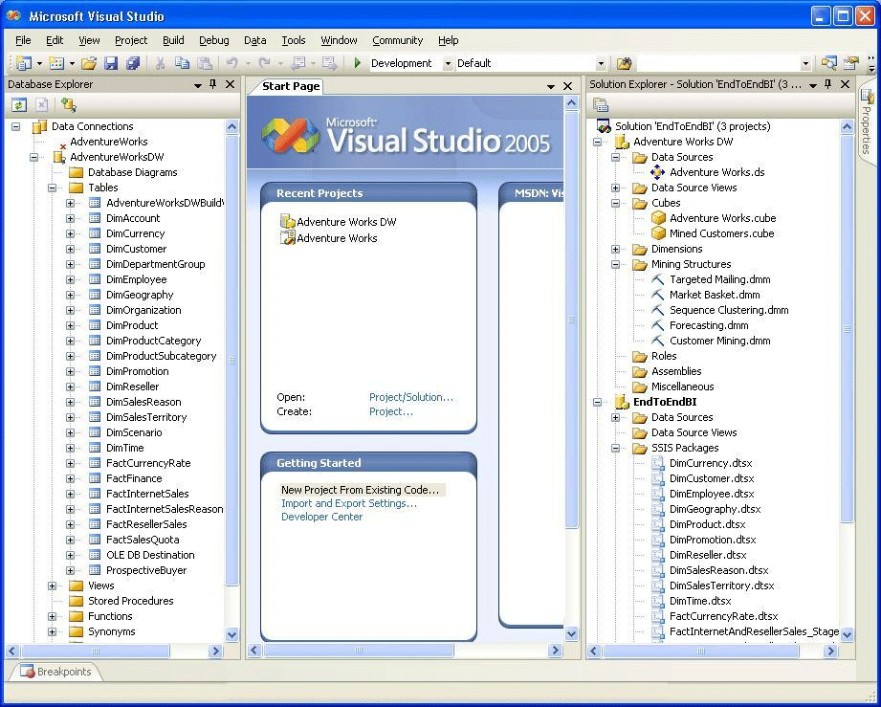
Figure 1. SQL Server 2005 Business Intelligence Development Studio

Management Studio
Similar in look and feel to the development environment, the new management tool in SQL Server 2005, Management Studio, is feature-rich but easy to navigate with a minimal learning curve for administrators who are familiar with SQL Server 2000 Enterprise Manager. Management Studio (see Figure 2) allows for the administration of all the SQL Server BI components from one interface, including:
- The Relational Engine
- Integration Services
- Analysis Services
- Reporting Services
- Notification Services
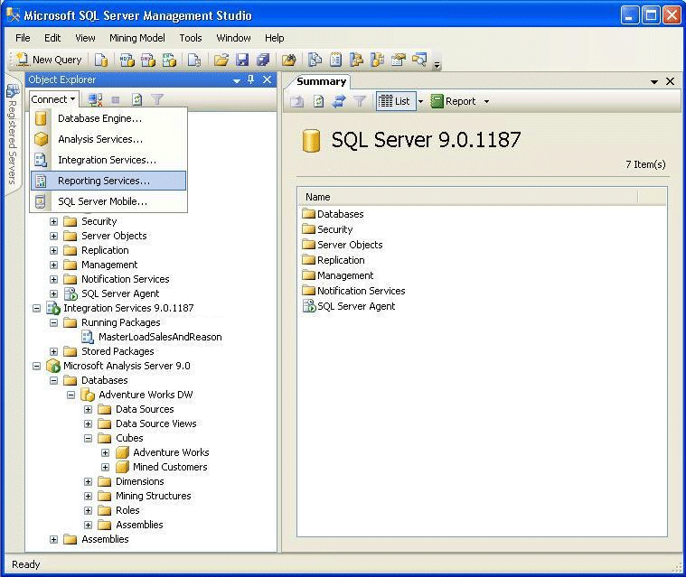
Figure 2. SQL Server 2005 Management Studio

Other Management Tools
SQL Server Profiler gives your administrators more extensive monitoring capabilities with the ability to trace MDX queries against an Analysis Services engine along with more detailed SQL Server 2005 relational counters. Automated administration tools such as the SQL Server 2005 Configuration Manager simplify the configuration and management of SQL Server services.

Integrated tools and environment
The SQL Server 2005 BI platform is truly a one-stop shop that bridges application tiers and network infrastructure together across the data, development, management, and security layers. For example, the shared security authentication model is completely integrated with your enterprise domain environment. This mitigates the need for a secondary sign-on and provides more comprehensive data security and reduced security management. The integrated environment and feature-rich toolset make a compelling case to consolidate data technologies and move to SQL Server 2005.

Managing Costs

Increasing your capabilities
Here are just a few of the ways in which SQL Server 2005 will make better use of your existing hardware.
- The Analysis Services aggregation engine is optimized to handle exponentially more dimension attributes while consuming less memory overall.
- The cube security model scales to allow more dimension filtering and custom security for flexible requirements, which in turn allows you to do more with your current hardware.
- Intelligent partition logic, called Proactive Caching, can determine when to refresh data and isolate changes for optimal data updates.

Integration Services
Given that the new Integration Services architecture is entirely different from SQL Server 2000 DTS, an upgrade performance comparison would be limited to the few features they share in common. However, when reworking a current DTS design to take advantage of new Integration Services features, the scalability will be staggering. Because the memory-based data flow engine in Integration Services requires less impact on the SQL Server engine and generates less disk I/O, processing is not dependant on serial workflow. Rather, data can be streamed and parallelized, making the transfer of data from point A to point B with transformations very scalable on existing hardware.

Reporting Services
SQL Server 2005 Reporting Services also comes with more-for-less scalability, providing increased concurrency and the ability to schedule and cache reports. An upgrade yields immediate gains in your environment.

Build on existing skills
You’ve made a significant investment in hiring and training a staff to build and maintain your SQL Server 2000 BI solution. You certainly don’t want to do that again, and with SQL Server 2005 you won’t need to. Although the SQL Server 2005 Business Intelligence platform has a new look and many new features, your developers and administrators will find the transition to be a smooth one and will be up and running in no time. What’s more, SQL Server has been the market leader for past three years and it will continue to be so with the release of SQL Server 2005. Thus, you will always be able to find qualified candidates to add to your staff.
By upgrading to SQL Server 2005, you have best-of-breed BI components on a single, integrated platform with common management and development tools. This reduces the number of skill sets required to develop and maintain your BI solution, thereby simplifying your staffing needs without compromising your ability to deliver the BI solutions your business demands.

Security, Reliability, and Availability
In today’s global enterprise, security and availability are nonnegotiable requirements.

Enhanced security
Whether your enterprise data is actively being queried or sitting in a database backup or standby server, security is a priority. SQL Server 2005 includes many new features to increase data security as follows:
- Data encryption is supported for SQL databases both active and at rest.
- Grantable permissions and granular administration rights are assignable to users and groups within your domain.
- More flexible database object groupings are available for securing like information.
Within SQL Server 2005 Analysis Services, a scalable security model allows cube users and roles to be assignable from cube access down to granular dimension member slices. Perspectives, a new feature of Analysis Services, provides groupings of measures and dimension to help manage and isolate appropriate information for the appropriate user groups, thereby increasing your ability to control access to data.

Fault tolerance and high availability
High-availability features in SQL Server 2005 help you minimize downtime and meet your availability requirements. Each tier provides an appropriate high-availability model for its respective architectures:
- Analysis Services now supports failover clustering with Microsoft Clustering Services, so system errors do not affect cube availability.
- The growth model for the .NET Framework-based Reporting Services architecture allows load balancing, report access scalability, and also high availability as servers participating in a Reporting Services server farm can act as backups for each other.
- Integration Services comes with built-in fault tolerance. With package execution check pointing, distribute transaction support, and robust logging, errors can cause data rollback to certain checkpoints where a package can be restarted without much user intervention or complicated workflows.
On the relational side, SQL Server 2005 comes with a host of new availability features. Adding to the clustering and log shipping features already packaged with the product, database mirroring is now available. Database mirroring requires low overhead but provides complete database standby availability, as compared to the shared disk approach that clustering supports. Snapshot isolation is also supported for databases as another mechanism for availability. When implemented, snapshot isolation helps to ensure that your data marts remain in a consistent state through an ETL cycle.

An Upgrade Process Made Easy
Now that you understand the value of the new and improved features of SQL Server 2005, how do you get there? Good news! Included with SQL Server 2005 are upgrade tools and wizards that make upgrading straightforward and manageable. The upgrade results have been proven in several real-world environments, so you can be confident in the process.

Straightforward upgrade paths
You can follow several different paths to upgrade your SQL Server 2000 BI solution to SQL Server 2005. The most common, and most straightforward, path is to upgrade the relational engine that houses your BI data warehouses and marts. Upgrading your SQL Server 7.0 and 2000 databases to SQL Server 2005 is a simple in-place upgrade of the server. Alternatively, if you need to move your databases to a new server with SQL Server 2005, you can perform a backup and restore or detach and reattach on the new platform with minimal time and effort.
You can also upgrade Reporting Services and Analysis Services to SQL Server 2005 during the installation process. For Reporting Services, the direct upgrade has no significant impact on reports that were created in SQL Server 2000 other than making the new features available. In fact, SQL Server 2000 Reporting Services reports can be rendered with the SQL Server 2005 Reporting Services engine without upgrading them. With Analysis Services cubes, SQL Server 2005 comes with a migration wizard that makes the transition to the new platform easier. With some of the changes made to cubes and dimensions, however, you will need to validate and readjust MDX reports.
Given the more extensive changes in Integration Services from Data Transformation Services, this upgrade is slightly more involved. Included in the installation of SQL Server 2005 is a wizard that helps you convert DTS packages to Integration Services. With the fundamentally different architectures of these two products, however, you may need to redesign some components to complete the process. During SQL Server 2005 setup, you have the option to install the DTS run-time files so that DTS packages can run on a SQL Server 2005 computer without requiring a full SQL Server 2000 installation. By using this option, you can convert DTS packages to Integration Services in a rolling fashion so as not to delay the overall platform upgrade process.

Upgrade Advisor gets you there
SQL Server 2005 Upgrade Advisor is similar to some of the informational tools that are designed to help optimize and secure your databases, such as the SQL Server 2000 Security Analyzer and Best Practices Analyzer. Upgrade Advisor analyzes SQL Server 2000 and 7.0 solutions and identifies areas that will need attention during the upgrade. Targeting more that just the relational engine, Upgrade Advisor also examines Data Transformation Services, Analysis Services, Reporting Services, and Notification Services, reporting back upgrade blocking issues and recommending pre- and post-upgrade steps for you to perform on the system.
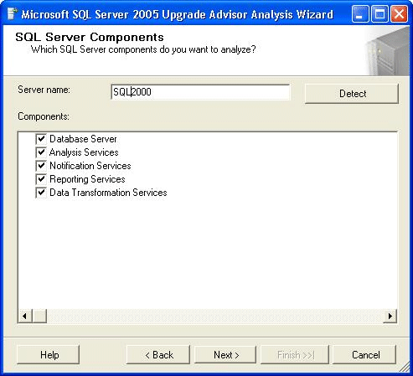
Figure 3. SQL Server 2005 Upgrade Advisor
SQL Server 2005 Upgrade Advisor, as shown in Figure 3, is a valuable tool that you should take advantage of to help isolate potential issues and areas to focus post-upgrade testing. Because Upgrade Advisor uses an extensible rules based engine, the more feedback it receives from upgrades, the better it becomes. It currently uses more than 100 rules during its analysis.

Resources
The proven results of SQL Server 2005 are coming in as customers share their successes. See the SQL Server 2005 Testimonials Web site.
To read about Project REAL, the Microsoft end-to-end SQL Server 2005 reference implementation built from a live customer solution on the new platform, visit the Project Real Web site.
For a more complete abstract of business intelligence features in SQL Server 2005, see the Business Intelligence and Data Warehousing in SQL Server 2005 white paper on the SQL Server TechCenter.

Conclusion
So what’s the bottom line? SQL Server 2005 makes BI better with benefits far outweighing the costs. Over and above SQL Server 2000, the business intelligence capabilities of SQL Server 2005 are ready today to take your organization to the next level of business understanding with integrated tools, faster performance, more reliability and availability, and an easy and low-cost upgrade path.

For more information:
http://www.microsoft.com/sql/

Did this paper help you? Please give us your feedback. On a scale of 1 (poor) to 5 (excellent), how would you rate this paper?

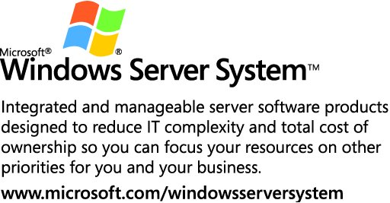

The information contained in this document represents the current view of Microsoft Corporation on the issues discussed as of the date of publication. Because Microsoft must respond to changing market conditions, it should not be interpreted to be a commitment on the part of Microsoft, and Microsoft cannot guarantee the accuracy of any information presented after the date of publication.
This white paper is for informational purposes only. MICROSOFT MAKES NO WARRANTIES, EXPRESS OR IMPLIED, IN THIS
DOCUMENT.
Complying with all applicable copyright laws is the responsibility of the user. Without limiting the rights under copyright, no part of this document may be reproduced, stored in, or introduced into a retrieval system, or transmitted in any form or by any means (electronic, mechanical, photocopying, recording, or otherwise), or for any purpose, without the express written permission of Microsoft Corporation.
Microsoft may have patents, patent applications, trademarks, copyrights, or other intellectual property rights covering subject matter in this document. Except as expressly provided in any written license agreement from Microsoft, the furnishing of this document does not give you any license to these patents, trademarks, copyrights, or other intellectual property.
© 2005 Microsoft Corporation. All rights reserved.
The example companies, organizations, products, domain names, e-mail addresses, logos, people, places, and events depicted herein are fictitious. No association with any real company, organization, product, domain name, e-mail address, logo, person, place, or event is intended or should be inferred.
Microsoft and SQL Server are either registered trademarks or trademarks of Microsoft Corporation in the United States and/or other countries.
All other trademarks are property of their respective owners.

