Microsoft Connected Services Framework for the Publishing Industry
White Paper
Published: December 2004
For the latest information, please see: http://www.microsoft.com/serviceproviders/microsoftsolutions/connectedservices


.

Abstract
The publishing industry is facing the harsh realities of several years of flat-lined growth, industry consolidation, and increased competition from new media. But with these obstacles, an opportunity has emerged. Digital media is forging new possibilities to achieve growth, increase revenues, and build customer loyalty. The challenge, however, lies in a disconnected infrastructure that impedes the move to digital format. Fortunately, Microsoft offers a solution that will facilitate the evolution—the Microsoft® Connected Services Framework.
The purpose of this white paper is to introduce a new breed of technology to technical and business decision makers in the publishing industry. The paper presents challenges faced by those in the publishing industry, along with information about how the Microsoft Connected Services Framework can facilitate the creation of a streamlined organization. In addition, the paper includes publishing-specific scenarios to demonstrate the benefits of the technology.

Executive Overview
The digital age is changing the core business model of the publishing world. In an industry where print media has reigned supreme, publishers are becoming more competitive by finding innovative, flexible ways to deliver content to customers. By expanding delivery channels and creating multiple subscription plans, publishers of newspapers, magazines, and books will be better positioned to overcome challenges, such as increased competition and thinner profit margins. What’s more, by creating a more connected infrastructure of business data, executives can get a holistic view of operations, manage costs more efficiently, and paint a better picture of their customers.
The difficulty in accomplishing these improvements stems from a highly proprietary infrastructure of business, production, and data systems that don’t interact or share information. Consequently, processes are inefficient, business insight is hampered, and a connected work environment is impossible to achieve. When publishers embrace new technology and electronic content delivery methods, they can face the competition head-on, and deliver pioneering, flexible services that cater to customer demands, drive long-term growth and, ultimately, increase revenues.

The Solution
Microsoft is committed to solving the problems facing the publishing industry. Microsoft has assembled a team of professionals from the publishing industry and has forged selective partnerships with solution providers, all with the intent to deliver solutions that alleviate the internal and external pressures that publishers face every day. The Microsoft® Connected Services Framework can help publishers improve operational efficiency, drive better business decisions, and deliver content more flexibly to customers.
The Microsoft Connected Services Framework is based on a suite of products and services from Microsoft, and provides the framework for building systems that maximizes data sharing, automates complex workflows, provides a rich collaborative environment and, ultimately, streamlines the creation, management, and delivery of news and entertainment content. Built on the Microsoft .NET Framework and industry standards, the Microsoft Connected Services Framework provides an overlying layer to a publisher’s infrastructure that connects existing applications by using powerful Web services.

The Benefits
With technology that helps create a more fluid infrastructure, publishers can begin to realize the business benefits that stem from an open, flexible operating environment.
- Boost revenues with multiple distribution options. Many customers no longer want to access only a printed version of a magazine, newspaper, or book. They want access to content online, as well as the ability to download media to mobile devices, even if they are not regular subscribers. Microsoft technology empowers publishers to accommodate this need for flexibility by facilitating electronic delivery output and multiple billing options. Customers remain happy and loyal, and publishers benefit from increased opportunities for revenue.
- Increase productivity and lower operational costs. Production processes too often can be delayed by costly, manual workflows, which result from a hodge-podge of disconnected, proprietary systems. Using Web services, Microsoft technology connects systems and workers to help enable the fluid sharing of data. As a result, workflow efficiencies and productivity increases while operational costs decrease.
- Facilitate communication among teams and beyond. Publishing a book or newspaper requires a high-level of input from internal and third-party team members who might be scattered across the globe. Coordinating these resources can be cumbersome and can result in work delays and inefficiencies. Microsoft technology provides powerful, easy-to-use collaboration capabilities that facilitate the successful management of each publishing project.
- Drive growth with intelligent business decisions. Making the right business decisions requires access to key data regarding sales, customer trends, and more. Access to complete and timely business data helps create more effective marketing campaigns or strategic plans for book releases. By connecting business and data management systems, the Microsoft solution empowers executives with deep business insight that helps enable smart business decisions that drive growth.

Conclusion
Publishing companies are facing the pressure of increased competition; at the same time, they face a new and exciting future. Now, publishers have an opportunity to implement innovative technology that streamlines operations, provides better business insight, and helps them to meet the growing demands of consumers.
The Microsoft Connected Services Framework helps publishers embrace a new mode of operating—one that capitalizes on the benefits of Web services and can open up new revenue streams. By providing a medium through which existing and partner systems can connect, the Microsoft Connected Services Framework offers realistic answers to meet the new demands of the publishing industry.

Contents
Introduction 1
The Challenges 2
Increasing Pressure for Digital Output 2
Streamlining Operations 2
Enabling Effective Communication and Collaboration 2
Providing Real-Time Data Access 3
Enabling Mobile Operations 3
The Solution 4
The Microsoft Connected Services Framework 4
Key Functions and Components 5
Benefits of the Microsoft Connected Services Framework 7
Accommodate Demand for Digital Output 7
Streamline Operations 7
Enable Effective Communication and Collaboration 8
Empower Real-Time Data Access 8
Enable Mobile Operations 9
Scenarios 10
Scenario 1: Creating an Automated Newspaper Headline Notification Service 10
Scenario 2: Connecting Magazine Content to the Final Print Production System 10
Scenario 3: Creating a Customized, Education Book Catalog Service 10
Why Microsoft? 12
Conclusion 13

Introduction
Diverse. This word succinctly describes the publishing industry. From magazines to newspapers to educational and consumer-oriented book publishers, the industry comprises a wide variety of content creators and distributors that appeal to every niche of society. But despite the differences that exist among the range of content that publishers produce, the industry itself is united through several sobering realities.
Through the past few years, the publishing industry has seen flat-to-slight growth. In addition, new forms of media—such as self-published authors, webzines, and online news sources—are chipping away at the industry’s core sources of revenue: advertising dollars and consumer spending. While publishers have relied traditionally on reputation to drive existing and new business, the need for a new business model has emerged.
Increased competition and slow growth are driving publishers to reduce costs and streamline operations. As a result, companies are merging, global publishing firms are rising, and executives are searching for new, innovative ways to drive business. For example, O, the Oprah Magazine uses celebrity branding to drive sales, while Better Homes & Gardens magazine uses a weekly television show to help boost subscription numbers.
Despite the recent changes in publishing methods, the most significant is only now starting to gain momentum. Publishers are re-examining content delivery methods and embracing electronic distribution as a means to provide audiences with customized, modular, interactive, digital content. Publishers who maintain traditional print media and foster an electronic publishing environment can lower production and distribution costs, increase revenue opportunities, and provide multiple channels to distribute content to consumers. But first, publishers must overcome several obstacles that lie in their path.

The Challenges
While change in the publishing industry is imminent, before a publishing house, newspaper, or magazine agency can fight external pressures, it must change from within. A highly proprietary infrastructure composed of disconnected systems and applications not only tempers productivity, but also limits an organization’s ability to embrace a digital environment. By adopting a new breed of technology, publishers can begin to overcome some of the more prominent challenges they face, especially those related to streamlining operations and increasing revenues.

Increasing Pressure for Digital Output
A growing number of consumers want, at the very least, the option to access content electronically. E-books and online magazines and newspapers add additional flexibility and control to a customer’s everyday life. And the demand extends beyond reading content online. Customers want the ability to access content across a range of mobile devices. For example, customers want to be able to download an audio book file to their personal device assistant (PDA), or receive on their mobile phones text messaging that announces breaking news stories or up-to-the-minute sports scores. The company that can accommodate these needs might ultimately win the customer’s business.
Not all the push for providing digital content is coming externally from the public. Internally, publishers realize they need streamlined methods for creating, repurposing, and archiving large volumes of books, articles, ads, cover art, or graphic images. And manual, paper-oriented processes have become time-consuming, costly, and glaringly inefficient.

Streamlining Operations
The infrastructure at a typical publishing organization is composed of isolated business systems that don’t share information. Such a disconnected environment is largely due to highly specialized applications that are being used during production processes, and that have been designed without regard to other line-of-business applications. In addition, mergers and acquisitions have helped to increase the potpourri of applications used throughout the organization. Unfortunately, this kind of infrastructure impedes workflows and makes it difficult to produce, manage, and distribute digital content. In addition to hampering information sharing within the organization, an infrastructure of internally isolated systems makes it difficult to share information with external partners, such as advertising agencies, production houses, and others.

Enabling Effective Communication and Collaboration
Whether a newspaper, magazine, or a book publisher, people must be empowered to work together regardless of location. For example, reporters might need to collaborate on a story, or an editor might want to brainstorm with other editors or an author. In addition, both print and digital media production requires the input of numerous individuals, including editors, authors, artists, production specialists, and more. A disconnected infrastructure, in addition to a dispersed workforce, often results in production delays and multiple work revisions. Publishers, by empowering workers to collaborate and communicate, can take a step closer to achieving a higher level of operational efficiency.

Providing Real-Time Data Access
Three tasks―forecasting production costs and sales, reducing the disparities between gross sales and net sales, and understanding reader interests to help increase advertising sales—all require one crucial element: access to historic and real-time data. For example, publishers can make more strategic decisions about where to place ads when they have access to information about readers’ preferences. Or, when editors have access to past performance metrics, they can more accurately forecast sales numbers for new publications and help to avoid printing too many books. Unfortunately, this information is locked away in various data systems, and editors can find comparing and contrasting a compilation of data to be tedious and, even, to delay decision making.

Enabling Mobile Operations
Nothing about a publishing organization is static. Editors work with writers who may be located on the other side of the world; reporters are “on the streets,” finding and polishing stories for the evening newspaper; and sales people for magazines and newspapers are out selling print space for advertising. With so many people working remotely, a publishing organization will only benefit from an infrastructure that fosters a mobile workforce. True mobility allows reporters to write stories on location and get them to editors in time for the evening paper, allows a book editor to get the managing editor’s final stamp of approval on a book without delays caused by geographic boundaries, and allows advertising sales people out in the field to access sales and reader data instantly on a mobile device.

The Solution
To the organization with the opportunity to boost revenues, increase the customer loyalty, and increase operational efficiency by embracing a digital environment, the question is not “why,” but “how?” Microsoft provides the answer in the form of the Microsoft® Connected Services Framework.

The Microsoft Connected Services Framework
The Microsoft Connected Services Framework is based on a suite of Microsoft products and services including, Microsoft BizTalk® Server, Microsoft SQL ServerTM, Microsoft Visual Studio® .NET, and the Microsoft Windows ServerTM 2003 operating system. The Microsoft Connected Services Framework provides the platform and framework for building an end-to-end solution that maximizes data sharing, automates complex workflows, provides a rich collaborative environment and, ultimately, streamlines the creation, management, and delivery of news and entertainment content. Built on the Microsoft .NET Framework and industry standards—such as Extensible Markup Language (XML) and Simple Object Access Protocol (SOAP)—the Microsoft Connected Services Framework provides an overlying layer to a publisher’s infrastructure and connects existing applications by using powerful Web services. (See Figure 2.)
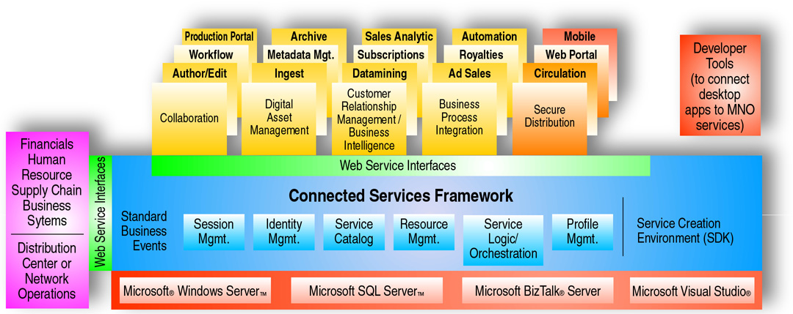
Figure 1. The Microsoft Connected Services Framework architecture
The Microsoft Connected Services Framework is a viable solution for publishers because it provides a medium through which existing applications can connect and, by doing so eliminates the need to replace the proprietary equipment that is already in place. Publishers don’t have to spend exorbitant amounts of money replacing expensive, proprietary equipment, and employees don’t have to learn new systems.
The Microsoft Connected Services Framework makes once-disconnected applications work better together by creating a service-oriented architecture (SOA). An SOA provides a flexible, scalable architecture that binds independent applications through the development of loosely coupled, autonomous, Web services. And by creating and implementing Web services, publishers ultimately enable a smooth, automated exchange of data among otherwise disconnected applications.
For example, a publishing house might have separate systems for authors’ contracts and manuscripts and, because these applications cannot be integrated, tracking the author royalties and payment schedules is a manual process. An SOA enables a developer to create a service that tracks the manuscript’s production and compares progress to the payment schedule in an author’s contract. Once the manuscript reaches a payment milestone, the services notifies the project’s editor that payment is due.
What’s more, the Microsoft Connected Services Framework accelerates and simplifies an SOA deployment by providing a reference framework to facilitate Web service development. Publishers can quickly transform an existing or new application or process into a Web service. In addition, the flexible run-time environment facilitates the management and execution of Web services against various business processes.

Key Functions and Components
Microsoft Connected Services Framework consists of components (as shown in Figure 3) that provide environments for creating, deploying, executing, and managing Web services. And the use of Web services also provides an open, flexible environment that enables the integration of partner networks and other third-party applications.
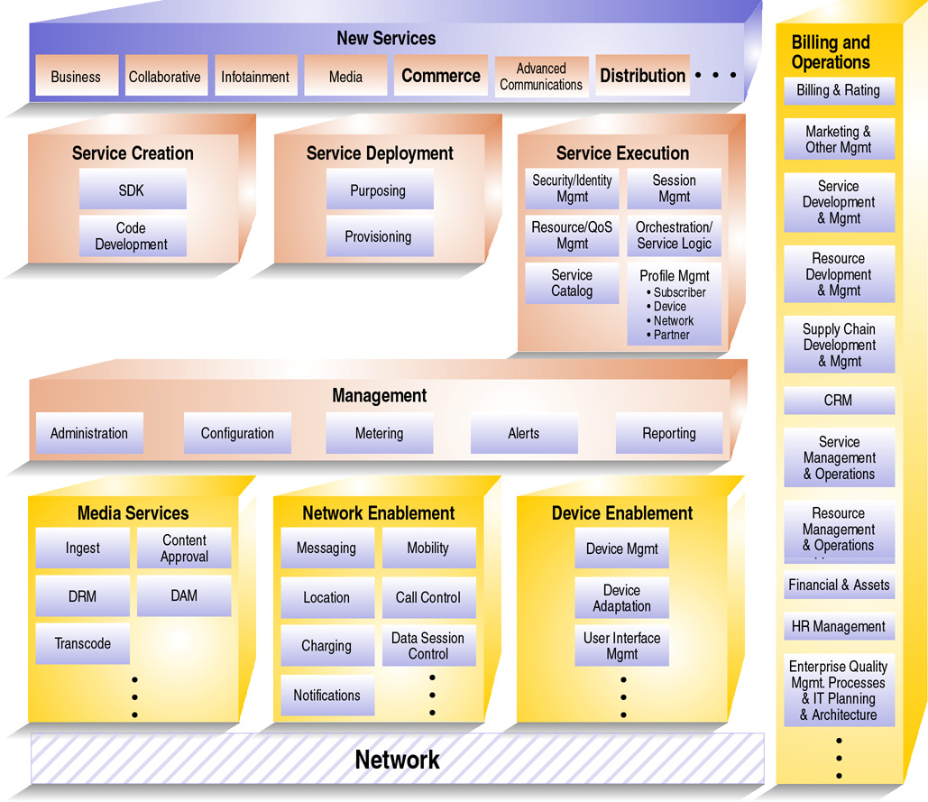
Figure 2. Microsoft Connected Services Framework functional diagram

Service Creation Environment
The components within this environment create an integrated development medium and software development kits (SDKs) for software developers to use when creating services that provide connecting points between disparate applications. Developers with authentication on the Microsoft Connected Services Framework have access to a service catalog of exposed Web services for internal functionality. For example, using the Visual Studio .NET development system, a developer for a news organization can create a service that automates the conversion of a single source of content into Web-based and print-based formats and notifies editors when the files are available. First, the developer would browse the service catalog to discover exposed services for file conversion and automated notifications. Second, the developer would combine the existing services and, then, complete any additional customization work to create the final service.

Service Deployment Environment
The components within this environment provide tools and mechanisms that help developers manage the deployment of new services. Developers can automate service deployment to reduce complexity and minimize downtime. Plus, developers can manage deployed services information in terms of version number, operating system, system configuration, hardware configuration, and so on.

Service Execution Environment
This environment consists of several services that provide support for the execution of publishing-related services. For example, control services provide:
- Identity management to help control system access;
- Metering services to create billable data records;
- Profile and personalization management;
- A notification engine to support push-based alerts to users and customers; and
- Content provider services to facilitate integrating the Microsoft Connected Services Framework with third-party content providers.
The service orchestration component enables publishers to customize workflow processes according to business requirements. Integration services provide a common framework for integrating the Microsoft Connected Services Framework with contract management systems, production systems, billing systems, and more.
In addition, the session manager provides a centralized environment that provides a scalable, dynamic message router where loosely coupled services can collaborate and exchange messages, and new services can be added without disruption. Multiple sessions can run on the same server with unique rules, policies, identities, and services collaborating in a given session. The session manager also controls the creation, hibernation, and state of all the running sessions in the Microsoft Connected Services Framework—each session is a manageable context for the collaboration of autonomous Web services.

Management Environment
The components within this environment provide tools and capabilities that help developers manage the services that have been deployed. With the management environment, developers can avoid common oversights that often lead to reduced agility and increased costs over the life of a service. The Microsoft Connected Services Framework leverages the capabilities of Microsoft technologies—including fault management, configuration management, accounting, performance and quality of service monitoring, and security—and helps developers to manage every aspect of a service network.

Benefits of the Microsoft Connected Services Framework
Digital technology is creating a huge opportunity for publishers, and those who implement the Microsoft Connected Services Framework will be able to capitalize on this opportunity and will position themselves to experience the vast benefits that come with this enabling technology.

Accommodate Demand for Digital Output
As consumers demand more online content, and a digital environment becomes the standard in the publishing industry, publishers can move more confidently to this new medium by using innovative Microsoft technology. The Microsoft Connected Services Framework enables a common content management infrastructure across the organization and enables interaction among previously discreet silos of processes in the digital asset lifecycle, including:
- Creation or acquisition
- Rights management
- Repurposing
- Workflows to distribution
- Hosting, syndication, usage tracking, and reporting.
Digital assets—from financial back-office data to archived books and articles to cover art and photographed images—are available across the organization and beyond. Microsoft technology facilitates creation and delivery of online content and enables publishers to expand delivery channels beyond print to the Internet, mobile devices, and more. For example, a news magazine can create for its online subscribers a service that automatically sends subscribers links to a current issue’s financial articles. Subscribers can then use a Web-enabled mobile phone or PDA to access the content. Or, by creating an online news service, a newspaper doesn’t have to wait to deliver a breaking news story to readers until the evening edition of the paper; instead, the story can be posted online and updated as the event unfolds.
In addition, workers have access to content through a secure Web portal, and having seamless access helps to fuel a more productive environment. For example, a marketing team for a book publisher can get an early start on creating promotional materials by having been allowed immediate and open access to the manuscript, preliminary book reviews, or archived files that contain the author’s picture and biography.

Streamline Operations
A publisher’s infrastructure is a mixture of proprietary applications, and the Microsoft Connected Services Framework reduces the complexity that results from the disconnected nature of this infrastructure. Instead of requiring publishers to replace existing systems with more integrated production, data, and business systems, Web services join together both new and existing applications to software and services across platforms, applications, and programming languages. Publishers can make use of the investment already made in highly specialized equipment by exposing its functions through web services, and information can then flow seamlessly from system to system through the entire value chain of print production, management, and distribution. In addition, tasks can be automated to increase efficiency, lower costs, and facilitate the success of each publishing project.
Using Web services, publishers can begin to realize cost-savings with an infrastructure that enables the simultaneous, secure sharing of content with advertisers, publication houses, and other partner organizations. For example, before the marketing department of a newspaper runs a new ad, they must get final approval on an ad’s appearance. While this process once required meeting face-to-face with the advertiser or mailing the ad to another location, now the newspaper can create a secure, online site where the advertiser can access a digital copy of the ad, suggest changes, or send final approval. What’s more, once final approval has been received, the newspaper can use Web services to automate the file conversion and delivery of the ad to the final print production system.

Enable Effective Communication and Collaboration
Fostering a collaborative environment is critical for the success of any publisher. Preparing a manuscript or newspaper for final print production or planning content for a new magazine issue involves a significant amount of teamwork. For many organizations, collaborative projects can be a frantic process that involves volumes of e-mail messages and hours of meetings. But the Microsoft Connected Services Framework integrates with collaborative tools, such as shared workspaces and information portals that help to automate manual approval processes and facilitate rapid communication through instant messaging (IM).
In addition, using Microsoft technology, publishers can connect people and link content around the globe. With a more connected business environment, publishers can realize more efficient workflows. For example, a newspaper publisher can be more confident that a reporter covering the World Cup Soccer Championship on location in Brazil has the tools necessary to meet his morning deadline. Using a secure, online workspace, the story can be edited and revised, regardless of the location of the reporter, editor, or copy editor. If an editor has a question, he can IM the reporter, thus avoiding any additional delays. In addition, once final approval has been received, the newspaper can implement Web services that automate the formatting and delivery of the story to the production system.

Empower Real-Time Data Access
Success in most industries requires a fine-tuned understanding of the customers’ needs and wishes. For publishers, this understanding also includes knowing exactly who its readers are and the type of content to which they respond. This knowledge ultimately drives more intelligent decisions about running targeted advertising campaigns, story placement, and content creation that is compelling to readers—all which help to boast advertising revenue and consumer spending.
With the Microsoft Connected Services Framework, publishing executives have a way to take a comprehensive look at reader statistics. By providing an overlay to all of its once-disconnected systems, the Microsoft Connected Services Framework provides a filter through which demographic data and sales figures can be compared and contrasted. This connected look helps executives to answer the question, “Who are my readers?”
This ability to compare and contrast information from multiple systems not only drives better business decisions, but also fuels more effective management of costs. For example, a magazine publisher can compare ad sales and revenues more easily against editorial and production costs, and apply this knowledge to managing costs for the next issues of the magazine. To avoid manually tracking this information, the same publisher can create a Web service that automatically tracks and compares newer data and provides automatic notifications when net sales fall below a predetermined figure.

Enable Mobile Operations
Publishers have numerous mobile employees and contractors and, to avoid process delays, all of them must be supported—from the overseas freelance writer to a remote ad salesperson to a roving reporter. The Microsoft Connected Services Framework helps to breakdown geographic boundaries that often slow decision and approval processes.
For example, while an advertising sales person is meeting with a client, the customer requests some changes be made to the current ad. With the mobility that Microsoft technology provides, the sales person does not have to delay until he gets back to the office to do the mark ups. Instead, he can access the existing ad from the magazine’s network, and allow the client to indicate where changes should be made. Once these changes have been saved to the network, a Web service automatically forwards the marked up file to the design department, where changes will be incorporated. Another Web service automates the transfer of the new ad from the design system to the customer’s approval site and notifies the client that the ad is ready for approval.

Scenarios
This section provides a detailed scenario for each media segment in the publishing industry.

Scenario 1: Creating an Automated Newspaper Headline Notification Service
After conducting a poll of online readers, a local newspaper identifies that there is high demand for a service that delivers breaking-news headlines to subscribers, both online and to their mobile phones. While creating this service could be a time-consuming task, the newspaper recently implemented the Microsoft Connected Services Framework, which empowers organizations to create services that respond to customer demand faster, better, and cheaper.
To create the service, an authorized developer browses the service catalog to identify existing services that can be reused. In only a few days, he locates in the Microsoft Connected Services Framework service catalog all the existing Web services that he needs—including an event alert Web service and Short Message Service (SMS)—and completes any additional customization work necessary to make the service function correctly.
Once the service has been created, the newspaper makes the service quickly available to customers through the newspaper’s Web site. Customers who subscribe can indicate which kinds of headlines they want to receive—for example, sports, news, or business. As these stories are posted to the newspaper’s online news site, a subscriber also receives notifications, either through e-mail, IM, or a text message delivered to their cell phone.

Scenario 2: Connecting Magazine Content to the Final Print Production System
A magazine publisher wants to streamline its production process by linking all the systems that contain content for a final print run of a magazine—including graphic elements, advertising, and editorial content. Currently these systems are disconnected, so final content must be manually uploaded to the final print production system. The Microsoft Connected Services Framework, however, creates a layer through which systems can interact, enabling the publisher to more easily link content from best-of-breed, yet proprietary systems.
To connect these systems, a developer creates a service that both transfers final, approved ads to the production system and converts them to the appropriate format for final printing. This same service completes a similar action on final graphics and stories, as well. Overall, the publisher is able to create a more streamlined, automated production process that uses Web services and the Microsoft Connected Services Framework to unite its systems and processes.

Scenario 3: Creating a Customized, Education Book Catalog Service
An educational book publisher was struggling to find the most effective way to use its 100+ page book catalog to sell textbooks to highly targeted markets segments, such as high school English teachers or first grade curriculum designers. The company’s sales people would make copies of pages that contained books or instructional materials of interest to their client. However, this process was proving inefficient, costly, and was not projecting the most professional or savvy image.
By using the Microsoft Connected Services Framework, the publishing house was able to improve the situation because the framework provides a single environment for services execution, and help link together existing services and systems that were once completely separate entities. As a result, the publishing company integrates its digital asset management system, book titles database, and catalog design services so catalogs can be created on an ad hoc, on-demand basis. Now, for example, when a sales person attends a conference for high school math teachers, she can quickly create and present a high-quality catalog that contains only the titles of the high school-level math textbooks sold by the publication company.

Why Microsoft?
When publishers implement the Microsoft Connected Services Framework, they receive more than technologies; publishers benefit from the commitment Microsoft makes to provide solutions that help them work efficiently, increase revenues, as well as expand, attract, and retain customers and subscribers.
To push this initiative forward, Microsoft has assembled the Media and Entertainment group—a team of experts from the publishing industry—working within the walls of Microsoft and acting as your advocates. These people have worked in the industry and understand your needs and pains. They can bring to Microsoft unique insight that Microsoft can apply when developing solutions specifically for your industry.
What’s more, Microsoft plays a leading role in creating and delivering SOA technology. The combination of this technical prowess and industry insight plays a powerful role in developing the right, enabling solutions for you.
In addition, when you work with Microsoft, you work with the best in the field. We have forged partnerships with a tier-one list of service and solution providers to develop integrated solutions for the publishing industry. Microsoft has access to the largest network of line-of-business and application development specialists in the publishing industry and the publishing ecosystem of independent software vendor partners. You can be sure to receive technology products and services that are open, flexible, and interchangeable.

Conclusion
Flat-lined growth, industry consolidation, and increased competition from new media—these challenges are driving an evolution in the publishing industry. While straying from traditional print media hardly seems viable, publishers are extending delivery outlets to embrace the digital age. This move allows them to address pressures from customers and competition while enabling a more connected internal infrastructure to help drive operational efficiency and productivity.
In this era of advanced and developing systems and devices, publishers have a rich opportunity to embrace a new breed of technology that streamlines the creation, delivery, and management of content. With the Microsoft Connected Services Framework, publishers can connect disparate applications and systems by using an SOA. Then, publishers can deliver integrated services for streamlining business processes, facilitating data management, and providing a rich collaborative environment for workers. Departments across all spectrums of the publishing business can work together more effectively and efficiently. And, most importantly, publishers can offer a range of delivery options to customers—flexibility that will help to drive customer spending and, ultimately, boost revenues.

The information contained in this document represents the current view of Microsoft Corporation on the issues discussed as of the date of publication. Because Microsoft must respond to changing market conditions, it should not be interpreted to be a commitment on the part of Microsoft, and Microsoft cannot guarantee the accuracy of any information presented after the date of publication.
This white paper is for informational purposes only. MICROSOFT MAKES NO WARRANTIES, EXPRESS OR IMPLIED, IN THIS
DOCUMENT.
Complying with all applicable copyright laws is the responsibility of the user. Without limiting the rights under copyright, no part of this document may be reproduced, stored in, or introduced into a retrieval system, or transmitted in any form or by any means (electronic, mechanical, photocopying, recording, or otherwise), or for any purpose, without the express written permission of Microsoft Corporation.
Microsoft may have patents, patent applications, trademarks, copyrights, or other intellectual property rights covering subject matter in this document. Except as expressly provided in any written license agreement from Microsoft, the furnishing of this document does not give you any license to these patents, trademarks, copyrights, or other intellectual property.
© 2004 Microsoft Corporation. All rights reserved.
Microsoft, BizTalk, Visual Studio, and Windows Server are either registered trademarks or trademarks of Microsoft Corporation in the United States and/or other countries.

