Microsoft Connected Services Framework for the Broadcast Industry
White Paper
Published: April 2005
For the latest information, please see: www.microsoft.com/resources/mediaandentertainment/default.mspx


Abstract
The evolving landscape of the broadcast industry is sparking a revolution in the way broadcasters do business. Broadcasters now have access to more delivery channels, require more delivery outputs, and understand that digital media will soon be the norm. To successfully address these changes, broadcast companies must find ways to create a connected media environment and streamline the creation, delivery, and management of content. Fortunately, innovative technologies from Microsoft can respond to this challenge—with the Microsoft® Connected Services Framework for Media and Entertainment.
The purpose of this white paper is to introduce a new breed of technology to technical and business decision makers in the broadcast industry. The paper presents challenges faced by those in the broadcast industry, along with information about how the Connected Services Framework can facilitate the creation of a streamlined organization. In addition, the paper includes broadcast-specific scenarios to demonstrate the benefits of the technology.

Executive Overview
The digital age finally is dawning on the broadcast industry. As innovative technology and cable and satellite providers vie for the attention and dollars of the core source of revenue for broadcasters—advertising—and government regulations mandate a move away from an analog production environment, broadcasters struggle to stay afloat. Challenges include facing the reality of an eroding market-segment share, thinning profit margins, increasingly inefficient processes, and rising distribution costs.
But in this era of changing technology, an opportunity has emerged. If broadcasters can embrace new technology, such as digital networks or high bandwidth, and Internet protocol (IP) networks, they can face the competition head-on. In addition, they can deliver innovative services that cater to consumer demands, maintain and expand audience numbers, lower the cost of IT technologies, and drive long-term growth, and ultimately, revenues.
To achieve these goals, broadcast companies must:
- Transform the digital production environment and streamline processes to maximize information sharing, automate complex workflows, and provide a rich collaborative environment.
- Obtain actionable insight into business intelligence so that well-informed, strategic programming decisions can be made.
- Deliver compelling, ubiquitous service to audiences to help increase ratings and drive consumer loyalty.
- Create and manage multiple media services quickly and effectively by maximizing the reuse of common elements and by using specialized deployment tools to help increase efficiencies and to help companies take advantage of new business opportunities.
- Extend the value of existing technology investments by deploying new services within the existing infrastructure.
The difficulty in accomplishing these improvements stems from a highly proprietary infrastructure of business, production, and data systems that don’t interact or share information. Consequently, many steps in the production process are manual and time-consuming. To be able to gain a holistic view of business operations is tedious. Additionally, integration with third-party solutions that enable the creation and delivery of compelling services seems impossible.

The Solution
Microsoft is committed to helping solve the problems the broadcast industry faces. Microsoft has assembled a team of professionals from the broadcast industry and has forged selective partnerships with industry leading solution providers and system integrators, all with the intent to deliver solutions that alleviate the internal and external pressures that broadcasters face each and every day. The Microsoft® Connected Services Framework for Media and Entertainment can help broadcasters improve operational efficiency, can help them to drive better business decisions, and can help deliver an optimal viewing experience.
The Connected Services Framework is a flexible product that transforms the digital production environment and enables companies to embrace the challenges and capitalize on the opportunities of the 21st century. Broadcasters can build an interoperable, manageable, and scalable infrastructure of shared services that connect existing technology and support a dynamic production process across organizational boundaries.

The Benefits
With technology that creates a more fluid infrastructure, broadcasters can begin to realize the business benefits that stem from an open, flexible operating environment.
- Reduce overhead costs and shorten production time. Microsoft provides a solution that helps enable broadcasters to embrace a digital environment. Broadcasters can reduce manual processes and redundant data entry, and improve organizational productivity by connecting front-office and back-office systems with key operational applications, such as resource management and planning or scheduling systems. In addition, the Connected Services Framework can help shorten production timelines by enabling dynamic workflows that support nonlinear creative and production processes.
- Enable secure, cost-effective content distribution. With the Microsoft solution, broadcasters can apply digital rights management more easily to content and minimize revenue lost because of piracy. In addition, the Microsoft solution empowers broadcasters to implement digital or IP-centric networks, a move which reduces the high distribution costs associated with existing satellite and proprietary methods.
- Repurpose assets for multiple delivery channels. Today’s audiences want content to be accessible in myriad ways: TV, Internet, magazines, and so on. The Connected Services Framework enables a seamless, automated exchange of information both within a broadcaster’s infrastructure and with external partners, such as newspapers, magazines, or other parent networks. This “bridge” of sharing helps to shorten content delivery cycles and increase the number of delivery options, and helps provide a cost-effective, competitive edge in an aggressive industry.
- Increase workflow efficiency while lowering costs. Creation of a news or feature story requires a high degree of input from various producers, writers, audio and video specialists, and others. Schedules, programming strategies, or marketing campaigns often depend on input from experts both inside and outside company walls. The Microsoft solution empowers a collaborative environment that helps to increase workflow efficiency, enhance communication, and lower costs.
- Provide real-time insight into production and business support performance. Making the right business decisions requires access to key data regarding demographics and audience behavior. Having complete and timely information helps to create effective marketing campaigns, to manage production costs, or even to select a targeted customer audience, such as running an ad in a time slot that will be most effective in reaching a specific age population. By connecting business and data management systems, the Microsoft solution helps empower executives by providing them with deep business insight that can help them to make the best decisions for their business.

Conclusion
Facing a vastly different future, the opportunity has arisen for broadcast companies to implement innovative technology that can help streamline operations, help provide better business insight, and help enable broadcasters to meet the growing demands of consumers.
The Connected Services Framework helps enable broadcasters to embrace a new mode of operating—one that capitalizes on the benefits of a Web services network and can open up new revenue streams. By providing a medium through which existing and partner systems can connect, the Connected Services Framework offers realistic answers to meet the new demands of the broadcast industry.

Contents
Introduction 1
The Challenges 2
Facilitating Data Management 2
Distributing Content Cost-Effectively and Securely 2
Integrating Applications, Business Processes, and Systems 3
Facilitating Communication and Collaboration 4
Gaining Deep Insight into Strategic Operations 4
Enabling Mobile Operations 4
The Solution 5
The Microsoft Connected Services Framework for Media and Entertainment 5
Key Functions and Components 6
Benefits of the Connected Services Framework 9
Facilitate Data Management 9
Empower Secure, Cost-Effective Data Sharing 10
Integrate Applications, Processes, and Systems 10
Foster Communication and Collaboration 11
Boost Business Insight 11
Enable Mobile Operations 12
Catering to Audience Demands 13
Why Microsoft 14
Conclusion 15

Introduction
Change: a theme that has infiltrated the broadcast industry for the past twenty years, and a theme that applies to all aspects of the industry.
The number of cable and satellite channels has grown from 60 to 267 in just 12 years. Simply put, entertainment options for consumers have exploded. While broadcasters once delivered content for a single radio or television station, they now are creating and repurposing content for multiple television, radio, cable, and online outlets. For example, it would not be unusual for a broadcaster to operate several public television channels, a 24-hour cable news channel, numerous digital channels, both national and digital radio networks, and an online news service.
As a result of industry mergers and consolidations, content creation, management, and distribution have changed. The Federal Communications Commission (FCC) has made sweeping changes in media ownership rules and digital content. But the most significant change is still only on the horizon.
Technology is igniting a revolution in the broadcast industry. Huge windows of opportunity have been opening up since the advent of the Internet and digital content. An IP-centric network empowers broadcasters to deliver an interactive viewing experience or Video on Demand (VOD) to audiences across a range of devices. Digital content provides a high-quality viewing experience for the television viewer, and the nature of digital presentation practically forces broadcasters to streamline operations and reduce overhead associated with many manual, internal processes.
However, to seize and profit from this opportunity successfully, the broadcast industry must first change from within and overcome industry stereotypes and obstacles that lie in its path.

The Challenges
The core of a broadcaster’s business lies in the successful management, distribution, and consumption of content. And success can be achieved by delivering news stories, sitcoms, dramas, and more―content that draws in consumers. In addition to increasing advertising revenue through increasing consumership and ratings, broadcast executives are realizing that they must seek innovative ways to sustain audience appeal. The recent onslaught of technical advances has left audiences in control and wanting more flexibility in how they access their chosen entertainment and news content. It’s no longer enough to televise a soccer game only on TV. Instead, audiences also want the ability to listen to the game on the radio or follow it on the Internet, as well as to access game highlights by using a mobile device. Audiences even want to control the televised angle at which they watch the game. But an infrastructure composed of highly proprietary systems often prevents a broadcaster from meeting these evolving audience demands.
Broadcasters can give audiences what they want more readily by employing a more flexible infrastructure that speeds the delivery of content to multiple mediums and helps enable more enticing broadcasting methods, such as Picture-in-Picture. But as explained by André Mendes, Vice President and Chief Technology Integration officer for the Public Broadcasting Service (PBS), historically, broadcasters have been slow to embrace new technology because of the risk involved.
“Supply chain optimization is not part of the traditional broadcast mindset. Broadcast content is demanding from latency, bandwidth, and reliability standpoints. With advertisers spending U.S.$2 million for a single Super Bowl spot, broadcasters can’t afford for anything to go wrong. This situation has led to proprietary environments that are exceedingly risk-averse. Consequently, broadcasters have been slow to adopt IT efficiencies that have become common place in other industries.”
But by adopting a new breed of technology, broadcasters can begin to overcome some of the more prominent challenges they face, especially those related to streamlining operations and increasing revenues.

Facilitating Data Management
As digital media becomes the new standard in television, broadcasters are replacing the old video tape format with digital media files. As stations embrace this new digital environment, they are challenged to find a better way to manage a voluminous number of files that not only contain a diverse range of content, from audio to video to static images, but also have been saved in a variety of different formats. Finding the most effective, efficient way to manage this content streamlines internal operations, introduces multiple opportunities to repurpose content and to also deliver a significant competitive edge in an industry where, for instance, being first-to-air a breaking news story can dramatically increase audience numbers.
As an example, consider a news organization that has a well-organized, sophisticated, digital asset management solution in place. This organization can shorten the amount of time it takes to locate and piece together audio and visual background elements for a breaking-news story. The time savings might make the difference between this organization and its competitors, by allowing it to be the first to air the story on the five o’clock news, while the others won’t air the same piece until later, on the six o’clock news.

Distributing Content Cost-Effectively and Securely
The move to digital media has also challenged the broadcasting industry to discover the most secure method to distribute digital content. The world has been watching the proliferation of piracy issues that have plagued the music industry since the introduction of digitized content—duplication of such another, similar event would be an undesired result for any industry.
How can the process for securely licensing and clearing content for different distribution channels be simplified? For example, how can a VOD movie be downloaded to a viewer’s laptop computer and be viewed only by that paying customer and not be distributed to others?
What about security when sharing content with a partner news station or online distributor? For example, if a local news story were to become a national event, the local broadcast station should be able to share footage and interviews easily with its parent network station. Content can be shared safely by using a secure connection to its local video archives.
What is the most cost-effective means to distribute content? This question, in addition to security issues, is at the forefront of the minds of many broadcast executives. Distribution, currently, is a process handled by using expensive, proprietary distribution methods and satellites.

Integrating Applications, Business Processes, and Systems
The IT infrastructure at a broadcast station is complex, to say the least. This complexity is a result of industry consolidations, mergers, and acquisitions, and highly specialized business, production, and data management applications that don’t interoperate with one another. (See Figure 1.) Consequently, business processes, such as the production life cycle, involve multiple, manual steps, which delay the production process. This disconnected infrastructure also creates challenges when tracking production costs, managing talent contracts, and such. In addition, the lack of integration prevents broadcasters from partnering easily with other vendors, such as newspapers, magazines, or parent networks.
Says David Heppe, Senior Vice President of Sales and Marketing at Telestream, “The industry has been challenged by vendors trying to produce solutions for complex workflows on their own or with unique, custom integration. Both methods resulted in long lead times and expensive implementations.”
Figure 1. The disconnected infrastructure of a broadcast station

Facilitating Communication and Collaboration
Working behind the scenes at any broadcast station requires a significant amount of communication and collaboration between producers, production managers, audio visual specialists, and others. And this need to work together extends beyond just production tasks. For example, making business decisions—such as defining programming strategies or licensing content—involves a high level of coordination among business and production executives. For many, these critical decisions are made through a combination of hallway conversations and meetings while jotting down notes on clipboards, and e-mails—methods of communication that typically slow down the decision process and can limit input from other experts, both inside and outside of the organization.

Gaining Deep Insight into Strategic Operations
Understanding audience trends is crucial to running a successful broadcast station, and this understanding becomes even more important as cable, satellite, and other enhanced service providers steal a portion of a broadcaster’s market share and advertising revenue. Only with a firm comprehension of the programming “likes and dislikes” of an audience can broadcasters begin to create and distribute content that truly caters to audience trends. To acquire this knowledge, executives need access to market research data, such as program ratings, demographic data, and audience behaviors. Only with this information can they aim advertising at targeted blocks of consumers and create strategic programming strategies that will help to build audience numbers and show ratings. Unfortunately, because much of the key information is locked away in individual systems, it is hard to compare and contrast these vital data statistics.
In addition to audience statistics, broadcasters also lack the ability to effectively track human and physical infrastructure costs. How much is talent being paid? How often is specialized camera equipment being used? How much has the organization spent on contract editors in a given month? The answers to these questions are vital to the executives keeping a finger on the pulse of the financial health of an organization, and making sure money is being spent in the most effective way.

Enabling Mobile Operations
Nothing about a broadcast station is static. Producers and talent are frequently on location around the globe, covering international events. News reporters are on the streets, finding stories for the daily news or news magazines; and sales people are out and about at local businesses, selling air time for advertising. With so many people working remotely, a broadcast station will only benefit from a solution that fosters a mobile workforce. True mobility prevents the delay of processes and approvals, and allows workers to capture metadata about video bits while they are in the field, or allows newscasters to create news segments outside of the organization’s walls. A mobile solution even makes it possible for a station to obtain the approval of content, regardless of a producer’s geographic location, by using a device such as a personal data assistant (PDA) or Tablet PC.
For example, the airing of a documentary that celebrates the life of a historical figure on the anniversary of his or her death should not be delayed because the final piece has to be physically shipped for final approval to the executive producer who is on location in Brazil. Instead, the executive producer should be able to access the content online and submit his or her approval or edits instantly so that the show can be finalized and aired according to schedule.

The Solution
The broadcast industry now has the opportunity to use the same technology that already has been a driving force of change in so many other industries. The same two trends that have pervaded other industries are occurring in broadcasting: one trend is toward a digital environment and the evolution of an IP-centric network, and the other trend is towards the proliferation of Web services and a service-oriented architecture (SOA) that enables once-disconnected systems to interact. So, too, continues―and increases―the degree of opportunity that comes with a connected infrastructure that facilitates an automated, secure flow of information among systems and roles.

The Microsoft Connected Services Framework for Media and Entertainment
Microsoft provides a solution for the broadcast industry in the form of the Microsoft Connected Services Framework for Media and Entertainment. The Connected Services Framework for is a flexible product that transforms the digital production environment and enables companies to embrace the challenges and capitalize on the opportunities of the twenty-first century. Broadcasters can build an interoperable, manageable, and scalable infrastructure of shared services that integrates with existing technology to support dynamic, nonlinear production processes across organizational boundaries.

The Connected Services Framework is built on the Microsoft .NET Framework―an integral component of the Windows® operating system that provides a programming model. By building on industry standards such as Extensible Markup Language (XML), Simple Object Access Protocol (SOAP), and Web Services Description Language (WSDL), the Connected Services Framework harnesses the power of Web services to build connected systems that move information across platforms and applications and streamline the creation, management, and delivery of digital content. (See Figure 2.)
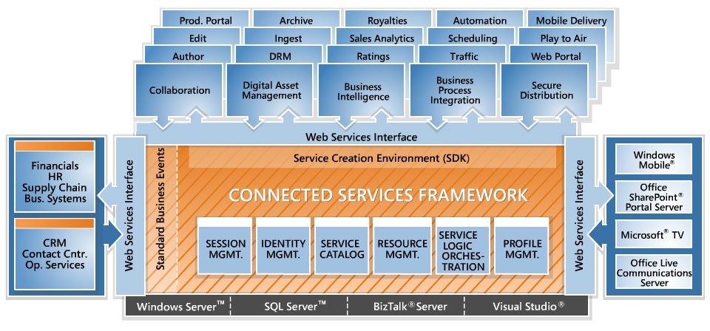
Figure 2. The Connected Services Framework architecture

Supporting Integration with an SOA and Web Services
The Connected Services Framework is a viable solution for broadcasters because it provides a medium through which existing applications can connect, and thus, there is no need to replace the proprietary equipment that is already in place. Instead of a disconnected infrastructure, broadcasters create an integrated system and can enable dynamic workflows by building shared services that take advantage of the existing infrastructure.
Much of this is possible because the Connected Services Framework creates an SOA, which provides a flexible, scalable architecture that binds independent applications through the development of loosely coupled, autonomous Web services. And by creating and implementing Web services, broadcasters ultimately enable a fluid, automated exchange of data among otherwise disconnected applications.
For example, a broadcast station might have separate systems for video editing and video conversion, but because these applications cannot be integrated, a video that has gone through a final edit must be transferred manually to the conversion system to be saved to other file formats. However, an SOA enables a developer to create services that will speed the process: one service moves the video files from the editing system to the conversion system, and the other service automates the conversion of the video file to one that is high resolution, low resolution, and so on—all while maintaining the metadata that was associated with the original file.
Expanding on the benefits of Web services, Jason Turner, President and Chief Executive Officer for Agnostic Media says, “By defining things as Web services, we can have encoding or distribution services talk to each other, but one of them can be changed without affecting the other. Different parts of the service can be deployed and never touched again, and others can be repeatedly adjusted. The result is real ease of deployment as well as long-term usability.”

Taking a Flexible Approach to Deployment
The Connected Services Framework is also a realistic solution for broadcasters because it supports an incremental deployment. Broadcasters can develop and release shared services strategically and cost-effectively across their business by starting small and gradually building their service library over time. In addition, the Connected Services Framework is flexible and scalable enough accommodate growth and change, and thereby helps to increase organizational agility.
While many experts today are touting the rich benefits of Web services, many organizations lack a tool that provides an environment that facilitates the creation of these Web services. The Connected Services Framework, however, provides a manageable, scalable environment for developers that simplifies and speeds the creation of Web services and helps to make the implementation of this technology a reality.

Key Functions and Components
The Connected Services Framework consists of components (as shown in Figure 3) that provide environments for creating, deploying, executing, and managing Web services. And the use of Web services also provides an open, flexible environment that enables the integration of partner networks and other third-party applications.
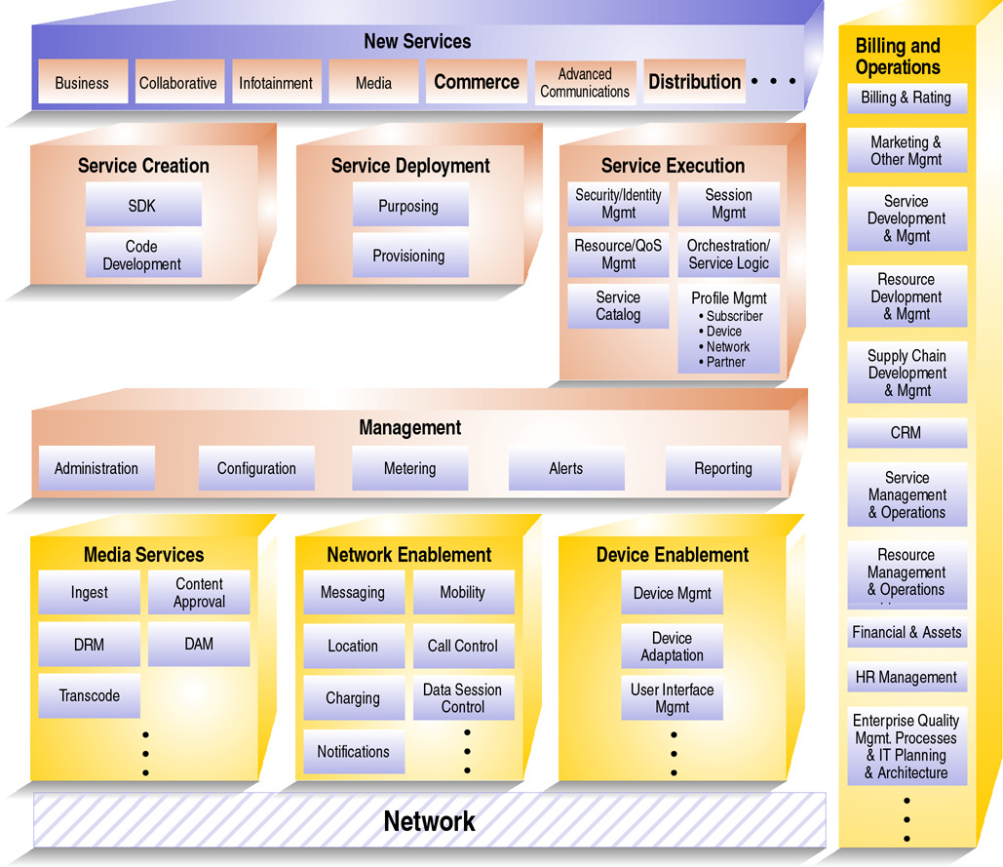
Figure 3. The Connected Services Framework functional diagram

Service Creation Environment
The components within this environment create an integrated development medium and software development kits (SDKs) for software developers to use when creating services or applications that provide connecting points between disparate applications. Developers with authentication on the Connected Services Framework have access to a service catalog of exposed Web services for internal functionality. For example, using the Microsoft Visual Studio® .NET development system, a developer can create a service that automates the creation of a streaming file and distribution of a rough cut of a promotional news segment. First, the developer would browse the service catalog to discover exposed services for file conversion, media streaming, and automated notifications. Secondly, the developer would combine the existing services and, then complete any additional customization work to create the final service.

Service Deployment Environment
The components within this environment provide tools and mechanisms that help developers manage the deployment of new services. Developers can automate service deployment to reduce complexity and minimize downtime. Plus, developers can manage deployed services information in terms of version number, operating system, system configuration, hardware configuration, and so on.

Service Execution Environment
This environment consists of several services that provide support for the execution of broadcast-related services. For example, control services provide:
- Identity management to help control system access;
- Metering services to create billable data records;
- Profile and personalization management;
- A notification engine to support push-based alerts to users, customers, and partners; and;
- Content provider services to facilitate integrating the Connected Services Framework with third-party content providers.
The service orchestration component enables broadcasters to customize workflow processes according to business requirements. Integration services provide a common framework for integrating the Connected Services Framework with contract management systems, production systems, content management systems, and more.
In addition, the session manager provides a centralized environment that provides a scalable, dynamic message router where loosely coupled services can collaborate and exchange messages, and new services can be added without disruption. Multiple sessions can run on the same server with unique rules, policies, identities, and services collaborating in a given session. The session manager also controls the creation, hibernation, and state of all the running sessions in the Connected Services Framework—each session is a manageable context for the collaboration of autonomous Web services.

Management Environment
The components within this environment provide tools and capabilities that help developers manage the services that have been deployed. With the management environment, developers can avoid common oversights that often lead to reduced agility and increased costs over the life of a service. The Connected Services Framework leverages the capabilities of Microsoft technologies—including fault management, configuration management, accounting, performance and quality of service monitoring, and security—and helps developers to manage every aspect of a service network.

Benefits of the Connected Services Framework
The Internet and digital technology are creating a huge opportunity for broadcasters. Those who implement the Connected Services Framework will be able to capitalize on this opportunity and will position themselves to experience the vast benefits that come with this technology.

Facilitate Data Management
As a digital environment becomes the standard in the broadcast industry, broadcasters can more confidently move to this new medium with the Connected Services Framework. The Connected Services Framework enables a common content management infrastructure across the organization and enables interaction among previously discreet silos of processes in the digital asset life cycle, including:
- Creation or acquisition
- Rights management
- Repurposing
- Workflows to distribution
- Format conversion
- Hosting, syndication, usage tracking, and reporting.
Digital assets—from financial back-office data to archived video files to audio content—are available across the organization and beyond. Ultimately, access through a secure Web interface, rich client applications, or PDA helps to fuel a more productive environment.
For example, using the Connected Services Framework, a broadcast company can log production information as digital content is being captured, and thus, increase accuracy and relevance. The broadcast company can also share production information efficiently with digital asset management and storage applications. As a result, in this scenario, a five-minute segment chronicling the life of a rising star in the political scene can be created during the day and be ready for that same day’s five-o’clock news because digital video segments are easier to locate and share. The video archivist assigned to the story can conduct detailed searches of video archives and quickly locate past footage in which the politician is discussing his decision to go into politics. The archivist places the short list of video footage on the producer’s share site. In the meantime, the reporter assigned to the story interviews people to get their reactions and posts these files to the producer’s share site, as well. By three o’clock in the afternoon, the producer has all the necessary information and rapidly pieces together the feature segment, which is available for the early evening newscast.
The Connected Services Framework makes large amounts of production data not only more available, but also easier to track and manage. From proposals and contracts, to scripts and storyboards, to audio and video files—managing this information is tedious work, especially when stored in various file cabinets or locked on individual desktops and proprietary systems. But with the Connected Services Framework, all of the production-related data can be managed digitally, and developers can create services that help to aggregate this once-dispersed information.
For example, one system coordinates the scheduling of studios, equipment, and technicians for a specific production while another system tracks the costs associated with these resources. A service can be created that automatically will calculate the amount of time for which each resource has been scheduled, can pull cost information from the contract management system, and then generate a report of planned costs for the producer’s review.

Empower Secure, Cost-Effective Data Sharing
A digital environment helps enable more than an increasingly productive workforce and comprehensive data management; digitizing can offer significant cost savings as well. For example, PBS predicts an estimated U.S.$100 million annual savings after moving from a real-time, satellite video distribution system to a file-based, digital video distribution system.
With the Connected Services Framework, more broadcasters can begin to realize these cost-savings with an infrastructure that not only facilitates content delivery, but also enables the simultaneous, secure sharing of content by TV and radio editors, promotional producers, closed-caption writers, and others.
For example, a broadcast station that produces a news entertainment show can post content and stories from daily productions to a secure, shared site that partners can access and reuse relevant content for partners’ broadcasts. Because the Connected Services Framework creates an SOA, a developer can create a service that proactively notifies partners when a story has been posted to the site. In addition, the service can provide a short overview of the story’s content, and can offer the option for an automatic download of the story to the partner’s network. If the partner chooses to download the story, the service first detects whether or not the partner is an authorized user on the station’s network. If so, the service converts the format of the file to one that is appropriate for the partner. If the partner is a radio station, for instance, the service might convert a video file to an audio file.
What’s more, the Connected Services Framework provides a medium through which digital asset management and rights management systems are linked. As a result, it’s easier to apply different licensing rights to the same content, and it becomes a more simple process to repurpose content for different distribution channels. For example, a broadcast station can securely distribute programming over a broadband connection to computers or to interactive televisions and, consequently, minimize lost revenues due to piracy.

Integrate Applications, Processes, and Systems
A broadcast station’s infrastructure is a mixture of proprietary applications. The Connected Services Framework reduces the complexity that results from the disconnected nature of this kind of infrastructure. Instead of requiring stations to replace existing systems with more integrated production, data, and business systems, Web services join together both new and existing applications to software and services across platforms, applications, and programming languages. Broadcasters can make use of the investment already made in highly specialized equipment, and information can flow seamlessly from system to system through the entire value chain of media production, management, delivery, and experience without boundary restrictions between internal departments and external partners. In addition, tasks can be automated for more efficient, streamlined business processes.
For example, post-production work on promotional clips for an upcoming TV “movie of the week” typically involves editing, video enhancements, and audio formatting. Each stage in this process requires work to be completed through separate applications, a process that typically will require a different file format. The Connected Services Framework can help broadcast stations streamline this process by enabling the creation of a service that automates the transformation of a file from one format to another. After video editing has been completed, the video editor enables an editing service that automatically transfers the files to the video enhancement system, and also converts the file format. A service that completes a similar process can be used also to transfer a file from the video enhancement system to the audio formatting system, and so on.
Not only do production systems become more connected, but also content from business and data systems can be integrated. For example, throughout the post-production process as artists from each department log time worked on a project, a service can pull this information, compare it to hourly wage information stored in the human resources payroll system, and generate a daily report that summarizes existing production costs. In addition, a broadcast company can implement a collaboration solution, such as Microsoft Office SharePoint® Portal Server, and a notification tool, such as Microsoft Office Live Communication Server, and connect these solutions to its back-office systems through the Connected Services Framework. As a result of this connectivity, content from the broadcaster’s digital asset management system can be shared easily across a specific workgroup through a SharePoint Web site, and an automated notification process for a content approval workflow can be initiated. (See following section, Foster Communication and Collaboration, for a more specific scenario.)

Foster Communication and Collaboration
Fostering a collaborative environment is critical for the success of any broadcast station. Development of features and in-house newscasts involves a significant amount of teamwork. For many organizations, collaborative projects can be a frantic process that involves volumes of e-mail message exchanges and hours of meetings. But the Connected Services Framework helps improve collaboration by enabling shared access to media and information for faster review and feedback cycles. In addition, it integrates with collaborative tools, such as shared sites and information portals, tools that help to automate manual approval processes and facilitate rapid communication through instant messaging (IM).
For example, consider a scenario in which a producer, while developing a feature segment for an entertainment talk show, must collect feedback and approvals from her team members. With the Connected Services Framework, this entire process can be simplified with an online team workspace and Web services. Once the rough cut has been saved, a Web service automatically creates a streaming file, places it on a shared workspace, and sends automatic e-mail alerts to those on the producer’s approval list. Those reviewing the segment place their comments and corrections back on the shared workspace, where the producer can incorporate their suggestions into her rough cut. If she has questions about a particular comment, she can contact the originator of the comment by using IM. This entire process can be repeated until the rough cut has received all the necessary approvals.

Boost Business Insight
Success in most industries requires a fine-tuned understanding of internal operations to help control costs and project timelines. For broadcasters, this means having the ability to access real-time insight into information related to outsourced project status and costs, and having the ability to track detailed production costs. Possessing key information at their fingertips can help broadcasters make the best decisions at critical project checkpoints and, as a consequence, help reduce cost overruns. Because the Connected Services Framework links front-office and back-office applications with key operational systems, gaining this valuable business insight is easier than ever.
In addition, broadcasters also require a deep understanding of its consumers’ needs and wishes. Broadcasters want to know exactly who the consumers are and what they want to watch. With this knowledge, broadcasters can develop strategies that help to increase audience and, ultimately, help to attract and retain other advertisers.
With the Connected Services Framework, broadcast executives have a way to take a comprehensive look at audience statistics. By providing an overlay to all of its once-disconnected systems, the Connected Services Framework provides a filter through which demographic data and ratings can be compared and contrasted. This connected look helps executives to get a better idea of who is tuning into their programming.

Enable Mobile Operations
Broadcast stations have numerous mobile employees and, to avoid process delays, a station must support all of them, from the roving reporter to the on-location producer. The Connected Services Framework helps to break down geographic boundaries that often slow decision and approval processes.
For example, a not-too-uncommon scenario might involve the executive producer of a television station who is traveling overseas. The team who is adding the final touches on his documentary becomes concerned about meeting the deadline. The documentary, scheduled to air the following week, requires the producer’s approval before airing. With the Connected Services Framework in place, the team simply posts the final video file to a secure, virtual workspace. The producer accesses and views the video—from his overseas location—by using his mobile computing device. He incorporates his final comments and re-posts the file to the team workspace—all while the documentary team members are asleep in their own time zones. The documentary is ready to air on time.

Catering to Audience Demands
Advancements in technology are changing not only the inner workings of a broadcast station, but also the demands that audiences place on the media and entertainment industry, in general. Audiences want multiple forms of content on multiple devices, and the competition to meet these demands is fierce. Fortunately, the Connected Services Framework helps empower broadcasters to provide an optimal experience for its audiences, regardless of how the consumer accesses content.
With the Connected Services Framework, broadcasters can create multiple versions of files to accommodate every viewing device. For example, broadcasters can create high-resolution, digital content for television viewers while creating lower-resolution files that are available for downloading online. Because broadcasters can create multiple formats quickly, content flows to the consumer faster, whether over the network, on optical media, or through other devices.
Says Mendes, “With Microsoft software and services, we can create programming at multiple bit rates, so the same show can be consumed on a home TV, a PDA, the Internet, or even on other future devices.”
Here’s a sample scenario: after televising an interview with a movie star, a local broadcast station also wants to make this interview available to the public on the station’s Web site. In the past, completing this task required multiple, manual steps that resulted in a significant delay between the morning airing and the Web site posting. That situation changes when the station implements the Connected Services Framework. To speed up the process, a developer creates a service that automates the conversion of a high-resolution data file to a low-resolution file appropriate for posting to the Internet. Not only does the entire conversion process happen automatically, but also the transformed file instantly posts to the Web site. The broadcast station avoids the expense and delay that can occur when an employee manually completes the conversion. And the interview is available online immediately following the initial, televised program.
The Connected Services Framework does more than enable the rapid delivery of content through multiple channels; it also can enable a truly interactive consumer experience. For example, by using the Connected Services Framework as an integration point, broadcasters can implement and deliver the services enabled by Microsoft TV. By enabling an Internet Protocol TV (IPTV) service, broadcasters can create more enticing broadcast methods, such as Picture-in-Picture, and enable viewers to watch multiple views of a sporting event and, even, give viewers customization capabilities so they can see their team’s dugout during a baseball game.

Why Microsoft
When broadcasters implement the Connected Services Framework, they receive more than technologies; broadcasters benefit from the commitment Microsoft makes to provide solutions that help broadcasters work efficiently, increase revenues, and expand and retain audiences.
To push this initiative forward, Microsoft has assembled the Worldwide Media & Entertainment group—a team of experts from the broadcast industry—working within the walls of Microsoft and acting as your advocates. These people have worked in the industry and understand your needs and pains. As a result, they bring to Microsoft unique insight that Microsoft can apply when developing solutions specifically for your industry.
What’s more, Microsoft plays a leading role in creating and delivering SOA technology. The combination of this technical prowess and industry insight plays a powerful role in developing the right, enabling solutions for you.
In addition, when you work with Microsoft, you work with the best in the field. We have forged partnerships with a list of tier-one service and solution providers to develop integrated solutions for the broadcast industry. As a result, you work with people who have the right level of technical and industry expertise—from industry-savvy Microsoft system integrator partners who can connect your disparate systems and build a flexible end-to-end solution, to Microsoft independent software vendors who develop best-of-breed solutions. Microsoft has access to the largest network of line-of-business and application development specialists in the broadcast industry and the broadest ecosystem of independent software vendor partners. You can be sure to receive technology products and services that are open, flexible, and interchangeable.

Conclusion
Up to this point in time, Broadcasters have faced substantial challenges in their efforts to deliver the most compelling content to audiences. These challenges have been rooted in incompatible systems that consume time, money, and resources.
Explains Mendez, “The more stations spend on purchasing and maintaining proprietary equipment and control systems, and on labor-intensive distribution systems, the less they’re able to spend on developing new programming. Aggregating and distributing program content has been consuming a disproportionate amount of our resources.”
But in this era of advanced and developing systems and devices, broadcasters have a rich opportunity to embrace a new breed of technology that streamlines the creation, delivery, and management of content. With the Connected Services Framework, broadcasters can bridge operations and IT to support changing business dynamics by connecting isolated systems across organizational boundaries and across multiple technologies and platforms.
As a result, broadcasters can deliver integrated services for streamlining business processes, facilitating secure data management, and providing a rich collaborative environment for workers. Departments across all spectrums can work together more effectively and efficiently, and leverage dynamic workflows that support nonlinear creative and production processes. And, most importantly, broadcasters can provide the services that will keep their audiences from straying to competing stations and networks.

The information contained in this document represents the current view of Microsoft Corporation on the issues discussed as of the date of publication. Because Microsoft must respond to changing market conditions, it should not be interpreted to be a commitment on the part of Microsoft, and Microsoft cannot guarantee the accuracy of any information presented after the date of publication.
This white paper is for informational purposes only. MICROSOFT MAKES NO WARRANTIES, EXPRESS OR IMPLIED, IN THIS
DOCUMENT.
Complying with all applicable copyright laws is the responsibility of the user. Without limiting the rights under copyright, no part of this document may be reproduced, stored in, or introduced into a retrieval system, or transmitted in any form or by any means (electronic, mechanical, photocopying, recording, or otherwise), or for any purpose, without the express written permission of Microsoft Corporation.
Microsoft may have patents, patent applications, trademarks, copyrights, or other intellectual property rights covering subject matter in this document. Except as expressly provided in any written license agreement from Microsoft, the furnishing of this document does not give you any license to these patents, trademarks, copyrights, or other intellectual property.
© 2005 Microsoft Corporation. All rights reserved.
Microsoft, BizTalk, SharePoint, Visual Studio, Windows, the Windows logo, Windows Mobile, Windows Server, and Windows Server System are either registered trademarks or trademarks of Microsoft Corporation in the United States and/or other countries.
All other trademarks are property of their respective owners.

According to the United States Entertainment Industry’s 2002 MPA Market Statistics
See http://www.microsoft.com/casestudies to access “Public Broadcaster Uses IT Technologies to Reduce Operational Costs up to $100 Million,” a case study detailing the benefits of PBS’s move to an all digital environment.

