Integrated business intelligence solutions for your organization

In the business world, critical information influences individuals’ goals, affects how people work across teams and ultimately helps organizations achieve objectives. But it wasn’t that long ago when business workers struggled to gather, locate and process the information they needed to perform their jobs effectively. The tools available to help them work with business data were rudimentary, with limited data connections and with significant bandwidth constraints that impeded access to the information.

Today, things have changed. We are engulfed in business data, it’s almost everywhere we look. At times it seems there is actually too much information, kept in too many places with no efficient process for pulling it all together. That’s where business intelligence (BI) and performance management solutions come into play. They help you make sense of the information you have to make better decisions and drive your business forward. However it’s no secret that traditional BI and performance management approaches have often fallen short because they only address a fraction of the information needs of today’s businesses. And because these systems are generally hard to use and maintain, access is often restricted to only a few individuals or groups across the company. Even worse, usage of these systems often peaks during the first few weeks of implementation. This is because the tools don’t work as the organization expected and the solution does not accurately reflect how the company intends to use the information.

Thinking Bigger About BI
The solution to these challenges comes from thinking bigger about business intelligence. Because when it comes down to it, most of the information people use and interact with on a daily basis isn’t kept in an ERP or a transactional system. Instead, the information is kept in a variety of places across the organization, ranging from people’s brains, to the Internet, to documents and spreadsheets maintained independently across the organization.

It is critically important that a BI tool set provide tailored functionality for people across the organization. If a BI suite offers so much functionality that it is too complicated for the average user, or if it isn’t robust enough for power users, it won’t be embraced and it will not be used for long. The solution needs to be flexible enough to adapt to the needs of a diverse group of users and it must work the way your people want to work.

Additionally, it must be able to pull data from virtually any data source while also working well with line of business applications, including familiar and commonly used desktop productivity tools like the 2007 Microsoft® Office system, portals and other document repositories. Only accurate, trustworthy and timely data, powered by a stable and fully integrated platform, can help organizations realize the benefits of true business intelligence.

Finally, if a BI solution is too costly to license, implement and maintain, broad deployment isn’t feasible. Because of this, many of the people within the company often go un-served, leaving the majority of the people responsible for tactical and operational decision-making unable to come to informed conclusions.

The Microsoft Business Intelligence Approach
To accomplish your company-wide objectives, you need a comprehensive and integrated approach to business intelligence. Individuals, teams and organizations need more than just a single tool, data source or application to access the information required to increase productivity and drive better decisions.

Only Microsoft provides the fully-integrated platform, infrastructure and applications to help organizations access and understand personal, team and organizational information that impacts business performance. We believe that providing business insight to all employees leads to better, more relevant decisions, and increases productivity across an organization. The best part is that most employees already know how to use many of the Microsoft BI products because they are using them today.
Personal BI is information that we use daily to achieve individual goals and objectives; it is information created for personal use. For example, it can exist in a Microsoft® Office Excel 2007 spreadsheet created to understand the particulars of a specific deal, a visual diagram built to plan a process, a Microsoft® Office Outlook® 2007 task list or simply information stored in someone’s head.

Departmental BI is information that is used to work effectively in teams, ensuring that the goals of the department or group are met. Whether a person is part of a reservations team at a hotel or they are a part of an accounts payable team for a heavy equipment manufacturer, these individuals need an environment that facilitates group interaction and information sharing. The latest version of the most critical information is always necessary in order to be most productive and make the best decisions.

Organizational BI is used to achieve the larger strategic goals of an organization. Operating margin, ROI on strategic investments, market share goals and gains are a few examples of objectives that require centrally maintained information to help the company drive performance.

Microsoft Business Intelligence Products and Services
Given the wide range of tasks, goals and objectives organizations face on a daily basis, the need for agility, accessibility and speed of business information is critical. A centralized approach, based upon products and technologies already in use in the work place can help. Microsoft Business Intelligence tools, applications and services provide simplified access to timely information that leads to more informed decision-making and stronger business performance.

Microsoft BI Infrastructure
Organizations cannot increase productivity or provide centralized access to business intelligence without a scalable, fully integrated infrastructure. Microsoft® SQL Server 2005, with its powerful combination of services is in use in organizations of all sizes around the world. Microsoft BI infrastructure products and services include:

Microsoft SQL Server 2005 – for organizations that require comprehensive, integrated data management and analysis software that enables them to reliably manage mission-critical information and confidently run today’s increasingly complex business applications. SQL Server 2005 allows companies to gain greater insight from their business information and achieve faster results for a competitive advantage.

Microsoft SQL Server Reporting Services– for organizations that want to enable the creation, management and delivery of both traditional, paper-oriented reports and interactive, Web-based reports. An integrated part of the Microsoft Business Intelligence framework, Reporting Services combines the data management capabilities of SQL Server and Microsoft Windows Server with familiar and powerful Microsoft Office system applications to deliver real-time information to support daily operations and drive decisions.

Personal BI Tools
Microsoft Personal BI productivity tools consist of the Microsoft Office system products that employees are familiar with and are using today. For example, with the rich feature and functionality set in Office Excel 2007, people can quickly create pivot tables, charts and graphs to perform the analysis necessary to make informed decisions. The full range of Microsoft Personal BI products includes:

Microsoft® Office AccessTM 2007 - for people that create their own databases to store information. It does not require deep database knowledge to use; people can start from predefined applications, modify them, and adapt them to changing business needs. Information can be collected via forms by e-mail or imported from external applications.

Microsoft® Office Excel 2007 - for people that create and format spreadsheets, and analyze and share information to make better informed and more confident business decisions. With the Microsoft Office Fluent TM user interface in Microsoft Excel, rich data visualization and PivotTable views, professional-looking charts and graphs are easy to create and use.

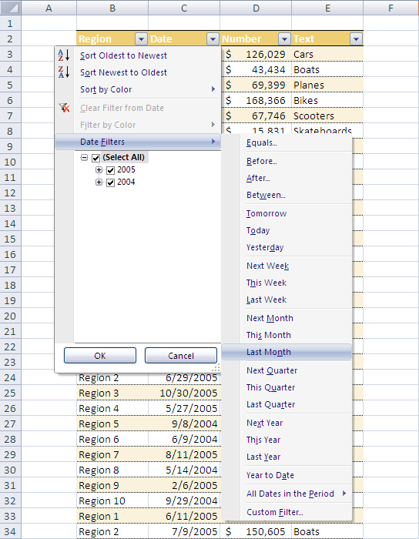

Use Excel to create a PivotTable or PivotChart® view more easily by using data fields to reorient data quickly to summarize and find the answers you need.

Microsoft® Office Visio® 2007 - for IT Professionals who need to visualize, analyze and communicate complex IT systems and processes for improved understanding, insight and decision making. Using Office Visio 2007 people can easily understand and analyze the current and desired state of the organization’s IT systems and gain valuable insights.
MapPoint® 2007 - for people who need to analyze and communicate critical business data visually using geospatial information. With high quality maps, comprehensive and up-to-date data, easy-to-use mapping tools and intuitive wizards, MapPoint helps people visualize and communicate important business information, and integrate maps into the work they do in 2007 Microsoft Office suites.

Microsoft SQL Server 2005 Data-Mining Add-ins for 2007 Microsoft Office suites - for people that analyze large data sets to identify issues and opportunities facing their organization. These add-ins help users derive patterns and trends that exist in complex data, visualize those patterns in charts and interactive views, and generate rich, colorful summaries for presentation and analysis. They can also be used to utilize the predictive analytics of SQL Server 2005 in Office Excel 2007 and Office Visio 2007.

Report Builder - for people that create static ad-hoc reports for personal use. It is a component of SQL Server 2005 Reporting Services that enables users to quickly get started building tables, matrixes and chart reports using templates and predefined report models.

Team BI Tools
Microsoft Team BI tools help organizations share, report, and drive results. With a touch of a button Microsoft® Office SharePoint® Server 2007 and other Team BI products and services can facilitate more efficient and more informed decision making and help departments everywhere be more productive.

Office SharePoint Server 2007 (Standard Edition) - for organizations that require a single, integrated location for people to collaborate with team members, locate organizational resources, search for experts and corporate information and manage content.
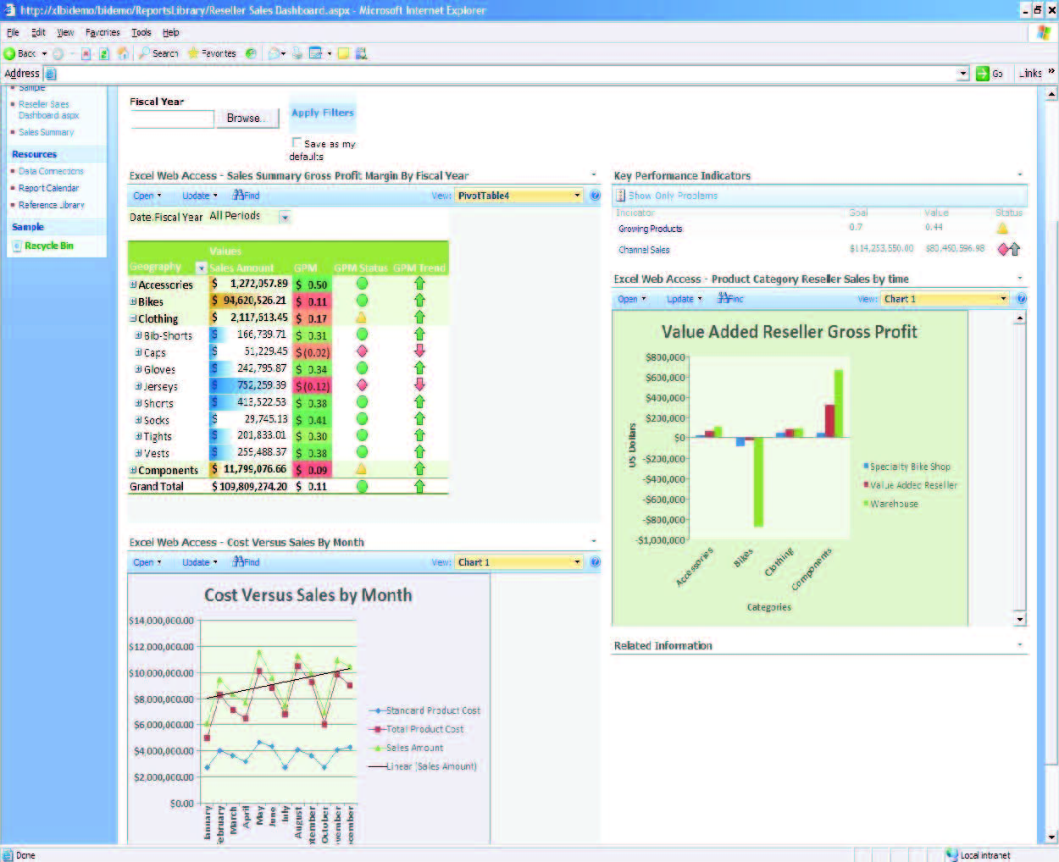

Sample Report Center dashboard using Excel services, KPIs and filtered Web parts

Office SharePoint Server 2007 (Enterprise Edition) - for organizations with people that require the functionality contained in the Standard Edition, plus the ability to create workflows and electronic forms. Additional functionality includes secured access to information found across repositories and other back-end systems. Additional advanced BI capabilities include:
Excel® Services in Microsoft® Office SharePoint® Server 2007 - for organizations that want to provide their people with live, Office Excel-based reports that include pivot tables and links to databases for viewing using only a browser.

Business Data Catalog is a shared service that enables Office SharePoint Server 2007 to surface business data from back-end server applications without any coding. It bridges the gap between the portal site and business applications, enabling people to bring in key data from various applications into Office SharePoint Server 2007 lists, Web parts, search, user profiles and custom applications.

Key Performance Indicators (KPI) - for organizations that want to centrally publish visual cues for teams, managers and businesses to quickly evaluate the progress made against measurable goals. KPIs are created using KPI lists, which can be stored in the Report Center or in any other site in Office SharePoint Server 2007, where they can be reused by anyone with permission to access them.

Organizational BI Tools
The Microsoft Corporate BI solution provides employees across the entire organization with greater visibility into critical business performance information. Employees can track their performance against corporate goals and analyze and understand budgets and forecasts within one fully integrated product.

Microsoft® Office PerformancePointTM Server2007 - for organizations that need a comprehensive performance management solution that enables employees to formulate strategy, drive execution and more effectively monitor performance through integrated monitoring, analytics and advanced planning capabilities.
© 2008 Microsoft Corporation. All rights reserved. Microsoft, Excel, the Office logo, PerformancePoint, SharePoint, SQL Server, Windows, and Windows Server are either registered trademarks or trademarks of Microsoft Corporation or the Microsoft group of companies. All other trademarks are property of their respective owners.
021808

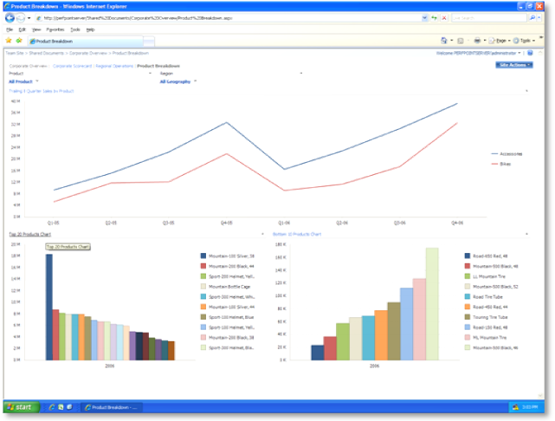

Answering the “why” is easier with the PerformancePoint Server analytics functionalities

Next Steps
Optimal business performance requires a comprehensive approach to business intelligence. To unlock the potential of your entire organization, you need a flexible solution that allows people to work the way they want to work. At the same time your business intelligence tools need to provide IT with the security, stability and centralization they require, and all this at a price that allows you to deploy the solution company-wide.

Only Microsoft provides you with a complete and cost-effective set of familiar, integrated business intelligence solutions and services that massively simplify the BI process. Our solutions are designed to help organizations just like yours transform data and informational assets into insightful analysis that drives performance forward.

To learn more about Microsoft Business Intelligence products and services including system requirements, visit
www.microsoft.com/BI

