



Attention Exchange Administrators… There Is a Better Way to Back Up!
If your company relies on Microsoft® Exchange Server to manage and deliver information, as well as to communicate with your
customers and partners, who will you trust to maximize its protection and recovery?

Exchange administrators are looking for a better way to protect and recover the e-mail that their company depends on.
Microsoft has heard from our customers and partners and delivered a complete solution with System Center Data Protection Manager (DPM) 2007.

Microsoft System Center Data Protection Manager (DPM) 2007
DPM 2007 is a member of the Microsoft System Center family of management products, which are designed to help IT Professionals manage their Windows Server® infrastructure. DPM 2007 sets a new standard for Windows® backup and recovery — delivering continuous data protection for Microsoft application and file servers to a seamlessly integrated secondary disk and tape solution on the DPM server. DPM enables rapid and reliable recovery through advanced technology for enterprises of all sizes.

Microsoft protection and recovery for Microsoft applications
Microsoft designed DPM 2007 to provide the best backup and most reliable restore for Microsoft Exchange Server. Focused on the primary Microsoft server workloads, DPM 2007 was specifically built to protect and recover Exchange Server, as well as Microsoft SQL Server™, SharePoint® Portal Server, Virtual Server and Windows file services. In addition, DPM 2007 blends the best aspects of continuous data protection (CDP) with traditional tape backup.

DPM 2007 provides continuous protection for the core Microsoft server workloads to a DPM server, which then provides
disk-based recovery and tape-based, long-term archival storage for a complete data protection and recovery solution.

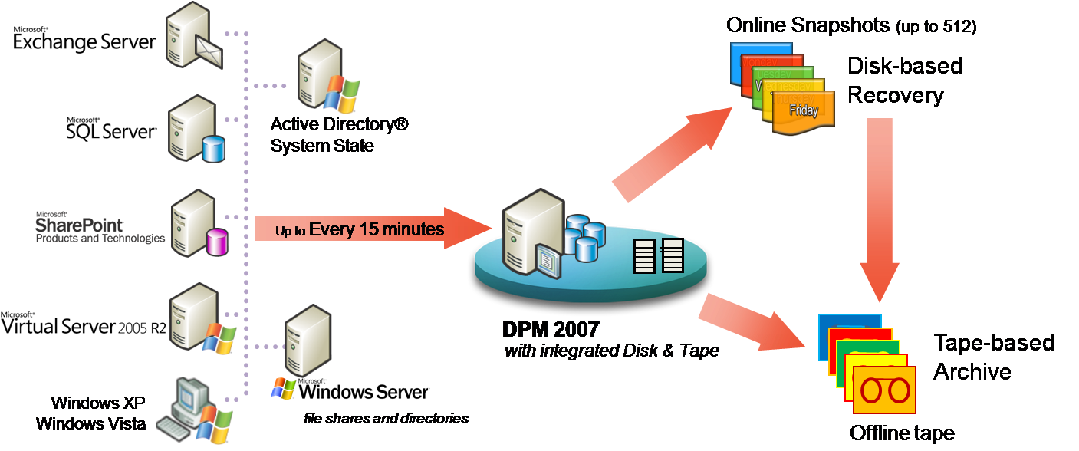

Maximizing protection of Microsoft Exchange Server with Microsoft DPM

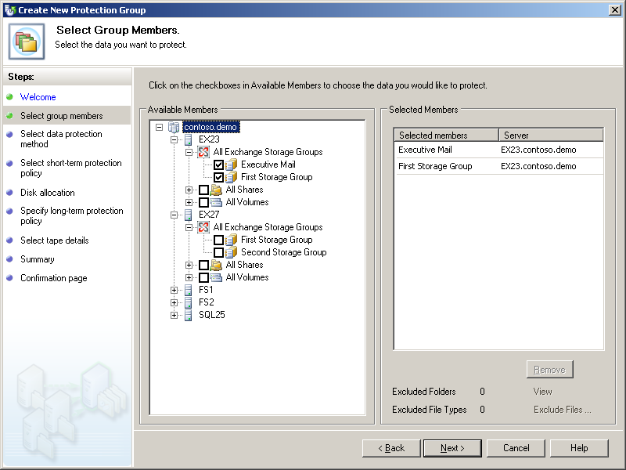
DPM 2007 is designed for the E-Mail Administrator or the IT Generalist, as opposed to requiring specialized skills as a “Backup Administrator” or Storage-Expert. DPM offers wizards and workflows to help ensure that you can protect your data — without requiring an advanced degree, training, or certification in storage and backup technologies.

DPM presents the data to be protected in the same context as users access it. In the Data Protection Wizard, one can select, Exchange Server storage groups, SQL Server databases, SharePoint farms, Virtual Server guest systems or Windows file shares/directories to be protected.

In fact, multiple kinds of data can be protected, such that you can select the Storage Group with your executive’s mailboxes, the executive team’s SharePoint farm, supporting databases, and even their home directories – and the various data can be protected the same way – with one policy defining encryption, length of retention, frequency of protection, etc.

Designed for Exchange Server
Because DPM was designed specifically for Exchange Server, DPM understands the advanced configurations of Exchange Server that often cause other data protection tools to fail:

  - Designed for Exchange Server clusters, DPM is not only “Exchange-savvy,” but “cluster-competent.” During deployment, DPM 2007 is aware of the physical nodes, the cluster’s identity, and the virtual servers running within it. DPM 2007 will help you ensure that the DPM agent is on all clustered nodes to maximize protection of the Exchange data. And when Microsoft Cluster Services changes the Exchange Server to a different clustered-node, DPM 2007 will continue to help protect the virtual Exchange server without administrator intervention. Cluster support includes Exchange 2003 and Exchange 2007.

  - Designed for Exchange 2007 LCR (Local Continuous Replication), DPM is LCR aware and protects the active database.

  - Designed for Exchange 2007 CCR (Clustered Continuous Replication), DPM is CCR aware and enables “Preferred Node Backup” — allowing the active node, the passive node or a particular geographically desirable node to be protected – to eliminate I/O impact during backups.

  - Support for Exchange 2007 SCR (Standby Continuous Replication) environments with Exchange Service Pack 1, Since the SCR server does not have an active store, DPM protects one of the CCR nodes within the SCR configuration

DPM is designed not only to protect generic installs of common applications to deliver the most robust backup and recovery solution for the myriad of advanced deployment scenarios for Microsoft applications like Exchange Server.

Older backup applications require brick-level backups if you want to do brick-level restore (like a mailbox), which significantly increases the size of the backup disks or tapes. Because DPM 2007 was built by Microsoft for Microsoft applications like Exchange, we made sure that isn’t necessary.

DPM 2007 protects a storage group; but can select restores of a storage group, a database, or a single mailbox.

DPM also minimizes backup-related performance impact by offloading the typical ESEUTIL operations that most backup applications force on the production server. Instead, the DPM server handles this on the redundant data, lightening the load on the production Exchange Server so that it can serve more users.
How does Exchange Server protection with DPM work?
DPM uses a combination of transaction log replication and block-level synchronization in conjunction with the Exchange VSS Writer to help ensure your ability to recover Exchange Server databases. After the initial baseline copy of data, two parallel processes enable continuous data protection with integrity:

- Transaction logs are continuously synchronized to the DPM server, as often as every 15 minutes.

- An “express full” uses the Exchange Server VSS Writer to identify which blocks have changed in the entire production database, and send just the updated blocks or fragments. This provides a complete and consistent image of the datafiles on the DPM 2007 server. DPM 2007 maintains up to 512 shadow copies of the full Exchange Server database(s) by storing only the differences between any two images.

Flexible Restore Options for Microsoft Exchange Server
DPM 2007 is focused on “restore” instead of just “backup,” which is why Microsoft blended CDP and backup, disk and
tape, synchronizations and log shipping—all to enable the most supportable and best possible recovery experience.

With only a few mouse clicks and DPM 2007, you can choose to restore an Exchange Storage Group, a Database, or a mailbox:

- Restore Exchange SG/DB directly back to the original server As a traditional restore, but with no additional work for the Exchange administrator to do afterwards, DPM restores directly back into the active Exchange data set. This improves recovery time and reduces the number of people needed during a crisis recovery.

- Copy database files to an alternate server – through either the RSG or simply restoring the files themselves
This option enables disaster recovery, compliance auditing, or software testing—without affecting the production environment. The files can be mounted by another Exchange Server.

- Copy the database file to tape
Use this option to create a long-term archive or portable media of the data at any recovery point, even after the fact—directly to tape—without backing up anything else or impacting the production server that is already serving new data.

Other backup technologies may claim to have a single-mailbox restore solution. However, they often won’t tell you that their method is unsupported from Microsoft (see knowledge base article 904845). DPM 2007 only delivers backup and recovery solutions that are entirely supportable by the original workload’s product support and services teams, so you can be assured that our Exchange protection and recoveries are performed exactly as the Exchange product team believes that they should be.

To restore a mailbox – simply select it from the DPM 2007 console and it handles the process of restoring the mailbox’s database to an appropriate Recovery Storage Group (RSG), and then selectively mounts just that mailbox for extraction and recovery – the right way.

Built to meet Customer Needs
Common customer questions about their existing Exchange Server solutions include:

“Who can help me restore?”
During a crisis, as part of the data recovery, many customers are frustrated when bringing in multiple support organizations to help restore their data. The third-party backup vendor may say that the data restored successfully. But, Microsoft Exchange Server product support may say that the data is un-mountable. And the systems integrator and email administrator can be stuck
in the middle. Having a Microsoft backup product protecting a Microsoft Exchange Server means customers don’t have to worry about misunderstandings between vendors when restoring their data.

“My backup product does some things well, but protecting my advanced Exchange configuration isn’t one of them.”
Because third-party backup products try to back up a wide variety of applications, it is very difficult to protect every application well, particularly with robust and flexible applications like Microsoft Exchange Server 2003 or 2007. Microsoft is dedicated to making sure that our backup solution is the most supportable and best for protecting our application workloads. Microsoft protects our own enterprise Exchange 2007 servers and clusters with DPM, beginning with early betas. This helps ensure that no DPM build will go to a customer that Microsoft IT hasn’t signed off on as tested in our own demanding production environment.


Unique to DPM 2007 is “lossless recovery” of Exchange Server data, meaning that after DPM 2007 restores your mail database(s) to the latest 15 minute recovery point, it can automatically reapply the surviving logs from the production server to the very last committed transaction. Thus, the last completed Exchange database transaction (i.e., mail message) is recovered and ready for your users.

DPM is built to protect Exchange Server — in every environment

Microsoft developed DPM to meet customer needs in Exchange Server protection that are not being met by alternative protection technologies, for “enterprises of all sizes.”

For Exchange Administrators within larger enterprises
Traditional backup products are often managed by an enterprise’s IT storage team, while the applications are maintained elsewhere. E-mail administrators have asked for the ability to restore data themselves.

To meet this customer need, DPM provides Exchange Administrators and other Microsoft application stakeholders with a reliable protection and recovery platform from the same vendor that produces their application—with the flexibility to protect as often as the application or the business demands it, but be archived to tape by either DPM or the existing third-party tape solution for long-term retention.

For IT Generalists within medium-sized businesses
In environments that rely primarily on Microsoft applications (Microsoft Exchange for e-mail, SQL Server as their database, SharePoint for collaboration, as well as Windows file services), DPM provides an opportunity to be assured that all of your core applications are receiving maximum protection by the same company that created them, with the added value of being able to purchase and obtain support for your protection package with all of your other Microsoft licensed products.

Data Protection Manager is part of System Center, the family of management products from Microsoft that have our knowledge built-in. In DPM, this means that workflows and wizards walk the IT Generalist through the straight-forward browsing of your Exchange Server data sets and setting your own recovery goals and retention requirements. DPM locates the data, manages the disk-based images and logs, and rotates the tapes—so you don’t have to.

Take a look at how DPM 2007 can protect your Exchange Server infrastructure
Microsoft is committed to listening to our customers and partners – to help shape the products and services that we offer. While most customers currently have some form of tape backup technology, there are many who are discontent with the current offerings, either looking for better support of key business applications like Microsoft Exchange Server 2007, or looking for better than nightly protection to a medium other than tape. Microsoft is meeting those needs with Data Protection Manager 2007.

If you depend on Microsoft Exchange Server to manage and deliver information within your company, and to communicate with your customers and partners, take a look at how DPM 2007 can help you protect your business critical data.

To learn more about how DPM 2007 can help you protect your Microsoft Exchange environment
www.microsoft.com/DPM and click on the “How to protect Exchange” link

This document is for informational purposes only. MICROSOFT MAKES NO WARRANTIES, EXPRESS OR IMPLIED, IN THIS SUMMARY

