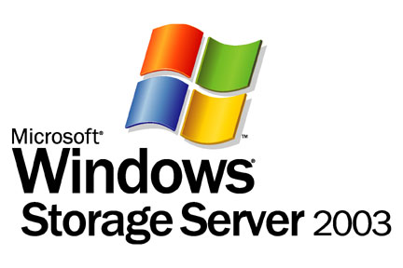

Migrating from Direct Attached Storage (DAS) to Storage on the Network

Microsoft Corporation
Published: May, 2005

Abstract
Why consolidate storage onto a storage network? If you’re new to storage networking technologies, read this paper to learn about the limitations to direct attached storage, and the benefits of moving storage onto a network, whether in the form of network attached storage (NAS) system or a storage area network (SAN).


The information contained in this document represents the current view of Microsoft Corporation on the issues discussed as of the date of publication. Because Microsoft must respond to changing market conditions, it should not be interpreted to be a commitment on the part of Microsoft, and Microsoft cannot guarantee the accuracy of any information presented after the date of publication.
This White Paper is for informational purposes only. MICROSOFT MAKES NO WARRANTIES, EXPRESS, IMPLIED OR STATUTORY, AS TO THE INFORMATION IN THIS DOCUMENT.
Complying with all applicable copyright laws is the responsibility of the user. Without limiting the rights under copyright, no part of this document may be reproduced, stored in or introduced into a retrieval system, or transmitted in any form or by any means (electronic, mechanical, photocopying, recording, or otherwise), or for any purpose, without the express written permission of Microsoft Corporation.
Microsoft may have patents, patent applications, trademarks, copyrights, or other intellectual property rights covering subject matter in this document. Except as expressly provided in any written license agreement from Microsoft, the furnishing of this document does not give you any license to these patents, trademarks, copyrights, or other intellectual property.
© 2005 Microsoft Corporation. All rights reserved.
Microsoft, Microsoft Windows Server 2003, Microsoft Windows Storage Server are either registered trademarks or trademarks of Microsoft Corporation in the United States and/or other countries.
The names of actual companies and products mentioned herein may be the trademarks of their respective owners.
Contents
Introduction 1
The Limitations to Direct Attached Storage 2
What is Storage on the Network? 3
The Advantages of Attaching Storage to the Network 4
Using Windows Servers and Networked Storage 5
Summary 6
Related Links 7

Introduction
Why consolidate storage onto a storage network? Why move away from the tried and true technology of housing storage hard drives directly in each workstation or server and instead attach storage to the network itself?
For the small business not yet overwhelmed by the accumulation of information, or not yet struggling to find the resources to manage, access and of course protect ever growing volumes of information, why indeed? Some networked storage solutions, storage area networks (SANs) in particular, are not only a costly investment, but are a considerable challenge to manage effectively—and so for many businesses, such a solution doesn’t make sense. But for the midsize business that has gone through several upgrade cycles to keep up with demands for more storage, consolidating storage onto the network might be the answer to the increasingly costly and difficult task of managing directly attached storage. And for many growing business, networked storage can provide the opportunity to offer new and better services to their customers, making the investment in the technologies a smart business choice.
This paper outlines the limitations to direct attached storage, discusses the benefits of storage on the network, and then briefly mentions a number of Microsoft storage networking technologies designed to help bring high end storage networking solutions to a broader market than previously possible.

The Limitations to Direct Attached Storage
Most computers are designed with storage on board (see Figure 1). And where in the past storage capacity was measured in megabytes, today it is more commonly measured in gigabytes—a huge increase in capacity that delays, although never altogether defers, the need for more space. What happens when hard drives run out of space? Bad things: applications can crash, data may be lost, and productivity comes grinding to a halt, all until a solution—additional computers or more/higher capacity hard drives—is found. Adding more computers or hard drives, especially if you can anticipate the need for it, is a good stop-gap; for many growing businesses, however, it can perpetuate or even create a host of additional problems, including:
- Inflexible Resource Sharing. With information distributed across the storage systems of multiple workstations and servers, staff may not be aware of what information already exists or where to find it; once these are determined, the data must still be copied from one machine to another. This problem can be circumvented by setting up network shares, but the net result is not only duplication of data on multiple systems, but also out-of-date information. Moreover, since network shares do not enable sharing of the storage capacity itself, the problem persists that while some computers have excess capacity, others may have almost none. With no means of accessing or sharing underutilized storage resources, the net result is inefficient storage utilization across the organization.
- Backup Complexity. As the computers in the organization proliferate, protecting the data on them becomes more expensive and complex to accomplish. Since backups must be done directly on the system housing the data, IT personnel usually find themselves required to purchase additional tape backup systems. Full backups become more difficult to schedule without cutting into working hours. And unless individual users back up their own data or make them available on a server, it is seldom the case that all organizational data is backed up.
- Hardware Proliferation. More equipment means less space for other business purposes, more licensing expenses, more setup time, and more hardware to troubleshoot and fix should a failure occur. Overbuying storage to insulate against shortages ties up capital resources, and since storage disks are bound to a specific server, sever use remains inherently inflexible, since servers cannot readily be repurposed for other application use.
Getting around these issues doesn’t necessarily mean that you have to migrate from DAS directly to a storage network; in fact, this is rarely the first step a small business takes. Many of the problems mentioned here can readily be controlled by shifting critical business information to a server jointly accessed by many client systems. Shifting shared resources to a centralized server enables consolidation of backups, shared access of both information and storage resources, and simplified management.
However, if storage requirements continue to escalate, it’s only a matter of time before more servers must be added to meet the needs for increased storage. And when that happens, servers become the new desktop: storage capacity is locked into the server; backup equipment must be duplicated in order to protect the organizations ever more dispersed servers; resource management and maintenance become more complex. And that’s where networked storage comes in.

What is Storage on the Network?
Unlike with DAS storage (Figure 1), storage on the network uncouples the server from its disks. Disks can either be housed in an appliance dedicated to sharing and storing files directly on the local area network (LAN), as with a NAS appliance (Figure 2), or they can be stored in disk arrays or other media on a specialized high performance SAN (Figure 3).

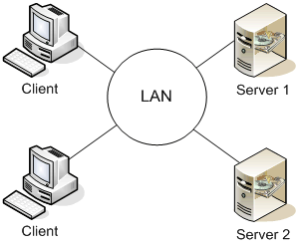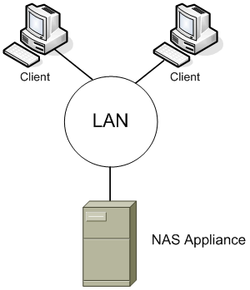
Figure 1. Direct Attached Storage Figure 2. Network Attached Storage

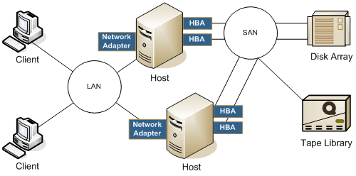
Figure 3. A Storage Area Network
Designed for ease of deployment, NAS servers can be plugged directly into the network without disruption of services and management is minimal and simplified. NAS servers are an ideal means by which to consolidate file servers and backup equipment and to expand storage capacity.
SAN solutions are ideal for database and on-line processing applications requiring rapid data access and block (unformatted) storage; however, because a SAN is a dedicated network that can require specialized equipment, a great deal more expertise is required to set up and maintain them.

The Advantages of Attaching Storage to the Network
The key distinction of storage networking technologies is that storage is uncoupled from the server and housed on a storage network where multiple servers can access it. Servers continue to run applications and send traffic across the network, but the final destination of data is now a storage array on the network. This approach to storage has several critical advantages:
- Better Storage Utilization. Storage capacity utilization increases from about 50% with direct attached storage to about 80% on a storage network. This increased storage utilization, occurring because multiple servers now access a common pool of storage, dramatically reduces the need for the common practice of storage over-provisioning.
- Highly Effective Resource Sharing. Data is no longer local to a server, but rather is available to anyone with permission to access it. And because storage networks enable any server to access a shared pool of storage resources, underutilization of storage resources is no longer a common phenomenon.
- Centralized Storage Management and Data Protection. With all storage resources consolidated into a single place on the network, storage management—from resource provisioning to data protection is simplified.
- Hardware Consolidation. Consolidating storage onto the network is the force that drives equipment consolidation: multiple servers deployed solely to provide additional storage can be repurposed for other needs; the need for additional data protection equipment (such as tape libraries) declines; licensing costs are slashed.
These advantages all add up to considerable benefits for the organization: not only lower costs because of equipment and labor savings, but better LAN performance (since the high volume traffic is shifted off the LAN), more effective backups and more up-to-date data.
NAS or SAN?
There are many answers to this question, depending on your organization’s IT constraints (such as cost and available expertise), and the pain points you are trying to solve (such as scalability and simpler management). The most basic answer to this question, however, depends heavily on the type of information your organization predominantly needs to share—is it files or data generated by database-based applications?
If the majority of documents users must access are file based, then network attached storage solutions provide the most effective and low-cost networked storage solution. On the other hand, if the greatest amount of information to be shared is produced by database applications, then storage area networks, until recently, were the leading solution. For those many organizations that must share both block and file-based data, a joint NAS-SAN solution (a NAS gateway to a SAN) can effectively meet both needs.

Using Windows Servers and Networked Storage
If you’re new to storage networking, you should be aware that SAN technologies can be both costly and complex. Storage networking technologies grew up in parallel to intranet and internet networking technologies—the storage networking infrastructure, until recently, was based exclusively on specialized technologies, such as Fibre Channel. Such technologies required substantial expertise; knowledge of IT networking was not sufficient background for effectively managing a storage network. But that’s changing, thanks to two recent developments.
The first is the development of storage over IP. Microsoft’s innovative iSCSI technologies have helped bring advanced storage area networking technologies to any business that has an in-place IP network.
The second is the move to simplify SAN technologies into a prepackaged framework, enabling the end customer to essentially plug in a “simple SAN.” In this arena as well, Microsoft is helping to drive the industry toward more user-friendly SAN solutions.
The combination of both of these innovations is helping to bring the advantages of high performance storage networking and high data availability, as well as newer storage technologies such as data replication, to small and medium businesses. For these reasons and more, the migration of DAS to SAN is well worth considering, and two Windows Server products in particular can help you make the move to networked storage.
Network Attached Storage using Windows® Storage Server 2003
Windows Storage Server 2003 is a dedicated file and print server based on Windows Server™ 2003. Designed for dependability, seamless integration, and best value in networked storage, Windows Storage Server 2003 integrates with existing infrastructures and supports heterogeneous file serving as well as backup and replication of stored data. Windows Storage Server is also an ideal solution for consolidating multiple file servers (including Exchange deployments with less than 1500 mailboxes) into a single solution that enables cost reduction and policy-based management of storage resources.
NAS servers based on Windows Storage Server 2003 can be deployed for optimized file serving, server consolidation, and local and remote replication for business continuity. As a gateway, they can be seamlessly integrated into a SAN. For more details, see the paper, “Introduction to Windows Storage Server 2003 Architecture and Deployment.”
Using Windows Server 2003 for SANs
Earlier versions of the Windows server platform provide basic connectivity to SANs, but were not specifically designed for SANs and therefore did not support the high performance and management needs of SANs. That has changed with the release of Windows Server 2003, which has been redesigned to manage pooled storage resources more effectively. New SAN management resources include tools for configuring storage, for discovery of storage resources, and for effective resource sharing. For full details, see the paper, “Windows Servers in a Storage Area Network Environment.”

Summary
Shifting from a distributed, or directly attached storage model, to a consolidated model of storage where storage is uncoupled from the server and placed directly on a storage network can solve a number of IT problems. This paper discusses points to consider when evaluating whether a networked storage solution is right for your organization. It also briefly introduces two Microsoft products, Windows Storage Server 2003 and Windows Server 2003, both of which can help provide a networked storage solution for the Windows platforms in your organization.

Related Links
See the following resources for further information:
- Windows Server 2003 and Windows Storage Server 2003: Meeting the Storage Challenges of Today's Businesses at http://www.microsoft.com/windowsserversystem/wss2003/techinfo/plandeploy/wss2k3storagechal.mspx
- Introduction to Windows Storage Server 2003 Architecture and Deployment at http://www.microsoft.com/windowsserversystem/wss2003/techinfo/plandeploy/wss2k3archdeploy.mspx
- Windows Servers in a Storage Area Network Environment, at http://www.microsoft.com/windowsserversystem/wss2003/techinfo/plandeploy/mssans.mspx
For the latest information about Windows Server 2003, see the Windows Server 2003 Web site at http://www.microsoft.com/windowsserver2003.

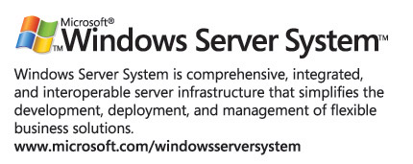
For more information about iSCSI, visit http://www.microsoft.com/windowsserversystem/storage/technologies/iscsi/default.mspx.
For more information about Microsoft Storage Server 2003, visit http://www.microsoft.com/windowsserversystem/wss2003/default.mspx.

From Enterprise Design for DAS; see http://www.microsoft.com/technet/itsolutions/wssra/raguide/Storage_Devices_SB_2.mspx
From Enterprise Design for NAS; see http://www.microsoft.com/technet/itsolutions/wssra/raguide/Storage_Devices_SB_2.mspx
From Enterprise Design for SAN; see http://www.microsoft.com/technet/itsolutions/wssra/raguide/Storage_Devices_SB_2.mspx

