

Using Data Protection Manager with Windows Backup

Microsoft Corporation
Published: September 2005

Abstract
This paper gives specific guidance on integrating Microsoft System Center Data Protection Manager with Windows Backup. It explains how DPM works and how the customer will benefit from using it in conjunction with Windows Backup. It gives specific technical guidance on the specific issues and configuration questions the Backup administrator will encounter during a DPM deployment. It also addresses the typical backup and recovery scenarios to assist in disaster recovery planning.


The information contained in this document represents the current view of Microsoft Corporation on the issues discussed as of the date of publication. Because Microsoft must respond to changing market conditions, it should not be interpreted to be a commitment on the part of Microsoft, and Microsoft cannot guarantee the accuracy of any information presented after the date of publication.
This White Paper is for informational purposes only. MICROSOFT MAKES NO WARRANTIES, EXPRESS, IMPLIED OR STATUTORY, AS TO THE INFORMATION IN THIS DOCUMENT.
Complying with all applicable copyright laws is the responsibility of the user. Without limiting the rights under copyright, no part of this document may be reproduced, stored in or introduced into a retrieval system, or transmitted in any form or by any means (electronic, mechanical, photocopying, recording, or otherwise), or for any purpose, without the express written permission of Microsoft Corporation.
Microsoft may have patents, patent applications, trademarks, copyrights, or other intellectual property rights covering subject matter in this document. Except as expressly provided in any written license agreement from Microsoft, the furnishing of this document does not give you any license to these patents, trademarks, copyrights, or other intellectual property.
Unless otherwise noted, the example companies, organizations, products, domain names, e-mail addresses, logos, people, places, and events depicted herein are fictitious, and no association with any real company, organization, product, domain name, e-mail address, logo, person, place, or event is intended or should be inferred.
© 2005 Microsoft Corporation. All rights reserved.
Microsoft, Active Directory, Windows, Windows Server, and Windows Server System are either registered trademarks or trademarks of Microsoft Corporation in the United States and/or other countries.
All other trademarks are property of their respective owners.
Contents
Introduction 1
How DPM Works 1
DPM Benefits 3
Using DPM with Windows Backup 4
Deploying DPM 6
Verifying Requirements 7
Domain and network 7
DPM server 7
Protected file server 7
Installing the DPM Server 8
Allocating Storage on the DPM Server 8
Installing the DPM Agent on File Servers 8
Creating and Configuring Protection Groups 9
Configuring Windows Backup on DPM Servers 9
Configuring the Protected File Servers 10
Creating the Backup Job 10
Scheduling Backups 11
Performing System State Backups 12
Recovering Data 14
Recovering Protected Data 14
Rebuilding a Protected Server 15
Restoring the DPM Server 17
Restoring a Complete Site 18
Summary 19
Related Links 20

Introduction
Disk-based data protection strategies are a growing alternative to tape backup solutions. They provide a number of benefits when compared to traditional backup media, such as easier handling of file and server recovery, faster backup, and better use of network bandwidth. As low-priced and reliable disk systems enter the market, many organizations are looking at how best to integrate them into their data protection strategies.
Microsoft System Center Data Protection Manager 2006 (DPM), the newest member of the Microsoft® Windows Server System™ family, provides an efficient disk-based data protection and recovery solution. DPM protects Microsoft® Windows® 2000 Server, Microsoft Windows Server 2003, and Windows Storage Server 2003, and makes use of advanced features such as replication, policy-driven protection, and the Windows Server 2003 Volume Shadow Copy Service (VSS). DPM is designed to work in conjunction with your existing backup solution to help you achieve the following goals:
- Reduce backup and restore times to below those offered by traditional tape-based systems.
- Simplify your backup infrastructure and make it easier to manage.
- Reduce the amount of data your organization will lose in the event of a server failure or emergency.
- Allow your users to restore their own files in many cases.
This paper discusses how to integrate DPM with Windows Backup and gives you step-by-step directions for common backup and recovery scenarios.

How DPM Works
DPM is designed to be installed on dedicated server hardware running the Windows Server 2003 operating system. Your DPM server should have a large amount of available disk storage. Depending on the amount of data you want to protect, you may need to deploy a hardware ATA or SATA RAID disk array; software RAID is not supported. DPM integrates with the Windows Active Directory® directory service to ease management and discovery of protected servers. If your environment requires protecting servers in multiple Active Directory domains, you will need to have at least one DPM server in each domain.
After your DPM servers are installed, you use the DPM Administrator Console to push the DPM agent to each protected file server and create your protection groups. A protection group is a collection of data resources that share the same protection policy, such as shared folders and disk volumes. You define the data to protect, at which point the DPM agent begins to replicate the designated data to the DPM server according to the policy-defined schedule. The DPM agent tracks the data, replicates only the changed blocks, validates the replica, and corrects errors. By performing incremental replication at the disk block level, DPM can dramatically reduce the bandwidth required by your protection solution.
Because DPM fully integrates with VSS, your protection policy can define how many shadow copies or snapshots to make available, independently of your replication schedule. Your administrators can then access these snapshots to perform file recoveries as requested. If you want to allow your users to directly access the snapshots and recover files themselves, they can install an optional hotfix for Windows XP and Windows Server 2003 that extends the included Shadow Copies of Shared Folders client to work with DPM. The updated clients allow direct recovery of files from within Windows Explorer and Microsoft® Office 2003 applications.
The final layer of protection comes from integrating DPM with BackupExec. Using the BackupExec Remote Agent for Windows, you create backups of your data from the replicas on the DPM server instead of from the live data on the protected file servers. Because you are using a read-only snapshot of the data, you can backup your data at any time without affecting the performance or reliability of your protected file servers.
DPM helps you make better use of your tape backup resources, no matter where your protected file servers are located in your enterprise. As shown in Figure 1, it can be used to streamline backup operations in a data center, or consolidate multiple backup servers in branch offices into a central location, all while offering a greater degree of protection for your data.
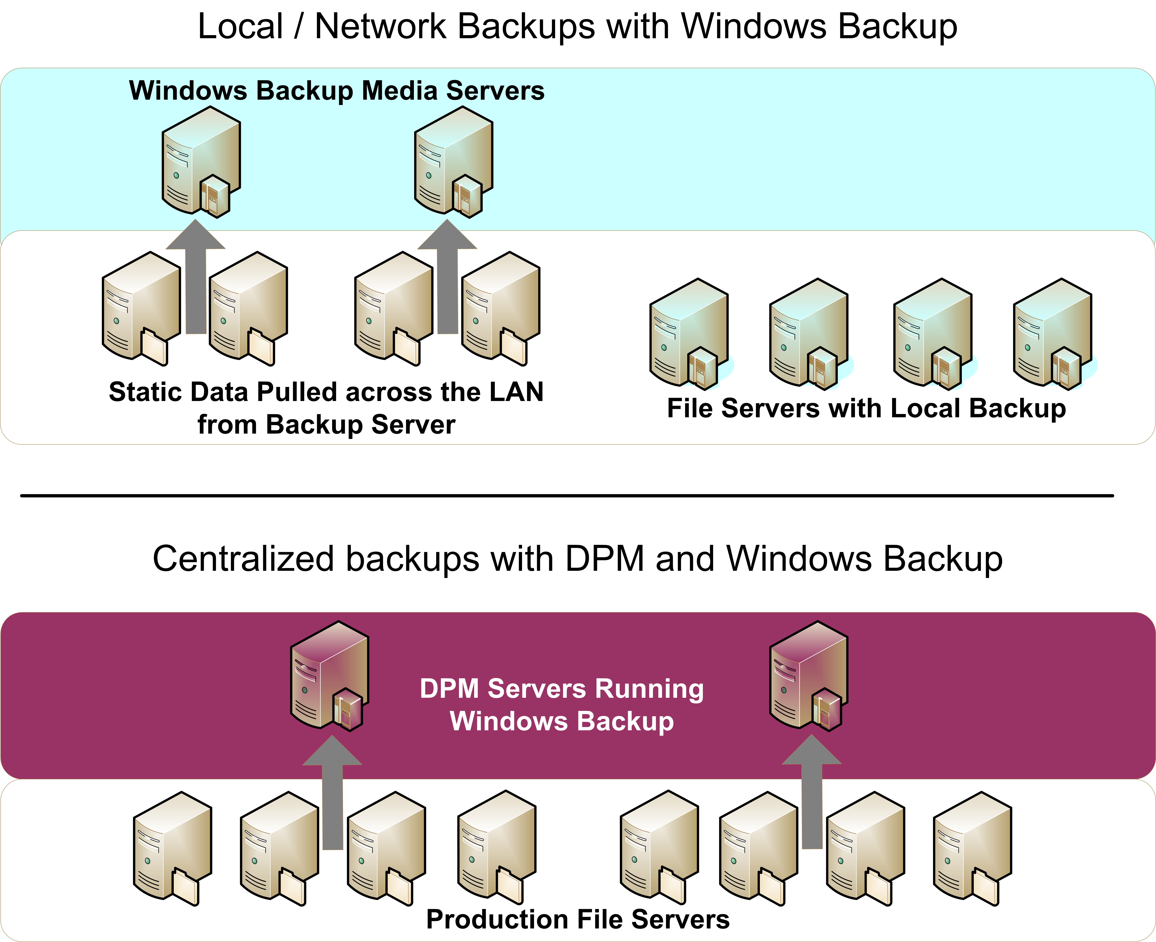
Figure 1: Local versus centralized backups with Windows Backup and DPM
In addition, you can eliminate the open-file problems associated with pulling content from a remote file server to a backup server running NTBackup. DPM handles synchronization of the data from the source servers to the DPM server, where NTBackup can then back up the data. The DPM agent running on the source servers makes this synchronization possible.
See Chapter 1, "Introducing Data Protection Manager," of the Data Protection Manager 2006 Planning and Deployment Guide for more information on how DPM works and common deployment and recovery scenarios.

DPM Benefits
Data Protection Manager provides the following benefits:
- Minimize data loss. You can define your protection schedules based on your real business needs instead of being limited by your tape backup system. DPM allows you to protect your data more quickly and more often, reducing your window for potential data loss to as little as a single hour.
- Recover lost data quickly and reliably. Your protected data is replicated to a central DPM server, which uses fast disk storage instead of slow, bulky tape. You can immediately restore just the files you need from disk without waiting for the many delays of a tape backup system.
- Allow end-user data recovery. DPM works with your existing Windows file servers to help you maintain centralized control over end-user recovery of data. Your end users will be able to recover point-in-time file copies from their desktop through the familiar interface of Windows Explorer or Microsoft Office applications.
- Eliminate your backup window. DPM moves the backup load off your file servers and efficiently protects your important data around the clock. You can then perform tape backups of your DPM data at any time without affecting performance on your protected file servers.
- Replace incremental backups to tape. DPM can completely replace onsite incremental tape backups with shadow copies on disk, providing more reliable and cost-effective protection for your data.
- Consolidate your backup infrastructure. Use DPM to protect the data in your branch offices and remote locations and remove the need for multiple tape backup systems or complex and slow centralized tape management configurations.
- Lower your total cost of ownership. DPM reduces your total cost of ownership by removing the need to deploy backup agents and licenses to your protected file servers, thus reducing the amount of time and network bandwidth required to manage backup and recovery operations. It also removes the need to have your backup operations occur during off-hours.

Using DPM with Windows Backup
NTBackup is included with Windows Server and is therefore an inexpensive backup solution popular with many small- and midsized companies, particularly those that do not require agent-enabled backup of remote clients or servers. In many situations, administrators use NTBackup to back up files to a local tape unit. NTBackup can also back up files from network shares, enabling it to back up data from other file servers and client systems. However, in this latter scenario, NTBackup can only pull from a share (administrative or not) on the target server, making open-file issues a major consideration because no agent exists locally on the file server to mitigate open-file conflicts.
NTBackup is an inexpensive backup solution that supports backup to disk as well as to tape. However, backup scenarios involving NTBackup are subject to the same drawbacks as those using non-Microsoft solutions, including the inability to quickly and easily recover backups and the lack of redundant backups. By using DPM with your existing NTBackup installation, you can simplify your backup infrastructure, mitigate most of the weaknesses in any tape-based backup system, and use the strengths of NTBackup to make tape archival a part of your total data protection solution.
Tape backup systems suffer from several key drawbacks:
- Tape systems are fragile and susceptible to environmental degradation. Tape drives can easily become dirty or misaligned, requiring frequent cleaning and maintenance. Tapes are sensitive to temperature, humidity, and contaminants and frequently go bad during storage.
- Tape systems have a higher level of management overhead. Because tapes are a linear medium, they must be read and written sequentially and must be rewound or forwarded to a specific position to recover a specific piece of data. This overhead increases the delays involved in using a tape backup system.
- In order for tape backups to be usable, the backup system needs to be able to access a static copy of each file; files that are open or in use by other processes will often not be backed up unless you use special software agents. Ideally, the backup system needs to have access to a static copy of the entire resource being backed up so that all of the data is consistent.
- Tape backup systems track changes on a file-by-file basis rather that at the block level within the file. Any change to a file, no matter how small, will result in the entire file being rearchived during an incremental backup.
- Tape backup systems can often have a high impact on the performance of the servers and networks they protect. It is a common practice to schedule backups during periods when the protected resources are not heavily used.
The minimum length of the backup window is a product of the speed of the backup system and the amount of data to be backed up. This in turn must be balanced by operational needs; users must be able to access and change data during the course of typical operations.
Figure 2 shows a typical NTBackup deployment:
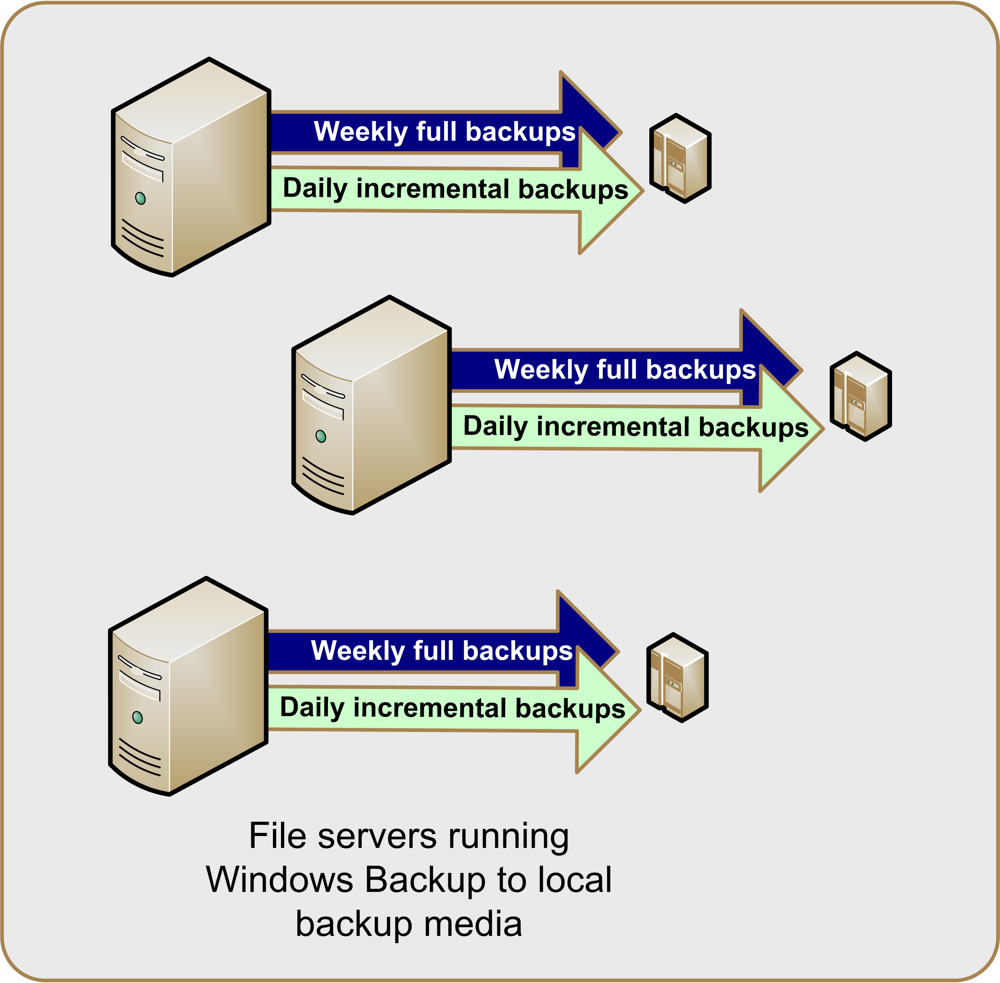
Figure 2: Windows Backup local deployment
DPM helps mitigate these issues by effectively eliminating the backup window. The DPM agents on your file servers synchronize changes to the DPM server. NTBackup archives the DPM replicas of your data and consolidates data from multiple servers into one location. This in turn reduces the complexity of your backup configuration, changes your backup window requirements, and makes better use of your existing backup resources.
Figure 3 shows one common scenario for deploying DPM and NTBackup together:
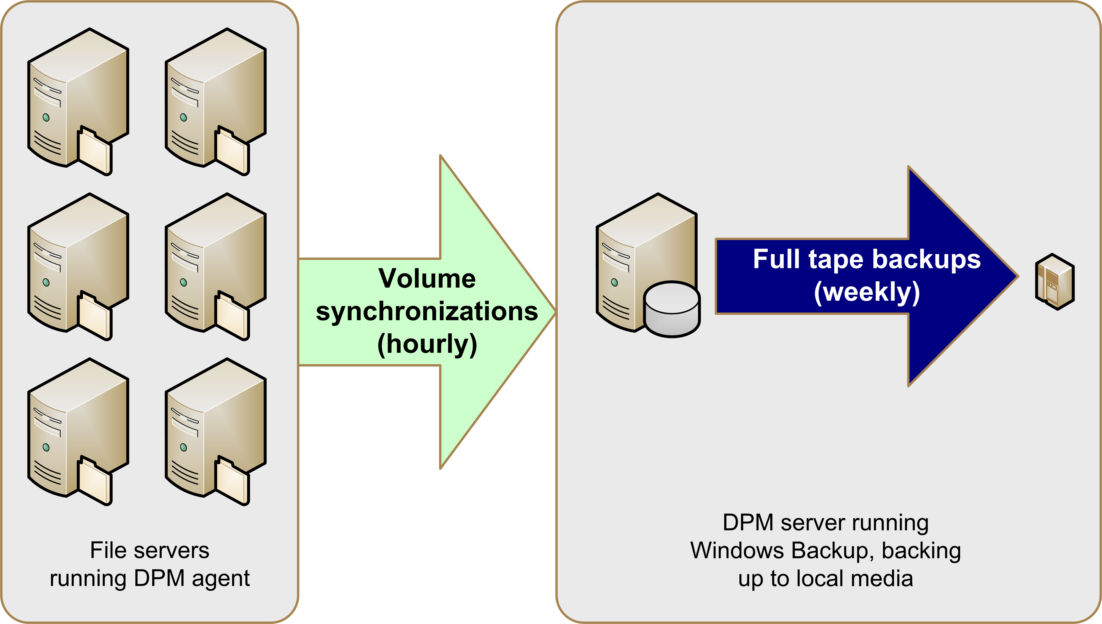
Figure 3: DPM plus Windows Backup deployment
To introduce DPM into an existing NTBackup environment, you need to perform the following steps:
- Deploy DPM:
- Verify requirements.
- Install the DPM server.
- Allocate storage on the DPM server.
- Install the DPM agent on protected file servers.
- Create and configure protection groups.
- Configure NTBackup
- Create jobs on the DPM server.
- Modify jobs on the protected file servers.
When used to backup DPM replicas, NTBackup interacts directly with the replica data. It does not use VSS to capture a snapshot of the data.

Deploying DPM
When you are ready to introduce DPM into your production environment, the first major task you need to perform is to install the DPM server. This involves installing and configuring DPM. You can find detailed guidance on this process in the Data Protection Manager 2006 Planning and Deployment Guide, which is available for download at: http://go.microsoft.com/fwlink/?linkid=51651

Verifying Requirements
Before you begin the deployment process, verify that your deployment meets the following requirements:
Domain and network
- The domain controllers are running either Windows Server 2003 or Windows 2000 Server.
- Windows 2000 Server domain controllers have Windows 2000 Server Service Pack 3 or later installed and schema updates enabled if end-user recovery will be deployed.
- The domain has the Kerberos V5 authentication protocol enabled. This is the case by default.
DPM server
- The server is running a 32-bit version of either Windows Server 2003 (Standard or Enterprise Edition) with Service Pack 1 or Windows Storage Server 2003 (Standard or Enterprise Edition) with Service Pack 1. You can install DPM on 32-bit operating systems running on 64-bit hardware; you cannot install it on 64-bit operating systems.
- The server has Microsoft .NET Framework 1.1 with Service Pack 1 installed.
- The server has the Windows Server 2003 VSS post-SP1 update package installed. See http://support.microsoft.com/kb/891957 for more details.
- The server meets the hardware and software requirements for Microsoft® SQL Server® 2000 Service Pack 3a (see http://www.microsoft.com/sql/default.mspx for more details).
- The server is a member of the same Active Directory domain as the protected file servers it will protect, even if the protected file servers are located across a WAN link. You will need at least one DPM server for every domain in which protected servers reside.
- The server is not a domain controller or an application server.
- The network between the DPM server and the protected file servers supports Internet Protocol Version 4 (IPv4). DPM cannot operate on networks that exclusively use IPv6.
- The server has at least two disks available:
- One disk dedicated to the system and DPM installation files.
- One or more disks dedicated to the DPM storage pool.
- The server is configured to use NTFS.
- The server has a persistent virtual private network (VPN) connection to any branch office file servers it protects.
Protected file server
- The server is running one of the following operating systems:
- Windows Server 2003 with Service Pack 1 installed.
- Windows Storage Server 2003 with Service Pack 1 installed.
- Windows 2000 Server with Service Pack 4 and the Windows 2000 Update Rollup 1 installed.
- The server is a member of the same Active Directory domain as the DPM server that protects it.
- The server is not part of a cluster. Clustered file servers cannot be protected.
- The server has a minimum of 500MB of free space available on each volume to be protected.
- The server disk volumes are one of the following:
- Direct attached storage (DAS) volumes.
- Fibre Channel storage area network (SAN) devices.
- Internet SCSI (iSCSI) devices with Windows Hardware certification.
See the Data Protection Manager 2006 Planning and Deployment Guide for more information on how DPM works and common deployment and recovery scenarios.

Installing the DPM Server
After you have verified that your servers meet the prerequisites for their roles, you can install the DPM software on your DPM server. You can install directly from the installation media or copy the setup files to a shared network location. Microsoft recommends that you do not install DPM on the system volume, as this configuration can produce complications if you ever need to rebuild your DPM server from tape backups during a disaster recovery scenario.
Remember that you must install at least one DPM server in each Active Directory domain that contains a protected file server you want to protect. This requirement may be particularly relevant in many branch office deployment scenarios. Although DPM relies on Active Directory for discovery of new servers, it does not require a domain controller to be located on a local network segment.
See Chapter 4, "Installing DPM," of the Data Protection Manager 2006 Planning and Deployment Guide for detailed guidance on the DPM installation procedures.

Allocating Storage on the DPM Server
The next step in deploying DPM is to create the storage pool. The storage pool consists of one or more dynamic disks that are used exclusively by DPM to store replicas, shadow copies, and logs. DPM will use the entire volume and reformat it, so ensure that you have no data on the devices you add. You can use three types of disk storage: direct attached storage (DAS), storage area networks (SAN), or Windows-certified iSCSI devices. You can add RAID volumes to your storage pool, but some common RAID configurations such as RAID 5 are less suitable for use with DPM because of the characteristics of their write performance.
See Chapter 3, "Planning Protection," of the Data Protection Manager 2006 Planning and Deployment Guide for more information on storage pool sizing and determining which RAID arrays will be suitable for your DPM server, and Chapter 5, "Configuring DPM," for specific guidance on allocating storage.

Installing the DPM Agent on File Servers
After installation DPM will scan Active Directory to find file servers to protect. After DPM finds them, you will need to deploy the DPM File Agent. If you are using NTBackup to protect servers running Microsoft Exchange Server, then NTBackup will continue to protect these servers directly at the local server level. However, if you are creating file-level backups of Exchange Server and backing up the files, you can use the DPM agent on these servers instead.
See Chapter 5, "Configuring DPM," of the Data Protection Manager 2006 Planning and Deployment Guide for instructions on deploying the DPM File Agent.

Creating and Configuring Protection Groups
After the DPM agent has been installed on your protected file servers, you can begin to configure DPM and designate which disk volumes and network shares to protect. You do this by defining protection groups, which are collections of data sources that share common usage characteristics and are protected under the same policies. Each protection group consists of three elements:
- The disk allocation reserves space in the storage pool for the log files, replicas, and shadow copies of the data sources in the protection group.
- The replication schedule determines how frequently the DPM agent synchronizes the data source to the DPM server.
- The snapshot schedule determines how often shadow copies are made of the replica data.
If you have more than one protected data source from the same disk volume, they must be in the same protection group. Otherwise, you are free to assign data sources to protection groups based on factors such as the nature of the data, how frequently it is accessed or updated, network bandwidth and performance, related business requirements, or the potential impact on your business if the data source is lost for a period of time.
If the volume or share that you are protecting is part of a Distributed File System (DFS) hierarchy or File Replication Service (FRS) replica tree, special issues exist that you must take into consideration. To protect targets within a DFS namespace, you must choose the target directly through its actual file server namespace instead of through the DFS namespace. If the target is part of a FRS replica tree, you should protect only one target in the replica tree to prevent storing multiple copies of the data. Microsoft recommends that you protect only one of the DFS link targets; this prevents duplication of data and guarantees a consistent recovery experience. If you prefer to protect multiple targets, you can do so, but you must use the same protection policy on each target in the replica tree, and you should set replication schedules to keep the targets in close synchronization. Alternatively, you may want to consider enabling local Windows Server 2003-based shadow copies on those targets instead of using DPM to protect them.
See Chapter 3, "Planning Protection," and Chapter 5, "Configuring DPM," of the Data Protection Manager 2006 Planning and Deployment Guide for more information on planning and configuring protection groups.

Configuring Windows Backup on DPM Servers
The second major task in deploying DPM is to configure NTBackup to backup shadow copy data on the DPM server instead of directly archiving data locally on the protected file servers or pulling static data across the network from file servers. As your organization changes and grows over time, you will likely add new servers and data sources to your network. By default, DPM runs a nightly autodiscovery task that finds new servers and ensures they can be protected. You will need to ensure the data sources on these new servers are accounted for not only in the DPM configuration but in the NTBackup tape archive configuration as well.
After you begin this phase, you will begin to benefit from the expanded backup window offered by DPM. Most administrators schedule backup jobs late at night, the early morning, or other low-usage hours to reduce open file contention. Backup jobs are carefully configured to ensure that all operations can be completed within the allowable backup window. The goal of this phase of the deployment is to simplify your backup configuration by extending DPM protection to your protected file servers, ensuring that NTBackup protects the resulting data snapshots on the DPM servers, reducing or eliminating the time constraints imposed by your current backup window, and removing backup jobs from the file servers themselves. As always, you should test your deployment thoroughly before making any permanent changes in your backup configuration.
DPM is intended to protect file-based data on file servers. If your file servers currently run any additional services and you want to protect them with DPM, you should research how to protect these services using the volume- and file-centric replication provided by DPM. Otherwise, you should strongly consider migrating or consolidating these services onto a group of servers that will continue to be protected directly by NTBackup. Whenever possible, you should avoid a permanent mixed backup strategy for these servers. Using DPM to protect your file data and NTBackup to archive additional services on the same server complicates your data protection scenario by making it harder to verify that your server backup data is in a consistent state. It also makes server recovery extremely complex.
As you plan your protection scheme, keep system state data recovery in mind. Plan to configure each file server to produce system state backup files stored in a DPM-protected folder. When DPM synchronizes its replicas from the file server to the DPM server, the system state data will then be included in the backup set where it can be recovered if needed.

Configuring the Protected File Servers
After you have the DPM agent deployed on a given protected file server, you no longer need to use NTBackup locally on the server to back up DPM-protected data. The period of time in which you run both backup schemes in parallel does not have to be long, but you should implement a transition period to thoroughly test your new DPM configuration, confirm that your data is being protected, and verify that your DPM replica data can be archived and restored by NTBackup. At that point you can remove the NTBackup jobs from the target servers. If needed, you can also migrate backup hardware from these servers to your DPM servers.
Although Microsoft recommends a period of simultaneous agent deployment to ensure consistent protection for your data, you can also remove the NTBackup jobs before installing the DPM agent on the protected file server.

Creating the Backup Job
The next task is to create backup jobs in NTBackup to archive the data stored within DPM. You can backup at the server level or select specific shares, volumes, or folders on the server, according to your protection strategy. Microsoft recommends dedicating a media set for each protected server; this allows you to quickly and easily restore that server's data in the event a rebuild or restore is needed. Because the shadow copy uses the Windows mount point feature to place your data under the DPM installation directory, you will need to ensure that your jobs are set to span mount points.
NTBackup does not provide a VSS requestor for DPM; instead, it reads directly from the DPM replicas, which triggers the transparent creation and mounting of shadow copies as the NTBackup job runs. You do not need to run the DpmBackup.exe utility for regular backups of replicated data from your protected file servers. You do, however, use this utility to perform backups of the DPM databases; it creates copies of the databases in a folder NTBackup can reach. To initially set up the job to back up the DPM databases, you must run the utility manually. You will need to configure your backup job to run the utility as part of a scheduled task.
By default DPM will scan Active Directory once a day to alert you to any changes, such as new servers and volumes. After you know about them, you can then add them into your existing protection groups and create new NTBackup jobs for them.
The following steps demonstrate how to create a new volume-level NTBackup job against a DPM server:
- Log on to the DPM server as an administrative user and launch NTBackup: Start, All Program Files, Accessories, System Tools, Backup. If it starts in Wizard Mode, click Advanced Mode.
- Choose Tools, Options, and click the General tab. Ensure the check box Back up the contents of mounted drives is selected and click OK.
- Click the Backup tab.
- In the folder pane in NTBackup, navigate down to the mounted shadow copy: Local Disk (D:), Program Files, Microsoft Data Protection Manager, DPM, Volumes, Replica, Server Name.
- Select the check boxes for each volume you want to archive.
- In the Backup media or file name box, specify the target location for the backup, or click Browse to browse for and select the target.
- Click Start Backup, type appropriate backup set descriptions in the Backup Job Information dialog box, and click Advanced.
- From the Backup Type list, choose Copy. (The shadow copies are mounted read-only, so you will not be able to use a method that relies on modifying the data you are archiving, which includes setting the archive bit.) Then, click OK.
- Click Start Backup. The job will begin to run immediately.
To protect against loss of the DPM server, you should create an additional backup job that archives the DPM server system state data and the DPM database backups. Before you can use Windows Backup to backup these databases; you must run the DpmBackup.exe utility (provided with DPM) to dump them to files located in the D:\Program Files\Microsoft Data Protection Manager\DPM\Volumes\ShadowCopy\Database Backups folder.

Scheduling Backups
After you have created the backup job in NTBackup you need to schedule it to run on a regular basis. Because you are backing up from a snapshot of the protected data, you can run the job at any time after the snapshot has been completed; you no longer have to wait until off-hours for all of your backup jobs. To account for synchronization delay on the replicas, plan your tape backup job schedule to permit a sufficient amount of time for replication to complete. You should run the backup jobs on a regular basis to ensure recoverability in the event the DPM server is lost. The frequency of your archive backups depends on the amount of data you are willing to lose. If you must ensure that documents created each day are available for recovery, for example, you should run an archive each day.
Your first and easiest option for automating your backup jobs is to use the Windows Task Scheduler utility, included with Windows Server. When you use this utility to backup the DPM databases, you must schedule a task to run DpmBackup.exe before your backup task. A second task runs the backup job after DpmBackup.exe has completed. However, the Task Scheduler does not enable you to link multiple tasks together conditionally; there is no guarantee that DpmBackup.exe has completed successfully when the backup task is launched. Also, the Task Scheduler offers no direct mechanism for success or failure notification. Even with these flaws, the Task Scheduler provides a useful compromise between manual execution and more complicated scheduling options.
As a rule of thumb, you should plan for DpmBackup.exe to take two minutes per replica volume.
A second option for automating your backup jobs is scripting. The contents of the script will vary depending on the script language and execution method (scripting versus batch processing, for example), but the general process should be the same. Figure 4 illustrates the process a backup script should follow:
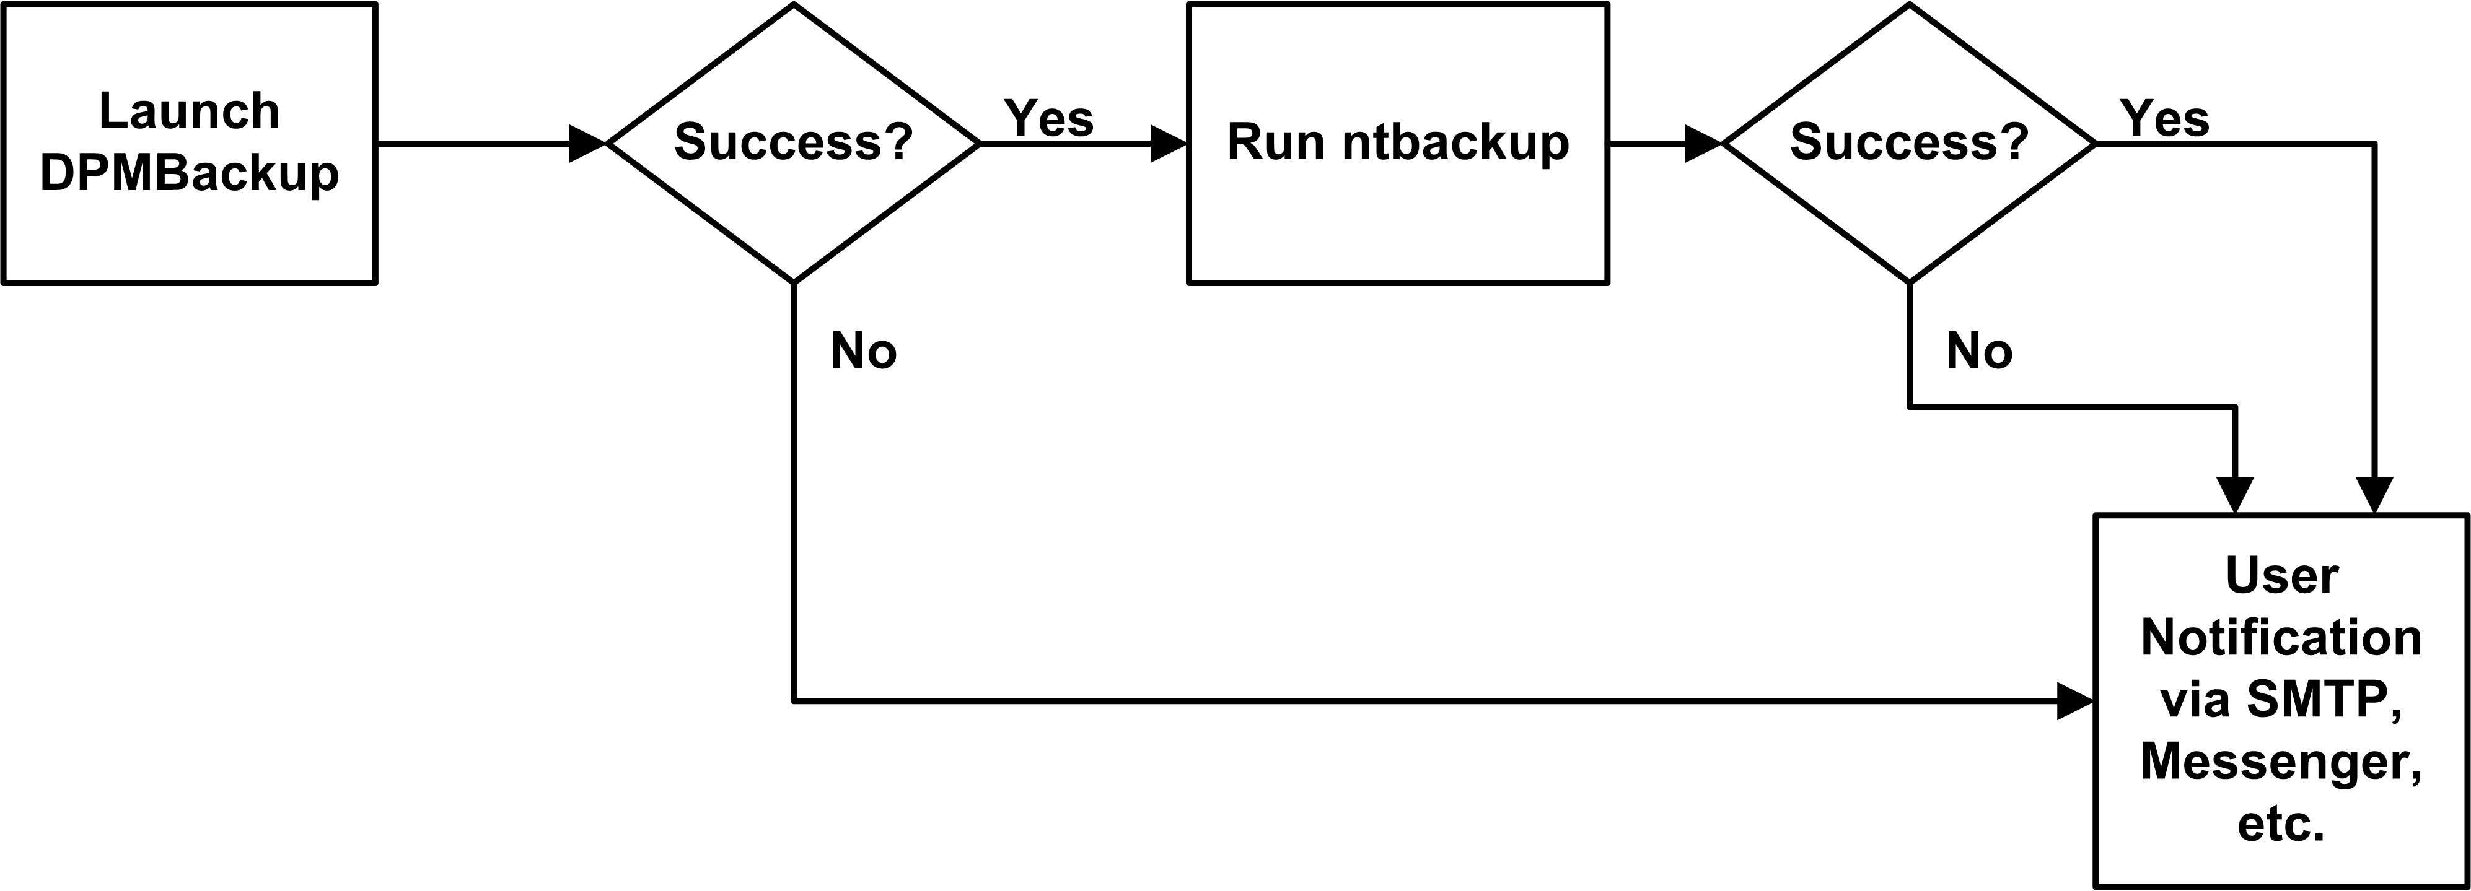
Figure 4: Flowchart of a typical NTBackup / DPM scripting solution
Whatever method you choose to automate the backup process, you must run the task with Administrator or Backup Operator privileges.

Performing System State Backups
Now that you have configured DPM and NTBackup to protect your data, you still need to consider the case of system state backups for each of your Windows servers. This is especially important if you are only using share-level protection between your protected file servers and your DPM server, or have not selected your system volume for replication; the relevant system information will not get backed up any other way, making the process of restoring the server a long, manual chore. Even if you are using volume-level protection, having a separate system state backup greatly simplifies your restoration scenario if you have to rebuild a server.
The easiest way to capture the system state is to use NTBackup on each file server to back up the system state data. Use the Task Scheduler to run this utility on a regular basis to create a system state backup and dump it to a local folder which is protected by DPM. The system state dump will be synchronized by DPM. In the event the server needs to be rebuilt, the system state dump can be easily retrieved without resorting to tape backup just like any other DPM-protected file.
The following steps describe how to configure your protected file server to create system state backups using NTBackup and the Task Scheduler:
- Log on to the protected server as an administrative user and launch NTBackup: Start, All Program Files, Accessories, System Tools, Backup. If it starts in Wizard Mode, click Advanced Mode.
- Click Backup Wizard (Advanced) to start the Backup Wizard. Click Next.
- Select Only back up the System State data and click Next.
- Unless you have a tape drive attached to the server, the backup type field should read Files and should be unavailable. Click Browse and select a location to write the backup file to; ensure that it is in a location that is protected by DPM. Type a name for the backup job and click Next.
- Select the Verify data after backup check box and click Next.
- Select Replace the existing backups, select the Allow only the owner and administrator access to the backup data and to any backups appended to this medium check box, and click Next.
- Select Later, provide a name for the backup job, and click Set Schedule. Select a Daily Schedule Task and an appropriate time, and then click OK. Enter the administrator credentials, click OK, and click Next.
- Click Finish.
The backup job is automatically added to the Scheduled Tasks folder.
You also need to take the appropriate precautions to capture the recovery information you will need to rebuild the server in the event you lose it. You do this by using the Automated System Recovery (ASR) functionality of NTBackup to capture crucial system information for each protected server. The ASR data, combined with a recent system-state backup, allows you to perform bare-metal recovery from the original Windows installation media:
- Log on to the protected server as an administrative user. Launch NTBackup: Start, All Program Files, Accessories, System Tools, Backup. If it starts in Wizard Mode, click Advanced Mode.
- Click Automated System Recovery Wizard to start the ASR Wizard. Click Next.
- Unless you have a tape drive attached to the server, the backup type field should read Files and should be unavailable. Click Browse and select a location to place the backup file. It should not be on your system partition; it should be in a location that is protected by DPM. Type a name for the backup job and click Next.
- Click Finish to begin the ASR backup process. After the necessary system files have been backed up, you will be prompted for a floppy disk. Insert a disk and complete the backup process; this disk will hold key data files that will be used in conjunction with the backup file and your Windows Server 2003 installation CD in the event you need to rebuild your DPM server.
- Ensure that the ASR backup file produced in step 3 is backed up to tape. You may rely on your DPM replication or use a manual or specially scheduled backup job instead of using the usual backup schedule. This is especially important for your ASR backup of the DPM server; you will not be able to recover your most current information from the DPM shadow copies unless you recover the ASR backup from tape.
While you do not need to perform an ASR backup daily, you should ensure that it is run on a regular basis. You do not need to copy those backup files to tape unless your recovery plan requires you have one or more critical protected file servers that must be rebuilt without depending on a rebuild of the DPM server in the event of a site loss. Additionally, you should perform an ASR backup of the DPM server whenever you add a new protected server; this backup should be archived to tape.

Recovering Data
The best tape backup system in the world is useless if you can't successfully restore your data when files are lost. Data loss events can happen at several stages: the loss of individual files, the loss of a server, or even the loss of the DPM server. In extreme cases, you may even lose an entire site and need to rebuild multiple servers at once. It is important to know what steps you must perform when these events happens so that you can adequately plan for them and have the right data in the right place to make your recovery process as smooth and painless as possible.
End-user file recovery is one of the key features of DPM. In most of your data loss events, your administrators or users will be able to use Windows Explorer or Office 2003 applications to easily access the DPM shadow copies and recover point-in-time copies of their files. The process of enabling this feature is covered in more detail in Chapter 5, "Configuring DPM," of the Data Protection Manager 2006 Planning and Deployment Guide.
However, there will be occasions when you need to recover files from your NTBackup tape archives. This process is slightly complicated by the fact that NTBackup is not DPM-aware; it archives the protected data from the namespace of the DPM server, not from the original protected file server it originated on. When recovering files from tape, you need to either recover them to a local disk of the DPM server and move them to their actual destination with the DPM Administrator or recover them to an alternate location.

Recovering Protected Data
The actual process of recovering DPM-protected data from tape is fairly simple. You need to know which server the desired files were originally on; from there, it is a straightforward process to recover them to the DPM server. You can then move the files to the protected file server or other location.
You will also use this process during a disaster recovery rebuild of the DPM server. In this scenario, detailed in “Restoring the DPM Server," you will recover directly to the live replica directories. You should only attempt this during a data recovery scenario to prevent production data corruption.
To recover DPM-protected data:
- Log on to the DPM server as an administrative user. Launch NTBackup and click the Restore and Manage Media tab.
- In the browser window, navigate through the server, shadow copy, and folders that contain the backups you want to restore and ensure the required files are selected.
- Choose the appropriate backup set and drill down through its folder structure to choose the items to restore.
- Choose the recovery destination:
- If you are recovering to the protected file server / alternate server: choose Alternate location from the Restore files to list. Then, enter the location in the Alternate location box or click Browse to browse for the location.
- If you are restoring the DPM replicas: accept the default restore location; by default NTBackup will attempt to restore them to the original replica location. Before you begin the restore, stop the DPM services on the DPM server.
- Click Start Restore. Confirm the details of the recovery job and click OK to begin the recovery process.
- After the files have been recovered, they will be in the DPM server namespace: \Program Files\Microsoft Data Protection Manager\DPM\Volumes\Replica\ServerName:
- If you are recovering to the protected file server / alternate server: run the FsPathMerge.exe command, which is located in the \Support\Tools directory of the DPM installation media. This utility moves restored data to the appropriate destination folder. The path names must be fully qualified from the root of the volume and cannot be in UNC format:
Example:
You are protecting folder C:\Sales on the file server FS01. You use Windows Backup to backup the DPM replica. The backup shadow copy of C:\Sales is located at D:\Program Files\Microsoft Data Protection Manager\DPM\Volumes\Replica\FS01\C-8d2a01f3-4b01-11d9-b735-806e6f6e6963\ReplicaDir\Sales.
The replica data on the DPM server is backed up to tape. When you restore the Sales folder from tape to file server FS01, it creates the following path:
C:\Sales\Program Files\Microsoft Data Protection Manager\DPM\Volumes\Replica\FS01\C-8d2a01f3-4b01-11d9-b735-806e6f6e6963\Replicadir\Sales
To restore the correct path information, you run the following command:
FsPathMerge.exe –FS “C:\Sales\Program Files\Microsoft Data Protection Manager\DPM\Volumes\Replica\FS01\C-8d2a01f3-4b01-11d9-b735-806e6f6e6963\ReplicaDir\Sales” C:\Sales
To restore the correct path information and delete the original contents of C:\Sales, you run the following command:
FsPathMerge.exe –FS “C:\Sales\Program Files\Microsoft Data Protection Manager\DPM\Volumes\Replica\FS01\C-8d2a01f3-4b01-11d9-b735-806e6f6e6963\ReplicaDir\Sales” C:\Sales -Y
- If you are restoring the DPM replicas: restart the DPM services.

Rebuilding a Protected Server
If you lose a protected file server, you will need to rebuild it. This process can be done entirely from DPM if you are managing your ASR backups from DPM. You will need to recover the ASR backup file and make it locally available to the server.
You initiate an ASR restore by booting off the installation media and selecting the ASR option. ASR will then gather your critical system information from the floppy disk and restore the system and boot volumes. It does so by formatting these drives and installing the operating system, merging the installation with the data from the backup file. Because the system drives are formatted during the restore, any user or application information on them will be lost.
Disk volumes that store user or application data are not backed up as a part of a typical ASR backup, and are not included in an ASR restore. If these disks have been unaffected by the server failure, you will still have their data available; otherwise, you will need to restore them from DPM (if the DPM server is available) or tape.
Before you begin an ASR restore, ensure that your system meets the following requirements:
- You have the same hardware as the original system. This does not include hard disks, video cards, and network adapters.
- You have a sufficient number of disks to restore the critical system disks.
- Your storage capacity is at least as much, both in number and storage capacity, as the original system.
If your server does not have a floppy disk drive or you want to restore the system over a network or remotely, you can integrate ASR with a Remote Installation Services (RIS) server. This usually requires that your server network cards support the Preboot eXecution Environment (PXE) standard. The use of RIS is outside the scope of this paper, but you can refer to the Microsoft Windows Server 2003 Deployment Kit for more details on how to integrate RIS and ASR. You can download this paper at http://www.microsoft.com/resources/documentation/WindowsServ/2003/all/deployguide/en-us/Default.asp?url=/resources/documentation/WindowsServ/2003/all/deployguide/en-us/welcome.asp.
The following steps demonstrate how to recover a protected file server using ASR:
- Boot the protected file server off the Windows media.
- At the Press F2 to run Automated System Recovery (ASR) message, press F2.
- Insert the ASR floppy disk when prompted.
- The system and boot volumes will be formatted and the operating system will be installed.
- The system will start the ASR Recovery Wizard. Confirm the location of the backup file and proceed with the recovery.
- Restart the system and restore the latest system state backup.
- Restart the system and verify that the operating system and critical system data have been restored.
- Recover your protected data from tape using the process described in “Recovering Protected Data” earlier. Because you are restoring data on the DPM server, you can either copy the data to a temporary location on the DPM server and then copy it to your file server, or restore to a network drive mapped from a share on your file server. Be sure to use the FsPathMerge.exe utility to merge the restored data to the correct location.
- On the DPM server, launch the DPM Administrator Console and perform a synchronization with consistency check.

Restoring the DPM Server
Restoring the DPM server after a data loss event is, for the most part, like recovering a protected file server. The key difference is that after you have restored the operating system, you must restore the DPM databases and replica data from tape.
The following steps demonstrate how to recover a DPM server using ASR:
- Boot the DPM server off the Windows media.
- At the Press F2 to run Automated System Recovery (ASR) message, press F2.
- Insert the ASR floppy disk when prompted.
- The system and boot volumes will be formatted and the operating system will be installed.
- The system will start the ASR Recovery Wizard. Confirm the location of the backup file and proceed with the recovery.
- Restart the system and restore the latest system state backup.
- Restart the system and verify that the operating system and critical system data have been restored.
- Follow the procedure outlined in the section “Repairing DPM” in Chapter 4 of the Data Protection Manager 2006 Planning and Deployment Guide to reinstall DPM. This process involves uninstalling and reinstalling DPM while retaining the databases. Do not restart the server until you have reinstalled DPM successfully.
- Follow standard NTBackup restore processes to recover the DPM databases to a temporary location on the system volume such as D:\DPMBackups.
- From a command line, run the D:\Program Files\Microsoft Data Protection Manager\DPM\bin\DpmSync.exe utility to move the database and log files to the proper location and recover the configuration information:
DpmSync -DpmDbLoc D:\DPMBackups\DPMDB.bak
DpmSync -DpmReportDbLoc D:\DPMBackups\ReportServer.bak
- Launch the DPM Administrator Console and add disks to the storage pool.
- From a command line, run the D:\Program Files\Microsoft Data Protection Manager\DPM\bin\DpmSync.exe utility to reallocate the replicas:
DpmSync -ReallocateReplica
- Follow the steps provided in “Recovering Protected Data” to restore the protected data from NTBackup to the replica folder on the DPM server. Follow the instructions for restoring to the DPM replicas.
- Do not run the synchronization with consistency check until you have restored all replicas. Microsoft recommends that you create a manual snapshot of all of your replicas before performing the consistency check, although this is only absolutely required if you will be recovering the data on your protected files servers from the DPM snapshots.
- After all of your protected resources have been recovered, use the DPM Administrator to perform a synchronization with consistency check on each replica.
If you are building a new DPM server and restoring the replica data from another server, you must follow additional steps at this point. See the Data Protection Manager 2006 Operations Guide: Archiving and Restoring Data guide for more information. You can find this guide online at: http://go.microsoft.com/fwlink/?linkid=43087

Restoring a Complete Site
In a wide-scale data loss event, you could lose your DPM server and one or more protected file servers at the same time. In this case, you need to decide the order in which you will recover your servers. You have two basic choices: recover your DPM server first and use it to stage recovery of your protected file servers, or recover one or more protected file servers directly and restore the DPM server after the critical servers are back online.
Recovering the DPM server first will probably be a slower process, because you have to recover multiple replicas to the DPM server and then restore the data back to the protected file servers. This requires you to have all of your usual disk storage capacity for the DPM server; during a wide-scale outage, you may not have the spare disk resources on hand. It also turns your DPM server into a bottleneck; therefore, this option does not scale well if you have a large number of servers to rebuild.
Recovering at least some of your protected file servers first will in many circumstances get them up and running more quickly than the other option. However, it is marginally more complex to manage, as you must manually restore the protected data to the various protected file servers directly from NTBackup. You will either have to restore the data to a staging server and copy it to the protected file server over the network, or attach a tape unit to each protected file server and restore directly from tape. This option may be both faster and more scalable than rebuilding the DPM server first. That response time is often critical when you have mission-critical servers and data that need to be restored.

Summary
Microsoft System Center Data Protection Manager is a comprehensive disk-based data protection solution. DPM provides significant benefits when deployed into an existing tape-based archival solution:
- DPM minimizes data loss by allowing you to define your protection schedules according to your business needs, not your technology.
- DPM eliminates the backup windows and can in many cases reduce or remove the need for daily incremental backups.
- DPM quickly and accurately restores data from fast disk storage instead of slow, inefficient, and fragile tape systems.
- DPM provides centralized control over end-user recovery of data and allows your users to recover point-in-time file copies from their desktop.
- DPM consolidates your backup infrastructure, from your data centers to your branch offices and remote locations.
This paper has presented the issues and tasks you must be familiar with to successfully integrate NTBackup with DPM.

Related Links
See the following resources for further information:
- Microsoft Data Protection Server home page at http://www.microsoft.com/windowsserversystem/dps/default.mspx.
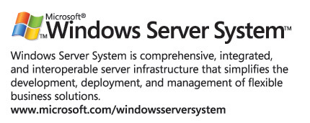
For the latest information about Windows Server 2003, see the Windows Server 2003 Web site at http://www.microsoft.com/windowsserver2003.

