

Using Data Protection Manager with Veritas BackupExec

Microsoft Corporation
Published: September 2005

Abstract
This paper gives specific guidance on integrating Microsoft® System Center Data Protection Manager 2006 (DPM) with a customer’s existing Veritas BackupExec deployment. It explains how DPM works and how the customer will benefit from using it in conjunction with BackupExec. It gives specific technical guidance on the specific issues and configuration questions the BackupExec administrator will encounter during a DPM deployment. It also addresses the typical backup and recovery scenarios to assist in disaster recovery planning.



The information contained in this document represents the current view of Microsoft Corporation on the issues discussed as of the date of publication. Because Microsoft must respond to changing market conditions, it should not be interpreted to be a commitment on the part of Microsoft, and Microsoft cannot guarantee the accuracy of any information presented after the date of publication.
This White Paper is for informational purposes only. MICROSOFT MAKES NO WARRANTIES, EXPRESS, IMPLIED OR STATUTORY, AS TO THE INFORMATION IN THIS DOCUMENT.
Complying with all applicable copyright laws is the responsibility of the user. Without limiting the rights under copyright, no part of this document may be reproduced, stored in or introduced into a retrieval system, or transmitted in any form or by any means (electronic, mechanical, photocopying, recording, or otherwise), or for any purpose, without the express written permission of Microsoft Corporation.
Microsoft may have patents, patent applications, trademarks, copyrights, or other intellectual property rights covering subject matter in this document. Except as expressly provided in any written license agreement from Microsoft, the furnishing of this document does not give you any license to these patents, trademarks, copyrights, or other intellectual property.
Unless otherwise noted, the example companies, organizations, products, domain names, e-mail addresses, logos, people, places, and events depicted herein are fictitious, and no association with any real company, organization, product, domain name, e-mail address, logo, person, place, or event is intended or should be inferred.
© 2005 Microsoft Corporation. All rights reserved.
Microsoft, Active Directory, Windows, Windows Server, and Windows Server System are either registered trademarks or trademarks of Microsoft Corporation in the United States and/or other countries.
All other trademarks are property of their respective owners.

Contents
Introduction 1
How DPM Works 1
DPM Benefits 3
Using DPM with Veritas BackupExec 4
Deploying DPM 6
Verifying Requirements 6
Domain and network 6
DPM server 6
Protected file server 7
Installing the DPM Server 7
Allocating Storage on the DPM Server 8
Installing the DPM Agent on File Servers 8
Creating and Configuring Protection Groups 8
Reconfiguring BackupExec 9
Creating the Backup Job 10
Scheduling Backups 12
Performing System State Backups 12
Recovering Data 14
Recovering Protected Data 14
Rebuilding a Protected Server 16
Restoring the DPM Server 17
Restoring a Complete Site 18
Summary 20
Appendix 21
How to use DpmShareBackup.vbs 21
Related Links 24

Introduction
Disk-based data protection strategies are a growing alternative to tape backup solutions. They provide a number of benefits when compared to traditional backup media, such as easier handling of file and server recovery, faster backup, and better use of network bandwidth. As low-priced and reliable disk systems enter the market, many organizations are looking at how best to integrate them into their data protection strategies.
Microsoft® System Center Data Protection Manager 2006 (DPM), the newest member of the Microsoft® Windows Server System™ family, provides an efficient disk-based data protection and recovery solution. DPM protects Microsoft® Windows® 2000 Server, Microsoft Windows Server 2003, and Windows Storage Server 2003 and makes use of advanced features such as replication, policy-driven protection, and the Windows Server 2003 Volume Shadow Copy Service (VSS). DPM is designed to work in conjunction with your existing backup solution to help you achieve the following goals:
- Reduce backup and restore times to below those offered by traditional tape-based systems.
- Simplify your backup infrastructure and make it easier to manage.
- Reduce the amount of data your organization will lose in the event of a server failure or emergency.
- Allow your users to restore their own files in many cases.
This paper discusses how to introduce DPM into your network and make it work well with your Veritas BackupExec deployment and gives you step-by-step directions for common recovery scenarios.

How DPM Works
DPM is designed to be installed on dedicated server hardware running the Windows Server 2003 operating system. Your DPM server should have a large amount of available disk storage. Depending on the amount of data you want to protect, you may need to deploy a hardware ATA or SATA RAID disk array; software RAID is not supported. DPM integrates with the Windows Active Directory® directory service to ease management and discovery of protected servers. If your environment requires protecting servers in multiple Active Directory domains, you will need to have at least one DPM server in each domain.
After your DPM servers are installed, you use the DPM Administrator Console to push the DPM agent to each file server and create your protection groups. A protection group is a collection of data resources that share the same protection policy, such as shared folders and disk volumes. You define the data to protect, at which point the DPM agent begins to replicate the designated data to the DPM server according to the policy-defined schedule. The DPM agent tracks the data, replicates only the changed blocks, validates the replica, and corrects errors. By performing incremental replication at the disk block level, DPM can dramatically reduce the bandwidth required by your protection solution.
Because DPM fully integrates with VSS, your protection policy can define how many shadow copies or snapshots to make available, independently of your replication schedule. Your administrators can then access these snapshots to perform file recoveries as requested. If you want to allow your users to directly access the snapshots and recover files themselves, they can install an optional hotfix for Windows XP and Windows Server 2003 that extends the included Shadow Copies of Shared Folders client to work with DPM. The updated clients allow direct recovery of files from within Windows Explorer and Microsoft® Office 2003 applications.
The final layer of protection comes from integrating DPM with BackupExec. Using the BackupExec Remote Agent for Windows, you create backups of your data from the replicas on the DPM server instead of from the live data on the protected file servers. Because you are using a read-only snapshot of the data, you can backup your data at any time without affecting the performance or reliability of your protected file servers.
DPM helps you make better use of your tape backup resources, no matter where your file servers are located in your enterprise. As shown in Figure 1, it can be used to streamline backup operations in a data center, or consolidate multiple backup servers in branch offices into a central location, all while offering a greater degree of protection for your data.
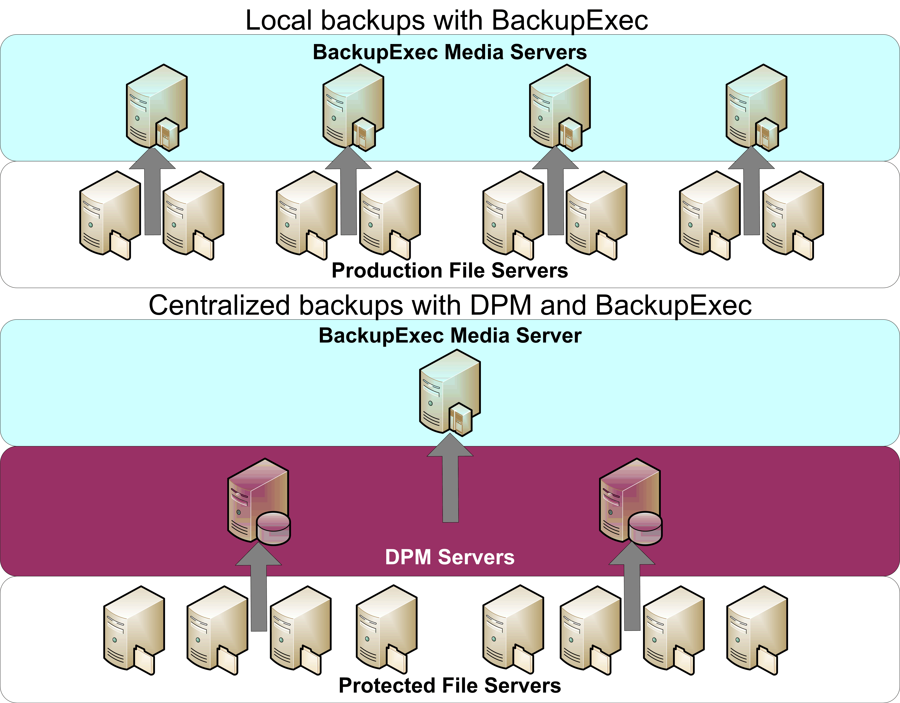
Figure 1: Local versus centralized backups with BackupExec and DPM
See Chapter 1, "Introducing Data Protection Manager," of the Data Protection Manager 2006 Planning and Deployment Guide for more information on how DPM works and common deployment and recovery scenarios.
This solution was developed and tested with BackupExec 10. You may be able to use BackupExec version 9, although you may find that some of the steps and procedures are different.

DPM Benefits
Data Protection Manager provides the following benefits:
- Minimize data loss. You can define your protection schedules based on your real business needs instead of being limited by your tape backup system. DPM allows you to protect your data more quickly and more often, reducing your window for potential data loss to as little as a single hour.
- Recover lost data quickly and reliably. Your protected data is replicated to a central DPM server, which uses fast disk storage instead of slow, bulky tape. You can immediately restore just the files you need from disk without waiting for the many delays of a tape backup system.
- Allow end-user data recovery. DPM works with your existing Windows file servers to help you maintain centralized control over end-user recovery of data. Your end users will be able to recover point-in-time file copies from their desktop through the familiar interface of Windows Explorer or Microsoft Office applications.
- Eliminate your backup window. DPM moves the backup load off your file servers and efficiently protects your important data around the clock. You can then perform tape backups of your DPM data at any time without affecting performance on your protected file servers.
- Replace incremental backups to tape. DPM can completely replace onsite incremental tape backups with shadow copies on disk, providing more reliable and cost-effective protection for your data.
- Consolidate your backup infrastructure. Use DPM to protect the data in your branch offices and remote locations and remove the need for multiple tape backup systems or complex and slow centralized tape management configurations.
- Lower your total cost of ownership. DPM reduces your total cost of ownership by removing the need to deploy backup agents and licenses to your protected file servers, thus reducing the amount of time and network bandwidth required to manage backup and recovery operations. It also removes the need to have your backup operations occur during off-hours.

Using DPM with Veritas BackupExec
Veritas BackupExec is a popular backup solution for mid-to-large enterprise networks. It offers a high degree of scalability and flexibility along with support for multiple operating systems and agents. While a powerful system, it can be complex to learn and manage. By using DPM with your existing BackupExec installation, you can reduce the size and complexity of your backup infrastructure, address the weaknesses in any tape-based backup system, and use the strengths of BackupExec to make tape archival a part of your total data protection solution.
Tape backup systems suffer from several key drawbacks:
- Tape systems are fragile and susceptible to environmental degradation. Tape drives can easily become dirty or misaligned, requiring frequent cleaning and maintenance. Tapes are sensitive to temperature, humidity, and contaminants and frequently go bad during storage.
- Tape systems have a higher level of management overhead. Because tapes are a linear medium, they must be read and written sequentially and must be rewound or forwarded to a specific position to recover a specific piece of data. This overhead increases the delays involved in using a tape backup system.
- In order for tape backups to be usable, the backup system needs to be able to access a static copy of each file; files that are open or in use by other processes will often not be backed up unless you use special software agents. Ideally, the backup system needs to have access to a static copy of the entire resource being backed up so that all of the data is consistent.
- Tape backup systems track changes on a file-by-file basis rather that at the block level within the file. Any change to a file, no matter how small, will result in the entire file being rearchived during an incremental backup.
- Tape backup systems can often have a high impact on the performance of the servers and networks they protect. It is a common practice to schedule backups during periods when the protected resources are not heavily used.
The minimum length of the backup window is a product of the speed of the backup system and the amount of data to be backed up. This in turn must be balanced by operational needs; users must be able to access and change data during the course of typical operations.
Veritas BackupExec helps solve this problem by allowing the backup operators to use multiple tape devices as part of a unified solution to keep the backup window as small as possible. As the amount of data to backup increases, this usually requires additional investment in tape drive hardware. It can also increase the complexity of restoration.
Figure 2 shows a typical Veritas BackupExec deployment:
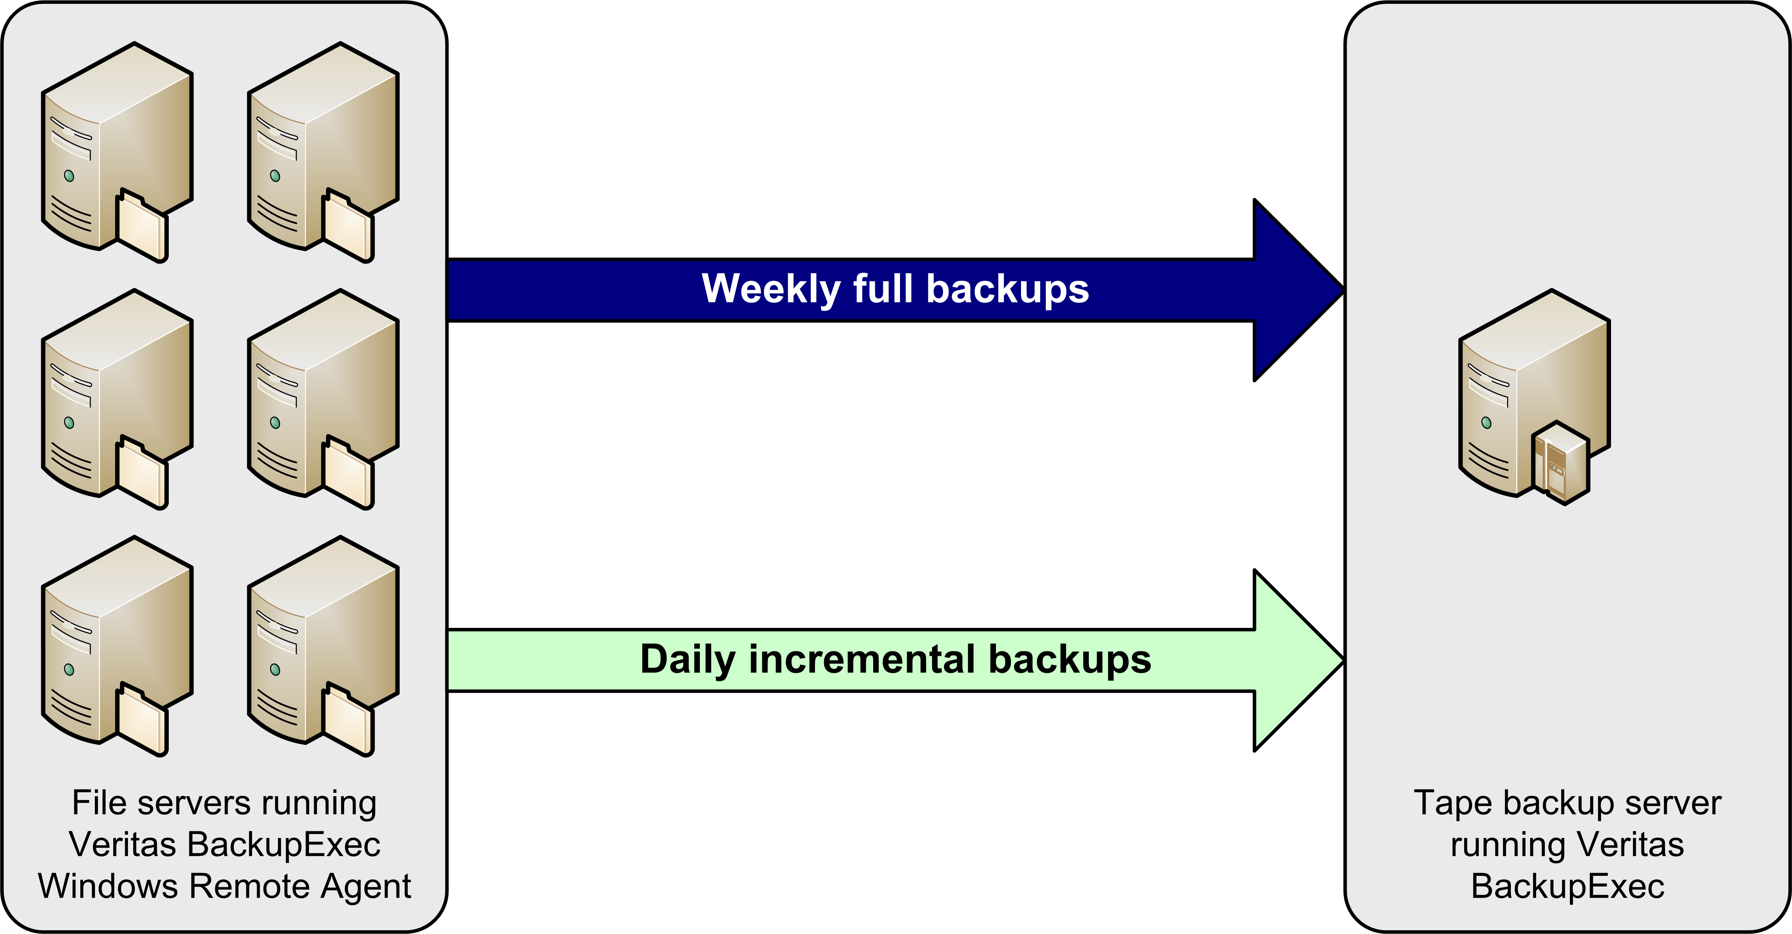
Figure 2: Veritas BackupExec deployment
By adding DPM to your organization, you can dramatically change your backup window requirements and make better use of your existing BackupExec resources. DPM gathers data from your protected file servers and ensures that BackupExec has a consistent snapshot to work from. DPM can also consolidate data from multiple servers into one location, in turn decreasing the complexity of your BackupExec configuration.
Figure 3 shows one common scenario for deploying DPM and BackupExec together:
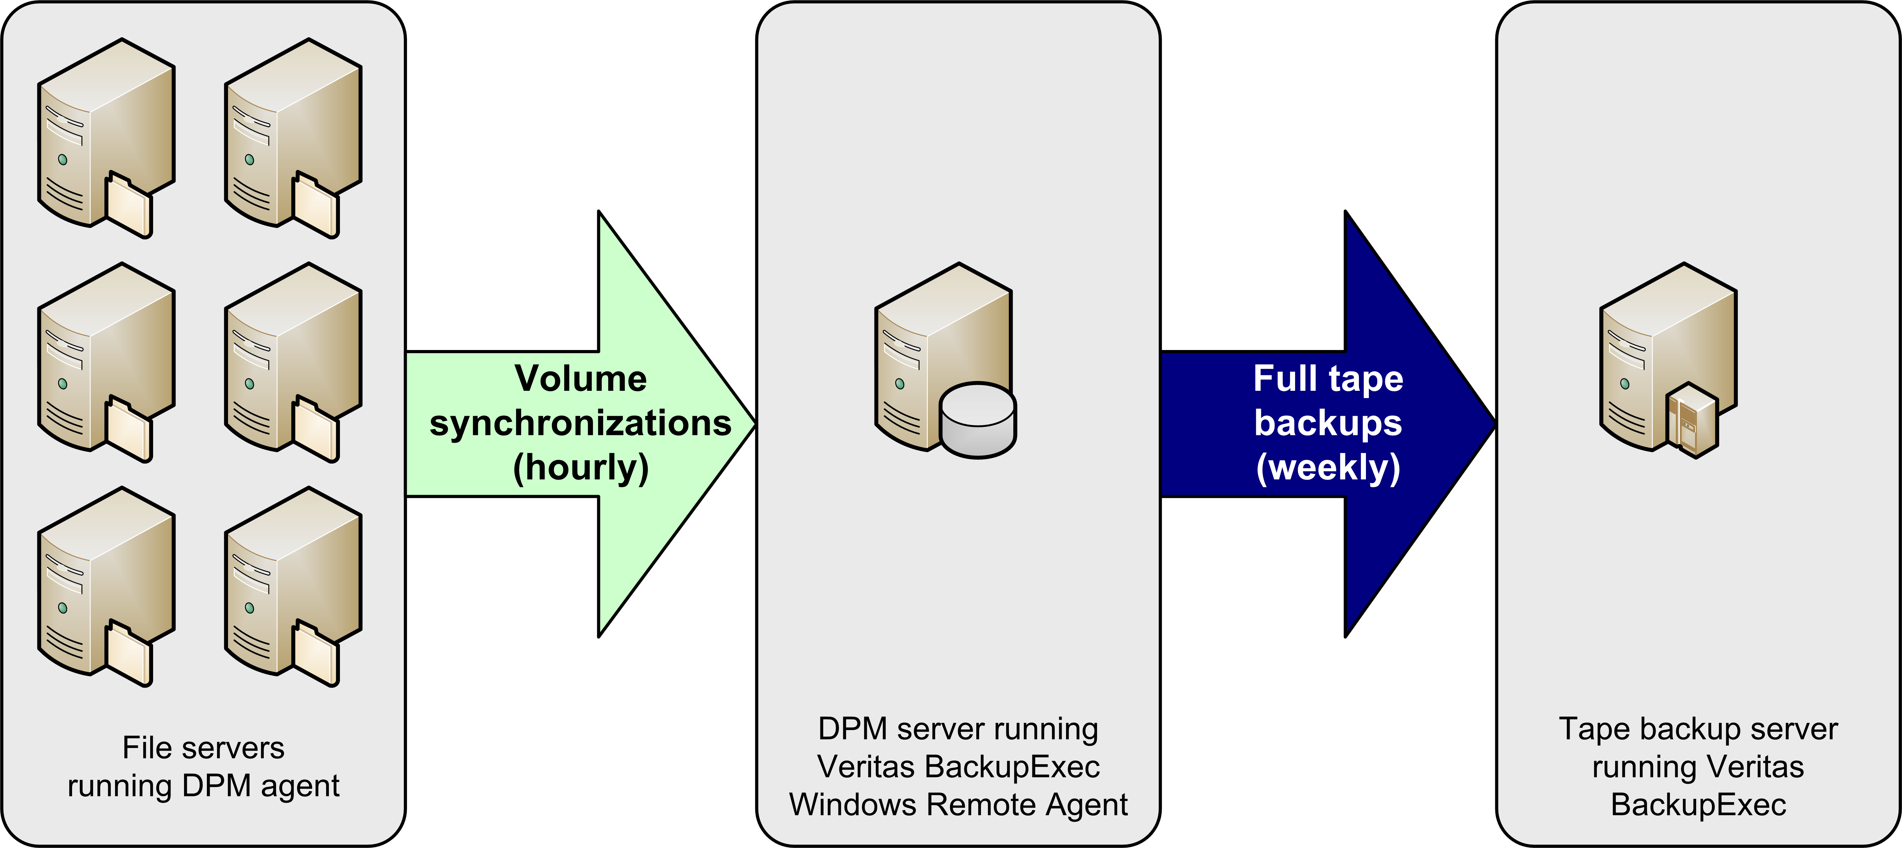
Figure 3: DPM plus Veritas BackupExec deployment
To introduce DPM into an existing BackupExec environment, you need to perform the following steps:
- Deploy DPM:
- Verify requirements.
- Install the DPM server.
- Allocate storage on the DPM server.
- Install the DPM agent on file servers.
- Create and configure protection groups.
- Install the BackupExec agent on the DPM server.
- Reconfigure BackupExec:
- Create the backup jobs for the DPM server.
- Schedule backups.
DPM uses VSS to create and mount snapshots of the replica data for the BackupExec agent. Veritas provides the Advanced Open File Option for BackupExec starting with version 9.1; this option gives the BackupExec agent VSS support for user data. While it is possible to use this option in combination with DPM, Microsoft does not recommend it. Instead, BackupExec users should run the DpmBackup.exe utility, provided with DPM, to create shadow copies of the replicas on the DPM server, mount them in the DPM server namespace, and create backups of the DPM databases. You can then select the protected data you want the BackupExec agent to include in the backup job.

Deploying DPM
When you are ready to introduce DPM into your production environment, the first major task you need to perform is to install the DPM server. This involves installing and configuring DPM. You can find detailed guidance on this process in the Data Protection Manager 2006 Planning and Deployment Guide, which is available for download at: http://go.microsoft.com/fwlink/?linkid=51651

Verifying Requirements
Before you begin the deployment process, verify that your deployment meets the following requirements:
Domain and network
- The domain controllers are running either Windows Server 2003 or Windows 2000 Server.
- Windows 2000 Server domain controllers have Windows 2000 Server Service Pack 3 or later installed and schema updates enabled if end-user recovery will be deployed.
- The domain has the Kerberos V5 authentication protocol enabled. This is the case by default.
DPM server
- The server is running a 32-bit version of either Windows Server 2003 (Standard or Enterprise Edition) with Service Pack 1 or Windows Storage Server 2003 (Standard or Enterprise Edition) with Service Pack 1. You can install DPM on 32-bit operating systems running on 64-bit hardware; you cannot install it on 64-bit operating systems.
- The server has Microsoft .NET Framework 1.1 with Service Pack 1 installed.
- The server has the Windows Server 2003 VSS post-SP1 update package installed. See http://support.microsoft.com/kb/891957 for more details.
- The server meets the hardware and software requirements for Microsoft® SQL Server® 2000 Service Pack 3a (see http://www.microsoft.com/sql/default.mspx for more details).
- The server is a member of the same Active Directory domain as the production servers it will protect, even if the file servers are located across a WAN link. You will need at least one DPM server for every domain in which protected servers reside.
- The server is not a domain controller or an application server.
- The network between the DPM server and the protected file servers supports Internet Protocol Version 4 (IPv4). DPM cannot operate on networks that exclusively use IPv6.
- The server has at least two disks available:
- One disk dedicated to the system and DPM installation files.
- One or more disks dedicated to the DPM storage pool.
- The server is configured to use NTFS.
- The server has a persistent virtual private network (VPN) connection to any branch office file servers it protects.
Protected file server
- The server is running one of the following operating systems:
- Windows Server 2003 with Service Pack 1 installed.
- Windows Storage Server 2003 with Service Pack 1 installed.
- Windows 2000 Server with Service Pack 4 and the Windows 2000 Update Rollup 1 installed.
- The server is a member of the same Active Directory domain as the DPM server that protects it.
- The server is not part of a cluster. Clustered file servers cannot be protected.
- The server has a minimum of 500MB of free space available on each volume to be protected.
- The server disk volumes are one of the following:
- Direct attached storage (DAS) volumes.
- Fibre Channel storage area network (SAN) devices.
- Internet SCSI (iSCSI) devices with Windows Hardware certification.
See the Data Protection Manager 2006 Planning and Deployment Guide for more information on how DPM works and common deployment and recovery scenarios.

Installing the DPM Server
After you have verified that your servers meet the prerequisites for their roles, you can install the DPM software on your DPM server. You can install directly from the installation media or copy the setup files to a shared network location. Microsoft recommends that you do not install DPM on the system volume, as this configuration can produce complications if you ever need to rebuild your DPM server from tape backups during a disaster recovery scenario.
Remember that you must install at least one DPM server in each Active Directory domain that contains a file server you want to protect. This requirement may be particularly relevant in many branch office deployment scenarios. Although DPM relies on Active Directory for discovery of new servers, it does not require a domain controller to be located on a local network segment.
See Chapter 4, "Installing DPM," of the Data Protection Manager 2006 Planning and Deployment Guide for detailed guidance on the DPM installation procedures.

Allocating Storage on the DPM Server
The next step in deploying DPM is to create the storage pool. The storage pool consists of one or more disk volumes that are used exclusively by DPM to store replicas, shadow copies, and logs. DPM will use the entire volume and reformat it, so ensure that you have no data on the devices you add. You can use three types of disk volume: direct attached storage (DAS), storage area networks (SAN), or Windows-certified iSCSI devices. You can add RAID volumes to your storage pool, but some common RAID configurations such as RAID 5 are less suitable for use with DPM because of the characteristics of their write performance.
See Chapter 3, "Planning Data Protection," of the Data Protection Manager 2006 Planning and Deployment Guide for more information on storage pool sizing and determining which RAID arrays will be suitable for your DPM server, and Chapter 5, "Configuring DPM," for specific guidance on allocating storage.

Installing the DPM Agent on File Servers
After installation DPM will scan Active Directory to find file servers to protect. When DPM finds them, you will need to deploy the DPM File Agent. You will also need to decide whether you want to keep the BackupExec Remote Agent for Windows on your protected file servers along with the DPM File Agent. You are not required to remove the BackupExec agent before installing the DPM agent; in fact, Microsoft recommends that if you choose to remove the BackupExec agent, you do so after the DPM agent has been installed, configured, and verified. Following this procedure ensures that you have continuous protection for your data.
If you are using special BackupExec agents to protect special-purpose servers such as Microsoft® Exchange Server, Microsoft SQL Server, or Microsoft Windows® SharePoint Services™ or Microsoft SharePoint Portal Server, then your BackupExec server will continue to protect these servers directly. However, if you are creating file-level data dumps from these applications and backing up the files, you can use the DPM File Agent on these servers instead.
See Chapter 5, "Configuring DPM," of the Data Protection Manager 2006 Planning and Deployment Guide for instructions on deploying the DPM File Agent.

Creating and Configuring Protection Groups
After the DPM agent has been installed on your protected file servers, you can begin to configure DPM and designate which disk volumes and network shares to protect. You do this by defining protection groups, which are collections of data sources that share common usage characteristics and are protected under the same policies. Each protection group consists of three elements:
- The disk allocation reserves space in the storage pool for the log files, replicas, and shadow copies of the data sources in the protection group.
- The replication schedule determines how frequently the DPM agent synchronizes the data source to the DPM server.
- The snapshot schedule determines how often shadow copies are made of the replica data.
If you have more than one protected data source from the same disk volume, they must be in the same protection group. Otherwise, you are free to assign data sources to protection groups based on factors such as the nature of the data, how frequently it is accessed or updated, network bandwidth and performance, related business requirements, or the potential affect on your business if the data source is lost for a period of time.
If the volume or share that you are protecting is part of a Distributed File System (DFS) hierarchy or File Replication Service (FRS) replica tree, special issues exist that you must take into consideration. To protect targets within a DFS namespace, you must choose the target directly through its actual file server namespace instead of through the DFS namespace. If the target is part of a FRS replica tree, you should protect only one target in the replica tree to prevent storing multiple copies of the data. Microsoft recommends that you protect only one of the DFS link targets; this prevents duplication of data and guarantees a consistent recovery experience. If you prefer to protect multiple targets, you can do so, but you must use the same protection policy on each target in the replica tree, and you should set replication schedules to keep the targets in close synchronization. Alternatively, you may want to consider enabling local Windows Server 2003-based shadow copies on those targets instead of using DPM to protect them.
See Chapter 3, "Planning Data Protection," and Chapter 5, "Configuring DPM," of the Data Protection Manager 2006 Planning and Deployment Guide for more information on planning and configuring protection groups.

Reconfiguring BackupExec
The second major task in deploying DPM in your BackupExec storage solution is to reconfigure BackupExec to backup shadow copy data from the DPM server instead of directly archiving data from the protected file servers. As your organization changes and grows over time, you will likely add new servers and data sources to your network. By default, DPM runs a nightly autodiscovery task that finds new servers and ensures they can be protected. You will need to ensure the data sources on these new servers are accounted for not only in the DPM configuration but in the BackupExec tape archive configuration as well.
After you begin this phase, you will begin to benefit from the expanded backup window offered by DPM. Most BackupExec deployments schedule backup jobs late at night, the early morning, or other low-usage hours to reduce open file contention and provide the maximum amount of network bandwidth to the backup system. Backup jobs are carefully configured to ensure that all operations can be completed within the allowable backup window. The goal of this phase of the deployment is to simplify your BackupExec configuration by extending DPM protection to your file servers, ensuring that BackupExec protects the resulting data snapshots on the DPM servers, and reducing or eliminating the time constraints imposed by your current backup window. As always, you should test your deployment thoroughly before making any permanent changes in your backup configuration.
Before you begin adjusting your BackupExec configuration, you must install the BackupExec Remote Agent for Windows on your DPM server. This agent will allow your BackupExec media servers to archive the shadow copies of your protected data. You do not need to install the Advanced Open Files Option; DPM includes a utility that creates and mounts the shadow copies so that the standard BackupExec agent can access and archive the snapshots.
Veritas supports the use of BackupExec versions 9.1 and above only on Windows Server 2003 computers because of the changes to the way the BackupExec agent integrates with the underlying Volume Shadow Copy Service.
DPM is intended to protect file-based data on file servers. If your file servers currently run any additional services and you want to protect them with DPM, you should research how to protect these services using the volume- and file-centric replication provided by DPM. Otherwise, you should strongly consider migrating or consolidating these services onto a group of servers that will continue to be protected directly by BackupExec. Whenever possible, you should avoid a permanent mixed backup strategy for these servers. Using DPM to protect file data and BackupExec to archive additional services on the same server complicates your data protection scenario by making it harder to verify that your server backup data is in a consistent state. It also makes server recovery extremely complex.
As you plan your protection scheme, keep system state data recovery in mind. Plan to configure each file server to produce system state backup files stored in a DPM-protected folder. When DPM synchronizes its replicas from the file server to the DPM server, the system state data will then be included in the backup set where it can be recovered if needed.
When you have the DPM agent deployed on a given file server, you no longer need the BackupExec agent to run backup jobs. The period of time in which you have both agents running backup jobs in parallel does not have to be long, but you should have a transition period to thoroughly test your new DPM configuration, confirm that your data is being protected, and verify that your DPM replica data can be archived and restored by your BackupExec deployment. If you want to be able to restore your production data from tape in an emergency, you should not remove the BackupExec agent from your protected file servers.

Creating the Backup Job
The first task is to create backup jobs in BackupExec to archive the data stored within DPM. Although DPM gives you the ability to protect an entire server or select specific shares, volumes, or folders to be protected, when you use BackupExec to protect your DPM server you will select shares on the DPM server. These shares correspond to the various protected folders, shares, and volumes on your protected servers. Microsoft recommends dedicating a media set for each protected file server; this allows you to quickly and easily restore that server's data in the event a rebuild or restore is needed. Because the shadow copy uses the Windows mount point feature to place your data under the DPM installation directory, you will need to ensure that the job is set to span mount points.
The BackupExec agent does not provide a VSS requestor for DPM. To create and mount the shadow copies for the agent, you must run the DpmBackup.exe program on the DPM server. In addition to creating snapshots of the replica data, this utility is also used to backup the DPM databases by creating copies of the databases in a folder the BackupExec agent can reach. To initially set up the job to backup the DPM databases, you must run the utility manually. You will need to configure your backup job to run the utility as part of a scheduled task.
You only need to run DpmBackup.exe once per each backup period, as it creates snapshots of each replica on the DPM server and makes copies of the DPM databases all at one time.
After you have created the shadow copies by running DpmBackup.exe manually for the first time, you need to use the DPMShareBackup.vbs script, provided in the Appendix. This script takes each of the replica shadow copy mount points created by DpmBackup.exe and configures them as separate shares. You then configure the backup job to attach to these shares. This method allows you to recover your protected data from tape to any server or target location by using a redirected restore.
The DPMShareBackup.vbs script is a workaround for a limitation in BackupExec that affects backups that take place through mount points. Veritas has developed a hotfix for the latest version of BackupExec that provides the capability to perform a redirected restore to a location where the original mount point does not exist.
By default DPM will scan Active Directory once a day to alert you to any changes, such as new servers and volumes. After you know about them, you can then add them into your existing protection groups and create new BackupExec jobs for them. As you add new servers or protect new folders, shares, and volumes on existing servers, you must rerun the DPMShareBackup.vbs script to make them available to BackupExec.
The following steps demonstrate how to create a new volume-level BackupExec backup job against a DPM server. These steps assume you are using the DPMShareBackup.vbs script:
- Log on to the DPM server as an administrative user.
- If the DPMShareBackup.vbs script does not already exist on this computer, open Notepad, copy the contents of the script from the Appendix, paste them into the new file, and save it as a file named DPMShareBackup.vbs in a folder of your choice.
- Open a command prompt and run the following program: D:\Program Files\Microsoft Data Protection Manager\DPM\bin\DpmBackup.exe
- Run the DPMShareBackup.vbs script that you created in step 2: CScript.exe DPMShareBackup.vbs
- Examine the new shares that it creates and record the ones that you want to back up to tape.
- Log on to the BackupExec server as an administrative user. Launch the BackupExec Administration Console. Navigate to the Tools menu, click Options, click Network and Firewall under Properties, ensure that the Select user shares check box is selected, and click OK.
- Select Job Setup from the navigation bar. Right-click under Jobs and click New Backup Job.
- In the Selections window, navigate down to the DPM server: Remote Selections, Microsoft Windows Network, Domain Name, Server Name.
- Select the check boxes for each share created by the DPMShareBackup.vbs script that you recorded in step 5.
- In the Properties window, under Destination, click Device and Media. Select the backup device and media set. It is recommended to use one media set per server to make recovery scenarios simpler.
- Under Settings, click General. Assign the backup job a name and description.
- Select the appropriate backup method, usually Full - Back up files - Copy the files. This ensures that you will not be modifying the replica data while archiving it, as that would lead to corruption.
- Under Settings, click Advanced. Ensure that the Back up files and directory by following junction points check box is selected.
- Under Settings, click Pre/Post Commands. Type the following value in the Pre-command box: D:\Program Files\Microsoft Data Protection Manager\DPM\bin\DpmBackup.exe
- Ensure that the following check boxes are selected: Allow pre- and post-commands to be successful only if completed with a return code of zero and Run job only if pre-command is successful.
- If you have selected data from multiple DPM servers, ensure that you select the On each server backed up option on the Run these commands field.
- Click Run Now. Verify the settings and click OK. The job will begin to run immediately.
To protect against loss of the DPM server, you should create an additional backup job that archives the DPM server system state data and the DPM database backups. If DpmBackup.exe runs successfully, it creates the DPM database backup files in the D:\Program Files\Microsoft Data Protection Manager\DPM\Volumes\ShadowCopy\Database Backups folder.

Scheduling Backups
After you have created the backup job in BackupExec you need to schedule it to run on a regular basis. Because you are backing up from a snapshot of the protected data, you no longer have to wait until off-hours for all of your backup jobs. To account for synchronization delay on the replicas, plan your tape backup job schedule to permit a sufficient amount of time for replication to complete. You should run the backup jobs on a regular basis to ensure recoverability in the event the DPM server is lost. The frequency of your archive backups depends on the amount of data you are willing to lose. If you must ensure that documents created each day are available for recovery, for example, you should run an archive each day.
You have your choice of scheduler: the Windows scheduler or the BackupExec scheduler. In either scheduler, you need to configure the task to be run with Administrator or Backup Operator privileges so that DpmBackup.exe can be run. The BackupExec scheduler is recommended for BackupExec jobs.
The following steps describe how to schedule BackupExec backup jobs using the BackupExec scheduler:
- Log on to the BackupExec server as an administrative user. Launch the BackupExec Administration Console and select Job Setup from the navigation bar.
- Under Jobs, right-click the backup job and select Properties.
- In the Properties window, under Frequency, click Schedule.
- Select Run according to schedule and click Edit Schedule Details.
- Configure the schedule to your requirements. When you are finished, click OK, and then click Submit.

Performing System State Backups
Now that you have removed the BackupExec backup jobs that directly backup resources on the protected file servers and have configured BackupExec to protect your DPM replicas, you still need to consider the case of system state backups for each of your Windows servers. Even if you are using volume-level protection, you will need to have a separate system state backup to successfully rebuild your protected file server from backups.
If you keep the BackupExec agent on your protected file servers, you should configure a new daily backup job for each file server. If you need to rebuild a file server, you will either need to restore the BackupExec agent or reinstall it, then recover the system state using standard BackupExec processes.
Another way to capture the system state is to use the Windows Backup (NTBackup) utility that comes with Windows. Use the Windows Scheduler to run this utility on a regular basis to create a system state backup and dump it to a local folder which is protected by DPM. The system state dump will be synchronized by DPM. In the event the server needs to be rebuilt, the system state dump can be easily retrieved without resorting to tape backup just like any other DPM-protected file.
The following steps describe how to configure your protected file server to create system state backups using NTBackup and the Windows scheduler:
- Log on to the protected server as an administrative user. Launch NTBackup: Start, All Program Files, Accessories, System Tools, Backup. If it starts in Wizard Mode, click Advanced Mode.
- Click Backup Wizard (Advanced) to start the Backup Wizard. Click Next.
- Select Only back up the System State data and click Next.
- Unless you have a tape drive attached to the server, the backup type field should read Files and should be unavailable. Click Browse and select a location to write the backup file to; ensure that it is in a location that is protected by DPM. Type a name for the backup job and click Next.
- Select the Verify data after backup check box and click Next.
- Select Replace the existing backups, select the Allow only the owner and administrator access to the backup data and to any backups appended to this medium check box, and click Next.
- Select Later, provide a name for the backup job, and click Set Schedule. Select a Daily Schedule Task and an appropriate time and click OK. Enter the administrator credentials, click OK, and click Next.
- Click Finish.
You also need to take the appropriate precautions to capture the recovery information you will need to rebuild the server in the event you lose it. You do this by using the Automated System Recovery (ASR) functionality of NTBackup to capture crucial system information. The ASR data, combined with a recent system-state backup, allows you to perform bare-metal recovery from the original Windows installation media:
- Log on to the protected server as an administrative user. Launch NTBackup: Start, All Program Files, Accessories, System Tools, Backup. If it starts in Wizard Mode, click Advanced Mode.
- Click Automated System Recovery Wizard to start the ASR Wizard. Click Next.
- Unless you have a tape drive attached to the server, the backup type field should read Files and should be unavailable. Click Browse and select a location to place the backup file. It should not be on your system partition; it should be in a location that is protected by BackupExec. Type a name for the backup job and click Next.
- Click Finish to begin the ASR backup process. After the necessary system files have been backed up, you will be prompted for a floppy disk. Insert a disk and complete the backup process; this disk will hold key data files that will be used in conjunction with the backup file and your Windows Server 2003 installation CD in the event you need to rebuild your DPM server.
- Ensure that the ASR backup file produced in step 3 is backed up to tape. You may rely on your DPM replication or use a manual or specially scheduled backup job instead of using the usual backup schedule. This is especially important for your ASR backup of the DPM server; you will not be able to recover your most current information from the DPM shadow copies unless you recover the ASR backup from tape.
While you do not need to perform an ASR backup daily, you should ensure that it is run on a regular basis. You do not need to copy those backup files to tape unless your recovery plan requires you have one or more critical file servers that must be rebuilt without depending on a rebuild of the DPM server in the event of a site loss. Additionally, you should perform an ASR backup of the DPM server whenever you add a new protected server; this backup should be archived to tape.
You cannot successfully perform an ASR backup and recovery of your DPM server if you installed DPM to your system drive. If you plan to use ASR backups to rebuild your DPM server in the event of a disaster, be sure to install DPM on a separate volume.

Recovering Data
The best tape backup system in the world is useless if you can't successfully restore your data when files are lost. Data loss events can happen at several stages: the loss of individual files, the loss of a server, or even the loss of the DPM server. In extreme cases, you may even lose an entire site and need to rebuild multiple servers at once. It is important to know what steps you must perform when these events happens so that you can adequately plan for them and have the right data in the right place to make your recovery process as smooth and painless as possible.
End-user file recovery is one of the key features of DPM. In most of your data loss events, your administrators or users will be able to use Windows Explorer or Office 2003 applications to easily access the DPM shadow copies and recover point-in-time copies of their files. The process of enabling this feature is covered in more detail in Chapter 5, "Configuring DPM," of the Data Protection Manager 2006 Planning and Deployment Guide.
However, there will be occasions when you need to recover files from your BackupExec tape archives. This process is slightly complicated by the fact that BackupExec is not DPM-aware; it archives the protected data from the namespace of the DPM server, not from the original protected file server it originated on. When recovering files from tape, you need to either recover them to a local disk of the DPM server and move them to their actual destination or recover them to an alternate location.

Recovering Protected Data
The actual process of recovering DPM-protected data from tape is fairly simple. You need to know which server the desired files were originally on; from there, it is a straightforward process to recover it to the DPM server or protected file server. These steps assume that you used the DPMShareBackup.vbs script when you created your backups.
You will also use this process during a disaster recovery rebuild of the DPM server. In this scenario, detailed in “Restoring the DPM Server,” you will recover directly to the live replica directories. You should only attempt this during a disaster recovery scenario to prevent corruption of the replica data.
To recover DPM-protected data:
- Log on to the BackupExec server as an administrative user. Launch the BackupExec Administration Console and select Restore from the navigation bar.
- In the browser window, navigate through the server, backup versions, and folders that contain the backups you wish to restore and ensure the required files are selected, usually the ReplicaDir directory of each share you wish to recover. If you are recovering to the DPM server, you should select the shares created by the DPMShareBackup.vbs script.
- In the Properties window, under Destination, click File Redirection. You must specify an alternate recovery location for the recovered files; by default, BackupExec will attempt to restore them to the shadow copy mount point (which is mounted read-only). Alternately, you can restore the files to any server that runs the BackupExec agent.
- If you are recovering to the protected file server / alternate server: Choose a path on the protected file server or other suitable server.
- If you are restoring the DPM replicas: You will need to restore the data into the replica directory:
\Program Files\Microsoft Data Protection Manager\DPM\Volumes\Replica\<ServerName>\[<volume drive letter>-]<volume GUID>
Before you begin the restore, stop the DPM services on the DPM server.
- In the Properties window, under Source, click Selections and click Run Now. Confirm the details of the recovery job and click OK to begin the recovery process.
- When the recovery job is finished, confirm that the files have been restored to the selected location.
- After the files have been recovered, they will be in the DPM server namespace: \Program Files\Microsoft Data Protection Manager\DPM\Volumes\Replica\ServerName:
- If you are recovering to the protected file server / alternate server: Run the FsPathMerge.exe command (located in the Support\Tools folder of the DPM installation media) to strip the extra directory information and move the data to the appropriate destination folder. The path names must be fully qualified from the root of the volume and cannot be in UNC format.
Example:
You are protecting folder C:\Sales on the file server FS01. You run DpmBackup on the DPM server to prepare the replica for backup.
The backup shadow copy of C:\Sales is located at C:\Program Files\Microsoft Data Protection Manager\DPM\Volumes\ShadowCopy\FS01\C-8d2a01f3-4b01-11d9-b735-806e6f6e6963\ReplicaDir\Sales.
The backup shadow copy on the DPM server is backed up to tape. When you restore the Sales folder from tape to file server FS01, it creates the following path:
C:\Sales\Program Files\Microsoft Data Protection Manager\DPM\Volumes\ShadowCopy\FS01\C-8d2a01f3-4b01-11d9-b735-806e6f6e6963\Replicadir\Sales
To restore the correct path information, you run the following command:
FsPathMerge.exe –FS “C:\Sales\Program Files\Microsoft Data Protection Manager\DPM\Volumes\ShadowCopy\FS01\C-8d2a01f3-4b01-11d9-b735-806e6f6e6963\ReplicaDir\Sales” C:\Sales
To restore the correct path information and delete the original contents of C:\Sales, you run the following command:
FsPathMerge.exe –FS “C:\Sales\Program Files\Microsoft Data Protection
Manager\DPM\Volumes\ShadowCopy\FS01\C-8d2a01f3-4b01-11d9-b735-
806e6f6e6963\ReplicaDir\Sales” C:\Sales -Y
- If you are restoring the DPM replicas: Restart the DPM services.

Rebuilding a Protected Server
If you lose a protected file server, you will need to rebuild it. This process can be done entirely from DPM if you are managing your ASR backups from DPM. You will need to recover the ASR backup file and make it locally available to the server.
You initiate an ASR restore by booting off the installation media and selecting the ASR option. ASR will then gather your critical system information from the floppy disk and restore the system and boot volumes. It does so by formatting these drives and installing the operating system, merging the installation with the data from the backup file. Because the system drives are formatted during the restore, any user or application information on them will be lost.
Disk volumes that store user or application data are not backed up as a part of an ordinary ASR backup, and are not included in an ASR restore. If these disks have been unaffected by the server failure, you will still have their data available; otherwise, you will need to restore them from DPM (if the DPM server is available) or tape.
Before you begin an ASR restore, ensure that your system meets the following requirements:
- You have the same hardware as the original system. This does not include hard disks, video cards, and network adapters.
- You have a sufficient number of disks to restore the critical system disks.
- Your storage capacity is at least as much, both in number and storage capacity, as the original system.
If your server does not have a floppy disk drive or you wish to restore the system over a network or remotely, you can integrate ASR with a Remote Installation Services (RIS) server. This usually requires that your server network cards support the Preboot eXecution Environment (PXE) standard. The use of RIS is outside the scope of this paper, but you can refer to the Microsoft Windows Server 2003 Deployment Kit for more details on how to integrate RIS and ASR. You can download this paper at http://www.microsoft.com/resources/documentation/WindowsServ/2003/all/deployguide/en-us/Default.asp?url=/resources/documentation/WindowsServ/2003/all/deployguide/en-us/welcome.asp.
The following steps demonstrate how to recover a protected file server using ASR:
- Boot the protected server off the Windows media.
- At the Press F2 to run Automated System Recovery (ASR) message, press F2.
- Insert the ASR floppy disk when prompted.
- The system and boot volumes will be formatted and the operating system will be installed.
- The system will start the ASR Recovery Wizard. Confirm the location of the backup file and proceed with the recovery.
- Restart the system and restore the latest system state backup.
- Restart the system and verify that the operating system and critical system data have been restored.
- Recover your protected data:
- If you are recovering your data from the DPM server, install the DPM agent on the file server. Restore your data from the DPM server, as it contains the latest replicas of your user and application data.
- If you are recovering data from the BackupExec tape archives, install the BackupExec agent and follow the standard recovery process described in “Restoring Protected Data” to retrieve the user and application data volumes from tape. Be sure to use the FSPathMerge.exe utility to merge the restored data to the correct location.

Restoring the DPM Server
Restoring the DPM server after a data loss event is, for the most part, like recovering a protected file server. The key difference is that after you have restored the operating system, you must restore the DPM databases and replica data from tape.
The following steps demonstrate how to recover a DPM server using ASR:
- Boot the DPM server off the Windows media.
- At the Press F2 to run Automated System Recovery (ASR) message, press F2.
- Insert the ASR floppy disk when prompted.
- The system and boot volumes will be formatted and the operating system will be installed.
- The system will start the ASR Recovery Wizard. Confirm the location of the backup file and proceed with the recovery.
- Restart the system and restore the latest system state backup.
- Restart the system and verify that the operating system and critical system data have been restored.
- Reinstall the DPM binaries to ensure that the all binaries, accounts, and databases have been properly recreated.
- Follow standard BackupExec restore processes to recover the DPM databases to a temporary location on the system volume such as D:\DPMBackups. By default, they will be restored to the DPM namespace under your target (D:\DPMBackups\Program Files\Microsoft Data Protection Manager\DPM\Volumes\ShadowCopy\Database Backups); you should move the two resulting files (DPMDB.bak and ReportServer.bak) to a more accessible location.
- From a command line, run the D:\Program Files\Microsoft Data Protection Manager\DPM\bin\DPMSync.exe utility to move the database and log files to the proper location, recover the configuration information, and reallocate the replicas:
DpmSync -DpmDbLoc D:\DPMBackups\DPMDB.bak
DpmSync -DpmReportDbLoc D:\DPMBackups\ReportServer.bak
- Launch the DPM Administrator Console and add disks to the storage pool.
- From a command line, run the D:\Program Files\Microsoft Data Protection Manager\DPM\bin\DpmSync.exe utility to reallocate the replicas:
DpmSync -ReallocateReplica
- Follow the steps provided in “Recovering Protected Data” to restore the protected data from BackupExec to the replicas on the DPM server. Follow the instructions for restoring to the DPM replicas.
- Do not run the synchronization with consistency check until you have restored all replicas. Microsoft recommends that you create a manual snapshot of all of your replicas before performing the consistency check, although this is only absolutely required if you will be recovering the data on your protected files servers from the DPM snapshots and not from BackupExec.
- After all of your protected resources have been recovered, use the DPM Administrator to perform a synchronization with consistency check on each replica.
If you are building a new DPM server and restoring the replica data from another server, you must take additional steps at this point. See the Data Protection Manager 2006 Operations Guide: Archiving and Restoring Data guide for more information. You can find this guide online at http://go.microsoft.com/fwlink/?linkid=43087.

Restoring a Complete Site
In a wide-scale data loss event, you could lose your DPM server and one or more protected file servers at the same time. In this case, you need to decide the order in which you will recover your servers. You have two basic choices: recover your DPM server first and use it to stage recovery of your file servers, or recover one or more file servers directly and restore the DPM server after the critical servers are back online. Both options have their advantages and disadvantages.
Recovering the DPM server first will probably be a slower process, because you have to recover multiple replicas to the DPM server and then restore the data back to the file servers. This requires you to have all of your typical disk storage capacity for the DPM server; during a wide-scale outage, you may not have the spare disk resources on hand. Another disadvantage to this method is that the DPM server is a bottleneck; this option does not scale well if you have a large number of servers to rebuild.
On the other hand, this method has the advantage of conserving your BackupExec licenses. Because you are only recovering to your DPM servers, you only need to redeploy a limited number of tape agents. During an emergency, you may find it easier to only need to find licenses for a few client installs instead of all of your protected file servers. It also ensures that your file servers are once again being protected as soon as they are brought back online.
Recovering at least some of your file servers first will in many circumstances get them up and running more quickly than the other option. However, it is marginally more complex to manage, as you must manually restore the protected data to the various production servers directly from BackupExec. You will need to install the BackupExec agent on each protected file server and restore directly from tape using the file recovery process described previously. This option is both faster and more scalable than rebuilding the DPM server first, however. That response time is often critical when you have mission-critical servers and data that need to be restored.

Summary
Microsoft System Center Data Protection Manager is a comprehensive disk-based data protection solution. DPM provides significant benefits when deployed into an existing Veritas BackupExec archival solution:
- DPM minimizes data loss by allowing you to define your protection schedules according to your business needs, not your technology.
- DPM eliminates the backup windows and can in many cases reduce or remove the need for daily incremental backups.
- DPM quickly and accurately restores data from fast disk storage instead of slow, inefficient, and fragile tape systems.
- DPM provides centralized control over end-user recovery of data and allows your users to recover point-in-time file copies from their desktop.
- DPM consolidates your backup infrastructure, from your data centers to your branch offices and remote locations.
This paper has presented the issues and tasks you must be familiar with to successfully integrate BackupExec with DPM.

Appendix

How to use DpmShareBackup.vbs
The following source code contains the implementation of DpmShareBackup.vbs. Copy this code into an empty file and name the file DpmShareBackup.vbs. This VBScript file can be run on the DPM server to share the mount points of each DPM replica backup shadow copy that is mounted in the ShadowCopy hierarchy of the DPM server. (To mount backup shadow copies in this hierarchy, you need to use DpmBackup.exe). You can execute the following script by running the command "CScript.exe DpmShareBackup.vbs" from anywhere on the DPM server. Please see the comments section of the script for more information on its functionality, usage, and security considerations.

'//+-------------------------------------------------------------------------------------------
'// VBScript source code
'//+-------------------------------------------------------------------------------------------
'// Copyright(c) Microsoft Corp., 2002-2006
'//
'// File: DpmShareBackup.vbs
'//
'// Contents: A VBScript to create shares for all DPM replica mount
'// points in the ShadowCopy hierarchy. These shares allow
'// access to only Administrators and Backup Operators of the
'// DPM server. This script has to be run after a successful
'// execution of DpmBackup.exe; DpmBackup is the DPM utility
'// that mounts the backup shadow copies in the ShadowCopy
'// hierarchy. Backup applications can use these shares to
'// back up the DPM replicas to tape or other forms of storage.
'// Note that these shares are shared as read-only, and the
'// underlying data is write-protected because they reside on a
'// snapshot. This utility will display the share names created.
'//
'// When to execute: Run this script after every protection membership change on the
'// DPM server (i.e. A new volume or server is now protected by DPM)
'//
'// How to execute: CScript.exe DpmShareBackup.vbs
'//
'// History: 07-07-2005 dpspart Created
'//
'//+-------------------------------------------------------------------------------------------
'// SECURITY NOTICE:
'//
'// This file contains code that can expose your DPM replicas outside of the DPM server.
'// Please only run this code if you need to back up the DPM replicas through shares.
'// If you stop backing up the DPM server or switch to a backup method that no longer
'// requires these shares, then you can delete them by opening the Computer Management
'// MMC snap-in and clicking on the "System Tools\Shared Folders\Shares" menu item.
'//+-------------------------------------------------------------------------------------------

' Enable error handling to be displayed immediately during script execution
On Error Goto 0

' Global constant variables
Const DpmVolumesDir = "Volumes\\"
Const DpmReplicaDir = "Replica\\"
Const DpmShadowCopyDir = "ShadowCopy\\"
Const SharingCmd = " /GRANT:"".\Administrators"",READ /GRANT:"".\Backup Operators"",READ /REMARK:""Share for the DPM replica backup shadow copy mount point"" /CACHE:None"

' Global variables
Dim WSHShell, WSHNetwork
Dim strDpmInstallationPath
Dim objFSO, objProtectedServers, objDpmReplicasRootFolder, objServerShadowCopyFolder
Dim objProtectedServer, objServerVolumesShadowCopyFolder, objProtectedServerVolumeGUID

' Create the necessary Windows Script Host and other file system objects
Set WSHShell = WScript.CreateObject("WScript.Shell")
Set WSHNetwork = WScript.CreateObject("WScript.Network")
Set objFSO = CreateObject("Scripting.FileSystemObject")

' Use the registry location below to later get the DPM installation path from the registry key that DPM setup creates
strDpmInstallationPath = "HKLM\SOFTWARE\MICROSOFT\MICROSOFT DATA PROTECTION MANAGER\SETUP\InstallPath"

' Now use the path from the registry key to get a list of all protected servers based on the directory structure of the replicas
Set objDpmReplicasRootFolder = objFSO.GetFolder(WSHShell.RegRead(strDpmInstallationPath) & DpmVolumesDir & DpmReplicaDir)
Set objProtectedServers = objDpmReplicasRootFolder.SubFolders

' Enumerate all protected servers
For Each objProtectedServer In objProtectedServers

Dim protectedFileServerName : protectedFileServerName = objProtectedServer.Name

' Get a list of all shadow copy folder names
Set objServerShadowCopyFolder = objFSO.GetFolder(WSHShell.RegRead(strDpmInstallationPath) & DpmVolumesDir & DpmShadowCopyDir & protectedFileServerName)
Set objServerVolumesShadowCopyFolder = objServerShadowCopyFolder.SubFolders

' Enumerate the shadow copy folder hierarchy for this protected server
For Each objProtectedServerVolumeGUID In objServerVolumesShadowCopyFolder

' Generate the desired share name for the replica volume of this protected server
' Example share name: "dpmserver-redmond_E-07f2bba4-e67b-11d9-9d85-806e6f6e6963$"
Dim shareName : shareName = protectedFileServerName & "_" & objProtectedServerVolumeGUID.Name & "$"

' Stop sharing this mount point if it is already shared (ignore the return value here)
Call WSHShell.Run("%WINDIR%\System32\NET.exe SHARE " & shareName & " /DELETE", 0, TRUE)

' Now, recreate the share using the proper sharing permissions (Administrators and Backup Operators READ-ONLY)
Dim returnValue : returnValue = WSHShell.Run("%WINDIR%\System32\NET.exe SHARE " & shareName & "=""" & objProtectedServerVolumeGUID.Path & """" & SharingCmd, 0, TRUE)

If (0 <> returnValue) Then
WScript.Echo "Failed to create share: \\" & WSHNetwork.ComputerName & "\" & shareName
Else
WScript.Echo "Share created: \\" & WSHNetwork.ComputerName & "\" & shareName
End If
Next
Next

' Return a successful exit code
WScript.Quit(0)

Related Links
See the following resources for further information:
- Microsoft Data Protection Server home page at http://go.microsoft.com/fwlink/?LinkId=33686.
- The Veritas BackupExec home page at http://www.veritas.com/Products/www?c=product&refId=57.
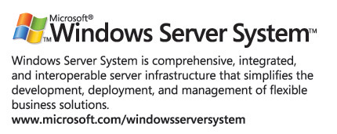
For the latest information about Windows Server 2003, see the Windows Server 2003 Web site at http://www.microsoft.com/windowsserver2003.

