
Multi-Company

Microsoft Dynamics™ SL

Benefits
- Tailor to your system
Configure Microsoft Dynamics SL
Multi-Company to operate with
several companies in a single database, multiple databases, or both. Bring
your businesses together — whether centralized or decentralized and geographically disbursed — while automating time consuming and error-prone tasks.

- Process transactions seamlessly
Create due-from/due-to entries
automatically to keep your inter-company transactions in balance. Companies in separate databases and locations can easily transfer inter-company general ledger transactions from one location to another, so that accounting entries are applied to the correct company, while ensuring
balanced sets of books.

- Centralize your cash control
Assemble accounting and reporting into a single location or company, and apply payments, write checks, or take requisitions for subsidiary companies. This helps reduce duplicate efforts and training from location to location, and maintains the inter-company balances between the subsidiary and the central companies for full reporting and tracking at the transaction level.

- Improve information access
Present data in an unlimited number of
ways. Make quick inquiries on accounts and sub-accounts by ledger and company, drilling down to the source document level if necessary. Obtain customer and vendor information; generate general ledger, accounts receivable, and accounts payable reports; and generate necessary tax reports by company or across companies.

Monitor, analyze, and report on multiple companies or functional divisions within your organization. Focused and flexible capabilities help you set up multiple companies in one or more databases, run processes, close books, and report results by company or in a consolidated company.

Create
due-from/due-to entries automatically
to keep your inter-company
transactions in balance.

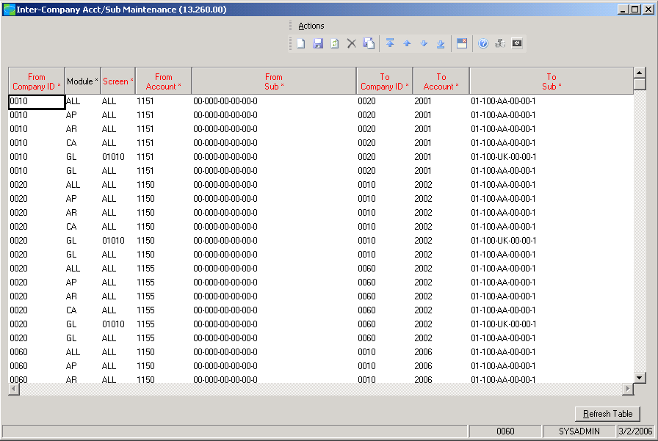

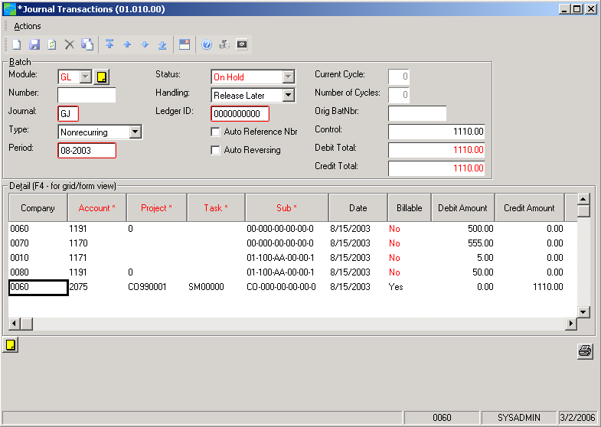

Easily transfer
inter-company general ledger transactions from one location to another.

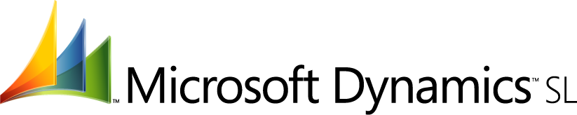

Inter-Company Transaction Processing  features  BENEFITS | Maintain balances by subsidiary ledgers for companies in a single database. Then look up customer balances within or across companies. Consolidate other multi-company processing, such as entering vouchers or releasing accounts payable batches for all companies.
Powerful Customization | Identify the accounts and sub-accounts to be used in creating inter-company  transactions. Define inter-company codes at the company, application, or  screen level.
Shared Setup | Set up multi-company vendors and customers only once. Companies in the same database can share the same setup information for customers and vendors, as well as currency and exchange rate information.
Inter-Company Export/Import | Use the Inter-Company Export/Import feature to transfer inter-company  transactions for companies in separate databases. The Export/Import Report option helps confirm that transactions were properly processed.
Secure User Access | Define access rights to company data at the screen level and by company  For users and user groups. Users can view only company data that they are authorized to see.
Diverse Account Maintenance | Maintain separate databases for multiple companies — each with different charts of accounts — so long as they use the same account structure. A full audit trail is provided across all companies.
Overhead Expense Management | Allocate expenses to other companies within and across databases.  Allocations can be generated by ledger, by company, or by all companies.
Centralized Invoicing | Enter invoices for multiple companies in the same batch. Invoices can also be vouchered for multiple companies in the same batch. In tandem with Microsoft Dynamics SL Centralized Cash, you can apply payments to multiple companies’ invoices and reverse applied invoices for another company.
Centralized Payment | Pay vouchers for any company through the central company and print  checks by company. Tax IDs, sales tax history, and business addresses are  maintained by company.
Flexible Database Management | Set up multi-company variables within one or multiple databases. Closing of  all companies within one database is supported.

This document is for information purposes only.
MICROSOFT MAKES NO WARRANTIES, EXPRESS, IMPLIED, OR STATUTORY, AS TO THE INFORMATION IN THIS DOCUMENT.

© 2005 Microsoft Corporation. All rights reserved.
Microsoft, The Microsoft Dynamics Logo, are either registered trademarks or trademarks of Microsoft Corporation or Microsoft Business Solutions ApS in the United States and/or other countries. Microsoft Business Solutions ApS is a subsidiary of Microsoft Corporation.

For more information about Microsoft Dynamics™ SL, visit: http://www.microsoft.com/dynamics/sl

