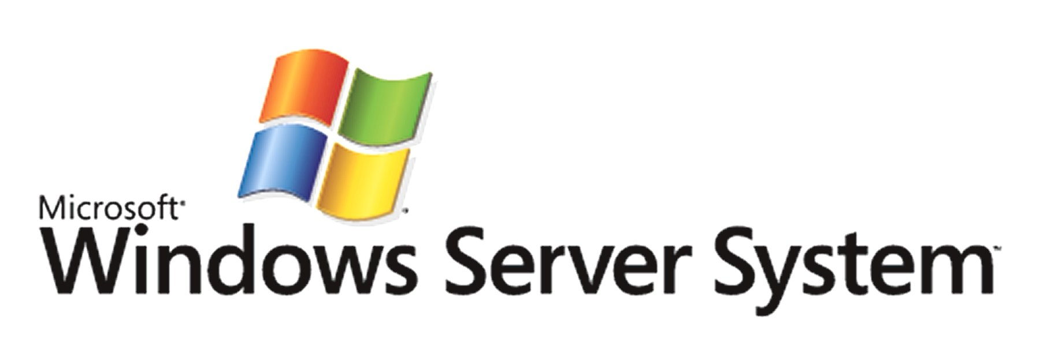

Microsoft® System Center Data Protection Manager
Technical Overview
Published: March 2005
For the latest information, please see http://www.microsoft.com/dataprotectionmanager.

Abstract
As the amount of data stored on servers has grown, many organizations have amassed data stores that cannot easily or quickly be backed up by tape-based technology. This problem can be eliminated with a solution that backs data up to disk on a central backup server. However, such systems are typically designed ad hoc and require manual administration and monitoring. Microsoft System Center Data Protection Manager (DPM) offers a standardized, reliable mechanism for backing up data to a central host, where it can also be backed up to tape for long-term retention and offsite protection. This white paper describes how DPM works and how to install and deploy it to protect your critical information assets.

This is a preliminary document and may be changed substantially prior to final commercial release of the software described herein.
The information contained in this document represents the current view of Microsoft Corporation on the issues discussed as of the date of publication. Because Microsoft must respond to changing market conditions, it should not be interpreted to be a commitment on the part of Microsoft, and Microsoft cannot guarantee the accuracy of any information presented after the date of publication.
This white paper is for informational purposes only. MICROSOFT MAKES NO WARRANTIES, EXPRESS OR IMPLIED, IN THIS
DOCUMENT.
Complying with all applicable copyright laws is the responsibility of the user. Without limiting the rights under copyright, no part of this document may be reproduced, stored in, or introduced into a retrieval system, or transmitted in any form or by any means (electronic, mechanical, photocopying, recording, or otherwise), or for any purpose, without the express written permission of Microsoft Corporation.
Microsoft may have patents, patent applications, trademarks, copyrights, or other intellectual property rights covering subject matter in this document. Except as expressly provided in any written license agreement from Microsoft, the furnishing of this document does not give you any license to these patents, trademarks, copyrights, or other intellectual property.
© 2005 Microsoft Corporation. All rights reserved.
Microsoft, Windows, Windows Server, and Windows Server System are either registered trademarks or trademarks of Microsoft Corporation in the United States and/or other countries.
The names of actual companies and products mentioned herein may be the trademarks of their respective owners.
Contents
Contents iii
Introduction 4
What is the Microsoft System Center Data Protection Manager? 6
DPM Benefits 6
Common Scenarios 9
DPM Technology Overview 10
Architecture 10
Deploying DPM 11
Identifying Servers to Protect 12
Agent Management 12
How Ongoing Synchronization Works 12
Protecting Data with DPM 15
Designing Protection Groups 15
Restoring Data 17
Reporting and Monitoring 19
DPM Monitoring 19
DPM Reporting 20
Integration with Microsoft Operations Manager 20
Summary 22
Where to Learn More 23

Introduction
Data protection, including backup and restore technology and processes, integrity protection, and data security, has become a critical part of the IT world. Information is the most valuable asset that most companies possess, and threats that put the integrity and availability of that information at risk must be mitigated. A growing number of enterprises have found that backup and recovery processes are at the center of their protection efforts, and that these efforts are growing in importance. This is happening for four primary reasons:
- The value of information held in corporate IT systems increases as more business processes become computerized, and as companies increase the rate at which they centralize business-critical information.
- Storage requirements in most organizations are growing rapidly. This growth is driven by the decreasing per-gigabyte cost of disk storage, the increasing ubiquity of large-scale storage solutions in the form of storage area networks (SANs), and the demand of users to store larger numbers of larger files and data items.
- Data retention requirements are becoming central to compliance initiatives. Regulatory and legal compliance issues are driving a wave of IT modernization and technology deployment; that wave includes systems and processes to keep large volumes of data available for longer periods (including indefinitely, in some cases).
- Data protection systems and processes are being identified as critical components of IT infrastructure, not just an add-on or second-tier capability. These systems are now often designed as an integral part of new IT deployments or restructurings.
However, the deployment and function of data protection systems has been constrained by a number of factors. The three primary problems with conventional backup systems are simple.
First, recovery is unreliable and painful. The speed of tape-based recovery systems is constrained by the speed of the tape hardware, and it is vulnerable to failures or misalignments of the tape hardware, loss or damage to the tapes themselves, or unexpected unavailability of tapes or media (as when tapes cannot be returned from offsite storage due to bad weather). By some analyst estimates, more than 40 percent of recoveries fail, but which recoveries will fail cannot always be predicted in advance. Verification procedures are necessary, but they add more time and overhead to an already complex and time-consuming process.
Second, existing backup systems and processes are too complex, too slow, and too inefficient. Business needs drive the requirement for shorter backup times, but these are very difficult to achieve because the volume of data requiring protection keeps growing. Conventional backup systems require too much manual scheduling and monitoring, and they are often not flexible enough to easily accommodate changes in disaster recovery planning caused by changes in the business or environment. Backup systems are typically used to meet four distinct types of protection needs:
- Recovering individual files after loss or damage to specific items
- Recovering the entire contents of one or more servers after a failure
- Providing offsite data protection
- Providing long-term archiving capability
Tape-based systems work better for the latter two requirements than for the first two, but most organizations have adopted a "one size fits all" approach that tries to adapt tape systems to the time, space, and speed requirements of individual item or server recovery.
Finally, backup costs are too high. Enterprise-scale backup systems have typically been built in two primary ways. The first way involves centralizing data to dedicated backup systems, which requires licensing individual agents for each machine to be protected, along with large-scale tape backup capability. The second way is to perform local tape backups on individual servers, which multiples the licensing and hardware purchase costs. In either case, though, the software and hardware acquisition cost pales in comparison to the labor and overhead cost of making, tracking, and keeping tape-based backups. The staffing and overhead expenses associated with designing and maintaining backup systems continues to be a significant cost obstacle. According to some analyst estimates, the labor costs associated with backup and recovery make up 70 percent of the total cost of backup over a three-year period. Understaffing in this area makes the time problem worse, because the availability of server or backup administrators is often the limiting factor in timely recovery.
These three factors lead to a number of difficulties and problems with conventional backup implementations:
- Recovery of even a single file requires the direct involvement of administrators and generally takes several hours for even a simple file recovery. Users can't recover their own files, which raises the cost and difficulty of what should otherwise be simple user-directed recoveries.
- Compared to disk-based backup, tape systems tend to be unreliable and inconvenient. However, proprietary disk-based backup systems are generally too expensive for widespread use, in part because of their relatively high purchase cost and in part because they are typically not well integrated with the Microsoft® Windows® operating systems or with conventional backup solutions.
- Companies that depend on tape often find that their ideal recovery time objective (RTO) is faster than their backup system is able to deliver. This leads to increasingly complex backup schedules and procedures, or to attempts to break up critical data in a way that allows backup processes to be more highly parallelized.

What is the Microsoft System Center Data Protection Manager?
Through its work with small and medium business clients and enterprise customers, Microsoft understands the increasing weight that customers are placing on improving their backup and recovery processes and reducing their costs for executing them. Microsoft has designed the Microsoft System Center Data Protection Manager (DPM) product to provide efficient, near-continuous protection, rapid and reliable recovery, and operational simplicity. This combination provides better value than conventional tape-only or hybrid disk/tape backup systems.

DPM Benefits
DPM offers significant benefits over conventional tape-based systems.

Efficient, near-continuous protection
Backing up file servers to tape more than once a day is often not feasible because of the server performance degradation that tape backup causes. IT managers typically schedule a full tape backup once per week and perform incremental backups daily. This requires the use of many tapes, a more expensive option than disk-based recovery, and creates the risk of greater daytime data loss and more difficult recovery from incremental backups. DPM provides efficient, continuous protection that offers several significant benefits:
- More efficient data protection. DPM logs and replicates byte-level changes to the files on the production servers. This makes backups more efficient and eliminates the problem of scheduling backup windows. In addition, because DPM captures changes as they happen instead of copying entire files, DPM backups place less load on production servers than conventional backup tools that have to copy entire files if even a single byte changes.
- Flexible backup scheduling. IT administrators can tailor the backup frequency to match the business value of the data. DPM provides default schedules for hourly and daily backups, but IT administrators can also customize protection schedules for specific data sources, and they can review and update their protection plans as necessary.
- Multiple point-in-time backups using frequent shadow copies. (Shadow copies are also known as snapshot, point-in-time, past-time, or cache copies.) DPM uses the Windows Server 2003 Volume Shadow Copy Services (VSS) component to capture data from protected servers and create replicas that can be stored on the server running DPM. This allows you to browse and recover deleted or corrupted files from multiple points in time, and to save the data in those shadow copies to tape as part of your normal backup process. Shadow copies can be scheduled independently of the backup schedule. As new shadow copies are made, old shadow copies are purged as soon as the size of all shadow copies reaches either a configurable maximum or a total of 64 shadow copies per volume, whichever occurs first.
- Protection from network outages and hardware failures. The DPM agent logs and backs up the data from each of the production servers to the server running DPM. If the production server goes down or is destroyed, a copy of the data is still available on the server running DPM. If the network goes down, the agent that is local on the production server continues to cache all the changes in the production server until the network is working again.
- Network throttling. You can minimize the impact that backups will have on your network by using the ability of DPM to throttle network traffic by setting limits for maximum network utilization. These metrics control scheduled backups so that, if the network is busy, the backup will not have a negative impact on network performance.
- Integration without disruption. DPM integrates with existing backup systems to supplement them, not replace them. IT administrators can, at any time, perform a backup to tape of data from the server running DPM. They can do this without compromising product server performance. This feature increases the overall efficiency of the data protection infrastructure and lowers total protection costs. This enables businesses to change their scheduled nightly tape backups to daytime, further reducing the need to have specialized administrators available on nights and weekends.

Rapid and reliable disk-based recovery
DPM provides better control of a business's legacy data protection and recovery infrastructure so that the IT staff can more rapidly, reliably, and predictably recover data at a lower cost. With disk-based data protection, businesses achieve greater certainty about disaster recovery because IT administrators can verify a successful backup by simply browsing the disk and inspecting the copied files. In addition, RAID disk technology offers significantly better I/O performance and uptime than conventional tape technology; when combined with the steadily increasing mean time between failures (MBTF) of hard disks and controllers, using DPM to leverage RAID storage as a backup mechanism yields superior protection and speed .
Recovering data using disk-based data protection is as fast and simple as browsing a set of folders on a file share and copying them directly from the server running DPM to the production server. DPM makes disk-based recovery smooth and simple by providing:
- Rapid and reliable data recovery from disk. Because DPM is disk-based, it can take advantage of the additional reliability benefits of a redundant array of inexpensive disks (RAID) for protection, an advantage over tape, because tape has the potential to be a single point of failure. Because DPM is disk-based, IT administrators can easily browse the server running DPM to confirm that the shadow copy has been made and perform online checking and verification of the backup. Recovering information from a DPM backup is as simple as browsing a share and copying the needed data to the correct location on the production server.
- Automatic error correction. DPM monitors its backup jobs to ensure that they complete without error. If an error is detected, DPM has a two-stage error correction process. First, DPM automatically validates the replica against the production server to ensure that the replication is consistent and has occurred as planned. Second, if inconsistencies between a data source and its replica are found during validation, the fix-up activity re-sends the object(s) from the data source to the replica.
- Recovery options. The most common scenario for recovering lost or corrupted files is a request by the end-user to the IT help desk to find an archived version. Assuming that the business has an archiving system in place, this request usually means a costly and time-intensive search of archived media, which, in many instances, is a tape backup. DPM provides practical recovery alternatives, including the ability for administrators to delegate recovery to file server administrators, help-desk staff, or end users and the ability to recover the contents of full servers and shares, not just individual files and folders.
- End-user recovery. DPM makes it easy for end users to recover their own files. DPM is integrated with the Microsoft® Windows XP operating system and Microsoft® Office 2003, allowing users can recover previous versions of their files directly from the Open and Save dialog boxes in Office applications or from Windows Explorer.

Best value for data protection
DPM offers the best overall value for data protection by lowering initial costs, administrative costs, and ongoing hardware and labor costs. By leveraging DPM to speed the recovery process, recoveries of accidentally deleted or corrupted files becomes much faster because the data are restored from disk, rather than from tape. Backups of the server running DPM can be made to tape at any time without impacting production server or network performance.
Because DPM uses industry-standard hardware and software, its acquisition cost is much lower than that of any other proprietary, data protection technology. DPM also offers:
- Lower training costs. Because DPM is part of Windows Server System, it's managed with familiar administrative tools, such as Microsoft Management Console (MMC) and Windows Explorer. Users can easily recover their own files using the simple copy and paste mechanism in Windows Explorer. DPM also leverages Distributed File System (DFS) so end-users can browse read-only shadow copies without having to know the location of the missing files on the server running DPM. Wizard-driven administrative tools automate common tasks, enabling the administrator to get the job done with the fewest number of steps and the most intuitive commands.
- Automation of discovery and common tasks. When initially installed, DPM automatically discovers all the production servers in the domain that need to be protected. As new servers are added to the network, DPM discovers and alerts the administrator that there are unprotected servers in the environment, creating a seamless protection, recovery, and maintenance solution.
Once DPM is deployed, it offers low ongoing administration costs compared to conventional backup systems. It does this by offering:
- Simplified administration. Simplified administration allows the delegation of recovery and simplified administrative tasks, report creation, and process automation. DPM automates many of the error diagnosis and other functions that system administrators must currently perform manually, such as automatically sending status reports and alert notifications via email, notifying administrators of new servers as they are added to the domain, making changes to protected groups, and so on. State-based monitoring provides easy-to-understand, real-time indications of the state of protected resources, and alert synthesis intelligently combines multiple events to provide a continuously updated picture of exception or alert conditions.
- Automated protection schedule. DPM makes it easy to develop a protection schedule based on the business goals of the IT administrator, thereby simplifying the development of the protection schedule. By default, DPM creates a default schedule so data protection happens automatically; the production servers' administrator does not need to initiate the backup process. When new volumes or shares are added to a previously protected server, DPM alerts the administrator, who can then choose to protect or ignore the new resources.
- Rich reporting and monitoring. DPM monitors and fixes common protection problems, alerting the administrator when complications arise. Instead of requiring administrators to sift through dozens or hundreds of event log entries, DPM presents a state-based display that consolidates event and alert information to give a real-time picture of resource protection. DPM also provides a set of preconfigured reports to keep the IT administrator aware of metrics such as storage usage trending and number of daily recoveries.
- Cost-effective recovery. A typical file recovery from tape takes hours and can be costly. Many organizations find that they have to perform 10-20 or more recoveries per month. DPM enables the same recoveries in minutes, saving IT administrators' time and saving businesses money. In addition, faster recovery means more efficient information workers because they spend less downtime waiting for their files to be recovered.
For ongoing operations, DPM also lowers the cost of making and keeping backups for recovery (as opposed to archival and retention) use. DPM makes it possible for IT administrators to maintain 30 days worth of shadow copies on disk and to create tape backups for disaster recovery scenarios on a less frequent basis. This policy will result in fewer tape backups and less money spent on tape media.

Common Scenarios
DPM is specifically designed to simplify and improve data protection processes in five common scenarios that often cause difficulties in conventional backup deployments.

Server recovery
Server administrators can recover the data they need from DPM in the event they need to perform a full file server recovery because of hardware or software corruption. The administrator's choice of Windows-aware backup tools must be used to capture the system state data; once the system state is restored, DPM can be used in conjunction with traditional recovery tools.

Administrator file recovery
By using the DPM recovery console, IT administrators can recover files for end users in minutes instead of spending hours recovering from tape. Administrators can easily search DPM replicas for needed files and restore the files to any location, not just to their original location. This allows substantial time and cost savings for even the simplest file recoveries, and even more savings for advanced recoveries.

Help desk file recovery
Administrators can delegate user file recovery to help desk or other operations staff. The easy-to-use DPM interface allows less-skilled employees to assist with end-user recoveries. This saves money because it uses less IT server administrator time, which is more costly.

Self-service file recovery for users
DPM takes advantage of the end-user recovery functionality available in Microsoft Windows XP and Office 2003. This means that end users can handle their own file level recoveries in a very easy and cost-effective manner, directly from within Windows Explorer. No special training or client software is necessary.

Branch office protection and restore
For organizations with branch offices in multiple locations, it is normally necessary to train local staff to act as backup operators, or to perform traditional backups over WAN connections. DPM enables easy, policy-driven backup from any number of remote offices to a central site that can safeguard data and restore it, at the file or server level, with minimal involvement from the branch office staff. The network bandwidth throttling features included in DPM allow backups to happen without interfering with normal network operations.

DPM Technology Overview
DPM is designed to allow efficient, continuous backup and fast restores of protected data. It accomplishes this using a three-step process:
- When an object or server is selected for protection (by including it in a protection group), an initial copy of the data from the protected server is made to the DPM server. This initial copy of the data is called a replica.
- Changes to the protected data items are synchronized to the DPM server's replica, using a synchronization schedule that you set.
- At predefined intervals (which you can adjust), point-in-time copies (or shadow copies) of the replica are created on the DPM server.
The shadow copies can be used for restores at any point in time, and they can be backed up to tape. This three-step process provides maximum flexibility and control while still preserving the DPM benefits described earlier.

Architecture
A data protection infrastructure using DPM consists of several components, as shown in Figure 1. These components include:
- The DPM server software, which is installed on a dedicated server running Windows Server 2003 Service Pack 1 or Windows Storage Server 2003 Service Pack 1. The software is available as a standalone server application that the user can install on top of the appropriate operating system, or the software can be ordered as a preinstalled DPM device from a number of OEMs.
- An Active Directory domain, which is required to facilitate the discovery of servers and maintain the security settings of files and folders through access control lists. The Active Directory schema also holds the configuration settings required for the end user recovery client to retrieve shadow copies from the DPM server
- One or more servers to be protected. These servers may run Windows 2000 (SP4 with the Update Rollup), Windows Server 2003, or Windows Storage Server 2003. DPM cannot be used to protect clustered servers or servers that are not members of the same Active Directory domain as the DPM server.
- The DPM agent software, which is installed on each server to be protected. This software handles the scheduling and execution of the DPM data protection process and must be installed on the protected file servers from within the DPM administrator console.
- Windows XP and Windows Server 2003 clients. The shadow copy client included with these operating systems allows users to access and recover previous versions of their files; enabling end user recoveries with DPM requires a hotfix for computers running Windows XP Service Pack 2 and Windows Server 2003 Service Pack 1. This hotfix can be distributed by several methods, including using Microsoft Systems Management Server (SMS), application publishing through Active Directory group policy, e-mail, or posting to a file share.
- Microsoft SQL Server 2000 (with SP3a or later), along with the SQL Server 2000 Reporting Services (SP1 or later). The DPM setup process will install the necessary SQL Server components; the DPM product includes a restricted license of SQL Server 2000 for use only with DPM.
- Optionally, a tape backup software agent can be installed on the DPM server; this software can be used to back up DPM-protected data from the server to tape for offsite archiving or long-term retention. Several Microsoft partners have developed solutions that enable direct recovery from tape backups of DPM-protected data to the DPM server; for more information, see the DPM partner page at http://www.microsoft.com/windowsserversystem/dpm/partners/default.mspx.
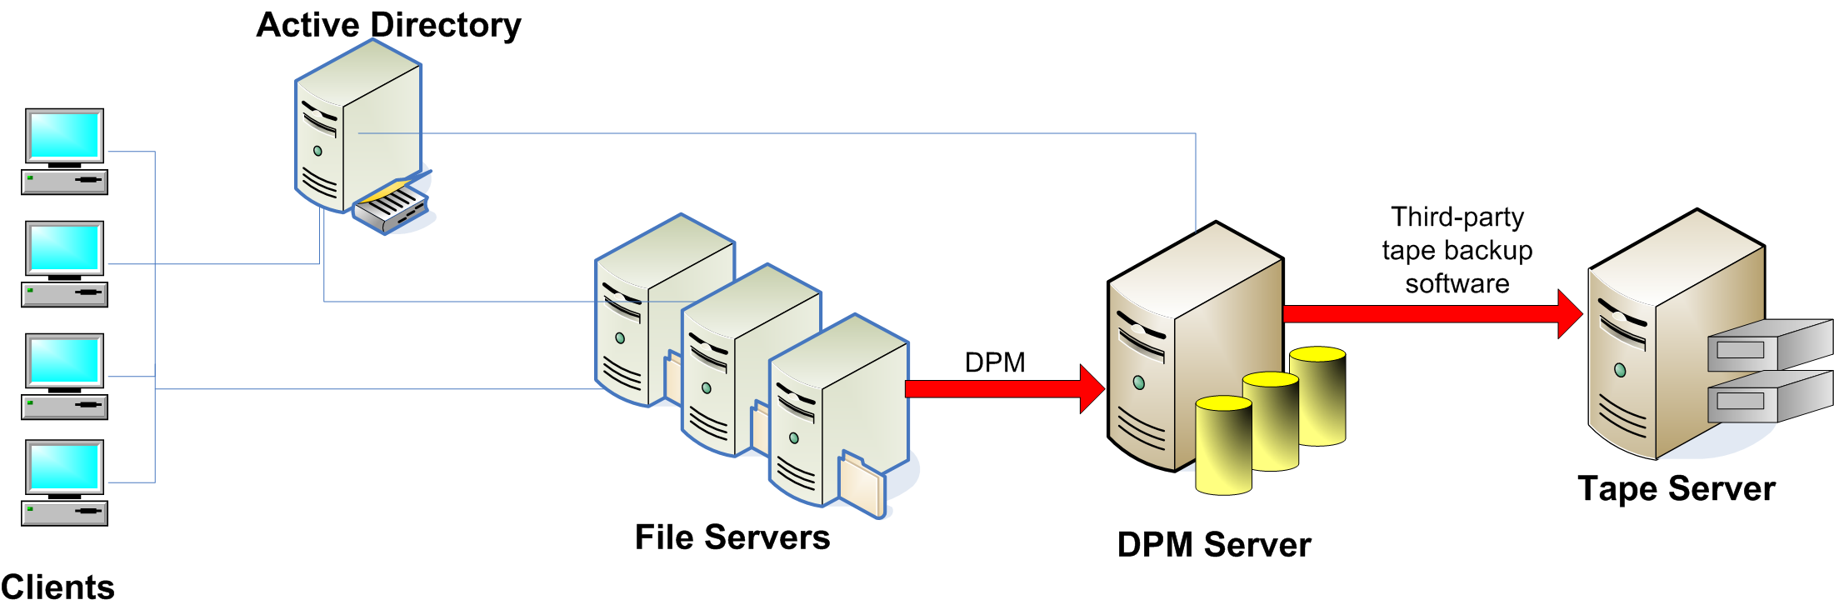

Figure 1. DPM architecture overview

Deploying DPM
A complete installation of DPM includes the Windows Server 2003 operating system with both Internet Information Services (IIS) 6.0 and Service Pack 1 (SP1) or later installed, the DPM application, and the DPM prerequisite software. The prerequisite software, which is included with the DPM product, includes:
- Microsoft® SQL Server™ 2000 (Standard or Enterprise Edition)
- Microsoft® SQL Server™ 2000 Service Pack 3a (SP3a) or later
- Microsoft® SQL Server™ 2000 Reporting Services (Standard or Enterprise Edition)
- Microsoft® SQL Server™ 2000 Reporting Services Service Pack 1 (SP1) or later
These products will be automatically installed on the DPM server if they are not already present. DPM is distributed on a set of four CDs that contain the Standard Editions of SQL Server 2000 and SQL Server 2000 Reporting Services, and include all languages available for DPM.
Note
Chapter 4 of the DPM Planning and Deployment Guide describes the installation process in more detail.

Server Prerequisites
The DPM server itself must be:
- Running either Windows Server 2003 (Standard or Enterprise Edition) or Windows Storage Server 2003 (Standard or Enterprise Edition) with Service Pack 1 or later installed.
- A member of the same Active Directory domain as the file servers it protects.
- An ordinary single-purpose server; the DPM server must not be an Active Directory domain controller
- Equipped with at least one logical volume (which may be made of multiple physical disks) and at least one additional unused disk.
Note
Refer to Table 4.1 in the DPM Planning and Deployment Guide for specific hardware configuration recommendations.
Servers to be protected by DPM must meet the following requirements:
- The server must be running only one of the following operating systems:
- Windows Server 2003 with Service Pack 1 or later installed
- Windows Storage Server 2003 with Service Pack 1 or later installed
- Windows 2000 Server with both Service Pack 4 and the Windows 2000 Update Rollup installed
- The server must be a member of the same Active Directory domain as the DPM server that protects it.
- DPM can be used to protect stand-alone file servers only. Clustered file servers cannot be protected.
- DPM cannot be used to protect file servers on which case insensitivity for file names has been disabled. (See the DPM Planning and Deployment Guide for more information on this requirement.)

Identifying Servers to Protect
Administrators can always browse the network to identify shares, volumes, and servers to protect. However, DPM takes advantage of Active Directory to automatically discover new servers and shares to protect. The DPM server runs a scheduled discovery task that scans Active Directory and alerts the DPM administrator when a new server or share is discovered.
As new shares or volumes are added to protected servers, the DPM monitoring agent will alert the DPM administrator, who can then decide whether to add the new items to protection groups. The automatic discovery process combines with the DPM Administrator console to give administrators great flexibility in choosing what to protect and when.

Agent Management
Every file server to be protected must have the DPM agent installed on it. The DPM administrative console allows administrators to browse for available servers and remotely install the agent using a simple wizard-based interface. Once installed, the DPM console provides complete support for the full agent lifecycle, including upgrading, removing, updating, and inventorying installed agents on all protected servers.
The agent is responsible for monitoring changes to protected items on the server and synchronizing those changes to the DPM server. The DPM agent is implemented as two components: a file system filter driver that runs in kernel mode and the DPM File Agent service, a user mode component that handles the actual synchronization.

How Ongoing Synchronization Works
Synchronization is the process by which DPM transfers only the changes made on your file servers to the DPM server and applies those changes to the replica of your protected data. In other words, the synchronization process updates the replica to match the state of the protected data at the time the synchronization begins. DPM updates data at the byte level within protected files; file operations themselves (like renames, deletes, and creates) are replicated, as are the actual bytes written to protected files. The unit of operation for replication operations is the protected volume.
DPM synchronization is asynchronous, meaning that synchronization occurs without blocking disk I/O on the protected objects. Changes to the protected objects are stored in the agent synchronization log, then replicated across the network to the DPM server, where they are stored in the transfer log. Keeping a local synchronization log on the protected server provides resiliency during network problems or service interruptions; changes written to the synchronization log are stored until network service is restored, then transmitted to the DPM server.
Data in the transfer log is later used to construct complete replicas that can be used to create a point-in-time shadow copy of the protected data. As synchronization progresses, checkpoints are used to provide a fallback method for resynchronization. After two minutes have elapsed or 10MB of changes have been transmitted (whichever is less), a checkpoint is set. If synchronization or network access is interrupted on either end, it will resume from the last checkpoint when it restarts.
There are two channels for communication between the DPM server and its agents. Control commands are sent using the Distributed Component Object Model (DCOM) protocol, while replication updates are transmitted using TCP with a secure data mover protocol. Both of these channels can be secured using the Internet Protocol security extensions (IPsec) to provide enhanced security for data in transit.

Scheduled Synchronizations
The DPM synchronization model is centered on the DPM server, which requests synchronization updates according to the schedule you set. DPM enables you to choose between an hourly and a specified synchronization schedule.
- Hourly synchronization takes place 24 times per day, either on the hour or at a particular number of minutes after the hour. An hourly synchronization schedule can enable restoration of data to within an hour of a data loss event.
- Specified synchronizations occur on whatever schedule you set. With a specified synchronization schedule, the amount of data loss you could sustain depends on how often synchronization runs. Synchronizing just once each day enables restoration of data to within a day of a data loss event—approximately the same as conventional tape backup systems. You can have up to eight synchronizations set per protection group.
When you create a new protection group, you can easily set the synchronization interval (as shown in Figure 2).
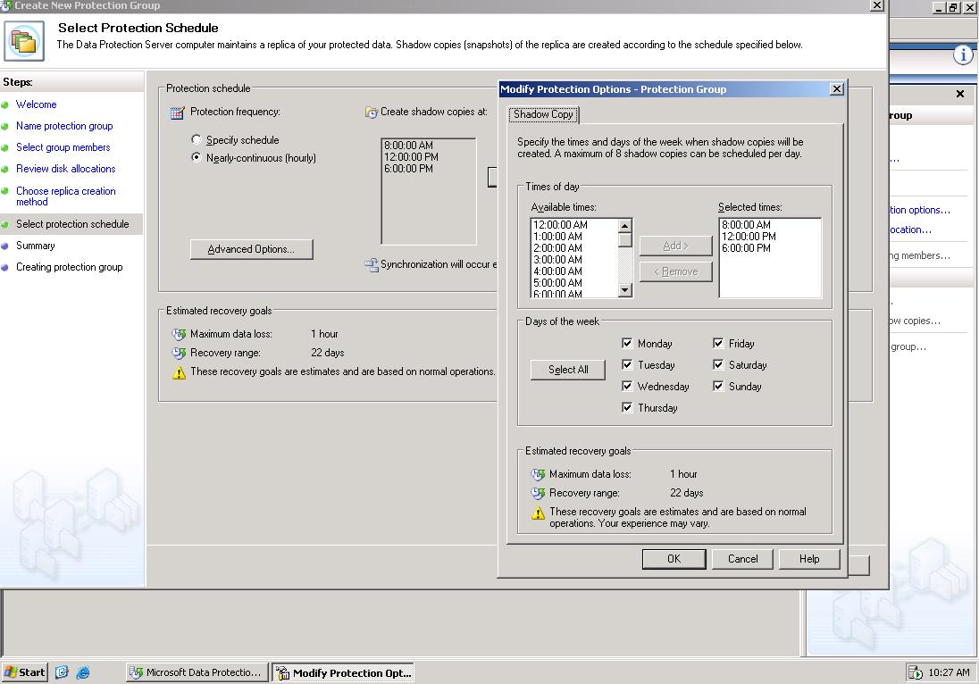
Figure 2. Creating a new protection group lets you set the synchronization schedule
DPM provides bandwidth throttling, which enables you to limit the amount of network bandwidth a synchronization job can consume within a protection group. You set throttling limits as an absolute maximum of megabits of data to be transferred per second. By limiting the amount of network bandwidth used for synchronization, throttling gives you flexibility to tailor your synchronization schedule in heavily loaded network environments. Applying throttling may lengthen the amount of time each synchronization job takes to complete. Because each protected server maintains its own synchronization log, synchronization updates can be buffered and transmitted when network loads are low. This synchronization flexibility provides an efficient, effective means to protect both local and branch office file servers.
Note
See the DPM Planning and Deployment Guide for information on how to calculate the amount of bandwidth required for data synchronization.

Self-Healing Synchronization
Various events may create the need to resynchronize the DPM server's copy of the data with the source. For example, an unexpected reboot of the protected server will interrupt synchronization, and a network service interruption may cause the synchronization log on the protected server to fill up before network connectivity is re-established. DPM can detect these events and automatically start a self-healing synchronization, which includes a comprehensive consistency check. During this type of synchronization, the DPM server traverses the entire tree of protected objects on the protected server; the modification time of every protected object is checked against the time recorded on the replica shadow copy. If the times differ, DPM computes a checksum for each block in the file, then resynchronizes any blocks whose checksums differ between the source server and the replica. Checksums are computed for all open files on the protected server without regard to their modification time.

Protecting Data with DPM
The first step in planning a DPM deployment is selecting the data you want to protect. Although DPM is designed primarily to protect file data, you can protect other types of data, including databases or messaging data, by exporting it to a flat file, then protecting the file with DPM. Similarly, you can protect system data by using Windows Backup to export the system state to a file and then protecting the file. DPM can protect data at the level of volumes, folders, or shares on the protected server.
Note
A best practice for selecting data is to focus on the types of data for which you experience the most restore requests. Key candidates for protection are data types that change frequently and for which you want to be able to quickly restore point-in-time copies in case of loss. Alternatively, you can choose to simply protect all of the data you currently include in your backups.
The amount of data you select for protection dictates the storage pool capacity requirements for the DPM server and the number of DPM servers you include in your deployment.

Designing Protection Groups
After you have selected the data you want to protect, you can plan how you want to collect the data in protection groups. A protection group is a set of volumes, folders, or shares that you want to protect. You create protection groups to assemble sets of data to which you want to apply the same protection policy. Items included in a particular protection group are referred to as members of that group. The protection policy comprises both the synchronization schedule and the shadow copy schedule.
The key consideration in creating protection groups is tolerance for data loss. Customers typically group data for which they have a relatively low loss tolerance in one protection group, data for which they have a relatively high loss tolerance in another, and data for which they have a medium loss tolerance in another. A given protection group may contain members from different volumes and servers, although each protected object can be associated with only one protection group.

Restrictions and Guidelines
The following restrictions and guidelines apply for selection of protection group members:
- A data source can be a member of only one protection group.
- You can include data sources from more than one volume in a single protection group. However, the data sources on any one volume can be protected by only one protection group. You can select folders or shares on more than one volume for a protection group. However, only one protection group can protect data sources on any single volume.
- You can't exclude subfolders from a protection group; if you include a folder in a protection group, all of its child folders will automatically be included as well.

Choosing a Protection Model
DPM supports protecting data using two methods: volumes and folder paths or share names. Although you can use the two models simultaneously, Microsoft recommends choosing the model you are more comfortable with and using it exclusively. Each model has advantages:
- The volume and folder namespace model is familiar to most administrators and makes it easy to identify precisely what items should be protected. As items are added to protected folders or volumes, DPM automatically protects them.
- The share namespace model simplifies recovery, because it's not necessary to use the object paths during restoration. When a protected share is moved, DPM will allow the administrator to keep it protected in the new location.
For more guidance on the specific benefits of each protection model, please see Chapter 2 of the DPM Planning and Deployment Guide.

Allocating Disk Space
The amount of disk space that you allocate on the DPM server will directly affect how far back your backup history will reach. The total set of available storage for replicas and shadow copies is known as the storage pool. DPM allows you to distribute a single server's storage pool across multiple disks, adding more space to the pool when necessary. The storage pool provides a simple way to manage the disk space used by DPM to protect data on the protected servers.
Note
Refer to Chapter 2 of the DPM Planning and Deployment Guide for more information on using DPM with storage area networks (SANs) and redundant array of independent disks (RAID) configurations.
By default, DPM suggests a cumulative space allocation for a given protected volume. This suggested allocation includes:
- A replica allocation of the smaller of 1.5 times the space used on the protected volume or the total volume capacity (with a minimum of 1.5GB). For a 10GB volume that's 40 percent full, this would equal 6GB.
- A shadow copy allocation of 20 percent of the size of the replica allocation (with a minimum of 550MB).
- A transfer log allocation of 1.4 times the synchronization log space allocated on the protected server (with a minimum of 700MB).
In addition to this suggested method, DPM also includes a calculator that can more precisely estimate the amount of space required to protect a given volume of data, and you can always manually specify space allocations either when creating the protection group or afterwards.

The Role of Shadow Copies
Shadow copies are point-in-time snapshots of the replica of your protected file server data. You use shadow copies to restore data in case of loss. The shadow copy creation schedule enables you to specify how frequently you want DPM to create shadow copies of your replica. Data replicated from individual protected servers is used to create the shadow copies according to the schedule you set.
The advantage of using shadow copies is that they use disk space economically. Instead of keeping multiple copies of individual files in a replica, DPM shadow copies store changes for each successive shadow copy, reducing the amount of disk space required significantly.
The default shadow copy schedule for DPM is intended to provide approximately 30 calendar days of shadow copies, taken as three shadow copies per business day. This provides coverage for the vast majority of recovery requirements while still efficiently using disk resources. Organizations with differing recovery requirements can tailor the schedule to their needs.

Restoring Data
DPM enables a number of recovery scenarios. The three most common are restoring individual files under an administrator's control, restoring an entire protected server under an administrator's control, and restoring a user's files under that user's control. The DPM agents must be installed on any server to which DPM is used to restore data.

Restoring Individual Files
The DPM Administrator console provides a simple mechanism by which administrators can restore individual files, folders, or shares (see Figure 3). After switching to the Recovery tab in the administrative console, administrators can either pick individual files from a familiar Windows tree view or search for selected items. Each protected item is shown along with time and version data that make it simple to recover either the latest version or a selected previous version. As part of the recovery operation, the administrator can choose the target location for the recovery.

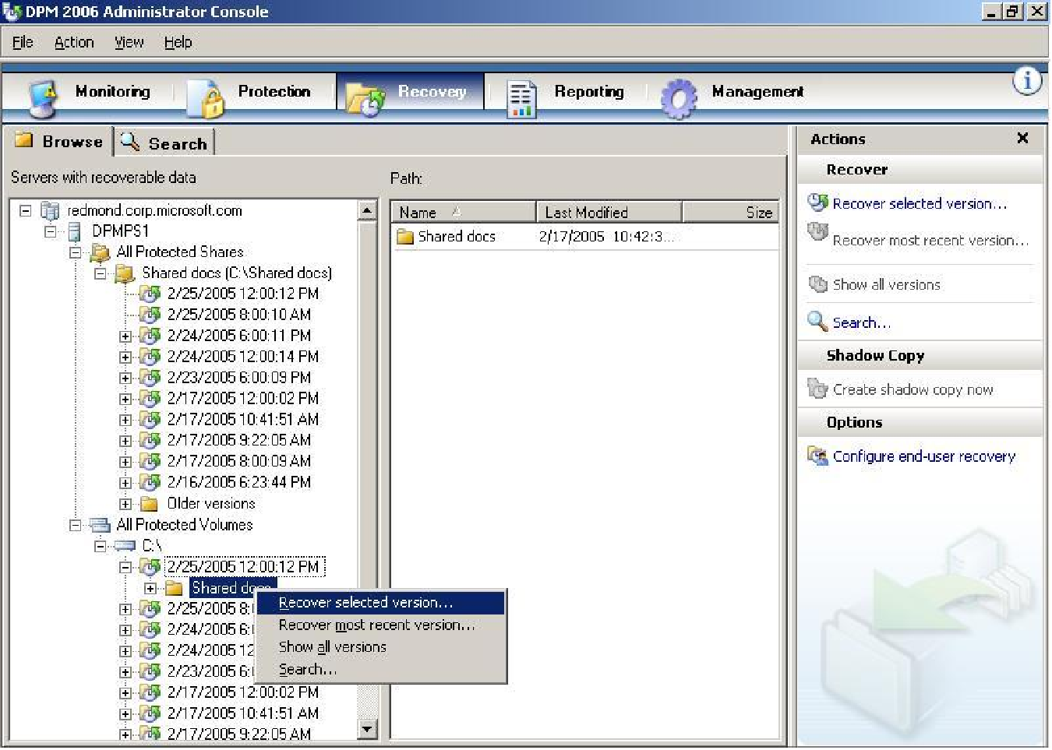
Figure 3. Choosing files to restore from the DPM Administrator console

Restoring Servers
There are two separate sub-scenarios for restoring a server: restoring only the protected data, without the operating system or configuration settings, and completely restoring the server from "bare metal." Recovering a server in the first scenario is simple: restore the server OS and settings using Windows Backup or a third-party utility, then use the DPM Administrator console to recover the latest versions of all protected data back to the server. The second scenario is slightly more complex, because DPM is not designed to perform complete server recoveries by itself. However, DPM can easily protect the system state data needed to perform a full recovery of a failed server. In order to accomplish this, the protected server should be backed up with Windows Backup or a third-party tool that supports creating system state backups. These backups can be used to restore the server to a bootable state, and they can also be stored on a volume that's added to a protection group on the DPM server. When a recovery is required, the system state data can be retrieved from the DPM server and written to restore media, which can then be used with the appropriate backup tool to restore the system to a bootable state. At that point, protected data can be restored to the server using the normal DPM workflow.

Supporting End-User Restores
End-user recovery enables users to independently recover their own data by retrieving previous versions of files through Windows Explorer or directly from Microsoft Office 2003 applications. The goal of this recovery mechanism is to allow users to recover their own files without requiring help desk or administrator involvement. This increases user productivity and satisfaction and lowers operational costs.
End users can recover shadow copies by browsing through shadow copies on the DPM server with Windows Explorer or by using the Recover Previous Version command on the Microsoft Office 2003 Tools menu (see Figure 4).
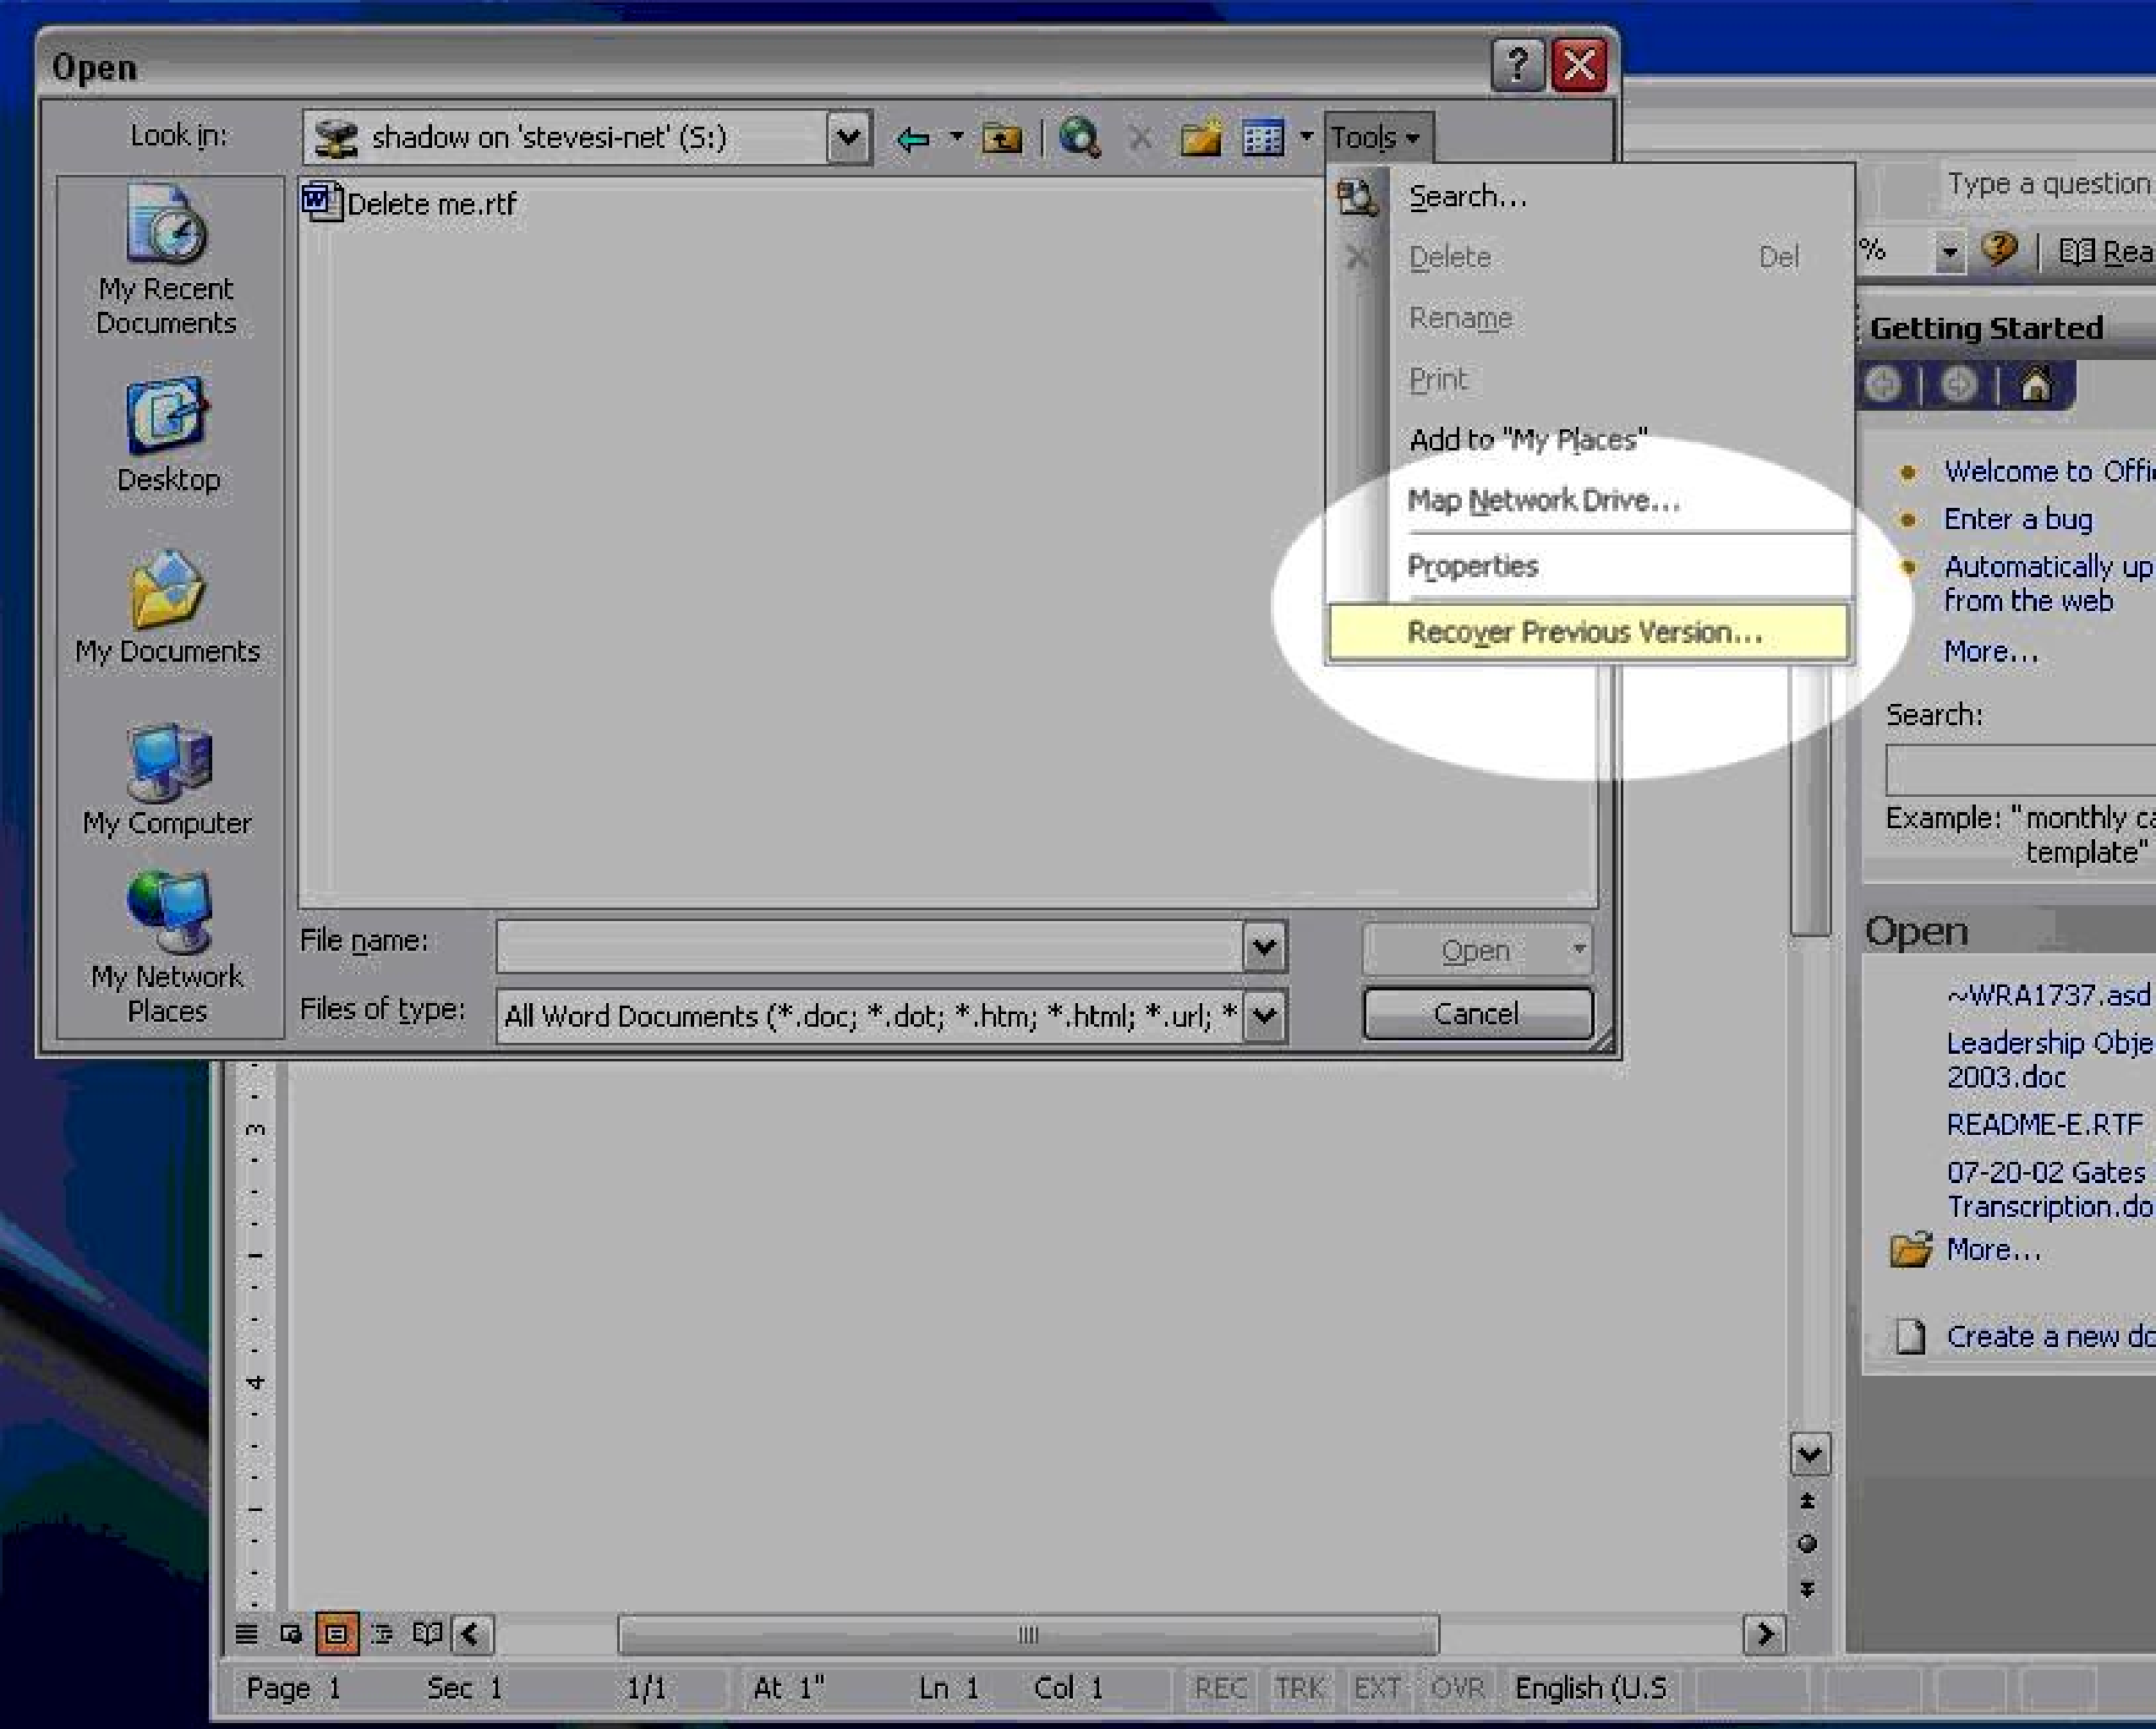
Figure 4. End-user recovery directly from within Office 2003

Reporting and Monitoring
One weakness in conventional backup systems is the reporting and monitoring process. Often administrators don't find out about problems with their backups until they attempt to complete a restore during a recovery operation. DPM includes comprehensive tools that provide alerting, notification, job and status monitoring, and reporting. The difference between reporting and monitoring is simple: monitoring alerts administrators to important events that occur during operations, while reporting gathers and presents historical data for analysis.

DPM Monitoring
Every DPM action is logged on the DPM server, using SQL Server 2000 as the logging engine. This provides robust performance and reliability. From within the DPM Administrator console (see Figure 5), administrators can quickly review the status of synchronization jobs, the results of scheduled server discovery processes, and replica generation and consistency checking. DPM also offers two important features to make responding to critical events easier: state-based reporting and alert synthesis.
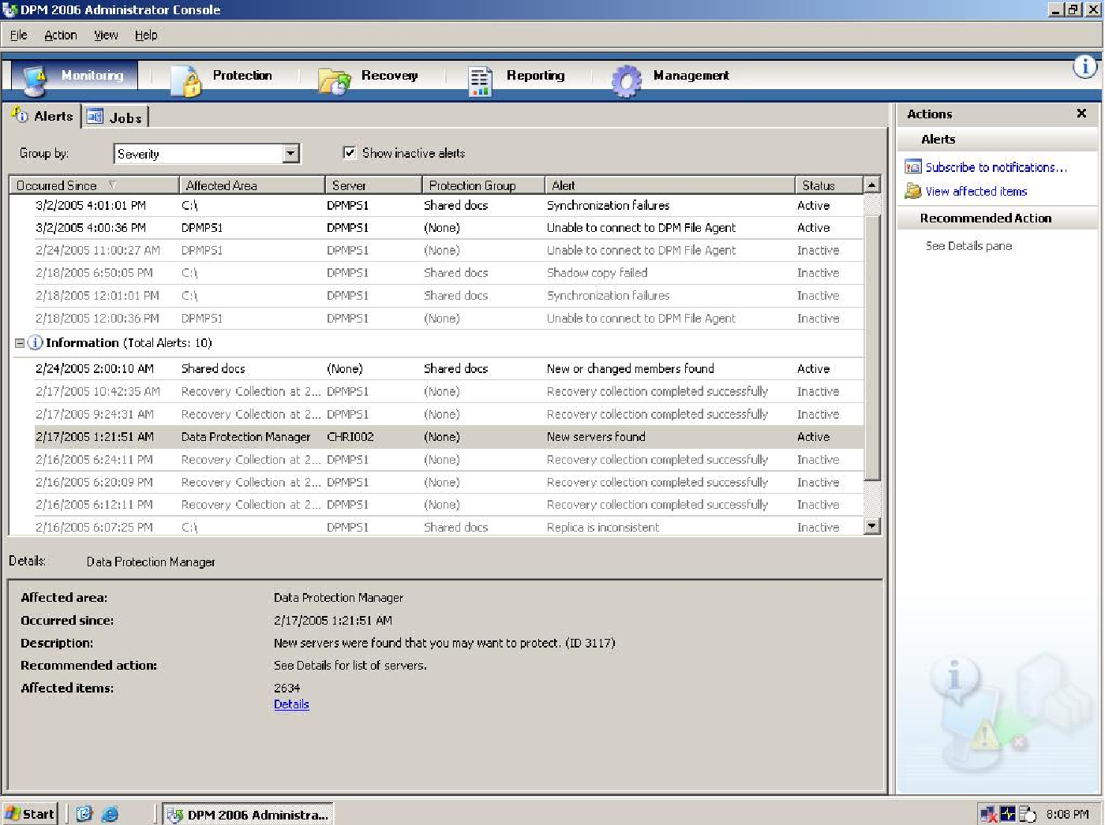
Figure 5. The DPM reporting interface
State-based monitoring provides a real-time, consolidated look at the health of the data protection of computers within the managed environment. State-based monitoring improves upon the traditional monitoring experience for backup and recovery solutions by keeping a state for all protected objects (servers, volumes, shares, and folders). The state reflects the data protection status of a given object at a given point in time. Instead of sifting through logs or checking alert notifications, an administrator can simply look at a list of all the protected resources, each showing a simple color-coded health state: green for protected, yellow for warning, and red for not protected. The state indicator provides a more aggregated and efficient view of monitoring data, and it updates as circumstances change. For example, in case of a network failure, protection jobs start to fail. As the job failure rate reaches the alerting threshold, alerts are raised and the health state of protected objects changes to yellow or red. As soon as the network comes back up, jobs start to resume, alerts are resolved, and the state of the objects returns to green.
Alert synthesis intelligently processes individual job success and failure notifications and raises actionable alerts when preset targets are exceeded. The standard workflow for backup and recovery processes is for administrators to arrive in the morning and comb through a log file that could have thousands of lines to try to answer the simple questions “Did the backup work?” Alert synthesis automates this process and only raises alerts when serious, actionable issues exist. For example, consider a scheduled network maintenance outage that takes place at 01:00. In a typical large enterprise, this outage might cause hundreds of backup jobs to fail. At 02:00, the network comes back online and most of the previously failed jobs now run successfully to completion. Without alert synthesis, when the backup administrator arrives in the morning, he faces having to weed through all the logs to try and see what the backup status looks like. With alert synthesis in DPM, no alerts are raised because the rule for raising an alert is 3 consecutive failures.

DPM Reporting
DPM includes a number of standardized reports that provide broad visibility into the health and status of the data protection process. More importantly, these reports provide trend information that shows data and space utilization, synchronization traffic usage, and recovery operations over time, not just at a given point in time, These reports include:
- Administrator Recovery reports provide statistics on administrator-initiated recoveries, including the number of recoveries, and the average size and time of these recoveries over a selected period of time. The data is collected per file server or protection group and aggregated for all file servers or protection groups.
- Disk Utilization reports provide a summary view of disk capacity, allocation, and usage on the DPM storage pool. The data is collected per file server or protection group and aggregated for all file servers or protection groups.
- Shadow Copy reports give statistics about shadow copy success and failure rates, their total number, and protection coverage information. The data is collected per volume and aggregated for all volumes.
- Synchronization reports show successes and failures of synchronization jobs over time. They indicate frequency of failures by 6-hour increments over a 24-hour time period; the reports include top reasons for failure. The data is collected per file server or protection group and aggregated for all file servers or protection groups.
- Synchronization Traffic reports show network traffic generated by synchronization jobs. This report also charts data transmission, job duration, and tracks data throughput. The data is collected per file server or protection group and aggregated for all file servers or protection groups.
You can schedule these reports to run at intervals you define, send notifications of new reports using e-mail, or view previously collected historical reports on the server.

Integration with Microsoft Operations Manager
The DPM Management Pack for Microsoft Operations Manager 2005 (MOM) enables central monitoring of data protection, including the state, health, and performance of multiple DPM servers from a MOM management server. Health and status information can be viewed and analyzed in the context of the health and status of the network and other services, providing a much clearer perspective on the overall health of the infrastructure. From the MOM management server, administrators can perform the following monitoring tasks for managed DPM servers and the file servers they protect (see Figure 6):
- Centrally monitor the health and status of data protection and critical performance indicators of multiple DPM servers.
- Monitor actionable alerts relating to replica creation, synchronization, and shadow copies on DPM servers. The DPM Management Pack filters out alerts that do not require an action, such as a synchronization job that is in progress.
- Connect to the protected server that generated a data protection alert in order to diagnose and resolve an issue.
- Customize views of DPM alerts, state, and performance data by creating rules in the MOM Administrator console.
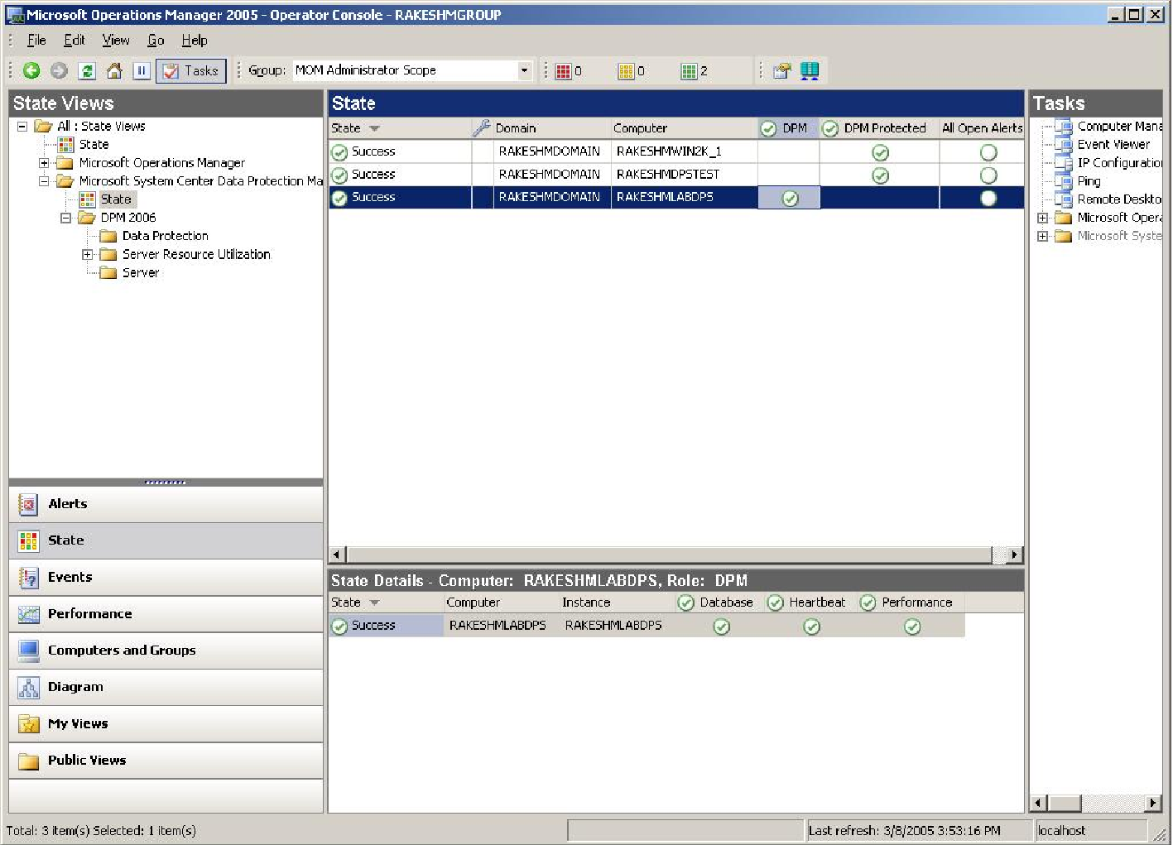
Figure 6. MOM 2005 management of DPM servers
The DPM Management Pack for MOM is included with the DPM installation software, and it may be downloaded from Microsoft's Web site. The basic installation process for the DPM Management Pack is straightforward; after importing the management pack, and installing the MOM agents on the DPM servers, you can create MOM discovery rules that gather data for MOM monitoring and reporting. Once the attribute discovery process is complete, MOM will begin monitoring the protected servers and DPM servers. Ay existing alerts will be imported into the MOM alerts database; new alerts and notifications will be stored there also, enabling MOM as a single management point for all DPM servers in the enterprise.

Summary
Microsoft realizes that data protection is increasingly important to customers. As the volume and value of data created and managed within business operations increases, conventional backup systems impose a high operating and labor cost. In return for this cost, businesses get some protection, but that protection is typically hard to use and somewhat unreliable. The Microsoft System Center Data Protection Manager 2006 provides efficient, continuous protection of critical data, removing the burden of scheduling and tracking backup jobs and maintaining backup systems on multiple servers. By centralizing protected data on the DPM server, DPM enables rapid disk-based recovery of files, folders, shares, and servers, saving administrators' time and reducing the downtime cost associated with recovery. DPM provides flexible synchronization and replica options that enable administrators to fine-tune synchronization and replica behavior to match their business requirements and operating environment. As a result, DPM delivers superior data protection value by providing a low-cost, high-speed way to safeguard critical data and to quickly recover it when necessary.

Where to Learn More
- The Management Server must have either Microsoft Operations Manager 2005 or Microsoft Operations Manager 2005 Workgroup Edition installed. For information about purchasing and installing MOM, see the Microsoft Operations Manager Web site (http://go.microsoft.com/fwlink/?LinkId=42382).
- You can download the Management Pack from the Microsoft Download Center Windows Base Operating System Management Pack 2005 Web site (http://go.microsoft.com/fwlink/?LinkId=42383).
- DPM Planning and Deployment Guide on Microsoft TechNet: http://go.microsoft.com/fwlink/?linkid=43087
- Microsoft's list of Independent software vendors and hardware providers supporting DPM: http://www.microsoft.com/windowsserversystem/dpm/partners/default.mspx

