MSlogo_rev_1118

September 2006

Microsoft Office Professional 2007

Table of Contents

Cover is for   
position only

[Introduction to Microsoft Office Professional 2007 1](#_Toc144694307)

[Business Challenges 1](#_Toc144694308)

[Office Professional 2007 2](#_Toc144694309)

[What Is Included in Office Professional 2007? 2](#_Toc144694310)

[Save Time and Stay Organized 3](#_Toc144694311)

[Work More Efficiently with the Microsoft Office Fluent User Interface 3](#_Toc144694312)

[Easily Manage Your Daily Priorities 4](#_Toc144694313)

[Reduce Junk E-Mail 5](#_Toc144694314)

[Track Tasks More Effectively with the New To-Do Bar 5](#_Toc144694315)

[Schedule Tasks on Your Outlook Calendar 6](#_Toc144694316)

[Instant Search 6](#_Toc144694317)

[Organize E-Mail by Using Color Categories 7](#_Toc144694318)

[Create Professional-Quality Business Documents 9](#_Toc144694319)

[Format Documents in a Snap with Quick Styles 9](#_Toc144694320)

[Save Time with Building Blocks 10](#_Toc144694321)

[Save as PDF or XPS 10](#_Toc144694322)

[Centralize Contact and Customer Management 12](#_Toc144694323)

[Centralize Contact and Customer Information 13](#_Toc144694324)

[Organize Accounts and Business Contacts 13](#_Toc144694325)

[Share Customer Information Throughout Your Organization 14](#_Toc144694326)

[Effectively Track Leads and Forecast Sales Opportunities 14](#_Toc144694327)

[Sales Leads and Opportunities 15](#_Toc144694328)

[Sales Leads Reports 16](#_Toc144694329)

[Information Dashboard 17](#_Toc144694330)

[Market More Effectively 18](#_Toc144694331)

[From Custom Mailing Lists to Personalized Campaigns 18](#_Toc144694332)

[Improve Project Management 19](#_Toc144694333)

[Produce Professional-Quality Marketing Materials In-House 21](#_Toc144694334)

[Create Designer-Quality Marketing Materials 21](#_Toc144694335)

[Get Started with Publisher Tasks 23](#_Toc144694336)

[Use Designer-Quality Templates or Create Your Own 23](#_Toc144694337)

[Promote Your Company Brand 24](#_Toc144694338)

[Capitalize on Existing Content 25](#_Toc144694339)

[Easily Share, Publish, and Print 26](#_Toc144694340)

[Personalize Distribution 26](#_Toc144694341)

[Publish as PDF or XPS 27](#_Toc144694342)

[Build Effective Presentations 28](#_Toc144694343)

[Use Slide Layout and Prebuilt Slides 28](#_Toc144694344)

[Create Impact with Document Themes 29](#_Toc144694345)

[Graphics, Tables, and Charts 29](#_Toc144694346)

[Track and Manage Data with Ease 30](#_Toc144694347)

[Get a Clear View of Your Business Information 31](#_Toc144694348)

[Task-Based User Interface 31](#_Toc144694349)

[Simple, Custom Charting Tools 31](#_Toc144694350)

[Conditional Formatting 32](#_Toc144694351)

[Improved Sorting and Filtering 33](#_Toc144694352)

[Easy-to-Use PivotTable and PivotChart Views 34](#_Toc144694353)

[Simplify Database Creation and Use 35](#_Toc144694354)

[Work with Predefined Database Templates 36](#_Toc144694355)

[Import Your Data 37](#_Toc144694356)

[Navigate Your Database 38](#_Toc144694357)

[Quickly Create Tables 38](#_Toc144694358)

[Track Your Data and Report Results 40](#_Toc144694359)

[One-Step Filtering 40](#_Toc144694360)

[Simple Report Editing 40](#_Toc144694361)

[Office Professional 2007 Highlights 41](#_Toc144694362)

[Office Access 2007 41](#_Toc144694363)

[Office Excel 2007 43](#_Toc144694364)

[Office Outlook 2007 with Business Contact Manager 45](#_Toc144694365)

[Office PowerPoint 2007 48](#_Toc144694366)

[Office Publisher 2007 49](#_Toc144694367)

[Office Word 2007 51](#_Toc144694368)

[Resources 53](#_Toc144694369)

[System Requirements 54](#_Toc144694370)

# Introduction to Microsoft Office Professional 2007

Welcome to Microsoft® Office Professional 2007, the suite of Microsoft Office system products designed with business professionals in mind. Office Professional 2007 helps business professionals save time and stay organized with powerful and easy-to-use tools for managing customer information and marketing activities, analyzing and reporting business information, and producing professional-quality communications.

## Business Challenges

Today’s business professionals often have difficulty finding the time and getting the information they need to complete mission-critical business activities such as customer relations, analyzing information, making decisions, and marketing.

While information technology can help address some of these challenges, business software can be difficult to use, and business professionals do not have time to invest in learning new tools. Business professionals need the software they already know and use every day to address their key challenges, such as:

* Finding the right information quickly so they can take more effective action.
* Analyzing information easily so they can make better informed decisions.
* Keeping track of customer information in one place, so commitments and opportunities do not fall through the cracks.
* Marketing products and services effectively to stay ahead of the competition.
* Eliminating the expense and long lead times associated with outsourcing sales and marketing materials.
* Being more responsive to time-sensitive business opportunities.
* Prioritizing tasks and managing information overload.
* Streamlining business processes to increase operational efficiency and cut costs.
* Being more efficient, whether working in the office or remotely.

## Office Professional 2007

Office Professional 2007 provides a complete set of productivity and information management software tools that helps business professionals to:

* Gain greater efficiency and business insight.
* Better manage customer and contact information, and respond to sales opportunities and customer needs.
* Create compelling marketing campaigns and communications.
* Easily develop and manage company databases.

This guide provides an overview of each of the programs included in Office Professional 2007, with an emphasis on new and improved features. We will also take a close look at each program in action, providing guidance on specific details that demonstrate the new capabilities.

### What Is Included in Office Professional 2007?

Office Professional 2007 includes the following Microsoft Office system programs:

* Microsoft Office Access 2007
* Microsoft Office Excel® 2007
* Microsoft Office Outlook® 2007 with Business Contact Manager
* Microsoft Office PowerPoint® 2007
* Microsoft Office Publisher 2007
* Microsoft Office Word 2007

For details about the new and improved features in each of these programs, please see the Product Highlights section.

# Save Time and Stay Organized

In most business environments, individuals shoulder multiple responsibilities—everything from sales and marketing to project management, accounting, and IT support. Business professionals are often stretched thin with back-to-back meetings, hundreds of e-mail messages to sort through each day, and loads of data to process, analyze, and communicate. To help ensure successful business operations, they must track critical information, prioritize tasks, and produce communications with skill and efficiency.

Office Professional 2007 provides the tools business professionals need to work quickly and efficiently, so they can spend more time doing business and interacting with customers.

Office Professional 2007 in Action: Getting more done in less time

Carol Philips works for Contoso Landscape Design, a small residential and commercial landscape design firm with 10 employees. As the senior designer for Contoso, Carol spends a lot of time in the field doing site assessments and overseeing site installations. Carol gets only a little desk time each day. When she is in the office, she makes the most of her time by using Office Professional 2007 to respond to e-mail inquiries from prospective clients, plan and get tasks done, and write project proposals and status reports.

## Work More Efficiently with the Microsoft Office Fluent User Interface

People often do not use software as efficiently as possible, simply because they do not have the time to invest in learning all the tools and shortcuts available. Office Professional 2007 can take the time out of learning new tools and performing routine tasks.

The Microsoft Office Fluent™ user interface available across the Microsoft Office system helps you to work more efficiently by automatically displaying the appropriate tools for your current task. You no longer have to navigate complex menus or open multiple toolbars to make a small format change or change a drawing. Microsoft Office system programs recognize the features you currently use and tailor the interface accordingly.

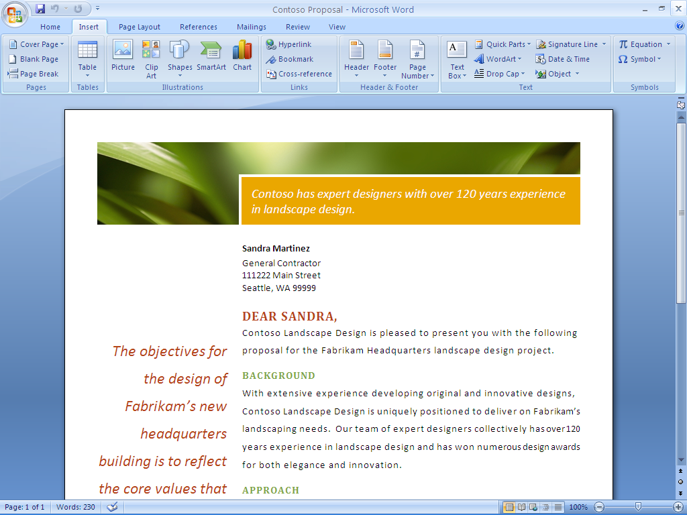

Figure 1: The Office Fluent user interface in Office Word 2007 makes the right tools available to you when you need them.

## Easily Manage Your Daily Priorities

For many business professionals, it is an ongoing challenge to process e-mail and voice mail messages quickly without losing track of critical work. The number of hours in a day remains the same; the amount of information that you have to process in that time continues to multiply at a rapid rate. Office Outlook 2007 includes many new and improved features to help you control e-mail and prioritize your tasks.

### Reduce Junk E-Mail

If you are in the business of managing customers, making business decisions, or handling day-to-day operations, you cannot afford to waste time sorting through junk mail. An improved junk e-mail filter sorts out undesirable messages based on your preferences. Office Outlook 2007 also helps protect you against e-mail phishing scams by automatically disabling links within any suspicious messages and warning you of potentially threatening or malicious links.

### Track Tasks More Effectively with the New To-Do Bar

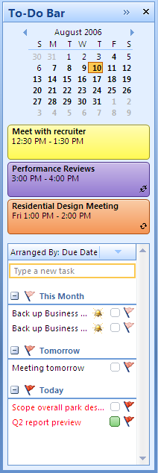It is hard to stay on top of daily tasks when your to-do list is scattered across multiple locations. The new To-Do Bar consolidates task and appointment information from Microsoft Office Outlook 2007 with Business Contact Manager, Microsoft Office OneNote® 2007, and Microsoft Office Project 2007 in one convenient place, giving you a complete view of your priorities for the day. It shows tasks, e-mail messages you have flagged as tasks, and upcoming appointments. And the To-Do Bar is integrated with your Outlook calendar, so you can easily schedule and block off time to follow up on items.

Upcoming appointments

Quick calendar view

Flagged e-mail items and tasks can be sorted in a number of ways, including by due date.

Figure 2: The new To-Do Bar in Office Outlook 2007 gives you a consolidated view of your priorities.

### Schedule Tasks on Your Outlook Calendar

Office Outlook 2007 integrates your To-Do Bar task list with your calendar, so you can better schedule your time. When you complete a task on a given day, the task ”sticks” to that day, providing a visual record of the work you performed. Tasks you do not complete roll over to the next day and accumulate until you finish them.

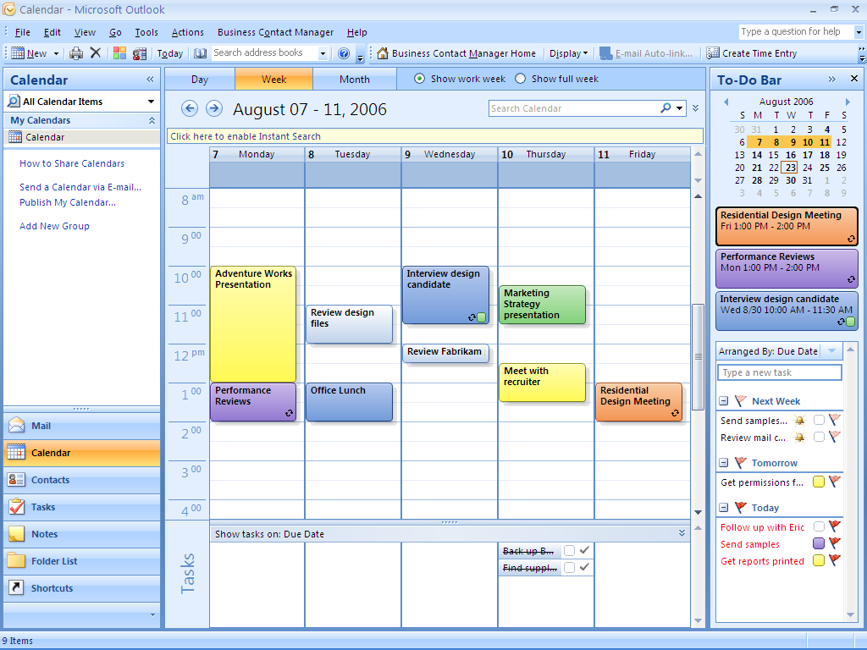

Tasks that appear on the To-Do Bar also appear in your daily task list below the calendar. This way, you can drag tasks from the daily task list to the calendar to easily block off time to complete them.

Figure 3: View and work with your tasks and your Office Outlook 2007 calendar in an integrated manner.

### Instant Search

With new and powerful integrated Instant Search, you can quickly find the information you need, whether it is in your e-mail, calendar, contacts, or tasks. Type in a keyword, and Instant Search quickly searches all your Outlook data. Results begin to appear in Instant Search as soon as you start typing your search terms. You also have the flexibility to create queries with different criteria, such as date, color categories, and importance.

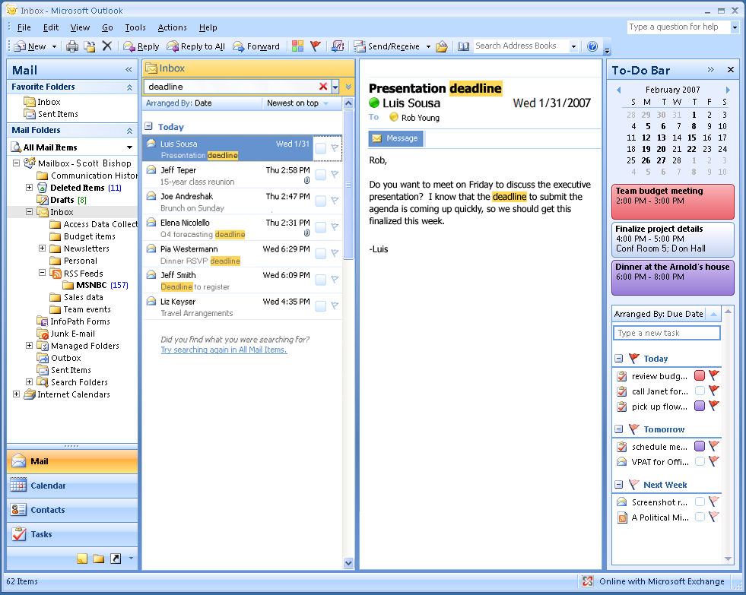

Figure 4: Instant Search helps you quickly find the information you need in Office Outlook 2007.

### Organize E-Mail by Using Color Categories

The new color categories feature in Office Outlook 2007 gives you a quick, visual way to distinguish types of mail items from one another, making it easier to sort and find information. For example, you could assign a color category to all items related to a certain project. Simply right-click each e-mail message, calendar item, or contact related to that project and select a color. Later, when you need to find information related to that project, you can sort by color category to quickly and visually identify what you are looking for.

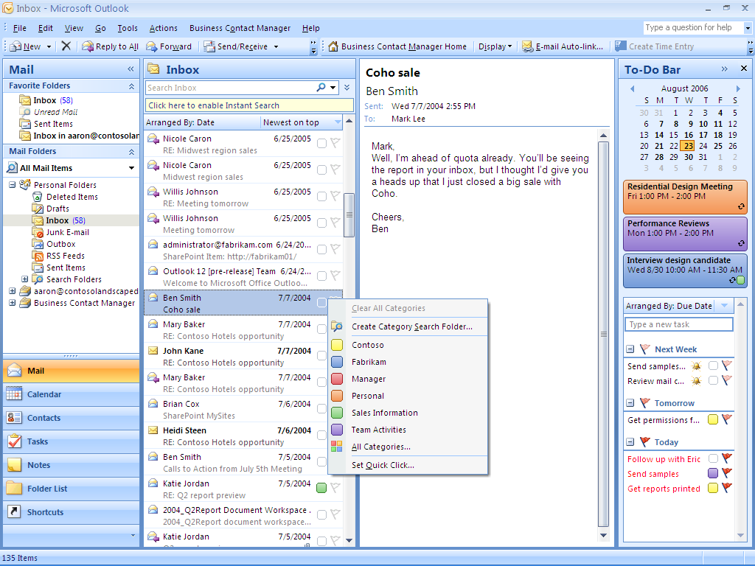

Figure 5: Color categories can help you search and organize your Outlook information.

Office Outlook 2007 in Action: Managing time better

Each morning, as Carol reads through her e-mail, she uses color categories to visually identify messages related to specific projects, so she can find pertinent information faster when completing her project reports. Next, she flags important messages for follow-up. Each flag represents one less thing she has to remember because Office Outlook 2007 reminds her when she must act on a critical e-mail message. Finally, Carol uses Instant Search to quickly find a particular message she received several months ago.

## Create Professional-Quality Business Documents

Office Word 2007 includes many new and improved features to expedite the process of creating and formatting polished business documents. The Office Fluent user interface, for example, automatically display the tools you need for whatever task you might be doing. With Quick Styles and Building Blocks you can spend more time writing and less time formatting documents. And with the Live Preview feature, you can view your changes easily, so you no longer have to undo or redo them.

### Format Documents in a Snap with Quick Styles

You can use the new Quick Styles feature in Office Word 2007 to change how documents look in a single click. You can modify fonts, colors, margins, table formatting, and other elements by simply choosing a different format. Simply select the text you want to change and then choose the style you want from the Quick Styles Gallery.

And you can use the Live Preview to help ensure that the formatting of your document is correct before you finalize any changes. You can also create a style and add it to a gallery that shows your frequently used styles. Quick Styles provide the added benefit of being very flexible; you can update them whenever you need to from within Office Word 2007.

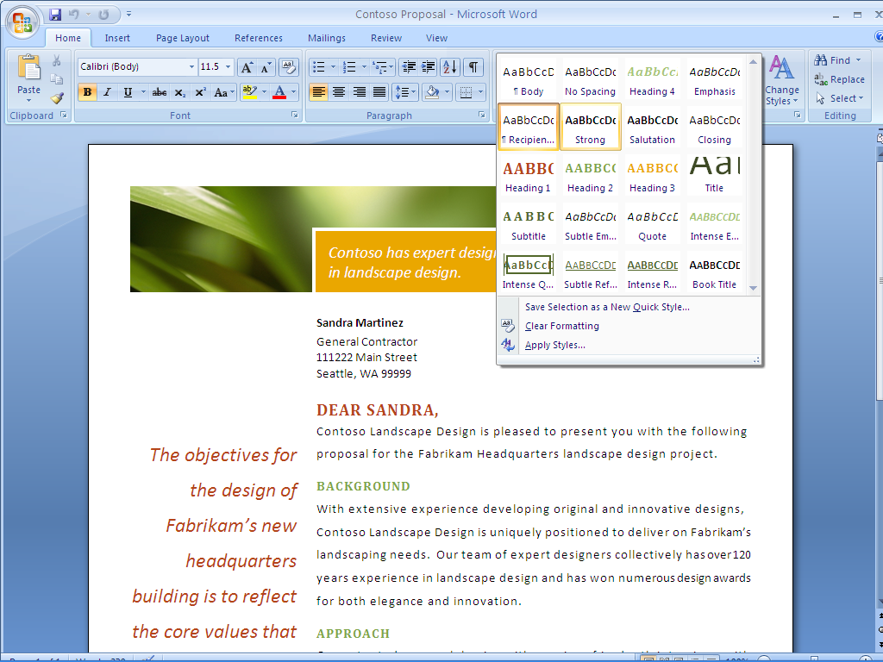

Figure 6: The new Quick Styles feature in Office Word 2007 makes formatting easy.

### Save Time with Building Blocks

Most organizations use some of the same information—company address or profile, people’s bios, and legal disclaimers—in all their business documents. The new Building Blocks feature helps you save time and reduce errors by creating building blocks of frequently used information that everyone in your company can access. Simply select the content you want from the Building Blocks menu and insert it into your document.

### Save as PDF or XPS

Sometimes you may need to save your Word document in a fixed file format so that other people who may not have Office Word 2007 can view it. Office Word 2007 now supports saving your document as a Portable Document Format (PDF) or XML Paper Specification (XPS) file.[[1]](#footnote-2)\* Now you can post your documents on the Internet, or share them with others, knowing that users can view them regardless of the type of computer or programs they use.

Office Word 2007 in Action: Create professional-quality documents quickly

Carol creates many proposals each month, each of which contains similar content. She uses Building Blocks to insert company contact information and past project descriptions into all her project proposals. After she completes the proposal content, Carol likes to format the document in a style evocative of the landscape design she is proposing. She has a set of company-approved design styles stored in the new Quick StylesGallery that enables her to set the font, colors, and table formatting with just a few clicks. And, with the Live Preview feature, Carol can see the effect of her changes to be sure that her formatting looks exactly the way she wants it before applying it. After she is satisfied with the content and format of a proposal, she can publish her document in PDF format to help ensure her customer will see it exactly the way she intended.

# Centralize Contact and Customer Management

To provide consistent, effective customer service and to close sales, a business must manage its customer contacts, track customer commitments, and follow up promptly on sales opportunities. Without the right tools, that is a Herculean task. Office Professional 2007 provides a practical, attractively priced solution for managing customer relations. Office Outlook 2007 with Business Contact Manager extends the functionality of Outlook to provide a complete contact and customer management solution within the familiar Outlook environment.

Office Outlook 2007 with Business Contact Manager gives you the tools you need to better manage customer information and communications history from one place and to share business contacts, accounts, and opportunities across your organization. Now you can more easily and effectively track, prioritize, and manage leads and sales opportunities from the initial opportunity through closing, while keeping your sales processes organized and productive. You can also create and monitor marketing campaigns and track their overall effectiveness by using Office Outlook 2007 with Business Contact Manager.

Office Outlook 2007 with Business Contact Manager in Action: Centralize customer information

Contoso account managers Sandra Martinez and Michael Holm used to rely on improvised methods for managing their customer accounts. While this worked when the company had only a few active projects at a time, Sandra and Michael began to find it increasingly difficult to track their many customers and prospects. Office Outlook 2007 with Business Contact Manager helps them increase sales and provide better customer service by effectively managing each opportunity throughout the sales cycle.

## Centralize Contact and Customer Information

Many companies have leads and customer information spread all over the place—in e-mail, spreadsheets, custom software or databases, and handwritten notes. With critical contact information located in so many different places, important sales calls and follow-up with customers can happen slowly, if they happen at all.

Office Outlook 2007 with Business Contact Manager can change that. It adds complete contact management capabilities to Office Outlook 2007 so you can organize your accounts, centralize critical business information, and improve customer service across your organization.

### Organize Accounts and Business Contacts

Office Outlook 2007 with Business Contact Manager helps you organize and track all your customer and prospect information from one location. You can link information such as notes, appointments, documents, and tasks to the appropriate record. Office Outlook with Business Contact Manager can also automatically associate incoming and outgoing e-mail messages to a contact. You can even link a Word document or Excel spreadsheet directly back to a related contact while you are working in the document or spreadsheet.

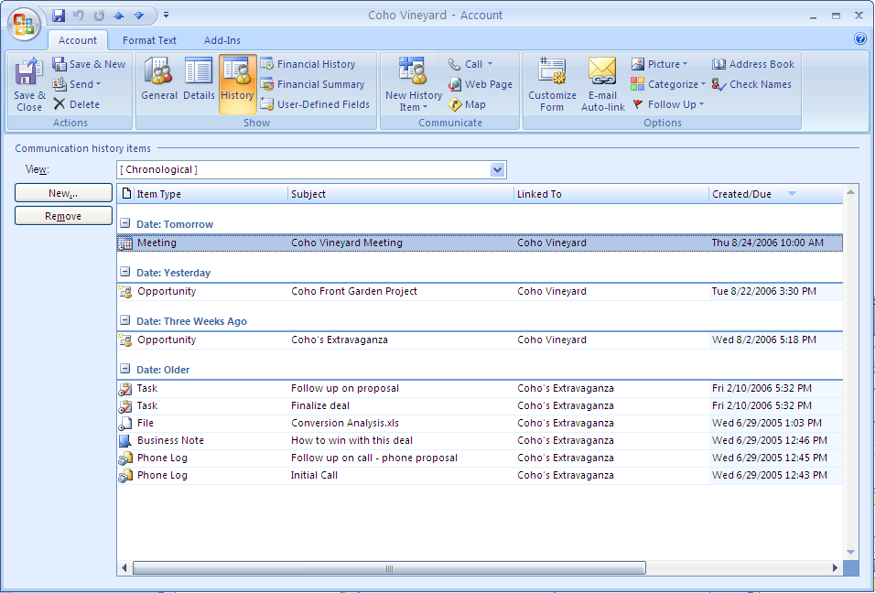

Figure 7: Get a consolidated view of all your business contact information.

### Share Customer Information Throughout Your Organization

Office Outlook 2007 with Business Contact Manager offers multiuser capabilities that make it easy to share information with coworkers. You can grant access to important customer information to other people in your organization. As an added bonus, when you work in multiuser mode, you can work offline on your laptop or Pocket PC and synchronize your changes when you reconnect to your network.

## Effectively Track Leads and Forecast Sales Opportunities

It is a challenge to succeed at sales. Salespeople have to attend to every step in the sales cycle and follow up on every lead. They cannot afford to waste valuable time chasing down sales-related data: it needs to be available at the drop of a hat. Office Outlook 2007 with Business Contact Manager helps to organize the information associated with managing and following up on sales opportunities so you can work more efficiently.

Just as you can associate e-mail messages, phone logs, documents, notes, and more to your contacts, you can also track sources of leads and the probability of closing a sale by using Office Outlook 2007 with Business Contact Manager. You can also get a consolidated view of your sales pipeline across the company so you can easily follow up with prospects and determine where to focus your efforts.

### Sales Leads and Opportunities

Get the help you need to stay on top of every opportunity and maximize sales potential. In Office Outlook 2007 with Business Contact Manager, a contact page contains essential information for each business opportunity, and uses reminders, rules, and alerts to help you manage the opportunity throughout the sales cycle. An opportunity form provides a complete activity history for each lead, including the products or services being sold, product pricing, sales stage, and probability of closing the sale. Sales managers can use that information to assess revenue potential, build accurate quotes, and provide fast, accurate answers to questions from customers.

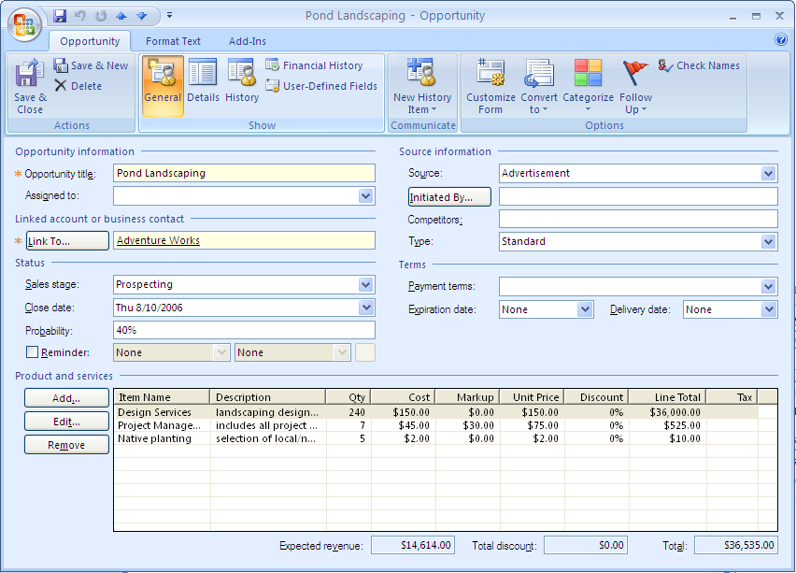

Figure 8: Track new sales opportunities in Office Outlook 2007 with Business Contact Manager.

### Sales Leads Reports

Office Outlook 2007 with Business Contact Manager provides more than 50 customizable customer and prospect business reports to help you stay on top of the entire sales cycle. To accurately measure and predict sales activity across opportunities, you can run reports that show sales status, order information, and probability of closing, for all opportunities and accounts or for a subset that you define. You can filter data to view the status of specific accounts and opportunities or to show customers who have not been contacted recently, and then export the results to Office Excel 2007 for further analysis. Equipped with this information, you can set priorities for sales efforts, organize daily tasks, and make sure that your important customer requests and sales opportunities do not fall through the cracks.

### Information Dashboard

Get the data you need to plan and manage your daily activities. A fully customizable reporting solution, the information dashboard gives you a complete at-a-glance view of customer and prospective customer information. You and your coworkers can choose the metrics that are most important to your roles and define the scope of the reports.

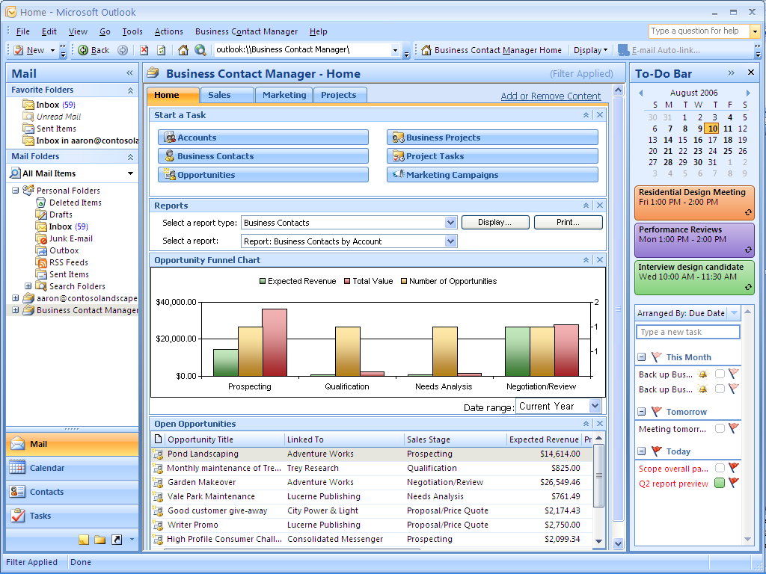

Figure 9: The information dashboard in Office Outlook 2007 with Business Contact Manager gives you a complete view of customer information.

Office Outlook 2007 with Business Contact Manager in Action: Streamline information

Now that Contoso employees use Office Outlook 2007 with Business Contact Manager to track contact information, the whole sales cycle is much smoother. When Michael Holm gets a call from a former client interested in additional services, he uses Office Outlook 2007 with Business Contact Manager to get a complete history of that account, including the design work Contoso completed for that client two years earlier. Michael uses the design information to generate a new opportunity for the customer, and this information is automatically included along with other information from the conversation in the client’s contact record. Carol Philips is then able to access the opportunity information when she writes up the project design proposal for this customer.

## Market More Effectively

A good marketing campaign helps a business promote products and services, keep in touch with existing customers, generate new leads, and convey a consistent and professional business identity. A good marketing campaign can be even more effective when you personalize communications.

Office Outlook 2007 with Business Contact Manager can help you manage your marketing campaign activities for better results. It includes tools to help you compile your mailing list, distribute materials, and track the results.

### From Custom Mailing Lists to Personalized Campaigns

Developing a mailing list for a marketing campaign does not have to be a manual, time-consuming task. With the improved filtering capabilities in Office Outlook 2007 with Business Contact Manager, you can create custom mail lists based on the customer and prospect data you specify. And thanks to the tight integration of all the Microsoft Office system programs, you can now use mail merge capabilities to personalize all the marketing materials that you create in Publisher or Word. The E-Mail Merge wizard in Office Publisher 2007 walks you through the process of creating a custom mailing list and personalizing messages for your e-mail marketing campaigns. After you have sent a campaign to a list, a record of that campaign automatically becomes part of each contact’s history. You can also track responses to your campaigns to assess which campaigns have been the most effective.

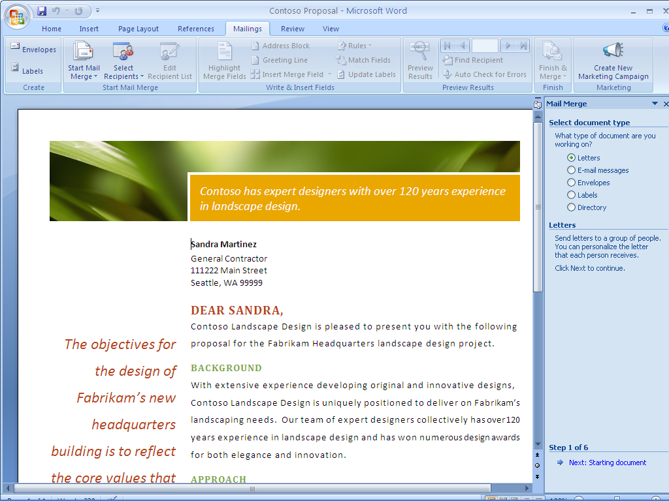

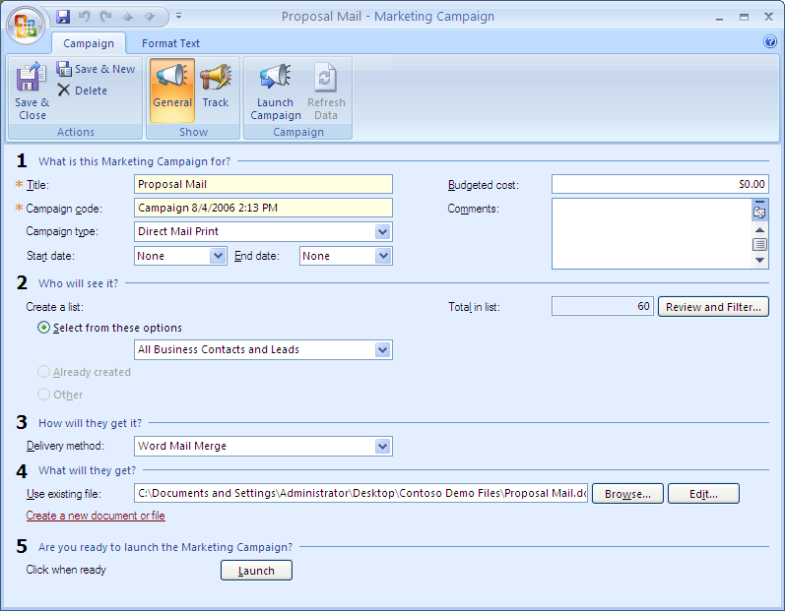

Figure 10: Create a marketing campaign list by using Office Outlook 2007 with Business Contact Manager.

## Improve Project Management

Keeping project information stored in multiple documents, spreadsheets, and databases hampers effective project management and creates risks. When employees do not have timely access to project-related information, critical tasks often take longer than they should, or they do not get done at all.

Office Outlook 2007 with Business Contact Manager helps you track project activities and manage project tasks in one central location. Your team can view and share the complete history of project-related communications from Office Outlook 2007 with Business Contact Manager, including e-mail messages, phone calls, notes, meetings, and documents. You can also assign project tasks to team members from Office Outlook 2007; these tasks will appear on your To-Do Bar as well as the To-Do Bar of the person assigned to complete the task, so you will remember to follow up on those important project deliverables.

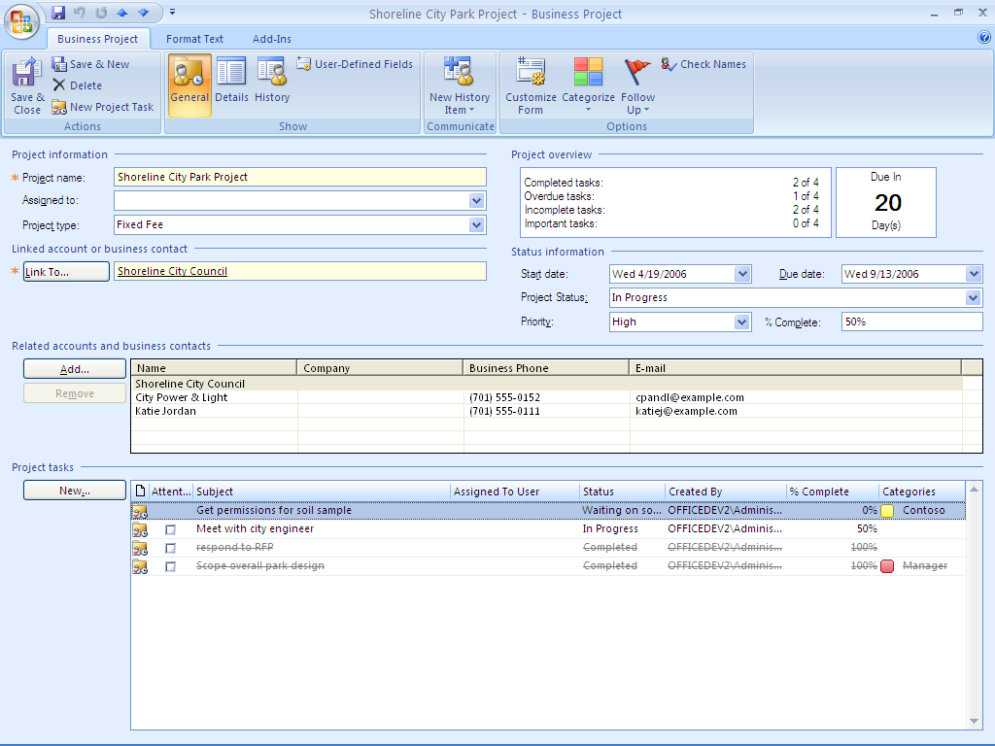

Figure 11: Collect all of your project information in one place with Outlook 2007 with Business Contact Manager.

# Produce Professional-Quality Marketing Materials In-House

Sales and marketing materials help you promote your business, keep in touch with existing customers, generate new leads, and convey a consistent and professional business identity. But hiring a vendor to create brochures, Web sites, and other communications can be both expensive and time-consuming, and the results are not guaranteed. Office Professional 2007 provides the powerful features you need to easily and confidently create designer-quality communications in-house.

Office Publisher 2007 in Action: Building new marketing materials

Contoso Landscape Design recently added commercial landscape design to its portfolio of services. They want to market this new service, but do not have the budget to hire a marketing firm. Michael Holm, the commercial accounts manager, has volunteered to tackle the marketing campaign himself. Aside from a few marketing classes in college, Michael has no experience with creating and distributing marketing materials, but he knows that Office Publisher 2007 includes easy-to-use guides to lead him through the process, from concept to delivery.

## Create Designer-Quality Marketing Materials

Your business collateral and marketing materials can enhance or damage your company’s image. Well-designed brochures, postcards, catalogs, and e-newsletters can help boost your professional image, support your creativity, and deliver your message with clarity. Office Publisher 2007 has the tools you need to project the right image for your business and make an impact with customers in person or online. With Office Publisher 2007 you can easily and confidently design and publish professional sales and marketing materials in-house.

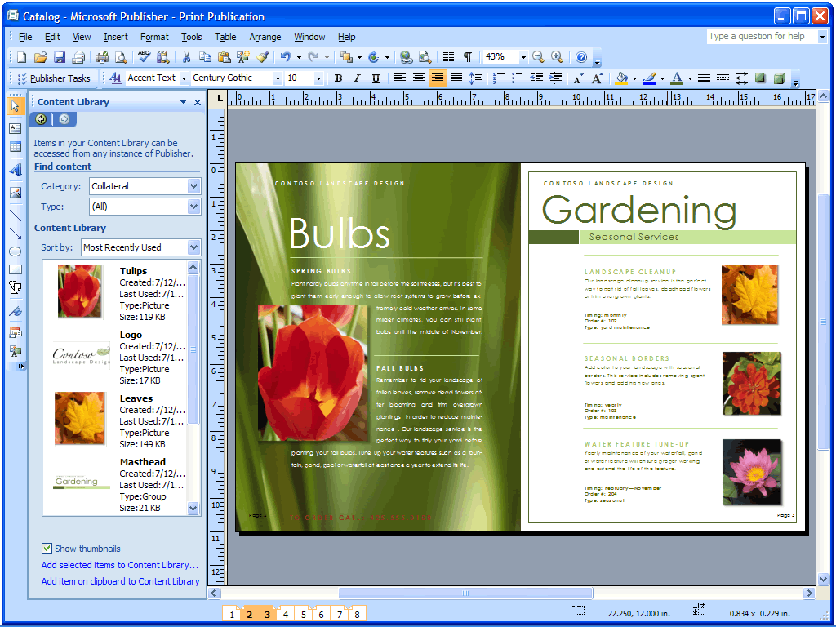

Figure 12: Store reusable layout elements such as logos, pictures, lists, and text in the new Content Library.

### Get Started with Publisher Tasks

To help guide you through the most common procedures, new Publisher Tasks expose you to the features you will most likely need to use during creation, distribution, and follow-upof marketing materials. Publisher Tasks also include tips for personalizing your publication, preparing your mailing lists, preparing your publication for commercial printing, tracking its effectiveness, working with images, and more.

### Use Designer-Quality Templates or Create Your Own

To get you started quickly, choose from an extensive library of designer-quality templates that you can customize, or begin with one of the many design templates for newsletters, brochures, flyers, postcards, Web sites, e-mail messages, and other publications. You can also create your own publication templates and categorize, preview, open, and save them within My Templates. You can also preview and open templates from the Microsoft Office Online Template Gallery within Publisher.

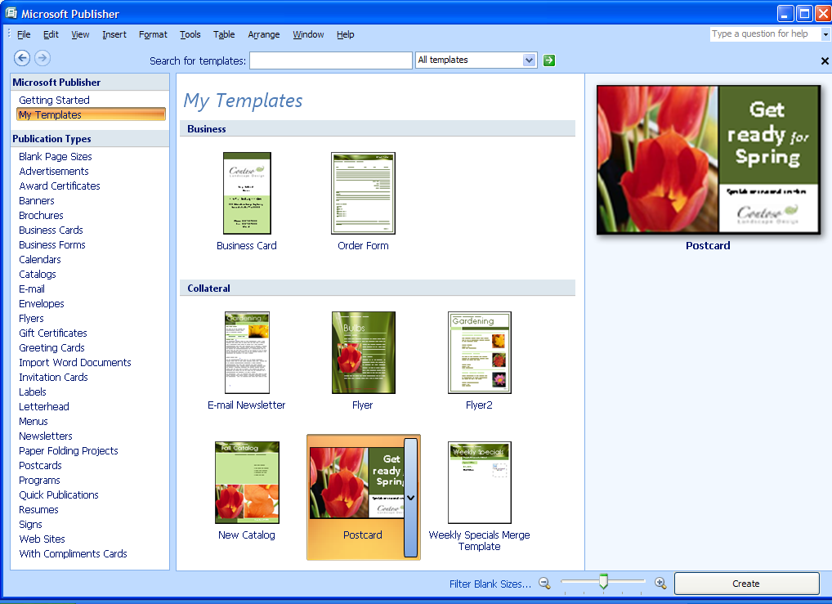

Figure 13: Save modified or created Office Publisher templates in My Templates.

### Promote Your Company Brand

The new Getting Started experience provides dynamic previews so you can easily create and apply your brand elements to all Office Publisher 2007 templates before you begin creating a document. Develop your brand identity by using custom color and font schemes, your logo, and your business information. Then, after you have created your business identity, apply it to all the Office Publisher 2007 templates and save these customized templates in the My Templates library.

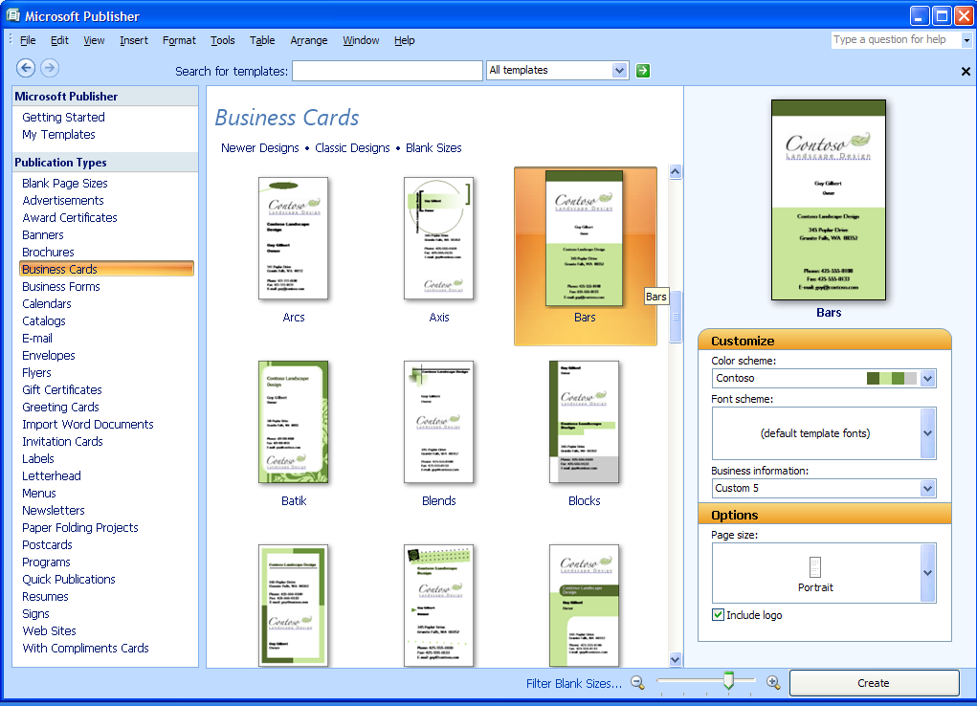

Figure 14: Create publications faster. Apply your own brand elements—colors, fonts, logo, and business information—to all Publisher templates in one step.

### Capitalize on Existing Content

With Office Publisher 2007, you can make the most of the time you invest in your work by publishing a single publication in multiple ways, and reusing content and design elements across publications. Using the new Content Library, you can access and save frequently used design elements, text, and graphics for use in other Office Publisher 2007 publications. You can also quickly reuse content from one publication type to another by changing the template. Just a few clicks help you move your content from a multipage newsletter into an e-mail publication, your letterhead into a business card, or the latest postcard into a flyer.

Office Publisher 2007 in Action: Quick and easy design

Michael decides to kick off the campaign with a small, targeted e-mail campaign to existing clients of Contoso Landscaping. He plans to use an e-mail template from the template library in Office Publisher 2007, but it does not quite match the Contoso brand. So Michael creates a business identity in Office Publisher 2007 and applies it to the e-mail template, and then customizes it further. Now, the e-mail message has the right color scheme and includes the company logo. Michael saves the business identity he created so he can use it for other projects in the future.

## Easily Share, Publish, and Print

When you create a polished set of marketing materials, you want the final printed product to be flawless. To help ensure that what you see is what your customers get, Office Publisher 2007 offers new capabilities to help you easily share, print, and publish marketing publications.

### Personalize Distribution

Office Publisher 2007 helps you give your customers the individual attention they deserve. Use enhanced mail merge, catalog merge, and the new E-Mail Merge with bookmarks and personalized hyperlinks to publish personalized communications for print or e-mail distribution. From the Merge task pane, you can select your mailing list, add text and image fields, and complete your mailing. Improvements in e-mail distribution and viewing, including support for sending multipage publications as a single-page message, make it easier than ever to create and send publications as e-mail messages.

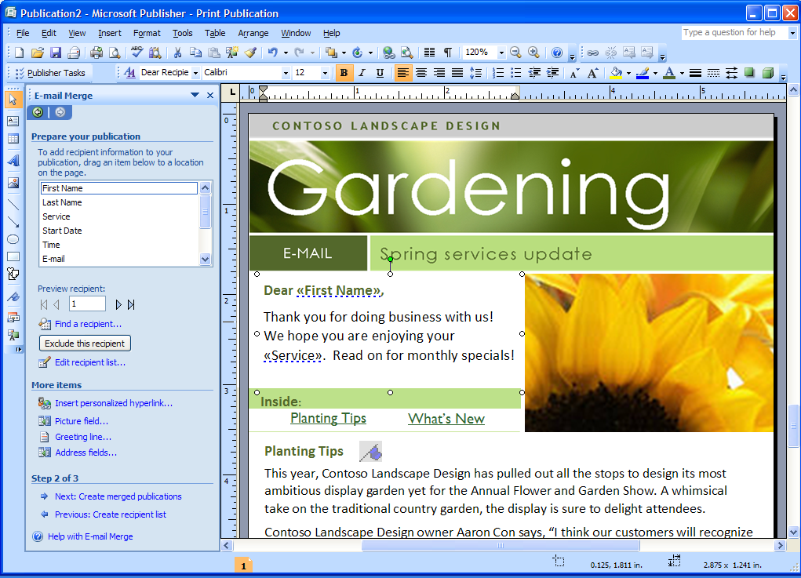

Figure 15: Send personalized e-mail marketing campaigns by using new Publisher E-Mail Merge.

### Publish as PDF or XPS

As with other Microsoft Office system programs, Office Publisher 2007 includes the option to convert your publications to PDF or XPS format. This is especially useful when you want to share your publications with customers or business partners or make them ready for commercial printing. You can choose to optimize these formats for commercial press, high-quality desktop printing, online distribution, or on-screen display.

Publisher 2007 in Action: Getting it right

Michael is pleased with the results of the e-mail campaign, so he decides to reuse the content as a printed direct-mail piece to targeted business districts. Publisher Tasks guide him through the process of converting the e-mail message to a printed letter.

## Build Effective Presentations

When you give a presentation to your customers, partners, or investors, you want it to have impact. To communicate effectively, your slides need to be crisp, clear, and polished. You can get just the look you want with the new and enhanced features in Office PowerPoint 2007.

### Use Slide Layout and Prebuilt Slides

Get started by choosing from the library of professionally designed slide layouts in Office PowerPoint 2007. You can customize slides to get exactly the layout you want, or use new prebuilt slide layouts for the most common topics. You can also create layouts with multiple charts, tables, and text, and then save them as templates.

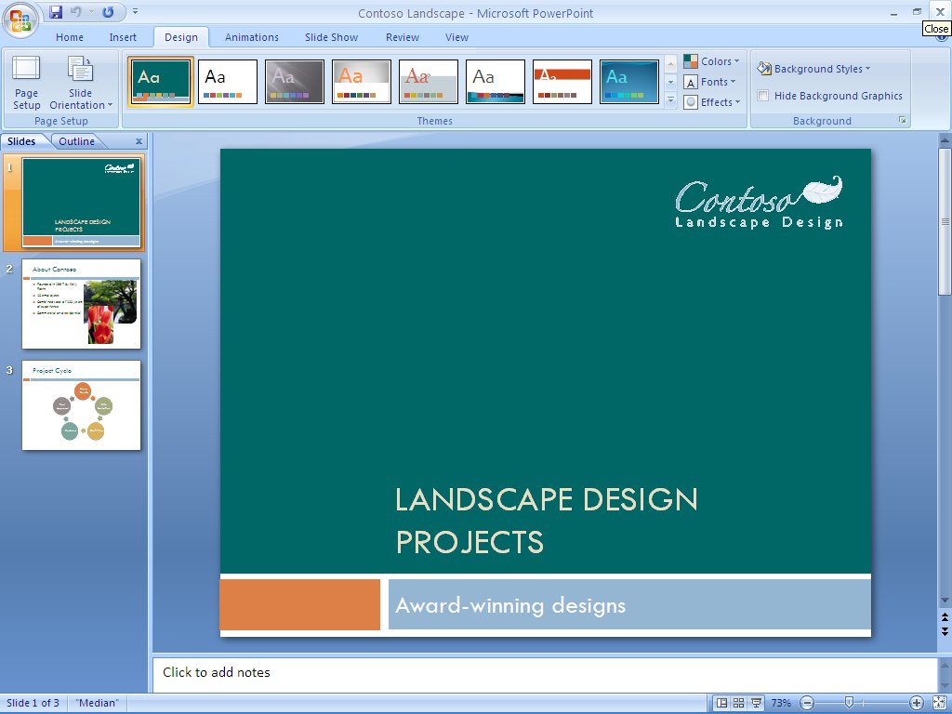

Figure 16: Choose from a selection of prebuilt slides in Office PowerPoint 2007.

### Create Impact with Document Themes

New Document Themes help to ensure a consistent appearance between the documents you create in Office Word 2007, Office Excel 2007 spreadsheets, and the slides you create in Office PowerPoint 2007. Now, instead of manually applying the same color, font, and special effects that you used in your Word document to your PowerPoint presentation, you can just select the theme you used to format the Word document, and Office PowerPoint 2007 does the rest.

### Graphics, Tables, and Charts

You can now build tables and charts in Office PowerPoint 2007 by using the same easily accessible tools you have come to depend on in Office Word 2007. Improved graphics capabilities help you add, edit, and modify images in your slides. With new AutoShape enhancements and improvements in the selection and manipulation of objects, you no longer have to worry about getting the picture you want on the page.

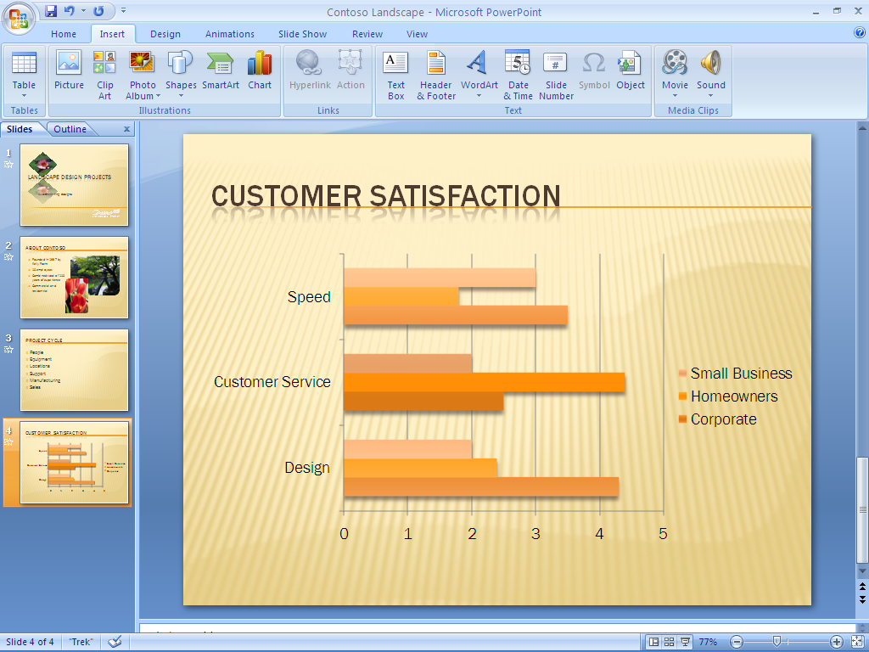

Figure 17: Including charts in Office PowerPoint 2007 is easy.

# Track and Manage Data with Ease

Business professionals depend on reliable, accessible data to help ensure efficient operations and to drive better business decisions. They need dependable tools to help them manage and analyze that data. Office Professional 2007 provides a comprehensive set of integrated tools to meet even the most complex data management needs.

Office Excel 2007 helps you analyze and display business data. You can identify important business trends quickly by using the powerful analytical tools in Office Excel 2007, and you can communicate your analysis clearly with the improved report and charting features.

For larger, more complex data sets, Office Professional 2007 includes Office Access 2007, an efficient, user-friendly data management solution. With prebuilt database templates and a new interface, Office Access 2007 helps you get up and running quickly without any special development or programming experience. And Office Access 2007 is fully integrated with Office Excel 2007, so you can track data relationships in Office Access 2007 and use Office Excel 2007 to analyze subsets of data and create reports.

## Get a Clear View of Your Business Information

You rely on data to make critical business decisions. You need to be able to easily view and analyze that data to make the best decisions for your business, and you need to communicate results in a manner that your colleagues, customers, and business associates understand.

Office Excel 2007 includes new and enhanced tools to help you analyze, communicate, and manage your data. The enhanced task-based user interface presents the tools you need, when you need them, so you can complete even the most complex tasks in minimal time. Office Excel 2007 also has a greater spreadsheet capacity so you have more room to work on larger data sets.

### Task-Based User Interface

With the Microsoft Office Fluent user interface of the Microsoft Office system, Office Excel 2007 presents the appropriate tools at the right time so that you can produce your best work more quickly. When you work with a table, for example, and you need help choosing the right format, the intuitive table galleries in Office Excel 2007 help you preview how a table will look before you make your final selection.

### Simple, Custom Charting Tools

Nothing communicates business data as clearly as a chart, and now it is easy to create professional charts and graphs in Office Excel 2007. With easy charting tools available from the redesigned interface of the Microsoft Office system, you can create more professional-looking charts with just a few clicks of your mouse. In your charts, you can use 3-D, soft shadowing, and antialiasing effects to identify key data trends or focus on future projections.

And the improved charting capabilities in Office Excel 2007 are shared with other Microsoft Office system programs, which means that you can create and interact with charts the same way—regardless of the program you are using.

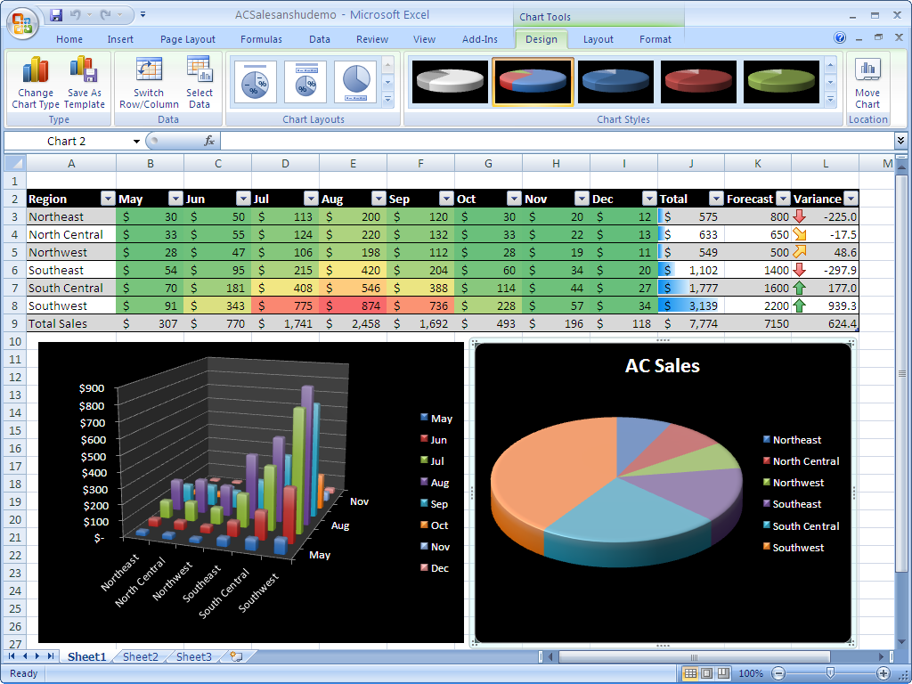

Figure 18: Charting tools in Office Excel 2007 make it easy to visualize your data.

### Conditional Formatting

You can now discover and illustrate important trends and highlight exceptions in your data by using conditional formatting. When you apply conditional formatting, you can identify relevant values within a data set and where these values lie within the range of data in question. You can also identify trends by using colors, data bars, and icons.

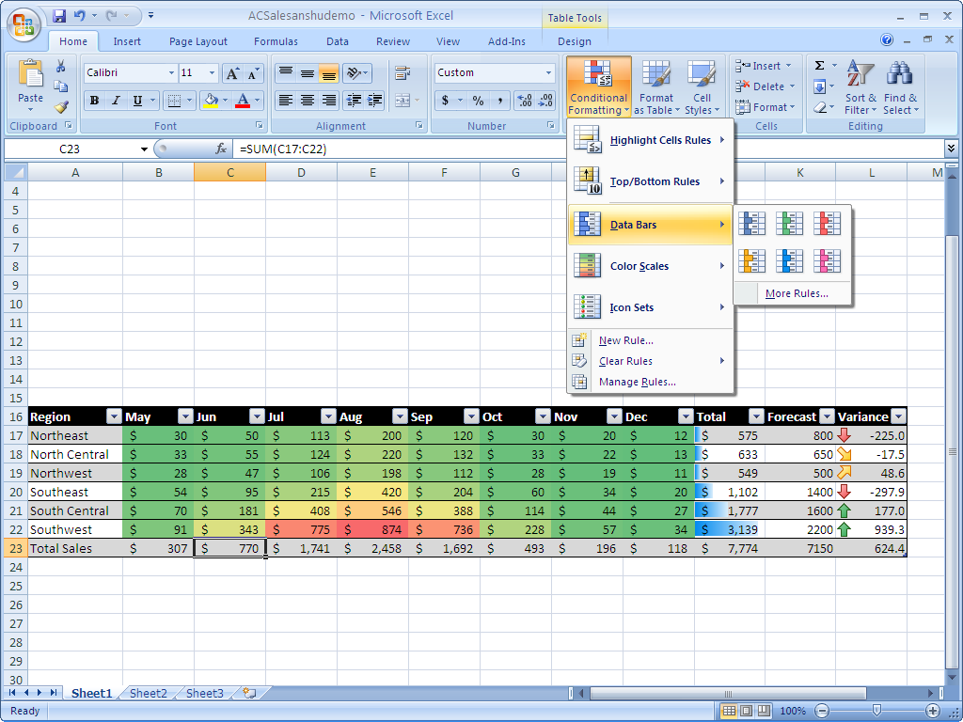

Figure 19: Use conditional formatting in Office Excel 2007 to visually track data trends.

### Improved Sorting and Filtering

New options for sorting and filtering make Office Excel 2007 the ideal tool for working with large amounts of business data. You can:

* Sort by date, selection, or even color.
* Manage up to 64 sorting levels from a central location.
* Use AutoFilter to simplify filtering, such as applying custom filters to more than two items. With the AutoFilter drop-down menu, you can select multiple items by checking them off.

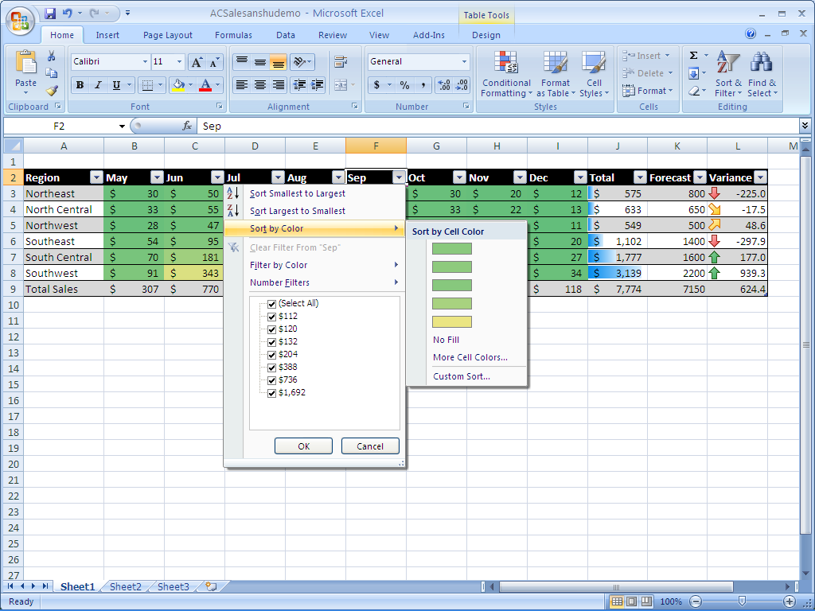

Figure 20: Enhanced filtering and sorting in Office Excel 2007 helps you organize your data.

### Easy-to-Use PivotTable and PivotChart Views

PivotTable® and PivotChart® views have always been two of the most popular features in Excel. A PivotTable is an interactive table that combines and compares large amounts of data. Users can rotate the columns and rows in a PivotTable for different views of their data. A PivotChart provides a graphical representation of the data in a PivotTable.

Office Excel 2007 offers new PivotTable and PivotChart tools, so business professionals can create them in just a few simple steps. For example, you can select the fields you want to include in a PivotTable by using the new PivotTable Field list. You can also sort by various fields and drill up or down on any part of the data by using new in-line “drill indicators.”

The enhanced context menus, contextual tooltips, and new layout and design options make sophisticated PivotTable and PivotChart views accessible to all Office Excel 2007 users, regardless of their skill level.

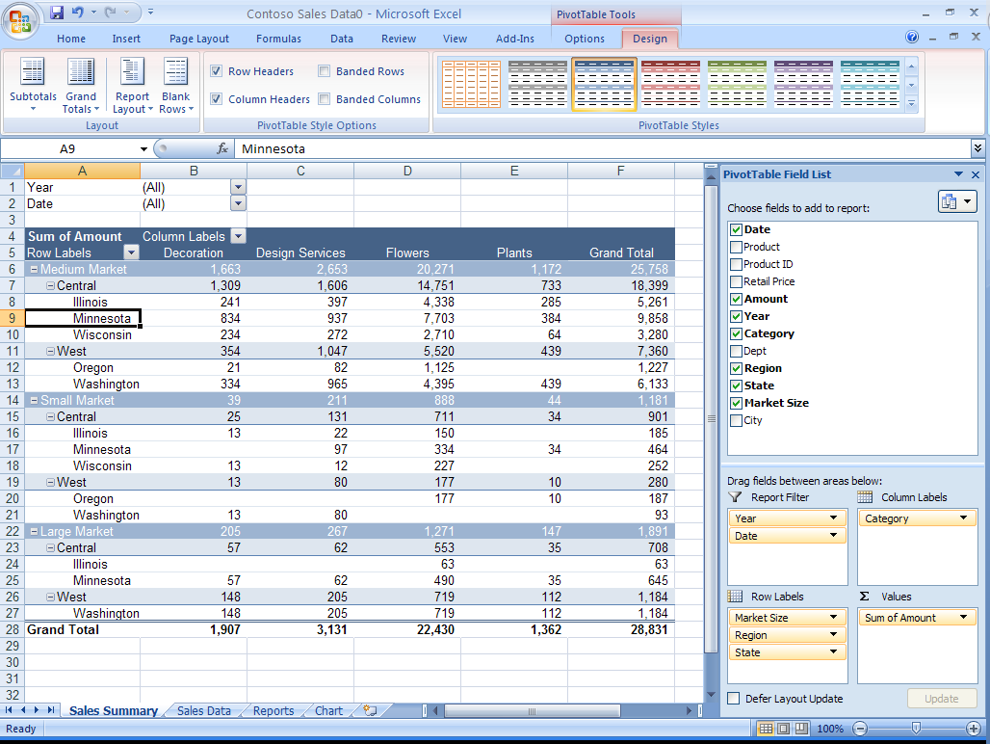

Figure 21: Use the new PivotTable Field List in Office Excel 2007 to customize your PivotTable.

## Simplify Database Creation and Use

Many business professionals are reluctant to adopt a database solution because they do not believe that they have the technical skills and resources to set up and manage a database. With Office Professional 2007, database implementation is easy. Office Access 2007 simplifies the entire database experience, from creating the database to analyzing and reporting the data.

Office Access 2007 eliminates the initial hurdles to database development by providing an intuitive Getting Started experience that includes options for launching a new application, opening an existing application, or choosing a template to build a new application.

### Work with Predefined Database Templates

You can quickly begin building a database by using one of the predefined database templates included in Office Access 2007. These templates support the most common information management needs for companies, including asset management, expense reports, issues, and customer orders. Of course, you can easily modify each template by adding new fields or creating tables to accommodate the unique requirements of your business.

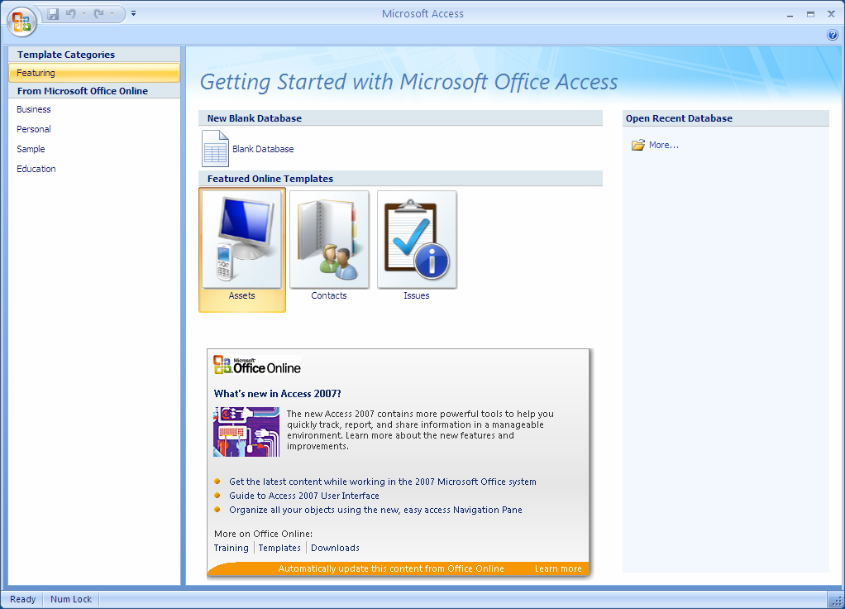

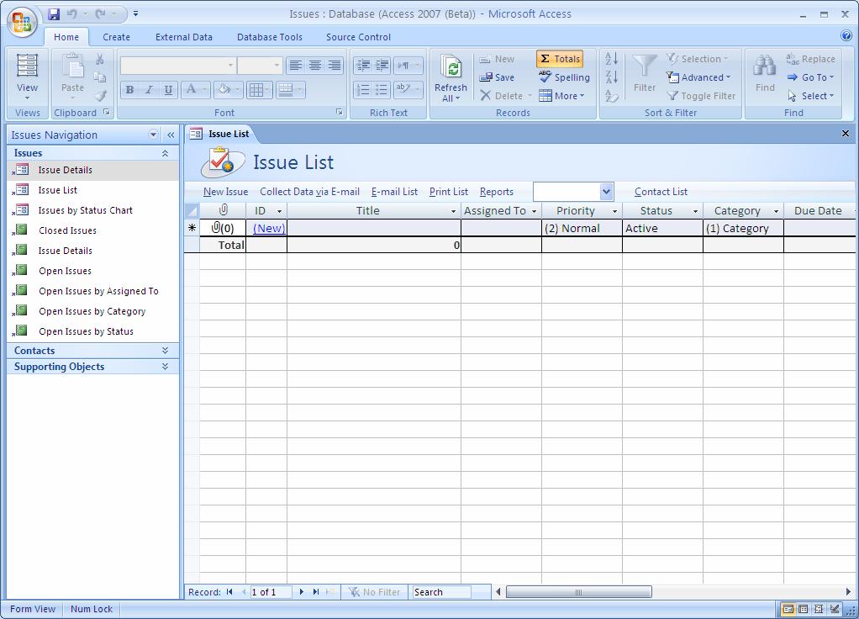

Figure 22: Use Office Access 2007 templates to build your database.

### Import Your Data

After your database is set up, it is easy to populate it with data. Because Office Access 2007 is tightly integrated with all other Microsoft Office system programs, you have a variety of options for collecting and distributing data. You can import the data from programs such as Office Excel 2007, Office Outlook 2007, and Office Outlook 2007 with Business Contact Manager.

### Navigate Your Database

Like other Microsoft Office system programs, Office Access 2007 has the task-based Office Fluent user interface designed to help you work with maximum efficiency. While nearly 1,000 commands are available in Office Access 2007, the Fluent interface displays only those tools and menus that are relevant to the task you are performing. These commands appear on a toolbar that is completely customizable to meet your needs. And new features such as the Add New Field column and improved selection capabilities make the Office Access 2007 experience similar to that of Office Excel 2007.

Office Access 2007 also provides you with a comprehensive view of tables, forms, queries, and reports with a new Navigation Pane. You can even create custom groups to organize and see all the forms and reports related to a single table.

### Quickly Create Tables

With Office Access 2007, it’s easier to workdirectly within a datasheet to create and customize tables. Simply start entering information into a data cell—just as you do today in Excel. When you enter a new value, Office Access 2007 automatically adds a new field and detects the data type (such as date, number, and text). You can paste Excel tables into a new datasheet, and Office Access 2007 will build all the fields and recognize the data types automatically. You can also use the Field Template pane to insert fields that were predefined for you. You simply drag the fields to the table.

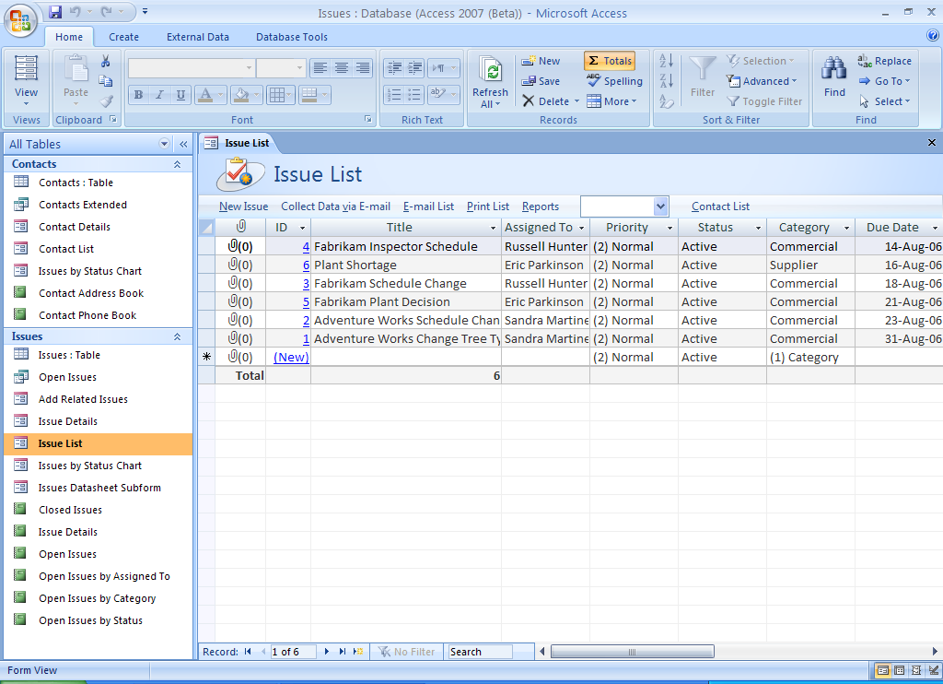

Figure 23: Get a clear view of your data by using the improved datasheet view in Office Access 2007.

Access 2007 in Action: Tracking complex relationships

Contoso designer Carol decides that the company could benefit from a database of the plants they typically use in their designs. Using an Office Access 2007 database, they can track the bloom time, soil requirements, and disease vulnerabilities of each plant. Not only will the information in the database help Contoso designers decide how to combine plantings effectively, it will also help them provide appropriate care instructions for each type of plant to their customers. With Office Access 2007, Carol is able to build a powerful plant database solution quickly and easily. She imports the plant lists she has in various Excel spreadsheets, and uses a wizard to customize the database design for her needs.

## Track Your Data and Report Results

One of the great strengths of Office Access 2007 is its ability to help you make sense of all of your data. Filters and groups help you manage the complexity of your data, while the simple report editor makes it easy to design effective reports that present key information for analysis and decision-making.

### One-Step Filtering

Filtering and sorting numbers, dates, and data types has become much easier and more intelligent in Office Access 2007. You can right-click a column to access a group of common filter options. For example, in a column formatted for dates, right-clicking gives you the option of filtering by year, quarter, or month.

### Simple Report Editing

With Office Access 2007, you can see how data will appear in a report while you are creating it. You can manipulate the report layout directly with the simple interface while browsing the data in the report designer, eliminating the need to run the report to see how it will look when printed. This makes it far easier to create a great-looking report, and significantly speeds up the reporting process.

# Office Professional 2007 Highlights

## Office Access 2007

Office Access 2007 helps individuals and teams within an organization to gather, track, and share information quickly, easily, and effectively. Even if you are a nontechnical user, Office Access 2007 has been designed to help you create and refine databases that help you manage your specific information. Key enhancements to the latest edition of Access include:

* **New! Getting Started** experience offers a library of prebuilt database templates.
* **Improved!** **Field insertion** in a table is as simple as typing a value in a new column in a datasheet.
* **Improved! Data transfer capabilities** enable you to paste an Office Excel 2007 table into a new Office Access 2007 table for easy data transfer.
* **New!** **Automatic data type detection in tables** improves schema and table creation.
* **New! Attaching external documents and files** to individual records in the data store helps you incorporate even more information into your databases.
* **Improved! Importing and exporting information** is easier than ever. You can even save frequently used import and export operations for quick reuse.
* **New!** **The results-oriented user interface** (available across the Microsoft Office system) presents tools to you when you need them, in a clear and organized fashion.
* **New!** **The** **Navigation Pane** provides easy access to all object types (including tables, forms, and reports).
* **New!** **Tabbed document window viewing** displays all open objects in the same window for easier navigation.
* **New!** **Interactive form design capabilities** provide a “what you see is what you get” (WYSIWYG) experience. You can modify form layout while seeing the results of your changes in real time.
* **New!** **Integration with Office Outlook 2007** enables you to use e‑mail to collect or update data in an Office Access 2007 table.
* **New!** **Automatically generate a Microsoft Office InfoPath® 2007 or HTML form** based on the fields in an Office Access 2007 table.
* **Improved!** **Automatic or manual data imports** improve data collection for your tracking.
* **New! Close integration with Microsoft Windows® SharePoint® Services** enables you to move your database to a SharePoint list where your coworkers can access, edit, or add information and view reports.
* **Improved!** **Rich reports** can be created with one click.
* **New!** **Interactive design capabilities** help you edit your reports in a true WYSIWYG experience. You can:
  + **Filter** **and** **sort** information more easily.
  + **Use grouping** capabilities to organize information in one or more layers and add subtotals.
  + **Add totals and counts quickly and easily** to any report.
  + **With drag-and-drop editing**, add new fields to a report by dragging to the position you want from the Field List pane.
* **Improved! Title and graphics** **support** helps you place titles and graphics directly in the report layout and see your changes quickly.
* **Improved!** **Instant text search** helps you find information quickly.
* **Improved!** **PivotTable and PivotChart support** helps you analyze across data collections.
* **New!** **One-click data transfer** gives you easy accessto a SharePoint site.
* **New!** **Revision history** is available within Office Access 2007 and within SharePoint lists.
* **New!** **Recycle Bin for deleted data** enables you to recover erroneously deleted data.
* **New!** **Server-side backup** helps you maintain the integrity of your databases.

## Office Excel 2007

Key enhancements to Office Excel 2007 include:

* **New!** **Results-driven interface** presents accessible, task-based tools at the right time.
* **New! Shared charting engine** across the Microsoft Office system helps you to create and interact with charts the same way, regardless of the program.
* **Improved! Accessible charting tools** help you create professional-looking charts and format axes, titles, and other chart labels—all by using fewer clicks.
* **Improved! More styles and effects**, such as 3-D, soft shadowing, and antialiasing, simplify the process of formatting charts.
* **Improved!** **Customization with Microsoft Office Art**, predefined styles, and integrated graphics help you quickly apply a consistent, professional look to your spreadsheets.
* **Improved! Printing experience** with a new Page Layout view to help ensure that what you see on the screen is what you will get in printed output.
* **New! Browser-based data access** helps you to share business information safely, without revealing confidential data.
* **New! PivotTable support** helps you to navigate, sort, filter, and interact with any PivotTable by using a browser.
* **New! Microsoft Office Open XML Formats** reduce file sizes, improve data recovery, and give you greater data interoperability.
* **New! Binary file format** helps avoid extensive load times, so you can open large spreadsheets faster.
* **Improved! Support for PDF and XPS** file formats help you convert your spreadsheet into a fixed file format for easier sharing.
* **Improved! Support for dual processors and multithreaded chipsets** help youperform faster calculations in large, formulae-intensive spreadsheets.
* **New!** **Increased row and column capacity** of 1 million rows by 16,000 columns enables you to work with massive amounts of data.
* **New!** **Enhanced table tools** help you create a table in just one click and format it quickly. Column headings remain in view as you scroll, and autofill populates and expands any table automatically.
* **New!** **Structured referencing** helps you to refer to tables, column headings, or the information they contain when you are writing formulae.
* **Improved!** **Formulae and range management tools** include a resizable formulae bar, a central location for managing multiple ranges, and context-based formulae AutoComplete. These tools can help you write the proper syntax the first time, every time.
* **Improved!** **Conditional formatting** offers new visual enhancements, such as gradients and icons, for highlighting data trends.
* **Improved!** **Sorting and filtering** helps you find the information you need, quickly and easily. Sort by using up to 64 sorting fields, including color, and apply multiple filters to a column by using AutoFilter.
* **Improved!** **PivotTable views and PivotChart** views offer greater automation and tools that make them easier to work with—regardless of your skill level.
* **New!** **Permissions-based control** enables you to manage which users can view and modify spreadsheets on the server.
* **New!** **Data Connection Libraries** enable you to connect to external data sources quickly and with enhanced safety.
* **New! Support for Web services** enables you to publish Excel results into a server-based or client-based application by using Web services.

## Office Outlook 2007 with Business Contact Manager

Office Outlook 2007 provides an integrated solution to help you better manage your time and information and improve your security. Office Outlook 2007 with Business Contact Manager adds complete business contact management capabilities to Office Outlook 2007, so you can more easily manage contact information and sales opportunities in one centralized location. Key enhancements to Office Outlook 2007 include:

* **New! Results-oriented user interface** makes composing, formatting, and acting upon e-mail easier and more intuitive.
* **New and improved! Anti-phishing and junk e-mail technologies** help reduce the amount of junk and malicious e-mail messages that enter your inbox.
* **New! Instant Search** enables you to search through your e-mail, e-mail attachments, calendar, contacts, and tasks simultaneously, helping you find the information you need much faster.
* **New! Flagging e-mail as tasks** helps you to create tasks from e-mail in one simple step.
* **New! To-Do Bar** efficiently centralizes calendar and task management. The integration with tasks from other programs gives users a consolidated view of their daily priorities.
* **New! Task integration on the calendar** provides an interactive way to work with your tasks and flagged e-mail by dragging them onto your calendar in order to schedule time to complete them.
* **New! Color categories** help you assign categories to any type of information, providing a quick way to quickly identify and visually distinguish related items.
* **New!** **Calendar snapshots** provide an easy and visual way to share calendar information with others outside of your organization.
* **New! Calendar publishing through Microsoft Office Online** gives you an easy and more secure way to post and share information.
* **New and Improved! Sharing requests** make it easy for you to share your information by giving permissions to access any Office Outlook 2007 folder to anyone using Microsoft Exchange. You can ask the recipient to share the same folder in return.
* **New! Integration with Microsoft Windows SharePoint Services** information enables you to import SharePoint calendars, contacts, or tasks into Office Outlook 2007 and have full editing capabilities whether you're online or offline. You can make edits to this information right from within Office Outlook 2007 and take it offline, helping to ensure any changes you make in Office Outlook 2007 are reflected on the server version.
* **New! Attachment Previewer** helps you to preview attachments in the reading pane, giving you insight into e-mail attachments and speeding decision-making.
* **New! Mini navigation bar** speeds access to important Office Outlook 2007 information.
* **New! Sender Contact Photo** displays a picture of the person who is sending you e-mail within that message, enabling you to scan your e-mail messages by photo and quickly identify the sender.
* **New! Outlook E-Mail Postmark** helps ensure that e-mail messages that reach your inbox are legitimate and that e-mail messages sent by Office Outlook 2007 will be trusted by the recipient's computer.

Key features of Office Outlook 2007 with Business Contact Manager include:

* **Improved! Contact management tracking features** help you more easily track contact information and communications history.
* **Improved! Sales leads and opportunity** tracking helps you respond and close the sale more quickly.
* **Improved! Integration with Office Small Business Accounting** helps you to view financial data in Office Outlook 2007 with improved data sharing features.
* **New! Customization** helps you to change fields, reports, and more to meet your specific needs.
* **New! Business Contacts dashboard** gives you a comprehensive view of your sales pipeline.
* **Improved! Report filters** help you to view data according to what metrics you need.
* **Improved! Export reports to Office Excel** for more detailed analysis whenever you need it.
* **New! Marketing Campaign** guides you through the process of compiling lists, and personalizing and tracking campaigns.
* **New! Marketing Campaign** personalization tools help you personalize your marketing campaigns by using mail merge integration with Office Word 2007, Publisher, Microsoft List Builder, and HTML.
* **New! Marketing Campaign tracking** features help you determine which marketing efforts were successful, and which weren’t.
* **New! Business Projects** helps you track all your project-related information in one place.
* **New! Business Project Tasks** appear on your To-Do Bar and Reminders, so you remain efficient.
* **New! Offline Access** means you can access your business contacts when you’re on the road. Use your laptop or Pocket PC—and then synchronize when you get back to the office.
* **New! Software development kit (SDK)** helps software developers integrate Office Outlook 2007 with Business Contact Manager with their software.

## Office PowerPoint 2007

Office PowerPoint 2007 makes it easier than ever to create dynamic and professional-looking presentations. Its redesigned interface offers new graphic styles, more presentation themes, and custom layout support, enabling you to create more effective presentations. Key enhancements include:

* **New!** **Custom layouts** help you quickly create precisely the layout you envision without being bound by one of the prepackaged standard layouts.
* **New! Better shape and drawing tools,** along with graphics and text effects, help you create professional diagrams and flow models.
* **New! Rich text** and typography boost the impact of your design.
* **New! Office Styles** help ensure a consistent appearance among the diagrams, tables, and shapes you create in Office Word 2007 and Office Excel 2007 and paste into presentations in Office PowerPoint 2007.
* **New! Office XML Formats** are more compact so you can share presentations more effectively.
* **New! Slide Libraries** help you store and share slide layouts and easily access other presentations.
* **New! Print in PDF or XPS format** to share your presentations with users on other platforms.
* **New! Revised user interface** streamlines workflow and boosts productivity.
* **New! Improved styles** help ensure a consistent appearance between the documents you create in Word, your spreadsheets in Excel, and your presentations in PowerPoint.
* **Improved! Presenter View** gives you more information to plan and deliver effective live presentations.

## Office Publisher 2007

With Office Publisher 2007 you can create and publish professional sales and marketing communications that are ready for desktop printing, commercial printing, e-mail distribution, or viewing on the Web. Office Publisher 2007 offers professional design template collections, built-in design expertise, and the familiar user interface, menus, tools, and features of other Microsoft Office system programs within Office Professional 2007. Key enhancements include:

* **New! See dynamic previews** of Office Publisher 2007 templates with your brand elements applied, including your colors, fonts, logo, and business information before choosing a template.
* **Improved! A template library** gets you started quickly by supplying hundreds of customizable design templates and blank publications, including newsletters, brochures, flyers, postcards, Web sites, e-mail formats, and more.
* **Improved! Create a business identity** for all your business and personal needs, including company name, contact information, and logo. Maintain a consistent, professional look by applying your business identity, as well as custom color and font schemes, to all your publications.
* **New!** **Instant** **Search tool** can help you quickly locate and preview high-quality Publisher templates from Microsoft Office Online right within the Publisher Catalog. You can also now efficiently categorize, preview, open, and save your templates within My Templates for fast retrieval.
* **New!** **Content Store** saves time and effort by storing frequently used text, design elements, and graphics in an easy location for use in other publications.
* **Improved!** **Reuse content** for other publication types and distribution methods. For example, easily place content from a multipage newsletter into an e-mail template or Web layout for online distribution.
* **Improved!** **Choose color schemes** from more than 70 designer-created color schemes or create one of your own. If you are using Pantone colors, choose them from within Publisher.
* **New!** **Publisher Tasks** provide assistance with common Publisher procedures, such as inserting images, creating a mail merge, and reusing content.
* **Improved!** **Catalog merge** helps you quickly build custom materials such as datasheets or catalogs by merging text and images from a database.
* **Improved!** **Design tools** can help you customize your publication. Use the collection of intuitive design and graphics tools to adjust tracking and kerning, insert images from a scanner or digital camera, recolor and crop images, and more.
* **Improved!** **Design Checker** identifies common problems in commercial print files, Web files, and e-mail. Use it prior to distributing or printing your publication to quickly identify and fix any design errors.
* **New!** **Save Publisher files in a fixed-file format**, such as PDF or XPS, for hassle-free sharing. PDF settings within Office Publisher 2007 include options for online viewing, desktop printing, and commercial press-ready printing.
* **Improved!** **For large quantities and high-quality printing**, Office Publisher 2007 offers full commercial printing support including 4-color process printing, spot color printing, CMYK composite PostScript, and more. Use the improved Pack and Go Wizard to prepare your Publisher files, including a press-ready PDF file, for a commercial printer.
* **Improved!** **E-mail distribution and viewing,** including support for sending multipage publications as a single-page message, make it easier than ever to create and send publications as e-mail messages that appear exactly as you intended.
* **Improved!** **Convert publications for viewing on the Web** and easily update, edit, post, and add navigation.

## Office Word 2007

Office Word 2007 adds new, easy-to-use quick formatting controls, mathematical equation editing, and predefined and customizable Building Blocks for adding commonly used content, like citations, references, headers, and footers. Word document templates can be structured and deployed across organizations to standardize document formats, and can be used to connect and present information stored in back-end systems by using new data-binding capability. Key enhancements include:

* **New! Quick Styles** save you time by quickly formatting text and tables throughout your document.
* **New! Building Blocks** of predefined content reduce the errors associated with copying and pasting commonly used content.
* **New! Equation editing** boosts the capabilities of Word with a comprehensive equation editor built right into the familiar Word environment.
* **New! Citations and references features** help you add citations and references to your document with a single click.
* **New! SmartArt™ graphics** add a professional look to documents.
* **New! A results-oriented user** **interface** streamlines workflow and boosts your productivity.
* **New! Live word count** keeps track of the number of words in your document as you type.
* **New! Save as PDF or XPS** option enables you to use the file format that is most convenient for you.
* **Improved! Bullets and numbering features** now offer more choices and are easier to use.
* **New! The tri-pane review** **panel** helps you quickly identify the differences between documents.
* **New! The Document Comparison** feature enables you to conduct more thorough reviews by tracking moved, updated, and deleted text.
* **New! An immersing full-screen reading experience** makes reading online easier, reducing the need to print.
* **New! A simple, step-by-step interface** helps you make sense out of the changes of multiple reviewers by merging their changes.
* **New! Improved styles features** help you manage large documents more easily.
* **New! Integration between Office** **Outlook 2007 and Windows SharePoint Services** helps you to conduct and administer document review cycles.
* **New! Finish Menu** gives you options for helping to protect private information and intellectual property.
* **New! Mail Merge Tab** on the new Office Word 2007 interface simplifies mailings.

# Resources

For more information about Office Professional 2007 and the Microsoft Office system, please visit <http://www.microsoft.com/office/suites/professional>.

# System Requirements

For complete system requirements, visit <http://www.microsoft.com/office/suites/professional>.

This document is developed prior to the product’s release to manufacturing, and as such, we cannot guarantee that all details included herein will be exactly as what is found in the shipping product. The information contained in this document represents the current view of Microsoft Corporation on the issues discussed as of the date of publication. Because Microsoft must respond to changing market conditions, this document should not be interpreted to be a commitment on the part of Microsoft, and Microsoft cannot guarantee the accuracy of any information presented after the date of publication. The information represents the product at the time this document was printed and should be used for planning purposes only. Information is subject to change at any time without prior notice.

This document is for informational purposes only. MICROSOFT MAKES NO WARRANTIES, EXPRESS OR IMPLIED, IN THIS DOCUMENT.

© 2006 Microsoft Corporation. All rights reserved.

Microsoft, Excel, Fluent, InfoPath, the Office logo, OneNote, Outlook, PivotChart, PivotTable, PowerPoint, SharePoint, and Windows are either registered trademarks or trademarks of Microsoft Corporation in the United States and/or other countries. All other trademarks are property of their respective owners.

1. \* You can save as a PDF or XPS file from a 2007 Microsoft Office system program only after you install an add-in. For more information, see Install [and use a PDF or XPS add-in](http://r.office.microsoft.com/r/rlidOOPDFXPSAddin?clid=1033). [↑](#footnote-ref-2)