Improving Remote Access Using MOF at Microsoft
The Strategy, Process, and Benefits of using MOF to Improve RAS at Microsoft
Technical White Paper
Published: June 2004

Contents
Executive Summary 3
Introduction 4
The Microsoft Global Enterprise 4
Microsoft IT Organization 5
Problem Statement 6
Deploying MOF 11
Establish a Service Management Framework 11
Define Goals 12
Baseline for Service Level Agreements and Operations Level Agreements 12
Establish a Virtual Team 13
Apply MOF Models to RAS Service Management 20
TCO 34
Lessons Learned 37
Application Failures 37
Systems 38
Networks 38
Egress 38
Service Level Management 39
Problem Management 39
Capacity Management 40
Service Continuity Management 40
Financial Management 40
Conclusion 41
For More Information 43

Executive Summary
As the role of IT steadily increases in today’s enterprise business strategy, to be successful, IT services must be compelling, reliable, and efficient. This paper presents the strategy and process of how the Microsoft IT group applied Microsoft Operations Framework (MOF) processes to a service improvement project for its enterprise Remote Access Service (RAS). Included in this paper is an overview of the following:
- Microsoft enterprise
- RAS infrastructure and overall service
- MOF terms
- Service Management Functions (SMFs) from the four quadrants of the MOF Process Model
The focus of this paper is best practices and lessons learned, sharing tips, tools, and advice with customers that they can use to manage and improve RAS or any IT service delivery.
The MOF process improvements described in this paper were implemented in several phases over two years. The essential enabling technologies described in this paper run on Microsoft® Windows Server™ 2003. However, most of the technologies were developed when the infrastructure was based on Microsoft Windows® 2000 Server, and can be implemented on Windows 2000 Server. All of the technologies and deployments continue to mature based on evolving security requirements, future strategic plans, and product testing and validation requirements.
This paper is intended for:
- Enterprise technical decision makers
- Security operations staff
- Service operation personnel
- Infrastructure engineering staff
This paper assumes that readers are already familiar with Windows Server 2003 remote access technologies, such as Connection Manager (CM), Remote Authentication Dial-In User Service (RADIUS), and virtual private network (VPN), as well as with associated technologies, such as Public Key Infrastructure (PKI) security, smart cards, and Microsoft Operations Manager (MOM) 2000.
Many of the principles and techniques that are described in this paper can be employed to improve service within any organization, and the design considerations for remote access infrastructure can likewise be applied to most any enterprise-scale IT environment. However, this paper is based on Microsoft IT experience and recommendations. It is not intended to serve as a procedural guide. Each enterprise environment has unique circumstances; therefore, each organization should adapt the plans and lessons learned that are described in this paper to meet its specific needs.
Situation
The Remote Access Service (RAS) offered by Microsoft IT facilitates connecting ~65,000 users making 1 million connections per month to the corporate network.
Microsoft IT needed an effective service and support framework to manage the delivery of this enterprise IT service. Strategic goals included: continually improving the service delivery quality; reducing total cost of ownership; and facilitating early product adoption, evaluation, and feedback for Microsoft product development teams.
Solution
Microsoft IT implemented the Microsoft Operations Framework (MOF) for its Remote Access Service. MOF provides guidance for achieving high availability, reliability, security, and reduction in total cost of ownership.
Benefits
- Improved reliability. Achieved 99.9 percent availability for Remote Access Service, measured by automated polling using synthetic events; includes all internal IT maintenance and external service outages.
- Improved manageability. Reduced RAS infrastructure trouble tickets by 47 percent over 12 months.
- Improved stability. Reduced highest-priority incidents by 63 percent, second highest priority by 61 percent over 12 months.
- Reduced Total Cost of Ownership (TCO) by over 27 percent in 12 months.
- Improved client satisfaction by 22 percent over 36 months.
Products and Technologies
- Microsoft Operations Framework
- Microsoft Windows Server 2003
- Microsoft Windows XP Professional SP1
- Microsoft Internet Security and Acceleration Server 2000 SP1
- Microsoft SQL Server 2000
- OLAP Cube data technologies
- Microsoft Operations Manager 2000
- Connection Manager
- Smart card and Microsoft PKI technologies

Note: For security reasons, the sample names of forests, domains, internal resources, organizations, and internally developed tool names used in this paper do not represent real resource names used within Microsoft and are for illustration purposes only.
Introduction
Today’s information systems increasingly integrate the Internet and private networks, connecting businesses with their employees, customers, and partners. With this growth has come the challenge of efficiently and securely implementing and operating a major service, such as RAS, from planning through deployment to achieve targeted, strategic business benefits. Microsoft upgraded its internal RAS solution from September 2001 through February 2003, using MOF to manage and overcome many of the obstacles encountered during the process. The information gained and lessons learned during this implementation can serve as a valuable blueprint for any company that is considering enterprise-level remote access as a managed service. Many of the lessons learned can be applied to any enterprise-scale service development, deployment, or support project.
MOF is a highly structured approach to help IT organizations achieve operational excellence through a collection of best practices, principles, and models, all of which provide guidance for achieving high availability, reliability, security, and reducing the total cost of ownership (TCO) on mission-critical production systems built on Microsoft technology. In this paper, we will discuss how MOF was implemented to manage the evolution of the RAS architecture, the technology development and deployment, and day-to-day operational management to support mission-critical business strategies across the Microsoft enterprise. More detailed information on the design and deployment of the RAS solution can be found in the Security Enhancements for Remote Access at Microsoft white paper at: http://www.microsoft.com/technet/itsolutions/msit/security/rasecwp.mspx.
The Microsoft Global Enterprise
It is important to understand the scope of the environment and the strategic goals that drive the Microsoft IT organization prior to discussing MOF. The large size, complexity, and dynamic nature of the Microsoft computer network create significant challenges for all IT services.
At the time of this writing, the corporate network includes:
- A user base of approximately 55,000 Microsoft employees and approximately 10,000 additional contract employees worldwide.
- Three enterprise data centers and a total of 14 regional data centers worldwide.
- More than 400 sites in 83 countries/regions.
- The largest wireless local area network (LAN) in the world, employing 802.1X with authentication provided by IAS RADIUS servers.
- More than 24,000 wireless devices.
- More than 4,000 wireless access points.
- More than 250 wide area network (WAN) circuits.
- More than 200 WAN sites
- More than 3,300 Internet Protocol (IP) subnets.
- More than 2,000 routers.
- More than 2,600 network layer 2 switches.
- More than 275 asynchronous transfer mode (ATM) switches.
- More than 10,000 worldwide servers.
- More than 150,000 managed desktop computers.
Microsoft IT Organization
Microsoft IT is a highly customer-focused organization with the mission to “proactively deliver IT infrastructure and applications that exceed defined expectations of our clients, customers, and partners—making it easy to work anywhere at any time.”
The phrase “exceed defined expectations” in the mission reflects an emphasis on service measurement and analysis. This part of the mission is based on the tenet that “you cannot manage what you do not measure.” For example, in the IT operations area, expectations are documented in the form of service level agreements (SLAs). The service level agreement metrics are reviewed monthly in an IT scorecard.
Microsoft IT priorities are as follows:
Be Microsoft’s First and Best Customer
The primary business of Microsoft is software design. Consequently, Microsoft IT has a mission that is unique among global enterprises: Deploy products across the enterprise prior to release to customers, thereby providing feedback to the product development teams. The early deployment of Microsoft technology and the continual growth of the enterprise results in a highly dynamic IT environment.
During the RAS improvement project all desktops were upgraded to Windows XP Professional in 2002 as part of the company-wide security strategy. The RAS server infrastructure was also upgraded to Windows Server 2003, completed in March of 2003, in an early adopter product evaluation project and as the core element in the RAS infrastructure overhaul. Internal real-world evaluation activities drive a very high rate of change in the environment, with many more software deployments to servers and desktop computers than is typical at enterprises of comparable size.
Provide Intellectual Leadership
Microsoft IT drives the early adoption of technologies that help define the Microsoft vision of the leading-edge IT professional, developer, and information worker. Microsoft IT also provides product feedback to the Microsoft product development groups and contributes directly to the development and improvement of IT processes such as MOF.
Set a Coordinated IT Strategy
Microsoft IT leads the process that defines and delivers high-value IT solutions at both the business-unit level and the enterprise level. Setting strategy is a critical Microsoft IT function because the IT infrastructure is centralized, whereas line-of-business application development is decentralized. Although application development occurs independently in each business unit, Microsoft IT provides centralized support for applications, hosting in the data center, and architectural guidance and standards (including security standards).
Run a World-Class Utility
A unique challenge for Microsoft IT is to deliver on all the previously mentioned priorities while providing world-class availability, reliability, and cost-effectiveness in a global environment that includes high client expectations and technically skilled users.
Note: This paper is based on the infrastructure of the primary production forest and excludes references to the extranet, research, product development, testing, and support infrastructures, except where noted.
Problem Statement
As of this writing, remote access services at Microsoft are a set of integrated technologies built on the foundation of Windows Server 2003 and Windows XP Professional SP1 that transparently connect an authorized user computer, located at off-site or remote locations worldwide, to Microsoft network resources.
As a leading technology company, Microsoft offers its employees and approved contractors the ability to access their corporate e-mail accounts, data files, and company computer network resources through RAS—anywhere, anytime. Approximately 55,000 Microsoft and 10,000 contract employees at 400 sites worldwide gain access to these resources through RAS, establishing between 800,000 and 1,000,000 connections monthly. Effectively managing the engineering, deployment, and operational support and costs of this distributed client service, while delivering a positive and productive RAS experience for all users, is an ongoing challenge for the Microsoft IT group.
Prior to 1998, RAS was considered a “nice to have” tool by Microsoft IT. It was not a core IT service, nor did it play a major role in key business functions across the company; therefore, it was supported on a best effort basis. This approach to RAS technologies and support worked sufficiently for many years and was cost effective.
In the past, remote access was also relatively simple, with the only user requirements being a working PC, a valid RAS phone number, and valid user name and its associated password. However, this simplicity created potential security exposures. Often the user’s RAS experience was inconsistent as the design of the underlying technologies and the support model did not follow any disciplined processes.
Individual employees, as members of business units, routinely had their business unit IT (BUIT) support teams set up remote access solutions that were not approved by central IT at local regional offices, within labs, and even under desks for their groups. Typically, a server was configured for remote access, a standard modem or NT-1 (Network Termination) Integrated Services Digital Network (ISDN) modem was attached, and the access phone number was provided to those who would be using the particular access point and resources. The access phone numbers and circuits for these private systems were not centrally managed. Often, access numbers were provided to Microsoft employees by regional site managers to use for remote connections while traveling. Because Microsoft IT may or may not have been consulted on these installations they followed no proven or consistent design. Service quality and reliability were often unpredictable, and there was no official Microsoft IT operational support or central security management.
Several factors led to low client satisfaction with Microsoft’s RAS prior to releasing the new service. Microsoft’s goal for RAS infrastructure trouble tickets is that no more than 20 percent are “reactive,” meaning that something has broken and it was not proactively detected by monitoring. “High” priority infrastructure tickets were running at 86 percent, “immediate” tickets at 47 percent, and “normal” tickets at only 12 percent. These tickets indicated a highly volatile and unreliable service that was causing users unpredictable and ongoing problems. Almost 40 percent of dial-up disconnects were not by user choice.
There was little built-in technology or operational focus to measure the effectiveness of the service delivery. There were also few automated tools to gather necessary performance data to give accurate feedback to the internal product development groups on ways to improve the service in new versions of the operating system.
As the Microsoft enterprise grew, the RAS technology continued to evolve. RAS increasingly used the Internet as transport; internal business models changed and budget constraints dictated creative design, technology, and support for all IT services. Under these business demands and security requirements, the design and support processes quickly became inadequate.
Figure 1 shows the RAS infrastructure as it existed until 1998.
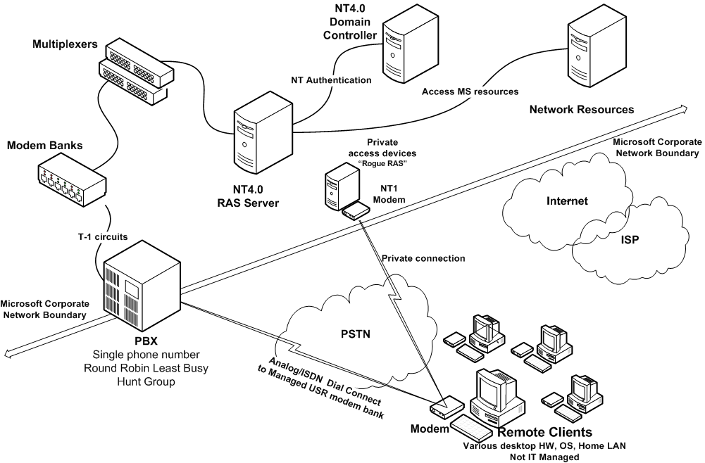
Figure 1. Remote access infrastructure circa 1998
Technology challenges during this period of time included:
- Inability to manage remote clients. The lack of established and enforced client computer standards, and no means to enforce management of the remote client software configurations as a part of the logon process, presented a potential security risk and increased support costs related to client computer usability.
- Lack of consistency across Microsoft IT organizations. To develop and deploy a more secure, predictable service for the enterprise, key organizations needed to share a unified vision and risk-based security framework.
- Lack of detailed monitoring, alerting, or metrics for analysis. To effectively manage the security, quality, and cost containment of a service end-to-end—as well as to improve the overall user experience—the Microsoft IT support teams needed to measure that service. Microsoft IT was able to monitor the basic aspects of server function, but not end-to-end service function and security status.
- Compatibility challenges. Solutions in place were built from many product parts, which lacked built-in feature integration capability in the client operating system, the server operating system, and third-party platforms. This lack of integration increased complexity and management.
- Unclear service management roles and responsibilities. Various groups within Microsoft IT struggled with unclear roles and responsibilities. The technology and process discussions to help secure and manage the service led to the evaluation of organizational responsibilities to support the service improvement initiative. This organizational alignment was a significant challenge because remote access consists of many unique dependencies supported by various functional groups in Microsoft IT.
Starting in late 2001 and finishing in February 2003, Microsoft IT undertook a top-to-bottom overhaul of the RAS infrastructure that included monitoring, alarming, metrics gathering, and the setting of new standards for client technologies and applications to access the network.
"MOF helps an IT organization in achieving high levels of dependability, predictability, and cost control for any service delivered by IT. MOF empowers an IT organization to expand services, raise quality, and reduce costs. The more complex the IT environment, the more MOF can help an organization achieve aggressive goals.”
Patrick Garwood
Senior Network Engineer
Microsoft Corporation

To improve security, users would be required to use a smart card and run client-based, remote access management software (a customized version of Connection Manager) to initiate a connection to a VPN remote access server across the Internet. This customized version of Connection Manager also includes settings for connections through Microsoft IT—managed dial-up network routers.
The new solution takes advantage of the flexibility of the Internet as a key part of the design, and as a means of providing a direct dial-up component to connect users to the corporate network from hundreds of locations worldwide. The solution is fully integrated with the global Microsoft corporate network.
In parallel to these technology upgrades, Microsoft IT began a phased implementation of MOF to help manage the upgrade and service improvement projects. In hindsight, the implementation of MOF should have begun a year earlier, and the RAS teams learned some important lessons that will be shared throughout this paper.
The goals of the multiple RAS upgrade projects and the implementations of MOF were to:
- Improve security for all remote connections to corporate resources by removing all non-Microsoft IT RAS access points globally
- Improve reliability and predictability of the service
- Measure and report on the service, end-to-end, in detail
- Reduce the overall cost to deploy and operate the service
- Meet current and future business needs
- Improve client satisfaction
As a result, the improved RAS solution deployed would differ significantly from the solution in place from 1998–2001, in service management approach, technology used, functional design, and relevance to Microsoft business strategies. As of this writing, the RAS environment includes:
- Approximately 150 managed direct-dial numbers.
- More than 500 managed Remote access Over the Internet (ROI) phone numbers.
- 92 managed VPN edge servers.
- 45 managed Internet Authentication Service (IAS) authentication servers using RADIUS.
- 18 stand-alone Cisco direct-dial devices.
- 51 direct-dial modules on shared Cisco network devices.
Figure 2 depicts the integrated technologies deployed (as of this writing) in the Microsoft IT remote access infrastructure. This diagram does not show, but assumes core Microsoft IT infrastructure components are in place, such as proxy servers, domain controllers, the Microsoft Active Directory® directory service, core network elements, and Internet egress.
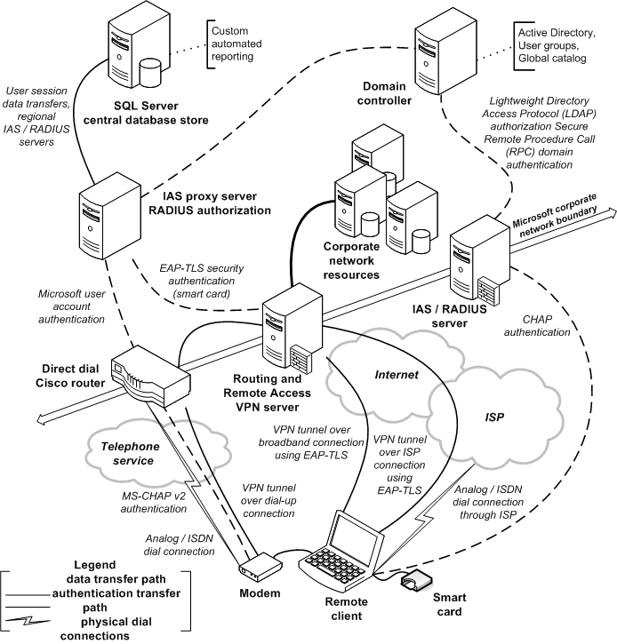
Figure 2. Remote access infrastructure at Microsoft circa 2004
In 2001, Microsoft IT launched a corporate-wide initiative to incorporate a more disciplined service management structure and process for delivering IT services. The key drivers for the service management initiative implementation were:
- Real-Time Availability. Knowing the service status 24 hours a day, 7 days a week.
- Status Communication. Service status reports to key stakeholders.
- Capacity. Trends for the service that affect service performance or data storage.
- Usage. Knowing who and what uses the service.
- End-user requirements. Monitoring and managing end-user needs.
- Risk. Communication and management of service risk
As of this writing MOF is the management vehicle for the Remote Access Service inside Microsoft. The external dependencies, cross-organizational support, cost containment and reduction, quality of the service delivery, and metrics gathering and reporting are all today effectively managed, in some degree, by MOF principles and processes.
Deploying MOF
As the use of Microsoft enterprise server platforms for mission-critical production systems continues to grow, so has demand for guidance in operating those platforms cost-effectively to achieve increased reliability, availability, and security. MOF was created by Microsoft to provide this guidance to help its customers achieve the maximum possible reliability, availability, and security on Microsoft platforms.
Remote access at Microsoft is a service that has many internal and external dependencies, as well as many external influences that can drastically impact the user experience and increase the cost of delivery. MOF provides the structure, the discipline, and the thought processes to help Microsoft IT manage these inputs to the service and significantly reduce opportunities for negative impacts.
The Microsoft IT RAS solution seeks to make the user experience on a remote access session virtually indistinguishable from a corporate-connected LAN experience in accessibility, security, and performance. Without a disciplined support model in place across organizations, the service quality and total cost of ownership goals simply could not be met.
The project to improve RAS using MOF had three principal drivers:
- Drastically changing internal business demands. RAS was quickly evolving into a strategic business-enabling service used to enhance mobility and reduce business unit costs to achieve business goals.
- TCO to support the current and growing business demands was unacceptable. The cost of the service was quickly escalating, and there was no day-to-day structure, long-term vision, architecture, or design.
- Evolving security requirements and support processes could not be achieved effectively without MOF to structure the approach and provide the process discipline.
In the early stages of the project, Microsoft IT only applied certain sections of MOF to RAS. In hindsight, the RAS team should have more aggressively applied MOF up front, prior to the major infrastructure upgrade development and deployment projects. Applying MOF from the beginning would have improved the execution of both the RAS improvement project and the follow-on improvement projects for other IT services.
Establish a Service Management Framework
The RAS improvement project team began by establishing a structure for the project teams, roles, and processes. They established a mission statement for RAS that included:
- Operate a unified, cross-discipline operational infrastructure for Microsoft, providing world-class availability, reliability, and cost effectiveness.
- Provide a seamless client interface for the RAS support disciplines, with the first point of entry for all users being the Helpdesk.
- Provide feedback to the product development groups for continuous product improvement.
- Proactively identify opportunities for operational improvements through rigorous self-assessment and tuning.
The team identified several process changes that were key to success. These included:
- The service owner must be accountable for the service. The service would be explicitly owned end-to-end by the Service Manager or the Operations Manager, including all areas not within the direct control of the owner.
- The service owner would need to successfully influence areas outside of their direct management control to ensure the quality and stability of the service delivery.
- Even though Microsoft IT does not operate on an internal “charge-back” model for RAS, the organizations supporting and delivering the IT service would approach the end users as if they were paying customers.
- Services would be monitored and measured in detail, end-to-end, and not simply by observing the individual components. Service health “Dashboards” would be developed to capture key performance, cost, and user satisfaction metrics for regular reporting and analysis.
Define Goals
Next, the team defined the core service management goals:
- Provide global infrastructure management and break/fix support for all RAS services across the Microsoft enterprise (Tier 1- 4 engagement model).
- Support Tier 1 Helpdesk and Tier 2 Data Center Operations teams through consistent training, documentation, process standards (compliance globally), and established communication and interaction processes.
- Deploy Microsoft Beta and RTM products into the enterprise RAS environment, providing feedback to product development groups.
- Provide technical leadership for Microsoft, supporting security tactics and strategy, application development, end-to-end performance optimization, Business Continuance/Disaster Recovery, and RAS best practices.
- Continuously seek and identify opportunities for operational improvements through rigorous self-assessment, leveraging operational metrics, reports, and post-incident reviews.
- Continue to improve operational expertise worldwide, through the RAS Virtual Team, for consistent support processes globally.
- Use a standard ticketing system and taxonomy across regions and teams to control costs.
Baseline for Service Level Agreements and Operations Level Agreements
A Service Level Agreement is a contract between the service provider and the individual or business units (end users) consuming the service. To be able to successfully meet the obligations of any SLA put in place, the RAS Team first needed to establish Operations Level Agreements (OLAs). OLAs are contracts between supporting IT service organizations that set expectations for the service owner. The RAS Team began by first putting tools and procedures in place to support the initial measurement of the systems, processes, and operations levels. Baselining the environment in this way gave the organizations involved in maintaining SLAs specific areas to target for improvement, including:
- Reduced support costs overall
- A cohesive “steady-state” support model
- Real-Time Availability. Knowing the service status 24 hours a day, 7 days a week.
- Status Communication. Service status reports to key stakeholders.
- Capacity. Trends for the service that affect service performance or data storage.
- Usage. Knowing who and what uses the service.
- End-user requirements. Knowing what the end-user really needs.
- Risk. Communication of risk related to the service.
- Quick disaster recovery ability, worldwide, for business continuance
- Continual improvement of tactical Operations Support model and strategic Service Management processes
The following are examples of specific SLAs and OLAs for RAS at Microsoft:
- Tier 1, Helpdesk Call Center
- 75 percent of calls answered within 60 seconds. (SLA)
- 85 percent of service requests resolved within 60 minutes. (SLA)
- 80 percent of all service requests resolved at the Tier 1 Helpdesk call center. (OLA)
- Tier 2, 24 x 7 Data Center Operations Team
- For Priority 1 escalations, respond within 15 minutes and resolve within 4 hours. (OLA and SLA)
- For Priority 2 escalations, respond within 15 minutes and resolve within 12 hours. (OLA and SLA)
- 80 percent of all infrastructure trouble tickets or Tier 1 escalations resolved at the Tier 2 Operations Center. (OLA)
- Tier 3 Operations
- 5 percent or less trouble tickets reactivated after being closed. (OLA)
- 80 percent or greater trouble tickets will be proactive. (OLA)
- 90 percent of trouble tickets will be resolved within SLA. (SLA)
Establish a Virtual Team
Virtual teaming is a common way of working at Microsoft, especially for technology deployments. Virtual teams are made up of people from across Microsoft that communicate with each other largely through e-mail and other collaborative technologies, such as Microsoft SharePoint™ Team Services and SharePoint Portal Server.
The RAS virtual team operates the service in relation to the standard Microsoft IT support model:
- Tier 1 provides direct client support, serving as the first entry point for users into IT.
- Tier 2 provides central 24 x 7 Data Center Operations, including: monitoring, emergency response, incident management, evaluation and escalation. This tier is supported by Regional Operations teams located in regional data centers and by Site Services teams globally.
- Tier 3 provides service management and integration of new designs or technologies into the production IT environment. This team is responsible for training, documentation, standards development and adherence and overall ownership of the service end-to-end.
- Tier 4 provides IT Engineering, system and software debug and triage, and is responsible for Microsoft product development or integration, and engineering and support for third-party products.
The project leaders structured the virtual team with the roles and responsibilities shown in Table 1.
Table 1. Microsoft IT RAS virtual team roles and responsibilities.
Role | Responsibilities
Service Owner | Accountable for the service; responsible for coordinating and communicating across groups to drive operational excellence into the service.  Investigates and evaluates client requirements for the service; investigates and understands significant problems, trends and root causes of systemic issues, and drives plans to resolve the highest priority issues.  Defines success for the service and creates objective, quantifiable metrics to measure that success.
Regional Virtual RAS Team members  (an extension of the central RAS Team) within each region | Available 24 hours a day, 7 days a week.  Single points of contact for regional RAS issues within their time zone.  Attends virtual team conference calls and RAS Technical Status meetings.  Assists in planning for the region’s Remote Access capacity.  Addresses telecommunications-related issues and manages spare parts shipping and customs within their region.  Works collaboratively with the regional Account Managers as service experts and acts as the point of contact for the service manager in issue resolution and communication with end users.  Assists in communications with the regional operations teams.
Central operations team | Creation and management of training, support documentation for Tier1 and Tier 2, Web page content for FAQ and self-help.  New technology deployment, feedback loop to Microsoft product development groups and “dogfood” participation for engineering.  Centralized system administration, monitoring, and alarming.  Remote metrics gathering and reporting.

Figure 3 is a visual representation of the operations and service management support structure that shows the ticket escalation and communication flow. This model blends MOF role clusters (Release, Service, Infrastructure, Support, Operations, and Security) into an integrated virtual team with well-defined roles, functions, and capabilities. The figure also shows the virtual team groupings and touch points within each group category, or tier.
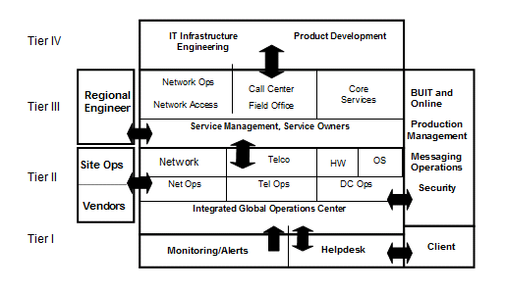
Figure 3. Microsoft IT escalation model
MOF Process Model Quadrants
In MOF, operations activities are defined and grouped into quadrants, each of which is focused on a particular set of processes and tasks. Significant milestones in the operations life cycle are represented by operations management reviews, which are major decision and review points in the Process Model. The processes are typically quite specific and prescriptive toward a single activity; for example, capacity management or help desk functions.
Each of the quadrants in the Process Model has a unique mission of service that is accomplished through the implementation and execution of underlying operational processes and activities contained in the Service Management Functions (SMFs).
The four MOF quadrants, with their associated SMFs are illustrated in Figure 4.
Figure 4. MOF Process Model and SMF Map
Changing
The goal of the Changing Quadrant is the effective introduction of approved changes into the IT environment quickly and with minimal disruption of service. Change is defined as changes in technologies, systems, software, and hardware, as well changes in processes, roles, and responsibilities. The Changing Quadrant includes the SMFs required to identify, review, approve, and incorporate change into a managed IT environment.
Operating
The goal of the Operating Quadrant is the highly predictable and reliable execution of day-to-day IT operations tasks, both manual and automated. The Operating Quadrant is responsible for the deployment of released service solutions and includes the SMFs regularly applied to service solutions to achieve and maintain service level commitments.
Supporting
The goal of the Supporting Quadrant is the timely and effective resolution of incidents, service requests, and problems for end users of the IT services provided. The Supporting Quadrant includes the SMFs required to identify, assign, diagnose, track, and resolve incidents, problems, and service requests within agreed service levels.
Optimizing
The goal of the Optimizing Quadrant supports running IT operations to achieve RAS business success in the competitive marketplace by focusing on two fundamental elements of operations; business focused service level management and awareness and management of service delivery costs.
Team Roles within Process Model Quadrants
The MOF Team Model provides a flexible set of guidelines for organizing effective IT operations teams, and it is based on the experience that an operations team must achieve a number of key quality goals to be successful. The role clusters of the Team Model define seven general categories of activities that share a common goal, with communication and information sharing at its hub.
The roles within the MOF Team Model and their functions in the overall service management life cycle align with the MOF Process Model by quadrant. The Process Model quadrants are parallel, not linear, and therefore multiple roles can be, and often are, involved in each quadrant depending on the team and the system. Each role can also take part in more than one quadrant at the same time, if that role is involved in the service management of multiple systems.
The seven distinct role clusters are Release, Infrastructure, Support, Operations, Service, Security, and Partner. Each of these clusters encompasses specific responsibilities within each cluster role
Figure 5 shows the MOF team model and its roles.
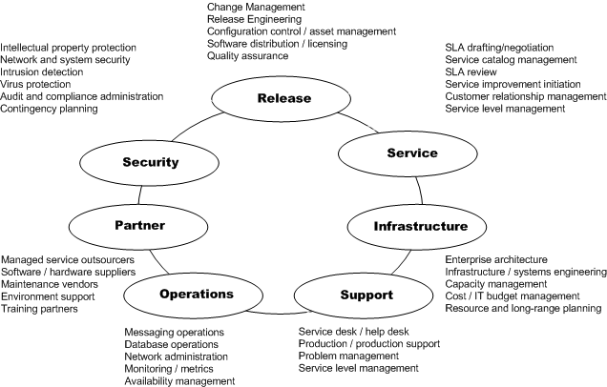
Figure 5. MOF Team Model
The objective of this model is to accurately map out and present the team structure supporting a service, providing a simplified view of team roles. This model can help management focus on organizing groups and people efficiently to optimize headcount, man-hours, and technical expertise to maximize the effectiveness of available resources in support of service delivery.
Support Role Cluster
The support role includes the Service Desk, incident management, and problem management functions, all with the goal of timely, accurate, and efficient support to customers.
Operations Role Cluster
The Operations Role comprises the Tier 2 Data Center Operations team, which is supported globally by the Regional Site Operations team, Regional Operations Engineering and Implementation, and Tier 3 Central Operations teams.
Infrastructure Role Cluster
The Infrastructure Role Cluster includes Site Operations, Regional Site Operations, Facilities, and Manageability Tools Team. This cluster team is responsible for the management of physical environments and automated tools. The role functions of these Microsoft IT teams are focused on ensuring physical site stability and capability to house systems; leading edge automation to ensure effective monitoring, alerting, and ticketing; data storage and reporting; and to make certain these elements are cost effective.
Release Role Cluster
The Release Role Cluster includes Tier 4 Engineering, Tier 3 Central Operations Support, Regional Engineering, IT Client Development Team, Security Development Team, and Microsoft Product Development. This cluster facilitates the introduction of software and hardware into the managed Microsoft IT environments, including live production and pre-production environments, with the goal of ensuring successful deployment of changes with minimal business disruption.
Security Role Cluster
The Security Role Cluster is led by the Microsoft Security group and plays a very important and mission-critical part in all IT activities, ensuring the confidentiality, integrity, and availability of data. For example, this cluster sets the strategy, requirements, and enforces security system and process adherence for RAS.
Partner Role Cluster
The Partner Role Cluster is a broad collection of IT partners, service suppliers, and outsourcers who work as virtual members of the IT staff in providing hardware, software, networking, hosting, facilities, and support services. Some of the team functions associated with the partner role cluster in support of RAS includes Internet service providers (ISPs), Telco (domestic and international), equipment manufacturers, third-party integrators, vendor project management, and supply chains.
Service Role Cluster
The Service Role Cluster owns the overall end-to-end management of and is accountable for a specific service across organizations. This cluster is responsible for the operations representation in the design and deployment of the solution as well as the operations aspects of the solution.
Apply MOF Models to RAS Service Management
The Microsoft RAS team now had the foundational planning in place for the initial application of MOF to RAS. The basic fundamentals, tactics, and strategic goals were agreed to by all of the stakeholders, clearly communicated to all of the management and service support teams, and the active application of MOF to the service began.
It is important to note that one of the most valuable concepts of MOF is flexibility. The core plans and concepts stay in place throughout the RAS upgrade projects and continue to expand, but the MOF elements can be reprioritized or modified to quickly address new challenges driven by operational changes or project impacts to the service.
Owning the Service
One of the most important steps the RAS team took was to unequivocally own and be accountable for every aspect of the service. With this mandate, the team treats the service like it is their own independent business and the users are paying customers.
The first step was to establish a global virtual team whose members would each own a stake in the success and outcome of RAS worldwide. Once the teams were established, they began a broad two-way communication campaign with end users, business units, and product development groups to clearly explain the short- and long-term objectives to deliver a more robust, stable, secure remote access solution.
The RAS virtual teams then designed, tested, and deployed an initial solution that was robust and superior to the unmanaged devices that users had deployed privately. That meant Identifying all “rogue” devices or access points globally and setting firm dates to remove these devices, thereby bringing all remote access under Microsoft IT management and control. To take full ownership and accountability for the service, IT needed to ensure that all devices that had previously contributed to a users’ poor perception of the service were removed. This step would also reduce the security “attack surface” by only having IT-managed devices in the infrastructure.
Finally, they begin to enforce the use of connection management software as part of the management of the service. Initially, the software would manage only the global telephone numbers and establishing connections, but this application would set the stage for managing future enhancements and security requirements while enabling users to become familiar with the technology.
Determining Key Service Management Functions
SMFs are processes and policies that are applied across service solutions in the management of IT services. Examples are change management, system administration, and Service Desk. In this section, we will present the key SMFs that are at the core of formal OLAs.
In determining the initial SMFs for RAS, which are essential to support viable cross group OLAs, many factors were considered. One of the most important considerations was prioritizing which SMFs would be developed, implemented, and improved first. The initial SMFs for RAS were based on the need to get the most value and impact out of the early implementation of MOF and to make the MOF goals manageable and attainable. You can view the complete list of SMFs at http://www.microsoft.com\MOF.
The initial SMFs, in order or importance were:
- Changing: Change Management; Configuration Management; Change Control; Release Management
- Operating: System Administration; Service Monitoring and Control; Network Administration; Security Administration; Data Collection and Reporting; Problem Management; Service Continuity; Business Continuance and Disaster Recovery
Changing
Changes in any IT environment—if the process is not carefully managed, documented, and reviewed—will drive incidents up, client satisfaction down, and increase the cost to deliver the service. The goal of the Changing Quadrant is the effective introduction of approved changes into the IT RAS environment quickly and with minimal disruption of service. Change is defined as changes in technologies, systems, software, and hardware, as well as changes in processes, roles, and responsibilities.
Change Management
The Change Management function manages all changes in the IT and RAS environments, and ensures that changes are recorded and tracked. Change management also attempts to identify all affected systems, processes, and parties before the change is implemented in order to mitigate or eliminate any business disruption or adverse affects. This is especially relevant to RAS. For example, RAS is dependent on many areas of IT function, such as network connectivity, Internet egress, Domain Controllers, Active Directory, and security PKI certificates and services. RAS is disrupted if change management activity disrupts any of these dependencies.
Configuration Management
This SMF is responsible for the identifying, recording, tracking, and reporting of components of the RAS environment. The three main goals of configuration management are to ensure that:
- Only authorized Configuration Items (CIs) are used in the RAS environment.
- All changes to CIs are recorded and tracked throughout their life cycle.
- The relationship between the CIs is documented and accurate.
Control
Implementing processes and tools to control how every change takes place in the RAS environment was instrumental in improving service stability. The RAS team implemented strict rules to control changes that affected RAS infrastructure, including the service organizations for dependencies.
For example, a Change Control application was developed to capture and track all infrastructure change information. The application uses a form of a Request for Change (RFC). For example, for each RFC the application captures:
- Work category, such as network, Active Directory, security, or facility.
- Work type, such as planned with major outage, routine/project work; emergency change; customer initiated change.
- Four approval categories: Auto approve; Functional/Direct Manager approval; Change Approval Board (CAB) approval (change owner must present to the CAB); Emergency Change Approval Board (ECAB) approval (change owner must present to the ECAB or designated emergency approver).
- Start and stop date/times
- Site, and impact to user, site, or service, including affected business units
- Primary and secondary escalation contact
- Comments form
This application and process forces anyone performing a change in a production IT service environment to think carefully and research the change, understand the impacts, and attain approval from the proper person or group to implement the change.
The Change Control application also provides an e-mail notification subscription function as a benefit to business owners, allowing individual users, business units, or other service organizations across Microsoft to subscribe to various categories of IT change. Any changes entered in selected categories will send the subscribers a Change Control e-mail for the custom subscription categories that they have selected. For example, a person can subscribe to all Network changes, or all RAS changes, or all Facilities changes. This flexibility provides the user with an opportunity to engage IT if the proposed change would cause unacceptable impacts to the business.
Figure 6 shows an example screen shot of the Change Control application.
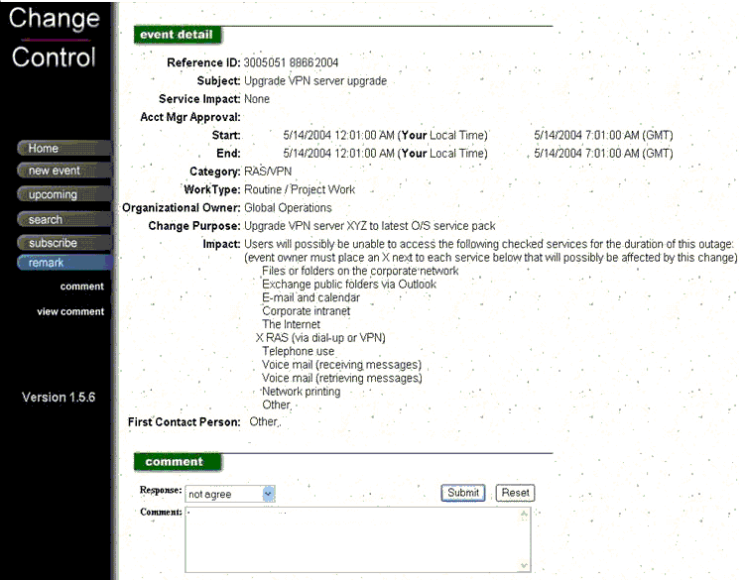
Figure 6. Example Change Control application screen shot
Implementing Change Management led to a significant reduction in RAS client trouble tickets. Initially, ticket requests went as high as 15,443 a month during the period of most significant and frequent change. Just ten months later, with changes carefully scheduled to avoid overlap, and MOF concepts and principles fully adopted and in practice, tickets have been reduced by approximately half, to just over 8,000 per month and on a downward trend.
All changes entered into the Change Control application are documented, from the initial request entry through approval and all stages of the change. Because of this documentation, there is a “trail” for anyone to review in analyzing the success or failure of any change activity. Teams can review historical change success, review past changes for details of the change or linked documents, or look at upcoming change events and status.
All changes are reviewed at each stage, from the initial request through implementation to post-incident analysis, if necessary. A change request is either auto-approved based on previous review, approved at a functional or Direct Manager approval level, or for more complex, non-standard changes, they are approved by the CAB with emergency change requests going to the ECAB. Any CAB or ECAB change request reviews submitted must be presented in person to these boards by the person owning the change.
Configuration Management
Because of the high rate of change to the IT environment driven by product testing, configuration was at the top of the problem list driving RAS trouble tickets. Hardware was at different operating system versions, patches, and memory levels, and server hardware was often not uniform in terms of age, components, or capacity.
Enforcing server standards for software, hardware, and firmware eliminated a high degree of service instability immediately. Microsoft recommends having all configuration standards and baseline measurements in place before going forward with a service improvement project. This step will help remove confusion or false paths when trying to figure out problems in a variable environment—when problems do arise, they will occur across the whole network. This means a fix for a bug or integration issue can be developed and deployed much quicker.
Managing the myriad of configurations across IT technologies and systems that make up a service is a challenge. The amount of change in an environment will impact the ability of a support group to accurately manage configurations on systems, thereby impacting the accuracy of the data. The Microsoft IT organizations follow strict configuration management processes, using an internal tool called the IT Configuration Database (ITCDB).
This tool and the data are used to:
- Build servers and enter required information.
- Track information about server location, configuration, owner, contacts, and support service level.
- Retrieve critical information about a server.
- Define LANs to be used for distribution of static IP addresses for production servers.
- Determine capacity that is used and available in key Data Centers, with respect to power, rack space, and network data ports
The following processes were implemented for RAS and dependent services to support configuration management:
- Review and baseline configurations to set basic standard configuration specifications for RAS production systems and related service systems.
- Expand configuration entry requirements over time to capture additional configuration information to improve service support.
- Maintain parity across similar systems and technologies within RAS to remove variables in configuration that can cause disruptions when changes or troubleshooting takes place. Removing configuration variables contributes significantly to improving the overall manageability of any service by maintaining consistency from top to bottom.
- Audit the ITCDB against systems regularly to ensure service owners and delegates are maintaining the data entries in the required fields, adhering to process requirements. Auditing keeps the data accurate and relevant.
The ITCDB contains fields for typical infrastructure server configuration information and provides the operations teams with several functions, including:
- Quick retrieval of critical server information with linked documents for troubleshooting or technical specifications for the specific server, easily accessible to an ITCDB user. This facilitates quick troubleshooting and issue resolution.
- Means for a quick inventory status.
This configuration database is a key element in the operations support structure across all server environments, and the information the database quickly provides support information to all tiers. Sample required fields in the ITCDB for IT-supported devices are shown in Table 2.
Table 2. Sample IT Configuration Database fields.
Category | Value
DC Server | Yes/No
Server Category | Production/Test
Server Name | RAS123
Serial Number | 123abc789xyz
Asset Number | 5551212
Model/Type | Compaq Proliant DL380
Building | Headquarters Data Center 1
Rack | 25
Mission Critical | Yes/No
Server Domain Name | Domain XYX
Maintenance Window | Friday 4:00PM – 7:59PM
Monitored By | Client
Cost Center | 123456789
Business Unit Sponsor | IT Services
Contact Information | 24 x 7 Operations
Coverage Window | 12:00AM – 11:59PM
Release Management
Release management facilitates the introduction of software and hardware releases into managed IT environments, including live production and managed pre-production environments. The goal of release management is to ensure the successful deployment of changes into the IT environment with minimal business disruption.
Release management reviews incorporate two types or reviews:
- Release-based (release readiness and release approved)
- Time-based (Operations and Service Level Agreement)
Each process quadrant has an associated Operations Management Review (OMR):
- Changing: Release readiness review
- Operating: Operations readiness review
- Supporting: Service Level Agreement review
- Optimizing: Change initiation review.
The product development teams at Microsoft have long adhered to strict guidelines for development, and equally strict requirements for managing the release of new products. Microsoft IT, although having many elements of release management in their processes, has not always adhered to strict requirements. The RAS Team, as part of the service management improvements, adopted a more rigid release management process in three key areas:
- Development and release of all RAS client software or applications.
- Release of all RAS infrastructure components.
- Release of all infrastructure designs introduced into the production RAS service.
The Release Ready Review is the OMR in the Changing Quadrant and determines if the release is ready to go “live” and become fully operational in the target environment.
An example process path to prepare for a release readiness review for a client application upgrade is shown in Figure 7.
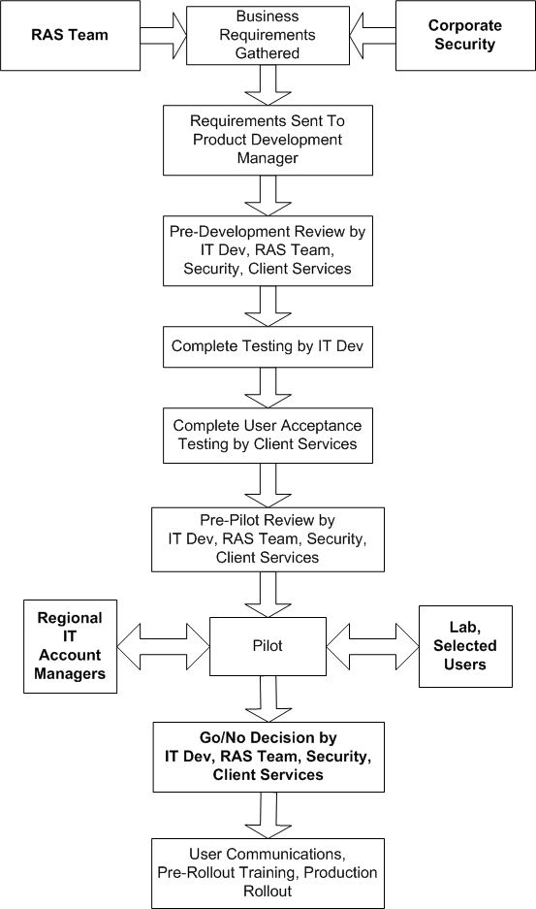
Figure 7. Sample Release Ready Review process flow
These formal release management procedures, with the built-in checks and balances, have improved the stability of the service during changes, including predictability and awareness for users, as well as reduced costs associated with minimizing service disruptions for business units.
Operating
The goal of the Operating Quadrant is the highly predictable and reliable execution of day-to-day IT operations tasks, both manual and automated. The Operating Quadrant is responsible for the deployment of released RAS solutions and includes the SMFs regularly applied to RAS and IT solutions to achieve and maintain service level commitments.
System Administration
Responsible for providing day-to-day administrative services in support of the production RAS environment. This SMF involves managing and providing operational support for elements such as network connectivity, Internet egress, accounts and network resources, patching, and overall server and infrastructure health and stability. System administration staff may also assist or work with other SMFs by providing basic monitoring services.
The team tasked with this SMF is responsible for producing operations documentation standards adherence; up-to-date technical and contact content; the most current processes and procedures; clear roles and responsibility matrix, as well as current and accurate configuration information.
Service Monitoring and Control
Allows the operations staff to observe the health of RAS in real time. However, knowing the current health of RAS or determining that a service outage may occur is of little benefit unless the operations staff has the ability to do something about it, or at the very least notify the appropriate group that immediate corrective action is required. As part of the RAS service upgrades, the support teams put extensive efforts into combining automated tools such as monitoring, alerting, and automated ticketing, with rigidly structured and linked documentation readily available to support the 24 x 7 operations and Helpdesk teams. This SMF provides the critical capability to ensure that service levels are always in a state of compliance and that awareness of any problems are proactive rather than reactive.
Network Administration
Responsible for the maintenance of all of the physical components that make up the organization’s network. Network administration is a comprehensive discipline that involves the management of people, processes, procedures, technology products and tools, and vendors and service providers. The network elements are the foundation upon which the RAS services are delivered, and improving the coordination of network changes and administration has added another layer of stability and reliability to the service.
Security Administration
Sets strict requirements for remote access and enforces them, including leveraging the internal PKI infrastructure for certificate management and tight certificate management and control. The security team performs routine and random security scans, enforces configuration compliance on RAS servers, provides and requires training in security awareness and adherence for IT personnel, and manages broad communications to end users to raise awareness.
Data Collection and Reporting
One of the most critical areas of supporting any service is the ability to capture meaningful data that will lead to an actionable activity. There is much data that can be collected from many sources within most service support functions. The key is not to just collect data, but to collect the correct data. For RAS, the team began by identifying the data needed to analyze and establish baselines, identify problems, and begin to stabilize the infrastructure.
The data collected includes:
- Helpdesk and Infrastructure ticket trends with basic categories, including: total trouble tickets, ticket priority (Immediate, High, Normal), percentage of tickets reactivated, and tickets closed within SLA.
- Basic server health and stability trending, including: reboots and reboot annotations (reason), configuration database compliance (hardware configuration and updated operating system version), server system inventory (for capacity planning, and hardware consolidation projects).
- Long-term trending to identify problems based on incidents, and track the effectiveness of the remediation plans.
From this initial identification of meaningful data, the IT Management Tools organization, along with other groups, worked with the Operations and Engineering teams to implement tools to efficiently automate the capture and storage of basic data, while developing the tools to gather and report on data stored in increasing detail. This data collection and tools development process led to creation of the service “Dashboard” to give a team essential data, in an easy-to-read format. The dashboard Web site data presentation layer uses Online Analytical Processing (OLAP) cube technology to present the data in a number of different user-defined views. For example, Figure 8 shows a dashboard report for 90-day trend of trouble tickets, segmented into client tickets versus server tickets.
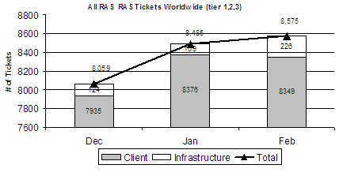
Figure 8. Sample categorized 90-day trouble ticket trend
Teams also use the dashboard to view long-term trending. For example, Figure 9 shows long-term trending of total RAS tickets to track how effective service improvement plans are over time, or how events, such as early product releases to internal users, affect overall ticket volumes.
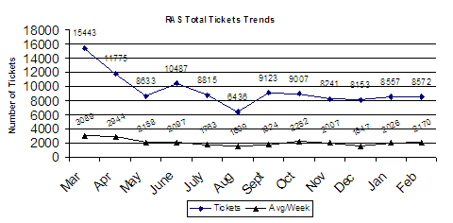
Figure 9. Sample 12-month trend
Figure 10 shows 90-day trending and in what priority area the majority of the infrastructure trouble tickets occurred. The goal is to see most tickets in the Normal category (Priority 3, least impact), or the Planned category (scheduled work). This chart provides a view into the number of seriously impacting issues versus the least impacting issues, and is one indicator of infrastructure health.
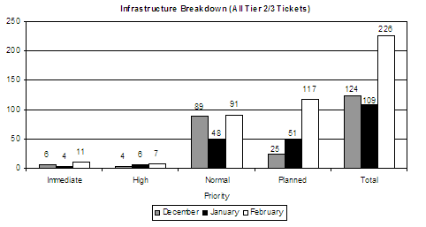
Figure 10. Sample 90-day trending of tickets by priority
Problem Management, Introduction of Six Sigma
Incident analysis helps identify the root cause of incidents, raises a RFC when needed, and ensures that all problems and known errors affecting the IT infrastructure are recorded and identified. This in-depth analysis is extremely valuable in determining specific service improvement focus areas. With this new level of detailed data available, the RAS service owner was able to use Six Sigma processes and tools to analyze and improve the service. The Microsoft Office Accelerator for Six Sigma was not available when the project started.
Six Sigma is defined as a rigorous approach to solving problems and improving processes by leveraging facts and data. Sometimes described as a philosophy, measure, or methodology—Six Sigma is all three. Using Six Sigma helped the service manager leverage facts and data to make service improvements and sustain the improvements over time.
Six Sigma is being used across the Microsoft IT organization as a complementary process to MOF. It gives organizations the tools to eliminate defects, remove variations in an operations environment, and drive repeatability and predictability in any service organization.
Different teams use the same data provided in the RAS dashboard to achieve different goals within the service support framework. For example, Table 3 shows some of the detail used in tracking of monthly trouble tickets. Six Sigma is used in forming and implementing targeted action plans to attack very specific problem areas.
Table 3. Sample Problem Management Ticket Cause Report
Combined Issue List - February | Count | %
Smartcard Pin Reset | 1579 | 19%
Installation Assistance | 1117 | 13%
Performance Issue | 589 | 7%
Configure Assistance | 564 | 7%
Certificate Issues | 447 | 5%
Activation Assistance | 356 | 4%
Exception - Other | 345 | 4%
eTrust Issues | 236 | 3%
Error 769 - specified destination | 186 | 2%
Help configure | 166 | 2%
Installation Assistance | 160 | 2%
Install Error / Failure | 156 | 2%
Remaining Issues  (110 other categories) | 2458 | 29%

As each new phase of the updated remote access service was implemented, Six Sigma was used to analyze ”critical to quality“ metrics and target the action plans to reduce the incidents. For example, client trouble tickets were reduced from a weekly high of 3,323, tickets to a low of 1,609. As security certificates began to expire in September, tickets increased as users contacted Helpdesk to renew their certificates—a normal yearly event. At about the same time, Smart Card PIN resets began to rise. A new Six Sigma project will analyze the data to pinpoint the true root cause of the issues behind this trend and determine if there is any correlation between the two issues.
The impacts of MOF and very focused Six Sigma driven actions plans on trouble ticket trends over time is shown in Figure 11.
To learn more about The Microsoft Accelerator for Six Sigma, go to: http://www.microsoft.com/office/solutions/accelerators/sixsigma/overview.mspx. You can download the Accelerator at http://www.microsoft.com/downloads/details.aspx?familyid=303C13E0-20A1-4680-BAA8-EE890D4668DB&displaylang=en.
You can also read a case study on how the accelerator has helped drive operational excellence inside Microsoft at http://www.microsoft.com/resources/casestudies/CaseStudy.asp?CaseStudyID=15029.
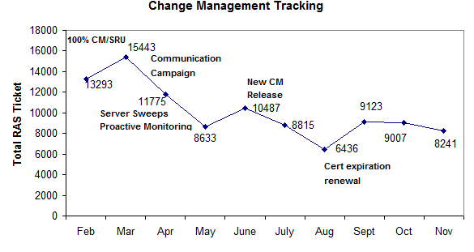
Figure 11. Long-term tracking of action plans being implemented
Service Continuity: Client and Server
Service continuity ensures that the IT organization can continue providing RAS or other services in the event of an unlikely or unanticipated event. Service continuity is accomplished by analyzing business processes, their impact on the organization, and the IT infrastructure vulnerabilities related to these processes.
Service continuance capabilities were crucial requirements in the redesign of RAS beginning in 2001. Service continuity was addressed in the two main categories that constitute the service: client service continuance and infrastructure service continuance.
- Client Service Continuance. There are many combinations of circumstances in which RAS infrastructure may be available and yet there can still be service disruptions affecting an individual user or a broader group of users. Alternative plans for the four top causes were developed, including:
- Alternative connectivity options are provided for general RAS connectivity issues. Microsoft Outlook® Web Access (OWA) provides e-mail access for employees who are using public or shared computers; Outlook 2003 (using the RPC over Hypertext Transfer Protocol feature) provides e-mail access; Exchange ActiveSync ® (EAS) provides e-mail access for employees using a Smart Phone or Internet-enabled Pocket PC; Outlook Mobile Access (OMA) allows users to browse e-mail on an Internet-enabled hand-held mobile device.
- For broken or lost Smart Cards, a tightly managed exception process is managed and monitored by the corporate security group.
- An externally facing self-help Web site is provided for employees needing to update application software and to troubleshoot and download the updates for the custom Connection Manager application.
- Infrastructure service continuance. The RAS infrastructure is a mixture of external services (ISP, Telco, Carriers) and internal services (network, Active Directory, Domain Controller, hardware, software, power, cooling). The design of the global deployment is predicated on addressing these dependencies to provide reliable service continuity:
- Servers are protected with redundancy, usually in server clusters of two or more, on separate power sources, sometimes in separate racks, sometimes in separate data centers for the larger clusters, and sometimes in separate data centers spread across regions.
- VPN servers are protected with load sharing, in a round-robin load distribution design for server failover and easy maintenance. Connection Manager software allows users to configure the connection location to an alternate access point. If their normal access number does not work, a user can change the number (nearest alternate) and retry the connection. VPN clusters are many-to-one RADIUS authentication servers but are configured with an auto second choice RADIUS server (closest in region) in the event WAN outages sever the first choice option.
- RADIUS authentication servers; servers are configured in load sharing pairs.
- Hardware and software on the Microsoft IT managed direct-dial routers have dual power supplies, and load sharing circuits.
The custom Connection Manager software allows multiple methods to connect by using one of the following:
- RAS; direct dial to an RAS-managed router (analog, ISDN), direct dial to a RAS-managed local ISP access point and then connect over the Internet (analog, ISDN)
- Direct dial to a personal ISP and then connect over the Internet
- Connect on a persistent connection (DSL, cable modem)
- Direct dial 1-800 connection, where available
Business Continuance/Disaster Recovery (BC/DR)
RAS plays a major role in larger-scale disaster recovery scenarios globally, supporting the Microsoft Corporation by insuring a predetermined level of business continuance will always be possible if major sites or regional personnel are not available. While many people think in terms of activating resources in a worst-case scenario, Microsoft has a specific RAS alternate data center that shares day-to-day RAS traffic loads, providing continuity for RAS services in general, and if needed, the continuity of Microsoft corporate business for key organizations in multiple large-scale regional scenarios. This alternate site is always running and sharing the real world load daily, not sitting as a standby warm or cold room requiring human intervention. It is always preferable to “exercise” a service that supports business continuance and disaster recovery as a live part of the service delivery. This built-in contingency design ensures that: the service is always working properly, the service components are in the normal upgrade and refresh path; the service needs no hands-on intervention in the event of a disaster, and it is very cost effective as there is no equipment sitting idly by, unused. The very nature of the global architecture also provides alternate connectivity options, either user-defined or an automated failover as a part of the service.
In using MOF for disciplined, repeatable processes, the RAS team has driven reliability, predictability, and efficiencies to a high level within the service, allowing decision makers to place RAS in this mission-critical BC/DR role. Without the stability and quality of service MOF produces, this strategic use of the service would not have taken place.
TCO
TCO is a key factor in the decision making process when choosing any technology investment to meet a specific business need, or to support a strategic business objective.
Cost for implementation of any RAS solution will vary based on many factors, such as the size of the user base for the service, geographical locations supported, and overall business objectives for performance and security. In this section, the TCO for the Microsoft RAS implementation is detailed and cost considerations that affect TCO are discussed.
The costs presented below illustrate the efforts of the RAS Team to capture all areas of RAS development, deployment, maintenance, and operational support that contribute to the TCO of the service. However, for planning purposes, these costs are simplified to a per user and cost per minute value. In this manner, the RAS Team can clearly present to Microsoft IT fact-based costing.
For TCO calculation purposes, Microsoft IT counts infrastructure costs for its RAS solution as shown in Table 4. Costs for Windows-based client computers, network bandwidth, and server software, installation, and maintenance costs are not included in this calculation. For example, Microsoft IT pays for internet egress with Microsoft MSN® on its dial infrastructure. Sharing the costs with MSN allows Microsoft IT to achieve rates that could not be negotiated based on the comparatively small call volumes Microsoft corporate generates for RAS usage.
Table 4. RAS infrastructure base costs.
Hardware Type | Total Cost
VPN Servers | $.55M
RADIUS/IAS Servers | $.25M
Microsoft SQL Server™ servers | $.129M
Dedicated Cisco direct-dial devices | $2M
Smart Cards and Readers | $1.5M
Total Base Cost | $4.429M
Virtual Private Network
The VPN server is the edge server device for RAS connectivity from dial devices, the Internet, or broadband connections. The VPN server establishes and authenticates the VPN tunnel that the client builds, and applies security policy as defined by the IAS (RADIUS) server. Security compliance checking is performed, and access policies modified per configurations based in the IAS (RADIUS) server. The VPN server assigns an additional Corporate IP address, DNS/WINS, and an additional default gateway.
Internet Authentication Service Radius
The IAS server receives the authentication requests from Cisco or VPN devices, and passes the authentication request to the appropriate Active Directory for user ID/password authentication. The IAS server administers Remote Access Policy upon receipt of an authentication acceptance.
Microsoft SQL Server (SQL)
SQL Server is used to store infrastructure system data and client-specific data that are related to individual RAS sessions. SQL Server runs on each of the RADIUS servers collecting specific session data and transfers the data to a central database store at scheduled intervals. SQL Server servers in the regional data centers receive data directly from client computers each time a user initiates a RAS session, and then these servers transfer this data to a central database store at headquarters. Automated reporting is then generated from the central database store for analysis. This analysis of the detailed data contained in these reports allows the operational support teams to determine with a high degree of confidence the overall health of the service.
Cisco Network Routers
Microsoft IT managed Cisco devices answer dial calls from the Public Switched Telephone Network (PSTN), which originate from the Microsoft RAS client. Calls can either be Analog or ISDN. The dial solution deployed at Microsoft shares existing network routers already in place by simply adding modem cards. This significantly reduced the cost to provide direct dial RAS for those areas where Internet access does not exist or is unreliable.
The infrastructure described above is all necessary to provide a flexible, robust service with many user options that allow Microsoft employees and contractors to work anywhere, anytime, and from many supported devices.
When the RAS Team applied MOF methodologies to the service in a more focused approach, they uncovered significant and immediate cost reduction opportunities in the infrastructure as indicated in Table 5.
Table 5. Infrastructure consolidation.
Server Role | Percentage Change | Before | After
VPN Server | -16% | 112 | 92
RADIUS Server | -12.5% | 48 | 42
SQL Server | 0% | 8 | 8
Dedicated Cisco direct-dial device | -12.5% | 18 | 16
Network W/RAS Modem Cards only | -6% | 51 | 48
For TCO calculation purposes, Microsoft IT makes the following assumptions:
- Service usage patterns and corporate expense policies will drive significant recurring costs. As an example, home line expense costs can range from $20-$50 dollars per month, per employee or greater depending on geographic location so this cost can be significant. These costs were not factored in to this TCO analysis.
- TCO only provides cost data. At Microsoft, the hourly value of a mythical “average employee” for return on investment (ROI) calculation purposes is $65 dollars. The value of the number of hours of increased employee productivity due to RAS access should be included in the benefits calculation. For example, employee satisfaction with the service improved by 25 percent, while unique RAS users increased by approximately 61 percent. As of this writing, 70-75 percent of Microsoft employees use RAS at least monthly.
- The cost of a potential security breach if the security-enhancing features of the deployment had not been performed should be factored in as part of the risk/cost analysis.
- RAS at Microsoft requires a Windows XP Professional SP 1 client and Windows 2003 Server. Software licensing costs were not factored into this analysis.
- Microsoft IT leverages the global Microsoft corporate network and MSN network, considerably reducing the LAN/WAN costs to provide RAS globally. Assigning a cost to the network elements in this design is imprecise but should be a factor in any cost analysis to deploy a similar RAS solution. Using existing network infrastructure may or may not be equally efficient when considering adding RAS traffic—customers should analyze capacity, egress, and per unit traffic costs.
- Historical data collection is key to capacity planning. In the past, Microsoft IT overspent on hardware because it lacked good capactiy planning. Savings attributed to better forecasting of hardware budgets going forward were not incuded as a benefit. Any data collection methods and associated infrastructure costs should be factored into the overall costs.
Implementing MOF has produced the ability to gain visibility into many aspects of the service that were previously unknown, and this insight has allowed the RAS Team to reduce operating costs in many areas over the period of March 2003 to March 2004, including:
- Headcount: 19 percent reduction in support headcount through automation, process improvements, and the structured support model.
- Helpdesk tickets: 47 percent reduction of RAS trouble tickets through improved incident analysis, targeted action plans for biggest cost drivers, process improvements, cross-team collaboration for release management training, readiness, and communication.
- Worldwide dedicated RAS circuit costs: 7 percent reduction due to detailed capacity analysis, circuit reductions based on traffic analysis, server dial router consolidations globally, and discounts enabled by better information on service usage.
- 1-800 RAS costs: 35 percent reduction due to improved performance of RAS over the Internet, user education on 1-800 toll costs to IT, and reduction in 1-800 circuits globally.
Taking these savings into account, Microsoft IT estimates a total net reduction in monthly RAS costs of 27 percent, driven by Helpdesk ticket reductions, circuit reductions globally, and toll-free price reduction. On a per-user basis, Microsoft IT estimates a total net reduction of 13 percent per RAS user, per year. Calculated as an average cost per user, per minute, Microsoft IT estimates it has saved 14 percent; a reduction driven primarily by renegotiated rates with the Microsoft carrier for 1-800 RAS services, improved RAS service over the Internet performance, and user education about RAS costs.
Total cost of ownership for RAS is forecast to continue to decrease over time with continued implementation of MOF. The operation support team’s constant analysis and self-assessment steadily improves operational support processes for ticket handling, alerting on events, and general knowledge transfer across support groups. The tangible costs for RAS directly related to tickets and less tangible user productivity costs have already been reduced significantly. As the end-to-end implementation continues to be tuned and stabilized, applying lessons learned, and user education continues across the user base for best practices for using RAS becoming routine, Microsoft IT expects to see continued TCO reduction.
Lessons Learned
According to industry studies, around 80 percent of unplanned enterprise server downtime is caused by users and process issues, while 20 percent is caused by technology failures and disasters. This holds true across service areas according to recent Microsoft research on levels of service management automation, as shown in Figure 12.
Figure 12. Degrees of IT automation
Improving availability requires a different strategy and set of investment choices—such as MOF—for each of the unplanned downtime categories. More than just infrastructure redundancy is required. To address the 80 percent of unplanned downtime caused by users and process failures (versus the downtime due to technology failures or disasters), enterprises should invest in MOF processes such as change and configuration management. Investments should also be made in automation. Other downtime causes should be addressed by eliminating single points of failure through redundancy, leveraging vendor service contracts with strong SLA penalties, and implementing component-level monitoring.
Application Failures
To reduce RAS downtime caused by application failures, enterprises should invest in improving and re-engineering IT processes. Based on the Microsoft IT experience with RAS, start with change management, problem management, and configuration management. Additionally, performance management and capacity planning proactively identifies current and future resource shortages impacting SLAs.
You should invest in people responsible for the procedures and the tools to facilitate process improvement as carefully as you invest in hardware and software. Solving redundancy-related failures does not require significant changes in human behavior. Solving process re-engineering failures usually does require changes in human behavior and can pose more of a challenge.
The Release Management process is the earliest stage at which application failures can be detected and corrected. Disciplined MOF-driven development processes, including rigorous testing using real world production infrastructure or emulated production infrastructure, with key management reviews, will reduce or eliminate most application failures when making changes in this area.
Systems
To improve the capabilities and robustness of systems and system designs introduced into the production IT environment, all efforts should begin with disciplined development processes and concise hand-off requirements. The core elements for shaping these processes are:
- Understand the business goals of the development efforts. Gather business requirements, understand what the desired outcome will look like, and form a consensus that these requirements are accurate.
- Replicate the production environment at a fractional scale, if possible, in a controlled lab setting with the capabilities to employ all elements of the production service delivery. This lab setting will quickly help separate the system, operating system, or application issues from issues that may be related to scale or capacity thresholds.
- Remove variables from the systems by implementing and following rigid configuration management processes, including the means to capture, store, and audit configurations on a regular schedule for adherence monitoring.
Networks
Consider network bandwidth constraints before modifying core IT services such as RAS. It is likely that the network was designed with different assumptions, and the risk of business disruption must be carefully managed. For example, if your IT organization has chosen to deploy worldwide remote access by using your existing internal network and Internet access points, your engineers should analyze Internet egress capacity and capability at the access points and across internal network segments between remote users and the corporate resources they need to access. Specific business-related applications and tools, or the routine transfer of large files and e-mail with attachments, may overrun certain segments of the existing network not designed for these traffic loads and usage patterns.
Using MOF as the structure, determine what network elements are to be measured relevant to RAS, what tools to put in place to capture the right data, and implement the processes and procedures to analyze the data regularly with repeatable routines for real time, near real time, and historical analysis. For example, specific measures pertaining to RAS include: shared routers monitoring and alarming, internet egress, and proactive auto-generated synthetic transactions to measure end-to-end status.
Share information within and across the frontline support groups (Helpdesk, Network Operations, Regional Operations) so each group better understands topology, shared resources, dependencies and shared impacts. This practice produces improved cross-service awareness for changes or events.
Egress
Microsoft IT leverages Internet egress pricing generated in part by MSN, established by the traffic on their dial infrastructure. This allows Microsoft IT to receive rates that could not be negotiated based on the comparatively small call volumes Microsoft corporate generates for RAS usage. You should look for areas of the enterprise network that are underused to leverage existing resources for cost containment, share resources where possible, and look for hidden opportunities. Based on the Microsoft IT expereince, the peak usage for RAS is almost always the opposite of the peak usage times for the core network.
Microsoft employs custom tools that measure ISP key performance indicators and specific threshold flags. If an ISP does not see the problem, Microsoft IT holds them accountable with remedies built into SLAs.
Service Level Management
The mission of service for this quadrant is to reduce costs while maintaining or improving service levels. This is accomplished through the management and negotiation of service levels and the evaluation of several key operational metrics in the managed environment. With a thorough evaluation and subsequent understanding of these operational attributes, the IT staff supporting RAS moved from simply "running" systems or devices to proactively managing a service solution:
- Planning is a key focus of this quadrant; you should look as far as possible into the future to align with changing business priorities. For example, Microsoft IT was initially caught off guard by the increased integration of RAS into core business models and the critical role RAS played in many of those scenarios.
- Service Level Management for RAS aims to assure that expectations between the IT organization and customers/users are properly set, and that required service levels are maintained. To this end, a service organization needs to clearly understand the typical user, know what the user needs, and know the business units goals and objectives.
- The RAS Tier 3 operations team is responsible and accountable for service level management for RAS and ensures that commitments in SLAs, Operational Level Agreements (OLA), and Underpinning Contracts (UC) are met, as well as making sure disruptions to normal service are minimized. This is a key link in the total ownership and accountability for the service; the service owner and team is 100 percent accountable.
- Establish SLAs that meet the user’s business needs and then practice rigorous self assessment within the various operational support areas (Helpdesk, 24 x 7 operations) to drive constant improvements in meeting those needs. RAS, in its early evolution, supported the resource loosely because the need was a “nice to have” resource. When the business needs changed, the SLAs and support processes needed to change as well to meet those needs.
- When meeting OLA commitments for the operational support of the service becomes routine, do not become complacent and rely on established target goals. Establish processes that support continuous improvement.
Extend this effort to external service providers through negotiating stronger UCs with meaningful penalties for non-compliance. As an example, the RAS team was able to reduce RAS toll charges by 35 percent by renegotiating the contract with a new service provider with OLAs that contain more aggressive penalties for missing OLA targets.
Problem Management
Problem management is key to constant service improvement, and incident analysis helps identify the root cause of incidents, raises a RFC when needed, and ensures that the larger, more impacting issues are visible. This will lead the service organization to develop specific action plans to reduce the cost, user impacts, or security risks. Problems should be actively monitored by trending relevant data to ensure the action plans put in motion are having the desired effect.
Capacity Management
Capacity management is the process of planning, sizing, and controlling service solution capability to meet commitments in SLAs and OLAs. The key goal of capacity management is to optimize the capacity of the IT infrastructure and IT organization to deliver sustained and cost-effective service availability.
The MOF structure and discipline requires you look at all the pieces, including design processes. For example: during the RAS upgrade project the team discovered there was inadequate network bandwidth for the traffic at some locations, in others the infrastructure was overbuilt. Implement reliable, automated data gathering for capacity planning to help guide pre-deployment planning.
Service Continuity Management
Service continuity can be viewed from many perspectives, including: user, system, site, regional, and global. Make a separate cost/benefit determination for each perspective:
- Know the business of the service. Use the MOF methods to know and understand your users and tailor the redundancy of a service to their needs. Do not rely simply on system redundancy—this is a false sense of security and can be very costly for a critical service.
- Develop and deploy proactive, automated monitoring in the critical areas of the service infrastructure to increase early warning for larger events. The benefit is reducing or eliminating the larger infrastructure events that drive the most impact or cost for users of the service.
- Use MOF to structure the support model for service continuity with the right processes and tools for:
- Documentation and configuration management processes to maintain accurate records.
- Well-documented emergency response and escalation procedures for all support teams, including external service providers (build response SLAs into contracts).
- Cross-training in the dependent service support areas to a level that provides an understanding of the relevance and correlation of supporting services or technologies, and have clear and effective communication plans in place for varying levels of response.
Financial Management
Consider TCO as the gauge for how effective financial management is related to planning, management, and execution of financial resources in support of organizational goals. The primary goal is to ensure that the solutions deployed and supported by the other Optimizing Quadrants SMFs (service continuity, availability, capacity, and workforce) can meet agreed-upon service levels yet be cost-justified. RAS at Microsoft enables employee productivity for more than 80% of employees worldwide who use RAS an estimated 13 hours per week per person on average. At a cost of around 3% of the IT services budget this benefit more than justifies the cost to deploy and support the service.
Conclusion
Prior to 2001, the remote access service at Microsoft was wasteful to operate, unstable, unwieldy to manage, and unpredictable for users. Most core business units did not consider RAS for any of their critical business needs. The Microsoft IT group implemented MOF to help manage the impact of infrastructure upgrades and set consistent service management processes in place over a period of 24 months. As of this writing more than 46,000 unique users a month access RAS, making over 800,000 connections around the world. Core Microsoft business units now routinely, and with confidence, structure strategies to achieve critical objectives with RAS as a major enabling component of their business plans.
With MOF, the management of the global RAS service has been streamlined, centralized, and documented for the week-to-week system change management and administration. Standardizing the processes, platforms, and supporting documentation has improved the agility and response of frontline day-to-day operational support of the service, improving ticket resolution times and reducing Helpdesk and infrastructure tickets overall. The automation and the integration of alerts with ticketing and information databases has reduced errors across all teams—issues are now resolved without escalation 90 percent of the time. Almost all categories of RAS support have shown major improvements, significantly reducing the impact to users and business units as a result.
The internal and external infrastructure is less complex and easier to administer and maintain, user satisfaction has steadily increased throughout the period of major infrastructure change, key security objectives have been achieved, and overall operational costs have been significantly reduced.
The results of implementing MOF to manage RAS end-to-end have been substantial and in multiple areas, including these key service performance indicators:
- Improved reliability of RAS, achieving over 98.9 percent availability for the service end to end, which includes scheduled internal maintenance and interruptions in RAS dependent external services.
- Improved manageability, reducing RAS infrastructure tickets by 47 percent over 12 months.
- Improved stability, reducing the highest-priority infrastructure tickets by 63 percent, second highest priority by 61 percent, over 12 months.
- Reduction of TCO by approximately 27 percent over 12 months.
- Improved client satisfaction by 22 percent over 36 months, based on user surveys.
In conclusion, during this time frame, Microsoft IT first offered RAS as an IT-supported service, began to enforce user requirements, implemented major early release software, totally rebuilt the infrastructure hardware, changed the design significantly, and added and enforced major Security features (Smart Card, Connection Manager, client system checks, and antivirus).
To emphasize the critical value of MOF in managing this very dynamic IT service, consider the following: Over the past four years, RAS users were surveyed on:
- Performance. “How well does the service execute? Please select the rating that best represents your experiences with RAS over the past six months.”
- Support. “Does Microsoft IT provide adequate support for the service? Please select the rating that best represents your experiences with RAS over the past six months.” Figure 13 shows that client (RAS user) satisfaction rose steadily during this extended period of change.
Figure 13. RAS client satisfaction trends 2000 - 2003
Approximately 85-90 percent of Microsoft employees now confidently leverage secure, user-friendly remote access to corporate resources they need to perform at their best on a regular basis around the world. The MOF solutions implemented to improve the reliability, predictability, and usability of RAS, while delivering a much more secure solution, translates directly into flexible end-user productivity, with fewer disruptions, and confidence that important work and critical corporate resources are available and protected. Using the information and lessons learned in this paper, RAS or any IT service can experience these same benefits with MOF as the foundation.
For More Information
- To view additional IT Showcase material please visit
http://www.microsoft.com/technet/showcase
- Security Enhancements for Remote Access at Microsoft White Paper:
http://www.microsoft.com/technet/itsolutions/msit/security/rasecwp.mspx.
MOF Process Model for Operations
http://www.microsoft.com/technet/itsolutions/techguide/mof/mofpm.mspx
Microsoft Accelerator for Six Sigma
http://www.microsoft.com/office/solutions/accelerators/sixsigma/overview.mspx
http://www.microsoft.com/downloads/details.aspx?familyid=303C13E0-20A1-4680-BAA8-EE890D4668DB&displaylang=en
For more information about Microsoft products or services, call the Microsoft Sales Information Center at (800) 426-9400. In Canada, call the Microsoft Canada information Centre at (800) 563-9048. Outside the 50 United States and Canada, please contact your local Microsoft subsidiary. To access information via the World Wide Web, go to: http://www.microsoft.com/.
The information contained in this document represents the current view of Microsoft Corporation on the issues discussed as of the date of publication. Because Microsoft must respond to changing market conditions, it should not be interpreted to be a commitment on the part of Microsoft, and Microsoft cannot guarantee the accuracy of any information presented after the date of publication.
This White Paper is for informational purposes only. MICROSOFT MAKES NO WARRANTIES, EXPRESS, IMPLIED OR STATUTORY, AS TO THE INFORMATION IN THIS DOCUMENT.
Complying with all applicable copyright laws is the responsibility of the user. Microsoft grants you the right to reproduce this White Paper, in whole or in part, specifically and solely for the purpose of personal education.
Microsoft may have patents, patent applications, trademarks, copyrights, or other intellectual property rights covering subject matter in this document. Except as expressly provided in any written license agreement from Microsoft, the furnishing of this document does not give you any license to these patents, trademarks, copyrights, or other intellectual property.
The names of actual companies and products mentioned herein may be the trademarks of their respective owners.
Unless otherwise noted, the example companies, organizations, products, domain names, e-mail addresses, logos, people, places and events depicted herein are fictitious, and no association with any real company, organization, product, domain name, email address, logo, person, place or event is intended or should be inferred.
© 2004 Microsoft Corporation. All rights reserved.
Microsoft, Active Directory, Exchange ActiveSync, MSN, Outlook, SharePoint, Windows, and Windows Server, are either registered trademarks or trademarks of Microsoft Corporation in the United States and/or other countries.

