

Estimate performance and capacity requirements for SharePoint Server 2010 Search

This document is provided “as-is”. Information and views expressed in this document, including URL and other Internet Web site references, may change without notice. You bear the risk of using it.

Some examples depicted herein are provided for illustration only and are fictitious. No real association or connection is intended or should be inferred.

This document does not provide you with any legal rights to any intellectual property in any Microsoft product. You may copy and use this document for your internal, reference purposes.

© 2010 Microsoft Corporation. All rights reserved.

Estimate performance and capacity requirements for SharePoint Server 2010 Search

Brion Stone  
Microsoft Corporation

April 2010

**Applies to: SharePoint Server 2010 Search**

Summary: This document provides capacity planning information for different deployments of SharePoint Server 2010 search, including small, medium, and large Microsoft® SharePoint® Server 2010 farms. For each of these configurations, this document provides:

* Test environment specifications, such as hardware, farm topology, and configuration
* The workload used for data generation, including the number and class of users and farm usage characteristics
* Test farm dataset, including database contents, search indexes, and external data sources
* Health and performance data specific to the tested environment
* Test data and recommendations for determining the hardware, topology, and configuration you need to deploy a similar environment, and for optimizing your environment for appropriate capacity and performance characteristics

# Contents

Contents

Contents 1

Introduction 3

Planning overview 4

Choosing a scenario 4

Search lifecycle 5

Scenarios 5

Small farm 5

Specifications 6

Workload 10

Dataset 10

Health and performance data 11

Test data 14

Medium farm 16

Specifications 16

Workload 20

Dataset 20

Health and performance data 22

Test data 26

Large farm 28

Specifications 28

Workload 33

Dataset 33

Health and performance data 34

Test data 35

Recommendations and troubleshooting 36

Recommendations 36

Hardware recommendations 36

Software limits 45

Optimizations 47

Troubleshooting performance and scale issues 53

Performance samples during search lifecycle 53

Troubleshooting query performance issues 54

Troubleshooting crawl performance issues 59

Common bottlenecks and their causes 61

# Introduction

This document provides capacity planning information for collaboration environment deployments of Microsoft SharePoint Server 2010 search. It includes the following information for three sample search farm configurations:

* Test environment specifications, such as hardware, farm topology, and configuration
* The workload used for data generation, including the number and class of users and farm usage characteristics
* Test farm dataset, including database contents and sizes
* Health and performance data specific to the tested environment

It also contains common test data and recommendations for how to determine the hardware, topology, and configuration you need to deploy a similar environment, and how to optimize your environment for appropriate capacity and performance characteristics.

SharePoint Server 2010 search contains a richer set of features and a more flexible topology model than earlier versions. Before you employ this architecture to deliver more powerful features and functionality to your users, you must carefully consider the impact upon your farm’s capacity and performance.

When you read this document, you will understand how to:

* Define performance and capacity targets for your environment
* Plan the hardware required to support the number and type of users, and the features you intend to deploy
* Design your physical and logical topology for optimum reliability and efficiency
* Test, validate, and scale your environment to achieve performance and capacity targets
* Monitor your environment for key indicators

Before you read this document, you should be familiar with the following:

* [Capacity Planning and Sizing for SharePoint Server 2010](http://technet.microsoft.com/en-us/library/cc261700(office.14).aspx)
* [SharePoint Server 2010 Capacity Management: Software Boundaries and Limits](http://technet.microsoft.com/en-us/library/cc262787(office.14).aspx)
* Availability
* Redundancy
* Database-specific content

# Planning overview

The scenarios in this document describe small, medium, and large test farms, with assumptions that allow you to start planning for the correct capacity for your farm. These farm sizes are approximations based on the following assumptions:

* The repositories crawled are primarily SharePoint content.
* The vast majority of the user queries can be found in the same 33% of the index. This means that most users query for the same terms.
* The default metadata settings are used, ensuring that the Property database(s) do not grow at a large rate.
* In medium and large farms, dedicated crawl targets (front-end Web servers) exist that can serve content to these search farms’ crawl components.
* Measurements taken on these farms may vary due to network and environmental conditions. We can expect up to a 10% margin of error.

## Choosing a scenario

To choose the right scenario, you need to consider the following questions:

* **Corpus size**How much content needs to be searchable? The total number of items should include all objects, including documents, Web pages, list items, and people.
* **Availability**What are the availability requirements? Do customers need a search solution that can survive the failure of a particular server?
* **Content freshness**How “fresh” do you need the search results? How long after the customer modifies the data do you expect searches to provide the updated content in the results? How often do you expect the content to change?
* **Throughput**How many people will be searching over the content simultaneously? This includes people typing in a query box, as well as other hidden queries like Web parts automatically searching for data, or Microsoft Outlook 2010 Social Connectors requesting activity feeds that contain URLs which need security trimming from the search system.

Based on the answers to the above questions, choose from one of the following scenarios

* **Small farm**   Includes a single search service application sharing some resources on a single SharePoint 2010 farm. Typical for small deployments, the amount of content over which to provide search is limited (less than 10 million items). Depending on the desired content freshness goals, incremental crawls may occur during business hours.
* **Medium farm**   Includes one or more search service applications in a dedicated farm, providing search services to other farms. The amount of content over which to provide search is moderate (up to 40 million items), and to meet freshness goals, incremental crawls are likely to occur during business hours.
* **Large farm**   Includes one or more search service applications in a dedicated farm, providing search services to other farms. The amount of content over which to provide search is large (up to 100 million items), and to meet freshness goals, incremental crawls are likely to occur during business hours.

## Search lifecycle

These scenarios allow you to estimate capacity at an early stage of the farm. Farms move through multiple stages as content is crawled:

* **Index acquisition**This is the first stage of data population. The duration of this stage depends on the size of your content sources. It is characterized by:
  + Full crawls (possibly concurrent) of content
  + Close monitoring of the crawl system, to ensure that hosts being crawled are not a bottleneck for the crawl
  + Frequent “master merges” that, for each query component, are triggered when a certain amount of the index has changed
* **Index maintenance**This is the most common stage of a farm. It is characterized by:
  + Incremental crawls of all content
  + For SharePoint content crawls, a majority of the changes encountered during the crawl are security changes
  + Infrequent “master merges” that, for each query component, are triggered when a certain amount of the index has changed
* **Index cleanup**This stage occurs when a content change moves the farm out of the index maintenance stage; for example, when a content database or site is moved from one search service application to another. This stage is triggered when:
  + A content source and/or start address is deleted from a search service application.
  + A host supplying content is not found by the search crawler for an extended period of time.

# Scenarios

This section describes the configurations we used for the small, medium, and large farm scenarios. It also includes the workload, dataset, performance data, and test data for each environment.

## Small farm

As the farm is small, multiple roles must be performed by some of the servers. We recommend combining a query role with a front-end Web server in order to avoid putting crawl and query components on the same server. This configuration uses three application servers and one database server, as follows:

* Because redundant query servers are generally suggested for enterprise search, we use two application servers for query, given the following configuration:
  + One application server also hosts the Search Center. This configuration can be omitted if the small farm is used as a service farm, and the search centers are created on “child” content farms that consume search from this “parent” service farm.
  + The preferred query configuration for less than 10 million items is to have one index partition. Each server then has one primary query component from the index partition. This “active/active” query component setup allows the failure of one of the query components, while still retaining the ability to serve queries from the remaining query component. Upon query component failure, search sends queries (round-robin) to the next available query component.
* One application server is used for crawling and administration. This means that Central Administration, the search administration component, and a crawl component are created on this server.
* A single database server to support the farm. The database server should have a dedicated number of input/output operations per second (IOPS) for crawl and property/admin databases (for example, use different storage arrays).

### Specifications

This section provides detailed information about the hardware, software, topology, and configuration of the test environment.

#### Topology

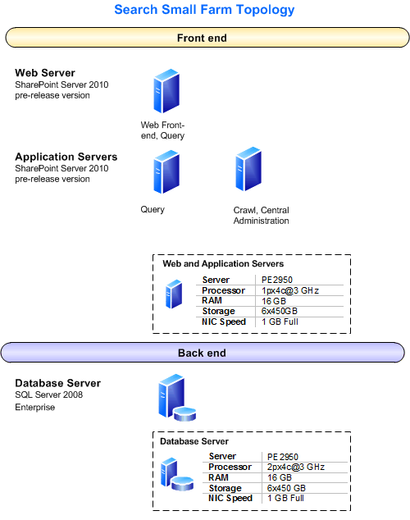

#### Hardware

|  |  |
| --- | --- |
| Note |  |
| Because the farm is running pre-release versions of SharePoint Server 2010, and the team wanted to avoid potential problems, the hardware used for the servers has more capacity than is required under more normal circumstances. | |

#### Web servers

|  |  |
| --- | --- |
| Web Server | Front-end Web server/Query (1) |
| Processor(s) | 1px4c@3 GHz |
| RAM | 16 GB |
| Operating System | Windows Server® 2008 R2, 64-bit |
| Storage | 2x450GB 15K SAS: RAID1:OS  2x450GB 15K SAS: RAID1:DATA1  2x450GB 15K SAS: RAID1:DATA2 |
| Number of NICs | 2 |
| NIC Speed | 1 gigabit |
| Authentication | NTLM |
| Load balancer type | none |
| Software version | SharePoint Server 2010 (pre-release version) |
| Services running locally | All services (including Search Query and Site Settings Service) |

#### Application servers

|  |  |  |
| --- | --- | --- |
| Server | Query (1) | Crawl/Admin (1) |
| Processor(s) | 1px4c@3 GHz | 1px4c@3 GHz |
| RAM | 16 GB | 16 GB |
| Operating System | Windows Server 2008 R2, 64-bit | Windows Server 2008 R2, 64-bit |
| Storage | 2x450GB 15K SAS:RAID1: OS  2x450GB 15K SAS:RAID1: DATA1  2x450GB 15K SAS:RAID1: DATA2 | 2x450GB 15K SAS: RAID1: OS  2x450GB 15K SAS: RAID1: TEMP  2x450GB 15K SAS: RAID0: DATA |
| Number of NICs | 1 | 1 |
| NIC Speed | 1 gigabit | 1 gigabit |
| Authentication | NTLM | NTLM |
| Load balancer type | none | none |
| Software version | SharePoint Server 2010 (pre-release version) | SharePoint Server 2010 (pre-release version) |
| Services running locally | SharePoint Server Search; Search Query and Site Settings Service | SharePoint Server Search |

#### Database servers

|  |  |
| --- | --- |
| Database | Shared (1) |
| Processor(s) | 2px4c@3 GHz |
| RAM | 16 GB |
| Operating System | Windows Server 2008 R2, 64-bit |
| Storage | 2x450GB 15K SAS: RAID1: OS  2x450GB 15K SAS: RAID0: DATA  2x450GB 15K SAS: RAID0: LOGS  (Note: due to the reduced number of drives, the best practice of segregating databases on different IO channels wasn’t applicable. |
| Number of NICs | 2 |
| NIC Speed | 1 gigabit |
| Authentication | NTLM |
| Software version | Microsoft SQL Server® 2008 Enterprise |

### Workload

This section describes the workload used for data generation, including the number of users and farm usage characteristics.

|  |  |
| --- | --- |
| **Workload Characteristics** | **Value** |
| High level description of workload | Search farms |
| Average queries per minute | 6 |
| Average concurrent users | 1 |
| Total # of queries per day | 8640 |

### Dataset

This section describes the test farm dataset, including database contents and sizes, search indexes, and external data sources.

|  |  |
| --- | --- |
| **Object** | **Value** |
| Search index size (# of items) | 9 million |
| Size of crawl database | 52 GB |
| Size of crawl database log file | 11 GB |
| Size of property database | 68 GB |
| Size of property database log file | 1 GB |
| Size of search administration database | 2 GB |
| Size of active index partitions | 38.4 GB (76.8 GB total, because the index is mirrored) |
| Total # of search databases | 3 |
| Other Databases | SharePoint_Config; SharePoint_AdminContent; State_Service; Bdc_Service_db;WSS_UsageApplication; WSS_Content |

### Health and performance data

This section provides health and performance data specific to the test environment

#### Query performance data

The following measurements were taken with 9 million items in the search index. The columns give the measurements taken during the specific test, and the results are at the bottom of the table. The measurements taken are described as follows:

* **Query Latency**   These measurements were taken during a query latency test, where a test tool submitted a set of standard set of queries as one user, and measured the resulting latency. No crawls were underway during the test.
* **Query Throughput**   These measurements were taken during a query throughput test, where a test tool submitted a standard set of queries against the farm as an increasing number of concurrent users (up to 80), and measured the resulting latency and throughput. No crawls were underway during the test.

|  |  |  |  |
| --- | --- | --- | --- |
|  | Scorecard Metric | Query Latency | Query Throughput |
| CPU Metrics | **Avg SQL Server CPU** | 3.4% | 12% |
|  | **Avg front-end Web server CPU** | 8% | 51% |
|  | **Avg Query Server CPU** | 13.3% | 95% |
| Reliability | **Failure rate** | 0 | 0 |
|  | **Front-end Web server crashes** | 0 | 0 |
|  | **APP crashes** | 0 | 0 |
| SQL Server | **Cache Hit Ratio (SQL Server)** | 99.97% | 100% |
|  | **SQL Server Locks: Average Wait Time [ms]** | .071 | .038 |
|  | **SQL Server Locks: Lock Wait Time [ms]** | .035 | .019 |
|  | **SQL Server Locks: Deadlocks/s** | 0 | 0 |
|  | **SQL Server Latches: Average Wait Time [ms]** | 31 | .017 |
|  | **SQL Server Compilations/sec** | 14.9 | 10.2 |
|  | **SQL Server Statistics: SQL Server Re-Compilations/s** | .087 | .05 |
|  | **Avg Disk queue length (SQL Server)** | .011 | .01 |
|  | **Disk Queue Length: Writes (SQL Server)** | .01 | .008 |
|  | **Disk Reads/sec (SQL Server)** | .894 | .05 |
|  | **Disk Writes/sec (SQL Server)** | 45 | 106 |
| Application Server | **Avg Disk queue length (Query Server)** | .013 | 0.001 |
|  | **Disk Queue Length: Writes (Query Server)** | 0 | 0.001 |
|  | **Disk Reads/sec (Query Server)** | 11.75 | 0.06 |
|  | **Disk Writes/sec (Query Server)** | 4 | 5.714 |
|  | **Average memory used (Query Server)** | 8.73% | 9% |
|  | **Max memory used (Query Server)** | 8.75% | 9% |
| Front-end Web server | **ASP.NET Requests Queued (Average of all FRONT-END WEB SERVERs)** | 0 | 0 |
|  | **Average memory used (front-end Web server)** | 9.67% | 95% |
|  | **Max memory used (front-end Web server)** | 9.74% | 100% |
| Test Results | **# Successes** | 1757 | 13608 |
|  | **# Errors** | 0 | 0 |
|  | **Query UI Latency (75th Percentile)** | 0.331 sec | 3.68 sec |
|  | **Query UI Latency (95th Percentile)** | 0.424 sec | 3.93 sec |
|  | **Query Throughput** | 3.29 Requests/sec | 22.4 requests/sec |

#### Crawl performance data

The following measurements were taken during initial, sequential full crawls of the given content source (content source size is given in millions of items). The columns give the measurements taken during the specific crawl, and the results are at the bottom of the table.

|  |  |  |  |  |
| --- | --- | --- | --- | --- |
|  | Scorecard Metric | SharePoint Content (4M) | File Share (1M) | HTTP (non-SharePoint) (1M) |
| CPU Metrics | **Avg SQL Server CPU** | 5.4% | 11.7% | 23% |
|  | **Avg Indexer CPU** | 41.6% | 69% | 71% |
| Reliability | **Failure rate** | 0 | 0 | 0 |
|  | **Front-end Web server crashes** | 0 | 0 | 0 |
|  | **APP crashes** | 0 | 0 | 0 |
| SQL Server | **Cache Hit Ratio (SQL Server)** | n/a | n/a | n/a |
|  | **SQL Server Locks: Average Wait Time [ms]** | 436 | 51.76 | 84.73 |
|  | **SQL Server Locks: Lock Wait Time [ms]** | n/a | n/a | n/a |
|  | **SQL Server Locks: Deadlocks/s** | n/a | n/a | n/a |
|  | **SQL Server Latches: Average Wait Time [ms]** | 1.05 | 1.64 | 3.53 |
|  | **SQL Server Compilations/sec** | n/a | n/a | n/a |
|  | **SQL Server Statistics: SQL Server Re-Compilations/s** | n/a | n/a | n/a |
|  | **Avg Disk queue length (SQL)** | 27.124 | 6.85 | 45 |
|  | **Disk Queue Length: Writes (SQL Server)** | 17.6 | 6.7 | 21.57 |
| Application Server | **Avg Disk queue length (Crawl Server)** | .008 | .032 | .02 |
|  | **Disk Queue Length: Writes (Crawl Server)** | .006 | .025 | .012 |
|  | **Average memory used (Crawl Server)** | 14.16% | 10.4% | 11.5% |
|  | **Max memory used (Crawl Server)** | 19.2% | 11.13% | 12.78% |
| Front-end Web server | **ASP.NET Requests Queued (Average of all front-end Web servers)** | 0 | 0 | 0 |
|  | **Average memory used (front-end Web server)** | n/a | n/a | n/a |
|  | **Max memory used (front-end Web server)** | n/a | n/a | n/a |
| Test Results | **# Successes** | 3934881 | 1247838 | 996982 |
|  | **# Errors** | 9645 | 302 | 2 |
|  | **Portal Crawl Speed (items/sec)** | 46.32 | 120.436 | 138.316 |
|  | **Anchor Crawl Speed (items/sec)** | 5197 | 3466.219 | 2192.982 |
|  | **Total Crawl Speed (items/sec)** | 45.91 | 116.392 | 130.086 |

### Test data

This section provides test data illustrating how the farm performed. Refer to the “Optimizations” section to understand how to improve farm performance.

#### Query latency

The following graph displays query latency percentiles for this farm as user load increases (gathered during the Query Throughput test). A query percentile of 95% means that 95% of the query latencies measured were below that value.

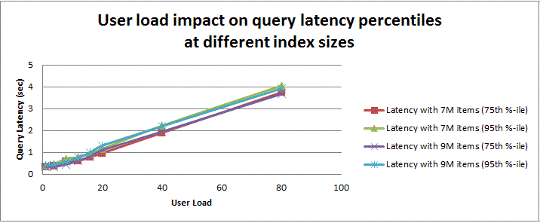

Takeaway: From this graph you can see that with a smaller index, this farm is able to maintain sub-second query latency, even as more concurrent users (20) are performing queries on this farm.

#### Query throughput

The following graph displays the query throughput for this farm as user load increases (gathered during the Query Throughput test). 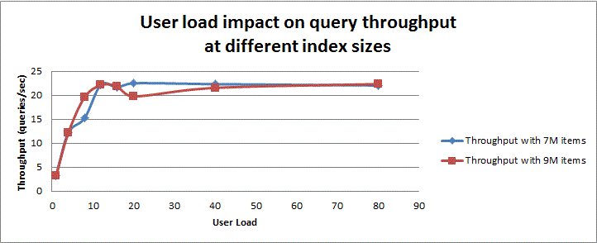

Takeaway: Taking into account both this graph and the last graph, you can see that adding additional user load beyond about 20 concurrent users, this farm will get no additional throughput, and the user latencies will increase.

#### Crawl rate

The following graph displays the crawl rate for this farm during the index acquisition stage of the search lifecycle. The values represent a full crawl, in items crawled per second.

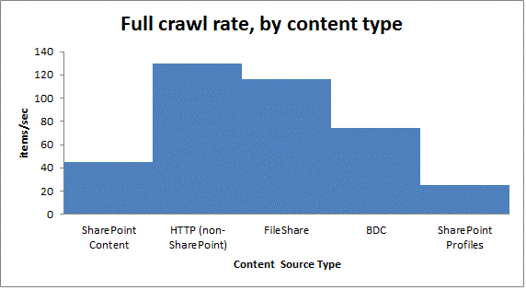

Takeaway: The extra overhead involved to effectively “full” crawl a SharePoint content source results in a lower overall crawl rate in this farm.

#### Overall takeaway

This farm was near capacity on RAM for the query servers. As the front-end Web server processes (also consuming RAM) were also on one of the query servers, it would affect latency on queries running on that server.

The next steps for this improving this farm would be to:

* Move front-end Web server processes to their own front-end Web server (adding another front-end Web server for redundancy).
* Adding more RAM to both query servers. We recommend enough RAM on the query server for 33% of the active query component’s index + 3GB for OS and other processes.
* Adding additional storage arrays for segregating databases on the database server.

## Medium farm

This configuration uses one Web server, six application servers, and two database servers, as follows:

* One Web server was used in this test configuration to provide a search center application. This Web server can be omitted if searches are always performed from a “child” farm using a search service application proxy (installed on the “child” farm). Otherwise, you would likely add another Web server to this farm for redundancy.
* Two application servers are used for crawling and administration. This means that:
  + Central Administration and the search administration component are created on one of the application servers.
  + Each server has two crawl components per server. On a given server, each crawl component is attached to a different crawl database for redundancy.
* The remaining four application servers are used for query. For up to 40 million items, the standard configuration is to have four index partitions. Redundant query functionality is achieved by arranging query components so that each server has one “active” query component from one of the index partitions and a “failover” query component from a different index partition. However, if, as in this example farm, you do plan to have more than 40 million items, it is better to start with 8 partitions (each with its own “active” and “failover” query components) on the four application servers in order to minimize index repartitioning, assuming each server meets the scaling guidelines to allow four components on the same application server:
  + Enough RAM and IOPS are available.
  + Each server has more than 6 CPU cores to support:
    - 4 CPU cores for the 2 active query components.
    - 2 CPU cores for the 2 failover query components.
* Two database servers support the farm. One database server is used for the two crawl databases. The other server is used for the property and search administration databases, as well as the other SharePoint databases. The database servers should have a dedicated number of IOPS for each crawl, property, and search administration database (for example, use different storage arrays).

### Specifications

This section provides detailed information about the hardware, software, topology, and configuration of the test environment.

#### Topology

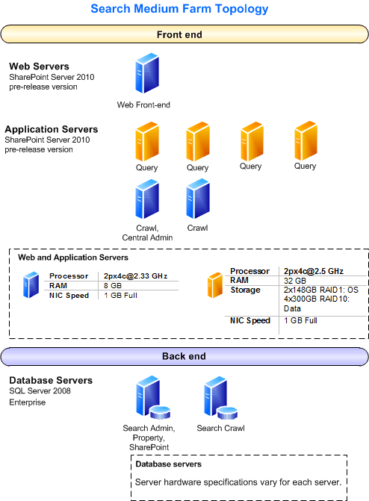

#### Hardware

|  |  |
| --- | --- |
| Note |  |
| Because the farm is running pre-release versions of SharePoint Server 2010, and the team wanted to avoid potential problems, the hardware used for the servers has more capacity than is required under more normal circumstances. | |

#### Web servers

|  |  |
| --- | --- |
| Web Server | Front-end Web server (1) |
| Processor(s) | 2px4c@2.33 GHz |
| RAM | 8 GB |
| Operating System | Windows Server 2008 R2, 64-bit |
| Storage | 2x148GB 15K SAS: RAID1: OS |
| Number of NICs | 2 |
| NIC Speed | 1 gigabit |
| Authentication | NTLM |
| Load balancer type | none |
| Software version | SharePoint Server 2010 (pre-release version) |
| Services running locally | All Services |

#### Application servers

There are six application servers in the farm; four servers are used for serving queries and two servers are used for crawling.

|  |  |  |
| --- | --- | --- |
| Server (count) | Query (4) | Crawl (1), Crawl/Admin (1) |
| Processor(s) | 2px4c@2.33 GHz | 2px4c@2.33 GHz |
| RAM | 32 GB | 8 GB |
| Operating System | Windows Server 2008 R2, 64-bit | Windows Server 2008 R2, 64-bit |
| Storage | 2x148 GB 15K SAS: RAID1: OS  4x300GB 15K SAS:RAID10:Data | 2x148 GB 15K SAS:RAID1: OS/Data |
| Number of NICs | 2 | 2 |
| NIC Speed | 1 gigabit | 1 gigabit |
| Authentication | NTLM | NTLM |
| Load balancer type | None | None |
| Software version | SharePoint Server 2010 (pre-release version) | SharePoint Server 2010 (pre-release version) |
| Services running locally | SharePoint Server Search; Search Query and Site Settings Service | SharePoint Server Search |

#### Database servers

There are two database servers. The first server contains the search administration, property, and other SharePoint databases; the second server contains the two crawl databases. Note that the storage volumes created optimized the existing hardware available for the test.

|  |  |  |
| --- | --- | --- |
| Database Server | Search Admin /Property/SharePoint | Crawl Databases |
| Processor(s) | 2px4c@3.2 GHz | 4px2c@2.19 GHz |
| RAM | 32 GB | 16 GB |
| Operating System | Windows Server 2008 R2, 64-bit | Windows Server 2008 R2, 64-bit |
| Storage | 2x148GB 15K SAS :RAID1: OS  2x148GB 15K SAS :RAID1: TEMP Log  2x450GB 15K SAS :RAID1: TEMP DB  6x450GB 15K SAS :RAID10: Property DB  2x450GB 15K SAS :RAID1:Search Admin, SharePoint DBs  2x450GB 15K SAS :RAID1:Logs | 2x148GB 15K SAS :RAID1: OS  2x148GB 15K SAS :RAID1: TEMP Log  2x300GB 15K SAS :RAID1: TEMP DB  6x146GB 15K SAS :RAID10: Crawl DB1  6x146GB 15K SAS :RAID10: Crawl DB2  2x300GB 15K SAS :RAID1:Crawl DB Log1  2x300GB 15K SAS :RAID1:Crawl DB Log2 |
| Number of NICs | 2 | 2 |
| NIC Speed | 1 gigabit | 1 gigabit |
| Authentication | NTLM | NTLM |
| Software version | SQL Server 2008 Enterprise | SQL Server 2008 Enterprise |

### Workload

This section describes the workload used for data generation, including the number of users and farm usage characteristics.

|  |  |
| --- | --- |
| **Workload Characteristics** | **Value** |
| High level description of workload | Search farms |
| Average queries per minute | 12 |
| Average concurrent users | 1 |
| Total # of queries per day | 17280 |
| Timer jobs | Search Health Monitoring – Trace Events; Crawl Log Report; Health Analysis Job; Search and Process |

### Dataset

This section describes the test farm dataset, including database contents and sizes, search indexes, and external data sources.

|  |  |
| --- | --- |
| **Object** | **Value** |
| Search index size (# of items) | 46 million |
| Size of crawl database | 356 GB |
| Size of crawl database log file | 85 GB |
| Size of property database | 304 GB |
| Size of property database log file | 9 GB |
| Size of search administration database | 5 GB |
| Size of active index partitions | 316 GB (79GB per active component). |
| Total # of databases | 4 |
| Other Databases | SharePoint_Config; SharePoint_AdminContent; State_Service; Bdc_Service_db; WSS_UsageApplication; WSS_Content |

### Health and performance data

This section provides health and performance data specific to the test environment.

#### Query performance data

The following measurements were taken with 46 million items in the search index. The columns give the measurements taken during the specific test, and the results are at the bottom of the table. The measurements taken are described as follows:

* **Query Latency**   These measurements were taken during a query latency test, where a test tool submitted a set of standard set of queries as one user, and measured the resulting latency. No crawls were underway during the test.
* **Query Throughput**   These measurements were taken during a query throughput test, where a test tool submitted a standard set of queries against the farm as an increasing number of concurrent users (up to 80), and measured the resulting latency and throughput. No crawls were underway during the test.

|  |  |  |  |
| --- | --- | --- | --- |
|  | Scorecard Metric | Query Latency | Query Throughput |
| CPU Metrics | **Avg SQL Server CPU (property DB server)** | 5% | 98% |
|  | **Avg front-end Web server CPU** | 3% | 33% |
|  | **Avg Query Server CPU** | 3% | 47% |
| Reliability | **Failure rate** | 0.07% | 0% |
|  | **Front-end Web server crashes** | 0 | 0 |
|  | **APP crashes** | 0 | 0 |
| SQL Server  (property DB server) | **Cache Hit Ratio (SQL)** | 100% | 99.9% |
|  | **SQL Server Locks: Average Wait Time [ms]** | 0.000 | 0.159 |
|  | **SQL Server Locks: Lock Wait Time [ms]** | 0.000 | 0.080 |
|  | **SQL Server Locks: Deadlocks/s** | 0 | 0 |
|  | **SQL Server Latches: Average Wait Time [ms]** | 0.041 | 1.626 |
|  | **SQL Server Compilations/sec** | 9.776 | 93.361 |
|  | **SQL Server Statistics: SQL Server Re-Compilations/s** | 0.059 | 0.071 |
|  | **Read/Write Ratio (IO Per Database)** | .01 | .81 |
|  | **Avg Disk queue length (SQL Server)** | 0.001 | 0.037 |
|  | **Disk Queue Length: Writes (SQL Server)** | 0.000 | 0.003 |
|  | **Disk Reads/sec (SQL Server)** | 0.057 | 14.139 |
|  | **Disk Writes/sec (SQL Server)** | 4.554 | 17.515 |
| Application Server | **Avg Disk queue length (Query Server)** | 0.000 | 0.001 |
|  | **Disk Queue Length: Writes (Query Server)** | 0.000 | 0.001 |
|  | **Disk Reads/sec (Query Server)** | 0.043 | 0.266 |
|  | **Disk Writes/sec (Query Server)** | 4.132 | 5.564 |
|  | **Average memory used (Query Server)** | 9% | 10% |
|  | **Max memory used (Query Server)** | 9% | 10% |
| Front-end Web server | **ASP.NET Requests Queued (Average of all front-end Web servers)** | 0 | 0 |
|  | **Average memory used (front-end Web server)** | 47% | 48% |
|  | **Max memory used (front-end Web server)** | 47% | 49% |
| Test Results | **# Successes** | 1398 | 14406 |
|  | **# Errors** | 1 | 0 |
|  | **Query UI Latency (75th Percentile)** | 0.47 sec | 2.57 sec |
|  | **Query UI Latency (95th Percentile)** | 0.65 sec | 3.85 sec |
|  | **Query Throughput** | 2.38 request/sec | 27.05 request/sec |

#### Crawl performance data

The following measurements were taken during initial, full crawls of the given content source (content source size is given in millions of items), which were added to an existing farm. The columns give the measurements taken during the specific crawl, and the results are at the bottom of the table.

|  |  |  |  |  |
| --- | --- | --- | --- | --- |
|  | Scorecard Metric | SharePoint Content (3.5M) | File Share (1M) | HTTP (non-SharePoint) (1M) |
| CPU Metrics | **Avg SQL Server CPU (crawl DB server, property DB server)** | 11%, 19% | 22%, 7% | 23%, 5% |
|  | **Max SQL Server CPU (crawl DB server, property DB server)** | 96%, 100% | 86%, 45% | 79%, 28% |
|  | **Avg Indexer CPU** | 41.6% | 69% | 71% |
| Reliability | **Failure rate** | 0.2% | 0.02% | 0% |
|  | **Front-end Web server crashes** | 0 | 0 | 0 |
|  | **APP crashes** | 0 | 0 | 0 |
| SQL Server  (crawl DB server, property DB server) | **Cache Hit Ratio (SQL)** | 99.5%, 99.8% | Not collected | 99.9%, 99.3% |
|  | **SQL Server Locks: Average Wait Time [ms]** | 1881.749, 1106.314 | 1617.980, 2.882 | 983.137, 0.904 |
|  | **SQL Server Locks: Max Wait Time [ms]** | 69919.500, 1081703 | 55412.000, 304.500 | 24000.500, 47 |
|  | **SQL Server Locks: Average Lock Wait Time [ms]** | 339.658, 10147.012 | Not collected | 739.232, 0.136 |
|  | **SQL Server Locks: Max Lock Wait Time [ms]** | 598106.544, 234708784 | Not collected | 52711.592, 23.511 |
|  | **SQL Server Locks: Deadlocks/s** | 0.001, 0 | Not collected | 0.008, 0 |
|  | **SQL Server Latches: Average Wait Time [ms]** | 2.288, 13.684 | 3.042, 13.516 | 2.469, 20.093 |
|  | **SQL Server Latches: Max Wait Time [ms]** | 2636, 1809 | 928, 858.5 | 242.929, 938.706 |
|  | **SQL Server Compilations/sec : Avg** | 20.384, 5.449 | Not collected | 76.157, 6.510 |
|  | **SQL Server Compilations/sec : Max** | 332.975, 88.992 | Not collected | 295.076, 42.999 |
|  | **SQL Server Statistics: SQL Server Re-Compilations/s: Avg** | 0.560, 0.081 | Not collected | 0.229, 0.125 |
|  | **SQL Server Statistics: SQL Server Re-Compilations/s: Max** | 22.999, 88.492 | Not collected | 17.999, 15.5 |
|  | **Read/Write Ratio (IO Per Database): Max** | 2.15, 1.25 | Not collected | 1.45, 0.364 |
|  | **Avg Disk queue length (SQL Server)** | 66.765, 27.314 | 129.032, 20.665 | 182.110, 11.816 |
|  | **Max Disk queue length (SQL Server)** | 4201.185, 5497.980 | 3050.015, 762.542 | 1833.765, 775.7 |
|  | **Disk Queue Length: Writes (SQL Server): Avg** | 58.023, 13.532 | 114.197, 19.9 | 175.621, 10.417 |
|  | **Disk Queue Length: Writes (SQL Server): Max** | 1005.691, 881.892 | 1551.437, 761.891 | 1018.642, 768.289 |
|  | **Disk Reads/sec (SQL Server): Avg** | 245.945, 94.131 | Not collected | 137.435, 154.103 |
|  | **Disk Reads/sec (SQL Server): Max** | 6420.412, 6450.870 | Not collected | 3863.283, 1494.805 |
|  | **Disk Writes/sec (SQL Server): Avg** | 458.144, 286.884 | Not collected | 984.668, 278.175 |
|  | **Disk Writes/sec (SQL Server): Max** | 2990.779, 5164.949 | Not collected | 2666.285, 4105.897 |
| Application Server | **Avg Disk queue length (Crawl Server)** | 0.052 | 0.043 | 0.030 |
|  | **Disk Queue Length: Writes (Crawl Server)** | 0.029 | 0.031 | 0.026 |
|  | **Disk Reads/sec (Crawl Server)** | 5.405 | Not collected | 0.798 |
|  | **Disk Writes/sec (Crawl Server)** | 48.052 | Not collected | 102.235 |
|  | **Average memory used (Crawl Server)** | 68% | 45% | 52% |
|  | **Max memory used (Crawl Server)** | 76% | 47% | 59% |
| Front-end Web server | **ASP.NET Requests Queued (Average of all front-end Web servers)** | 0 | 0 | 0 |
|  | **Average memory used (front-end Web server)** | n/a | n/a | n/a |
|  | **Max memory used front-end Web server)** | n/a | n/a | n/a |
| Test Results | **# Successes** | 3631080 | 1247838 | 200000 |
|  | **# Errors** | 7930 | 304 | 0 |
|  | **Portal Crawl Speed (items/sec)** | 82 | 148 | 81 |
|  | **Anchor Crawl Speed (items/sec)** | 1573 | 1580 | 1149 |
|  | **Total Crawl Speed (items/sec)** | 79 | 136 | 76 |

### Test data

This section provides test data illustrating how the farm performed under load.

#### Query latency

The following graph displays the query latency percentiles for this farm as user load increases (gathered during the Query Throughput test). A query percentile of 95% means that 95% of the query latencies measured were below that value.

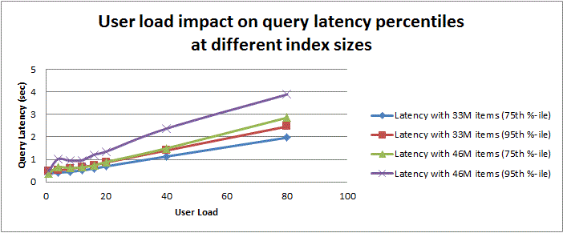

Takeaway: From this graph you can see that with a smaller index, this farm is able to maintain sub-second query latency at the 95th percentile, even as more concurrent users (22) are performing queries on this farm.

#### Query throughput

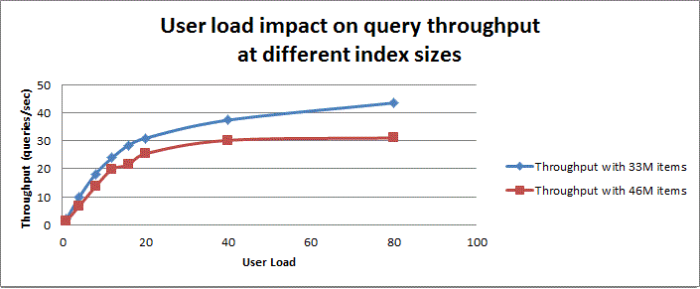The following graph displays the query throughput for this farm as user load increases (gathered during the Query Throughput test).

Takeaway: Taking into account both this graph and the last graph, you can see that, at 33 million items in the index, the farm is able to maintain sub-second latency at the 75th percentile with about 30 concurrent users; additional concurrent user load can still be accommodated, but query latency will increase beyond the sub-second mark.

However, at 46 million items in the index, no additional concurrent user load can be accommodated, and query latency will increase.

#### Crawl rate

The following graph displays the crawl rate for this farm during the index acquisition stage of the search lifecycle. The values represent a full crawl, in items crawled per second.

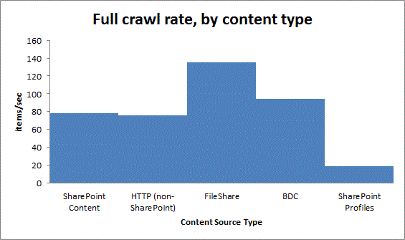

Takeaway: The extra overhead involved to effectively crawl a SharePoint profiles content source results in a lower overall crawl rate in this farm.

#### Overall takeaway

This farm was near capacity on RAM for the query servers.

The next steps for this improving this farm would be to:

* Adding more RAM to both query servers. We recommend enough RAM on the query server for 33% of the active query component’s index + 3GB for OS and other processes.
* Adding more RAM to the database server hosting the property DB. In this configuration, the key tables were about 92GB in size (including indices), which suggests a 30 GB RAM requirement. However, the DB server only had 32 GB RAM to serve the Property DB and Search Admin DB, and the other SharePoint databases.
* Adding additional storage arrays for segregating databases on the database server.
* Scale-out to increase throughput and/or reduce query latency.

Although crawl speed is high on this farm with 2 crawl databases and 4 crawl components, it may be an important goal for your farm to have certain “hot” or fresher parts of the index, that is, certain content sources that need to be crawled very frequently. Adding another crawl database dedicated to hosts in the desired content source (via host distribution rules), and associating two additional crawl components to the database, would support the fresher index goal.

## Large farm

The expected configuration uses 14 application servers and three database servers, as follows:

* One Web server is used, if desired, to provide a search center application. This Web server can be omitted if searches are always performed from a content farm using a search service application proxy (installed on the content farm).
* Three application servers are used for crawling and administration. This means that:
  + Central Administration and the search administration component are created on one of the application servers.
  + Each server has two crawl components per server. On a given server, each crawl component is attached to a crawl database.
* The remaining ten application servers are used for query. The preferred configuration is to have ten index partitions. Each server then has one primary query component from one of the index partitions, in addition to a failover query component from a different index partition.
* Three database servers support the farm. One server is used for the property and search administration databases. A second server is used for two crawl databases. The third server is used for one crawl database, as well as the other SharePoint databases. The database servers should have a dedicated number of IOPS for each crawl, property, and search administration database (for example, use different storage arrays).

### Specifications

This section provides detailed information about the hardware, software, topology, and configuration of the test environment.

#### Topology

This section describes the topology of the test environment.

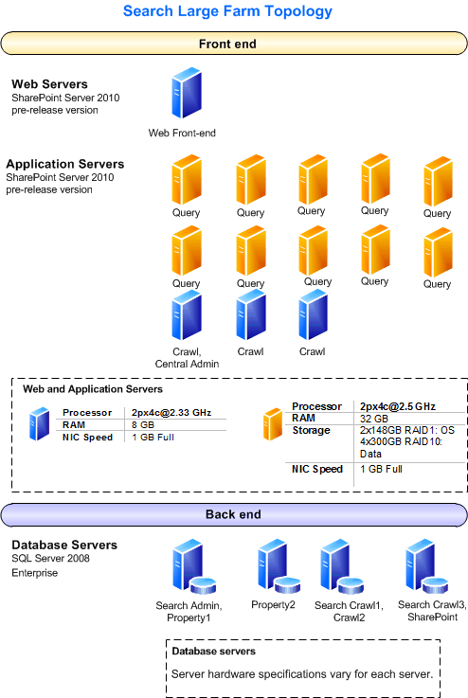

#### Hardware

This section describes the hardware used for testing.

|  |  |
| --- | --- |
| Note |  |
| Because the farm is running pre-release versions of SharePoint Server 2010, and the team wanted to avoid potential problems, the hardware used for the servers has more capacity than is required under more normal circumstances. | |

#### Web servers

|  |  |
| --- | --- |
| Web Server | Front-end Web server (1) |
| Processor(s) | 2px4c@2.33 GHz |
| RAM | 8 GB |
| Operating System | Windows Server 2008 R2, 64-bit |
| Storage | 2x148GB 15K SAS: RAID1: OS |
| Number of NICs | 2 |
| NIC Speed | 1 gigabit |
| Authentication | NTLM |
| Load balancer type | none |
| Software version | SharePoint Server 2010 (pre-release version) |
| Services running locally | All Services |

#### Application servers

There are thirteen application servers in the farm; ten servers are used for serving queries and three servers are used for crawling.

|  |  |  |
| --- | --- | --- |
| Server (count) | Query (10) | Crawl (2), Crawl/Admin (1) |
| Processor(s) | 2px4c@2.5 GHz | 2px4c@2.5 GHz |
| RAM | 32 GB | 32 GB |
| Operating System | Windows Server 2008 R2, 64-bit | Windows Server 2008 R2, 64-bit |
| Storage | 2x148GB 15K SAS: RAID1: OS  4x300GB 15K SAS:RAID10:Data | 2x148GB 15K SAS:RAID1: OS/Data |
| Number of NICs | 2 | 2 |
| NIC Speed | 1 gigabit | 1 gigabit |
| Authentication | NTLM | NTLM |
| Load balancer type | None | None |
| Software version | SharePoint Server 2010 (pre-release version) | SharePoint Server 2010 (pre-release version) |
| Services running locally | SharePoint Server Search; Search Query and Site Settings Service | SharePoint Server Search |

#### Database servers

There are four database servers. The first server contains the search administration, property, and other SharePoint databases; the second server contains the two crawl databases. Note that the storage volumes created optimized the existing hardware available for the test.

|  |  |  |
| --- | --- | --- |
| Database Server | Search Admin /Property/SharePoint | Crawl Databases |
| Processor(s) | 2px4c@3.2 GHz | 4px2c@2.19 GHz |
| RAM | 32 GB | 16 GB |
| Operating System | Windows Server 2008 R2, 64-bit | Windows Server 2008 R2, 64-bit |
| Storage | 2x148GB 15K SAS :RAID1: OS  2x148GB 15K SAS :RAID1: TEMP Log  2x450GB 15K SAS :RAID1: TEMP DB  6x450GB 15K SAS :RAID10: Property DB  2x450GB 15K SAS :RAID1:Search Admin, SharePoint DBs  2x450GB 15K SAS :RAID1:Logs | 2x148GB 15K SAS :RAID1: OS  2x148GB 15K SAS :RAID1: TEMP Log  2x300GB 15K SAS :RAID1: TEMP DB  6x146GB 15K SAS :RAID10: Crawl DB1  6x146GB 15K SAS :RAID10: Crawl DB2  2x300GB 15K SAS :RAID1:Crawl DB Log1  2x300GB 15K SAS :RAID1:Crawl DB Log2 |
| Number of NICs | 2 | 2 |
| NIC Speed | 1 gigabit | 1 gigabit |
| Authentication | NTLM | NTLM |
| Software version | SQL Server 2008 Enterprise | SQL Server 2008 Enterprise |

### Workload

This section describes the workload used for data generation, including the number and class of users, and farm usage characteristics.

(No data yet.)

### Dataset

This section describes the test farm dataset, including database contents and sizes, Search indexes, and external data sources.

(No data yet.)

### Health and performance data

This section provides health and performance data specific to the test environment.

(No data yet.)

### Test data

This section provides test data that shows how the farm performed under load.

# Recommendations and troubleshooting

This section provides recommendations for how to determine the hardware, topology, and configuration you need to deploy environments that are similar to these scenarios, and how to optimize your environment for appropriate capacity and performance characteristics.

## Recommendations

This section describes specific actions you can take to optimize your environment for appropriate capacity and performance characteristics.

### Hardware recommendations

For specific information about overall minimum and recommended system requirements, see [Determine hardware and software requirements](http://technet.microsoft.com/en-us/library/cc262485(office.14).aspx). Note that requirements for servers used for search supersede those overall system requirements. Follow the recommended guidelines below for RAM, processor, and IOPS, in order to meet performance goals.

#### Search sizing

This section explains the search system, including sizing requirements and guidelines, per component.

SharePoint Server 2010 can be deployed and configured in a wide variety of ways. As a result, there is no simple way to estimate how many users or items can be supported by a given number of servers. Therefore, make sure that you conduct testing in your own environment before you deploy SharePoint Server 2010 in a production environment.

##### Search query system

This section shows the components of the search query system for a given Search service application (SSA). The sizing requirements for each appear in the table below the diagram.

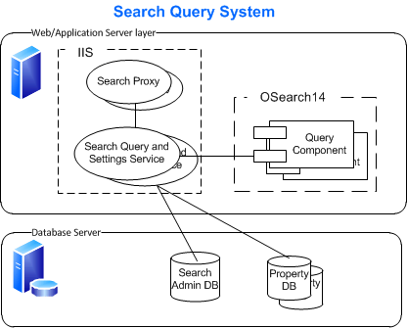

###### Object descriptions

This section defines the search query system objects in the above diagram:

* **Search proxy**   This is the SSA proxy that installs on any farm that consumes search from this SSA. It runs in the context of the Web applications that are associated with the SSA proxy.
* **Search Query and Site Settings Service**   This is also known as the query processor (QP). Receiving the query from an SSA proxy connection, a QP:
  + Sends the query to one active query component for each partition (and/or to the property database, depending on the query)
  + Retrieves Best Bets and removes duplicates to get the results set
  + Security trims the results based on security descriptors in the search administration database
  + Retrieves the final results set’s metadata from the property database,
  + Sends the query results back to the proxy
* **Index partition**   This is a logical group of query components, representing a subset of the full-text index. The sum of index partitions comprises the full-text index; however, note that query components contain the actual subset of the index. An index partition is associated with one property database.
* **Search query component**   A query component contains all or part of the full-text index. When queried by a QP, the query component determines the best results from its index, and returns those items. A query component can be created as:
  + “Active,” which means that it will respond to queries by default. Adding multiple active query components for the same index partition will increase throughput.
  + “Failover,” which means that it will only respond to queries if all “active” components for the same index partition have failed.
* **Search administration database**   Created at the same time as the SSA, the search administration database contains the SSA-wide data used for queries like Best Bets and security descriptors, as well as application settings used for administration.
* **Property database**   A property database contains the metadata (title, author, related fields) for the items in the index. The property database is used for property-based queries as well as retrieving metadata needed for display of the final results. If multiple index partitions exist, the index partitions can be mapped to different property databases.

###### Scaling details

|  |  |  |  |
| --- | --- | --- | --- |
| Object | Scale Considerations | RAM | IOPS (read/write) |
| Search proxy | This scales with the front-end Web servers on which it is associated. | N/A | N/A |
| Search Query and Site Settings Service | This service, installed in the **Services on Server** page in Central Administration, should be started on each server with a query component. It can be moved to a separate server (or pair, for high availability), to avoid using RAM on the servers containing the query components. Also, if a [custom security trimmer](http://msdn.microsoft.com/en-us/library/aa981563.aspx) is used, it may impact CPU and RAM resources. | This uses RAM (process cache) for caching security descriptors for the index. | N/A |
| Index partition | Increasing the number of index partitions decreases the number of items in the index partition, reducing the RAM and disk space needed on the query server that hosts the query component assigned to the index partition. | N/A | N/A |
| Query component | Created or modified as part of a Search Service Application’s topology, Each active query component on a server consumes memory when serving queries. Both active and failover components consume IO when crawling is occurring. Servers can be dedicated to query components (for example, 2 active and 2 failover on the same server), assuming RAM and IO requirements have been met.  When possible, dedicate at least 2 CPU cores per active component per server, and at least 1 CPU core per failover component per server. | For each active query component on an application server, 33% of its index should be in RAM (OS cache). | 2K needed per pair (active/failover) of query components on a given server.  The query component needs IO for:   * Loading the index into RAM for queries * Writing index fragments received from each crawl component * Merging index fragments into its index, such as during a master merge |
| Search administration database | For each query, best bets and security descriptors are loaded from the Search Admin DB. Ensure the DB server has enough RAM to serve this from cache. When possible, avoid placing this on a server with a Crawl DB, as the crawl DB tends to reset the cache of its DB server. | Ensure the database server has enough RAM to keep the critical table (MSSSecurityDescriptors) in RAM. | 700 |
| Property database | For each query, metadata is retrieved from the property database for the document results, so scaling up the DB server’s RAM is a scale consideration. If multiple index partitions exist, you can partition the Property DB and move to a different DB server to decrease RAM and IO requirements. | Ensure the database server has enough RAM to keep 33% of the critical tables (MSSDocSDIDs + MSSDocProps + MSSDocresults) in cache. | 2K  30% read, 70% write |

##### Search crawl system

This section shows the components of the search crawl system. The sizing requirements of each appear in the table below the diagram.

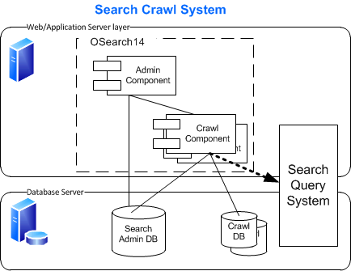

###### Object descriptions

This section defines the search crawl system objects in the above diagram:

* **Administration component**   An administration component is used when starting a crawl, as well as when performing an administration task on the crawl system.
* **Crawl component**   A crawl component processes crawls of content sources, propagates the resulting index fragment files to query components, and adds information about the location and crawl schedule of content sources to its associated crawl database.
* **Search administration database**   Created at the same time as the SSA, the search administration database stores the security descriptors discovered during the crawl, as well as application settings used for administration.
* **Crawl database**   A crawl database contains data related to the location of content sources, crawl schedules, and other information specific to crawl operations. They can be dedicated to specific hosts by creating host distribution rules. A crawl database only stores data; the crawl component(s) associated with the given crawl database do the crawling.
* **Search query system**

###### Scaling details

|  |  |  |  |
| --- | --- | --- | --- |
| Object | Scale Considerations | RAM | IOPS (Optionally, % read/write) |
| Administration component | The single administration component is not scalable. By default, it is placed on a server hosting a crawl component (and Central Administration, on smaller farms). | Minimal | Minimal |
| Crawl component | Crawl components aggressively use CPU bandwidth. Optimally, a given crawl component can utilize four CPU cores. RAM is not as critical. In larger farms, dedicating servers to host crawl components minimizes the crawler impact on other components (especially using crawl components associated with different crawl databases, if redundancy is desired). | Moderate. Note that when crawling East Asian documents, RAM requirements will increase due to the word breakers. | 300-400 |
| Search administration database | See query system table entry above. When possible, avoid placing this on a server with a crawl database, because the crawl database tends to reset the cache of its database server. | See query system table entry above. | 700 |
| Crawl database | Crawl databases aggressively use IO bandwidth. RAM is not as critical. A crawl database needs 3.5K IOPS for crawling activities; it will consume as much as 6K IOPS, based on the available bandwidth. | Moderate | 3.5 – 7k  73% read, 27% write |

##### Calculate storage sizing

Calculate the following factors to help estimate storage requirements. The sizing factors are based on an internal pre-deployment system with an index containing primarily SharePoint content (the size of the content databases is 13.3 TB). Overall, SharePoint search required approximately 20% of the content database disk space. As stated previously, make sure that you conduct testing in your own environment before you deploy SharePoint Server 2010 in a production environment.

Caveats:

* As the corpus used to derive these coefficients was primarily (English) SharePoint content, if your content differs (for example, it consists mostly of file shares or non-SharePoint HTTP sites), you will need to allow for more variation.
* Even if your content is primarily SharePoint, you may still vary your coefficients:
  + If you have large document repositories, your coefficients will be significantly larger.
  + If your content is primarily images, you may be able to reduce the coefficients.
  + Content in a different language will likely impact your coefficients.

###### 1. Calculate content database sizing factor (ContentDBSum)

Determine the sum of the SharePoint content databases that will be crawled. This is the **ContentDBSum** value that will be used as the correlation in the next storage computations.

###### 2. Calculate index-related sizes (TotalIndexSize and QueryComponentIndexSize)

Determine the size of the total index (which resides on the query components and is used for full text queries):

* Multiply **ContentDBSum** * .035.This is the **TotalIndexSize**, before partitioning and reserving room for merges and repartitioning.

Next, determine the number of index partitions you will have, based on your scenario. A general guideline is that an index partition should have between 5M and 10M items. Once you have the number of index partitions, you can calculate the size of the query component storage.

* Divide **TotalIndexSize /**  **(number of index partitions)**. This is the **QueryComponentIndexSize**. It is used to calculate the following sizes:
  + For RAM, multiply **QueryComponentIndexSize** * .33. This is the minimum of RAM required for this query component, if active.
    - If the component is failover, it does not require the RAM until it becomes active.
    - For a given server, having multiple active query components on the same server means that you need to sum each active query component’s RAM, to arrive at the RAM needs for the server.
  + For disk storage, use **QueryComponentIndexSize** to estimate disk requirements, depending on whether or not you will ever repartition the index (meaning you expect the index to grow greater than the 10M per partition boundary):
    - Multiply **QueryComponentIndexSize** * 3 to calculate disk storage for a single query component, to allow room for index merging.
    - Multiply **QueryComponentIndexSize** * 4 to calculate disk storage for a single query component, to allow room for index repartitioning.

For a given server, having multiple query components on the same server means you need to arrange for storage for each of the query components, given the IOPS requirements in the Scaling Details section of Search Query System, above.

###### 3. Calculate property database sizes

Determine the size of the property databases:

* Multiply **ContentDBSum** * .015**.** This is the **TotalPropertyDBSize**, before partitioning.
* Multiply **ContentDBSum** * .0031**.** This is the **TotalPropertyDBLogSize**, before partitioning. This assumes you use the out-of-box simple SQL recovery model.
* Multiply **ContentDBSum** * .00034**.** This is the property database **TempDBSize**. Because we recommend having 33% of the key tables in the property database in RAM, use of the temporary database is not heavy.

Next, determine the number of property databases you will have, based on your scenario. A general guideline is that a property database should contain up to 50M items, assuming there are no Query Performance Issues, and you have a limited number of managed properties (the Out-Of-Box configuration).

* + Divide **TotalPropertyDBSize / (number of property databases)**. This is the **PropertyDatabaseSize**
  + Divide **TotalPropertyDBLogSize / (number of property databases)**. This is the **PropertyDatabaseLogSize**
  + For RAM, multiply **PropertyDatabaseSize** * .33. This is the minimum amount of RAM recommended for this property database.

For a given database server, having multiple property databases on the same server means you need to arrange for storage and RAM for each of the property databases, given the IOPS and RAM requirements in the Scaling Details section of Search Query System Scaling, above.

###### 4. Calculate crawl database sizes

Next, determine the size needed for the crawl database(s):

* Multiply **ContentDBSum** * .046**.** This is the **TotalCrawlDBSize**, before partitioning.
* Multiply **ContentDBSum** *. 011**.** This is the **TotalCrawlDBLogSize**, before partitioning. This assumes you use the out-of-box simple SQL recovery model.
* Multiply **ContentDBSum** * .0011**.** This is the crawl database **TempDBSize**. As the search crawl system does impact the performance of the temporary database, we do not recommend locating other databases on servers hosting the crawl database(s) that would be impacted by this usage.

Next, determine the number of crawl databases you will have, based on your scenario. A general guideline is that a crawl database should contain up to 25M items, assuming there are no Crawl Performance Issues.

* + Divide **TotalCrawlDBSize / (number of crawl databases)**. This is the **CrawlDatabaseSize**.
  + Divide **TotalCrawlDBLogSize / (number of crawl databases)**. This is the **CrawlDatabaseLogSize**.

For a given database server, having multiple crawl databases on the same server means you need to arrange for storage for each of the crawl databases, given the IOPS requirements in the Scaling Details section of Search Crawl System, above. For RAM, we recommend at least 16 GB on database servers dedicated to crawl databases.

###### 5. Calculate search administration database size

Determine the size of the search administration database (assuming Windows Classic Auth):

* Multiply **number of items in the index (in millions)** * .3 . This is the **SearchAdminDBSize**.
* For RAM, multiply **SearchAdminDBSize** * .33. This is the minimum amount of RAM recommended for this search administration database.

For a given database server, having multiple databases on the same server means you need to arrange for storage and RAM for each of the databases, given the IOPS and RAM requirements in the Scaling Details section of Search Query System Scaling, above.

###### Optional: Calculate backup size

To determine the disk space needed for backing up one search service application:

* Add **TotalCrawlDBSize** + **TotalPropertyDBSize + TotalIndexSize + SearchAdminDBSize** to arrive at the basic backup size.

This basic backup size is a starting point. It will also be affected by:

* Additional index size included in the **TotalIndexSize** for any crawling that has occurred since the last master merge.
* Growth over time due to additional items, queries, and security descriptors.

In addition, you will likely want to retain multiple backups from different times, as well as reserving space for the next backup.

##### Sizing exercise

Using the sizing factors above, here is a sizing exercise for a 100M item farm that will serve queries over primarily SharePoint content. Using the “large farm” scenario, you would assume:

* 10 logical query partitions are needed to accommodate the 100M items.
* To serve queries, you need 10 “active” query components, one per query partition.
* Query redundancy is important, so you have 10 “failover” query components, one per query partition (located on a different server than the “active” component).

To determine storage and RAM needs, here are the steps you would follow:

1. You have a SharePoint content farm with multiple content databases. When you sum the content databases you want to crawl, you get **20 TB**.
2. Using the index coefficient above, you multiply **20 TB * .035** (Index Coefficient) **= 716.8 GB.** This is the **TotalIndexSize**. If you had only one partition, this would be the size of the index, at rest.
3. Divide **TotalIndexSize** by the number of partitions: **716.8 GB /10 = 71.68 GB**. This is the index size required per query component (**QueryComponentIndexSize**), with one query partition. The size is the same for either “active” or “failover” query components.
4. Multiply **TotalIndexSize** by 4 if you plan to repartition; otherwise, multiply by 3 for supporting master merges. **71.68 GB** * 4 = **286.72 GB**. You should have this many GB available on your query server’s disk to support one query component. If you have two query components on the same application server (as in the active/failover topology we recommended in the large farm scenario), you would have a disk drive layout as follows:
   1. OS Drive (**standard size**).
   2. Extra storage system 1: Query Component1_Share (size= **at least 300 GB**), used for active query component from Query partition 1.
   3. Extra storage system 2: Query Component2_Share (size = **at least 300 GB),** used for failover (mirror) query component from Query partition 2.

**Note:**   On this application server, with one “active” query component, you would want a minimum of **71.68 GB** * .33 = 23.65 GB of RAM + 3GB RAM for the OS, (we use **32 GB**), in order to cache most of the queries.

### Software limits

The following table gives software boundaries imposed to support an acceptable search experience:

|  |  |  |
| --- | --- | --- |
| Object | Limit | Additional Notes |
| SharePoint Search service applications (SSA) | Recommended maximum of 20 per farm. Absolute maximum of 256 total service applications. | You can deploy multiple SharePoint SSAs on the same farm, as you can assign search components and databases to separate servers. |
| Indexed documents | Overall recommended maximum of 10 million items per index partition and 100 million items per SSA. | SharePoint search supports index partitions, which each contain a subset of the entire search index. The recommended maximum is 10 million items for a given partition. The overall recommended maximum number of items, including people, list items, documents, and Web pages is 100 million. |
| Index partitions | Recommended maximum of 20 per SSA | This index partition is a logical subset of the SSA's index. The recommended limit is 20; increasing the number of index partitions decreases the number of items in the index partition, reducing the RAM and disk space needed on the query server hosting the query component assigned to the index partition. However, this may affect relevance, because the number of items in the index partition is decreased. The hard limit of index partitions is 128. |
| Property database | Recommended limit is 10 per SSA | The property database stores the metadata for items in each associated index partition associated with it. An index partition can only be associated with one property store. The recommended limit is 10 per SSA, with a hard limit of 255 (same as index partitions). |
| Crawl databases | The limit is 32 crawl databases per application | The crawl database stores the crawl data (including time and status) about all items that were crawled. The recommended limit is 25 million items per crawl database, or four total databases for a SharePoint SSA. |
| Crawl components | Recommended limit per application is 16 total crawl components, with two per crawl database, and two per server, assuming the server has at least eight processors (cores). | The total number of crawl components per server must be less than 128/(total query components) to minimize propagation I/O degradation. Exceeding the recommended limit may not increase crawl performance; in fact, crawl performance may decrease, based on available resources on crawl server, database, and content host. |
| Query components | Recommended limit per application is 128, with 64/(total crawl components) per server. | The total number of query components are limited by the crawl components' ability to copy files. The maximum number of query components per server is limited by the query components' ability to absorb files propagated from crawl components. |
| Concurrent crawls | Recommended limit is 20 per SSA | This is the number of crawls underway at the same time. Crawls are extremely expensive search tasks that can impact database as well as other application load; exceeding 20 simultaneous crawls may cause the overall crawl rate to degrade. |
| Content sources | Recommended limit of 50 content sources per SSA. | The recommended limit can be exceeded up to the hard limit of 500 per SSA; however, fewer start addresses should be used, and the concurrent crawl limit needs to be followed. |
| Start addresses | Recommended limit of 100 start addresses per Content Source. | The recommended limit can be exceeded up to the hard limit of 500 per content source; however, fewer content sources should be used. A better approach when you have many start address is to put them as links on an html page, and have the HTTP crawler crawl the page, following the links. |
| Crawl rules | Recommended limit of 100 per SSA | The recommendation can be exceeded; however, display of the crawl rules in search administration is degraded. |
| Crawl logs | Recommended limit of 100 million per application | This is the number of individual log entries in the crawl log. It will follow the "indexed documents" limit. |
| Metadata properties recognized per item | The hard limit is 10000. | This is the number of metadata properties that, when an item is crawled, can be determined (and potentially mapped and used for queries). |
| Crawled properties | 500,000 per SSA | These are properties that are discovered during a crawl. |
| Managed properties | 100,000 per SSA | These are properties used by the search system in queries. Crawled properties are mapped to managed properties. We recommend a maximum of 100 mappings per managed property. Exceeding this limit may degrade crawl speed and query performance. |
| Scopes | Recommended limit of 200 per Site | This is a recommended limit per site. Exceeding this limit may degrade the crawl efficiency as well as impact end-user browser latency if the scopes are added to the display group. Also, display of the scopes in search administration degrades as the number of scopes increases past the recommended limit. |
| Display groups | 25 per site | These are used for a grouped display of scopes through the user interface. Exceeding this limit will start degrading the search administration scope experience. |
| Scope rules | Recommended limit is 100 scope rules per scope, and 600 total per search application | Exceeding this limit will degrade crawl freshness, and delay potential results from scoped queries. |
| Keywords | Recommended limit of 200 per site collection | The recommended limit can be exceeded up to the maximum (ASP.NET-imposed) limit of 5000 per site collection with five Best Bets per keyword. Display of keywords on the site administration user interface will degrade. The ASP.NET-imposed limit can be modified by editing the Web.config and Client.config files (MaxItemsInObjectGraph). |
| Authoritative pages | Recommended limit of one top-level authoritative page, and as few as possible second- and third-level pages, while achieving desired relevance. | The hard limit is 200 per relevance level per SSA, but adding additional pages may not achieve the desired relevance. Add the key site to the first relevance level. Add subsequent key sites either second or third relevance levels, one at a time, evaluating relevance after each addition to ensure that the desired relevance effect is achieved. |
| Alerts | Recommended limit of 1,000,000 per SSA | This is the tested limit. |
| Results removal | 100 URLS in one operation | This is the maximum recommended number of URLs that should be removed from the system in one operation. |

## Optimizations

The following sections discuss methods for improving farm performance.

Many factors can affect performance. These factors include the number of users; the type, complexity, and frequency of user operations; the number of post-backs in an operation; and the performance of data connections. Each of these factors can have a major impact on farm throughput. You should carefully consider each of these factors when you plan your deployment.

Capacity and performance of a search system is highly dependent on its topology. You can either scale up by increasing the capacity of your existing server computers or scale out by adding additional servers to the topology.

#### Search query system optimizations

In general, search query optimizations follow one of the following scenarios, starting with user complaints about query latency:

* I need to scale to decrease query latency.
* Many more search requests than planned are occurring, and performance has started to degrade; I need to scale to increase query throughput.

Scaling the query subsystem always involves creating more query components. If you have excess capacity (RAM, IO, and CPU) on an existing query server, you may choose to scale up by creating more query components on that server, increasing RAM, CPU, or IO if you hit a bottleneck. Otherwise, you may choose to create more query components (or move your existing components) to a new server in order to scale out.

The following section shows various ways of adding query resources to the search query system.

##### Scale to reduce query latency

###### Adding additional query components to reduce latency

The following graph illustrates the effect of adding additional active query components on different servers without changing index size.

Takeaway: Add more active query components to retain sub-second query latency as the user load on the system (measured in simultaneous user queries) increases.

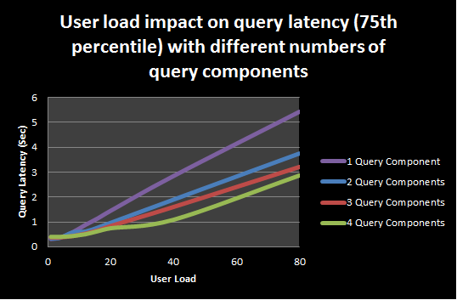

###### Adding additional query processors (Query and Site Settings Service) to reduce latency

The following graph illustrates the effect of adding additional active query processor services on different servers without changing any other parts of the query system.

Takeaway: Start other active instances of the Query and Site Settings Service on different servers to retain sub-second query latency as the user load on the system (measured in simultaneous user queries) increases.

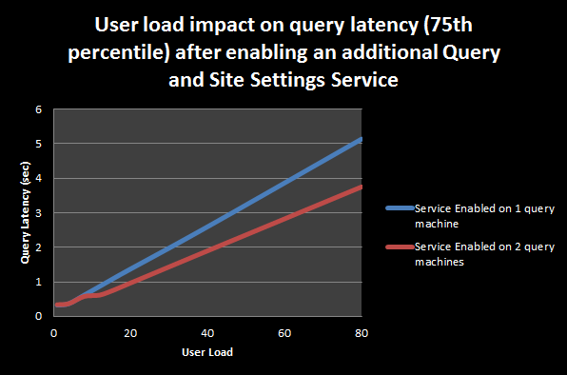

##### Scale out to increase query throughput

###### Adding additional query components to increase throughput

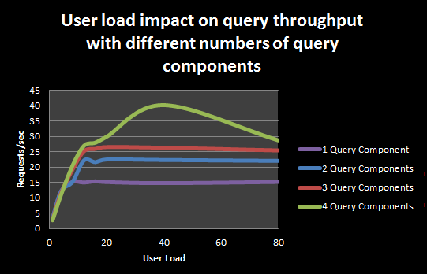The following graph illustrates the effect of adding additional active query components on different servers without changing index size.

Takeaway: Add more active query components to increase query throughput as the user load on the system (measured in simultaneous user queries) increases.

###### Adding additional query processors (Query and Site Settings Service) to increase throughput

The following graph illustrates the effect of adding additional active query processor services on different servers without changing any other parts of the query system.

Takeaway: Start other active instances of the Query and Site Settings Service on different servers to increase the throughput as the user load on the system (measured in simultaneous user queries) increases.

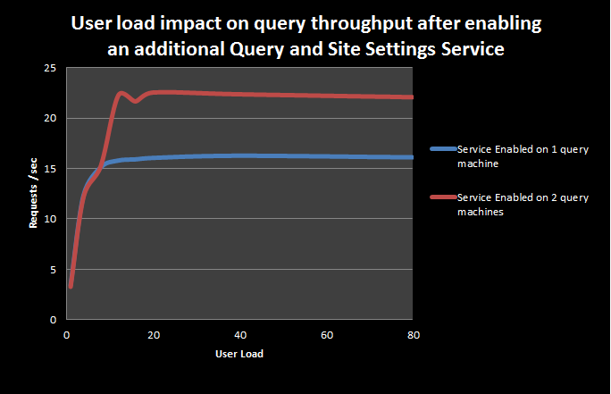

#### Search crawl system optimizations

In general, search crawl optimizations follow one of the following scenarios, starting with user complaints about query results that either should be there but aren’t, or are there but stale.

While attempting to crawl the content source start address within freshness goals, you may run into the following crawl performance issues:

* Crawl rate is low due to IOPS bottlenecks in the search crawl subsystem.
* Crawl rate is low due to lack of CPU threads in the search crawl subsystem.
* Crawl rate is low due to slow repository responsiveness.

Each of these issues assumes that the crawl rate is low. Use the [search administration reports](http://technet.microsoft.com/en-us/library/ee808861(office.14).aspx) (given the software lifecycle phases) to baseline typical crawl rate for your system over time. When this baseline regresses, the following sub-sections will show various ways of addressing these crawl performance issues.

##### Crawl IOPS bottleneck

After determining that a crawl or property database is a bottleneck, you need to scale up or scale out your crawl system to address it using the appropriate resolutions. The following table shows how adding IOPS (another crawl database) yields an improved crawl rate (until adding more components makes it the bottleneck again).

Takeaway: Always check the crawl database to make sure it is not the bottleneck. If crawl database IOPS are already bottlenecked, adding additional crawl components or increasing the number of threads does not help.

|  |  |  |  |  |  |
| --- | --- | --- | --- | --- | --- |
| **Topology**  **(Crawl Component/**  **Crawl DB)** | **CPU %** | **RAM: Buffer Cache Hit ratio %** | **Read Latency** | **Write Latency** | **Crawl Speed (docs/sec)** |
| 2 / 1 DB | 19.5 | 99.6 | 142 ms | 73 ms | 50 |
| 4 / 2 DB | 8.502 | 99.55 | 45 ms | 75 ms | ~75 |
| 6 / 2 DB | 22 | 99.92 | 55 ms | 1050 ms | ~75 |

##### Crawl CPU thread bottleneck

If you have a large number of hosts, and have no other crawl bottlenecks, you need to scale up or scale out your crawl system to address it using the appropriate resolutions. The crawler can accommodate a maximum of 256 threads per search application. We recommend having a quad core processor to realize the full benefit of the maximum number of threads. Once it is conclusively determined that the repository is serving data fast enough (see Crawl Bottleneck on Repository section), the crawl throughput can be increased by requesting data faster from the repository by increasing the number of crawler threads. This can be achieved in three ways as outlined below:

1. Change the indexer performance level to **Partially Reduced** or **Maximum** by using PowerShell. The **Maximum** value is used if using a processor with less than four cores.
   1. Get-SPEnterpriseSearchService | Set-SPEnterpriseSearchService –PerformanceLevel “Maximum”
2. Use crawler impact rules to increase the number of threads per host. This should take into consideration that we support a maximum of 256 threads, and assigning a large number of threads to a few hosts might result in slower data retrieval from other repositories.
3. If there are a large number of hosts, the ideal solution is to add another crawl component on a separate indexer to crawl the hosts we want to index faster.

Takeaway: The ideal way to seamlessly increase crawl throughput is to add another indexer if the search subsystem is not bottlenecked on IOPS and the repository is serving content fast.

##### Crawl bottleneck on repository

At times, when crawling a SharePoint Web application with many nested sites collections or remote file shares, the search crawler might be bottlenecked on the repository. A repository bottleneck can be identified if the following two conditions are true:

1. There is a low (<20%) CPU utilization on the indexer boxes.
2. There is a large number of threads (almost all in worst case) waiting on the network.

This is identified by looking at OSS Search Gatherer/Threads Accessing Network performance counter.

What this situation represents is that the threads are blocked waiting for data from the repository. In an environment with multiple content sources, it might be useful to identify the host whose responsiveness is slow by pausing all other crawls and just crawling the content source having the suspected host as one of its start address.

Once we’ve identified a problematic host, we need to investigate the cause of their slow response times. For SharePoint content in particular, please refer to the “[Capacity Planning and Sizing for SharePoint Server 2010-based Divisional Portal](http://technet.microsoft.com/en-us/library/ff608068(office.14).aspx)”.

Takeaway: The crawl throughput can be significantly improved by performance tuning the crawled data repositories.

## Troubleshooting performance and scale issues

Understanding the load on the farm is critical before troubleshooting performance. The following section uses data from a live farm containing 60 million items, to show various system metrics at different phases in the search lifecycle.

### Performance samples during search lifecycle

|  |  |  |  |
| --- | --- | --- | --- |
| **Metric** | **Index acquisition** | **Index maintenance** | **Index cleanup** |
| **SQL Server CPU (in %)**  **Property database / crawl database** | 14.8 / 19.13 | 35 / 55 | 11 / 63 |
| **SQL Server page life expectancy**  **Property database / crawl database** | 60548 / 5913 | 83366 / 5373 | 33927 / 2806 |
| **SQL Server Avg Disk sec/ Write**  **Property database / crawl database** | 9 ms / 48 ms  MAX:  466 ms / 1277 ms | 12 ms / 28 ms | 20 ms / 49 ms  MAX:  253ms / 1156 ms |
| **SQL Avg Disk sec/ Read**  **Property database / crawl database** | 8 ms / 43 ms  MAX:  1362 ms / 2688ms | 11 ms / 24 ms | 24 ms / 29ms  MAX:  2039 ms / 2142 ms |
| **Crawler CPU (in %)**  **Index server 1 (2 crawl components) / Index server 2 (2 crawl components)** | 18 / 11 | 25.76 / 21.62 | 8.34 / 7.49  Max peaks to 99% |
| **Disk Writes/Sec**  **Index server 1 (2 crawl components) / Index server 2 (2 crawl components)Index server 1 (2 crawl components) / Index server 2 (2 crawl components)** | 64.32 / 42.35 | 93.31 / 92.45 | 99.81 / 110.98 |
| **Disk Reads/Sec**  **Index server 1 (2 crawl components) / Index server 2 (2 crawl components)** | 0.23 / 0.20 | 4.92 / 2.03 | 1.38 / 1.97 |
| **Avg Disk sec/Write**  **Index server 1 (2 crawl components) / Index server 2 (2 crawl components)** | 11ms / 11ms | 1ms / 2ms | 5ms / 4ms  MAX:  1962ms / 3235ms |
| **Avg Disk sec/Read**  **Index server 1 (2 crawl components) / Index server 2 (2 crawl components)** | 1ms / 2ms | 12ms / 11ms | 10ms / 16ms  MAX:  2366ms / 5206ms |

### Troubleshooting query performance issues

SharePoint search has an instrumented query pipeline and associated [administration reports](http://technet.microsoft.com/en-us/library/ee808861(office.14).aspx) that help troubleshoot server-based query performance issues. This section will show reports and use them to help understand how to troubleshoot issues on the server. In addition, this section also contains tools and guidance available to assist in addressing client-based (browser) performance issues.

#### Server-based query issues

Server-based query performance can be segregated into two levels of issues:

* Search front-end performance issues
* Search backend performance

The following two subsections give the details for troubleshooting each of them. Please note that these are high level guidelines.

##### Front-end performance issues

The first step in troubleshooting front-end query performance should be reviewing the **Overall Query Latency** search administration report. Here is an example report:

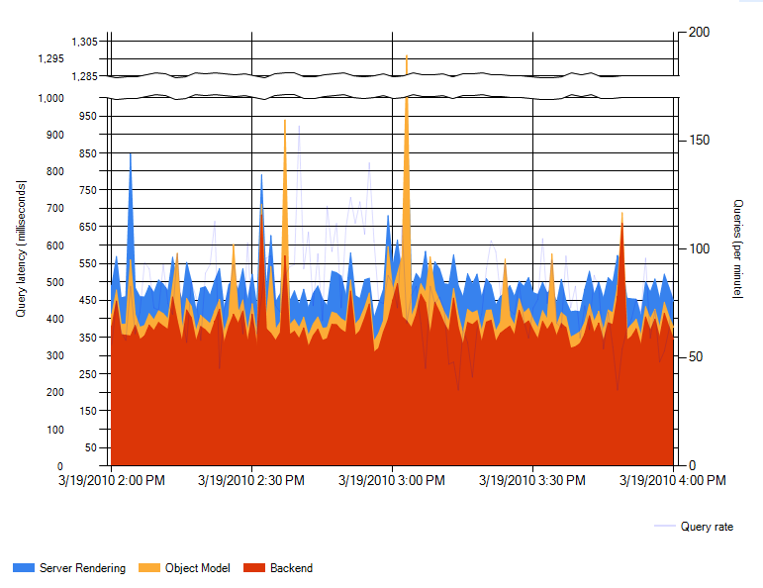

In this report, front-end performance is represented by the following data series:

* Server Rendering: This value represents, for the given minute, the average time spent per query in the various search Web Parts in the front-end Web server.
* Object Model: This value represents, for the given minute, the average time spent in communication between the front-end Web server and the search back-end.

###### Troubleshooting server rendering issues

Server rendering issues can be affected by anything occurring on the front-end Web server serving the search center results page. In general, you want to understand how much time is being spent in retrieving the various Web parts, in order to find where the extra latency is being added. Enable the [Developer Dashboard](http://blogs.msdn.com/russmax/archive/2010/02/10/sharepoint-2010-logging-improvements-part-2-introducing-developer-dashboard.aspx) on the search results page for detailed latency reporting. Common issues that manifest as excess server rendering latency include:

* Platform issues. This includes:
  + Slow Active Directory lookups.
  + Slow SQL times.
  + Slow requests to User Profile Application in people queries in SharePoint Server 2010 or all queries in FAST Search for SharePoint Server 2010
  + Slow requests for fetching the user preferences
  + Slow calls to get the user’s token from secure token service
* Code-behind issues. This includes modified search results pages (such as results.aspx, and peopleresults.aspx) that are checked in but not published.

###### Troubleshooting object model issues

Object model issues can be affected by:

* Issues with the WCF layer:
  + Timeouts and threadabortexception in WCF calls in your deployment.
  + High time in communication between the front-end Web server and application server. This can be due to IPSec issues or slow network connections.
* Issues with communication between the content and service farms (if configured).

##### Backend performance issues

The first step in troubleshooting backend query performance should be reviewing the **SharePoint Backend Query Latency** search administration report. Here is an example report:

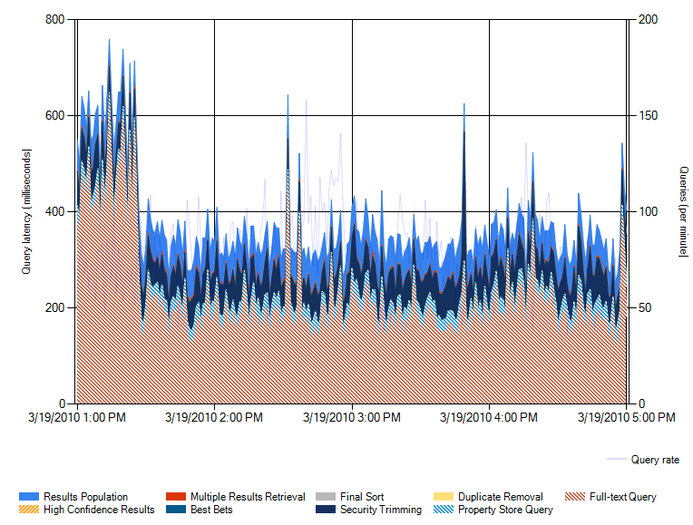

In this report, backend performance is represented by the following data series (each is average time spent per query, in the given minute), grouped by functional component:

* Query Component:
  + Full-text Query: This value shows the average time spent querying the full-text index for results.
* Property DB:
  + Multiple Results Retrieval: This value shows the average time spent retrieving document metadata, such as title or author, to appear in the query results.
  + Property Store Query: This value shows the average time spent querying the property database for property-based queries.
* Search Administration DB:
  + Best Bets: This value shows the average time spent determining whether there are best bets available for the query terms.
  + High Confidence Results: This value shows the average time spent to retrieve high confidence results for queries.
* Query Processor:
  + Security Trimming: This value shows the average time spent removing items the user does not have access to.
  + Duplicate Removal: This value shows the average time spent removing duplicates.
  + Results Population: This value shows the average time spent creating the in memory table to be passed back to the object model.

###### Troubleshooting query component performance issues

Query components are resource intensive, especially when the component is “active”; that is, responding to query requests. Troubleshooting query component performance is one of the more complicated search areas. Here are general areas to consider:

* The most resource intensive query component event is the master merge, where shadow indexes are merged with the master index. This event occurs independently for each query component. An example of the impact can be seen in the **SharePoint Backend Query Latency** report above, at times prior to 1:30 PM. If this event is impacting end-user query latency, it is possible to define “blackout” periods where a master merge event is avoided unless the percentage of change exceeds the defined limit.
* Sustained high values for your environment mean you should probably:
  + Examine the index size for each component on the server. Ensure enough RAM on the server exists to allow ~33% of the sum of index sizes to be cached.
  + Examine the query component IO channel on the server. Ensure you are not experiencing an IO bottleneck.
  + If IO and RAM are not the source of the performance issue, you should repartition your query components (adding additional index partitions), scaling out the additional query components to new servers.

###### Troubleshooting property database issues

Examine SQL Server health using concepts in the “[Storage and SQL Server capacity planning and configuration](http://technet.microsoft.com/en-us/library/cc298801(office.14).aspx)”. If you are executing custom queries, you may need to look at hints, to guide the correct query plan.

###### Troubleshooting search administration database issues

Examine SQL Server health using concepts in the “[Storage and SQL Server capacity planning and configuration](http://technet.microsoft.com/en-us/library/cc298801(office.14).aspx)”.

###### Troubleshooting query processor issues

Troubleshooting query processor issues depends on the area of the query processor that is exhibiting the degraded query latency:

* Security trimming:
  + For windows claims, examine the Active Directory connection from the server hosting the query processor.
  + For all cases, the cache size used by the QP can be adjusted higher, if there is a correlation between a large number of SQL Server round trips (determined by SQL Server profiler). More than 25% of queries should not need a SQL Server call to retrieve security descriptors from the search administration database. If they do, adjust the QP cache size using the instructions (link to article on QP cache).
* Duplicate removal:
  + Look at whether you are crawling the same content in multiple places. Disable duplicate detection in the search center.
* Multiple results retrieval:
  + Examine SQL health using concepts in the “[Storage and SQL Server capacity planning and configuration](http://technet.microsoft.com/en-us/library/cc298801(office.14).aspx)”.

#### Browser-based query issues

Users can be either delighted or exasperated by the speed of search results. Page load time (PLT) is one of the important factors in a user’s impression of a user experience. Most of the focus around PLT is on the server-side, namely the time it takes the server to return results. Client-side rendering, however, can compose a significant portion of PLT and is important to consider.

The out-of-box search user experience is designed to provide sub-second responses for total PLT. Out of that time, client rendering typically takes less than 280 milliseconds, depending upon your browser and rendering measurement. This experience delights users with very fast results.

Customizations to the results experience can easily degrade rendering performance. Search administrators and developers must be vigilant in measuring the rendering time after each modification to ensure performance has not regressed significantly. Every addition to the page from a new Web Part to a new CSS style will increase rendering time on the browser and delay results for your users. The amount of delay, however, can vary greatly based on whether certain best practices are followed when customizing the page.

Here are some general guidelines:

* Basic branding and style customizations to the page should not add more than approximately 25 ms to PLT. Measure PLT before and after implementing customizations to observe the change.
* Users typically notice a change (faster or slower) in an increment of 20%. Keep this in mind when making your changes; 20% of the out of the box rendering time is only 50 ms. (Source: [Designing and Engineering Time](http://www.engineeringtime.com/))
* Cascading Style Sheets (CSS) and JavaScript (JS) are the most common and largest culprits to high rendering performance. If you must have customized CSS and JS, ensure they are minimized to one file each.
* JS can load on-demand after the page renders to provide the user with visible results sooner. Details on how to do this are discussed in the performance considerations article.
* The more customizations added to the page, the slower it will load. Consider whether the added functionality and style is worth the extra delay on results for your users.

In addition to these guidelines, there is a wealth of information and tips on the internet about how to reduce PLT and the effect of slow pages on a user experience. Read up on the literature and delight your users with fast pages!

### Troubleshooting crawl performance issues

SharePoint search may experience bottlenecks in the crawl sub-system as the system moves through content acquisition, maintenance and deletion phases. To effectively troubleshoot crawl performance issue, the Search Health Monitoring Reports should be used in conjunction with the common bottlenecks and their causes section to isolate crawl issues.

#### Troubleshooting during Index Acquisition Phase

The first place to identify crawl issues is the Crawl Rate Per Content Source health report. As shown below, the report gives an overview of the crawl rate for each of the content sources in the system. In general , the crawl rate should be greater than 15 docs/sec for people content source and greater than 35 docs/sec for all other types of content sources.

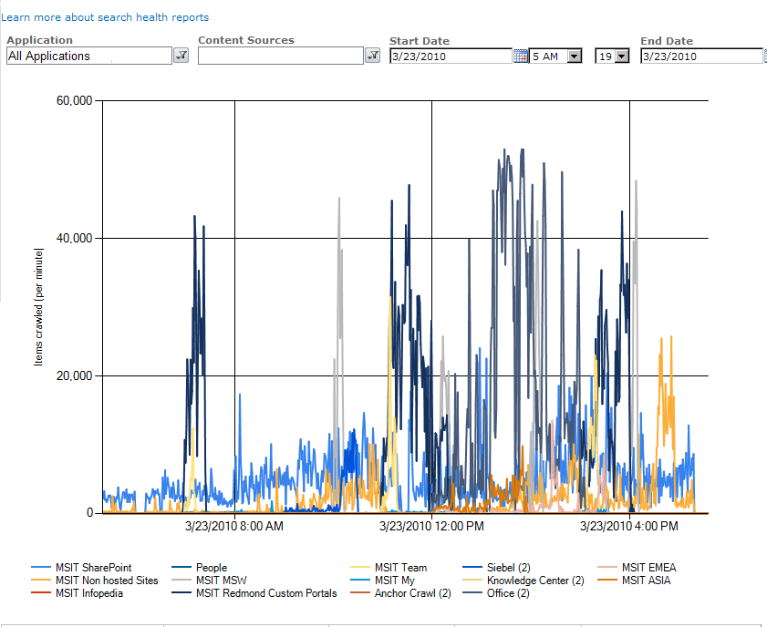

Once the content source with suboptimal crawl rate is identified, the following steps are recommended:

1. Pause all other crawls except the content source under investigation. Did the crawl rate improve beyond the specified 15/35 docs/sec goal?
2. If the above does not help, then ensure that the repository being crawled is responsive enough and not the cause for slow crawl. Refer to **Crawl bottleneck on repository**section of this document.
3. If the repository is not the bottleneck, the next step is to identify the bottleneck in the indexer or DB servers and optimize around them. Guidance can be found in the Crawl IOPS Bottleneck and Crawl CPU Thread Bottleneck sections.

#### Troubleshooting during Index Maintenance Phase

The primary goal during the content maintenance phase is to keep the search index as fresh as possible. Two of the key indicators for this are index freshness and incremental crawl speed.

1. **Index freshness :** Are the crawls finishing in their budgeted time and in accordance with the IT guidelines for index freshness?
2. **Incremental crawl speed:** If the index freshness goal is not met, then the first step is to investigate if whether the incremental crawl speeds are 10 docs/sec for people content sources and 25 docs/sec for all other content sources. If the incremental crawl speeds are suboptimal, a bottleneck analysis should be performed on the crawled repository and the crawl subsystem as described above.

### Common bottlenecks and their causes

During performance testing, several different common bottlenecks were revealed. A bottleneck is a condition in which the capacity of a particular constituent of a farm is reached. This causes a plateau or decrease in farm throughput.

The following table lists some common bottlenecks and describes their causes and possible resolutions.

|  |  |  |
| --- | --- | --- |
| Bottleneck | Symptom (perf counter) | Resolution |
| Database RAM | Property database,  Search administration database exhibit:   * SQL Server Buffer Manager/ Page Life Expectancy < 300(s) *(should be > 1000 (s))* * SQL Server Buffer Manager/ Buffer Cache Hit Ratio < 96% *(should be > 98%)* | * Add more memory to the database server. * Defragment the property database, if the weekly defrag rule has been disabled. * Ensure you are using SQL Server 2008 Enterprise edition, to enable page compression. * Move database to separate server, adding multiple property databases, if necessary. |
| Database server IOPS | A Property DB or  Crawl DB exhibits:   * Avg Disc Sec/Read and Avg Disc Sec/Write ~50 ms or > 50 ms | * Ensure the database server has enough RAM to keep 33% of the critical tables (MSSDocSDIDs + MSSDocProps + MSSDocresults) in cache. * Increase the dedicated number of IOPS for the database:   + Use different storage arrays   + Optimize your storage configuration; for example, by adding spindles (disk drives) to the storage array. * Run SPHA property database defragment rule, if it has been disabled. * Run SPHA crawl database defragment rule. * Ensure you are using SQL Server 2008 Enterprise edition, to enable page compression. * Move database to separate server, adding multiple property databases and/or crawl databases, if necessary. |
| Query component IOPS | The logical disk used for a query component’s index exhibits:   * Avg Disc Sec/Read and Avg Disc Sec/Write ~30 ms or > 30 ms for a sustained period of time *(i.e., most of the day; not just during an index merge)*. | * Ensure that each application server has enough RAM to keep 33% of each active query component 's index (on that server) in cache (OS cache). * Increase the dedicated number of IOPS for the drive used for the query component’s index:   + Use different storage arrays for different components.   + Optimize your storage configuration; for example, by adding spindles (disk drives) to the storage array. |