Title of Paper
Author Name
Company Name
July 31, 2026
Abstract
This paper …..
Author: Strike off OS names as appropriate
This information applies for the following operating systems:
Microsoft Windows Server™ “Longhorn”
Microsoft Windows Vista™
Microsoft Windows Server 2003
Microsoft Windows XP
Microsoft Windows 2000
Contents
Begin Text Here — Press F9 to update this list 3

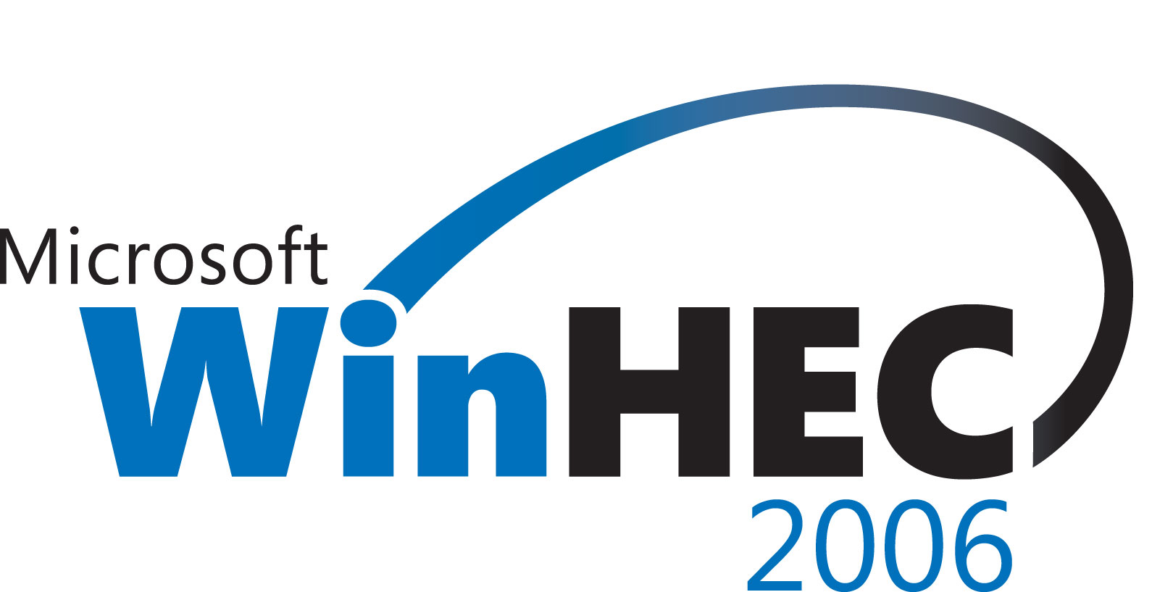

Author's Disclaimer and Copyright: <<Add your company disclaimer here
Windows Hardware Engineering Conference - WinHEC Sponsors’ Disclaimer: The contents of this document have not been authored or confirmed by Microsoft or the WinHEC conference co-sponsors (hereinafter “WinHEC Sponsors”). Accordingly, the information contained in this document does not necessarily represent the views of the WinHEC Sponsors and the WinHEC Sponsors cannot make any representation concerning its accuracy. THE WinHEC SPONSORS MAKE NO WARRANTIES, EXPRESS OR IMPLIED, WITH RESPECT TO THIS INFORMATION.
Microsoft, Windows, Windows NT, Windows Server, and Windows Vista are either registered trademarks or trademarks of Microsoft Corporation in the United States and/or other countries. The names of actual companies and products mentioned herein may be the trademarks of their respective owners.

Begin Text Here
Text

