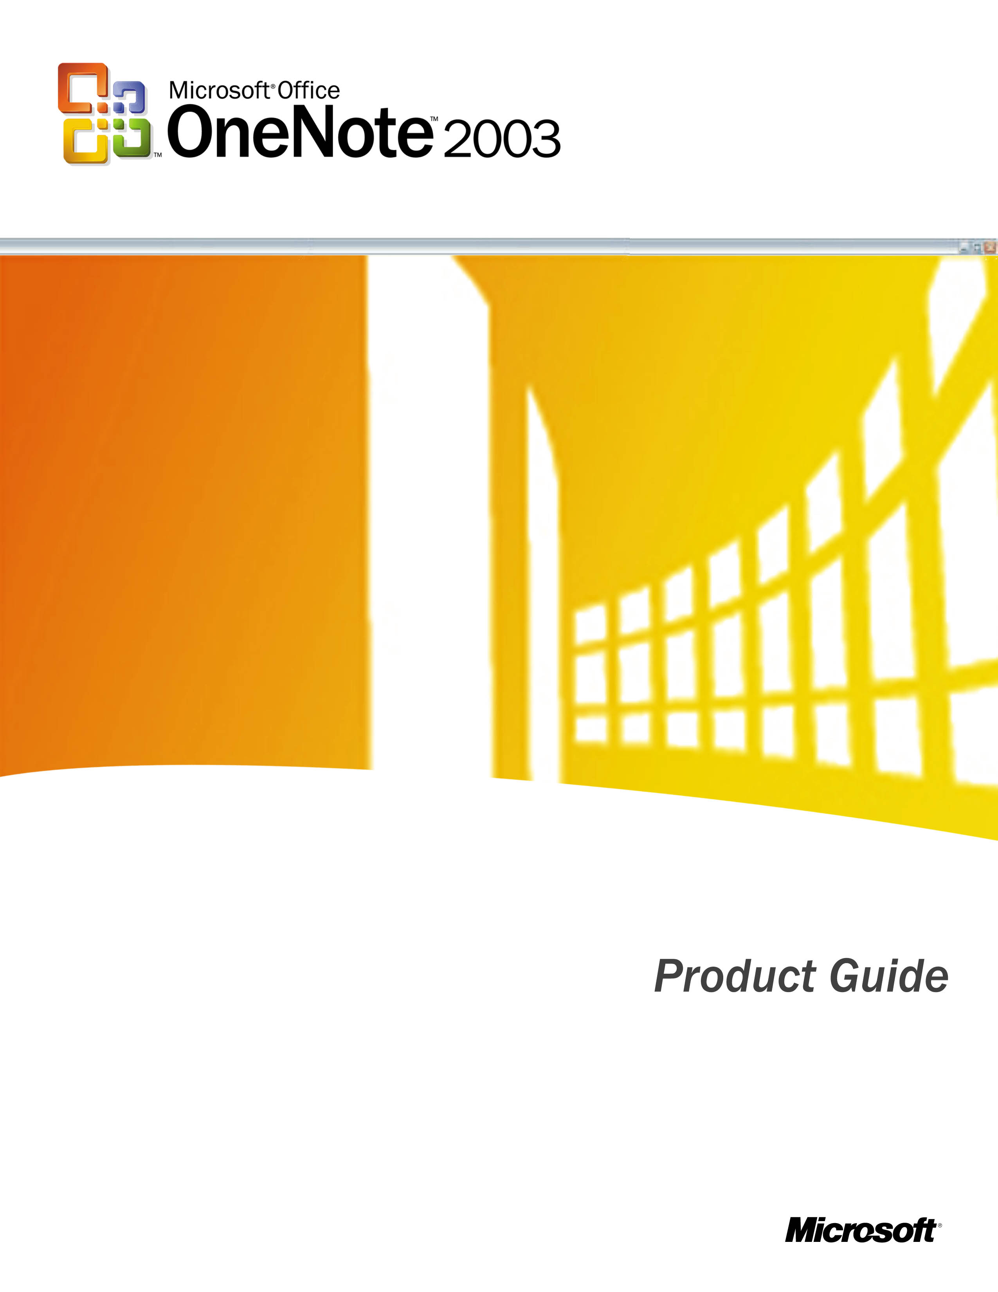

Contents

Introducing Microsoft Office OneNote 2003 1
OneNote in Action 1
Jack—Project Manager 1
Scott—Engineer 1
Abby—Consultant 1
Walter—Journalist 1
Roxanne—Student 1
OneNote: Your Digital Notebook 1
The User Interface 1
Free-Form Page Surface 1
Page Header 1
Notebook Sections 1
Page Tabs 1
Page Groups 1
Menu and Tool Bars 1
Taking Notes 1
Type Notes Anywhere 1
Note Containers 1
Rearranging Notes on the Page 1
Organizing Notes 1
Page Groups, Sections, and Folders 1
Page Groups for Related Notes 1
Sections for Categories of Notes 1
Folders for Multiple Sections 1
Moving Pages, Sections, and Folders 1
Organizing Notes on the Page 1
Bullets and Numbering 1
Outlining 1
Stationery 1
Saving and Deleting Notes 1
Automatic Save 1
My Notebook 1
Deleting Pages 1
Deleting Sections and Folders 1
Highlighting Important Notes 1
Note Flags 1
Finding Notes 1
Find 1
History Navigation 1
Recording Audio Notes 1
Doing Research 1
Copy and Paste 1
Side Notes 1
Research Library Task Pane 1
Sharing Notes 1
E-mail 1
Publish as HTML 1
Shared Workspace Pane 1
Printing Notes 1
Handwriting and Drawing 1
Convert Ink to Text 1
Predefined Ink Styles 1
Insert/Remove Space 1
Additional Information 1
Integration with Office 1
Keyboard Shortcuts 1
Additional Resources 1
System Requirements 1

Introducing Microsoft Office OneNote 2003
Microsoft® Office OneNote™ 2003, a new program in the Microsoft Office System of products, allows users to electronically capture, organize, and reuse notes on a laptop, desktop, or Tablet PC. OneNote 2003 provides a single place to collect and customize notes as you like—capturing information in multiple ways and organizing it according to your needs.
With OneNote 2003, the everyday act of note-taking becomes a dynamic and integral part of your work. OneNote allows you to:
- Take down notes as you like.
- Organize information easily.
- Access information quickly.
- Reuse and share notes effectively.
Microsoft Office OneNote 2003 helps you become more productive by transforming the note-taking process into an active and effective part of your day. Rather than transcribing paper-based notes into electronic form, you can capture your notes electronically so they are ready for distribution as soon as a meeting concludes. Add to that the ability to insert diagrams and Web research, and business notes transform from something that pile up unused and forgotten into a central part of your business process. OneNote 2003 helps you:
- Increase efficiency by centralizing all notes electronically.
- Reduce downtime associated with note transcription.
- Boost productivity by easily integrating OneNote content into other Microsoft Office programs.
While OneNote 2003 can be used on a laptop, desktop, or Tablet PC, the pen input device on a Tablet PC enables additional capabilities in OneNote. For example, with a Tablet PC, you can handwrite your notes (and convert them to text if desired) and draw diagrams or pictures as part of your notes. If you use OneNote with a laptop or desktop PC with a pen input accessory, you can also write and draw in OneNote, but your handwriting is treated as picture files and cannot be converted to text as in a Tablet PC.
OneNote 2003 is expected to be available in 2003. In the meantime, visit www.microsoft.com/office/onenote for the latest information and updates.

OneNote in Action
Microsoft Office OneNote 2003 is a versatile note-taking program that can help professionals in just about all walks of life. With OneNote, you don't just take notes, you take action. Here are some examples of how OneNote can be used at work:

Jack—Project Manager

Jack is an example of a project manager for a large manufacturing company. He uses OneNote 2003 on his laptop to take notes during all of his meetings, both in person and over the phone. Jack keeps his notes for each of his current projects in a separate OneNote notebook section, and he also keeps a special OneNote section for meetings. He appreciates the fact that OneNote keeps all this information in one place for him. He often uses OneNote to record the audio portion of meetings, which are automatically synchronized with his typed notes. After meetings, Jack will listen to parts of his audio recording again so that he can make sure he understands important customer comments and action items that he may have overlooked during the meeting.

Scott—Engineer

Scott is an example of an engineer who designs circuits and chips for a high-tech company. He uses OneNote 2003 on his desktop PC along with a pen input accessory to take notes and draw diagrams for his various projects and meetings. Since all of Scott’s notebooks are in one place, it’s really easy for him to search his notes quickly to find information. For example, Scott’s manager just asked him for the price quote of a new alloy that he is currently investigating. Scott knows that he took down this quote for the alloy several weeks ago, but he doesn’t remember exactly where or when. By searching for the word “alloy” in his OneNote notes, Scott can find this information with a few clicks of his mouse.

Abby—Consultant

Abby is an example of a consultant for a leading professional services firm. She uses OneNote 2003 on her notebook PC to keep track of her client notes, meetings, and phone calls. Abby particularly values the fact that OneNote makes it very easy to share her notes with her colleagues via e-mail or their team’s Microsoft Windows® SharePoint™ Services site. This enables her entire team to share ideas and reuse each other’s notes and information easily and efficiently.

Walter—Journalist

Walter is an example of a staff researcher for a major travel magazine. He uses OneNote 2003 on his desktop PC to take notes and gather information about new destinations for upcoming articles. He keeps a separate OneNote notebook section for each destination. Walter often uses the OneNote ability to simply drag pictures, text, or other information from a Web site directly into OneNote—and OneNote even conveniently notes the URL for him so that he can easily reference his sources later.

Roxanne—Student

Roxanne is an example of a first-year student in college. She uses OneNote 2003 on her Tablet PC for typing notes to prepare for exams. She also uses the pen to handwrite notes while she’s in class. Roxanne keeps a separate notebook section for each of her classes, and when the semester ends, she starts a new folder to hold a new set of notes. She particularly likes the fact that OneNote enables her to flag important sections of her notes and then lets her find all of her Note Flags across every class notebook section, so she doesn’t forget about an assignment for other classes—or to call mom!

OneNote: Your Digital Notebook
We all face challenges tracking the information we generate, the information we receive from others, and the information we share. People need to efficiently organize and access the right data at the right time so that they can create reports, prepare presentations, organize for important meetings, or study for tests. Often it is difficult to remember where you wrote down that key piece of information. Was it in your paper notebook, in one of hundreds of files on your personal computer, in your planner, on your handheld personal digital assistant, or on a sticky note on your desk?
Microsoft Office OneNote 2003 gives you one convenient place for all of your information, as well as powerful features to help organize your notes the way you want. The flexible interface of your OneNote digital notebook lets you create as many folders, sections, and pages as you need, while still keeping them all in one convenient place. And, no matter how you decide to organize information, you can easily search across all of your notes to quickly find the information you want.

The User Interface
The following is an overview of the OneNote User Interface and the way it enables you to organize your notes.

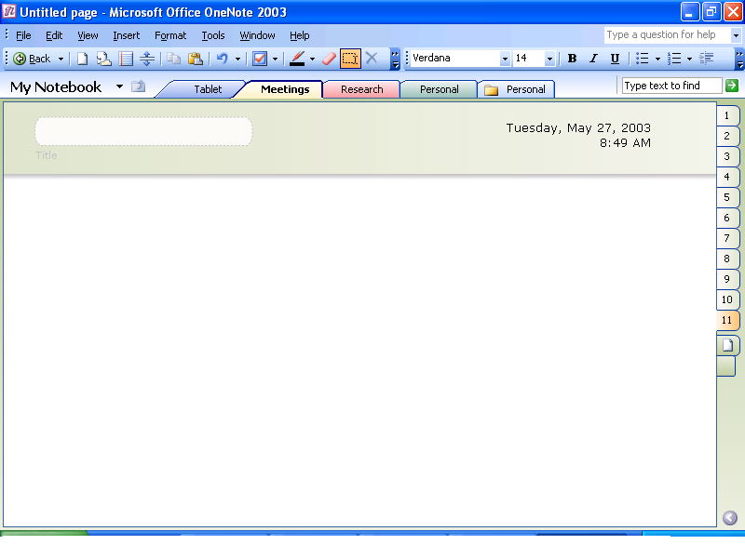
Figure 1 Take notes anywhere on the page surface in OneNote 2003.

Free-Form Page Surface
Just as with paper, you can capture notes anywhere on the page in OneNote. You can use the arrow keys to move around the page, or you can click in the space where you want to take notes. People using a Tablet PC or a PC with a pen input device can also write anywhere they want on the page. (You can convert your handwritten notes to text with Tablet PCs, but with pen input devices with laptops or PCs, you cannot do this.) This free-form page surface means that you can organize your thoughts and ideas the way you prefer.
Wherever you take notes within this page surface, you can take advantage of rich word-processing features as you type. (See page 8 for more information on rich word-processing features.) Also, as you take notes, the page will expand both horizontally or vertically to accommodate your notes.

Page Header
Figure 2 Keep important information visible at all times in the page header.

Sometimes, in long meetings or lectures, you may have a page of notes that extends beyond the available screen area. In such a situation, it can be hard to keep track of the information or notes that you want continuous access to, such as follow-up questions. OneNote overcomes this issue with the page header.
The page header of each page is a separate, colorful region that doesn’t scroll with the main page contents. It contains information such as date, time, the title of the page, and any notes you enter. The title that you enter in the page header becomes the title for that page of notes. All the content in that area remains visible at all times and can be resized to fit as much information as necessary.
The page header contains the same rich word-processing features (see page 8 for more information on these features) and the ability to write anywhere as in the rest of the OneNote page surface.

Notebook Sections
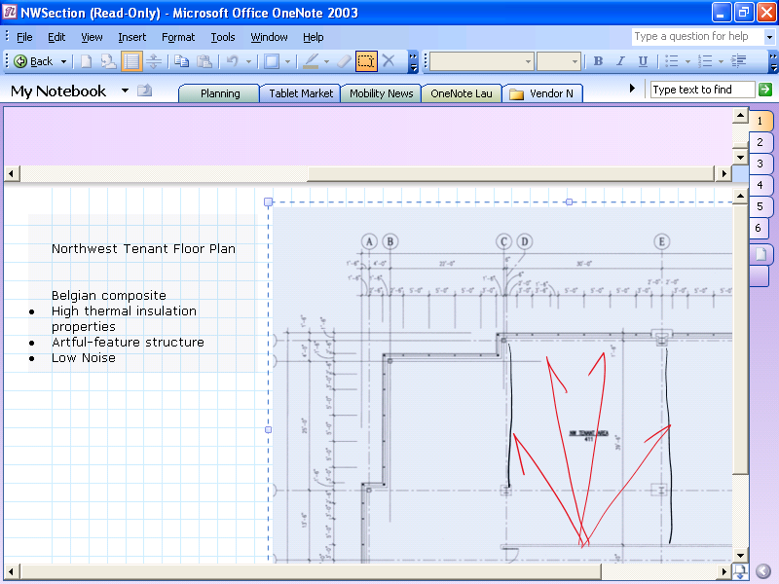
Figure 3 Organize different types of notes in notebook sections that you define.

Near the top of the screen are tabs representing each section of your OneNote notebook, which are much like tabs of hanging file folders or sections within a three-ring binder. You can create as many sections as you need, and customize them by naming them after different projects, courses, types of meetings, or anything you want. For example, a project manager might have a notebook section for meeting notes and additional sections for each project that he is working on. Or, he might have a notebook folder for a particular project and a section for each component of the project (for example, vendor meetings, client meetings, and project timelines).
To create a new section, go to File, then New, then Section or right-click on any existing section tab and choose New Section. You can also customize the color of any section simply by right-clicking on the section tab and choosing Section Color.
However you decide to organize your notes, each notebook section created represents a separate .one file, the binary file format for OneNote files, within the My Notebook folder. (See pages 9-11 for more detailed information on how to organize and move your notebook sections, and how to create notebook folders.)

Page Tabs
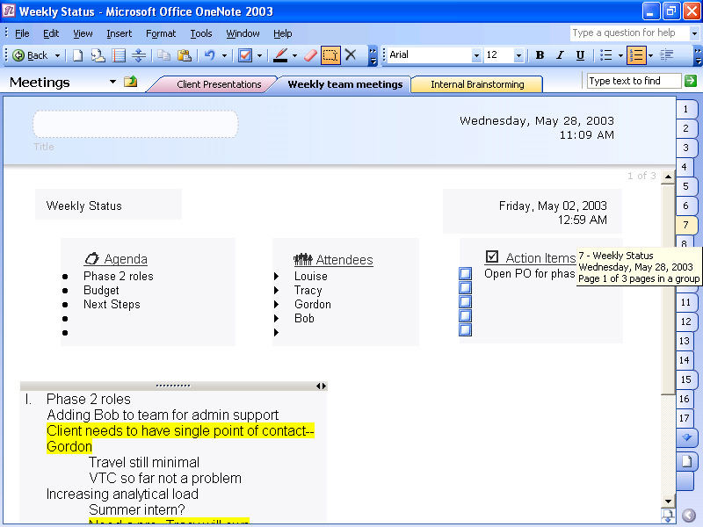
Figure 4 Find the correct page quickly with Page Tabs.

Along the right side of the screen, there is a separate set of tabs for the individual pages within each notebook section. Clicking these tabs takes you to the corresponding page. Hovering the mouse or pen over these Page Tabs will quickly give you information for each page, including the page title and date created. You can also select multiple pages using Page Tabs.
Just as you flip through (or "riffle” through) paper notes to find the one page you are looking for, you can do the same with OneNote pages. This riffling action is recreated in OneNote when you hold down the mouse button and drag across all the Page Tabs.
Each page will be named after the title that you have typed (or handwritten if you are using OneNote on a Tablet PC) into the title area. If you do not create a title for the page, the default name for the page will be the first text or handwritten note that you enter on the page. You can expand these Page Tabs to show the title of the pages by going to View and checking the Titles in Page Tabs option, or by clicking the small horizontal arrow in the lower right corner of the OneNote screen. You can also move all your Page Tabs to the left of the page if you prefer by going to Tools, Options, Other, and then Page Tabs Appear on Left.

Page Groups
You can create a page group, which is a collection of pages with the same title area. A page group has a primary page and at least one sub-page. All pages within the group contain the same information in the title area as the original page. New sub-pages within a group appear as smaller Page Tabs on the right, directly after the normally sized tab that indicates the first primary page in the group. You can create as many new sub-pages within a group as you like. (See page 9 for instructions on how to create a subgroup.)

Menu and Tool Bars
Similar to other familiar Office programs, the menu and toolbars for OneNote appear at the top of the user interface, above the section tabs. You can customize these toolbars by adding or removing icons for the features that you use most often.

Taking Notes

Type Notes Anywhere
As mentioned earlier, you can take notes anywhere on the page surface within OneNote 2003 by clicking in the area where you would like to take notes and typing there. In this way, OneNote enables you to take notes visually by grouping related notes together. For example, before a meeting you might create an area for notes titled “agenda,” a second area titled “attendees,” and a third titled “to-dos.” During the meeting, you can quickly add relevant notes to any of those three areas, or click elsewhere to start a completely new group of notes.
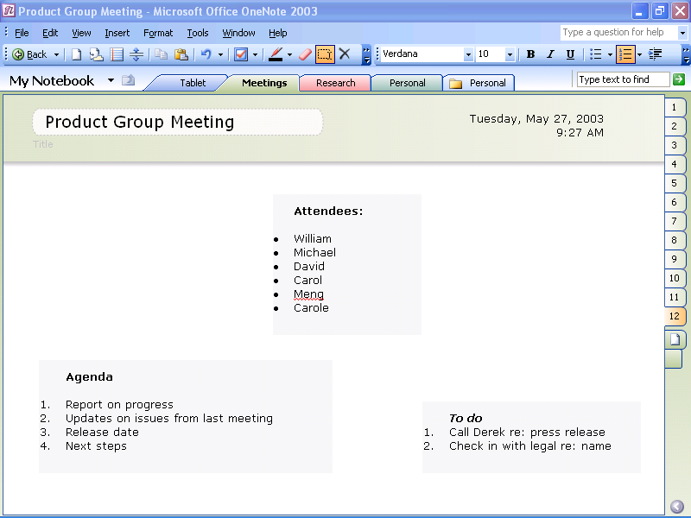
Figure 5 Type notes anywhere on the screen.

Note Containers
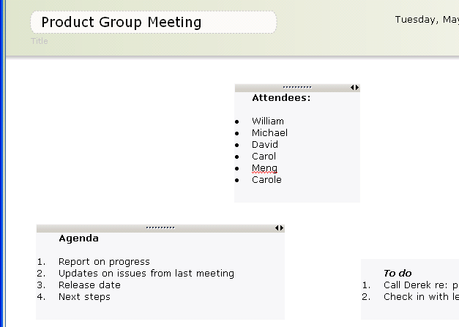
Figure 6 Move your notes around the page with handles.

When you click in a new area to start typing notes, OneNote will create a new “container” of notes in that area. Similar to other Office programs, OneNote provides a rich authoring and word-processing experience. You can format text by using colors, bolding, italicizing, and underlining, as well as benefit from features such as AutoCorrect and the spelling checker. You will experience this rich authoring experience in every container of notes.
If you hover your cursor over a container of notes, you will notice a horizontal gray bar will appear over the container. This horizontal gray bar is the “handle” for a container of notes, and it enables you to work with and move any container. When your mouse cursor moves over the handle, the cursor will change from an arrow into a cross. You can then easily move that entire container of notes and drag it anywhere on the page.
The handle on top of each note container also has two small horizontal arrows in the upper right corner. These arrows enable you to resize that container of notes, so that you can easily make those notes into tall thin columns or long horizontal rows.
When you click on or close to an existing note container, OneNote will enable you to add additional notes to that container. To start a new container of notes, click about an inch away from any existing note containers. Dragging and dropping one note container on top of another one will combine the notes within those containers into one large note container.

Rearranging Notes on the Page
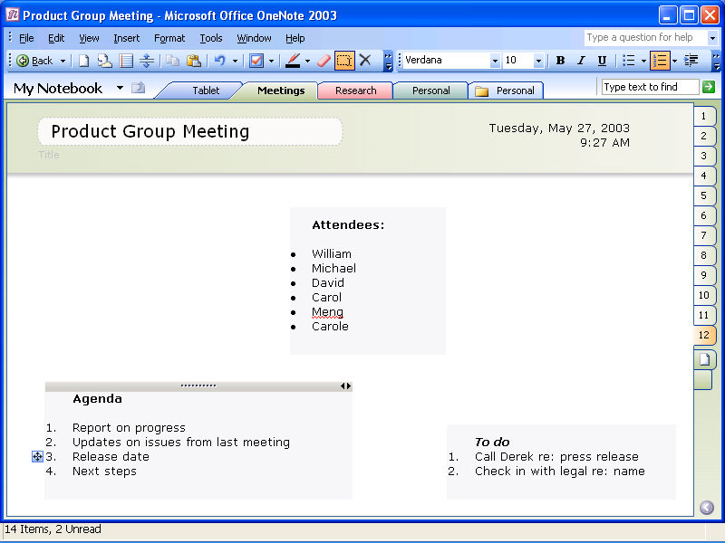
Figure 7 Move paragraphs within notes.

Another way to rearrange your notes is by selecting specific paragraphs within a note container and moving only those paragraphs. You can do this either by using the arrow keys on your keyboard to select specific paragraphs of text to cut and paste, or by hovering your mouse cursor over a paragraph within a container of notes. When you hover over a paragraph, a small blue box with a cross appears to the left of the paragraph. You can use this box as a “paragraph handle” by clicking on it and then dragging and dropping that paragraph of notes anywhere on the page. If you drag it on top of another container of notes, you will add it to that note container; if you drag it to open space on the page, you will create a new note container with that paragraph of notes.

Organizing Notes

Page Groups, Sections, and Folders
OneNote 2003 gives you the tools to better organize your notes, both while you are taking them and when reviewing them later. It is easy to begin taking notes simply by typing on a new page, but as you accumulate more notes, OneNote gives you the tools to manage that information. With OneNote, you can create a digital note-taking and filing system that works best for you.

Page Groups for Related Notes
As you take notes in OneNote, your page will expand to accommodate your notes. However, once you have a taken a large amount of notes devoted to one subject, you will have a very long page of notes. You may find it useful to divide that information among several pages of notes that are related to one another. OneNote enables you to create sub-pages that are related to the primary page of notes by going to File, New, then Subpage or by clicking the New Subpage tab located under the Page Tabs. For example, a salesperson might create multiple sub-pages in a page group with notes pertaining to a client offsite, or a student taking notes in political science class may create multiple sub-pages in a page group with all her notes related to amendments.

Sections for Categories of Notes
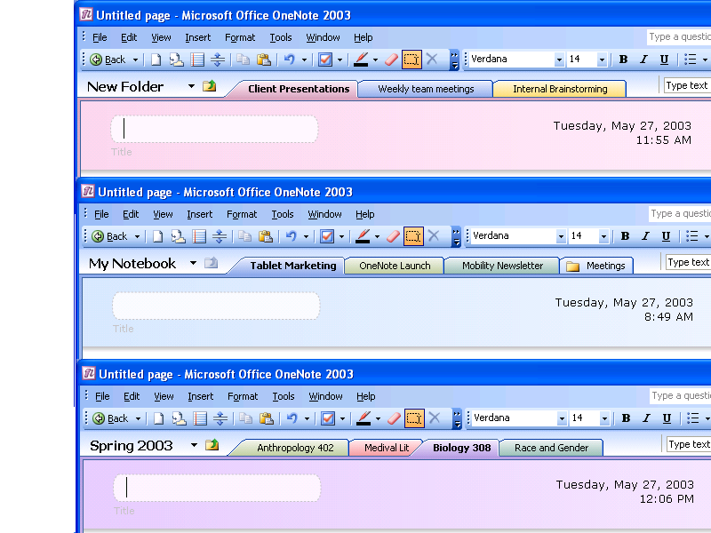
Figure 8 Create sections to keep your notes organized.

As you take more pages of notes, you will probably find it very valuable to separate them into different sections, much as you might add sections in a three-ring binder or add hanging file folders to your file cabinet, as discussed earlier. Different ways that you might organize your sections are to have one for each project, one for each course, or one for each type of meeting (for example client presentations, internal brainstorming, and weekly team meetings)—you can structure your sections the way you prefer. You can create new sections by going to File, New, then Section, or by right-clicking on any section tab and choosing New Section.

Folders for Multiple Sections
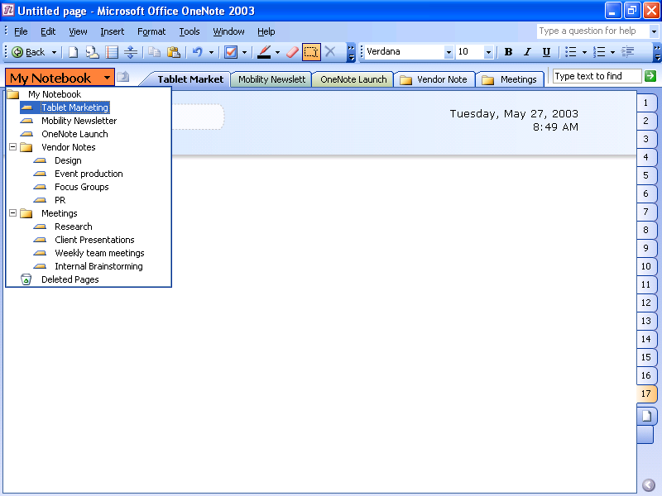
Figure 9 Store your sections in notebook folders.

When you have created a large number of notebook sections, it can be advantageous to create folders to store related sections. For example, you may want to create a folder for a project and then move all the sections related to that project into that folder—so that you have one project folder containing separate sections for your client meetings, proposals, budget, timeline, notes from phone calls, and more. The OneNote folder structure is similar to the folder structure within Microsoft® Windows® Explorer, allowing you to create folders within a folder to further subdivide your sections.
Notebook folders and sections created in OneNote are automatically saved to a "My Notebook" folder found inside the "My Documents" folder on your computer. You can access all of the information saved to My Notebook through the intuitive interface of OneNote. Each .one file will always be represented as a separate section tab in OneNote. This makes it easy for you to access information for multiple projects without needing to remember where you saved specific files within your computer.

Moving Pages, Sections, and Folders
To reorder your pages within the same section—for example, moving the last page to the beginning of the section—just select the Page Tab and then drag that page or page group to the new location.
To move pages from one section to another, right-click on the Page Tab, choose Move Page To, and choose the name of the section to which you would like to move that page.
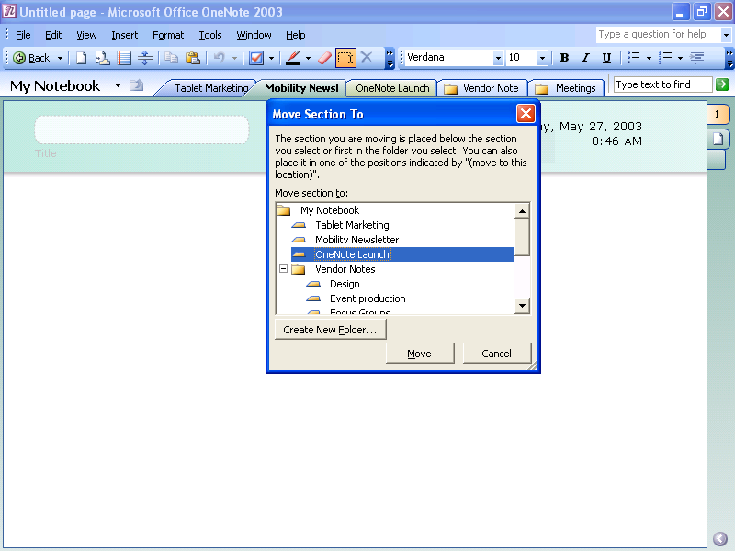
Figure 10 Reorder sections with a few clicks of the mouse.

Reordering sections within the same folder is simply a matter of a few clicks. For example, if you have sections A, B, C, and D, and you want to move D, right-click on the section tab for section D, and choose Move. Then click on section A. This action will move section D so that it appears to the right of section A, and your notebook will be organized as sections A, D, B, and C.
To move sections from one folder to another, follow the same steps but click the name of a folder instead of a section.
To move your folders, open up the My Notebook folder within Windows Explorer and move the folders where you prefer.

Organizing Notes on the Page
In addition to enabling you to organize your notes among different folders, sections, and page groups, OneNote also provides you with a number of tools to help you organize your notes on each page.

Bullets and Numbering
You can easily add bullets to visually separate items in a list and draw attention to specific entries, or use numbers to show a sequence. With OneNote, you can even combine bullets and numbers within the same list
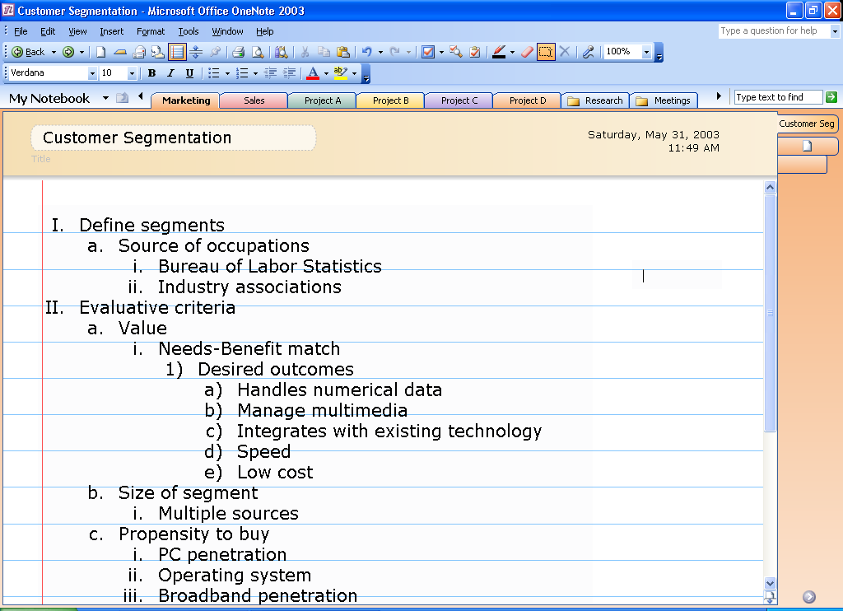
Figure 11 Outline your notes easily with OneNote.

Outlining
OneNote automatically recognizes different types of outlines as you create them, such as a simple list of phrases, a series of bulleted paragraphs, or the traditional number and letter hierarchy of headings. Because this is automated, you can concentrate on the information you are taking down, rather than how to format it. OneNote also allows you to expand and contract multiple levels of an outline, as well as customize the number format of outlines.
In addition, the strict outline structure of OneNote ensures that sub-bullets are never indented more than one level underneath the preceding bullet. This makes dragging and dropping a paragraph into an outline easy, because that paragraph can only go in three possible positions: the same as the preceding bullet, one bullet point out from the preceding point, or one bullet point in from the preceding point. Again, because OneNote automates this process and makes simple organizational decisions for you, you can concentrate on capturing and manipulating your ideas.

Stationery
When you launch OneNote, a blank white page opens by default. However, there are also stationery styles—pages with predefined looks. OneNote offers six basic kinds of stationery:
- Blank paper. Standard paper sizes such as Letter, A4, billfold, and index cards. Using blank paper sizes as your stationery helps to ensure that your notes will print out correctly on the corresponding paper size.
- Planner. Stationery for your to-do lists and action items.
- Business. Various templates to help you organize your meeting and project notes.
- Academic. Stationery to help you organize your class notes.
- Tablet PC. Special stationery for OneNote that can be used on a Tablet PC.
- Designer paper. Stationery with pictures and coordinated fonts and font colors.
To choose a stationery style, go to File, New, Change Stationery and choose the stationery that you want from the task pane on the right. Once specific stationery is chosen in a notebook section, OneNote will use that as the default blank page for that section.
Stationery pages give you a consistent look in all note-taking sessions, make typing recurrent text (such as the word “attendees” in every meeting note) unnecessary, and help you achieve visually pleasing notes without needing to format layout and font styles every time.
You can create your own customized stationery by formatting a page in your notebook, and then saving it as stationery in OneNote.
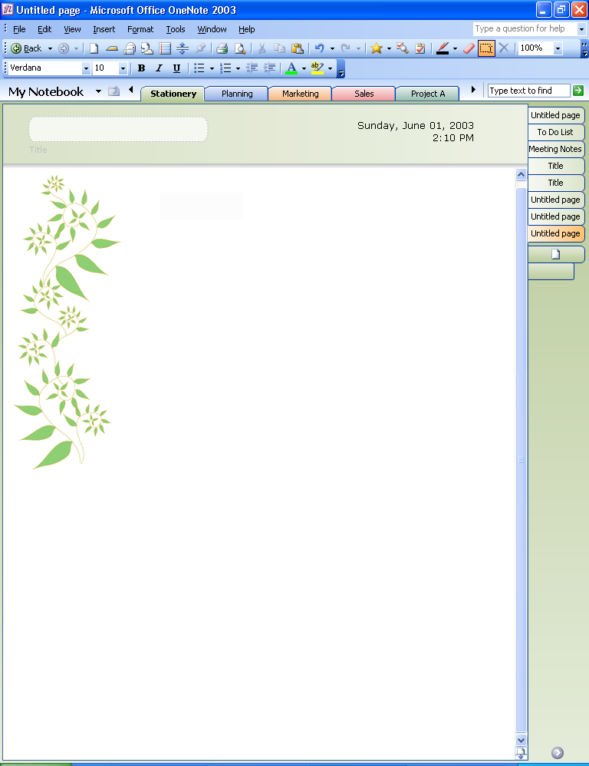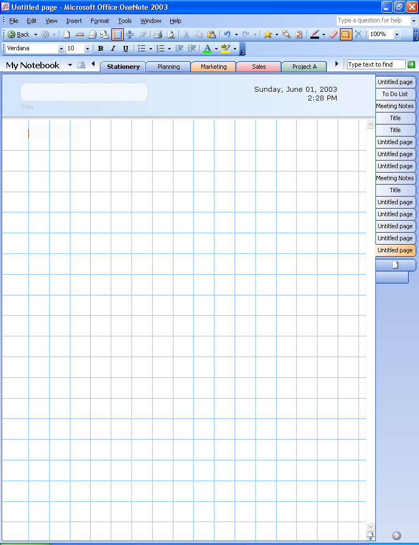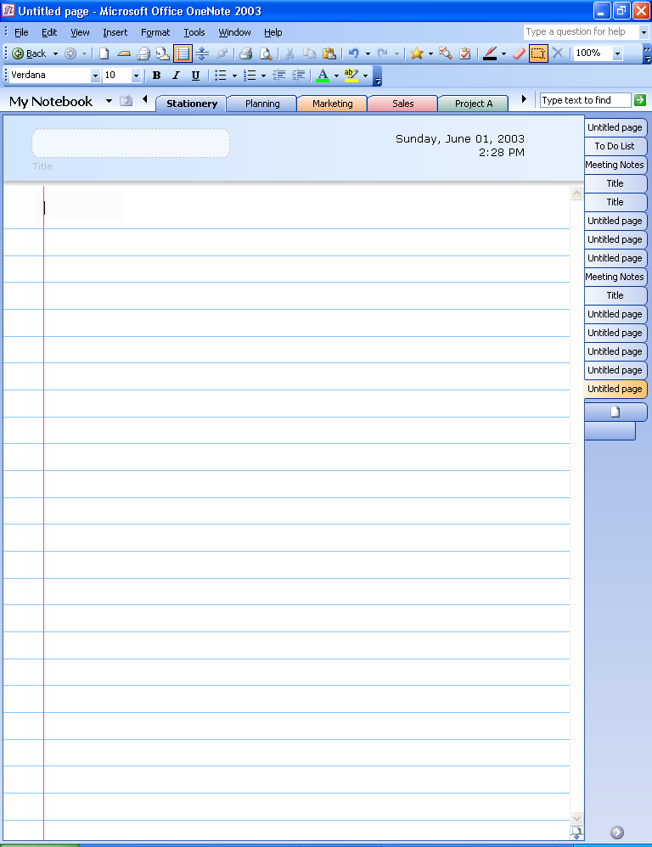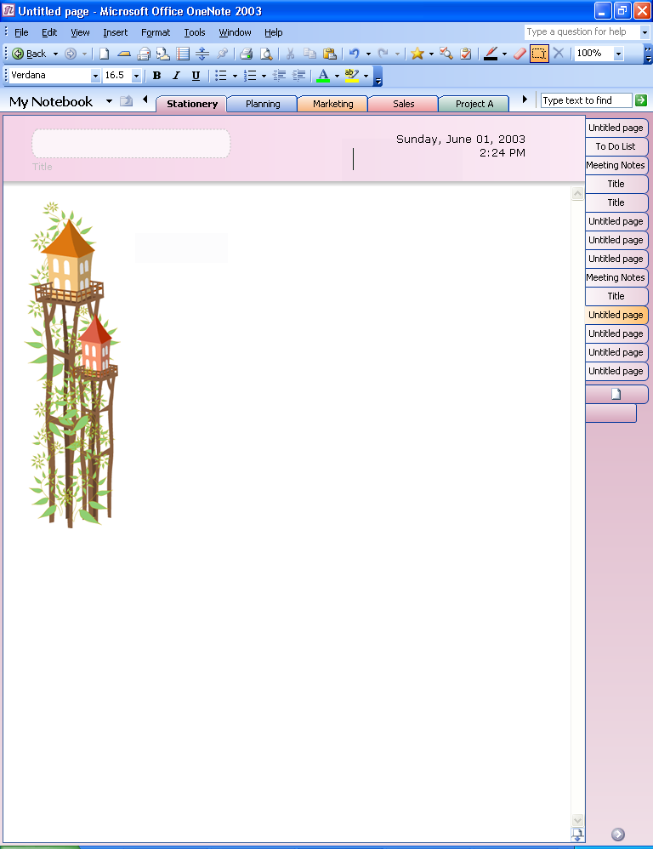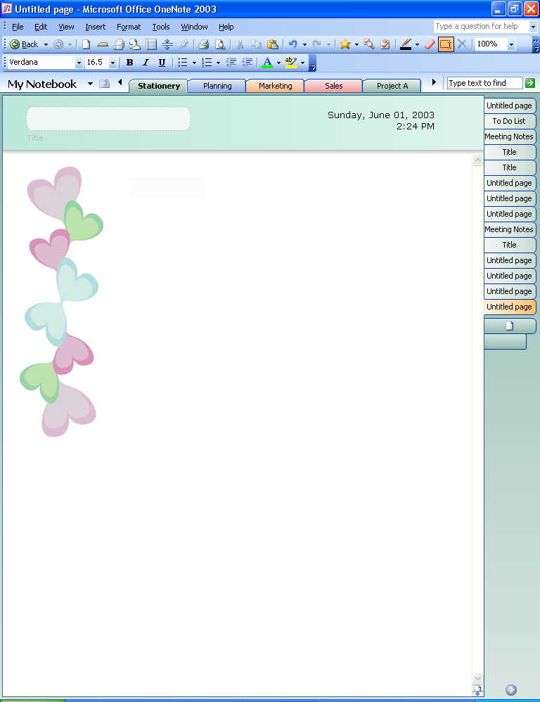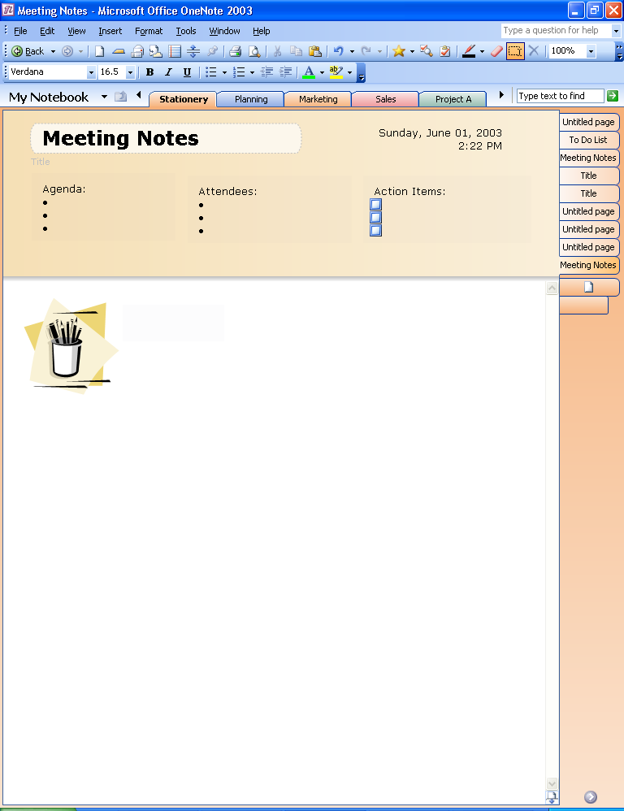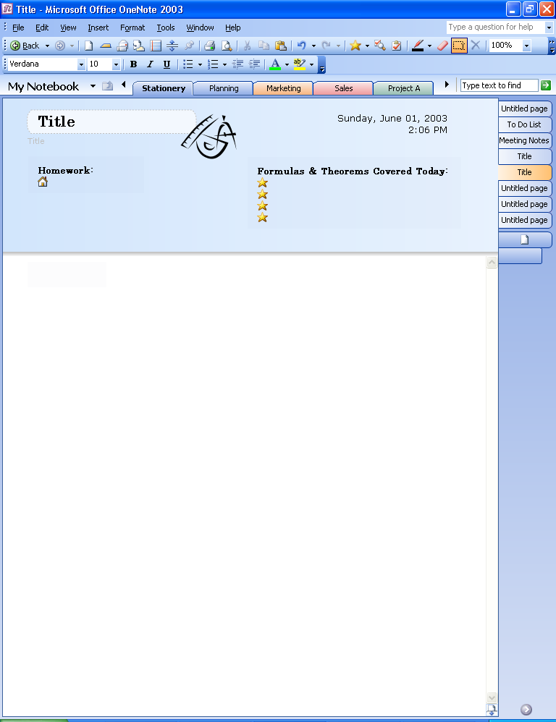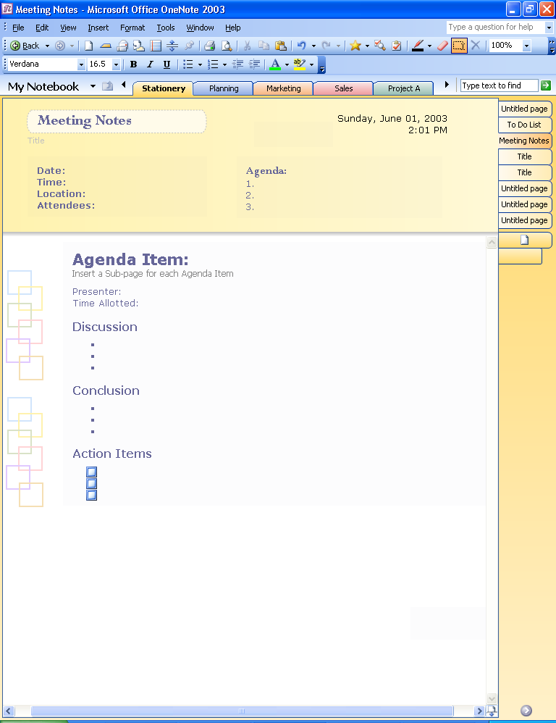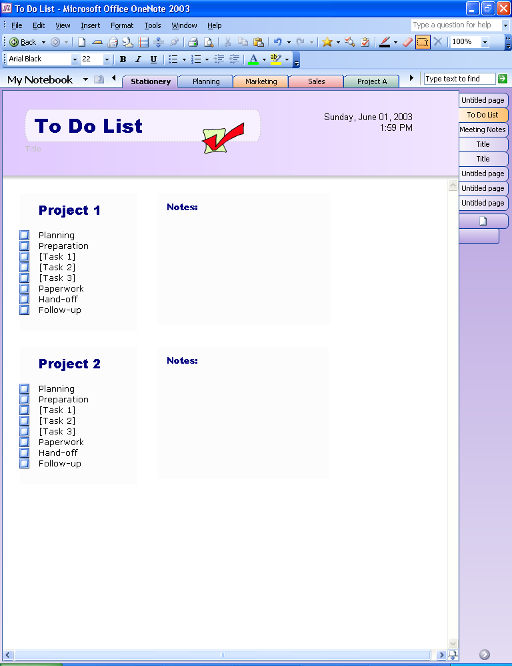
Figure 12 Examples of stationery available to OneNote users.

Saving and Deleting Notes
We have all experienced the frustration of searching for a particular file that we know is on our computer, but are unable to find it—whether it is because we don’t remember where we saved it or because we accidentally saved it in an incorrect location. OneNote 2003 was designed to help make finding your notes as intuitive as possible.

Automatic Save
One advantage of paper is that you never need to hit the “Save” button. Once you write it down, it’s there. OneNote offers the same kind of convenience. There is no Save button in OneNote—everything is automatically saved. So if it’s necessary to quickly turn off the computer or close the program, you don’t need to worry about losing important information. In addition, you never have to decide where to save a particular note. Any notes you take in OneNote are always automatically saved within the My Notebook folder and are easily accessible through the OneNote interface as one of the sections or pages.
When OneNote is opened, it automatically returns to the last page that was modified. This gives you quick access to the notes you were working on last.

My Notebook
When you first install OneNote, a “My Notebook” folder will automatically be created within your “My Documents” folder. By default, any new OneNote section will be created within your My Notebook folder, as will any new folders that you add in OneNote. All of your sections and folders are easily accessible via the tabs in OneNote.
If you prefer, you can move sections and folders within OneNote to locations other than “My Notebook,” such as a network file share or other locations on your hard disk drive. You can do this by using Windows Explorer to move the appropriate .one file to the location of your choice, and then double clicking on that .one file. OneNote will open that file and show that it is linked to a different location with a shortcut arrow on that section tab. This enables you to still access .one files via the section tabs within OneNote even if those files are not saved in your My Notebook folder.
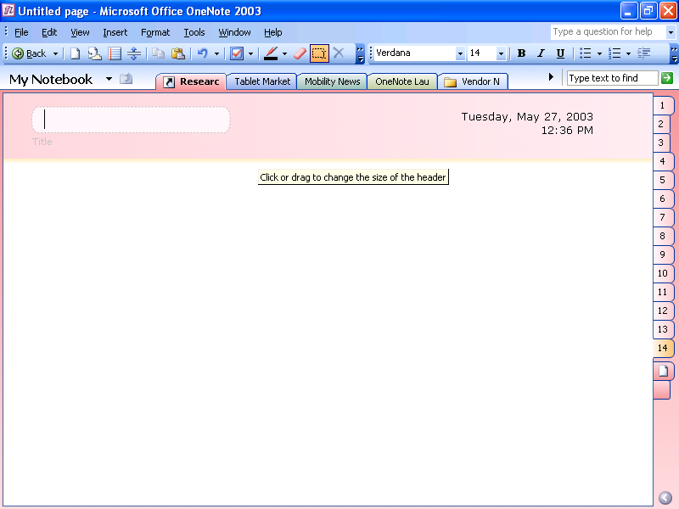
Figure 13 Save your notebook sections in any Windows Explorer folder.

Deleting Pages
You can delete a page by right-clicking on a Page Tab and choosing Delete. You can delete a subpage by first selecting a subpage by clicking on the Subpage Tab, right-clicking on that Subpage Tab, and choosing Delete.
When you delete a page, it goes to a section called Deleted Pages. You can move a deleted page back into a section in your notebook as long as you have not emptied this Deleted Pages section. To restore a deleted page, go to the drop-down tab labeled “My Notebook” to the left of your section tabs. Clicking on this tab will reveal the entire folder and section structure of your OneNote files. Click on the small recycle bin icon called “Deleted Pages.” This will open up all of your deleted pages by section. To restore any page or page group, right-click on the Page Tab and choose Restore.

Deleting Sections and Folders
You can delete a section or folder by right-clicking on the section or folder tab and choosing Delete. When you delete an entire section of your notebook, you have deleted a OneNote .one file. It goes to the Recycle Bin on your desktop. You can move a deleted section from the Recycle Bin back into your My Notebook folder, as long as you have not emptied your Recycle Bin.
To restore an entire section or folder, open up the Recycle Bin on your desktop. Find the appropriate OneNote file and right-click on it. Choose Restore.

Highlighting Important Notes

Note Flags
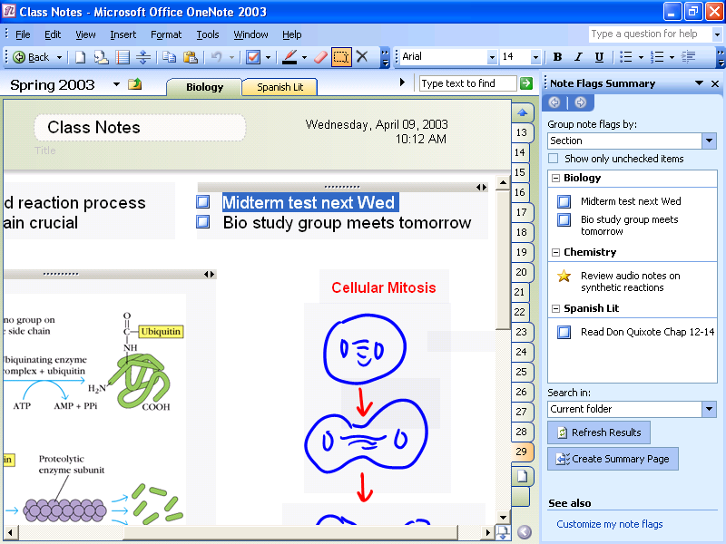
Figure 14 View important notes in one glance with Note Flags.

OneNote 2003 has a set of nine Note Flags that can be used to mark key items, urgent notes, or notes that require follow-up. You can customize icons and names for your Note Flags, apply any combination of font color and highlighting to a Note Flag, and add check boxes to appear next to the note. This feature ensures that important tasks and reminders are only one click away. Moreover, you can add Note Flags in OneNote to the task list in Microsoft Office Outlook® 2003—an example of how OneNote and the other products in the latest version of the Microsoft Office System work together to help you be more productive.
In addition to prioritizing and marking notes, you can use Note Flags to organize your information. The Note Flags Summary Pane makes it easy to manage and view flagged items, which can be viewed by page, notebook section, or across all notebook sections. This pane shows hyperlinks to all of the notes that you have marked with Note Flags on the page or notebook and presents management features that allow you to prioritize items and take necessary action.
Clicking a flagged note in the summary pane takes you to that note in your notebook sections. In this way, you can navigate through notes according to the flags. For example, you could customize a Note Flag as a “supervisor” flag—and after a meeting call up all the action items your supervisor had mentioned.

Finding Notes

Find
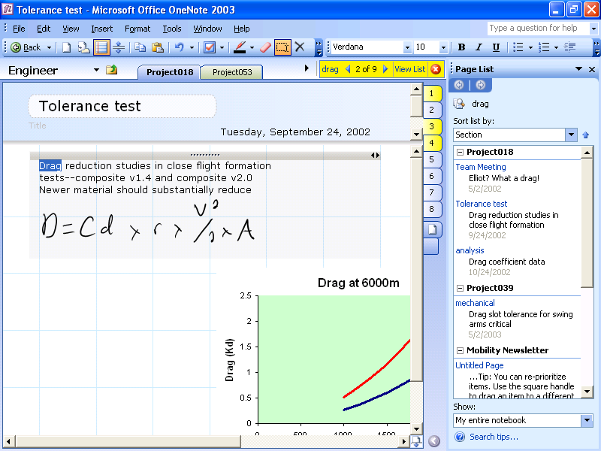
Figure 15 Find important information with just a few clicks.

Another capability that enables the efficient use of notes is the Find feature in OneNote, which searches notes by keywords.
When keywords are typed into the Find box, OneNote instantly finds those keywords across all notes in any notebook sections that are open. OneNote also highlights the pages that contain matches in the Page Tabs. When you press Enter or click the “next match” arrow, OneNote jumps quickly to the next match in the notes, across any notebook section, making it easy to search across multiple sections at the same time.
In addition to jumping through the matches, you can click View List. OneNote will display a list of results, similar to those returned by Internet search engines. By default, these results are grouped by section order, but they can be regrouped by date or title by clicking the Date or Title buttons in the Page List Pane.

History Navigation
With the many ways to navigate through OneNote and locate information, it’s important to have an easy way to get back to pages that have been viewed recently. OneNote tracks all of the pages visited across all notebooks—just as a Web browser tracks all of the Web pages that have been visited. And, just like in a browser, you can move backward and forward through these pages by clicking Back and Forward in the upper left corner of the program. The history is cleared each time the program is closed.

Recording Audio Notes
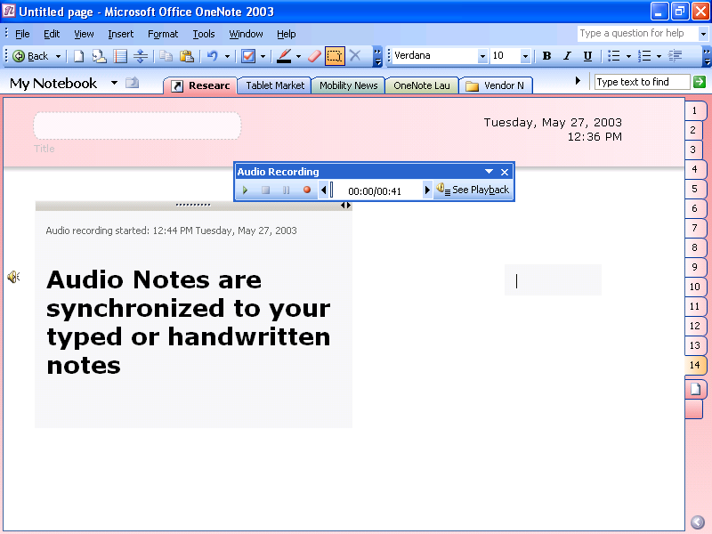
Figure 16 Recording linked audio ensures that you won't miss important items.

The nature of notes is that they are brief summaries of ideas or discussions. However, sometimes brevity ends up being ambiguous, and you may not always remember what a particular word or phrase means. Or, you may have a difficult time deciphering a particular handwritten note. OneNote 2003 solves these problems by enabling you to record linked Audio Notes, which is particularly valuable when you don’t want to miss anything important during an interview, lecture, presentation, or meeting.
If you have a microphone built in or connected to your computer, click Record in OneNote to start recording audio. Then take notes with OneNote as usual. OneNote synchronizes the audio to the notes being written. By doing this, OneNote tracks the audio that occurred at the exact moment that each note was typed or written.
Then, if you need to clarify a certain note, you can hover your mouse cursor over the note in question and an audio icon appears. When the icon is clicked, OneNote plays back the audio that occurred exactly when that note was taken.
Alternatively, OneNote can play back all of the recorded audio while highlighting the note that was written at each point.

Doing Research

Copy and Paste
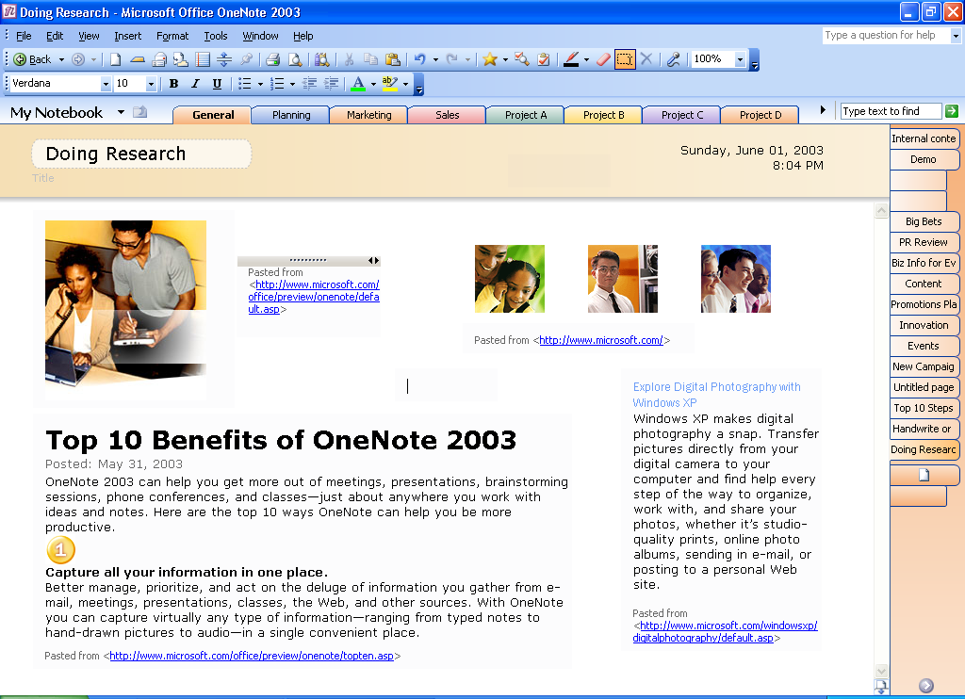
Figure 17 Copy and paste information from almost anywhere.

Microsoft Office users are used to copying and pasting within and among any Office programs. OneNote 2003 provides the same capability and more.
With OneNote, you can copy and paste by using the drag-and-drop feature to move notes around within OneNote (as discussed on page 9) or between any other Office program and many non-Office programs. Simply point to or select the desired information with the cursor, and then move it to any page in your notes. Items that can be moved with the drag-and-drop feature into OneNote include pictures and text from Web sites and Microsoft Office Word documents; graphs, charts, text, or even entire slides from Microsoft Office PowerPoint® presentations; and columns and rows of numbers and charts from Microsoft Office Excel sheets.
When you copy and paste handwritten digital ink notes created in OneNote on a Tablet PC into other programs, the handwriting is automatically converted to text. Drawings are pasted as picture files.
Also, when you copy and paste information from Web sites, the source URL is automatically inserted with the information, so you can quickly return to the source of the information if you need to. This feature lets you conduct research more efficiently by capturing all of the information you need in one place.

Side Notes
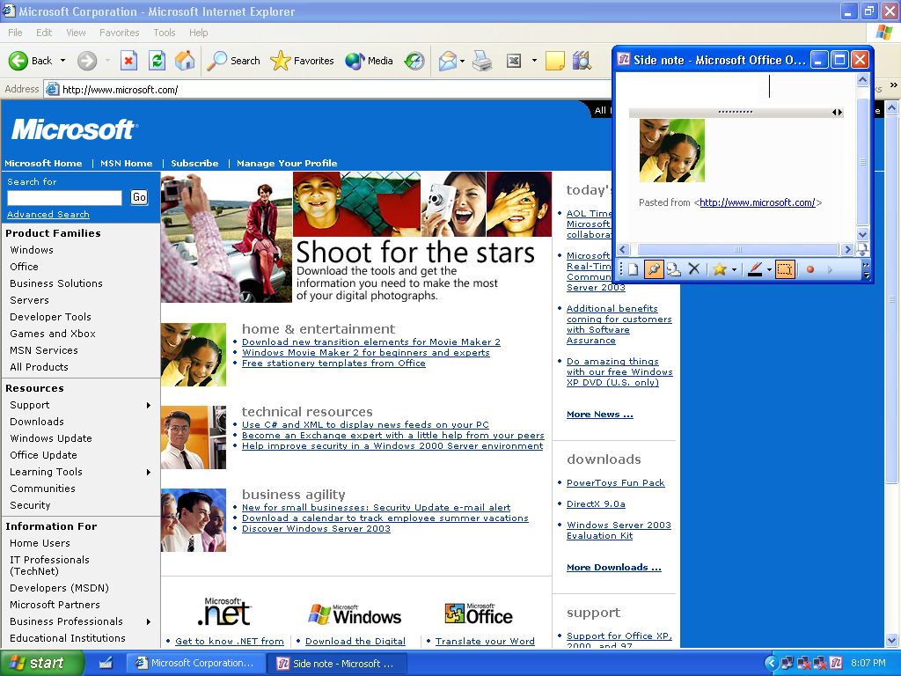
Figure 18 The side note interface makes it easy to gather research.

Sometimes you need to take short notes on the fly, such as when you are on the phone. The side note is a feature of OneNote that enables you to do just that.
You can access a streamlined, smaller view of OneNote through the OneNote side note icon in the Microsoft Windows taskbar. This small window of OneNote gives you access to all of the functionalities of OneNote, but in a smaller display called the side note. If you click the pushpin icon, you can “pin” the note to any part of the screen, and it will “float” or stay open on top of your other PC programs. This is a great way to keep pertinent information or reminders on hand—it’s like a “sticky note” for the PC with all the powerful features of OneNote. And you can open as many side notes as you want.
This feature is also a convenient way to do research. For example, you might pin a side note to the top of the screen, open a Web browser, and drag information from a Web site into the side note. All notes taken in side notes are automatically saved--right in OneNote. You can open OneNote and click the Side Notes tab to see all of the notes you created in the side notes window.

Research Library Task Pane
OneNote hosts a Research Library Task Pane that you can use to look up information on your local network or the Web, as well as entries in dictionaries, encyclopedias, thesauruses, translation services, and more—all right from within OneNote. OneNote shares this feature with many other Microsoft Office System programs. For more information about this feature, please see the product guide for the newest edition of the Microsoft Office System, available at www.microsoft.com/office.

Sharing Notes
Too often, paper notes that you take just sit in stacks with all your other papers because sharing them requires time and effort to retype them into another program. With OneNote 2003, you have several easy ways to share important information and ideas more effectively.
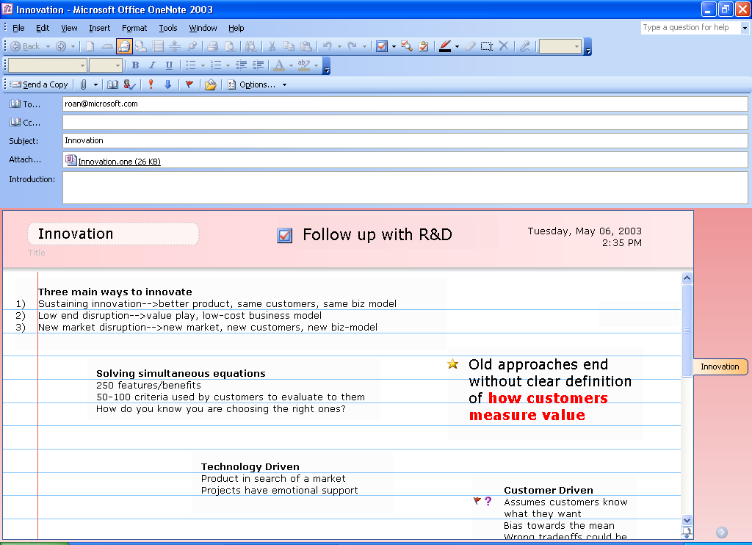
Figure 19 E-mail notes with one click of the mouse.

E-mail
By clicking the envelope icon on the toolbar, users with Microsoft Office Outlook 2003 can quickly e-mail any note taken in OneNote. OneNote automatically converts the notes to HTML and puts them into the message body so that even recipients who don’t have OneNote can read them. (Handwriting and drawings in the notes are converted into picture files.)
In addition, the program creates an attachment of the notes as a .one file so that recipients who have OneNote can easily add that page to their own notebooks by simply double-clicking the attachment. Users with older versions of Outlook will also be able to e-mail OneNote notes as attachments, just like any other type of Microsoft Office document.

Publish as HTML
Another effective way to share information is by publishing your notes as HTML. You can easily save your notes as HTML and store them on a file share, a Web server, or a Microsoft Windows SharePoint Services (WSS) site. As with e-mail, handwriting and drawings are converted into pictures.

Shared Workspace Pane
OneNote also hosts a Shared Workspace Task Pane that you can use to create tasks, work on related documents, and more in a shared OneNote notebook that is saved on a WSS site. Shared Workspaces provide intelligent document collaboration capabilities, improved version control, the ability to share documents in real time, assign tasks and deadlines, and easily review the status of a document project. OneNote shares this feature with many other Microsoft Office System programs. For more information about this feature, please see the product guide for the newest edition of the Microsoft Office System, available at www.microsoft.com/office.

Printing Notes
You can print your notes in OneNote 2003 by choosing File, then Print. You can help ensure that your notes fit to the correct paper size either by going to File, then Print Preview and selecting Scale content to paper width or by setting the correct paper size with Blank Paper stationery before you begin taking notes.

Handwriting and Drawing
OneNote 2003 offers enhanced features and benefits if you have a Tablet PC or a pen input device for your laptop or desktop, based on the ability to handwrite notes and draw pictures and diagrams.
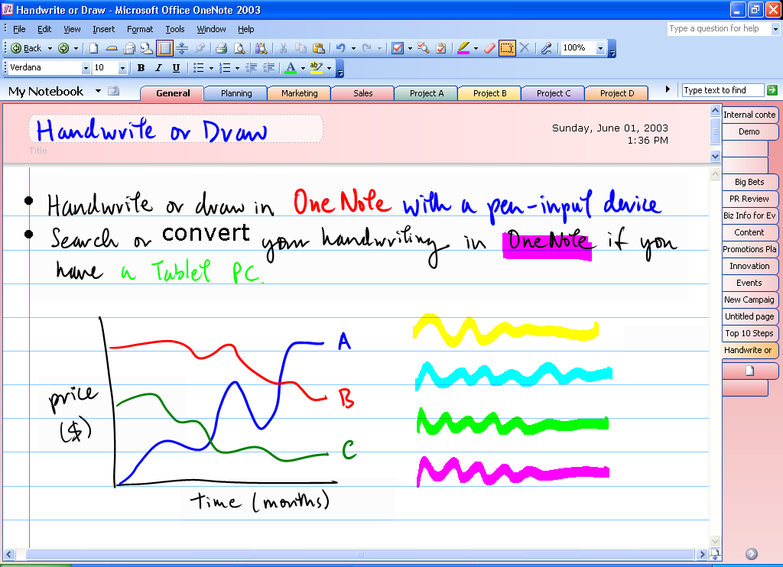
Figure 20 Hand write notes using a variety of colors and line thicknesses.

If you are using OneNote with a pen input device, you can handwrite notes easily and naturally. OneNote also enables you to both handwrite and type notes on the same page. In meetings and lectures, you may draw a diagram to illustrate a point or brainstorm all over the page as if on a whiteboard. If you don’t have a pen input device, you can use your mouse to draw and sketch diagrams in OneNote.
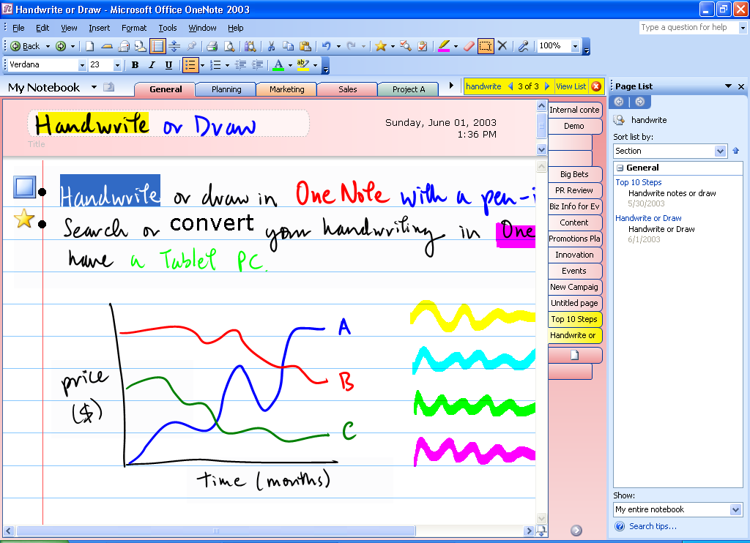
Figure 21 Search or add Note Flags to your handwritten notes.

If you are using OneNote on a Tablet PC, you can search your handwritten notes, add bullets and numbering, and mark them with Note Flags.
If you are using pen input devices with OneNote on your desktop or laptop, your handwritten notes are saved as picture files. These notes will not have the enhanced features of digital ink, such as bullets and numbering or being able to search them with the Find feature. These notes also cannot be converted to typed text.

Convert Ink to Text
With OneNote on Tablet PC, you can easily convert your handwritten notes to text. You can convert anything from just one word to a whole section at once by using your cursor to highlight the ink notes you want to convert. You then can choose the Convert option from the toolbar. If OneNote incorrectly converts a word, that word can be right-clicked to bring up a list of alternative words.

Predefined Ink Styles
There are a variety of ink styles to choose from in OneNote, including different colors and thicknesses. You can also highlight sections of notes with the pen or use the pen as an eraser.

Insert/Remove Space
Sometimes conversations in a meeting or a discussion group veer off on tangents and then return to the original subject. When taking notes on paper in such a meeting, you can end up with information on the same subject scattered across your notes. With OneNote, you can use the Insert/Remove Space tool to open up space on the page to add additional notes or drawings. Using a tool on the toolbar, you can drag open a vertical space and stretch the length of the page to create more space easily. This ensures that your notes on one subject can all be in the same place. You can use the same tool to remove excess space between notes or drawings.

Additional Information

Integration with Office
OneNote 2003 will work as a separate, stand-alone program independently of the other Office System programs. As a result, OneNote will work with or without the Office System programs and earlier versions of Office.
However, there are enhanced features that you will enjoy if you have installed both OneNote and other Office System programs.
- Clipboard integration enables you to copy and paste freely to and from OneNote and other programs.
- Note Flags within OneNote can be added to your tasks in Outlook 2003.
- Integration with Outlook 2003 enables you to click the envelope icon within OneNote and e-mail your notes as both an attachment and as HTML in the body of the e-mail.
- OneNote shares dictionaries with the other Office System programs so that any words you add to the custom dictionary in Word will be recognized within OneNote as well.
- The Research and Reference Pane enables you to look up information on your local network or the Web, as well as entries in dictionaries, encyclopedias, thesauruses, translation services, and more—all right from within OneNote.
- There is an Ifilter for OneNote files so that they can be searched with SharePoint Portal Server V2.0.
- You can create a shared team notebook section using Microsoft Windows SharePoint Team Services.
- You can provision your own site on SharePoint Portal Server V2.0, which results in the Shared Workspace Pane within OneNote. (Note that if you do not have SharePoint Portal Server V2.0, the Shared Workspace option will be grayed out in the Tools menu.)

Keyboard Shortcuts
Special consideration was put into making OneNote work well for people who prefer to work with the keyboard. Convenient keyboard shortcuts are available for all common operations. For example, each of the nine Note Flags can be inserted by entering Ctrl-1 through Ctrl-9.

Additional Resources
Visit http://www.microsoft.com/office/onenote, where you will find much more information about OneNote, including a detailed Technical Frequently Asked Questions document, a full community site, newsgroups where you can ask questions and give feedback to fellow OneNote users, and chat sessions with the OneNote product team.

System Requirements
To use Microsoft Office OneNote 2003 you need:
- PC with Pentium 233 MHz or higher processor. Pentium III recommended.
- Microsoft Windows 2000 with Service Pack 3 or later or Microsoft Windows XP or later operating system.
- 128MB of RAM or above recommended.
- 100MB of available hard disk space (hard disk usage will vary depending on configuration; custom installation choices may require more or less hard disk space).
- Optional installation files cache (recommended) requires an additional 100 MB of available hard disk space.
- Super VGA (800X600) or higher resolution monitor.
Additional items or services required to use certain features:
- Microsoft Windows Server 2003 running Windows SharePoint Services required for certain advanced collaboration functionality.
- Certain inking features require that you run OneNote on Microsoft Windows XP Tablet PC Edition.
- Recording audio notes requires a microphone, audio output device, Windows Media Player 8.0 or later, and DirectX 8.1 or later (Windows Media Player 9.0 or later, and DirectX 9.0a or later recommended).

© 2003 Microsoft Corporation. All rights reserved.

The information contained in this document represents the current view of Microsoft Corporation on the issues discussed as of the date of publication. Because Microsoft must respond to changing market conditions, it should not be interpreted to be a commitment on the part of Microsoft, and Microsoft cannot guarantee the accuracy of any information presented after the date of publication.

This document is for informational purposes only. MICROSOFT MAKES NO WARRANTIES, EXPRESS OR IMPLIED, IN THIS DOCUMENT.

The example companies, organizations, products, domain names, e-mail addresses, logos, people, places, and events depicted herein are fictitious. No association with any real company, organization, product, domain name, e-mail address, logo, person, places, or events is intended or should be inferred.

Microsoft, the Office logo, OneNote, Outlook, PowerPoint, SharePoint, and Windows are either registered trademarks or trademarks of Microsoft Corporation in the United States and/or other countries. The names of actual companies and products mentioned herein may be the trademarks of their respective owners.

