Overview
Country: Global
Industry: Media and entertainment
Customer Profile
TV Guide Online is a division of Gemstar-TV Guide, a leading media, entertainment, and technology company whose products deliver video guidance to enhance the entertainment experience of consumers.
Business Situation
TV viewers look to the Internet for information and video clips about their favorite TV shows, but Internet search engines were not providing truly relevant results.
Solution
Using Microsoft® Office SharePoint® Server 2007, Microsoft SQL ServerTM 2005, and other Microsoft technologies, TV Guide built a new, targeted broadband Internet video guide.
Benefits
- Rapid access to relevant, high-quality content
- Rapid indexing and responsive search functions
- Attractive to advertisers
- Increased usership and revenue generation
TV Guide Online delivers video guide using Microsoft technologies

“Microsoft Office SharePoint Server 2007...is helping us increase our usership and our revenue potential. It is also helping us to reposition and promote the TV Guide brand in an entirely new way.”
— Paul Greenberg, General Manager, TV Guide Online
TV Guide Online executives wanted to develop an Internet search engine that would help TV viewers find relevant, professional-quality videos related to their favorite TV shows online—without having to weed through millions of search results. Using technologies from Microsoft, including Microsoft® Office SharePoint® Server 2007 and Microsoft SQL ServerTM 2005 database software, TV Guide Online has developed a high-performance online video guide that can quickly and consistently provide the kinds of results TV viewers seek—without any of the extraneous materials they don’t want. Because it is so capable of providing this kind of content to visitors, the TV Guide Online Video Guide is also proving very attractive to online advertisers who want to find new ways to reach TV viewers interested in high-quality content.

“It is clear to the advertisers we have talked to that this is a unique Internet product that TV fans are going to find exciting.”
— Kirsten Rasanen, Director of Product Management, TV Guide Online
Situation
Search for “Lost,” or “the Office,” or “24” using any of the Internet’s most well-known search engines and you are likely to end up with millions of results—billions in the case of “24.” So how is a television aficionado—who instantly recognizes these as names of popular TV shows—to weed through this overwhelming response to find truly relevant, high-quality content about a favorite show?
This challenge lay at the heart of the decision that TV Guide Online executives made in 2006 to develop a new Internet video guide that would focus exclusively on high-quality Internet content related to TV programming. TV Guide Online is a division of Gemstar-TV Guide, publisher of TV Guide Magazine, the TV Guide Web site, and interactive programming guides (IPGs) used by many subscription TV services. As a brand, TV Guide has a 53-year history of providing TV listings, information, and editorial guidance to TV users.
Its executives understand what TV viewers are looking for and saw that viewers’ needs were largely unmet by the existing technologies. In particular, TV Guide Online executives understood that TV viewers turning to the Internet to find information about their favorite shows and stars were not for the most part looking for spoofs on YouTube; fan sites; or brief, low-quality captures of old shows. These viewers want professional-quality programming—whether that be online versions of old episodes, previews of upcoming shows, or interviews with cast and crew members—and that content constitutes only a small fraction of the millions of hits that popular search engines routinely return.
“We realized that we could offer more than guidance on your set top box,” says Kirsten Rasanen, Director of Product Management for TV Guide Online. “After all, we have a fair amount of expertise in this area. We know TV. We know entertainment. We know movies. So, we decided to build an online video listings area—and deliver guidance to online video in much the same way we provide listings for TV and movies. It’s all designed for the TV viewer, and it helps them find videos on the Internet that really would be of interest to them.”
Solution
TV Guide Online already relies on many software products from Microsoft—including the Windows Server® 2003 Enterprise Edition operating system, Microsoft SQL Server 2005 database software, Microsoft BizTalk® Server 2006, and the Microsoft .NET framework. So, as long as Microsoft could demonstrate a solution that could help deliver the relevant, high-quality content that TV Guide Online managers wanted to deliver, TV Guide was predisposed to take advantage of its existing administrative expertise and hardware infrastructure and choose a Microsoft solution. For the online video portal that TV Guide Online envisioned, Microsoft had just the tool: Microsoft Office SharePoint Server 2007.
Office SharePoint Server is a new server application that is part of the 2007 Microsoft Office system. It is designed to provide access to information that is essential to organizational goals and processes, to facilitate content management, and to support key business processes. Within the architecture of the TV Guide Online Video Guide, it delivers the critical search and indexing capabilities that enable this site to present contextually relevant content to TV viewers searching for information about their favorite shows.
A three-tiered architecture
Working with architects from Microsoft Consulting Services, TV Guide Online built the TV Guide Online Video Guide (video.tvguide.com) using a familiar presentation, application, and data layer model. On the top layer sits an Internet Web site, with a user interface that presents information about TV shows and online content. Beneath that reside the application layer and the tools for responding to queries and directions entered at the Web site itself. Office SharePoint Server 2007 runs in this middle tier, and it connects to the user-facing Web site through a set of Web services. Below the middle tier resides the SQL Server database.
There are two Web servers running Windows Server 2003 Enterprise Edition with Internet Information Services version 6.0 and Microsoft ASP.NET, two servers running Windows Server 2003 and Office SharePoint Server 2007 for query and content management, a third server running Windows Server 2003 and Office SharePoint Server 2007 that acts as the indexing server, and two servers running Windows Server 2003 and SQL Server 2005 Enterprise Edition in a mirrored configuration.
Separately, an application running elsewhere captures and stores metadata about new Internet videos from a variety of sources, including really simple syndication (RSS) feeds, third-party information aggregators, and screen scraping technologies that gather information from sites with which TV Guide Online has no formal information-sharing relationships. On a daily basis, new metadata is pulled into the production SQL Server database.
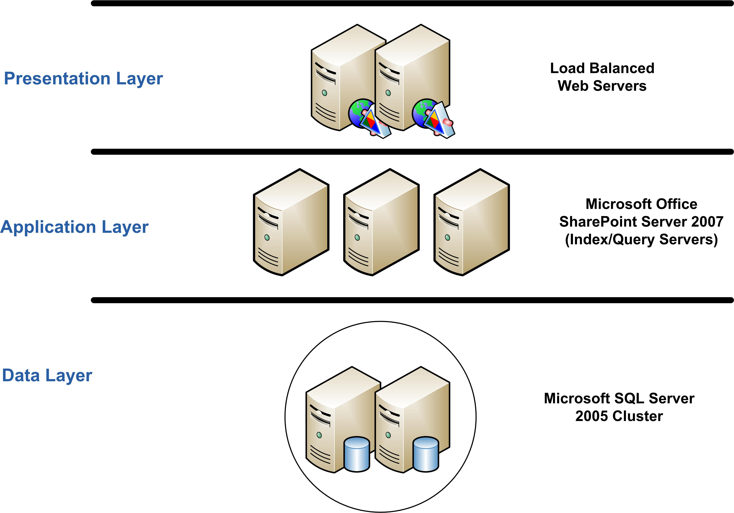
All the servers associated with the TV Guide Online Video Guide are from HP Compaq, have between two and four CPUs, and are configured with 4 gigabytes (GB) of memory. All servers are running the Microsoft .NET Framework version 3.0, an integral component of the Windows operating system that provides a programming model and runtime for Web services, Web applications, and smart client applications. Within the architecture of the TV Guide video portal, the .NET Framework provides the Web services infrastructure that enables communication between the presentation layer Web servers and the search and indexing functionality of Office SharePoint Server running in the middle layer.
The high-level architecture of the TV Guide Online Video Guide
“What we’re doing online is really the next generation of the TV listings grid. It’s a way to channel surf the Internet.”
—Paul Greenberg, General Manager, TV Guide Online
Indexing the business data catalog for fast access
Once a day, Office SharePoint Server analyzes and builds a new index of the metadata in the SQL Server database, which Office SharePoint Server treats as a linked business data catalog. As the SQL Server database acquires new information, Office SharePoint Server performs an incremental index update, so that its index is always synchronized with the metadata in the database. The index itself resides in memory on the middle layer server running Office SharePoint Server, which enables Office SharePoint Server to respond very rapidly to visitor queries from the Web site itself.
Benefits
For TV Guide Online, the key to the success of its Internet video guide would be its ability to provide rapid access to the high-quality content that TV fans are seeking. If it could do that, it could add real value for TV fans that would help ensure the relevance of the TV Guide brand in the Internet age. Moreover, its ability to deliver this kind of relevant content to TV viewers would help it to attract top advertisers to the TV Guide Online Video Guide, which would in turn continue to bolster the financial strength of Gemstar-TV Guide.
Office SharePoint Server 2007 is proving itself capable of helping TV Guide accomplish all those goals.
Rapid access to relevant information
Viewers can type in the title of any popular show or character, and the TV Guide Online Video Guide immediately presents links to interviews, episodes, and more—all of it relevant, all of it high quality, all of it much more accessible than it would be if hidden among millions or billions of other irrelevant hits. The Web site returns results as a series of thumbnail images linked to online videos, and a visitor can select whether to order the list by relevance, popularity, or most recent posting. Beneath each thumbnail is the title of a show and the episode information if it is available, so someone searching for a particular episode of a show can find it quickly.
The Web site also provides users with a “search within results” function so that a query on a popular show that yields many results can be further refined very quickly. As with the initial search, the Web presentation layer passes the more refined search criteria on to Office SharePoint Server though a Web service, which searches the Office SharePoint Server index and quickly returns the relevant results to the Web server, which presents them to the visitor. Clicking a thumbnail connects a visitor to the requested content.
In addition to this powerful search function, the TV Guide Online Video Guide provides mechanisms to search for content by genre and network. It also provides quick links to top videos, shows and movies, and celebrities. As part of the top video selections, a visitor can view what TV Guide Online editors and writers feel are some of the most interesting video clips on the Internet.
“TV Guide Online has a staff of 10 full-time editors and writers,” says Rasanen, “and several of them spend a good deal of time contributing to our online video site. They are incredibly knowledgeable about television, movies, and online content. Thanks to them, we have a whole section with online content recommendations that we refresh every day, sometimes more than once.”
Despite the rapid rate at which the site absorbs new information about online assets—and the SQL Server database supporting the site had pointers to more than 100,000 high-quality Internet video assets within its first few weeks of operation, a number that can climb by thousands per day—the site’s ability to respond rapidly to visitor queries remains unchanged. This is due in large part to the power of Office SharePoint Server and its enterprise search functionality. Office SharePoint Server performs incremental index updates whenever new metadata is added to the SQL Server database. It completes this index update in three to four minutes, so even the newest video content can pop on the screen quickly in response to a visitor’s query. Even a complete update of the SQL Server database, which Office SharePoint Server performs daily, takes less than nine minutes, so the index is always running at peak performance.
An attractive advertising platform
This ability to deliver relevant content quickly has captured the attention of advertisers, as TV Guide Online executives had hoped. The site has is proving its ability to deliver targeted content and many advertisers have expressed interest in becoming involved.
“We’ve had an enthusiastic response from advertisers,” Rasanen says. “We showed the concept to a number of sponsors before we went live, and there was a lot of interest. Since the product has launched, though, there has been even more interest. It is clear to the advertisers we have talked to that this is a unique Internet product that TV fans are going to find exciting. It’s useful, it’s unique, and there’s a great brand identity behind it. Put all those elements together and it gives prospective advertisers a lot of confidence in what we can do.”
Plans for the evolution of the TV Guide Online Video Guide include adding functionality to allow for sponsors to tie into specific kinds of searches and presentations—so that ads from specific sponsors would appear whenever a visitor searches for a specific show, genre, or actor or when a visitor views the TV Guide Online recommendations.
“The bottom line,” adds Paul Greenberg, General Manager of TV Guide Online, “ is that Microsoft Office SharePoint Server 2007 provides huge benefits for us. It is helping us increase our usership, and our revenue potential. It is also helping us to reposition and promote the TV Guide brand in an entirely new way.”
“What we’re doing online is really the next generation of the TV listings grid,” Greenberg goes on to say. “It’s a way to channel surf the Internet. That’s what TV Guide has always been good at. We’ve just extended that expertise into a different medium.”

For More Information
For more information about Microsoft products and services, call the Microsoft Sales Information Center at (800) 426-9400. In Canada, call the Microsoft Canada Information Centre at (877) 568-2495. Customers who are deaf or hard-of-hearing can reach Microsoft text telephone (TTY/TDD) services at (800) 892-5234 in the United States or (905) 568-9641 in Canada. Outside the 50 United States and Canada, please contact your local Microsoft subsidiary. To access information using the World Wide Web, go to:
www.microsoft.com
For more information about Microsoft solutions for the media and entertainment industries, go to: http://www.microsoft.com/resources/mediaandentertainment/default.mspx.
For more information about TV Guide Online visit the Web site at: www.tvguideonline.com.

§
Solution Overview
Software and Services
Microsoft Server Product Portfolio
- Windows Server 2003 Enterprise Edition
- Microsoft SQL Server 2005 Enterprise Edition
Microsoft Office System
- Microsoft Office SharePoint Server 2007
Services
- Microsoft Consulting Services
Technologies
- Microsoft .NET Framework
- Internet Information Services 6.0
- Microsoft ASP.NET
- Web services
Hardware
HP ProLiant servers

© 2007 Microsoft Corporation. All rights reserved.

