  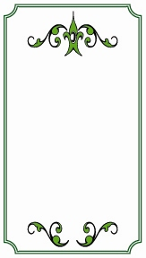  CORIANDER  From Grandma Ellis’ garden | SAGE | THYME | CORIANDER
CORIANDER | CORIANDER | CORIANDER | CORIANDER
CORIANDER | CORIANDER | CORIANDER | CORIANDER
For the best view, go to View > Print Layout.
Print spice labels on full-sheet label paper then cut out each label along the dotted line.

