

Windows Home Server Toolkit User Manual

Microsoft Corporation
Published: November 2008
Version: 1.1
Abstract
The Windows Home Server Toolkit is a powerful collection of diagnostic tools that run on your home computers and home server.
To download the most recent version of this document, see the Microsoft Web site (http://go.microsoft.com/fwlink/?LinkId=108364). The update might contain critical information that was not available when this document was published.

The information contained in this document represents the current view of Microsoft Corporation on the issues discussed as of the date of publication. Because Microsoft must respond to changing market conditions, it should not be interpreted to be a commitment on the part of Microsoft, and Microsoft cannot guarantee the accuracy of any information presented after the date of publication.
This White Paper is for informational purposes only. MICROSOFT MAKES NO WARRANTIES, EXPRESS, IMPLIED OR STATUTORY, AS TO THE INFORMATION IN THIS DOCUMENT.
Complying with all applicable copyright laws is the responsibility of the user. Without limiting the rights under copyright, no part of this document may be reproduced, stored in or introduced into a retrieval system, or transmitted in any form or by any means (electronic, mechanical, photocopying, recording, or otherwise), or for any purpose, without the express written permission of Microsoft Corporation.
Your right to copy this documentation is limited by copyright law and the terms of the software license agreement. As the software licensee, you may make a reasonable number of copies or printouts for your own use. Making unauthorized copies, adaptations, compilations, or derivative works for commercial distribution is prohibited and constitutes a punishable violation of the law.
Microsoft may have patents, patent applications, trademarks, copyrights, or other intellectual property rights covering subject matter in this document. Except as expressly provided in any written license agreement from Microsoft, the furnishing of this document does not give you any license to these patents, trademarks, copyrights, or other intellectual property.
Unless otherwise noted, the companies, organizations, products, domain names, e-mail addresses, logos, people, places, and events depicted in examples herein are fictitious. No association with any real company, organization, product, domain name, e-mail address, logo, person, place, or event is intended or should be inferred.
© 2008 Microsoft Corporation. All rights reserved.
Microsoft, Internet Explorer, Windows, and Windows Vista are trademarks of the Microsoft group of companies.
All other trademarks are property of their respective owners.

Contents
Windows Home Server Toolkit User Manual 5
Components 5
Installing the Toolkit 5
Installing the add-in 7
Using the Toolkit 8
Common Tasks 10
Diagnosing Connector Software Installation Issues 11
Sending Error Reports to Product Support 11
Advanced Mode 12
Using the Toolkit Add-in on Your Home Server 15
Home Server Connectivity 15
Refresh 15
Details 15
Remote Access Web site 15
Custom Error Mode 15
Session Timeout 15
Restart IIS 16
Home Server Support Tools 16
Command Prompt 16
Event Viewer 16
Send Logs 16
Log Options 17
Known Issue 17
Version of the Connector software 17

Windows Home Server Toolkit User Manual
Home network configurations and components can vary greatly from home to home. In some cases, this variety makes it harder for your home computer to communicate with your home server when you install the Connector software for the Windows® Home Server server software. The Windows Home Server Toolkit is designed to help you diagnose the issues that you may encounter during Windows Home Server Setup.
The Toolkit is easy to use even if you are not a computer expert. If you are an expert, you can use advanced features in the Toolkit to help you troubleshoot further.
The Toolkit can also help you gather pertinent information, such as log files, which you can send to other people if you need additional help. The Toolkit never sends any information to Microsoft or to anyone else without your consent.

Components
The Toolkit has the following five components:
• Connector Troubleshooter. Helps you with Connector software installation issues.
• Error Reporting. Collects all relevant Windows Home Server troubleshooting information from your home computer, so you can send it to Microsoft or to another person. You can review the information before it is sent, and you can approve or deny the transmission.
• Readme. Briefly describes the Toolkit components.
• Publish Server Add-in. Copies the Add-in file to your home server so you can install it by using the Console.
• End User License Agreement. The license terms for the Toolkit.

Installing the Toolkit
To install the Toolkit, do the following:
1. Ensure that you have administrative rights on the computer where you want to install the Toolkit.
Note
Install the Toolkit on a home computer, not on your home server.
1. Download the most recent version of the Toolkit from the Microsoft Web site (http://go.microsoft.com/fwlink/?LinkId=98872).
2. Download and save the WHSToolkit.msi file in a temporary folder on your home computer.
3. Navigate to the folder where you saved the WHSToolkit.msi file, and then double-click the file. Ensure that the file is from Microsoft.
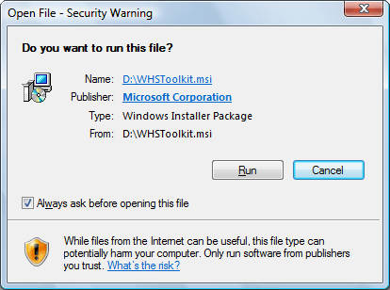

4. Follow the Setup screens to complete the installation.
After the Toolkit is installed, you have the following Start menu entries:
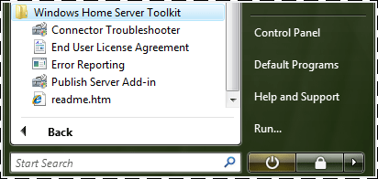

Each of these is described later in this document.
Important
If you already have the Toolkit installed and you are upgrading to a newer version, you must uninstall the previous version first. The Toolkit does not uninstall a previous version, and if you proceed the Toolkit may not work correctly.
To uninstall the Toolkit from Windows Vista
1. Click Start, and then click Control Panel.
2. Click Programs, and then click Uninstall a program.
3. Select Windows Home Server Toolkit, and then click Uninstall.
4. Click Yes.
To uninstall the Toolkit from Windows XP
1. Click Start, click Settings, and then click Control Panel.
2. Double-click Add or Remove Programs.
3. Select Windows Home Server Toolkit, and then click Remove.
4. Click Yes.

Installing the add-in
To copy the Toolkit Add-in file to your home server, click Start, click All Programs, click Windows Home Server Toolkit, and then click Publish Server Add-in.
If you previously installed the Toolkit Add-in, you must first uninstall it by using the Windows Home Server Console, and then delete the Toolkit.msi file from the Software\Add-ins folder on your home server.
Important
Uninstalling the Toolkit Add-in from your home server is not enough. You also must delete the Toolkit.msi file.
The Toolkit does not copy the add-in file over an existing Toolkit.msi file, and it warns you about this.
Alternatively, you can use a command prompt or Windows Explorer to copy Toolkit.msi from the %ProgramFiles%\Windows Home Server\Toolkit folder on your home computer to the \\ServerName\Software\Add-Ins shared folder on your home server.
After you copy Toolkit.msi to your home server, install the add-in using the Console. The Toolkit Add-in adds a Settings page that is called Toolkit 1.1.
To install the add-in by using the Console
1. On your home computer, double-click the Windows Home Server tray icon to open the Console.
2. Click Settings to open the Windows Home Server Settings page.
3. In the navigation pane, click Add-ins, and then, in the details pane, click the Available tab.
4. On Windows Home Server Toolkit 1.1, click Install.
The Console closes after the add-in is installed. Open the Console again, and then open the Settings page. Verify that Toolkit 1.1 appears in the navigation pane.
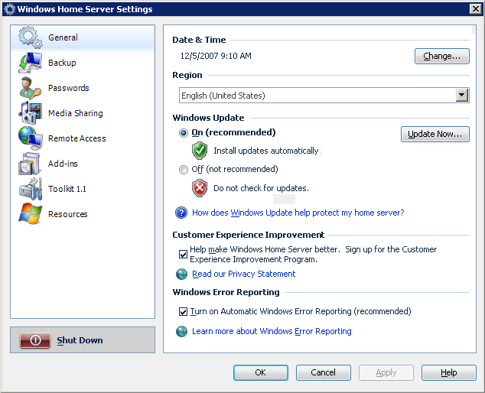

Using the Toolkit
The Connector Troubleshooter Default Mode (also called Simple Mode) is very easy to use. It is designed for the non-technical user. Just make sure that you have Administrator permissions on the computer where you run the Connector Troubleshooter.
If you experience a problem and call Product Support, you may be asked to install the Toolkit and to run the Connector Troubleshooter in order to collect information about your home computer and your network. You can then use Error Reporting to send the information to Microsoft. The Connector Troubleshooter does not send any information to Microsoft.
To start the Connector Troubleshooter on Windows XP
1. Click Start, and then click Programs.
2. Click Windows Home Server Toolkit, and then click Connector Troubleshooter.
To start the Connector Troubleshooter on Windows Vista
1. Click Start, and then click All Programs.
2. Click Windows Home Server Toolkit, and then click Connector Troubleshooter.
If you run the Connector Troubleshooter on the Windows Vista® operating system and User Account Control (UAC) is enabled (default), you are prompted to continue. You must click Continue to run the Connector Troubleshooter.
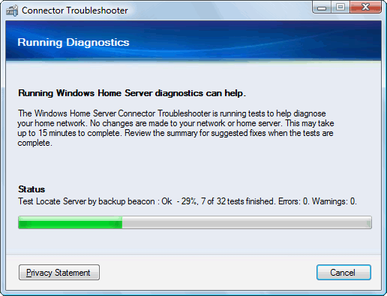

You can view the Privacy Statement while the Connector Troubleshooter is running. You can also cancel the Connector Troubleshooter at any time.
The Connector Troubleshooter is non-intrusive. It never makes changes to the computer that it runs on. It diagnoses problems and suggests solutions, but only you can implement the solutions.
After the Connector Troubleshooter finishes gathering information, you see a page with a summary report, similar to the following:
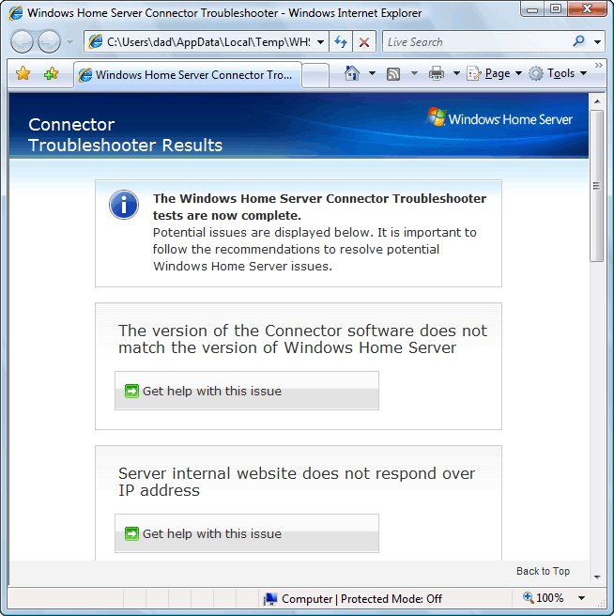

You can click any of the buttons to get a detailed explanation of a particular issue. The following two links are at the bottom of the page and they are always the same:
• The Connector Troubleshooting document. This document is updated regularly. Ensure that you have the most recent version of it.
• The local readme file. The readme.htm file briefly describes the Toolkit components.

Common Tasks
The following are common tasks that you can perform with the Toolkit.

Diagnosing Connector Software Installation Issues
To diagnose Connector software installation issues
1. Install the Toolkit on a home computer, as described in the Installing the Toolkit section of this document.
2. Click Start, click Programs, click Windows Home Server Toolkit, and then click Connector Troubleshooter.
3. Let the Connector Troubleshooter run all of the tests and report the results.
For more information, see Using the Toolkit, earlier in this document.
Important
You do not need to have the Connector software installed on your home computer to install the Toolkit.

Sending Error Reports to Product Support
If Product Support requests an error report, you can send it by using the Toolkit. There are reports for your home computers and reports for your home server. You may need to send both.
To send a report, you must have the Toolkit installed. For more information about how to do this, see Installing the Toolkit, earlier in this document. For more information about installing the add-in on your home server, see Installing the add-in, later in this document.
Important
Error Reporting collects and sends some personally identifiable information to Microsoft. For details about the information that is sent, see the "Windows Home Server Toolkit Privacy Statement" at the Microsoft Web site (http://go.microsoft.com/fwlink/?LinkID=96499). No information is sent to Microsoft unless you choose to do so.
To send an error report from your home computer
1. Click Start, click Programs, click Windows Home Server Toolkit, and then click Error Reporting.
2. A new window opens, which displays the progress of the error report.
3. Press Y when prompted to send the information.
4. A Diagnostics window appears. Click Send Error Report.
5. On the More Information window, click Continue.
6. Write down the CAB number that is displayed in the command window.
7. Press ENTER to close the command window.
To send an error report from your home server
1. Open the Windows Home Server Console.
2. Click Settings, click Toolkit 1.1, and then click the Send Logs.
3. Click Collect and Send.
4. Write down the CAB number, and then click OK.
Important
There are no other confirmations. After you click Collect and Send, the reports are collected and sent to Microsoft. For more information about the data in the reports, see the “Windows Home Server Toolkit Privacy Statement” at the Microsoft Web site (http://go.microsoft.com/fwlink/?LinkID=96499).

Advanced Mode
If you want to see the tests that the Connector Troubleshooter performs, run the Connector Troubleshooter in Advanced Mode.
To run the Connector Troubleshooter in Advanced Mode
1. Open a Command Prompt window, by doing one of the following:
• On Windows XP, click Start, click Run, type cmd, and then click OK.
• On Windows Vista, click Start, type cmd, and then press ENTER.
2. At the command prompt, type the following, and then press ENTER:
cd /d "%ProgramFiles%\Windows Home Server\Toolkit"
3. At the command prompt, type the following, and then press ENTER:
ConnectorTroubleshooter.exe -a
The -a parameter is very important. If you do not include this parameter, the Connector Troubleshooter starts in default mode.
If you run the Connector Troubleshooter on Windows Vista and User Account Control (UAC) is enabled (default), you are prompted to continue. You must click Continue to run the Connector Troubleshooter.
A window opens, which looks similar to the following:
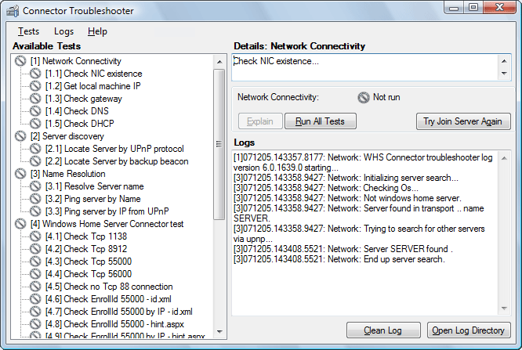

To start, the Connector Troubleshooter takes a few seconds to gather information about your home computer and your network. When it is ready, the Run All Tests button in the middle is enabled. To start the tests, click Run All Tests. A dialog opens, which asks for your server administrator password. This password is the Windows Home Server password that you create when you install the Connector software.
If you have not been able to successfully install the Connector software, you can still run most of the tests. Some of the tests fail, but the other tests may tell you why the Connector software cannot successfully be installed. If you have not yet created a password, leave the password blank and click OK.
The Connector Troubleshooter may need several minutes to run all of the tests. While it is running, most of the user interface is disabled. When the tests are finished, the user interface is enabled again.
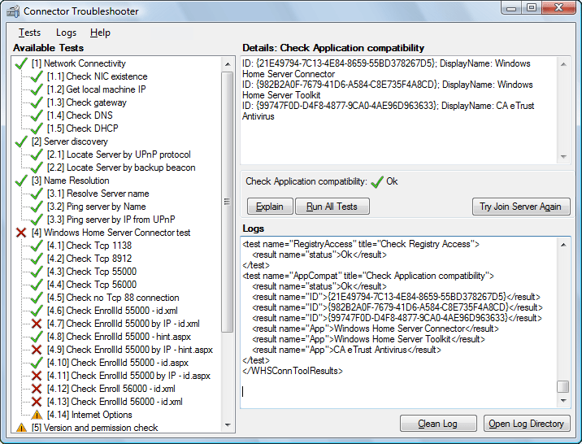

You can click the following after the tests are finished:
• Explain
You can click Explain to get more information about the test results. A summary report opens, similar to the Default Mode summary report. You can click any of the buttons to get a detailed explanation of a particular issue.
Advanced Mode runs more tests than Default Mode. It examines which version of Windows Home Server is running on your home server and determines if that version is compatible with the Connector software (if any) that is on your home computer.
• Try Join Server Again
If the Connector software is installed on your home computer, you can click Try Join Server Again. This attempts to associate your home computer with your home server. This is the same association that happens when you install the Connector software. If your home computer was previously associated with your home server, your home computer is recognized, and any of its existing backups are preserved. To preserve the backups for a home computer, the computer must be the same and have the same name.
• Clean Log
This removes the log results from the last time you ran the Connector Troubleshooter.
• Open Log Directory
All of the Windows Home Server log files are in the same folder. To look at them, click Open Log Directory. This opens the Microsoft® Internet Explorer® browser to the folder that contains the log files. You can delete log files to save space, but this is not recommended. Windows Home Server automatically manages the size of this folder, which prevents the folder from growing too large.

Using the Toolkit Add-in on Your Home Server
The Toolkit Add-in has three sections to help you troubleshoot Windows Home Server: Home Server Connectivity, Remote Access Web site, and Home Server Support Tools.

Home Server Connectivity
The Home Server Connectivity section has two buttons: Refresh and Details.

Refresh
Click Refresh to refresh the diagnostic message in this section.

Details
If the diagnostic message in the Home Server Connectivity section indicates there are errors, click Details to open the Server Connectivity Details page. The page shows connectivity tests that passed or failed.

Remote Access Web site
The Remote Access Web site section has three items: a Custom Error Mode setting, a Session Timeout setting, and a Restart IIS button.

Custom Error Mode
If you clear this check box, you see more detailed error information on your Windows Home Server Web pages. This is useful for troubleshooting Remote Access issues.

Session Timeout
If you upload a large file or group of files by using Remote Access, the session may time out before the upload finishes. To resolve this issue, you can increase the Session Timeout value.
Caution
If you increase the Session Timeout value, you increase your security risk. Do not leave a computer that has an active session unattended in a public place. Always remember to log out.

Restart IIS
Internet Information Services (IIS) on your home server is stopped and then restarted. You do not receive a warning when IIS stops. All Web sites (not just Remote Access) are unavailable while IIS is restarting. All active connections to your Web sites are disconnected. Users who are viewing your public pages (for example http://YourName.homeserver.com/home) may not notice this, but all users who are logged on are logged off.
Note
This disconnects all active Remote Access sessions.

Home Server Support Tools
The Home Server Support Tools section has four buttons: Command Prompt, Event Viewer, Send Logs, and Log Options.

Command Prompt
The Windows Home Server Console provides the tools that you normally need to manage your home server. If you are an advanced user, you also may want to occasionally use some of the advanced tools. You can access the advanced tools with the command prompt.
However, you need to use caution if you use the advanced tools. If you can perform a task by using the Windows Home Server Console, you should use the Console. For example, if you want to add a user account, you should use the Console. You may break your home server functionality if you use a tool that is native to Windows (instead of to Windows Home Server) to perform the task.
The command prompt is terminated after 30 minutes, even if you are still using it. This prevents the Console sessions from using all of the available connections to your home server. If this were to happen, you would be unable to open the Console from any home computer.
Any processes that you start from the command prompt are not subject to this time limit and are not terminated. You should use caution and, when any remaining processes are no longer needed, you should manually close them. Do not merely minimize them.

Event Viewer
This opens Windows Event Viewer for your home server, so you can inspect the Event Logs. This information is useful to Product Support.

Send Logs
You can send log files from your home server that are just like the log files that the Error Reporting component creates for your home computers. When you do this, Windows Home Server collects all of the log files and sends them to Microsoft, by using Microsoft Error Reporting technology. For privacy information, see the "Windows Home Server Toolkit Privacy Statement" at the Microsoft Web site (http://go.microsoft.com/fwlink/?LinkID=96499).
You can use this tool if Product Support asks you to provide log files from your home server.
You are given a CAB number after the log files are collected and sent to Microsoft. Write down the CAB number and send it to Product Support, so that they can associate your log files with your support case.
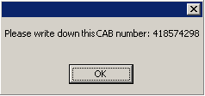

Log Options
By default, Windows Home Server is configured for optimal tracing levels. If Product Support needs to investigate a specific issue, they may ask you to change the tracing level for certain processes on your home server. Note that all of the log files are saved on the C: partition of your home server, which has a total size of just 20 GB. Even though Windows Home Server has a built-in mechanism to prevent the partition from filling up with log files, under certain conditions it may still fill up. Do not increase tracing levels unnecessarily.
To change tracing levels
1. Click a component in the list.
2. Select a level in the dropdown list.
3. Click Set. Or you can click Set All to change the tracing levels for all components.
To copy the log files from their default location to the LogsCopy folder in the Software shared folder on your home server, click Copy. The original log files are not deleted. The log files in the shared folder are overwritten as needed.
To delete all of the log files from the default location on your home server, click Delete.

Known Issue
The following is a known issue with the Toolkit version 1.1.

Version of the Connector software
In some cases, the Toolkit generates a warning that states, “The version of the Connector software does not match the version of Windows Home Server.” This warning can safely be ignored.

