Developing a reliable, scalable architecture for enterprise solutions is critical for the success of the implementation, the productivity of the end user, and the overall cost of the solution itself. Over-utilized servers result in performance degradation and loss of end user productivity.
Microsoft System Center Capacity Planner 2006 will provide the IT professional with the guidance required to plan a deployment in the most efficient manner, while also allowing for “what-if” analysis for future planning.

Plan More Efficient Deployments, Reduce Costs

Whether planning an upgrade or a new installation, understanding the number and sizing of servers, as well as the recommended locations of those servers within the enterprise can assist you in designing an architecture that puts the application servers where they will be used most efficiently. Doing so can potentially reduce costs of hardware and software.
System Center Capacity Planner 2006 will help the IT professional to effectively size an application implementation by:

- Providing and analyzing infrastructure sizing information for distributed server deployments: Capacity Planner will provide an easy way to identify the hardware, software and architecture required for an organization to deploy an enterprise application. It will also provide prescriptive architecture recommendations tailored to the requirements of the enterprise.

- Delivering hardware utilization analysis: Capacity Planner will simulate the user workload on a model of the IT infrastructure. It will calculate the utilization of each device of the infrastructure including servers, disk subsystems, LANs, and WANs. Based on this information, the IT professional can determine if the proposed deployment will meet current and future performance and capacity requirements.

- Delivering transaction latency analysis: Capacity Planner can calculate the latency of key transactions running on the infrastructure. For example, in an Exchange 2003 environment, the IT professional can view the latency of an e-mail sent from Tokyo to the New York office. If the delivery time for the e-mail is unacceptable, Capacity Planner will provide analysis to guide the IT professional to upgrade the specific hardware component which is in the critical path of the transaction.
- Providing hardware and architecture “what-if” analysis: The IT professional can propose changes to a modeled IT infrastructure to determine the most desirable hardware configuration and architecture. Once the model is changed, a load simulation can be run to predict, for example, how much mail traffic will be generated or the impact of a change in hardware performance such as disk speed. This helps the IT professional better understand how to design for future capacity needs.

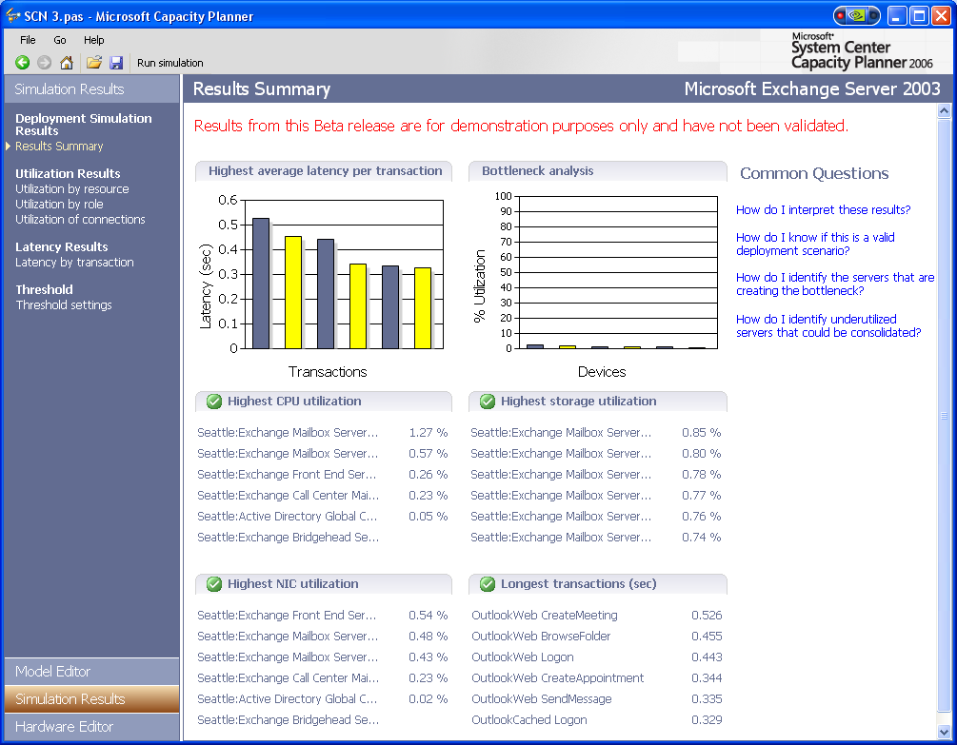
Figure 1. Viewing the results summary for an Exchange 2003 load simulation.

- Enabling software “what-if” analysis: Similar to the hardware “what-if” analysis, IT professionals can experiment with various software options. For example, for Exchange 2003, the IT professional can analyze the performance implications of deploying the Outlook® Web Access (OWA) service in their infrastructure.

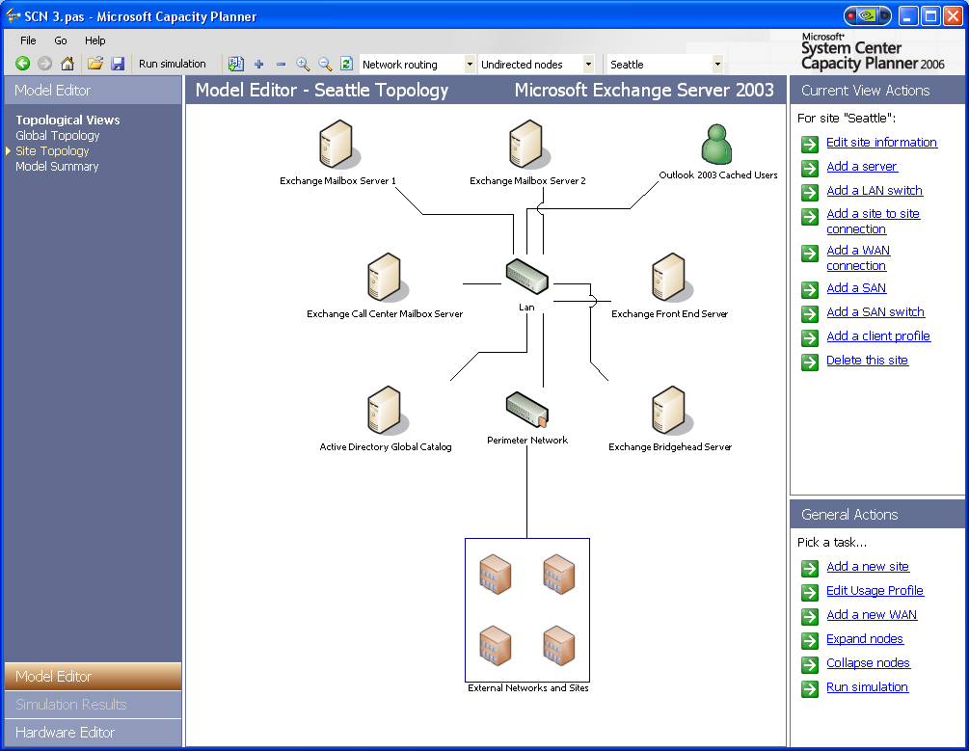
Figure 2 Viewing the Exchange Server 2003 branch topology.

- Identifying impacts of changes to the organization. Capacity Planner will provide the ability to determine the impact of adding new users or sites to the application. The IT professional could modify the usage scenario to reflect the additional sites and users and identify the impact these changes would have on existing servers or user performance.

Stay a Step Ahead of Performance Issues

The use of Capacity Planner throughout the lifecycle of an application will help the IT professional continuously ensure that the enterprise applications and servers are running at efficient levels and avoid future bottlenecks. Capacity Planner can help answer questions, such as:

What if we add spindles to the RAID array?

What will be the impact of consolidating the Exchange store and Internet Information Services (IIS) on the same box?

What is the impact of using Outlook cached mode versus Outlook connect mode in an Exchange deployment?

This provides the IT professional the ability to proactively plan and change the infrastructure as needed to continuously meet desired service levels throughout the application lifecycle.

Integrating Operations and Technology
System Center Capacity Planner 2006 will help to increase operational efficiency by providing a way to efficiently plan an Exchange 2003 or MOM 2005 environment for immediate needs and future requirements. To realize the full benefits of this technology, it is important for enterprises to implement the operational processes and best practices necessary to effectively manage Windows-based systems and applications.

System Center Capacity Planner 2006 evaluation version will be available as a free download from Microsoft TechNet once released. A full version of the product will be available through TechNet subscription.

Solution Accelerators
With the majority of TCO attributed to operational costs, Microsoft also offers a series of solution accelerators for Infrastructure Management. The solution accelerators are focused on addressing the operational, people and process issues associated with managing your environment. Integrated with Microsoft Operations Framework (MOF) management best practices, based on the discipline of the IT Infrastructure Library (ITIL), the solution accelerators provide the prescriptive guidance required for planning, implementing and operating your environment according to industry best practices.

Microsoft solution accelerators include:
- Microsoft Operations Manager 2005 - SLA Scorecard for Exchange
- Systems Manager Server 2003 - Desired Configuration Monitoring
- Patch Management
- Business Desktop Deployment
- Service Monitoring

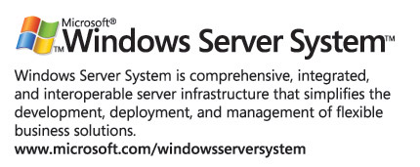
Solution accelerators are available for download from Microsoft TechNet or as a service by Management Delivery Partners and Microsoft Worldwide Services.

Note: For more information about System Center Capacity Planner 2006, visit http://www.microsoft.com/systemcenter. For the latest management news and information on the broad range of resources for managing your enterprise, visit http://www.microsoft.com/management. For more information on solution accelerators, visit http://www.microsoft.com/msm
© 2005 Microsoft Corporation. All rights reserved. This document was developed prior to the product's release to manufacturing, and as such, we cannot guarantee that all details included herein will be exactly as what is found in the shipping product. The information represents the product at the time this document was printed and should be used for planning purposes only. Information subject to change at any time without prior notice. This data sheet is for informational purposes only. MICROSOFT MAKES NO WARRANTIES, EXPRESS OR IMPLIED, IN THIS SUMMARY.
Microsoft, Outlook, Windows, the Windows logo, Windows Server, and Windows Server System are either registered trademarks or trademarks of Microsoft Corporation in the United States and/or other countries.

