Microsoft Office
Communications Server 2007
Planning Guide

Published: July 2007
Updated: April 2008

Information in this document, including URL and other Internet Web site references, is subject to change without notice. Unless otherwise noted, the companies, organizations, products, domain names, e-mail addresses, logos, people, places, and events depicted in examples herein are fictitious. No association with any real company, organization, product, domain name, e-mail address, logo, person, place, or event is intended or should be inferred. Complying with all applicable copyright laws is the responsibility of the user. Without limiting the rights under copyright, no part of this document may be reproduced, stored in or introduced into a retrieval system, or transmitted in any form or by any means (electronic, mechanical, photocopying, recording, or otherwise), or for any purpose, without the express written permission of Microsoft Corporation.
Microsoft may have patents, patent applications, trademarks, copyrights, or other intellectual property rights covering subject matter in this document. Except as expressly provided in any written license agreement from Microsoft, the furnishing of this document does not give you any license to these patents, trademarks, copyrights, or other intellectual property.
© 2008 Microsoft Corporation. All rights reserved.
Microsoft, Active Directory, DirectX, MSN, Outlook, RoundTable, SQL Server, Windows, Windows Media, Windows Server, and Windows Vista are trademarks of the Microsoft group of companies.
All other trademarks are property of their respective owners.

Contents
Introduction 1
Step 1. Determine Key Planning Considerations 2
Determine What Features You Want to Deploy 2
Evaluate Your Organization’s Environment For Specific Needs 4
Step 2. Select Your Topology 7
Small to Medium Deployment Scenarios 8
Centralized Enterprise Deployment Scenarios 22
Global Deployments 32
Step 3. Plan Your Deployment Path 41
Things You Must Know Before You Deploy 41
Overview of the Deployment Process 45
Permissions Required for Deployment 49
Step 4. Prepare Your Infrastructure 50
Active Directory Domain Services 51
Certificate Infrastructure 56
DNS (Domain Name Service) 63
Requirements for Automatic Client Sign-In 69
Ports Required by Office Communications Server 71
Step 5. Review System and Network Requirements 73
Capacity Planning 74
User Model 76
Network Requirements 78
Server Platform Requirements 79
Client Software Requirements 85
Step 6. Plan for External User Access 86
When You Need an Access Edge Server 87
When You Need a Web Conferencing Edge Server 89
When You Need an A/V Edge Server 90
Supported Topologies 90
Plan for Edge Servers in Your Perimeter Network 99
Edge Server Deployment Process 100
Publicly Routable IP Address for External A/V Access 102
DNS Requirements 103
Certificate Requirements for Edge Servers 108
Firewall Requirements 113
Step 7. Plan for Deploying Load Balancers 132
Hardware Load Balancers 132
General Requirements 132
Load Balancer Requirements for Office Communications Server 2007 Enterprise Pools 133
Load Balancer Requirements for Edge Servers 135
Step 8. Plan for VoIP 141
Determine the Number and Distribution of Users 141
Select a Deployment Option 142
Migration Paths and Integration Strategies 148
Plan for Media Gateways 150
Plan for User Authorization and Outbound Call Routing 158
Plan for Exchange Server 2007 SP1 Unified Messaging 175
Planning to Move Users to Enterprise Voice 180
Step 9. Plan for Address Book Server 183
Step 10. Plan for High Availability and Fault Tolerance 186
Making Your System Fault Tolerant 187
Protecting Your Back-End Database 188
Step 11. Plan for Database Storage 188
Step 12. Plan for Compliance and Usage Analysis 199
Archiving Topologies 199
Archiving and CDR Scalability 204
Configuring the Archiving and CDR Service 205
Appendix A Implementing in a QoS Environment 205
QoS Service Types 206
QoS Packet Scheduler 208
Appendix B Disabling IPSec 209

Introduction
Welcome to the Microsoft® Office Communications Server 2007 Planning Guide. This guide describes how to plan a smooth, successful Office Communications Server 2007 deployment for organizations of all sizes and levels of complexity, from large, geographically dispersed global enterprises to small, local businesses.
Planning is essential to successful deployment. The new Office Communications Server 2007 deployment tool, combined with new wizards for many of the more common tasks, such as configuring pools and obtaining certificates, greatly simplifies the process of installing, configuring, and activating Office Communications Server 2007. But the deployment tool and wizards do not take the place of planning; they simply make carrying out your plans easier.
This guide divides the planning process into 12 steps. Some steps are essential for all deployments; others are more important for some environments than for others; but all should be reviewed before actual deployment begins. These steps are summarized below:
Important
This guide presents guidance and topologies specifically for Office Communications Server 2007. If you are migrating from Live Communications Server 2005, use this guide in conjunction with the Migrating to Microsoft Office Communications Server 2007 document.
- Step 1. Determine Key Planning Decisions
Discusses the main decision points you need to consider before selecting a topology.
- Step 2. Select Your Topology
Presents several sample deployments based on size and desired functionality. These topologies are intended to guide you through the possible options available when you plan your deployment.
- Step 3. Plan Your Deployment Path
Summarizes important things you need to know before you begin any Office Communications Server deployment and provides an overview of the deployment process.
- Step 4. Prepare Your Infrastructure
Discusses requirements for Active Directory® Domain Services, certificates, DNS, automatic client sign-in, and ports.
- Step 5. Review System and Network Requirements
Lists hardware and software requirements for Office Communications Server 2007 server roles and clients.
- Step 6. Plan for External User Access
Provides guidelines for deploying Office Communications Server 2007 in your perimeter network for the purpose of supporting messaging, presence, and conferencing with users connecting from outside your organization firewall.
- Step 7. Plan for Deploying Load Balancers
Examines hardware load balancer requirements and configurations for an Enterprise pool. Also discusses the advantages of using hardware load balancers with edge server arrays.
- Step 8. Plan for VoIP
Discusses all the factors, requirements, and configuration tasks that you need to consider in order to deploy Microsoft’s software-powered VoIP solution.
- Step 9. Plan for Address Book Server
Discusses requirements for supporting the Address Book Server, including IIS (Internet Information Services), network file share, and required disk space.
- Step 10. Plan for High Availability and Fault Tolerance
Provides guidelines for assuring high availability and describes Office Communications Server 2007 features for optimizing availability and fault tolerance.
- Step 11. Plan for Database Storage
Discusses storage requirements for the various databases and file shares that are required by Office Communications Server 2007, including storage requirements for Archiving and CDR (Call Detail Records) database and new messaging support for rich text format. Also discusses RAID (DAS), NAS, and SAN tradeoffs, as well as basic calculations of disk space needed per meeting and per pool, based on numbers of users.
- Step 12. Plan for Compliance and Usage Analysis
Describes how to meet compliance requirements for archiving and call data recording.

Step 1. Determine Key Planning Considerations
Microsoft Office Communications Server 2007 is the first Microsoft product to combine enterprise-ready IM (instant messaging), presence, and conferencing in a single offering. Built on Microsoft Office Live Communications Server 2005, Office Communications Server adds more capabilities to the core features of IM and presence, and provides additional functionality of on-premise Web conferencing, multimedia capabilities, and Enterprise Voice.
In initial planning phase, several key decision factors will affect how you choose to deploy Office Communications Server 2007 in your organization. Decide what features of Office Communications Server you want to enable within your organization and evaluate your organization’s particular requirements.

Determine What Features You Want to Deploy
Office Communications Server 2007 Standard Edition server and Enterprise pool provide IM, presence, and conferencing for users within your internal organization. Office Communications Server also provides a several other features that you can offer by deploying additional server roles, depending on the functionality that your organization wants to support. For example, if your organization wants to provide internal users with the ability to communicate with external users, then an edge server is required. If you want to archive your instant messages or call detail records, an Archiving and CDR Service is required.
The following table lists the major features and functionality provided by Office Communications Server 2007 along with the server roles and clients they require. For more detailed discussion on the Office Communications Server 2007 server roles and architecture, see the Microsoft Office Communications Server 2007 Technical Overview.
Table 1 Communications Server functionality mapped to server roles and clients
If you want to provide this functionality | You must deploy this server role in addition to Standard Edition Server or Enterprise pool | …and this client
Instant messaging and presence for internal users | No additional server roles required. | Communicator 2005 or 2007  Communicator 2007 is required for enhanced presence
On-premise Web conferencing | Standard Edition: No additional server roles required.  Enterprise Edition: Web Conferencing Server and Web Components Server | Communicator 2007  Live Meeting 2007 client  Microsoft Outlook ® add-in for scheduled conferences
A/V conferencing | Standard Edition: No additional server roles required.  Enterprise Edition: A/V Conferencing Server | Communicator 2007  Live Meeting 2007 client  Outlook add-in for scheduled conferences
Address Book Server | No additional server roles required.  Enterprise Edition: Web Components Server | No requirement
Archiving and Call Detail Records | Archiving and CDR Server | No requirement
External User Access | Access Edge Server *  HTTP reverse proxy* | Communicator 2005 or 2007
Federation | Access Edge Server *  HTTP reverse proxy* | Communicator 2005 or 2007
Public IM Connectivity | Access Edge Server *  HTTP reverse proxy* | Communicator 2005 or 2007
Web conferencing with external users | Web Conferencing Edge Server*  HTTP reverse proxy* | Communicator 2007  Live Meeting 2007 client
A/V conferencing with external users | A/V Edge Server* | Communicator 2007  Live Meeting 2007 client
IM and presence through a browser based client | Communicator Web Access Server | Communicator Web Access
Enterprise Voice | Mediation Server and basic media gateway  OR  basic-hybrid media gateway (Mediation Server is collocated with basic media gateway)  OR  advanced media gateway (Mediation server logic incorporated in gateway design; available soon)  A/V Edge Server (on which the A/V Authentication Service is collocated) | Communicator 2007  OR  Office Communicator 2007 Phone Edition

* Access Edge Server is always required if you want to support external user access. Additionally, an HTTP reverse proxy is required to support external user access to meeting content, Address Book files and distribution group expansion.

Evaluate Your Organization’s Environment For Specific Needs
Before you begin to design your Office Communications Server environment, you must address the main points that will dictate the topology you choose:
- Importance of high availability
- Geographic distribution of your organization
- Whether or not you plan to support external user access
- Whether or not you plan to deploy Enterprise Voice

Importance of High Availability
If your organization will require that your Office Communications Server 2007 topology offer high availability, then you will want to deploy one or more Enterprise pools in your internal topology. If high availability is not a consideration and simplicity and economy are more important, Standard Edition Server may be an appropriate choice. You can also support high availability in your perimeter network if required. The following sections summarize the availability offerings of these deployment options.

Standard Edition
Standard Edition provides all IM, presence, and conferencing components, including data storage, on a single computer. This is an efficient, economical solution for organizations consisting of a relatively small number of users who are based at a single location and whose IM and online conferencing requirements are not mission critical. A Standard Edition server monitors its own state and in the event of failure restarts automatically without loss of files, meeting content, or meeting schedules. Meetings and conversations, however in progress, are interrupted, a situation that may persist for a prolonged period, depending on the reason for the failure.
Because a Standard Edition server represents a single point of failure, we do not recommend it for mission-critical deployments where high availability is essential. For such deployments, Enterprise Edition is the necessary choice.

Enterprise Edition
The architecture of Office Communications Server 2007 Enterprise Edition reduces single points of failure through the use of multiple Enterprise Edition Servers and dedicated Back-End Database server. For greater redundancy, the database can be clustered in a two-node active-passive configuration. Office Communications Server 2007 also provides mechanisms for automatically reconnecting clients. Momentary interruptions and terminated sessions can occasionally occur, but the system is largely immune to total outages.
Important
The back-end database must be installed on a separate physical computer from any Enterprise Edition server. For Enterprise Edition, collocating the back-end database with any Office Communications Server role is not supported. Additionally, Office Communications Server requires a separate SQL instance not shared with any other server application.
The multiple Front End Servers that make up an Enterprise Edition pool provide a high availability solution wherein if a single Front End Server fails, clients will detect the failure and automatically reconnect to one of the other available Front End Servers. Meeting state is preserved because a meeting is hosted by the pool, not by any single server. Multiple Front End Servers also make it possible to take any given server offline for hardware or software updates with minimal service interruption. When the server goes down due to hardware or network failure, there will be an interruption in the experience of the clients that are using that server for IM, presence, and conferencing. Those clients will reconnect to resume the service.
Locating the pool’s SQL databases on one or a cluster of back-end servers that are separate from the Front End Servers not only insulates the databases from possible Front End failure, but improves overall throughput and Front End performance. The same is true for deploying the Web Conferencing Server and A/V Conferencing Server on separate computers from the Front End Servers in the Enterprise Edition Expanded Configuration.

Perimeter Network
If you plan to enable external access in a highly available topology, then you will want to deploy multiple edge servers connected to a hardware load balancer (referred to as an array of edge servers) in your perimeter network. Conversely, if your organization does not require high availability in the perimeter network, you can collocate all three server roles (Access Edge, Web Conferencing Edge and A/V Edge) on a single server.
The Step 2. Select Your Topology section later in this document explains these configurations in greater detail.

Compliance Availability
If your organization must meet compliance requirements to archive instant messages or capture call detail records (CDRs), you can deploy the Archiving and CDR Service with a topology that offers high availability. For more details, see Step 12, Plan for Compliance and Usage Analysis.

Geographic Distribution
The geographic distribution of your company affects the design of your system topology. If your organization is geographically dispersed across WANs, we recommend placing a Standard Edition server or an Enterprise pool in each local site. This recommendation is a departure for Live Communications Server 2005, where a centralized model could often service remote sites. In Office Communications Server 2007, the addition of audio and video features requires greater bandwidth, and a better user experience is achieved with a local server or pool.

Number of Users in Each Location
Closely related to the geographic distribution of your company is the number of users in each location. If you have more than 100 users in a remote site that is connected by a WAN to a central site or data center, we recommend placing a local server in that site. Similarly, if you plan to support external access to Web conferences and audio/video conferences and you expect a high amount of usage in this site, then we recommend deploying a local Web Conferencing Edge Server and A/V Edge Server because of the higher bandwidth requirements for this type of traffic. The following section Step 2, Select Your Topology presents a variety of regional site topologies that you can use as a basis for planning your own Office Communications Server topology.

Support for External User Access
If you choose to support external user access to your Office Communications Server topology, you will need to plan for this support in your perimeter network topology.
For any type of external user access, an Access Edge Server is required. The HTTP reverse proxy is also required to allow external users to download Address Book files, expand distribution lists, and download meeting content for Web conferences. If you also choose to support external user participation in Web conferencing, a Web conferencing Edge server is required. If you want to make media such as audio and video available to external users, then you must also deploy an A/V Edge Server. Each of these three edge server roles can be collocated on a single computer for a small deployment, or you can use a load balancer with multiple servers to support a larger user base and achieve server redundancy and load distribution.
The following section, Step 2. Select Your Topology, presents the available edge server topologies and guides you through the process of selecting the appropriate topology for your environment. Step 6, Plan for External User Access explains in more detail other planning decisions specific to edge servers and your perimeter network.

Support for Enterprise Voice
Enterprise Voice is Microsoft’s software-powered VoIP solution. If you choose to enable Enterprise Voice, you will need to plan to deploy a media (IP/PSTN) gateway to handle calls between users enabled for VoIP and the PSTN, as well as an Office Communications Server 2007 Mediation Server, which intermediates signaling and media between the gateway and your internal Communications Server infrastructure. The Mediation Server is the only additional Communications Server role required for Enterprise Voice.
Communications Server offers three options for deploying a Mediation Server and media gateway. The first option consists of a basic media gateway and a separate Mediation Server. The second option is a basic-hybrid gateway, in which the basic gateway and Mediation Server are collocated on a single computer. The third option is an advanced media gateway, in which the Mediation Server logic is incorporated within the gateway software itself. For more information on gateway choices, see Choosing the Type of Gateway to Deploy.
In addition to deploying gateways, you must also plan for the normalization of your phone numbers that are stored in Active Directory and create dial plans for each location where your organization does business. To provide call answering, subscriber access, and auto-attendant services, you also need to deploy Microsoft Exchange Server 2007 Unified Messaging (UM) and configure Exchange UM and Communications Server to work together.
Enterprise Voice supports two main deployment scenarios: stand-alone configurations in greenfield or departmental scenarios, and PBX coexistence, in which users enjoy both the familiarity of their existing PBX phones and the advantages of Unified Communications, including rich audio, intuitive call control, enhanced presence notification, and the ability to communicate directly from Microsoft Office applications. The following section includes some basic Enterprise Voice scenarios, but for an in-depth discussion of supported voice topologies, as well as other VoIP planning issues, see Step 8. Plan for Enterprise Voice. For a complete guide to understanding, planning, deploying, and managing Enterprise Voice in a single guide, see the Microsoft Office Communications Server 2007 Enterprise Voice Planning and Deployment Guide.

Step 2. Select Your Topology
This section presents examples of Office Communications Server topologies designed to provide IM and conferencing functionality and other features of Office Communications Server ranging from a very small or pilot deployment up to a large global deployment. These topologies are provided as sample deployments; depending on your specific requirements, you can combine different pieces of these topologies to meet your needs. They are presented in order of complexity and size:
- Small to Medium Deployment Scenarios present topologies appropriate for small or pilot deployments where high availability is not a requirement. These topologies build upon Standard Edition server to support internal IM and conferencing a user base of less than 5,000.

- Centralized Enterprise Deployment Scenarios present topologies that provide high availability and support for user population of over 5,000 for organizations in a single physical site.
- Global Deployments presents topologies that span multiple sites and provide high availability and scalability.

Small to Medium Deployment Scenarios
This section provides sample deployments that are based on Standard Edition Server internally. The simplest topology, a Standard Edition Server, is presented first. Each subsequent topology builds upon this topology, adding functionality and the components necessary to enable it.
The following deployment scenarios are presented:
- Small deployment supporting IM and conferencing for internal users only
- Small deployment with support for internal and external access
- Medium-sized deployment with support for external user access and voice
- Medium-sized deployment with support for archiving, external access and voice

Small Deployment Supporting IM, Presence and Conferencing for Internal Users Only
The simplest Office Communications Server topology provides IM and conferencing internally for a small user base. It consists of a single Standard Edition Server deployment in which the Front-End, Web Conferencing, A/V Conferencing server roles, and IIS are installed on a single computer. This topology is appropriate for small to medium organizations with fewer than 5,000 users or pilot deployments in which the main goals are simplicity and ease of management and where high availability is not a requirement. The following figure shows a sample Standard Edition deployment.
Figure 1 Standard Edition Deployment
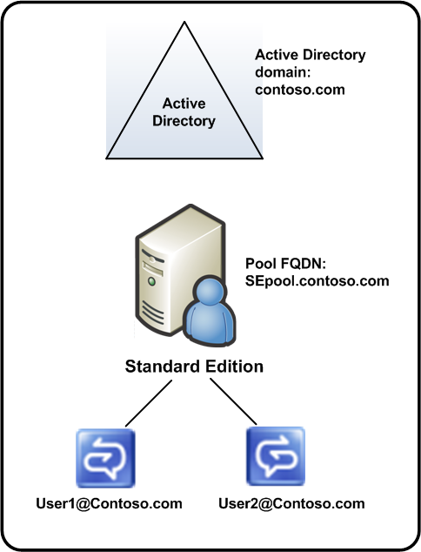

Deployment Profile
The following table summarizes the key characteristics of this topology.
Table 2 Deployment Profile for Standard Edition Topology
Key Aspect | Description
Deployment scenario | - Small to medium business  - Initial pilot or regional site deployment in an enterprise
Key goals for deployment | Simplicity, ease of management
Geographic distribution | Centralized single location
Functionality | IM presence and conferencing
Functionality not provided | - No external user access, including federation, public IM connectivity, anonymous user participation in Web conferencing and no external user access to audio and video conferencing or media  - No high availability  - No PSTN voice  - No IM archiving or CDR functionality
Number of Office Communications Server servers | 1
User base | Fewer than 5,000 users
Prerequisites | Active Directory deployed in Microsoft Windows® 2000 native mode in the domain where Standard Edition Server will be deployed  PKI infrastructure available

How to Use the Planning Guide for this Topology
Although you may want to read the entire planning guide for a comprehensive understanding of Office Communications Server planning considerations, you may also choose to focus on the key chapters specific to your deployment.
Read these key chapters
Plan Your Deployment Path
Prepare Your Infrastructure
Review System and Network Requirements
Plan for Address Book Server
Plan for Database Storage
Skip these chapters if you choose
Plan for External User Access
Plan for Deploying Load Balancers
Plan for VoIP
Plan for High Availability and Fault Tolerance
Plan for Compliance and Usage Analysis

Deployment Steps and Relevant Documents for this Topology
If this topology is appropriate for your organization, begin your deployment by preparing Active Directory for Office Communications Server. After you complete your Active Directory preparation, deploy a Standard Edition server, and then deploy Office Communicator 2007 and the Live Meeting 2007 client for your users.
Table 3 Deployment Steps and Where to Get More Information
Required Step | Read this guide for step-by-step instructions
Active Directory Preparation | Microsoft Office Communications Server 2007 Active Directory Guide
Deploy Standard Edition Server | Microsoft Office Communications Server 2007 Standard Edition Deployment Guide
Deploy Office Communicator clients | Microsoft Office Communicator 2007 Deployment Guide
Deploy Live Meeting 2007 clients | Deploying the Microsoft Office Live Meeting 2007 Client with Office Communications Server 2007

Small Deployment with Support for External User Access
If you are deploying Office Communications Server 2007 in a small company or a pilot project and want to support IM, presence, and conferencing both for internal users and external users, build upon the Standard Edition deployment by adding an edge server to allow external user access—specifically, public IM connectivity, remote user access, federation, and the ability of external users to participate in A/V sessions and Web conferencing. For this topology, a single edge server is deployed in the perimeter network and all three edge server roles, Access Edge Server, Web Conferencing Edge Server, and A/V Edge Server are installed on a single computer. Figure 2 shows a simple deployment with support for external user access.
Figure 2 Simple Deployment with Support for External User Access
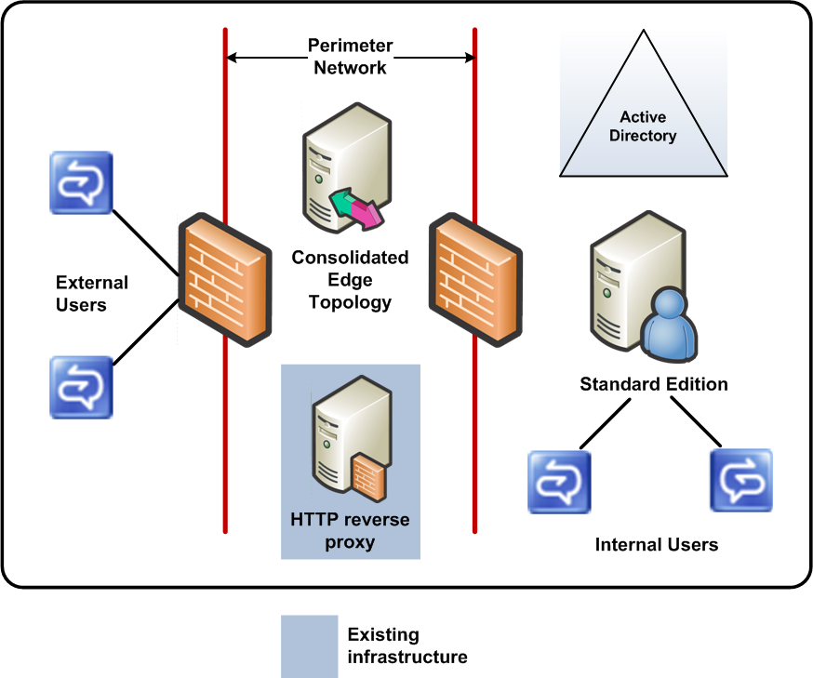

Deployment Profile
The following table summarizes the key characteristics of this topology.
Table 4 Deployment Profile for Small Deployment Supporting IM, Presence and Conferencing for Internal and External Users
Key Aspect | Description
Deployment scenario | - Small to medium business  - Initial pilot or regional site deployment in an enterprise
Key goals for deployment | Simplicity, ease of management
Geographic distribution | Centralized single location
Functionality | - IM presence and conferencing  - External user access including federation, public IM connectivity, anonymous user participation in Web conferencing external user access to audio and video sessions
Functionality not provided | - No high availability  - No PSTN voice  - No IM archiving or CDR functionality
Number of Office Communications Server servers | 2
User base | Less than 5,000 active users *  For external, 10 percent of the total active users or 500
Prerequisites | Active Directory deployed in Windows 2000 native mode in the domain where Standard Edition Server will be deployed  PKI infrastructure available  Reverse proxy available in the perimeter network

How to use the Planning Guide for This Topology
Although you may want to read the entire planning guide for a comprehensive understanding of Office Communications Server planning considerations, you may also choose to focus on the key chapters specific to your deployment.
Read these key chapters
Plan Your Deployment Path
Prepare Your Infrastructure
Review System and Network Requirements
Plan for External User Access
Plan for Address Book Server
Plan for Database Storage
Skip these chapters if you choose
Plan for Deploying Load Balancers
Plan for VoIP
Plan for High Availability and Fault Tolerance
Plan for Compliance and Usage Analysis

Deployment Steps and Relevant Documents for this Topology
If this topology is appropriate for your organization, we recommend that you deploy Office Communications Server internally first. Deploying Office Communications Server internally involves preparing Active Directory and then deploying and configuring your Standard Edition Server and deploying your clients. After your internal topology is operational, deploy the edge server. In the perimeter network, also ensure that you have a reverse HTTP proxy. This proxy will allow outside users access to meeting content, address book files and distribution group expansion information that is stored internally on the IIS server.
Table 5 Deployment Steps and Where to Get More Information
Required Step | Read this guide for step-by-step instructions
Active Directory Preparation | Microsoft Office Communications Server 2007 Active Directory Guide
Deploy Standard Edition Server | Microsoft Office Communications Server 2007 Standard Edition Deployment Guide
Deploy Office Communicator clients | Microsoft Office Communicator 2007 Deployment Guide
Deploy Live Meeting 2007 clients | Deploying the Microsoft Office Live Meeting 2007 Client with Office Communications Server 2007
Deploy Edge Server | Microsoft Office Communications Server 2007 Edge Server Deployment Guide

Medium-Sized Deployment with Support for External User Access and Voice
If you are deploying in a small to medium sized company and want to support IM, presence, and conferencing both for internal users and external users and voice functionality, build upon the simple deployment with external access, and connect your Standard Edition Server to an existing advanced media gateway. Like the simple deployment with external access described earlier in this document, a single edge server is deployed in the perimeter network, and all three edge server roles—Access Edge Server, Web Conferencing Edge Server, and A/V Edge Server—are installed on a single computer. The Standard Edition Server is connected to through an Office Communications Server Mediation Server to a media gateway for voice functionality. The following figure shows a simple deployment with support for external user access and voice.

Figure 3 Medium-Sized Deployment with Support for External User Access and Voice in a Single Location
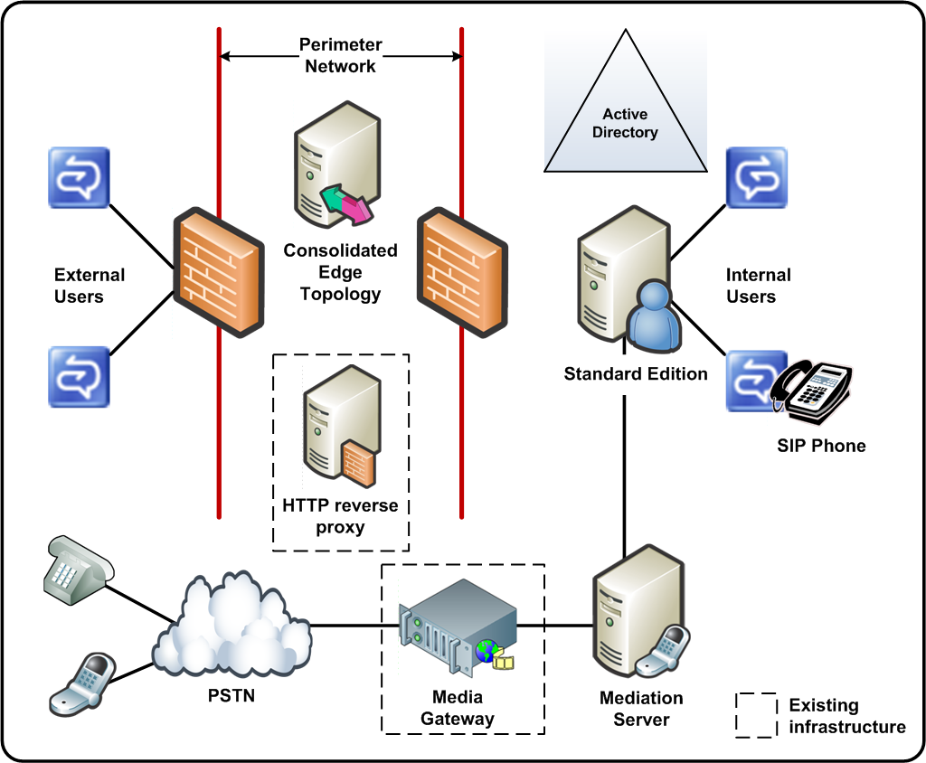

Deployment Profile
The following table summarizes the key characteristics of this topology.
Table 6 Deployment Profile for Small Deployment Supporting IM, Presence and Conferencing for Internal and External Users
Key Aspect | Description
Deployment scenario | Small to medium business  Initial pilot or regional site deployment in an enterprise
Key goals for deployment | Simplicity, ease of management
Geographic distribution | Centralized single location
Functionality | - IM presence and conferencing  - External user access including federation, public IM connectivity, anonymous user participation in Web conferencing external user access to audio and video sessions  - Voice functionality for a single area code and location with a unique PSTN termination point.
Geographic distribution | Centralized single location
Functionality not provided | No high availability  No IM archiving or CDR functionality
Number of Office Communications Server servers | 3
User base | Fewer than 5,000 active users*  For external, 10 percent of the total active users or 500  For supported voice usage, refer to the Plan for VoIP section later in this guide and the Microsoft Office Communications Server 2007Enterprise Voice Planning and Guide.
Prerequisites | Active Directory deployed in Windows 2000 native mode in the domain where Standard Edition Server will be deployed  PKI infrastructure available  Reverse http proxy available in the perimeter network  Advanced media gateway

How to Use the Planning Guide for This Topology
Although you may want to read the entire planning guide for a comprehensive understanding of Office Communications Server planning considerations, you may also choose to focus on the key chapters specific to your deployment.
Read these key chapters
Plan Your Deployment Path
Prepare Your Infrastructure
Review System and Network Requirements
Plan for External User Access
Plan for VoIP
Plan for Address Book Server
Plan for Database Storage
Skip these chapters if you choose
Plan for Deploying Load Balancers
Plan for High Availability and Fault Tolerance
Plan for Compliance and Usage Analysis

Deployment Steps and Relevant Documents for this Topology
If this topology is appropriate for your organization, we recommend that you deploy IM, presence, and Web conferencing functionality first and then deploy voice. To configure IM, presence, and conferencing, you will need to prepare Active Directory for Office Communications Server and then deploy Standard Edition Server. After your Office Communications Server is deployed, roll out your Communicator and Live Meeting clients to your end users. After your internal deployment is operational, you can deploy an edge server in your perimeter network.
In the perimeter network, also ensure that you have a reverse HTTP proxy. This proxy will allow outside users access to meeting content, address book files and distribution group expansion information that is stored internally on the IIS server (which runs on the Standard Edition Server in this topology). Once these pieces are working together, you will want to deploy enterprise voice.
Table 7 Deployment Steps and Where to Get More Information
Required Step | Read this guide for step-by-step instructions
Active Directory Preparation | Microsoft Office Communications Server 2007 Active Directory Guide
Deploy Standard Edition Server | Microsoft Office Communications Server 2007 Standard Edition Deployment Guide
Deploy Office Communicator clients | Microsoft Office Communicator 2007 Deployment Guide
Deploy Live Meeting 2007 clients | Deploying the Microsoft Office Live Meeting 2007 Client with Office Communications Server 2007
Deploy Enterprise Voice | Microsoft Office Communications Server 2007 Enterprise Voice Planning and Deployment Guide
Deploy Edge Server | Microsoft Office Communications Server 2007 Edge Server Deployment Guide

Medium Sized Deployment with External Access and Voice in Multiple Locations
If you are deploying in a medium size company and want to support the following functionality, the following topology may meet your needs:
- IM, presence and conferencing both for internal users and external users
- Voice functionality for multiple locations
This topology is based upon the preceding topology with a single voice location, with the addition of existing media gateway in each voice location. An Office Communications Server 2007 Mediation Server is placed between an existing media gateway to translate between the gateway and Standard Edition Server. In the advanced media gateways or the basic hybrid media gateway, the Mediation Server is not required because the logic of the Mediation Server is integrated into the gateway itself. You can find a current list of qualified gateways that work with Communications Server at http://r.office.microsoft.com/r/rlidOCS?clid=1033&p1=IPpbxVend. The following figure depicts a sample topology.

Figure 4 Medium Sized Deployment with Support for External User Access and Voice in Multiple Locations
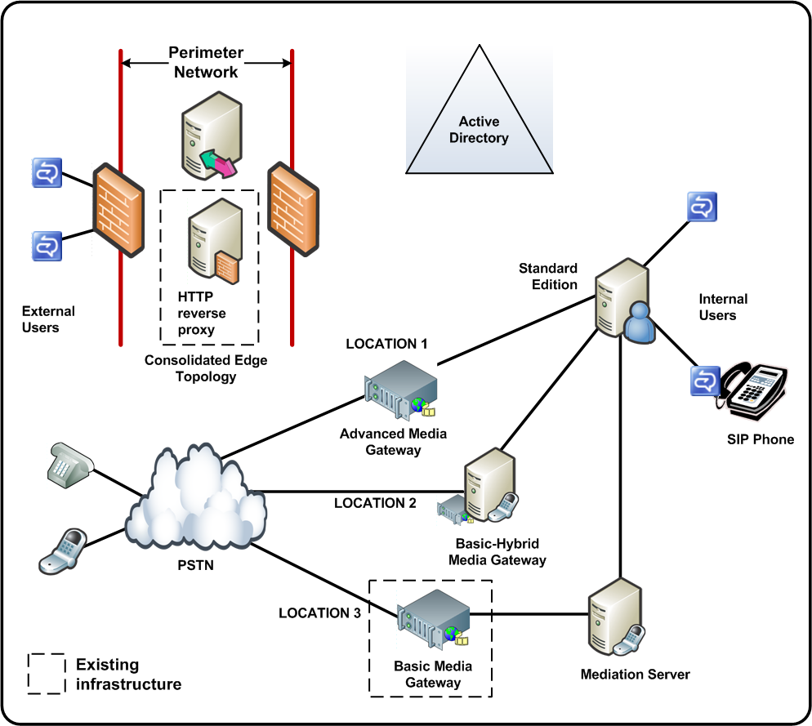

Deployment Profile
The following table summarizes the key characteristics of this topology.
Table 8 Medium Sized Deployment with Support for External User Access and Voice in Multiple Locations
Key Aspect | Description
Deployment scenario | Medium business  Deployment in an enterprise supporting external user access and voice in multiple locations
Key goals for deployment | Simplicity, ease of management
Geographic distribution | Centralized single location with multiple regional voice locations
Functionality | IM presence and conferencing  External user access including federation, public IM connectivity, anonymous user participation in Web conferencing external user access to audio and video sessions  Voice functionality for multiple locations and area codes (one area code per PSTN termination point).
Functionality not provided | No high availability  No IM archiving or CDR functionality
Number of Office Communications Server servers | 3 plus the basic hybrid media gateway and the advance media gateway
User base | Fewer than 5,000 active users  For external, 10 percent of the total active users or 500  For supported voice usage, refer to Step 8. Plan for VoIP later in this document
Prerequisites | Active Directory deployed in Windows 2000 native mode in the domain where Standard Edition Server will be deployed  PKI infrastructure available  Reverse http proxy available in the perimeter network  Advanced media gateway*  Basic media gateway

How to Use the Planning Guide for This Topology
Although you may want to read the entire planning guide for a comprehensive understanding of Office Communications Server planning considerations, you may also choose to focus on the key chapters specific to your deployment.
Read these key chapters
Plan Your Deployment Path
Prepare Your Infrastructure
Review System and Network Requirements
Plan for External User Access
Plan for VoIP
Plan for Address Book Server
Plan for Database Storage
Skip these chapters if you choose
Plan for Deploying Load Balancers
Plan for High Availability and Fault Tolerance
Plan for Compliance and Usage Analysis

Deployment Steps and Relevant Documents for this Topology
If this topology is appropriate for your organization, we recommend that you deploy IM, presence, and Web conferencing functionality first and then deploy voice. To configure IM, presence, and conferencing, we recommend you deploy Office Communications Server internally first and then deploy inside your perimeter network. First, you will need to prepare Active Directory for Office Communications Server, and then deploy a Standard Edition Server. After your Office Communications Server is deployed, roll out your Communicator and Live Meeting clients to your end users.
Next, deploy your edge server in the perimeter network, and ensure that you have a reverse HTTP proxy. This proxy will allow outside users access to meeting content, address book files and distribution group expansion information that is stored internally on the IIS server.
After these pieces are working together, you will want to deploy enterprise voice.
Table 9 Deployment Steps and Where to Get More Information
Required Step | Read this guide for step-by-step instructions
Active Directory Preparation | Microsoft Office Communications Server 2007 Active Directory Guide
Deploy Standard Edition Server | Microsoft Office Communications Server 2007 Standard Edition Deployment Guide
Deploy Office Communicator clients | Microsoft Office Communicator 2007 Deployment Guide
Deploy Live Meeting 2007 clients | Deploying the Microsoft Office Live Meeting 2007 Client with Office Communications Server 2007
Deploy Enterprise Voice | Microsoft Office Communications Server 2007 Enterprise Voice Planning and Deployment Guide
Deploy Edge Server | Microsoft Office Communications Server 2007 Edge Server Deployment Guide

Deployment with Archiving, Communicator Web Access, External Access, and Voice in Multiple Locations
If you are deploying in a medium size company and want to support the following functionality, this sample topology may meet your needs:
- IM, presence, and conferencing both for internal users and external users
- Voice functionality for multiple locations
- Internet access to IM functionality using a Web browser
- The ability to archive messages or usage data and capture call detail records
This topology is based upon the preceding topology but adds an Archiving and CDR Server to enable your company to archive instant messages and capture call data records, and a Communicator Web Access Server to provide your users with Communicator Web Access for instant messaging over secure HTTP (HTTPS). In our sample topology, the Archiving and CDR Server is collocated with its required back-end SQL database. As a variation, you could deploy the back-end SQL database on a dedicated server. Figure 5 depicts a sample topology.

Figure 5 Medium Sized Deployment with Support for External User Access and Voice in a Multiple Locations
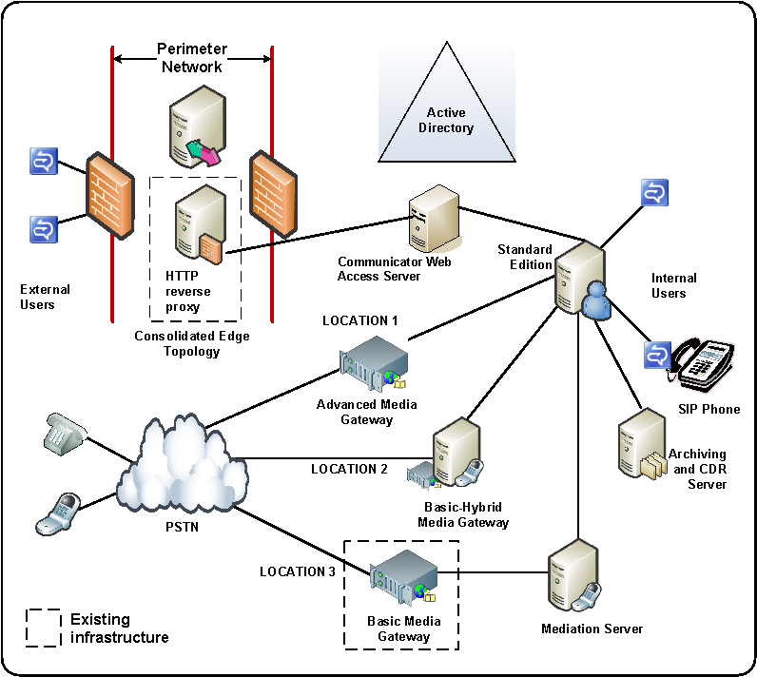

Deployment Profile
The following table summarizes the key characteristics of this topology.
Table 10 Deployment Profile for Small Deployment Supporting IM, Presence, and Conferencing for Internal and External Users
Key Aspect | Description
Deployment scenario | Small to medium business  Initial pilot or regional site deployment in an enterprise
Key goals for deployment | Simplicity, ease of management
Geographic distribution | Centralized single location with multiple regional voice locations
Functionality | IM presence and conferencing  External user access including federation, public IM connectivity, anonymous user participation in Web conferencing external user access to audio and video sessions  Voice functionality for a multiple locations and area codes (one area code per PSTN termination point).  Communicator Web Access for Office Communications Server users  Archiving and CDR
Functionality not provided | No high availability
Number of Office Communications Server servers | 6 including a Mediation Server for each basic media gateway
User base | Fewer than 5,000 active users
Prerequisites | Active Directory deployed in Windows 2000 native mode in the domain where the Standard Edition Server will be deployed  PKI infrastructure available  Reverse HTTP proxy available in the perimeter network  Advanced media gateway  Basic media gateway

How to Use the Planning Guide for This Topology
Although you may want to read the entire planning guide for a comprehensive understanding of Office Communications Server planning considerations, you may also choose to focus on the key chapters specific to your deployment.
Read these key chapters
Plan Your Deployment Path
Prepare Your Infrastructure
Review System and Network Requirements
Plan for External User Access
Plan for VoIP
Plan for Address Book Server
Plan for Database Storage
Plan for Compliance and Usage Analysis
Skip these chapters if you choose
Plan for Deploying Load Balancers
Plan for High Availability and Fault Tolerance

Deployment Steps and Relevant Documents for this Topology
If this topology is appropriate for your organization, we recommend that you deploy IM, presence, and Web conferencing functionality first and then deploy voice. To configure IM, presence and conferencing, we recommend that you deploy Office Communications Server internally and then deploy inside your perimeter network. Internally, you will need to prepare Active Directory for Office Communications Server and then deploy the Standard Edition Server and the Archiving and CDR Server. Finally, roll out your Communicator and Live Meeting clients to your end users.
Next, deploy your edge server in the perimeter network, and ensure that you have a reverse HTTP proxy. This proxy will allow outside users access to meeting content, address book files and distribution group expansion information that is stored internally on the IIS server, which in this topology runs on the Standard Edition Server. You can deploy Communicator Web Access independently of your client deployment, but your Office Communications Server 2007 infrastructure must be in place.
Once these pieces are working together, you will want to deploy Enterprise Voice.
Table 11 Deployment Steps and Where to Get More Information
Required Step | Read this guide for step-by-step instructions
Active Directory Preparation | Microsoft Office Communications Server 2007 Active Directory Guide
Deploy Standard Edition Server | Microsoft Office Communications Server 2007 Standard Edition Deployment Guide
Deploy Archiving and CDR Server | Microsoft Office Communications Server 2007 Archiving and CDR Server Deployment Guide
Deploy Office Communicator clients | Microsoft Office Communicator 2007 Deployment Guide
Deploy Live Meeting 2007 clients | Deploying the Microsoft Office Live Meeting 2007 Client with Office Communications Server 2007
Deploy Communicator Web Access | Microsoft Office Communicator Web Access (2007 release) Planning and Deployment Guide
Deploy Edge Server | Microsoft Office Communications Server 2007 Edge Server Deployment Guide
Deploy Enterprise Voice | Microsoft Office Communications Server 2007 Enterprise Voice Planning and Deployment Guide

Centralized Enterprise Deployment Scenarios
This section provides sample deployments that are designed for large centralized enterprises that require high availability internally. The simplest topology that provides high availability internally is an Enterprise pool in the consolidated configuration. For more robust internal deployments with scaling flexibility, an Enterprise pool in the expanded configuration can be used. The remaining deployments in this scenario build upon the two configurations of an Enterprise pool, adding additional functionality and components required to enable it.
The following deployment scenarios are presented:
- Enterprise deployment supporting IM and conferencing for internal users only
- Enterprise deployment supporting IM and conferencing for internal and external users
- Scaled external deployment with high availability

Enterprise Deployment Supporting IM and Conferencing for Internal Users Only
In larger enterprises, when instant messaging, presence, and conferencing are considered mission critical, high availability is a requirement. Any Enterprise pool with multiple Enterprise Edition Servers can provide basic high availability. It its simplest configuration, a consolidated topology, each Enterprise Edition Server in a pool runs all server roles: Front-End, A/V Conferencing, and Web Conferencing, as well as IIS for the Web Components. A consolidated pool can support up to 30,000 users. The advantage of the consolidated configuration over the expanded configuration is ease of management, but performance is not as fast as the expanded configuration. The following figure shows a sample topology.
Figure 6 Enterprise Deployment Supporting IM and Conferencing for Internal Users Only
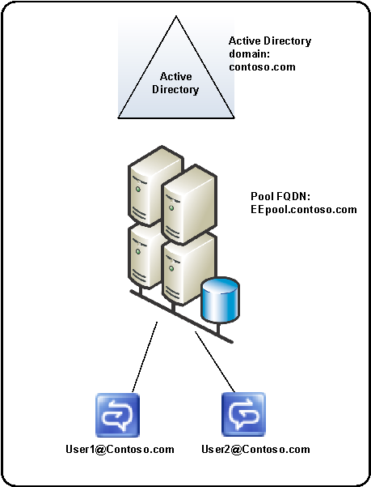

Deployment Profile
The following table summarizes the key characteristics of this topology.
Table 12 Deployment Profile for Small Deployment Supporting IM, Presence and Conferencing for Internal and External Users
Key Aspect | Description
Deployment scenario | Initial deployment for mission critical large enterprise instant messaging and conference usage
Key goals for deployment | High availability  Ease of management
Geographic distribution | Centralized single location
Functionality | IM presence and conferencing
Functionality not provided | No external user access, including federation, public IM connectivity, anonymous user participation in Web conferencing and no external user access to audio and video conferencing or media  No PSTN voice  No IM archiving or CDR functionality
Number of Office Communications Server servers | 4 servers (1 server role)
User base | Fewer than 30,000 active users
Prerequisites | Active Directory deployed in Windows 2000 native mode in the domain where Standard Edition Server will be deployed  Microsoft SQL Server® 2005 SP1 or SQL Server 2000 SP4 or later available for the back-end database of the pool  PKI infrastructure available  Hardware load balancer

How to Use the Planning Guide for This Topology
Although you may want to read the entire planning guide for a comprehensive understanding of Office Communications Server planning considerations, you may also choose to focus on the key chapters specific to your deployment.
Read these key chapters
Plan Your Deployment Path
Prepare Your Infrastructure
Review System and Network Requirements
Plan for Deploying Load Balancers
Plan for Address Book Server
Plan for High Availability and Fault Tolerance
Plan for Database Storage
Skip these chapters if you choose
Plan for External User Access
Plan for VoIP
Plan for Compliance and Usage Analysis

Deployment Steps and Relevant Documents for this Topology
If this topology is appropriate for your organization, begin your deployment by preparing Active Directory for Office Communications Server. After you complete your Active Directory preparation, deploy an Enterprise pool in the consolidated configuration, and then deploy Office Communicator 2007 and the Live Meeting 2007 client for your users.
Table 13 Deployment Steps and Where to Get More Information
Required Step | Read this guide for step-by-step instructions
Active Directory Preparation | Microsoft Office Communications Server 2007 Active Directory Guide
Deploy an Enterprise pool in the consolidated configuration | Microsoft Office Communications Server 2007 Enterprise Edition Deployment Guide
Deploy Office Communicator clients | Microsoft Office Communicator 2007 Deployment Guide
Deploy Live Meeting 2007 clients | Deploying the Microsoft Office Live Meeting 2007 Client with Office Communications Server 2007

High Scale, High Availability Enterprise Deployment Supporting IM and Conferencing for Internal Users Only
In larger enterprises that require high availability and scalability to support mission-critical IM and conferencing internally, an Enterprise pool in the expanded configuration is appropriate. A single Enterprise pool in an expanded configuration can support user base of up to 125,000 active, concurrent users.
In this configuration, each server role resides on a dedicated computer, and the Front End Servers and Web Component Servers (IIS server_) are connected to a hardware load balancer. (You can use a single load balancer for both server roles or use two separate load balancers) Placing server roles on separate computers allows you to scale based on server roles. For example, if your organization uses A/V functionality heavily, you can add additional A/V Conferencing Servers to meet this need. Additionally, placing IIS on separate computers can help if IIS is managed by a different team or your organization has stricter lockdown requirements for these servers. If you plan to deploy Enterprise voice at a later time, but expect heavy voice usage, this topology will more easily scale for those needs. A/V Conferencing Servers and A/V Edge Servers can support a larger number of users when deployed on dedicated servers.
In the following figure, the Back-End Database Server is clustered in a two-node active passive configuration. A Microsoft SQL Server® cluster for the back-end database provides additional high availability and provides failover capabilities. Clustering the database is optional.
Figure 7 High Availability Enterprise Deployment Supporting IM and Conferencing for Internal Users Only
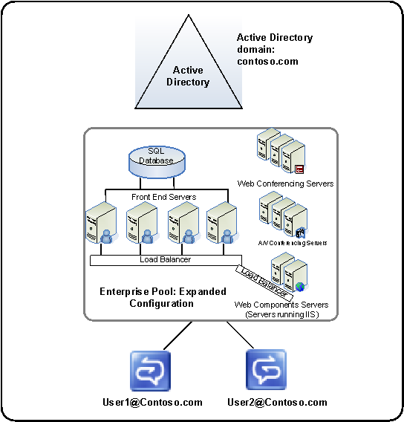

Deployment Profile
The following table summarizes the key characteristics of this topology.
Table 14 Deployment Profile for High Scale, High Availability for Internal IM and Conferencing Use
Key Aspect | Description
Deployment scenario | Initial deployment for mission critical large enterprise instant messaging and conference usage
Key goals for deployment | High availability; high scalability, higher performance
Geographic distribution | Centralized single location
Functionality | IM presence and conferencing
Functionality not provided | No external user access, including federation, public IM connectivity, anonymous user participation in Web conferencing and no external user access to audio and video conferencing or media  No PSTN voice  No IM archiving or CDR functionality
Number of Office Communications Server servers | 9 servers (4 roles)
User base | Up to 125,000 active, concurrent users internally
Prerequisites | Active Directory deployed in Windows 2000 native mode in the domain where Standard Edition Server will be deployed  SQL Server 2005 SP1 or SQL Server 2000 SP4 or later available for the back-end database of the pool  PKI infrastructure available  Hardware load balancer

How to Use the Planning Guide for This Topology
Although you may want to read the entire planning guide for a comprehensive understanding of Office Communications Server planning considerations, you may also choose to focus on the key chapters specific to your deployment.
Read these key chapters
Plan Your Deployment Path
Prepare Your Infrastructure
Review System and Network Requirements
Plan for Deploying Load Balancers
Plan for Address Book Server
Plan for High Availability and Fault Tolerance
Plan for Database Storage
Skip these chapters if you choose
Plan for External User Access
Plan for VoIP
Plan for Compliance and Usage Analysis

Deployment Steps and Relevant Documents for this Topology
If this topology is appropriate for your organization, begin your deployment by preparing Active Directory for Office Communications Server. After you complete your Active Directory preparation, deploy an Enterprise pool in the expanded configuration, and then deploy Office Communicator 2007 and the Live Meeting 2007 client for your users.
Table 15 Deployment Steps and Where to Get More Information
Required Step | Read this guide for step-by-step instructions
Active Directory Preparation | Microsoft Office Communications Server 2007 Active Directory Guide
Deploy an Enterprise pool in the consolidated configuration | Microsoft Office Communications Server 2007 Enterprise Edition Deployment Guide
Deploy Office Communicator clients | Microsoft Office Communicator 2007 Deployment Guide
Deploy Live Meeting 2007 clients | Deploying the Microsoft Office Live Meeting 2007 Client with Office Communications Server 2007

High Scale, High Availability Enterprise Deployment Supporting IM and Conferencing for Internal and External Users
In larger enterprises that require high availability and scalability to support mission-critical IM and conferencing internally and provide basic external access, an Enterprise pool in the expanded configuration must be deployed internally, and edge servers are deployed in the perimeter network.
In the following edge topology, the Access Edge Server and the Web Conferencing Edge Server are deployed on one computer, and the A/V Edge Server is deployed on another dedicated computer. This topology is well positioned to scale if your need for external access becomes more critical. To scale, you add additional computers that are running the same server roles and connect them to a load balancer, as explained in the next section, Scaled External Access with High Availability in the Perimeter Network.
Figure 8 High Scale High Availability Enterprise Deployment Supporting IM and Conferencing for Internal and External Users
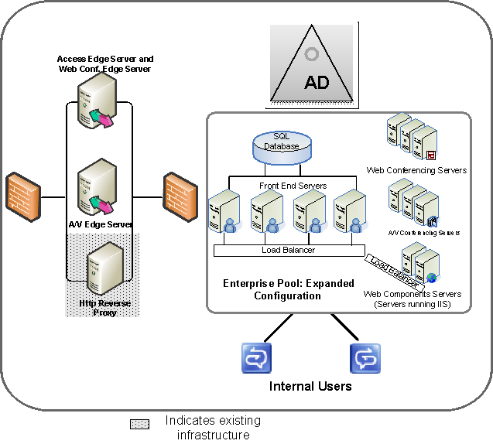

Deployment Profile
The following table summarizes the key characteristics of this topology.
Table 16 Deployment Profile for High Scale, High Availability for Internal and External IM and Conferencing Use
Key Aspect | Description
Deployment scenario | Initial deployment for mission critical large enterprise instant messaging and conference usage
Key goals for deployment | High availability; high scalability, higher performance internally
Geographic distribution | Centralized single location
Functionality | IM presence and conferencing  External user access, including federation, public IM connectivity, anonymous user participation in Web conferencing and external user access to audio and video conferencing or media
Functionality not provided | No PSTN voice  No IM archiving or CDR functionality
Number of Office Communications Server servers | 11 servers (7 roles)
User base | Up to 125,000 active concurrent users.  10 percent of this user base is assumed to be external
Prerequisites | Active Directory deployed in Windows 2000 native mode in the domain where Standard Edition Server will be deployed  SQL Server 2005 SP1 or SQL Server 2000 SP4 or later available for the back-end database of the pool  PKI infrastructure available  Hardware load balancer for pool  Hardware load balancer for edge servers
Notes | For a simpler, edge topology, you can place all your edge server roles on a single computer; however, the model discussed earlier in this document scales more easily, because you cannot load balance multiple edge servers in the consolidated topology.

How to Use the Planning Guide for This Topology
Although you may want to read the entire planning guide for a comprehensive understanding of Office Communications Server planning considerations, you may also choose to focus on the key chapters specific to your deployment.
Read these key chapters
Plan Your Deployment Path
Prepare Your Infrastructure
Review System and Network Requirements
Plan for External User Access
Plan for Deploying Load Balancers
Plan for Address Book Server
Plan for High Availability and Fault Tolerance
Plan for Database Storage
Skip these chapters if you choose
Plan for VoIP
Plan for Compliance and Usage Analysis

Deployment Steps and Relevant Documents for this Topology
If this topology is appropriate for your organization, we recommend you deploy Office Communications Server internally and then deploy edge servers in your perimeter network. For your internal deployment, you will need to prepare Active Directory for Office Communications Server, and then deploy Enterprise pool in the expanded configuration. After you have deployed your Office Communications Server infrastructure, deploy Communicator 2007 and Live Meeting 2007 clients for your end users.
In the perimeter network, before you deploy your edge servers, ensure that you have a hardware load balancer to which you will connect your edge servers and a reverse HTTP proxy. This proxy will allow outside users access to meeting content, address book files and distribution group expansion information that is stored internally on the IIS server.
Table 17 Deployment Steps and Where to Get More Information
Required Step | Read this guide for step-by-step instructions
Active Directory Preparation | Microsoft Office Communications Server 2007 Active Directory Guide
Deploy an Enterprise pool in the expanded configuration | Microsoft Office Communications Server 2007 Enterprise Edition Deployment Guide
Deploy Office Communicator clients | Microsoft Office Communicator 2007 Deployment Guide
Deploy Live Meeting 2007 clients | Deploying the Microsoft Office Live Meeting 2007 Client with Office Communications Server 2007
Deploy Edge Server | Microsoft Office Communications Server 2007 Edge Server Deployment Guide

Scaled External Access with High Availability in the Perimeter Network
As a variation of the high scale, high availability deployment with external access, you can scale the edge topology to provide high availability for external access. In a scaled edge topology, one or more A/V Edge Servers are deployed on dedicated servers, and Access Edge and Web Conferencing Edge are collocated on separate dedicated computers. All edge servers are connected to a hardware load balancer.
Note
You cannot load balance the consolidated edge topology (all three server roles deployed on a single computer).
Figure 9 Scaled External Access Topology
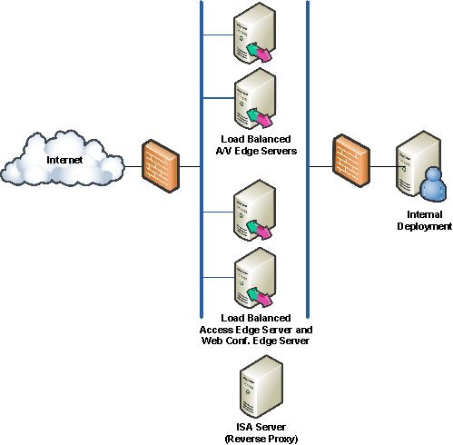

Global Deployments
This section provides two sample global deployment enterprises with geographically dispersed sites that require high availability across multiple sites:
- Global IM and conferencing supporting internal and external users
- Global IM and conferencing supporting internal and external users and Enterprise Voice

Global Conferencing with Multiple Regional Sites
In a global deployment, an enterprise may have one or more data centers in different physical locations. To support IM and conferencing, each of these data centers must host one or more pools for local users and deploy edge servers in its respective perimeter network in order to support external access.
The central corporate data center hosts a pool in the expanded configuration to support a user base of up to 125,000. In the primary perimeter network, an Access Edge Server and Web Conferencing Edge Server are collocated on one computer, and the A/V Edge Server is deployed on a separate dedicated computer. In this topology, a Director is used in the primary data center. The Director is an Office Communications Server 2007 Standard Edition server or Enterprise pool that does not host users but that, as a member of an Active Directory domain, has access to Active Directory for purposes of authenticating remote users and routing traffic to the appropriate server or Enterprise pool. Directors are recommended when you support external user access, but they are not required. You could deploy a similar topology without using a Director.
In the secondary datacenter site, a pool in the consolidated configuration is deployed to support a smaller user base of less than 30,000. In the secondary perimeter network, two local Web Conferencing Edge Server and two A/V Edge Servers are load balanced to provide high availability and to accommodate the heavy network bandwidth utilization of audio/video and Web conferencing traffic. Users in the secondary site still use the Access Edge Server in the primary data center to send SIP traffic to the corporate datacenter servers. The Access Edge Server in the primary data center routes all SIP traffic through the Director, which then routes the traffic to the appropriate pools. For audio/video or Web conferencing, users first send SIP requests through the Access Edge Server to the Director, and then the Director returns the appropriate Web Conferencing Edge Server or A/V Edge Server to which the user connects for Web conferencing or audio/video sessions. To ensure a good user experience for inter-pool scenarios, the pools should be well-connected, with low network latency.
Figure 10 Global Deployment Supporting IM and Conferencing for Internal and External Users
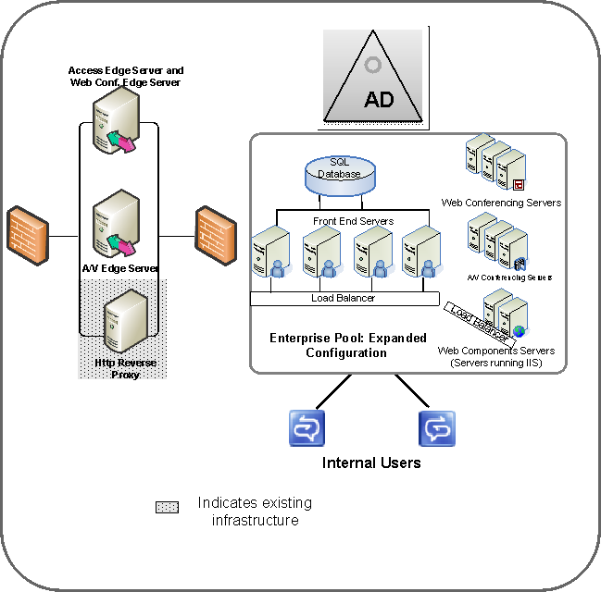
The following figure shows an example of how one or more physical sites may be dispersed.
Figure 11 Example of Dispersed Sites
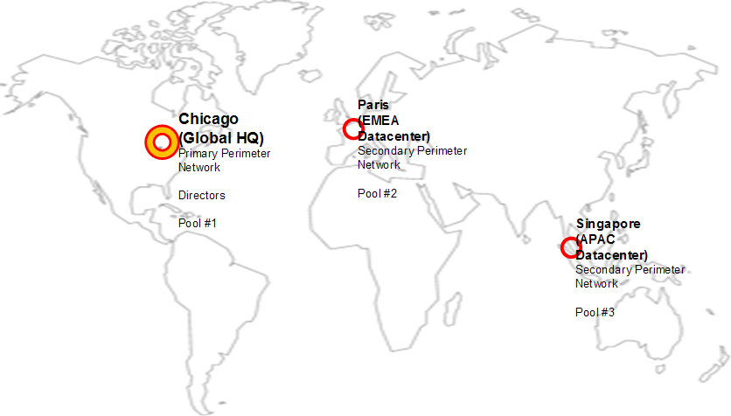

Deployment Profile
The following table summarizes the key characteristics of this topology.
Table 18 Deployment Profile for High Scale, High Availability for Internal and External IM and Conferencing Use
Key Aspect | Description
Deployment scenario | Global, mission critical IM and conferencing usage with global external access. This topology can also form the basis for voice functionality added later
Key goals for deployment | Global availability with external access
Geographic distribution | A central data center and one or more secondary data centers
Functionality | IM presence and conferencing  External user access, including federation, public IM connectivity, anonymous user participation in Web conferencing and external user access to audio and video conferencing or media
Functionality not provided | No PSTN voice  No IM archiving or CDR functionality
Number of Office Communications Server servers | 21 servers (10 roles)
User base | Over 125,000 dispersed geographically
Prerequisites | Active Directory deployed in Windows 2000 native mode in the domain where Standard Edition Server will be deployed  SQL Server 2005 SP1 or SQL Server 2000 SP4 or later available for the back-end database of the pool  PKI infrastructure available  Hardware load balancers for pools and the Director  Hardware load balancer for edge servers in central and regional sites

How to Use the Planning Guide for This Topology
Although you may want to read the entire planning guide for a comprehensive understanding of Office Communications Server planning considerations, you may also choose to focus on the key chapters specific to your deployment.
Read these key chapters
Plan Your Deployment Path
Prepare Your Infrastructure
Review System and Network Requirements
Plan for External User Access
Plan for Deploying Load Balancers
Plan for Address Book Server
Plan for High Availability and Fault Tolerance
Plan for Database Storage
Skip these chapters if you choose
Plan for VoIP
Plan for Compliance and Usage Analysis

Deployment Steps and Relevant Documents for this Topology
If this topology is appropriate for your organization, we recommend you deploy Office Communications Server internally first, in each site, roll out your clients, and then deploy your edge servers in your perimeter network. For your internal deployment, you will need to prepare Active Directory for Office Communications Server, and then deploy the Enterprise pool in the expanded configuration. After you have deployed your Office Communications Server infrastructure, deploy Communicator 2007 and Live Meeting 2007 clients for your end users. In the perimeter networks, before you deploy your edge servers, ensure that you have an available hardware load balancer and a reverse HTTP proxy. This proxy will allow outside users access to meeting content, address book files and distribution group expansion information that is stored internally on the IIS server.
Table 19 Deployment Steps and Where to Get More Information
Required Step | Read this guide for step-by-step instructions
Active Directory Preparation | Microsoft Office Communications Server 2007 Active Directory Guide
Deploy an Enterprise pool in the expanded configuration | Microsoft Office Communications Server 2007 Enterprise Edition Deployment Guide
Deploy Office Communicator clients | Microsoft Office Communicator 2007 Deployment Guide
Deploy Live Meeting 2007 clients | Deploying the Microsoft Office Live Meeting 2007 Client with Office Communications Server 2007
Deploy Edge Server | Microsoft Office Communications Server 2007 Edge Server Deployment Guide

Global Conferencing with Multiple Sites External Access and Voice
A global deployment that supports both external access and voice is basically a variation of the preceding topology, with the addition of existing basic media gateways and advanced media gateways in each voice location. An Office Communications Server 2007 Mediation Server is placed adjacent to each existing basic media gateway to translate between the gateway and Enterprise pools. In the advanced media gateways or the basic hybrid media gateway, the Mediation Server is not required because the logic of the Mediation Server is integrated into the gateway itself You can find a current list of qualified gateways that work with Communications Server at http://r.office.microsoft.com/r/rlidOCS?clid=1033&p1=IPpbxVend. Figure 11 shows a sample deployment.
Figure 12 Global Deployment with External Access and Voice
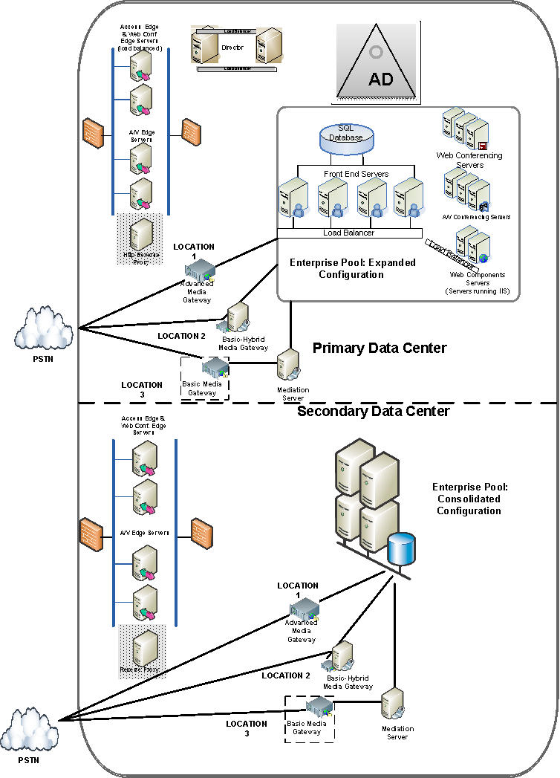
The following figure shows an example of how one or more physical sites may be dispersed.
Figure 13 Example of a Global Deployment
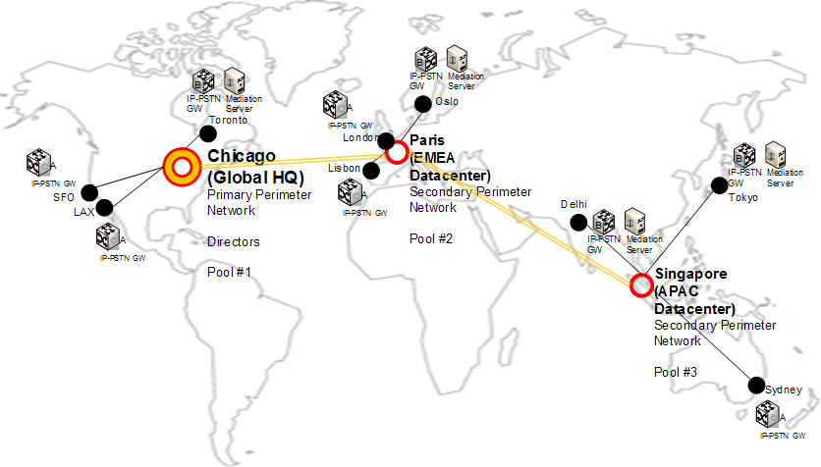

Deployment Profile
The following table summarizes the key characteristics of this topology.
Table 20 Deployment Profile for High Scale, High Availability for Internal and External IM and Conferencing Use
Key Aspect | Description
Deployment scenario | Global, mission critical IM and conferencing usage with global external access. This topology can also form the basis for voice functionality added later
Key goals for deployment | Global availability with external access
Geographic distribution | A central data center and one or more secondary data centers
Functionality | IM presence and conferencing  External user access, including federation, public IM connectivity, anonymous user participation in Web conferencing and external user access to audio and video conferencing or media
Functionality not provided | No PSTN voice  No IM archiving or CDR functionality
Number of Office Communications Server servers | 27 servers (10 roles)
User base | Over 125,000 dispersed geographically
Prerequisites | Active Directory deployed in Windows 2000 native mode in the domain where Standard Edition Server will be deployed  SQL Server 2005 SP1 or SQL Server 2000 SP4 or later available for the back-end database of the pool  PKI infrastructure available  Hardware load balancers for pools and the Director  Hardware load balancer for edge servers in central and regional sites

How to Use the Planning Guide for This Topology
Although you may want to read the entire planning guide for a comprehensive understanding of Office Communications Server planning considerations, you may also choose to focus on the key chapters specific to your deployment.
Read these key chapters
Plan Your Deployment Path
Prepare Your Infrastructure
Review System and Network Requirements
Plan for External User Access
Plan for Deploying Load Balancers
Plan for VoIP
Plan for Address Book Server
Plan for High Availability and Fault Tolerance
Plan for Database Storage
Skip these chapters if you choose
Plan for Compliance and Usage Analysis

Deployment Steps and Relevant Documents for this Topology
If this topology is appropriate for your organization, we recommend you deploy Office Communications Server internally in each site, roll out your clients, and then deploy edge servers in your perimeter network. For your internal deployment, you will need to prepare Active Directory for Office Communications Server, and then deploy Enterprise pool in the expanded configuration. After you have deployed your Office Communications Server infrastructure, deploy Communicator 2007 and Live Meeting 2007 clients for your end users.
Before you deploy your edge servers, in the perimeter network, ensure that you have a hardware load balancer to which you will connect your edge servers and a reverse HTTP proxy. This proxy will allow outside users access to meeting content, address book files and distribution group expansion information that is stored internally on the IIS server.
Table 21 Deployment Steps and Where to Get More Information
Required Step | Read this guide for step-by-step instructions
Active Directory Preparation | Microsoft Office Communications Server 2007 Active Directory Guide
Deploy an Enterprise pool in the expanded configuration | Microsoft Office Communications Server 2007 Enterprise Edition Deployment Guide
Deploy Office Communicator clients | Microsoft Office Communicator 2007 Deployment Guide
Deploy Live Meeting 2007 clients | Deploying the Microsoft Office Live Meeting 2007 Client with Office Communications Server 2007
Deploy Enterprise Voice | Microsoft Office Communications Server 2007 Enterprise Voice Planning and Deployment Guide
Deploy Edge Server | Microsoft Office Communications Server 2007 Edge Server Deployment Guide

Step 3. Plan Your Deployment Path
This chapter explains how to plan your deployment path. It contains the following sections:
- Things you must know before deploying
- Overview of the deployment process
- Permissions required for deployment

Things You Must Know Before You Deploy
Before you begin implementing your chosen topology, there are some important things you must know about the Office Communications Server 2007 requirements and specific topologies:

Infrastructure Considerations
A PKI infrastructure is required for Office Communications Server 2007. If you do not have an internal PKI infrastructure, you can use a public CA as well.
All domains in which you deploy Office Communications Server are using Microsoft Windows® 2000 native mode. You cannot deploy Office Communications Server in a mixed mode domain. Microsoft Windows Server® 2003 native mode is strongly recommended.
You must use a certificate issued by a public CA for federation and public IM connectivity. (Public IM connectivity requires an additional license). For the MSN® network of Internet services and Yahoo!®, a Web server certificate is required. For AOL®, the certificate must also be configured for client authentication.

Important: Voice Considerations

Power, Network, or Telephone Service Outages
If there is an outage, disruption, or other degradation of the power, network, or telephone services at your location, the voice, instant messaging, presence, and other features of Office Communications Server 2007 and any device connected to Office Communications Server 2007 may not work properly.

Enterprise Voice Depends on Server Availability and Voice Client and Hardware Operability
Voice communications via Office Communications Server 2007 depend upon the availability of the server software and the proper functioning of the voice clients or the hardware phone devices connecting to the server software.

Alternative Means of Accessing Emergency Services
For those locations where you install a voice client (for example, a PC running Office Communicator 2007 or an Office Communicator Phone Edition device), we recommend that you maintain a backup option for users to call emergency services (for example, 911 and 999) in case of a power failure, network connectivity degradation, telephone service outage, or other problem that may inhibit operation of Office Communications Server 2007, Office Communicator 2007, or the Phone Edition devices. Such alternative options could include a telephone connected to a standard PSTN line or a cell phone.

Emergency Calls and Multi-Line Telephone Systems
The use of a multi-line telephone system (MLTS) may be subject to U.S. (state and/or federal) and foreign MLTS laws that require the MLTS to provide a caller’s telephone number, extension, and/or physical location to applicable emergency services when a caller makes a call to emergency services (for example, when dialing an emergency access number such as 911 or 999). Neither Office Communications Server 2007, Office Communicator 2007, nor Office Communicator Phone Edition Devices provide the caller’s physical location to emergency services when a caller dials emergency services. Compliance with such MLTS laws is the sole responsibility of the purchaser of Office Communications Server 2007, Office Communicator 2007, and Office Communicator Phone Edition devices.

Web Conferencing Considerations
As a best practice, you should also periodically run disk defragmentation on the disk drives where the meeting content is hosted.
Running real-time anti-virus scanning on the shares that store meeting content, meeting content meta data, and meeting compliance data is not recommended. Doing so can adversely affect performance for Web Conferencing. We recommend scanning for virus only when the server has little or no load and that you run anti-virus protection enabled on client computers at all times.

Edge Server Considerations
You cannot load balance multiple edge servers in the consolidated topology. The only supported load balanced topology for a central site involves one or more dedicated computers with collocated Access Edge Servers with Web Conferencing Edge Servers and one or more dedicated computers with A/V Edge Conferencing Servers. Thus, if you deploy the consolidated edge topology initially and then want to scale, you will have to deploy an entirely new edge topology.
An external DNS SRV record must exist for your Access Edge Server or array of edge servers in order to support public IM connectivity and federation. For more information, see Step 6. Plan for External User Access.
Only one Access Edge Server or an array of Access Edge Servers can be used in an organization for public IM connectivity and federation. In other words, an Access Edge Server or an array of Access Edge Servers can only be in one physical data center (multiple data centers or remote sites cannot deploy Access Edge Servers).
A reverse HTTP proxy is to allow remote users to download address book files, and expand distribution lists and to allow external users access to meeting content for Web conferences.
The network interfaces of the AV Edge Server must be directly addressable at the IP layer and not behind a NAT.
For Web and IM conferences involving federated participants, Office Communications Server edge servers verify that the connecting server has the appropriate certificates and is configured for federation. However, the Office Communications Server edge servers in your organization rely on the federated peer server to send the legitimate SIP URI of the participant and hence cannot guarantee the identity of the external conference participants in a federated Web or IM conference. To distinguish external users, Office Communicator 2007 provides a visual indication for users from a federated domain in the conference roster. Additionally, the title bar of the conversation window contains a globe icon to indicate that external participants are included. When clients connect to a Web conference or an A/V conference hosted by a federated domain, the clients treat the roster and all conferencing information coming from the federated domain as trusted information.
You should only have one inbound MTLS listener configured on your Director. This is the default configuration, which is recommended. If you have more than one listener configured on your Director, all other listeners besides the default connection (MTLS on port 5061) must be configured to use TLS or TCP. Having more than one MTLS listener can result in problems communicating with external users and attending external conferences. If you have a requirement for more than one MTLS listener, verify that the port numbers corresponding to each MTLS listener are open on the internal firewall for communication between the Access Edge Server and Director. This configuration applies to your Front End Servers if you do not have a Director deployed for external access.

General Office Communications Server Considerations
Standard Edition server requires enough local disk space for meeting content. Particularly if you leverage multimedia functionality of Live Meeting client, the size required for meeting content can grow large.
Installing any Office Communications Server 2007 role on a global catalog controller or any other domain controller is not supported.
Office Communications Server should not be installed in a domain in which the last part of the FQDN begins with a numeral. For example, xxx.yyy.4zz and aaa.bbb.1ab are both invalid names, whereas 4xx.yyy.zzz and aaa.bbb.ab1 are both valid domain names.
You should use only standard characters (including A-Z, a-z, 0-9 and hyphens) when assigning FQDNs of your Office Communications Server servers, edge servers, pools and arrays. Do not use Unicode characters or underscores. Non-standard characters in an FQDN are often not supported by external DNS and public CAs (when the FQDN must be assigned to the SN in the certificate).
For both Standard Edition Server and an Enterprise pool, you should always place the transaction log files and the database files on separate physical disks that are distinct from any system disks, such as the page file disk . We do not recommend placing these files on system disks, for instance the page file disk.
All Office Communications Server servers rely on service accounts. If the passwords to these service accounts expire, the servers cannot operate. Ensure you have a policy in place for updating service account passwords before they expire.
Multi-homed network adapters or multiple network adapters configured with more than one default gateway are not supported on individual Office Communications Server servers with the exception of edge servers.
The service account used by the Web Conferencing Edge Servers to allow anonymous access to on premise conference meetings is set in the IIS metabase. When it expires, no event logs are written by Office Communications Server. You can use the IIS metabase to learn what service account is being used and Active Directory to learn the password age of the service account. You may also find the following ALofInfo.exe tool useful: http://r.office.microsoft.com/r/rlidOCS?clid=1033&p1=LckOutTool.

Client Considerations
If you deploy Office Communications Server and Communicator 2007, and configure users for enhanced presence, when a user logs into Office Communications Server using Communicator 2007, this account can no longer use previous versions of Communicator or Communicator Web Access (2005 release) or Communicator Mobile (2005 release). We recommend that you upgrade all client computers for a particular user at the same time. Additionally, Communicator 2007 clients cannot sign in to Live Communications Server 2005. Verify that any user whose client is upgraded to Communicator 2007 is already provisioned on an Office Communications Server.

User Considerations
Communications Server and Office Communicator do not support escaped characters in URIs. You should make sure that all SIP URIs conform to standard SIP grammar and contain no escaped characters.

Overview of the Deployment Process
The following flow chart depicts the high-level deployment tasks that are involved in deploying an Office Communications Server 2007 topology and summarizes some of the key decision points that were outlined previously. As depicted, deploying Office Communications Server 2007 in an organization that does not already have Live Communications Server 2005 with SP1deployed involves deploying your internal Office Communications Server 2007 topology. Once your internal deployment is complete, you can then deploy edge servers for external user access.
Figure 14 Deployment Process
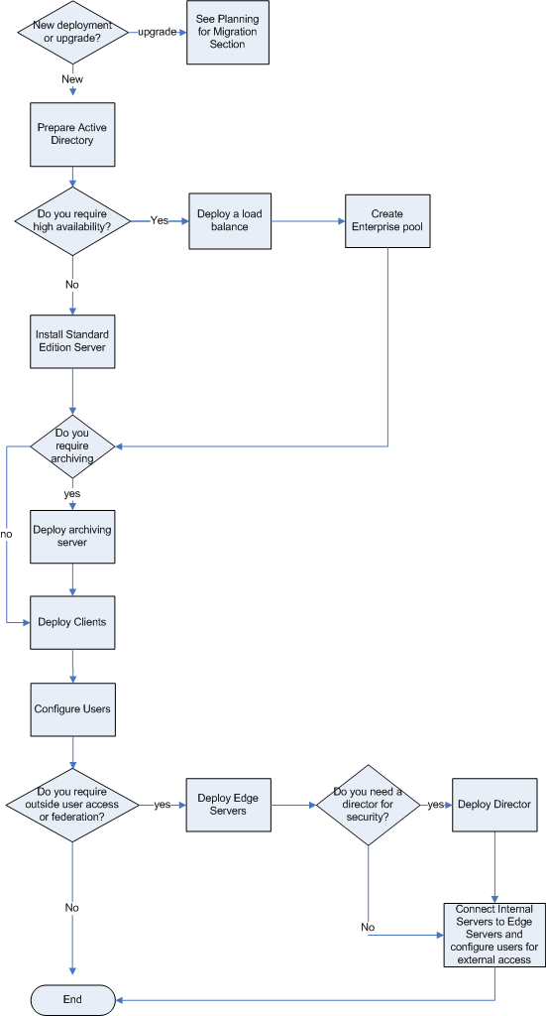

General Preparation
Before you start the Office Communications Server 2007 Deployment Tool, you must do the following:
- Determine your storage requirements and create file shares to store the following:
- Meeting presentations to be downloaded or streamed by meeting attendees.
- Information (metadata) used internally by the pool’s Web Conferencing Server.
- Information used by Address Book Server.
- Meeting content logged for compliance requirements.
Note
For detailed information on planning your storage solution, see Step, 11 Plan for Database Storage.
- Make sure the following are installed:
- The Microsoft Windows Server 2003 SP1 or R2 or later operating system for Office Communications Server; the Microsoft Windows 2000 operating system SP4 or higher for Active Directory Domain Services.
- Active Directory in Windows 2000 Server or higher native mode in all domains where you plan to deploy Office Communications Server 2007 servers or users. Windows Server 2003 native mode is recommended.
- For Enterprise Edition, Microsoft SQL Server 2005 with Service Pack 2 (recommended) or SQL Server 2005 SP1, SQL Server 2000 with Service Pack 4 on the computer where you plan to deploy the Back-End Database.
- DNS (Domain Name Service).
- An Enterprise (recommended), Standalone, or public Certificate Authority.
- IIS (Internet Information Services) 6.0 on each computer where you intend to install Standard Edition, or Enterprise Edition Front End Server. Or, if you are deploying Enterprise Edition, Expanded Configuration, on computers that are to serve as your Web farm.
- Active Server Pages components of IIS 6.0 on each computer where you install the Web Components Server. For Standard Edition, this means the computer running Standard Edition Server. For Enterprise Edition, Consolidated Configuration, this means all Front End Servers. For Expanded Configuration, it means all dedicated IIS servers.
- Review the infrastructure requirements in the following chapter, Step 4. Prepare Your Infrastructure.

Preparing Active Directory
When you start the Office Communications Server 2007 Deployment Tool to deploy an Enterprise pool or Standard Edition Server, the first three steps that you encounter prepare your Active Directory infrastructure for Office Communications Server. These steps are Schema Prep, Forest Prep, and Domain Prep. Before you perform these steps, you’ll want to review the Step 4, Prepare Your Infrastructure chapter and read the Microsoft Office Communications Server 2007 Active Directory Guide.
- Schema Prep extends the Active Directory schema to include Office Communications Server 2007 classes and attributes.
- Forest Prep creates Office Communications Server 2007 objects in the forest root domain. Access to the root domain is required for activation of server roles and for servers to function properly if you use the default option and store your global objects in the system container of the root domain. If you have a distributed topology or some other configuration in which access to the forest domain is not always assured, you have the option of selecting Configuration partition during forest prep. Configuration partition is available from every domain.
- Domain Prep adds the necessary ACEs to universal groups that grant permissions to host and manage users within the domain.

Configuring DNS
After you prepare your Active Directory infrastructure for Office Communications Server, you must create the DNS A records and SRV records that make it possible for clients to locate and connect to your Office Communications Server 2007 Standard Edition Server or Enterprise Edition Pool. Additionally, if you plan to support external user access, then the see Step 4, Prepare Your Infrastructure and Step 6. Plan for External Access for more details on DNS.

Installing Office Communications Server 2007
The process of installing Office Communications Server 2007 varies depending on the edition, configuration, and server roles you are installing. The Microsoft Office Communications Server 2007 Standard Edition Deployment Guide and the Microsoft Office Communications Server 2007 Enterprise Edition Deployment Guide provide step-by-step instructions on the setup tasks involved in deploying a Standard Edition Server or Enterprise pool, respectively.
- Standard Edition. The Deploy Server Wizard prompts you for the location where the files are to be installed and for the name of the service accounts to be used on the server.
- Enterprise Edition. The Deployment Tool prompts you for configuration type (Consolidated or Expanded). The Create Enterprise Pool Wizard prompts you for pool name, the domain in which it resides, and the names of various servers and services that it will require. The wizard then copies the appropriate files.

Configuring Server or Pool
After installing the necessary files, you are prompted to configure the newly installed server or pool. The Configure Pool/Server Wizard prompts you for the SIP domains that will access the server or pool, whether you want to support automatic client logon and, if you have deployed edge servers, the information necessary to connect them to the server or pool.

Configuring Certificates
After a server or pool is configured, you must configure certificates on each Standard Edition or Enterprise Edition server. The Certificate Wizard will create and configure a Web certificate with an enhanced usage key for server authentication on your Standard Edition Server. IIS certificates must still be configured manually (for Web Components Server).

Validating Server or Pool Configuration
After configuring certificates, the next step is to verify that the Active Directory changes have been replicated, after which you can start the services to validate that your server or pool configuration operates correctly.

Adding Front End Servers
The best time to add Front End Servers to a pool is after your pool configuration has been validated. An Enterprise pool can consist of a single Front End Server, but the typical deployment will have two or more configured behind a hardware load balancer. You use the Deployment Tool to install additional Front End Servers.

Installing Additional Components
If you are deploying Enterprise Edition, Expanded Configuration, you must install the Web Conferencing Server and A/V Conferencing Server on separate computers from those hosting the Front End Servers. You must also install IIS on the computers that you have deployed as a Web Components Servers.
If you are deploying Consolidated Configuration, the conferencing servers and Web components are installed automatically on computers hosting the Front End Servers. IIS should be pre-installed on the computers that are to act as Front End Servers.

Creating User Accounts and Enabling Users
After installing and configuring servers and pools, the next step is to create user accounts and enable those users for Office Communications Server.

Deploying Office Communications Server 2007 Clients
Office Communications Server 2007 requires deploying three separate clients:
- Office Communicator 2007 for IM and multimode communications.
- Meeting Console for Web conferencing.
- Microsoft Outlook® Add-in for scheduling.
Client applications are provided as standard Windows Installer files (.msi), which you can make available to users from standard download sites.

Installing and Configuring Edge Servers
Edge servers are necessary to support IM, audio/video features, and conferencing for external users.

Deploying Enterprise Voice
Enterprise Voice provides software-powered VoIP telephony for enterprise users. After your internal and edge infrastructure is in place, installing media gateways and configuring your infrastructure for VoIP routing completes your Office Communications Server 2007 deployment.

Permissions Required for Deployment
The following table outlines the permissions required to deploy the various server roles.
Note
By default, membership in the Domain Admins group is required to deploy or activate a server that is joined to an Active Directory domain. If you do not want to grant this level of privilege to the group or people deploying Office Communications Server, you can use the setup delegation wizard to provide a specific group the subset of permissions required for this task.
Table 22 Administrative credentials required Deployment Tasks
Procedure | Administrative credentials or roles required
Standard Edition
Deploy Server | Domain Admins and RTCUniversalServerAdmins
Configure Server | RTCUniversalServerAdmins
Configure Certificates | Local Administrator
Start Services | RTCUniversalServerAdmins
Validate Server Functionality | RTCUniversalServerAdmins
Enterprise Edition
Create Pool | Domain Admins, RTCUniversalServerAdmins and Local Administrator on the back-end
Configure Pool | RTCUniversalServerAdmins
Add Server (consolidated configuration) | Domain Admins and RTCUniversalServerAdmins
Add Front-End Server (expanded configuration) | Local Administrator
Activate Front-End Server  (expanded configuration) | Domain Admins and RTCUniversalServerAdmins (or Domain Admins only if activating in the forest root domain)
Add Web Components  (expanded configuration) | Local Administrator
Activate Web Components  (expanded configuration) | Domain Admins and RTCUniversalServerAdmins (or Domain Admins only if activating in the forest root domain)
Add Web Conferencing Server  (expanded configuration) | Local Administrator
Activate Web Conferencing Server (expanded configuration) | Domain Admins and RTCUniversalServerAdmins (or Domain Admins only if activating in the forest root domain)
Add A/V Conferencing Server (expanded configuration) | Local Administrator
Activate A/V Conferencing Server (expanded configuration) | Domain Admins and RTCUniversalServerAdmins (or Domain Admins only if activating in the forest root domain)
Configure Certificates | Local Administrator
Start Services | RTCUniversalServerAdmins
Validate Pool Configuration | RTCUniversalServerAdmins
Archiving and CDR Server
Install Archiving | Local Administrator
Activate Archiving | Domain Admins and RTCUniversalServerAdmins
Edge Servers
Install Edge Server | RTC Local Administrator
Activate Edge Servers | RTC Local Administrator
Configure Edge Servers | RTC Local Administrator
Configure Certificates | RTC Local Administrator

Step 4. Prepare Your Infrastructure
Before you start the Office Communications Server 2007 Deployment Tool, you must verify the following:
- Active Directory is deployed with the necessary prerequisites and in a supported topology.
- A certificate infrastructure is in place or available for server-to-server communications and for client-to-server communications.
- You are aware of all the DNS records that your Office Communications Server deployment will require to enable servers and pools to communicate with one another, and clients to automatically locate their server or pool.
- You have elected to enable automatic client sign-in and understand the requirements for this option.
- You understand the port requirements for your Office Communications Server topology.

Active Directory Domain Services
Office Communications Server relies on Active Directory Domain Services to store global settings and groups necessary for the deployment and management of Office Communications Server.

Active Directory Prerequisites
Before you prepare Active Directory for Office Communications Server 2007, ensure that your Active Directory infrastructure meets the following prerequisites.
- Domain controllers are running Microsoft Windows 2000 Server, SP4 (Service Pack 4) or Microsoft Windows Server 2003 SP1 or Windows Server 2003 R2 operating systems.
- Global catalog servers are running Windows 2000 Server SP4, Windows Server 2003 SP1 or Windows Server 2003 R2.
- .All domains in which you deploy Office Communications Server are using Windows 2000 native mode or higher. You cannot deploy Office Communications Server in a mixed mode domain. For more information about raising your domain functional level to Windows 2000 native mode or higher, go to http://r.office.microsoft.com/r/rlidOCS?clid=1033&p1=revdomain.

- Global catalogs are recommended in each Office Communications Server domain to optimize performance of Communications Servers and to ensure inter-domain IM, presence and conferencing scenarios operate properly.
- Office Communications Server 2007 supports Active Directory and Windows 2000 Server 2000 and Windows Server 2003 validation rules for domain name components, which mostly aligns with DNS naming rules. All Active Directory recommendations also apply. There are certain cases where deviations from DNS RFC naming is allowed by Active Directory and Windows DNS Servers, as long as they are appropriately configured. Active Directory team recommends against this, since they may lead to various potential DNS problems including incompatibility with non-Windows DNS servers. The specific cases for this scenario include underscores and/or at least one extended or Unicode character, in the domain name component.
- You must run Active Directory preparation steps on a computer running Windows Server 2003 SP1 or later, Windows Server 2003 R2 or later. You cannot run Active Directory preparation from a Windows 2000 Server and earlier versions or any client versions of the Windows operating system.

Supported Active Directory Topologies
Office Communications Server 2007 supports the same server topologies as Live Communications Server 2005 with SP1 with the additional of support for disjoint DNS namespaces. This section presents a high-level view of each of these supported topologies.
Active Directory can exist in the following structures:
- Single forest
- Multiple forests
Enterprises can deploy a single forest for their entire infrastructure, or can deploy a separate forest for each business unit. A multiple-forest deployment allows each unit to maintain network administrative autonomy.

Single Forest Topologies
Office Communications Server 2007 supports three types of single forest topologies:
- Single domain
- Single tree with multiple domains
- Multiple trees with disjoint namespaces
Single Domain The most basic topology that is supported by Office Communications Server 2007 features a single domain in a single Active Directory tree. This topology is common among smaller organizations and is shown in the following figure.
Figure 15 Single-forest topology
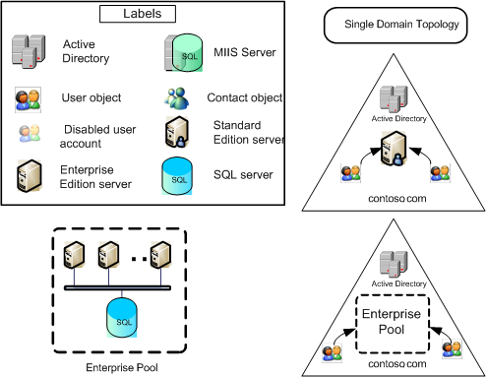

Single Forest with Multiple Domains A more complex Active Directory structure is the single forest consisting of a root domain and one or more child domains. You can deploy servers in different domains from the domain where you create users. An Enterprise pool must be deployed across a single domain. Office Communications Server 2007 support for Windows Universal administrator groups enables cross-domain administration.
Figure 16 A single Forest with multiple domains
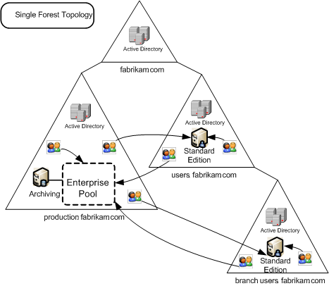

Single Forest with Multiple Trees Another complex Active Directory structure is the single forest with multiple trees and disjoint DNS namespaces. This configuration consists of a root domain and one or more child domains. You can deploy servers in different domains from the domain where you create users.
Figure 17 Single Forest with multiple trees
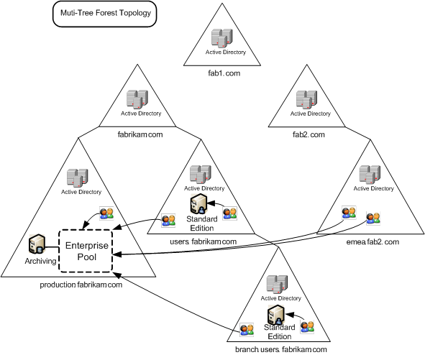

Multiple Forest Topologies
Larger organizations that have multiple business units may prefer to deploy a separate Active Directory forest for each unit, thereby providing autonomy for with respect to schemas and security. Each business unit can extend its schema without affecting other business units, and administrators in one business unit cannot be administrators in another business unit.
Office Communications Server supports two distinct multiple-forest topologies, resource forest topologies and central forest topologies.
Resource Forest The resource forest topology is used by Microsoft Exchange Server. This topology dictates that one of the forests in the organization is dedicated for server applications only (for example, Microsoft Exchange Server). Users from other forests are represented as disabled user accounts in the resource forest. These disabled user accounts are then enabled for a mailbox on the Exchange Servers. Office Communications Server 2007 takes advantage of the investment in this particular topology. In the same way that disabled user accounts in the resource forest are enabled for Exchange Server, they can also be enabled for Office Communications Server. This provides the benefit of only extending the Active Directory schema in a single forest (the resource forest) and leveraging the existing Active Directory.
Figure 18 A resource forest topology
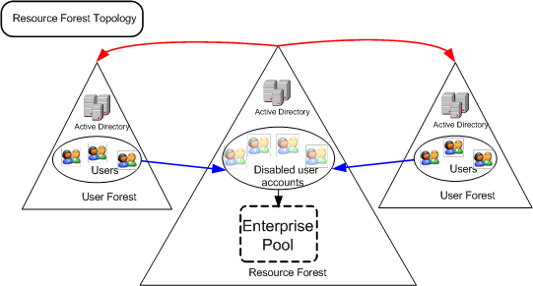
Central Forest The central forest topology is a variation of the resource forest. Instead of using disabled user accounts to represent users from other forests, Active Directory Contact objects represent users in forests other than the central forest. MIIS (Microsoft Identity Integration Server) is required to synchronize users as Contact and Group objects in the central forest. The use of MIIS automates the lifecycle management of users within the organization when new employees are hired or other employees leave the company. Additionally, the use of Active Directory Contact and Group objects is more lightweight than Active Directory User objects. Finally, users within the central forest are not restricted from being enabled for Office Communications Server 2007.
Figure 19 Central forest topology
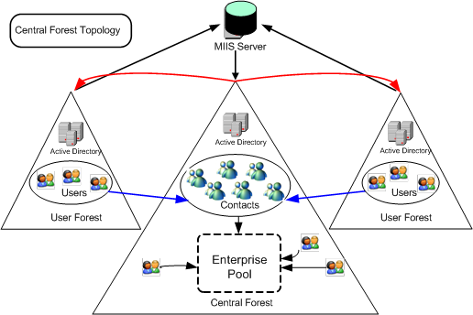

Certificate Infrastructure
Office Communications Server 2007 now requires a public key infrastructure to support TLS and MTLS connections. Office Communications Server uses certificates for the following purposes:
- TLS connections between client and server
- MTLS connections between servers
- Federation using automatic DNS discovery of partners
- Remote user access for instant messaging
- External user access to A/V sessions and Web conferencing
For Office Communications Server 2007, the following common requirements apply:
- All server certificates must support server authorization (Server EKU).
- All server certificates must contain a CRL Distribution Point (CDP).
- Auto-enrollment is supported for internal Office Communications Server servers, including an array of Standard Edition Servers configured as Director.
- Auto-enrollment is not supported for Office Communications Server edge servers.

Certificate Requirements for Internal Servers
Internal Communications Servers include Standard Edition Server, Enterprise Edition Front End Server, Web Conferencing Server, A/V Conferencing Server, Director, and Web components. The following table shows high-level certificate requirements for internal Office Communications Server servers. For edge servers certificate requirements, see Certificate Requirements for Edge Servers. Although an internal Enterprise CA is recommended for internal servers, you may also use a public CA. For a list of public certificate authorities that provide certificates that comply with specific requirements for Unified Communications certificates and have partnered with Microsoft to ensure they work with the Office Communications Server Certificate Wizard, see the Microsoft Web site at http://r.office.microsoft.com/r/rlidOCS?clid=1033&p1=SupportedCAs.
Table 23 Certificate requirements by server role
Topology | Server Role | Recommended CA | Subject Name/  Common Name | SAN | Comments
Standard Edition server | All server roles (which are collocated) | Enterprise CA. | FQDN of the Standard Edition Server | If you have multiple SIP domains and have enabled automatic client configuration, the certificate wizard detects and adds each supported SIP domain FQDNs. (The wizard detects any SIP domains you specified during setup and automatically adds them to the SAN) | Additionally, you must use the IIS administrative snap-in to assign the certificate used by the Web Component Server
Enterprise pool: consolidated | All server roles. Certificate configured on each Enterprise Edition Server | Enterprise CA. | FQDN of the pool  For the Web Components Server role, the certificate must have the URL of the internal Web farm in the SN or SAN. | If you have multiple SIP domains and have enabled automatic client configuration, the wizard detects the SIP domains, adds them to the SAN, and then adds each supported SIP domain FQDN.  (The wizard detects any SIP domains you specified during setup and automatically adds them to the SAN)  For the Web Components Server role, the certificate must have the URL of the internal Web farm in the SAN (if the FQDN is different from the pool FQDN). | Certificate must be installed on each server in the pool.  Additionally, you must use the IIS administrative snap-in to assign the certificate used by the Web Component Server.
Enterprise pool: expanded | Front End | Enterprise CA | FQDN of the pool | If you have multiple SIP domains and have enabled automatic client configuration, add each supported SIP domain FQDN.  (The wizard detects any SIP domains you specified during setup and automatically adds them to the SAN) | Certificate must be installed on each server in the pool
Enterprise pool: expanded | Web Conferencing | Enterprise CA | FQDN of the pool |  | Certificate must be installed on each server in the pool
Enterprise pool: expanded | A/V Conferencing | Enterprise CA | FQDN of the pool |  | Certificate must be installed on each server in the pool
Enterprise pool: expanded | Web Components | Enterprise CA | FQDN of the VIP (virtual IP) of the load balancer used by the Web Components Server | SAN must contain the URL of the internal Web farm in the SAN (if the FQDN is different from the pool FQDN) | A certificate has to be configured in IIS on the all servers that are running the Web Component Services
Director,  Standard Edition | Director | Enterprise CA | FQDN of Standard Edition Server | If you have multiple SIP domains and have enabled automatic client configuration and all clients use this Director for logon, add each supported SIP domain FQDN.  (The wizard detects any SIP domains you specified during setup and automatically adds them to the SAN)
Director,  Enterprise pool | Director | Enterprise CA | FQDN of the pool | If you have multiple SIP domains and have enabled automatic client configuration and all clients use this Director for logon, add each supported SIP domain FQDN. | .
Array of Standard Edition Directors | Director | Enterprise CA. | FQDN of the Director Server | FQDN of Director Server and the FQDN of the virtual IP (VIP) used by the array  If you have multiple SIP domains and have enabled automatic client configuration and all clients use this Director for logon, add each supported SIP domain FQDNs. | FQDN of the server is in the SUBJECT field  FQDN of the Director VIP and the FQDN of the server must be in the SUBJECT_ALT_NAME as DNS values

Certificate Requirements for Edge Servers
The following sections summarize the certificate requirements for edge servers on the internal and external interfaces of these servers. For topology specific requirements, refer to Plan for External User Access section of this document.

Internal Interface
The following summarizes the certificate requirements for the internal interface of your edge servers.
- Each edge server in the perimeter network of the data center requires a certificate for the internal interface:
- If you are deploying a load balancer with multiple collocated Access Edge Servers and Web Conferencing Edge Servers, use a single certificate with a subject name that matches the FQDN for the virtual IP address used by the Access Edge Servers on the internal load balancer of the servers, for example, Certificate SN = accessedge_array.contoso.com
- For Web Conferencing Edge Servers (collocated on the computer with the Access Edge Server), by default, this certificate is shared by the Web Conferencing Edge Server. If an A/V Edge Server is also collocated on the server, it also shares this certificate by default. If the servers are not collocated, you must use separate certificates for each server role.
- The A/V Edge Server in the perimeter network requires a certificate for the internal interface if it is running on a separate computer than the Access Edge Server. If you are deploying multiple A/V Edge Servers (with a load balancer), use a single certificate with a subject name that matches the FQDN for the virtual IP address used by the A/V Edge Server on the internal load balancer, for example: Certificate SN = avedge_array.contoso.com.
- The Web Conferencing Edge Server in each remote site of a multiple-site edge topology requires a certificate on the internal interface with a subject name that matches the FQDN published on the internal interface of the firewall in the data center, and mapping to the Web Conferencing Edge Server in the remote site.

External Interface
The certificate requirements for the external interface include the following:
- For each unique IP address on the external interface that you use for the Access Edge Server and Web Conferencing Edge Server, you will need a separate certificate. We recommend that you use a separate external IP addresses for each server role, even if all servers are collocated. An external certificate is not required on the A/V Edge Server. A separate A/V authentication certificate is required for the A/V Edge Server, but this certificate is not interface dependent.
- For the scaled single site edge topology, we recommend that each server role use a separate VIP address on the external load balancer. A separate certificate matching the FQDN of each VIP address used by each Access Edge and Web Conferencing Edge server role must be installed on that server. For example, the Web Conferencing Edge Servers must have a certificate that matches the VIP (virtual IP) address used by the Web Conferencing Edge Servers on the external load balancer. The certificate must be marked as exportable on the first physical computer where you configure the certificate and then imported into each additional computer in the array. An external certificate is not required for the A/V Edge Server array on the external interface. A single, identical A/V authentication certificate is required for each A/V Edge Server in a load balanced array, but this certificate is not interface dependent.
- If you are deploying a multiple-site topology, the Web Conferencing Edge Server in the perimeter network of each remote site requires a certificate with a subject name that matches the external FQDN of the Web Conferencing Edge Server in the remote site. A certificate is not required for the external interface of the A/V Edge Server.
- If you are supporting public IM connectivity with AOL, AOL requires a certificate that is configured for both client and server authentication. For Yahoo! and MSN, a Web Server certificate will suffice. Public CAs that have partnered with Microsoft to comply with Office Communications Server 2007 will have client authentication configured for their Office Communications Server certificates. See http://r.office.microsoft.com/r/rlidOCS?clid=1033&p1=SupportedCAs to locate these CAs.
Public certificates are required for public IM connectivity, and they are highly recommended for federation. The public certificate installed on the server must be from a public CA that is on the default list of trusted root CAs installed on the client. For a list of public certificate authorities that provide certificates that comply with specific requirements for Unified Communications certificates and have partnered with Microsoft to ensure they work with the Office Communications Server Certificate Wizard, see the Microsoft Web site at http://r.office.microsoft.com/r/rlidOCS?clid=1033&p1=SupportedCAs.
Note
Although not recommended, it is possible to use your Enterprise subordinate CA for federation if your federated partners agree to trust the CA.
For a detailed description of supported edge server topologies and server roles, see Plan for External User Access.

A/V Authentication Certificate
For the A/V Edge Server, an additional certificate is required for audio/video authentication. The private key of the A/V authentication certificate is used to generate authentication credentials. As a security precaution, you should not use the same certificate for A/V authentication that you use for the internal interface of the A/V Edge Server (covered earlier in this guide). We recommend that you issue this certificate from an internal CA, but you can also use a certificate from a public CA.
The same A/V authentication certificate must be installed on each A/V Edge Server if multiple servers are deployed in a load balanced array. This means that the certificate must be from the same issuer and use the same private key. Refer to the Plan for External User Access section later in this guide and the Microsoft Office Communications Server 2007 Edge Server Deployment Guide for more information.

DNS (Domain Name Service)
Office Communications Server 2007 uses DNS in the following ways:
- To discover internal servers or pools for server-to-server communications.
- To allow clients to discover the Enterprise pool or Standard Edition Server used for various SIP transactions.
- To allow external servers and clients to connect to edge servers or the HTTP reverse proxy for instant messaging or conferencing.

DNS Records for Standard Edition Servers and Enterprise Pools
The following table specifies DNS requirements for various Office Communications Server 2007 Standard Edition and Enterprise Edition deployment scenarios:
Table 24 DNS Requirements
Deployment Scenario | DNS Requirement
Standard Edition server | An internal A record that resolves the FQDN of the server to its IP address.
Enterprise Edition pool with multiple Front End servers and a required load balancer | An internal A record that resolves the FQDN of your Enterprise pool to the VIP address of the load balancer.
Enterprise Edition pool with a single Front End server and a dedicated Back-End Database but no load balancer. | An internal A record that resolves the FQDN of the Enterprise pool to the IP address of the single Enterprise Edition server.
An internal URL for Web conferencing that is different from the default pool FQDN. | An internal A record that resolves the host name portion of the URL to the VIP of the Web conferencing load balancer (or single Front End server if appropriate).
Automatic client logon. | For each supported SIP domain, an SRV record for _sipinternaltls._tcp.<domain> over port 5061 that the FQDN of the Standard Edition Server or Enterprise pool that authenticates and redirects client requests for sign-in.
A reverse proxy to support Web conferencing for external users. | An external A record that resolves the external Web farm FQDN to the external IP address of the reverse proxy. The client uses this record to connect to the reverse proxy.

DNS Records for Edge Servers
DNS requirements for edge servers are more complicated than for internal servers because:
- There are three types of edge servers, each with a different function and requirements.
- All edge servers have two interfaces: an external (or public) interface and an internal (or private) interface. Each interface has its own separate DNS requirements.
- Edge servers may serve multiple SIP domains, each requiring a separate DNS record.
- DNS requirements also vary according to the edge server topology that is deployed.
When you collocate multiple edge server roles on a single computer, you should use a separate external IP address for each role. Specific DNS settings must be configured on each external and internal interface of each edge server. In general, this includes configuring DNS records to point to appropriate servers in the internal network and configuring DNS records as appropriate for each edge server.
Note
To prevent DNS SRV spoofing and ensure that certificates provide valid ties from the user URI to real credentials, Office Communications Server 2007 requires that the FQDN returned from DNS SRV query match the server name on the certificate. The subject name (SN) must point to sip.<domain>.
The actual DNS records that may be required depend on which edge servers you deploy and on your deployment topology, as covered in this section. The following tables provide details about each DNS record required for each topology.
The following table describes the DNS records that must be configured for the external interface and the internal interface of the edge servers in the consolidated edge topology. For a detailed description of supported edge server topologies, see Plan for External User Access.
Note
The port numbers referenced in the following tables and later in this document are typically the default ports. If you use different port settings, you will need to modify the procedures in this guide accordingly.
Table 25 DNS records for the consolidated edge topology
Internal/External Record | Server | DNS Settings
External | Collocated Access Edge Server, Web Conferencing Edge Server, and A/V Edge Server | An external SRV record for all Access Edge Servers for _sipfederationtls._tcp.<domain>, over port 5061 (where <domain> is the name of the SIP domain of your organization). This SRV should point to an A record with the external FQDN of the Access Edge Server. If you have multiple SIP domains, you need a DNS SRV record for each domain. This SRV record supports federation and public IM connectivity.  A DNS SRV (service location) record for _sip._tls.<domain>, over port 443 where <domain> is the name of your organization’s SIP domain. This SRV record must point to the A record of the Access Edge Server. If you have multiple SIP domains, you need a DNS SRV record for each domain. This SRV record supports external user access through Office Communicator and the Live Meeting client.  Note: Configuring multiple SRV records for the same SIP domain is not supported. If multiple DNS records are returned to a DNS SRV query, the Access Edge Server will always pick the DNS SRV record with the lowest numerical priority and highest numerical weight.  For each supported SIP domain in your organization, an external A record for sip.<domain> that resolves to the external IP address of the Access Edge Server for each SIP domain. If a client cannot perform an SRV record lookup to connect to the Access Edge server it will use this A record as a fallback.  An external DNS A record that resolves to the external name of the Web Conferencing Edge Server to the external IP address of the Web Conferencing Edge Server.  An external DNS A record that resolves the external FQDN of the A/V Edge Server to the external IP address of the A/V Edge Server. This IP address must be a publicly routable IP address.
External | Reverse proxy | An external DNS A record that resolves the external Web farm FQDN to the external IP address of the reverse proxy. The client uses this record to connect to the reverse proxy.
Internal | Collocated Access Edge Server, Web Conferencing Edge Server, and A/V Edge Server | An internal DNS A record that resolves the internal FQDN of the edge server to the internal IP address of the edge server. Office Communications Server 2007 servers within the organization use this DNS A record to connect to the internal interface of the edge server.

The following table describes the DNS records that must be configured for the external interface and the internal interface of the edge servers in the single-site edge topology.
Table 26 DNS records for the single-site edge topology
Interface | Server | DNS Settings
External | Collocated Access Edge Server and Web Conferencing Edge Server | An external SRV record for all Access Edge Servers for _sipfederationtls._tcp.<domain>, over port 5061 (where <domain> is the name of the SIP domain of your organization). This SRV should point to an A record with the external FQDN of the Access Edge Server. If you have multiple SIP domains, you need a DNS SRV record for each domain. This SRV record supports federation and public IM connectivity.  A DNS SRV (service location) record for _sip._tls.<domain>, over port 443 where <domain> is the name of your organization’s SIP domain. This SRV record must point to the A record of the Access Edge Server. If you have multiple SIP domains, you need a DNS SRV record for each domain. This SRV record supports external user access through Office Communicator and the Live Meeting client.  Note: Configuring multiple SRV records for the same SIP domain is not supported. If multiple DNS records are returned to a DNS SRV query, the Access Edge Server will always pick the DNS SRV record with the lowest numerical priority and highest numerical weight.  For each supported SIP domain in our organization, an external DNS A record for sip. <domain> that points to the external interface of the Access Edge Server. If you have multiple SIP domains, you need a DNS A record for each. If a client cannot perform an SRV record lookup to connect to the Access Edge server it will use this A record as a fallback.  An external DNS A record that resolves the external FQDN of the Web Conferencing Edge Server to its external IP address.
External | A/V Edge Server | An external DNS A record that points the external FQDN of the A/V Edge Server to its external IP address. This IP address must be a publicly routable IP address.
External | Reverse proxy | An external DNS A record that resolves the external Web farm FQDN to the external IP address of the reverse proxy. The client uses this record to connect to the reverse proxy.
Internal | Collocated Access Edge Server and Web Conferencing Edge Server | An internal DNS A record that resolves the internal FQDN of the collocated Access Edge Server and Web Conferencing Edge Server to its internal IP address.
Internal | A/V Edge Server | An internal DNS A record that resolves the internal FQDN of the A/V Edge Server to its internal IP address.

The following table describes the DNS records that must be configured for the external interface and the internal interface of the edge servers in the scaled single-site edge topology.

Table 27 DNS records for the scaled single-site edge topology
Interface | Server | DNS Settings
External | Access Edge Server  Web Conferencing Edge Server | An external SRV record for all Access Edge Servers for _sipfederationtls._tcp.<domain>, over port 5061 (where <domain> is the name of the SIP domain of your organization). This SRV should point to an A record that resolves the external FQDN of the Access Edge Server array to the VIP address used by the Access Edge Server array on the external load balancer. If you have multiple SIP domains, you need a DNS SRV record for each domain. This SRV record supports federation and public IM connectivity.  A DNS SRV (service location) record for _sip._tls.<domain>, over port 443 where <domain> is the name of your organization’s SIP domain. This SRV record must point to the A record of the Access Edge Server. If you have multiple SIP domains, you need a DNS SRV record for each domain. This SRV record supports external user access through Office Communicator and the Live Meeting client.  Note: Configuring multiple SRV records for the same SIP domain is not supported. If multiple DNS records are returned to a DNS SRV query, the Access Edge Server will always pick the DNS SRV record with the lowest numerical priority and highest numerical weight.  For each supported SIP domain in your organization, an external A record for sip.<domain> that points to the external IP address of the virtual IP address used by the Access Edge Server on the external load balancer. If a client cannot perform an SRV record lookup to connect to the Access Edge server, it uses this A record as a fallback.  An external DNS A record that resolves the external FQDN of the Web Conferencing Edge Server array to the VIP address used by the Web Conferencing Edge Server array on the external load balancer.
External | A/V Edge Server | An external DNS A record that resolves the external FQDN of the A/V Edge Server array to the virtual IP address used by the A/V Edge Servers on the external load balancer on the external edge.
External | Reverse proxy | An external DNS A record that resolves the external Web farm FQDN to the external IP address of the reverse proxy. The client uses this record to connect to the reverse proxy.
Internal | Access Edge Server  Web Conferencing Edge Server | An internal DNS A record that resolves the internal FQDN of the Access Edge Server array to the virtual IP address used by the Access Edge Servers on the internal load balancer.  An internal DNS A record that resolves the internal FQDN of each Web Conferencing Edge Server to its internal IP address.
Internal | A/V Edge Server | An internal DNS A record that resolves the internal FQDN of the A/V Edge Server array to the virtual IP address used by the A/V Edge Servers on the internal load balancer.

The data center configuration for the multiple-site edge topology is the same as that for the scaled single-site edge topology, but additional configuration is required for the remote site. The following table describes the DNS records that must be configured for the external interface and the internal interface of the edge servers in the remote site of the multiple-site edge topology.
Table 28 DNS records for the multiple-site edge topology remote site with one or more Web Conferencing Edge Servers and a single A/V Edge Server
Interface | Remote Site Server | DNS Settings
External | Web Conferencing Edge Server | An external DNS A record that resolves to the external FQDN of each Web Conferencing Edge Server in the remote site to its external IP address.
External | A/V Edge Server | An external DNS A record that resolves the external FQDN of the A/V Edge Server in the remote site to its external IP address. This IP address must be a publicly routable IP address.
External | Reverse proxy | An external DNS A record that resolves the external Web farm FQDN to the external IP address of the reverse proxy. The client uses this record to connect to the reverse proxy.
Internal | Web Conferencing Edge Server | An internal DNS A record that resolves the internal FQDN of each Web Conferencing Edge Server in the remote site to its internal IP address.
Internal | A/V Edge Server | An internal DNS A record that resolves the internal FQDN of the A/V Edge Server to its internal IP address.

The following table describes the DNS records that must be configured for the external interface and the internal interface of the edge servers in the remote site for a scaled remote site topology where two or more Web Conferencing Edge Servers and two or more A/V Edge Servers are load balanced in the remote site.

Table 29 DNS records for the scaled remote edge topology
Interface | Server | DNS Settings
External | Web Conferencing Edge Server | An external DNS A record that resolves the external FQDN the Web Conferencing Edge Server array to the VIP address used by the Web Conferencing Edge Server array on the external load balancer.
External | A/V Edge Server | An external DNS A record that resolves the external FQDN of the A/V Edge Server array to the virtual IP address used by the A/V Edge Servers on the external load balancer on the external edge.
External | Reverse proxy | An external DNS A record that resolves the external Web farm FQDN to the external IP address of the reverse proxy. The client uses this record to connect to the reverse proxy.
Internal | Web Conferencing Edge Server | An internal DNS A record that resolves the internal FQDN of each Web Conferencing Edge Server to its internal IP address.
Internal | A/V Edge Server | An internal DNS A record that resolves the internal FQDN of the A/V Edge Server array to the virtual IP address used by the A/V Edge Servers on the internal load balancer.

Requirements for Automatic Client Sign-In
This section explains the DNS records required for automatic client sign-in. When you deploy your Standard Edition Servers or pools, you can configure your clients to use automatic discovery to sign into the appropriate Standard Edition Server or Enterprise pool.
To support automatic client sign-in, you must:
- Designate a single server or pool to distribute and authenticate client sign-in requests. This may be one of the existing server or pool in your enterprise that host users or you can designate a dedicated server or pool for this purpose that hosts no users. For high availability, we recommend that you designate an Enterprise pool for this function.
- Create an internal DNS SRV record to support automatic client sign-in for this server or pool
Note
SIP domain refers to the host portion of the SIP URIs assigned to users. For example, if SIP URIs are of the form *@contoso.com, then contoso.com is the SIP domain. The SIP domain is often different from the internal Active Directory domain. An organization may also support multiple SIP domains For more information on configuring SIP domains, see the Microsoft Office Communications Server 2007 Administration Guide.
To enable automatic configuration for your clients, you must create an internal DNS SRV record that maps one of the following records to the FQDN of the Enterprise Edition pool (or Standard Edition server) that distribute sign-in requests from Office Communicator:
- _sipinternaltls._tcp.<domain> - for internal TLS connections
- _sipinternal._tcp. <domain> - for internal TCP connections (performed only if TCP is allowed)
You only need to create a single SRV record for the Standard Edition Server or Enterprise pool that will distribute sign-in requests.
Important
Only a single pool or Standard Edition Server can be designated to distribute sign-in requests. Create only one SRV record for the designated server or pool. Do NOT create this SRV record for additional internal servers or pools.
The following table shows some example records required for the fictitious company, Contoso that supports SIP domains of contoso.com and retail.contoso.com
Table 30 Example DNS Records Required for Automatic Client Sign-In with Multiple SIP Domains
FQDN of pool used to distribute sign-in requests | SIP Domain | DNS SRV Record
Pool1.Contoso.com | Contoso.com | An SRV record for _sipinternaltls._tcp.contoso.com domain over port 5061 that maps to Pool1.Contoso.com
Pool1.Contoso.com | Retail.Contoso.com | An SRV record for _sipinternaltls._tcp.retail.contoso.com domain over port 5061 that maps to Pool1.Contoso.com

Note
By default, queries for DNS records adhere to strict domain name matching between the domain in the user name and the SRV record. If you prefer that client DNS queries use suffix matching instead, you can configure the DisableStrictDNSNaming group policy. See the Microsoft Office Communicator 2007 Deployment Guide for more information.

Example of the Certificates and DNS Records Required for Automatic Client Sign-in
Using the examples in the preceding table, the Contoso organization supports the SIP domains of contoso.com and retail.contoso.com and all its users have a SIP URI in the form of either:
<user>@retail.contoso.com
<user>@contoso.com
The administrator at Contoso would configure pool1.contoso.com as the pool that will distribute its sign-in requests.

Required DNS Records:
- SRV record for _sipinternaltls._tcp.contoso.com domain over port 5061 that maps to pool1.contoso.com
- SRV record for _sipinternaltls._tcp. retail.contoso.com domain over port 5061 that maps to pool1.contoso.com

Required Certificates
In addition to this, the certificate assigned to the Front End servers in pool1.contoso.com must have the following in their Subject Alternate Names:
- sip.contoso.com
- sip. retail.contoso.com

Ports Required by Office Communications Server
The following table summarizes the ports and protocols used by Office Communications Server servers and clients.
For details on firewall configuration, see the Plan for External User Access section. For details on load balancer configuration, see the Plan for Deploying Load Balancers section.
Table 31 Ports and Protocols Used by Office Communications Server and Clients
Component (Server role or client) | Port | Protocol | Notes
Front End Servers | 5060/5061 | TCP  MTLS | Used by Standard Edition Servers and Enterprise pools for all internal SIP communications between servers and between servers and Office Communicator
Front End Servers | 443 | HTTPS | Communication from front-end servers to the Web farm FQDNs (the URLs used by Web Components)
Front End Servers | 444 | HTTPS | Communication between the focus (Office Communications Server component that manages conference state) and the conferencing servers
Front End Servers | 135 | DCOM and RPC | Used when a load balancer is deployed, port 135 is used by the Front End Servers for WMI operations and moving users (a remote DCOM-based database operation)
Web Components | 443 | TCP | HTTPS traffic to the pool URLs
Web Conferencing Server | 443 | TLS | HTTPS communications to Web Components Servers
Web Conferencing Server | 444 | TLS | HTTPS between the Web Conferencing Server and the Front End Server
Web Conferencing Server | 8057 | TLS | Used to listen to direct PSOM connections from Live Meeting client
A/V Conferencing Server | 5063 | TCP | Used for incoming SIP listening requests
A/V Conferencing Server | 49152 – 65535 media port range | UDP | Port range used for media requests sent.
Reverse Proxy | 443 | TCP | Used for SIP/TLS communications from external users on both the internal and external firewalls for external user access
Access Edge Server | 5061 | TCP | Used for SIP/MTLS communication for remote user access or federation.
Access Edge Server | 443 | TCP | Used for SIP/TLS communication for remote user access
Web Conferencing Edge Server | 8057 | TCP | Used to listen for PSOM/MTLS communications from the Web Conferencing Server on the internal interface of the Web Conferencing Edge Server
Web Conferencing Edge Server | 443 | TCP | Used for inbound communications for access of remote, anonymous and federated users to access internal Web conferences
A/V Edge Server | 443 | TCP | Used for STUN/TCP inbound and outbound media communications to allow external users to access media and A/V sessions
A/V Edge Server | 5062 | TCP | Used for SIP/MTLS authentication of A/V users. Communications flow outbound through the internal firewall.
A/V Edge Server | 3478 | UDP | Used for STUN/UDP inbound and outbound media communications
A/V Edge Server | 50,000-59,999 | RTP/TCP | Used for inbound and outbound media transfer through the external firewall.
Office Communicator | 5060 | TCP (SIP) | Used by Office Communicator for SIP communications internally
Office Communicator | 5061 | TCP (SIP) | Used by Office Communicator for SIP communications internally and for SIP/MTLS authentication of A/V users. Communications flow outbound through the internal firewall
Office Communicator | 443 | TCP (HTTP) | Used by Communicator clients connecting from outside the intranet for SIP communications
Office Communicator | 1024-65535 | UDP/TCP | Port range used for inbound and outbound media transfer through the external firewall.
Office Communicator | 6891-6901 | TCP | Port ranged used by Office Communicator for file transfer.
Live Meeting 2007 client | 443 | TCP | Used by Live Meeting 2007 clients connecting from outside the intranet for:  SIP traffic sent to the Access Edge Server  PSOM traffic sent to the Web Conferencing Edge Server
Live Meeting 2007 client | 8057 | TCP | Used for outgoing PSOM traffic sent to the Web Conferencing Server
Live Meeting 2007 client | 5061 | TCP | Used for SIP/TLS communication between Live Meeting and the Front End Servers or the Access Edge Server and for SIP/MTLS authentication of A/V users. Communications flow outbound through the internal firewall
Live Meeting 2007 client | 1024-65535 | UDP/TCP | Port range used for inbound and outbound media transfer through the external firewall
Live Meeting 2007 client | 6891-6901 | TCP | Port ranged used by Live Meeting for file transfer

Step 5. Review System and Network Requirements
After determining the features and components your Office Communications Server 2007 deployment will require, you will need to determine the degree to which your existing infrastructure meets the platform requirements for Office Communications Server 2007 and, if necessary, what changes or additions need to be made before deployment begins.
Changes or additions are likely because Office Communications Server 2007 includes many new components that were not present in its predecessor, Live Communications Server 2005 with SP1, including, Web and A/V conferencing servers, edge servers, integrated Address Book Server, and various Web components, as well as new client applications for IM, meetings, and scheduling.
This section provides detailed software and hardware requirements for both Office Communications Server 2007 and the Office Communicator 2007 client and bandwidth requirements for your network.

Capacity Planning
The following requirements are based on the following user model and assumes that each deployment supports IM, Web conferencing and audio-video and voice.
Table 32 Maximum Supported Users for each Topology
Topology | Servers Required | Maximum Users Supported
Standard Edition Server | 1 Standard Edition server  (Optional) Archiving Server collocated | 5,000
Enterprise pool: Consolidated Configuration | 4 Enterprise Edition Front-End servers running all server roles  1 Backend SQL Server  (Optional) 1 Archiving Server | 30,000
Enterprise pool: Expanded configuration  With Mid-Range Performance SQL Backend | 4 Front-End Servers  2 Web Conferencing Servers  2 A/V Conferencing Servers  2 IIS Servers  1 Backend SQL Server  (Optional) 1 Archiving Server | 50,000
Enterprise pool: Expanded configuration  With High Performance SQL Backend | 8 Front-End Servers  4 Web Conferencing Servers  4 A/V Conferencing Servers  2 IIS Servers  1 Backend SQL Server  (Optional)2 Archiving Servers | 125,000

Note
Two IIS Servers are recommended for improved availability in the Expanded Configurations.
Edge server topologies assume 10 percent of the total user base will be connected from outside the intranet. The following table shows the maximum number of client connections supported by each of the following edge server roles and topologies.
Table 33 Maximum Supported Users for each Topology
Topology | Supported Performance
Stand-alone Access Edge Server | 15,000 client connections
Stand-alone Web Conferencing Edge Server | 3,000 client connections
Stand-alone A/V Edge Server | 1,500 concurrent audio/video sessions
Collocated Access Edge & Web Conferencing Edge Server | Access Edge Server: 5,000 client connections  Web Conferencing Edge Server: 1,500 client connections
Collocated Access Edge, Web Conferencing Edge & A/V Edge Servers (Consolidated Edge Topology) | Access Edge Server: 5,000 client connections  Web Conferencing Edge Server: 1,000 client connections  A/V Edge Server 500 concurrent audio/video sessions  Note A/V experience may be degraded if sessions approach the maximum limit. We recommend that you deploy a separate A/V Edge Server for the optimal A/V experience

Deployment of a Director is recommended for external access. An array of Standard Edition Directors with at least two servers is recommended for topologies with up to 125,000 users. Additional servers may be added to the array for increased performance.

Audio/Video Capacity Planning Model
This section summarizes the model used as a basic of our hardware recommendations for audio and video. Our capacity planning model is based on the following assumptions:
- In meeting with more than five participants, five users have active bidirectional (send/receive) media streams at a time. All other users are muted (receive only).
- All media streams are encrypted using SRTP.
- Audio Talking profile is based on the following:
- 80 percent of the time 1 user talks
- 7 percent of the time 2 users talk
- 13 percent of the time nobody talks
All video streams assumed are 244 Kbps with 15 fps.
When running on the recommended hardware, the following table summarizes the Audio/Video Conferencing Server capacity in different scenarios based on this audio/video model.

Table 34 Audio Video Conferencing Scale Numbers on Recommended Hardware
Scenario | Description | Total # of Users | Bandwidth Consumption
Small Conferences | 65 conferences x 3(Audio +Video) users | 454 | 143 Mbps
Small Conferences | 35 conferences x 3(Audio-Only) users | 454 | 143 Mbps
Small Conferences | 21conferences x 5 (Audio+Video ) users | 454 | 143 Mbps
Small Conferences | 11 conferences x 5 (Audio-Only) users | 454 | 143 Mbps
Large Conferences | 8 conferences x 250(Audio+Video) users | 3,000 | 555 Mbps
Large Conferences | 4 conferences x 250 (Audio-Only) users | 3,000 | 555 Mbps
Small, Medium and Large Mixture | 32 conferences x 3 (Audio+Video) users | 1,190 | 253 Mbps
Small, Medium and Large Mixture | 13 conferences x 3 (Audio) users
Small, Medium and Large Mixture | 23 conferences x 5 (Audio +Video) users
Small, Medium and Large Mixture | 9 conferences x 5 (Audio) users
Small, Medium and Large Mixture | 5 conferences x 15 (Audio + Video) users
Small, Medium and Large Mixture | 4 conferences x 15 (Audio) users
Small, Medium and Large Mixture | 4 conferences x 50 (Audio + Video) users
Small, Medium and Large Mixture | 2 conferences x 50 (Audio) users
Small, Medium and Large Mixture | 2 conferences x 105 (Audio) users
Small, Medium and Large Mixture | 1 conferences x 250 (Audio + Video) users
Small, Medium Mixture | 35 conferences x 3 (Audio + Video) users | 889 | 210 Mbps
Small, Medium Mixture | 18 conferences x 3 (Audio) user
Small, Medium Mixture | 19 conferences x 5 (Audio + Video) users
Small, Medium Mixture | 16 conferences x 5 (Audio) users
Small, Medium Mixture | 8 conferences x10 (Audio + Video) users
Small, Medium Mixture | 5 conferences x 10 (Audio) users
Small, Medium Mixture | 8 conferences x 25 (Audio + Video) users
Small, Medium Mixture | 3 conferences x 25 (Audio) users
Small, Medium Mixture | 2 conferences x 50 (Audio+ Video) users
Small, Medium Mixture | 1 conferences x 50 (Audio) users

User Model
The following requirements are based on the following user model and assumes that each deployment supports IM, Web conferencing and audio-video and voice.

Table 35 User Model for Recommended Requirements
Category | Description
Client distribution | 30 percent of clients running Office Communicator 2005  70 percent clients running Office Communicator 2007
Remote user distribution | 90 percent of users connecting internally  10 percent of users connecting through an Edge Server, and (recommended) a Director
Contact distribution | Average of 50 contacts  70 percent of contacts within the organization  10 percent of enterprise users are remote  10 percent of contacts are federated  10 percent of contacts of public IM contacts
IM sessions | 2 IM sessions/user/hour  10 instant messages per session  200 byte average message size  3 person average for multi-party IM sessions

Table 36 Conferencing Model for Recommended Requirements
Category | Description
Scheduled meetings versus “Meet now” meetings | 50 percent of each category
Meeting media distribution | 30 percent: PSTN audio, PPT  25 percent: PSTN audio, app sharing  15 percent: Group IM with DG integration  10 percent: VoIP audio, IM  10 percent: VoIP audio, video, app sharing  10 percent: VoIP audio, video, IM
Meeting participant distribution | 25 percent Remote Access  15 percent Anonymous  10 percent Federated  50 percent Internal

Table 37 Meeting Content Size
Content Type | Average Size | # of Instances
Multimedia Content (Flash, Windows Media® player) | 50 MB | 1
PowerPoint | 20 MB | 2
Other MODI Documents | 10 MB | 3
Handouts | 5 MB | 1
Multimedia Content (Flash, Windows Media) | 50 MB | 1
PowerPoint | 20 MB | 2

Network Requirements
The following section lists the network requirements for Office Communications Server. We recommend that all Office Communications Server servers be deployed on 1GB Ethernet LAN.

Audio Video Requirements
The following section summarizes some key network requirements for audio/video in an Office Communications Server deployment:
- If you plan to deploy an A/V Edge Server, a publicly routable IP address is required on the external interface of the A/V Edge Server. For more information about this requirement, see Publicly Routable IP Address for External A/V Access.
- If you anticipate a high volume of audio/video traffic or experience packet loss after you deploy, you should optimize the network interface card to accommodate the A/V traffic. Refer to any of the following documents for details: the Microsoft Office Communications Server 2007 Edge Server Deployment Guide, or the Microsoft Office Communications Server 2007 Standard Edition Deployment Guide, Microsoft Office Communications Server 2007 Enterprise Edition Deployment Guide.
- If your organization uses a Quality of Service (QoS) infrastructure, the media subsystem is designed to work within this existing infrastructure. See Appendix A, for more information.
- If you use IPSec, we recommend disabling IPSec over the port ranges used for audio and video traffic, See Appendix B for more information.
To ensure optimal media quality, do the following
- Provision your network links to support throughput of 45 Kbps per audio stream and 300 Kbps per video stream, if enabled, during peak usage periods. A bi-directional audio or video session consists of two streams.
- To cope with unexpected spikes in traffic above this level and increased usage over time, Office Communications Server media endpoints can adapt to varying network conditions and support loads of three times the throughput (see previous paragraph) for audio and video while still retaining acceptable quality. However, do not assume that this adaptability will support an under-provisioned network as this will reduce the ability of the Office Communications Server media endpoints to dynamically deal with varying network conditions, such as temporary high packet loss.
- For network links where provisioning is extremely costly and difficult, you may be forced to consider provisioning for a lower volume of traffic and let the elasticity of the Office Communications Server media endpoints absorb the difference between that traffic volume and the peak traffic level, at the cost of some reduction in the voice quality, but also of a decrease in the headroom otherwise available to absorb sudden peaks in traffic.
- For links that cannot be correctly provisioned in the short term, for example a site with very poor WAN links, consider disabling video for certain users.
- Provision your network to ensure a maximum end to end delay of 150 ms under peak load. Delay is the one network impairment that Office Communications Server media components cannot reduce, and it is important to find and eliminate the weak points.
For additional information about how Microsoft provides an optimal quality of experience, see the Microsoft Quality of Experience at the Microsoft Web site: http://r.office.microsoft.com/r/rlidOCS?clid=1033&p1=MSQoE.

Web Conferencing Requirements
The bandwidth utilization for a standalone Web Conferencing Server in an expanded pool configuration in terms of average bandwidth per user for an application sharing session is approximately 14 KBps. Bandwidth utilization for meeting content download from the IIS server is dependent upon the size of the content which is uploaded. The user model defines average content sizes which have been tested.

Server Platform Requirements

Hardware for Standard Edition and Enterprise Edition Servers
Hardware requirements vary according to server role, configuration, and storage requirements. This topic summarizes the requirements for the following server configurations. Server roles not listed in this section are addressed in subsequent sections for the following server configurations.

Standard Edition Server configured as one of the following:
- Front End Server, Web Conferencing Server, and A/V Conferencing Server
- Director
- Web Conferencing Edge Server or Access Edge Server

Enterprise Edition Server configured as one of the following:
- Consolidated Enterprise Edition Server (Front-End Server, Web Conferencing Server, A/V Conferencing Server, and IIS collocated on server)
- Front End Server in expanded configuration (conferencing servers and IIS installed on separate computers)
- Web Conferencing Server in the expanded configuration
- IIS Server in the expanded configuration
- Archiving and CDR Server
CPU | Dual processor, dual core 2.6 GHz +
Disk | 2 x 18 GB  For collocated Standard Edition Server, add:  2 x 36 GB, 15K RPM, RAID 0, for database log files  2 x 36 GB, 15K RPM, RAID 0, for database data
Cache | 1 MB L2 per core
Memory | 2 GB (4 GB for Standard Edition Server or Consolidated Enterprise Edition Server)
Network | GBit NIC

Hardware for A/V Conferencing Servers and A/V Edge Servers
The following hardware requirements are required for A/V Conferencing Servers in an expanded pool configuration and all standalone A/V Edge Servers.
CPU | Dual processor, dual core 3.0 GHz
Disk | 2 × 18 GB
Cache | 1 MB L2 per core
Memory | 4 GB
Network | GBit NIC (for A/V Conferencing Server)  2 × GBit NIC (for A/V Edge Server)

Hardware for Archiving and CDR Database
For the Archiving and CDR database server, the recommended hardware is as follows if only CDRs are enabled:
CPU | Dual processor, dual-core 2.6 GHz +
Disk | Drive 1 (2 × 18 GB) for OS and Page File  Drive 2 (4 x 36GB, 15K RPM, RAID 0+1) for database log file  Drive3 (4 x 36GB, 15K RPM, RAID 0+1) for database file
Cache | 2 MB L2 per core
Memory | 4 GB (CDR only)
Network | GBit NIC
Additional memory and disk capacity is required if CDRs and IM archiving are enabled:
CPU | Dual processor, dual-core 2.6 GHz +
Disk | Drive 1 (2 × 18 GB) for OS and Page File  Drive 2 (6 x 72GB, 15K RPM, RAID 0+1) for database log file  Drive3 (6 x 72GB, 15K RPM, RAID 0+1) for database file
Cache | 2 MB L2 per core
Memory | 16 GB (CDR and Archiving)
Network | GBit NIC
Note
The disk recommendations for the Archiving Server are based upon a disk write rate of 140 writes/sec for the database file, 910 writes/sec for the log file, or the equivalent of 1430 IMs/sec. Disk reads are effectively zero through in-memory caching provided by the SQL server. Alternative disk configurations may be possible to sustain the same I/O rate and reliability. Consult your storage solution vendor for more information.

Hardware for Small to Medium Size Back-End Database for an Enterprise Pool
For an Enterprise Edition Server deployed as a small to medium size (up to 50,000 users) Back-End Database server, the recommended hardware is as follows:
CPU | Dual processor, dual-core 2.6 GHz +
Disk | Drive 1 (2 × 18 GB) for OS and Page File  Drive 2 (36GB, 15K RPM) for database log file  Drive 3 (36GB, 15K RPM) for database log file  Drive 4 (8 x 36GB, 15K RPM, RAID 0+1) for database files
Cache | 2 MB L2 per core
Memory | 8 GB
Network | GBit NIC

Hardware for Large Back-End Database for an Enterprise Pool
For an Enterprise Edition Server deployed as a large size (up to 125,000 users) Back-End Database, the recommended hardware is as follows:
CPU | Quad processor, dual-core 2.6 GHz +
Disk | Drive 1 (2 × 18 GB) for OS and Page File  Drive 2 (4 x 36GB, 15K RPM, RAID 0+1) for database log file  Drive 3 (4 x 36GB, 15K RPM, RAID 0+1) for database log file  Drive 4 (8 x 36GB, 15K RPM, RAID 0+1) for database files
Cache | 2 MB L2 per core
Memory | 16 GB
Network | GBit NIC
The disk recommendations for the backend database server are based upon the following I/O pattern for a 125,000 user deployment. Alternative disk configurations may provide equivalent scalability and reliability. Consult your storage hardware vendor for more information.
Table 38 Performance Counter Values
Performance counter | Avg. value
Transactions/sec (RTC) | 2700
Transactions/sec (rtcdyn) | 1000
Transactions/sec (tempdb) | 11000
Log Flushes/sec (RTC) | 170
Log Flushes/sec (rtcdyn) | 600
Log Flushes/sec (tempdb) | 80
Disk Transfers/sec (read+write) - RTC db | 50
Disk Transfers/sec - RTC log | 170
Disk Transfers/sec - rtcdyn db | 90
Disk Transfers/sec - rtcdyn log | 600

Hardware Requirements and Scaling Numbers for Mediation Server
The following table indicates minimum hardware requirements for Mediation Server based on the required transmission standard (T1 or E1) and the desired number of T1 or E1 interfaces.

Table 39 Mediation Server hardware requirements
Hardware | T1 | E1
Single processor, dual core, 2 GHz, Memory: 2GB RAM  2 x 1 GBit NIC | 4 | 3
Single processor, dual core, 3 GHz  Memory: 2GB RAM  2 x 1 GBit NIC | 5 | 4
Dual processor, dual core, 3 GHz  Memory: 2GB RAM  2 x 1 GBit NIC | 10 | 8
Dual Proc/ Quad Core 2.66 GHz,  Memory: 2GB RAM  2 x 1 GBit NIC | 18 | 14

CPU utilization is assumed to be 75 percent of the capacity, a conservative estimate that allows sufficient performance capacity for traffic and bandwidth spikes.

Operating System
The minimum and recommended operating system platform requirements for all Office Communications Server 2007 server roles are as follows:
- Minimum: Microsoft Windows Server 2003 SP1.
- Recommended: Windows Server 2003 R2 with SP2.

Support for 64-bit Operating Systems
Office Communications Server 2007 supports the following tested 64-bit configurations
- The 64-bit edition of SQL Server 2005 SP2 on the Back-End Database of an Enterprise pool or the Archiving and CDR database.
- Running the 32-bit version of the Access Edge Server on 64-bit hardware with WOW (Windows on Windows) 64 mode on the 64-bit edition of Windows Server 2003 SP1 and later.
- Running the 64-bit kernel driver component of the A/V Edge Server natively on 64-bit hardware plus the A/V Edge Server service component with WOW64 mode on the 64-bit edition of Windows Server 2003 SP1 and later.
- Running the 32-bit version of Standard Edition server on 64-bit hardware with WOW64 mode on the 64-bit edition of Windows Server 2003 SP1 and later.

Active Directory
For all servers requiring Active Directory Domain Services, the minimum supported configuration is the Microsoft Windows 2000 SP4 operating system in Windows 2000 Native Mode.

SQL Server
For all servers requiring SQL Server, the minimum and recommended versions are as follows:
- Minimum: SQL Server 2000 SP4 or SQL Server 2005, SP1 (32-bit or 64-bit versions of SQL Server SP1 or later are supported)
- Recommended: SQL Server 2005, SP2

IIS
For all servers running IIS, the required version is 6.0.

.NET Framework
Office Communications Server 2007 requires .NET framework 2.0.
See the Release Notes for additional recommended updates to the .NET Framework.

Supported Clients
The supported clients for Office Communications Server 2007 are as follows:
- Required: A version of Microsoft Office Communicator
- Minimum: Office Communicator 2005 for IM and legacy presence.
- Recommended: Office Communicator 2007 for IM, group IM, multimode conferencing, and enhanced presence.
- Required: Microsoft Office Live Meeting 2007 client for meetings.
- Required: the Conferencing Add-In for Microsoft Office Outlook for scheduling meetings. based conferencing products. The add-in is compatible with Microsoft Office Outlook 2002, 2003, and 2007
- Optional: Communicator Web Access for Office Communications Server 2007 for IM and enhanced presence.

Caution
If you deploy Office Communications Server and Communicator 2007, and configure users for enhanced presence, when a user logs into Office Communications Server using Communicator 2007, this account can no longer use previous versions of Communicator. The user can also not log on to Communicator Web Access (2005 release) or Communicator Mobile (2005 release). Additionally, Communicator 2007 clients cannot log on to Live Communications Server 2005. Verify that any user whose client is upgraded to Communicator 2007 is hosted on an Office Communications Server.

Client Software Requirements
This section contains the system requirements for Office Communicator 2007.
Table 40 Minimum system requirements for Office Communicator 2007
System Component | Minimum Requirement
Display Resolution | Required: Super VGA 800x600  Recommended: Super VGA 1024x768 or higher  Note: Microsoft Windows Tablet PC portrait mode is supported.
Operating System | Windows Vista® 32-bit (RTM) operating system  Microsoft Windows XP Professional with Service Pack 2  Windows 2000 Professional with Service Pack 4 (requires Microsoft Windows Media technologies player, version 9, and Microsoft Windows Installer, version 3.0 or later)
Computer/Processor | Data and Voice: 500-megahertz (MHz) or higher processor, Intel Pentium-compatible  For video: 1 GHz or higher  For Microsoft RoundTable™ communications and archival system: 1.8 GHz or higher
Memory | 512 megabytes (MB) of RAM
Install Space | 1.5 MB
Video Memory | Video card with 64 MB of RAM (video RAM or VRAM) and Microsoft DirectX® application programming interface
Telephony | Microphone and speakers, headset with microphone, or equivalent device
Video | Video camera or RoundTable device
Bandwidth Requirements |  | Minimum¹ | High-Quality¹
Bandwidth Requirements | Data | 56 kbps | 56 kbps
Bandwidth Requirements | Voice | 50 kbps | 80 kbps
Bandwidth Requirements | Video | 50 kbps | 350 kbps
Bandwidth Requirements | RoundTable | 50 kbps | 350 kbps
Security | Administrator privileges, or, in Windows Vista Standard User Mode, administrator credentials.
Other Requirements | Microsoft Office Outlook 2002 or 2007 and Microsoft Exchange Server are required for Outlook integration options.

Note
Communicator 2007 installed on Windows 2000 requires installation of the Microsoft DirectX application programming interface, version 9.0c or later. To find the newest version of DirectX, see http://r.office.microsoft.com/r/rlidOCS?clid=1033&p1=directx.
Interoperation with Windows Messenger 5.x is not supported. Interoperation with the Communicator 2005 client is supported with the limitations described in the cautionary note in the preceding topic.

Step 6. Plan for External User Access
Edge servers enable your internal users and external users to communicate using Communicator or the Live Meeting 2007 client. Depending on your needs, you install edge servers in one or more of the following roles:
- Access Edge Server
- Web Conferencing Edge Server
- A/V Edge Server
In addition to these Office Communications Server 2007 roles, you need to install an HTTP reverse proxy to allow external access to Address Book files, meeting content and distribution group expansion.
The following table provides an overview of how these servers are used.

Table 41 Edge server requirements overview
Server | Required to Support | Corresponding Internal Server Required | Protocol
Access Edge Server | Any external user scenario, including public IM connectivity, remote user access, federation, external access to conferences, and external access to voice functionality | Office Communications Server 2007 server or pool and, optionally, a Director | Session Initiation Protocol (SIP)
Web Conferencing Edge Server | External Web conferencing | Web Conferencing Server | Persistent Shared Object Model (PSOM)
A/V Edge Server | A/V conferences with external users  Point-to-point A/V calls with external users | A/V Conferencing Server | RTP/RTCP, Simple Traversal of UDP through NAT (STUN)/
Reverse Proxy | Group expansion, address book file download, and access to meeting content (such as slides) for Web conferencing | Web Components Server (IIS) | HTTP(s)

Additional details about when you need each edge server is provided in the following sections.

When You Need an Access Edge Server
If you want to enable external or remote users to collaborate with any Office Communications Server users in your organization, you must deploy an Access Edge Server, in addition to any other edge servers and internal servers you might deploy.
The Access Edge Server provides the core functionality for collaboration between your internal users and users outside your internal network who are using Communicator or the Live Meeting 2007 client. The Access Edge Server provides a single, trusted connection point for both outbound and inbound Session Initiation Protocol (SIP) traffic.
Like the Live Communications Server 2005 Access Proxy, the Office Communications Server 2007 Access Edge Server enables the following capabilities:
- Federation. Internal users can communicate with external users of a federated organization by using IM or conferencing.
- Remote user access. Remote or roaming users of your organization can access servers running Office Communication Server from outside your intranet.
- Public IM connectivity. Employees can use IM to communicate with users of instant messaging services that are provided by the MSN network of Internet services, Yahoo!®, and AOL®. Public IM connectivity requires a separate license.

Available Federation Methods
Using Office Communications Server 2007 to enable access by federated partners, you can implement federation using the following methods:
- Allow discovery of federation partners. This is the default option during initial configuration of an Access Edge Server because it balances security with ease of configuration and management. For instance, when you enable discovery of federated partners on your Access Edge Server, Office Communications Server 2007 automatically evaluates incoming traffic from discovered federation partners. If any federated partner sends requests to more than 1000 URIs (valid or invalid) in the local domain, the connection first placed on the watch list. Any additional requests are then blocked by the Access Edge Server, unless this domain has been configured on the Allow tab of the Access Edge Server.
- Do not allow discovery of federation partners and limit access of federated partners to only those listed on the Allow list. Connections with federated partners are allowed only if the federated partner domain and, optionally, the partner’s Access Edge Server FQDN are listed in the Allow list. This method offers the highest level of security, but does not offer the ease of management and other features available with automatic discovery.

If you enable discovery of federation partners AND add federated partners to the Allow tab on the Access Edge Server properties. When a domain is configured on the Allow list, communications with this domain are assumed to be legitimate. The Access Edge Server does not throttle connections for these domains. In case of DNS-based discovery of federated domains that are not on the Allow tab, connections are not assumed to be legitimate, so the Access Edge Server actively monitors these connections and limits the allowed throughput.

Security Monitoring
As explained earlier, Office Communications Server 2007 cannot guarantee the identity of external conference participants in Web conferences or IM conferences. The edge server relies on the connecting SIP server to send the legitimate SIP URI of the user. However, Office Communications Server provides some monitoring capabilities for federated communications:
If you have configured support for federated partners, which might be one or more specific external organizations or an audio conferencing provider (ACP) providing telephony integration, you can monitor the external domains that can communicate with the servers in your organization using the Open Federation tab on the details pane in Computer Management on an Access Edge Server. Office Communications Server 2007 provides mechanisms to facilitate tracking and control of federated domain connections, including the following:
- Domains. You can view a list of the federated domains that have most recently made at least one connection to your Access Edge Server.
- Usage. DNS-based discovery of Access Edge Servers is the recommended configuration for the Access Edge Server. This configuration can be used in conjunction with the Allow tab, on which you can configure allowed domains and for heightened security explicitly specify the FQDN of a federated partner’s Access Edge Server. When a domain is configured on the Allow list, communications with this domain are assumed to be legitimate. The Access Edge Server does not throttle connections for these domains. In case of DNS-based discovery of federated domains that are not on the Allow tab, connections are not assumed to be legitimate, so the Access Edge Server actively monitors these connections and limits the allowed throughput. The Access Edge Server marks a connection for monitoring in one of two situations:
- If suspicious traffic is detected on the connection. To detect suspicious activity, the server monitors the percentage of specific error messages on the connection. A high percentage can indicate attempted requests to invalid users. In this situation, the connection is placed on a watch list, and the administrator can choose to block this connection.
- If a federated party has sent requests to more than 1000 URIs (valid or invalid) in the local domain, the connection first placed on the watch list. Any additional requests are then blocked by the Access Edge Server. Two possible situations can cause a federated domain to exceed 1000 requests:
  - The federated party is attempting a directory attack on the local domains. In this case the administrator would want to block the connection.
  - Valid traffic between the local and federated domains exceeds 1000 requests. In this situation, the administrator would probably not want to the connection to be throttled. In this case, the administrator would probably want to add the domains associated with that connection to the Allow list.

An administrator can review lists and take appropriate action, which can be any of the following:
- Leave the list as is.
- If the domain is a federated partner that requires more than 1000 legitimate, active requests on a consistent basis, add the specific domain to the Allow list.
- To permanently block the federated domain from connecting to your organization, add the name to the Block list and revoke the certification (move it to the revoked list) so that the TLS connection is automatically dropped upon initiation.
See the Microsoft Office Communications Server 2007 Administration Guide for specific details.

When You Need a Web Conferencing Edge Server
If you want external users to participate in your internal conference meetings, you must deploy a Web Conferencing Edge Server.
The Web Conferencing Edge Server permits external users to join on-premise meetings by using the Live Meeting 2007 client. When your organization deploys a Web Conferencing Edge Server, internal users can invite remote users to meetings, including users from a federated domain (federated users) or other external users (anonymous users, who do not have an Active Directory identity in your organization or in a domain that is federated with your organization).
Enterprise users and federated users are authenticated by their Active Directory credentials. Anonymous users are authenticated using a per-meeting conference key provided to them inside the invitation conference organizers send. All recipients of an e-mail containing a conference key are authenticated using the same conference key. For more information about anonymous users, see the Microsoft Office Communications Server 2007 Technical Overview.

When You Need an A/V Edge Server
Add an A/V Edge Server if you want to make it possible to share audio and video with external users, such as vendors or employees who are working from home. With an A/V Edge Server, users can:
- Add audio and video data to meetings with external participants.
- Share audio and video directly with an external user (point-to-point).
An A/V Edge Server provides a single, trusted connection point through which media traffic enters and exits your network.

Supported Topologies
Office Communications Server 2007 supports a variety of topologies for edge server deployment. This section describes the supported topologies and explains the considerations for choosing the edge server topology that best addresses the needs of your organization, as well as for deploying components in the internal topology to support edge servers.
The size, geographical distribution, and needs of your organization are the primary determinants of which edge server topology is most appropriate for your organization. This section describes technical considerations for locating edge servers and the various edge server topologies and considerations for choosing the topology that is best suited for your organization.
Although your business requirements should drive your topology decisions, your decisions should also take into account the following technical considerations:
- A single computer can provide multiple edge server roles.
- A load balancer may be required to support multiple Access Edge Servers, multiple Web Conferencing Edge Servers, and multiple A/V Edge Servers. You must always use a load balancer to support multiple Access Edge Servers or A/V Edge Servers in a single location.
- Each edge server role requires a single external interface to which users can connect by using the fully qualified domain name (FQDN).
- The external IP address of the A/V Edge Server must be a external IP address that is directly contactable by external parties. This requirement does not apply to Access Edge Servers and Web Conferencing Edge Servers. These server roles do not require a publicly routable IP address on the external interface.
Note
To conform to the requirement of a publicly routable IP address of the A/V Edge Server, the external firewall of the perimeter network must not act as a NAT (Network Address Translator) for this IP address.
Additionally, the internal firewall must not act as a NAT for the internal IP address of the A/V Edge Server. The internal IP address of the A/V Edge Server must be fully routable from the internal network to the internal IP address of the A/V Edge Server.
- To prevent port conflicts, if multiple edge servers (such as an A/V Edge Server and a Web Conferencing Edge Server) are collocated on a single computer, each edge server should have its own external IP address.
- Each collocated edge server must use a unique port and IP address combination on both the internal and external interfaces.
- If you configure the Access Edge Server, A/V Edge Server, or Web Conferencing Edge Server to use a port other than 443, an attempt by a remote user to sign in by using Office Communicator 2007 or to join a conference from within another organization’s intranet may fail. This situation can occur because many organizations prevent traffic traveling through their firewall over non-default ports.
The following table summarizes the supported edge server topologies, which are listed in order of increasing complexity.
Table 42 Supported Edge Server Topologies
Topology | Description
Consolidated Edge Topology | The Access Edge Server, Web Conferencing Edge Server, and A/V Edge Server are collocated on a single computer.
Single-Site Edge Topology | The Access Edge Server and Web Conferencing Edge Server are collocated.  The A/V Edge Server is on a separate computer.
Scaled Single-Site Edge Topology | Computers with a Web Conferencing and Access Edge Server role collocated on them are load balanced.  Two or more A/V Edge Servers are each installed on separate computers and load balanced.
Remote Site Edge Topology in a Multiple Site Topology | In the data center:  - Two or more computers with a Web Conferencing and Access Edge Server role is collocated on them are load balanced  - Two or more A/V Edge Servers are each installed on separate computers and load balanced.  In each remote location:  - One ore more Web Conferencing Edge Server are installed on a dedicated computer.  - The A/V Edge Server is installed on a dedicated computer.
Scaled Remote Site Edge Topology in a Multiple Site Edge Topology | In the data center:  - Two or more computers with a Web Conferencing and Access Edge Server role collocated on them are load balanced.  - Two or more A/V Edge Servers are each installed on separate computers and load balanced.  In each remote location:  - Two or more A/V Edge Servers are each installed on separate computers and load balanced.  - Two or more Web Conferencing Edge Servers are each installed on separate computers and load balanced.

Consolidated Edge Topology
The consolidated edge topology is appropriate for small organizations.
In the consolidated edge topology, all three edge server roles (Access Edge Server, Web Conferencing Edge Server, and A/V Edge Server) are collocated on a single physical computer.
This topology offers:
- Reduced server cost.
- Ease of deployment and administration.
This topology does not:
- Scale easily.
- Provide load balancing.
- Provide high availability.
Note
To avoid port conflicts when running all server roles on a single computer, use a different IP address for each server role.
The following figure illustrates the consolidated edge topology.
Figure 20 Consolidated edge topology
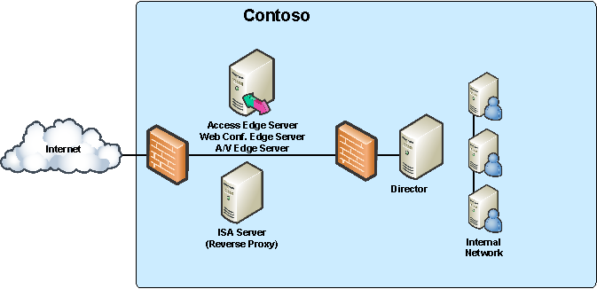

Single-Site Edge Topology
The single-site edge topology is appropriate for medium to large organizations.
In the single-site edge topology:
- The Access Edge Server and Web Conferencing Edge Server are collocated on a single physical computer.
- The A/V Edge Server is installed on a separated dedicated computer.
This topology is recommended because it offers:
- Flexibility.
- Efficient bandwidth utilization (because the A/V Edge Server, which uses the most bandwidth, is on a separate computer).
- The fewest number of computers to manage.
This topology does not:
- Scale easily
- Provide load balancing
- Provide high availability
The following figure illustrates the single-site edge topology.
Figure 21 Single-site Edge topology
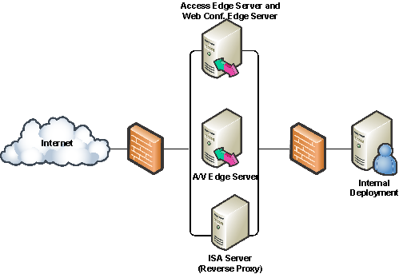

Scaled Single-Site Edge Topology
The scaled single-site edge topology is appropriate for large organizations.
This topology is recommended because it:
- Provides load balancing
- Provides high availability
- Scales easily
The scaled single-site edge topology is the single-site edge topology scaled out in the following ways:
- A load balancer is connected to two or more computers, with Access Edge Server and Web Conferencing Edge Server collocated on each computer.
- Another load balancer is connected to two or more separate computers, each of which serves as an A/V Edge Server.
The following figure illustrates the scaled single-site edge topology.
Figure 22 Scaled single-site edge topology

Multiple Site with Remote Site Edge Topology
The remote-site edge topology supports multiple sites and is appropriate for organizations with remote sites that are geographically dispersed and are connected by using a WAN.
In the multiple-site edge topology using a remote site, you integrate remote locations into a scaled topology by deploying:
- The scaled topology in your data center (as specified in the scaled single-site edge topology).
- Local A/V Conferencing and Web Conferencing Edge Servers and a local Standard Edition server or pool in each remote location.
In this topology, traffic from remote or federated users in the remote location travels across the WAN only to contact the Access Edge Server for authentication and instant messaging and presence, which incurs lower bandwidth cost. The Access Edge Server returns the local pool or Standard Edition server for users at the remote site, and the pool or server points the user to the local A/V or Web Conferencing Edge Server. A/V traffic and traffic from the Web Conferencing Server remain local, which results in a better user experience and lower bandwidth usage of the WAN.
In a remote site topology, you can have one or more stand-alone Web Conferencing Edge Servers but only a single A/V Edge Server. If you need more than one A/V Edge Server, use the scaled remote site topology for the A/V Edge Servers.
Note
If you want to add more than one Web Conferencing Edge Server in a remote site, we recommend load balancing them, as described in the scaled remote edge topology section.
The following figure illustrates a remote site topology in multiple-site edge deployment.
Figure 23 Multiple-site edge topology with remote site
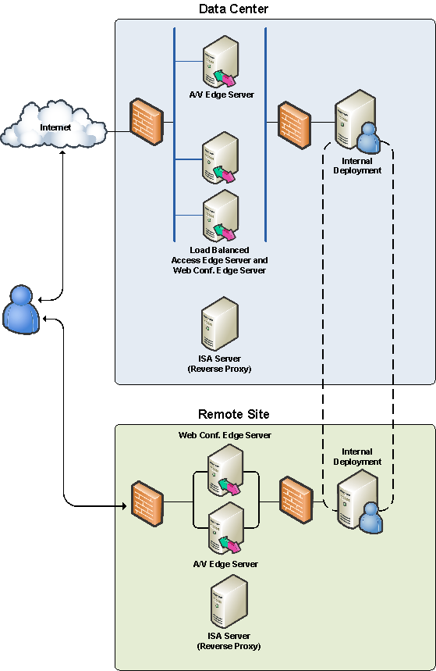

In the remote office, you can also scale the edge topology to provide high availability for external access. In a scaled edge topology of a remote office, one or more A/V Edge Servers are deployed on dedicated servers and Web Conferencing Edge Servers are deployed on separate dedicated computers. All edge servers are connected to a hardware load balancer.

Multiple Site with Scaled Remote Site Edge Topology
As a variation to the multiple-site edge topology, if you have large remote sites or want to enable high availability in these sites, you can scale the topology in the remote sites by load-balancing your Web Conferencing Edge Servers and your A/V Edge Servers in a topology similar to that in the topology shown in the following figure.
Figure 24 Scaled Remote-site Edge Topology
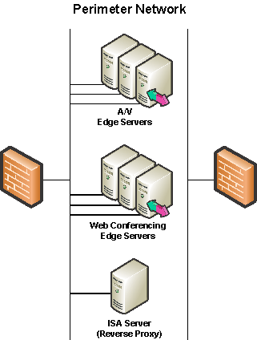

Connecting to Internal Servers
When you deploy an Access Edge Server, you can connect it to your internal network components in either of the following ways:
- Connecting directly to an internal server or Enterprise pool.
- Using a Director. A Director is optional but is strongly recommended in all topologies that involve connections across the Internet, especially those that support remote users. The Director is an Office Communications Server 2007 Standard Edition server or Enterprise pool that does not host users but that, as a member of an Active Directory domain, has access to Active Directory for purposes of authenticating remote users and routing traffic to the appropriate server or Enterprise pool. By authenticating inbound SIP traffic from remote users, the Director helps insulate home servers and Enterprise pools from potentially malicious traffic, while relieving them of the overhead of performing authentication.
You can deploy either a single Director as a Standard Edition server or Enterprise pool or as an array of Standard Edition servers behind a load balancer that function as a Director. In a large deployment with significant external traffic, an Enterprise pool Director or Standard Edition array Director with a load balancer provides a significant improvement in performance.

Plan for Edge Servers in Your Perimeter Network
To help increase security in your perimeter network, we recommend that you deploy edge servers in the following way.
- Create a new subnet out of your router for Office Communications Server.
- Verify that traffic coming to the Office Communications subnet does not route to other subnets.
- On your initial router, configure rules to ensure that there is no routing between your Office Communications Server 2007 subnet and other subnets (with the exception of a management subnet that can include management services for your perimeter network).
- On your internal router, do not allow any broadcasts or multicasts coming from the Office Communications Server 2007 subnet in the perimeter network.
- Deploy the edge server between two firewalls (an internal firewall and an external firewall) to ensure strict routing from one network edge to the other.
Figure 25 Example of Office Communicator Server 2007 in Perimeter Network
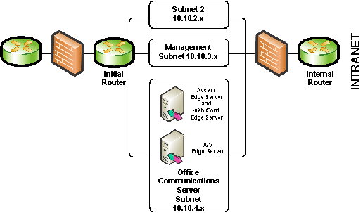

Using the example in the previous figure you would configure your initial router rules to deny routing between all the 10.10.4.x subnet and all other subnets with the exception of the management subnet 10.10.3.x.

Edge Server Deployment Process
Your deployment process should contain all the details required to deploy your edge servers, including what you want to deploy and how to deploy all components. You can use this guide as the starting point for your deployment process, tailoring it as appropriate to your deployment needs.
To enhance edge server performance and security, as well as to facilitate deployment, use the following guidelines when establishing your deployment process:
- Deploy edge servers only after you have finished deploying Office Communications Server 2007 inside your organization, unless you are migrating from Microsoft Office Live Communications Server 2005 with Service Pack 1 to Microsoft Office Communications Server 2007. For information about the migration process, see Migrating to Microsoft Office Communications Server 2007.
- Deploy edge servers in a workgroup rather than a domain. Doing so simplifies installation and keeps the Active Directory Domain Services out of the perimeter network. Locating Active Directory in the perimeter network can present a significant security risk.
- Deploy your edge servers in a staging or lab environment before deploying them in your production environment. Deploy it in your perimeter network only when you are satisfied that the test deployment meets your requirements and that it can be incorporated successfully in a production environment.
- Deploy at least one Director to act as an authentication gateway for inbound external traffic. As explained earlier, a Director is not required, but recommended.
- Deploy edge servers on dedicated computers that do not run anything that is not required. This includes disabling unnecessary services and running only essential programs on the computer, such as programs embodying routing logic that are developed by using MSPL (Microsoft SIP Processing Language) and the Office Communications Server API.
- Enable monitoring and auditing as early as possible on the computer.
- Use a computer that has two network adapters to provide physical separation of the internal and external network interfaces.
- Deploy the edge server between two firewalls (an internal firewall and an external firewall) to ensure strict routing from one network edge to the other.

Prerequisites
Before you deploy your edge servers, ensure that your IT infrastructure, network, and systems meet the following requirements:
- Each computer on which you plan to use as an edge server is running one of the following operating systems:
- Microsoft Windows Server 2003, Standard Edition, Service Pack 1 or later
- Windows Server 2003, Enterprise Edition Service Pack 1 or later
- Windows Server 2003, Datacenter Edition Service Pack 1 or later
- Microsoft Windows Server 2003 R2, Standard Edition, Service Pack 1 or later
- Windows Server 2003 R2, Enterprise Edition Service Pack 1 or later
- Windows Server 2003 R2, Datacenter Edition Service Pack 1 or later
- PKI (Public Key Infrastructure) is deployed and configured to use a certification authority (CA) infrastructure that is provided by either Microsoft or other provider.
- A perimeter network that supports the assignment of a publicly routable IP address to A/V Edge Servers.
- Your perimeter firewalls can support opening the ports that are described in the following section.
- A reverse HTTP proxy is deployed in your perimeter network.
- All users that require any of the new functionality that is provided by an Office Communications Server 2007 edge server install Live Meeting 2007 client and Communicator 2007.

Publicly Routable IP Address for External A/V Access
To enable this external access to media sessions and audio and video, the A/V Edge server and Office Communications Server clients rely on Interactive Connectivity Establishment (ICE) and Simple Traversal of User Datagram Protocol (UDP) through network address translators (NATs) (STUN) protocols. To support the protocol requirements, the A/V Edge server requires the assignment of a publicly routable IP address to its external interface.
The follow except from RFC 3489 summarizes the reasons that STUN requires a publicly routable IP address.
STUN assumes that the server exists on the public Internet. If the server is located in another private address realm, the user may or may not be able to use its discovered address to communicate with other users. There is no way to detect such a condition. (RFC 3489 Section 14.3).
STUN imposes some restrictions on the network topologies for proper operation. If client A obtains an address from STUN server X, and sends it to client B, B may not be able to send to A using that IP address. The address will not work if any of the following is true:
The STUN server is not in an address realm that is a common ancestor (topologically) of both clients A and B. For example, consider client A and B, both of which have residential NAT devices. Both devices connect them to their cable operators, but both clients have different providers. Each provider has a NAT in front of their entire network, connecting it to the public Internet. If the STUN server used by A is in A's cable operator's network, an address obtained by it will not be usable by B. The STUN server must be in the network which is a common ancestor to both - in this case, the public Internet.
The STUN server is in an address realm that is a common ancestor to both clients, but both clients are behind the same NAT connecting to that address realm. For example, if the two clients in the previous example had the same cable operator, that cable operator had a single NAT connecting their network to the public Internet, and the STUN server was on the public Internet, the address obtained by A would not be usable by B. That is because some NATs will not accept an internal packet sent to a public IP address which is mapped back to an internal address. To deal with this, additional protocol mechanisms or configuration parameters need to be introduced which detect this case. (RFC 3489 Section 14.3).
In an A/V Edge Server array, where the edge servers operate as logical entity one and are supported by the use of hardware load balancer, each A/V Edge Server in the array requires a dedicated public IP address.
Not placing a publicly routable IP address on the A/V Edge Server drastically reduces the effectiveness of STUN and hampers the ability of the ICE protocol to establish A/V communications between clients. The loss of functionality due to this improper configuration ranges from inconsistent A/V connectivity between clients to the complete inability to establish a successful connection.
In Office Communications Server 2007, Microsoft does not support non-publicly routable IP address on the A/V Edge server. If a reported problem is believed to be caused by the A/V Edge Server, we will be unable to continue support until the configuration is adjusted.

DNS Requirements
As covered earlier in this document, when collocating multiple server roles on a single computer, you should use a separate external IP address for each role. Specific DNS settings must be configured on each external and internal interface of each edge server. In general, this includes configuring DNS records to point to appropriate servers in the internal network and configuring DNS records as appropriate for each edge server.
Note
To prevent DNS SRV spoofing and ensure that certificates provide valid ties from the user URI to real credentials, Office Communications Server 2007 requires that the name of the DNS SRV domain match the server name on the certificate. The subject name (SN) must point to sip.<domain>.
The actual DNS records required depend on which edge servers you deploy and on your deployment topology, as covered in this section. The following tables provide details about each DNS record required for each topology.
The following table describes the DNS records that must be configured for the external interface and the internal interface of the edge servers in the consolidated edge topology.
Note
The port numbers referenced in the following tables and later in this document are typically the default ports. If you use different port settings, you will need to modify the procedures in this guide accordingly.
Table 43 DNS records for the consolidated edge topology
Internal/External Record | Server | DNS Settings
External | Collocated Access Edge Server, Web Conferencing Edge Server, and A/V Edge Server | An external SRV record for all Access Edge Servers for _sipfederationtls._tcp.<domain>, over port 5061 (where <domain> is the name of the SIP domain of your organization). This SRV should point to an A record with the external FQDN of the Access Edge Server. If you have multiple SIP domains, you need a DNS SRV record for each domain. This SRV record supports federation and public IM connectivity.  A DNS SRV (service location) record for _sip._tls.<domain>, over port 443 where <domain> is the name of your organization’s SIP domain. This SRV record must point to the A record of the Access Edge Server. If you have multiple SIP domains, you need a DNS SRV record for each domain. This SRV record supports external user access through Office Communicator and the Live Meeting client.  Note: Configuring multiple SRV records for the same SIP domain is not supported. If multiple DNS records are returned to a DNS SRV query, the Access Edge Server will always pick the DNS SRV record with the lowest numerical priority and highest numerical weight.  For each supported SIP domain in your organization, an external A record for sip.<domain> that resolves to the external IP address of the Access Edge Server for each SIP domain. If a client cannot perform an SRV record lookup to connect to the Access Edge server it will use this A record as a fallback.  An external DNS A record that resolves to the external name of the Web Conferencing Edge Server to the external IP address of the Web Conferencing Edge Server.  An external DNS A record that resolves the external FQDN of the A/V Edge Server to the external IP address of the A/V Edge Server. This IP address must be a publicly routable IP address.
External | Reverse proxy | An external DNS A record that resolves the external Web farm FQDN to the external IP address of the reverse proxy. The client uses this record to connect to the reverse proxy.
Internal | Collocated Access Edge Server, Web Conferencing Edge Server, and A/V Edge Server | An internal DNS A record that resolves the internal FQDN of the edge server to the internal IP address of the edge server. Office Communications Server 2007 servers within the organization use this DNS A record to connect to the internal interface of the edge server.

The following table describes the DNS records that must be configured for the external interface and the internal interface of the edge servers in the single-site edge topology.

Table 44 DNS records for the single-site edge topology
Interface | Server | DNS Settings
External | Collocated Access Edge Server and Web Conferencing Edge Server | An external SRV record for all Access Edge Servers for _sipfederationtls._tcp.<domain>, over port 5061 (where <domain> is the name of the SIP domain of your organization). This SRV should point to an A record with the external FQDN of the Access Edge Server. If you have multiple SIP domains, you need a DNS SRV record for each domain. This SRV record supports federation and public IM connectivity.  A DNS SRV (service location) record for _sip._tls.<domain>, over port 443 where <domain> is the name of your organization’s SIP domain. This SRV record must point to the A record of the Access Edge Server. If you have multiple SIP domains, you need a DNS SRV record for each domain. This SRV record supports external user access through Office Communicator and the Live Meeting client.  Note: Configuring multiple SRV records for the same SIP domain is not supported. If multiple DNS records are returned to a DNS SRV query, the Access Edge Server will always pick the DNS SRV record with the lowest numerical priority and highest numerical weight.  For each supported SIP domain in our organization, an external DNS A record for sip. <domain> that points to the external interface of the Access Edge Server. If you have multiple SIP domains, you need a DNS SRV record for each. If a client cannot perform an SRV record lookup to connect to the Access Edge server it will use this A record as a fallback.  An external DNS A record that resolves the external FQDN of the Web Conferencing Edge Server to its external IP address.
External | A/V Edge Server | An external DNS A record that points the external FQDN of the A/V Edge Server to its external IP address. This IP address must be a publicly routable IP address.
External | Reverse proxy | An external DNS A record that resolves the external Web farm FQDN to the external IP address of the reverse proxy. The client uses this record to connect to the reverse proxy.
Internal | Collocated Access Edge Server and Web Conferencing Edge Server | An internal DNS A record that resolves the internal FQDN of the collocated Access Edge Server and Web Conferencing Edge Server to its internal IP address.
Internal | A/V Edge Server | An internal DNS A record that resolves the internal FQDN of the A/V Edge Server to its internal IP address.

The following table describes the DNS records that must be configured for the external interface and the internal interface of the edge servers in the scaled single-site edge topology.
Table 45 DNS records for the scaled single-site edge topology
Interface | Server | DNS Settings
External | Access Edge Server  Web Conferencing Edge Server | An external SRV record for all Access Edge Servers for _sipfederationtls._tcp.<domain>, over port 5061 (where <domain> is the name of the SIP domain of your organization). This SRV should point to an A record that resolves the external FQDN of the Access Edge Server array to the VIP address used by the Access Edge Server array on the external load balancer. If you have multiple SIP domains, you need a DNS SRV record for each domain. This SRV record supports federation and public IM connectivity.  A DNS SRV (service location) record for _sip._tls.<domain>, over port 443 where <domain> is the name of your organization’s SIP domain. This SRV record must point to the A record of the Access Edge Server. If you have multiple SIP domains, you need a DNS SRV record for each domain. This SRV record supports external user access through Office Communicator and the Live Meeting client.  Note: Configuring multiple SRV records for the same SIP domain is not supported. If multiple DNS records are returned to a DNS SRV query, the Access Edge Server will always pick the DNS SRV record with the lowest numerical priority and highest numerical weight.  For each supported SIP domain in your organization, an external A record for sip.<domain> that points to the external IP address of the virtual IP address used by the Access Edge Server on the external load balancer. If a client cannot perform an SRV record lookup to connect to the Access Edge server, it uses this A record as a fallback.  An external DNS A record that resolves the external FQDN of the Web Conferencing Edge Server array to the VIP address used by the Web Conferencing Edge Server array on the external load balancer.
External | A/V Edge Server | An external DNS A record that resolves the external FQDN of the A/V Edge Server array to the virtual IP address used by the A/V Edge Servers on the external load balancer on the external edge.
External | Reverse proxy | An external DNS A record that resolves the external Web farm FQDN to the external IP address of the reverse proxy. The client uses this record to connect to the reverse proxy.
Internal | Access Edge Server  Web Conferencing Edge Server | An internal DNS A record that resolves the internal FQDN of the Access Edge Server array to the virtual IP address used by the Access Edge Servers on the internal load balancer.  An internal DNS A record that resolves the internal FQDN of each Web Conferencing Edge Server to its internal IP address.
Internal | A/V Edge Server | An internal DNS A record that resolves the internal FQDN of the A/V Edge Server array to the virtual IP address used by the A/V Edge Servers on the internal load balancer.

The data center configuration for the multiple-site edge topology is the same as that for the scaled single-site edge topology, but additional configuration is required for the remote site. The following table describes the DNS records that must be configured for the external interface and the internal interface of the edge servers in the remote site of the multiple-site edge topology.
Table 46 DNS records for the multiple-site edge topology remote site with one or more Web Conferencing Edge Servers and a single A/V Edge Server
Interface | Remote Site Server | DNS Settings
External | Web Conferencing Edge Server | An external DNS A record that resolves to the external FQDN of each Web Conferencing Edge Server in the remote site to its external IP address.
External | A/V Edge Server | An external DNS A record that resolves the external FQDN of the A/V Edge Server in the remote site to its external IP address. This IP address must be a publicly routable IP address.
External | Reverse proxy | An external DNS A record that resolves the external Web farm FQDN to the external IP address of the reverse proxy. The client uses this record to connect to the reverse proxy.
Internal | Web Conferencing Edge Server | An internal DNS A record that resolves the internal FQDN of each Web Conferencing Edge Server in the remote site to its internal IP address.
Internal | A/V Edge Server | An internal DNS A record that resolves the internal FQDN of the A/V Edge Server to its internal IP address.

The following table describes the DNS records that must be configured for the external interface and the internal interface of the edge servers in the remote site for a scaled remote site topology where two or more Web Conferencing Edge Servers and two or more A/V Edge Servers are load balanced in the remote site.
Table 47 DNS records for the scaled remote edge topology
Interface | Server | DNS Settings
External | Web Conferencing Edge Server | An external DNS A record that resolves the external FQDN the Web Conferencing Edge Server array to the VIP address used by the Web Conferencing Edge Server array on the external load balancer.
External | A/V Edge Server | An external DNS A record that resolves the external FQDN of the A/V Edge Server array to the virtual IP address used by the A/V Edge Servers on the external load balancer on the external edge.
External | Reverse proxy | An external DNS A record that resolves the external Web farm FQDN to the external IP address of the reverse proxy. The client uses this record to connect to the reverse proxy.
Internal | Web Conferencing Edge Server | An internal DNS A record that resolves the internal FQDN of each Web Conferencing Edge Server to its internal IP address.
Internal | A/V Edge Server | An internal DNS A record that resolves the internal FQDN of the A/V Edge Server array to the virtual IP address used by the A/V Edge Servers on the internal load balancer.

Certificate Requirements for Edge Servers
The following sections summarize the certificate requirements for edge servers on the internal and external interfaces of these servers. For topology specific requirements, refer to the Microsoft Office Communications Server 2007 Edge Server Deployment Guide.

Certificate Requirements for the Internal Interface
The following summarizes the certificate requirements for the internal interface of your edge servers.
- Each edge server in the perimeter network of the data center requires a certificate for the internal interface:
- If you are deploying a load balancer with multiple collocated Access Edge Servers and Web Conferencing Edge Servers, use a single certificate with a subject name that matches the FQDN for the virtual IP address used by the Access Edge Servers on the internal load balancer of the servers, for example:
Certificate SN = accessedge_array.contoso.perimeter
- For Web Conferencing Edge Servers (collocated on the computer with the Access Edge Server), by default, this certificate is shared by the Web Conferencing Edge Server. If an A/V Edge Server is also collocated on the server, it also shares this certificate by default. If the servers are not collocated, you must use separate certificates for each server role.
- The A/V Edge Server in the perimeter network of the data center requires a certificate for the internal interface if it is running on a separate computer than the Access Edge Server. If you are deploying multiple A/V Edge Servers (with a load balancer), use a single certificate with a subject name that matches the FQDN for the virtual IP address used by the A/V Edge Server on the internal load balancer, for example:
Certificate SN = avedge_array.contoso.perimeter
- The Web Conferencing Edge Server in each remote site of a multiple-site edge topology requires a certificate on the internal interface with a subject name that matches the FQDN published on the internal interface of the firewall in the data center, and it should map to the Web Conferencing Edge Server in the remote site.
- The A/V Edge Server in each remote site of a multiple-site edge topology requires a certificate on the internal interface with a subject name that matches the FQDN published on the internal interface of the firewall in the data center, and it should map to the A/V Edge Server in the remote site.

Certificate Requirements for Each Topology
The following table summarizes the certificate requirements for the internal interface of each edge server role in the consolidated edge topology.

Table 48 Certificates for internal interface of the edge server in the consolidated edge topology
Server role | Certificate
Access Edge Server , Web Conferencing Edge Server  A/V Edge Server | A single, shared certificate configured on the internal interface with a subject name that matches the internal FQDN of the edge server.

The following table summarizes the certificate requirements for the internal interface of each edge server role in the single-site edge topology.
Table 49 Internal Certificates for the single-site edge topology
Server role | Certificate
Access Edge Server  Web Conferencing Edge Server | A certificate configured on the internal interface with a subject name that matches the internal FQDN of the computer with the Access Edge and Web Conferencing Edge Servers collocated.
A/V Edge Server | A certificate configured on the internal interface with a subject name that matches the internal FQDN of the A/V Edge Server.

The following table summarizes the certificate requirements for the internal interface of each edge server role in the scaled single-site edge topology.
Table 50 Internal Certificates for the scaled single-site edge topology
Server role | Certificate
Access Edge Server  Web Conferencing Edge Server | A certificate configured on the internal interface with a subject name that matches the internal FQDN of the VIP address used by the Access Edge Server on the internal load balancer. This certificate is shared between the Web Conferencing Edge Server and Access Edge Server and must be configured on the internal interface of the Web Conferencing Edge Server and the Access Edge Server. This certificate must be marked as exportable on the first computer where you configure the certificate and then imported onto each additional computer in the Access Edge Server and Web Conferencing Edge Server array.
A/V Edge Server | A certificate configured on the internal interface with a subject name that matches the internal FQDN of the VIP address used by the A/V Edge Server on the internal load balancer. This certificate must be marked as exportable on the first computer where you configure the certificate and then imported onto each additional computer in A/V Edge Server array.

The following table summarizes the certificate requirements for the internal interface of each edge server in the remote site in a multiple edge site topology. The servers in the central site will use the same certificates as those in the scaled single-site topology.

Table 51 Internal Certificates for the remote site in a multiple-site edge topology
Server role | Certificate
Access Edge Server | No Access Edge Server is deployed in the remote site.
Web Conferencing Edge Server | For each Web Conferencing Edge Server, a certificate configured on the internal interface with a subject name that matches the internal FQDN of the Web Conferencing Edge Server in the remote site.
A/V Edge Server | A certificate configured on the internal interface with a subject name that matches the internal FQDN of the A/V Edge Server in the remote site.

The following table summarizes the certificate requirements for the internal interface of each edge server role in the scaled remote-site edge topology.
Table 52 Internal Certificates for the scaled remote-site edge topology
Server role | Certificate
Web Conferencing Edge Server | For each Web Conferencing Edge Server, a certificate with a subject name that matches the internal FQDN of the Web Conferencing Edge Servers.
A/V Edge Server | A certificate configured on the internal interface with a subject name that matches the internal FQDN of the VIP address used by the A/V Edge Server on the internal load balancer. This certificate must be marked as exportable on the first computer where you configure the certificate and then imported onto each additional computer in A/V Edge Server array.

Certificate Requirements for the External Interface
The certificate requirements for the external interface include the following:
- For each unique IP address on the external interface that you use for the Access Edge Server and Web Conferencing Edge Server, you will need a separate certificate. We recommend that you use a separate external IP addresses for each server role, even if all servers are collocated. An external certificate is not required on the A/V Edge Server.
- For the scaled single-site edge topology, we recommend that each server role use a separate VIP address on the external load balancer. A separate certificate matching the FQDN of each VIP address used by each Access Edge and Web Conferencing Edge server role must be installed on that server. For example, the Web Conferencing Edge Servers must have a certificate that matches the VIP address used by the Web Conferencing Edge Servers on the external load balancer. The certificate must be marked as exportable on the first physical computer where you configure the certificate and then imported into each additional computer in the array. An external certificate is not required for the A/V Edge Server array on the external interface.
- If you are deploying a multiple-site topology, the Web Conferencing Edge Server in the perimeter network of each remote site requires a certificate with a subject name that matches the external FQDN of the Web Conferencing Edge Server in the remote site. A certificate is not required for the external interface of the A/V Edge Server.
- If you are supporting public IM connectivity with AOL, AOL requires a certificate configured for both client and server authorization. (For MSN and Yahoo!, a Web certificate will suffice).
- Public certificates are required if you enable Web conferencing and enable your users to invite anonymous participants (individuals from outside your organization that do not have Active Directory credentials).
- Public certificates are required for public IM connectivity, and they are highly recommended for enhanced federation. The public certificate must be from a public CA that is on the default list of trusted root CAs installed on the server.
Note
It is possible to use your Enterprise subordinate CA for direct federation, as well as for testing or trial purposes if all partners agree to trust the CA or cross-sign the certificate.

Certificate Requirements for Each Topology
The following tables summarize the certificate requirements for each topology.
The following table summarizes the certificate requirements for the external interface of each edge server role in the consolidated edge topology.
Table 53 External Certificates for the edge server in the consolidated edge topology
Server role | Certificate
Access Edge Server | A certificate configured on the external interface with a subject name that matches the external FQDN of the edge server. If you have multiple SIP domains, each supported SIP domain must be entered as sip.<domain> in the Subject Alternate Name of the certificate. For example, if your organization supports two domains a.contoso.com and b.contoso.com and a.contoso.com is the external FQDN of your Edge Server, SN=sip.a.contoso.com, SAN=sip.a.contoso.com, sip.b.contoso.com.
Web Conferencing Edge Server | A certificate configured on the external interface that matches the external FQDN of the Web Conferencing Edge Server.
A/V Edge Server | Not required.

The following table summarizes the certificate requirements for the external interface of each edge server role in the single-site edge topology.

Table 54 External Certificates for the single-site edge topology
Server role | Certificate
Access Edge Server | A certificate configured on the external interface with a subject name that matches the external FQDN of the computer with the Access Edge and Web Conferencing Edge Servers collocated. If you have multiple SIP domains, each supported SIP domain must be entered as sip.<domain> in the Subject Alternate Name of the certificate. For example, if your organization supports two domains a.contoso.com and b.contoso.com, and a.contoso.com is the external FQDN of your Access Edge Server, then SN=sip.a.contoso.com, SAN=sip.a.contoso.com, sip.b.contoso.com.
Web Conferencing Edge Server | A certificate configured on the external interface with a subject name that matches the external FQDN of Web Conferencing Edge Server.
A/V Edge Server | Not required.

The following table summarizes the certificate requirements for the external interface of each edge server role in the scaled single-site edge topology.
Table 55 External Certificates for the scaled single-site edge topology
Server role | Certificate
Access Edge Server | A certificate configured on the external interface with a subject name that matches the external FQDN of the VIP address used by the Access Edge Server on the external load balancer. If you have multiple SIP domains, each supported SIP domain must be entered as sip.<domain> in the Subject Alternate Name of the certificate. For example, if your organization supports two domains a.contoso.com and b.contoso.com, and a.contoso.com is the external FQDN of your Access Edge Server SN=sip.a.contoso.com, SAN=sip.a.contoso.com, sip.b.contoso.com.  This certificate must be marked as exportable on the first computer where you configure the certificate and then imported onto each additional computer in the Access Edge Server and Web Conferencing Edge Server array. This certificate must be used as the certificate on the external interface of the Access Edge Server.
Web Conferencing Edge Server | A certificate configured on the external interface with a subject name that matches the external FQDN of the VIP address used by the Web Conferencing Edge Server on the external load balancer.  This certificate must be marked as exportable on the first computer where you configure the certificate and then imported onto each additional computer in the Access Edge Server and Web Conferencing Edge Server array. This certificate must be used as the certificate on the external interface of the Web Conferencing Edge Server.
A/V Edge Server | Not required.

The following table summarizes the certificate requirements for the external interface of each edge server in the remote site in a multiple edge site topology. The servers in the central site will use the same certificates as those in the scaled single-site topology.
Table 56 External Certificates for the remote site in a multiple-site edge topology
Server role | Certificate
Access Edge Server | No Access Edge Server is deployed in the remote site.
Web Conferencing Edge Server | A certificate configured on the external interface with a subject name that matches the external FQDN of the Web Conferencing Edge Server in the remote site.
A/V Edge Server | Not required.

The following table summarizes the certificate requirements for the external interface of each edge server role in the scaled remote-site edge topology.
Table 57 External Certificates for the scaled remote-site edge topology
Server role | Certificate
Web Conferencing Edge Server | A certificate configured on the external interface with a subject name that matches the external FQDN of the VIP address used by the Web Conferencing Edge Server on the external load balancer.  This certificate must be marked as exportable on the first computer where you configure the certificate and then imported onto each additional computer in the Web Conferencing Edge Server array. This certificate must be used as the certificate on the external interface of the Web Conferencing Edge Server.
A/V Edge Server | Not required.

A/V Authentication Certificate
For the A/V Edge Server, an additional certificate is required for audio/video authentication. The private key of the A/V authentication certificate is used to generate authentication credentials. As a security precaution, you should not use the same certificate for A/V authentication that you use for the internal interface of the A/V Edge Server (covered earlier in this guide).
The same A/V authentication certificate must be installed on each A/V Edge Server if multiple servers are deployed in a load balanced array. This means that the certificate must be from the same issuer and use the same private key. Refer to the Microsoft Office Communications Server 2007 Edge Server Deployment Guide for more information.

Firewall Requirements
Configuring firewalls includes configuring both of the following:
- Internal firewall between the perimeter network and your internal network.
- External firewall between the perimeter network and the Internet.
How you configure your firewalls is largely dependent on the specific firewalls you use in your organization, but each firewall also has common configuration requirements that are specific to Office Communications Server 2007. Follow the manufacturer’s instructions for configuring each firewall, along with the information in this section, which describe the settings that must be configured on the two firewalls.
To conform to the requirement of a publicly routable IP address of the A/V Edge Server, the external firewall of the perimeter network must not act as a NAT (Network Address Translator) for this IP address.
Additionally, the internal firewall must not act as a NAT for the internal IP address of the A/V Edge Server. The internal IP address of the A/V Edge Server must be fully routable from the internal network to the internal IP address of the A/V Edge Server.
The following figure shows the default firewall ports for each server in the perimeter network.
Figure 26 Firewall ports for the perimeter network
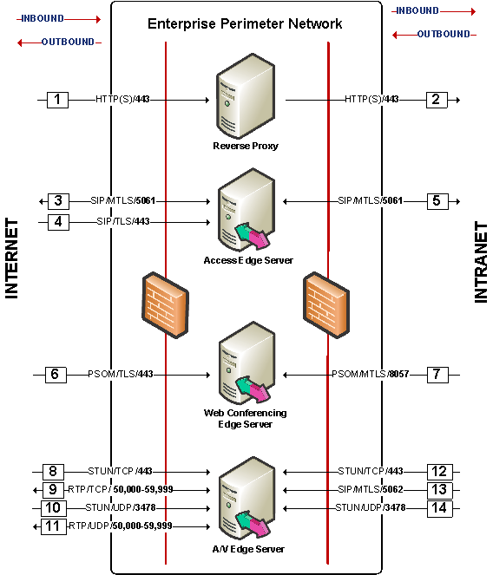
The following sections provide additional information about each port to be configured for each server role in each topology, as well as a mapping of the numbers in the previous figure to the respective port descriptions.
In the following tables, the direction for firewall policy rules that is indicated as outbound is defined as follows:
- On the internal firewall, it corresponds to traffic from servers on the internal (private) network to the edge server in the perimeter network.
- On the external firewall, it corresponds to traffic from the edge server in the perimeter network to the Internet.

Consolidated Edge Topology Firewall Policy Rules
The following tables explain the firewall policy rules that are required on each server in the perimeter network when you deploy edge servers in the consolidated edge topology.
The following describes the firewall policy to be configured for the reverse proxy.
Table 58 Firewall Settings for the Reverse Proxy
Firewall | Policy Rules | Figure Mapping
Internal | Local Port: Any  Direction: Inbound (for external user access to Web conferences)  Remote Port: 443 TCP (HTTP(S))  Local IP: The internal IP address of the reverse proxy  Remote IP: Any | 2
External | Local Port: 443 TCP (HTTP(S))  Direction: Inbound  Remote Port: Any  Local IP address: The external IP address of the HTTP reverse proxy  Remote IP: Any  Note: If you want your users to be able to connect from inside your intranet to external conferences hosted by other companies, then you will also need to open port 443 outbound | 1

The following table describes the firewall policy rules to be configured for the Access Edge Server.
Table 59 Firewall Settings for the Access Edge Server
Firewall | Policy Rules | Figure Mapping
Internal | Local Port: Any  Direction: Inbound (for remote user access and federation)  Remote Port: 5061 TCP (SIP/MTLS)  Local IP address: The internal IP address of the Access Edge Server  Remote IP: The IP address of the next hop server. If a Director is deployed, use the IP address of the Director or VIP of the load balancer, if the Directors are load balanced | 5
Internal | Local Port: 5061 TCP (SIP/MTLS)  Direction: Outbound (for remote user access and federation)  Remote Port: Any  Local IP address: The internal IP address of the Access Edge Server  Remote IP: If no Director is deployed, you must use any IP address. If a Director is deployed, use the IP address of the Director or VIP of the load balancer, if the Directors are load balanced | 5
External | Local Port: 5061 TCP (SIP/MTLS)  Direction: Inbound/Outbound (federation)  Remote Port: Any  Local IP: The external IP address of the Access Edge Server  Remote IP: Any IP address | 3
External | Local Port: 443 TCP (SIP/TLS)  Direction: Inbound (for remote user access)  Remote Port: Any  Local IP: The external IP address of the Access Edge Server.  Remote IP: Any IP address | 4

The following table describes the firewall policy rules to be configured for the Web Conferencing Edge Server.
Note
PSOM is the Microsoft proprietary protocol used for Web conferencing.
Table 60 Firewall Settings for the Web Conferencing Edge Server
Firewall | Policy Rules | Figure Mapping
Internal | Local Port: 8057 TCP (PSOM/MTLS)  Direction: Outbound (for traffic between internal Web Conferencing Servers and the Web Conferencing Edge Servers)  Remote Port: Any  Local IP: The internal IP address of the Web Conferencing Edge Server  Remote IP: Any IP address | 7
External | Local Port: 443 TCP (PSOM/TLS)  Direction: Inbound (for access of remote, anonymous, and federated users to internal Web conferences)  Remote Port: Any  Local IP: The external IP address of the Web Conferencing Edge Server  Remote IP: Any IP address | 6

The following table describes the firewall policy rules to be configured for the A/V Edge Server.
Table 61 Firewall Settings for the A/V Edge Server
Firewall | Policy Rules | Figure Mapping
Internal | Local Port: 443 TCP (STUN/TCP)  Direction: Outbound (for internal users to send media to external users)  Remote Port: Any  Local IP: The internal IP address of the A/V Edge Server  Remote IP: Any IP address | 12
Internal | Local Port: 5062 TCP (SIP/MTLS)  Direction: Outbound (For authentication of A/V users)  Remote Port: Any  Local IP: The internal IP address of the A/V Edge Server.  Remote IP: Any IP Address | 13
Internal | Local Port: 3478 UDP (STUN/UDP)  Direction: Outbound (for internal users to send media to external users)  Remote Port: Any  Local IP: The internal IP address of the A/V Edge Server  Remote IP: Any IP Address  Note: If you are using ISA Server as your firewall, you must configure the rule for send/receive | 14
External | Local Port: 443 TCP (STUN/TCP)  Direction: Inbound (for external users access to media and A/V sessions)  Remote Port: Any  Local IP: The external IP address of the A/V Edge Server  Remote IP: Any IP Address | 8
External | Local Port Range: 50,000-59,999 TCP (RTP /TCP)  Direction: Inbound/Outbound (for media transfer)  Remote Port: Any  Local IP: The external IP address of the A/V Edge Server. This IP address must be a publicly routable IP address.  Remote IP: Any IP Address | 9
External | Local Port: 3478 UDP (STUN/UDP)  Direction: Inbound (for external users connecting to media or A/V sessions)  Remote Port: Any  Local IP: The external IP address of the A/V Edge Server  Remote IP: Any IP Address  Note: If you are using ISA Server as your firewall, you must configure the rule for send/receive | 10
External | Local Port Range: 50,000-59,999 UDP (RTP/UDP)  Direction: Inbound/Outbound (for media transfer)  Remote Port: Any  Local IP: The external IP address of the A/V Edge Server. This IP address must be a publicly routable IP address.  Remote IP: Any IP Address | 11

Single-site Edge Topology Firewall Policy Rules
The following tables explain the firewall policy rules required on each server in the perimeter network when you deploy edge servers in the single-site edge topology.
The following table describes the firewall policy to be configured for the reverse proxy.
Table 62 Firewall Settings for the Reverse Proxy
Firewall | Policy Rules | Figure Mapping
Internal | Local Port: Any  Direction: Inbound (for external user access to Web conferences)  Remote Port: 443 TCP (HTTP(S))  Local IP: The internal IP address of the reverse proxy  Remote IP: Any | 2
External | Local Port: 443 TCP (HTTP(S))  Direction: Inbound  Remote Port: Any  Local IP address: The external IP address of the HTTP reverse proxy  Remote IP: Any  Note: If you want your users to be able to connect from inside your intranet to external conferences hosted by other companies, then you will also need to open port 443 outbound | 1

The following table describes the firewall policy rules to be configured for the Access Edge Server.
Table 63 Firewall Settings for the Access Edge Server
Firewall | Policy Rules | Figure Mapping
Internal | Local Port: Any Direction: Inbound (for remote user access and federation)  Remote Port: 5061 TCP (SIP/MTLS)  Local IP address: The internal IP address of the Access Edge Server  Remote IP: The IP address of the next hop server. If a Director is deployed, use the IP address of the Director or VIP of the load balancer, if the Directors are load balanced | 5
Internal | Local Port: 5061 TCP (SIP/MTLS)  Direction: Outbound (for remote user access and federation)  Remote Port: Any  Local IP address: The internal IP address of the Access Edge Server  Remote IP: If no Director is deployed, you must use any IP address. If a Director is deployed, use the IP address of the Director or VIP of the load balancer, if the Directors are load balanced | 5
External | Local Port: 5061 TCP (SIP/MTLS)  Direction: Inbound/Outbound (federation)  Remote Port: Any  Local IP: The external IP address of the Access Edge Server  Remote IP: Any IP address | 3
External | Local Port: 443 TCP (SIP/TLS)  Direction: Inbound (for remote user access)  Remote Port: Any  Local IP: The external IP address of the Access Edge Server  Remote IP: Any IP address | 4

The following table describes the firewall policy rules to be configured for the Web Conferencing Edge Server.
Note
PSOM is the Microsoft proprietary protocol used for Web conferencing.
Table 64 Firewall Settings for the Web Conferencing Edge Server
Firewall | Policy Rules | Figure Mapping
Internal | Local Port: 8057 TCP (PSOM/MTLS)  Direction: Outbound (for traffic between internal Web Conferencing Servers and the Web Conferencing Edge Servers)  Remote Port: Any  Local IP: The internal IP address of the Web Conferencing Edge Server  Remote IP: Any IP address | 7
External | Local Port: 443 TCP (PSOM/TLS)  Direction: Inbound (for access of remote, anonymous, and federated users to internal Web conferences)  Remote Port: Any  Local IP: The external IP address of the Web Conferencing Edge Server  Remote IP: Any IP address | 6

The following table describes the firewall policy rules to be configured for the A/V Edge Server.
Table 65 Firewall Settings for the A/V Edge Server
Firewall | Policy Rules | Figure Mapping
Internal | Local Port: 443 TCP (STUN/TCP)  Direction: Outbound (for internal users to send media to external users)  Remote Port: Any  Local IP: The internal IP address of the A/V Edge Server  Remote IP: Any IP address | 12
Internal | Local Port: 5062 TCP (SIP/MTLS)  Direction: Outbound (For A/V authentication of users)  Remote Port: Any  Local IP: The internal IP address of the A/V Edge Server  Remote IP: Any IP Address | 13
Internal | Local Port: 3478 UDP (STUN/UDP)  Direction: Outbound (for internal users to send media to external users)  Remote Port: Any  Local IP: The internal IP address of the A/V Edge Server  Remote IP: Any IP Address  Note: If you are using ISA Server as your firewall, you must configure the rule for send/receive | 14
External | Local Port: 443 TCP (STUN/TCP)  Direction: Inbound (for external users access to media and A/V sessions)  Remote Port: Any  Local IP: The external IP address of the A/V Edge Server  Remote IP: Any IP Address | 8
External | Local Port Range: 50,000-59,999 TCP (RTP/TCP)  Direction: Inbound/Outbound (for media transfer)  Remote Port: Any  Local IP: The external IP address of the A/V Edge Server. This IP address must be a publicly routable IP address  Remote IP: Any IP Address | 9
External | Local Port: 3478 UDP (STUN/UDP)  Direction: Inbound (for external users connecting to media or A/V sessions)  Remote Port: Any  Local IP: The external IP address of the A/V Edge Server  Remote IP: Any IP Address  Note: If you are using ISA Server as your firewall, you must configure the rule for send/receive | 10
External | Local Port Range: 50,000-59,999 UDP (RTP/UDP)  Direction: Inbound/Outbound (for media transfer)  Remote Port: Any  Local IP: The external IP address of the A/V Edge Server. This IP address must be a publicly routable IP address  Remote IP: Any IP Address | 11

Scaled Single-site Edge Topology Firewall Policy Rules
The following tables explain the firewall policy rules required on each server in the perimeter network when you deploy edge servers in the single-site edge topology.
The following table describes the firewall policy to be configured for the reverse proxy.
Table 66 Firewall Settings for the Reverse Proxy
Firewall | Policy Rules | Figure Mapping
Internal | Local Port: Any  Direction: Inbound (for external user access to Web conferences)  Remote Port: 443 TCP (HTTP(S))  Local IP: The internal IP address of the reverse proxy  Remote IP: Any | 2
External | Local Port: 443 TCP (HTTP(S))  Direction: Inbound Remote Port: Any  Local IP address: The external IP address of the HTTP reverse proxy  Remote IP: Any  Note: If you want your users to be able to connect from inside your intranet to external conferences hosted by other companies, then you will also need to open port 443 outbound | 1

The following table describes firewall policy rules to be configured for the Access Edge Server.
Table 67 Firewall Settings for the Access Edge Server
Firewall | Policy Rules | Figure Mapping
Internal | Local Port: Any  Direction: Inbound (for remote user access and federation)  Remote Port: 5061 TCP (SIP/MTLS)  Local IP address: The internal IP address of the Access Edge Server  Remote IP: The IP address of the next hop server. If a Director is deployed, use the IP address of the Director or VIP of the load balancer, if the Directors are load balanced. | 5
Internal | Local Port: 5061 TCP (SIP/MTLS)  Direction: Outbound (for remote user access and federation)  Remote Port: Any  Local IP address: The internal IP address of the Access Edge Server  Remote IP: If no Director is deployed, you must use any IP address. If a Director is deployed, use the IP address of the Director or VIP of the load balancer, if the Directors are load balanced. | 5
Internal | Local Port: 443 TCP (SIP/TLS)  Direction: Inbound (for remote user access)  Remote Port: Any  Local IP: The VIP address used by the Access Edge Server array on the external load balancer.  Remote IP: Any IP address | 4
External | Local Port: 5061 TCP (SIP/MTLS)  Direction: Inbound/Outbound (federation)  Remote Port: Any  Local IP: The VIP address used by the Access Edge Server array on the external load balancer.  Remote IP: Any IP address | 3
External | Local Port: 443 TCP (SIP/TLS)  Direction: Inbound (for remote user access)  Remote Port: Any  Local IP: The VIP address used by the Access Edge Server array on the external load balancer.  Remote IP: Any IP address | 4

The following table describes the firewall policy rules to be configured for the Web Conferencing Edge Server.
Note
PSOM is the Microsoft proprietary protocol used for Web conferencing.
Table 68 Firewall Settings for the Web Conferencing Edge Server
Firewall | Policy Rules | Figure Mapping
Internal | Local Port: 8057 TCP (PSOM/MTLS)  Direction: Outbound (for traffic between internal Web Conferencing Servers and the Web Conferencing Edge Servers)  Remote Port: Any  Local IP: The internal IP addresses of the Web Conferencing Edge Servers  Remote IP: Any IP address | 7
External | Local Port: 443 TCP (PSOM/TLS)  Direction: Inbound (for access of remote, anonymous, and federated users to internal Web conferences)  Remote Port: Any  Local IP: The VIP address used by the Web Conferencing Edge Server array on the external load balancer  Remote IP: Any IP address | 6

The following table describes the firewall policy rules to be configured for the A/V Edge Server.
Table 69 Firewall Settings for the A/V Edge Server
Firewall | Policy Rules | Figure Mapping
Internal | Local Port: 443 TCP (STUN/TCP)  Direction: Outbound (for internal users to send media to external users)  Remote Port: Any  Local IP: The VIP address used by the A/V Edge Server array on the internal load balancer  Remote IP: Any IP address | 12
Internal | Local Port: 5062 TCP (SIP/MTLS)  Direction: Outbound (For A/V authentication of users)  Remote Port: Any  Local IP: The VIP address used by the A/V Edge Server array on the internal load balancer  Remote IP: Any IP Address | 13
Internal | Local Port: 3478 UDP (STUN/UDP)  Direction: Outbound (for internal users to send media to external users)  Remote Port: Any  Local IP: The internal IP address of the A/V Edge Server and the VIP address used by the A/V Edge Server array on the internal load balancer  Remote IP: Any IP Address  Note: If you are using ISA Server as your firewall, you must configure the rule for send/receive | 14
External | Local Port: 443 TCP (STUN/TCP)  Direction: Inbound (for external users access to media and A/V sessions)  Remote Port: Any  Local IP: The VIP address used by the A/V Edge Server array on the external load balancer  Remote IP: Any IP Address | 8
External | Local Port Range: 50,000-59,999 TCP (RTP/TCP)  Direction: Inbound/Outbound (for media transfer)  Remote Port: Any  Local IP: The external IP address of the A/V Edge Server. This IP address must be a publicly routable IP address  Remote IP: Any IP Address | 9
External | Local Port: 3478 UDP (STUN/UDP)  Direction: Inbound (for external users connecting to media or A/V sessions)  Remote Port: Any  Local IP: The external IP address of the A/V Edge Server and the VIP address used by the A/V Edge Server array on the external load balancer  Remote IP: Any IP Address  Note: If you are using ISA Server as your firewall, you must configure the rule for send/receive | 10
External | Local Port Range: 50,000-59,999 UDP (RTP/UDP)  Direction: Inbound/Outbound (for media transfer)  Remote Port: Any  Local IP: The external IP address of the A/V Edge Server. This IP address must be a publicly routable IP address  Remote IP: Any IP Address | 11

Multiple- Site Edge Topology Firewall Policy Rules for the Remote Site with one or more Stand-alone Web Conferencing Edge Servers and a Single A/V Edge Server
The following tables explain the firewall policy rules required on each server in the perimeter network in the remote site when you deploy edge servers in the multiple edge site topology. The firewall policy rules that are required in the central data center are the same as those required in the scaled single-site topology described in the previous section. Because the users in the remote site use the Access Edge Server in the central site, there is no table for the Access Edge Server in this section.
The following table describes the firewall policy to be configured for the reverse proxy.
Table 70 Firewall Settings for the Reverse Proxy
Firewall | Policy Rules | Figure Mapping
Internal | Local Port: Any  Direction: Inbound (for external user access to Web conferences)  Remote Port: 443 TCP (HTTPS)  Local IP: The internal IP address of the reverse proxy in the remote site  Remote IP: Any | 2
External | Local Port: 443 TCP (HTTP(S))  Direction: Inbound  Remote Port: Any  Local IP address: The external IP address of the HTTP reverse proxy in the remote site  Remote IP: Any  Note: If you want your users to be able to connect from inside your intranet to external conferences hosted by other companies, then you will also need to open port 443 outbound | 1

The following table describes the firewall policy rules to be configured for the Web Conferencing Edge Server.
Note
PSOM is the Microsoft proprietary protocol used for Web conferencing.
Table 71 Firewall Settings for the Web Conferencing Edge Server
Firewall | Policy Rules | Figure Mapping
Internal | Local Port: 8057 TCP (PSOM/MTLS)  Direction: Outbound (for traffic between internal Web Conferencing Servers and the Web Conferencing Edge Servers)  Remote Port: Any  Local IP: The internal IP address of each Web Conferencing Edge Servers in the remote site  Remote IP: Any IP address | 7
External | Local Port: 443 TCP (PSOM/TLS)  Direction: Inbound (for access of remote, anonymous, and federated users to internal Web conferences)  Remote Port: Any  Local IP: The external IP address of each Web Conferencing Edge Server in the remote site  Remote IP: Any IP address | 6

The following table describes the firewall policy rules to be configured for the A/V Edge Server.

Table 72 Firewall Settings for the A/V Edge Server
Firewall | Policy Rules | Figure Mapping
Internal | Local Port: 443 TCP (STUN/TCP)  Direction: Outbound (for internal users to send media to external users)  Remote Port: Any  Local IP: The internal IP address of the A/V Edge Server in the remote site  Remote IP: Any IP address | 12
Internal | Local Port: 5062 TCP (SIP/MTLS)  Direction: Outbound (For A/V authentication of users)  Remote Port: Any  Local IP: The internal IP address of the A/V Edge Server in the remote site  Remote IP: Any IP Address | 13
Internal | Local Port: 3478 UDP (STUN/UDP)  Direction: Outbound (for internal users to send media to external users)  Remote Port: Any  Local IP: The internal IP address of the A/V Edge Server in the remotes site  Remote IP: Any IP Address  Note: If you are using ISA Server as your firewall, you must configure the rule for send/receive | 14
External | Local Port: 443 TCP (STUN/TCP)  Direction: Inbound (for external users access to media and A/V sessions)  Remote Port: Any  Local IP: The external IP address of the A/V Edge Server in the remote site  Remote IP: Any IP Address | 8
External | Local Port Range: 50,000-59,999 TCP (RTP /TCP)  Direction: Inbound/Outbound (for media transfer)  Remote Port: Any  Local IP: The external IP address of the A/V Edge Server in the remote site. This IP address must be a publicly routable IP address  Remote IP: Any IP Address | 9
External | Local Port: 3478 UDP (STUN/UDP)  Direction: Inbound (for external users connecting to media or A/V sessions)  Remote Port: Any  Local IP: The external IP address of the A/V Edge Server in the remote site.  Remote IP: Any IP Address  Note: If you are using ISA Server as your firewall, you must configure the rule for send/receive | 10
External | Local Port Range: 50,000-59,999 UDP (RTP/UDP)  Direction: Inbound/Outbound (for media transfer)  Remote Port: Any  Local IP: The external IP address of the A/V Edge Server. This IP address must be a publicly routable IP address  Remote IP: Any IP Address | 11

Scaled Remote-site Edge Topology Firewall Policy Rules
The following tables explain the firewall policy rules required on each server in the perimeter network when you deploy edge servers in a scaled remote-site edge topology.
The following table describes the firewall policy to be configured for the reverse proxy.
Table 73 Firewall Settings for the Reverse Proxy
Firewall | Policy Rules | Figure Mapping
Internal | Local Port: Any  Direction: Inbound (for external user access to Web conferences)  Remote Port: 443 TCP (HTTP(S))  Local IP: The internal IP address of the reverse proxy  Remote IP: Any | 2
External | Local Port: 443 TCP (HTTP(S))  Direction: Inbound Remote Port: Any  Local IP address: The external IP address of the HTTP reverse proxy  Remote IP: Any  Note: If you want your users to be able to connect from inside your intranet to external conferences hosted by other companies, then you will also need to open port 443 outbound | 1

The following table describes the firewall policy rules to be configured for the Web Conferencing Edge Server.
Note
PSOM is the Microsoft proprietary protocol used for Web conferencing.

Table 74 Firewall Settings for the Web Conferencing Edge Server
Firewall | Policy Rules | Figure Mapping
Internal | Local Port: 8057 TCP (PSOM/MTLS)  Direction: Outbound (for traffic between internal Web Conferencing Servers and the Web Conferencing Edge Servers)  Remote Port: Any  Local IP: The internal IP addresses of the Web Conferencing Edge Servers  Remote IP: Any IP address | 7
External | Local Port: 443 TCP (PSOM/TLS)  Direction: Inbound (for access of remote, anonymous, and federated users to internal Web conferences)  Remote Port: Any  Local IP: The VIP address used by the Web Conferencing Edge Server array on the external load balancer  Remote IP: Any IP address | 6

The following table describes the firewall policy rules to be configured for the A/V Edge Server.
Table 75 Firewall Settings for the A/V Edge Server
Firewall | Policy Rules | Figure Mapping
Internal | Local Port: 443 TCP (STUN/TCP)  Direction: Outbound (for internal users to send media to external users)  Remote Port: Any  Local IP: The VIP address used by the A/V Edge Server array on the internal load balancer  Remote IP: Any IP address | 12
Internal | Local Port: 5062 TCP (SIP/MTLS)  Direction: Outbound (For A/V authentication of users)  Remote Port: Any  Local IP: The VIP address used by the A/V Edge Server array on the internal load balancer  Remote IP: Any IP Address | 13
Internal | Local Port: 3478 UDP (STUN/UDP)  Direction: Outbound (for internal users to send media to external users)  Remote Port: Any  Local IP: The internal IP address of the A/V Edge Server and the VIP address used by the A/V Edge Server array on the internal load balancer  Remote IP: Any IP Address  Note: If you are using ISA Server as your firewall, you must configure the rule for send/receive | 14
External | Local Port: 443 TCP (STUN/TCP)  Direction: Inbound (for external users access to media and A/V sessions)  Remote Port: Any  Local IP: The VIP address used by the A/V Edge Server array on the external load balancer  Remote IP: Any IP Address | 8
External | Local Port Range: 50,000-59,999 TCP (RTP/TCP)  Direction: Inbound/Outbound (for media transfer)  Remote Port: Any  Local IP: The external IP address of the A/V Edge Server. This IP address must be a publicly routable IP address  Remote IP: Any IP Address | 9
External | Local Port: 3478 UDP (STUN/UDP)  Direction: Inbound (for external users connecting to media or A/V sessions)  Remote Port: Any  Local IP: The external IP address of the A/V Edge Server and the VIP address used by the A/V Edge Server array on the external load balancer  Remote IP: Any IP Address  Note: If you are using ISA Server as your firewall, you must configure the rule for send/receive | 10
External | Local Port Range: 50,000-59,999 UDP (RTP/UDP)  Direction: Inbound/Outbound (for media transfer)  Remote Port: Any  Local IP: The external IP address of the A/V Edge Server. This IP address must be a publicly routable IP address  Remote IP: Any IP Address | 11

Step 7. Plan for Deploying Load Balancers
Before you deploy Office Communications Server 2007, you should have one or more hardware load balancers in place and configured appropriately. A load balancer performs the critical role of delivering load distribution and high availability across multiple servers. This section provides the information to help you configure load balancers for your Office Communications Server 2007 deployment.

Hardware Load Balancers
Hardware load balancers are devices that often combine an Ethernet layer 3 switch with the ability to load balance, and switch multiple streams of traffic, such as client to server, server to server, server to Active Directory, server to DNS, and management access to server pool. They are sophisticated devices that feature extensive monitoring capabilities; operate at multiple gigabit levels; generate powerful load balancing metrics that can be configured to route traffic based on such conditions as least connections on a server, the latency times of servers, weighted round robin or weighted least connections. A load balancer exposes a single VIP (virtual IP) address to clients so that they do not directly access individual Enterprise Edition Front End Servers. A load balancer is not required to decrypt TLS (Transport Layer Security) or parse SIP messages

General Requirements
An Office Communications Server 2007 Enterprise pool consisting of more than one Front End Server requires a hardware load balancer. If you are deploying a Standard Edition Server or a single Enterprise Edition Front End Server, a load balancer is not required. A hardware load balancer is also required for arrays of Office Communications Server 2007 Edge Servers or an array of Standard Edition Servers configured as a Director. These requirements are summarized in the following table:
Table 76 Hardware load balancer requirements for Office Communications Server 2007
Deployment | Load Balancer Requirement
Standard Edition Server | Load balancer not required
Enterprise Pool with multiple Front End Servers | Hardware load balancer required
Enterprise Pool with single Front End Server | Load balancer not required
Array of Directors | Hardware load balancer required
Array of Edge Servers | Hardware load balancer required

Note
Office Communications Server 2007 does not support the use of Windows Server 2003 Network Load Balancer in any production deployments.

Load Balancer Requirements for Office Communications Server 2007 Enterprise Pools
This topic lists requirements for a hardware load balancer deployed in an Office Communications Server 2007, Enterprise pool.

Prerequisites for a Load Balancer Connecting to a Pool
Before a hardware load balancer can connect to the Office Communications Server Enterprise pool, you must configure the following:
- A static IP address for servers within your pool.
- Using a load balancer in SNAT (source network address translation) mode is recommended for ease of deployment, however be aware each SNAT IP address on the load balancer limits the maximum number of simultaneous connections to 65,000. If you deploy load balancer in SNAT mode, ensure you configure a minimum of one SNAT IP address for each group of 65,000 users. (The open number of connections generally corresponds to the number of active users.) For example, in a deployment supporting 100,000 users, you would configure two SNAT IP addresses.

- If you use a DNAT (destination network address translation) load balancer for your Enterprise pools, the following is required:
- Each pool must reside in a distinct IP subnet from other pools, because the Front End Servers in each pool must reside in this distinct IP subnet.
- For a pool in the expanded configuration, only the Front End Servers must be placed in this distinct IP subnet. All other roles – the Web Conferencing, A/V Conferencing and Web Component Servers – must reside outside the distinct IP subnet for the Front End Servers. There is no additional restriction on how these other roles can be placed on the network.
- A VIP address and associated DNS record for the load balancer. See the DNS (Domain Name Service) section for more information.
Important
The following requirements apply to all load balancers that are deployed in an Office Communications Server 2007, Enterprise pool. For information about configuring and deploying a particular brand and model of hardware load balancer, see the documentation that is included with the product of your choice.
A load balancer for an Office Communications Server 2007, Enterprise Pool must meet the following requirements.
- Expose a VIP Address through ARP (Address Resolution Protocol). The VIP must have a single DNS entry, called the pool FQDN and must be a static IP address.
- Allow multiple ports to be opened on the same VIP. The following ports are required:
Table 77 Hardware load balancer ports that are required for Office Communications Server 2007
Port Required | Virtual IP | Port Use
5060 | Load balancer VIP used by the Front End Servers | Client to server SIP communication over TCP
5061 | Load balancer VIP used by the Front End Servers | Client to Front End Server SIP communication over TLS  SIP Communication between Front End Servers over MTLS
135 | Load balancer VIP used by the Front End Servers | To move users and perform other “pool” level WMI operations over DCOM
444 | Load balancer VIP used by the Front End Servers | Communication between the internal components that manage conferencing and the conferencing servers
443 | Load balancer VIP used by the Web Components Server | HTTPS traffic to the pool URLs

- Provide TCP-level affinity. This means that the load balancer must ensure that TCP connections can be established with one Office Communications Server in the pool and all traffic on that connection will be destined for that same Office Communications Server.
- Each Front End Server must have an IP address that is directly routable within the internal network (specifically to allow communications between Front End Servers across different pools).
- The load balancer must provide a configurable TCP idle-timeout interval with its value set to 20 minutes or greater. This value must be 20 minutes or higher because it should be above the following values:
- Maximum SIP connection idle timeout of 20 minutes (this is the major determining value).
- SIP Keep-alive interval 5 minutes.
- Maximum REGISTER refresh interval of 15 minutes in absence of keep-alive checks.
- Enable TCP resets on idle timeout; also disable TCP resets when servers are detected to be down.
- Front Ends within a pool behind a load balancer must be capable of routing to each other. There can be no NAT device in this path of communication. Any such device will prevent successful RPC between Front End Servers within a pool.
- Front Ends behind a load balancer must have access to the Active Directory environment.
- Front Ends must have static IP addresses that can be used to configure them in the load balancer. In addition, these IP addresses must have DNS registrations (referred to as Front End FQDN).
- Any computer running Office Communications Server 2007 administrative tools must be able to route through the load balancer to both the Pool FQDN as well as the Front End FQDN of every Front End in the pool(s) to be managed. In addition, there can be no NAT device in the path of communication to the Front Ends to be managed. Again, this is a restriction enforced by the usage of the RPC protocol by DCOM.
- The load balancer should support a least-connections-based Load balancing mechanism. This means that the load balancer will rank all Office Communications Server servers based on the number of outstanding connections to each of them. This rank will then be used to pick the Office Communications Server to be used for the next connection request.
- The load balancer must allow for adding and removing servers to the pool without shutting down.
- The load balancer should be capable of monitoring server availability by connecting to a configurable port for each server.
Important
The monitor for ports 135 and 444 should open TCP connections to port 5060 or 5061 for determining server availability. Attempting to monitor ports 135 and 444 on the servers will cause the load balancer to incorrectly detect these servers to be available because these ports are open even though Office Communications Server is not running.

Load Balancer Requirements for Edge Servers
You can use load balancers to distribute incoming connections across multiple edge servers. You deploy load balancers for traffic from both the external network and traffic from the internal network. A single load balancer can be used for all three server roles; however, using separate virtual IP addresses (VIPs) for each server role is recommended. If you are deploying in a scaled single-site edge topology or scaled remote site edge topology, you must use a load balancer.
For load-balanced Web Conferencing Edge Servers and A/V Edge Servers in the perimeter network, outgoing requests are connected directly to a specific Web Conferencing Edge Server or A/V Edge Server. These outgoing requests are handled as follows:
- Each time an internal Web Conferencing Server starts up, it looks up the Web Conferencing Edge Servers that are configured in its environment, and then it looks up the DNS A record of each. The internal Web Conferencing Server then initiates four outbound TCP connections to the internal IP and port of each Web Conferencing Edge Server.
- The load balancer for the A/V Edge Servers routes each A/V request to one of the A/V Edge Servers, which then manages the connection until it ends.
The basic requirements for load balancing are as follows:
- If you want to load balance Web Conferencing Edge Servers, you must collocate each Web Conferencing Edge Server with an Access Edge Server. The A/V Edge Server must not be collocated on the same server.
- The external interfaces of multiple collocated Access Edge Servers and Web Conferencing Edge Servers must be load balanced; however, only the internal interface of the Access Edge Servers in this configuration should be load balanced. The internal interface of the Web Conferencing Edge Servers must not be load balanced.
- The load balancer must provide a configurable TCP idle-timeout interval with a maximum value greater than or equal to the minimum of the REGISTER refresh or SIP Keep-Alive interval of 20 minutes.
- All Access Edge Servers and Web Conferencing Edge Servers that are connected to the load balancer must be configured identically, including identical internal and external ports, Allow lists, Block lists, federated partners, internal domain lists, internal server lists, remote user settings, and proxy connections.
- Certificates must be installed and configured to support load balancing (as covered in the Microsoft Office Communications Server 2007 Edge Server Deployment Guide).
- Federated partner Access Edge Servers, and remote user clients must target the virtual IP address used by the Access Edge Server array on the external load balancer.
- The internal next hop server (typically, a Director) must target the virtual IP address used by the Access Edge Server on the internal load balancer. If you are deploying a Director for an Enterprise Pool, you do this as part of the Director configuration, as covered in Microsoft Office Communications Server 2007 Edge Server Deployment Guide.

Sample Configuration
The following figure shows how a load balancer is configured for collocated Access Edge Servers and Web Conferencing Edge Servers and two dedicated A/V Edge Servers. In the diagram below, two Access Edge Servers are collocated with Web Conferencing Edge Servers in an array. These servers are called A and B. Two dedicated A/V Edge Servers are called C and D. These servers are configured as follows:
- Each server role—A/V Edge Server, Web Conferencing Edge Server and Access Edge Server—has its own external FQDN that resolves to a separate VIP on the external load balancer. In this example:
- Access Edge Servers use the external FQDN of ExternaAccesslLB.contoso.com.
- Web Conferencing Edge Servers use the external FQDN of ExternaWeblLB.contoso.com.
- A/V Edge Servers use the external FQDN of ExternalAVLB.contoso.com.
- The Access Edge Servers and the A/V Edge Servers each have a unique internal FQDN that resolves to a separate VIP on the internal load balancer. In this example:
- Access Edge Servers use the internal FQDN of InternalAccessLB.corp.contoso.com.
- A/V Edge Servers use the internal FQDN of InternalAVLB.corp.contoso.com.
- The Web Conferencing Edge Servers are not load balanced on the internal side.
Internally, a Front-End Server, a Web Conferencing Server, and an A/V Conferencing Server are installed together on three Enterprise Edition Servers in an Enterprise pool in the consolidated configuration (Servers E, F, and G). This internal topology is for illustration purposes only. You may install any of the internally supported topologies as discussed in the Planning Guide.
Figure 27 Load Balancing Example
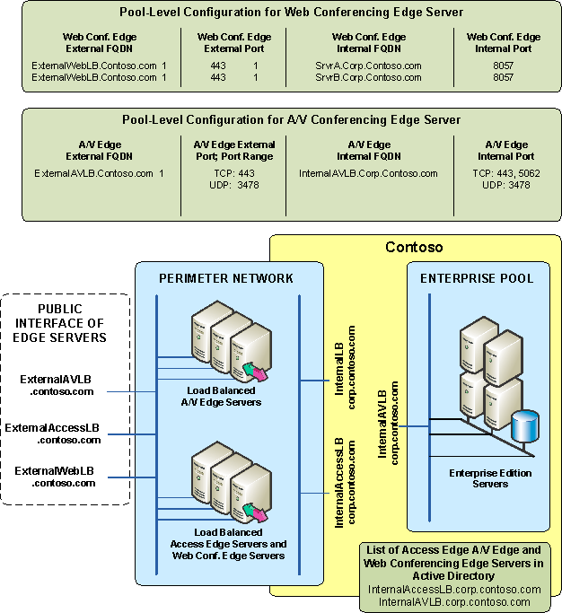

DNS records
The following DNS SRV records are required by the Access Edge Server:
- If you are enabling public IM connectivity or using DNS based discovery for your Access Edge Server, an external SRV record for all edge servers that points to _sipfederationtls._tcp.contoso.com over port 5061 (where contoso.com is the name of the SIP domain of this organization). This SRV record should point to an A record with the external FQDN of the Access Edge Server that resolves to the VIP on the external load balancer that is used by the Access Edge Servers. In this example, because there is only one SIP domain, only one SRV record like this is needed. If you have multiple SIP domains, you need a DNS SRV record for each. This is required only if you are enabling public IM connectivity or want to allow other organizations that want to federate with your organization to discover your Access Edge Server by using DNS.
- If you are enabling remote user access to IM and presence, a DNS SRV (service location) record for _sip._tls.contoso.com over port 443 where contoso.com is the name of your organization’s SIP domain. This SRV record must point to an A record with the external FQDN of the Access Edge Server that resolves to the VIP on the external load balancer used by the Access Edge Servers. If you have multiple SIP domains, you need a DNS SRV record for each to supports automatic configuration for remote users for instant messaging and conferencing. If you are configuring your clients manually, you do not need this DNS SRV record.
The following external DNS A records are required:
- An external A record for sip.ExternalAccessLB.contoso.com that points to the VIP address used by the Access Edge Servers on the external load balancer in the perimeter network. (One A record for each SIP domain).
- ExternalWebLB.contoso.com resolves to the VIP address used by the Web Conferencing Edge Servers on the external load balancer in the perimeter network.
- ExternalAVLB.contoso.com resolves to the VIP address used by the A/V Edge Servers on the external load balancer in the perimeter network.
The following internal DNS A records are required:
- InternalAccessLB.corp.contoso.com, points to the VIP of the internal load balancer in the perimeter network used by the Access Edge Servers.
- InternalAVLB.corp.contoso.com, points to the VIP of the internal load balancer in the perimeter network used by the A/V Edge Servers.
- InternalLB.corp.contoso.com points to the VIP of the load balancer of the Enterprise pool in which the internal A/V Conferencing Servers and Web Conferencing Servers reside.
- SrvrA.corp.contoso.com points to the internal interface of Web Conferencing Edge Server on Server A.
- SrvrB.corp.contoso.com points to the internal interface of Web Conferencing Edge Server on Server B.

Certificates
The certificates are configured in the following way:
- The external interface of the load balancer Access Edge Server has a certificate with a subject name (SN) of ExternalAccessLB.contoso.com. You would configure this certificate on server A and mark it as exportable and then import it to Server B. (Each server in the Web Conferencing Edge Server and Access Edge Server array must use the same certificate). If this organization was supporting multiple SIP domains, then each supported SIP domain would need to be added to the SAN.
- The external interface of the Web Conferencing Edge Server has a certificate with a subject name (SN) of ExternalWebLB.contoso.com. You would configure this certificate on server A and mark it as exportable and then import it to Server B. (Each server in the Web Conferencing Edge Server and Access Edge Server array must use the same certificate).
- No certificate is required on the external interface of the A/V Edge Server.
- The internal interface of each Access Edge Server has a certificate with an SN of InternalAccessLB.corp.contoso.com. This certificate is shared with the internal edge of the Web Conferencing Edge Server You would configure this certificate on server A and mark it as exportable and then import it to Server B. (Each server in the Web Conferencing Edge Server and Access Edge Server array must use the same certificate).
- The internal edge of the A/V Edge Server has a certificate with an SN of InternalAVLB.corp.contoso.com. You would configure this certificate on server C and mark it as exportable and then import it to Server D. (Each server in the A/V Edge Server array must use the same certificate).
- The internal edge of the A/V Edge Server is configured with an additional certificate used for A/V authentication. The same A/V authentication certificate must be installed on each A/V Edge Server. This means that the certificate must be from the same issuer and use the same private key. For this reason, the same certificate must be imported on all A/V Edge Servers in the array.
Internal Web Conferencing Servers in Your Enterprise Pool:
- Each internal Web Conferencing Server in the Enterprise pool has a certificate with the subject name (SN) of InternalLB.corp.contoso.com.
Internal A/V Conferencing Servers:
- Each internal A/V Conferencing Server has a certificate with the subject name (SN) of InternalLB.corp.contoso.com.

Edge Server Configuration
The FQDN of the VIP of the load balancer, InternalLB.corp.contoso.com is configured on the internal server list on each Edge Server and port 5061 is configured as the port. (With the edge server wizard, you can configure this setting, or this setting can be configured on Computer Management on the Internal tab of the edge server properties page.)

Trusted Edge Server List in Active Directory
The trusted edge server list in Active Directory is configured when you run the Configure Pool or Server wizard and configure external access or you can configure it manually on the Edge Server tab in Global Properties. (See the Microsoft Office Communications Server 2007 Administration Guide for step-by-step instructions) This list defines edge servers that internal servers allow to connect to them. The FQDN of each VIP on the internal load balancer of the edge servers must be added to this list. In this example: InternalAccessLB.corp.contoso.com and InternalAV.corp.contoso.com.

Web Conferencing Edge Servers Configured on the Pool or Server
The list of trusted Web Conferencing Edge Servers contains an entry for each Web Conferencing Edge Server with its internal and external FQDN and port number. These entries are configured when you run the Configure Pool or Server wizard and configure external access or you can configure these entries manually on the Web Conferencing Edge Server tab in the pool or server properties.
In the example, the internal pool would have these entries
Server A:
Internal FQDN: SrvrA.corp.contoso.com
Internal port: 8057
External FQDN ExternalWebLB.contoso.com
External port: 443
Server B:
Internal FQDN: SrvrB.corp.contoso.com
Internal port: 8057
External FQDN ExternalWebLB.contoso.com
External port: 443

A/V Edge Servers Configured on the Pool or Server
The list of trusted A/V Edge Servers are defined at the global level and the pool uses these settings when you configure your Standard Edition Server or Enterprise pool. Additionally, you specify the internal FQDN of the A/V Edge Server used by this server or pool. You can also update the A/V Edge Server used by your server or pool manually on the A/V Edge Server tab in the pool or server properties.
In the example, the internal pool would have these entries that apply to all servers in the pool:
Internal FQDN: InternalAVLB.corp.contoso.com
Internal port: TCP: 443, 5062, UDP:3478
External FQDN: ExternalAVLB.contoso.com
External port: TCP: port 443 UDP: port 3478

Configuring Your Load Balancer for Edge Servers
After configuring edge servers in the perimeter network of your data center, ensure that they are correctly connected to the load balancer, and then ensure that the ports listed in the following tables are open on the internal interface of the load balancer and on the external interface of the load balancer, respectively.
Table 78 Internal Load Balancer Port Settings
Component | Port
Access Edge Server | TCP 5061  Note: No Access Edge Server is deployed in a scaled remote-site edge topology so this setting is not necessary.
Web Conferencing Edge Server | N/A
A/V Edge Server | TCP 5062 TCP 443, UDP 3478

Table 79 External Load Balancer Port Settings
Component | Port
Access Edge Server | TCP 5061, 443  Note: No Access Edge Server is deployed in a scaled remote-site edge topology so this setting is not necessary.
Web Conferencing Edge Server | TCP 443
A/V Edge Server | TCP 443, UDP 3478

Step 8. Plan for VoIP
Planning for Enterprise Voice differs from other Office Communications Server planning tasks in that you must consider the impact on both your telephony and IP infrastructures. Microsoft’s software-powered VoIP solution, however, has a modest hardware requirement and does not require replacing your existing PBX.
The topics in this section will help you to:
- Determine the number and distribution of users.
- Select the deployment option that best fits your organization.
- Determine the number and distribution of media gateways that your organization requires.
- Define routing rules and user privileges for you Enterprise Voice deployment.
- Plan for call notification, voice mail, and other call services provided by Exchange Unified Messaging.
- Move users to Enterprise Voice.

Determine the Number and Distribution of Users
The total number of users to be enabled for Enterprise Voice is less important than the distribution of users among the locations where your organization conducts business.
For each location, you will need to:
- Determine valid dialing patterns for each location and create location profiles consisting of normalization rules that convert those patterns to E.164 format.
- Estimate call traffic and decide on the size, number, and location of the media gateways that will be required. See Plan for Media Gateways.
- Enable users for Enterprise Voice and create voice policies that specify the types of calls various individuals and user groups are allowed to make.

Select a Deployment Option
Enterprise Voice provides several deployment scenarios that address various deployment strategies, timelines, and existing telephony investments. These scenarios fall into two groups:
- Communications Server-PBX Coexistence
- Communications Server stand-alone

Communications Server-PBX Coexistence
This option involves a PBX coexisting with Office Communications Server 2007 and Office Communicator 2007 to provide a flexible and powerful combination of traditional telephony and the benefits of unified communications, including rich audio, intuitive call control, enhanced presence notification, and the ability to communicate directly from Microsoft Office applications.
This Communications Server-PBX Coexistence option offers two alternatives:
- Native IP-PBX integration
- TDM-PBX integration through a media gateway

Native IP-PBX Integration
Native IP-PBX integration refers to full coexistence between Communications Server and a PBX that natively supports SIP and IP media in a format that is interoperable with Microsoft Enterprise Voice. With native PBX integration, all users in an organization can make and receive phone calls using their existing desktop PBX phone or Office Communicator 2007.
A call is anchored on the system that originates the call. Calls from the PSTN or internal PBX phones are anchored on the PBX; Calls initiated in Communicator are anchored on Office Communications Server. The system anchoring a call is configured to “fork” the call to the other system in addition to ringing its own endpoints. All signaling and media is terminated and normalized on the Mediation Server, which mediates both signaling and media between the two systems.
The following diagram shows a typical topology for PBX Integration:
Figure 28 Native IP-PBX integration deployment option
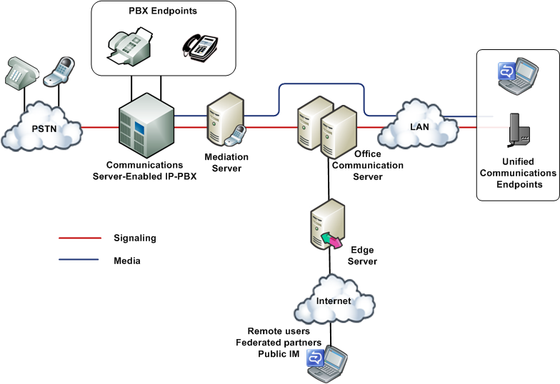

PBX integration is possible only with an IP-PBX that natively supports SIP and internet protocol media in a form that is interoperable with Communications Server.
Only the latest IP-PBX models will support native PBX integration and even then it is likely that a software upgrade will need to be provided by the PBX vendor. These next-generation IP-PBXs are being developed by several third-party vendors (for a list of vendors, see http://r.office.microsoft.com/r/rlidOCS?clid=1033&p1=IPpbxVend). For information about the availability and functionality consult each vendor directly.
The following simple call scenarios demonstrate how PBX integration works:
Outside Call to Internal User Bob calls Alice from the PSTN. The call is routed by the PSTN service provider to the enterprise PBX, which rings Alice’s desktop PBX phone and also forks the call to Office Communications Server. The PBX forks the call by translating the incoming call alert to a SIP INVITE transaction and passing this request to the Mediation Server that connects it with Office Communications Server. In turn, Office Communications Server performs reverse number lookup on the called number to obtain all of Alice’s registered SIP endpoints and, upon finding them, “rings” all the endpoints. Alice has the choice of answering the call on whichever endpoint device is most convenient. When Alice answers the call on one of her endpoints, all other endpoints stop ringing.
Ann, a mobile worker, calls Alice from her laptop by clicking on Alice’s name in her Communicator Contacts List. The call takes the form of a SIP INVITE request. Office Communications Server performs reverse number lookup on the called number and rings all of Alice’s SIP endpoints. Office Communications Server also forks the call to the PBX, which understands SIP and therefore uses the TEL URI to ring Alice’s desktop PBX phone. Once again, Alice has the option of answering the call on whichever device is most convenient.
Internal Calls Among Users Because all internal users are enabled for both PBX and VoIP calls, the device each user chooses to place a call determines which system handles the routing. If Alice uses her PBX phone to call Dan’s extension, the call will be routed to Dan’s desktop phone by the PBX. But the PBX will also fork the call to Office Communications Server, which will route the call to all Dan’s SIP endpoints.
If Alice uses Communicator or a SIP phone to make the call, the SIP INVITE is sent to Office Communications Server, which routes the INVITE to all Dan’s SIP endpoints and also forwards it to the PBX, which rings Dan’s desktop PBX phone.
Internal Call to Outside User The routing of calls to external numbers depends on routing rules that are configured on both the PBX and Office Communications Server. Routing rules may be configure on Office Communications Server to route calls to phone numbers to the PBX or to a media gateway, if deployed.
Voice Mail Users who are enabled for PBX integration, do not have access to Office Communications Server voice mail. Therefore, when deploying PBX integration, you should plan to keep the voice mail system on your PBX. If you eventually retire the voice mail system on your PBX, you can then disable PBX integration and reconfigure voice mail on Exchange Unified Messaging, as described in this guide.
Call Forwarding Call forwarding can be configured on either Communicator or the PBX phone or both. If both are configured, then both should point to the same destination.
Conferencing Conference calls are established on the system that initiates the conference. If Communicator establishes a conference on the Office Communications Server A/V Conferencing Server, PBX telephones are enrolled in the conference by means of “dial out” as an outbound call leg. If a PBX user initiates a PBX conference, an Enterprise Voice user can join or be “dialed in” to the conference as a normal inbound or outbound call leg.
RCC RCC allows users to use Communicator to monitor and control their PBX phones. This feature is disabled for Enterprise Voice, but remains available with PBX integration. If you have previously implemented RCC for your Office Communications Server users, there is no need to change that setting when you enable them for PBX integration.

TDM-PBX Integration Through a Media Gateway
In order to enable the coexistence scenario, in the event you have TDM-PBX infrastructure that supports forking of calls, an alternative approach is to deploy a Microsoft-certified media gateway or gateway/Mediation Server combination between Office Communications Server and the PBX. A number of these media gateways are available within the Microsoft Unified Communications Media Gateway partner program (for the current list, see http://r.office.microsoft.com/r/rlidOCS?clid=1033&p1=IPpbxVend). These media gateways interoperate with the Office Communications Server Mediation Server by means of SIP and IP media and with the PBX by means of various telephony protocols.

Figure 29 TDM-PBX Integration Through a Media Gateway
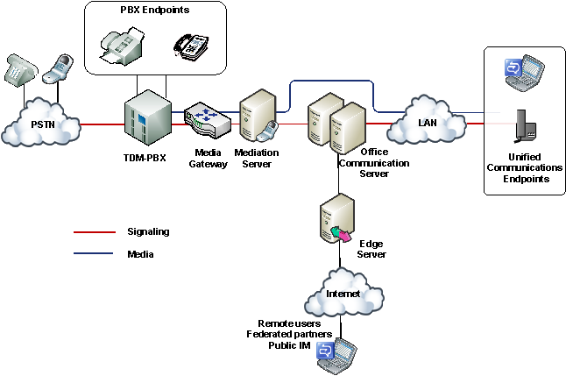

Communications Server Stand-Alone
Three deployment scenarios use Office Communications Server 2007 as the sole telephony solution for part or all of an organization. These scenarios include the following deployments:
- Departmental deployment
- Greenfield deployment
The following topics describe these scenarios in detail.

Departmental Deployment
In this scenario, Office Communications Server is deployed as the sole telephony solution for individual teams or departments, while the rest of the users in an organization continue using a PBX. This incremental deployment strategy provides one way to introduce IP telephony into your enterprise through controlled pilot programs. Workgroups whose communication needs are best served by Microsoft Unified Communications are moved to Enterprise Voice, while other users remain on the existing PBX. Additional workgroups can be migrated to VoIP as needed.
The departmental option is recommended for clearly defined user groups that share communication requirements in common and lend themselves to centralized management. This option is also attractive for teams or departments that are spread over wide geographic areas, where the savings in long-distance charges can be significant. In fact, this option is useful for creating virtual teams whose members may be scattered across the globe. Such teams can be created, amended, or disbanded in rapid response to shifting business requirements.
The following figure shows the generic topology for deployment of Enterprise Voice behind a PBX. This is the recommended topology for departmental deployment.
Figure 30 Departmental migration option
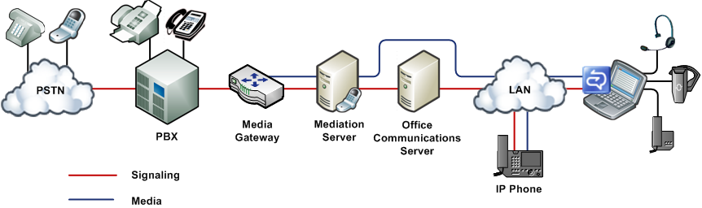

In this topology, selected departments or workgroups are enabled for VoIP. A media gateway links the VoIP-enabled workgroup to the PBX. Users enabled for VoIP, including remote workers, communicate across the IP network. Calls by VoIP users to the PSTN and to coworkers who are not enabled for VoIP are routed to the appropriate media gateway. Calls from colleagues who are still on the PBX system, or from callers on the PSTN, are routed to the media gateway, which forwards them to Office Communications Server 2007 for routing.
There are two recommended topologies for connecting Enterprise Voice with an existing PBX infrastructure for interoperability:
Enterprise Voice behind the PBX. In this topology, all calls from the PSTN arrive at the PBX, which routes calls to Enterprise Voice users to a media gateway, and calls to PBX users in the usual way. The following table shows the advantages and disadvantages of this topology.
Table 80 Advantages and disadvantages of deploying Enterprise Voice behind PBX
Advantages | Disadvantages
PBX still serves users not enabled for Enterprise Voice. | If necessary, tie line board in PBX must be added for gateway connection.
PBX handles all legacy devices. | PBX must be configured to route Enterprise Voice numbers to gateway.
Users can keep same phone numbers.

Enterprise Voice in front of the PBX. In this topology, all calls arrive at the media gateway, which routes calls for Enterprise Voice users to Office Communications Server and calls for PBX users to the PBX. Calls to the PSTN from both Enterprise Voice and PBX users are routed over the IP network to the most cost-efficient media gateway. The following table shows the advantages and disadvantages of this topology.
Table 81 Advantages and disadvantages of deploying Enterprise Voice in front of PBX
Advantages | Disadvantages
PBX still serves users not enabled for Enterprise Voice. | Existing gateways may not support desired features or capacity.
PBX handles all legacy devices. | It may be necessary to rehome trunks from the local exchange carrier to point to media gateway.
Enterprise Voice users keep the same phone numbers.

The remote worker option and departmental option both assume that you have an existing PBX infrastructure and intend to introduce Enterprise Voice incrementally to smaller groups or teams within your organization. The greenfield option assumes that you are considering deploying Enterprise Voice at a site without traditional telephony infrastructure.

Greenfield Deployment
Enterprise Voice provides new businesses or even new office sites for existing businesses with the opportunity to implement a full-featured VoIP solution without having to worry about PBX integration or incurring the substantial deployment and maintenance costs of an IP-PBX infrastructure. This solution supports both on-site and remote workers.
In this scenario, all calls are routed over the IP network. Calls to the PSTN are routed to the appropriate media gateway. Communicator or Communicator Phone Edition serve as softphones. RCC is unavailable and unnecessary because there are no PBX phones for users to control. Voice mail and auto-attendant services are available through the optional deployment of Exchange Unified Messaging.
Note
In addition to the network infrastructure that is required to support Communications Server 2007, a greenfield deployment may require a small PBX to support fax machines and analog or ISDN devices. In certain scenarios this may require a new PRI (Primary Rate Interface) link with a new set of numbers.
The following figure shows a typical topology for a greenfield deployment.
Figure 31 Greenfield deployment option

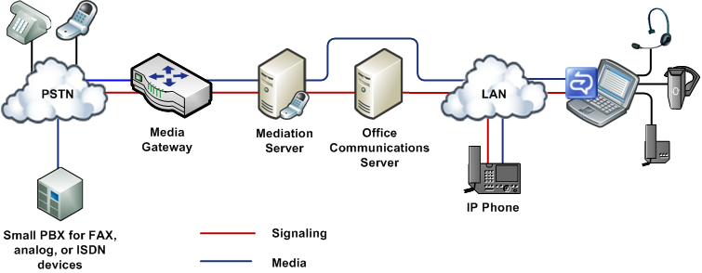

Migration Paths and Integration Strategies
The following table lists the requirements and recommended deployment steps for the deployment options described in Figure 29.
Table 82 Enterprise Voice Deployment Options
Deployment Option | Requirements | Deployment Steps
PBX coexistence | IP-PBX that natively supports SIP and IP media in a format that is interoperable with Office Communications Server.  OR  A PBX combined with a media gateway that connects the PBX to the Communications Server infrastructure.  A/V Edge Server for media relay across NATs and firewalls.  Mediation Server configured with the IP address of the PBX and the FQDN of the A/V Edge Server.  Users enabled for Enterprise Voice and PBX integration.  Voice Mail configured on PBX. | - Deploy Office Communications Server, including Mediation Server that connects to PBX.  - Deploy Office Communicator 2007.  - Enable users for IM and presence.  - Configure Communications Server for Enterprise Voice.  - Configure PBX to fork calls to Communications Server.  - Deploy media gateways (if required).  - Deploy RCC gateway (if required).  - Enable users for Enterprise Voice and PBX integration.
Stand-Alone Options
Departmental | IP-or TDM PBX.  Basic, basic hybrid, or advanced media gateway configured to connect departmental deployment with PBX.  Additional other gateways as required for PSTN connections.  A/V Edge Server for media relay across NATs and firewalls.  Mediation server configured with IP address of basic or basic hybrid media gateway (not required for advanced gateway).  Users enabled for Enterprise Voice.  Call forwarding independently configured separately on Communicator and PBX.  Exchange UM deployed and configured to provide voice mail for Enterprise Voice users (PBX continues to supply voice mail for all other users). | - Deploy Office Communications Server.  - Deploy Office Communicator 2007.  - Configure Communications Server for Enterprise Voice.  - Enable users for IM and presence.  - Deploy Exchange Server 2007 Unified Messaging and configure to integrate with Communications Server.  - Deploy media gateways.  - Enable one or more subsets of users for Enterprise Voice.  - Migrate users to Enterprise Voice in one or more phases.
Greenfield | Basic, basic hybrid, or advanced media gateway configured to connect to PSTN.  A/V Edge Server for media relay across NATs and firewalls.  Mediation server configured with IP address of basic or basic hybrid media gateway (not required for advanced gateway).  Users enabled for Enterprise Voice.  Call forwarding configured on Communicator.  Exchange UM deployed and configured to provide voice mail.  A small PBX for fax and 911.  Additional gateway to connect to small PBX. | - Deploy Office Communications Server.  - Deploy Office Communicator 2007.  - Configure Communications Server for Enterprise Voice.  - Deploy Exchange Server 2007 Unified Messaging and configure to integrate with Communications Server.  - Deploy media gateways.  - Enable users for Enterprise Voice.
PBX integration to stand-alone option  NOTE  This migration path is used only when PBX integration is used as a stepping stone to a stand-alone Communications Server deployment. | Basic, basic hybrid, or advanced media gateway configured to connect to PSTN. (If one or more gateways are already deployed, they may have to be repurposed for new role in network.)  SIP phones, such as the Communicator Phone Edition are optional. | - Deploy media gateways.  - Reassign DID numbers (if any) to media gateways.  - Deploy and configure Exchange UM. This can be done before, after, or concurrently with deployment of media gateways.  - If necessary, rename location profiles to the FQDN of their corresponding Exchange UM dial plans.  - Replace PBX desktop phones with Communicator and/or Communicator Phone Edition or other SIP clients.

Plan for Media Gateways
The number, size, and location of media gateways is perhaps the most important and potentially costly decision you must make when planning your Enterprise Voice infrastructure. The main questions to answer:
- What type of gateway should you deploy?
- How many media gateways are needed? The answer depends at least in part on the size of the gateways and where they are to be deployed.
- What size should the gateways be? The answer depends in part on how many you plan to deploy and where you plan to put them.
- Where should the gateways be located? The answer depends in part on the topology and geographic distribution of your organization.
In other words, no one of the previous questions can be answered independently of the other three. Answers to all four depend ultimately on how much telephone traffic you anticipate and how that traffic is distributed across your organization. But that is only the beginning, the base data, so to speak. You must also consider your gateway topology options.

Choosing the Type of Gateway to Deploy
Communications Server 2007 supports three types of media gateways: Advanced, Basic, and Basic Hybrid. You can find a current list of qualified gateways that work with Communications Server at http://r.office.microsoft.com/r/rlidOCS?clid=1033&p1=IPpbxVend. The advantages and disadvantages of these three gateway types are summarized in the following table.

Table 83 Basic and Collocated Gateways Compared
Gateway Type | Advantages | Disadvantages
Basic Media Gateway | Existing hardware can perhaps be used for Mediation Server. | Mediation Server entails additional overhead for installation, configuration, and management.
Basic Hybrid  Media Gateway | Does not require separate Mediation Server.  Installation, configuration, and management are simpler than for combination of Basic Media Gateway and Mediation Server.
Advanced Media Gateway | Does not require separate Mediation server. Installation, configuration, and management, are simpler than that of other gateway types

Gateway Topologies
When attempting to answer the four fundamental questions of gateway deployment listed earlier in Plan for Media Gateways, the obvious approach is to:
- Count the sites at which your organization has offices.
- Estimate the traffic at each site.
- Deploy one or more gateways at each site to handle the anticipated traffic.
The resulting distributed gateway topology is shown in the following figure.
Figure 32 Distributed gateway topology
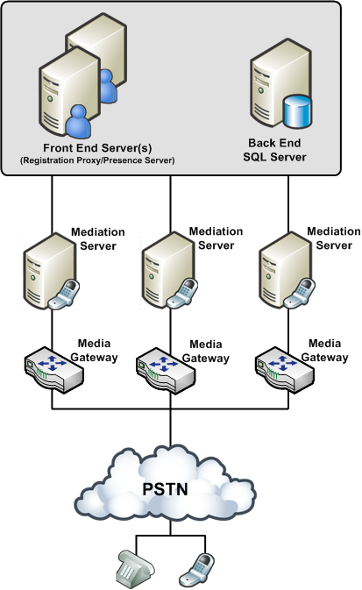
With this topology, calls among workers at each site and between the sites are all routed over the company intranet. Calls to the PSTN are routed over the enterprise IP network to the gateways that are closest to the location of the destination numbers.
But what if your organization supports dozens or hundreds or even thousands of sites spread across one or more continents, as many financial institutions and other large enterprises do? In such cases deploying a separate gateway at each site is impractical.
To address this problem, many large companies prefer to deploy one or a few large telephony data centers, as shown in the following figure.
Figure 33 Datacenter Gateway Topology
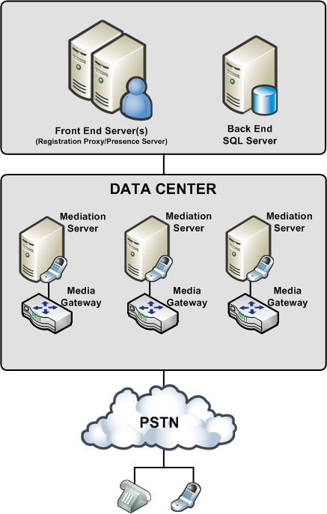

In this topology, several large gateways sufficient to accommodate the anticipated user load are deployed at each data center. All calls to users in the enterprise are forwarded by the company’s telephone service provider to a data center. Routing logic at the data center determines whether the call should be routed over the intranet or to the PSTN.
Placing a gateway at every site on the one hand or at a single data center on the other represent the extremes of a deployment continuum along which seemingly infinite combinations are possible. You can deploy single gateways at several sites and several gateways at a data center in nearly any possible combination. The best solution in each case depends on a variety of factors that are specific to each organization.

Gateway Location
Gateway location may also determine the types of gateways you choose and how they are configured. There are dozens of PSTN protocols, and these vary from country to country. If all your gateways are located in a single country, this is not an issue, but if you locate gateways in several countries, each must be configured according to the PSTN standards of that country. Moreover, gateways that are certified for operation in, say, Canada, may not be certified in India, Brazil, or the European Union.

Gateway Size and Number
The media gateways that most organizations will consider deploying range in size from 2 to as many as 960 ports. (There are even larger gateways, but these are used mainly by telephone service providers.) When estimating the number of ports your organization requires, use the following guidelines:
- Light telephony users (1 PSTN call per hour) should allocate 1 port for every 15 users. For example, if you have 20 users, you will require a gateway with 2 ports.
- Moderate telephony users (2 PSTN calls per hour) should allocate 1 port for every 10 users. For example, if you have 100 users, you will require a total of 10 ports allocated among one or more gateways.
- Heavy telephony users (3 or more PSTN calls per hour) should allocation 1 port for every 5 users. For example, if you have 47,000 users, you will require a total of 9,400 ports allocated among at least 10 large gateways.
- Additional ports can be acquired as the number of users or amount of traffic in your organization increases.
For any given number of users you must support, you have the choice of deploying fewer, larger gateways, or smaller ones. As a rule, a minimum of two gateways for an organization is recommended in the event one goes down. Beyond that, the number and size of gateways that an organization deploys are going to vary widely, based on a careful analysis of each organization’s volume of telephone traffic.
Each basic media gateway that you deploy must have at least one corresponding Mediation Server. It is possible, though not recommended, to point a single gateway to multiple Mediation Servers, but you cannot point a single Mediation Server to more than one media gateway.
For specific hardware requirements, review the Hardware Requirements and Scaling Numbers for Mediation Server section earlier in this document.
Note
A basic hybrid media gateway is configured to work only with the collocated Mediation Server and therefore should not be pointed to other Mediation Servers.

Gateway Configuration
The settings that you must configure on your Basic Media Gateway are specified in the following list, but for information about how to configure these settings on a given gateway, refer to the manufacturer’s product documentation. Each gateway must be configured according to the vendor’s documentation. Depending on the vendor, there are potentially many attributes that must be set, but the attributes specific to Enterprise Voice are as follows:
- The FQDN and IP Address of the Mediation Server that is associated with the gateway.
- The listening port (5060) that is used for TCP connections to the Mediation Server
Important
The previous settings must match those of corresponding settings for the Mediation Server. If the settings do not match, the connection between the gateway and Mediation Server will fail.
- SIP Transport – specify either TLS (recommended) or TCP.
Important
If you specify TLS as the SIP transport to be used by your basic or basic-hybrid media gateway, you must also configure the corresponding Mediation Server for TLS.
- If the SIP transport for the link between the gateway and the Mediation Server is set to TLS, the gateway must be configured with a certificate for purposes of authentication during the MTLS handshake with the Mediation Server. The certificate on the gateway must be configured as follows:
- The certificate may be directly signed by the trusted CA configured in the Mediation Server. Alternatively, a certificate chain may have to be traversed to verify the certificate provided by the gateway. The gateway must provide this chain as part of its TLS handshake with the Mediation Server.
- The CN part of the subject field should be set to the FQDN of the gateway. If the FQDN in the CN part of the subject field does not match the expected and configured FQDN for the gateway, the certificate must also contain a SAN (subject alternate name) that lists the expected and configured FQDN for the gateway.
The Mediation Server validates the certificate provided by the gateway by checking that the FQDN on the certificate exactly matches the gateway FQDN configured on the Mediation Server. If the FQDNs do not match, the session is terminated. Additional validation includes checking the signature and expiration date, and making sure that the certificate has not been revoked.
- If the SIP transport for the link between the gateway and the Mediation Server is set to TLS, separate ports must be opened for the TLS connection to the gateway and the TLS connection to the Office Communications Server pool. The port assignments should be configured as follows:
- TLS link between media gateway and Mediation Server: 5060
- TLS link between Mediation Server and Office Communications Server pool:5061
- Each gateway must be configured so that the E.164 numbers routed by Enterprise Voice to the gateway are normalized to a locally dialable format.
- Each gateway must also be configured to pass only E.164 numbers to the Mediation Server. Please see each gateway vendor’s documentation for specific instructions on how to normalize source phone numbers to E.164.
- Each gateway should be configured to convert the source number (the number presented as caller id) to a normalized E.164 number. This ensures the caller ID can be matched to a Communicator contact, an Outlook contact, or a member of the corporate directory, thereby enabling Communicator to provide additional information about the caller. This number will also appear in e-mails notifying the user of missed calls and voice mail, allowing the user to click the phone number in order to quickly return a call. If the number has been normalized by the gateway, no further processing is required. If for some reason the number cannot be normalized by the gateway, then the normalization rules defined by the location profile will be applied when returning a call. It might be necessary to add normalization rules to a location profile to handle numbers that cannot be normalized by the gateway. Please see each gateway vendor’s documentation for specific instructions on how to normalize source phone numbers to E.164.
For a list of media gateway vendors, see http://r.office.microsoft.com/r/rlidOCS?clid=1033&p1=IPpbxVend.

Configure Dual Interface Cards for Mediation Server
To help ensure the physical as well as logical separation of your Enterprise Voice infrastructure from the media gateways, you should install Mediation Server on a computer that is equipped with two network interface cards (NICs). One card faces the gateway; the second card faces the Communications Server 2007 server that acts as the Mediation Server’s internal next hop.
When you install Mediation Server, the Deployment Wizard detects the presence of the two network cards and writes their IP addresses to the Communications Server listening IP address list and the Gateway listening IP address list, both on the General tab of the Mediation Server properties dialog box.
The Communications Server listening IP address is the address on an advanced media gateway that listens for call traffic from Communications Server. Until advanced media gateways are available, this address corresponds to the network card that serves as the internal edge of the Mediation Server.
Important
The IP address that you select from the Communications Server listening IP address must match the address that is returned by a DNS query on the Mediation Server’s FQDN. If the two addresses do not match, the IP address listed in DNS for your FQDN you will not be able to connect, and call traffic will be directed to an interface that isn’t listening for Office Communications Server traffic rather than to the one that is listening.
The Gateway listening IP address is the address on the Mediation Server that lists traffic from a basic media gateway or Basic Hybrid Media Gateway. For Communications Server 2007, this address corresponds to the network card that serves as the external edge of the Mediation Server.
Note
It is possible to configure both edges on a single adapter card, but this alternative is not recommended.

Media Bandwidth
For basic media gateways, the bandwidth requirement between gateway and Mediation Server is 64 Kbps for each concurrent call. Multiplying this number by the number of ports for each gateway is a fair estimate of the required bandwidth on the gateway side of the Mediation Server. On the Communications Server side, the bandwidth requirement is considerably lower.
When configuring Mediation Server, you are advised to accept the default media port gateway range of 60,000 to 64,000. Reducing the port range greatly reduces server capacity and should be undertaken only for specific reasons by an administrator who is knowledgeable about media port requirements and scenarios. For this reasons, altering the default port range is not recommended.
High-bandwidth traffic such as voice and video tends to stress poorly provisioned networks. Limiting media traffic to a known range of ports makes troubleshooting such problems easier.

Media Security
Because a media gateway receives calls from the PSTN, it presents a potential security vulnerability. The recommended mitigation is to:
- Enable TLS on the link between the gateway and the Mediation Server. This will assure that signaling is encrypted end to end between the gateway and your internal users.
- Physically isolate the media gateway from the internal network by deploying the Mediation Server on a computer with two network interface cards: one accepting traffic only from the internal network; the second accepting traffic from a media gateway. Each card is configured with a separate listening address so that there is always clear separation between trusted traffic originating in the Communications Server network and untrusted traffic from the PSTN.
The internal edge of a Mediation Server should be configured to correspond to a unique static route that is described by an IP address and a port number. The default port is 5061.
The external edge of a Mediation Server should be configured as the internal next-hop proxy for the media gateway. It should be identified by a unique combination of IP address and port number. The IP address should not be the same as that of the internal edge, but the default port is 5060.

Encryption
Media flowing both directions between the Mediation Server and Communications Server network is encrypted using SRTP.
Organizations that rely on IPSec for packet security are strongly advised to create an exception on a small media port range if they are to deploy Enterprise Voice. The security negotiations required by IPSec work fine for normal UDP or TCP connections, but they can slow down call setup to unacceptable levels.

Plan for User Authorization and Outbound Call Routing
Outbound call routing applies to calls that are destined for a PBX or the PSTN. User authorization refers to policies that specify which users have permission to place calls along which routes.
To configure user authorization and outbound call routing for your organization, you must create the following Active Directory objects:
Table 84 Communication Server Active Directory Objects for Enterprise Voice
Object | Description
Location profile | A location profile defines all phone numbers that can be dialed from a named location. A location contains one or, typically, more normalization rules.
Normalization rule | A normalization rule is a .NET regular expression that defines a phone number pattern. A set of normalization rules associated with a particular location constitute a location profile.
Phone usage record | A phone usage record specifies a class of call (internal, local, long distance, or whatever) that can be made by various users, or groups of users, in an organization.
Voice policy | A voice policy associates one or more phone-usage records with one or a group of users.
Route | A voice route associates target phone numbers with particular IP-PSTN gateways and phone usage records.

The following figure illustrates the relationship among the various routing components. You may find it helpful to refer to this diagram as you go through the configuration process.
Figure 34 Configuring Outbound Routing
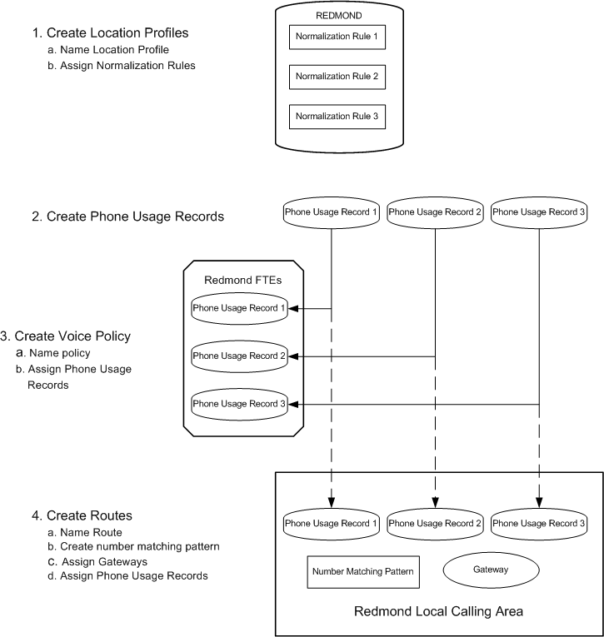
You use the Office Communications Server 2007 Administrative Tools to create the Active Directory objects shown in the previous figure. The following topics explain how to configure outbound call routing for your organization and the issues you need to consider when you do so.

Location Profiles
Planning location profiles consists of:
- Listing all the locales in which your organization has an office.
In a large multinational company with numerous small branch offices this can be a time-consuming task. The list must be up to date and complete. It will need to be revised as company organization evolves.
- Identifying valid number patterns for each locale.
The most time-consuming part of planning your location profiles is identifying the valid number patterns for each location. In some cases, you may be able to copy normalization rules that you have written for one location profile to other location profiles, especially if the corresponding locales are within the same country or even on the same continent. In other cases, small changes may be enough to make normalization rules appropriate in other locations.
- Developing an organization-wide scheme for naming location profiles and their corresponding Exchange Server 2007 UM dial plans.
Adopting a standard naming scheme assures that names assigned to location profiles and their corresponding UM dial plans are consistent across the organization and over time, regardless of who or how many people are doing the work.
- Deciding whether multiple location profiles are required for a single location.
If your organization maintains a single dial plan across multiple locations, you may still need to create a separate dial plan for Enterprise Voice users who are migrating from a PBX and need to have their existing extensions retained.
- Deciding whether to deploy Exchange UM before or after you have created location profiles.
If you deploy Exchange UM before you create location profiles (recommended), then assigning names to location profiles consists simply of using the FQDN of their corresponding dial plans.
If you create location profiles before you deploy Exchange UM, you have two main options:
- Rename the location profiles later, when you know the FQDNs of their corresponding UM dial plans.
- Duplicate existing location profiles and rename the copies with the FQDNs of their corresponding UM dial plans. You can keep the old location profiles, so long as you use the new ones when configuring Exchange UM.
- Assigning location profiles to Communications Server Front End Server, Enterprise Edition Pool, and Mediation Servers (or Advanced Media Gateways).
Mediation Servers use location profiles to convert incoming numbers from a national number format to E.164 format for purposes of routing to Communications Server. Each Communications Server 2007 Front End Server and pool must be associated with a location profile to determine how outgoing calls to the PSTN or a PBX are to be routed.
- Determining whether you will need to configure your location profiles to handle scenarios in which Exchange UM initiates calls on a user’s behalf. For more information about this issue, along with the pros and cons of two options, see Configuring Location Profiles for Exchange UM Call Initiation Scenarios.
When you create a location profile, you must provide a name, a description, and a set of normalization rules.

Name
A location profile name normally should reflect the location to which it applies, and within certain constraints the choice is yours. However, integrating Exchange UM with Communications Server imposes an additional requirement on location profile names; namely, that they match the FQDNs of their corresponding UM dial plans. For example, if the name of a UM dial plan is, say, “London”, then the name of the corresponding location profile must be London.forestFQDN, where forest FQDN is the forest in which the UM dial plan is located.
These values are captured in the phone-context attribute of the Exchange UM dial plan. For example, if the Exchange UM dial plan name is, say, London, then the phone-context attribute is set to London.forestFQDN. And if the forest FQDN is Contoso.com, then the name of the London location profile should be London.Contoso.com.
With regard to naming location profiles, you have two deployment options:
Regardless of the order of deployment, a separate location profile must exist for each Exchange UM dial plan. If the same dial plan name is used in multiple Exchange forests, a matching location profile must be created that matches the UM dial plan FQDN for each forest.
The OCSUMUtil tool that is included with Office Communications Server 2007 can be used to validate location profile names. The tool does not correct invalid names; it simply alerts you to the need to do so.

Note
If you are not deploying Exchange 2007 Unified Messaging, then you can, with only a few constraints, give whatever name you like to a location profile, so long as that name is unique.

Description
We recommend that you type the common, recognizable name of the geographic location to which the corresponding location profile applies. For example, if the location profile name is London.Contoso.com, then the recommended Description would be London. If you have deployed the Office Communicator 2007 Phone Edition, the name in this field will be displayed to end users for the purpose of allowing them to select the appropriate location profile for a call.

Normalization rules
Normalization rules specify how to convert numbers dialed in various formats to standard E.164 format. Normalization rules are necessary for call routing and authorization because users can, and do, use various formats when entering phone numbers in their contact lists.
Normalizing user-supplied phone numbers provides a consistent format that facilitates:
- Matching a dialed number to the intended recipient’s SIP-URI.
- Applying dialing authorization rules to the calling party.
The following number fields are among those that your normalization rules may need to account for:
- Dial plan
- Country Code
- Area Code
- Length of extension
- Site prefix
You create normalization rules in the Communications Server 2007 snap-in for MMC, using .NET Regular Expressions. The following table shows sample normalization rules that are written as .NET regular expressions. The samples are examples only and are not meant to be a prescriptive reference for creating normalization rules.
Table 85 Normalization Rules Using .NET Regular Expressions
Rule Name | Description | Number Pattern | Translation | Example
4digitExtension | Translates 4-digit extensions | ^(\d{4})$ | +1425555$1 | 0100 is translated to +14255550100
5digitExtension | Translates 5-digit extensions | ^5(\d{4})$ | +1425555$1 | 50100 is translated to +14255550100
7digitcallingRedmond | Translates 7-digit numbers to Redmond local number | ^(\d{7})$ | +1425$1 | 5550100 is translated to +14255550100
7digitcallingDallas | Translates 7-digit numbers to Dallas local number | ^(\d{7})$ | +1972$1 | 5550100 is translated to +19725550100
10digitcallingUS | Translates 10-digit numbers in US | ^(\d{10})$ | +1$1 | 2065550100 is translated to +12065550100
LDCallingUS | Translates numbers with LD prefix in US | ^1(\d{10})$ | +$1 | 12145550100 is translated to +12145550100
IntlCallingUS | Translates numbers with international prefix in US | ^011(\d*)$ | +$1 | 01191445550100 is translated to +91445550100
RedmondOperator | Translates 0 to Redmond Operator | ^0$ | +14255550100 | 0 is translated to +14255550100
RedmondSitePrefix | Translates numbers with on-net prefix (6) and Redmond site code (222) | ^6222(\d{4})$ | +1425555$1 | 62220100 is translated to +14255550100
NYSitePrefix | Translates numbers with on-net prefix (6) and NY site code (333) | ^6333(\d{4})$ | +1202555$1 | 63330100 is translated to +12025550100
DallasSitePrefix | Translates numbers with on-net prefix (6) and Dallas site code (444) | ^6444(\d{4})$ | +1972555$1 | 64440100 is translated to +19725550100

The normalization rules contained in location profiles are used by the Communicator Phone Edition to optimize the user’s dialing experience. When the Communicator Phone Edition is off hook while a user is entering digits, it uses the rules contained in the location profile to determine if sufficient digits have been entered in order to generate an INVITE request to Communications Server.
For detailed information about using .NET regular expressions, see .NET Framework Regular Expressions.
The following table illustrates a sample location profile for Redmond, Washington, USA, based on the normalization rules shown in the previous table.
Table 86 Redmond location profile based on normalization rules shown in the previous table
Redmond.forestFQDN
5digitExtension
7digitcallingRedmond
10digitcallingUS
IntlCallingUS
RedmondSitePrefix
NYSitePrefix
DallasSitePrefix
RedmondOperator

Note
The normalization rules names shown in the preceding table do not include spaces, but this is a matter of choice. The first name in the table, for example, could have been written “5 digit extension” or “5-digit Extension” and still be valid.

Phone Usage Records
Configuring Location Profiles for Exchange UM Call Initiation Scenarios
Multiple scenarios, such as playing a voice message on the phone or calling a personal contact, require Exchange UM to initiate calls on a user’s behalf. Often, the targets of such calls are users in the GAL or people in a user’s personal contacts. Calls initiated by UM are routed through Communications Server, just like calls from other clients.
When Exchange UM SP1 sends an E.164 number to Communications Server, UM does not pass the prefixed plus sign (+) required for E.164 numbers. To work around this problem, two options are available to administrators:
Option 1: Define one location profile for both UM and Communications Server clients.
This option requires that you add rules to the location profile that identify E.164 numbers whose plus sign (+) prefix is missing. For example, a Redmond, WA, USA, location profile might require a rule that prefixes the plus sign (+) to all 11-digit numbers starting with the number 1. In practice, formulating rules that correctly identify all instances of E.164 numbers whose initial plus sign (+) is missing can be difficult and time-consuming.
This is the recommended option when the dial patterns are similar across Communications Server clients and UM (for example, when there is no requirement for an off-net prefix).
Even when dialing patterns are not similar across Communications Server clients and UM, administrators have the option of defining and ordering normalization rules to cater to both scenarios. This approach introduces additional complexity, but enables Communications Server clients to make calls from Outlook contact lists, even if the number format does not adhere to the normal dial plan.
Option 2: Define two location profiles - one that translates numbers from Communications Server clients, and another one that translates numbers from Exchange UM.
This option eliminates the complexity of having to assure that a single location profile accounts for two sets of dialing patterns, one from Exchange UM, the other from Communications Server clients. The disadvantage is the need to configure and maintain two location profiles.
Planning phone usage records consists mainly of listing all the call permissions that are currently in force in your organization, from the CEO down to temporary workers, consultants, and contingent staff. This process also provides an opportunity to re-examine existing permissions and revise them if desired. You can create phone usage records only for those permissions that apply to your anticipated Enterprise Voice users, but a better long-range solution might be to simply create phone usage records for all permissions regardless of whether some may not currently apply to the group of users to be enabled for Enterprise Voice. If permissions change or new users with different permissions are added, you will have already created the required phone usage records.
The following table shows a typical phone usage table:
Table 87 Phone Usage Records
Phone Attribute | Description
Local | Local calls
Long-Distance | Long distance calls
International | International calls
Delhi | Delhi full-time employees
Redmond | Redmond full-time employees
RedmondTemps | Redmond temporary employees
Zurich | Zurich full-time employees

By themselves, phone usage records don’t do anything. For them to work, you must associate them with:
- Voice policies, which are assigned to users.
- Routes, which are assigned to phone numbers.
The following two topics describe voice policies and routes.

Voice Policies
Enterprise Voice policies are essentially collections of phone usage records that are assigned to one or more users. Policies also include an option of enabling or disabling the simultaneous ringing feature. The simultaneous ringing feature enables users to configure Communicator such that incoming calls, in addition to ringing the users registered endpoints, also ring an additional nonregistered endpoint, such as a personal mobile phone. Normally, simultaneous ringing should be enabled, but in the event of excessive congestion, you have the ability to disable this feature.
Most organizations will have multiple voice policies, typically a default policy that applies to all users and one or more special policies that are applied on a per-user basis. You have the option of creating your own voice policies from scratch or editing existing policies.
Phone usage order is critical because in matching users to routes, the server compares phone usages from top to bottom. If the first usage matches the call route, the call is routed. The remaining phone usages provide backup in the event of route congestion or call failure.
Defining voice policies for users includes:
- Creating a default policy for your organization. This policy will apply to all users to whom you have not explicitly assigned a per user policy.
- Defining one or more per-user policies as needed.
- Adding one or more phone usage records
- Specifying whether to enable the simultaneous ringing feature for Enterprise Voice users (not available if you are enabling PBX integration).
- You create voice policies in the Communications Server 2007 MMC snap-in.
- If you want to apply a single policy to all Enterprise Voice users in your organization, then you need only to choose or customize the default policy.
- If you want to apply special policies to certain individuals or groups of Enterprise Voice users, then you must choose the “Use per user” option, and then create one or more special policies and explicitly assign them to specific individuals or groups of users. Any users to whom you do not explicitly assign a policy will be governed by the default policy.

Call Routes
Enterprise Voice Routes specify how Communications Server 2007 handles calls placed by Enterprise Voice users. When a user places a call, the server, if necessary, normalizes the phone number to E.164 format and attempts to match it to a SIP-URI. If the server is unable to make the match, it applies outgoing call routing logic based on the number. You define that logic in the form of a separate route for each set of target phone numbers that are listed in the location profile for each locale.
Before you define outbound call routes, you should have completed the following steps:
- Deployed one or more media gateways and, if necessary, Communications Server 2007, Mediation Servers.
- Created a location profile consisting of normalization rules for target phone numbers.
- Created phone usage records.
In addition, to enable outbound call routing, you must also create and assign one or more voice policies, but this step can be done either before or after you define outbound call routes.
For each route, you must specify:
- A name by which it can be readily identified.
- An optional description in cases where the name alone may not be sufficient to describe the route.
- The regular expression that identifies the target phone numbers to which the route is applied.
- The FQDNs of the gateways that can route to the target numbers.
- The phone usages that users must have in order to call numbers matching the target phone number regular expression.
You create routes in the Communications Server 2007 snap-in for MMC. These routes populate the routing table, which embodies the outbound call routing logic that is followed by the server for numbers to the PSTN.

Least Cost Routing
The ability to specify the PSTN gateways to which various numbers are routed enables you to determine which routes incur the lowest costs and implement them accordingly. The rule of thumb in selecting gateways is to choose the one closest to the location of the destination number in order to minimize long-distance charges. For example, if you are in New York and calling a number in Rome, you would carry the call over the IP network to the gateway in your Rome office, thereby incurring a charge only for a local call.

Additional Routing Logic
In creating outbound call routes, you should be aware of the following factors affecting routing logic:
- If the domain portion of the Request URI does not contain a supported domain for the enterprise, the outbound routing component on the server does not process the call. For example, In certain scenarios where a call is established over a federated boundary, the domain portion of the URI is used to route the call over to the enterprise that is responsible for applying the outbound routing logic.
- If a user is not enabled for Enterprise Voice, the server applies other routing logic as appropriate.
- If a call is routed to a gateway that is fully occupied (all trunk lines are busy) the gateway will reject the call and the Outbound Routing Component will redirect the call to the next-least-cost route. Careful consideration should be given to this because a gateway sized for a small office overseas (for example, Zurich), may actually carry a significant amount of non-local traffic for international calls to Switzerland. If the Gateway is not correctly sized for this additional traffic, calls to Switzerland may be routed by way of a gateway in Germany, resulting in larger toll charges.

Routing Configuration Examples
This section will provide guidance on routing configuration on some common scenarios, this is by no means a prescriptive guidance, but is just meant to illustrate the flexibility offered by the routing framework.
As mentioned earlier, the routing logic uses the phone usage attribute assigned to the caller as well as the dialed number in order to determine the optimal route, the following scenarios include configuration settings for phone usages for the user and routing table configuration to accomplish the desired routing behavior.
Important
The following examples demonstrate how routes are configured in Communications Server. For these routes to work, numbers routed to each gateway must be localized on the gateway, using the gateway’s administrative interface.
The following figure captures the gateway deployment and site topology that will be used to illustrate the scenarios in this section:
Figure 35 Gateway deployment and site topology
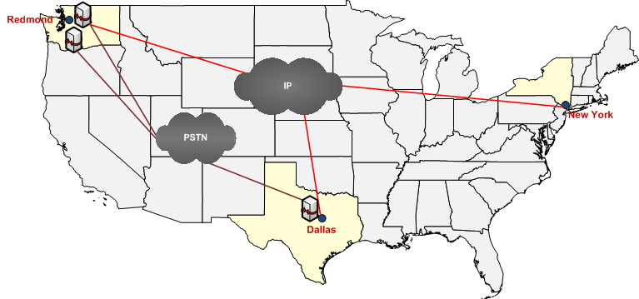
The following are the characteristics in the sample deployment:
- 3 sites (Redmond, Dallas, New York)
- Redmond site has 2 gateways (Red-GW1, Red-GW2)
- Dallas site has 1 gateway (Dallas-GW1)
The example scenarios in this section assume that the normalization rule and location profiles have been configured, and the post-translated number is what is used for the routing decision.
Note
The examples in this section assume that gateways have been deployed and configured, see the Microsoft Office Communications Server 2007 Enterprise Voice Planning and Deployment Guide for instructions on gateway deployment.

Basic Routing Setup
Assuming that a few users from Redmond, Dallas, and New York are being enabled for Enterprise Voice, here is a sample definition of a phone usages and routes that enable a very basic routing setup:
Note
The phone usage names used in the following examples omit spaces, but this is a matter of taste or convention. Spaces are valid for phone usage names.
Table 88 Sample Definition of Phone Usages
User Policy | Phone Usages
Default Calling Policy | GlobalPSTNHopoff

Route Name | Number Pattern | Phone Usages | Gateway
Universal Route | ^\+?(\d*)$ | GlobalPSTNHopoff | Red-GW1  Red-GW2  Dallas-GW1

Description:
- In the previous example, all the users that are being enabled for Enterprise Voice in the 3 sites are assigned a policy of DefaultCallingPolicy
- The illustrated route is configured to direct all calls from users with a phone usage of GlobalPSTNHopoff (users with DefaultCallingPolicy, in this example) to one of 3 gateways (the \+? indicates that the leading + is optional).

Using correct gateway for local calls
Extending the previous simple example, if administrators would like to configure the routes so that calls that are local to the context of the gateway are routed via that gateway, and other calls are routed through any of the gateways, the following configuration enables that scenario.
Table 89 User Policy
User Policy | Phone Usages
Default Calling Policy | Local  GlobalPSTNHopoff

Table 90 Routes
Route Name | Number Pattern | Phone Usages | Gateway
Redmond Local Route | ^\+1(425|206|253)(\d{7})$ | Local | Red-GW1  Red-GW2
Dallas Local Route | ^\+1(972|214|469)(\d{7})$ | Local | Dallas-GW1
Universal Route | ^\+?(\d*)$ | GlobalPSTNHopoff | Red-GW1  Red-GW2  Dallas-GW1

- All users are assigned the Default Calling Policy.
- The policy has 2 phone usage attributes, Local and GlobalPSTNHopoff. For any number dialed by users with this policy, a route matching the Local phone usage attribute is sought first before trying to match a route with the GlobalPSTNHopoff phone usage attribute.
- Redmond Local Route: This route will be used for calls made to a number that starts with ‘+1’ followed by either 425, 206, or 253, followed by 7-digits, for users with a phone usage of Local.
- Dallas Local Route: This route will be used for calls made to a number that starts with ‘+1’ followed by either 972, 214, 469, or 817, followed by 7-digits, for users with a phone usage of Local.
Examples:
- Calls made to +1425555 0100 are routed using either Red-GW1 or Red-GW2 (Redmond Local Route).
- Calls made to +1214555 0100 are routed using Dallas-GW1 (Dallas Local Route).
- Calls made to +1203555 0100 are routed using either Red-GW1, Red-GW2, or Dallas-GW1 (Universal Route).
- If Dallas-GW1 is unavailable, calls made to +1214555 0100 are routed using the Universal Route (based on using the globalPSTNHopoff phone usage).

Limit certain users to only call local numbers
This scenario illustrates an example where an administrator in Redmond would like to set up a calling policy to limit certain users in Redmond to just call local numbers in the Redmond Area.
Table 91 User Policy
User Policy | Phone Usages
Default Calling Policy | Local  GlobalPSTNHopoff
Redmond Local Policy | RedmondLocal

Table 92 Routes
Route Name | Number Pattern | Phone Usages | Gateway
Redmond Local Route | ^\+1(425|206|253)(\d{7})$ | Local  RedmondLocal | Red-GW1  Red-GW2
Dallas Local Route | ^\+1(972|214|469)(\d{7})$ | Local | Dallas-GW1
Universal Route | ^\+?(\d*)$ | GlobalPSTNHopoff | Red-GW1  Red-GW2  Dallas-GW1

- Administrators assign the ‘Redmond Local Policy’ to users for whom they would like to restrict the calling to just Redmond destinations.
- Since the only route that has the RedmondLocal phoneUsage is ‘Redmond Local Route’, that is the only authorized route for users with the ‘Redmond Local Policy.’

Source-Based Routing
There are certain situations where the administrator would like to limit the gateway that is used for calls from users from a particular location. The following configuration illustrates how this may be accomplished for a situation where an administrator would like to limit calls from Dallas users to always exit out of the Dallas gateway.
Table 93 User Policy
User Policy | Phone Usages
Default Calling Policy | Local  GlobalPSTNHopoff
Redmond Local Policy | RedmondLocal
Dallas Calling Policy | DallasUsers

Table 94 Routes
Route Name | Number Pattern | Phone Usages | Gateway
Redmond Local Route | ^\+1(425|206|253)(\d{7})$ | Local  RedmondLocal | Red-GW1  Red-GW2
Dallas Local Route | ^\+1(972|214|469)(\d{7})$ | Local | Dallas-GW1
Universal Route | ^\+?(\d*)$ | GlobalPSTNHopoff | Red-GW1  Red-GW2  Dallas-GW1
Dallas Users Route | ^\+?(\d*)$ | DallasUsers | Dallas-GW1

- Administrator creates a policy called Dallas Calling Policy and assigns a phone usage of DallasUsers to it.
- All users in Dallas are assigned the Dallas Calling Policy.
- For a call originated by a user with this policy, since the only route that contains this policy is the Dallas Users Route, Dallas-GW1 is always selected as the egress gateway for all calls.
- The previous configuration example does not preclude users from other locations (for example, with Default Calling Policy) from using the gateway located in Dallas.

Configuring a failover route
Extending the previous example, if an administrator wants to define a failover route that may be used in case the Dallas-GW1 is brought down for maintenance, or is unavailable, the following example illustrates the required configuration change.
Table 95 User Policy
User Policy | Phone Usages
Default Calling Policy | Local  GlobalPSTNHopoff
Redmond Local Policy | RedmondLocal
Dallas Calling Policy | DallasUsers  GlobalPSTNHopoff

Table 96 Routes
Route Name | Number Pattern | Phone Usages | Gateway
Redmond Local Route | ^\+1(425|206|253)(\d{7})$ | Local  RedmondLocal | Red-GW1  Red-GW2
Dallas Local Route | ^\+1(972|214|469)(\d{7})$ | Local | Dallas-GW1
Universal Route | ^\+?(\d*)$ | GlobalPSTNHopoff | Red-GW1  Red-GW2  Dallas-GW1
Dallas Users Route | ^\+?(\d*)$ | DallasUsers | Dallas-GW1

- In the previous example, a phone usage of GlobalPSTNHopoff is added after the DallasUsers phone usage in the Dallas Calling Policy.
- This enables calls with the Dallas Calling policy to use routes that are configured for the GlobalPSTNHopoff if a route for DallasUsers phone usage is unavailable.

Setting up basic 911 routing
Basic 911 routing requires that calls to 911 is routed to the gateway local to the location of the user, this may be accomplished using the following configuration.
Table 97 User Policy
User Policy | Phone Usages
Default Calling Policy | Local  GlobalPSTNHopoff
Redmond Calling Policy | Redmond911  Local  GlobalPSTNHopoff
Redmond Local Policy | Redmond911 RedmondLocal
Dallas Calling Policy | Dallas911  DallasUsers  GlobalPSTNHopoff

Table 98 Routes
Route Name | Number Pattern | Phone Usages | Gateway
Redmond Local Route | ^\+1(425|206|253)(\d{7})$ | Local  RedmondLocal | Red-GW1  Red-GW2
Dallas Local Route | ^\+1(972|214|469)(\d{7})$ | Local | Dallas-GW1
Universal Route | ^\+?(\d*)$ | GlobalPSTNHopoff | Red-GW1  Red-GW2  Dallas-GW1
Dallas Users Route | ^\+?(\d*)$ | DallasUsers | Dallas-GW1
Redmond 911 route | ^911$ | Redmond911 | Red-GW1
Dallas 911 route | ^911$ | Dallas911 | Dallas-GW1

- A new policy called Redmond Calling Policy is created and a phone usage of Redmond911 is added to it, similarly a phone usage of Dallas911 is added to the Dallas Calling Policy.
- 911 calls made from users with a phone usage of Redmond911 will be routed via Red-GW1 using the Redmond 911 route, and users with a phone usage of Dallas911 are routed via the Dallas 911 route.
The previous configuration illustrates the flexibility where the same number is routed via different gateways based on the calling user.

Setting up an International Gateway
Due to lower negotiated international calling rates from a particular site, administrators might want to configure all international calls from US to route out of a particular gateway, the following configuration illustrates how all international calls are routed via Red-GW1.
Table 99 User Policy
User Policy | Phone Usages
Default Calling Policy | Local  International  GlobalPSTNHopoff

Table 100 Routes
Route Name | Number Pattern | Phone Usages | Gateway
Redmond Local Route | ^\+1(425|206|253)(\d{7})$ | Local | Red-GW1  Red-GW2
Dallas Local Route | ^\+1(972|214|469)(\d{7})$ | Local | Dallas-GW1
Universal Route | ^\+?(\d*)$ | GlobalPSTNHopoff | Red-GW1  Red-GW2  Dallas-GW1
Intl Route | ^\+([2-9])(\d*)$ | International | Red-GW1

Though there are different ways to implement regular expression patterns, the previous example shows a sample configuration.
- A phone usage of International is added to the policy.
- An Intl route is introduced that matches a number that starts with +2 through +9 (international to the US), and has a phone usage of international.

Configuring a new gateway
If for instance, the administrator decided to deploy a new gateway, once the gateway is setup and configured, the gateway can be configured into the Routing tables. In this example, a new gateway is deployed in New York and is configured to be the gateway of choice for local New York numbers and also is used as part of the Universal Route.
Table 101 User Policy
User Policy | Phone Usages
Default Calling Policy | Local  International  GlobalPSTNHopoff

Table 102 User Policy
Route Name | Number Pattern | Phone Usages | Gateway
Redmond Local Route | ^\+1(425|206|253)(\d{7})$ | Local | Red-GW1  Red-GW2
Dallas Local Route | ^\+1(972|214|469)(\d{7})$ | Local | Dallas-GW1
NY Local Route | ^\+1(212|646|917)(\d{7})$ | Local | NY-GW1
Universal Route | ^\+?(\d*)$ | GlobalPSTNHopoff | Red-GW1  Red-GW2  Dallas-GW1  NY-GW1
Intl Route | ^\+([2-9])(\d*)$ | International | Red-GW1

- A new route is created to route calls local to NY via the new NY-GW1.
- The same gateway is also added to the Universal route to help with load sharing.

Blocking calls to certain Destination Numbers
There are situations where the administrator would like to block calls from the enterprise to certain destinations due to toll-charges (for example, premium numbers like 1900 numbers, operator assistance, and 1411).
Note that the current release of Office Communications Server does not allow for a configuration that can be used to explicitly block a destination, calls are blocked implicitly if there is no matching pattern found in the Routing table.
For example, if the administrator chooses to block calls to 1900 and 1411 numbers, they would have to define regular expressions that exclude 1900*. The following configuration shows an example of how this may be accomplished, and does not preclude other ways of accomplishing the same effect.
Table 103 User Policy
User Policy | Phone Usages
Default Calling Policy | Local  International  GlobalPSTNHopoff

Table 104 Routes
Route Name | Number Pattern | Phone Usages | Gateway
Redmond Local Route | ^\+1(425|206|253)(\d{7})$ | Local | Red-GW1  Red-GW2
Dallas Local Route | ^\+1(972|214|469)(\d{7})$ | Local | Dallas-GW1
NY Local Route | ^\+1(212|646|917)(\d{7})$ | Local | NY-GW1
Universal Route | ^\+?(?!(1900|1411))(\d*)$ | GlobalPSTNHopoff | Red-GW1  Red-GW2  Dallas-GW1  NY-GW1
Intl Route | ^\+([2-9])(\d*)$ | International | Red-GW1

The Universal Route is modified to route on all numbers except 1900 or 1411 numbers with an optional leading ‘+’

Plan for Exchange Server 2007 SP1 Unified Messaging
Exchange 2007 Unified Messaging (UM) combines voice messaging, and e-mail messaging into a single messaging infrastructure. Office Communications Server 2007 Enterprise Voice leverages the UM infrastructure to provide call answering, subscriber access, call notification, and auto attendant services. Implementing these services requires integrating Exchange UM and Communications Server in a shared Active Directory topology.
Important
If you are implementing the PBX integration deployment option, in which all users are provisioned both for Enterprise Voice and a legacy PBX, the recommendation is to continue to use the PBX for voice mail and related services. At such time as you may move all or part of an organization to a stand-alone Enterprise Voice deployment, you will need to deploy Exchange UM for those users who are no longer homed on the PBX.
To integrate Exchange UM with Communications Server you must perform the five following tasks:
- Deploy the following Exchange Server 2007 SP1 server roles: Unified Messaging, Hub Transport, Client Access, and Mailbox in either the same or a different forest as Communications Server 2007 (see Supported Topologies for details). For information about deploying Exchange 2007 see the Exchange Server 2007 product documentation http://r.office.microsoft.com/r/rlidOCS?clid=1033&p1=ExcProdDoc.
- On the Exchange UM Server:
- Create a SIP dial plan based on your specific deployment requirements (see your Exchange documentation for details). A location profile should be created that matches the dial plan FQDN.
- Associate users with the appropriate SIP dial plan.
- Also on the Exchange UM server, open the Exchange Management Shell and run the exchucutil.ps1 script, which:
- Creates a UM IP gateway object in Active Directory for each Communications Server pool or Standard Edition Server that hosts users who are enabled for Enterprise Voice.
- Creates an Exchange UM hunt group for each gateway. The hunt group pilot identifier will be the name of the dial plan associated with the corresponding gateway.
- Grants Communications Server permission to read Exchange UM Active Directory objects, specifically, the SIP dial plans created in the previous task.
- On the Communications Server, run Exchange UM Integration Utility, which:
- Creates contact objects for subscriber access and auto-attendant.
- Validates that there is a location profile name whose name matches the Exchange UM dialplan.FQDN.

Supported Topologies
Office Communications Server 2007 supports the following topologies for Exchange 2007 Unified Messaging integration:

Single Forest
This is the simplest topology to deploy and manage and the one most commonly used by companies that deploy Active Directory.
Single Domain Small and medium-sized companies tend to favor a single forest consisting of a single domain. In this configuration, Communications Server, Exchange, and users all reside in the same domain. Authentication and trust relationships are simplified compared to more complicated topologies, making both deployment and management easier as well.
Figure 36 Single forest
Multiple Domain A more complex Active Directory structure is the single forest with multiple domains. This configuration consists of a root domain and one or more child domains. You can deploy Communications Server and Exchange servers in different domains from the domain where you create users. An Enterprise pool must be deployed within a single domain, but each domain can host its own pool. A UM server does not have to reside in the same domain as the pool it supports.

Multiple Forest
Larger organizations that have multiple business units may prefer to deploy a separate Active Directory forest for each unit. Communications Server 2007 must be deployed in a single forest, but users can be distributed across multiple forests. Exchange Server 2007 can be deployed in multiple forests.
Communications Server 2007 supports a single multiple-forest topology: resource forest. Exchange UM should be deployed in the same forest as Communications Server.
Resource Forest The resource forest topology features a single forest — the resource forest — that hosts server applications and one or more other forests that host users. For the purposes of this discussion, assume that the resource forest hosts both Exchange UM and Communications Server. In this topology, users from other forests are represented in the resource forest as disabled user accounts.
The resource forest topology offers two principal benefits:
- Centralized server administration.
- The Active Directory schema needs extending only in the resource forest itself.
Figure 37 Resource forest

Security Levels
An Exchange UM dial-plan supports three different security levels: Unsecured, SIPSecured, and Secured. You configure security levels by means of the UM dial-plan’s VoipSecurity parameter. The following table shows appropriate dial plan security levels depending on whether Mutual TLS and/or SRTP are enabled or disabled.

Table 105 VoipSecurity values for various combinations of Mutual TLS and SRTP
Security Level | Mutual TLS | SRTP
Unsecured | Disabled | Disabled
SIPSecured | Enabled (required) | Disabled
Secured | Enabled (required) | Enabled (required)

When integrating Exchange UM with Communications Server 2007, you need to select the most appropriate dial plan security level for each voice profile. In making this selection, you should consider the following:
- Mutual TLS is required between Exchange UM and Communications Server. Therefore, the dial-plan security level must not be set to Unsecured.
- Communicator 2005 does not support SRTP. Instead, it uses DES media encryption, which is not supported by Exchange UM. If you require Exchange UM to take calls from Communicator 2005 clients, you need to set the UM dial-plan to SIPSecured. In addition, the Communicator 2005 client encryption level must be set to either rejected or optional.
- When setting dial plan security to SIPSecured, SRTP is disabled. In this case, Communicator 2007 client encryption level must be set to either rejected or optional.
- When setting dial plan security to Secured, SRTP (Secure Real-Time Transport Protocol) is enabled and is required by Exchange UM. In this case, Communicator 2007 client encryption level must be set to either optional or required.

Planning Tasks
Before you begin, make sure you complete the following tasks:
- Work with Exchange administrators, if necessary, to verify the tasks that each of you will perform to assure a smooth, successful integration.
- Deploy the Exchange Mailbox, HubTransport, ClientAccess, and UnifiedMessaging roles in each forest where Exchange UM is deployed. For information about installing Exchange server roles, see your Exchange 2007 documentation.
- Obtain a certificate for each Exchange UM server from a trusted root CA (certificate authority). The certificates are required for mutual TLS between the servers running Exchange UM and Communications Server.
Important
When Exchange 2007 SP1 UM is installed, it is configured to use a self-signed certificate (to view the certificate, type
Get-ExchangeCertificate | fl run
from the Management Console on the Exchange 2007 SP1 UM server).
Do not delete the self-signed certificate. Without it, Exchange 2007 UM cannot communicate with other Exchange 2007 server roles including the Hub Transport Server, which sends voice mail notifications.
The self-signed certificate, however, does not enable Communications Server and Exchange 2007 UM to trust each other, which is why it is necessary to request a separate certificate from a CA that both trust.
- If Communications Server and Exchange UM are installed in different forests, configure each Exchange forest to trust the Communications Server forest.
- If necessary, install the Exchange Management Console on each UM server.
- Deploy a Microsoft Office Communications Server 2007 Standard Edition server (minimum requirement) or Enterprise Edition pool. For installation information, see the Microsoft Office Communications Server 2007 Standard Edition Deployment Guide and Microsoft Office Communications Server 2007 Enterprise Edition Deployment Guide. For information about installing Microsoft Office Communicator 2007, see Microsoft Office Communicator 2007 Deployment Guide.
- Obtain valid phone numbers for Outlook Voice Access, and auto-attendant.
- Coordinate names for Exchange UM dial plans and Enterprise Voice location profiles.
- For each Exchange UM dial plan, select the SIP gateway.
After completing the preparations listed previously in this section, you are ready to begin the procedures for integrating Exchange 2007 UM with Communications Server 2007 Enterprise Voice. For step-by-step instructions, see the Microsoft Office Communications Server 2007 Enterprise Voice Planning and Deployment Guide.

Planning to Move Users to Enterprise Voice
The process of moving users from an existing telephony infrastructure to Enterprise Voice consists of the following steps:
- Designate primary phone numbers.
- Enable users for Enterprise Voice.
- Enable users for PBX integration.
- Plan user voice policies.
- Configure PBX to reroute calls for users enabled for Enterprise Voice.
- Move users to Exchange Unified Messaging.
This topic describes the planning that is necessary for each of these steps.

Step 1 Designate primary phone numbers
Enterprise Voice integrates voice with other messaging media, such that when an incoming call arrives at the server, the server maps the number to the user’s SIP-URI and then forks the call to all the client endpoints associated with that SIP-URI. This process, known as reverse number lookup, requires that each user be associated with a primary phone number.
A Primary Phone Number must be:
- Globally unique or, in the case of internal extensions, unique in the enterprise.
- Owned by and routable in the enterprise. Personal numbers should not be used.
Enterprise users may have two or more telephone numbers listed for them in Active Directory. All the telephone numbers associated with a particular user can be viewed or changed on the property sheet for that user in the Active Directory Users and Computers snap-in.
The Telephone number text box on the General tab of the User Properties dialog box should contain the user’s main work number. This number will usually be designated as the user’s Primary Phone Number.
Certain users may have exceptional requirements (for example, an executive who wants all incoming calls routed through an administrative assistant), but such exceptions should be limited only to those where the need is clear and critical.
Once a primary number is chosen, it must be:
- Normalized to E.164 format
- Copied to the Active Directory msRTCSIP-line attribute
Coexisting with Remote Call Control
Remote call control is the ability to use Office Communicator to monitor and control a desktop PBX phone. Control is routed through the server, which acts as a gateway to the PBX. Remote call control first became available with Live Communications Server 2005 with SP1 and Communicator 1.0. Communications Server 2007 and Communicator 2007 together continue to provide remote call control to users who are not enabled for Enterprise Voice.
If you have enabled remote call control in your organization, you know that remote call control also uses the msRTCSIP-line attribute to designate the primary phone number for users. If your organization will have some users enabled for Enterprise Voice and others, perhaps most, still connected to a PBX, you may be concerned about whether Enterprise Voice and remote call control can coexist.
There are two methods for populating the msRTCSIP-line attribute:
- Advanced settings in the Office Communications Server snap-in for the Active Directory Users and Computers management console.
- MIIS (Microsoft Identity Integration Server) or WMI (Windows Management Instrumentation) scripts. MIIS is recommended for this purpose.
Where many phone numbers must be processed, a script is the obvious choice. Depending on how your organization represents telephone numbers in Active Directory, the script may have to normalize primary phone numbers to E.164 format before copying them to the msRTCSIP-line attribute.
- If your organization maintains all telephone numbers in Active Directory in a single format, and if that format is E.164, then your script only needs to write each Primary Telephone Number to the msRTCSIP-line attribute.
- If your organization maintains all telephone numbers in Active Directory in a single format, but that format is not E.164, then your script should define an appropriate normalization rule to convert Primary Telephone Numbers from their existing format to E.164 before writing them to the msRTCSIP-line attribute.
- If your organization does not enforce a standard format for telephone numbers in Active Directory, then your script should define appropriate normalization rules to convert Primary Phone Numbers from their various formats to E.164 compliance before writing the Primary Telephone Numbers to the msRTCSIP-line attribute.
Your script will also have to insert the prefix Tel: before each primary number before writing them to the msRTCSIP-line attribute.
The expected format of the number specified in this attribute is:
- Tel:+14255550100;ext=50100.
- Tel:5550100 (for unique enterprise wide extensions)

Important
The normalization performed by ABS does not replace or otherwise eliminate the need to normalize each user’s primary phone number in Active Directory because ABS does not have access to Active Directory and therefore cannot copy primary numbers to the msRTCSIP-line attribute.

Step 2 Enable users for Enterprise Voice
Other than identifying which users are to be enabled, no special planning is required to complete this step.

Step 3 Enable users for PBX integration (optional)
Users who are enabled for Enterprise Voice can also be enabled for PBX integration. If you have elected to deploy Communications Server using the PBX integration option, then you must enable users for PBX integration for the option to work. If you do not have a PBX enabled for Communications Server, enabling users for PBX integration will have no effect. Communications Server will continue forking calls to all endpoints, but the PBX will be unable to fork incoming calls to a user’s SIP endpoints.
For information about deploying Communications Server with PBX integration, see Communications Server-PBX Coexistence.

Step 4 Plan user voice policies
User class-of service settings on a legacy PBX, such as the right to make long-distance or international calls from company phones, must be reconfigured as VoIP policies for users moved to Enterprise Voice. For more information about planning and creating policies for Enterprise Voice, see Voice Policies and Step 6. Plan for External User Access.

Step 5 Configure PBX to reroute calls for Enterprise Voice users
Users who formerly were hosted on a traditional PBX retain their phone numbers after the move. The only requirement is that after the move, the PBX must be reconfigured to route incoming calls for Enterprise Voice users to the media gateway that connects to the Communications Server 2007 infrastructure. Contact your PBX vendor for details about how to configure dual forking.

Step 6 Move users to Exchange Unified Messaging (optional)
Moving users to Exchange Unified Messaging consists of the following tasks:
- Configuring Exchange UM and Communications Server to work together (see Plan for Exchange Server 2007 SP1 Unified Messaging).
- Enable users for Exchange UM call answering and Outlook Voice Access. This task is performed on the Exchange UM server using Exchange Server 2007 product documentation, which is available at the Microsoft Web site: http://r.office.microsoft.com/r/rlidOCS?clid=1033&p1=exchangedocs.

Step 9. Plan for Address Book Server
The Office Communications Server 2007 Address Book Server performs two important functions:
- Its primary function is providing global address list information from Active Directory to Microsoft Office Communicator 2007. If Communicator accesses Active Directory directly, it could affect network performance. To make address book updates faster and more efficient, the Address Book Server acts as an intermediary to provide the updated local copy of the address list to the Communicator client. Address Book Server updates information for all users—not all users enabled for Office Communications Server.
- Its secondary and optional function is performing phone number normalization for Communicator telephony integration.
The Address Book Server is an integral component of the Office Communications Server 2007 Front End Server and is installed along with other server components. In an Enterprise Pool, the Address Book Server runs on every Front End Server.
Each day, the Address Book Server performs the following tasks:
- Retrieves contact information from an SQL Server Back-End Database (or an SQL Server Express Edition database stored on a Standard Edition Server).
- Generates a set of compressed full files and delta files, which are stored in a standard NTFS folder.
The advantage of the full file and delta file generation is that it minimizes the impact of the client download. When a Communicator client logs on to its Enterprise pool or Standard Edition Server, it receives a URL to the NTFS folder. By using this URL, the client retrieves a full file the first day it connects to the server and delta files on subsequent days.
The following figure shows how the Address Book Server retrieves, stores, and propagates information.
Figure 38 Information Flow through Address Book Server
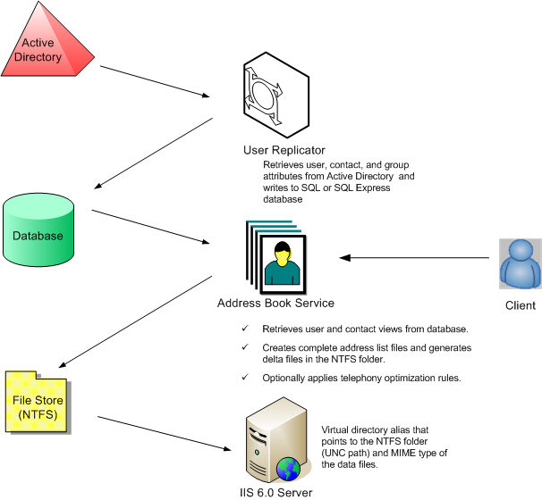

Address Book File Store and Data Files
The Address Book File Store is a shared NTFS folder with the name AddressBook. You must create this file before you run Office Communications Server 2007 Setup. During installation of Front End Server components, you will be asked by Setup to specify the Address Book File Store.
The data gathered by the Address Book Server is stored in a binary format in compressed files. The number of days the delta files are kept is set at the static value of 30 days, and this number cannot be changed. After 30 days, Address Book Server reaches a steady state, and a set of 465 files that include 30 full files and 435 delta files is stored in a directory accessible to clients through the Address Book URL.
The files are compressed to minimize storage requirements. The complete set of data files (30 full files and 435 delta files) is stored in the NTFS folder.
Each time the Address Book Server starts, it determines if there are data files in the output directory. If no data files are found, it will generate one full file. A delta file is not generated if there are no initial full files to compare against. The output files are written to a folder that can be assigned an access control list (ACL) by using the standard NTFS share permissions.
The following table illustrates how the full files and delta files are generated.
Table 106 Address Book Server file generation
Day | Files Generated
Day 1 | Full (F1)
Day 2 | Full (F2), Delta of F2 - F1
Day 3 | Full (F3)  Delta of F3 –F2  Delta of F3 –F1
Day 4 | Full (F4)  Delta of F4 - F3  Delta of F4 - F2  Delta of F4 - F1
-------------------------------------- | --------------------------------------
Day 30 | Full (F30)  Delta of F30-F29  Delta of F30-F28  ----  -----  Delta of F30-F1

All data files are stored in one directory. File names for full files are of the form F-xxxx, where xxxx is the file creation date expressed as the hexadecimal 0-based number of days since January 1, 2001. Delta file names are of the form D-xxxx-yyyy.lsabs, where xxxx is the full file creation date, and yyyy is the delta file creation date and .lsabs is a fixed extension. Files are created in memory and are written using a file handle that is created with no sharing allowed so that client applications cannot access a file before it has been completely written.

Information Flow
As explained earlier, Active Directory is the source for all user data. Information flows from Active Directory and through the components of the Address Book Server as shown in the previous figure.

File Size Guidelines
As a best practice, store Address Book data files on separate storage. The storage can be any of the many types, for example a DASD (direct access storage device) or a SAN (storage area network). The storage needs specific to the Address Book Server are very minimal and are expected to be in the range of 300 MB to 1 GB, depending on the number of users in the forest. The size of the full data files depends on the number of users and contacts stored in your Active Directory. The size of the delta files increases with the number of daily changes that occur to users and contacts in Active Directory. A large number of changes increases the delta file size and the time it takes to generate the delta file.
Table 107 Delta file changes
Number of Users | Full file average size
15,000 | 1.526 Mb
60,000 | 6.098 Mb
100,000 | 10.155 Mb
400,000 | 40.623 Mb

Step 10. Plan for High Availability and Fault Tolerance
High availability refers to a system’s ability to minimize system down time while continuing normal operation in the event of disruptions due to hardware, software, or service requirements. Fault tolerance refers specifically to reducing the risk of service disruption in the event of system or component failure. Designing fault tolerance into your messaging infrastructure is essential for ensuring high availability for your Office Communications Server 2007 deployment.
Office Communications Server 2007 extends the high availability and fault tolerant architecture of Live Communications Server 2005 to provide the same high level of reliability for online conferencing as already exists for IM. Planning for high availability is critical to deploying Office Communications Server 2007, Enterprise Edition. This section discusses Office Communications Server 2007 features that support high availability and the various options and strategies that need to be considered before the first server is installed.

Making Your System Fault Tolerant
You have probably already taken steps to design fault tolerance in your system, using practices such as ensuring hardware redundancy, guarding against power loss, routinely installing security updates and antivirus measures, and monitoring server activity. These practices benefit not only your Office Communications Server 2007 infrastructure, but also your entire network. If you have not implemented these practices, we recommend that you do so before deploying Office Communications Server 2007.

Hardware Redundancy
It is crucial that you incorporate special server and storage hardware configurations that build redundancy in the hardware within your Office Communications Server 2007 deployment so that you minimize single points of failure. By incorporating such measures, Office Communications Server 2007 hardware components can fail without affecting server operations.
The hardware you use to minimize the single points of failure depends on which components you want to make redundant. Some of the latest products from hardware vendors build redundancy into their server or storage solution products, so there may be no necessity to physically install redundant units.
Note
Beyond the technologies presented, a detailed discussion about additional technologies associated with this type of hardware is outside the scope of this guide.

Power Control
Using a UPS (uninterruptible power supply) and a battery backup to increase fault tolerance in your Office Communications Server 2007 organization is a necessity for servers that contain mission-critical data, especially in large deployments. A UPS and battery backup provide protection against power surges and short-term power losses that can cause damage to your servers, disk storage units, and the data they contain. If the location of your servers requires cooling to keep the hardware working properly, consider making the climate control system fault tolerant. For example, keep a battery backup power supply available for each cooling unit.

Security Updates and Antivirus Measures
To help protect the servers in your Office Communications Server 2007 organization from accidental or purposeful harm that may result in downtime, take the following precautions:
- Keep your servers up-to-date with security updates. Subscribing to the Microsoft Security Notification Service helps ensure that you receive immediate notification of security bulletin releases for any Microsoft product. To subscribe, go to the Microsoft Technical Security Notifications Web site at http://r.office.microsoft.com/r/rlidOCS?clid=1033&p1=secnotif.
- Ensure that access permissions are set up correctly.
- Keep your servers in a physical environment that prevents unauthorized access. Ensure that adequate antivirus software is installed on all your servers. Keep the software up-to-date with the latest virus signature files. Use the automatic update feature of your antivirus application to keep the virus signatures current.

Monitoring
Manage, monitor, and troubleshoot your servers and applications on an ongoing basis to help maximize system reliability. If a problem occurs, react quickly so that you can recover data and make it available as soon as possible. Microsoft Operations Manager is a system-wide monitoring solution and provides a management pack that you can use with Office Communications Server 2007.

Ensuring Availability of Active Directory and DNS
Office Communications Server 2007 relies on Active Directory and DNS. If either is unavailable, the server cannot function. For this reason, ensure that domain controllers, global catalog servers, and DNS servers in your organization are well protected from possible failure.
In addition, to help maximize the safety of your Active Directory information, store the information on more than one domain controller. If one of the servers experiences a problem, you should have at least one backup server to preserve your Active Directory information.

Protecting Your Back-End Database
Office Communications Server 2007 also depends on SQL databases for storing user information, conference state, archiving data, and CDRs (call data records). You can maximize the availability of Office Communications Server data on Office Communications Server 2007, Back-End Databases, by partitioning the application data in a way that improves fault tolerance and simplifies troubleshooting. To achieve these goals, partition the application data by:
- Using server partitioning best practices. Separate your operating system, application, and program files from your data files.
- Storing transaction log files and database files. Store these files separately to increase fault tolerance and optimize recovery.
- Using server clustering. Cluster the back-end servers to optimize Office Communications Server 2007 system availability.

Step 11. Plan for Database Storage
Planning a storage solution for Office Communications Server 2007 requires knowing what types of data it generates and where each type is stored. The following table lists this information.
Table 108 Data types and storage
Type of Data | Name of Data Store | Location
Persistent user data (for example, ACLs, contacts, home server or pool, scheduled conferences) | RTC | Enterprise Edition, Back-End Database  Standard Edition, SQL Express
Persistent Office Communications Server 2007 settings | RTCConfig | Enterprise Edition, Back-End Database  Standard Edition, SQL Express
Transient user data (for example, endpoints and subscriptions, and transient conferencing state) | RTCDyn | Enterprise Edition, Back-End Database  Standard Edition, SQL Express
Meeting content (for example, PowerPoint presentations, question and answer logs, polling, chat, and uploaded content) | User-specified UNC path | File share created on a Standard Edition Server on a separate computer (recommended) from the Enterprise Edition Front End Server
Meeting Content metadata (XML data that describes the meeting content (for example, data and time a PowerPoint presentation is uploaded) | User-specified UNC path | File share created on a Standard Edition Server on a separate computer (recommended) from the Enterprise Edition Front End Server
Meeting Content Compliance Log (XML data that records content upload activities, along with the uploaded meeting content) | User-specified UNC path | File share created on a Standard Edition Server on a separate computer (recommended) from the Enterprise Edition Front End Server
Archiving and CDR data | LCSLog (the default name; can be changed) | Archiving Service SQL Server database normally deployed on separate computer (recommended) from the SQL Server Back-End Database.

Storage Considerations
Planning an effective storage strategy, particularly if you are deploying an Enterprise, Back-End Database, is essential to the success of your Office Communications Server 2007 deployment. Failure to accurately assess your storage requirements and implement strategies optimizing data access and security can be inconvenient at best and catastrophic at worst.
As you plan your storage strategy for Office Communications Server 2007, you need to balance three criteria: capacity, availability, and performance. The choices you make as you plan and implement your storage solution affect the cost associated with administration and maintenance of your Office Communications Server 2007 environment.
- Capacity. In Office Communications Server 2007, your total capacity for the Enterprise Edition Back-End database is approximately 10 gigabytes for a large deployment. By traditional standards, a database of this size is not considered to be large.
- Availability. The availability of your database can be increased by redundancy. Redundancy can mean that you should cluster applications to provide CPU redundancy or implement a RAID solution to provide data redundancy.
- Performance. Performance requirements are also unique to each organization. This refers to performance as it relates to throughput. With regard to storage technology, throughput is measured by how many reads and writes per second a storage device can perform.
Before you design your storage solution for Office Communications Server 2007, determine how your company prioritizes these three criteria, especially when considering a balance between availability and performance. The following sections discuss the factors you should consider regarding storage.

General Storage Principles
Regardless of the application that you are running, consider the following storage principles to help maximize capacity, performance, and availability.
- Decrease the processing required from the CPU by implementing a specialized hardware solution, such as a RAID or a SAN, that incorporates RAID technology. In this scenario, it is assumed that you use a hardware solution rather than a software (host-based) RAID solution.
- Decrease the overall time it takes to complete a transaction by separating files that are accessed sequentially from files that are accessed randomly. Storing sequentially accessed files separately keeps the disk heads in position for sequential I/O, which reduces the amount of time required to locate data.
- Use multiple small disks, because they perform better than a single large disk. For example, if you need to store 50 GB of data, consider using three 18 GB disks instead of one 50 GB disk. In general, more disks result in faster performance.
Use the information in the following sections to compare and contrast these storage technologies.

RAID Solutions
By using a RAID solution, you can increase the fault tolerance of your Office Communications Server 2007 deployment. In a RAID configuration, part of the physical storage capacity contains redundant information about data stored on the hard disks. The redundant information is either parity information (in the case of a RAID-5 volume) or a complete, separate copy of the data (in the case of a mirrored volume). The redundant information enables data regeneration.

Considerations for Office Communications Server 2007
When planning your storage solution, consider the following features of Office Communications Server 2007.
- Office Communications Server can support up to 125,000 concurrent users on a pool in the expanded configuration. The back-end SQL database of each pool or Standard Edition has a set of transaction log files and database files.
- Not all data stored on Office Communications Server is managed in the same way. A single storage solution for all data types is not the most efficient. For example, both transient and static data reside on the back-end database. The RTCDyn database stores conference state information and other information that is transient in nature. Because of its temporary nature, this information does not need to backed up or saved regularly for restoration purposes. However, persistent data stored in the RTC and RTCConfig database on Standard Edition Server and Enterprise pool contain important user settings and configuration settings respectively. The Archiving and CDR Server database also contains compliance information that is important for archival purposes. It is important to plan for availability and redundancy of this data.
- In Office Communications Server 2007, transaction log files are accessed sequentially, and databases are accessed randomly. In accordance with general storage principles, you should separate the transaction log files (sequential I/O) from databases (random I/O) to maximize I/O performance and increase fault tolerance. Specifically, you should move the transaction log files to a separate array separated from database file storage.
Among the more common methods of protecting your Office Communications Server 2007 infrastructure against failure of back-end SQL storage are SQL clustering, NAS (network-attached storage), SAN (storage area network) RAID (redundant array of independent disks) and SQL clustering.
SQL Server 2005 Enterprise Edition can be configured as a failover cluster to provide high availability support. For example, during an operating system failure or a planned upgrade, one can configure one node in the failover cluster to fail over to any other node in the failover cluster configuration. This ability helps to minimize system downtime, thereby providing high server availability. Additionally, if you decide to implement archiving in critical mode, which means that the Office Communications Server shuts down if archiving is not available, you may want to use a failover cluster because a SQL server failure can potentially bring down the entire Office Communications Server infrastructure.
We recommended that you use a SAN for the storage of your Office Communications Server 2007 data files, particularly for Enterprise Edition deployments larger than 50,000 clients, where availability, performance, and data protection are critical. This configuration optimizes server performance and reliability. It is expected that such organizations may already have a SAN deployed and can provision additional LUNs (logical unit numbers) and ports.
Important
As a best practice, use Directly Attached Storage (DAS) or Storage Area Network storage array solutions because this configuration optimizes performance and reliability for Office Communications Server 2007.
A SAN provides storage and storage management capabilities for company data. SANs use Fiber Channel switching technology to provide fast and reliable connectivity between storage and applications.
A SAN has three major component areas:
- Fiber Channel switching technology
- Storage arrays on which data is stored and protected
- Storage and SAN management software
Hardware vendors sell complete SAN packages that include the necessary hardware, software, and support. SAN software manages network and data flow redundancy by providing multiple paths to stored data. Because SAN technology is relatively new and continues to evolve rapidly, you can plan and deploy a complete SAN solution to accommodate future growth and emerging SAN technologies. Ultimately, SAN technology facilitates connectivity between multivendor systems with different operating systems to storage products from multiple vendors.

Server Partitioning Best Practices
To increase fault tolerance and provide for easier troubleshooting, do the following:
- Partition your disks so you can start with a command prompt in an emergency. Partitioning your disks in this way increases your recovery options. For example, you can start with a command prompt and modify or replace any damaged startup files that prevent you from starting Windows.
- Partition your disks so that your Office Communications Server 2007 application files, database files, and transaction log files are all on separate volumes to increase performance and reduce the amount of data you need to recover.
If you partition your hard disks by using these recommendations, each set of files is assigned a separate drive letter. Having each set of files represented by its own drive letter helps you keep track of which partitions you must back up in accordance with the data recovery method you choose.

Storing Transaction Log Files and Database Files
As previously mentioned, to provide fault tolerance in the event of a hard disk failure, keep your Office Communications Server 2007 transaction log files and database files on separate physical hard disks. Furthermore, if you keep these log files and database files on separate disks, you significantly improve performance of hard disk I/O. For the data and transaction file access, select separate I/O channels on the RAID controller and, if possible, place each I/O channel on a separate RAID controller.
If the hard disk containing the transaction log files fails, but not the disk containing your databases, you do not have to restore any Office Communications Server 2007 data from backup. SQL transaction logs for Office Communications Server 2007 are collapsed on a periodic basis and are kept within a limited size. You should also enable write caching if the controller supports this capability. Enabling write caching increases throughput significantly.
Important
If you keep your Office Communications Server 2007 databases and transaction log files on the same physical hard disk and that disk fails, you can recover only the data that existed up to your last backup.

Hard Disk Space Considerations
Ensure that you have adequate hard disk capacity for your Office Communications Server servers. You should have enough space on your hard disk to restore both the database and the log files. If you don’t, you could have backup files that are too large to restore to their original location.
Performing normal backups on a daily basis reduces the amount of data that is potentially not recoverable in the event of a disk failure.
Also, you should never let your database drive become more than half full. Although a database drive that is half full results in unused disk space, it can still reduce extended server downtime for the following reasons.
- You can restore databases faster than with a full drive (especially if the file system is fragmented).
- You can perform offline defragmentation on the same physical disk instead of copying databases over to a maintenance server, (a task that takes much longer than copying database files to a temporary directory on the same physical hard disk).
- You can back up a copy of the databases to the same physical disk before you restore them, which enables you to attempt to repair the databases if a problem occurs during the restore process (for example, the existing backup contains errors). For this reason, we recommend that you move or copy the current database and log files before restoring a database.

Using Server Clustering
Microsoft Clustering Service (MSCS) is a Windows Server feature that you can use to achieve scalability and high availability for the Office Communications Server 2007, Back-End Database. A cluster consists of individual computers (also called nodes) that function cohesively in a cluster service. These computers act as network service providers or as reserve computers that take over server operations for another node if it experiences problems. Clustering provides fault tolerance and reliability. Furthermore, depending on how you configure your cluster, clustering can simplify the process of recovering a single server from disasters.
In a clustering environment, SQL runs as a virtual server (not as a stand-alone server), because any node in a cluster can assume control of a virtual server. If the node running the SQL virtual server experiences problems, the SQL virtual server goes offline for a brief period until another node takes control of the damaged node.
Office Communications Server 2007 supports two-node active/passive for the Back-End Database. Active/active clusters are not supported.
You must be familiar with MSCS concepts before you plan and deploy Office Communications Server 2007 clusters. Many resources, including Windows Server 2003 Help, Windows Server 2003 Resource Kit, and Web sites such as the MSDN® developer program (http://r.office.microsoft.com/r/rlidOCS?clid=1033&p1=MSdevProg), offer information about Windows Server 2003 clustering concepts.

Office Communications Server 2007 Database Clustering
A failover cluster comprises one or more nodes, or servers, with a set of shared cluster disks specifically configured for use with the cluster. If the active node running the application encounters a problem and becomes unavailable, the cluster fails over to the passive node. In addition to the benefits of server clustering, database clustering provides a higher level of availability to the data and to the Office Communications Server servers.
This section discusses the following aspects of Office Communications Server 2007 database clustering. You can use this information to familiarize yourself with the basic concepts around clustering and decide if you want to cluster your Office Communications Server 2007 database.
- Windows clustering and SQL virtual servers
- Quorum disk resource
- Cluster configurations
- Windows, SQL Server and Office Communications Server 2007 version requirements
- Understanding failovers
- IP addresses and network names
- Cluster hardware compatibility list
- Scalability-related considerations

Windows Clustering and SQL Virtual Servers
Office Communications Server 2007 and SQL virtual server use the following Windows clustering features.
- Shared-nothing architecture. The shared-nothing architecture of Windows clustering specifies that all nodes in a cluster can access shared data, but they cannot access it at the same time. For example, if a physical disk resource is assigned to node 1 of a two-node cluster, node 2 cannot access the disk resource until node 1 fails or is taken offline, or the disk resource is removed from node 1 and assigned to node 2.
- Resource DLL. Windows communicates with resources in a cluster by using a resource DLL. Office Communications Server 2007 does not provide its own custom resource DLL; it uses the SQL virtual server to communicate with Cluster service.
- Resources SQL. SQL 2000 virtual servers include Windows Cluster service resources, such as IP address resources, network name resources, and physical disk resources.
Office Communications Server 2007 and SQL Virtual Server To create an Office Communications Server 2007, Back-End Database, cluster, you create a Windows Server 2003 cluster group and then install SQL virtual server (cluster) on it. Office Communications Server 2007 schema and stored procedures are loaded into the SQL virtual server. SQL Server 2000 cluster creates a logical server referred to as SQL virtual server. Unlike a standalone (non-clustered) computer running SQL Server 2000 or SQL Server 2005, a SQL virtual server is a cluster group that can be failed over if the server currently running the SQL virtual server fails.
A SQL virtual server is a cluster group that requires, at a minimum, the following resources.
- Static IP address
- Network name
- One or more physical disks for shared storage
Enterprise Edition Servers connect to an Office Communications Server 2007, Back-End Database SQL virtual server the same way they connect to a standalone SQL Server. Microsoft Windows Server 2003 provides the IP address resource, the network name resource, and disk resources associated with the SQL virtual server.

Quorum Disk Resource
The most important disk in the cluster is the disk designated as the quorum disk resource. The quorum disk resource maintains configuration data in the quorum log, cluster database checkpoint, and resource checkpoints. The quorum disk resource also provides persistent physical storage across system failures. Because the cluster configuration is kept on a quorum disk resource, all nodes in the cluster must be able to communicate with the node that owns it.
When a cluster is created or when network communication between nodes in a cluster fails, the quorum disk resource prevents the nodes from forming multiple clusters. To form a cluster, a node must arbitrate for and gain ownership of the quorum disk resource. For example, if a node cannot detect a cluster during the discovery process, the node attempts to form its own cluster by taking control of the quorum disk resource. However, if the node does not succeed in taking control of the quorum disk resource, it cannot form a cluster.
The quorum disk resource stores the most current version of the cluster configuration database in the form of recovery logs and registry checkpoint files. These files contain cluster configuration and state data for each individual node. When a node joins or forms a cluster, the Cluster service updates the nodes individual copy of the configuration database. When a node joins an existing cluster, the Cluster service retrieves the configuration data from the other active nodes.
Cluster service uses the quorum disk resource recovery logs to:
- Guarantee that only one set of active, communicating nodes can operate as a cluster.
- Enable a node to form a cluster only if it can gain control of the quorum disk resource.
- Allow a node to join or remain in an existing cluster only if it can communicate with the node that controls the quorum resource.

Cluster Configurations
With the clustering process, you can manage a group of independent servers as a single system. Each server in the cluster has individual memory, processors, and network adapters, but it shares a common storage medium. Each server also has an identical processor and the same amount of RAM. A separate private network, used only for cluster communication between the nodes, can connect these servers.
The following sections discuss Office Communications Server 2007 cluster configuration.
Active/Passive Clustering In active/passive clustering, the cluster includes a primary node and one secondary node. The secondary node is idle until a failover occurs on a primary node. When the primary node in an active/passive cluster fails or is taken offline, the clustering feature in Windows takes over. The failed node is taken offline, and a secondary node takes over the operations of the failed node. It usually takes only a few minutes for the cluster to fail over to another node. As a result, the Office Communications Server 2007 resources on your cluster are unavailable to users for only a brief period of time.

Windows, SQL Server, and Live Communications Server Version Requirements
Specific versions of Windows and SQL Server are required to create an Office Communications Server 2007 cluster. The following table outlines these requirements.
Table 109 Windows, SQL Server, and Office Communications Server version requirements
Windows versions | SQL Version | Communications Server Version | Cluster nodes available
Windows Server 2003 Standard Edition R2 (recommended)  Windows Server 2003 Standard Edition SP1 (supported) | SQL Server Enterprise Edition 2005 , SP1 or later (SP2 recommended)  SQL Server Enterprise Edition 2000 SP4  (supported) | Office Communications Server 2007 Standard Edition  Office Communications Server 2007 Enterprise Edition | None
Windows Server 2003 Enterprise Edition R2 (recommended)  Windows Server 2003 Enterprise Edition SP1 (supported) | SQL Server Enterprise Edition 2005, SP1 or later (SP2 recommended)  SQL Server Enterprise Edition 2000 SP4  (supported) | Office Communications Server 2007 Enterprise Edition | Up to two
Windows Server 2003 Datacenter Edition R2 (recommended)  Windows Server 2003 Datacenter Edition SP1 (supported) | SQL Server Enterprise Edition 2005, SP1 or later (SP2 recommended)  SQL Server Enterprise Edition 2000 SP4  (supported) | Office Communications Server 2007 Enterprise Edition | Up to two

Understanding Failover
The failover time for SQL virtual servers is important. To maintain high availability, the failover time must be short. There are two scenarios for failover: planned and unplanned. A planned failover occurs when you schedule time to remove a server from operation maintenance or other reasons. An unplanned failover occurs when a server encounters a failure.
In a planned failover:
- You use the Cluster service to move the SQL virtual server to another node.
- All resources of the SQL virtual server go offline.
- You move resources move to your specified node.
- All resources of the SQL virtual server go online, Office Communications Server 2007 application comes online.
In an unplanned failover:
- At least one resource of the SQL virtual server fails. The failure is discovered with the next IsAlive check or if one of the resources fails.
- Cluster service automatically takes all dependent resources offline.
- If the failed resource is configured to restart (the default setting), Cluster service attempts to restart the failed resource and all its dependent resources.
- If the resource fails again, one of the following happens:
- Cluster service tries to restart it again.
- If the resource is configured to affect the group (default) and the resource has failed a certain number of times (default 3) within a configured time period (default 300 seconds), the Cluster service takes all resources in the SQL virtual server offline.
- All resources are failed over (moved) to another node in the cluster. If specified, this is the next node in the Preferred Owners list.
- Cluster service attempts to bring all resources of the SQL virtual server online on the new node.
- If the same or another resource fails again on the new node, the Cluster service repeats the previous steps and may need to fail over to the original node.
- If the SQL virtual server keeps failing over, the Cluster service fails over the SQL virtual server a maximum number of times (default 10) within a specified time period (default 6 hours). After this time, the SQL virtual server stays in a failed state.
- If fail back is configured (default is turned off), the Cluster service either moves the SQL virtual server back to the original node immediately when the original node becomes available or at a specified time of day if the original node is available again, depending on the group configuration.

IP Addresses and Network Names
A typical installation of a cluster includes a network that client computers use to connect to Office Communications Server 2007 Enterprise Edition and a separate private network for cluster node communication.
- Each node of the cluster has two static IP addresses (the public and private network connection IP addresses of each node) and one NetBIOS name.
- The cluster itself has a static IP address and a NetBIOS name.
Important
We recommend that you use a private network for cluster communication and static IP addresses in any cluster deployment. Using DHCP (Dynamic Host Configuration Protocol) prevents client computers from connecting to the cluster, and the entire cluster may fail if the DHCP server fails to renew the IP lease. Using a private network for cluster communication is strongly recommended. Otherwise, a failure of the public network connection of one node prevents the cluster nodes from communicating with each other, and the failure blocks affected resources from failing over and may even cause the entire cluster to collapse.

Cluster Hardware Compatibility List
For Windows Server 2003, Enterprise Edition and Windows Server 2003, Datacenter Edition, Microsoft supports only complete server cluster systems chosen from the Windows Server Catalog (http://r.office.microsoft.com/r/rlidOCS?clid=1033&p1=WinServCat). To see if your system or hardware components, including your cluster disks, are compatible, browse the hardware in this catalog. For a geographically dispersed cluster, both the hardware and software configuration must be certified and listed in the Windows Server Catalog.
The network adapters used in certified cluster configurations must be chosen from the Windows Catalog.
We recommend that your cluster configuration consist of identical storage hardware on all cluster nodes to simplify configuration and eliminate potential compatibility problems. In addition, ensure that both nodes in the cluster are identical in terms of DLLs, version of software, drivers, and patches and that no data is written to the Direct Attached Storage of either node that is critical or needs to be accessible by the other node. All data that is required subsequent to a failover must be on the shared storage.

Scalability-Related Considerations
Determining the sizing and scalability of your clusters depends on how you plan to implement server clustering. This section discusses the following aspects of cluster sizing.
- Sizing active/passive clusters
- Testing server components

Sizing Active/Passive Clusters
Active/passive clusters are the required configuration for Office Communications Server 2007 clusters. Windows Server 2003, Enterprise Edition supports two-node active/passive clusters, and Microsoft Windows 2000 Datacenter Server operating system supports two-node active/passive clusters.

Testing Server Components
It is important to test the capacity of your clusters before making them available in your organization.
The following list identifies some of the hardware components you need to test.
- Individual computer components such as hard disks, controllers, processors, and RAM.
- External components such as routers, bridges, switches, cabling, and connectors.
The following are some of the stress tests you need to set up.
- Test cluster performance under heavy network loads.
- Test cluster performance under heavy disk I/O to the same disk.
- Test cluster performance under heavy Office Communications Server 2007 services load.
- Test cluster performance under a large number of simultaneous logon attempts.
- Fail over each SQL virtual server at least once to each of the nodes.

Step 12. Plan for Compliance and Usage Analysis
Corporations and other organizations are subject to an increasing number of industry and government regulations that require the retention of both e-mail and IM conversations. Compliance requirements also extend to conferencing, including meeting content. Demonstrating compliance presents a significant challenge for today's organization, and failure to do so can result in significant financial and legal liabilities. The Office Communications Server 2007 Archiving and CDR Server enables companies to comply with those regulations and policies that require retention of IM communications.
Office Communications Server 2007 Archiving and CDR Service also provides a mechanism known as Call Data Records (CDR) for capturing usage figures as a way for organizations to assess productivity gains, current return on investment, and future needs. Call Data Record capture usage figures for IM, conferencing, and VoIP calls.
Before you deploy the Archiving Service, ensure that your IT infrastructure, network, and systems meet the following infrastructure requirements described earlier in this guide.
- Message Queuing is installed on the computer that will run the Archiving service and on all Communications Servers that you want to archive. Every server in an Enterprise pool must be connected to the Archiving service separately.
- Microsoft SQL Server 2005 SP1 or later or SQL Server 2000 with Service Pack 4 is installed on a dedicated database server (SQL 2005 SP2 is strongly recommended for Enterprise pools) or on a server running the Archiving service. Default or named instances are both supported. Windows Integrated Authentication is required.
- Office Communications Server administrative tools are installed on the computer that will run the Archiving and CDR service.

Archiving Topologies
The Office Communications Server 2007 Archiving and CDR Service architecture consists of:
- One or more Office Communications Server servers, hosting an Archiving and CDR Agent, which captures both archiving and CDR details from each server.
- Message Queuing, which enables the Archiving and CDR Agent to communicate with Archiving Services.
- A SQL database for storing IM and meeting content captured by the Archiving and CDR Agent. You can install the database on a separate, dedicated SQL back-end computer that is attached to the server or servers running the Archiving and CDR Agent. Optionally, you can collocate the database on the computer running the Archiving and CDR Agent. The Archiving and CDR database must be a dedicated SQL database, and cannot be on the same computer as a back-end database of an Enterprise pool.
Note
Archiving interoperability is not supported. You must archive all Office Communications Server 2007 servers by using the Office Communications Server 2007 Archiving Service. Similarly, you must archive all Live Communications Server 2005 servers by using the Live Communications Server 2005 Archiving Service.
If you have both Office Communications Server 2007 and Live Communications Server 2005 Archiving Services running in your organization, the default behavior is different for the different versions.
The Office Communications Server 2007 Archiving and CDR components previously described can be deployed in the several different supported topologies based upon which Office Communications Server servers are being archived and the configuration of the Archiving and CDR service which is largely informed by your performance and scalability requirements (the number of users targeted for archiving).
For any archiving and CDR deployment you can choose between two basic topologies:
- Single-tier in which the Archiving and CDR Service and the back-end archiving database reside on a single computer.
- Two-tier in which the Archiving and CDR Service resides on a dedicated computer and the back-end database resides on a different dedicated computer.
As a variation of either of these two topologies, you can configure multiple Archiving and CDR Services connecting to the same archiving and CDR back-end database.
Note
A Standard Edition Server can be collocated with the Archiving and CDR Server, but this configuration is strongly discouraged because of performance limitations.
The topology you choose depends on your compliance requirements and whether or not Office Communications Server is mission critical in your enterprise. For example, if your organization is required to meet compliance regulations, you will probably enable archiving and CDR in critical mode so that the Office Communications Server 2007 becomes unavailable if archiving is unavailable.
When archiving is enabled in critical mode, the availability of your entire Office Communications Server infrastructure depends on the availability of the Archiving and CDR Service. If IM and conferencing are not considered mission critical and do not need to be highly available, then a single tier Archiving and CDR topology may meet your needs and save hardware costs. However, if IM and conferencing are mission critical, then you will want to consider using a two-tiered Archiving and CDR Service and possibly clustering the archiving and CDR database. For an Enterprise pool in the expanded configuration, you can also connect different front-ends to different Archiving and CDR Services. In this situation, if one of the Archiving and CDR Services becomes unavailable, the affected Front-End Servers will shut down, and users will be redirected to the Front-End Servers that are connected to the available Archiving and CDR Service.

The topologies shown in the following figures represent one or more Standard Edition Servers or Enterprise Pools connected to the Archiving and CDR Service, either in single-tier or two-tier configuration. A two-tier Archiving Service provides improved scalability and performance.
The following figure shows a single Standard Edition Server connected to a single-tier Archiving and CDR Service. One or more additional Standard Edition Servers can be configured to connect to the same Archiving Service.
Figure 39 Standard Edition Server connected to single-tier Archiving and CDR Service
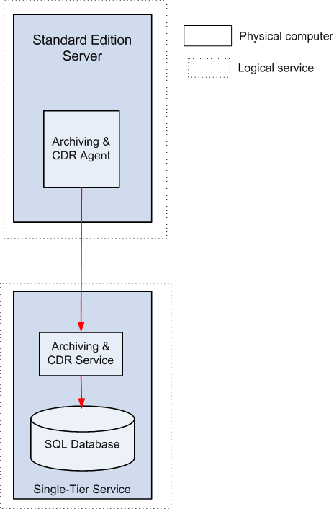
The following figure shows an expanded Enterprise Pool and a second Enterprise Pool of unspecified configuration, both connected to a two-tier Archiving Service.
Figure 40 Two Enterprise Edition Pools connected to two-tier Archiving Service
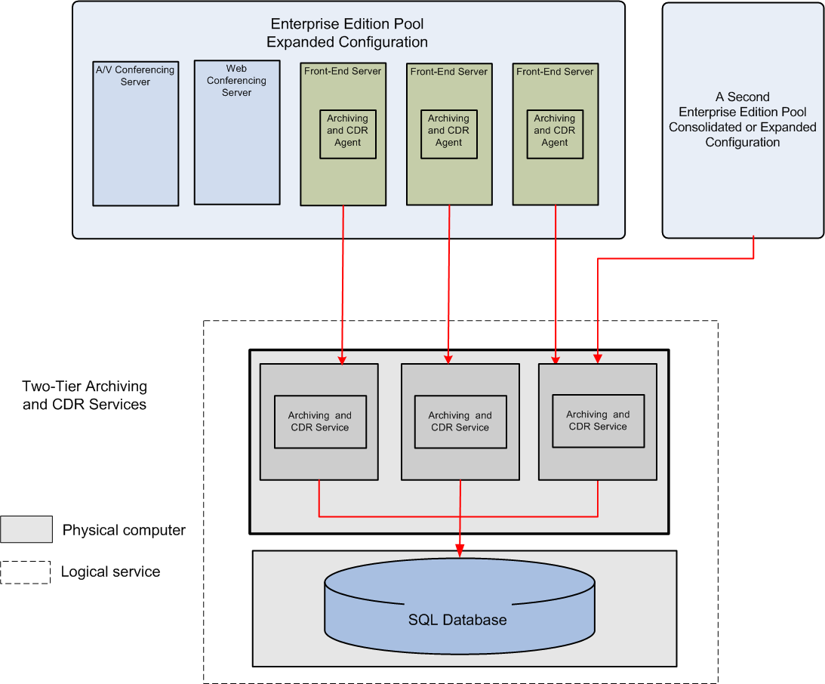

The following figure shows a single Enterprise Edition Pool of where each Front-End Server uses a dedicated Archiving and CDR Service that is connected to a shared SQL database. In this situation, if one of the Archiving and CDR Services becomes unavailable, the affected Front-End Servers will shut down, and users will be redirected to the Front End Servers that are connected to an available Archiving and CDR Service.
Figure 41 A single Enterprise Edition Pool connected to multiple Archiving Services
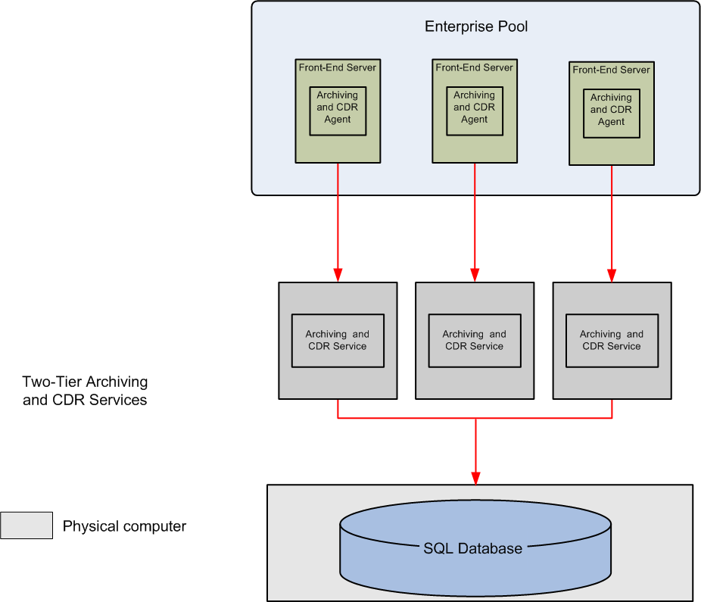
The following figure shows an Enterprise pool in the expanded configuration connected two logical Archiving and CDR Services comprised of multiple Archiving and CDR Services that reside on separate physical computers and two SQL databases.
Figure 42 Enterprise Pool Connected to two Archiving and CDR Services
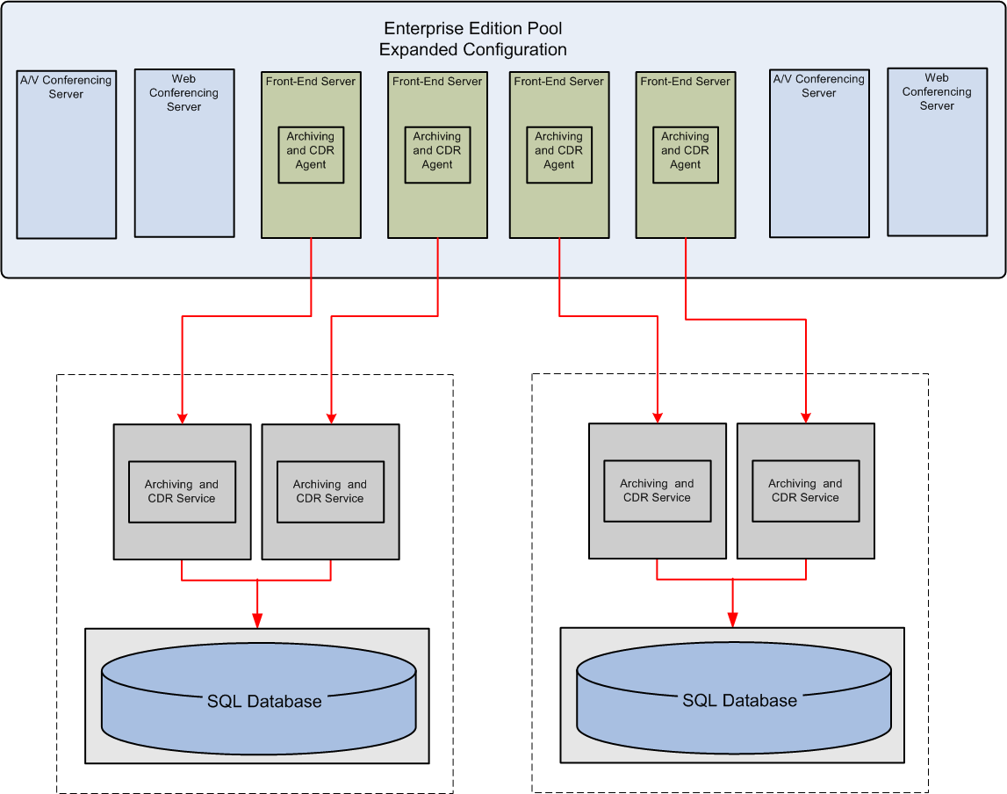

Archiving and CDR Scalability
The scalability of the Archiving and CDR server depends on whether only CDRs are enabled or CDRs and archiving is enabled for the topology. The following summarizes the scalability of the Archiving and CDR Server as well as recommendations for configuration of purging of the database to achieve these scaling limits
- 125,000 users per Archiving and CDR server with only CDRs enabled. For optimal performance, the database should be configured to purge every seven days.
- 65,000 users per Archiving and CDR server with both CDRs and IM archiving enabled. For optimal performance, the database should be configured to purge every three days. Additional RAM and disk I/O capacity is also required for this configuration.

Configuring the Archiving and CDR Service
If you choose to deploy the Archiving and CDR Service in your organization, you must install it on every Office Communications Server and Enterprise Pool. Once you have done so, you then configure settings for both content archiving and CDR capture for your entire forest.
Configuring archiving is straightforward. At the forest level, you choose whether to archive internal and/or external communications for all users, no users, or on per-user basis. If you enable archiving on a per user basis, by default, archiving is turned off for all users until you enable them for archiving in the user properties for each user. At the server or pool level, you simply indicate whether content archiving is enabled or not. For step-by-step instructions for configuring archiving, refer to the Microsoft Office Communications Server 2007 Archiving and CDR Service Deployment Guide.
Important
If you disable archiving on a pool hosting a meeting, none of the conversations for that meeting will be archived, even if archiving is enabled for all its participants.
Configuring forest-wide CDR settings is a little more complicated. You can choose to capture one or more of the following:
- Peer-to-peer call details: The details of all peer-to-peer sessions including IM communications, audio/vide, file transfer, application sharing and remote assistance sessions.
- Conference call details: The details of all multiparty sessions including IM conferences, and audio/video conferencing and on-premise Web conferences using the Live Meeting client.
- Voice call details: The details of all voice calls that use Office Communications Server 2007 enterprise voice capabilities.
Note
CDRs do not capture the content of IM sessions or meetings. To capture content, you must enable archiving on the servers or pools.
The previous settings are off by default. You can enable any or all of them from the Office Communications Server 2007 snap-in.

Appendix A Implementing in a QoS Environment
If you are deploying Office Communications in an environment with existing QoS policies, Office Communications Server 2007 is designed to work within this framework. Office Communications Server applications based on synchronous traffic like audio or video streams are highly sensitive to delay, jitter and packet loss. QoS policies are typically deployed to give more bandwidth to synchronous audio and video streams compared to the asynchronous traffic like instant messaging, application sharing data or file downloads.
The implementation of QoS policies in a network can be done according to several approaches such:
- Differentiated Service (DiffServ)
- Integrated Services (IntServ)
- Call Admission Control (CAC)
Differentiated Service (DiffServ) provides a class-level prioritization based on Differentiated Services Code Point (DSCP) marking of the IP packets. See IETF RFC 2474 for a description of the 6-bit DSCP field values in the Type of Service byte of any IP packet. Each value corresponds to a class of service for forwarding packets from the sender or intermediary router to the next router or receiver in the network. The forwarding behaviors can be implemented using a variety of techniques, including priority queuing, weighted fair queuing or conventional leaky bucket-based techniques. Relevant classes for the delivery of audio and video media stream are the Assured Forwarding (AH) and the Expedited Forwarding (EF) classes.
Integrated Services (IntServ) is a framework provides strict Quality of Service guarantees and requires that routers maintain per stream state information for that purpose.
Call Admission Control (CAC) is a framework for authorizing or rejecting calls based on available bandwidth or types of calls.
Although Office Communicator Server 2007 has been designed to work without any QoS framework, it is possible to configure the media stack to mark the IP traffic conveying the real time audio and video IP traffic according to well established classes of services.
The marking may be enabled or disabled by means of registry keys. If enabled, the marking of the IP packets is done by the QoS Packet Scheduler service. The resulting marked packets can subsequently be recognized by network entities (end systems and routers) to manage the media traffic according to the QoS priorities.
The QoS marking is applied to all media ports and regardless whether the audio/video traffic is delivered over the Real Time Protocol (RTP; see IETF RFC 3350) or the Secure Real Time Protocol (SRTP; see IETF RFC 3711). Because QoS policies are often tied to UDP or TCP ports, Office Communicator Server 2007 also includes a registry setting to specify the port range for the UDP and TCP ports used in delivering media streams.

QoS Service Types
The Office Communications Server 2007 media sub-system in Office Communication Server 2007 uses the following two ServiceType values:

SERVICETYPE_GUARANTEED
The SERVICETYPE_GUARANTEED setting guarantees that IP datagrams will arrive within the guaranteed delivery time and will not be discarded due to queue overflows, provided the flow's traffic stays within its specified traffic parameters. This service is intended for applications that need a firm guarantee that a datagram will arrive no later than a certain time after it was transmitted by its source.
The Real Time Media Communications stack marks the RTP/SRTP Audio packets (default payload type value equal to 0, 3, 4, 8, 101, 111, 112, 114, 115, or 116) as SERVICETYPE_GUARANTEED. This marking is off by default.
To turn it on this marking on, the following is required on all server and client computers:
- The Windows QoS Packet Scheduler service must be running on each computer.
- The following registry key must be set to must be set to 1 (DWORD). The marking translates to setting the value of the TOS Precedence field in the header of the IP packets conveying digital speech to 101 (in binary). These marking can be modifying DSCP values for conforming packets in Group Policy snap-in (gpedit.msc). For more information, see the Microsoft Office Communications Server 2007 Technical Reference.
HKEY_LOCAL_MACHINE \Software\Microsoft\RTC\Transport\QoSEnabled
Caution
Incorrectly editing the registry may severely damage your system. Before making changes to the registry, you should back up any valued data on the computer.

SERVICETYPE_CONTROLLEDLOAD
The SERVICETYPE_CONTROLLEDLOAD setting provides an end-to-end QOS that closely approximates transmission quality provided by best-effort service, as expected under unloaded conditions from the associated network components along the data path.
Applications that use SERVICETYPE_CONTROLLEDLOAD may therefore assume the following:
- The network will deliver a very high percentage of transmitted packets to its intended receivers. In other words, packet loss will closely approximate the basic packet error rate of the transmission medium.
- Transmission delay for a very high percentage of the delivered packets will not greatly exceed the minimum transit delay experienced by any successfully delivered packet.
The Real Time Media Communications stack marks the RTP/SRTP Video packets (default payload type value equal to 34 or 121) as SERVICETYPE_CONTROLLEDLOAD. This marking is off by default.
To turn it on this marking on, the following is required on all server and client computers:
- The Windows QoS Packet Scheduler service must be running on each computer.
- The following registry key must be set to must be set to 1 (DWORD). This marking will translate to setting the value of TOS Precedence field in the header of the IP packets conveying digital video to 011 (in binary). These markings can be modifying DSCP values for conforming packets in Group Policy snap-in (gpedit.msc). For more information, see the Microsoft Office Communications Server 2007 Technical Reference.
HKEY_LOCAL_MACHINELM\Software\Microsoft\RTC\Transport\QoSEnabled
Caution
Incorrectly editing the registry may severely damage your system. Before making changes to the registry, you should back up any valued data on the computer.
The two IP packet marking described previously can be disabled by setting the registry key HKLM\Software\Microsoft\RTC\Transport\QoSEnabled to 0 . This value means that no marking will be done on any of the RTP/SRTP traffic coming from Office Communicator Server 2007.

QoS Packet Scheduler
The Quality of Service Packet Scheduler is a Windows platform component that is enabled by default on Windows Vista® and Windows XP computers. It is, however, not enabled by default on Windows 2003 computers. This scheduler is designed to control the IP traffic for various network services, including Real Time Communications traffic. This component must be installed and enabled if the QoS markings described earlier for audio and video traffic are to be implemented by the IP stack.
Below are described the procedures to follow to install the QoS Packet Scheduler in the case it is not present. As mentioned earlier in this document, the QoS Packet Scheduler will mark the outgoing IP packets according to the directives captured in the QOS and FLOWSPEC structures.
To install the QoS Packet Scheduler on Windows XP
- Click Start and then click Control Panel.
- In Classic View, click Network Connections.
- Right-click the network entry where you want to enable the QoS Packet Scheduled, and then click Properties.
- Click Install.
- In Select Network Component Type, click Service.
- Click Add.
- In Select Network Service, click QoS Packet Scheduler, and then click OK.
To install the QoS Packet Scheduler on Windows Vista
- Click Start and then click Control Panel.
- In Classic View, click Network and Sharing Center.
- Right-click the network entry where you want to enable the QoS Packet Scheduled, and then click Properties.
- Click Install.
- In Select Network Feature, click Service.
- Click Add.
- In Select Network Service, click QoS Packet Scheduler, and then click OK.
For information about enabling QoS marking and the QoS Packet Scheduler service, see the Microsoft Office Communications Server 2007 Technical Reference.

Appendix B Disabling IPSec
For Enterprise networks where IPSec (see IETF RFC 4301-4309) has been deployed, IPSec must be disabled over the range of ports used for the delivery of audio, video and panorama video. The recommendation is motivated by the need to avoid any delay in the allocation of media ports due to IPSec negotiation.
The following table explains the recommended IPSec exception settings. For clients, see the minimum and maximum media port range section in the Microsoft Office Communications Server 2007 Technical Reference Guide for details about how to specify a range of ports to limit the extent of the IPSec exceptions that must be put in place in your network.
Table 110 Recommended IPSec Exceptions
Rule Name | Source IP | Destination IP | Protocol | Source Port | Dest Port | Filter Action
A/V Edge Server Internal Inbound | Any | A/V Edge Server Internal | UDP & TCP | Any | Any | Permit
A/V Edge Server External Inbound | Any | A/V Edge Server External | UDP & TCP | Any | Any | Permit
A/V Edge Server Internal Outbound | A/V Edge Server Internal | Any | UDP & TCP | Any | Any | Permit
A/V Edge Server External Outbound | A/V Edge Server External | Any | UDP & TCP | Any | Any | Permit
Mediation Server Inbound | Any | Mediation  Server(s) | UDP & TCP | Any | Any | Permit
Mediation Server Outbound | Mediation  Server(s) | Any | UDP & TCP | Any | Any | Permit
A/V Conferencing Inbound | Any | A/V Conferencing Servers | UDP & TCP | Any | Any | Permit
A/V Conferencing Server Outbound | A/V Conferencing Servers | Any | UDP & TCP | Any | Any | Permit
Exchange Inbound | Any | Exchange Unified Messaging | UDP & TCP | Any | Any | Permit
Exchange Outbound | Exchange Unified Messaging | Any | UDP & TCP | Any | Any | Permit
Clients | Any | Any | UDP | Specified Media Port Range | Any | Permit

