Situation
Creating and maintaining multiple applications for managing online software orders resulted in extra development costs, a longer time to market for products, and inconsistent e-commerce solutions across the company.
Solution
Order Management (OM) provides a standard application for creating online stores across all Microsoft business groups. Web pages created through OM are highly customizable yet provide customers with a consistent ordering experience. OM is also integrated with the worldwide network of Microsoft vendors to provide a centralized infrastructure for both order fulfillment and customer service.
Benefits
- Elimination of the costs associated with business groups creating and supporting their own e-commerce applications.
- Decreased time to market for products—as little as three business days to create a complete e-commerce site for software sales.
- Increased sales opportunities, such as offering related products on a Web site.
- Low cost of adoption. Using OM for two prominent Microsoft initiatives saved more than $500,000 for each Web site.
- Higher customer satisfaction.
- Scalability to meet business needs. OM can handle up to 2,000 orders per hour.
Products & Technologies
- Microsoft .NET Passport
- Microsoft Internet Information Services (IIS) version 6.0
- Microsoft SQL Server 2000
- Microsoft ASP.NET
- Microsoft BizTalk Server 2000
Managing Online Software Sales at Microsoft
Published: October 2003
Different Microsoft business groups were creating their own applications to take online orders for software. Creating and maintaining multiple applications resulted in extra development costs and inconsistent e-commerce solutions across the company. Microsoft created an application called Order Management (OM)—based on Microsoft technology—to provide an organization-wide e-commerce standard. OM can provide a Microsoft group with a complete e-commerce Web site in as little as three business days.
Enterprise E-Commerce Challenges
Microsoft determined that online orders for its products are more cost-effective than phone orders. For example:
- The cost to Microsoft of an online order is $1. The cost of a phone order is $5.
- On average, for every four online orders, customer service receives one phone call about order status. On average, for every four phone orders, customer service receives eight phone calls about order status.
To maximize the business value of online sales and marketing, an effective e-commerce solution is essential.
In the past, the Microsoft e-commerce environment consisted of 25 business-specific e-commerce applications. Five different Information Technology (IT) groups built these applications for nine major marketing initiatives that communicated with 39 vendors in four regions (North America; Europe, Middle East, and Africa; Latin America; and Asia-Pacific) worldwide.
Creating individual e-commerce applications extended the time to market for the products sold on the Web and incurred high development costs. In addition, the individual applications were based on different systems and technologies, resulting in:
- Disparate purchasing experiences for customers due to differing user interface (UI) elements, validation technologies, and authentication technologies.
- Disparate customer service experiences. For example, notification e-mail messages about customer service issues contained varying levels of detail.
- Disparate customer service representative (CSR) tools for order status lookup. The CSR tool for each e-commerce application contained unique functionality and search methods, and it required its own user name and password for each representative.
Microsoft uses vendors for financial processing, product fulfillment (manufacturing, sales, and distribution), and customer service. In the past, Microsoft business groups contracted with different vendors for similar services. The lack of uniformity among vendors resulted in the following e-commerce challenges:
- Applications were built for one particular need and were not scalable to incorporate other marketing opportunities—for example, opportunities to sell related items developed by other groups.
- Slower response to business needs. For example, if Microsoft wanted to make a change in a marketing program, it needed to ensure that all of the vendors made the change on all of their systems.
In addition, a challenge of selling products internationally is localizing online stores and complying with different regional tax laws. Accounting for these factors added development time and expenses for the groups that needed to create their own applications.
An example of the challenges that Microsoft typically encountered when creating an e-commerce Web site can be illustrated with the Software Assurance licensing initiative, which enables organizations worldwide to automatically access new software and training materials. Microsoft needed to provide the online ordering capability for two components of this initiative in seven weeks. The first component is the employee purchase program, which allows the employees of certain enterprise customers to purchase Microsoft products at a discounted price. The second component is home-use rights, which allows employees to optionally use those products at home through license extensions. Vendors expressed difficulty in meeting the deadline and bid approximately $1 million for the project. Microsoft wanted to save costs and attain the scheduled time to market by using its own resources.
The Solution: Order Management
The Order Management system provides a standardized platform for any group at Microsoft to set up an online store. The features of OM include the following:
- Configurable branding, order processing, and worldwide fulfillment.
- A flexible online catalog, including subscription renewals.
- Integration with Microsoft internal applications to provide a more efficient ordering process. Examples of internal applications include product activation keys (allowing users to activate products immediately after purchase), a database that houses subscription management data, and a Siebel customer relations management (CRM) system.
- Support for localization in 11 languages.
Tenants—the Microsoft business groups that use OM for their online sales and marketing—can use OM to track the statuses of orders, maintain their product catalogs, set prices and discounts, choose shipping options, and browse customer lists.
The OM user interface consists of a familiar shopping-cart system and intuitive navigation, in addition to any customized elements required to maintain the features, branding, and appearance of the Web site for a particular business unit. OM supports anonymous shopping—in which the user shops and enters billing information without authentication or sign-in—and secured shopping through Microsoft® .NET Passport. OM uses Secure Sockets Layer (SSL) to encrypt data for credit-card transactions.
Figure 1 shows how OM is integrated into the subscriptions area of the Microsoft MSDN® Web site through a series of links.
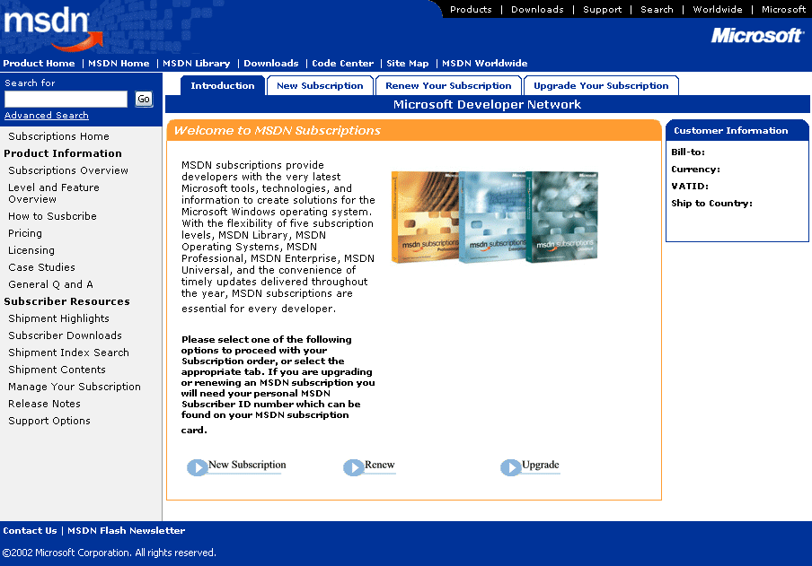
Figure 1. Example of how links to OM-based Web pages appear on a Web site
Figure 2 shows the page that appears when a customer clicks New Subscription and selects criteria to order a product on the MSDN Web site. The UI elements on this page are consistent with those on the order pages for other OM tenants, though the branding and product-specific details are customized.
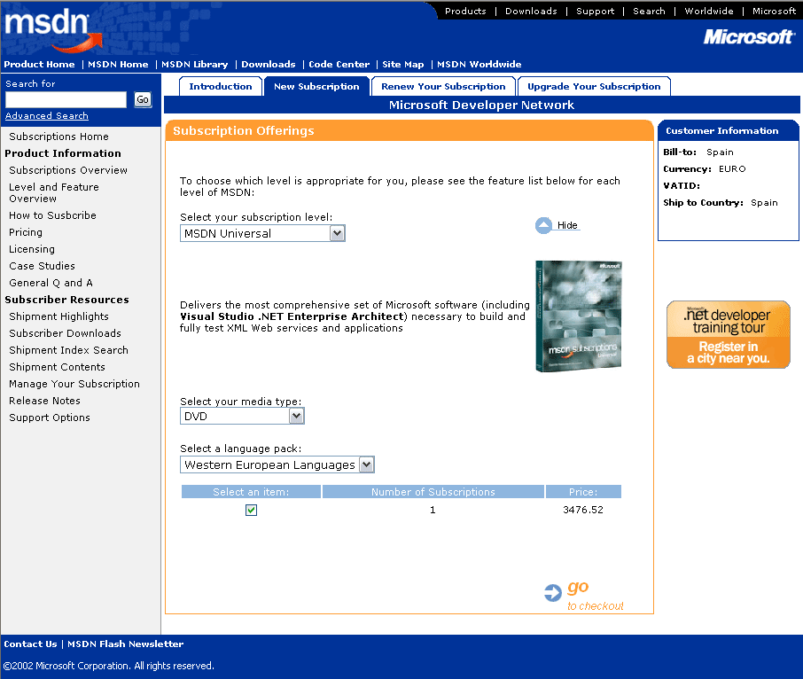
Figure 2. Example of an OM-based ordering page
By holding values in the system—such as the base prices of stock-keeping units (SKUs), currency exchange rates, promotional discounts, vendor codes, and taxes—OM provides dynamic pricing for the individual shopper. OM can determine the price of a SKU based on the specific criteria that the user selects and the values held in the system.
OM is integrated with the worldwide network of vendors to provide a centralized infrastructure for both order fulfillment and Internet-based customer service. OM includes the ability to send real-time Extensible Markup Language (XML) data or encrypted batch files to vendors to enable order fulfillment and billing.
Architecture
Two project managers and three support analysts on the OM development team work with current and prospective OM tenants to determine business requirements. Approximately six developers write the code for the application. The team has developed OM over a three-year period, releasing new upgrades and features on a quarterly and sometimes monthly basis. A separate, five-person team tests the application.
OM consists of a presentation layer (the browser on the user's computer), a business layer (Microsoft Internet Information Services [IIS] version 6.0), and a data layer (Microsoft SQL Server™ 2000). In the business layer, traditional Active Server Pages (ASP) server-side interpreted code scripts work in conjunction with Component Object Model (COM) objects that are derived from the Active Template Library (ATL) and coded in C++. These COM objects contain and handle the business-level processing requirements and manage database connectivity, including sending and receiving data between the IIS-based server and the databases in the data layer. The databases contain product information, customer information, and order information.
Figure 3 shows the basic architecture of OM.
Figure 3. OM architecture
Other technologies used in OM include:
- C#. Components of C# access data that is stored on the SQL Server–based server to return SKUs for dynamic pricing. The OM development team has also used C# components from the ASP Web pages by using COM+, but do this only to communicate with subscription management services, whose application programming interface (API) is based on Microsoft ASP.NET. In this way, OM is partially integrated with Microsoft .NET.
- Transact-SQL (T-SQL). The IIS layer of OM calls Structured Query Language (SQL) stored procedures through T-SQL.
- Microsoft BizTalk® Server 2000. BizTalk is used to export and transform order data into the SAP enterprise resource planning system, which uses the Advanced Business Application Programming (ABAP) language.
The technology on which OM is built is an internally developed Hypertext Markup Language (HTML) text parser designed at first to do localization, then also used to do tenant-based configuration, such as processing parameters. Information about configuration or localized text is stored in a separate database under an HTML tag name in ASP. At design time, the OM development team runs the text parser, which either creates a hard-coded version of the site specific to that tenant or creates XML configuration files specific to that tenant.
The OM development team has been trained extensively on various security-related aspects of application programming and has taken steps to incorporate security into OM at the design level. In an early version of OM, the team identified potential security risks, such as cross-site scripting bugs and buffer overruns in the COM objects. In addition to fixing these problems during security reviews, the team has considered authorization paradigms for tools that CSRs use and ensures that only valid representatives can enter the system.
Business Benefits
OM is flexible and fast. Implementations range from simple on-line campaigns (Buy Now buttons) that can be set up literally within hours, to more complex worldwide online stores that can take up to a month to configure, implement, and test. In the past, when each business group spent time developing its own e-commerce application, time to market for products was usually several months at minimum. OM can provide most Microsoft groups with a complete e-commerce Web site in as little as three business days.
Approximately 17 percent of the Web sites implemented through OM require some level of custom development in the OM application. For example, one Web site required integration with a database of Microsoft Windows® XP product activation keys. When the development team adds new features to OM, those features become part of the application so that other groups can use them.
OM reduces costs. Examples of cost savings for creating an online store for two prominent Microsoft initiatives are as follows:
- The online store created for Microsoft Xbox® returns and warranties was originally estimated at $650,000, which included the cost of creating an individual e-commerce application. Creating the store through OM cost $57,000, saving $593,000.
- For the employee purchase program and home-use rights, the OM development team met the seven-week deadline and created an online store that offers over 50 products in seven languages and nine currencies. Creating the Web site through OM cost 40 percent of the vendor bids of approximately $1 million, saving Microsoft $600,000.
Standardizing an e-commerce application across Microsoft also provides the following benefits:
- A consistent customer experience for online purchasing and customer support, leading to higher customer satisfaction.
- Scalability to meet business needs. In the fourth quarter of FY03, OM handled an average of 97.4 orders per hour; however, the current OM infrastructure is designed to handle up to 2,000 orders per hour.
- A reduced number of vendors because business groups can use OM, instead of vendors, to create online stores.
- Reduction of the overhead of managing vendors for order fulfillment and Internet-based customer service. By using the integrated vendor network, an OM tenant can avoid issues such as establishing a relationship with a vendor, developing a contract, setting up payment methods, and ensuring that the vendor is meeting service level agreements.
OM has been widely adopted. As of this writing, approximately 120 Microsoft initiatives that provide important services to customers have used OM to rapidly and cost-effectively deploy online ordering. These services include products for developers on the MSDN and TechNet Web sites, and products for training and certification through the Microsoft Certified Technical Education Centers.
Future Directions
As part of the ongoing development of OM, the development team plans to update the oldest parts of the application to .NET. For example, the order processing part of the system uses ASP, which will be replaced with ASP.NET code.
In the future, OM will move to a rich object model that will allow for XML serialization and deserialization, as well as communication between layers through XML. The development team also plans to incorporate Simple Object Access Protocol (SOAP) Web services and extend BizTalk functionality to export data to vendors and other systems.
For More Information
For more information about Microsoft products or services, call the Microsoft Sales Information Center at (800) 426-9400. In Canada, call the Microsoft Canada information Centre at (800) 563-9048. Outside the 50 United States and Canada, please contact your local Microsoft subsidiary. To access information via the World Wide Web, go to:
http://www.microsoft.com/
http://www.microsoft.com/technet/itshowcase
© 2003 Microsoft Corporation. All rights reserved.
This case study is for informational purposes only. MICROSOFT MAKES NO WARRANTIES, EXPRESS OR IMPLIED, IN THIS SUMMARY. Microsoft, BizTalk Server, SQL Server, and Windows are either registered trademarks or trademarks of Microsoft Corporation in the United States and/or other countries. The names of actual companies and products mentioned herein may be the trademarks of their respective owners.

