*Live Meeting is a powerful conferencing solution that helps you:*

* *Form deeper connections across and between organizations with online meetings, events and training.*
* *Make meetings more effective with integrated audio, video and rich media.*
* *Free up IT to work on business-critical projects by offering a trusted, reliable service.*

Microsoft® Office Live Meeting Web Conferencing

Microsoft Office Live Meeting is a conferencing solution that connects and engages audiences in online meetings, training and events through a reliable, enterprise class hosted service. With meeting attendees participating from their PCs, you can deliver a presentation, kick off a project, brainstorm ideas, edit files, collaborate on whiteboards, and negotiate deals at a fraction of the cost and without the hassle of travel.

Live Meeting helps users streamline communications with colleagues, customers, and suppliers. From small collaborative meetings to large events, Live Meeting is the perfect web conferencing solution for conducting online events.

Host Collaborative Meetings Quickly and Cost-Effectively

* **Share and record your meeting notes.**
* Thealways-on Shared Notes pane enables every attendee to view and edit shared action items to ensure everyone is in synch on key deliverables. Store your team meeting notes and record the session for future reference.
* **Highlight and emphasize key aspects of your presentation.**
* The new interactive whiteboard and annotation tools improve online collaboration. Updated tools include rich text, sophisticated shapes, fonts and flowcharts to help you create more informative and dynamic presentations.

[**www.microsoft.com/livemeeting**](http://www.microsoft.com/livemeeting)

Train Employees and Partners, Conduct Large Audience Events

* **Streamline attendee management.**Surveys, calendar invitations, automatic confirmation emails and update emails streamline attendee management. Surveys can be incorporated as web slide resources in a meeting, or sent after the meeting to all participants as URLs.
* **Verify your audience comprehension.**Simple-to-create tests use a range of question styles, such as fill in the blanks, true-false, single-select, and multi-select, to validate the comprehension of your content. Save time by scoring test results automatically and provide scores to participants individually.
* **Get the most out of your recorded meetings**.  
  Find critical information easily with the new quick search, chapter index, and high fidelity playback features to enable a quicker and more focused review of meeting content. Transform your organizational recordings into more effective, and more often used, information assets.
* **Conduct high quality, large scale events with confidence.**Meetings can scale up to 1,250 attendees, or host 2,500 attendees when you engage Microsoft professional event services.

Engage Your Audience with Rich Media and Video Conferencing

* **Connect remote participants and teams.**The new 360-degree Panoramic Video of all conference room participants, delivered together withMicrosoft® Roundtable device, enriches collaboration sessions and makes participants feel like they are in the room with the other attendees.
* **Make a bigger impact with dynamic audio and video**.   
  Movie clips, Flash animations, and audio files make presentations more memorable. Presenters can easily upload media files and all media clips are virus scanned by Microsoft Forefront before distribution to meeting attendees.
* **Break out into groups.**

Use Virtual Breakout Rooms to break into groups for one-on-one discussion or more subject matter drill down. Easily roam between rooms and make announcements to address attendees in each specific breakout session.

* **Distribute handouts before or during your meetings.**

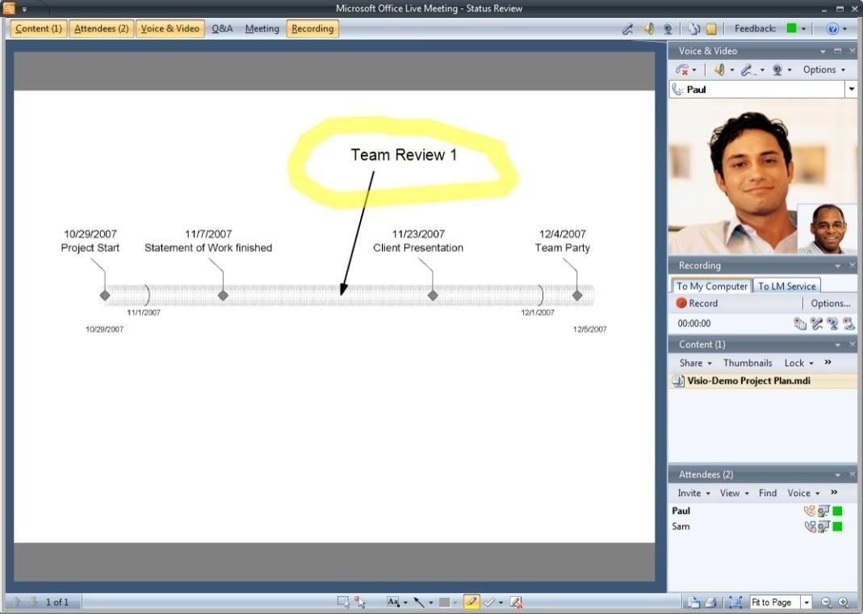Handouts in native file formats can be distributed before and during meetings to help you keep attendees on the same page. All handouts are virus scanned and protected by Microsoft Forefront. `

Reliable and More Secure Service

Screenshot Placeholder

* **Trustworthy, Reliable Service.**

Live Meeting’s record of high availability is proven by a decade of operating experience and backed by the resources of a Fortune 100 company.

* **Enhanced security you can count on.**

Cybertrust and SAS70 certified data centers provide security enhanced content storage. More secure communication across firewalls, SSL data encryption, strong password authentication policies and 128-bit encryption combine to dramatically improve security.

* **Integrate with Microsoft® Active Directory™.**

Leverage your existing identity infrastructure for a rapid and integrated deployment. The Live Meeting Intranet Portal automatically creates user accounts and authenticates with Active Directory.

**Register today for a FREE trial!**

[**www.microsoft.com/livemeeting**](http://www.microsoft.com/livemeeting)