

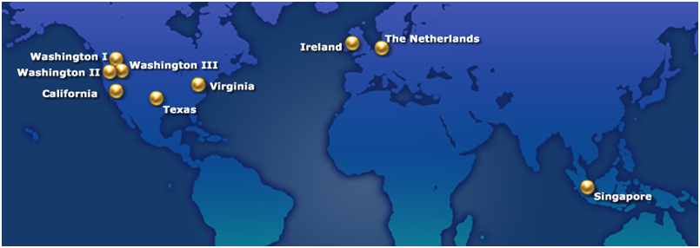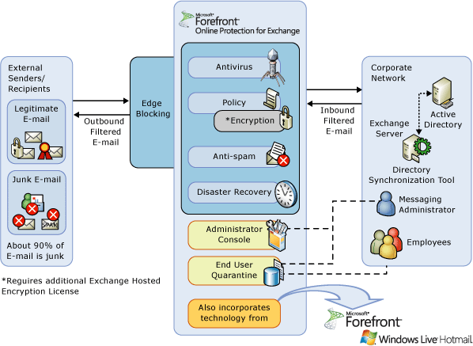

Electronic messaging is mission critical, but remains vulnerable to a growing array of threats. Viruses, worms, denial-of-service attacks, spam, legal e-discovery and the need to satisfy a growing set of regulations all make effective message management increasingly difficult.

Microsoft ® offers a range of solutions to assist companies in meeting complex e-mail requirements, including hosted services for e-mail filtering, encryption and archiving that help businesses communicate with confidence: Microsoft Forefront Online Protection for Exchange provides enterprise-class reliability for messaging security and management and can assist your organization by protecting itself from spam and malware; Exchange Hosted Archive helps satisfy complex retention requirements for e-Discovery and compliance and Exchange Hosted Encryption enables encryption of data to help preserve confidentiality.

Microsoft can help you simplify the administration of your messaging environments with services that are easy to deploy, manage, and maintain. The online services model requires no hardware or software installation, minimizes up-front investment and provides a predictable payment schedule through a subscription-based service.

These Microsoft Online Services provide a layer of protection features deployed across a global network of secure Internet data centers. The services create a security-enhanced message stream to and from your on-premises, hosted or Exchange Online messaging environment.

**Microsoft Exchange Hosted Services**

**Please visit   
www.microsoft.com/online  
to learn more about   
Microsoft Online Services**

**How it Works**With just a simple mail exchange (MX) record configuration change, the services can be up and running quickly. There is no hardware to provision; no software to buy, install or configure; and no expensive training required for your IT staff. The heart of Forefront Online Protection for Exchange and the other Exchange Hosted Services is a distributed network of data centers located at key sites along the Internet backbone. Each data center contains fault-tolerant servers that are load-balanced from site to site and from server to server. In the unlikely event that one data center is unavailable, traffic can be easily routed to another data center, minimizing the chances of interruption to the service. In addition, Microsoft algorithms analyze and route message traffic between data centers to help ensure secure and timely delivery. With this highly available network Microsoft provides service level guarantees of 99.999% uptime.

**EHS Data Center Network Overview**Forefront Online Protection for Exchange utilizes state-of-the-art, fully redundant, load-balanced data centers located strategically across the globe to help ensure high availability.

**Features and benefits**

**FEATURES AND BENEFITS**

Simplified Management

* Simplifies IT environment by minimizing the need to deploy, configure, monitor, and update in-house e-mail security servers and applications
* Helps free network and server resources
* Eliminates up-front capital investment
* Offers a predictable, subscription-based payment
* Lower total cost of ownership when compared with on-premises solutions
* Allows you to respond quickly to e-Discovery requests
* Helps free up administrator time to focus on other projects

Enterprise Class Reliability

* Scales to meet the needs of virtually any enterprise
* SLA-supported uptime and performance
* Secure, strategically located, geo-redundant data centers
* 24 x 7 phone and web support

Active Protection

* Layered real-time anti-spam and anti-virus defenses
* Eliminate threads before they reach the corporate firewall
* Assists with policy enforcement
* Directory Synchronization tool can help reduce “noise” and risk
* Helps increase available bandwidth



**SOLUTIONS OVERVIEW**

|  |  |
| --- | --- |
| **Microsoft Forefront Online Protection for Exchange** | **Multi-engine spam and virus scanning** - Powered by multiple filtering engines and an around-the-clock team of anti-spam experts, Forefront Online Protection for Exchange virtually eliminates spam from inboxes, helping to provide bandwidth for legitimate corporate use. FOPE virus scanning helps provide zero-day threat protection against known and unknown threats by using multiple antivirus engines that are integrated at the application programming interface level to provide timely virus definition updates and utilize sophisticated heuristic engines.  **Active content, connection and policy-based filtering** – This highly customizable filter helps administrators comply with corporate policies on e-mail usage and with government regulations.  **Forced TLS Option** – By creating a Forced TLS rule in the policy filter, administrators can help ensure that sensitive e-mail is encrypted in transport.  **Real-Time Message Trace and Reporting** – Real time reporting and the powerful Message Trace tool give administrators insight into their e-mail environment by retrieving the status of any e-mail processed by Forefront Online Protection for Exchange in real-time.  **Disaster Recovery** - If the destination e-mail server becomes unavailable for any reason, FOPE helps to ensure no e-mail is lost or bounced by automatically queuing e-mail for up to five days, attempting to deliver the e-mail every 20 minutes. |
| **Microsoft Exchange Hosted Archive** | **Support to help satisfy industry and regulatory retention requirements** –Exchange Hosted Archive (EHA) has many features that aid in compliance including multiple retention periods, legal hold, supervision monitoring by keyword or percentage and immutable storage.  **Granular Reporting and Auditing Capabilities** - Any good security policy encompasses granular audits and logging of system transactions. EHA has numerous auditing reports available in addition to several traceable administrative and user events.  **Rapid search and retrieval** - Indexed storage enables fast retrieval of messages for e-discovery and other investigations.  **Fully functional backup e-mail system** – If primary e-mail systems go down, users and administrators will still have access to archived e-mail and can send and receive new messages in real time. |
| **Microsoft Exchange Hosted Encryption** | **Policy-based encryption from sender to recipient -** Policy-based encryption consistently and automatically encrypts messages at the gateway based on policy rules.  **IBE Technology uses a common ID for Public Key**  **Web-based decryption and encrypted replies** - The Zero Download Messenger enables Web-based decryption and encrypted replies for any recipient of encrypted messages with no end user training or software installation. |



© 2010 Microsoft Corporation. All rights reserved. Microsoft is a registered trade­mark of Microsoft Corporation in the United States and/or other countries This datasheet is for informational purposes only. Microsoft makes no warranties, express or implied, in this summary.

© 2008 Microsoft Corporation. All rights reserved. Microsoft is a registered trade­mark of Microsoft Corporation in the United States and/or other countries This datasheet is for informational purposes only. Microsoft makes no warranties, express or implied, in this summary.