The Importance of Ergonomic Input Devices in the Workplace
The Scope of Computer-Related Repetitive Strain Injuries and Methods for Their Prevention

Microsoft Corp.
Published:September 2006

Abstract
The costs associated with repetitive strain injury (RSI) to businesses are very high; the federal Occupational Safety & Health Administration (OSHA) estimates them to be between $15 billion and $20 billion per year in the United States. Of the many risk factors associated with RSI, one of the easiest to address is improper workstation configuration. For computer users, this includes using an appropriate pointing device and keyboard, such as the variety of ergonomically designed mice and keyboards offered by Microsoft Corp. Properly designed ergonomic input devices have been shown to reduce computer-related pain and demonstrate a significant effect on the incidence of RSIs for primary prevention.

The cost savings resulting from a solid ergonomic program can be substantial. Using numbers derived from modern studies on injury rates and using a hypothetical company employing 500 computer users as an example, a 10 percent reduction in repetitive strain injuries and symptoms would yield an annual savings of $700,000. To provide guidance on establishing an effective ergonomics program, this paper offers 10 steps to a healthy workplace. Ultimately, implementing a solid ergonomic program not only provides computer users with a healthy and productive workplace, but is good for the bottom line as well.


©2006 Microsoft Corp. All rights reserved.

The information contained in this document represents the current view of Microsoft Corp. on the issues discussed as of the date of publication. Because Microsoft must respond to changing market conditions, it should not be interpreted to be a commitment on the part of Microsoft, and Microsoft cannot guarantee the accuracy of any information presented after the date of publication.

This white paper is for informational purposes only. MICROSOFT MAKES NO WARRANTIES, EXPRESS, IMPLIED OR STATUTORY, AS TO THE INFORMATION IN THIS DOCUMENT.

Complying with all applicable copyright laws is the responsibility of the user. Without limiting the rights under copyright, no part of this document may be reproduced, stored in or introduced into a retrieval system, or transmitted in any form or by any means (electronic, mechanical, photocopying, recording or otherwise), or for any purpose, without the express written permission of Microsoft Corp.

Microsoft may have patents, patent applications, trademarks, copyrights or other intellectual property rights covering subject matter in this document. Except as expressly provided in any written license agreement from Microsoft, the furnishing of this document does not give you any license to these patents, trademarks, copyrights or other intellectual property.

Microsoft Corp. ●One Microsoft Way ●Redmond, WA 98052-6399 ●USA

Microsoft and Natural are either registered trademarks or trademarks of Microsoft Corp. in the United States and/or other countries.
The names of actual companies and products mentioned herein may be trademarks of their respective owners.

Contents

Musculoskeletal Disorders: the Scope of the Problem 3
What Is Ergonomics and Why Does It Matter? 3
Addressing Workstation Configuration 3
Ergonomic Keyboards 3
Recent Advancements in Keyboard Comfort 3
Advanced Natural Keyboards 3
Comfort Curve 3
Pointing Devices 3
Recent Advancements in Mouse Comfort 3
Notebook Mice 3
The Cost Benefits of Ergonomic Programs 3
Ten Steps to a Healthier, More Productive Workplace 3
Summary 3
Related Links and References 3

Musculoskeletal Disorders: the Scope of the Problem
Musculoskeletal disorders (MSDs), a superset of repetitive strain injuries (RSIs), are a mammoth cause of medical costs, lost work time and reduced productivity. This issue affects both companies and employees. Government bodies that track such statistics consistently show that the problem is significant. The Washington State Department of Labor and Industries, for example, reports the following:
“The magnitude, cost and burden of work-related musculoskeletal disorders (WMSDs) are enormous. From 1992–2000, there were 380,485 Washington state accepted workers' compensation state fund claims for nontraumatic soft tissue musculoskeletal disorders of the neck, back and upper extremity. These claims resulted in $2.9 billion in direct costs, and 26.9 percent of all state fund workers' compensation claims. Of WMSD claims during this time period, 32.4 percent were compensable with an average of 123 lost time days per compensable claim.”¹
Clearly, the problems surrounding MSDs are daunting. This paper will describe the nature of these problems and illustrate the benefits of the ergonomic solutions that Microsoft offers.
According to a Microsoft study, computer users strike the keyboard space bar an average of 669 times per hour.
MSD is a term that refers to a broad range of soft tissue disorders, such as those affecting the spinal discs, muscles, joints, cartilage, nerves, blood vessels, tendons or ligaments. Carpal tunnel syndrome is a well-known example of this type of disorder. One of the causes of MSDs is repetitive motion, and disorders involving repetitive activities are commonly referred to as repetitive strain injuries. RSIs represent the accumulation of many small injuries suffered during daily, routine activities. These injuries result from decreased blood flow or strain to the affected areas of the body, which can cause nerve compression, tendon damage, muscle strain and joint damage — small injuries that begin to add up. Depending on the level of activity, the accumulation of injury can begin to outpace the ability of the body to heal itself, eventually leading to a potentially serious injury.
Since these injuries develop slowly over time, they can be much more difficult to identify than an injury that is attributable to a single traumatic event. As a result, people tend to neglect the warning signs and work through the pain, unaware that they may be suffering significant injury. Meanwhile, the damage continues to accumulate. Worse, these injuries can be very costly and difficult to treat once they develop into a full MSD. It is often much easier to address these problems early than it is to treat them after they have become full-blown disorders.
A survey found that PC users self-reported an average computer use rate of 5.8 hours per day, or 69 percent of their total working hours

RSIs have been appearing in increasing numbers in office environments since the early 1990s, according to the federal Bureau of Labor Statistics (BLS). On the surface, this may seem surprising, because the office seems safe when compared with industrial environments such as assembly lines, loading docks, etc. However, the data show the subtle nature of RSIs; they aren’t traumatic injuries, but low-level injuries that build up over time with repetitive actions.
Computer use requires large numbers of repetitive actions. A recent Microsoft study that measured the computer usage patterns of 88 participants over nine months found that computer users strike the keyboard space bar an average of 669 times per hour of active computer use. These periods of high activity often persist over the course of the day.
A survey of 335 professionals found that desktop PC users self-reported an average desktop computer use rate of 5.8 hours per day, accounting for 69 percent of their total working hours.² This combination of high-frequency activity with long periods of computer work means that even minute amounts of work-related damage to the body can accumulate very quickly.
Fifty percent of study participants reported repetitive strain symptoms during the first year of their new job; 68 percent of reported RSI symptoms were deemed to be severe enough to be classified as a musculoskeletal disorder.
The extent of the RSI epidemic is being explored by researchers concerned with the depth of the problem. A recent epidemiological study followed 632 newly hired computer users for up to three years and found that more than 50 percent of them reported repetitive strain symptoms during the first year of their new job.³ Worse, 68 percent of the reported RSI symptoms were deemed to be severe enough to be classified as musculoskeletal disorders (198 out of 291 instances).
Considering that a typical reported upper-extremity repetitive strain injury leads to an average of 12 lost days of work⁴ and costs on average $38,500 for worker’s compensation costs,⁵ there is a very strong financial incentive for correcting these problems, in addition to the humanitarian incentive. From a productivity standpoint, worker productivity and effectiveness have also been shown to diminish when workers suffer from musculoskeletal symptoms.⁶
Altogether, RSI represents 62 percent of all North American worker’s compensation claims and results in nearly $15 billion to $20 billion in lost work time and medical claims each year, as reported by OSHA.
RSI represents 62 percent of all North American worker’s compensation claims and results in nearly $15 billion to $20 billion in lost work time and medical claims each year.

What Is Ergonomics and Why Does It Matter?
As the severity and depth of these problems grow and begin to draw public attention, more emphasis is being placed on the science aimed at studying and addressing these work-related problems: ergonomics. Ergonomics is an applied science aimed at studying people’s physical patterns of work and helping improve them. Ergonomics seeks to make a better match between workers’ physical capabilities and their work environment and activities. This can be accomplished through better design and operation of tools, workstations, equipment and controls.
Ergonomically designed products have been appearing in a variety of industries in response to the increasingly visible problems addressed by ergonomics. Ergonomically designed office furniture, luggage, garden tools and computer products are growing in popularity.
Successes in the field of ergonomics have been demonstrated in a variety of industries. Some examples of these successes are listed below.
Textile manufacturer Fieldcrest Cannon reduced work-related MSDs from 121 in 1993 to only 21 in 1996, a drop of more than 80 percent. The company implemented engineering controls such as springs for the material-handling boxes. Workers designed and management implemented an improved bagging system. The company also purchased adjustable chairs.⁷
Bath vanity and furniture maker Woodpro Cabinetry Inc. made ergonomic changes that resulted in a decrease of almost 40 percent in workers' compensation costs, which declined from $103,824 to $61,000. The company adopted engineering controls such as dropping the conveyor belt so workers had easier access to the tops of cabinets, installing conveyors to minimize manual lifting, and purchasing angled tables to reduce bending and reaching. They also implemented job rotation.⁸
Charleston Forge, a metal furniture manufacturing company, established an ergonomics program that cut lost workdays from work-related MSDs from 176 in 1991 to 0 in 1997. Ergonomic changes increased productivity 25 percent.⁹
To drive these successes, ergonomics has identified many risk factors involved in the development of RSI. These risk factors include (among others) history of injury, rest and work patterns, workload, psychosocial factors (such as workplace stress), individual factors, work patterns, and workstation configuration. Addressing any of these risk factors can be helpful in reducing the incidence of RSI and increasing worker productivity.

Addressing Workstation Configuration
This paper emphasizes the importance of improving workstation configuration. Workstation configuration problems can be relatively easy to address, and workstation changes are one of the key ways to match a job’s physical requirements with individual workers’ capabilities. In addition, the benefits of proper ergonomic workstation design can be substantial. For example, researchers found that individual performance increased 25 percent when employees used an ergonomically designed workstation.¹⁰
In the area of computer input, ergonomics is aimed at maximizing productivity by reducing worker fatigue and discomfort, reducing errors, and increasing input speed. By applying the principles of ergonomics to the design of workplace tools such as keyboards and mice, Microsoft and other companies are able to make products more comfortable and worker-friendly, particularly during periods of extended use.

Ergonomic Keyboards
The keyboard is a crucial component of a properly designed computer workstation. One of the main emphases in designing ergonomic keyboards has been to try to improve user posture during keyboard use. To improve user posture, keyboards can be split so that each half better accommodates the natural posture of each arm (see Figure 1). This is in contrast to straight keyboards, which require users to modify their posture to fit the keyboard design. In this paper, the term “ergonomic keyboard” will be used to refer to keyboards that have been split to better accommodate a natural working posture.
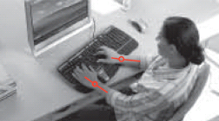
Figure 1. Overhead shot of split keyboard showing reduced ulnar deviation
Ergonomic keyboards come in two varieties: fixed and adjustable. Table 1 summarizes the advantages and disadvantages of each. Fixed ergonomic keyboards come in a set configuration to accommodate most users, and are simple to set up and use without training. But they cannot be customized to accommodate individuals of unusual body shapes and sizes. Conversely, adjustable keyboards have movable parts and can be adjusted to accommodate almost any body type. However, they can be difficult to set up, and the ergonomic advantage may be lost if they are not properly configured.

Table 1. Comparison of Fixed versus Adjustable Ergonomic Keyboards
 | Fixed Ergonomic Keyboard | Adjustable Ergonomic Keyboard
Advantages  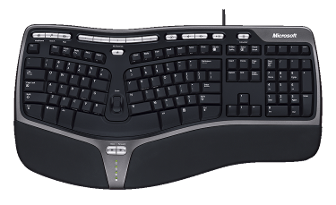  Disadvantages | - Very easy to set up  - Cannot be improperly configured  - Designed for the general population  The Natural Ergonomic Keyboard 4000 is an example of a fixed alternative keyboard design  - One size fits all — no customization | - Can be adjusted to accommodate individuals of unusual body shapes and sizes  - More difficult to set up to gain full benefit — special training may be required  - Improper setup can lead to poor ergonomic alignment

Microsoft has become one of the leaders in ergonomic keyboard design by launching the first fixed ergonomic keyboard, the Microsoft® Natural® Keyboard. This design, and Microsoft’s success with it, has been largely influenced by the fact that Microsoft is one of the few keyboard manufacturers to employ a full-time in-house ergonomist who helps design its input devices. Since the Microsoft Natural Keyboard launched in 1994, it has become the No. 1 best-selling ergonomic keyboard design of all time, selling more than all other brands of ergonomic keyboards 3 to 1.¹¹ In addition, the Natural Ergonomic Keyboard 4000, the latest ergonomic keyboard from Microsoft, is the No. 1 best-selling wired keyboard in the country.¹²
Because of the longevity of its popular design, the Microsoft Natural Keyboard has become one of the most researched ergonomic keyboards. “The Effect of Alternative Keyboards on Musculoskeletal Symptoms and Disorders” by Moore and Swanson, one of the largest and most meaningful studies of ergonomic computer peripherals, recently assessed whether keyboard design was directly linked to the risk of musculoskeletal disorders and symptoms.¹³
The Moore and Swanson study found that the Microsoft Natural keyboard design helped reduce the severity of symptoms for people who were already suffering, stating “the fixed alternative keyboard was associated with improvement of baseline wrist and carpal tunnel syndrome symptoms.”
This study followed 289 people for two years as they used a specific keyboard: a standard keyboard, an adjustable split keyboard, or a fixed split keyboard — the fixed split Microsoft Natural Keyboard design. The findings demonstrated the injury-prevention benefits of using the fixed split Microsoft Natural Keyboard over time, concluding, “In terms of primary prevention, only the fixed alternative keyboard demonstrated a significant effect on the incidence of musculoskeletal symptoms.”
The Moore and Swanson study also determined that the Microsoft Natural Keyboard design helped reduce the severity of symptoms for people who were already suffering, stating “the fixed alternative keyboard was associated with improvement of baseline wrist and carpal tunnel syndrome symptoms.”
Looking at the workers’ subjective pain over time, a separate longitudinal study in 1999¹⁴ compared a placebo standard keyboard with the Microsoft Natural Keyboard and two adjustable split keyboards. This study followed 80 computer users over six months and found that the Microsoft Natural Keyboard “demonstrated an improving trend in pain severity and hand function following six months of keyboard use” when compared with the standard keyboard. In addition, the Microsoft Natural Keyboard yielded the greatest user benefit of any of the tested keyboards. The 1999 study also established that users were able to type just as quickly on a split keyboard as they could on a straight keyboard.
In verifying the design intent of the Microsoft Natural Keyboard, a 2000 study¹⁵ examined users’ posture during use of this keyboard. The findings of this study yielded hints about the reasons for the reduction in pain and symptoms seen in the other studies. The study tested wrist posture of 16 participants using three keyboards: a standard keyboard, the Microsoft Natural Keyboard, and a keyboard with adjustable-angle design. This study concluded that the Microsoft Natural Keyboard design “promoted a more natural hand position while typing, thereby reducing the potential for cumulative trauma disorders of the wrist.”

Recent Advancements in Keyboard Comfort
Following on the success of the Natural Keyboard design, Microsoft has recently developed two new advancements in keyboard comfort. The first advancement is intended to provide additional ergonomic benefits to users of split keyboards. The second advancement, the Comfort Curve design, features a slightly curved design that provides some of the benefits of a split keyboard to users who prefer to use a straight keyboard.

Advanced Natural Keyboards
Several ergonomic advances have been developed at Microsoft in the 11 years since the release of the first Natural Keyboard. These advances include an increased gable angle, a padded palm rest, a palm lift, a curved key bed and a natural arc design. These innovations are described in detail below.
- The gable angle has been increased from 8 degrees to 14 degrees. This helps users untwist (depronate) their arms closer to a natural handshake position while typing.
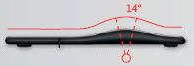
Figure 2. Gable angle
- Both a new padded palm rest and palm lift have been designed to help reduce wrist extension (bending in the vertical direction). The presence of the palm rest helps prevent the wrist from dropping excessively while typing. Padding the palm rest helps reduce contact pressure while the hand rests on it (note that the hand should not rest on the palm rest during typing). The removable palm lift provides a 7-degree reverse tilt to the keyboard, which helps even more to reduce wrist extension — an ergonomic benefit that has recently been documented by two independent studies.^{16,} ¹⁷
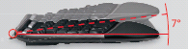
Figure 3. Palm lift
- The curved key bed was developed based on research indicating that keys at the extents of the keyboard are often struck off-axis, resulting in less efficient key strikes. The curved key bed helps address this by pointing the keys more toward the center of the user’s hand. This was designed to help users strike the keys more directly while typing, reducing any force wasted by pushing the keys sideways.
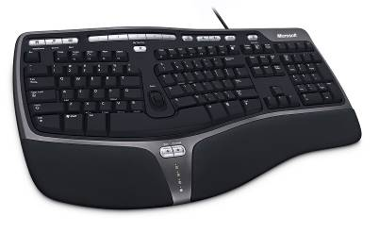
Figure 4. Curved key bed

- The Natural arc was designed based on the obvious observation that people’s hands are not squared off; their fingers all have different lengths. However, most keyboards provide keys in a squared off straight line. The Natural arc addresses this discontinuity between keyboards and hands by adding a gentle curve to the key layout. This not only helps the keyboard better match the hand, it also reduces key reach to the most distant keys (such as the Backspace key). This benefit is achieved by arching the keys closer to the center of the hand, rather than extending them out in a straight line.
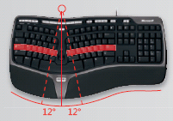
Figure 5. Natural arc reducing pinky reach

This new advanced Natural design is available in the Natural Ergonomic Keyboard 4000 (pictured above in figures 2–5).

Comfort Curve
The Comfort Curve concept provides a 6-degree curved design, in contrast to the 12-degree split angle used on Microsoft Natural keyboards. This reduced angle allows the keyboard keys to remain in a contiguous arc, rather than being split into two distinct keyboard halves. Evaluations have shown that this makes the keyboard more approachable to users who are hesitant to switch to a fully split design while still providing a more natural wrist posture relative to a traditional straight keyboard.¹⁸ In fact, Microsoft focus groups have shown that traditional keyboard users prefer the Comfort Curve design 3-to-1 when compared with traditional keyboards. This easy-to-approach design provides a comfort benefit that is accessible to everyone. Comfort Curve is available in a variety of keyboards at multiple price points.
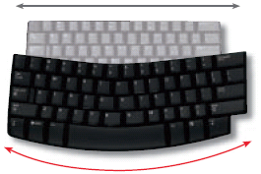
Figure 6. Six-degree curve
Ultimately, no single keyboard is ideal for everyone; each individual needs to choose the keyboard that works best for him or her. Microsoft responds to this need by offering a variety of ergonomic keyboard designs to suit various preferences in terms of size, shape and comfort level.

Pointing Devices
When considering workstation design, computer users can choose among a variety of pointing devices. This paper focuses on mice, while recognizing that some people may prefer different pointing devices.
Microsoft has run a variety of studies aimed at determining what makes a mouse feel comfortable. One of the key factors that influences subjective mouse comfort is contact pressure on the hand. Too much pressure on the hand is uncomfortable because it causes the mouse to press sharply into the palm. Proper contact pressure can be provided by a mouse that contacts a large portion of the hand and contacts it in an even, distributed manner.
Several approaches have been taken in the design of Microsoft mice to ensure that they provide the proper amount of contact area, and provide it in the proper locations. The first approach was the pressure-sensitive glove, which was used to determine the areas of the hand that were contacting the mice and the location of contact. Advancing the measurement of contact area, Microsoft then shifted to infrared thermography to help evaluate the contact area provided by its mice. This technique resulted in mice designed for long-lasting comfort.
One of the key criteria for selecting a mouse is whether it is designed for the right hand only or for use by either hand (ambidextrous). Both approaches have their advantages and disadvantages (see Table 2 for a summary). Right-hand-only mice have been optimized for comfort in the right hand, which allows for additional tailoring of contact area, and for the wrist to be positioned with less pronation (twist in the forearm). Ambidextrous mice can be used in either hand, and can therefore be switched between hands to balance use. However, mouse shape must remain more generic to accommodate use by either hand. An ambidextrous design can also be useful for corporate standards, to accommodate both right- and left-handed employees.
Table 2. Comparison of Right-Handed versus Ambidextrous Mice
 | Right-Hand-Only Mouse | Ambidextrous Mouse
Advantages | - Optimized for best right-hand comfort  - Provides reduced wrist twisting (pronation) | - Can be used in either hand  - Can be switched from hand to hand to balance work load
Disadvantages | - Cannot be used in the left hand | - Not optimized for single-handed comfort
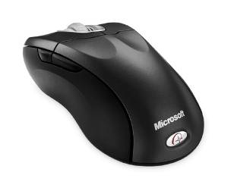
Figure 7. Example of right-hand mouse (Wireless Optical Mouse 5000)
Because hand sizes and comfort preferences differ, Microsoft offers a wide variety of desktop mouse shapes and sizes.

Recent Advancements in Mouse Comfort
Recently, Microsoft has generated some breakthrough new ideas in mouse comfort, and combined them with some of the concepts that have made the Natural line of keyboards so successful. The result of this effort is the Natural Wireless Mouse 6000.

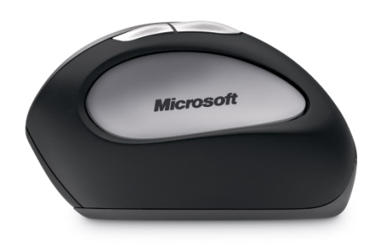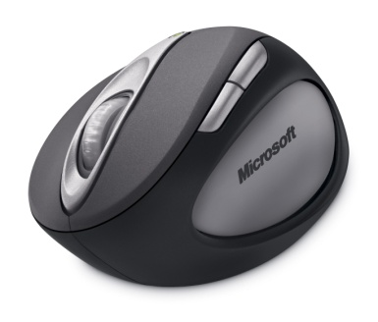
Figure 8. Natural Wireless Mouse 6000: looks different to fit you better

As evident in figure 8, the new Natural mouse design looks unique. This is due to the fact that because the mouse has been designed from the beginning to fit the relaxed posture of the hand. Poor posture has been identified as one of the key risk factors for RSI.²³. So the neutral, relaxed posture that this mouse provides is very important and was the core driver for the new design.
Specific features of the mouse have been designed to provide this relaxed posture. The vertical wrist posture is provided by the elevated thumb scoop and the slant of the top of the mouse. Such wrist posture has been shown to result in lower carpal tunnel pressures.²⁰. Similarly, the curved finger posture is provided by the curving form of the mouse. This rounded form was designed to reduce the static muscle load that is required with traditional mice to hold your fingers straight over the buttons. This bent finger posture has also been associated with reduced carpal tunnel pressure.²⁰
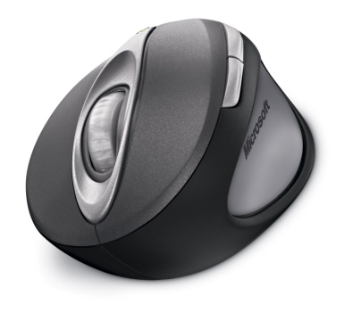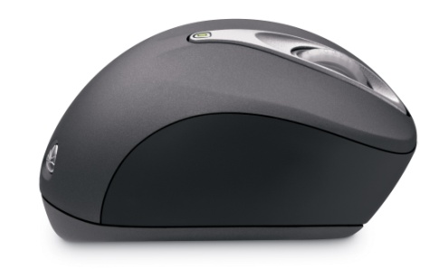
Figure 9. Features providing relaxed posture

Another important benefit of the vertical wrist posture is that it helps to get the sensitive area of the hand out of contact with the desktop. This area of the hand is just over the carpal tunnel, and previous research has shown that external force applied to this area of the hand has a powerful effect on carpal tunnel pressure.¹⁹ For instance, a 1kg force applied to the most sensitive part of the hand was found to drive carpal tunnel pressure to a mean pressure of 136 mm Hg. Other research has shown that once carpal tunnel pressure begins to exceed 30-40 mm Hg, the pressure begins to interfere with nerve function and circulation.^{21,22} It is thus very important to keep external forces off this area of the hand. Unfortunately, many people rest this area directly on the desktop while using a traditional mouse. The new Natural Wireless Laser Mouse was designed to roll the hand onto its side so that these sensitive areas are not in contact with the desktop (figure 11).

Figure 10. Examples of hand contact area with desk with the new Natural mouse on left and a traditional mouse on the right. The darker colors highlight the greatest amount of pressure a traditional mouse puts stress in the area of the carpal tunnel.

In addition to ergonomic design, the Natural mouse also offers productivity and performance features such as a laser sensor, a wireless connection and a tilt wheel. In testing, the Natural mouse demonstrated pointing performance equivalent to that of a traditionally shaped high-end mouse. In addition, new users were able to immediately use the Natural mouse effectively. Therefore, the Natural mouse helps you get your work done efficiently in addition to providing superior comfort. Many other ergonomic mouse designs have a learning curve and provide inferior pointing performance; the Natural mouse delivers all the comfort benefits of the ergonomic design along with the pointing performance expected from a traditional mouse.

Notebook Mice
A recent study² followed the differences in usage patterns between desktop and notebook computer users.
One of the most profound findings of this study was that notebook users who used an external pointing device reported a lower incidence of pain when compared with notebook users who used only the notebook’s internal pointing device. Based on this finding, an external pointing device is recommended for use with notebook computers. For this reason, Microsoft offers a variety of comfortable, portable and convenient notebook computer mice.
Findings showed a lower incidence of pain was reported for notebook users who used an external pointing device when compared with notebook users who did not use an external pointing device.
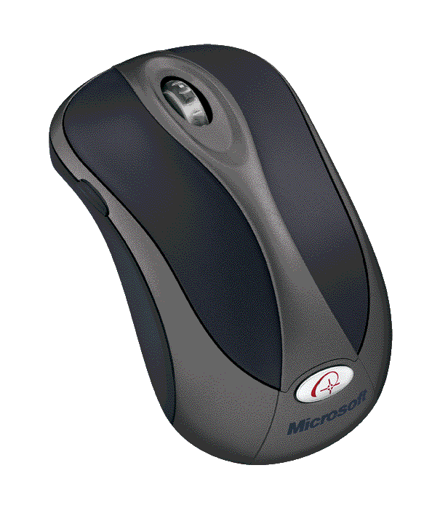

Figure 11. Example of external pointing device (Wireless Notebook Optical Mouse 4000) to provide improved comfort for notebook computer users

The Cost Benefits of Ergonomic Programs
As mentioned in the introduction, the costs related to repetitive strain injuries are very high — estimated by OSHA as costing U.S. businesses $15 billion to $20 billion per year. The incidence rate of musculoskeletal symptoms (a precursor to RSI) is also very high. A 2002 study⁶ surveyed 1,283 computer users from different occupations; 87 percent of females and 76 percent of males reported that they were experiencing at least one musculoskeletal symptom. Addressing these symptoms early is key to preventing full-blown injuries. This section of the paper will focus on some of the costs associated with computer-related RSI and demonstrate the potential cost savings of addressing the risk factors for RSI early, before serious problems develop.

Table 3. Quantifiable Costs Associated With RSI
Cost | Description | Source
$159.20 per day | Average white-collar labor rate | BLS, 2004⁴
$38,500 | Average workers’ compensation upper-extremity RSI claim | CA CHSWC, 2000⁵
12 days | Average number of work days lost per upper-extremity RSI injury | BLS, 2000⁴

The values in Table 3 have been compiled to calculate the cost of a single instance of RSI. These values represent several quantifiable costs associated with injury: worker’s compensation costs for medical treatment and the costs associated with lost work days. The total cost of an instance of RSI is calculated by adding the workers’ compensation cost to the cost to replace the lost labor. By this calculation, the direct medical and labor replacement costs of a single instance of RSI based on these studies are $40,410.
RSI cost = worker’s compensation cost + days lost per injury x (daily labor rate)
Of course, individual companies can and should make these same calculations using their own internal values to determine how costly an instance of RSI is to their company.
In addition to the direct costs mentioned above, there are costs associated with reduced productivity of those suffering from musculoskeletal symptoms. The Hagberg survey⁶ mentioned above was one of the first to quantify this effect. Of those workers suffering from at least one musculoskeletal symptom (87 percent of females and 76 percent of males), 9.9 percent on average reported reduced productivity due to their musculoskeletal symptoms. Furthermore, the researchers found that the “mean loss of productivity per month was 16.8 hours” for the workers who reported reduced productivity. Averaged out over the entire work force studied in this survey, the average employee lost roughly 1.66 hours of productivity per month due to musculoskeletal symptoms. At the average white collar labor rate cited above, that’s $33 per employee per month lost to musculoskeletal symptoms.
For an example of the potential savings available from reducing the risk of RSI, this paper will look at a hypothetical company with 500 newly hired computer users. This scenario is based on the assumption that these workers are similar to those studied by Gerr, et al. in 2002³ and that the workers make average white-collar labor rates. In the Gerr study, more than 50 percent of computer users reported RSI symptoms within the first year. And, as previously mentioned, 68 percent of them reported these musculoskeletal symptoms were severe enough to be classified as musculoskeletal disorders upon medical examination (198 of 291 instances).
Based on these numbers, it can be expected that 34 percent of workers from the hypothetical company in this scenario will experience a musculoskeletal disorder within one year of beginning their jobs. For this analysis, it is assumed that injuries require average medical costs for upper-extremity RSIs, or $38,500 per claim.⁵ This is the largest assumption in the analysis because it assumes both that the disorders documented in the Gerr study were similar to the average reported injury and that the cost to treat neck and shoulder disorders is similar to treatment costs for upper-extremity injuries.
Using these values, it can be expected that 170 of the 500 employees (or 34 percent) will experience a repetitive strain injury in their first year on the job. At a cost of $40,410 for each injury in workers’ compensation and replacement labor costs, the yearly total cost associated with repetitive strain injury is $6.87 million dollars. Adding to the cost $33 per month per employee for reduced productivity⁶ and $198,000 for reduced productivity ($33 x 12 months x 500 employees) results in a quantifiable cost of more than $7 million dollars a year to the company due to repetitive strain injuries.
These numbers make clear the strong financial incentive for addressing risk factors for repetitive strain injuries, in addition to the humanitarian incentive. Ergonomic changes that yield even a modest reduction in repetitive strain injuries and symptoms can have a very strong effect in cutting costs. For instance, a 10 percent reduction in injuries and symptoms for the hypothetical company discussed above would yield a reduction in costs of over $700,000 per year. Ultimately, implementing a solid ergonomics program is not only good for providing a healthy workplace, but good for the bottom line as well.

Ten Steps to a Healthier, More Productive Workplace
To take advantage of the potential cost benefits discussed in the previous section, a solid ergonomics program must be implemented. There are many important components of an ergonomics program for computer users, including keyboard and mouse selection. The following 10 steps are designed to provide a solid start to a high-quality ergonomics program:
- Conduct ergonomic assessments. Consider contracting an ergonomic specialist who can assess employees’ workstation needs on an individual basis and help you implement ergonomic solutions. These specialists can be great resources when considering which products to purchase.
- Make seating comfortable and adjustable. Good posture is important to comfort and well-being. You don’t have to spend thousands of dollars on a chair; look for something comfortable that allows a user to adjust the height, backrest and armrests to suit his or her body type. An office chair should support the lower back. Feet should reach the floor (if not, a foot rest will help).
- Select a good monitor. Purchase a high-quality computer screen. Make sure the text characters on the screen look sharp, are high in contrast (e.g., black on white), and are a comfortable viewing size. Monitors should be placed at a comfortable height that doesn’t make users tilt their heads excessively up or down. When seated comfortably, a user’s eyes should be in line with the top of the display (about 2–3 inches below the top of the monitor casing).
- Use ergonomic keyboards and mice. Employees spend a good part of the day with their hands on a mouse and keyboard. Ergonomic input devices are designed for comfortable posture, reducing repetition and minimizing forces. Consider purchasing mice and keyboards that have been designed by ergonomists, such as Microsoft products that can be viewed at http://www.microsoft.com/hardware.
- Utilize software and hardware tools. Work efficiency can be improved by effectively using the software and hardware features that ship with ergonomic keyboards and mice. Many keyboards and mice come with hot keys, wheels, programmable options and other shortcuts for improving productivity.
- Properly position keyboards and mice. Place keyboard and mouse at the same height, about elbow level. Center keyboards in front of users with mice as close as possible. Upper arms should fall relaxed at sides.
- Improve lighting. In the computerized office, workstation lighting should be lower than in traditional industrial workplaces. Desk lamps can supplement lighting for more visually intensive tasks such as reading paper documents.
- Offer training. New equipment is accompanied by both excitement and responsibility. To best understand these new tools, employees need to learn how to properly set up and use them. Also, encourage employees to take breaks throughout the day to exercise mind and body.
- Manage employee health. Provide medical management to handle workers’ compensation claims, provide necessary medical treatment, and get injured employees healthy and back to work as soon as possible.
- Evangelize ergonomics. Embrace the importance and success of your ergonomics program. Recognize good ergonomic activity by employees to demonstrate your commitment to their overall health and well-being.
Additional information can be found on the Web, including in the Microsoft Healthy Computing guide, available at http://www.microsoft.com/hardware/workplacewellness, and the Typing Injury FAQ, available at http://www.tifaq.org.

Summary
The incidence rate for symptoms of repetitive strain injury among computer users is very high. According to findings mentioned above from a 2002 study⁶ surveying 1,283 computer users from different occupations, 87 percent of females and 76 percent of males reported that they were experiencing at least one musculoskeletal symptom. Addressing these symptoms before they become full-blown injuries is very important because it is generally much easier to prevent RSIs than it is to treat them. For this reason, effective ergonomic programs are extremely important.
To help deliver on an important component of an effective ergonomic program, Microsoft has developed numerous input devices designed for comfort. The Microsoft Natural line of keyboards, launched in 1994, has become the No. 1 best-selling ergonomic keyboard design of all time.¹¹ In fact, this fixed alternative keyboard design has been shown to reduce wrist and carpal tunnel syndrome symptoms.¹³ Following on the success of the Natural Keyboard design, Microsoft now offers two new ergonomic keyboard designs. First, the advanced Natural Ergonomic Keyboard 4000, offers a breakthrough in ergonomic design that builds on the design principles used in the original Natural keyboard design. Second, the Comfort Curve design offers an easy-to-approach design, providing a greater comfort benefit that is more accessible to everyone, especially those who prefer a flat keyboard design.
Microsoft also has developed a comfortable line of mice by focusing on providing proper contact area with the hand. These designs have culminated with the release of the breakthrough Natural Wireless Laser Mouse 6000. This design represents a new approach to comfort, since it was designed from the start to fit the relaxed shape of the hand. The result is a mouse that improves posture while maintaining excellent pointing performance.
Using these devices as part of a solid ergonomics program can lead to a reduction in the instance of repetitive strain injury. A recent study¹³ demonstrated the injury-prevention benefits of using the fixed alternative design of the Microsoft Natural Keyboard over time, concluding that, “In terms of primary prevention, only the fixed alternative keyboard demonstrated a significant effect on the incidence of musculoskeletal symptoms.” In turn, this reduction in RSI risk can lead to dramatic cost savings — over $700,000 per year based on the hypothetical example of 10 percent injury reduction in a 500-person company.
This paper has emphasized the benefits of ergonomics to encourage companies to implement an effective ergonomics program. The 10 steps to a healthier, more productive workplace listed above provide a strong starting point for launching such a program. Implementing a strong ergonomics program based on ergonomically designed mice and keyboards — such as those offered by Microsoft — can result in many advantages and cost savings that not only boost employee morale and engagement, but bolster the bottom line as well.

Related Links and References
See the following resources for further information:
- Microsoft’s Healthy Computing guide: http://www.microsoft.com/hardware/workplacewellness
- Washington State Department of Labor and Industries MSD information: http://www.lni.wa.gov/safety/research/occhealth/muscdis/default.asp
- Ergoweb Inc.’s ergonomic success stories: http://www.ergoweb.com/news/detail.cfm?id=567
- Future Industrial Technologies press release, “Carpal Tunnel Syndrome Reaching Epidemic Proportions,” Jan. 18, 2005: http://www.prnewswire.com/cgi-bin/stories.pl?acct=109&story=/www/story/01-18-2005/0002858900&edate
- The Typing Injury FAQ: http://tifaq.org

¹ Washington State Department of Labor and Industries, 2005
² Sommerich, C., “A Survey of Desktop and Notebook Computer Use by Professionals,” Proceedings of the Human Factors and Ergonomics Society, 2002, 46th meeting, pp. 1124–1128.
³ Gerr, F., M. Marcus, C. Ensor, D. Kleinbaum, S. Cohen, A. Edwards, E. Gentry, D. Ortiz and C. Monteilh,, “A Prospective Study of Computer Users: I. Study Design and Incidence of Musculoskeletal Symptoms and Disorders,” AJIM April 2002, 41(4):221-35.
⁴ BLS, 2000
⁵ California Commission on Health and Safety and Workers’ Compensation, or CA CHSWC, 2000
⁶ Hagberg M, A. Toomingas and E. Wigeaus Tornqvist, “Self-reported reduced productivity due to musculoskeletal symptoms: Associations with workplace and individual factors among white collar computer users,” Journal of Occupational Rehabilitation, 2002,12:151–62.
⁷ Workshop on corporatewide settlement agreements, March 24, 1999, Washington, D.C.
⁸ Ergonomics: Effective Workplace and Practices Conference, Chicago, 1997, Proceedings of the National Institute for Occupational Safety and Health
⁹ Source: CTD News
¹⁰ “Ergonomics, Work, and Health,” Stephen Pheasant, 1991, Macmillan Publishing.
¹¹ The NPD Group Inc./NPD Techworld, January 2001–December 2004
¹² Source: The NPD Group/”Point-of-Sale”
¹³ Moore, J.S., and N. Swanson, “The Effect of Alternative Keyboards on Musculoskeletal Symptoms and Disorders,” HCI, 2003, pp. 103–107.
¹⁴ Tittiranonda P., D. Rempel, T. Armstrong and S. Burastero, “Effect of four computer keyboards in computer users with upper extremity musculoskeletal disorders,” American Journal of Industrial Medicine, 1999, 35(6):647–661.
¹⁵ Zecevic, A., D. Miller and K. Harburn, “An evaluation of the ergonomics of three computer keyboards,” Ergonomics, 2000, Vol. 43, No. 1, pp. 55–72.
¹⁶ Marklin, R., and G. Simoneau, “Design Features of Alternative Computer Keyboards: A Review of Experimental Data, Journal of Orthopaedic & Sports Physical Therapy, 2004, Vol. 34, No. 10, pp. 638–49.
¹⁷ Hedge, A., S. Morimot and D. McCrobie, “Effects of keyboard tray geometry on upper body posture and comfort,” Ergonomics, 1999, Vol. 42, No. 10, pp. 1333–1349.
¹⁸ McLoone, H., C. Hegg and P. Johnson, “Evaluation of Microsoft’s Comfort Curve Keyboard,” Human Factors and Ergonomics Society, 2005, in press.
¹⁹ Cobb, T., K.N. An and W. Cooney, “Externally applied forces to the palm increase carpal tunnel pressure,” Journal of Hand Surgery, 1995, 20(2):181-5.
²⁰ Rempel, D.M., J. Bach, L. Gordon and R. Tal R,, “Effects of forearm pronation / supination on carpal tunnel pressure,” Journal of Hand Surgery, 1998, 23(1):38-42.
²¹ Dahlin, L.B., “Aspects on pathosphysiology of nerve entrapments and nerve compression injuries”, Neurosurgery Clinics of North America, 1991, 2, 21-29.
²² Hargens, A., J. Romine, J. Sipe, J., K. Evans, S. Mubarak and W. Akeson, “Peripheral nerve-conduction block by high muscle-compartment pressure,” Journal of Bone & Joint Surgery, 1979, 61A, 192-200.
²³ Chengalur, S., S. Rodgers and T. Bernard, “Kodak’s Ergonomic Design for People at Work” Chengalur, S., Rodgers, S., Bernard, T., W. (2004), John Wiley and Sons publishing

