RMS helps organizations safeguard confidential information from unauthorized use. In RMS-enabled applications, RMS helps protect information through persistent usage policies, which remain with the information no matter where it goes.
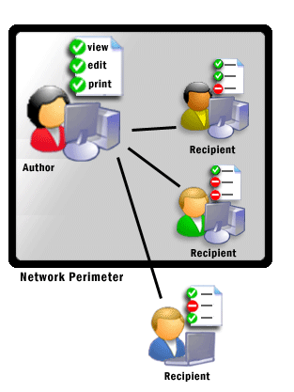RMS protects information both online and offline, inside and outside of the firewall.
Information at risk
Electronic communications and files are ubiquitous today. The ease of transmitting e-mails and information also increases the risk of unauthorized viewing and distribution. Leaks of confidential information can result in lost revenue, compromised ability to compete, unfairness in purchasing and hiring decisions, diminished customer confidence, and more.
Security methods such as firewalls and Access Control Lists (ACLs) help prevent unauthorized access to information. Encrypted delivery helps protect information in transport. These methods, however, stop protecting the information once the authenticated individual has accessed or received it. For that reason, organizations seek to augment their security strategies by providing persistent protection that remains with the information even after it leaves the corporate network.

RMS is information protection technology
Microsoft® Windows® Rights Management Services (RMS) for Windows ServerTM 2003 is information protection technology that works with RMS-enabled applications and browsers to help safeguard digital information from unauthorized use.
RMS combines Windows Server 2003 features, developer tools, and proven security technologies–including encryption, certificates based on Extensible Rights Mark-up Language (XrML), and authentication, to help create reliable information protection solutions.

Safeguard sensitive information
RMS helps safeguard confidential information from unauthorized use–both online and offline, inside and outside of the firewall. Information workers can define how the recipient may use the information: open, modify, print, forward, or take other action with it.
Organizations can create centralized custom usage policy templates such as “Confidential – Read Only” that work with any RMS-enabled application and can be applied directly to information such as financial reports, product specifications, customer data, and e-mail messages.

Apply persistent protection
Helping to enforce an organization’s security strategy and policies, RMS protects information through persistent usage policies, which remain with the information, no matter where it goes. If a recipient accidentally forwards rights-protected information or loses a diskette with a rights-protected file, the protection still applies.

Flexible, customizable information protection
Through flexible deployment options and developer tools, organizations can tailor their information protection solutions to fit into their existing infrastructure. Organizations can safeguard sensitive information with any RMS-enabled application including line-of-business, database-driven, and Web-based applications.
RMS lets organizations tailor solutions to fit specific back end system requirements through flexible deployment options, from single-box deployments to global distributed topology. Protection solutions developed by Microsoft Partners extend RMS with protection for collaborative workflows and files or communications in specific business situations.
RMS helps organizations comply with regulatory requirements that mandate information protection, such as the U.S. Sarbanes-Oxley Act, the Gramm-Leach-Bliley Act, the Health Insurance Portability and Accountability Act (HIPAA), and others.
Low-overhead administration and ease of use
RMS implementations can be fast and straight-forward. IT departments can streamline confidentiality policies through RMS templates that help users efficiently apply a predefined set of usage policies. IT can manage the RMS environment effectively through centralized administration, auditing, revocation, and exclusion.
How RMS works
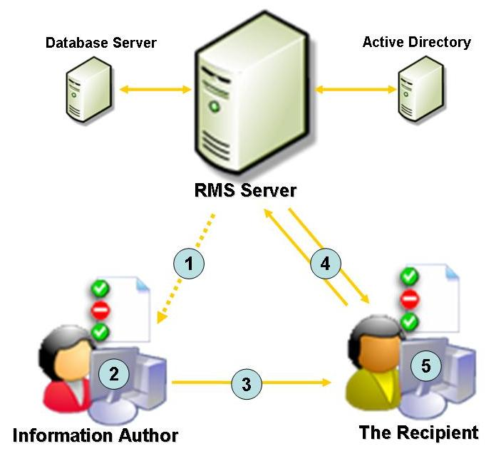Establish trusted entities.
- Organizations can specify the entities, including individuals, groups of users, computers, or applications that are trusted participants by their RMS server.
Assign rights to information.
- Using an RMS-enabled application, users can easily assign rights, such as read-only, to their digital information. These rights reside in a publishing license, which is attached to the information.
Distribute protected information.
- The application then encrypts the information and the publishing license together. The information and rights remain encrypted during transport, extending protection beyond the organization’s network.
View rights-protected information.
- When the recipient opens rights-protected information, a request goes to the RMS server to validate the user’s credentials and usage rights. The server issues a use license specifying the rights that apply to the information. The RMS-enabled application enforces the usage rights defined by the author or template.
RMS system requirements
Features and functionality described require Microsoft Windows Server 2003, Microsoft Active Directory® directory services, Microsoft Internet Information Services (IIS), a database such as Microsoft SQL Server 2000, and an RMS-enabled application, such as a program in the Microsoft Office 2003 Editionsi.

RMS includes client and server software along with SDKs
RMS server technology handles the XrML-based certification of trusted entities, licensing of rights-protected information, sub-enrollment of servers and users, and administration functions.
RMS also includes:
- Windows RMS client software.
- Software development kit (SDK) for the client and server.
For an end-to-end solution, the following is necessary:
- Windows RMS for Windows Server 2003
- Windows RMS client software
- RMS-enabled applications or browser

SDK allows developers to create RMS-enabled applications
- RMS uses XrML, which allows developers to build RMS-enabled applications with a high level of customizable rights and conditions of information protection, ranging from simple usage restrictions (print, forward) to complex conditions and restrictions (multiple principals, expirations).
- The server SDK includes Simple Object Access Protocol (SOAP) interfaces providing developers a way to integrate enterprise rights management into existing data storage and information management systems, mapping to the systems’ unique architecture, interface, and user needs.
- Other server applications (records management, e-mail archival, work flows, content inspection, and more) can be enabled to take advantage of RMS functionality.
The application programming interfaces (APIs) in the client SDK allow developers to build custom or line-of-business client applications.

i For creating or viewing rights-protected Microsoft Office documents–spreadsheets, presentations, and e-mail messages–Microsoft Office 2003 Professional Edition is required. Other Office 2003 Editions allow users to view–but not create–rights-protected Office content.

