Microsoft Web Platform
Customer Solution Case Study
 |  |  |   Facilities-Management Solution Firm Cuts Costs, Reinforces Leadership, Boosts Sales

Overview  Country or Region: United States  Industry: Professional services  Customer Profile  Based in Marina del Rey, California, SFW is a 10-person firm that provides software solutions for property and facilities management, with a focus on organizations that require high security.  Business Situation  After having developed its products for many years using scalable vector-graphic technology and JavaScript, SFW found that it needed a more powerful development environment.  Solution  Using the Microsoft .NET Framework, SFW converted its products to Microsoft Silverlight and Microsoft Visual C#, enhancing performance and compatibility and adding features.  Benefits  - Reinforcing industry leadership  - Boosting sales  - Maintaining product affordability  - Simplifying development  - Cutting implementation costs 30 percent |  |  | “Looking back at our goals for creating a next-generation user experience, we have exceeded those goals with the help of Silverlight and .NET.”  Ofer Azoulay, Founder and Chief Executive Officer, SFW
 |  |  | Since its founding in 2001, Southern California–based SFW has become a leading provider of Web-based solutions that offer a highly visual approach to facilities management. For most of its history, the company based its Accendo product line on scalable vector-graphic technology, but in recent years, it encountered problems with that technology in terms of performance and support. So SFW turned instead to the Microsoft Silverlight browser plug-in and the Microsoft .NET Framework development environment. By using Microsoft technologies, SFW is enhancing the power and utility of its products, streamlining development, cutting implementation costs by 30 percent, and doubling the “open rate” for its e-mail marketing campaigns. The company is also taking advantage of Microsoft support benefits to augment the resources of its staff and further strengthen its leadership position.
 |  |  | 

Situation
“We were pushing the limits of SVG, running into problems with accuracy controls, rendering, and performance…. It was clearly time to move to a different development environment.”
Ofer Azoulay, Founder and Chief Executive Officer, SFW

Headquartered in Southern California, SFW is a leader in providing Web-based vector-graphic mapping solutions for facilities management. From the beginning, executives at SFW understood the power of offering a Web-based solution that uses high-resolution visual images to help property managers, security personnel, and others do their jobs more effectively. The executives understood the utility of using vector-graphic mapping technology to build solutions that would deliver and support such images. And, as they grew the business, they understood the importance of having a development environment that would simplify the custom implementation that SFW provides for every customer— importing and integrating dozens of customer-specific architectural drawings.

Ofer Azoulay, Founder and Chief Executive Officer for SFW, and his colleagues came to these understandings through a process that is fairly typical of growing companies. To build the first release of the company’s solution platform, known as Accendo, they used HTML and JPEG image files, but that approach lacked the performance and flexibility they needed for delivery over the Web and required a lot of work to update. They then tried using geographic information system technology, but that, too, was lacking in performance and was very costly. So they decided to build their own mapping engine, using scalable vector-graphic (SVG) technology and JavaScript, as well as the Microsoft Visual C# .NET programming language and a back end based on Microsoft SQL Server data management software.

Over the following eight years, SFW used this environment for creating Accendo Assets, Accendo Incident, and Accendo Issues—database-driven products that support elaborate visualization of facilities and properties, as well as real-time and data-driven management of customer assets at any level of detail. In addition to being powerful and flexible, the Accendo product family was positioned as uniquely affordable and easy to use, in contrast to competitive products that required complex software and hardware and highly trained staff for operations and updates.

Over time, however, the uniqueness of Accendo was undermined by the emergence of Web-based mapping applications that opened the market to considerably more competition. To stay ahead of that competition, Azoulay and his colleagues wanted to build “next-generation” features and functionality into Accendo, but they found this to be a daunting challenge in the SVG development environment. “We were pushing the limits of SVG, running into problems with accuracy controls, rendering, and performance,” Azoulay explains. “Even more concerning, we were waiting longer than we wanted to for updates to the specification, and we anticipated that eventually it would no longer be supported. It was clearly time to move to a different development environment.”

Solution
Azoulay and his colleagues briefly considered using Flash, but were concerned about its robustness and the level of developer training necessary to make that technology a central part of their development environment. Then they discovered the Microsoft Silverlight browser plug-in, and in it, Azoulay says, they found a fit. “Considering that we were already using Visual C# .NET for some Accendo components and a Microsoft SQL Server database, we were familiar with the Microsoft environment,” he says. “So once Silverlight appeared, it was an easy decision to begin working with it.”
Over a period of six months, a team of three SFW developers converted the entire Accendo mapping platform from SVG and JavaScript to Silverlight 2 and Visual C# .NET. When Silverlight 3 was released, they began converting key HTML and JavaScript components, such as the product’s information window. This component enables SFW, its partners, and its customers to more easily integrate architectural drawings, floor plans, aerial photographs, and computer-aided design (CAD) documents for custom implementation.
“We can offer multitouch and other great new capabilities within a very competitive pricing structure because development is so efficient with Silverlight and .NET.”
Peter Kalev, Senior Programmer, SFW

Benefits
With the move to Silverlight, the .NET Framework, and other Microsoft tools, including the Microsoft Visual Studio 2008 Professional Edition development system, SFW is maintaining its market leadership and expanding customer interest by enhancing the capabilities of its Accendo product line while maintaining its trademark ease of use and affordability. In addition, SFW is streamlining development and implementation, reducing browser-compatibility testing time by 90 percent, and cutting implementation costs by 30 percent. The company is also positioning itself to respond successfully to future market trends.
Users of Accendo Assets can easily pinpoint the location of every asset in a facility and, with a click of the mouse, gather comprehensive information on that asset.

“Generating a Lot of Attention”
By moving from SVG to Silverlight for developing and enhancing the Accendo product family, SFW is maintaining its leadership in an increasingly competitive marketplace. “Looking back at our goals for creating a next-generation user experience, we have exceeded those goals with the help of Silverlight and .NET,” Azoulay says. “Accendo now provides smoother rendering, greater accuracy when users are working with drawings, and more ways of interacting with popular Web-based mapping platforms. Even more, the product now supports a multitouch screen, which is generating a lot of attention from existing and prospective customers alike.”

All of this means that customer interest in Accendo has increased, even in a less-than-ideal economic climate. “By including a video clip showing the Silverlight-based user interface in our most recent e-mail marketing campaign, we managed to double our e-mail open rate,” Azoulay reports. “In just six months, we also have doubled our sales volume, an improvement we can at least partly attribute to our move to Silverlight and the .NET Framework.”
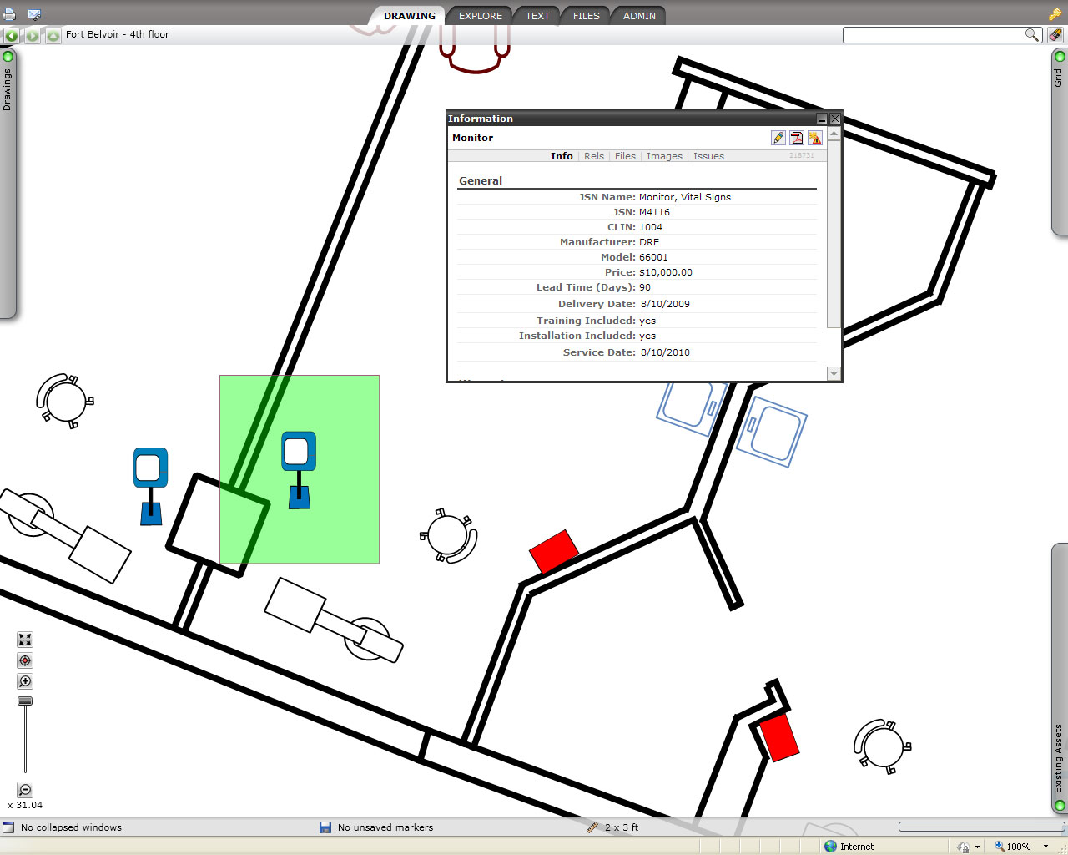

Cutting Customer Costs, Streamlining Development
Besides its obvious customer appeal, the Accendo multitouch screen is helping SFW to continue positioning Accendo as a product that is easy to learn and use. And with the move to a new development environment, SFW also can continue to position Accendo as affordable. “We can offer multitouch and other great new capabilities within a very competitive pricing structure because development is so efficient with Silverlight and .NET,” explains Peter Kalev, Senior Programmer at SFW.

As an example, Kalev describes the experience of converting from SVG to the Extensible Application Markup Language (XAML), the file format recognized by Silverlight. “At first, I was worried about the effort it would take to convert all of our SVG code to XAML,” he says. “But because SVG and XAML are similarly structured, the process went smoothly, and developers were able to maintain their existing workflows.”

Programming and testing have gone smoothly as well, Kalev adds. “By replacing the JavaScript code with Visual C# .NET and using the larger Visual Studio development system with its full support for object-oriented programming, we have streamlined coding and debugging,” he reports. “Moreover, because Silverlight-based solutions appear and perform identically on all supported browsers, we are spending just one-tenth the time we used to in compatibility testing, reducing those costs and delivering product to customers that much faster.”
“Because Silverlight handles the introduction of polygons so well, entering a customer’s architectural drawings is a lot easier than it was when we were using SVG. As a result, we are cutting implementation costs by 30 percent.”
Peter Kalev, Senior Programmer, SFW

The custom implementation required for each and every Accendo customer is also more efficient. “Because Silverlight handles the introduction of polygons so well, entering a customer’s architectural drawings is a lot easier than it was when we were using SVG,” Kalev says. “As a result, we are cutting implementation costs by 30 percent, a savings that we can pass on to our customers.”

Anticipating a Bright Future
With the new development and implementation environment behind Accendo, Azoulay believes that SFW is far better positioned for the future than it would have been had it continued to use SVG. “Silverlight, being the product of a single company, is more frequently enhanced with new features and functionalities than SVG ever was, being subject to the conflicting interests of a consortium,” he explains. “With those timely enhancements, we at SFW can offer enhancements to our own products, making existing customers happier and reaching new customers, too.”

Another advantage of the new development environment over SVG is a greater availability of talent. “There are many, many developers with skills in Visual Studio, .NET, and now Silverlight, ready to work with us from day one, without the downtime and cost of training,” Azoulay says. “By saving this time and cost, we can bring new features and products to our customers faster and more cost- effectively.”

Being a company with just 10 employees, SFW is also taking extensive advantage of the support benefits that Microsoft offers. “The discounts, no-cost tools, conferences, and online resources available to developers who use Silverlight are especially valuable for a small business like ours,” Azoulay points out. “These services, along with the other advantages of using Silverlight and the Microsoft Web technologies, make us more agile as a company—better able to respond rapidly and effectively to the surging interest in multitouch screen technology and other market trends.”

As a result, the future of SFW and Accendo looks very bright to Azoulay and his colleagues, who are now working on new Accendo modules for preventive maintenance and resource scheduling. They are also working to enhance the interaction of Accendo with leading CAD products and technologies, and, with the support of Silverlight for tablet and other mobile platforms, they are extending the product to run in those environments as well.

“These are all examples of how we are using the Microsoft platform to build an end-to-end solution that supports a broad set of client platforms and form factors, seamlessly extending our development investment to deliver more value to our customers,” Azoulay says. “No matter how competitive this market becomes, we will definitely have an edge.”
Microsoft Web Platform
For More Information
For more information about Microsoft products and services, call the Microsoft Sales Information Center at (800) 426-9400. In Canada, call the Microsoft Canada Information Centre at (877) 568-2495. Customers in the United States and Canada who are deaf or hard-of-hearing can reach Microsoft text telephone (TTY/TDD) services at (800) 892-5234. Outside the 50 United States and Canada, please contact your local Microsoft subsidiary. To access information using the World Wide Web, go to:
www.microsoft.com

For more information about SFW products and services, visit the Web site at:
www.sfwllc.com

This case study is for informational purposes only. MICROSOFT MAKES NO WARRANTIES, EXPRESS OR IMPLIED, IN THIS SUMMARY.

Document published February 2010

Software and Services  - Microsoft Server Product Portfolio  - Microsoft SQL Server 2008 Developer  - Microsoft Visual Studio  - Microsoft Visual C# .NET  - Microsoft Visual Studio 2008 Professional Edition | - Technologies  - Microsoft .NET Framework 3.5  - Microsoft Silverlight

Design, develop, and deliver innovative Web solutions for your business. The Microsoft Web Platform offers all the tools, technologies, and server software necessary to create satisfying Web experiences.
To learn more, go to:
www.microsoft.com/web

