Compliance Features in the 2007 Microsoft Office System
November 2006

Information in this document, including URL and other Internet Web site references, is subject to change without notice. Unless otherwise noted, the companies, organizations, products, domain names, e-mail addresses, logos, people, places, and events depicted in examples herein are fictitious. No association with any real company, organization, product, domain name, e-mail address, logo, person, place, or event is intended or should be inferred. Complying with all applicable copyright laws is the responsibility of the user. Without limiting the rights under copyright, no part of this document may be reproduced, stored in or introduced into a retrieval system, or transmitted in any form or by any means (electronic, mechanical, photocopying, recording, or otherwise), or for any purpose, without the express written permission of Microsoft Corporation.

Microsoft may have patents, patent applications, trademarks, copyrights, or other intellectual property rights covering subject matter in this document. Except as expressly provided in any written license agreement from Microsoft, the furnishing of this document does not give you any license to these patents, trademarks, copyrights, or other intellectual property.

© 2006 Microsoft Corporation. All rights reserved.

Microsoft, Windows, Windows Server, Excel, InfoPath, Outlook, PowerPoint, PivotTable, SharePoint, and Visual Studio are either registered trademarks or trademarks of Microsoft Corporation in the United States and/or other countries.

All other trademarks are property of their respective owners.

The example companies, organizations, products, domain names, e-mail addresses, logos, people, places, and events depicted herein are fictitious. No association with any real company, organization, product, domain name, e-mail address, logo, person, places, or events is intended or should be inferred."

Introduction 6
An Overview of Regulatory Compliance 6
Common Compliance Requirements 8
The 2007 Microsoft Office System Products 10
Description of the Products Relevant to Compliance 10
Architecture Overview 15
Compliance Capabilities in the 2007 Microsoft Office System 16
Auditing 16
Configuring Settings for Auditing 17
Viewing Reports for Auditing 19
Extending Functionality for Auditing 20
Workflow 21
Workflow in Office SharePoint Server 2007 22
Configuring a Workflow 23
Starting a Workflow 24
Extending Workflows 24
Creating a New Workflow 25
Digital Signatures 26
Signing a Document 27
Signature Criteria 28
Extending Digital Signatures 29
Records Center 29
Extensibility 30
Content Types and Routing 31
E-mail Message Record Management 34
Classifying E-mail 35
Extending Classified E-mail 35
Setting Policies 36
37
Extending Policies 37
Holds 38
Spreadsheet Management 39
Excel Services 40
Extending Excel Services 41
Barcodes and Labeling 41
Information Rights Management in the 2007 Microsoft Office System 43
Document Information Panel 45
Extending the Document Information Panel 45
Document Inspector 46
Extending Document Inspector 47
New Office File Format 48
Manipulating the Office File Format 48
Portal Search 49
Extending Portal Search 49
Compliance Extensibility Opportunities 52
Viewing Item-Level Audit History 52
Adding Instant Messaging History to the Records Center 52
Server-Side Signing of Documents 53
Linking Information Rights Management with Classifications for Advanced E-mail Protection 53
Client-Side Auditing for Granular Tracking of Changes to Document Internals 54
Mapping of Extensibility Opportunities to Major Regulations 55
Requirements for Extensibility Opportunities to Major Regulations 56
Extensibility Scenario: Controlling stock analyst upgrade and downgrade 57
Extensibility Scenario: Spreadsheet integrity 57
Extensibility Scenario: Auditing 3rd-party events on Office documents 58
Extensibility Scenario: Reporting suspicious activity 58
Extensibility Scenario: Removing sensitive metadata from outbound documents 58
Object Models and Interfaces for Extensibility 59
Microsoft Windows SharePoint Services 2007 60
Microsoft Office SharePoint Server 2007 61
InfoPath Forms Services 61
Microsoft Office System 2007 Client 62
Development Tools for Extending Office and Windows SharePoint Services 63
Summary 64
Appendix I: Resources 65
Resources for Compliance 65
Resources for Compliance Regulations 65
Resources for Developers 66
How-To Resources 66
Resources for Microsoft Products 66
Resources for Microsoft Technologies 67
Appendix II: References 67
References 67

Introduction
This white paper showcases compliance-related features and extensibility opportunities with the 2007 Microsoft® Office system, and demonstrates how the Office system can help you meet the demands of regulatory compliance. By focusing on a few core products, including Microsoft Office SharePoint® Server, Office client-side applications, and Microsoft Exchange Server 2007, this paper introduces built-in features of the Office system that address compliance requirements. The paper also focuses on the opportunities for developers to use expanded tools support to build customized solutions that facilitate regulatory compliance without bogging down business processes.

Out-of-the-box, the 2007 Office system provides many of the fundamental components required to support compliance regulations, such as auditing, records management, and data security. However, some degree of development and customization is necessary to tailor regulation-compliant solutions for particular organizations and environments. This paper provides examples of extending the platform to build custom compliance solutions for the financial services, healthcare, and accounting fields.

The target audience includes developers, technical architects, and technical decision makers interested in delivering business solutions that use and extend the compliance-related feature set of the 2007 Microsoft Office system. The paper talks about the technical and business opportunities for integrating with and extending the 2007 Office system feature set, and it shows how you can extend the system to facilitate compliance—either for a company's internally developed solutions or for vendors developing compliance solutions for the marketplace.

The first section provides an overview of regulatory compliance and governmental legislation. The second section describes specific products within the 2007 Microsoft Office system and how they address compliance requirements. The third section demonstrates how you can simplify compliance-related tasks by using features built into the Office system. The fourth section describes extensibility options provided by the 2007 Microsoft Office system for compliance and provides a non-technical overview of the principal interfaces and object models that developers use to build compliance solutions with the 2007 Office system. Three appendices provide additional resources, developer maps, and references.

An Overview of Regulatory Compliance
Many companies face increasing pressure to comply with governmental regulations for handling business and personal information. These regulations are designed to protect against a diverse array of risks that span different industries, disciplines, and government agencies. Reasons for increased regulations include:
- Recent corporate scandals involving large companies have resulted in an increase in the number and scope of compliance regulations intended to protect shareholders and improve the visibility, integrity, and accountability of financial reporting
- Concerns about the privacy of individuals and the possible abuse of personal information have prompted regulations for handling health care information
- Risks related to food supplies and to the development of pharmaceuticals have prompted increased regulation for all industries regulated by the United States Food and Drug Administration (FDA)
- The surge in identity theft and fraud has prompted regulations for handling personal identifiable information (PII) and informing consumers when their personal information is disclosed inappropriately
In the United States, compliance legislation designed to address these risks affects most publicly traded companies, the healthcare industry, government agencies, and financial institutions. Governments impose severe penalties for violations against compliance regulation laws, including major fines and imprisonment of company officials. For example, the penalties for violating certain Health Insurance Portability and Accountability Act (HIPAA) regulations range from $100 per person per incident for improper disclosures of health information to $250,000 and 10 years in prison for intentional violations (United States Department of Health and Human Services, May 2003). Noncompliance can also have a negative effect on a company’s reputation in the market.
Moreover, companies stand the best chance of success when they go beyond viewing compliance as overhead and that take the opportunity to streamline and improve core business processes as part of their compliance efforts. This is because much of what's contained in today’s compliance regulations is long-recognized best practices. Many companies not subject to certain compliance regulations are taking the initiative to follow some regulations anyway, because of the value both in operations and reputation. For example, ISO 9000, which is a set of standards around manufacturing process quality, requires good records management so that a company can demonstrate compliance. There are important reputation and financial benefits for companies to comply with that standard, even if there aren’t specific fines for non-compliance (ISO 9000 is a voluntary standard). A “follow the spirit of the law” approach (as opposed to “letter of the law”) not only tends to improve compliance scores, but also helps companies get value from their investment in compliance.
Companies must develop long-term compliance strategies to meet the requirements established by government regulations. Typically, these strategies involve formalizing compliance policies and implementing specific business processes to support, enforce, and demonstrate compliance with these policies. Unless IT is involved in automating these processes, a company risks being overwhelmed with a manual documentation effort and a weak control infrastructure. A major challenge is how to interpret compliance regulations and map them to IT implementations that use existing IT investments—investments that were often deployed before the rise of compliance requirements.
Key Compliance Regulations
Companies must comply with these key regulations:
- Sarbanes-Oxley Act (SOX) (United States, 2002) – A set of United States federal laws that establish new or enhanced standards for all U.S. publicly traded company Boards, Management, and public accounting firms. The Act contains 11 titles that affect corporate governance, financial disclosure, and public accounting practices.
- Data Protection Act (European Union, 1998) – A British Act of Parliament that provides a legal basis for the privacy and protection of data. The act states that data collected by one party to another party may be used only for the specific purposes for which it was collected. Personal data may be kept only for an appropriate length of time and must not be disclosed to other parties without the consent of the data owner.
- Health Insurance Portability and Accountability Act (HIPAA) (United States, 1996) – A set of United States federal laws that improve the efficiency and effectiveness of the health care system. HIPAA encourages the development of a health information system through the establishment of standards and requirements for the electronic transmission of certain health information. The Act aims to improve the portability and continuity of health insurance coverage in the group and individual markets; to combat waste, fraud, and abuse in health insurance and health care delivery; to promote the use of medical savings accounts; to improve access to long-term care services and coverage; to simplify the administration of health insurance; and to achieve other purposes.
- Title 21 Code of Federal Regulations (21 CFR Part 11) (United States, 1997) – A set of life sciences regulations that affect how biotechnology and pharmaceutical companies meet the criteria for acceptance by the U.S. Food and Drug Administration (FDA). The FDA considers under certain circumstances that electronic records, electronic signatures, and handwritten signatures executed to electronic records are equivalent to paper records and handwritten signatures executed on paper. These regulations, which apply to all FDA program areas, are intended to
permit the widest possible use of electronic technology, compatible with FDA's responsibility to promote and protect public health.
- Basel Capital Accord (Basel II) (Switzerland, 2004) –Basel II affects banks and other financial institutions by defining capital requirements for banks' exposures to certain trading-related activities, including counterparty credit risk, and for the treatment of double default effects (the risk that both a borrower and guarantor default on the same obligation).
Common Compliance Requirements
Although these various regulations vary in terms of scope, intent, and type of information, they all share common elements and rely on the fundamental principles of information security.
- Confidentiality. Confidential, personal, and sensitive information cannot be exposed to unauthorized organizations or individuals.
- Integrity. Data cannot be modified by unauthorized organizations or individuals, and the completeness and accuracy must be insured.
- Availability. Information must be available to the right people at the right time to support timely and accurate financial reporting and to fulfill demands for information by regulators, investigators, and court subpoenas.
Organizations must implement policies and procedures to make sure individual and departmental activities conform to compliance requirements. However, only publishing policies and procedures and buying technologies to ensure confidentiality, integrity, and availability falls short of compliance. An organization must exercise due diligence in enforcing the execution of those policies and procedures.
- Procedural rigor. An organization risks becoming quickly bogged down if executives and managers must manually enforce procedural rigor and workers must perform with busy-work mandated by a bureaucracy created out of compliance requirements. Good workflow automation enforces compliance and performance of business processes and policies as unobtrusively and automatically as possible.
To support audits and investigations, an organization must also be able to prove that it performed compliance procedures when needed and that its technology controls were active and they performed throughout the period in question. This requirement creates a documentation burden on top of other work associated with compliance policies. This documentation burden creates a need for IT involvement.
- Auditing and Logging. Auditing and logging trace how individuals access and use resources and the execute business procedures. Systems that process sensitive data must securely log, maintain, and provide critical event information to ensure a clear audit trail.
Audit trails and logging are especially important for two of the pillars of information security. First, audit trails are crucial in determining the scope of disclosures of confidential information. Being able to reconstruct who accessed what information and when allows an organization to inform just the people whose information was compromised, sometimes greatly reducing the fines and other costs that are in direct proportion to the quantity of individuals whose information was compromised. Second, logging facilitates integrity controls. Technology may not always be able to prevent an authorized user from maliciously or inadvertently modifying information, but an audit trail provides a control and allows the organization to understand the impact of the incident. For example, it is not enough to point to a written policy that governs how financial spreadsheets and their formulas are maintained. Compliance and audit professionals want to see an audit trail of changes to such spreadsheets that shows who accessed them, what was modified, and when.
The 2007 Microsoft Office System Products
This section describes the products within the 2007 Microsoft Office system that are most relevant to compliance. Compliance solutions based on the 2007 release deliver significant return on investment by using the ease-of-use and users’ familiarity with the most widely deployed desktop productivity environment.
Although the 2007 release is an application suite, it is also a full-featured development platform ready to be exploited by developers. With this release you can build collaboration, workflow, knowledge management, and business process automation solutions with fewer lines of code than on other platforms. And you deliver a solution with which users are immediately comfortable and productive.
In particular, the 2007 release lends itself to being a platform for powerful compliance solutions thanks to its advanced audit trail, encryption, information rights management, records and document management, and more.
Description of the Products Relevant to Compliance
The following table describes the products in the 2007 release that are relevant to regulatory compliance.
 |  | Feature-to-Compliance Mapping
Product | Description | Feature | Confidentiality | Integrity | Availability | Procedural Rigor | Auditing and Logging
Microsoft Office SharePoint® Server 2007 | Office SharePoint Server 2007 enables development of intelligent portals that seamlessly connects users, teams, and knowledge. Such portals can help people take advantage of relevant information across business processes and help them work more efficiently. An important feature is the business data catalog, which indexes data from external systems and databases, such as CRM systems, so that it can be searched by the portal search feature. | Web content management (WCM) |  |  | X | X
Microsoft Office SharePoint® Server 2007 |  | Enterprise search |  |  | X
Microsoft Office SharePoint® Server 2007 |  | Document and records management | X | X | X | X | X
Microsoft Office SharePoint® Server 2007 |  | Auditing and logging | X | X |  | X | X
Microsoft Office SharePoint® Server 2007 |  | Records center | X | X | X | X | X
Microsoft Office SharePoint® Server 2007 |  | Information rights management (IRM) | X | X
Microsoft Office SharePoint® Server 2007 |  | Document policies | X | X |  | X
Microsoft Office SharePoint® Server 2007 |  | Extensible hold and content expiration infrastructure |  |  | X | X
Microsoft Office SharePoint® Server 2007 |  | Role-based targeting and security | X | X |  | X
Microsoft Office SharePoint Designer 2007 | Office SharePoint Designer 2007 provides you with tools to create and deploy interactive solutions based on SharePoint Products and Technologies, without having to write code.  You can automate business processes such as document approval, custom event notification, and other collaboration tasks by using the workflow designer feature. | Custom workflows |  |  | X | X
Microsoft Office SharePoint Designer 2007 |  | Custom notifications |  |  | X | X
Microsoft Office SharePoint Designer 2007 |  | Custom tasks |  |  |  | X
Microsoft Office SharePoint Designer 2007 |  | Data aggregation and reporting |  |  | X
Microsoft Windows® SharePoint Services | Windows SharePoint Services allows teams to create Web sites for information sharing and document collaboration, benefits that help increase individual and team productivity. By supporting such IT resources as portals, team workspaces, e-mail messaging, and presence awareness, Windows SharePoint Services enables users to locate distributed information quickly and efficiently, and connect to and work with others more productively. | Workflow processes |  | X | X | X
Microsoft Windows® SharePoint Services |  | E-mail messages and alerts |  |  | X | X
Microsoft Windows® SharePoint Services |  | Content types | X | X | X | X
Microsoft Windows® SharePoint Services |  | Search |  |  | X |  | X
Microsoft Windows® SharePoint Services |  | Versioning and history |  | X |  | X
Microsoft Windows® SharePoint Services |  | Document metadata | X | X | X | X
Microsoft Windows® SharePoint Services |  | List-level and item-level security | X | X |  |  | X
Microsoft Office Communicator 2007, Microsoft Office Communications Server 2007 | Office Communicator 2007 is an integrated communications client that relies on Office Communications Server 2007 to help enables teams and information workers to more easily and effectively communicate in real time. Office Communicator 2007 integrates with Microsoft Office system applications and secure enterprise telephony infrastructure. Information workers can see the presence status of other team members at all times; for example, they can see whether someone is online and whether they are in the portal. | Instant Messaging (IM) session history |  |  | X |  | X
 |  | Encrypted messaging | X
 |  | Secure communications | X
Microsoft Exchange Server 2007 | Exchange Server 2007 enables knowledge workers to gain access to critical business communications almost whenever and wherever they need to, and it is designed to deliver greater security, availability, and reliability. | Secure e-mail message repository |  |  | X |  | X
Microsoft Exchange Server 2007 |  | Permission control | X | X | X | X
Microsoft Exchange Server 2007 |  | Message classification |  |  | X |  | X
Microsoft Exchange Server 2007 |  | Transport rules | X |  |  | X
Microsoft Exchange Server 2007 |  | Secure communications | X
Microsoft Office Outlook® 2007 | Office Outlook 2007 provides an integrated solution for managing your time and information, connecting across boundaries, and remaining in control of the information that reaches you. | Classified e-mail | X
Microsoft Office Outlook® 2007 |  | Information Rights Management (IRM) | X | X
Microsoft Office Outlook® 2007 |  | E-mail records management |  |  | X |  | X
Microsoft Office Outlook® 2007 |  | E-mail search |  |  | X |  | X
Microsoft Office Outlook® 2007 |  | Secure communications | X
Excel® Services | Excel Services, a feature of Office SharePoint Server 2007, supports loading, calculating, and displaying Microsoft Office Excel spreadsheets in a Web browser. Users can publish spreadsheets and view them with any modern browser, without installing any software on the local client computer. This capability allows organizations to share spreadsheets without exposing sensitive business information. | Spreadsheet integrity |  | X
Excel® Services |  | Spreadsheet archiving and centralization |  |  | X |  | X
Excel® Services |  | Role-based views and access control | X | X
Excel® Services |  | Data security | X
Microsoft Office Project 2007 | Office Project 2007 helps project managers, business managers, and planners manage schedules and resources. Office Project 2007 helps you set up projects quickly with templates, communicate project data, and track and analyze project status. | Sarbanes-Oxley (SOX) templates |  | X |  | X
Microsoft Office Project 2007 |  | ISO 9001 templates |  |  |  | X
Microsoft Office Project 2007 |  | Finance and accounting templates |  |  |  | X
Microsoft Office Project 2007 |  | Feedback monitoring |  |  |  | X
Microsoft Office Project 2007 |  | Report preparation |  | X
Microsoft Office Forms Server 2007 | Office Forms Server 2007 provides scalable, standards-based electronic forms solutions with enhanced security that can help your organization extend the reach of forms-driven business processes to anyone with a Web browser. | Forms archiving and centralization |  |  | X | X
Microsoft Office Forms Server 2007 |  | Data validation |  | X
Microsoft Visual Studio® 2005 Tools for the Microsoft Office System | Visual Studio 2005 Tools for the Microsoft Office System* is a professional development environment for individual developers building line-of-business applications using the Microsoft Office System. These tools enable developers to more easily extend solutions using managed controls, and provide a more intuitive design, development, and debugging experience. | Custom development and extensibility |  |  |  | X | X
Architecture Overview
The following figure shows the communication channels between the various products in the 2007 Office system.
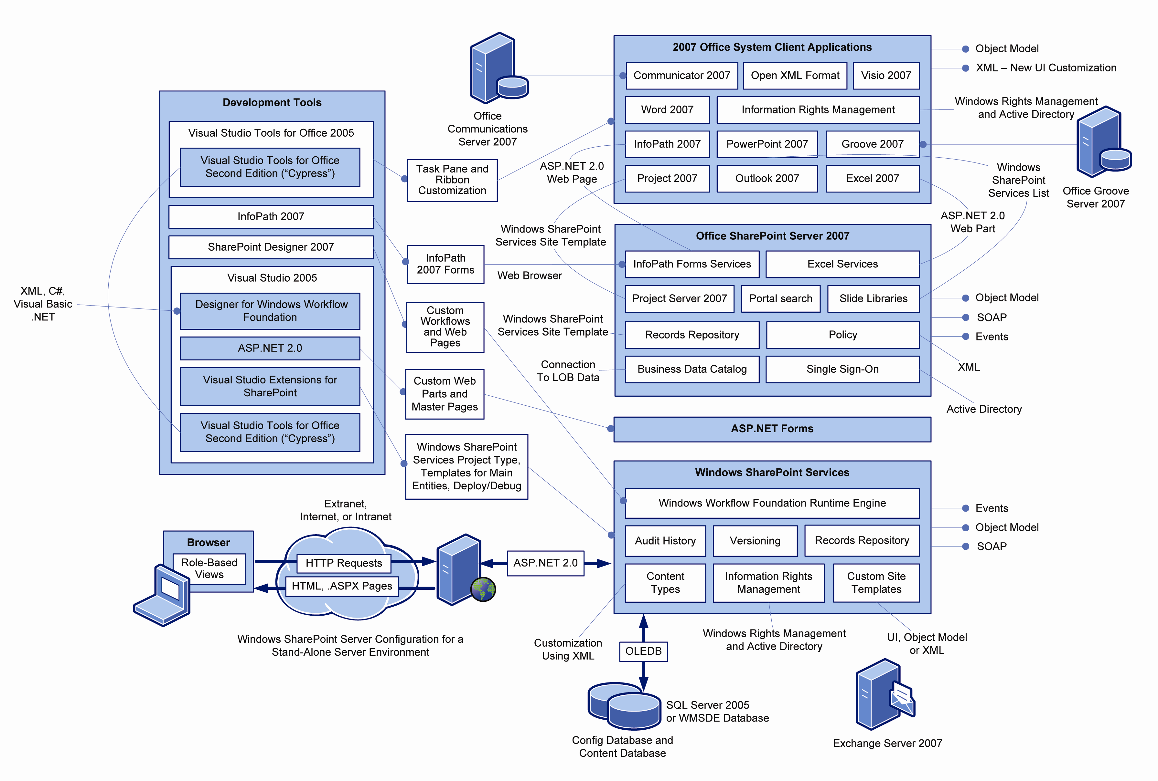
Compliance Capabilities in the 2007 Microsoft Office System
In this section, you'll learn how easy it is to perform compliance-related tasks using out-of-the-box features in the 2007 Office system. These features enable and simplify the following compliance requirements:
  - Auditing and logging
  - Workflow
  - Digital signatures
  - Records center
  - Classified e-mail
  - Document policies
  - Spreadsheet management
  - Barcodes and labeling
  - Information Rights Management
The 2007 Office release provides significant versatility because you can use features and settings out-of-the-box without writing any programmatic code. Or you can extend and customize the features to suit specific business requirements.
Auditing
Auditing provides a historical record of actions taken by users so that, when an authentic record is required, you'll know what happened and when it happened. Auditing is required by almost all regulations. For example, the Sarbanes-Oxley Act requires that all actions taken on a financial document must be fully audited to meet compliance.
Auditing allows companies to substantiate claims in cases of dispute or litigation. With effective auditing systems, policies, and processes in place, companies have the evidence to support and demonstrate their compliance. Auditing allows authorized users to see all of the people who have accessed resources on a site, and what actions those people took.
Office SharePoint Server 2007 allows administrators to audit key events within document libraries and global events on a site, such as search, user changes, and changes in content types and columns.
The underlying Windows SharePoint Services content database stores audit log events and provides access to the audit logs by using Microsoft Office Excel spreadsheets to simplify analysis, reporting, and exporting.
Office SharePoint Server 2007 also supports auditing extensibility by providing an audit log object model, which other applications and systems can use for custom analysis and reporting, or for custom auditing solutions built using the 2007 Office release.
Windows SharePoint Services provides server-side auditing functionality (such as opening a file, checking out a file, and checking in a file) that Office system products use at the site level. To address auditing of client-side activities such as printing or creating different copies with Save As, developers can use the extensible architecture of the 2007 Office release.
Configuring Settings for Auditing
At the Site Collection level, Office SharePoint Server 2007 allows you to configure various settings for auditing, such as selecting specific events to audit. You can perform basic configuration that tells Office SharePoint Server to audit all of the activities that you specify.
The following screenshot shows audit settings that you can configure through the Office SharePoint Central Administration site.

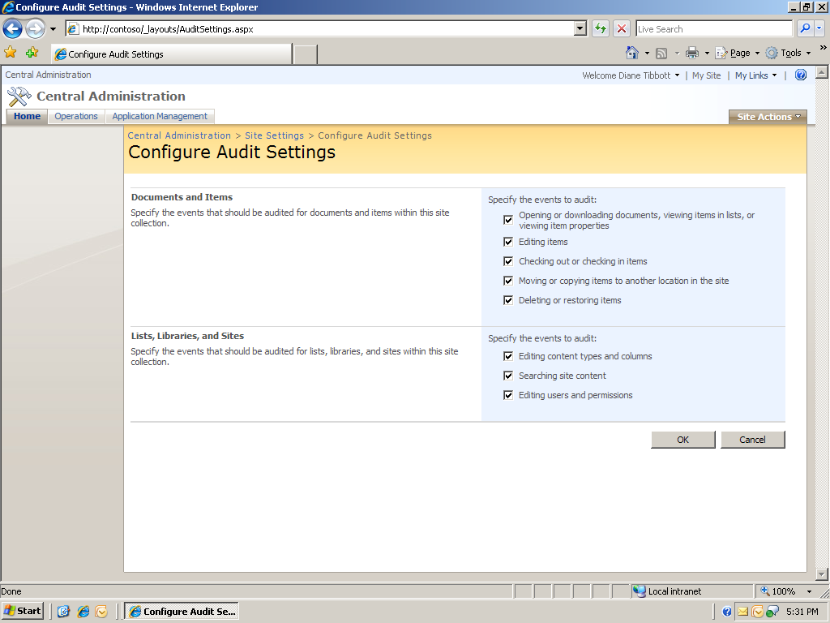

The following figure shows a screenshot of audit settings that you can configure for a document library or Content Type.
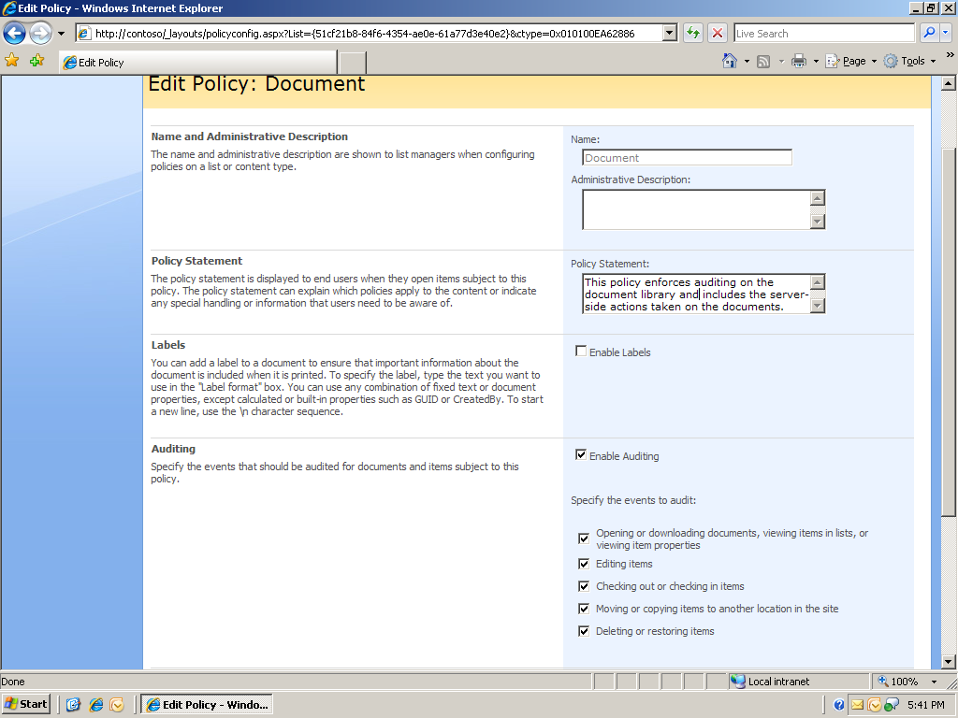

Performing Tasks for Auditing
After you configure the auditing settings, users can perform their normal tasks and SharePoint Server 2007 logs all server-side events to record the activities that you specified, creating substantiated evidence of which people accessed which resources at which time.
For example, a common scenario involves multiple people collaborating on a project. They can save and share their work, such as documents, schedules, and designs, on an Office SharePoint Server 2007 site to enable auditing of their resources and activities.
At the site level, Office SharePoint Server 2007 can audit the changes to any resource on the site, including the following actions:
- Download
- Rename
- Move
- Copy
- Check in/Check out
- New version creation
- Editing of content types and columns
- Search site content
- Edit users and permissions
- Change metadata
- Change policy (document lives in same location, with updated policy)
- Other changes to policy
- Deletion

These events are audited even if caused programmatically by a separate application that uses the object model.
Viewing Reports for Auditing
Office SharePoint Server 2007 provides various reports for auditing, such as reports about specific tasks and modifications.
The following screenshot shows the various auditing reports available to administrators, who can view them through top-level site settings. Administrators can also create custom audit reports from within the Office SharePoint Server 2007 Reports Center.

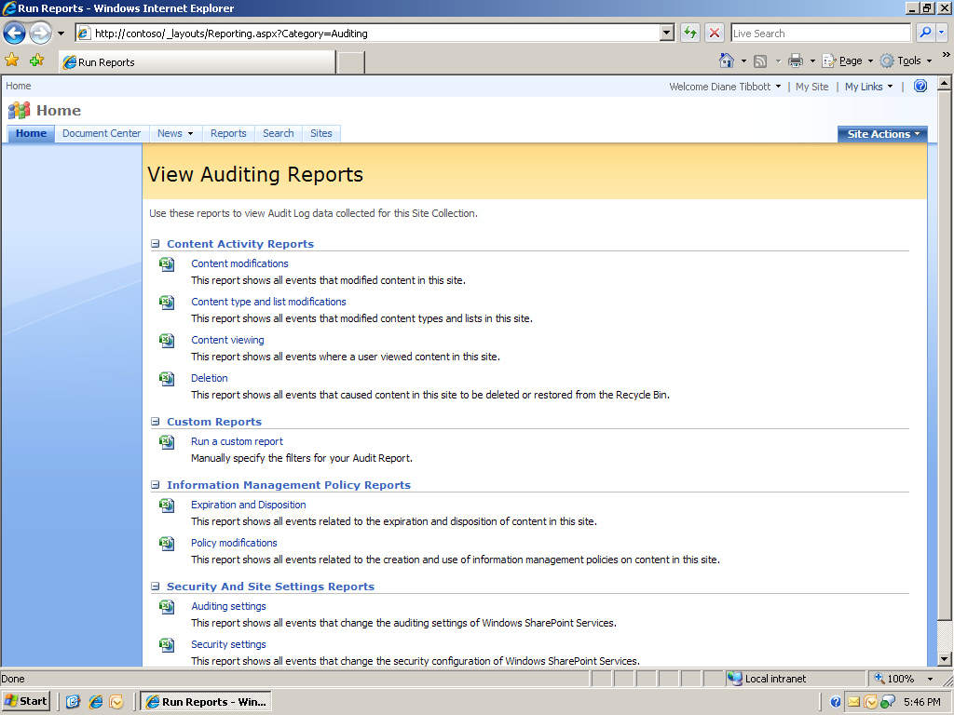
The following image shows the audit settings report.
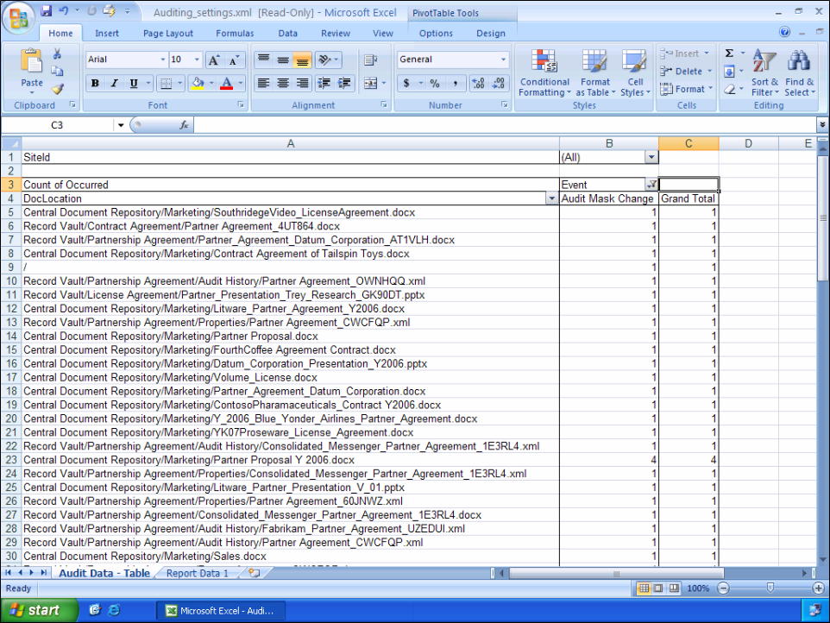
Extending Functionality for Auditing
You can extend the auditing functionality of the 2007 Office system by using the audit log service object model.
The following table summarizes the actions that you can perform on the Audit Log Service, and the position of these actions in the programmability stack.

Action | Windows SharePoint Services Object Model | Windows SharePoint Services Administration Object Model
Write to log | X
Read from log (by item) | X
Read from log (by user, date range) |  | X
Delete from log |  | X
The following image shows an example of extending auditing functionality by building a custom Web Part to view document-level auditing data such as who did what and when.

Workflow
Workflow is the collaborative process by which the various people working on a particular project or task participate and contribute to the activity. Workflow is important to compliance as a way to help ensure that the right information is made available to people at the right time and to enforce procedural rigor on business processes subject to regulatory compliance.
Workflow in the 2007 Office system can help ensure that the right people complete their respective tasks in the appropriate sequence (or in parallel), and also can make the workflow status visible to others. The workflow status is stored in Office SharePoint Server 2007, which helps ensure the authenticity and accuracy of the documented processes.
Because 67 percent of data loss in Records Management is directly related to user error (Craig Rhinehart, ILM Summit 2006), automated workflow is integral to the correct, secure, visible, and authentic processing of documents that is required to prove compliance. For example, a company can help defend itself against a lawsuit by proving that all stakeholders have approved the document in question and that their comments and digital signatures have been collected.
In Windows SharePoint Services, a workflow can be started for a particular item either on the server or the client. The workflow can also be configured so that it starts whenever a new item is created, has changed, or a new major version has been published. These capabilities are included out-of-the-box with the workflow templates available in Windows SharePoint Services.
A workflow process immediately notifies the next “assigned to” users once the previous user has completed work on the item. These users can either be assigned in series or in parallel; users have the flexibility to assign the tasks to someone else, if so configured.
Workflow promotes visibility because a separate list on the SharePoint site where the document resides displays who the item is assigned to, how long it has been assigned, and what the status is. The administrator is able to view which workflows are currently running on the site, their progress, and their associations.
Workflow in Office SharePoint Server 2007
Office SharePoint Server 2007 includes user-configurable workflow templates that can guide review and approval processes. Developers and IT administrators can also use Microsoft Visual Studio or Microsoft Office SharePoint Designer 2007 to define custom workflows, create document-handling processes, help users collaborate through portals and workspaces, and connect users to information in enterprise business systems.
Office SharePoint Server 2007 supplies the following workflows:
- Approval
- Collect Feedback
- Collect Signatures
- Disposition Approval
- Issue Tracking
- Translation Management

With Office SharePoint Server 2007, you don't need to write code to build workflows that map to important business processes. These capabilities facilitate more manageable collaboration, enforceable and measurable business processes, and more intelligent records management.

Office SharePoint Designer 2007 has the flexibility and extensibility to accommodate other types of custom workflows, so you can design them to suit your particular application and environment without writing any custom code.

Once in production, administrators can track each workflow and monitor how it is performing overall, as well drill down into specific instances of a workflow. For example, with the Activity Duration report, administrators can see how long each activity in the workflow takes to complete, and how long each instance takes to complete. The Cancellation & Error Report shows you which workflows are being canceled or are encountering errors before completion.
The workflow capabilities of the 2007 Microsoft Office system client applications and servers support sophisticated document life cycles and enterprise content management. Integration between the client applications and Office SharePoint Server 2007 allows users to initiate review and approval workflows, simplifying content review and approval processes, and reducing time spent managing documents through their life cycles. For documents stored on a SharePoint site library with an associated workflow template, users can initiate the workflow process from the File menu in the Office client application or from a browser-based interface.
Configuring a Workflow
Let us view the basic process of configuring a workflow. The following screenshot shows a workflow being added at the list level in Windows SharePoint Services. Workflows also can be added at the Content Type level.
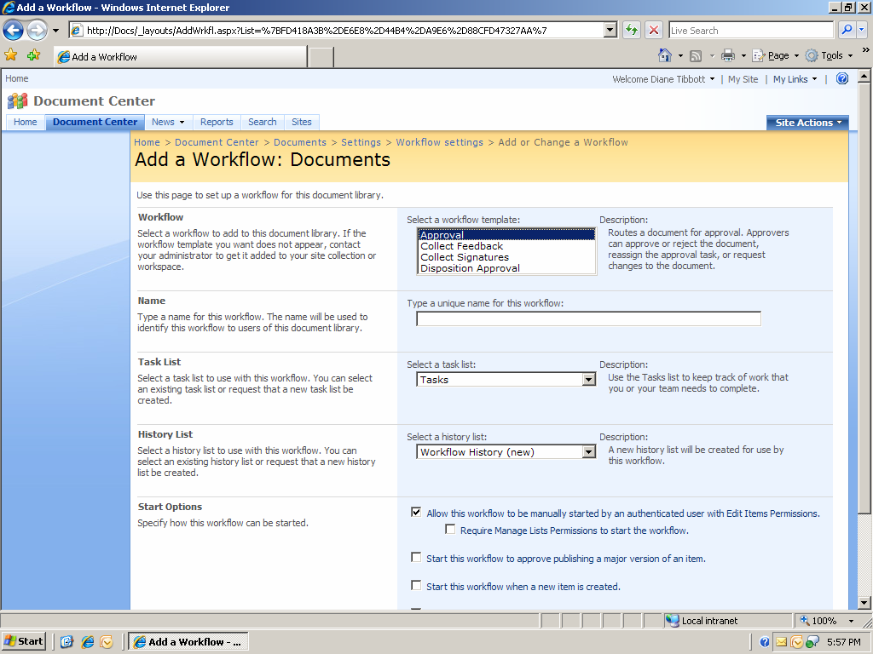
Starting a Workflow
The following screenshot shows the start a new workflow in the client.
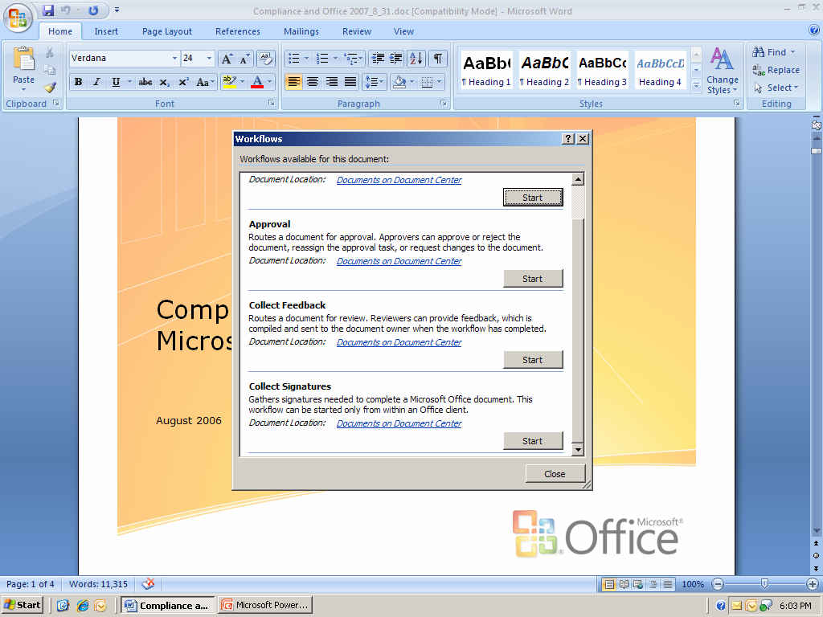

Extending Workflows
Workflows are extremely flexible and can be made to apply any settings to a document. Creation and customization of workflow processes is done without any code through Office SharePoint Designer 2007. For example, you can configure a custom workflow to put an item on hold or to apply a certain policy based on a conditional event. For greater customization and power, you can use the Visual Studio 2005 Designer for Windows Workflow Foundation to create workflow templates and custom workflow activities. You can include code in your workflow, and design forms to be used by the workflow to communicate with the workflow users during association and runtime. When you are developing workflow templates in the Visual Studio 2005 Designer for Windows Workflow Foundation, you are not programming against a specific SharePoint site, so your workflows can be reused for multiple sites. For a detailed comparison of the workflow development processes of Office SharePoint Designer 2007 and Visual Studio 2005 Designer for Windows Workflow Foundation, see “Workflow Development for Windows SharePoint Services” at http://msdn2.microsoft.com/en-us/library/ms414613.aspx.

Creating a New Workflow
2007 Microsoft Office system SharePoint Designer provides powerful capabilities for working with SharePoint lists and document libraries, including adding, modifying, copying, and removing items or documents; assigning tasks to people; routing documents for approval; and sending e-mail message notifications.
Office SharePoint Designer 2007 makes it easy to bind information in a SharePoint list to an action or event initiated by a workflow. If a step in the workflow involves sending an e-mail message to get managerial approval to start a project, you can use Office SharePoint Designer 2007 to create a generic e-mail message with linked fields that pull specific details right from a SharePoint list. The message appearing in the manager’s inbox would contain information that is specific to the project, such as its budget, due date, and project manager, all of which comes directly from the SharePoint list.

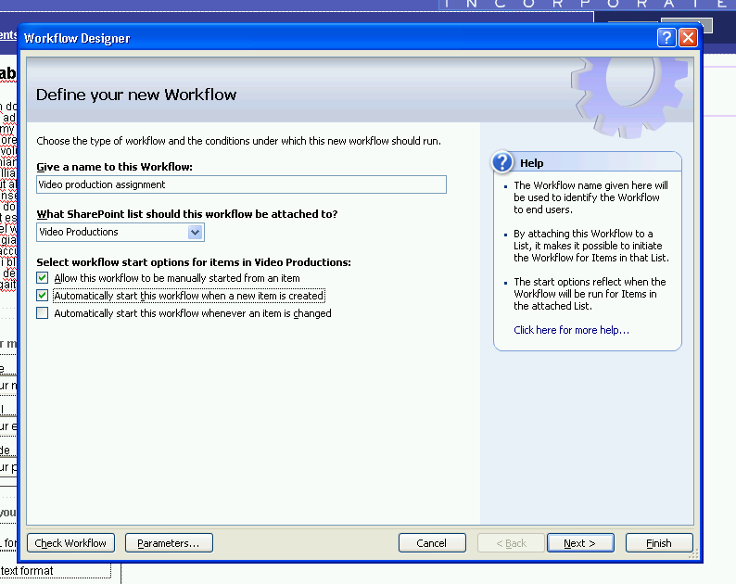

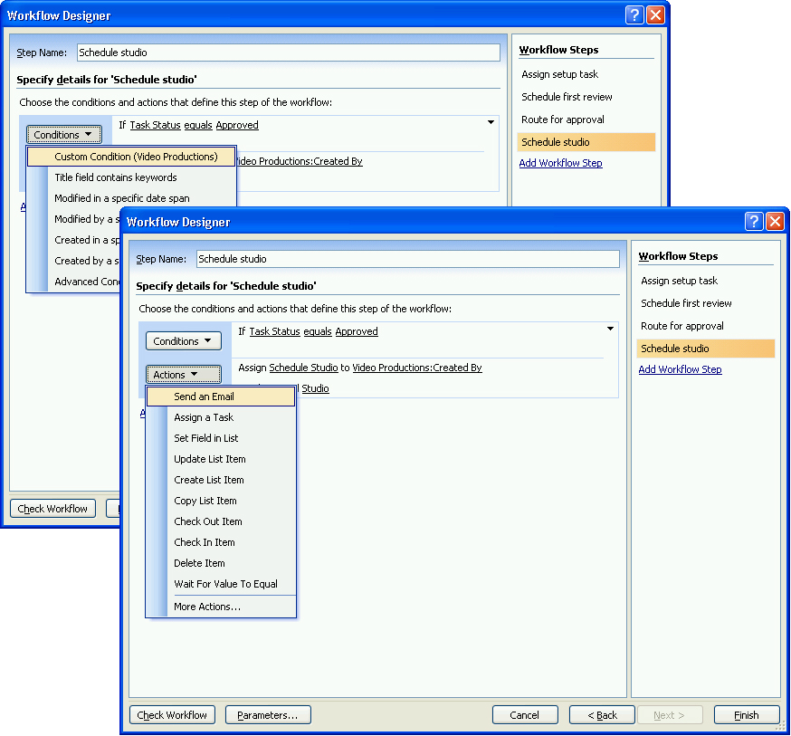

You can associate business logic to items in lists and documents in document libraries to create a custom workflow. The workflow framework is flexible so that, for example, you first send a dynamically created e-mail message based on the conditional state of the document or list item. You can add multiple branches and conditions to a workflow so that the business logic is captured, the process is streamlined, and efficiency is increased.
Digital Signatures
Digital signatures are important to compliance as a way to provide assurance that reports are authentic and that approvals and signoffs are duly authorized by the appropriate decision maker or controller. A digital signature also improves efficiency by reducing reliance on paper while meeting regulatory requirements. For example, companies in the pharmaceutical and healthcare industries are embracing digital signatures as a way to digitally manage, retrieve, and store official copies of record. Because digital signature functionality is built into the Microsoft Office products, these companies can gain the benefits of digital signatures without having to purchase add-in products. Digital signature functionality in the 2007 Office system has improved since the 2003 release. A user can now digitally sign a document by using the 2007 Office system as an extensible signing platform that has an open, standards-based file format.
Signing a Document
The following screenshot shows the initiation of digitally signing a document in a 2007 Office client application.

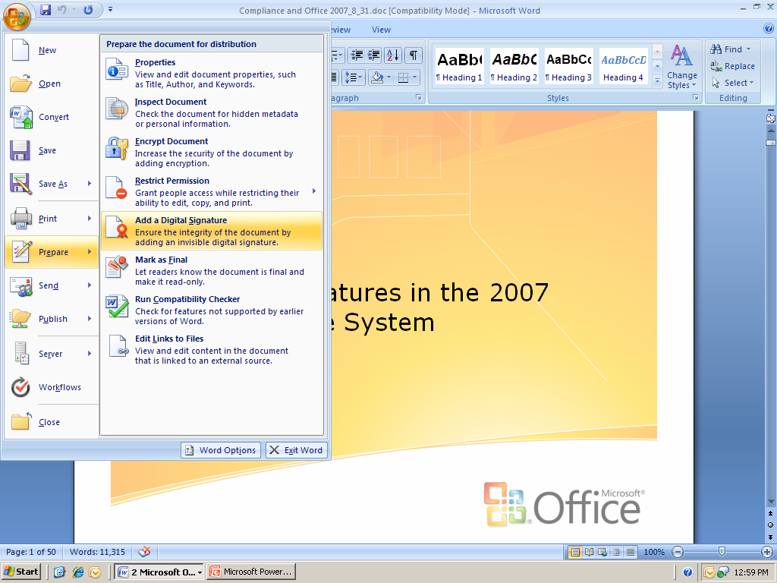

You can digitally sign a document for many of the same reasons you might sign a paper document. A digital signature is used to authenticate digital information—such as documents, e-mail messages, and macros—by using computer cryptography. Authentication is the process of verifying that people and products are who and what they claim to be. Digital signatures help to establish the following assurances:
- Authenticity - The digital signature helps to assure that the signer is who he or she claims to be. For example, you can confirm the source and integrity of a software publisher’s code by verifying the digital signature used to sign the code
- Integrity - The digital signature helps to assure that the content has not been changed or tampered with after it was digitally signed.
- Non-repudiation - The digital signature helps to prove to all parties the origin of the signed content. "Non-repudiation" means that a document signer cannot later deny that they were the ones who signed the content.
Signature Criteria
To make these assurances, the content creator must digitally sign the content by using a signature that satisfies the following criteria:
- The digital signature is valid. Valid refers to the status of a certificate checked against a certificate authority’s database and found to be legitimate, current, and not expired or revoked. Documents signed by a valid certificate and not altered since signing are considered valid.
- The certificate associated with the digital signature is current (not expired). A certificate is a digital means of proving identity and authenticity. Certificates are provided by a certification authority, and like a driver's license, can expire or be revoked.
- The signing person or organization, known as the publisher, is trusted. Trust is an indication of whether you trust the individual or group for whom the certificate is provided. The default setting is Inherit Trust from Issuer, which means that the certificate is trusted because the issuer, usually a certificate authority, is trusted.
- The certificate associated with the digital signature is provided to the signing publisher by a reputable certificate authority (CA). A certificate authority (CA) is usually a commercial organization that issues digital certificates, keeps track of who is assigned to a certificate, signs certificates to verify their validity, and tracks which certificates are revoked or expired.
2007 Microsoft Office system programs detect these criteria for you and alert you if there is a problem with the digital signature.
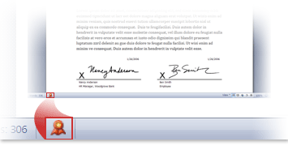

The ability to capture digital signatures by using signature lines in Office documents makes it possible for organizations to use paperless signing processes for documents such as contracts and other agreements. In the 2007 Office release, signatures “feel” like wet-ink signatures, because of the signature line: you know where to sign a paper document, and that a similar experience is now in the software.
Two advantages that digital signature lines offer are that—unlike signatures on paper—they can provide a record of exactly what was signed and they allow the signature to be verified in the future. After a document has been digitally signed, it becomes read-only to prevent modifications.
Extending Digital Signatures
Digital signatures offer ample opportunities for extensibility and customization with the IXMLDigitalSignature API and other interfaces. For example, you can write custom code to digitally verify the signatures written with a tablet pen. You can build conditional use of signatures into your workflows so that, when necessary, the workflow requires additional approvals (and signature) by stakeholders or other decision makers in the process.
Records Center
A common element in compliance regulations is the requirement to securely archive records for long periods of time in a safe and unalterable state. The ability to archive documents is just one component of a larger records management process that includes the collection, management, and expiration of corporate records (information important for the history, knowledge, or legal defense of a company) in a consistent and uniform manner based on a company’s policies. The 2007 Office release can help companies ensure that vital corporate records, including critical documents, are properly retained for legal, compliance, and business purposes and then properly disposed of when no longer needed.
Office SharePoint Server 2007 provides scalable and efficient records management components with the Records Center site template. Sites created based on the Records Center template become the hub for all record management processes, including content collection (such as spreadsheets, documents, and e-mail), consistent policy enforcement, item retention and holds in response to external events, and content expiration. Other locations, such as WSS servers, can be easily connected to the Records Center to ensure records from those locations are collected.
The Records Center site includes the following features:
- Security. The Records Center site has several features that help ensure the integrity of the document libraries and files stored within it. First, it helps ensure that records are never automatically modified by the system. This means that records uploaded to a records repository and then downloaded again later will always be identical, byte for byte. Second, it has default settings that prevent direct tampering of records, by versioning any changes made to document contents and by auditing specific types of changes. Third, it allows records managers to add and maintain metadata on items separately from the record’s metadata, so that information such as “who manages this item” can be changed without modifying the underlying record. Changes to this metadata can be audited as well, which is especially important for compliance with regulations such as 21 CFR Part 11 to ensure that enterprises can report exactly how they’ve used patient data.
- Information management policies. These policies provide controls that consistently and uniformly enforce the labeling, auditing, and expiration of records. You can configure policies for a specific storage location or content type. For example, to ensure that all contracts are retained uniformly in an organization, their expiration dates can be based on a common property such as the contract execution date.
- Record Collection Interface. Each Records Center site provides a set of services that aid in content collection. They let people and automated systems easily submit content to a records repository without necessarily having access or permission to any of the contents of the site. You can submit content through a Web service by using the simple object access protocol (SOAP) or through an e-mail message by using the SMTP protocol. Windows SharePoint Services version 3 and Microsoft Exchange Server 2007 provide out-of-the-box functionality to work with these interfaces to connect to a Records Center site.
- Record routing. When content is submitted to a Records Center site, it can be routed to its proper location within the records management system based on its content type.

Extensibility
To support deployments that require additional capabilities, Office SharePoint Server 2007 provides robust extensibility mechanisms. For example, the Record Collection Interface is fully documented and can be implemented on a different Records Center, allowing 2007 Office system client applications and servers to treat third-party repositories as records repositories. Or, you might want to perform additional processing on submitted documents before, or even instead of, the processing performed by the Records Center site. For these scenarios, Office SharePoint Server 2007 enables you to create a custom router by using the IRouter interface. The custom router can have the ability to edit the submitted document and its associated metadata, and update the location to which the submitted document is to be stored.
Content Types and Routing
To maintain compliance, companies must ensure that hundreds of thousands of employees follow complex and sometimes inconvenient procedures for managing documents and other content to ensure that records subject to compliance regulations are complete, accurate, secure and available.
One of the biggest difficulties in managing content in a large organization is making sure that everyone understands and follows corporate policies, such as managing out-of-date information or requiring labels so that paper copies can be tracked back to electronic originals. Office SharePoint Server 2007 supports robust information management policies that let site administrators and list managers control how content is managed. Although this section focuses on document management policies, all of the Office SharePoint Server 2007 policies can be applied to other types of content, such as pictures, list items, and third-party items.
Content Types, a new addition to Windows SharePoint Services 2007, allow you to pre-define metadata boilerplates so that all newly-created documents of a given type automatically have appropriate metadata such as workflow, resulting actions, expiration, and other policies. Content types address a significant obstacle to automating better compliance: the lack of information classification. If the system regards all content as plain “documents,” then the system can’t enforce policies such as expiration according to the type of content. For example, with the addition of Content Types, Office SharePoint Server 2007 can tell the difference between “contracts” and “memos” and automatically enforce different policies according to those content types.
Content Types are created by the administrator and specify a template that can be used from the document library, as shown in the following graphic.
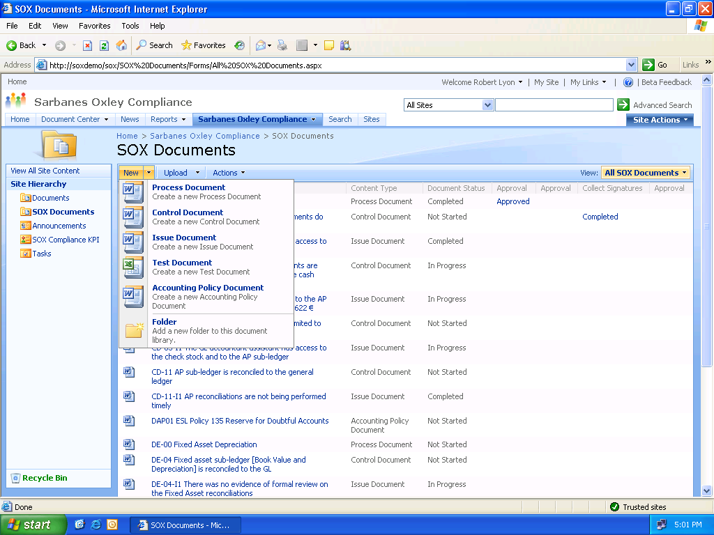

When a user clicks New in a document library to create a new file, they can now select a Content Type. Based on the selected content type, the metadata properties are already present in the new document. For example, you can create a pre-made Proposal content type that captures relevant attributes (such as customer, product type, and salesperson) for each sales proposal.
Several benefits arise from ensuring metadata inclusion at the time of documentation creation through content types.
- Finding documents is much easier thanks to the abundance of metadata. For example, in the case of Proposals, you can easily search and retrieve all Proposals associated with a specific product type, salesperson, or date.
- Content submitted to a Records Center site can be routed to the proper location within the records management system based on content type.
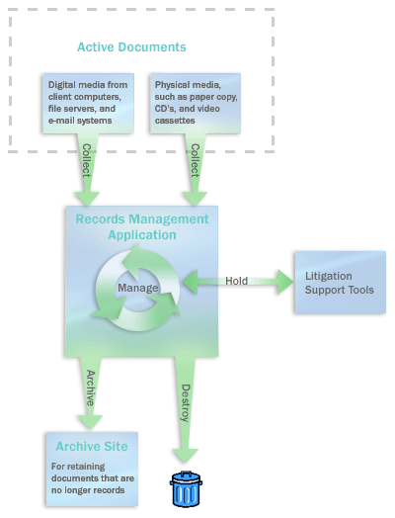

It is important to note that although users can submit content to a Records Center site, they may not have the permissions to view or modify the content because of security policies.

The following image shows a Records Center site hosted by Office SharePoint Server 2007.

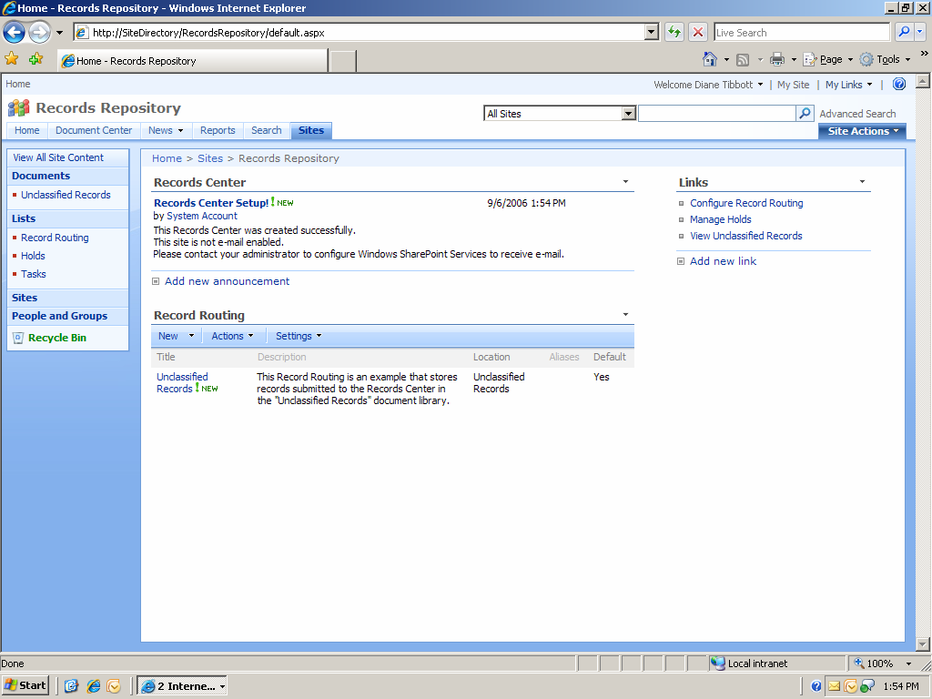

The Records Center site allows authorized users (such as IT staff, records managers, and legal authorities) to apply one or more holds that suspend records management policies on specific items to prevent documents from being changed during litigation, audits, or other investigations. The process of creating, managing, and releasing holds is monitored and recorded so that the system can account for all actions taken. Holds are discussed in more detail later.
E-mail Message Record Management
You can manage e-mail messages because of the tight integration between Office SharePoint Server 2007 and Exchange Server 2007. Administrators create managed e-mail folders in Exchange Server 2007 that get pushed out to users who have the option of opting into specific folders based on their job functions. These e-mail folders have policies associated with them that define things like the retention period and quota for the content of these folders. Using Exchange Server 2007 rules, you can set up these folders to send e-mail messages to a Records Center site implemented in Office SharePoint Server 2007. Users can drag e-mail records from their inbox into the appropriate managed e-mail folder and any required metadata can be entered asynchronously into the Records Center site.
Classifying E-mail
IT organizations need to provide users with a way to mark up messages with an outgoing classification. Certain industries have specific regulations for which mail classifications would satisfy their requirements. An example of a broad regulation that is aided by e-mail classifications is the HIPAA requirement to let users know that they are receiving messages that communicate benefits. Any message receiving the “Benefits Communication” policy then needs to be processed by the company (on behalf of the employee) with specific rules and regulations. For example, the employee has permission to know everyone that received a copy.

With Office Outlook 2007, this feature allows IT to distribute a set of e-mail classifications that users can use to communicate the rules or behaviors that they should be subject to while reading the e-mail. Configurable policies include:

- Attorney/Client Privileged. “This message is privileged and recipients are instructed to [take whatever action is described].”
- Benefits Communication. “This message originated from your benefits department and under HIPAA regulations.”
- HR Communication. “This message contains confidential and sensitive information.”

When a classified e-mail message is received, it contains exactly the same banner that was shown to the author when the message was created, thus providing the user additional metadata about what type of message this is or how to behave while reading this message. None of these policies use the 2007 Office system information rights management (IRM) technologies to enforce a lock-down of the To: or Cc: lines or the content itself, although developers can accomplish this through custom code.

IRM and Classifications exist side-by-side in the UI, although they do have different functions. Classified e-mail in Office Outlook 2007 is not IRM-protected, but you can write custom code to enforce IRM policies. Classifications have the benefit that they are extremely extensible. For example, an IT department can implement a classification so that all Company Confidential e-mail messages are restricted from being forwarded outside the company, that the e-mail must have a digital signature, and that it cannot be printed.
Extending Classified E-mail
In an organization with both Office Outlook 2007 and an e-mail system such as Exchange Server 2007, the policies can have even more sophisticated functionality. The policies listed above can be hints for the transport to add additional features to the e-mail message, such as signing, encryption, or IRM. For example, to help ensure integrity of messages sent over the Internet, you can extend Exchange Server 2007 to encrypt an attorney-client privileged or benefits e-mail messages.

In addition, you can create new classifications specifically designed to tell the recipient system what you are trying to send:
- Official Company E-mail – This message will be signed by the company so the recipient can verify the message authenticity.
- Personal E-mail – This message contains personal information and may not reflect the views or policies of the sender’s company.
Setting Policies
Office SharePoint Server 2007 includes a set of out-of-the-box policies that you can use for a specific list or content type. These policies provide controls that consistently and uniformly enforce the labeling, auditing, and expiration of records. You can configure policies for a specific storage location or content type. For example, to ensure that all contracts are retained uniformly in an organization, you can base expiration dates on a common property such as the contract execution date.

Although the out-of-the-box policy features of Office SharePoint Server 2007 support many common policies, organizations can have unique needs that require additional policy features. For example, an organization might have a policy that requires files to be saved in a specific format. The policy framework allows organizations to author custom information management policies that will appear on the policy settings page.

The following images show how easy it is to configure auditing and content expiration options.

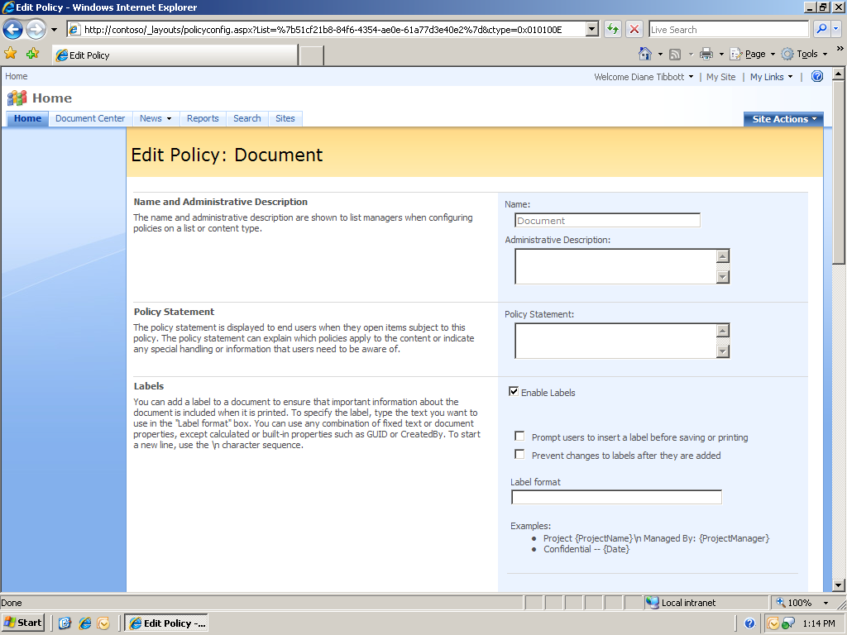
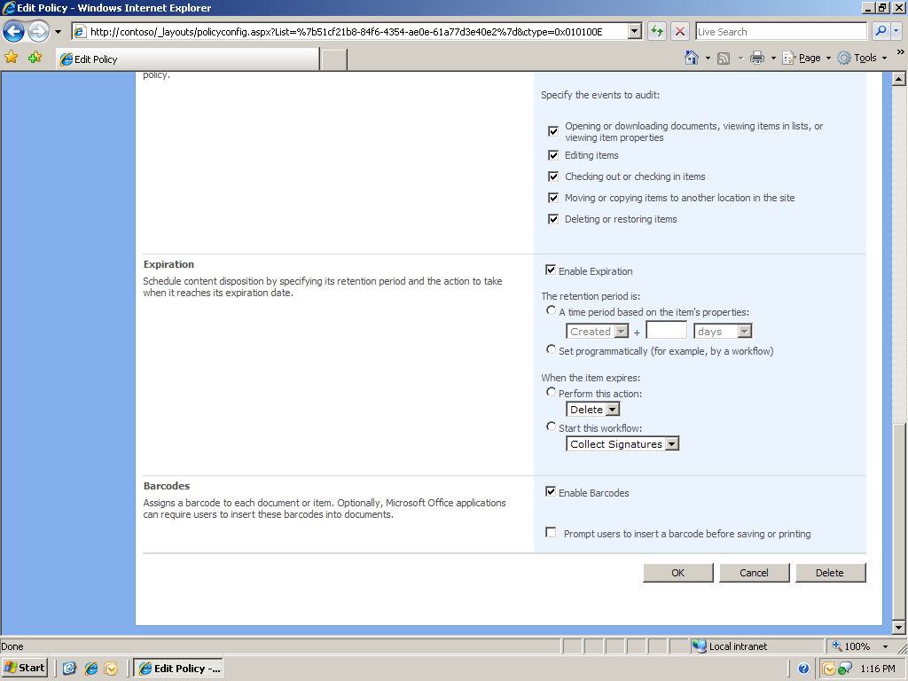
Extending Policies
As powerful as the information management policy features that come with Microsoft Office SharePoint Server 2007 are, they hardly cover every content management scenario. Because of this, Microsoft Office SharePoint Server 2007 also provides an extensibility framework that enables you to create a wide range of policies to suit your business processes.

Perhaps your company is concerned with controlling the dissemination of sensitive data through the circulation of printed copies. Therefore, you want to limit the printing of certain documents to a specific set of highly secure, access-controlled printers. You can achieve this goal through use of a policy feature.

You can create a policy feature that contains the list of "trusted" printers. Assign a policy with this feature to the appropriate content types. Then deploy a 2007 Microsoft Office system add-in on all of your company's client computers. This add-in listens for the Print event in 2007 Microsoft Office system applications, and then checks whether the user is printing to one of the "trusted" printers. If not, then the add-in on the user's computer cancels the print job and informs the user.

Another scenario is a corporation concerned with long-term record preservation; specifically, ensuring that your electronic files are in a format that can be read 15 to 20 years from today.

In this case, you can create a policy feature that generates a fixed-format copy of the content, and assign it to the content types you want to preserve. Then, for each document of that content type, the policy feature creates a fixed format rendering of the document, and stores that rendering as an attachment on the document in a SharePoint document library. The policy is enforced automatically for all items subject to the policy, with no intervention required from records managers or IT.
Holds
A number of compliance regulations mandate that organizations be able to produce records required by investigations and court discovery actions. Failure to fulfill such requests in a timely and complete fashion can expose the company and its officials to liability. Even the inadvertent destruction of records can create criminal liability issues.
Although many companies would like to preserve content only as long as they absolutely have to, events such as litigation require that relevant content be maintained for the lifespan of that event, even if it exceeds the normal lifespan of the item. If records are subjected to multiple audits or litigations, those records must be maintained until the last litigation or audit is completed. To meet this need, Office SharePoint Server 2007 includes a hold feature designed to respond to events by associating records with these events and overriding the expiration policy of these records appropriately to ensure that they cannot be deleted manually or automatically during the lifespan of the events.
By default, every Records Center site is provisioned with a hold list in which each item corresponds to a single hold order. The list provides tools for finding and holding relevant records, viewing the records currently on a hold, and releasing the hold after the hold order is no longer active. When an event such as a discovery motion occurs, a records manager, lawyer, or IT administrator defines a new hold by adding an item to the hold list. The item specifies a name for the hold event, a description, and the person responsible for managing the hold.
The next step in responding to the hold order is to suspend the policies on all relevant records that may be scattered across different document types and stores. The improved search function of Office SharePoint Server 2007 makes it easy to find all relevant records thanks to integrated metadata capture and content types. The records manager or administrator can analyze the search results and add relevant records one at a time or in bulk.
Legal staff can view a list of all records currently being held for a specific hold event by choosing the View hold report command on the appropriate item in the hold list. After the hold order is no longer in effect (for example, because the underlying litigation matter has been resolved), the records manager can release the hold order by using the Release hold command. This will automatically resume normal enforcement of policies on all records that were previously subject to this hold order. In the event that a record is subject to more than one hold, it will not revert to its original policy enforcement until all of its hold events are resolved.
The following screenshot shows a hold in Office SharePoint Server 2007 that identifies the matter under research and the user managing the hold.

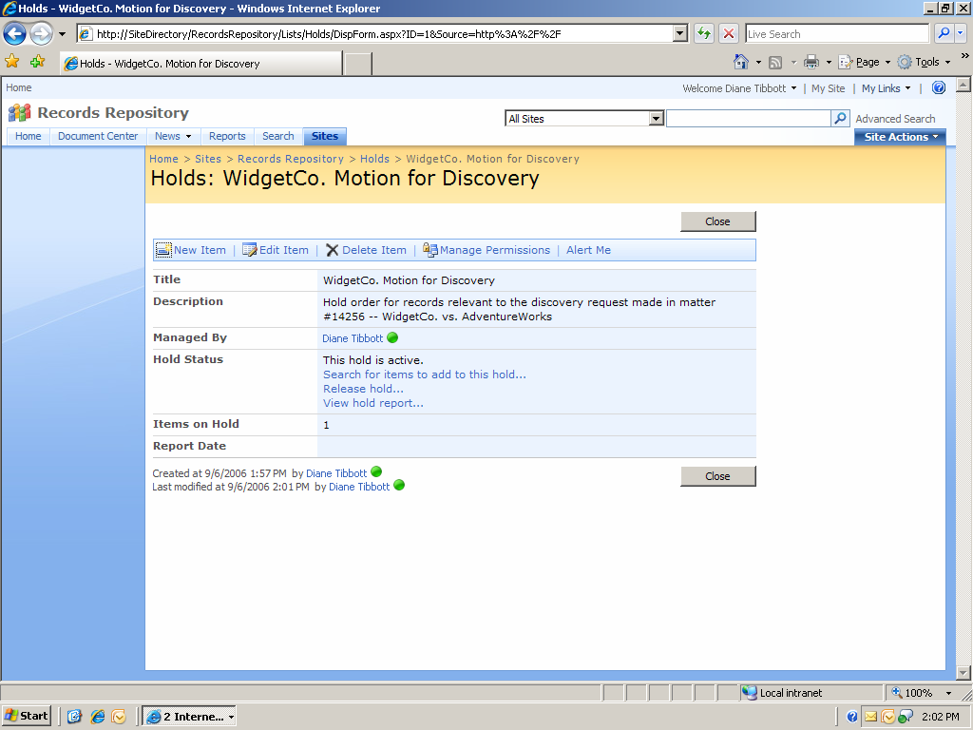

Spreadsheet Management
The Sarbanes-Oxley Act focuses on integrity and accuracy of financial reporting by publicly held companies. However, most publicly traded companies use Microsoft Office Excel spreadsheets to aggregate financial numbers from various divisions and applications for producing financial reports. The financial and logistics applications that generate these numbers incorporate numerous controls to ensure accuracy, completeness and integrity. But after these numbers make it into an Office Excel spreadsheet there is no way to ensure the integrity of the spreadsheet data and formulas.

Sending spreadsheets through e-mail messages or even storing them on a file server is a major challenge for companies struggling to maintain financial compliance. When users open a spreadsheet, they can see everything—all sheets, all calculations, and even hidden cells. They are able to arbitrarily change formulas and values and then forward the spreadsheet to other people. This can result in multiple versions of the spreadsheet and no assurance as to the integrity of the calculations or transparency as to who changed what. Spreadsheets are a pain point for companies that need to comply with strict regulations stating that all financial documents must be secure, have integrity, and be completely audited.

Excel Services addresses this issue by keeping the spreadsheet on an Office SharePoint Server 2007 site and using thin-client architecture to allow the user to view and interact with spreadsheets without having Office Excel installed on the client computer. Office Excel 2007 is required only to author the spreadsheet, not to view the published spreadsheet.
Excel Services
Excel Services has several advantages over using the Office Excel desktop application alone. First, by being posted to a Web Part, all viewers can see it in a centralized location where the original, posted document is protected from unauthorized changes. Users can download a copy of the spreadsheet and experiment with it but they can’t modify the original, official version of the document, which becomes part of the company’s official business record. As a result, there is one version of the spreadsheet for a company’s financial data. Authors can make cells editable so that an individual can perform calculations and models for themselves. Authors can also select which objects (such as a PivotTable dynamic view, a chart, or a list) or sheets that they want to be made public. Calculations are hidden so that all private and confidential information is not exposed.

With Excel Services, the spreadsheet still has the look and feel of the familiar client. Key performance indicators (KPIs), out-of-the-box (OOB) features, and custom calculations are the same as with the Office Excel desktop experience.

Extending Excel Services
An important aspect of Excel Services is that solution developers can use its power programmatically from their applications. These solutions can be either line-of-business (LOB) applications or custom enterprise solutions that an organization develops internally. You can use Excel Services to build multi-tiered applications, with the presentation layer implemented as a Web application (for example, an ASP.NET application) that calls Excel Web Services. The architecture allows you to use and extend Excel Services three ways:

- Develop solutions using Excel Web Services
- Extend the Office Excel function library on Excel Services by using user-defined functions
- Customize the Microsoft Office Excel Web Access Web Part
Barcodes and Labeling
Many of the critical business records that companies need to manage today are non-digital assets. Without proper management of non-digital assets, companies face potential loss of records due to misfiling, or the lack of workflow history, audit history, version history, or comments. Once a record becomes non-digital it often falls through the cracks of automated compliance controls and, if mishandled, can expose the organization to liability.

The 2007 Office system provides considerable functionality around policy and records management. The 2007 release facilitates document and records management with the capability to generate and embed barcodes and labels within documents. Text-based labels or barcodes can be generated from document metadata, such as subject keywords or customer numbers. Labels and barcodes are automatically printed with the document.

Barcodes enable users to manage physical items (such as print-outs of 2007 Office system documents) by linking those items back to corresponding items in Windows SharePoint Services. Companies can affix an identifier to a physical item, and then associate that identifier to any document or item in Windows SharePoint Services. With extensibility, users can get from the physical item to the Windows SharePoint Services item by scanning the barcode from the physical record, and the Windows SharePoint Services item can be used to track information about the physical item through its Windows SharePoint Services audit history.

The following graphic summarizes all document properties for a hypothetical “CD-00 Cash Disbursements” document, including its barcode.

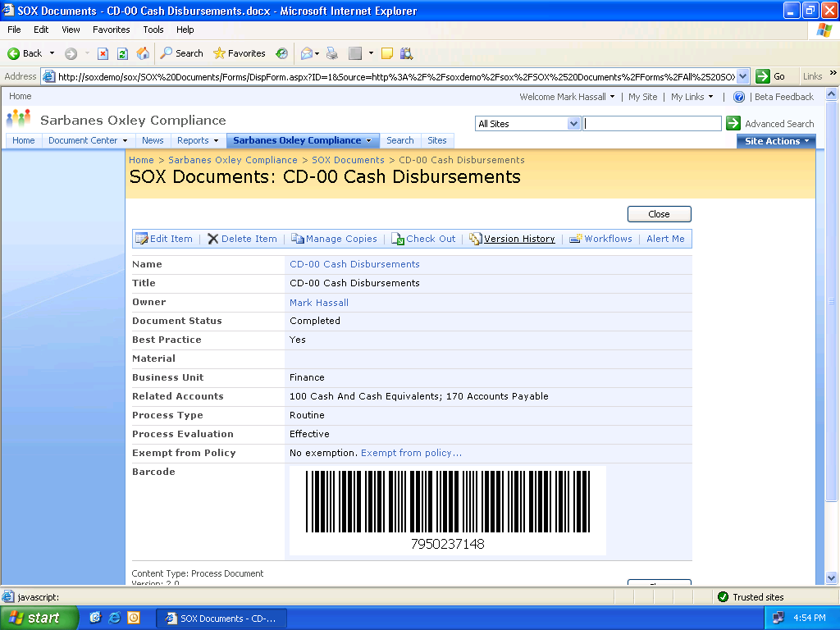

You can define a label that includes a collection of document information that can be shown visually in all Microsoft Office documents of a specific type. When setting up the policy for a document library or content type, you have profile-based control of these elements:
- What information you want included in the label
- The look-and-feel of the label
- When the label should appear in the document
- When the label should be "locked" for use as a means of referencing the document

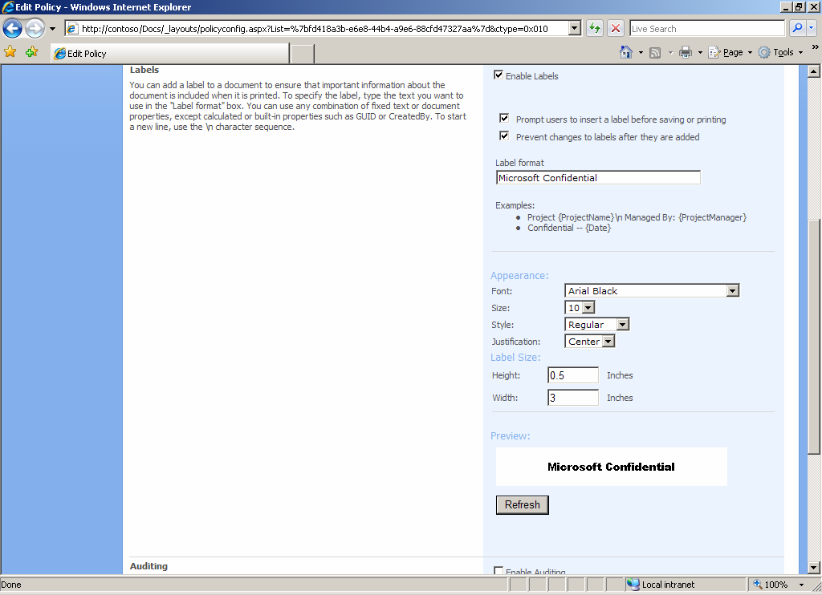

Information Rights Management in the 2007 Microsoft Office System
Confidentiality and integrity are central elements of most compliance regulations but it is very difficult to control what individuals do with copies of electronic documents. It is easy for people to send copies outside the organization or make unauthorized, untraceable modifications.

With information rights management (IRM) you can address these compliance risks by protecting and maintaining greater control over digital information, including confidential and sensitive documents. Microsoft Windows Rights Management Services (RMS) in the Microsoft Windows Server® 2003 operating system lets you set policies that allow better control over who can open, copy, print, or forward information created in 2007 Office system applications, and non-Office document formats implemented by third-party application developers.

The 2007 release includes sophisticated IRM capabilities and policy controls designed to help you safeguard digital information from unauthorized use. Through integration with RMS for Windows Server 2003, these IRM features enable information workers to define exactly how recipients can use the information contained in Office documents.
Specific features include:

- Information Rights Management. In conjunction with Windows RMS, the IRM features of the 2007 release enable users to define exactly who can open, modify, print, forward, and take other actions with the information in Microsoft Office documents.
- Policy Statements. You can create policy statements for specific e-mail message types and embed these statements in the message. Policy statements can instruct the reader how to handle the message content or serve as a flag to trigger Exchange Server 2007 to process custom-defined rules.

The limitation of access control lists (ACLs) is that they only limit access at the server. After someone downloads a document, ACLs can’t control whether a person with the rights to a document sends it to someone who does not have rights. IRM can help in this situation.
IRM works by encrypting the file and limiting the set of users and applications that are allowed to decrypt the file. It can also limit the rights of users who are allowed to read the file, so that they cannot print copies or copy text.

Although there is no technical way to prevent people from divulging sensitive information, IRM helps by restricting who can access sensitive documents and what people can do with these documents after opening them. Moreover, policy statements can help reinforce end-user responsibility by ensuring that end users know that information is sensitive, thus eliminating the “ignorance” defense in the event of a disclosure.

Although 2007 Office system applications allow information workers to manually protect individual documents, Windows SharePoint Services can now use IRM to protect entire libraries. This has two major benefits. First, it is easier to get consistent use of IRM across a set of documents without creating extra work for individual users or depending on users to use IRM correctly. The administrator controls what content is kept private and what isn’t controlled. Second, when the server manages the application of IRM, it stores the document without encryption so that it remains accessible for server-based processes such as search. Even though IRM always provides a means for an organization to decrypt an IRM-protected document in certain circumstances—such as when an employee leaves the organization—many organizations feel more comfortable when the original copy of a document is stored without encryption.

A list manager can use the Office SharePoint Server 2007 Web-based list settings to turn on IRM. The rights to view or edit a document are automatically based on the ACLs on the SharePoint site. The settings provide additional control over rights such as copying text from the document or printing.

But IRM and the 2007 Office system continue to protect information even after it leaves the SharePoint site. Because the permissions between Office SharePoint Server 2007 and RMS are now synchronized, the same permissions policy is preserved for documents that are no longer under control of the Records Center; for example, documents now stored on a desktop computer or sent through e-mail.
Document Information Panel
To facilitate compliance requirements such as fulfilling requests for business records, you need a way to find all records associated with certain projects, business entities, accounts or other characteristics. Simple keyword searches are often inadequate.

The Document Information Panel is available in Office Word 2007, Office Excel 2007, and Office PowerPoint 2007, and is a metadata capture mechanism that is easy to configure without writing program code. The Document Information Panel collects and retrieves metadata to give context to the document and increase the ability to search for it in the portal.

Metadata synchronizes bidirectionally between Office SharePoint Server 2007 and the Document Information Panel. For example, if the information panel is customized to pick up the status of the document workflow, then as soon as the workflow status changes on the SharePoint site, the metadata in the property panel changes, and vice versa. Although the Document Information Panel is only available for 2007 Office system documents, custom metadata is available via the Web user interface for any type of file.
Extending the Document Information Panel
Because the Document Information Panel is really an XML form, it is fully customizable by using Office InfoPath 2007. With the data connection capabilities of Office InfoPath 2007, an IT administrator can create a panel that brings LOB data into the form; for example, it could populate customer data fields with data from a customer records management (CRM) system. Before closing the document, the user would then add in any important document information such as links to related documents.

Metadata is thus captured with fewer errors and in a less intrusive way for users. With the improved search capabilities of Office SharePoint Server 2007, this metadata can be used to index and group results more accurately, and associate documents with a set of customers, products, and related documents.

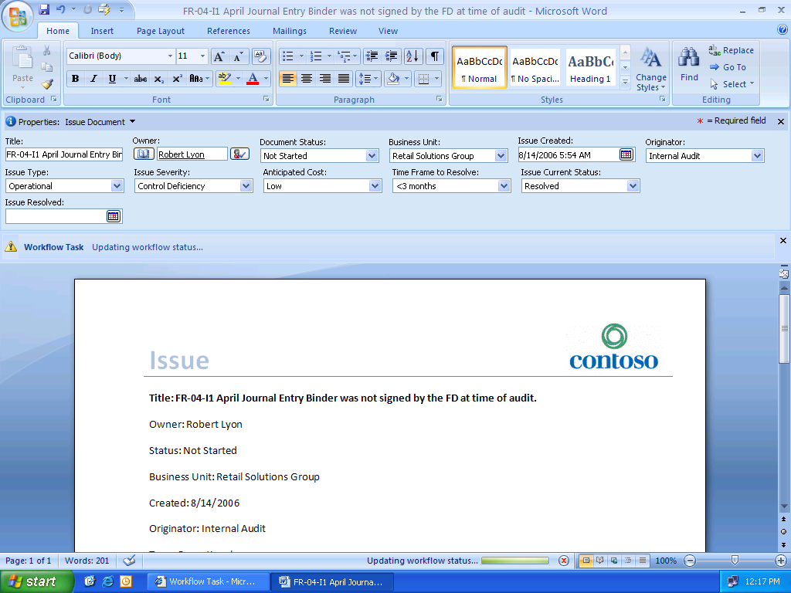

Document Inspector
It is more important than ever for users to be aware of and understand the data that is added to or contained in a document. In recent incidents, personal information in a document caused embarrassment and the exposure of sensitive information.

Document Inspector is an important feature in Microsoft Office client-side programs. Document Inspector facilitates compliance with confidentiality regulations. Document Inspector is intended to help users minimize the disclosure of personal information and to help them easily find and remove metadata from their documents.

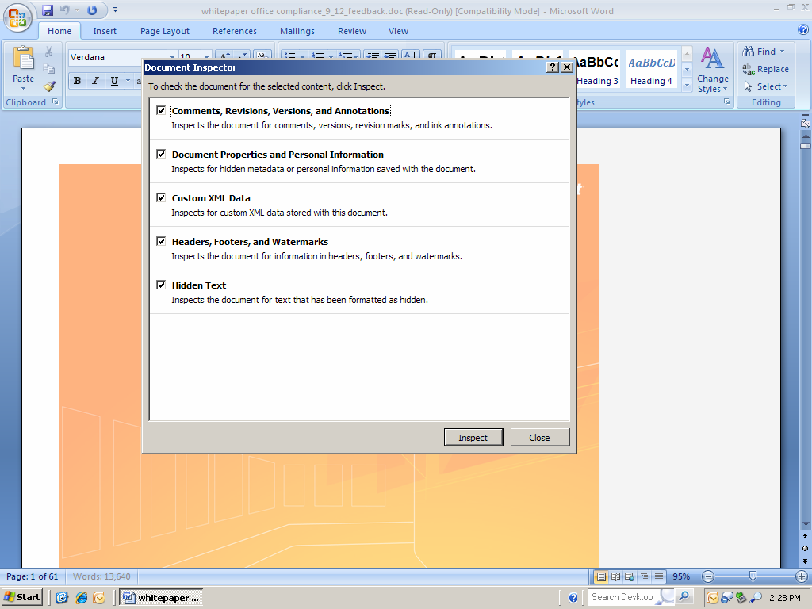

Extending Document Inspector
As a developer, you can extend the Document Inspector. The Document Inspector framework enables you to deploy custom Document Inspector modules that you can integrate into an application user interface, in addition to the built-in Document Inspector modules. For example, Howard is a developer for a law office that produces hundreds of documents each year. These documents frequently contain sensitive information about the client and about the document. Thanks to the fact that metadata and comments are separate document parts in the 2007 Office system file formats, it is possible to programmatically remove this information before transmitting it outside the enterprise. In this scenario, to protect against the public disclosure of this information, Howard has written a module that uses the Document Inspector object model to inspect and remove certain information common to all documents produced by the company. Howard knows that users can also use the Document Inspector UI to modify or remove any additional information not caught by his module. Howard’s custom module also tells users about words in documents that are sensitive and not recommended. Although the module does not help fix the document, it helps users scan through the document and find and instances of the sensitive words.
New Office File Format
The new 2007 Office system file formats introduce a number of benefits not only for developers and the solutions they build, but also for individual users and organizations of all sizes.

The Microsoft Office Open XML Formats enable rapid creation of documents from disparate data sources, accelerating document assembly, data mining, and content reuse. Exchanging data between 2007 Office system applications and enterprise business systems is simplified: alter information inside an Office document or create a document from scratch using standard tools and technologies; access to 2007 Office system applications is not required. Employees can improve productivity by publishing, searching, and reusing information more quickly and accurately in the environment they choose.

Office Open XML Formats are based on industry standard XML and ZIP technologies, support full integration by any technology provider, and are available via a royalty-free license. Format specifications will be published and made available under the same royalty-free license that exists for the Microsoft Office 2003 Reference Schemas: they are openly offered and available for broad industry use.

Smaller file sizes and improved recovery of corrupted documents enable 2007 Office system users to operate efficiently and confidently and reduces the risk of lost information. Office Open XML Formats use ZIP compression technology to store documents offering potential cost savings as it reduces the disk space required to store files and decreases the bandwidth needed to transport files by e-mail, over networks, and across the Web.

The new XML-based format of 2007 Office system document files facilitates compliance and extensibility because content is separated from formatting. Regulatory agencies often have strict format standards for specific documents. For example, the FDA has stringent standards around how FDA submissions documents should be formatted. In the past, pharmaceutical companies needed to hire legions of temporary workers to reformat documents to ensure that .dot templates were compliant with FDA standards.
Manipulating the Office File Format
You can use XML to add new document parts to facilitate custom compliance requirements. For example, with the extensible document format of the 2007 Office system you can construct a new, separate document part to store audit trails (this is analogous to the document parts that store metadata or comments) and this could pull audit trails from an Office SharePoint Server 2007 site. This way, if the document is removed from the SharePoint site, the complete audit trail is still preserved for compliance reasons.
Portal Search
Many compliance regulations require that companies only publish up-to-the-minute and approved data sets. Under SOX, for example, financial reporting must be accurate and disclosed on a timely basis, which requires the right people to have the right information at the right time. To comply, users must first find information—the right information and all the information related to a specific issue. Information related to a court case or other matter may be scattered across multiple systems, including enterprise resource planning (ERP) systems, servers and other databases and applications.
Office SharePoint Server 2007 has an integrated portal search engine that uses the latest search algorithms from Microsoft Research to return fast and relevant search results. Portal search allows you to find identical copies of documents, and you can search against unstructured and structured information simultaneously. Users can find information not only from Microsoft content repositories but also from multiple other sources, such as ERP systems and file shares, by using advanced, full-text search from within their integrated organizational portal. This search can include results for different file types and data sources using extensibility mechanisms, and can find not only information and data but also the relevant people who are experts in the search topics. These experts are found and organized by their degrees of separation from the user, based on the user’s known contacts. With the integration of the Property Panel capturing metadata information, search is improved and can provide instant access to critical documents.
Extending Portal Search
Enterprise Search in Office SharePoint Server 2007 is a shared service that provides extensive and extensible content gathering, indexing, and querying. This service supports full-text searching using query syntax based on structured query language (SQL), and provides new keyword syntax to support keyword searches. Enterprise Search uses the same underlying search service as in Windows SharePoint Services. The following diagram shows the main components of the enterprise search architecture and how they relate to content sources, the search portal, and custom search applications.
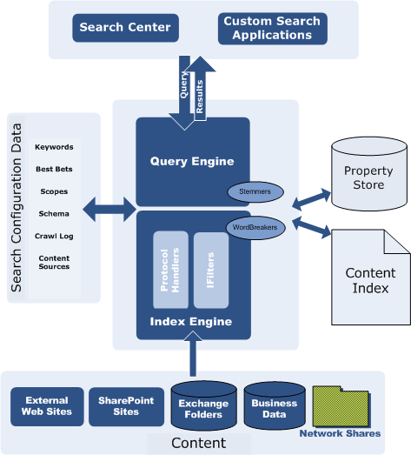
http://msdn2.microsoft.com/en-us/library/ms570748.aspx

Enterprise Search in Microsoft Office SharePoint Server 2007 provides a new Search Administration object model that you can use to create custom applications for programmatically administering Enterprise Search. The Enterprise Search Administration object model is implemented in the Microsoft.Office.Server.Search.Administration namespace. Using the Search Administration Object Model you can write code that uses the Enterprise Search Administration object model from different types of applications such as a console application, a custom search Web Part hosted in a SharePoint site, an ASPX Web application or from Windows Forms clients.
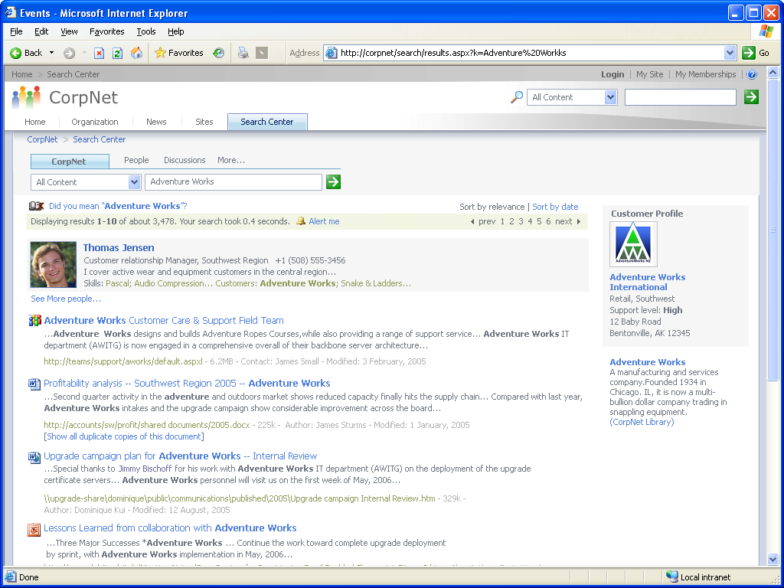
Out of the box, the portal search page (shown below) comes with tabs to show results for “All Sites” and “People” but you can customize the portal search page to add custom search tabs to enable users to search predefined scopes of information. For example, you can create custom queries and modify the page to have tabs for “Customers”, or “Legal Document”, or other categories relevant to the business or team.

Compliance Extensibility Opportunities
This section highlights principal areas where developers can extend the platform to fill compliance requirements, and it maps each of these areas to the five common regulatory compliance requirements discussed earlier in this document. This section also provides real-world example scenarios of custom solutions businesses could build with the extensible 2007 Office system platform, and gives a high-level introduction to the object models and interfaces within the platform that are relevant to compliance and how they relate to the extensibility opportunities.
Viewing Item-Level Audit History
Confidentiality | Integrity | Availability | Procedural Rigor | Auditing and Logging
 | X |  |  | X
Office SharePoint Server 2007 has the ability to audit server-side events for all files and global settings at the site level. For example, the audit log contains information about when a user opens or downloads a file, views items in a list, views item properties, edits items, checks items in or out, moves or copies files to another location in the site, and deletes or restores a file. All of this information is written to the Microsoft SQL Server™ 2005 content database, where an administrator can view all of the auditing history for the entire site. Unfortunately, Office SharePoint Server 2007 currently offers no out-of-the-box feature that lets a user view just the audit history for a single file.

By using the Office SharePoint Server 2007 object model, you can write custom code to provide a page view of the document history for a single file, based on the auditing history. To accomplish this, you would use the object model to query the audit log for the audit history pertaining to the ID of the specified file. From the results, you have several options for reporting. Using the object model, you can use ASP.NET to write the query results to a custom Web Part on a SharePoint site. You can also write the query results directly to a SharePoint list using the object model and ASP.NET to create the presentation of the page. Alternatively, you can write the query results to an Office Excel 2007 spreadsheet, which can then be published to a SharePoint site on a server running Excel Services. This option requires working with the Office SharePoint 2007 object model, the Excel Services object model, and ASP.NET.
Adding Instant Messaging History to the Records Center
Confidentiality | Integrity | Availability | Procedural Rigor | Auditing and Logging
 | X |  |  | X
A major issue on the technical side of compliance is handling unstructured data such as e-mail and instant messaging. E-mail records management is built into the 2007 Office system, but there is no out-of-the-box ability to store instant messaging conversations as records. Office Communicator has always been an enterprise-class, security-enhanced instant messaging application, but in the 2007 release, it also stores all session history on the Exchange Server 2007 system and makes it viewable to the user through a specially-created folder in the user’s Office Outlook 2007 inbox. This storage results in an audit log for each conversation and file transfer (for example, who participated, what was written, and at which date and time). With the Records Center feature in Office SharePoint Server 2007, you can now write custom code to quickly connect the two and send all instant messaging session history to the Records Center.

The custom code would first query the Exchange Server 2007 system to retrieve the session history files. It would then use SharePoint Products and Technologies to send the files to the Records Center site.
Server-Side Signing of Documents
Confidentiality | Integrity | Availability | Procedural Rigor | Auditing and Logging
 | X |  | X | X
In the 2007 Office release, you can digitally sign all Office Word 2007, Office Excel 2007, Office PowerPoint 2007, and Office InfoPath 2007 files to help ensure authenticity and then upload them to the server. The same is not true for all third-party files or all other non-core Microsoft Office file types. Authenticity is a major issue in compliance, and there are opportunities for you to extend the 2007 Office system platform to meet this need. With some custom code, no matter which file (such as a CAD file or a Windows media file) a user uploads to a SharePoint site, the user can digitally sign that file during the upload process to ensure that all necessary files are authenticated.

After the 2007 Office application initially verifies the signature, custom code can verify the third-party certificate and then modify the XML-DSIG. On the server side, you would parse the XML-DSIG to extract the public key, algorithm details, and the signed data. You could then verify the key and store it in an IRM-protected document library.
Linking Information Rights Management with Classifications for Advanced E-mail Protection
Confidentiality | Integrity | Availability | Procedural Rigor | Auditing and Logging
X | X | X | X
A user can specify a set of rights and permissions that allow an e-mail message or document to be opened or downloaded only by an authorized individual or group of individuals. In addition a user can specify whether an e-mail message or document can be printed, forwarded, or copied. The 2007 Office release adds e-mail classification to further notify users about the discretion of the message. For example, an administrator can create a classification where a user can mark a message as “Patient Confidential” or “Contoso Company Confidential.” This classification adds another level of security information.

Developers have the opportunity to link IRM and the classification features when creating a compliance solution. You can write custom code so that when a user selects a classification such as “Company Confidential,” the solution would automatically apply an IRM policy that would not allow it to be forwarded outside the company or opened by an external person. In addition to unifying the two features, this customization also allows IT to control e-mail message management, where these settings would be configured to be consistent and not user-dependent.

One way to programmatically accomplish this task would be to create client-side event triggers for when a user applies a specific classification to an e-mail message. When this classification occurs, you can use the IRM object model to apply authorization rights or other permissions to the message.
Client-Side Auditing for Granular Tracking of Changes to Document Internals
Confidentiality | Integrity | Availability | Procedural Rigor | Auditing and Logging
 | X |  |  | X
Office SharePoint Server 2007 provides server-side auditing so that all events that occur within a SharePoint site are audited. After a user downloads a file, Office SharePoint Server 2007 does not know what subsequent events occur. For example, the server cannot determine if a document has been printed, changed, or edited (such as calculations in a spreadsheet), copied, or sent in an e-mail message.

But with custom code, you can provide a full audit on any file that resides on a SharePoint site. To accomplish this task, you could write code to capture user actions in the client after a user downloads a file from the server. Either incrementally or whenever certain events are triggered, you could pass the event information (audit trail) through SOAP to custom code on the Office SharePoint Server 2007 system, which then writes it to the audit log.
Mapping of Extensibility Opportunities to Major Regulations
The checks in the table indicate which custom coding scenarios can be exploited to help facilitate compliance with various regulations.

 | Item Level Audit View | IM History as Records | Server-Side Signing | IRM Protected Classified E-mail | Client-Side Auditing
SOX | þ | þ | þ |  | þ
HIPPA | þ | þ | þ | þ | þ
GLBA | þ | þ | þ | þ | þ
Basel II | þ | þ | þ |  | þ
SEC | þ | þ | þ | þ | þ
21CFR | þ |  | þ | þ | þ
DoD 5015.2 | þ | þ |  | þ | þ
ISO | þ |  | þ |  | þ
Requirements for Extensibility Opportunities to Major Regulations
This table shows whether each custom coding scenario is required or applicable for each of the 8 major regulations.

 | Item Level Audit View | IM History as Records | Server-Side Signing | IRM Protected Classified E-mail | Client-Side Auditing
SOX | Required | Required if related to financial reporting | Required | N/A | Required
HIPPA | Applicable | Applicable | Applicable | Required for patient information | Applicable
GLBA | Required | Applicable | Applicable | Applicable | Required
Basel II | Applicable | Applicable | Applicable | N/A | Applicable
SEC | Required | Required | Applicable | Applicable for customer communications | Applicable
21CFR | Could be Required | N/A | Applicable | N/A | Applicable
DoD 5015.2 | Required | Applicable (might be in DoD 5015v3) | N/A | Applicable | Applicable
ISO | Required for RM | N/A | Applicable for RM |  | Applicable for RM

Extensibility Scenario: Controlling stock analyst upgrade and downgrade
Contoso Financial has a very strict process for its equity research department’s upgrade or downgrading of recommendations. Whenever the company wants to upgrade or downgrade an analyst’s rating of a company’s stock, they use a Web site for recording who sat in on the decision process, and who approved it.
Previously, that auditing of participation was purely based on self-reporting. There was no way to guarantee that everyone remembered to log their participation (even though they are heavily trained to do so), and worse, there was often no way to know for sure who was aware of the upgrade or downgrade before it occurred; for example, if there was any later concern over insider trading.
Contoso Financial developers solved the problem with the 2007 Office system. The Contoso Financial equity research department created a document profile for “upgrade/downgrade proposals,” which has a well-defined template, workflow for approval, and policy. They also created a new Windows SharePoint Services site for these proposals. Among other things like access control, the policy specifies that every time the document is opened, that event must be logged on the SharePoint site. Additionally, they specify that whenever anyone approves or disapproves a proposal, that action must also be logged. If a dispute ever arises over a particular upgrade or downgrade proposal, Contoso Financial can retrieve an audit history for that proposal from the SharePoint site. The site will return a “signed” copy of the history, which Contoso Financial can then submit to whoever needs it. Because the history is signed, the other party will know that Contoso Financial hasn’t tampered with the history to remove any incriminating activities.
Extensibility Scenario: Spreadsheet integrity
Like many publicly traded companies, Contoso World’s financial staff uses Office Excel spreadsheets to aggregate financial numbers from various divisions and applications for producing financial reports. The financial and logistics applications that generate these numbers incorporate numerous controls to ensure accuracy, completeness and integrity. But once these numbers are stored in the Office Excel spreadsheet there was no way to ensure the integrity of the spreadsheet data and formulas. Anyone with modify access to the spreadsheet could arbitrarily change balance figures or modify formulas. By moving these spreadsheets to an Office SharePoint Server 2007 system running Excel Services, Contoso was able to gain much more transparency and control over these financial spreadsheets but still lacked the ability to audit cell-level modifications.
Contoso developers created client-side code for Office Excel 2007, which logs each cell-level modification to the audit log on the SharePoint site. By specifying a “mandatory” audit event, the code waits for the server response before allowing the actual modification to the spreadsheet cell. Contoso then created a special content type for financial spreadsheets called Audited Financial Spreadsheets and associated the cell-level auditing code. Now whenever someone in the Contoso financial staff creates an Audited Financial Spreadsheet, all changes to the spreadsheet are reported to the audit log on the SharePoint site throughout the life cycle of the spreadsheet.
Extensibility Scenario: Auditing 3rd-party events on Office documents
Contoso Pharma, a pharmaceutical company, has built a custom solution using the 2007 Office system for including clinical study result data in Word docs that they’re going to submit to the FDA. In particular, they have built an add-in to Office Word 2007 that gives the user a button they can press to bulk-import data from their study results database. When pressed, the user is prompted to pick a data set, and the data is then retrieved and inserted into the current document as a table.

Due to HIPAA regulations, Contoso Pharma must be very careful about how they handle this medical information about study participants. Therefore, to track its usage, and to ensure that they can tell the FDA exactly how they’ve used that data when asked, they’ve modified their tool to utilize the audit log on the SharePoint site. Whenever the user presses the button, the tool writes an audit entry of type “Custom” to the audit log for the Office Word 2007 document, indicating what data set has been included in the document.

Now, whenever Contoso Pharma is required to disclose to the FDA how it has been handling that data, it can generate an audit report for all of the tool’s “Custom” events to know exactly which documents the data has made its way into, when the import occurred and who imported it.
Extensibility Scenario: Reporting suspicious activity
Contoso Associates, a professional services firm, is required to retain regulatory documents on behalf of many clients for whom it does accounting work.

Due to previous problems, the company is concerned about detecting suspicious document destruction. In particular, the company is concerned about “bulk shredding”—users destroying multiple documents at once. Even the deletion of less than 10 files may be an ethical violation, if they are all files relating to a particular client or transaction.

Therefore, Contoso Associates has built an add-in to the Windows SharePoint Services audit log to search for trails of suspicious activity: every night, their add-in retrieves the audit logs for the previous week, and checks if any user has deleted more than five files during that time. If any user meets that threshold, their tool sends a summary of the user’s activity to the company’s Compliance department, which can then investigate.
Extensibility Scenario: Removing sensitive metadata from outbound documents
Melissa works at a public relations company. She opens a document announcing a client's new product, for final distribution. The document will be posted online and sent to several news publications. Following corporate policy, she uses the Document Inspector to review the contents of the file and ensure that the document is safe to send. Melissa finds that the document contains some comments and revisions, metadata, and other hidden text. She also discovers that the document contains specific words that her company warns her against using.

Melissa first removes the comments and revisions by clicking Remove for the Comments and Revisions option. She decides to leave in the metadata because she is the author and is okay with being the primary contact of the document. Next, Melissa clicks Delete hidden text to remove all instances of the hidden text that she cannot see.

The custom module developed by her company tells her that she used three words that are sensitive and not recommended. The module does not help her fix the document, so Melissa scans through the document and finds the instances of these three words. She leaves two of the words because they are quotes from individuals, and she fixes the remaining instance. Melissa then closes on the Document Inspector window, saves the document, and sends it out for distribution.
Object Models and Interfaces for Extensibility
Every component of the 2007 Office system and the Windows SharePoint Services environment provides developers with programmatic access to the underlying functionality, thus facilitating extensibility wherever in the architecture those compliance requirements can best be filled—whether on the server side or the client side. The server components allow developers to extend the platform through .NET namespaces that are functionally rich and easy to use from high-level managed code programming languages. For integration with service oriented architecture requirements developers can use extensive Web services interfaces to the same functionality with SOAP. Server-side event sinks make it easy for developers to plug in functionality that augments and extends the Office SharePoint Server 2007 and Windows SharePoint Services environments at crucial points in the processing of documents, lists, workflows and other behaviors.
Microsoft Windows SharePoint Services 2007
Windows SharePoint Services offers a highly–structured, server-side object model that makes it easy to access objects representing the various aspects of a SharePoint site. From higher level objects, you can drill down through the object hierarchy to obtain the object that contains the members you need to use in your code. Using namespaces provided by Windows SharePoint Services, Contoso Associates was able to build the Audit Log add-in described in the Spreadsheet Integrity extensibility scenario above.

The Windows SharePoint Services object model consists of 42 namespaces in 10 assemblies used in SharePoint sites on the server that is running Windows SharePoint Services. Through these namespaces and related Web services the object model exposes the functionality of Windows SharePoint Services to allow extension by developers for custom compliance solutions. Developers can access the full range of audit logging, content types, administration, workflow, security and search features.

The programmatic access to document metadata available to developers is especially useful in compliance scenarios. You can easily use document metadata in third-party custom solutions. Custom applications can extract rich information from a bunch of documents without actually opening them. The platform provides the capability to support cascading attributes with metadata. That is, the ability to extract and abstract data so that one piece of metadata can be changed in multiple places by just one edit.

For detailed information and technical reference on the object models and programmatic interfaces to Windows SharePoint Services, see the Microsoft Windows SharePoint Services V3 Software Development Kit (SDK) at http://msdn2.microsoft.com/en-us/library/ms376633.aspx. This SDK describes the technologies that Windows SharePoint Services provides for developers. It contains overview information and step-by-step, how-to procedures for programming with Windows SharePoint Services and helps you find what you need to start writing applications. There are several code examples within the documentation and some tips and best practices for using the development platform of Windows SharePoint Services.
Microsoft Office SharePoint Server 2007
By providing almost 50 different namespaces, Office SharePoint Server 2007 provides a programmatic interface to the functionality built on top of Office SharePoint Server 2007. Namespaces expose the server side functionality—for example, Excel Services, the Business Data Catalog, Document Management, Search, information policy, and Record Repositories, and reports based on Windows SharePoint Services audit logs.

For detailed information and technical reference on the object models and programmatic interfaces to Office SharePoint Server 2007, see the Microsoft Office SharePoint Server 2007 Software Development Kit (SDK) at http://msdn2.microsoft.com/en-us/library/ms376609.aspx. The Microsoft Office SharePoint Server 2007 SDK describes the technologies that Office SharePoint Server 2007 provides for developers. It contains overview information and step-by-step, how-to procedures for programming with Office SharePoint Server 2007 and helps you find what you need to start writing applications. There are several code examples within the documentation and some tips and best practices for using the development platform of Office SharePoint Server 2007.
InfoPath Forms Services
Microsoft Office Forms Server 2007, along with the InfoPath Forms Services component supplied as part of Microsoft Office SharePoint Server 2007, enable Office InfoPath2007 form templates designed in Office InfoPath 2007 to be published as ASP.NET Web applications that provide a similar experience to using the Office InfoPath 2007 client.

The Microsoft.Office.InfoPath.Server namepspace exposes the functionality of Office Forms Server to developers for invoking forms, working with data connections, managing forms and templates, controlling access to forms and authoring custom Web pages that contain the InfoPath Form Control.

For detailed information and technical reference on the object models and programmatic interfaces to InfoPath Forms Server see the Office Forms Services SDK and the InfoPath Developer Portal.
Microsoft Office System 2007 Client
The 2007 Office system supplies the client-side applications of the Office System with which users are most familiar, including Office Communicator 2007, Office Word 2007, Office Excel 2007, Office InfoPath 2007, and Office Project 2007. Some compliance issues can only be addressed by being able to plug custom functionality in on the client side.

Through an extensive object model, the client exposes functionality and extensibility of these client programs, allowing developers to plug in custom behavior that executes on the client. This enables enterprises to build custom compliance solutions that interact directly with the user from within Office Word 2007 and other 2007 Office system client programs. The client-side extensibility of Office also makes it possible for developers to fill compliance requirements that can only be handled client-side, such as the Office Word 2007 add-in built by Contoso Pharma in the extensibility scenario above.

The 2007 Office system client-side object model also provides access to IRM integration with Office, allowing developers programmatic access to IRM for compliance scenarios.

For detailed information and technical reference on the object models and programmatic interfaces to System 2007 Client see the 2007 Microsoft Office system SDK at http://msdn2.microsoft.com/en-us/library/ms376609.aspx.

Development Tools for Extending Office and Windows SharePoint Services
You can choose from a variety of development to fit the type of application and level of interface required by your customization or extensibility project.
Visual Studio 2005
Visual Studio 2005 is the core integrated development environment for the Microsoft platform, including the development of applications that extend and customize the Office System at the object model or Web services levels. Visual Studio 2005 provides a range of tools that offer many benefits for individual developers and software development teams:

- Be more productive and obtain faster results
- Build dynamic Windows, Web, mobile, and Office-based solutions
- Communicate and collaborate more effectively within your software teams
- Ensure quality early and often throughout the development process
Visual Studio 2005 Tools for the 2007 Microsoft Office System Second Edition
Visual Studio 2005 Tools for the 2007 Microsoft Office System (also known as VSTO 2005 SE) is a fully supported, free add-on to Visual Studio 2005 Professional that enables developers to build applications targeting six applications within the 2007 Microsoft Office system: Office Word 2007, Office Excel 2007, Office Outlook 2007, Office PowerPoint 2007, Office Visio 2007, and Office InfoPath 2007. Developers can use VSTO 2005 SE to use key 2007 Office system features in their client applications, such as the Ribbon, Custom Task Panes, and Outlook form regions. With design-time support for Office InfoPath 2007 form templates, developers can build their forms right inside Visual Studio 2005. Additionally, VSTO 2005 SE ensures that Office 2003-based application developers have built with VSTO 2005 will run in 2007 Office system. You can download VSTO 2005 SE from http://www.microsoft.com/downloads/details.aspx?FamilyId=5012A573-0D84-4E39-983C-CA22F2107B07&displaylang=en.
Visual Studio extensions for Windows SharePoint Services 3.0
Visual Studio extensions for Windows SharePoint Services 3.0 is a fully supported, free add-on to Visual Studio 2005 that enables developers to customize Office SharePoint Server 2007. Visual Studio extensions for WSS 3.0 creates a new SharePoint node in the New Project dialog of Visual Studio 2005, enabling developers to start building new SharePoint-based applications and projects quickly and easily. You can download the CTP from http://www.microsoft.com/downloads/details.aspx?familyid=19F21E5E-B715-4F0C-B959-8C6DCBDC1057&displaylang=en.

“Orcas”
"Orcas" is the code name of the next version of Visual Studio. “Orcas” will integrate and build upon the “Cypress” release to provide the same level of functionality between Visual Studio and the 2007 Microsoft Office system that Visual Studio 2005 currently supports for Office 2003 and Office 2007. The “Orcas” release is currently expected to be ship in 2008.

Summary
Recent corporate scandals and the increasing number and scope of compliance regulations have increased pressure on companies to effectively meet compliance requirements without bogging down business processes. Most companies recognize the importance and value of technology in the design and development of regulation-compliant solutions, but they are challenged when it comes to mapping regulatory requirements to software implementations.

The ease-of-use and scalability of the 2007 Office system combined with built-in compliance features enable organizations to address regulatory requirements without adversely affecting employee productivity. The 2007 release provides fundamental components required for regulatory compliance such as document and records management, versioning control, workflow processes, and auditing capabilities without ever leaving the familiar environment of Microsoft Office. These components and the system’s extensible architecture provide compelling opportunities for developers to extend the 2007 Office system with optimized solutions for regulatory compliance that use the most widely deployed desktop productivity software in the world.

Appendix I: Resources
Resources for Compliance
- Regulatory Compliance Planning Guide
http://www.microsoft.com/technet/security/topics/complianceandpolicies/compliance/rcguide/default.mspx?mfr=true
- Regulatory Compliance Demystified: An Introduction to Compliance for Developers
http://msdn.microsoft.com/security/default.aspx?pull=/library/en-us/dnsecure/html/regcompliance_demystified.asp
- Association for Information and Image Management (AIIM)
http://www.aiim.org
- Association of Records Managers and Administrators (ARMA)
http://www.arma.org
- Sarbanes-Oxley Financial and Accounting Disclosure Information
http://www.sarbanes-oxley.com
- COSO Internal Control Evaluation Framework
http://www.coso.org
- The COBIT Appliance Framework
http://www.isaca.org/cobit
- Managing Regulatory Compliance with Microsoft Technology
http://www.microsoft.com/business/compliance.aspx
- Spreadsheet Compliance in the 2007 Microsoft Office System
http://download.microsoft.com/download/8/d/7/8d7ea200-5370-4f23-bdca-ca1615060ec4/Excel%20Regulatory%20White%20Paper_Final0424.doc&&DI=6066&IG=e443fb69651e4b0b8630adee7ea1655b&POS=1&CM=WPU&CE=1&CS=AWP&SR=1
- Microsoft Records Management Team Blog
http://blogs.msdn.com/recman/default.aspx
- Live Communications Server 2005—a Robust Solution for Instant Messaging
http://www.microsoft.com/office/livecomm/prodinfo/imcompliance.mspx
Resources for Compliance Regulations
- Health Insurance Portability and Accountability Act (HIPAA)
http://www.legalarchiver.org/hipaa.htm
- Gramm-Leach Bliley Act
http://www.ftc.gov/privacy/privacyinitiatives/glbact.html
- Department of Defense (DoD) Directive 5015.2
http://www.dtic.mil/whs/directives/corres/pdf2/p50152s.pdf
- BASEL II standards
http://info.sen.ca.gov/pub/01-02/bill/sen/sb_1351-1400/sb_1386_bill_20020926_chaptered.html
- Sarbanes-Oxley (SOX) Act of 2002
http://news.findlaw.com/hdocs/docs/gwbush/sarbanesoxley072302.pdf
- Senate Bill 1386
http://www.legalarchiver.org/sb1386.htm
Resources for Developers
- Developer Map for SharePoint Products and Technologies Poster http://download.microsoft.com/download/0/9/c/09cda3f2-6d3d-4082-aec5-9a62b7679ecf/sharepointdevelopermap.exe
- Office SharePoint Server 2007 SDK
http://msdn2.microsoft.com/en-us/library/ms376633.aspx
- Security Guidelines: .NET Framework 2.0 http://msdn.microsoft.com/library/default.asp?url=/library/en-us/dnpag2/html/PAGGuidelines0003.asp
- Security Guidelines: ASP.NET 2.0 http://msdn.microsoft.com/library/default.asp?url=/library/en-us/dnpag2/html/PAGGuidelines0001.asp
- Secure Coding Guidelines http://msdn.microsoft.com/security/securecode/default.aspx
- What’s New for Office Developers in the 2007 Microsoft Office system: http://msdn.microsoft.com/office/future
- Office System for Architects: http://msdn.microsoft.com/architecture/solvenow/office
- Forrester Trends Paper: Developers Get Ready! Office Is A Serious Platform: http://download.microsoft.com/download/7/c/5/7c51c83b-d873-40ce-9405-7f792927eeca/Forr%20060522%20Rymer%20-%20Developers,%20Get%20Ready%202007%20Office.pdf
How-To Resources
- Office Developer Webcasts: http://www.microsoft.com/events/series/officedeveloperlive.mspx
- How Do I? Screencasts: http://msdn.microsoft.com/office/learn/screencasts/
- XML File Formats: http://msdn.microsoft.com/office/tool/xml/2007/default.aspx
- Ribbon User Interface: http://msdn.microsoft.com/office/tool/ribbon/default.aspx
- 2007 Microsoft Office system SDK: http://msdn2.microsoft.com/en-us/library/ms376609.aspx
- Office Learning Portal: Free training, e-learning, books and skills assessments: http://www.microsoft.com/learning/office2007/default.mspx
Resources for Microsoft Products
- Office SharePoint Server 2007 Developer Portal http://msdn.microsoft.com/office/server/moss/
- What’s New for Developers in InfoPath 2007 http://msdn.microsoft.com/office/program/infopath/2007/default.aspx
- What’s New for Developers in Excel 2007 http://msdn.microsoft.com/office/program/excel/2007/
- Visual Studio Tools for Office Developer Portal http://msdn.microsoft.com/office/tool/vsto/
- What’s New for Developers in Project 2007 http://msdn.microsoft.com/office/program/project/2007/default.aspx
- What’s New for Developers in Outlook 2007 http://msdn.microsoft.com/office/program/outlook/2007/default.aspx
Resources for Microsoft Technologies
- MSDN Office Developer Center
http://msdn.microsoft.com/office/
- MSDN ASP.NET Developer Center
http://msdn.microsoft.com/asp.net/
- What’s New for Developers in the 2007 Microsoft Office System
http://msdn.microsoft.com/office/future/
- Microsoft Enterprise Content Management (ECM)
http://www.microsoft.com/office/preview/ecmwhitepaper.mspx
- 2007 Microsoft Office System Preview Site
http://www.microsoft.com/office/preview/default.mspx

Appendix II: References
References

Sodano, Lindsey and John Hagerty. Sarbanes-Oxley Survey: Fortune 1000 Will Spend More Than $2.5B in Initial Compliance. AMR Research Alert. May 5, 2003.

Office of Public Affairs. Schering Plough Signs Consent Decree with FDA Agrees to Pay $500 Million. United States Food and Drug Administration News. May 17, 2002.
Thompson, Tommy. Civil Money Penalties: Procedures for Investigations, Imposition of Penalties, and Hearings. United States Department of Health and Human Services. May 14, 2003.

Rhinehart, Craig. The Business Case for Electronic Records Management Summit 2006. February 13, 2006.

