Creating a Windows Mobile Line of Business (LOB) Application (Part 12 of 13): Application Deployment and Security (Level 300)

Webcast Date: 2006-03-22

Today you will learn how to deploy the RoadAssistance application via ActiveSync, using a standard Windows MSI file. If you have questions about the sample code, don’t hesitate to contact me via email: maarten.struys@pts.nl.

Demo 1 - Application Deployment with a CAB file

This time you are not going to add functionality to the RoadAssistance application, but instead you will create a desktop application to be able to deploy the RoadAssistance application to a device using ActiveSync. First off, you will create a CAB file that contains all assemblies necessary to install the application on a device. NOTE: Even though we now have two separate projects available, one to target Pocket PC (Phone Edition) and one to target SmartPhone, you will only create a deployment project for the Pocket PC project. However, creating one for the SmartPhone project is similar so you can do that easily on your own. More background information on deploying .NET Compact Framework 2.0 applications can be found in this MSDN article: http://msdn.microsoft.com/library/en-us/dnnetcomp/html/deploy_cf2_apps_cab_msi.asp.

The first thing you will do is create a Smart Device CAB project to the RoadAssistance solution.

- Open the RoadAssistance solution in Visual Studio 2005.
- Add a new project to the solution.
- Select Setup and Deployment from the Other Project Types.
- On the shown dialog, select a Smart Device CAB Project.

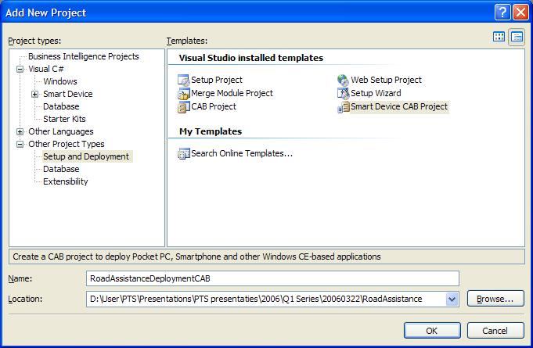

- Give the following name to the new project: RoadAssistanceDeploymentCAB.
- Click the OK button to add the new project to the RoadAssistance solution.

A new empty deployment project is now added to the solution. The next thing to do is add files to the deployment project. This can be done in an easy way, taking all the RoadAssistance assemblies and adding them to the deployment project.

- Right click the RoadAssistanceDeploymentCAB project in Solution Explorer and select Add – Project Output in the popup menu.

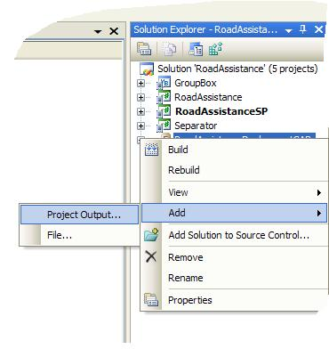

- In the Add Project Output Group dialog select Primary Output and click OK. Note: Make sure that you have selected the RoadAssistance Project. The GroupBox and Separator assemblies will automatically be added as well.

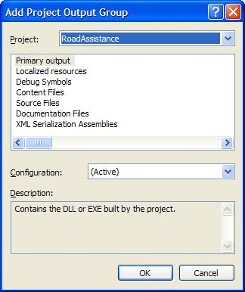
To successfully install the application to the device, you will also need a copy of the RoadAssistance database with at least the user credentials stored in the Employees table.

- Right click the RoadAssistanceDeploymentCAB project in Solution Explorer and select Add – File in the popup menu.
- Browse to the RoadAssistance folder and add the RoadAssistance.sdf database file to the RoadAssistanceDeploymentCAB project.
- Change the Product Name in the RoadAssistanceDeploymentCAB project properties to RoadAssistance.
- Right-click the RoadAssistanceDeploymentCAB project and select Properties in the popup menu.
- Change the project output file name in the RoadAssistanceDeploymentCAB Property Pages to RoadAssistance.cab.

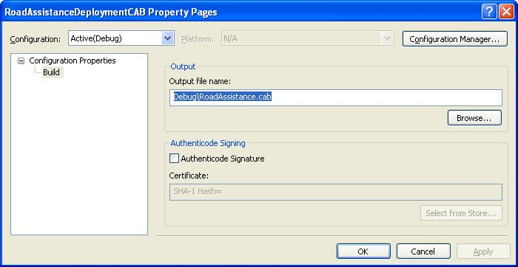

The next thing to do is create a shortcut to the RoadAssistance application, so it can be started on the device from within the Programs menu.

- Display the RoadAssistanceDeploymentCAB project’s File System in the Visual Studio 2005 workspace by right clicking the RoadAssistanceDeploymentCAB project in Solution Explorer and selecting View – File System in the popup menu.
- In the File System view, make sure that Application Folder is selected.
- In the Application Folder Details View, right click anywhere in the screen and select Create New Shortcut.

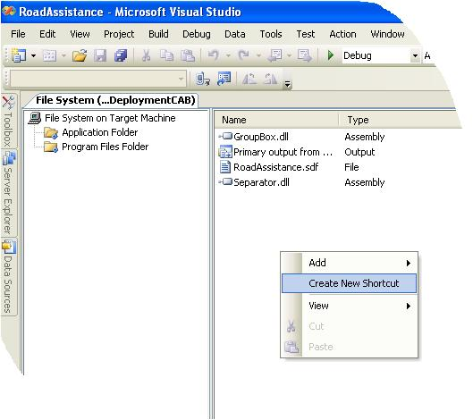

- In the Select Item in Project dialog, make sure to Look in Application Folder and select Primary Output from RoadAssistance (Active).

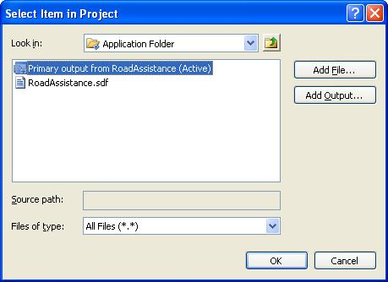

- Click OK to add a new shortcut to the application in the Cab file.
- Rename the just created shortcut to RoadAssistance.

The shortcut is created in the Application Folder. However, on the device you want the shortcut to be stored in the Programs Folder, so that you can select the RoadAssistance application by browsing through the Programs Menu.

- Right click File System on Target Machine in the left hand pane of the File System View and select Programs Folder from the Add Special Folder popup menu.

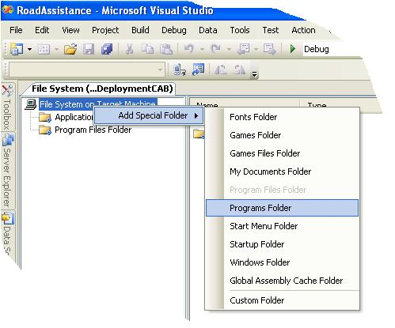

A new folder is created in the File System View with the name Programs Folder.

- Drag the previously created shortcut from the Application Folder to the Programs Folder.
- Build the RoadAssistanceDeploymentCAB project.

You can now test installing the RoadAssistance application on the device (or emulator) by copying the generated CAB file to the device using ActiveSync and install it on the device by clicking the just copied CAB file. Make sure that RoadAssistance is properly installed, that it can be started from the Programs menu and that it is fully functioning. Also, make sure that the application can be uninstalled completely on the device, using Remove Programs from System Settings.

Demo 2 – Auto-Installing the application from the desktop using the Windows Installer

Even though you created a fully functional CAB file in Demo1 that makes it possible to install the RoadAssistance application on the device, the user experience is not that great yet. After all, you need to copy the CAB file manually to the device and install the CAB file on the device. In this second demo you will create a Windows installer project that takes the CAB file that you just created, copies it to the device using ActiveSync and automatically installs the application to the device. In order to do so, you need to create two additional projects to the RoadAssistance solution. The first project you are going to create will contain a class library that exports some custom actions that get automatically run during the installation process using the Microsoft Installer. In this class library you will copy your device installation files to a subfolder of the ActiveSync installation folder. Since different users might have ActiveSync installed at different locations, you will use the class library to determine the location of ActiveSync prior to copying the device installation files.

- Open the RoadAssistance solution in Visual Studio 2005.
- Add a new project to the solution.
- Select a Visual C# Windows Class Library (NOTE: The project you are going to create here is a desktop class library, not a smart device class library).
- Give the following name to the new project: InstallerDLL.
- Remove the class1.cs file that was automatically generated by the new project wizard.
- Add a new Installer Class to the just created project and give it the following name: CustomInstaller.cs.

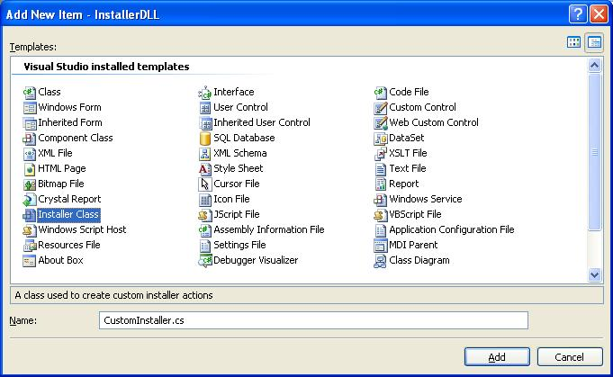

- Click the OK button to add the new project to the RoadAssistance solution.

The CustomInstaller is a special class that contains callback functions and events that will be invoked by the Windows Installer. You can use it to perform specific actions during installation of an application. In this Windows Installation you need to copy all the installation files for the device (in this case the output of the RoadAssistanceDeploymentCAB) to a subfolder of the ActiveSync directory to allow for automatic installation using ActiveSync on the device. Since you can’t assume a fixed location where ActiveSync is installed on the end user’s system, you will use the CustomInstaller to determine where ActiveSync is installed on the end user’s system and then copy all necessary files to a subdirectory of the ActiveSync installation path. To find out where ActiveSync is installed you will make use of some registry keys that are created when ActiveSync is installed on the system, in particular the CEAPPMGR_PATH and the ACTIVESYNC_INSTALL_PATH that you will define as constants in CustomInstaller.cs.

- Open the CustomInstaller class in the source code editor of Visual Studio 2005 and add the following using directives to it:

using System.IO;
using Microsoft.Win32;

- Create the following constants and instance variables to the CustomInstaller class:

private const string CEAPPMGR_PATH =
@"SOFTWARE\Microsoft\Windows\CurrentVersion\App Paths\CEAPPMGR.EXE";
private const string ACTIVESYNC_INSTALL_PATH = @"SOFTWARE\Microsoft\Windows CE Services";
private const string INSTALLED_DIR = "InstalledDir";
private const string CEAPPMGR_EXE_FILE = @"CEAPPMGR.EXE";
private const string CEAPPMGR_INI_FILE = @"RoadAssistance.ini";
private const string APP_SUBDIR = @"\RoadAssistance";
private string TEMP_PATH = Environment.SystemDirectory + @"\TEMP\RoadAssistance";

The next thing to do is subscribe to some events in the CustomInstaller.cs class. These events will be set by the Windows Installer prior to installing an application, after application installation is finished and prior to application uninstall.

- Find the CustomInstaller constructor and subscribe to the following events:

this.BeforeInstall += new InstallEventHandler(CustomInstaller_BeforeInstall);
this.AfterInstall += new InstallEventHandler(CustomInstaller_AfterInstall);
this.BeforeUninstall += new InstallEventHandler(CustomInstaller_BeforeUninstall);

When you subscribe to these events, empty event handlers for the different events are automatically generated in the CustomInstaller class.

The next thing to do is create a helper method that determines the installation path of ActiveSync and that creates a temporary directory under this path to store the installation files for the RoadAssistance application.

- Create the following private method inside the CustomInstaller class:

private string GetAppInstallDirectory()
{
// Get the ActiveSync install directory
RegistryKey keyActiveSync = Registry.LocalMachine.OpenSubKey(ACTIVESYNC_INSTALL_PATH);
if (keyActiveSync == null)
{
throw new Exception("ActiveSync is not installed.");
}
// Build the target directory path under the ActiveSync folder
string activeSyncPath = (string)keyActiveSync.GetValue(INSTALLED_DIR);
string installPath = activeSyncPath + APP_SUBDIR;
keyActiveSync.Close();
return installPath;
}

In this method you make use of the system registry to determine the path on the target system where ActiveSync is installed. If an ActiveSync installation is not found, an exception will be thrown. If an ActiveSync installation is found, you will create a subdirectory under the path where ActiveSync is installed. The path to this subdirectory is returned to the caller of the method. You will use this method in the CustomInstaller_BeforeInstall event handler to copy all necessary files for the RoadAssistance installation on the device. The Windows Installer copies all files that are necessary for installation of the RoadAssistance application to a temporary directory from which they are copied to the directory where CeAppMgr expects them. This will be clarified when you are working on the Windows Installer project in steps 47 – 52 of this step-by-step document.

- Locate the CustomInstaller_BeforeInstall event handler and replace the exception that is currently thrown in this method by the following code:

// Find the location where the application will be installed
string installPath = GetAppInstallDirectory();

// Create the target directory
Directory.CreateDirectory(installPath);
// Copy your application files to the directory

foreach (string installFile in Directory.GetFiles(TEMP_PATH))
{
File.Copy(installFile,
Path.Combine(installPath, Path.GetFileName(installFile)), true);
}

// Get the path to ceappmgr.exe
RegistryKey keyAppMgr = Registry.LocalMachine.OpenSubKey(CEAPPMGR_PATH);
string appMgrPath = (string)keyAppMgr.GetValue(null);
keyAppMgr.Close();

// Run CeAppMgr.exe to install the files to the device
System.Diagnostics.Process.Start(appMgrPath,
"\"" + Path.Combine(installPath, CEAPPMGR_INI_FILE) + "\"");

In the CustomInstaller_BeforeInstall event handler you are creating a directory under the directory where ActiveSync is installed on your system to hold the RoadAssistance installation files and you will run CeAppMgr to actually install the RoadAssistance application to the device that is currently connected.

- Locate the CustomInstaller_AfterInstall event handler and replace the exception that is currently thrown in this method by the following code:

// Delete the temp files
foreach (string tempFile in Directory.GetFiles(TEMP_PATH))
{
File.Delete(tempFile);
}

This event handler is responsible for removing the installation files from the temporary directory that the Windows Installer created prior to copying the installation files to the location where CeAppMgr expects them. Since you have created a Windows Installer project, files will be installed on your desktop machine. In order to remove those files from the desktop machine, you can simply use Add / Remove Programs from the Control Panel. To properly remove the files that were needed for the RoadAssistance application to be installed, you will need to provide a CustomInstaller_BeforeUninstall event handler to do the work for you.

- Locate the CustomInstaller_BeforeUninstall event handler and replace the exception that is currently thrown in this method by the following code:

// Find where the application is installed
string installPath = GetAppInstallDirectory();
// Delete the files
foreach (string appFile in Directory.GetFiles(installPath))
{
File.Delete(appFile);
}
// Delete the folder
Directory.Delete(installPath);

- Build the InstallerDLL project.

For CeAppMgr to properly copy and install the RoadAssistance.cab file on the device, one additional file is needed to register your cab file with CeAppMgr.

- Create a new blank text file inside Visual Studio 2005.
- Add the following to the just created text file:

[CEAppManager]
Version = 1.0
Component = RoadAssistance

[RoadAssistance]
Description = RoadAssistance Sample WM 5.0 LOB Application
CabFiles = RoadAssistance.cab

- Store the just created text file with the name RoadAssistance.ini in the root folder of the RoadAssistance solution.

The RoadAssistance.ini file informs CeAppMgr about the name of the application to install, it is also used to specify the version number of CeAppMgr that can use the ini file and it specifies all files that are needed to install the RoadAssistance application to the device (in this case only the RoadAssistance.cab file is needed for installation of the application).

The last thing you need to do is creating a Windows Installer project that can be used by the Windows Installer on the desktop to actually install the RoadAssistance application to the device.

- Open the RoadAssistance solution in Visual Studio 2005.
- Add a new project to the solution.
- Select Setup and Deployment from the Other Project Types.
- On the shown dialog, select a Setup Project. (NOTE: The project you are going to create will run on the desktop, not on the device itself).
- Give the following name to the new project: RoadAssistanceDeploymentMSI.
- Change the project output file name in the RoadAssistanceDeploymentMSI Property Pages to RoadAssistance.msi.

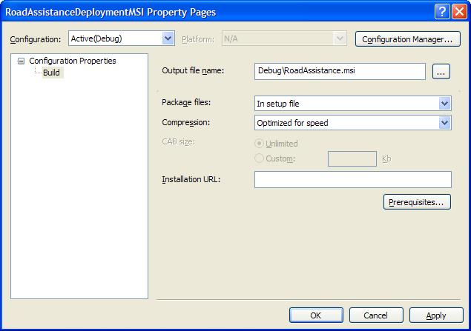

The installation files that will be generated when you are using the Windows Installer to install the RoadAssistance application to a device from the desktop computer need to be stored in a folder under the ActiveSync subdirectory. Since you don’t know where that subdirectory is located on a particular desktop computer, you should first store those installation files in a folder at a location that always exists on each desktop computer. For that purpose you are going to create a temporary folder in the Windows System Folder. You can do this from within the setup project that you are currently creating.

- Use the File System Explorer in the Setup Project to create a new folder by right clicking on the File System on Target Machine node and selecting Add Special Folder and System Folder.

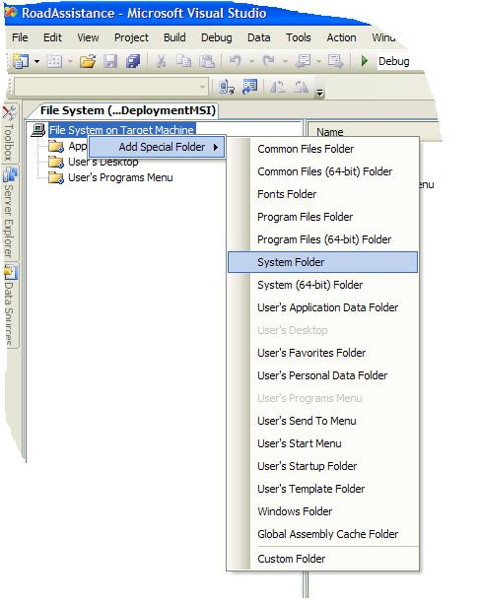

- Right click on the System Folder in the File System Explorer to add a new folder to it.
- Give the new folder the name Temp.
- Repeat the previous steps to create a new folder called RoadAssistance inside the just created Temp folder.

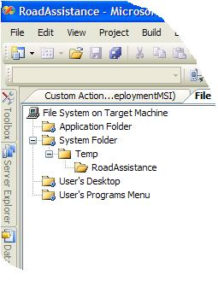

- Right click on the newly created RoadAssistance folder in the File System Explorer and select Add Project Output.
- In the Add Project Output Group select the RoadAssistanceDeploymentCAB project.

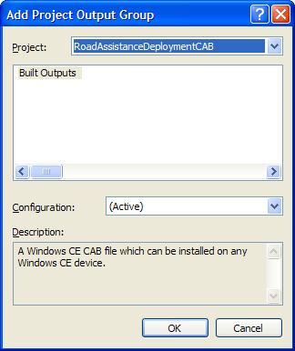

The next thing you need to do is making sure that the custom actions you created in the InstallerDLL will be called when running the RoadAssistanceDeploymentMSI installer. The custom actions will determine where ActiveSync is stored on the deployment machine and copy the RoadAssistance installation files to a folder under that location.

- Open the Custom Action Editor by right clicking on the RoadAssistanceDeploymentMSI project file in Solution Explorer and selecting View and Custom Actions.
- Right click on Custom Actions in the Custom Action Editor to add a new custom action.
- Select the Application Folder and click the Add Output button on the Select Item in Project dialog.
- In the Add Project Output Group dialog now select the InstallerDLL project.
- Click OK in both dialogs to add the InstallerDLL to your installer project.

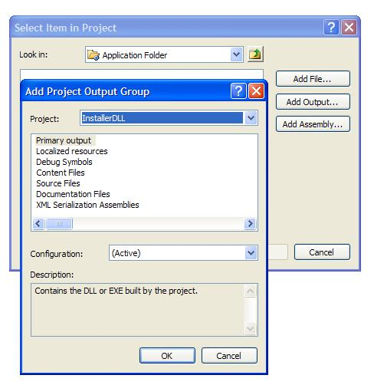

- Add the RoadAssistance.ini file that CeAppMgr uses as an explicit file to the RoadAssistanceDeploymentMSI project in the RoadAssistance folder.
- Rebuild the entire RoadAssistance solution.

Now you should be able to run the RoadAssistance installer. Make sure you have a device or the emulator connected via ActiveSync and start the Windows Installer from inside Visual Studio by right clicking the RoadAssistanceDeploymentMSI project in Solution Explorer and selecting Install.

Demo 3 – Auto-Installing the application from the desktop using a custom application

It is not necessary to make use of the Windows Installer to install the RoadAssistance application to the device, and yet have a good installation experience. Instead, you can create a little Windows application that takes care of installing the RoadAssistance to the device by directly starting the CEAppMngr process as long as the appropriate files are copied to a subfolder of the ActiveSync installation path.

- Create a new Windows Forms Project (either in a separate solution or as part of the RoadAssistance solution) and call the project RoadAssistanceDeviceInstaller.
- Create a User Interface according to the next figure (the background image is of course not important, but the two buttons on the form are important).

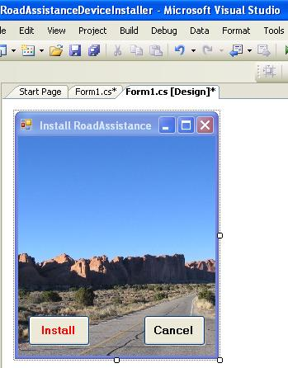

- Add Click event handlers for both of the buttons on the form.
- Add the following using directives to the Form1.cs source file:

using System.IO;
using Microsoft.Win32;

- Add the following constants and instance variables to the Form1.cs source file:

private const string CEAPPMGR_PATH =
@"SOFTWARE\Microsoft\Windows\CurrentVersion\App Paths\CEAPPMGR.EXE";
private const string ACTIVESYNC_INSTALL_PATH = @"SOFTWARE\Microsoft\Windows CE Services";
private const string INSTALLED_DIR = "InstalledDir";
private const string CEAPPMGR_EXE_FILE = @"CEAPPMGR.EXE";
private const string CEAPPMGR_INI_FILE = @"RoadAssistance.ini";
private const string APP_SUBDIR = @"\RoadAssistance";
private string TEMP_PATH = @"..\..\..\RoadAssistanceDeploymentCAB\Debug";
private string INI_FILE = @"..\..\..\RoadAssistance.ini";

In this sample application you are making use of some hard coded paths to locations where the RoadAssistance.CAB file and the RoadAssistance.ini file can be found. Of course you should change these paths to reflect the location where those files are stored on your system. It is never a good practice to use hard coded paths, but this little sample application is for demonstration purposes only, it is definitely not production quality code.

The next thing to do is create a helper method that determines the installation path of ActiveSync and that creates a temporary directory under this path to store the installation files for the RoadAssistance application.

- Create the following private method inside Form1.cs:

private string GetAppInstallDirectory()
{
// Get the ActiveSync install directory
RegistryKey keyActiveSync = Registry.LocalMachine.OpenSubKey(ACTIVESYNC_INSTALL_PATH);
if (keyActiveSync == null)
{
throw new Exception("ActiveSync is not installed.");
}
// Build the target directory path under the ActiveSync folder
string activeSyncPath = (string)keyActiveSync.GetValue(INSTALLED_DIR);
string installPath = activeSyncPath + APP_SUBDIR;
keyActiveSync.Close();
return installPath;
}

In this method you make use of the system registry to determine the path on the target system where ActiveSync is installed. If an ActiveSync installation is not found, an exception will be thrown. If an ActiveSync installation is found, you will create a subdirectory under the path where ActiveSync is installed. The path to this subdirectory is returned to the caller of the method. You will use this method in the btnInstall_Click event handler (assuming you have named the Install button on the form btnInstall).

- Locate the btnInstall_Click event handler and add the following code to it:

// Find the location where the application will be installed
string installPath = GetAppInstallDirectory();

// Create the target directory
Directory.CreateDirectory(installPath);

// Copy your application files to the directory
foreach (string installFile in Directory.GetFiles(TEMP_PATH))
{
if (installFile.CompareTo("RoadAssistance.CAB") == 0)
File.Copy(installFile,
Path.Combine(installPath, Path.GetFileName(installFile)),
true);
}

File.Copy(INI_FILE, Path.Combine(installPath, Path.GetFileName(INI_FILE)), true);

// Get the path to ceappmgr.exe
RegistryKey keyAppMgr = Registry.LocalMachine.OpenSubKey(CEAPPMGR_PATH);
string appMgrPath = (string)keyAppMgr.GetValue(null);
keyAppMgr.Close();

// Run CeAppMgr.exe to install the files to the device
System.Diagnostics.Process.Start(appMgrPath,
"\"" + Path.Combine(installPath,
CEAPPMGR_INI_FILE) + "\"");

this.Close();

This code copies the RoadAssistance.CAB file and the RoadAssistance.ini file to a subdirectory of the ActiveSync install directory and then activates CeAppMgr to get installation on the device started via ActiveSync. Once CeAppMgr is started, this application simply terminates.
- Locate the btnCancel_Click event handler and add the following code to it to terminate the application without installing RoadAssistance to the device:

this.Close();

Compile the just created application. Make sure a device is connected to the development machine via ActiveSync and run the application to make sure that RoadAssistance (including the RoadAssistance.sdf database and a shortcut in programs to RoadAssistance) is properly installed to the device.

You are now done with today’s sample code. Take a look at today’s final solution. You now have two different RoadAssistance applications with the same functionality. One of them runs on Pocket PC’s, the other one on Smart Phones. Both applications share as much code as possible. You can try both using the corresponding emulator in Visual Studio 2005.

